Supplementary Methods: Computational Image Analysis Workflow
S1.1 Scope and Nature of Analyses
The computational analyses reported in this study were exploratory and descriptive in nature and were not intended to provide inferential statistical conclusions. All computational comparisons were restricted to the 15 non-outlier images. All 17 stimuli were retained in the clinical and phenomenological analyses, as the exclusions applied solely to the computational image-feature dataset and did not affect the validity of the subjective distress ratings or clinical observations.
S1.2 Primary Spectral Analysis
To investigate the potential contribution of low-level visual features to the patient’s phobic response, a series of computational analyses was performed on the stimulus images. The primary spectral analysis was conducted using the method described by Penacchio and Wilkins (2015). This algorithm performs a two-dimensional Fast Fourier Transform (2D-FFT) on the central square section of the image and estimates the deviation of the image spectrum from the expected 1/f distribution to the two-dimensional spectral amplitude. The residuals from this model characterize the deviation of the image’s power spectrum from that of typical natural scenes and have been associated with visual discomfort in prior empirical work (Penacchio & Wilkins, 2015). These residual values formed the primary spectral measure used in the present study.
S1.3 Additional Image Properties
In addition to the primary spectral measure, several other image properties were quantified for descriptive purposes. These included image contrast, texture entropy (Haralick et al., 1973), and cluster density, estimated via spatial statistics methods (Silverman, 1986). To assess the stationarity of extracted features across image regions, a cropping sensitivity test was conducted (cf. Tuytelaars & Mikolajczyk, 2008). Feature robustness was further evaluated through a perturbation analysis involving systematic contrast manipulation and noise injection (Geirhos et al., 2018). These analyses were exploratory and descriptive in nature and were not intended to provide inferential statistical conclusions. The auxiliary properties are not presented as independent measures of trypophobia; they serve only to characterize the low-level visual structure of the stimulus set.
S1.4 Score Transformation and Robust Standardization
The raw spectral scores were subject to two transformations to improve robustness against skewed distributions and extreme values. First, a logarithmic transformation was applied to reduce positive skew and compress the dynamic range of the distribution. Second, the scores were expressed as a robust standardized index computed from the median and interquartile range (IQR), rather than the mean and standard deviation, to minimize the influence of extreme values on the central tendency estimate. These transformations were performed solely to improve descriptive robustness and were not intended to support inferential statistical testing. The log-transformed score and the robust index are reported alongside the raw spectral score in Table 1 of the manuscript.
S1.5 Outlier Identification and Exclusion
Two of the 17 stimulus images were identified as statistical outliers during the image-feature analysis phase. Their extracted visual-feature values had a disproportionate influence on the overall feature distributions, and were therefore excluded from the descriptive computational comparisons from the computational comparisons. Outlier status was determined on the basis of the feature distribution, not on the basis of the clinical response they elicited. Accordingly, these exclusions were strictly limited to the computational analyses. Both images were retained in all clinical assessments, and the Subjective Units of Distress (SUD) ratings obtained for these stimuli were included in the full phenomenological analysis without modification.
S1.6 Reproducibility and Analytic Transparency
The primary spectral analysis was conducted using the method of Penacchio and Wilkins (2015), as described in the original publication. The downstream processing steps — including logarithmic transformation, robust standardization based on the median and IQR, and the outlier identification procedure — were performed by the authors of this manuscript and are described in sufficient detail to permit interpretation of the computational workflow. All analyses were descriptive and exploratory; no inferential statistical tests were applied to the computational image data. The purpose of this supplementary description is to improve transparency of the computational workflow rather than to present additional analyses beyond those reported in the main manuscript.

Figure S1. Computational Analysis Pipeline
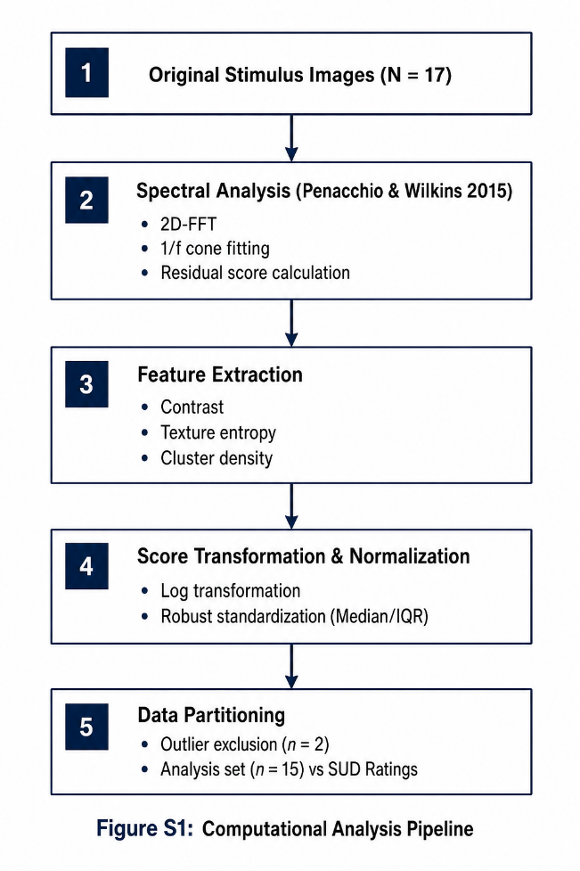

Table S1. Summary of Computational Features
Feature | Description | Purpose in Analysis
Spectral score | Residual spectral measure derived from the Penacchio & Wilkins (2015) algorithm | Primary descriptor of low-level image statistics
Log-transformed score | Logarithmic transformation of the spectral score | Reduce distributional skewness
Robust index | Robustly standardized spectral score | Minimize influence of extreme values
Contrast | Global image contrast | Descriptive image characteristic
Texture entropy | Measure of image complexity | Descriptive image characteristic
Cluster density | Spatial distribution of pattern elements | Descriptive image characteristic
SUD rating | Participant distress rating (0–100) | Clinical comparison only; not a computational feature

