Appendix
Table A1
The maximum influence distance and weight of threat factors.
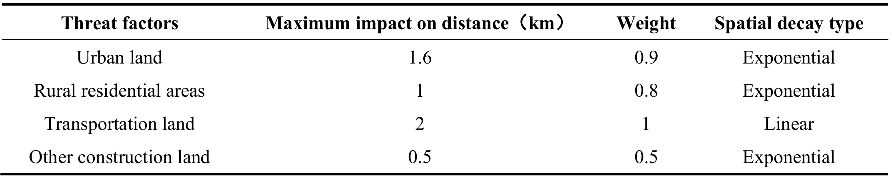
Table A2
The habitat sensitivity of land use types to threat factors.
Land use type | Habitat suitability | Sensitivity
Land use type | Habitat suitability | Urban land | Rural residential areas | Transportation land | Other construction land
Dry land | 0.8 | 0.8 | 0.6 | 0.3 | 0.5
Paddy field | 0.9 | 0.6 | 0.5 | 0.2 | 0.3
Other types | 0 | 0 | 0 | 0 | 0
Table A3
Summary of respondent characteristics in our survey.
Basic variables | Levels | Percentage | Basic variables | Levels | Percentage
Gender  Age  Education  Occupation  Region  Registration | Male  Female  ＜25  25-35  35-55  ＞55  Elementary school  Junior school  High school  College or above  Government employees  Technical personnel  Business  Service workers  Retirees and unemployed  Agriculture, forestry, fishery, and animal husbandry  Students  Others  Anhui  Jiangsu  Zhejiang  Shanghai  Urban areas  Rural areas | 50.00%  50.00%  49.78%  14.63%  19.84%  15.74%  10.31%  18.40%  13.97%  57.32%  5.76%  6.21%  9.65%  7.87%  2.22%  16.30%  48.12%  3.88%  37.14%  25.06%  32.48%  5.32%  28.71%  71.29% | Family population  Part-time situation  Annual income  Agricultural proportion  Presence/absence of cropland  Cropland area | ≤3  4-5  6-7  ≥7  Agriculture-based  Other business-based  Balanced  Full-time farmer  No agricultural engagement  10000-50000  50000-150000  150000-300000  ＞300000  0-10%  11%-20%  21%-50%  ＞50%  yes  no  0-3 acres  3-6 acres  6-9 acres  ＞9 acres | 24.50%  56.10%  13.30%  6.10%  18.18%  31.93%  3.44%  2.77%  43.68%  23.61%  43.46%  22.73%  10.20%  71.51%  12.08%  8.20%  8.20%  62.08%  37.92%  28.38%  19.51%  45.71%  31.43%  10.54%  12.32%
Table A4
Association of socio-demographic features with the preference of ecosystem services based on ordinal logistic regression.
Socioeconomic attribute | Ecosystem service
Group | FS | HQ | CS | SC
Gender | 0.1354 | 0.3836* | 0.4501** | 0.2569
Age | 0.1315 | -0.1523 | -0.1637 | -0.0187
Education | -0.0715 | 0.1164 | -0.0120 | -0.1834
Occupation | -0.1969** | -0.0834 | -0.0320 | -0.0553
Region | -0.1213 | 0.0117 | 0.03190 | -0.1145
Registration | -0.1143 | 0.0865 | -0.3144 | 0.5089
Family population | 0.0825 | 0.2089* | 0.0640 | -0.0229
Annual income | 0.0720 | -0.0103 | 0.0375 | -0.2216*
Agricultural income proportion | -0.3554*** | -0.2286** | -0.0471 | -0.2174*
Cropland area | -0.1259 | 0.3175 | -0.0207 | -0.0832
Note: Significance level * denotes P < 0.05, and ** denotes P < 0.01.
Table A5
Variations of cropland ESs in the YRD from 2000 to 2023.
Year | FS | CS | HQ | SC
2000 | 0.7165 | 48.2651 | 0.5638 | 174.9280
2010 | 0.7505 | 46.5307 | 0.5635 | 222.0947
2023 | 0.7665 | 47.1945 | 0.5630 | 196.2606
2000-2023 | 3.88% | -30.30% | -1.45% | 19.25%
Table A6
The proportion of the trade-off/synergy among ESs.
ES bundles | 2000-2010 |  | 2010-2023
ES bundles | Trade-off | Synergy | Trade-off | Synergy
CS_FS | 32.68% | 67.32% | 57.69% | 42.31%
CS_SC | 71.33% | 28.67% | 71.99% | 28.01%
FS_SC | 36.30% | 63.70% | 19.42% | 80.58%
HQ_CS | 51.27% | 48.73% | 13.62% | 86.38%
HQ_FS | 41.22% | 58.78% | 11.75% | 88.25%
HQ_SC | 7.68% | 92.32% | 6.44% | 93.56%
Table A7
State grading of driving variables.
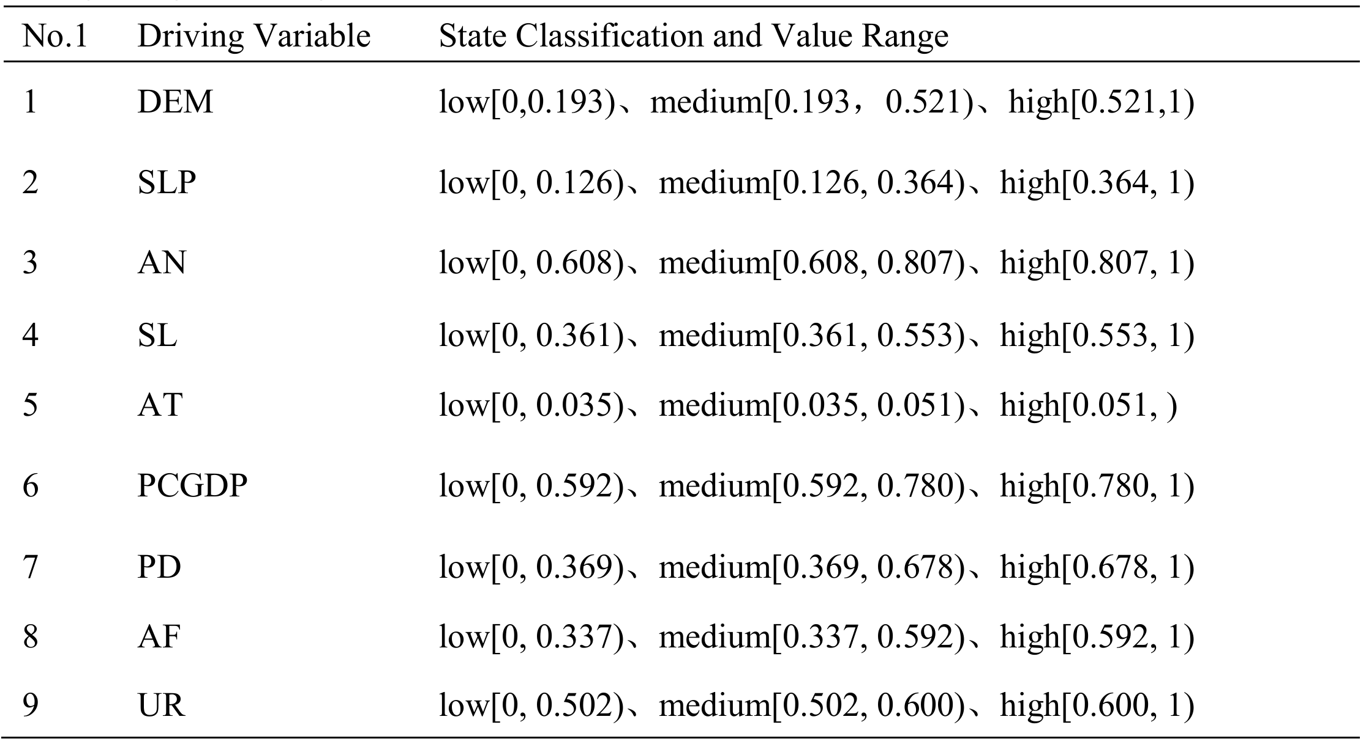
Table A8
Accuracy of the model performance.
Nodes | CS_FS | CS_SC | FS_SC | HQ_CS | HQ_FS | HQ_SC
Separate accuracy | 63.25% | 85.43% | 81.13% | 63.25% | 77.48% | 98.68%
Average accuracy | 78.20%

