Supplementary Appendix
Network meta-analysis of cardiac, coronary, and pulmonary dose-sparing effects of different deep-inspiration breath-hold techniques in radiotherapy for left-sided breast cancer

Xiaoyan Wuª, Peng Wu^{b}, Huaqiong Wang^{c}, Yin Zhang^{a,*}

Table of contents
Appendix 1: Search strategy 2
Appendix 2: Characteristics of included studies 6
Appendix 3: List of data extracted for network meta-analysis 11
Appendix 4: Methodological quality assessment according to the modified Newcastle-Ottawa Scale 12
Appendix 5: Evaluation of inconsistency and heterogeneity 15
Appendix 6: Network maps and forest plots of dose outcomes 24
Appendix 7: P-score ranking plots and ranking tables 31
Appendix 8: League tables of summary estimates derived from network meta-analysis 44
Appendix 9: Funnel plots and small-study effect assessment 49
Appendix 10: Sensitivity Analyses 56
Appendix 11: Subgroup Analyses 58
Appendix 12: Exploratory Meta-regression Analyses 59

Appendix 1: Search strategy
Table S1. Search strategy of PubMed
# | Searches
1 | (("Breast Neoplasms"[MeSH Terms]) OR (breast cancer*[Title/Abstract]) OR (breast neoplasm*[Title/Abstract]) OR (breast carcinoma*[Title/Abstract]) OR (mammary cancer*[Title/Abstract]) OR (mammary neoplasm*[Title/Abstract]))
2 | ((left-sided[Title/Abstract]) OR (left sided[Title/Abstract]) OR (left breast[Title/Abstract]) OR (left-sided breast[Title/Abstract]) OR (left sided breast[Title/Abstract]) OR (left-sided breast cancer[Title/Abstract]) OR (left sided breast cancer[Title/Abstract]))
3 | (("Radiotherapy"[MeSH Terms]) OR (radiotherap*[Title/Abstract]) OR (radiation therap*[Title/Abstract]) OR (irradiat*[Title/Abstract]) OR (adjuvant radiotherap*[Title/Abstract]) OR (breast irradiation[Title/Abstract]) OR (3DCRT[Title/Abstract]) OR (3D-CRT[Title/Abstract]) OR (IMRT[Title/Abstract]) OR (VMAT[Title/Abstract]))
4 | ((deep inspiration breath hold[Title/Abstract]) OR (deep-inspiration breath-hold[Title/Abstract]) OR (deep inspiratory breath hold[Title/Abstract]) OR (moderate deep inspiration breath hold[Title/Abstract]) OR (mDIBH[Title/Abstract]) OR (DIBH[Title/Abstract]) OR (breath hold[Title/Abstract]) OR (breath-hold[Title/Abstract]) OR (breathhold[Title/Abstract]) OR (inspiration breath hold[Title/Abstract]))
5 | ((voluntary breath hold[Title/Abstract]) OR (voluntary breath-hold[Title/Abstract]) OR (voluntary deep inspiration breath hold[Title/Abstract]) OR (voluntary deep-inspiration breath-hold[Title/Abstract]) OR (vDIBH[Title/Abstract]) OR (VBH[Title/Abstract]) OR (visual feedback[Title/Abstract]) OR (video-guided spirometry[Title/Abstract]) OR (spirometry guided[Title/Abstract]) OR (spirometer guided[Title/Abstract]) OR (SDX[Title/Abstract]))
6 | ((active breathing control[Title/Abstract]) OR (active breathing coordinator[Title/Abstract]) OR (ABC[Title/Abstract]) OR (ABC-DIBH[Title/Abstract]) OR (ABC_DIBH[Title/Abstract]) OR (mDIBH with ABC[Title/Abstract]))
7 | ((surface guided radiotherapy[Title/Abstract]) OR (surface-guided radiotherapy[Title/Abstract]) OR (SGRT[Title/Abstract]) OR (surface guidance[Title/Abstract]) OR (surface tracking[Title/Abstract]) OR (surface imaging[Title/Abstract]) OR (optical surface monitoring[Title/Abstract]) OR (optical surface management[Title/Abstract]) OR (OSMS[Title/Abstract]) OR (AlignRT[Title/Abstract]) OR (VisionRT[Title/Abstract]) OR (Vision RT[Title/Abstract]) OR (Catalyst[Title/Abstract]) OR (C-RAD[Title/Abstract]) OR (Sentinel[Title/Abstract]))
8 | #4 OR #5 OR #6 OR #7
9 | ((heart[Title/Abstract]) OR (cardiac[Title/Abstract]) OR (cardioprotect*[Title/Abstract]) OR (cardiac sparing[Title/Abstract]) OR (heart sparing[Title/Abstract]) OR (left anterior descending[Title/Abstract]) OR (LAD[Title/Abstract]) OR (coronary[Title/Abstract]) OR (lung[Title/Abstract]) OR (pulmonary[Title/Abstract]) OR (dose[Title/Abstract]) OR (dosimetric[Title/Abstract]) OR (dose-volume[Title/Abstract]) OR (DVH[Title/Abstract]) OR (organ at risk[Title/Abstract]) OR (organs at risk[Title/Abstract]) OR (OAR[Title/Abstract]) OR (OARs[Title/Abstract]))
10 | #1 AND #2 AND #3 AND #8
11 | #10 AND #9
12 | ((review[Publication Type]) OR (meta-analysis[Publication Type]) OR (meta-analysis[Title/Abstract]) OR (systematic review[Title/Abstract]))
13 | #11 NOT #12
Table S2. Search strategy of Web of Science: Science Citation Index Expanded
# | Searches
1 | TS=("breast cancer*" OR "breast neoplasm*" OR "breast carcinoma*" OR "mammary cancer*" OR "mammary neoplasm*")
2 | TS=("left-sided" OR "left sided" OR "left breast" OR "left-sided breast" OR "left sided breast" OR "left-sided breast cancer" OR "left sided breast cancer")
3 | TS=(radiotherap* OR "radiation therap*" OR irradiat* OR "adjuvant radiotherap*" OR "breast irradiation" OR 3DCRT OR "3D-CRT" OR IMRT OR VMAT)
4 | TS=("deep inspiration breath hold" OR "deep-inspiration breath-hold" OR "deep inspiratory breath hold" OR "moderate deep inspiration breath hold" OR mDIBH OR DIBH OR "breath hold" OR "breath-hold" OR breathhold OR "inspiration breath hold")
5 | TS=("voluntary breath hold" OR "voluntary breath-hold" OR "voluntary deep inspiration breath hold" OR "voluntary deep-inspiration breath-hold" OR vDIBH OR VBH OR "visual feedback" OR "video-guided spirometry" OR "spirometry guided" OR "spirometer guided" OR SDX)
6 | TS=("active breathing control" OR "active breathing coordinator" OR ABC OR "ABC-DIBH" OR ABC_DIBH OR "mDIBH with ABC")
7 | TS=("surface guided radiotherapy" OR "surface-guided radiotherapy" OR SGRT OR "surface guidance" OR "surface tracking" OR "surface imaging" OR "optical surface monitoring" OR "optical surface management" OR OSMS OR AlignRT OR VisionRT OR "Vision RT" OR Catalyst OR "C-RAD" OR Sentinel)
8 | #4 OR #5 OR #6 OR #7
9 | TS=(heart OR cardiac OR cardioprotect* OR "cardiac sparing" OR "heart sparing" OR "left anterior descending" OR LAD OR coronary OR lung OR pulmonary OR dose OR dosimetric OR "dose-volume" OR DVH OR "organ at risk" OR "organs at risk" OR OAR OR OARs)
10 | #1 AND #2 AND #3 AND #8
11 | #10 AND #9
12 | TS=(review OR "meta-analysis" OR "systematic review") OR DT=(Review)
13 | #11 NOT #12
Table S3. Search strategy of Cochrane Central Register of Controlled Trials (CENTRAL)
# | Searches
1 | ("breast cancer*" OR "breast neoplasm*" OR "breast carcinoma*" OR "mammary cancer*" OR "mammary neoplasm*"):ti,ab,kw OR MeSH descriptor: [Breast Neoplasms] explode all trees
2 | ("left-sided" OR "left sided" OR "left breast" OR "left-sided breast" OR "left sided breast" OR "left-sided breast cancer" OR "left sided breast cancer"):ti,ab,kw
3 | (radiotherap* OR "radiation therap*" OR irradiat* OR "adjuvant radiotherap*" OR "breast irradiation" OR 3DCRT OR "3D-CRT" OR IMRT OR VMAT):ti,ab,kw OR MeSH descriptor: [Radiotherapy] explode all trees
4 | ("deep inspiration breath hold" OR "deep-inspiration breath-hold" OR "deep inspiratory breath hold" OR "moderate deep inspiration breath hold" OR mDIBH OR DIBH OR "breath hold" OR "breath-hold" OR breathhold OR "inspiration breath hold"):ti,ab,kw
5 | ("voluntary breath hold" OR "voluntary breath-hold" OR "voluntary deep inspiration breath hold" OR "voluntary deep-inspiration breath-hold" OR vDIBH OR VBH OR "visual feedback" OR "video-guided spirometry" OR "spirometry guided" OR "spirometer guided" OR SDX):ti,ab,kw
6 | ("active breathing control" OR "active breathing coordinator" OR ABC OR "ABC-DIBH" OR ABC_DIBH OR "mDIBH with ABC"):ti,ab,kw
7 | ("surface guided radiotherapy" OR "surface-guided radiotherapy" OR SGRT OR "surface guidance" OR "surface tracking" OR "surface imaging" OR "optical surface monitoring" OR "optical surface management" OR OSMS OR AlignRT OR VisionRT OR "Vision RT" OR Catalyst OR "C-RAD" OR Sentinel):ti,ab,kw
8 | #4 OR #5 OR #6 OR #7
9 | (heart OR cardiac OR cardioprotect* OR "cardiac sparing" OR "heart sparing" OR "left anterior descending" OR LAD OR coronary OR lung OR pulmonary OR dose OR dosimetric OR "dose-volume" OR DVH OR "organ at risk" OR "organs at risk" OR OAR OR OARs):ti,ab,kw
10 | #1 AND #2 AND #3 AND #8
11 | #10 AND #9
12 | ("meta analysis" OR "meta-analysis" OR "systematic review" OR review):ti,ab,kw OR review:pt
13 | #11 NOT #12
Table S4. Search strategy of Embase
# | Searches
1 | 'breast cancer'/exp OR 'breast tumor'/exp OR 'breast neoplasm*':ti,ab,kw OR 'breast cancer*':ti,ab,kw OR 'breast carcinoma*':ti,ab,kw OR 'mammary cancer*':ti,ab,kw OR 'mammary neoplasm*':ti,ab,kw
2 | 'left-sided':ti,ab,kw OR 'left sided':ti,ab,kw OR 'left breast':ti,ab,kw OR 'left-sided breast':ti,ab,kw OR 'left sided breast':ti,ab,kw OR 'left-sided breast cancer':ti,ab,kw OR 'left sided breast cancer':ti,ab,kw
3 | 'radiotherapy'/exp OR radiotherap*:ti,ab,kw OR 'radiation therap*':ti,ab,kw OR irradiat*:ti,ab,kw OR 'adjuvant radiotherap*':ti,ab,kw OR 'breast irradiation':ti,ab,kw OR 3dcrt:ti,ab,kw OR '3d-crt':ti,ab,kw OR imrt:ti,ab,kw OR vmat:ti,ab,kw
4 | 'deep inspiration breath hold':ti,ab,kw OR 'deep-inspiration breath-hold':ti,ab,kw OR 'deep inspiratory breath hold':ti,ab,kw OR 'moderate deep inspiration breath hold':ti,ab,kw OR mdibh:ti,ab,kw OR dibh:ti,ab,kw OR 'breath hold':ti,ab,kw OR 'breath-hold':ti,ab,kw OR breathhold:ti,ab,kw OR 'inspiration breath hold':ti,ab,kw
5 | 'voluntary breath hold':ti,ab,kw OR 'voluntary breath-hold':ti,ab,kw OR 'voluntary deep inspiration breath hold':ti,ab,kw OR 'voluntary deep-inspiration breath-hold':ti,ab,kw OR vDIBH:ti,ab,kw OR vbh:ti,ab,kw OR 'visual feedback':ti,ab,kw OR 'video-guided spirometry':ti,ab,kw OR 'spirometry guided':ti,ab,kw OR 'spirometer guided':ti,ab,kw OR sdx:ti,ab,kw
6 | 'active breathing control':ti,ab,kw OR 'active breathing coordinator':ti,ab,kw OR abc:ti,ab,kw OR 'abc-dibh':ti,ab,kw OR abc_dibh:ti,ab,kw OR 'mdibh with abc':ti,ab,kw
7 | 'surface guided radiotherapy':ti,ab,kw OR 'surface-guided radiotherapy':ti,ab,kw OR sgrt:ti,ab,kw OR 'surface guidance':ti,ab,kw OR 'surface tracking':ti,ab,kw OR 'surface imaging':ti,ab,kw OR 'optical surface monitoring':ti,ab,kw OR 'optical surface management':ti,ab,kw OR osms:ti,ab,kw OR alignrt:ti,ab,kw OR visionrt:ti,ab,kw OR 'vision rt':ti,ab,kw OR catalyst:ti,ab,kw OR 'c-rad':ti,ab,kw OR sentinel:ti,ab,kw
8 | #4 OR #5 OR #6 OR #7
9 | heart:ti,ab,kw OR cardiac:ti,ab,kw OR cardioprotect*:ti,ab,kw OR 'cardiac sparing':ti,ab,kw OR 'heart sparing':ti,ab,kw OR 'left anterior descending':ti,ab,kw OR lad:ti,ab,kw OR coronary:ti,ab,kw OR lung:ti,ab,kw OR pulmonary:ti,ab,kw OR dose:ti,ab,kw OR dosimetric:ti,ab,kw OR 'dose-volume':ti,ab,kw OR dvh:ti,ab,kw OR 'organ at risk':ti,ab,kw OR 'organs at risk':ti,ab,kw OR oar:ti,ab,kw OR oars:ti,ab,kw
10 | #1 AND #2 AND #3 AND #8
11 | #10 AND #9
12 | review:it OR 'meta analysis':ti,ab,kw OR 'meta-analysis':ti,ab,kw OR 'systematic review':ti,ab,kw
13 | #11 NOT #12
Table S5. Search strategy of CNKI
# | Searches
1 | SU=(乳腺癌 OR 乳腺肿瘤 OR 乳腺癌放疗 OR 左侧乳腺癌) OR TI=(乳腺癌 OR 乳腺肿瘤 OR 左侧乳腺癌) OR AB=(乳腺癌 OR 乳腺肿瘤 OR 左侧乳腺癌)
2 | SU=(左侧 OR 左乳 OR 左侧乳腺癌) OR TI=(左侧 OR 左乳 OR 左侧乳腺癌) OR AB=(左侧 OR 左乳 OR 左侧乳腺癌)
3 | SU=(放疗 OR 放射治疗 OR 乳腺照射 OR 辅助放疗 OR 调强放疗 OR 三维适形 OR 容积旋转调强) OR TI=(放疗 OR 放射治疗 OR 乳腺照射 OR 辅助放疗 OR 调强放疗 OR 三维适形 OR 容积旋转调强) OR AB=(放疗 OR 放射治疗 OR 乳腺照射 OR 辅助放疗 OR 调强放疗 OR 三维适形 OR 容积旋转调强)
4 | SU=(深吸气屏气 OR 深吸气屏息 OR 深吸气屏住呼吸 OR 深吸气屏气技术 OR 中度深吸气屏气 OR 自愿深吸气屏气 OR 自主深吸气屏气 OR 呼吸屏气 OR 屏气) OR TI=(深吸气屏气 OR 深吸气屏息 OR 深吸气屏住呼吸 OR DIBH OR mDIBH OR vDIBH OR 屏气) OR AB=(深吸气屏气 OR 深吸气屏息 OR 深吸气屏住呼吸 OR DIBH OR mDIBH OR vDIBH OR 屏气)
5 | SU=(主动呼吸控制 OR 自主呼吸控制 OR 主动呼吸协调器 OR 自主呼吸门控 OR ABC) OR TI=(主动呼吸控制 OR 自主呼吸控制 OR 主动呼吸协调器 OR ABC) OR AB=(主动呼吸控制 OR 自主呼吸控制 OR 主动呼吸协调器 OR ABC)
6 | SU=(体表引导 OR 表面引导 OR 光学体表监测 OR 光学表面监测 OR 光学表面管理 OR 体表监测 OR Catalyst OR AlignRT OR OSMS OR C-RAD OR Sentinel OR VisionRT) OR TI=(体表引导 OR 表面引导 OR 光学体表监测 OR 光学表面监测 OR 光学表面管理 OR Catalyst OR AlignRT OR OSMS OR C-RAD OR Sentinel OR VisionRT) OR AB=(体表引导 OR 表面引导 OR 光学体表监测 OR 光学表面监测 OR 光学表面管理 OR Catalyst OR AlignRT OR OSMS OR C-RAD OR Sentinel OR VisionRT)
7 | SU=(视觉反馈 OR 视频引导 OR 肺量计 OR 自愿屏气 OR 自主屏气 OR vDIBH OR VBH OR SDX) OR TI=(视觉反馈 OR 视频引导 OR 肺量计 OR 自愿屏气 OR 自主屏气 OR vDIBH OR VBH OR SDX) OR AB=(视觉反馈 OR 视频引导 OR 肺量计 OR 自愿屏气 OR 自主屏气 OR vDIBH OR VBH OR SDX)
8 | #4 OR #5 OR #6 OR #7
9 | SU=(心脏 OR 心脏保护 OR 心脏剂量 OR 左前降支 OR 冠状动脉 OR 肺 OR 左肺 OR 肺剂量 OR 剂量学 OR 剂量体积 OR 危及器官) OR TI=(心脏 OR 心脏保护 OR 心脏剂量 OR 左前降支 OR LAD OR 冠状动脉 OR 肺 OR 左肺 OR 肺剂量 OR 剂量学 OR 危及器官) OR AB=(心脏 OR 心脏保护 OR 心脏剂量 OR 左前降支 OR LAD OR 冠状动脉 OR 肺 OR 左肺 OR 肺剂量 OR 剂量学 OR 危及器官)
10 | #1 AND #2 AND #3 AND #8
11 | #10 AND #9
12 | SU=(综述 OR Meta分析 OR 系统评价) OR TI=(综述 OR Meta分析 OR 系统评价 OR 网状Meta分析) OR AB=(综述 OR Meta分析 OR 系统评价 OR 网状Meta分析)
13 | #11 NOT #12

Appendix 2: Characteristics of included studies
Table S2.1: Baseline characteristics of included studies.
First author (year) | Total patients (experimental/control) | Clinical stage | Median age (years) | Prescription dose (Gy)/fractions (F) | Experimental-group technique | Control-group technique | NOS score
Muraleedharan (2024) | 32 (32/32) | IA–IIIC | 46 (22–64) | 50 Gy/25F (+10 Gy boost) | ABC-DIBH | FB | 9
Kunheri (2017) | 45 (45/45) | I–IIIA | 45.2 (29–62) | 40 Gy/15F | ABC-DIBH | FB | 8
Nair (2022) | 13 (13/13) | II–III | 50.9 (31–74) | 42.5 Gy/16F | ABC-DIBH | FB | 7
Shen (2023) | 58 (58/58) | Early-stage | 43.8 (27–63) | 42.6 Gy/16F (+boost) | ABC-DIBH | FB | 8
Falco (2021) | 1049 left-sided | NR | NR | 40.05–50 Gy/15–25F | ABC-DIBH | FB | 6
Ferdinand (2021) | 31 (31/31) | I–III | 49 (32–75) | 40 Gy/15F (+12.5 Gy/5F boost) | ABC-DIBH | FB | 8
Chi (2015) | 31 (31/31) | I–II | 39.5 (26–54) | 50 Gy | ABC-DIBH | FB | 8
Remouchamps (2003) | 5 (5/5) | I–II | 42 (37–65) | 45 Gy/25F or 50.4 Gy/28F | ABC-DIBH | FB | 6
Comsa (2014) | 50 (50/50) | NR | NR | NR | ABC-DIBH | FB | 7
Mast (2013) | 20 (20/20) | NR | NR | 42.56 Gy/16F | ABC-DIBH | FB | 8
Barry (2017) | 50 (50/50) | NR | NR | 50 Gy/25F | ABC-DIBH | FB | 8
Yuan (2023) | 35 (35/35) | NR | NR | 42.56 Gy/16F | ABC-DIBH | FB | 6
Chen HT (2024) | 50 (50/50) | IA–IIIC | 43.5 (27–64) | 50 Gy/25F | ABC-DIBH | FB | 8
Chen H (2022) | 74 (74/74) | IA–IVA | 43 (27–64) | 50 Gy/25F or 40.5–43.2 Gy/15–16F | ABC-DIBH | FB | 8
Eldredge-Hindy (2015) | 86 (86/86) | 0–III | 52 (25–80) | 42.4–50.4 Gy (+boost) | ABC-DIBH | FB | 8
Lin (2019) | 184 left-sided subset | Tis/I/II | 51.5 | 50 Gy/25F (+10–16 Gy boost) | ABC-DIBH | FB | 6
Al Matairi (2026) | 90 (90/90) | NR | 44 | 40.05 Gy/15F or 50 Gy/25F | ABC-DIBH | FB | 8
Wang (2024) | 20 (20/20) | II–III | 48/55 | 43.5 Gy/15F | ABC-DIBH | FB | 8
Dincoglan (2013) | 27 (27/27) | III | ≤65 | 50 Gy/25F | ABC-DIBH | FB | 7
Swanson (2013) | 87 (87/87) | Tis–T4 | 49 (29–70) | 47.6 Gy | ABC-DIBH | FB | 6
Seror (2023) | 50 (24/26) | T0–T4, N1–N4 | 48.3/53.9 | 40.05 Gy | ABC-DIBH | FB | 6
Wolf (2023) | 130 (130/130) | T1–T2 | NR | 40.05 Gy/15F or 50–50.4 Gy/25–28F | ABC-DIBH | FB | 8
Rochet (2015) | 35 (35/35) | pTis–pT3, N0–N1 | 51 (35–69) | 42.4–50.4 Gy/16–28F | SGRT-DIBH | FB | 8
Mkanna (2018) | 103 (103/103) | T0–T4 | 51.9 ± 11.8 | 50 Gy/25F | SGRT-DIBH | FB | 8
Tanguturi (2015) | 146 (146/146) | 0–IV | 49.5/58 | 50 Gy/25F | SGRT-DIBH | FB | 8
Abdollahi (2022) | 20 (20/20) | NR | NR | 50 Gy/25F (+10 Gy boost) | SGRT-DIBH | FB | 8
Zhang J-H (2023) | 20 (20/20) | Early-stage | 45 (27–63) | 43.5 Gy/15F (+SIB 49.5 Gy) | SGRT-DIBH | FB | 8
Kugele (2018) | 40 (40/40) | NR | 46/59 | 50 Gy/25F | SGRT-DIBH | FB | 7
Rudat (2024) | 26 (26/26) | T0–T4, N0–N3 | 46 (29–66) | 40.05 Gy/15F or 40 Gy/16F (+boost) | SGRT-DIBH | FB | 6
Schönecker (2024) | 585 (585/585) | Tis–T3, N0–N3 | 57 (24–84) | 40.05 Gy/15F or 50 Gy/25F | SGRT-DIBH | FB | 6
Schönecker (2016) | 13 (13/13) | NR | 46.9 (36–63) | 50 Gy/25F | SGRT-DIBH | FB | 7
Kadhim (2024) | 20 (20/20) | NR | 59 (45–77) | 50 Gy/25F | SGRT-DIBH | FB | 7
Huang CJ (2020) | 16 (8/8) | NR | 42 (35–50) | NR | SGRT-DIBH | FB | 7
Zhang W (2020) | 48 (48/48) | Early-stage | 54 (40–68) | 50 Gy/25F (+SIB 60 Gy) | SGRT-DIBH | FB | 8
Eber (2023) | 10 (10/10) | pT1–2N0 | 63 (48–80) | 40.05 Gy/15F | SGRT-DIBH | FB | 7
Vuong (2018) | 29 (29/29) | IA–IIB | 54 (32–80) | 42.56–50 Gy/16–27F | SGRT-DIBH | FB | 8
Cayez (2025) | 31 (31/31) | NR | 62 (32–81) | 40.05 Gy | SGRT-DIBH | FB | 7
Eskandari (2020) | 17 (17/17) | Early-stage | NR | 50 Gy/25F | SGRT-DIBH | FB | 7
Dankovics (2023) | 41 (41/41) | NR | 50.4 (31–68) | 50 Gy/25F (+SCV 40 Gy) | vDIBH | FB | 7
Yang (2015) | 28 (28/28) | NR | NR | 42.6–50.4 Gy | vDIBH | FB | 7
Mohamad (2017) | 22 (22/22) | NR | NR | 50.4 Gy | vDIBH | FB | 8
Song (2021) | 75 (75/75) | NR | 59 (37–78) | 40–42.5 Gy/15–16F | vDIBH | FB | 8
Bartlett (2017) | 93 (93/93) | pT1–3bN0–1M0/DCIS | 56 (27–78) | 40.05 Gy/15F or 26–27 Gy/5F | vDIBH | FB | 8
Poitevin-Chacon (2020) | 10 (10/10) | NR | NR | 50 Gy/25F | vDIBH | FB | 7
Al-Hammadi (2018) | 54 (54/54) | NR | 41 (30–64) | 50 Gy/25F | vDIBH | FB | 8
Shambhavi C (2025) | 14 (14/14) | NR | NR | 40.05 Gy/15F | vDIBH | FB | 8
Yeung (2015) | 20 (20/20) | DCIS–III | 47/51 | 42.5 Gy/16F or 50 Gy/25F | vDIBH | FB | 8
Degrande (2023) | 68 (68/68) | 0–III | 50.5 (34–78) | 40.05 Gy/15F | vDIBH | FB | 8
Lai (2024) | 30 (30/30) | 0–IIB | 51 (30–66) | 50 Gy/25F (+10–16 Gy boost) | vDIBH | FB | 8
González-del Portillo (2024) | 40 (40/40) | 0–IIIA | 52.8 ± 8.1 | 40 Gy/15F or 50 Gy/25F | vDIBH | FB | 8
Czeremszynska (2017) | 31 (31/31) | pT1–T2N0–N1aM0/DCIS | NR | 39.9 Gy/15F | vDIBH | FB | 8
Mohanty (2026) | 12 (12/12) | IIB–IIIB | 46.8 (31–61) | NR | vDIBH | FB | 7
Chan (2025) | 55 (16/19/20) | NR | 55 | 42.56 Gy/16F; 50 Gy/25F; 40.05 Gy/15F | vDIBH; ABC-DIBH; SGRT-DIBH | vDIBH; ABC-DIBH; SGRT-DIBH | 7
Shi YB (2024) | 48 (24/24) | Tis–T3N0–3M0 | 47.5/48 | 40.5 Gy/15F | ABC-DIBH | SGRT-DIBH | 8
Quan (2026) | 60 (30/30) | T0–T2 | 45/47 | 40.5 Gy/15F (+10 Gy/4F boost) | SGRT-DIBH | ABC-DIBH | 9
Bartlett (2013) | 23 (23/23) | pT1–3bN0–1M0/DCIS | 61 (36–82) | 40 Gy/15F | vDIBH | ABC-DIBH | 9
Ranger (2021) | 16 (7/9) | N1–N3 | 37/47 | 40.05 Gy/15F | vDIBH | ABC-DIBH | 9
Parasuramar (2017) | 20 (10/10) | NR | ≤70 | NR | ABC-DIBH | vDIBH | 8

References
1. Muraleedharan et al. A comparative study in left-sided breast cancer treated with moderate deep inspiratory breath hold versus free breathing. Journal of the Egyptian National Cancer Institute 2024;36:11. doi:10.1186/s43046-024-00214-6.
2. Kunheri et al. A dosimetric analysis of cardiac dose with or without active breath coordinator moderate deep inspiratory breath hold in left sided breast cancer radiotherapy. Journal of Cancer Research and Therapeutics 2017;13:56-61. doi:10.4103/jcrt.JCRT_1414_16.
3. Nair et al. A dosimetric study comparing different radiotherapy planning techniques with and without deep inspiratory breath hold for breast cancer. Cancer Management and Research 2022;14:3581-3587. doi:10.2147/CMAR.S381316.
4. Shen et al. Deep inspiratory breath-hold technique for patients with left-sided breast cancer: dosimetric analysis, clinical evaluation, and prediction. Research Square 2023. doi:10.21203/rs.3.rs-3054193/v1.
5. Falco et al. Deep inspiration breath hold reduces the mean heart dose in left breast cancer radiotherapy. Radiology and Oncology 2021;55:212-220. doi:10.2478/raon-2021-0008.
6. Ferdinand et al. Dosimetric analysis of deep inspiratory breath-hold technique (DIBH) in left-sided breast cancer radiotherapy and evaluation of pre-treatment predictors of cardiac doses for guiding patient selection for DIBH. Technical Innovations & Patient Support in Radiation Oncology 2021;17:25-31. doi:10.1016/j.tipsro.2021.02.006.
7. Chi et al. Dosimetric comparison of moderate deep inspiration breath-hold and free-breathing intensity-modulated radiotherapy for left-sided breast cancer. Cancer/Radiothérapie 2015;19:180-186. doi:10.1016/j.canrad.2015.01.003.
8. Remouchamps et al. Initial clinical experience with moderate deep-inspiration breath hold using an active breathing control device in the treatment of patients with left-sided breast cancer using external beam radiation therapy. International Journal of Radiation Oncology Biology Physics 2003;56:704-715. doi:10.1016/S0360-3016(03)00010-5.
9. Comsa et al. Introduction of moderate deep inspiration breath hold for radiation therapy of left breast: initial experience of a regional cancer center. Practical Radiation Oncology 2014;4:298-305. doi:10.1016/j.prro.2013.10.006.
10. Mast et al. Left-sided breast cancer radiotherapy with and without breath-hold: does IMRT reduce the cardiac dose even further? Radiotherapy and Oncology 2013;108:248-253. doi:10.1016/j.radonc.2013.07.017.
11. Barry et al. The impact of active breathing control on internal mammary lymph node coverage and normal tissue exposure in breast cancer patients planned for left-sided post-mastectomy radiation therapy. Practical Radiation Oncology 2017;7:228-233. doi:10.1016/j.prro.2016.11.010.
12. Yuan et al. Comparing breath hold versus free breathing irradiation for left-sided breast radiotherapy by PlanIQ. Radiation Oncology 2023;18:200. doi:10.1186/s13014-023-02386-2.
13. Chen HT, Chen WS, Piao Y, et al. Protective effects of active breathing control on the heart and cardiac substructures during radiotherapy for left-sided breast cancer. China Medical Equipment 2024;21(7). doi:10.3969/j.issn.1672-8270.2024.07.003. [in Chinese]
14. Chen et al. The effect of respiratory capacity for dose sparing in left-sided breast cancer irradiation with active breathing coordinator technique. Frontiers in Oncology 2022;12:989220. doi:10.3389/fonc.2022.989220.
15. Eldredge-Hindy et al. Active Breathing Coordinator reduces radiation dose to the heart and preserves local control in patients with left breast cancer: report of a prospective trial. Practical Radiation Oncology 2015;5:4-10. doi:10.1016/j.prro.2014.06.004.
16. Lin et al. A seven-year experience of using moderate deep inspiration breath-hold for patients with early-stage breast cancer and dosimetric comparison. Medicine 2019;98:e15510. doi:10.1097/MD.0000000000015510.
17. Al Matairi et al. Clinical predictors of dosimetric precedence for deep inspiratory breath hold radiation therapy for breast cancer. Diagnostics 2026;16:1236. doi:10.3390/diagnostics16081236.
18. Wang SJ, Zhai YR, Zhang WW, et al. Dosimetric benefit and clinical feasibility of deep inspiration breath-hold and volumetric modulated arc therapy-based postmastectomy radiotherapy for left-sided breast cancer. Scientific Reports 2024;14:24638. doi:10.1038/s41598-024-75560-5.
19. Dincoglan et al. Dosimetric evaluation of critical organs at risk in mastectomized left-sided breast cancer radiotherapy using breath-hold technique. Tumori 2013;99:76-82. doi:10.1700/1248.13792.
20. Swanson et al. Six-year experience routinely using moderate deep inspiration breath-hold for the reduction of cardiac dose in left-sided breast irradiation for patients with early-stage or locally advanced breast cancer. American Journal of Clinical Oncology 2013;36:24-30. doi:10.1097/COC.0b013e31823fe481.
21. Seror et al. The role of breath holding technique on minimizing cardiac dose in left breast cancer irradiation in the adjuvant setting. Oncology and Radiotherapy 2023;17:225-233.
22. Wolf et al. Deep inspiration breath-hold radiation therapy in left-sided breast cancer patients: a single-institution retrospective dosimetric analysis of organs at risk doses. Strahlentherapie und Onkologie 2023;199:379-388. doi:10.1007/s00066-022-01998-z.
23. Rochet et al. Deep inspiration breath-hold technique in left-sided breast cancer radiation therapy: evaluating cardiac contact distance as a predictor of cardiac exposure for patient selection. Practical Radiation Oncology 2015;5:e127-e134. doi:10.1016/j.prro.2014.08.003.
24. Mkanna et al. Predictors of cardiac sparing in deep inspiration breath-hold for patients with left sided breast cancer. Frontiers in Oncology 2018;8:564. doi:10.3389/fonc.2018.00564.
25. Tanguturi et al. Prospective assessment of deep inspiration breath-hold using three-dimensional surface tracking for irradiation of left-sided breast cancer. Practical Radiation Oncology 2015;5:358-365. doi:10.1016/j.prro.2015.06.002.
26. Abdollahi et al. Surface guided 3DCRT in deep-inspiration breath-hold for left sided breast cancer radiotherapy: implementation and first clinical experience in Iran. Reports of Practical Oncology and Radiotherapy 2022;27:881-896. doi:10.5603/RPOR.a2022.0103.
27. Zhang JH et al. Voluntary deep inspiration breath-hold whole-breast irradiation assisted by optical surface monitoring system in patients with left-sided breast cancer: a prospective phase II study. Technology in Cancer Research & Treatment 2023;22:15330338231173773. doi:10.1177/15330338231173773.
28. Kugele et al. Dosimetric effects of intrafractional isocenter variation during deep inspiration breath-hold for breast cancer patients using surface-guided radiotherapy. Journal of Applied Clinical Medical Physics 2018;19:25-38. doi:10.1002/acm2.12214.
29. Rudat et al. Impact of deep inspiration breath hold, surface-guided radiotherapy, and daily CBCT on the organs at risk in breast cancer radiotherapy. Scientific Reports 2024;14:27814. doi:10.1038/s41598-024-77482-8.
30. Schönecker et al. Surface-based deep inspiration breath-hold radiotherapy in left-sided breast cancer: final results from the SAVE-HEART study. ESMO Open 2024;9:103993. doi:10.1016/j.esmoop.2024.103993.
31. Schönecker et al. Treatment planning and evaluation of gated radiotherapy in left-sided breast cancer patients using the Catalyst/Sentinel system for deep inspiration breath-hold. Radiation Oncology 2016;11:143. doi:10.1186/s13014-016-0716-5.
32. Kadhim et al. Surface guided ring gantry radiotherapy in deep inspiration breath hold for breast cancer patients. Journal of Applied Clinical Medical Physics 2024;25:e14463. doi:10.1002/acm2.14463.
33. Huang CJ, Zhang DK, Yang JX, et al. Application of optical surface monitoring in radiotherapy for left-sided breast cancer. China Medical Devices 2020;35(S2). doi:10.3969/j.issn.1674-1633.2020.S2.020. [in Chinese]
34. Zhang et al. Dosimetry and feasibility studies of volumetric modulated arc therapy with deep inspiration breath-hold using optical surface management system for left-sided breast cancer patients. Frontiers in Oncology 2020;10:1711. doi:10.3389/fonc.2020.01711.
35. Eber et al. Evaluation of cardiac substructures exposure of DIBH-3DCRT, FB-HT, and FB-3DCRT in hypofractionated radiotherapy for left-sided breast cancer after breast-conserving surgery: an in silico planning study. Cancers 2023;15:3406. doi:10.3390/cancers15133406.
36. Vuong et al. Dosimetric comparison of deep-inspiration breath-hold and free-breathing treatment delivery techniques for left-sided breast cancer using three-dimensional surface tracking. Medical Dosimetry 2019;44:193-198. doi:10.1016/j.meddos.2018.06.002.
37. Cayez et al. Multi-criteria optimization for comparing free-breathing and breath-hold techniques in helical and volumetric treatment of locoregional left-sided breast cancer. Physica Medica 2025;138:105175. doi:10.1016/j.ejmp.2025.105175.
38. Eskandari et al. Evaluation of the heart and lung dosimetric parameters in deep inspiration breath hold using 3D Slicer. Radiation Oncology Journal 2020;38:68-76. doi:10.3857/roj.2019.00654.
39. Dankovics et al. Reducing the risk of radiation-induced cardiotoxicity in patients with left breast tumor. Orvosi Hetilap 2023;164:420-425. doi:10.1556/650.2023.32740.
40. Yang et al. Clinical experience using a video-guided spirometry system for deep inhalation breath-hold radiotherapy of left-sided breast cancer. Journal of Applied Clinical Medical Physics 2015;16:251-260. doi:10.1120/jacmp.v16i2.5218.
41. Mohamad et al. Deep inspiration breathhold for left-sided breast cancer patients with unfavorable cardiac anatomy requiring internal mammary nodal irradiation. Practical Radiation Oncology 2017;7:e361-e367. doi:10.1016/j.prro.2017.04.006.
42. Song et al. Dose-sparing effect of deep inspiration breath hold technique on coronary artery and left ventricle segments in treatment of breast cancer. Radiotherapy and Oncology 2021;154:101-109. doi:10.1016/j.radonc.2020.09.019.
43. Bartlett et al. The UK HeartSpare Study (Stage II): multicentre evaluation of a voluntary breath-hold technique in patients receiving breast radiotherapy. Clinical Oncology 2017;29:e51-e56. doi:10.1016/j.clon.2016.11.005.
44. Poitevin-Chacon et al. Voluntary breath-hold reduces dose to organs at risk in radiotherapy of left-sided breast cancer. Reports of Practical Oncology and Radiotherapy 2020;25:104-108. doi:10.1016/j.rpor.2019.12.016.
45. Al-Hammadi et al. Voluntary deep inspiration breath-hold reduces the heart dose without compromising the target volume coverage during radiotherapy for left-sided breast cancer. Radiology and Oncology 2018;52:112-120. doi:10.1515/raon-2018-0008.
46. Shambhavi et al. Dosimetric comparison of 3D-conformal radiotherapy, volumetric modulated arc therapy, and h-VMAT in left breast radiotherapy under free-breathing and breath-hold conditions. Scientific Reports 2025;15:33095. doi:10.1038/s41598-025-16665-3.
47. Yeung et al. Cardiac dose reduction with deep inspiration breath hold for left-sided breast cancer radiotherapy patients with and without regional nodal irradiation. Radiation Oncology 2015;10:200. doi:10.1186/s13014-015-0511-8.
48. Degrande et al. Deep inspiration breath hold: dosimetric benefits to decrease cardiac dose during postoperative radiation therapy for breast cancer patients. Reports of Practical Oncology and Radiotherapy 2023;28:172-180. doi:10.5603/RPOR.a2023.0027.
49. Lai et al. Dose advantage of abdominal deep inspiratory breath-hold in postoperative adjuvant radiotherapy for left breast cancer. Journal of the Egyptian National Cancer Institute 2024;36:29. doi:10.1186/s43046-024-00234-2.
50. González et al. Cardiac segments dosimetric benefit from deep inspiration breath hold technique for left-sided breast cancer radiotherapy. Reports of Practical Oncology and Radiotherapy 2024;29:21-29. doi:10.5603/rpor.99024.
51. Czeremszynska et al. Selection of patients with left breast cancer for deep-inspiration breath-hold radiotherapy technique: results of a prospective study. Reports of Practical Oncology and Radiotherapy 2017;22:341-348. doi:10.1016/j.rpor.2017.05.002.
52. Mohanty et al. Assessing the dosimetric advantage of deep inspiration breath hold technique in left-sided breast cancer radiotherapy: a prospective observational study. Journal of Clinical and Diagnostic Research 2026;20:XC05-XC08. doi:10.7860/JCDR/2026/82656.22448.
53. Chan et al. Comparing interfractional stability of heart dose among three breath-hold radiotherapy techniques in breast cancer. Clinical Oncology 2025;38:103699. doi:10.1016/j.clon.2024.103699.
54. Shi YB, Chen WS, Xu Y, et al. Dosimetric analysis of dynamic intensity-modulated radiotherapy using ABC and Catalyst respiratory gating systems after breast-conserving surgery for left-sided breast cancer. Chinese Journal of Radiological Medicine and Protection 2024;44:415-420. doi:10.3760/cma.j.cn112271-20230721-00013. [in Chinese]
55. Quan et al. Comparison of dose sparing between visual feedback guided- and active breathing coordinator-assisted deep inspiration breath hold for left whole breast radiotherapy. Radiation Medicine and Protection 2026;7:43-47. doi:10.1016/j.radmp.2026.01.004.
56. Bartlett et al. The UK HeartSpare Study: randomised evaluation of voluntary deep-inspiratory breath-hold in women undergoing breast radiotherapy. Radiotherapy and Oncology 2013;108:242-247. doi:10.1016/j.radonc.2013.04.021.
57. Ranger et al. Voluntary versus ABC breath-hold in the context of VMAT for breast and locoregional lymph node radiotherapy including the internal mammary chain. Clinical and Translational Radiation Oncology 2021;27:164-168. doi:10.1016/j.ctro.2021.02.003.
58. Parasuramar et al. Deep inspiration breath hold techniques in the radiotherapeutic management of left-sided breast cancer: active breathing coordinator vs. voluntary breath hold. International Journal of Gynecology & Clinical Practices 2017;4:133. doi:10.15344/2394-4986/2017/13

Appendix 3: List of data extracted for network meta-analysis
Table S3.1. List of data extracted from the included studies

Data category | List of variables
Study information | StudyID.; Comparison ID; First Author (Publication Year); Article Title; Country; Study Design
Patient and baseline characteristics | Total Sample Size (n); baseline characteristics reported in the included-study characteristics table, including clinical stage, median age, prescription dose/fractions, and NOS score
DIBH technique classification | Arm 1; Arm 2; treatment node mapping to FB, ABC-DIBH, SGRT-DIBH, or vDIBH
Treatment comparison | Comparison Type; Analysis Stratum; row-level comparison identifier retained from the extracted dataset
Dose outcomes | Heart Dmean; Heart Dmax; Heart V5; Heart V10; Heart V20; Heart V30; LAD Dmean; LAD Dmax; Left lung Dmean; Left lung V5; Left lung V10; Left lung V20; Left lung V30; Unit;
Effect-size input variables | Arm 1 n; Arm 1 Mean; Arm 1 SD; Arm 2 n; Arm 2 Mean; Arm 2 SD
Network meta-analysis variables | Effect ID; treatment 1; treatment 2; MD; SE; reference treatment; direct comparison edge; outcome-specific network geometry; P-score; heterogeneity and inconsistency statistics
Quality assessment and reference linkage | StudyID; reference number; formatted reference; modified NOS item ratings and total NOS score

Appendix 4: Methodological quality assessment according to the modified Newcastle-Ottawa Scale
Figure S4: Overall modified NOS assessment across included studies. Green indicates awarded star; red indicates no awarded star.
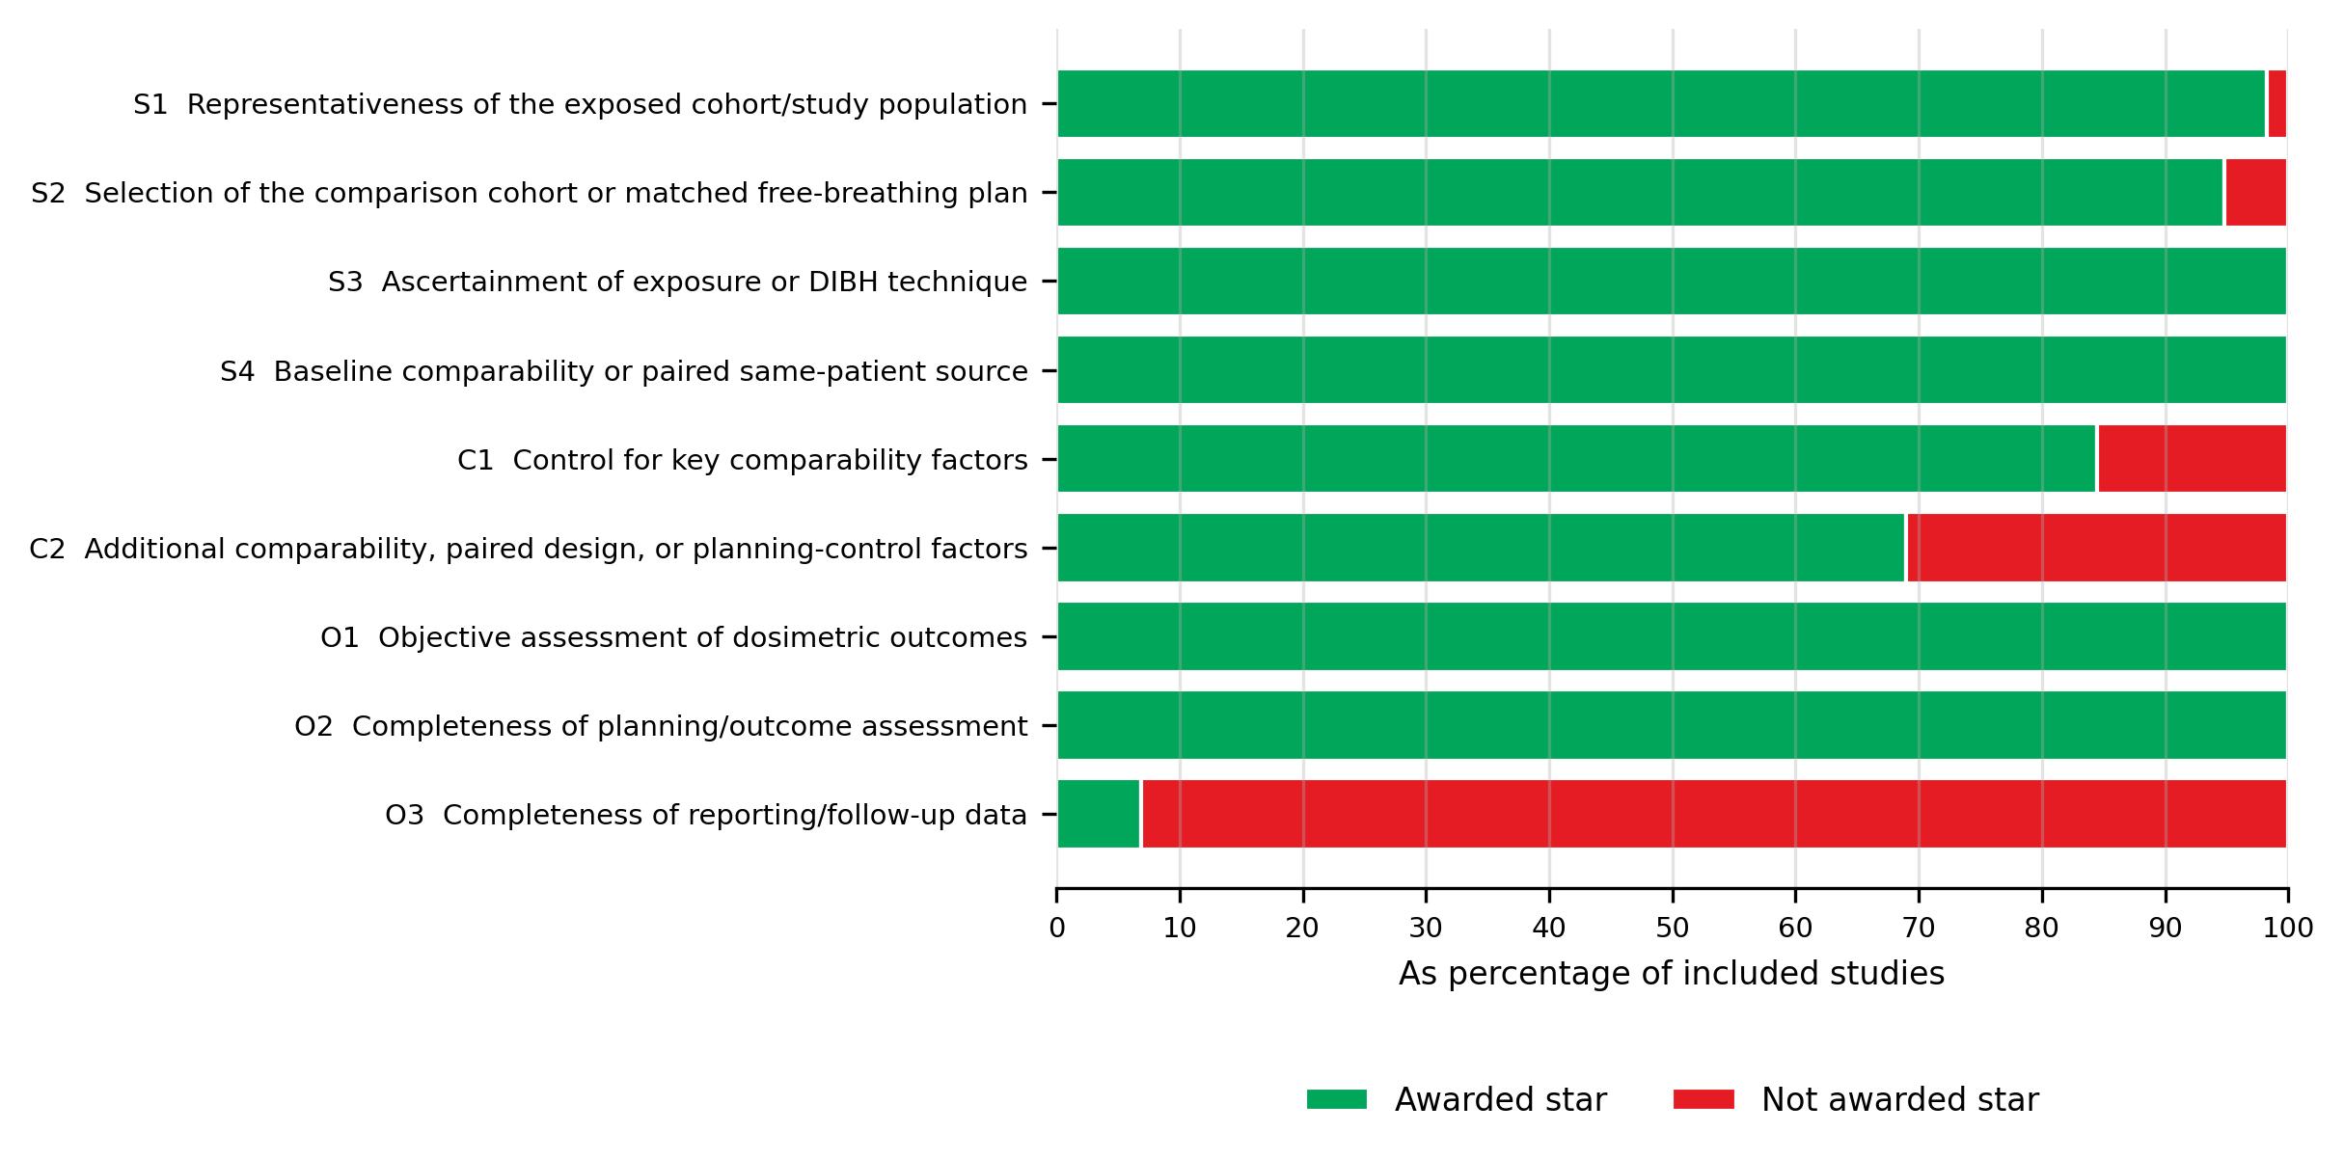

Table S4: Study-level methodological quality assessment using the modified Newcastle-Ottawa Scale for included studies.

StudyID | UniqueID | S1 | S2 | S3 | S4 | C1 | C2 | O1 | O2 | O3 | Totalscore
001 | Muraleedharan 2024 | 1 | 1 | 1 | 1 | 1 | 1 | 1 | 1 | 1 | 9
002 | Kunheri 2017 | 1 | 1 | 1 | 1 | 1 | 1 | 1 | 1 | 0 | 8
003 | Nair 2022 | 1 | 1 | 1 | 1 | 1 | 0 | 1 | 1 | 0 | 7
004 | Shen 2023 | 1 | 1 | 1 | 1 | 1 | 1 | 1 | 1 | 0 | 8
005 | Falco 2021 | 1 | 0 | 1 | 1 | 0 | 1 | 1 | 1 | 0 | 6
006 | Ferdinand 2021 | 1 | 1 | 1 | 1 | 1 | 1 | 1 | 1 | 0 | 8
007 | Chi 2015 | 1 | 1 | 1 | 1 | 1 | 1 | 1 | 1 | 0 | 8
008 | Remouchamps 2003 | 0 | 1 | 1 | 1 | 1 | 0 | 1 | 1 | 0 | 6
009 | Comsa 2014 | 1 | 1 | 1 | 1 | 1 | 0 | 1 | 1 | 0 | 7
010 | Mast 2013 | 1 | 1 | 1 | 1 | 1 | 1 | 1 | 1 | 0 | 8
011 | Barry 2017 | 1 | 1 | 1 | 1 | 1 | 1 | 1 | 1 | 0 | 8
012 | Yuan 2023 | 1 | 1 | 1 | 1 | 0 | 0 | 1 | 1 | 0 | 6
013 | Chen Hongtao 2024 | 1 | 1 | 1 | 1 | 1 | 1 | 1 | 1 | 0 | 8
014 | Chen 2022 | 1 | 1 | 1 | 1 | 1 | 1 | 1 | 1 | 0 | 8
015 | Eldredge-Hindy 2015 | 1 | 1 | 1 | 1 | 1 | 1 | 1 | 1 | 0 | 8
016 | Lin 2019 | 1 | 0 | 1 | 1 | 0 | 1 | 1 | 1 | 0 | 6
017 | Al Matairi 2026 | 1 | 1 | 1 | 1 | 1 | 1 | 1 | 1 | 0 | 8
018 | Wang 2024 | 1 | 1 | 1 | 1 | 1 | 1 | 1 | 1 | 0 | 8
019 | Dincoglan 2013 | 1 | 1 | 1 | 1 | 1 | 0 | 1 | 1 | 0 | 7
020 | Swanson 2013 | 1 | 1 | 1 | 1 | 0 | 0 | 1 | 1 | 0 | 6
021 | Seror 2023 | 1 | 0 | 1 | 1 | 0 | 1 | 1 | 1 | 0 | 6
022 | Wolf 2023 | 1 | 1 | 1 | 1 | 1 | 1 | 1 | 1 | 0 | 8
023 | Rochet 2015 | 1 | 1 | 1 | 1 | 1 | 1 | 1 | 1 | 0 | 8
024 | Mkanna 2018 | 1 | 1 | 1 | 1 | 1 | 1 | 1 | 1 | 0 | 8
025 | Tanguturi 2015 | 1 | 1 | 1 | 1 | 1 | 1 | 1 | 1 | 0 | 8
026 | Abdollahi 2022 | 1 | 1 | 1 | 1 | 1 | 1 | 1 | 1 | 0 | 8
027 | Zhang 2020 Phase II | 1 | 1 | 1 | 1 | 1 | 1 | 1 | 1 | 0 | 8
028 | Kugele 2018 | 1 | 1 | 1 | 1 | 1 | 0 | 1 | 1 | 0 | 7
029 | Rudat 2024 | 1 | 1 | 1 | 1 | 0 | 0 | 1 | 1 | 0 | 6
030 | Schönecker 2024 | 1 | 1 | 1 | 1 | 0 | 0 | 1 | 1 | 0 | 6
031 | Schönecker 2016 | 1 | 1 | 1 | 1 | 1 | 0 | 1 | 1 | 0 | 7
032 | Kadhim 2024 | 1 | 1 | 1 | 1 | 1 | 0 | 1 | 1 | 0 | 7
033 | 黄成剑 2020 | 1 | 1 | 1 | 1 | 0 | 1 | 1 | 1 | 0 | 7
034 | Zhang 2020 | 1 | 1 | 1 | 1 | 1 | 1 | 1 | 1 | 0 | 8
035 | Eber 2023 | 1 | 1 | 1 | 1 | 1 | 0 | 1 | 1 | 0 | 7
036 | Vuong 2018 | 1 | 1 | 1 | 1 | 1 | 1 | 1 | 1 | 0 | 8
037 | Cayez 2025 | 1 | 1 | 1 | 1 | 1 | 0 | 1 | 1 | 0 | 7
038 | Eskandari 2020 | 1 | 1 | 1 | 1 | 1 | 0 | 1 | 1 | 0 | 7
039 | Dankovics 2023 | 1 | 1 | 1 | 1 | 1 | 0 | 1 | 1 | 0 | 7
040 | Yang 2015 | 1 | 1 | 1 | 1 | 1 | 0 | 1 | 1 | 0 | 7
041 | Mohamad 2017 | 1 | 1 | 1 | 1 | 1 | 1 | 1 | 1 | 0 | 8
042 | Song 2020 | 1 | 1 | 1 | 1 | 1 | 1 | 1 | 1 | 0 | 8
043 | Bartlett 2017 | 1 | 1 | 1 | 1 | 1 | 1 | 1 | 1 | 0 | 8
044 | Poitevin-Chacón 2020 | 1 | 1 | 1 | 1 | 1 | 0 | 1 | 1 | 0 | 7
045 | Al-Hammadi 2018 | 1 | 1 | 1 | 1 | 1 | 1 | 1 | 1 | 0 | 8
046 | Shambhavi 2025 | 1 | 1 | 1 | 1 | 1 | 1 | 1 | 1 | 0 | 8
047 | Yeung 2015 | 1 | 1 | 1 | 1 | 1 | 1 | 1 | 1 | 0 | 8
048 | Degrande 2023 | 1 | 1 | 1 | 1 | 1 | 1 | 1 | 1 | 0 | 8
049 | Lai 2024 | 1 | 1 | 1 | 1 | 1 | 1 | 1 | 1 | 0 | 8
050 | González-del Portillo 2024 | 1 | 1 | 1 | 1 | 1 | 1 | 1 | 1 | 0 | 8
051 | Czeremszynska 2017 | 1 | 1 | 1 | 1 | 1 | 1 | 1 | 1 | 0 | 8
052 | Mohanty 2026 | 1 | 1 | 1 | 1 | 1 | 0 | 1 | 1 | 0 | 7
053 | Chan 2024 | 1 | 1 | 1 | 1 | 0 | 1 | 1 | 1 | 0 | 7
054 | Shi 2024 | 1 | 1 | 1 | 1 | 1 | 1 | 1 | 1 | 0 | 8
055 | Quan 2026 | 1 | 1 | 1 | 1 | 1 | 1 | 1 | 1 | 1 | 9
056 | Bartlett 2013 | 1 | 1 | 1 | 1 | 1 | 1 | 1 | 1 | 1 | 9
057 | Ranger 2021 | 1 | 1 | 1 | 1 | 1 | 1 | 1 | 1 | 1 | 9
058 | Parasuramar 2017 | 1 | 1 | 1 | 1 | 1 | 1 | 1 | 1 | 0 | 8

Abbreviations and scoring criteria: S1, representativeness of the exposed cohort/study population; S2, selection of the comparison cohort or free-breathing comparator; S3, ascertainment of exposure or DIBH technique; S4, baseline comparability; C1, control for key comparability factors; C2, additional comparability or planning-control factors; O1, objective assessment of dosimetric outcomes; O2, completeness of planning/outcome assessment; O3, completeness of reporting/follow-up data. A score of 1 indicates that a star was awarded for the item; 0 indicates that no star was awarded.
Quality thresholds: Total scores of 7-9 were considered high quality, 4-6 moderate quality, and 0-3 low quality.

Appendix 5: Evaluation of inconsistency and heterogeneity
For each outcome, inconsistency was assessed using global consistency tests and node-splitting comparisons where estimable. Heterogeneity was summarized using τ² from pairwise and network models. Effect estimates were expressed as mean differences. For all dose outcomes, lower values were considered better, and MD < 0 indicated a lower dose and favoured the DIBH technique.
Table S5.1: Global consistency.
Outcome | Chi-square | P value
Heart Dmean | 63.9 | 0.36
Heart Dmax | 1.80 | 0.17
Heart V5 | Not estimable | Not estimable
Heart V10 | 4.32 | 0.058
Heart V20 | Not estimable | Not estimable
Heart V30 | 30.8 | <0.001
LAD Dmean | 29.2 | 0.61
LAD Dmax | 1.40 | 0.498
Left lung Dmean | 0.200 | 0.906
Left lung V5 | 9.24 | 0.002
Left lung V10 | Not estimable | Not estimable
Left lung V20 | 3.67 | 0.76
Left lung V30 | Not estimable | Not estimable

Table S5.2: Node-splitting of Heart Dmean.
Comparison | Direct MD | Direct SE | Indirect MD | Indirect SE | Difference MD | Difference SE | P value
ABC-DIBH vs FB | -1.86 | 0.121 | -1.45 | 0.230 | -0.405 | 0.260 | 0.118
ABC-DIBH vs SGRT-DIBH | 0.0796 | 0.325 | -0.639 | 0.168 | 0.719 | 0.366 | 0.069
ABC-DIBH vs vDIBH | -0.0858 | 0.275 | -0.154 | 0.170 | 0.0678 | 0.324 | 0.834
SGRT-DIBH vs FB | -1.20 | 0.129 | -1.72 | 0.295 | 0.526 | 0.322 | 0.102
vDIBH vs FB | -1.62 | 0.130 | -1.70 | 0.264 | 0.0815 | 0.295 | 0.782
SGRT-DIBH vs vDIBH | 0.440 | 0.547 | 0.344 | 0.168 | 0.0956 | 0.573 | 0.867
Table S5.3: Node-splitting of Heart Dmax.
Comparison | Direct MD | Direct SE | Indirect MD | Indirect SE | Difference MD | Difference SE | P value
ABC-DIBH vs FB | -11.1 | 2.13 | -14.3 | 6.66 | 3.21 | 6.99 | 0.646
ABC-DIBH vs SGRT-DIBH | 0.388 | 6.32 | 3.60 | 2.98 | -3.21 | 6.99 | 0.646
ABC-DIBH vs vDIBH | Not estimable | Not estimable | -6.76 | 3.09 | Not estimable | Not estimable | Not estimable
SGRT-DIBH vs FB | -14.7 | 2.08 | -11.5 | 6.67 | -3.21 | 6.99 | 0.646
vDIBH vs FB | -4.66 | 2.33 | Not estimable | Not estimable | Not estimable | Not estimable | Not estimable
SGRT-DIBH vs vDIBH | Not estimable | Not estimable | -9.77 | 3.06 | Not estimable | Not estimable | Not estimable

Table S5.4: Node-splitting of Heart V5.
Comparison | Direct MD | Direct SE | Indirect MD | Indirect SE | Difference MD | Difference SE | P value
ABC-DIBH vs FB | -7.30 | 0.504 | Not estimable | Not estimable | Not estimable | Not estimable | Not estimable
ABC-DIBH vs SGRT-DIBH | Not estimable | Not estimable | -1.61 | 0.862 | Not estimable | Not estimable | Not estimable
ABC-DIBH vs vDIBH | Not estimable | Not estimable | -2.86 | 0.906 | Not estimable | Not estimable | Not estimable
SGRT-DIBH vs FB | -5.70 | 0.699 | Not estimable | Not estimable | Not estimable | Not estimable | Not estimable
vDIBH vs FB | -4.44 | 0.753 | Not estimable | Not estimable | Not estimable | Not estimable | Not estimable
SGRT-DIBH vs vDIBH | Not estimable | Not estimable | -1.26 | 1.03 | Not estimable | Not estimable | Not estimable
Table S5.5: Node-splitting of Heart V10.
Comparison | Direct MD | Direct SE | Indirect MD | Indirect SE | Difference MD | Difference SE | P value
ABC-DIBH vs FB | -5.92 | 0.577 | -3.13 | 2.64 | -2.78 | 2.70 | 0.302
ABC-DIBH vs SGRT-DIBH | 0.730 | 2.42 | -2.05 | 1.19 | 2.78 | 2.70 | 0.302
ABC-DIBH vs vDIBH | Not estimable | Not estimable | -1.59 | 0.948 | Not estimable | Not estimable | Not estimable
SGRT-DIBH vs FB | -3.86 | 1.04 | -6.65 | 2.49 | 2.78 | 2.70 | 0.302
vDIBH vs FB | -4.20 | 0.763 | Not estimable | Not estimable | Not estimable | Not estimable | Not estimable
SGRT-DIBH vs vDIBH | Not estimable | Not estimable | -0.0769 | 1.23 | Not estimable | Not estimable | Not estimable
Table S5.6: Node-splitting of Heart V20.
Comparison | Direct MD | Direct SE | Indirect MD | Indirect SE | Difference MD | Difference SE | P value
ABC-DIBH vs FB | -3.14 | 0.452 | Not estimable | Not estimable | Not estimable | Not estimable | Not estimable
ABC-DIBH vs SGRT-DIBH | Not estimable | Not estimable | -0.968 | 0.845 | Not estimable | Not estimable | Not estimable
ABC-DIBH vs vDIBH | Not estimable | Not estimable | 1.23 | 0.834 | Not estimable | Not estimable | Not estimable
SGRT-DIBH vs FB | -2.18 | 0.714 | Not estimable | Not estimable | Not estimable | Not estimable | Not estimable
vDIBH vs FB | -4.37 | 0.701 | Not estimable | Not estimable | Not estimable | Not estimable | Not estimable
SGRT-DIBH vs vDIBH | Not estimable | Not estimable | 2.19 | 1.00 | Not estimable | Not estimable | Not estimable

Table S5.7: Node-splitting of Heart V30.
Comparison | Direct MD | Direct SE | Indirect MD | Indirect SE | Difference MD | Difference SE | P value
ABC-DIBH vs FB | -3.23 | 0.360 | -1.47 | 1.56 | -1.76 | 1.60 | 0.271
ABC-DIBH vs SGRT-DIBH | 0.130 | 1.33 | -1.63 | 0.888 | 1.76 | 1.60 | 0.271
ABC-DIBH vs vDIBH | Not estimable | Not estimable | 2.39 | 0.972 | Not estimable | Not estimable | Not estimable
SGRT-DIBH vs FB | -1.60 | 0.812 | -3.36 | 1.38 | 1.76 | 1.60 | 0.271
vDIBH vs FB | -5.53 | 0.906 | Not estimable | Not estimable | Not estimable | Not estimable | Not estimable
SGRT-DIBH vs vDIBH | Not estimable | Not estimable | 3.47 | 1.15 | Not estimable | Not estimable | Not estimable
Table S5.8: Node-splitting of LAD Dmean.
Comparison | Direct MD | Direct SE | Indirect MD | Indirect SE | Difference MD | Difference SE | P value
ABC-DIBH vs FB | -9.98 | 1.12 | -6.27 | 2.25 | -3.71 | 2.52 | 0.14
ABC-DIBH vs SGRT-DIBH | 3.15 | 3.08 | -2.82 | 1.60 | 5.97 | 3.47 | 0.085
ABC-DIBH vs vDIBH | -0.261 | 2.92 | -1.21 | 1.43 | 0.950 | 3.26 | 0.77
SGRT-DIBH vs FB | -6.97 | 1.20 | -12.9 | 3.25 | 5.97 | 3.47 | 0.085
vDIBH vs FB | -8.13 | 0.959 | -9.08 | 3.11 | 0.950 | 3.26 | 0.77
SGRT-DIBH vs vDIBH | Not estimable | Not estimable | 0.529 | 1.44 | Not estimable | Not estimable | Not estimable
Table S5.9: Node-splitting of LAD Dmax.
Comparison | Direct MD | Direct SE | Indirect MD | Indirect SE | Difference MD | Difference SE | P value
ABC-DIBH vs FB | -10.2 | 2.38 | -9.68 | 5.70 | -0.532 | 6.18 | 0.931
ABC-DIBH vs SGRT-DIBH | 5.51 | 7.48 | 6.98 | 3.22 | -1.47 | 8.14 | 0.856
ABC-DIBH vs vDIBH | 2.00 | 8.06 | -0.703 | 3.13 | 2.70 | 8.64 | 0.754
SGRT-DIBH vs FB | -17.0 | 2.27 | -15.5 | 7.82 | -1.47 | 8.14 | 0.856
vDIBH vs FB | -9.62 | 2.16 | -12.3 | 8.37 | 2.70 | 8.64 | 0.754
SGRT-DIBH vs vDIBH | Not estimable | Not estimable | -7.10 | 3.01 | Not estimable | Not estimable | Not estimable

Table S5.10: Node-splitting of Left lung Dmean.
Comparison | Direct MD | Direct SE | Indirect MD | Indirect SE | Difference MD | Difference SE | P value
ABC-DIBH vs FB | -1.14 | 0.179 | -0.932 | 0.462 | -0.211 | 0.495 | 0.67
ABC-DIBH vs SGRT-DIBH | 0.000210 | 0.572 | -0.382 | 0.267 | 0.382 | 0.632 | 0.546
ABC-DIBH vs vDIBH | 0 | 0.674 | 0.0512 | 0.284 | -0.0512 | 0.732 | 0.944
SGRT-DIBH vs FB | -0.763 | 0.203 | -1.14 | 0.598 | 0.382 | 0.632 | 0.546
vDIBH vs FB | -1.16 | 0.226 | -1.11 | 0.696 | -0.0512 | 0.732 | 0.944
SGRT-DIBH vs vDIBH | Not estimable | Not estimable | 0.357 | 0.287 | Not estimable | Not estimable | Not estimable
Table S5.11: Node-splitting of Left lung V5.
Comparison | Direct MD | Direct SE | Indirect MD | Indirect SE | Difference MD | Difference SE | P value
ABC-DIBH vs FB | -1.34 | 0.819 | -4.76 | 2.57 | 3.43 | 2.70 | 0.204
ABC-DIBH vs SGRT-DIBH | -2.37 | 2.26 | 1.06 | 1.47 | -3.43 | 2.70 | 0.204
ABC-DIBH vs vDIBH | Not estimable | Not estimable | 0.704 | 1.31 | Not estimable | Not estimable | Not estimable
SGRT-DIBH vs FB | -2.40 | 1.23 | 1.03 | 2.40 | -3.43 | 2.70 | 0.204
vDIBH vs FB | -2.36 | 1.05 | Not estimable | Not estimable | Not estimable | Not estimable | Not estimable
SGRT-DIBH vs vDIBH | Not estimable | Not estimable | 0.670 | 1.52 | Not estimable | Not estimable | Not estimable
Table S5.12: Node-splitting of Left lung V10.
Comparison | Direct MD | Direct SE | Indirect MD | Indirect SE | Difference MD | Difference SE | P value
ABC-DIBH vs FB | -2.59 | 1.00 | Not estimable | Not estimable | Not estimable | Not estimable | Not estimable
ABC-DIBH vs SGRT-DIBH | Not estimable | Not estimable | 1.69 | 2.59 | Not estimable | Not estimable | Not estimable
ABC-DIBH vs vDIBH | Not estimable | Not estimable | 0.921 | 1.67 | Not estimable | Not estimable | Not estimable
SGRT-DIBH vs FB | -4.28 | 2.39 | Not estimable | Not estimable | Not estimable | Not estimable | Not estimable
vDIBH vs FB | -3.51 | 1.34 | Not estimable | Not estimable | Not estimable | Not estimable | Not estimable
SGRT-DIBH vs vDIBH | Not estimable | Not estimable | -0.768 | 2.74 | Not estimable | Not estimable | Not estimable

Table S5.13: Node-splitting of Left lung V20.
Comparison | Direct MD | Direct SE | Indirect MD | Indirect SE | Difference MD | Difference SE | P value
ABC-DIBH vs FB | -2.44 | 0.460 | -2.10 | 1.55 | -0.344 | 1.62 | 0.832
ABC-DIBH vs SGRT-DIBH | 0.144 | 1.57 | -0.268 | 0.766 | 0.413 | 1.75 | 0.814
ABC-DIBH vs vDIBH | 0.530 | 3.87 | 0.583 | 0.712 | -0.0526 | 3.93 | 0.989
SGRT-DIBH vs FB | -2.18 | 0.615 | -2.59 | 1.64 | 0.413 | 1.75 | 0.814
vDIBH vs FB | -3.00 | 0.557 | -2.95 | 3.89 | -0.0526 | 3.93 | 0.989
SGRT-DIBH vs vDIBH | Not estimable | Not estimable | 0.770 | 0.796 | Not estimable | Not estimable | Not estimable
Table S5.14: Node-splitting of Left lung V30.
Comparison | Direct MD | Direct SE | Indirect MD | Indirect SE | Difference MD | Difference SE | P value
ABC-DIBH vs FB | -2.35 | 0.718 | Not estimable | Not estimable | Not estimable | Not estimable | Not estimable
ABC-DIBH vs SGRT-DIBH | -0.140 | 2.07 | Not estimable | Not estimable | Not estimable | Not estimable | Not estimable
ABC-DIBH vs vDIBH | Not estimable | Not estimable | -0.00217 | 0.920 | Not estimable | Not estimable | Not estimable
SGRT-DIBH vs FB | Not estimable | Not estimable | -2.21 | 2.19 | Not estimable | Not estimable | Not estimable
vDIBH vs FB | -2.35 | 0.576 | Not estimable | Not estimable | Not estimable | Not estimable | Not estimable
SGRT-DIBH vs vDIBH | Not estimable | Not estimable | 0.138 | 2.26 | Not estimable | Not estimable | Not estimable
Table S5.15: Heterogeneity score by each comparison for Heart Dmean.
Treatment 1 | Treatment 2 | τ² pairwise | τ² network
ABC-DIBH | FB | 0.34 | 0.248
SGRT-DIBH | FB | 0.146 | 0.248
vDIBH | FB | 0.457 | 0.248
ABC-DIBH | SGRT-DIBH | 0.00892 | 0.248
ABC-DIBH | vDIBH | 0.077 | 0.248
SGRT-DIBH | vDIBH | Not estimable | 0.248
Table S5.16: Heterogeneity score by each comparison for Heart Dmax.
Treatment 1 | Treatment 2 | τ² pairwise | τ² network
ABC-DIBH | FB | 58.6 | 39.5
SGRT-DIBH | FB | 70.7 | 39.5
vDIBH | FB | 8.31 | 39.5
ABC-DIBH | SGRT-DIBH | Not estimable | 39.5
Table S5.17: Heterogeneity score by each comparison for Heart V5.
Treatment 1 | Treatment 2 | τ² pairwise | τ² network
ABC-DIBH | FB | 0.628 | 1.77
SGRT-DIBH | FB | 2.87 | 1.77
vDIBH | FB | 0.0 | 1.77
Table S5.18: Heterogeneity score by each comparison for Heart V10.
Treatment 1 | Treatment 2 | τ² pairwise | τ² network
ABC-DIBH | FB | 5.15 | 3.68
SGRT-DIBH | FB | 0.983 | 3.68
vDIBH | FB | 2.08 | 3.68
ABC-DIBH | SGRT-DIBH | Not estimable | 3.68
Table S5.19: Heterogeneity score by each comparison for Heart V20.
Treatment 1 | Treatment 2 | τ² pairwise | τ² network
ABC-DIBH | FB | 2.39 | 1.78
SGRT-DIBH | FB | 0.312 | 1.78
vDIBH | FB | 3.1 | 1.78

Table S5.20: Heterogeneity score by each comparison for Heart V30.
Treatment 1 | Treatment 2 | τ² pairwise | τ² network
ABC-DIBH | FB | 2.21 | 1.69
SGRT-DIBH | FB | 0.237 | 1.69
vDIBH | FB | 0.754 | 1.69
ABC-DIBH | SGRT-DIBH | Not estimable | 1.69
Table S5.21: Heterogeneity score by each comparison for LAD Dmean.
Treatment 1 | Treatment 2 | τ² pairwise | τ² network
ABC-DIBH | FB | 54.9 | 14.6
SGRT-DIBH | FB | 8.16 | 14.6
vDIBH | FB | 4.8 | 14.6
ABC-DIBH | SGRT-DIBH | 6.29 | 14.6
ABC-DIBH | vDIBH | 0.0 | 14.6
Table S5.22: Heterogeneity score by each comparison for LAD Dmax.
Treatment 1 | Treatment 2 | τ² pairwise | τ² network
ABC-DIBH | FB | 50.0 | 52.5
SGRT-DIBH | FB | 66.7 | 52.5
vDIBH | FB | 43.5 | 52.5
ABC-DIBH | SGRT-DIBH | Not estimable | 52.5
ABC-DIBH | vDIBH | Not estimable | 52.5
Table S5.23: Heterogeneity score by each comparison for Left lung Dmean.
Treatment 1 | Treatment 2 | τ² pairwise | τ² network
ABC-DIBH | FB | 0.59 | 0.412
SGRT-DIBH | FB | 0.157 | 0.412
vDIBH | FB | 0.789 | 0.412
ABC-DIBH | SGRT-DIBH | 0.0 | 0.412
ABC-DIBH | vDIBH | Not estimable | 0.412
Table S5.24: Heterogeneity score by each comparison for Left lung V5.
Treatment 1 | Treatment 2 | τ² pairwise | τ² network
ABC-DIBH | FB | 1.29 | 6.96
SGRT-DIBH | FB | 3.52 | 6.96
vDIBH | FB | 28.3 | 6.96
ABC-DIBH | SGRT-DIBH | 0.0 | 6.96
Table S5.25: Heterogeneity score by each comparison for Left lung V10.
Treatment 1 | Treatment 2 | τ² pairwise | τ² network
ABC-DIBH | FB | 2.3 | 7.48
SGRT-DIBH | FB | 0.0 | 7.48
vDIBH | FB | 20.7 | 7.48
Table S5.26: Heterogeneity score by each comparison for Left lung V20.
Treatment 1 | Treatment 2 | τ² pairwise | τ² network
ABC-DIBH | FB | 3.66 | 3.42
SGRT-DIBH | FB | 3.11 | 3.42
vDIBH | FB | 4.87 | 3.42
ABC-DIBH | SGRT-DIBH | 0.0 | 3.42
ABC-DIBH | vDIBH | Not estimable | 3.42
Table S5.27: Heterogeneity score by each comparison for Left lung V30.
Treatment 1 | Treatment 2 | τ² pairwise | τ² network
ABC-DIBH | FB | 0.115 | 2.14
vDIBH | FB | 3.16 | 2.14
ABC-DIBH | SGRT-DIBH | Not estimable | 2.14

Appendix 6: Network maps and forest plots of dose outcomes
The size of the nodes is proportional to the number of participants or records contributing to each treatment node, and the thickness of the lines is proportional to the number of direct comparisons. Forest plots show network estimates versus FB. MD < 0 indicates a lower dose with the DIBH technique because lower dose values are better.
Figure S6.1. Network map and forest plot for Heart V5.
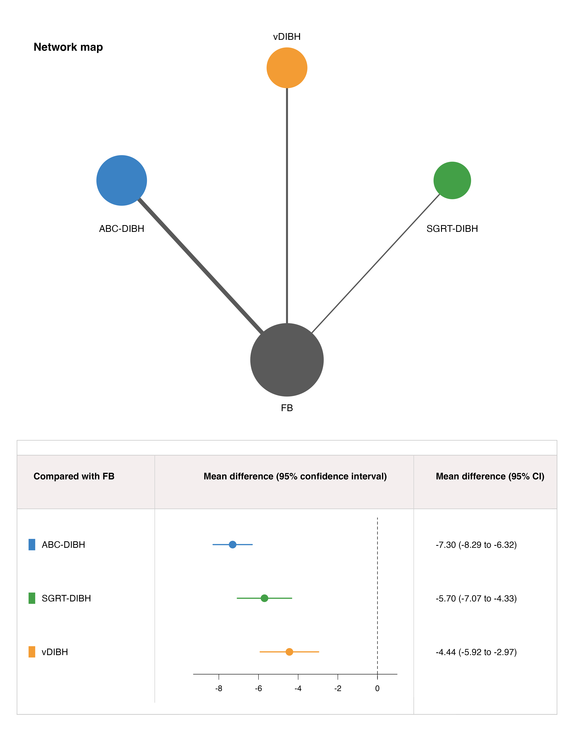

Figure S6.2. Network map and forest plot for Heart V10.
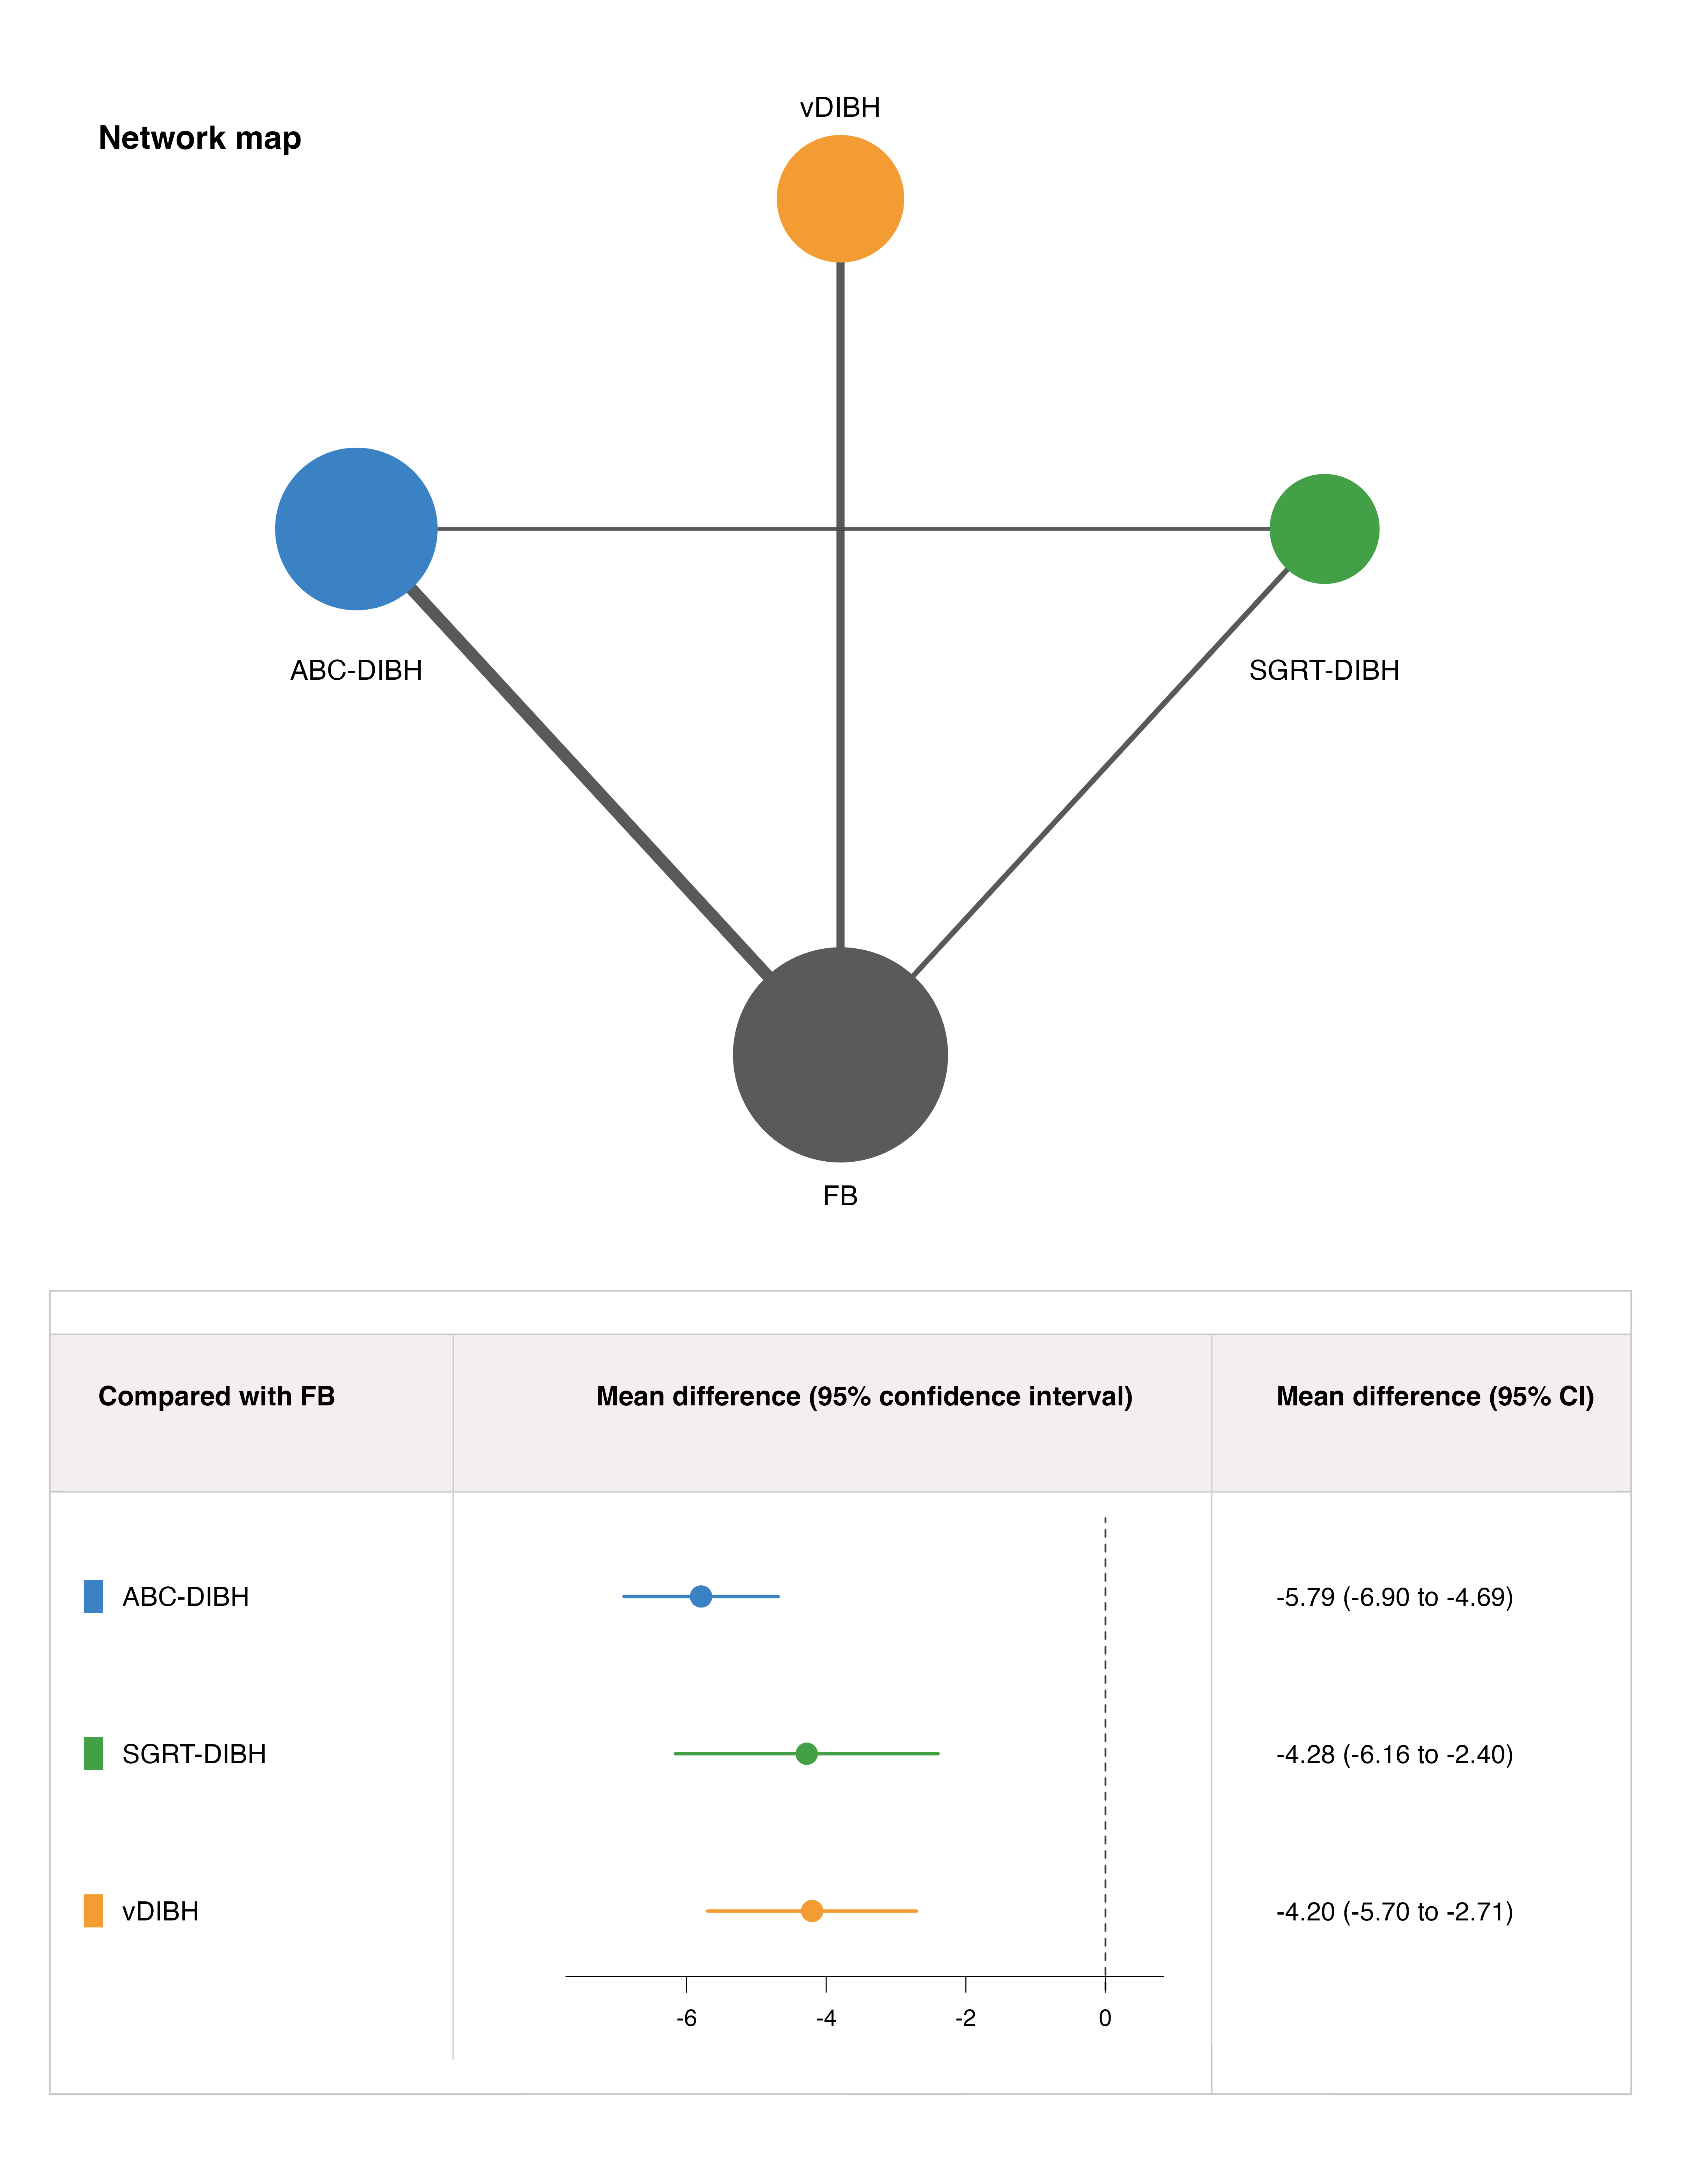

Figure S6.3. Network map and forest plot for Heart V20.
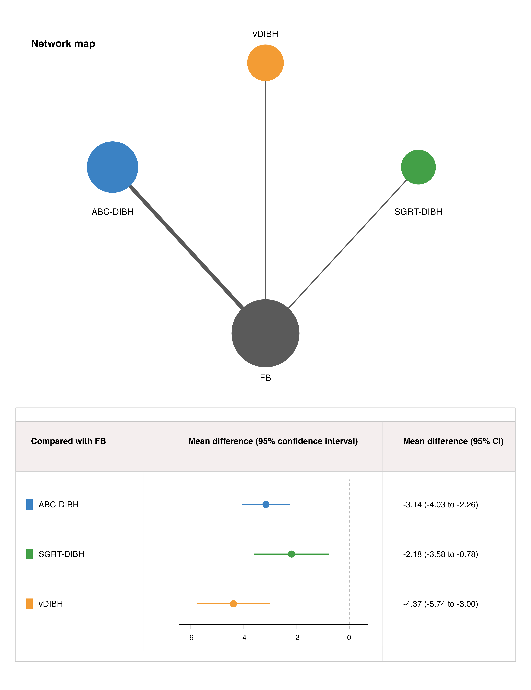

Figure S6.4. Network map and forest plot for Heart V30.
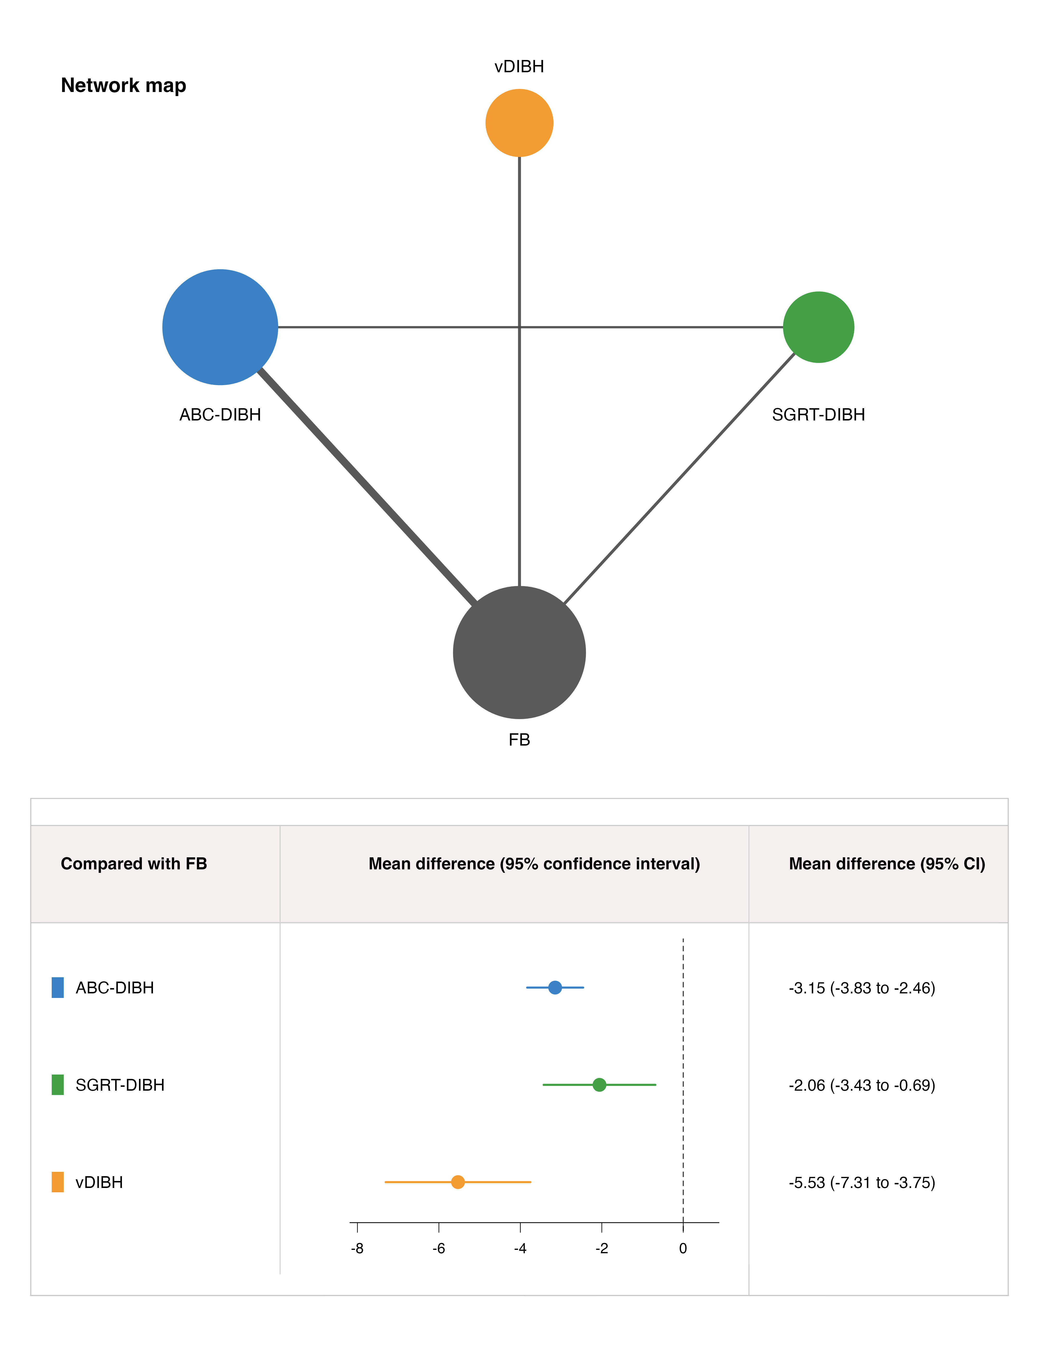

Figure S6.5. Network map and forest plot for Left lung V5.
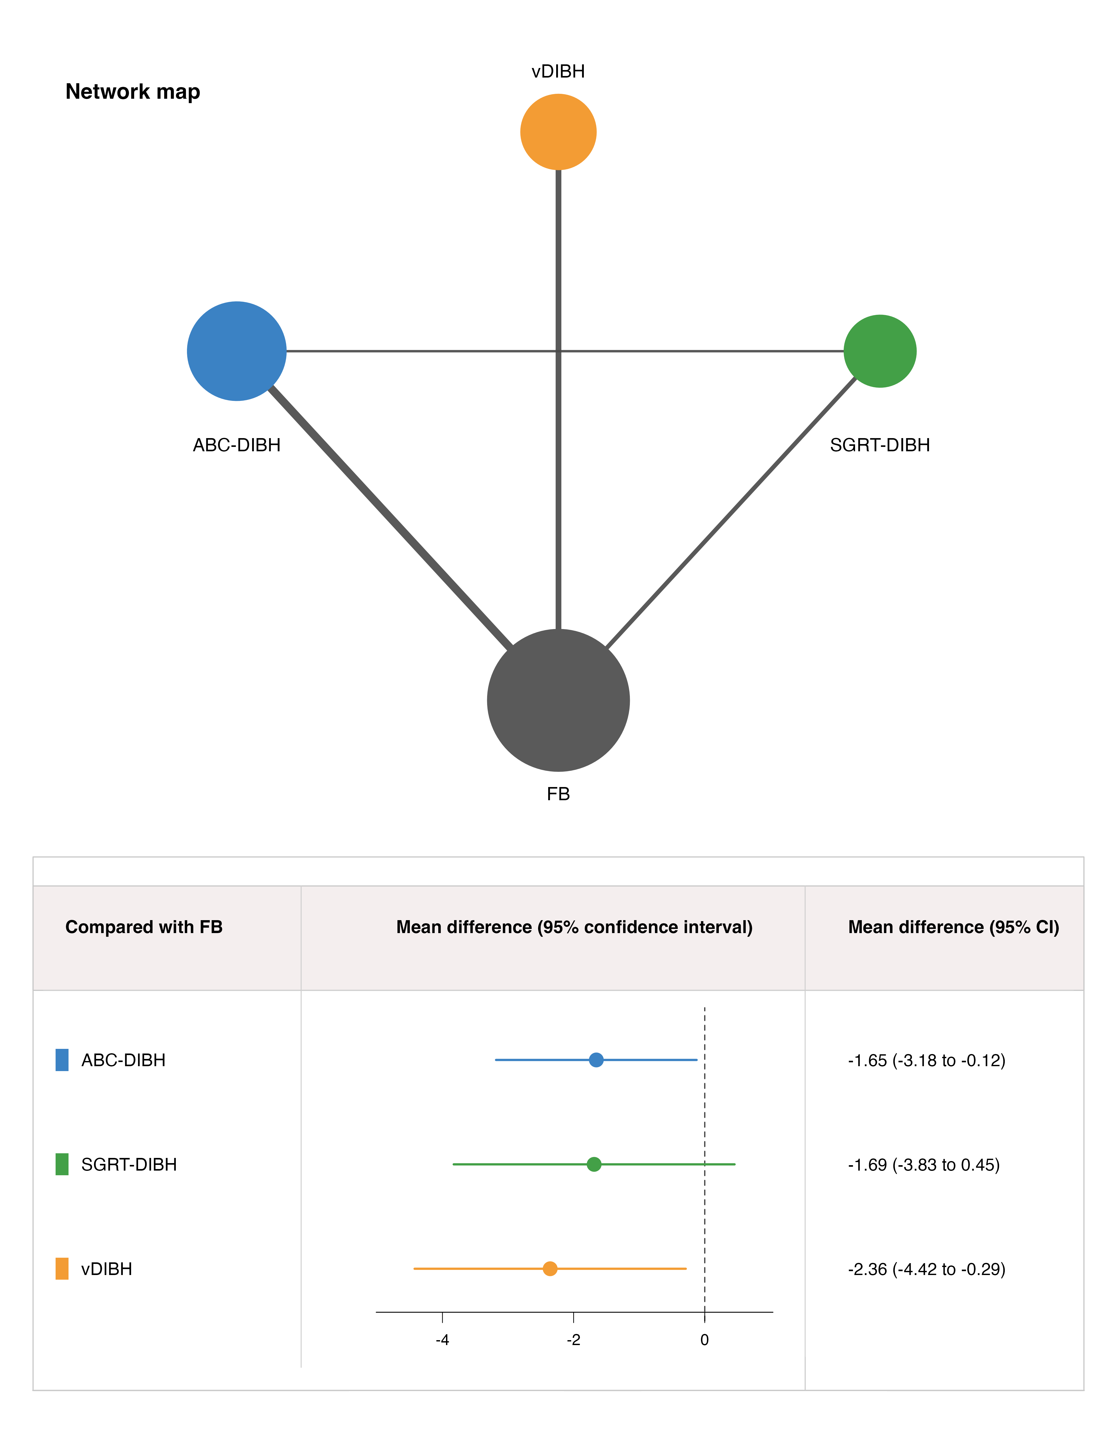

Figure S6.6. Network map and forest plot for Left lung V10.
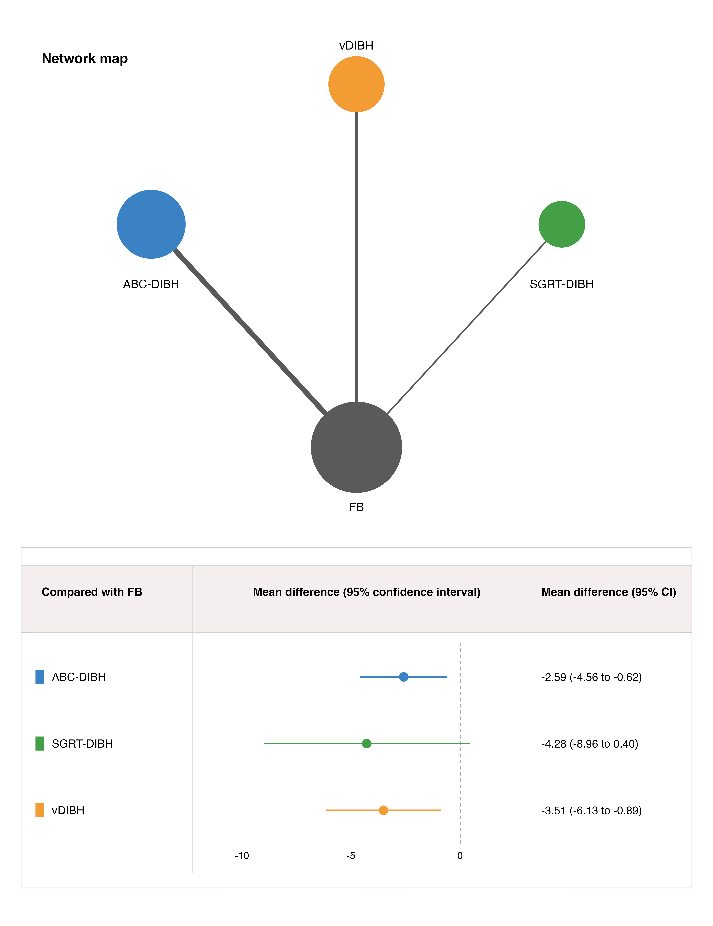

Figure S6.7. Network map and forest plot for Left lung V30.
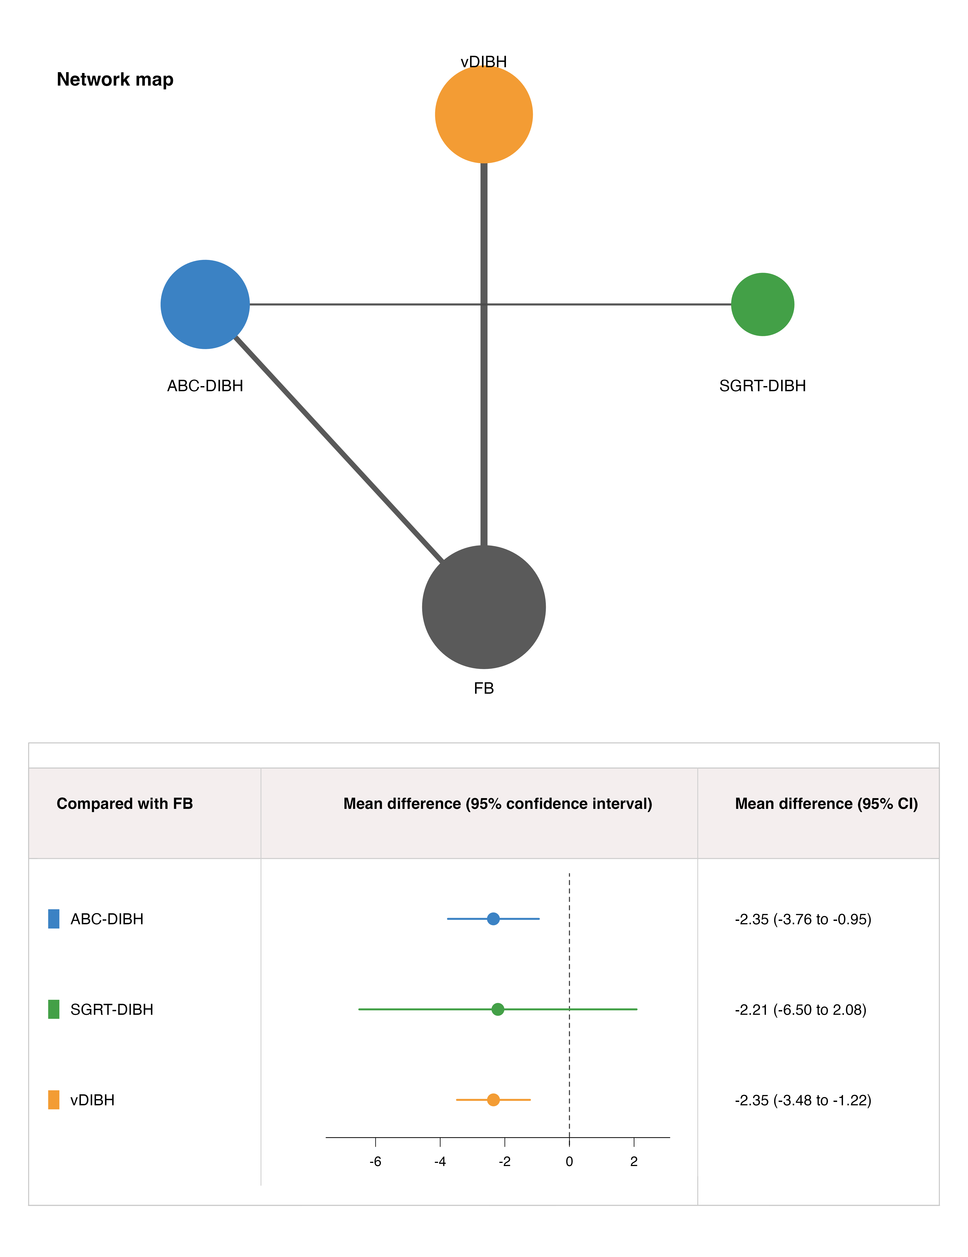

Appendix 7: P-score ranking plots and ranking tables
Higher P-score indicates a higher probability of being among the better treatments for reducing dose; lower dose values are better for all outcomes. Rankings are exploratory and should not be interpreted as definitive clinical superiority, especially when heterogeneity is substantial.
Figure S7.1: Heart Dmean P-score ranking.
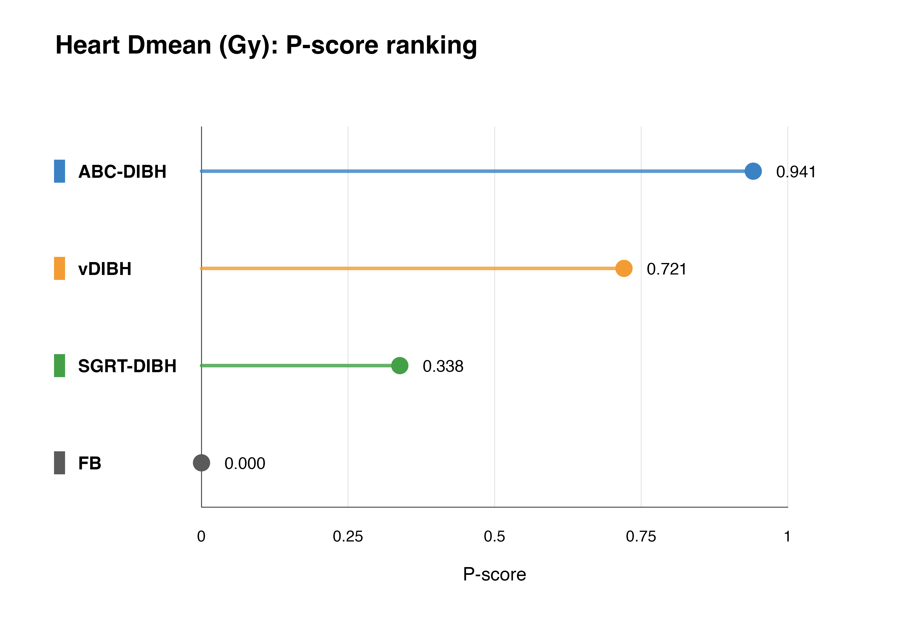
Table S7.1: Heart Dmean P-score ranking table.
Treatment | P-score | Rank | Unit
ABC-DIBH | 0.941 | 1 | Gy
vDIBH | 0.721 | 2 | Gy
SGRT-DIBH | 0.338 | 3 | Gy
FB | 0.000 | 4 | Gy
Figure S7.2: Heart Dmax P-score ranking.
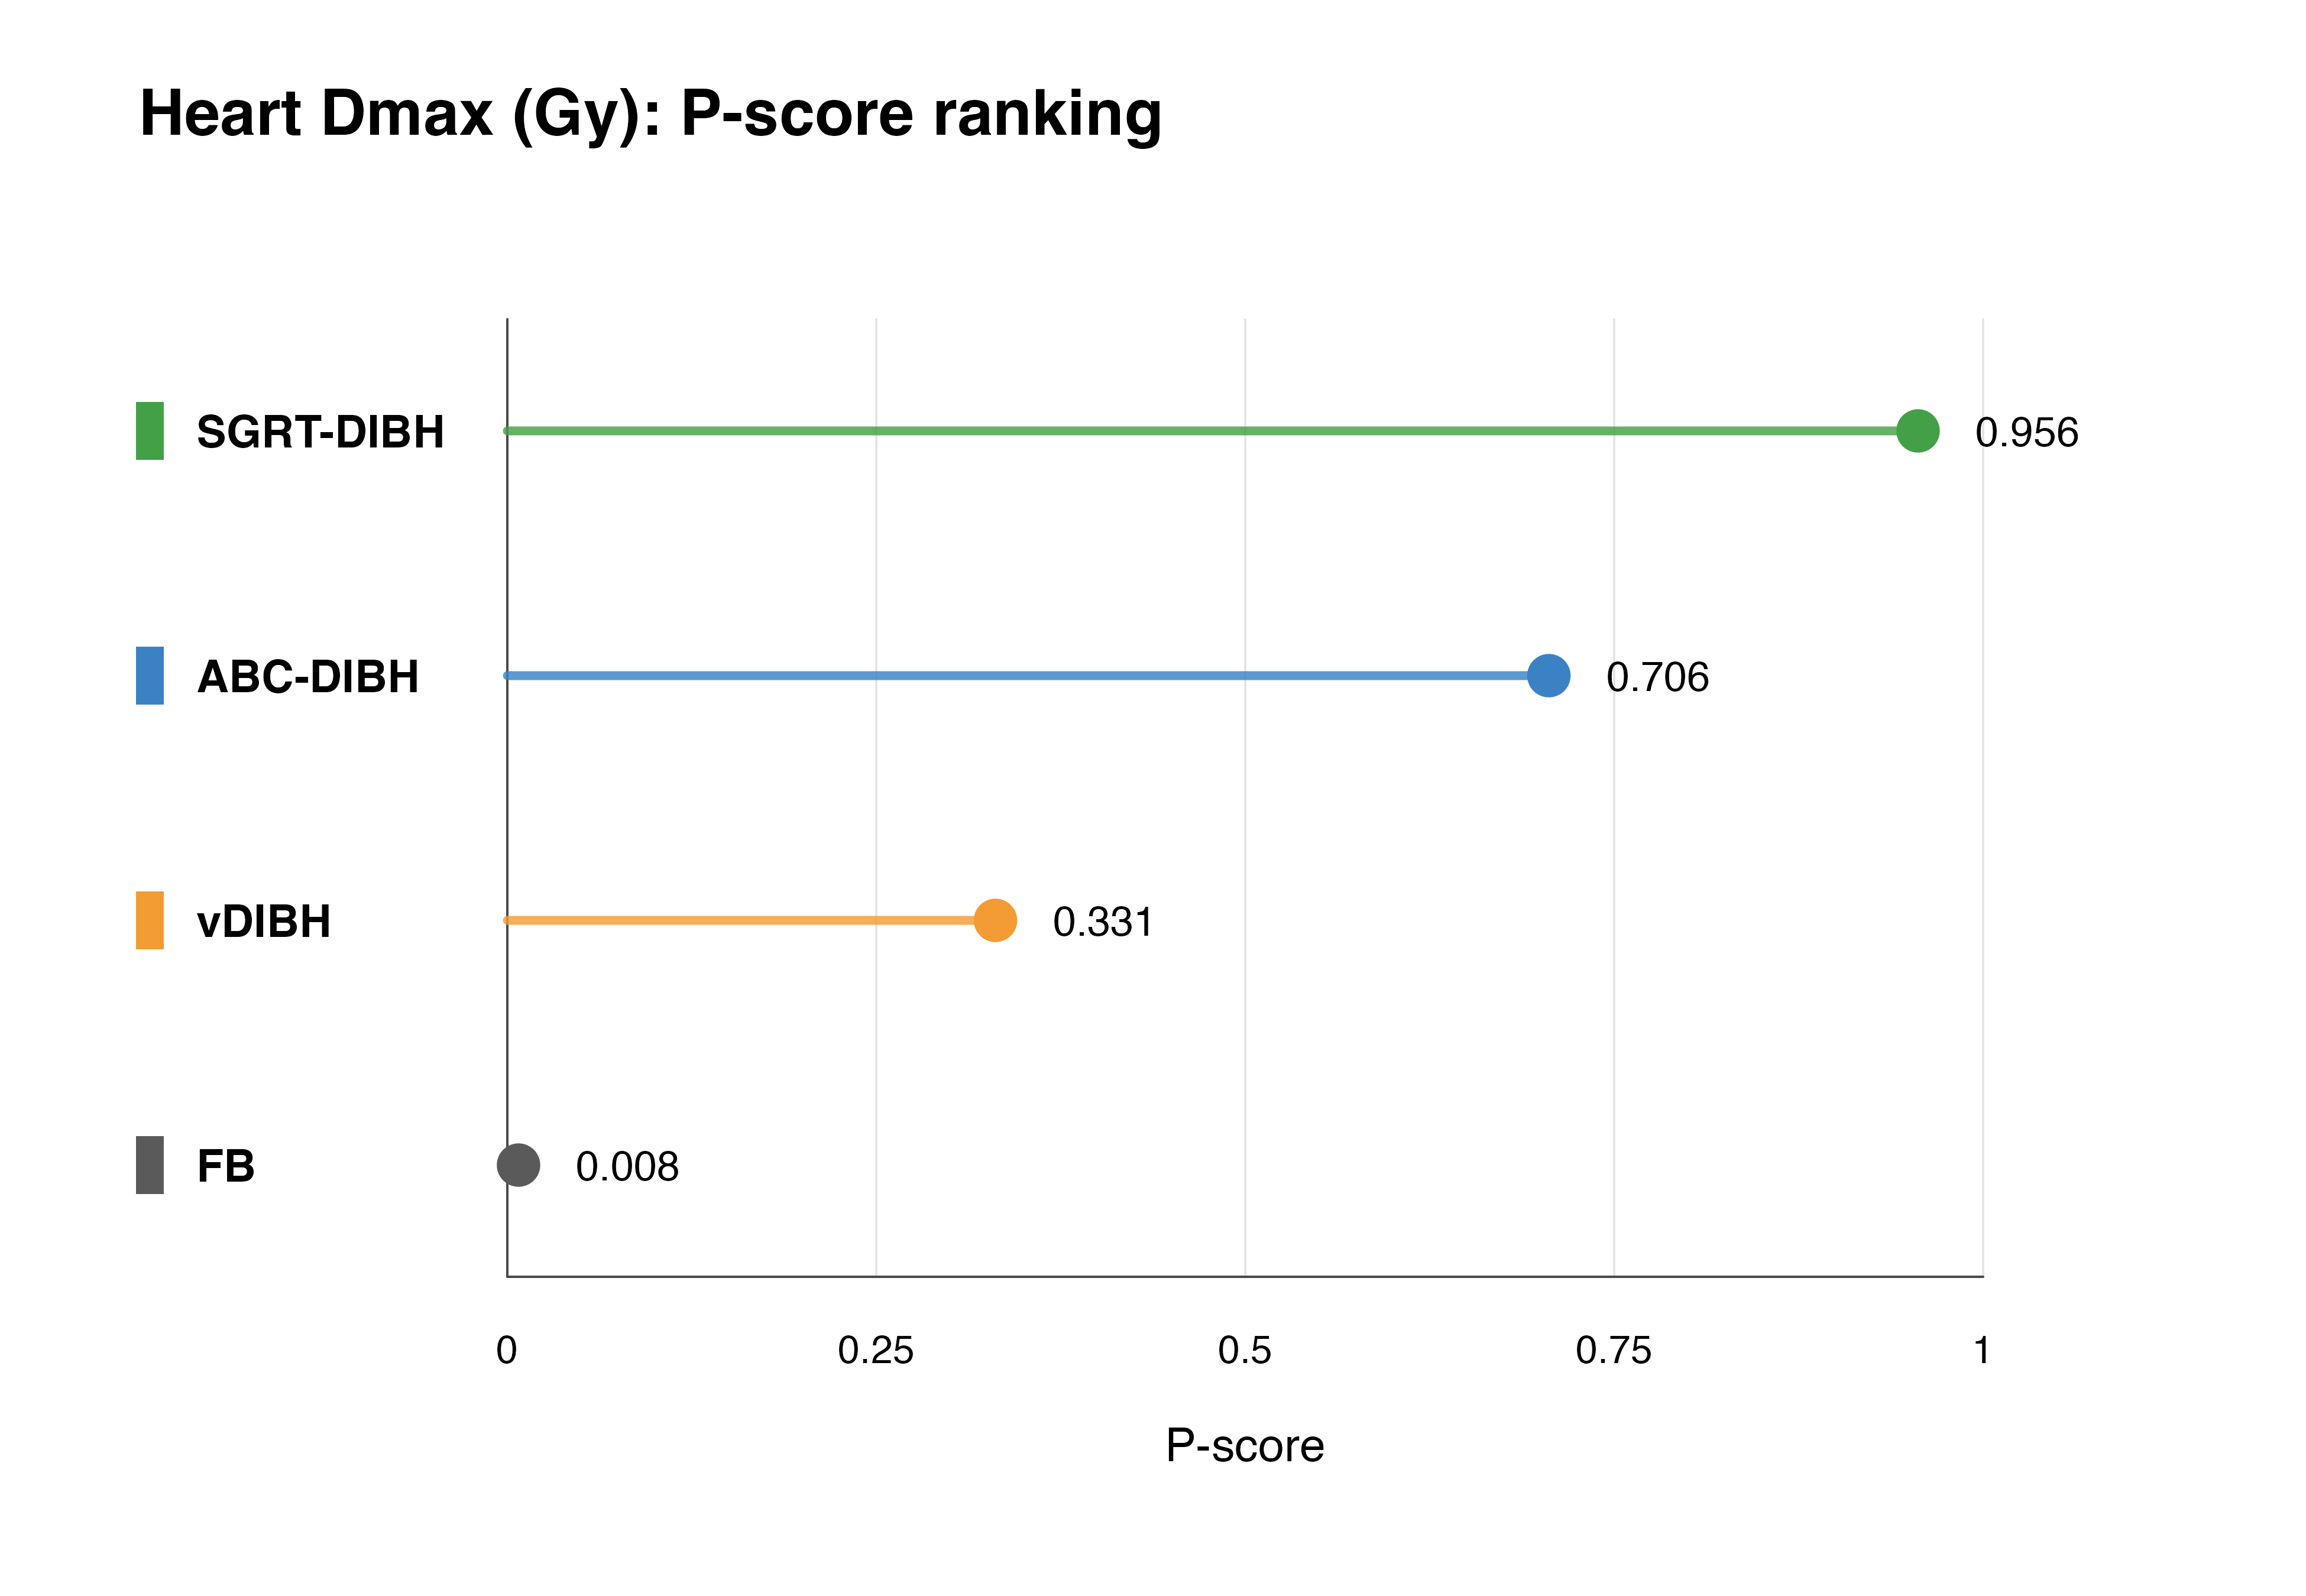
Table S7.2: Heart Dmax P-score ranking table.
Treatment | P-score | Rank | Unit
SGRT-DIBH | 0.956 | 1 | Gy
ABC-DIBH | 0.706 | 2 | Gy
vDIBH | 0.331 | 3 | Gy
FB | 0.008 | 4 | Gy
Figure S7.3: Heart V5 P-score ranking.
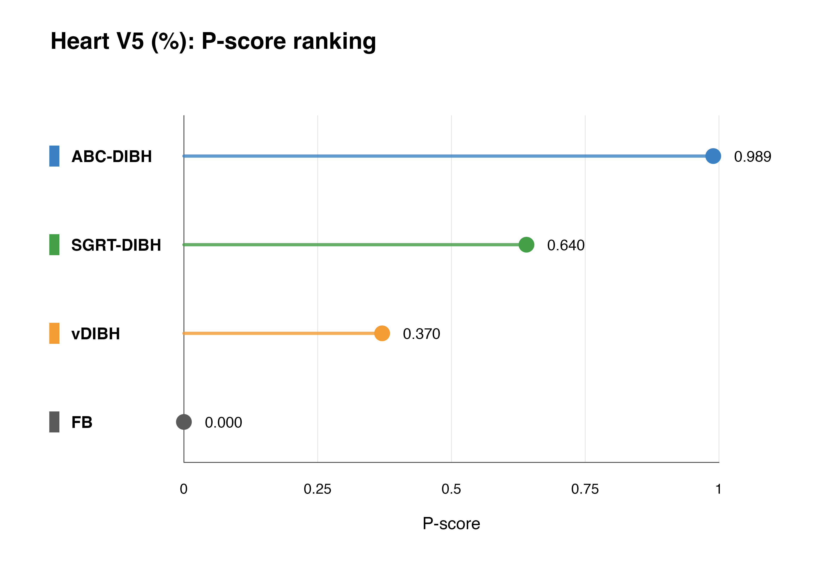
Table S7.3: Heart V5 P-score ranking table.
Treatment | P-score | Rank | Unit
ABC-DIBH | 0.989 | 1 | %
SGRT-DIBH | 0.640 | 2 | %
vDIBH | 0.370 | 3 | %
FB | 0.000 | 4 | %
Figure S7.4: Heart V10 P-score ranking.
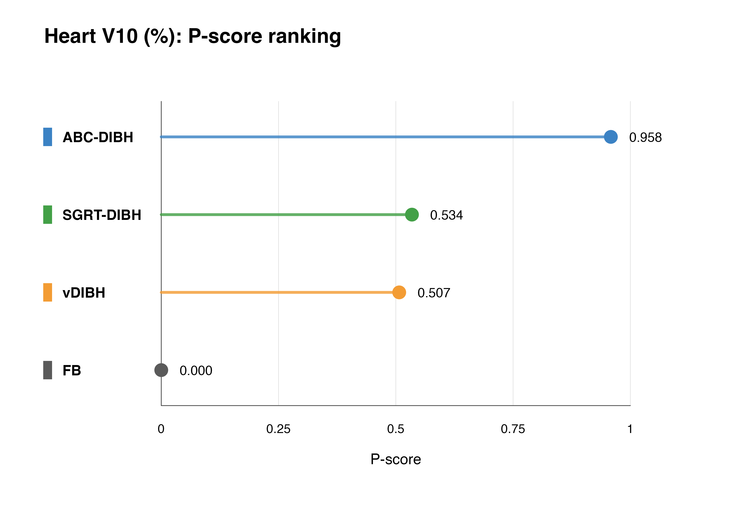
Table S7.4: Heart V10 P-score ranking table.
Treatment | P-score | Rank | Unit
ABC-DIBH | 0.958 | 1 | %
SGRT-DIBH | 0.534 | 2 | %
vDIBH | 0.507 | 3 | %
FB | 0.000 | 4 | %
Figure S7.5: Heart V20 P-score ranking.
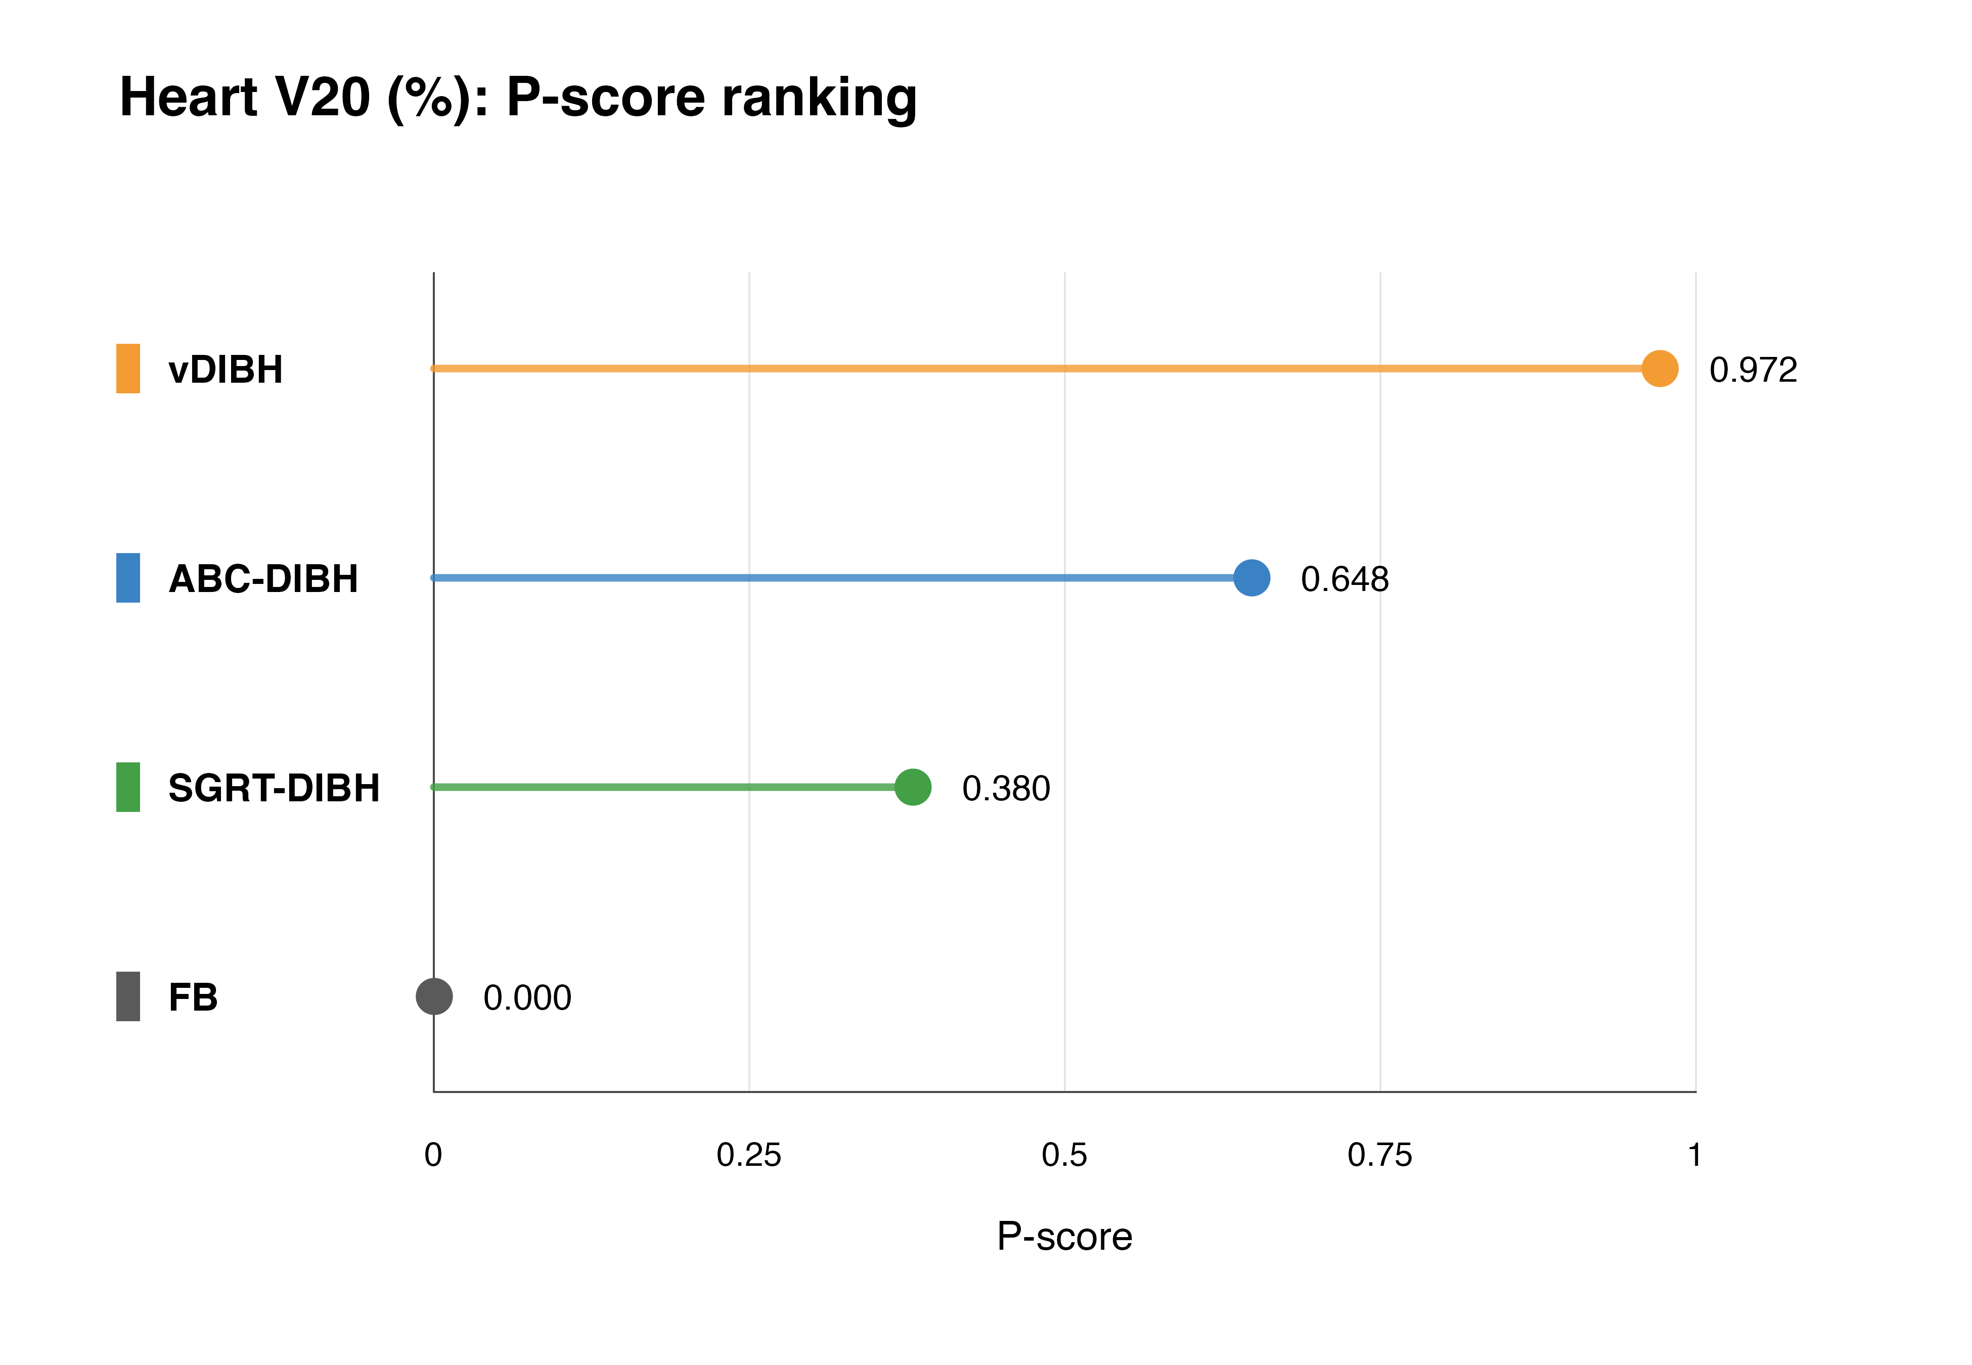
Table S7.5: Heart V20 P-score ranking table.
Treatment | P-score | Rank | Unit
vDIBH | 0.972 | 1 | %
ABC-DIBH | 0.648 | 2 | %
SGRT-DIBH | 0.380 | 3 | %
FB | 0.000 | 4 | %
Figure S7.6: Heart V30 P-score ranking.
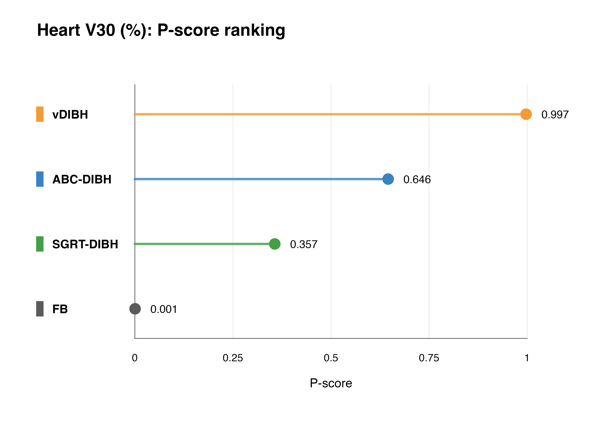
Table S7.6: Heart V30 P-score ranking table.
Treatment | P-score | Rank | Unit
vDIBH | 0.997 | 1 | %
ABC-DIBH | 0.646 | 2 | %
SGRT-DIBH | 0.357 | 3 | %
FB | 0.001 | 4 | %
Figure S7.7: LAD Dmean P-score ranking.
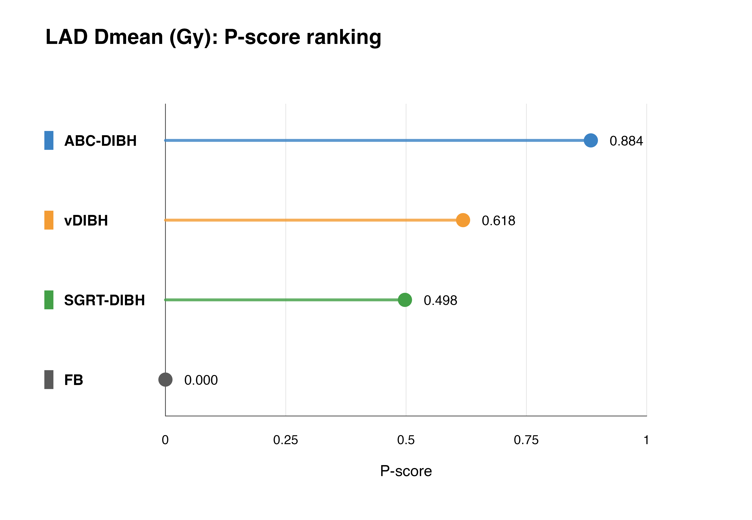
Table S7.7: LAD Dmean P-score ranking table.
Treatment | P-score | Rank | Unit
ABC-DIBH | 0.884 | 1 | Gy
vDIBH | 0.618 | 2 | Gy
SGRT-DIBH | 0.498 | 3 | Gy
FB | 0.000 | 4 | Gy
Figure S7.8: LAD Dmax P-score ranking.
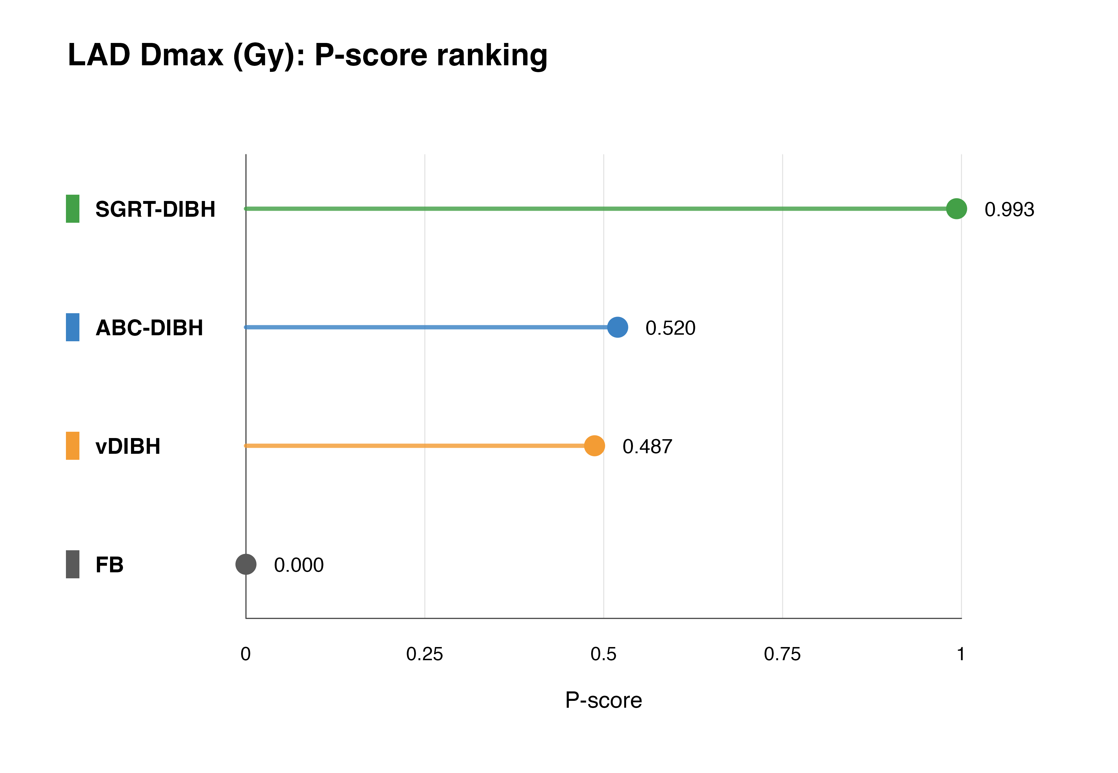
Table S7.8: LAD Dmax P-score ranking table.
Treatment | P-score | Rank | Unit
SGRT-DIBH | 0.993 | 1 | Gy
ABC-DIBH | 0.520 | 2 | Gy
vDIBH | 0.487 | 3 | Gy
FB | 0.000 | 4 | Gy
Figure S7.9: Left lung Dmean P-score ranking.
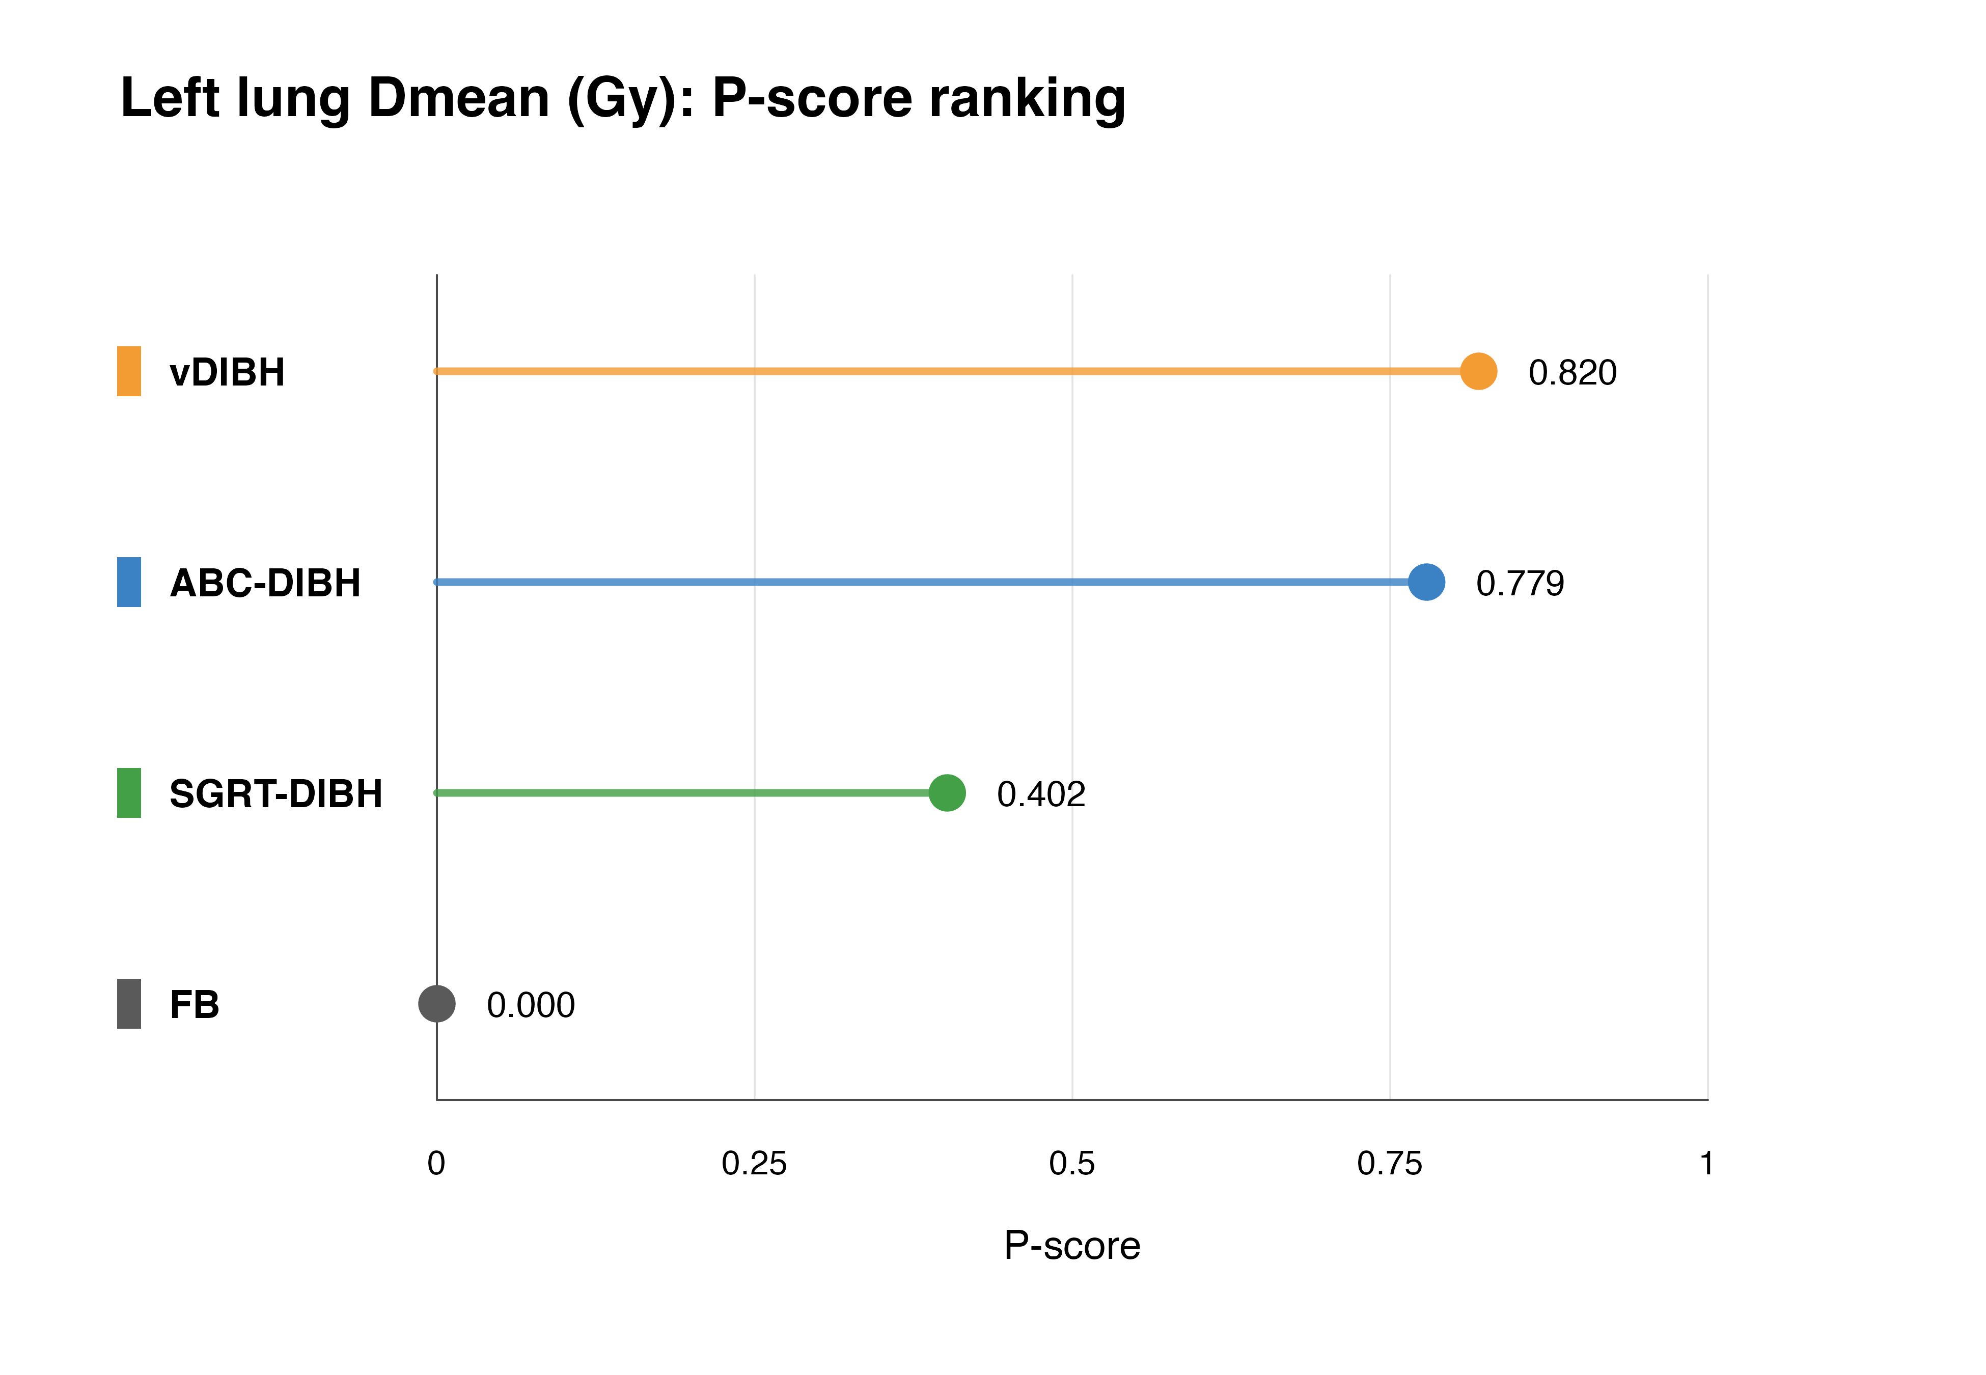
Table S7.9: Left lung Dmean P-score ranking table.
Treatment | P-score | Rank | Unit
vDIBH | 0.820 | 1 | Gy
ABC-DIBH | 0.779 | 2 | Gy
SGRT-DIBH | 0.402 | 3 | Gy
FB | 0.000 | 4 | Gy
Figure S7.10: Left lung V5 P-score ranking.
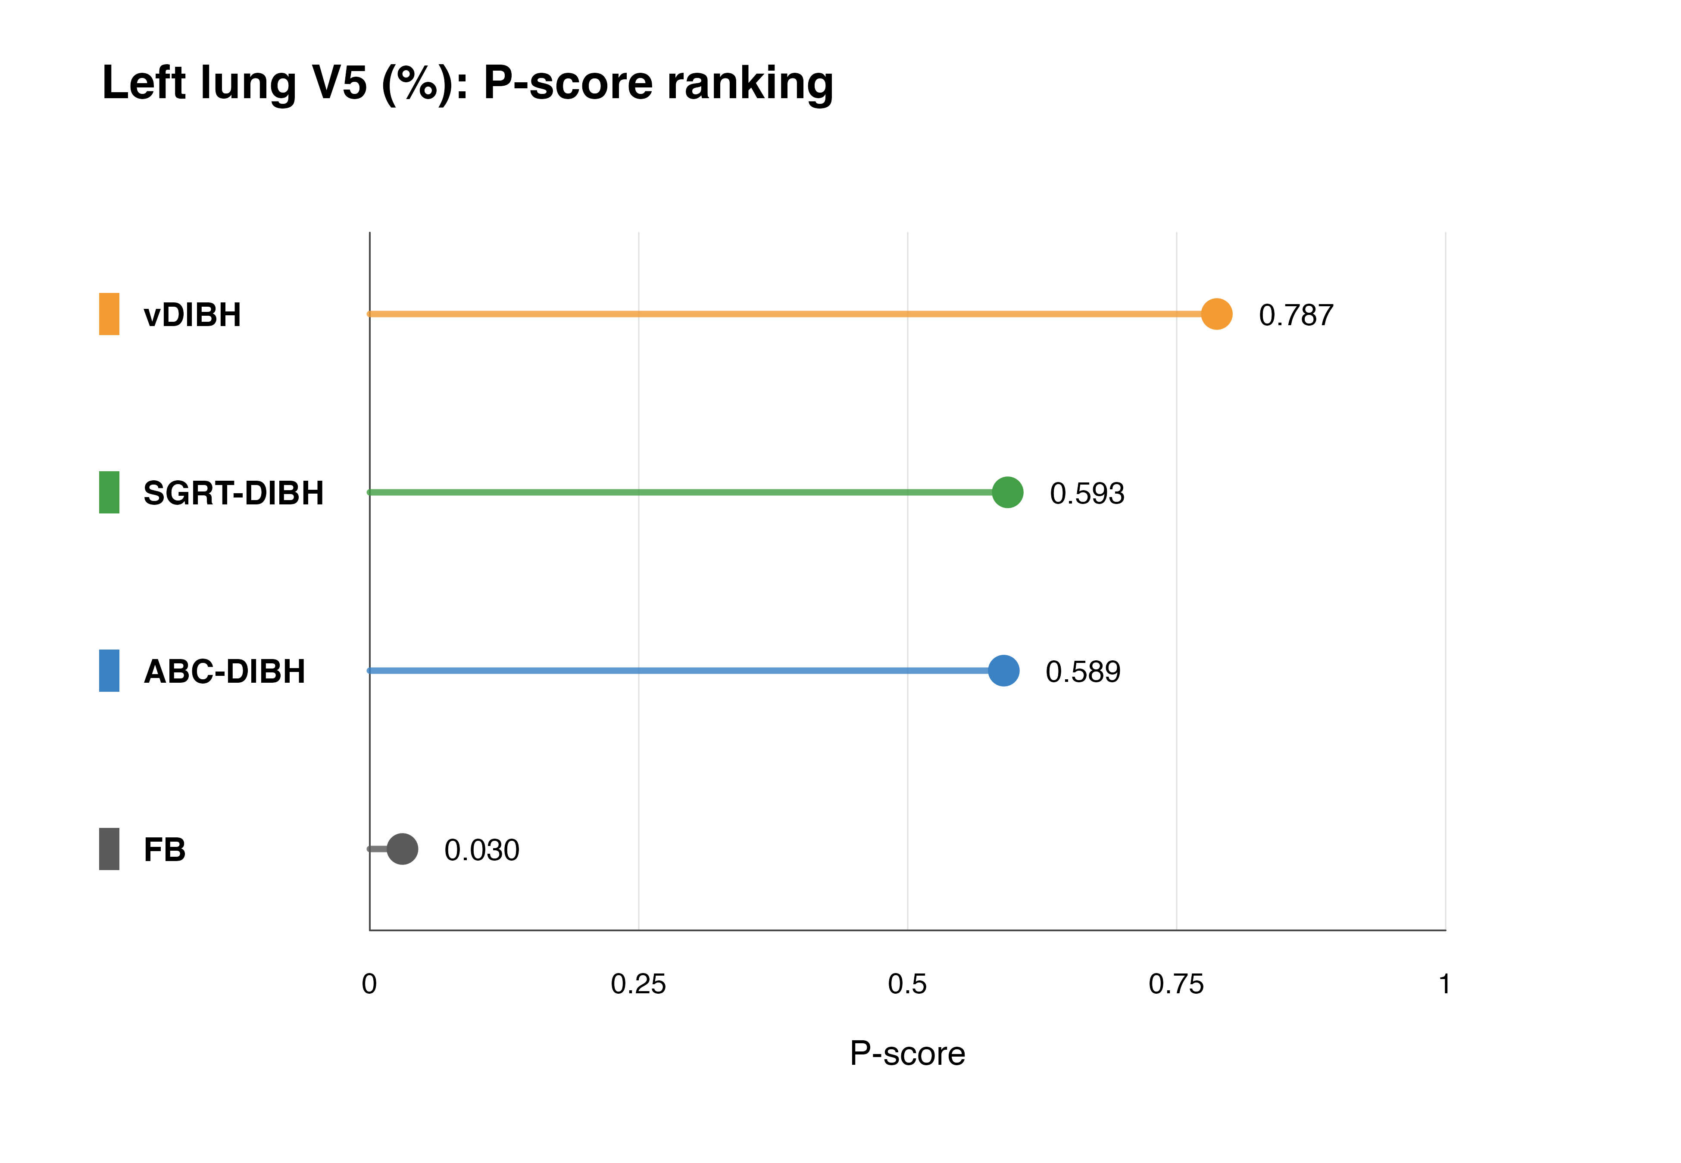
Table S7.10: Left lung V5 P-score ranking table.
Treatment | P-score | Rank | Unit
vDIBH | 0.787 | 1 | %
SGRT-DIBH | 0.593 | 2 | %
ABC-DIBH | 0.589 | 3 | %
FB | 0.030 | 4 | %
Figure S7.11: Left lung V10 P-score ranking.
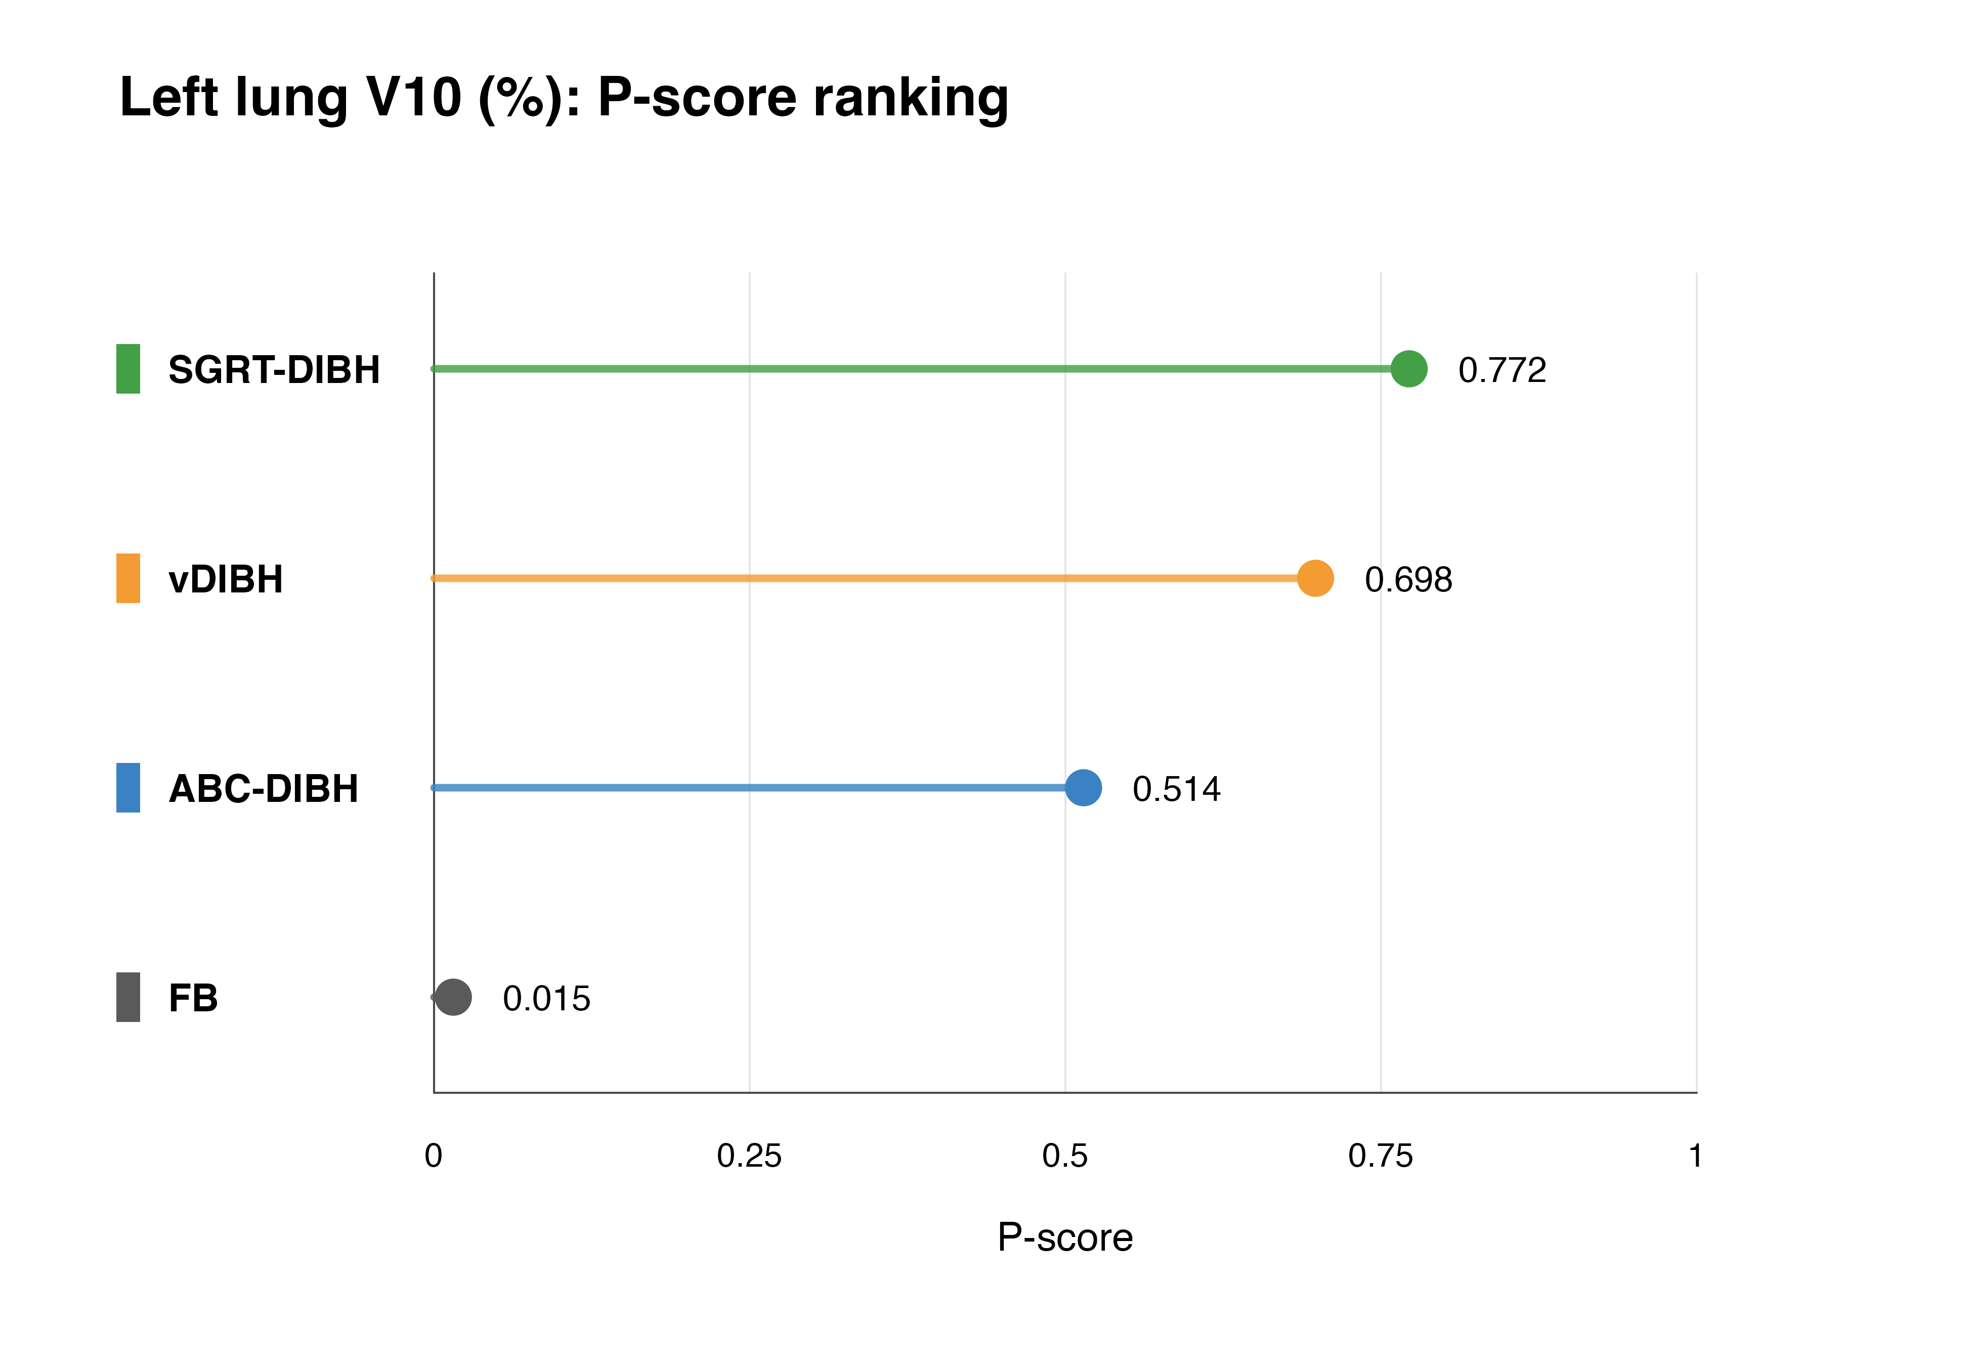
Table S7.11: Left lung V10 P-score ranking table.
Treatment | P-score | Rank | Unit
SGRT-DIBH | 0.772 | 1 | %
vDIBH | 0.698 | 2 | %
ABC-DIBH | 0.514 | 3 | %
FB | 0.015 | 4 | %
Figure S7.12: Left lung V20 P-score ranking.
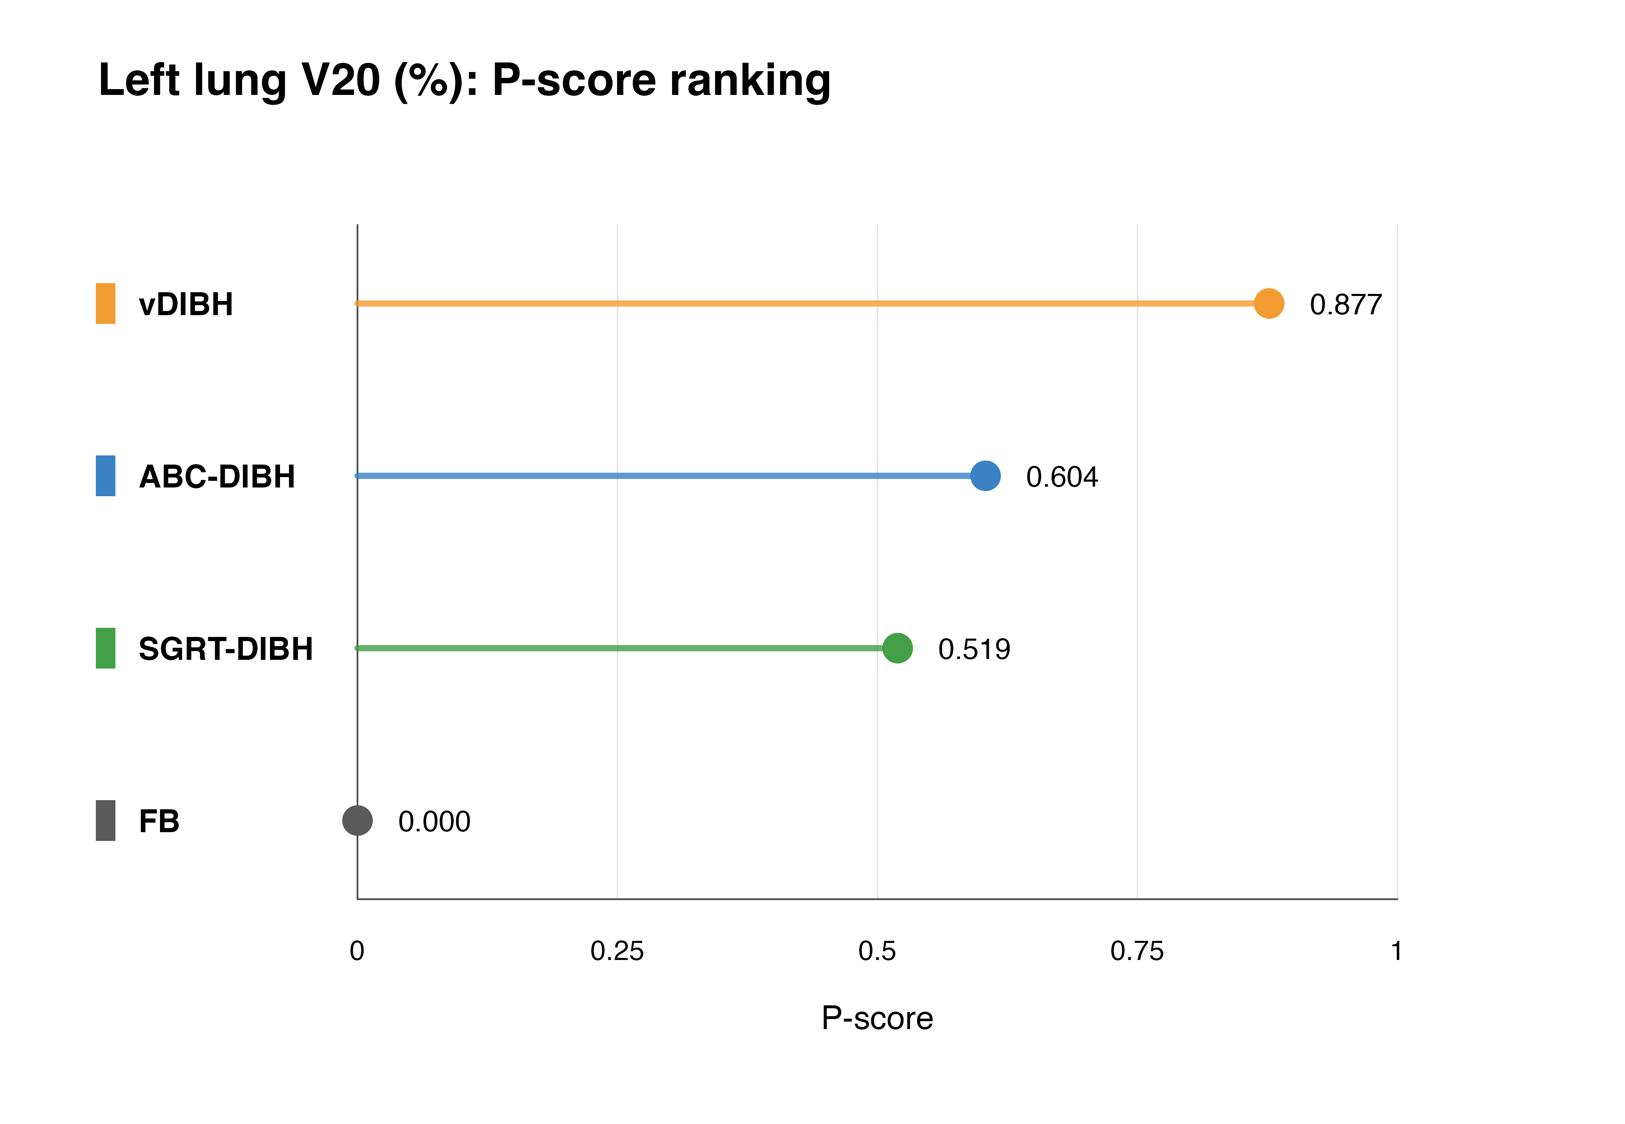
Table S7.12: Left lung V20 P-score ranking table.
Treatment | P-score | Rank | Unit
vDIBH | 0.877 | 1 | %
ABC-DIBH | 0.604 | 2 | %
SGRT-DIBH | 0.519 | 3 | %
FB | 0.000 | 4 | %
Figure S7.13: Left lung V30 P-score ranking.
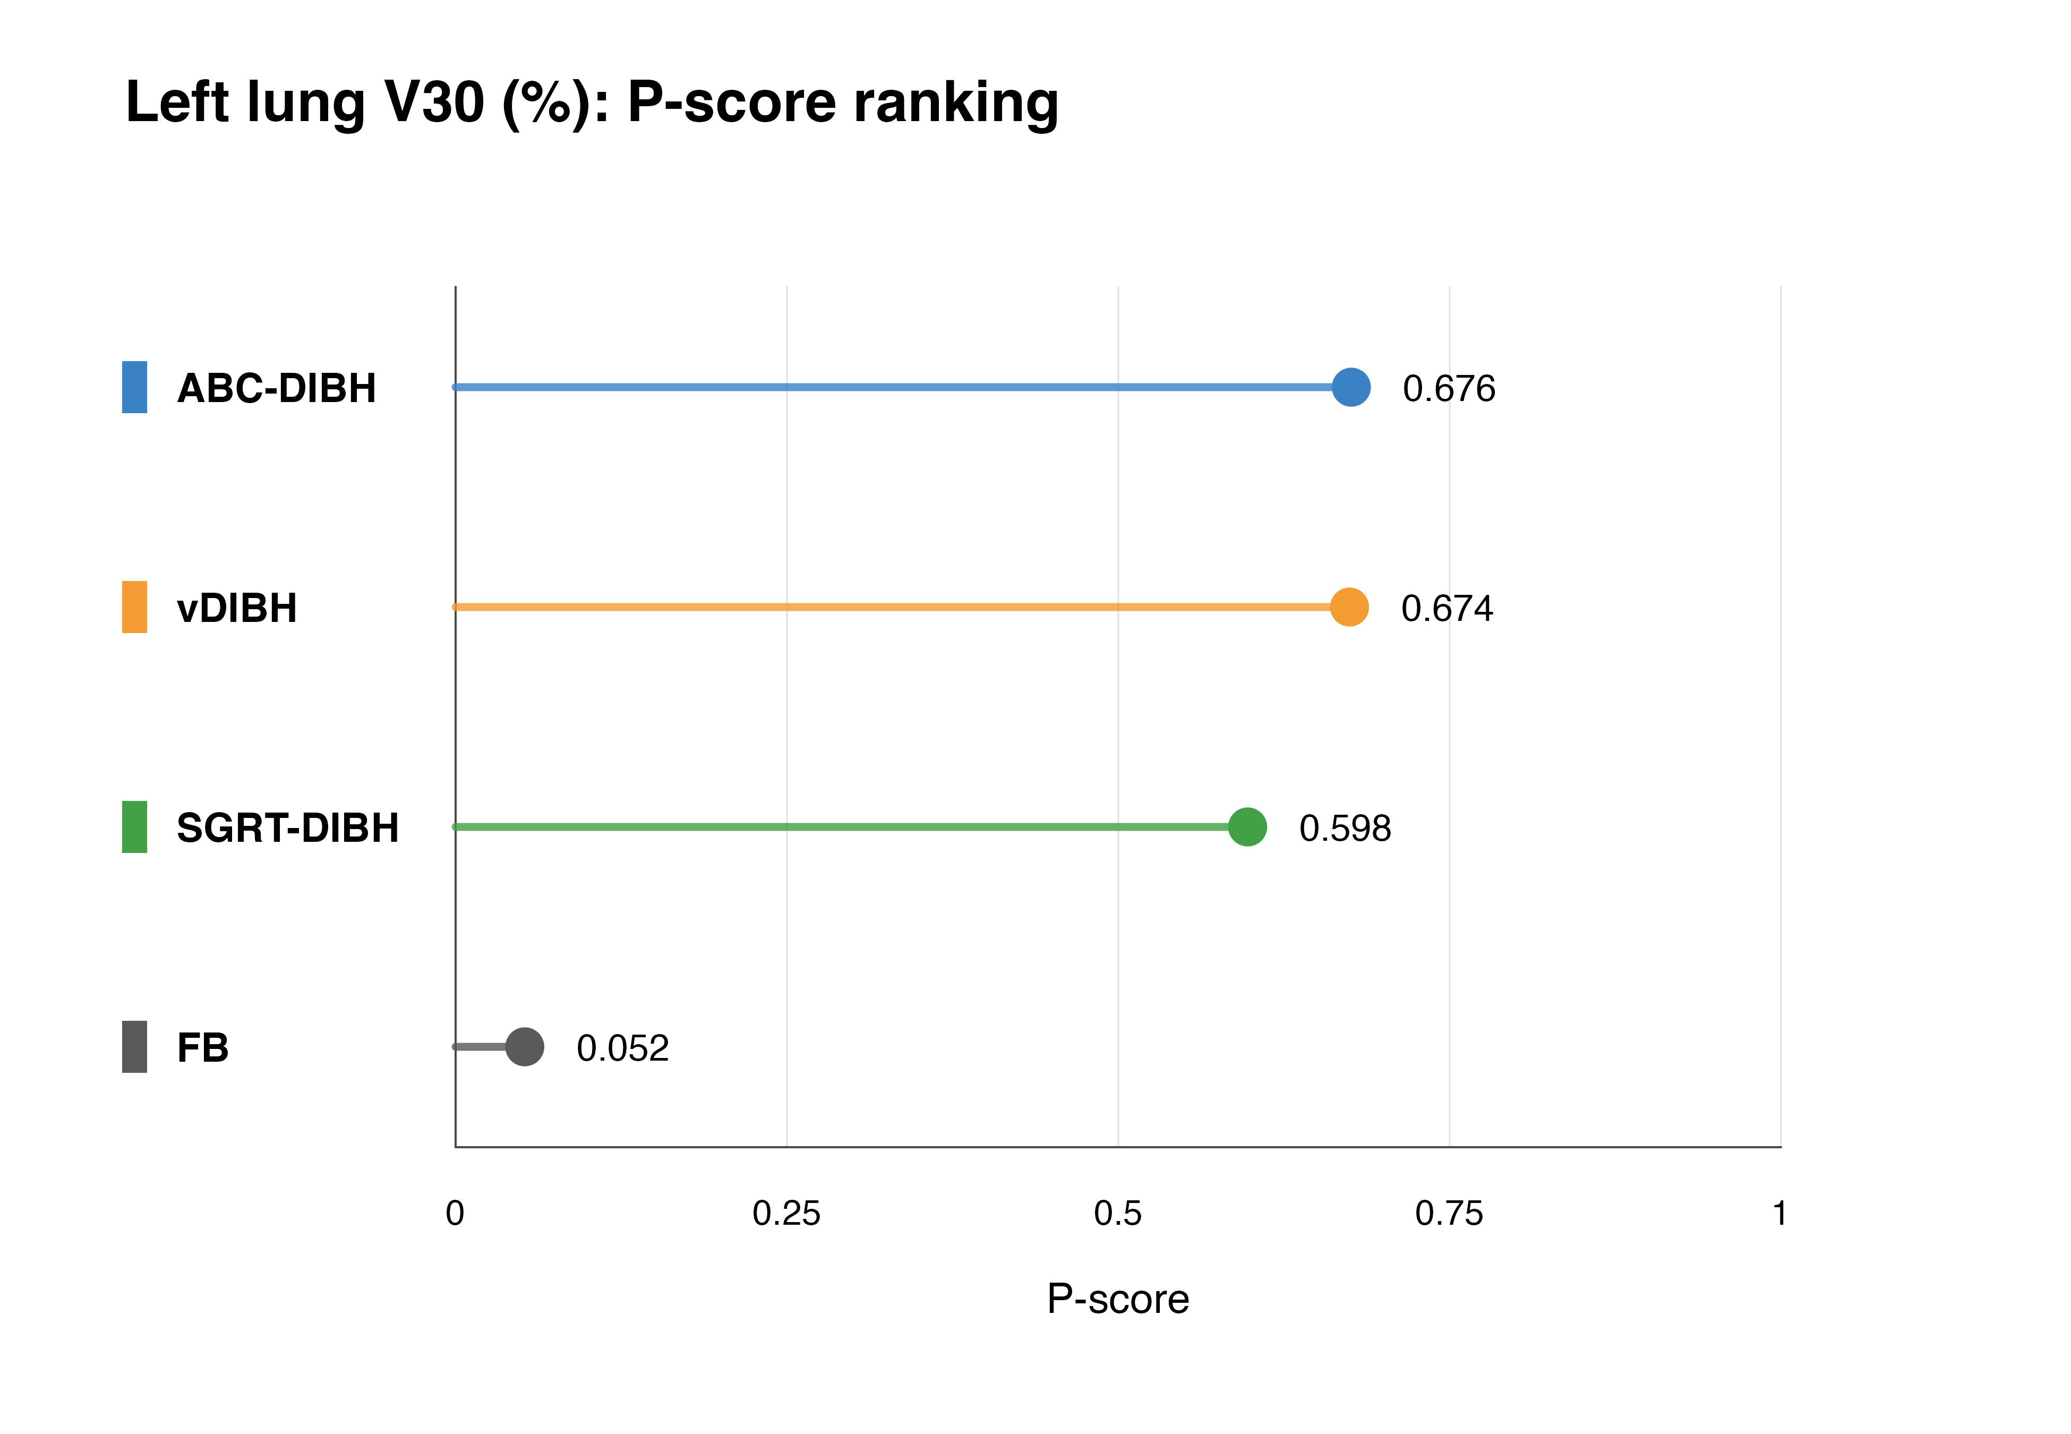
Table S7.13: Left lung V30 P-score ranking table.
Treatment | P-score | Rank | Unit
ABC-DIBH | 0.676 | 1 | %
vDIBH | 0.674 | 2 | %
SGRT-DIBH | 0.598 | 3 | %
FB | 0.052 | 4 | %

Appendix 8: League tables of summary estimates derived from network meta-analysis
League tables present network meta-analysis estimates for all pairwise treatment comparisons. Values are mean differences with 95% confidence intervals. The table is arranged as row treatment minus column treatment. MD < 0 indicates a lower dose for the row treatment. Lower values are better for all dosimetric outcomes.
Table S8.1: Heart Dmean (Gy).
Row treatment | FB | ABC-DIBH | SGRT-DIBH | vDIBH
FB | Reference | 1.769  (1.559 to 1.979) | 1.282  (1.050 to 1.514) | 1.634  (1.405 to 1.864)
ABC-DIBH | -1.769  (-1.979 to -1.559) | Reference | -0.487  (-0.780 to -0.195) | -0.135  (-0.419 to 0.149)
SGRT-DIBH | -1.282  (-1.514 to -1.050) | 0.487  (0.195 to 0.780) | Reference | 0.353  (0.037 to 0.668)
vDIBH | -1.634  (-1.864 to -1.405) | 0.135  (-0.149 to 0.419) | -0.353  (-0.668 to -0.037) | Reference
Table S8.2: Heart Dmax (Gy).
Row treatment | FB | ABC-DIBH | SGRT-DIBH | vDIBH
FB | Reference | 11.416  (7.437 to 15.394) | 14.430  (10.537 to 18.323) | 4.658  (0.092 to 9.225)
ABC-DIBH | -11.416  (-15.394 to -7.437) | Reference | 3.015  (-2.267 to 8.296) | -6.757  (-12.814 to -0.701)
SGRT-DIBH | -14.430  (-18.323 to -10.537) | -3.015  (-8.296 to 2.267) | Reference | -9.772  (-15.773 to -3.771)
vDIBH | -4.658  (-9.225 to -0.092) | 6.757  (0.701 to 12.814) | 9.772  (3.771 to 15.773) | Reference
Table S8.3: Heart V5 (%).
Row treatment | FB | ABC-DIBH | SGRT-DIBH | vDIBH
FB | Reference | 7.304  (6.316 to 8.291) | 5.698  (4.327 to 7.069) | 4.441  (2.965 to 5.916)
ABC-DIBH | -7.304  (-8.291 to -6.316) | Reference | -1.606  (-3.295 to 0.084) | -2.863  (-4.638 to -1.088)
SGRT-DIBH | -5.698  (-7.069 to -4.327) | 1.606  (-0.084 to 3.295) | Reference | -1.257  (-3.271 to 0.757)
vDIBH | -4.441  (-5.916 to -2.965) | 2.863  (1.088 to 4.638) | 1.257  (-0.757 to 3.271) | Reference
Table S8.4: Heart V10 (%).
Row treatment | FB | ABC-DIBH | SGRT-DIBH | vDIBH
FB | Reference | 5.792  (4.687 to 6.896) | 4.278  (2.397 to 6.159) | 4.201  (2.706 to 5.696)
ABC-DIBH | -5.792  (-6.896 to -4.687) | Reference | -1.514  (-3.606 to 0.579) | -1.591  (-3.449 to 0.268)
SGRT-DIBH | -4.278  (-6.159 to -2.397) | 1.514  (-0.579 to 3.606) | Reference | -0.077  (-2.479 to 2.326)
vDIBH | -4.201  (-5.696 to -2.706) | 1.591  (-0.268 to 3.449) | 0.077  (-2.326 to 2.479) | Reference
Table S8.5: Heart V20 (%).
Row treatment | FB | ABC-DIBH | SGRT-DIBH | vDIBH
FB | Reference | 3.143  (2.257 to 4.029) | 2.176  (0.776 to 3.576) | 4.369  (2.996 to 5.742)
ABC-DIBH | -3.143  (-4.029 to -2.257) | Reference | -0.968  (-2.625 to 0.689) | 1.226  (-0.409 to 2.860)
SGRT-DIBH | -2.176  (-3.576 to -0.776) | 0.968  (-0.689 to 2.625) | Reference | 2.193  (0.232 to 4.154)
vDIBH | -4.369  (-5.742 to -2.996) | -1.226  (-2.860 to 0.409) | -2.193  (-4.154 to -0.232) | Reference
Table S8.6: Heart V30 (%).
Row treatment | FB | ABC-DIBH | SGRT-DIBH | vDIBH
FB | Reference | 3.145  (2.458 to 3.833) | 2.057  (0.685 to 3.428) | 5.531  (3.754 to 7.307)
ABC-DIBH | -3.145  (-3.833 to -2.458) | Reference | -1.089  (-2.537 to 0.360) | 2.385  (0.481 to 4.290)
SGRT-DIBH | -2.057  (-3.428 to -0.685) | 1.089  (-0.360 to 2.537) | Reference | 3.474  (1.230 to 5.718)
vDIBH | -5.531  (-7.307 to -3.754) | -2.385  (-4.290 to -0.481) | -3.474  (-5.718 to -1.230) | Reference
Table S8.7: LAD Dmean (Gy).
Row treatment | FB | ABC-DIBH | SGRT-DIBH | vDIBH
FB | Reference | 9.238  (7.268 to 11.209) | 7.682  (5.477 to 9.887) | 8.211  (6.415 to 10.006)
ABC-DIBH | -9.238  (-11.209 to -7.268) | Reference | -1.557  (-4.336 to 1.222) | -1.028  (-3.549 to 1.493)
SGRT-DIBH | -7.682  (-9.887 to -5.477) | 1.557  (-1.222 to 4.336) | Reference | 0.529  (-2.297 to 3.355)
vDIBH | -8.211  (-10.006 to -6.415) | 1.028  (-1.493 to 3.549) | -0.529  (-3.355 to 2.297) | Reference
Table S8.8: LAD Dmax (Gy).
Row treatment | FB | ABC-DIBH | SGRT-DIBH | vDIBH
FB | Reference | 10.136  (5.833 to 14.440) | 16.888  (12.621 to 21.154) | 9.788  (5.697 to 13.880)
ABC-DIBH | -10.136  (-14.440 to -5.833) | Reference | 6.751  (0.954 to 12.548) | -0.348  (-6.074 to 5.378)
SGRT-DIBH | -16.888  (-21.154 to -12.621) | -6.751  (-12.548 to -0.954) | Reference | -7.099  (-12.992 to -1.206)
vDIBH | -9.788  (-13.880 to -5.697) | 0.348  (-5.378 to 6.074) | 7.099  (1.206 to 12.992) | Reference
Table S8.9: Left lung Dmean (Gy).
Row treatment | FB | ABC-DIBH | SGRT-DIBH | vDIBH
FB | Reference | 1.115  (0.787 to 1.443) | 0.802  (0.426 to 1.178) | 1.159  (0.738 to 1.580)
ABC-DIBH | -1.115  (-1.443 to -0.787) | Reference | -0.313  (-0.788 to 0.161) | 0.044  (-0.469 to 0.556)
SGRT-DIBH | -0.802  (-1.178 to -0.426) | 0.313  (-0.161 to 0.788) | Reference | 0.357  (-0.206 to 0.919)
vDIBH | -1.159  (-1.580 to -0.738) | -0.044  (-0.556 to 0.469) | -0.357  (-0.919 to 0.206) | Reference
Table S8.10: Left lung V5 (%).
Row treatment | FB | ABC-DIBH | SGRT-DIBH | vDIBH
FB | Reference | 1.653  (0.124 to 3.183) | 1.687  (-0.454 to 3.828) | 2.357  (0.290 to 4.425)
ABC-DIBH | -1.653  (-3.183 to -0.124) | Reference | 0.033  (-2.387 to 2.454) | 0.704  (-1.868 to 3.275)
SGRT-DIBH | -1.687  (-3.828 to 0.454) | -0.033  (-2.454 to 2.387) | Reference | 0.670  (-2.306 to 3.647)
vDIBH | -2.357  (-4.425 to -0.290) | -0.704  (-3.275 to 1.868) | -0.670  (-3.647 to 2.306) | Reference
Table S8.11: Left lung V10 (%).
Row treatment | FB | ABC-DIBH | SGRT-DIBH | vDIBH
FB | Reference | 2.590  (0.622 to 4.559) | 4.280  (-0.402 to 8.961) | 3.511  (0.891 to 6.132)
ABC-DIBH | -2.590  (-4.559 to -0.622) | Reference | 1.689  (-3.389 to 6.768) | 0.921  (-2.356 to 4.199)
SGRT-DIBH | -4.280  (-8.961 to 0.402) | -1.689  (-6.768 to 3.389) | Reference | -0.768  (-6.133 to 4.597)
vDIBH | -3.511  (-6.132 to -0.891) | -0.921  (-4.199 to 2.356) | 0.768  (-4.597 to 6.133) | Reference
Table S8.12: Left lung V20 (%).
Row treatment | FB | ABC-DIBH | SGRT-DIBH | vDIBH
FB | Reference | 2.417  (1.553 to 3.281) | 2.227  (1.100 to 3.355) | 2.998  (1.917 to 4.078)
ABC-DIBH | -2.417  (-3.281 to -1.553) | Reference | -0.189  (-1.539 to 1.160) | 0.581  (-0.792 to 1.954)
SGRT-DIBH | -2.227  (-3.355 to -1.100) | 0.189  (-1.160 to 1.539) | Reference | 0.770  (-0.790 to 2.331)
vDIBH | -2.998  (-4.078 to -1.917) | -0.581  (-1.954 to 0.792) | -0.770  (-2.331 to 0.790) | Reference
Table S8.13: Left lung V30 (%).
Row treatment | FB | ABC-DIBH | SGRT-DIBH | vDIBH
FB | Reference | 2.353  (0.946 to 3.760) | 2.213  (-2.078 to 6.504) | 2.351  (1.221 to 3.480)
ABC-DIBH | -2.353  (-3.760 to -0.946) | Reference | -0.140  (-4.194 to 3.914) | -0.002  (-1.806 to 1.802)
SGRT-DIBH | -2.213  (-6.504 to 2.078) | 0.140  (-3.914 to 4.194) | Reference | 0.138  (-4.299 to 4.575)
vDIBH | -2.351  (-3.480 to -1.221) | 0.002  (-1.802 to 1.806) | -0.138  (-4.575 to 4.299) | Reference

Appendix 9: Funnel plots and small-study effect assessment
Comparison-adjusted funnel plots were used to visually assess small-study effects for all dose outcomes. The horizontal axis represents the effect size expressed as mean difference. Plots were constructed using row-level effects adjusted by the corresponding network estimate for each observed direct comparison. Formal Begg’s and Egger’s tests were not performed because the outcome-specific networks were sparse or had insufficient numbers of contributing studies for formal asymmetry testing.

Figure S9.1: Heart Dmean comparison-adjusted funnel plot.
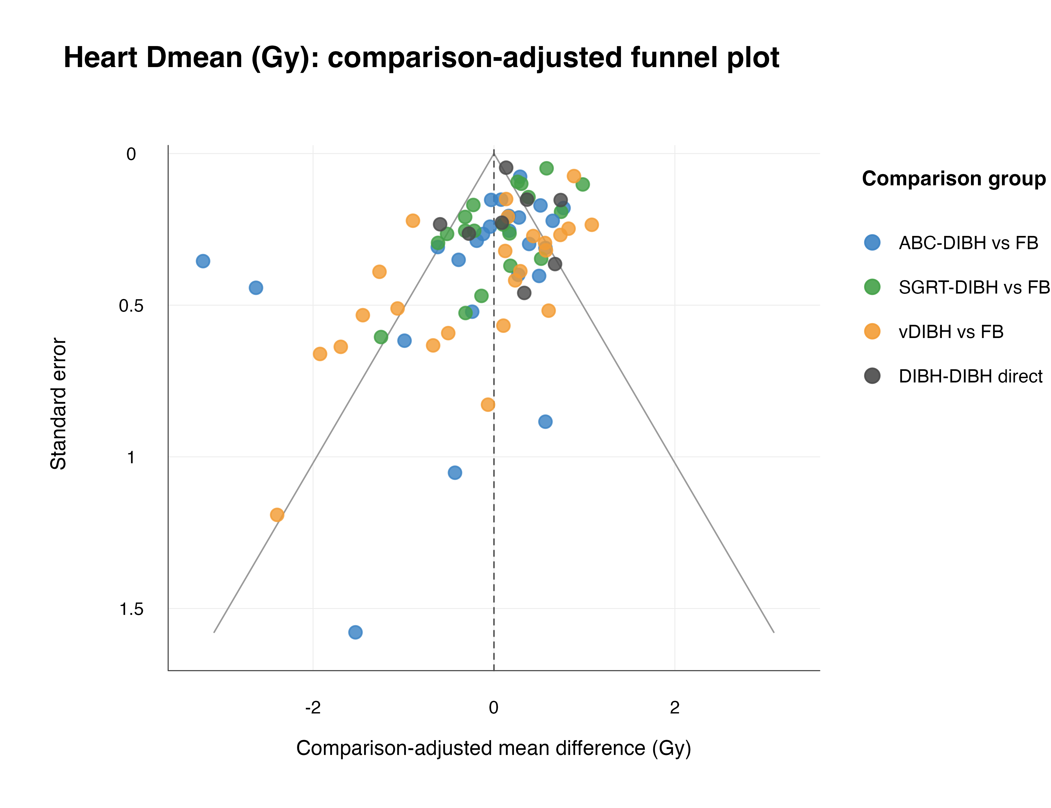
Figure S9.2: Heart Dmax comparison-adjusted funnel plot.
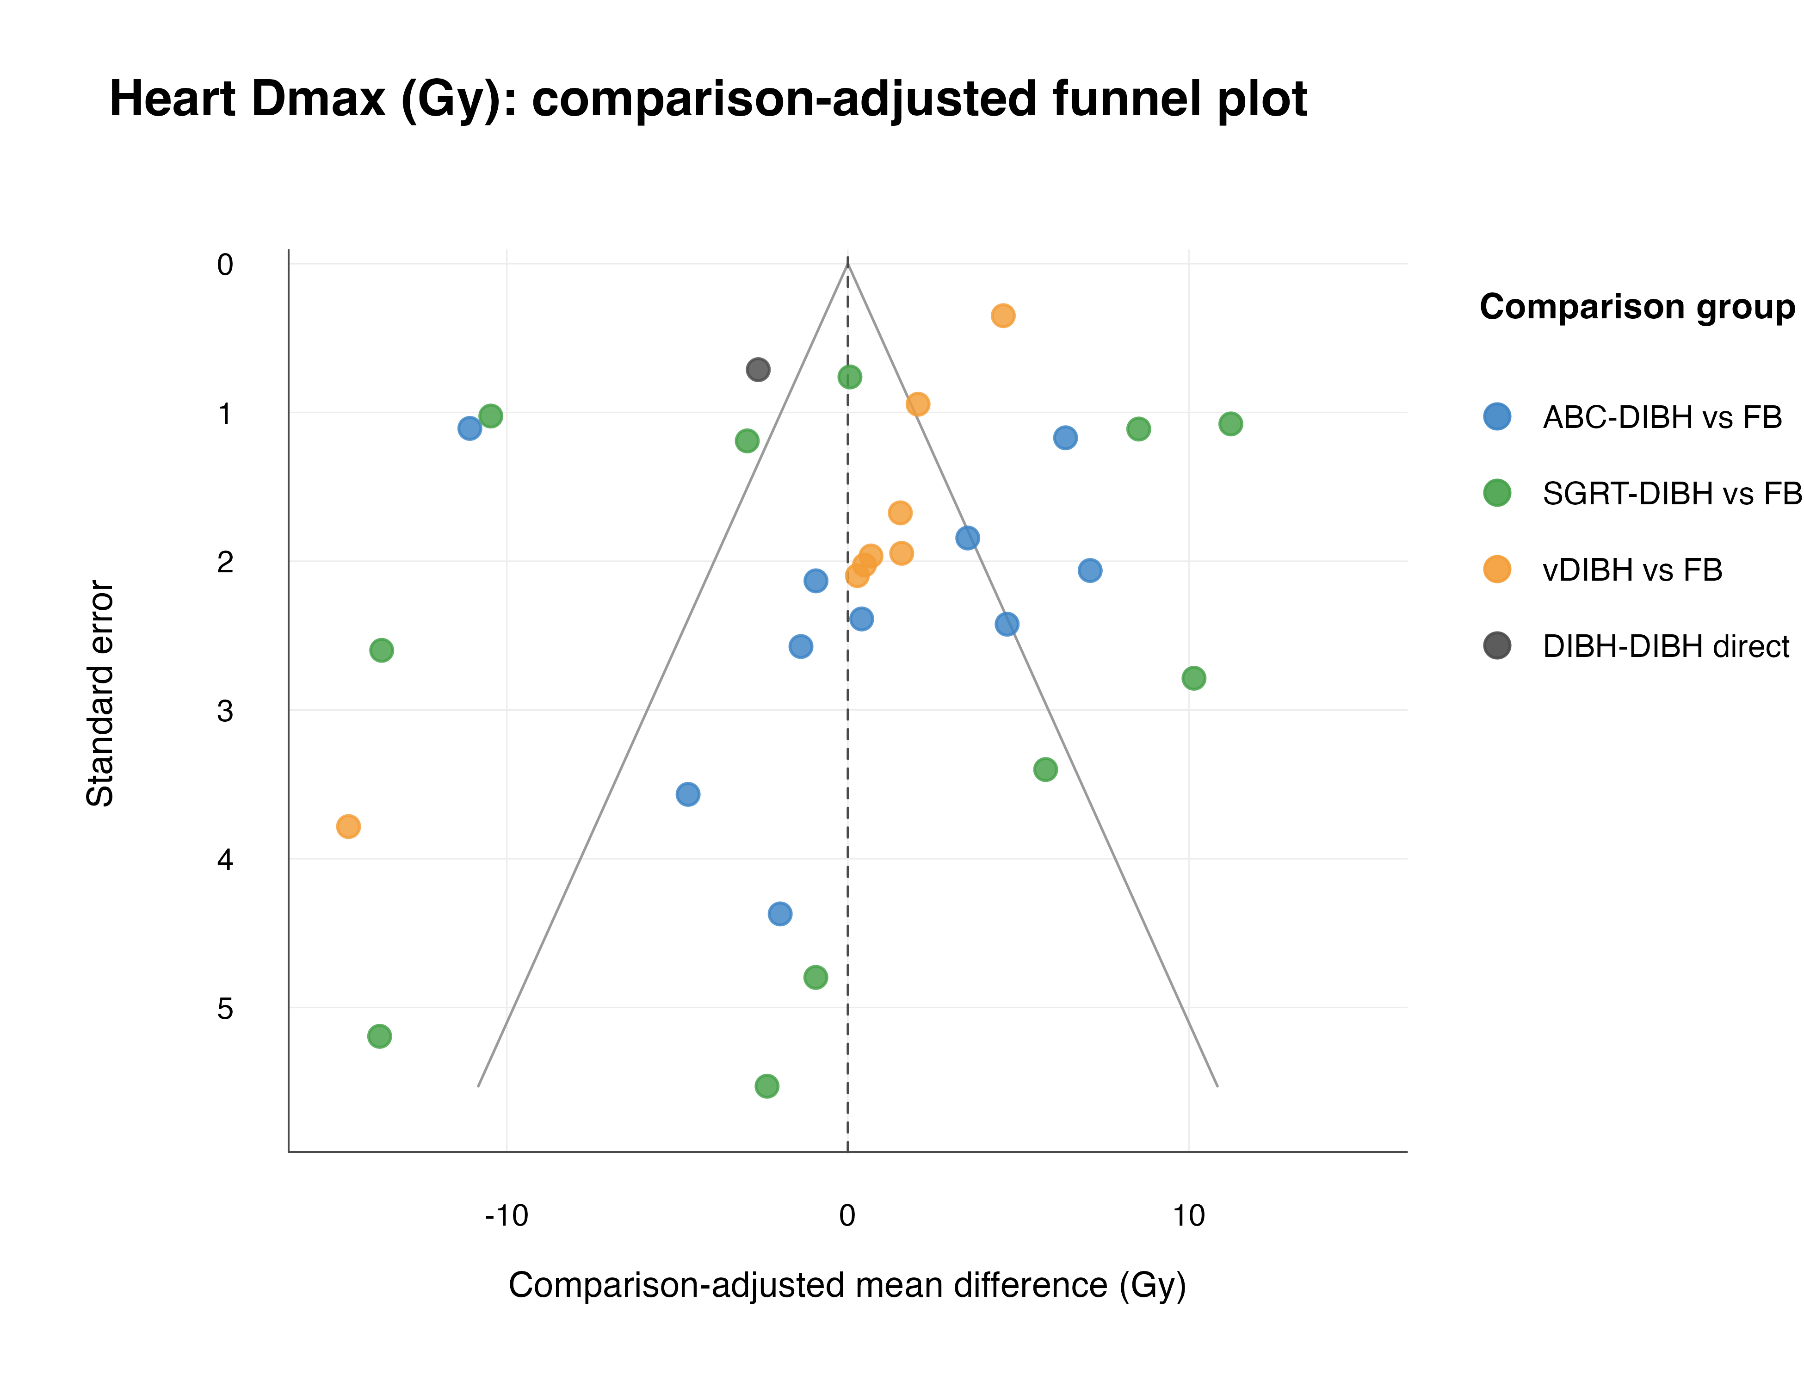
Figure S9.3: Heart V5 comparison-adjusted funnel plot.
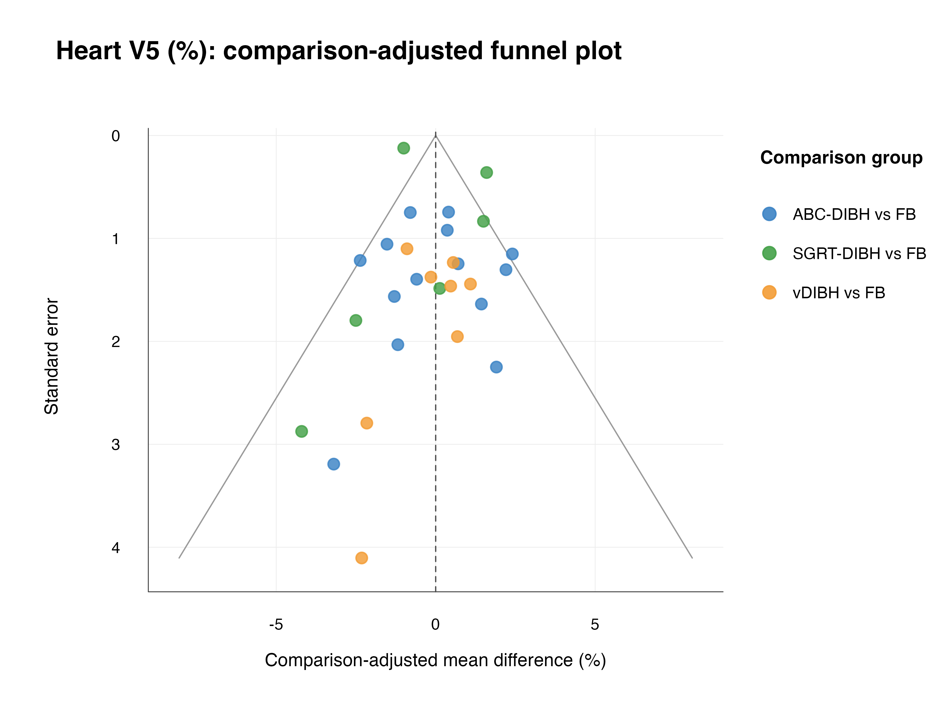
Figure S9.4: Heart V10 comparison-adjusted funnel plot.
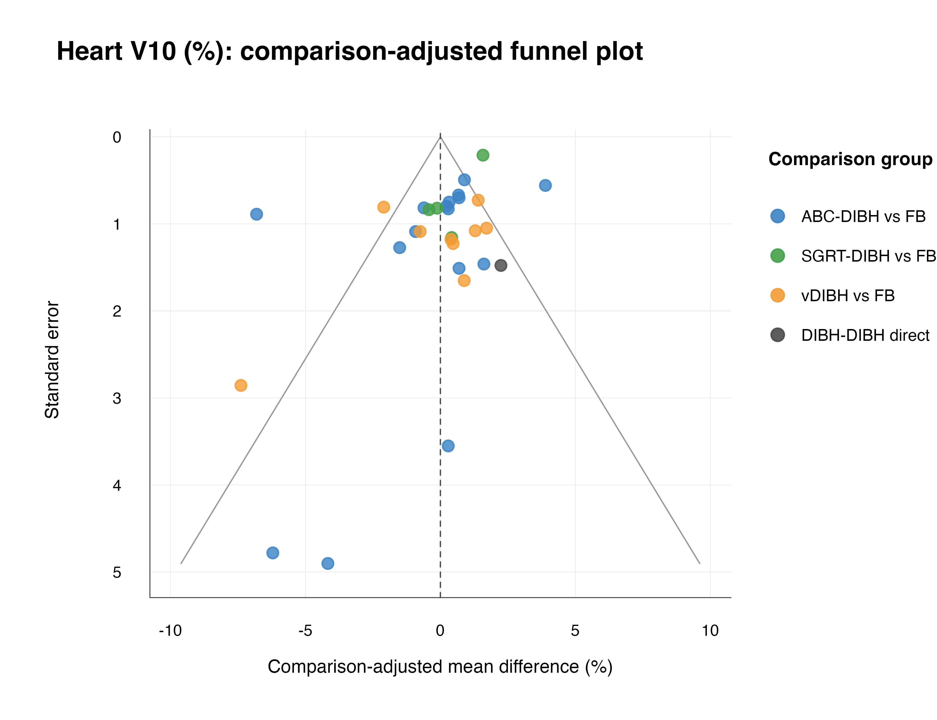
Figure S9.5: Heart V20 comparison-adjusted funnel plot.
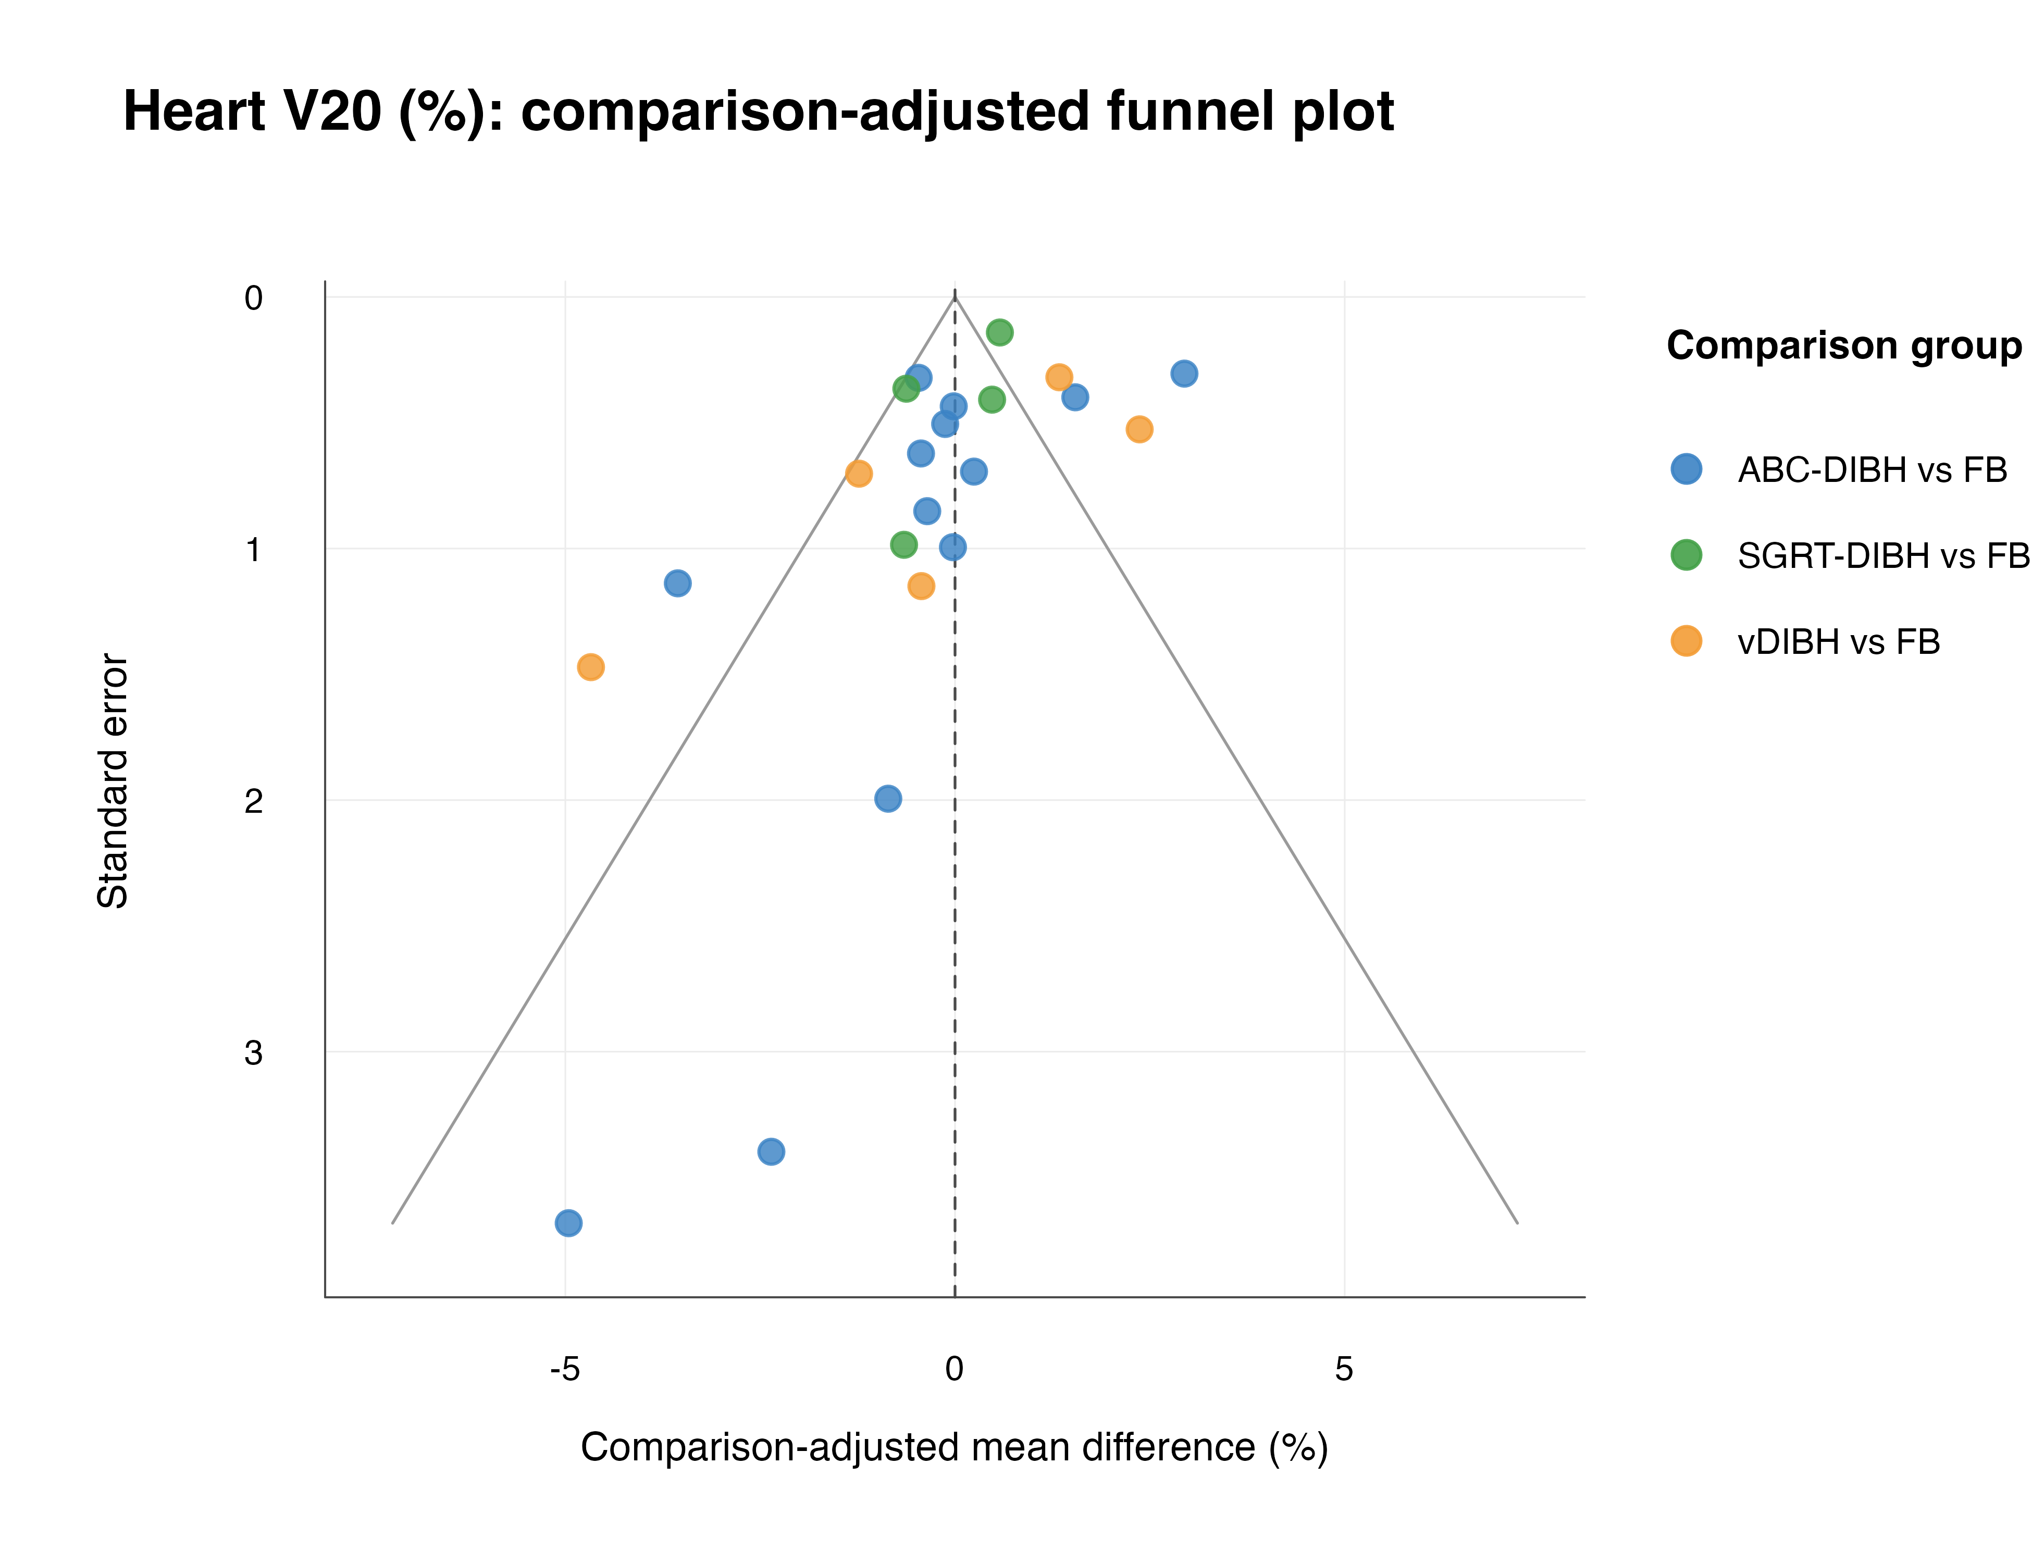
Figure S9.6: Heart V30 comparison-adjusted funnel plot.
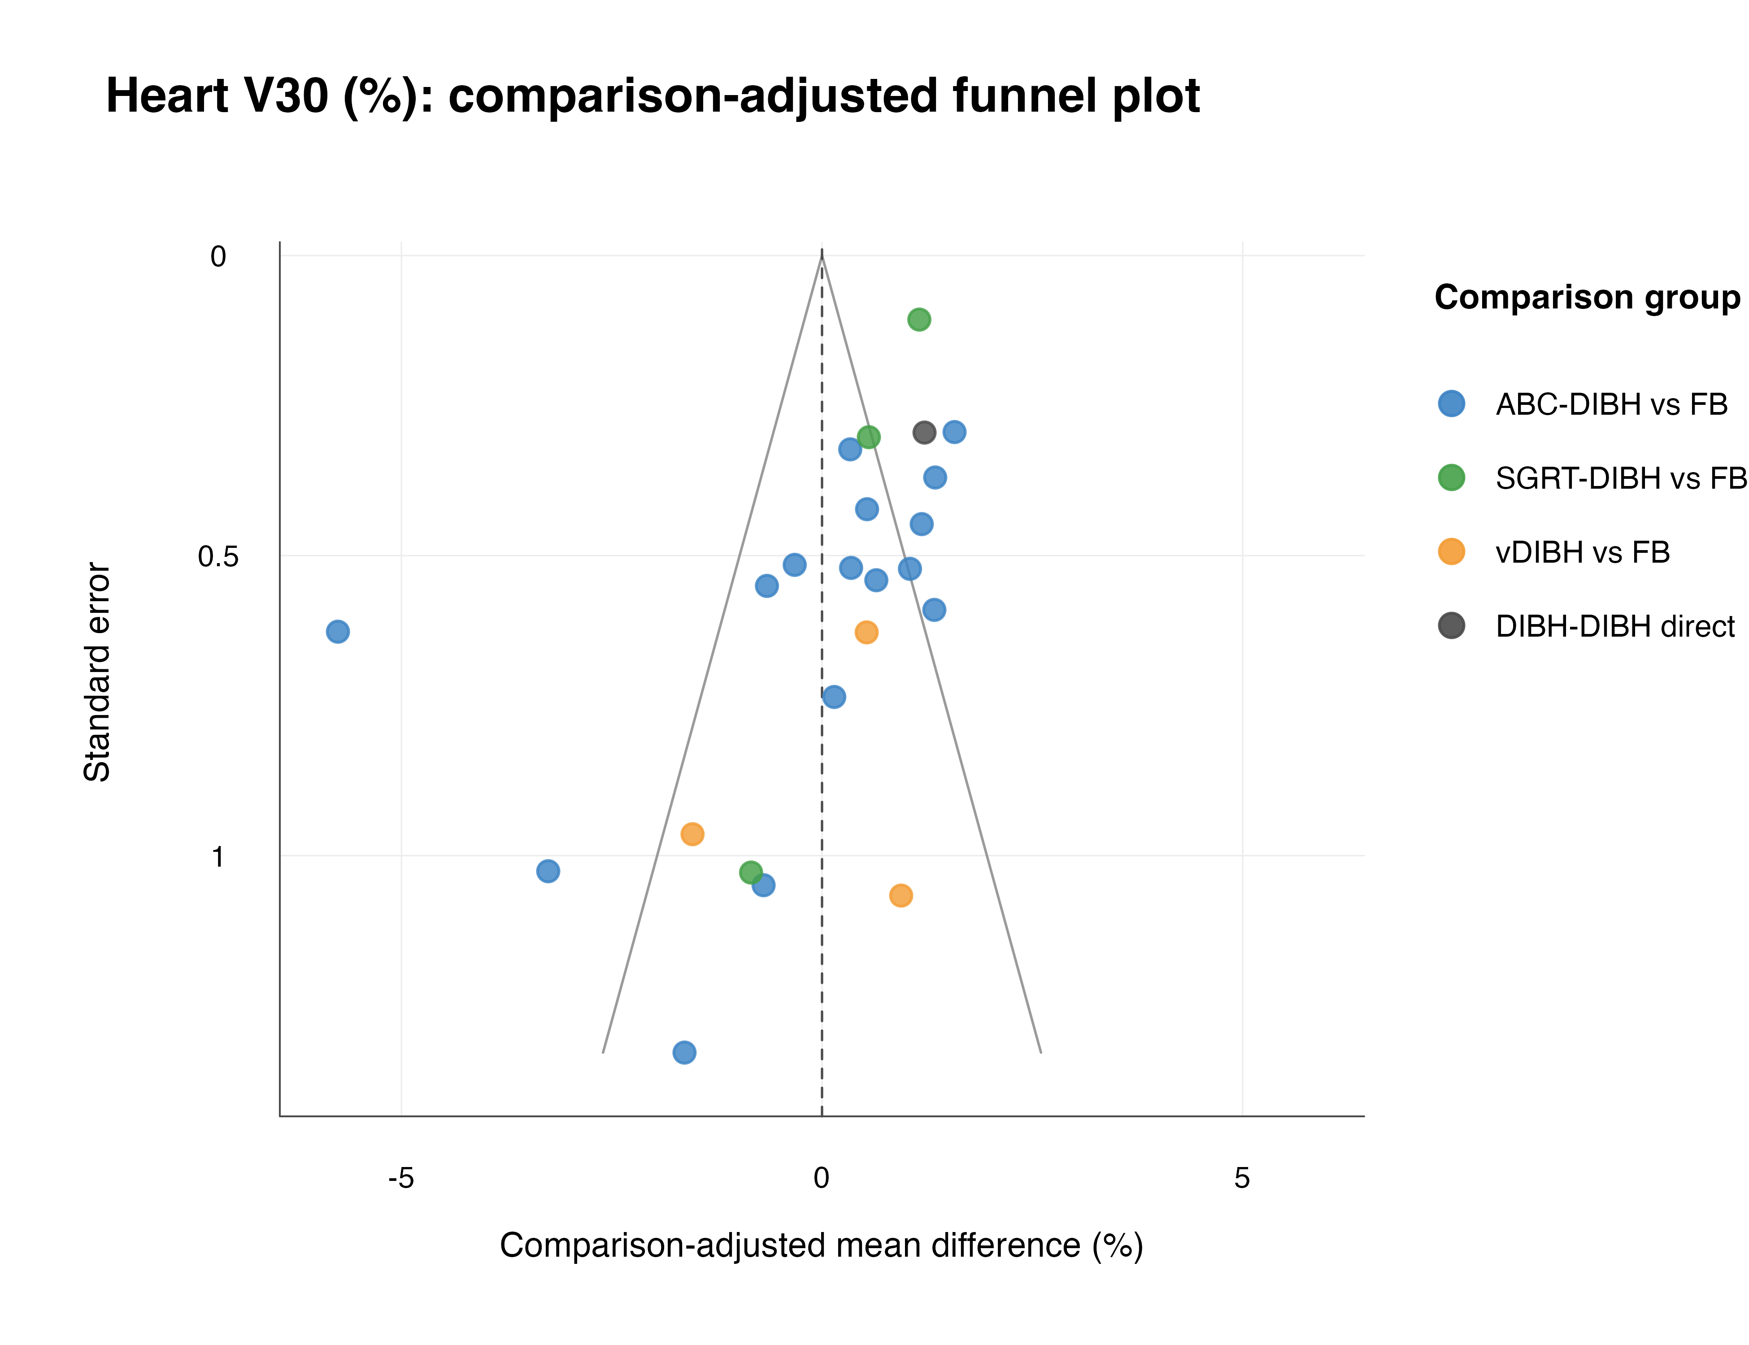
Figure S9.7: LAD Dmean comparison-adjusted funnel plot.
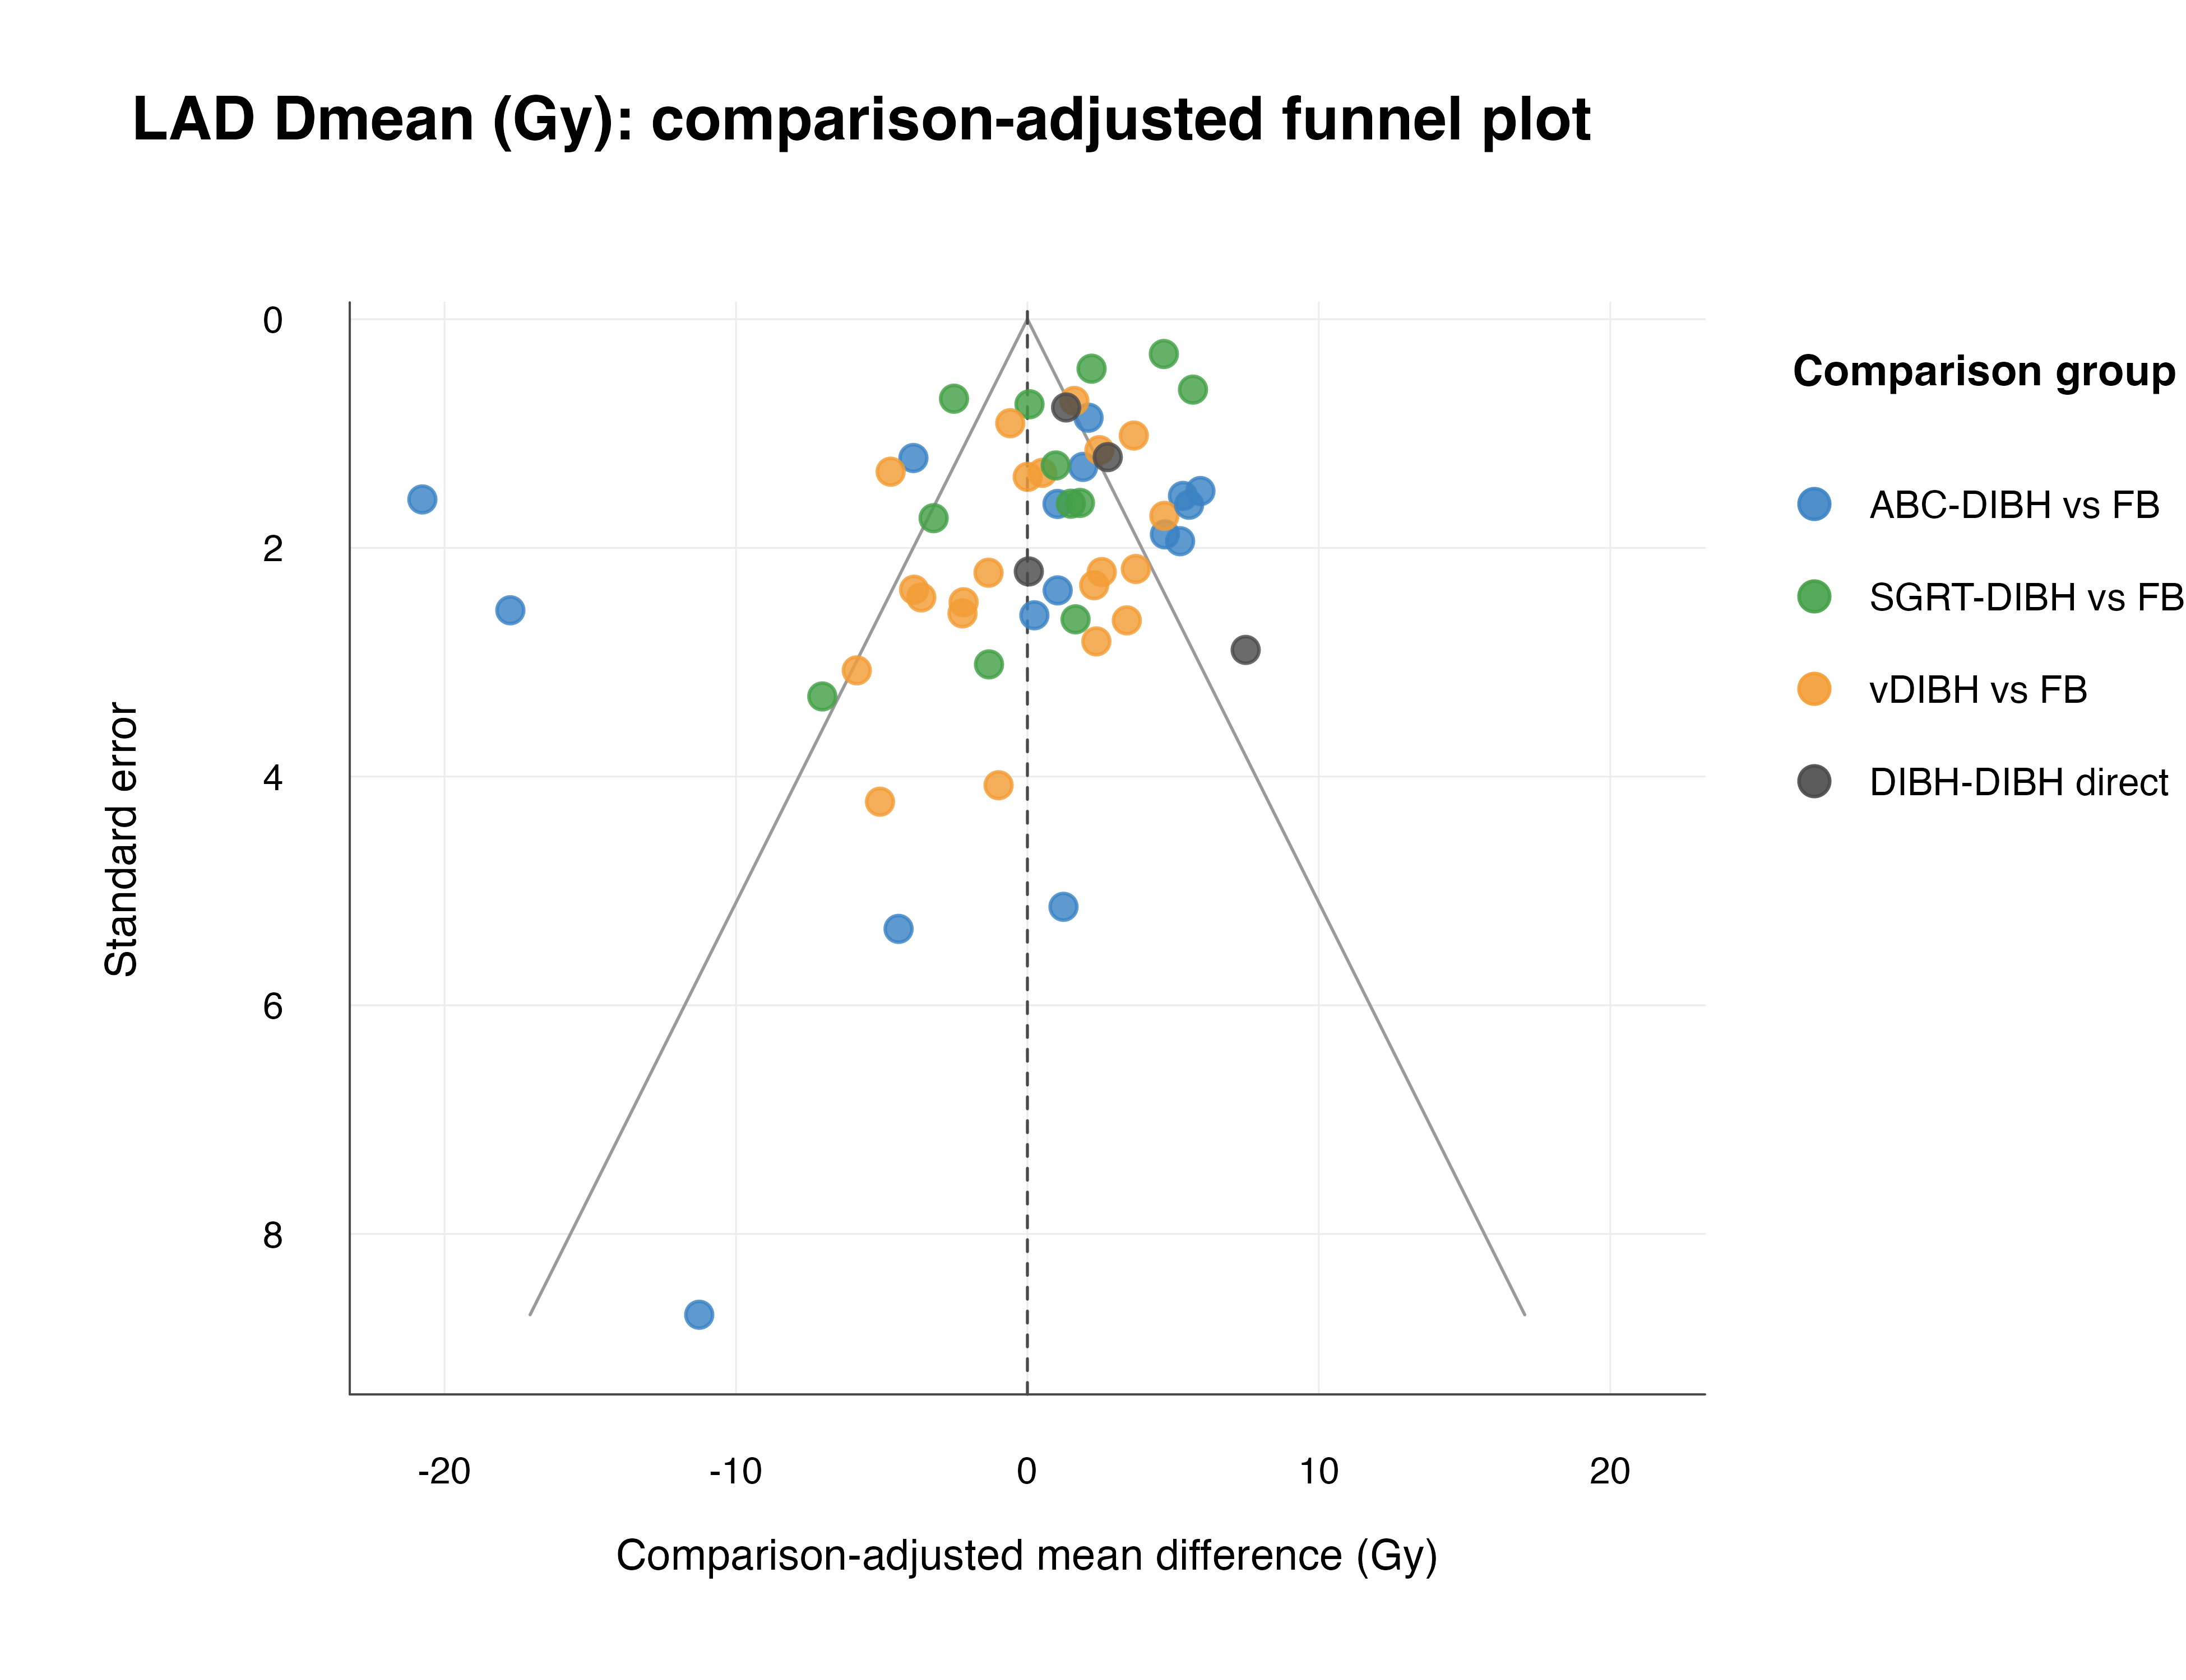
Figure S9.8: LAD Dmax comparison-adjusted funnel plot.
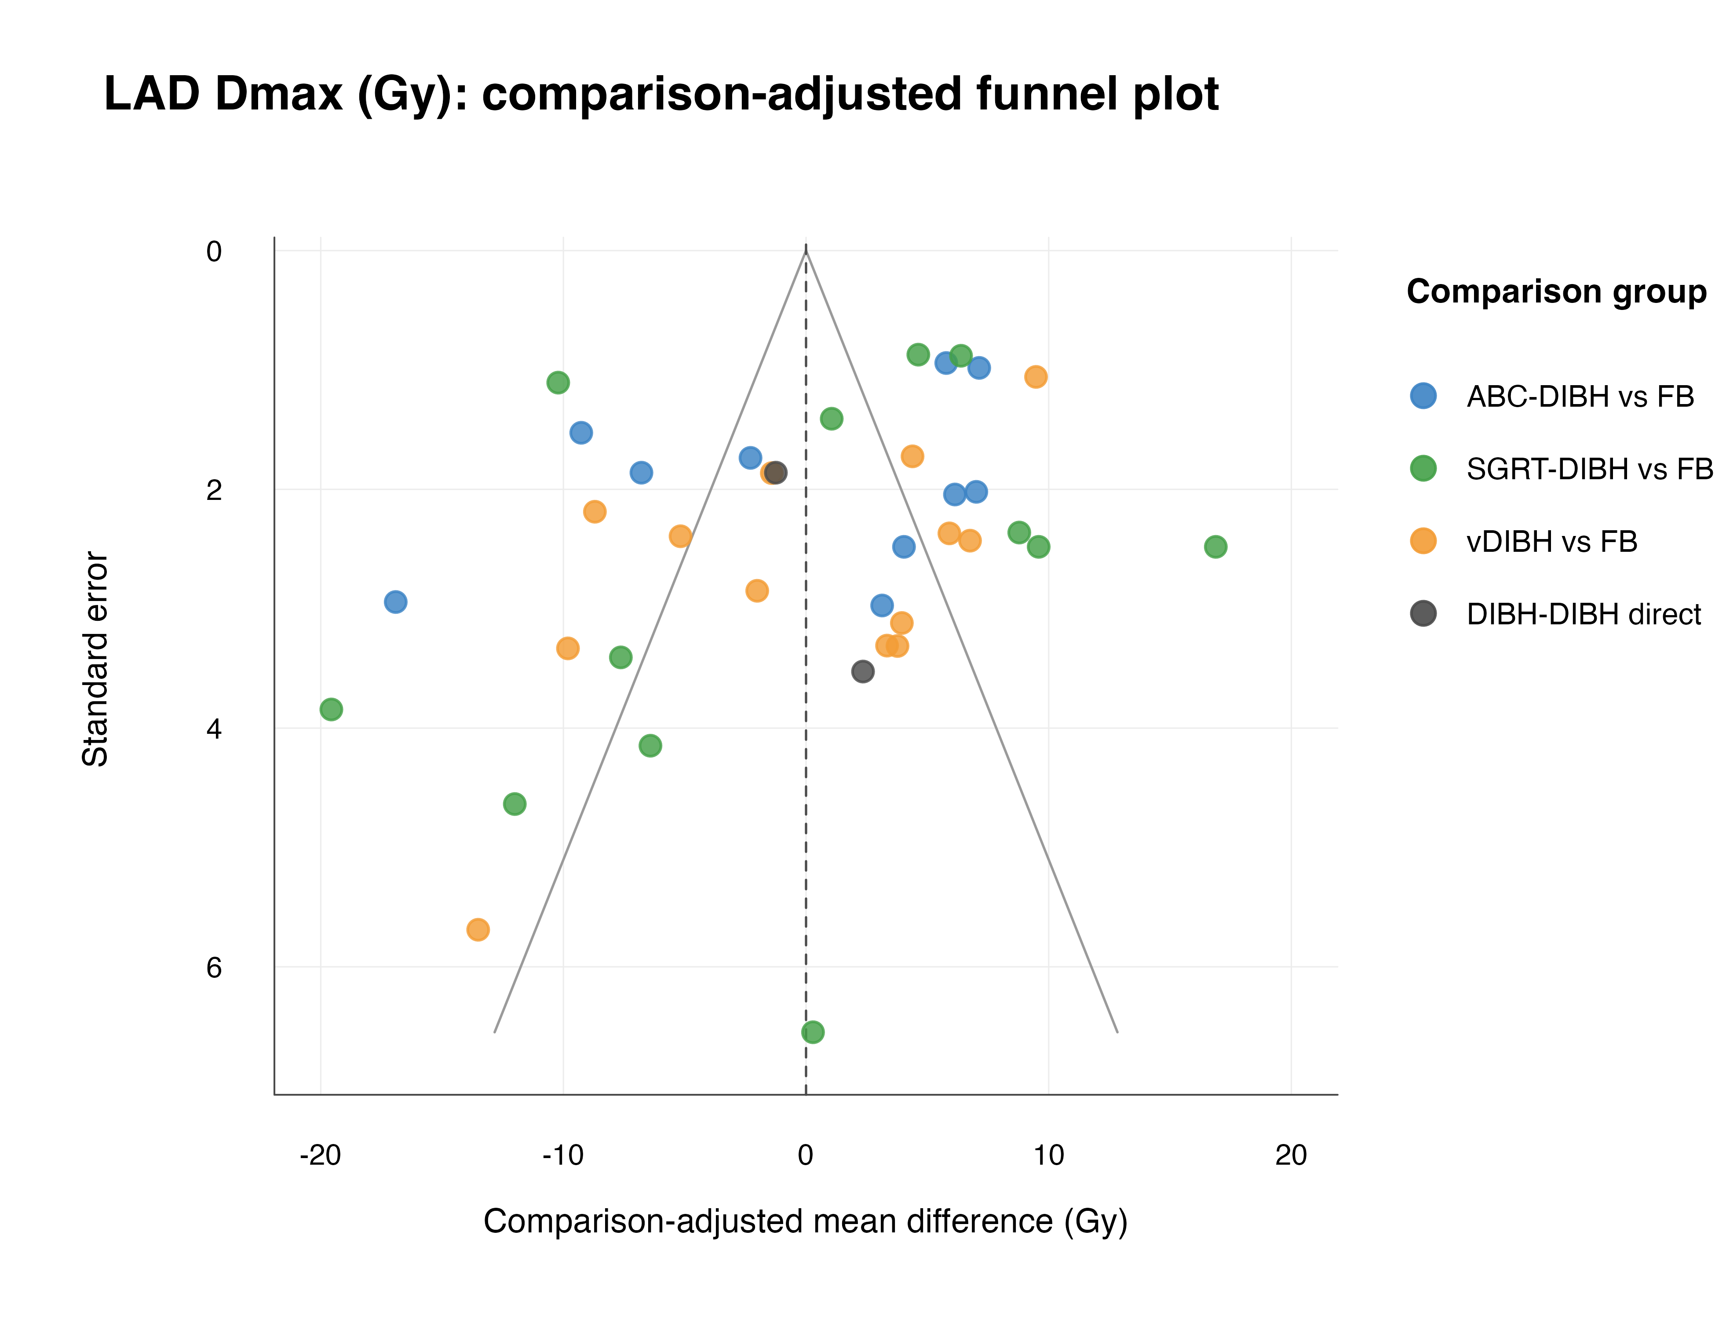
Figure S9.9: Left lung Dmean comparison-adjusted funnel plot.
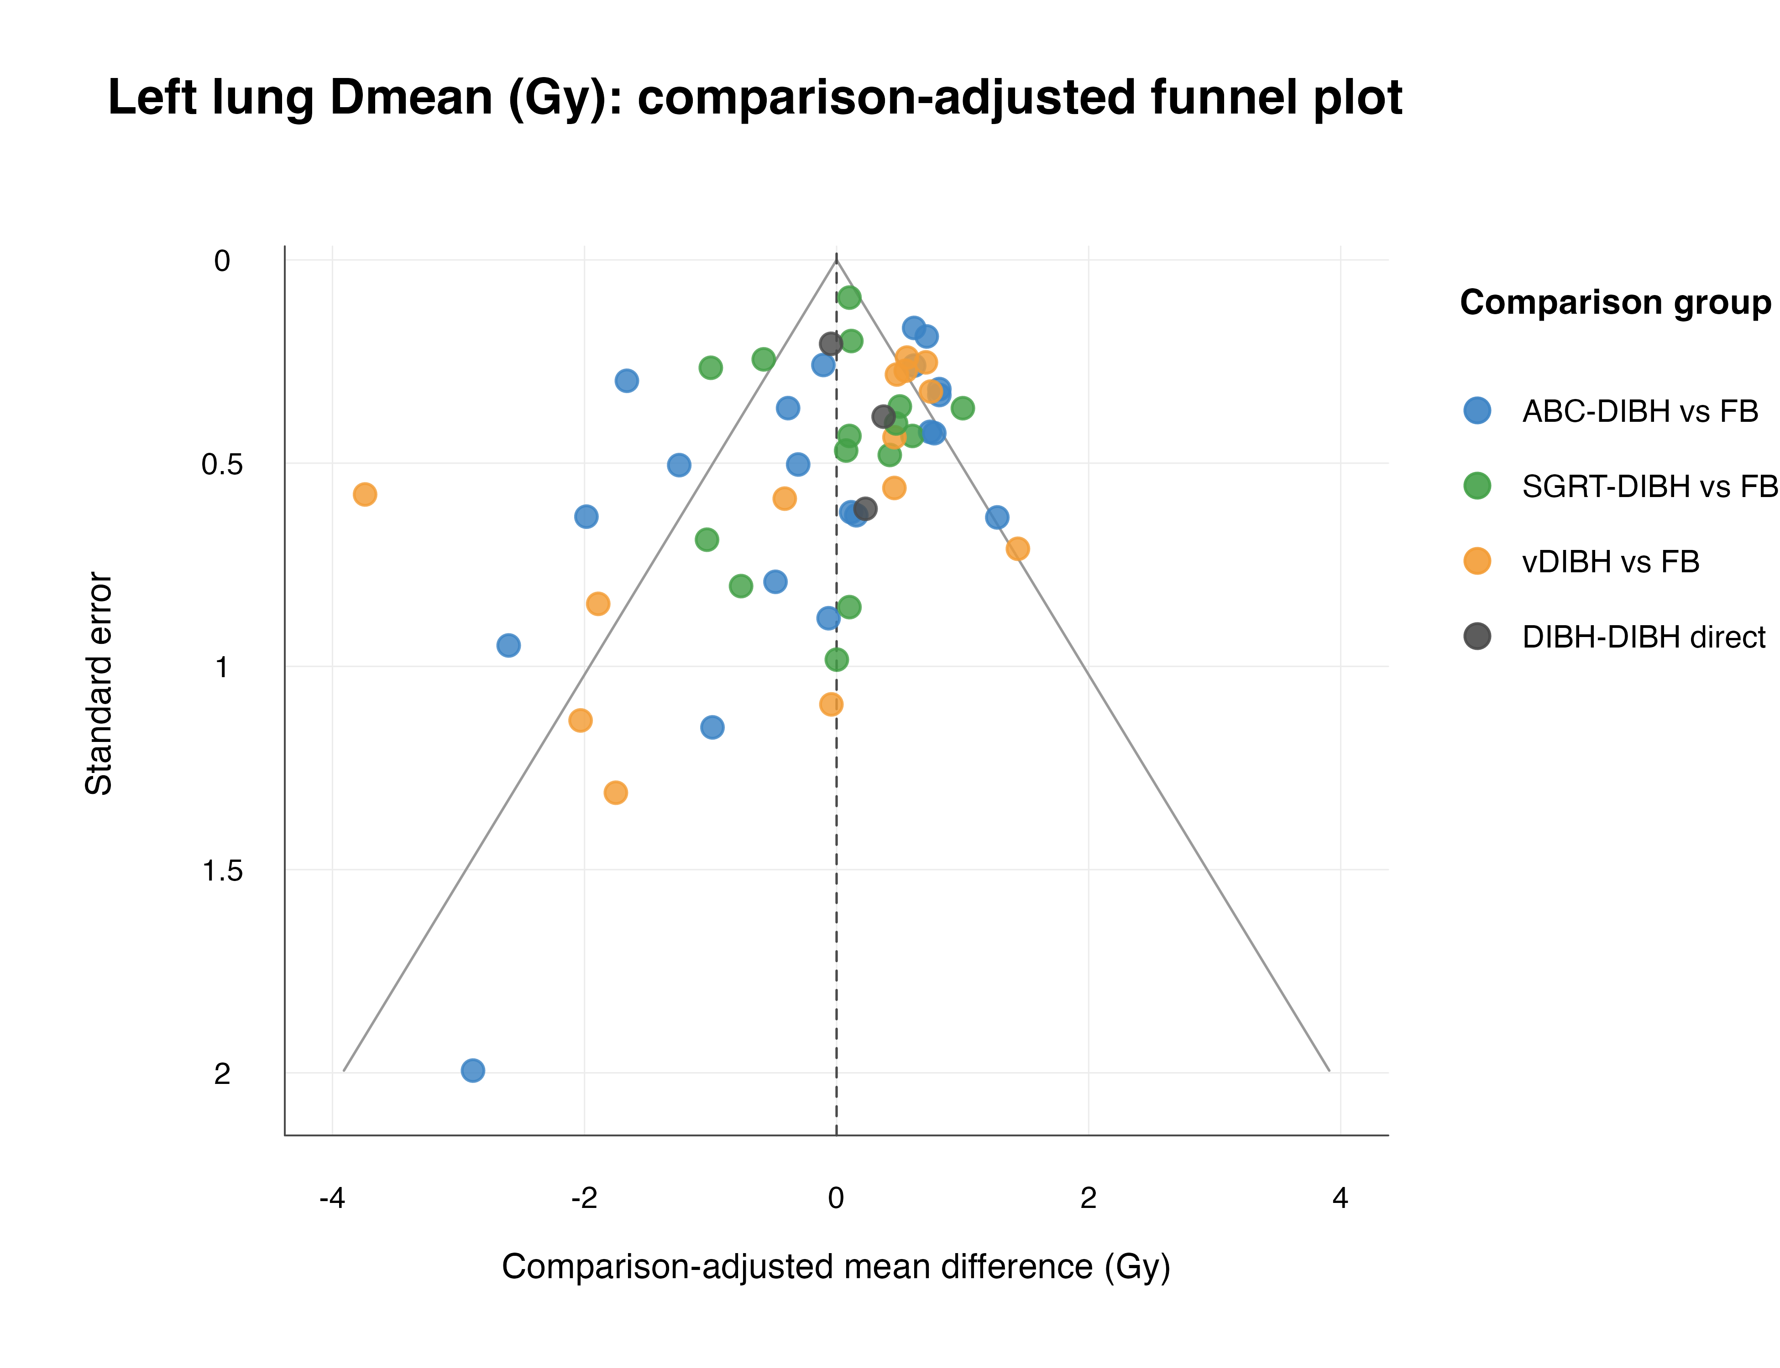
Figure S9.10: Left lung V5 comparison-adjusted funnel plot.
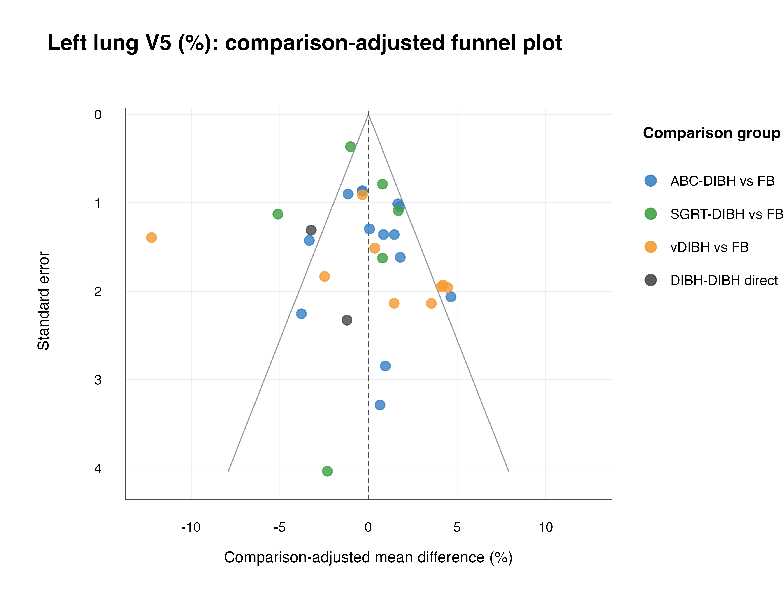
Figure S9.11: Left lung V10 comparison-adjusted funnel plot.
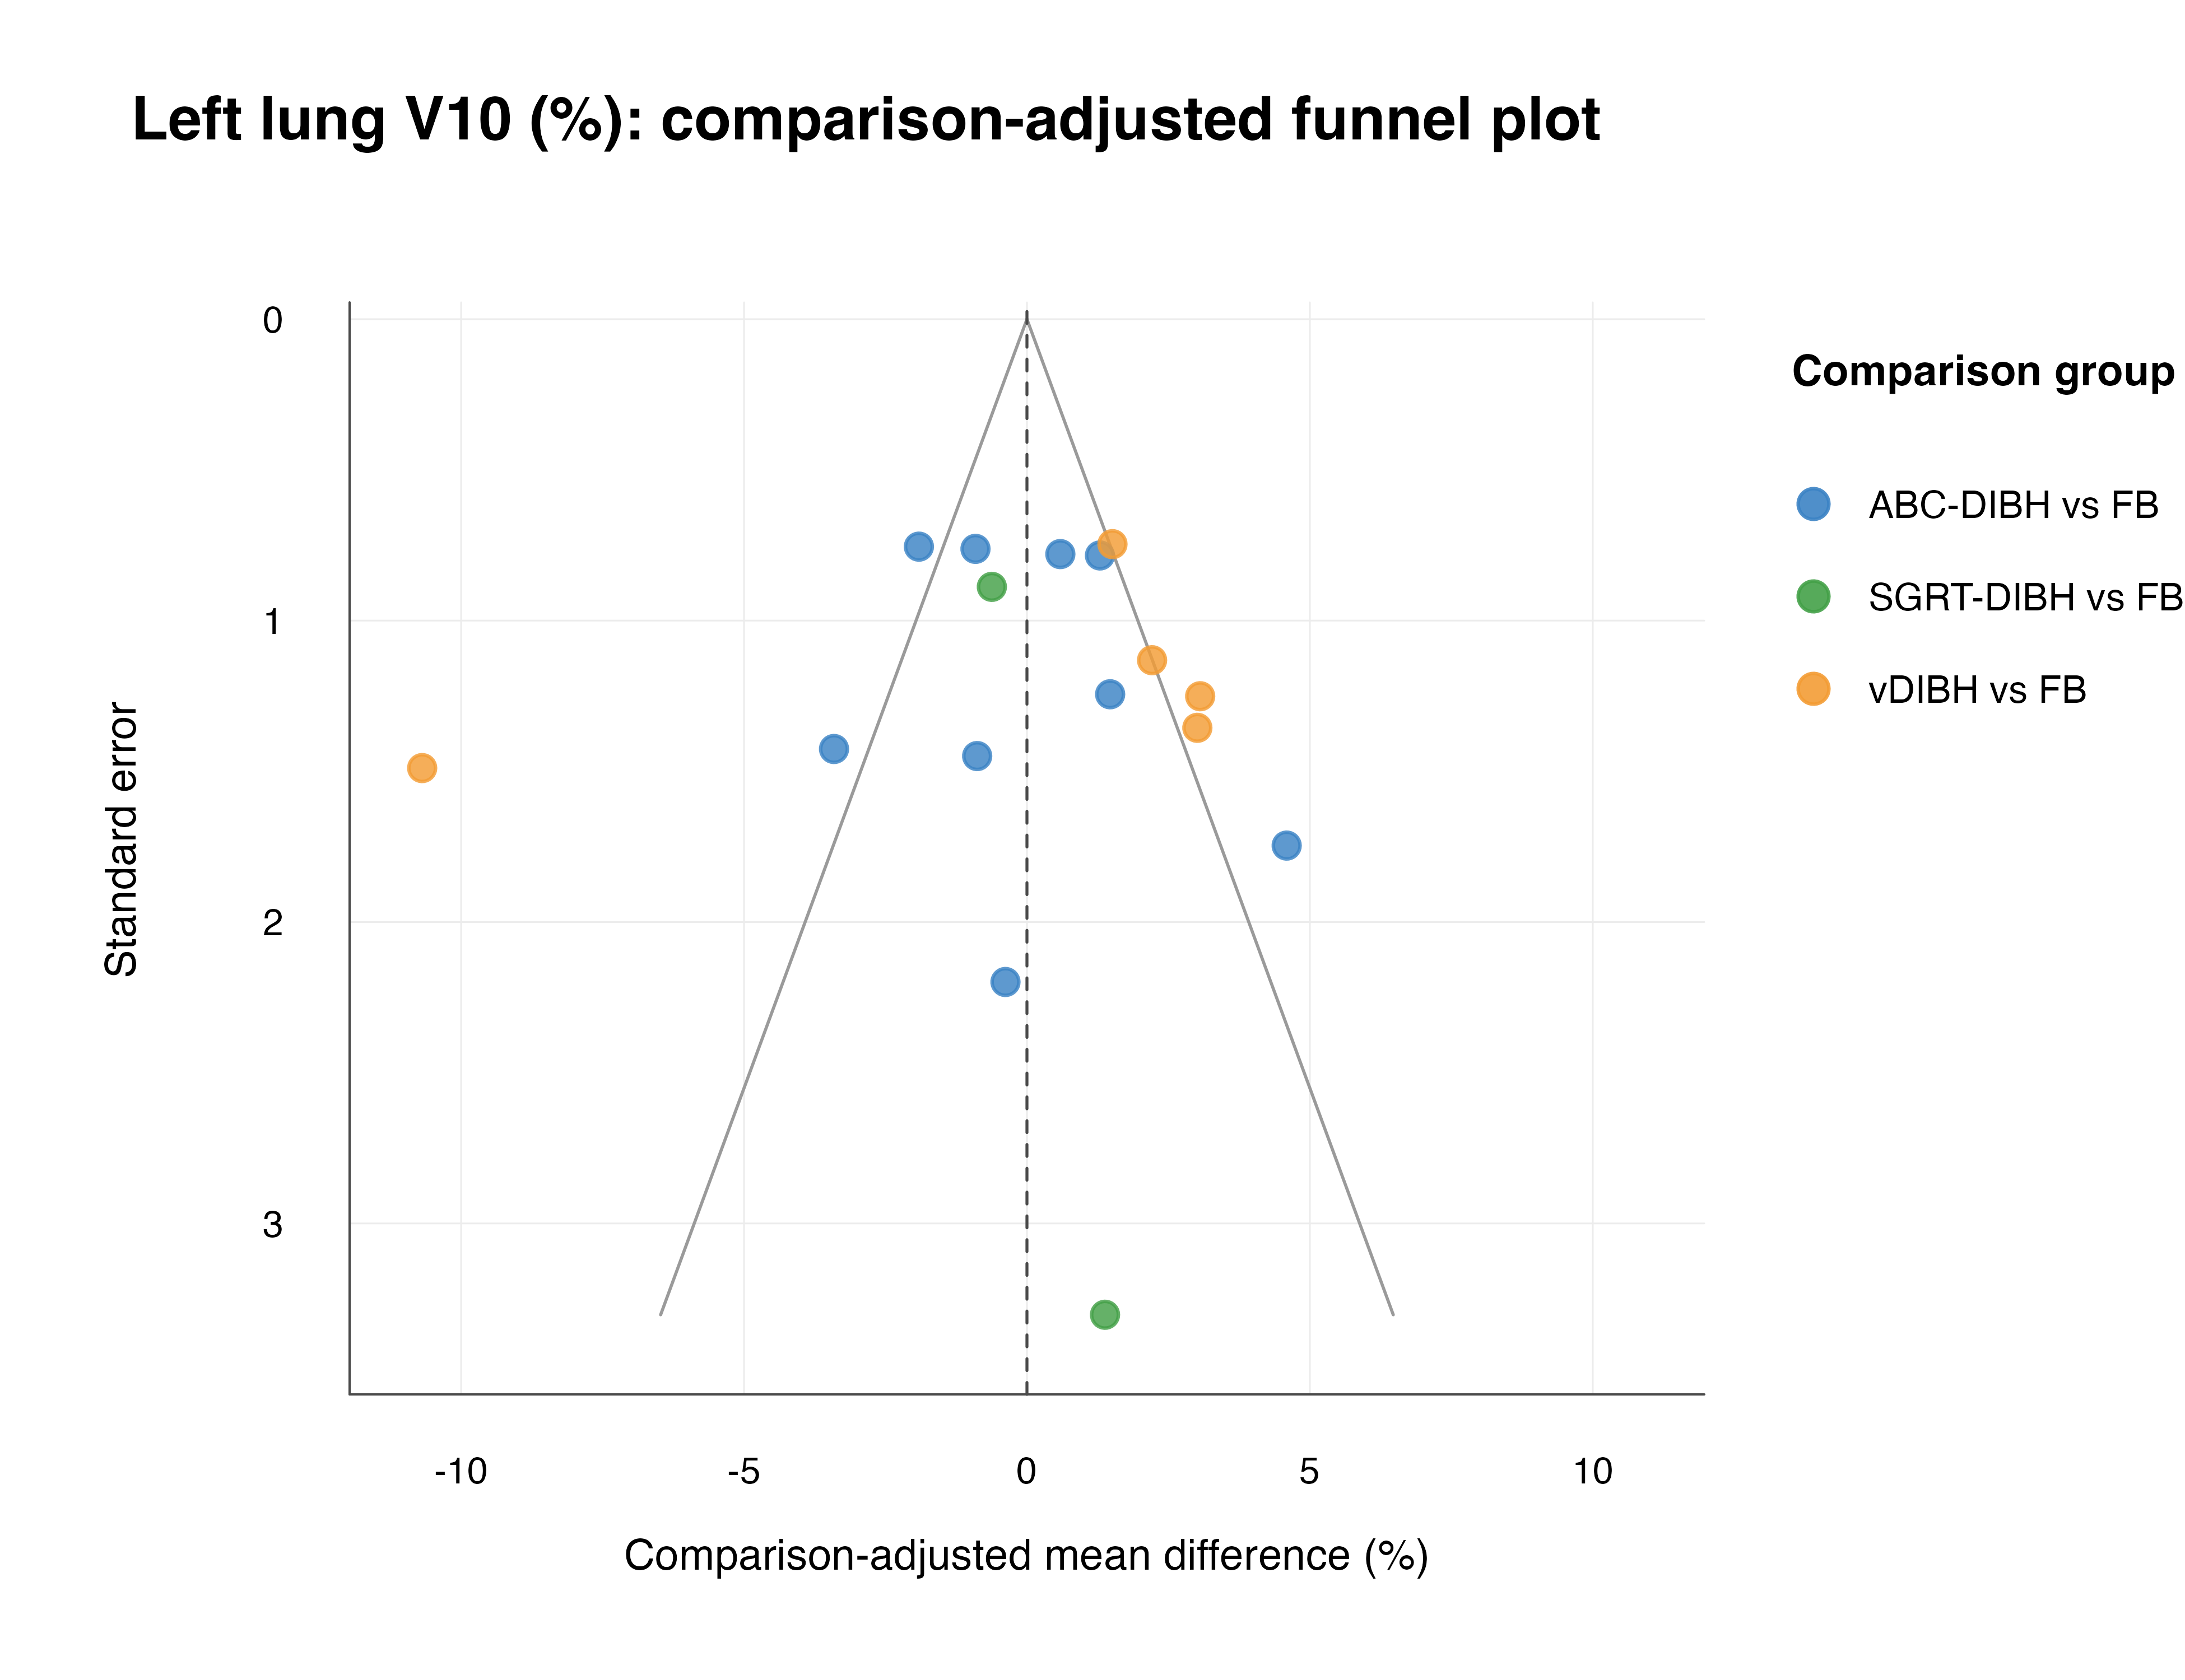
Figure S9.12: Left lung V20 comparison-adjusted funnel plot.
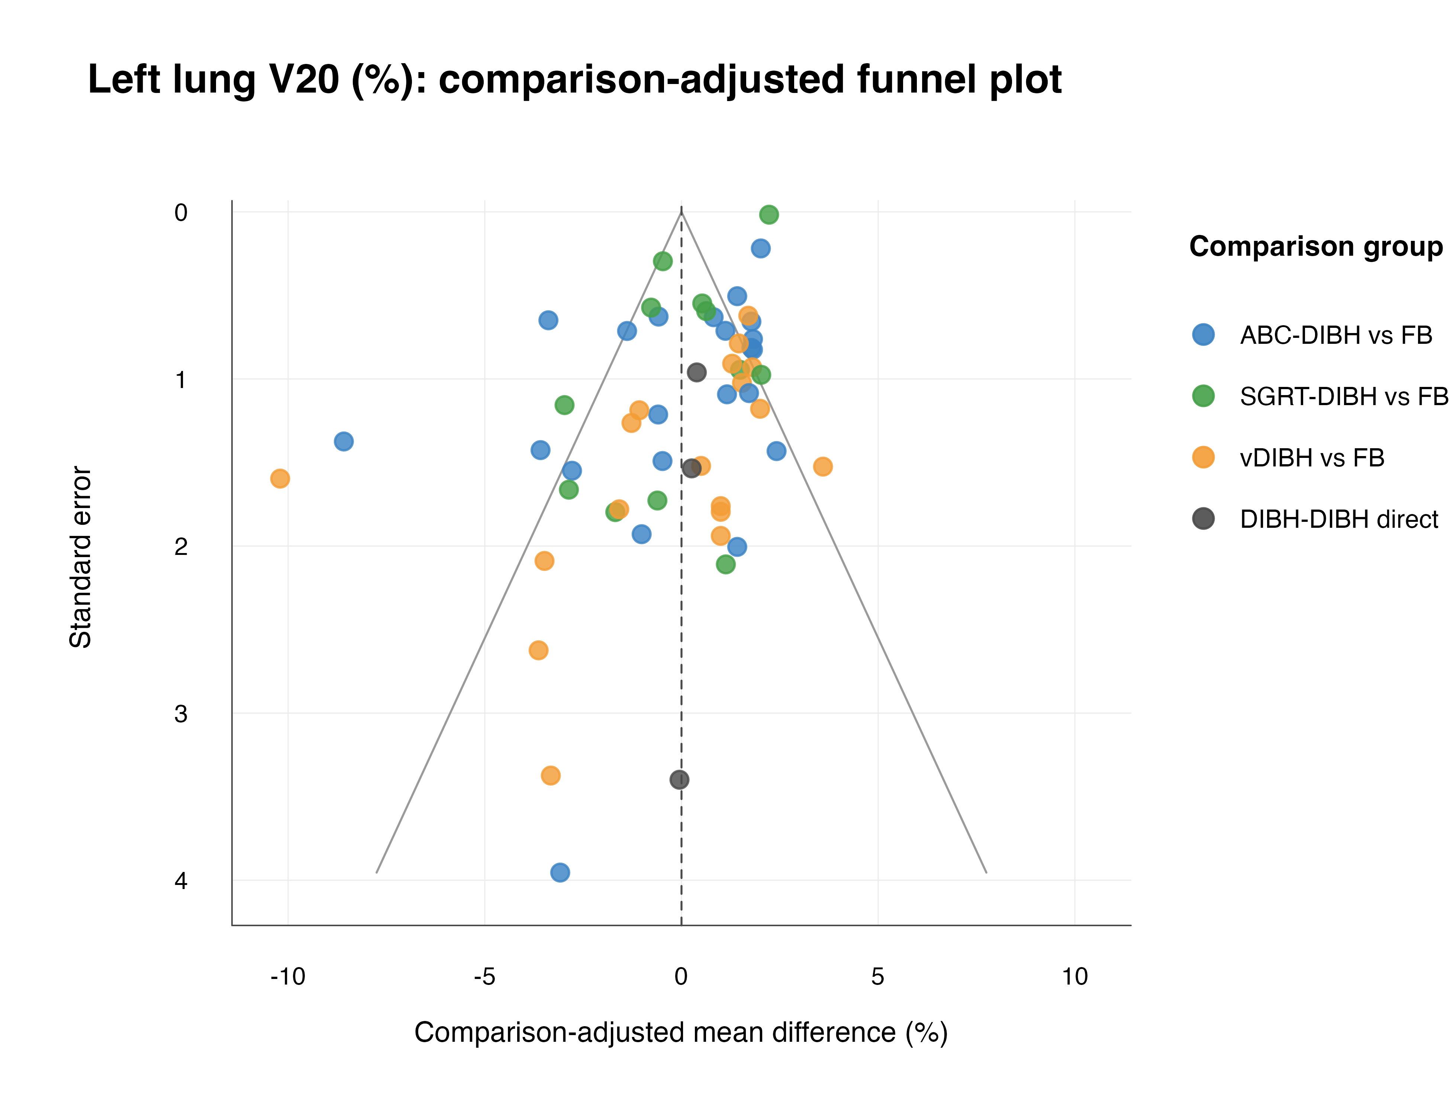
Figure S9.13: Left lung V30 comparison-adjusted funnel plot.
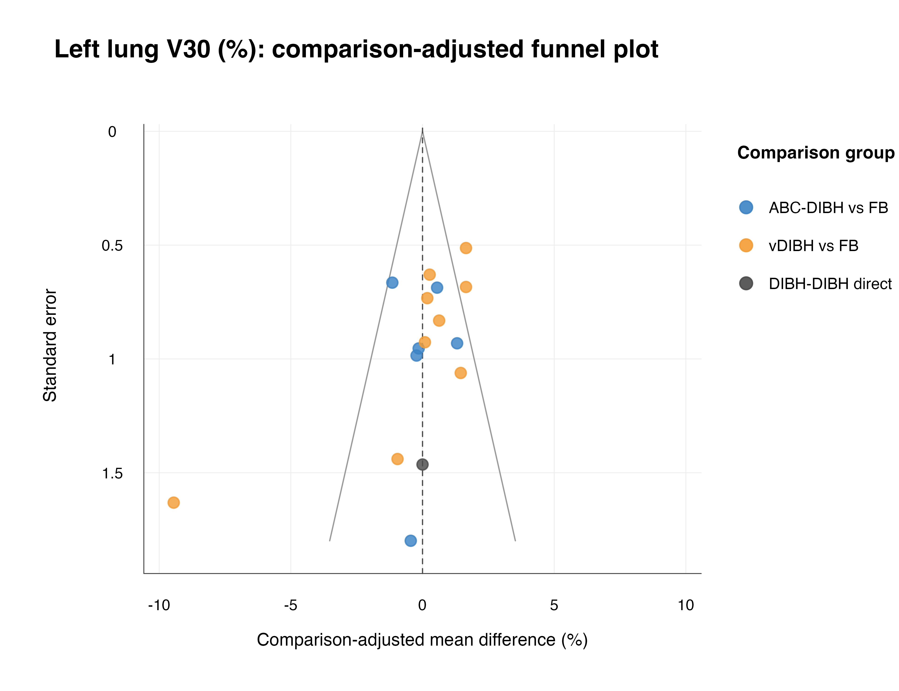

Appendix 10: Sensitivity Analyses
Sensitivity analyses are presented for the six primary outcomes. Values are MD versus FB (95% CI); negative values indicate a lower organ-at-risk dose than FB.
Outcome | Treatment | Main estimate | High-quality only | Fixed-effect model | Excluding small studies
Heart Dmean | ABC-DIBH | -1.77 (-1.98 to -1.56) | -1.82 (-2.1 to -1.55) | -1.43 (-1.5 to -1.36) | -1.8 (-2.02 to -1.58)
Heart Dmean | SGRT-DIBH | -1.28 (-1.51 to -1.05) | -1.24 (-1.53 to -0.938) | -0.912 (-0.972 to -0.851) | -1.29 (-1.54 to -1.04)
Heart Dmean | vDIBH | -1.63 (-1.86 to -1.41) | -1.8 (-2.12 to -1.48) | -1.32 (-1.39 to -1.24) | -1.79 (-2.07 to -1.52)
Heart Dmax | ABC-DIBH | -11.4 (-15.4 to -7.44) | -11.9 (-16.9 to -6.84) | -12.4 (-13.4 to -11.5) | -11.3 (-16 to -6.67)
Heart Dmax | SGRT-DIBH | -14.4 (-18.3 to -10.5) | -14.3 (-19.5 to -9.11) | -13.5 (-14.3 to -12.8) | -13.4 (-18.2 to -8.52)
Heart Dmax | vDIBH | -4.66 (-9.22 to -0.0919) | -6.53 (-15.6 to 2.54) | -0.936 (-1.53 to -0.338) | -2.6 (-17.3 to 12.1)
LAD Dmean | ABC-DIBH | -9.24 (-11.2 to -7.27) | -9.93 (-12.4 to -7.48) | -8.22 (-8.91 to -7.53) | -9.56 (-11.7 to -7.47)
LAD Dmean | SGRT-DIBH | -7.68 (-9.89 to -5.48) | -7.94 (-11 to -4.89) | -4.92 (-5.31 to -4.53) | -7.27 (-9.63 to -4.92)
LAD Dmean | vDIBH | -8.21 (-10 to -6.41) | -8.7 (-11.4 to -5.96) | -7.65 (-8.26 to -7.04) | -9.5 (-11.7 to -7.34)
LAD Dmax | ABC-DIBH | -10.1 (-14.4 to -5.83) | -10.4 (-15.3 to -5.56) | -7.86 (-8.79 to -6.93) | -12.3 (-17.4 to -7.17)
LAD Dmax | SGRT-DIBH | -16.9 (-21.2 to -12.6) | -17.6 (-22.9 to -12.4) | -14.8 (-15.7 to -13.9) | -16.3 (-20.9 to -11.6)
LAD Dmax | vDIBH | -9.79 (-13.9 to -5.7) | -12.6 (-18.3 to -6.84) | -6.81 (-7.97 to -5.65) | -13.6 (-19.4 to -7.67)
Left lung Dmean | ABC-DIBH | -1.12 (-1.44 to -0.787) | -1.06 (-1.42 to -0.701) | -0.865 (-1.01 to -0.724) | -1.18 (-1.55 to -0.807)
Left lung Dmean | SGRT-DIBH | -0.802 (-1.18 to -0.426) | -0.75 (-1.17 to -0.326) | -0.77 (-0.9 to -0.641) | -0.824 (-1.27 to -0.38)
Left lung Dmean | vDIBH | -1.16 (-1.58 to -0.738) | -0.883 (-1.47 to -0.298) | -0.826 (-1.01 to -0.638) | -1.78 (-2.43 to -1.13)
Left lung V20 | ABC-DIBH | -2.42 (-3.28 to -1.55) | -2.29 (-3.21 to -1.38) | -1.39 (-1.66 to -1.11) | -2.77 (-3.77 to -1.76)
Left lung V20 | SGRT-DIBH | -2.23 (-3.36 to -1.1) | -2.4 (-3.57 to -1.23) | -0.0179 (-0.0512 to 0.0155) | -2.16 (-3.42 to -0.909)
Left lung V20 | vDIBH | -3 (-4.08 to -1.92) | -1.58 (-3.03 to -0.136) | -2.33 (-2.89 to -1.78) | -3.21 (-4.61 to -1.82)
Table S10.1: Sensitivity analyses of primary outcomes.

Table S10.2: Leave-one-study-out influence analysis for primary outcomes.
Outcome | Treatment comparison | Main MD | Range of leave-one-out MDs
Heart Dmean | ABC-DIBH vs FB | -1.77 | -1.8 to -1.65
Heart Dmean | SGRT-DIBH vs FB | -1.28 | -1.34 to -1.24
Heart Dmean | vDIBH vs FB | -1.63 | -1.8 to -1.53
Heart Dmax | ABC-DIBH vs FB | -11.4 | -12.2 to -10.1
Heart Dmax | SGRT-DIBH vs FB | -14.4 | -15.6 to -13.1
Heart Dmax | vDIBH vs FB | -4.66 | -6.36 to -3.01
LAD Dmean | ABC-DIBH vs FB | -9.24 | -9.61 to -7.78
LAD Dmean | SGRT-DIBH vs FB | -7.68 | -8.22 to -7.27
LAD Dmean | vDIBH vs FB | -8.21 | -9.14 to -7.8
LAD Dmax | ABC-DIBH vs FB | -10.1 | -10.8 to -8.69
LAD Dmax | SGRT-DIBH vs FB | -16.9 | -18.3 to -15.4
LAD Dmax | vDIBH vs FB | -9.79 | -12.5 to -9.06
Left lung Dmean | ABC-DIBH vs FB | -1.12 | -1.17 to -0.991
Left lung Dmean | SGRT-DIBH vs FB | -0.802 | -0.874 to -0.718
Left lung Dmean | vDIBH vs FB | -1.16 | -1.54 to -0.916
Left lung V20 | ABC-DIBH vs FB | -2.42 | -2.54 to -2.08
Left lung V20 | SGRT-DIBH vs FB | -2.23 | -2.45 to -2
Left lung V20 | vDIBH vs FB | -3 | -3.2 to -2.54

Appendix 11: Subgroup Analyses
Subgroup analyses were retained only where numerical estimates could be compared across primary outcomes. Values are MD versus FB (95% CI). Planning-technique and comparison-type analyses were sparse or descriptive and are therefore not expanded into repeated numeric tables here.
Table S11.1: Comparison of DIBH effects by fractionation scheme.
Subgroup | Treatment | Heart Dmean | Heart Dmax | LAD Dmean | LAD Dmax | Left lung Dmean | Left lung V20
conventional fractionation | ABC-DIBH | -2.88 (-3.58 to -2.19) | -11.9 (-23.5 to -0.269) | -20.4 (-25.3 to -15.5) | -23.1 (-36.5 to -9.66) | -2.39 (-3.3 to -1.49) | -4.6 (-6.54 to -2.66)
conventional fractionation | SGRT-DIBH | -1.06 (-1.59 to -0.533) | -12.7 (-19.1 to -6.28) | -6.53 (-10.2 to -2.89) | -21.4 (-29.4 to -13.4) | -0.905 (-1.5 to -0.312) | -2.19 (-3.82 to -0.559)
conventional fractionation | vDIBH | -2.57 (-3.39 to -1.75) | -10.2 (-21.9 to 1.52) | -9.54 (-14.2 to -4.93) | -13.1 (-27.3 to 1.04) | -0.54 (-1.43 to 0.349) | -0.701 (-3.36 to 1.96)
hypofractionation | ABC-DIBH | -1.41 (-1.61 to -1.21) | -9.28 (-14.1 to -4.5) | -7.57 (-9.68 to -5.45) | -8.46 (-12.8 to -4.16) | -0.493 (-0.684 to -0.302) | -0.954 (-1.55 to -0.361)
hypofractionation | SGRT-DIBH | -1.68 (-2.07 to -1.29) | -11.7 (-19.7 to -3.64) | -9.39 (-13.7 to -5.11) | -14.8 (-24.6 to -5.03) | -0.371 (-0.953 to 0.211) | -3.19 (-4.96 to -1.42)
hypofractionation | vDIBH | -1.46 (-1.67 to -1.24) | NE | -7.51 (-10.5 to -4.48) | -14.9 (-21.9 to -7.95) | -0.539 (-0.865 to -0.213) | -1.45 (-2.67 to -0.23)
ultra-hypofractionation | All DIBH | NE | NE | NE | NE | NE | NE
mixed/unclear | ABC-DIBH | -1.69 (-1.94 to -1.45) | -12.6 (-19.4 to -5.78) | -4.92 (-7.99 to -1.84) | -5.2 (-17.2 to 6.82) | -1.27 (-1.74 to -0.787) | -2.54 (-3.77 to -1.31)
mixed/unclear | SGRT-DIBH | -1.11 (-1.4 to -0.813) | -18.9 (-26.5 to -11.3) | -7.72 (-10.4 to -5.02) | -12.7 (-20.3 to -5.13) | -0.78 (-1.31 to -0.246) | -2.05 (-4.46 to 0.353)
mixed/unclear | vDIBH | -1.27 (-1.64 to -0.903) | -0.1 (-13.2 to 13) | -7.87 (-10.4 to -5.35) | -10.4 (-19 to -1.78) | -3.05 (-4.98 to -1.12) | -2.59 (-4.9 to -0.282)

Table S11.2: Comparison of DIBH effects by study quality.
Subgroup | Treatment | Heart Dmean | Heart Dmax | LAD Dmean | LAD Dmax | Left lung Dmean | Left lung V20
NOS >=7 | ABC-DIBH | -1.79 (-2.02 to -1.57) | -11.9 (-17.1 to -6.7) | -9.91 (-12.3 to -7.55) | -10.3 (-14.1 to -6.53) | -1.02 (-1.34 to -0.697) | -2.16 (-2.92 to -1.41)
NOS >=7 | SGRT-DIBH | -1.2 (-1.44 to -0.967) | -14.3 (-19.7 to -9) | -7.91 (-10.9 to -4.96) | -17.4 (-21.6 to -13.2) | -0.743 (-1.12 to -0.368) | -2.29 (-3.25 to -1.34)
NOS >=7 | vDIBH | -1.75 (-2.01 to -1.49) | -6.58 (-15.9 to 2.76) | -8.69 (-11.3 to -6.05) | -12.3 (-16.9 to -7.79) | -0.859 (-1.38 to -0.342) | -1.54 (-2.76 to -0.315)
NOS 4-6 | ABC-DIBH | -2.06 (-2.9 to -1.21) | -6.75 (-12.8 to -0.735) | NE | NE | -1.47 (-2.47 to -0.475) | -3.83 (-5.78 to -1.87)
NOS 4-6 | SGRT-DIBH | -1.19 (-2.26 to -0.112) | -15.7 (-18.7 to -12.8) | -6.46 (-8.54 to -4.38) | -13.9 (-17.4 to -10.4) | -0.987 (-2.07 to 0.097) | -1.1 (-6.07 to 3.87)
NOS 4-6 | vDIBH | NE | NE | NE | NE | NE | NE

Appendix 12: Exploratory Meta-regression Analyses
Exploratory univariable network meta-regression was conducted for the six primary outcomes. Coefficients represent study-level associations with MD estimates and should be interpreted descriptively.
Table S12.1: Exploratory meta-regression for cardiac and LAD dose outcomes.
Factors | Heart Dmean |  |  | Heart Dmax |  |  | LAD Dmean |  |  | LAD Dmax
 | Coefficient | 95% CI | P value | Coefficient | 95% CI | P value | Coefficient | 95% CI | P value | Coefficient | 95% CI | P value
Fractionation scheme | -1.44 | -1.92 to -0.97 | <0.001 | -12.9 | -18.9 to -6.94 | <0.001 | -9.26 | -13.6 to -4.95 | <0.001 | -21.6 | -27.9 to -15.3 | <0.001
NOS score | 0.0291 | -0.172 to 0.23 | 0.777 | -1.44 | -6.1 to 3.21 | 0.544 | -0.332 | -2.8 to 2.13 | 0.792 | -1.76 | -5.81 to 2.28 | 0.393
Study size | -1 | -1.85 to -0.157 | 0.020 | -9.1 | -21.9 to 3.7 | 0.164 | -6.23 | -13.9 to 1.44 | 0.111 | -13.4 | -26.7 to -0.0761 | 0.049
Median age | -1.6 | -3.66 to 0.458 | 0.127 | -11.1 | -41.7 to 19.4 | 0.474 | 4.09 | -10.7 to 18.9 | 0.587 | -29.7 | -60.6 to 1.08 | 0.059

Table S12.2: Exploratory meta-regression for left lung dose outcomes.
Factors | Left lung Dmean |  |  | Left lung V20
 | Coefficient | 95% CI | P value | Coefficient | 95% CI | P value
Fractionation scheme | -1.02 | -1.53 to -0.514 | <0.001 | -2.74 | -4.21 to -1.27 | <0.001
NOS score | 0.0982 | -0.179 to 0.376 | 0.488 | -0.01 | -0.82 to 0.8 | 0.981
Study size | 0.249 | -0.977 to 1.48 | 0.690 | -0.292 | -3.78 to 3.2 | 0.870
Median age | -1.17 | -3.53 to 1.19 | 0.331 | -2.69 | -8.47 to 3.1 | 0.363

Abbreviations: DIBH, deep inspiration breath-hold; FB, free breathing; LAD, left anterior descending coronary artery; MD, mean difference; NE, not estimable; NOS, Newcastle-Ottawa Scale.

