SUPPLEMENTARY TABLES

Supplementary Table 1: Pearson's Correlation for respective variables
Variable |  | Total PSS | Total CHIP | CHIP I | CHIP II | CHIP III | Age (parent) | Child age (in years) | Age at diagnosis (in years) | Kuppuswamy score | No. of members in the family
1. Total PSS | Pearson's r | —
1. Total PSS | p-value | —
2. Total CHIP | Pearson's r | -0.268 | —
2. Total CHIP | p-value | 0.06 | —
3. CHIP I | Pearson's r | -0.14 | 0.898 | —
3. CHIP I | p-value | 0.334 | < .001 | —
4. CHIP II | Pearson's r | -0.427 | 0.843 | 0.594 | —
4. CHIP II | p-value | 0.002 | < .001 | < .001 | —
5. CHIP III | Pearson's r | 0.054 | 0.754 | 0.628 | 0.44 | —
5. CHIP III | p-value | 0.71 | < .001 | < .001 | 0.001 | —
6. Age (parent) | Pearson's r | 0.136 | 0.105 | 0.128 | -0.005 | 0.15 | —
6. Age (parent) | p-value | 0.346 | 0.469 | 0.375 | 0.972 | 0.297 | —
7. Child age (in years) | Pearson's r | -0.082 | 0.119 | 0.056 | 0.096 | 0.141 | 0.547 | —
7. Child age (in years) | p-value | 0.569 | 0.41 | 0.699 | 0.505 | 0.327 | < .001 | —
8. Age at diagnosis (in years) | Pearson's r | -0.234 | -0.055 | -0.062 | 0.042 | -0.166 | 0.104 | 0.495 | —
8. Age at diagnosis (in years) | p-value | 0.102 | 0.706 | 0.667 | 0.772 | 0.248 | 0.472 | < .001 | —
9. Kuppuswamy score | Pearson's r | 0.273 | 0.319 | 0.293 | 0.315 | 0.266 | 0.041 | -0.168 | -0.14 | —
9. Kuppuswamy score | p-value | 0.055 | 0.024 | 0.039 | 0.026 | 0.062 | 0.778 | 0.244 | 0.332 | —
10. No. of members in the family | Pearson's r | -0.068 | 0.097 | -0.053 | 0.162 | 0.169 | -0.013 | -0.033 | 0.035 | 0.102 | —
10. No. of members in the family | p-value | 0.639 | 0.505 | 0.714 | 0.262 | 0.241 | 0.929 | 0.818 | 0.808 | 0.482 | —
* p < .05, ** p < .01, *** p < .001

Supplementary Table 2: Multiple Linear Regression- coefficients

Model |  | Unstandardized | Standard Error | Standardized | t | p | 95% CI |  | Collinearity Statistics
 |  |  |  |  |  |  | Lower | Upper | Tolerance | VIF
M₀ | (Intercept) | 38.233 | 9.698 |  | 3.942 | < .001 | 18.6 | 57.867
M₀ | CHIP I | -0.074 | 0.184 | -0.07 | -0.403 | 0.689 | -0.447 | 0.298 | 0.418 | 2.392
M₀ | CHIP II | -0.71 | 0.18 | -0.602 | -3.951 | < .001 | -1.074 | -0.346 | 0.547 | 1.828
M₀ | CHIP III | 0.374 | 0.334 | 0.184 | 1.118 | 0.27 | -0.303 | 1.05 | 0.469 | 2.133
M₀ | Age (parent) | 0.164 | 0.241 | 0.104 | 0.681 | 0.5 | -0.324 | 0.651 | 0.548 | 1.825
M₀ | No. of members in the family | 1.133 | 1.017 | 0.183 | 1.115 | 0.272 | -0.925 | 3.191 | 0.469 | 2.131
M₀ | Marital status | 9.209 | 4.384 | 0.291 | 2.101 | 0.042 | 0.335 | 18.084 | 0.66 | 1.516
M₀ | Spousal/ Partner support | 1.901 | 3.296 | 0.086 | 0.577 | 0.568 | -4.772 | 8.573 | 0.566 | 1.766
M₀ | Type of family | -6.269 | 3.908 | -0.261 | -1.604 | 0.117 | -14.18 | 1.642 | 0.481 | 2.08
M₀ | Kuppuswamy score | 0.815 | 0.221 | 0.526 | 3.696 | < .001 | 0.369 | 1.262 | 0.628 | 1.593
M₀ | Child age (in years) | 0.035 | 0.422 | 0.015 | 0.083 | 0.934 | -0.819 | 0.889 | 0.4 | 2.502
M₀ | Age at diagnosis (in years) | -0.391 | 0.409 | -0.135 | -0.957 | 0.345 | -1.218 | 0.436 | 0.637 | 1.569
M₁ | (Intercept) | 38.107 | 9.457 |  | 4.03 | < .001 | 18.979 | 57.236
M₁ | CHIP I | -0.077 | 0.179 | -0.073 | -0.429 | 0.67 | -0.439 | 0.285 | 0.431 | 2.322
M₁ | CHIP II | -0.708 | 0.176 | -0.6 | -4.021 | < .001 | -1.064 | -0.352 | 0.555 | 1.802
M₁ | CHIP III | 0.382 | 0.316 | 0.188 | 1.207 | 0.235 | -0.258 | 1.021 | 0.51 | 1.96
M₁ | Age (parent) | 0.175 | 0.196 | 0.111 | 0.892 | 0.378 | -0.222 | 0.572 | 0.803 | 1.246
M₁ | No. of members in the family | 1.123 | 0.997 | 0.182 | 1.127 | 0.267 | -0.893 | 3.139 | 0.476 | 2.101
M₁ | Marital status | 9.281 | 4.244 | 0.294 | 2.187 | 0.035 | 0.697 | 17.864 | 0.686 | 1.458
M₁ | Spousal/ Partner support | 1.875 | 3.24 | 0.085 | 0.579 | 0.566 | -4.678 | 8.429 | 0.571 | 1.751
M₁ | Type of family | -6.238 | 3.84 | -0.259 | -1.624 | 0.112 | -14.005 | 1.529 | 0.485 | 2.061
M₁ | Kuppuswamy score | 0.813 | 0.216 | 0.524 | 3.766 | < .001 | 0.376 | 1.249 | 0.639 | 1.565
M₁ | Age at diagnosis (in years) | -0.374 | 0.346 | -0.129 | -1.08 | 0.287 | -1.074 | 0.326 | 0.866 | 1.155
M₂ | (Intercept) | 36.9 | 8.936 |  | 4.129 | < .001 | 18.84 | 54.959
M₂ | CHIP II | -0.743 | 0.154 | -0.63 | -4.82 | < .001 | -1.055 | -0.432 | 0.709 | 1.411
M₂ | CHIP III | 0.316 | 0.275 | 0.156 | 1.153 | 0.256 | -0.238 | 0.871 | 0.663 | 1.508
M₂ | Age (parent) | 0.166 | 0.193 | 0.105 | 0.861 | 0.395 | -0.224 | 0.557 | 0.811 | 1.232
M₂ | No. of members in the family | 1.215 | 0.963 | 0.197 | 1.262 | 0.214 | -0.732 | 3.162 | 0.499 | 2.004
M₂ | Marital status | 9.258 | 4.2 | 0.293 | 2.204 | 0.033 | 0.77 | 17.746 | 0.686 | 1.457
M₂ | Spousal/ Partner support | 1.754 | 3.194 | 0.08 | 0.549 | 0.586 | -4.702 | 8.211 | 0.576 | 1.737
M₂ | Type of family | -6.243 | 3.801 | -0.26 | -1.643 | 0.108 | -13.924 | 1.438 | 0.485 | 2.061
M₂ | Kuppuswamy score | 0.808 | 0.213 | 0.521 | 3.789 | < .001 | 0.377 | 1.24 | 0.641 | 1.561
M₂ | Age at diagnosis (in years) | -0.378 | 0.342 | -0.131 | -1.104 | 0.276 | -1.07 | 0.314 | 0.867 | 1.154
M₃ | (Intercept) | 38.352 | 8.463 |  | 4.532 | < .001 | 21.261 | 55.442
M₃ | CHIP II | -0.746 | 0.153 | -0.633 | -4.883 | < .001 | -1.055 | -0.438 | 0.709 | 1.409
M₃ | CHIP III | 0.359 | 0.261 | 0.177 | 1.378 | 0.176 | -0.167 | 0.886 | 0.722 | 1.386
M₃ | Age (parent) | 0.128 | 0.179 | 0.081 | 0.716 | 0.478 | -0.233 | 0.489 | 0.933 | 1.072
M₃ | No. of members in the family | 1.269 | 0.95 | 0.205 | 1.336 | 0.189 | -0.649 | 3.188 | 0.504 | 1.983
M₃ | Marital status | 8.612 | 3.997 | 0.273 | 2.154 | 0.037 | 0.539 | 16.685 | 0.745 | 1.343
M₃ | Type of family | -6.657 | 3.693 | -0.277 | -1.802 | 0.079 | -14.116 | 0.802 | 0.505 | 1.98
M₃ | Kuppuswamy score | 0.843 | 0.202 | 0.543 | 4.165 | < .001 | 0.434 | 1.251 | 0.7 | 1.428
M₃ | Age at diagnosis (in years) | -0.41 | 0.335 | -0.142 | -1.226 | 0.227 | -1.086 | 0.266 | 0.893 | 1.12
M₄ | (Intercept) | 42.216 | 6.483 |  | 6.512 | < .001 | 29.134 | 55.299
M₄ | CHIP II | -0.755 | 0.151 | -0.64 | -4.988 | < .001 | -1.061 | -0.45 | 0.714 | 1.4
M₄ | CHIP III | 0.395 | 0.255 | 0.195 | 1.552 | 0.128 | -0.119 | 0.909 | 0.749 | 1.335
M₄ | No. of members in the family | 1.299 | 0.944 | 0.21 | 1.377 | 0.176 | -0.605 | 3.204 | 0.505 | 1.979
M₄ | Marital status | 8.614 | 3.974 | 0.273 | 2.168 | 0.036 | 0.594 | 16.634 | 0.745 | 1.343
M₄ | Type of family | -6.979 | 3.645 | -0.29 | -1.915 | 0.062 | -14.334 | 0.377 | 0.513 | 1.951
M₄ | Kuppuswamy score | 0.851 | 0.201 | 0.549 | 4.238 | < .001 | 0.446 | 1.256 | 0.703 | 1.423
M₄ | Age at diagnosis (in years) | -0.372 | 0.328 | -0.128 | -1.132 | 0.264 | -1.034 | 0.291 | 0.916 | 1.091
M₅ | (Intercept) | 40.568 | 6.338 |  | 6.401 | < .001 | 27.787 | 53.349
M₅ | CHIP II | -0.776 | 0.151 | -0.658 | -5.15 | < .001 | -1.08 | -0.472 | 0.725 | 1.379
M₅ | CHIP III | 0.45 | 0.251 | 0.222 | 1.796 | 0.08 | -0.055 | 0.956 | 0.777 | 1.286
M₅ | No. of members in the family | 1.265 | 0.946 | 0.205 | 1.336 | 0.188 | -0.644 | 3.173 | 0.506 | 1.977
M₅ | Marital status | 8.09 | 3.96 | 0.256 | 2.043 | 0.047 | 0.104 | 16.076 | 0.755 | 1.325
M₅ | Type of family | -7.208 | 3.651 | -0.3 | -1.974 | 0.055 | -14.571 | 0.154 | 0.514 | 1.945
M₅ | Kuppuswamy score | 0.871 | 0.201 | 0.562 | 4.342 | < .001 | 0.467 | 1.276 | 0.708 | 1.412
M₆ | (Intercept) | 46.704 | 4.407 |  | 10.597 | < .001 | 37.822 | 55.587
M₆ | CHIP II | -0.775 | 0.152 | -0.657 | -5.095 | < .001 | -1.081 | -0.468 | 0.725 | 1.378
M₆ | CHIP III | 0.489 | 0.251 | 0.241 | 1.946 | 0.058 | -0.017 | 0.995 | 0.788 | 1.269
M₆ | Marital status | 6.314 | 3.764 | 0.2 | 1.678 | 0.101 | -1.271 | 13.899 | 0.851 | 1.176
M₆ | Type of family | -3.994 | 2.771 | -0.166 | -1.441 | 0.157 | -9.58 | 1.591 | 0.908 | 1.101
M₆ | Kuppuswamy score | 0.817 | 0.198 | 0.527 | 4.121 | < .001 | 0.417 | 1.216 | 0.739 | 1.353
M₇ | (Intercept) | 47.461 | 4.428 |  | 10.718 | < .001 | 38.542 | 56.38
M₇ | CHIP II | -0.815 | 0.151 | -0.691 | -5.383 | < .001 | -1.12 | -0.51 | 0.75 | 1.333
M₇ | CHIP III | 0.48 | 0.254 | 0.236 | 1.889 | 0.065 | -0.032 | 0.992 | 0.788 | 1.268
M₇ | Marital status | 6.361 | 3.808 | 0.201 | 1.67 | 0.102 | -1.309 | 14.031 | 0.851 | 1.176
M₇ | Kuppuswamy score | 0.778 | 0.199 | 0.501 | 3.915 | < .001 | 0.378 | 1.178 | 0.753 | 1.328
M₈ | (Intercept) | 49.686 | 4.304 |  | 11.543 | < .001 | 41.021 | 58.35
M₈ | CHIP II | -0.78 | 0.153 | -0.662 | -5.105 | < .001 | -1.088 | -0.473 | 0.764 | 1.308
M₈ | CHIP III | 0.473 | 0.259 | 0.233 | 1.825 | 0.074 | -0.049 | 0.994 | 0.789 | 1.268
M₈ | Kuppuswamy score | 0.652 | 0.187 | 0.42 | 3.479 | 0.001 | 0.275 | 1.029 | 0.88 | 1.136
ANNEXURES

1. Sociodemographic Questionnaire
2. Parental Stress Scale (PSS)
3. Coping Health Inventory for Parents (CHIP)
4. Interview guide
5. Content Validation Report
6. Content Validation form
7. Language Validation form

ANNEXURE 1: Sociodemographic Questionnaire

Parent details
Name:
Relationship to child:
Age: | Gender: | ☐ Female | ☐ Male
Education: |  | Occupation:
Marital status: | ☐ Married ☐ Divorced
Marital status: | ☐ Separated ☐ Widowed
Do you have any chronic illness or medical conditions:
Spouse/ Partner details
Name:
Age: | Gender: | ☐ Female | ☐ Male
Education: |  | Occupation:
Spousal/ Partner support: ☐ Very supportive ☐ Supportive ☐ Neutral ☐ Less supportive ☐ Not supportive
Do you have any chronic illness or medical conditions:
Family details
Type of family: | ☐ Nuclear | ☐ Joint | ☐ Single parent
No. of members in the family: |  | Annual family income:
No. of children in home:
No. of children in home with special needs:
Pedigree chart:
Child details
Name:
Age: | Gender: | ☐ Female | ☐ Male
Child attend daycare/ school:
Who is the primary caregivers of the child:
Neurological/ Neurodevelopmental disorder: |  |  | Age at diagnosis:
Any other chronic illness or medical conditions:
Medications prescribed to your child:
When was your child's last hospitalization:
How many times child hospitalized in last year:
How many days of work you have missed due to your child's symptoms:

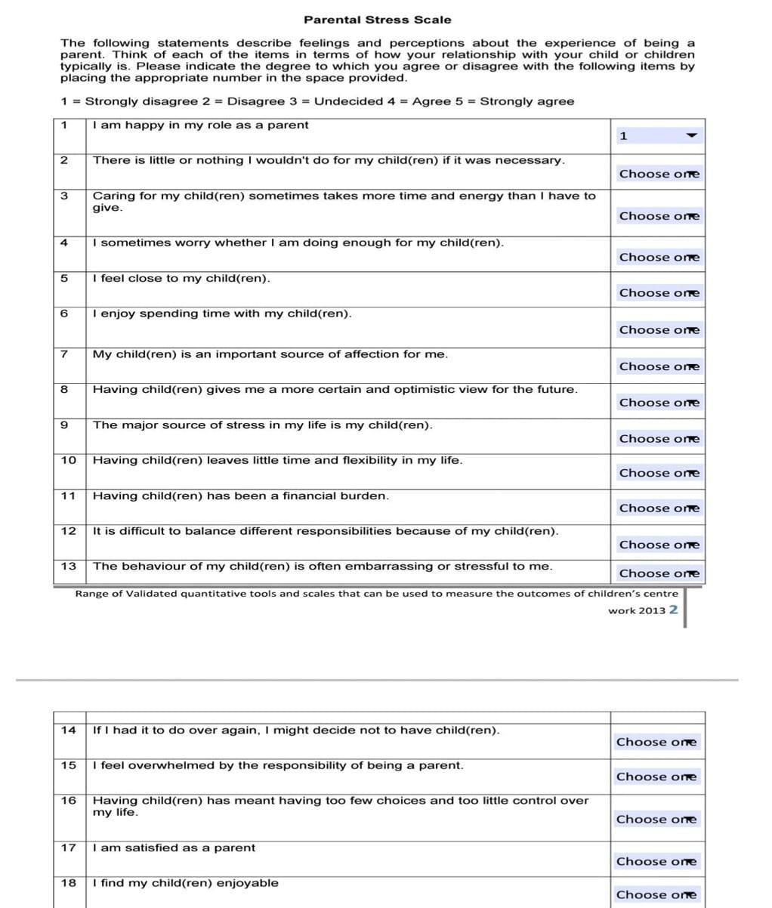
ANNEXURE II

ANNEXURE III
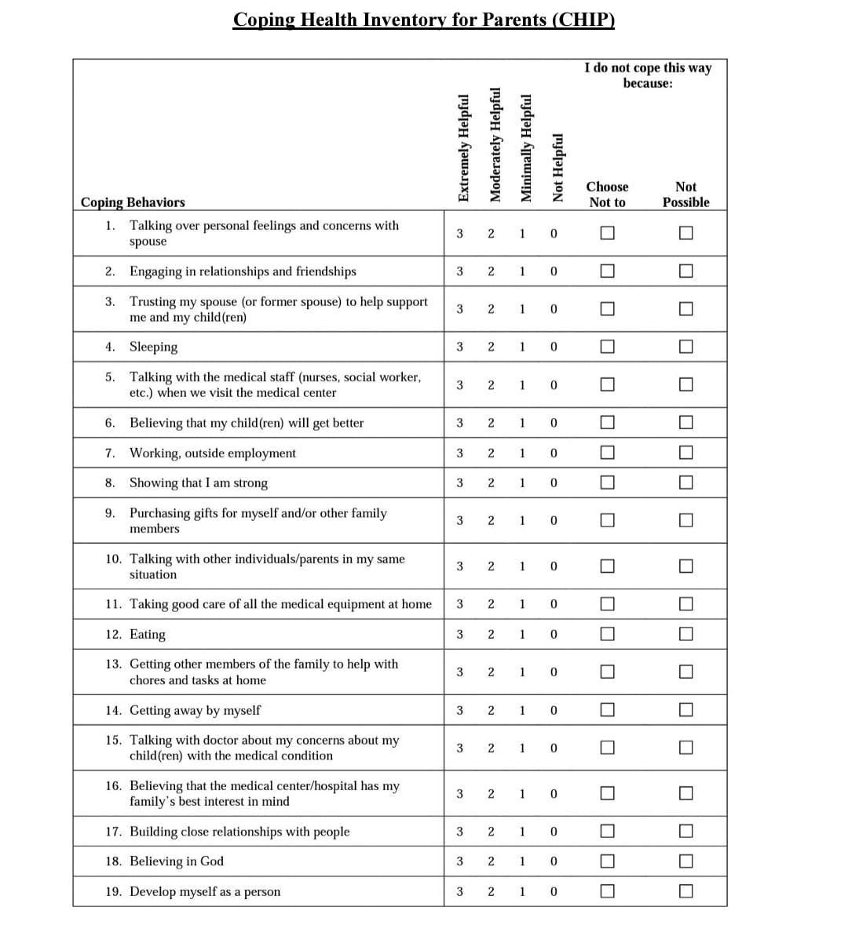
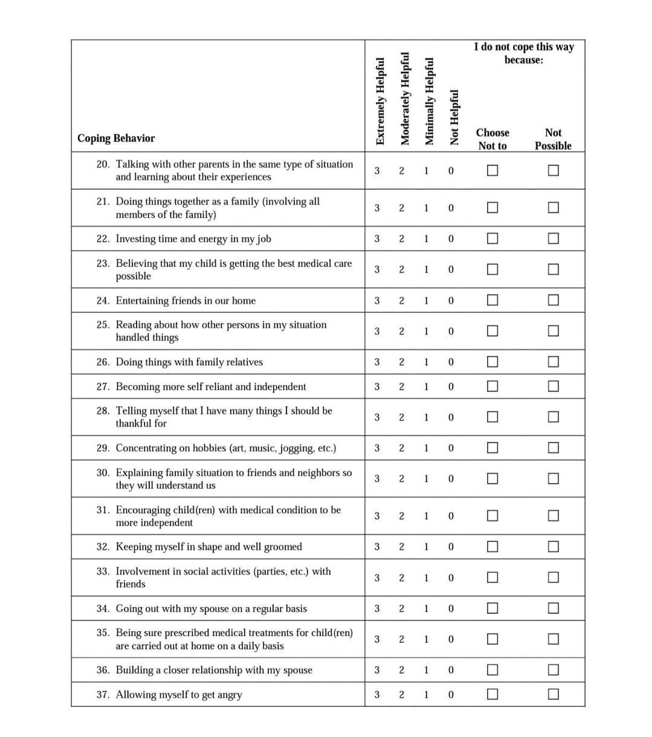
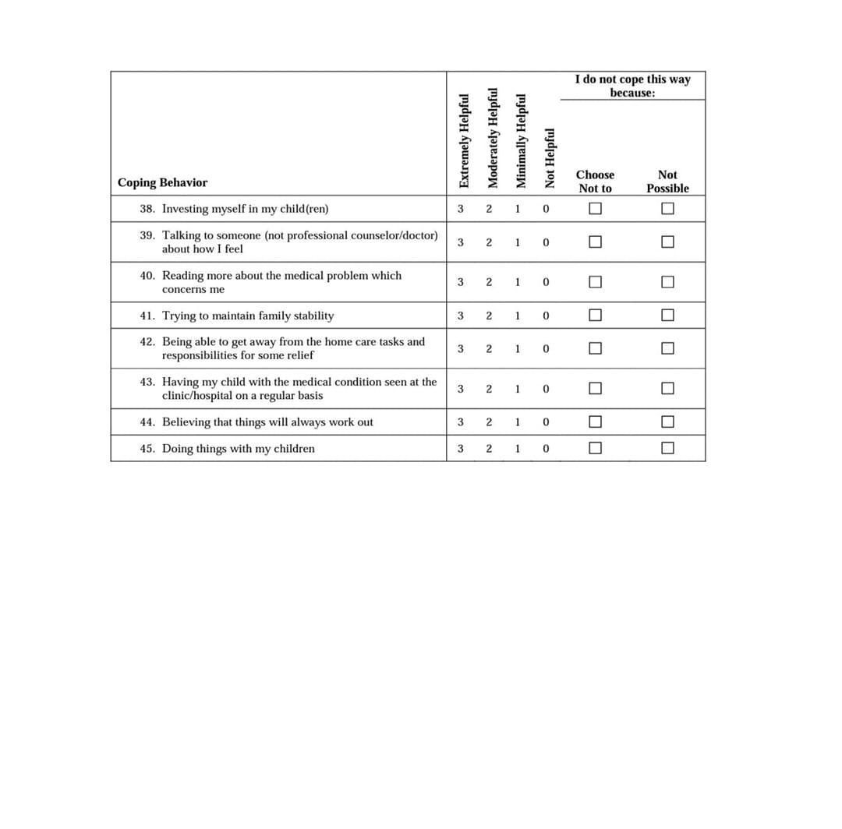
ANNEXURE IV

Interview Guide for the Qualitative Study
Study Title: Parental Stress and Coping Mechanisms in Indian Families of Children with Neurological and Neurodevelopmental Disorders: A Mixed Methods Study
This guide provides a step-by-step procedure for conducting a semi-structured interview with parents of children diagnosed with neurological (e.g., Cerebral Palsy, Epilepsy) and neurodevelopmental disorders (e.g., ASD, ADHD). The objective is to understand parental stress, coping strategies, and family experiences. The interviewer will follow these steps to ensure consistency across interviews. This guide uses polite, inclusive language to create a respectful and comfortable environment for parents to share their experiences. The interviewer should maintain an empathetic and non-judgmental tone throughout the interview.

Step 1: Introduction and Rapport Building
1.1 Welcome and Explanation :
- “Hello [ Name of parent ], thank you so much for taking the time to speak with me today. My name is [ Study Investigator name ], and I’ll be asking you a few questions about your experiences as a parent. Please know that your answers are completely confidential and will only be used to help understand how parents manage the challenges of raising a child with special needs.”
- “Before we begin, everything you share will be anonymous, and no names or details that identify you will be used. I’ll be recording this interview, but the recording won’t be shared outside the research team. You can stop the interview at any time for any reason. There are no right or wrong answers, so feel free to share your honest experiences.”
1.2 Build Rapport :
- “Could you start by telling me a little bit about yourself and your family?”
- “How many children do you have, and how old are they?”

Step 2: Understanding the Child’s Condition and Diagnosis
2.1 Understanding the Child’s Diagnosis :
- “Could you tell me a bit about your child’s condition? When did you first learn about the diagnosis?”
Probe: Who informed you, and what kind of information were you given at that time?
- “How did you feel when you first heard about the diagnosis? What were some of the thoughts that came to your mind?”
2.2 Initial Responses to the Diagnosis :
- “Looking back, how did you and your family adjust after the diagnosis? Were there particular concerns that came up at that time?”

Step 3: Daily Life Challenges and Stress
3.1 Daily Life and Routine :
- “Can you walk me through what a typical day looks like for you in terms of caring for your child?”
- “What are some of the challenges you experience on a daily basis? Is there something you find particularly difficult or stressful?”
Prompt: “For instance, does your child need special care at specific times of the day?”
3.2 Emotional and Physical Stress :
- “How does the responsibility of caring for your child impact your emotional and physical well-being?”
Probe: “Do you find that caring for your child takes a toll on your physical health as well? How do you manage that?”
3.3 Impact on Family Dynamics :
- “How has your child’s condition influenced your relationships with other family members, like your spouse/ partner, other children or extended family?
Probe: “Do you feel your family has grown closer, or have there been tensions because of the extra responsibilities?

Step 4: Coping Mechanisms and Support
4.1 Coping Strategies and Support System:
- “In difficult moments, what helps you manage stress and who do you rely on for support?”
Probe: “Do you have specific activities, routines, or strategies that help you cope? What kind of support do you receive from family, friends, or the community?”
Prompt: “Are there any practices, like meditation, religious activities, or hobbies or others, that you find helpful? Or people like friends, family, neighbors?
- “Have you joined any parent groups or support networks? How has that been for you?”
4.2 Cultural and Religious Influence :
- “Does your cultural or religious background influence how you approach your child’s care?”
Probe: “Are there religious or cultural or other practices that provide comfort or guidance during difficult times?”
Prompt: “Do your beliefs offer a sense of peace or direction when you’re faced with challenges?”

Step 5: Healthcare and Resources
5.1 Access to Healthcare :
- “How would you describe your experience with the healthcare system for your child?
Probe: “Have you encountered any difficulties in accessing the care or services your child needs?”
- “Are you satisfied with the care your child receives? Is there anything you wish the healthcare system would add or do differently?”
5.2 Informational Resources :
- “Do you feel like you have enough information about your child’s condition?”
Prompt: “For example, are there educational resources or guidance from doctors that have helped you understand the condition better?”
5.3 Financial Resources :
- “Has caring for your child had an impact on your family’s finances?”
Probe: “If so, how do you cope with those? Are there resources or programs that help manage the financial strain?”
Prompt: “For example: Have you applied for any government assistance or support programs?”

Step 6: Impact on Family Life
6.1 Impact on Daily Life :
- “How has your child’s condition affected your family’s daily life and routines? Are there things you do differently now than before your child’s diagnosis?”
- “Has your social life changed?”
Prompt: “For example, do you feel like you have less time to see friends or attend family gatherings?”
- “How has your child’s condition affected their siblings? Have there been changes in their behavior, responsibilities, or overall relationship dynamics?”
Prompt: “For example, do the siblings help with caregiving or feel that they receive less attention?”
6.2 Work-Life Balance :
- “Has your child’s condition affected your ability to work or manage other responsibilities? Have you had to make changes to your work schedule or reduce your work hours?”
Probe: “Have you or your partner had to change or reduce your work schedules to accommodate your child’s care?”

Step 7: Closing and Final Thoughts
7.1 Suggestions for Improvement :
- “If you could improve one thing about the way support is provided to families like yours, what would that be? Are there any gaps in healthcare or education that you have noticed?”
7.2 Final Thoughts :
- “Before we finish, is there anything else you would like to share that we haven’t talked about? Any advice you would give to other parents in a similar situation?”
7.3 Thank You :
- “Thank you so much for sharing your experience with me today. Your insights are really valuable. Please rest assured that everything you say is confidential and if you have any questions or would like to stay in touch, please feel free to reach out.”

Additional Considerations:
- Active Listening: Ensure that the interviewer listens attentively, allowing the participant time to reflect and respond without rushing them.
- Probing Questions: Use probes such as, "Could you tell me more about that?" or "Could you be more specific?" when needed to encourage elaboration.
- Inclusivity: Avoid making assumptions about family structure or resources; ask open-ended questions to allow the participant to provide their unique experience.
- Empathy: Always maintain an empathetic tone, especially when discussing sensitive topics like stress, emotional health, or family challenges.
This structured guide ensures that the interview process is respectful, inclusive, and thorough, while giving participants the space to share their experiences at their own pace.

ANNEXURE V

Content Validation Report

Objective
The content validation was conducted to assess the relevance, clarity, and appropriateness of the items in the interview guide for its intended purpose. The Content Validity Index (CVI) was calculated at both the item and scale levels, based on ratings provided by three experts.

S-CVI/Ave (scale-level content validity index based on the average method)
● Relevance= 0.98
● Clarity= 1
● Appropriateness= 1

I-CVI (Item-level content validity index)

Question No. | Relevance | Clarity | Appropriateness
1.1 | 1 | 1 | 1
1.2 | 1 | 1 | 1
2.1 | 1 | 1 | 1
2.2 | 1 | 1 | 1
3.1 | 1 | 1 | 1
3.2 | 1 | 1 | 1
3.3 | 1 | 1 | 1
4.1 | 1 | 1 | 1
4.2 | 1 | 1 | 1
5.1 | 1 | 1 | 1
5.2 | 1 | 1 | 1
5.3 | 1 | 1 | 1
6.1 | 0.67 | 1 | 1
6.2 | 1 | 1 | 1
7.1 | 1 | 1 | 1
7.2 | 1 | 1 | 1
7.3 | 1 | 1 | 1

ANNEXURE VI

Content Validation Form for Translated Interview Guide

Study Title: Parental Stress and Coping Mechanisms in Indian Families of Children with Neurological and Neurodevelopmental Disorders: A Mixed Methods Study

Instructions for Experts:
Please review the following interview questions and rate each item based on its relevance, clarity, and appropriateness. You can also provide comments and suggestions for improving the questions.

Scoring Scoring Scale:
1 = Not relevant/clear/appropriate
2 = Somewhat relevant/clear/appropriate
3 = Relevant/clear/appropriate
4 = Very relevant/clear/appropriate

Question No. | Relevance (1 = Not relevant, 4 = Highly relevant) | Clarity (1 = Not clear, 4 = Very clear) | Appropriateness (1 = Not appropriate , 4 = Very appropriate ) | Comments/ Suggestions
1.1 | 1 2 3 4 | 1 2 3 4 | 1 2 3 4
1.2 | 1 2 3 4 | 1 2 3 4 | 1 2 3 4
2.1 | 1 2 3 4 | 1 2 3 4 | 1 2 3 4
2.2 | 1 2 3 4 | 1 2 3 4 | 1 2 3 4
3.1 | 1 2 3 4 | 1 2 3 4 | 1 2 3 4
3.2 | 1 2 3 4 | 1 2 3 4 | 1 2 3 4
3.3 | 1 2 3 4 | 1 2 3 4 | 1 2 3 4
4.1 | 1 2 3 4 | 1 2 3 4 | 1 2 3 4
4.2 | 1 2 3 4 | 1 2 3 4 | 1 2 3 4
5.1 | 1 2 3 4 | 1 2 3 4 | 1 2 3 4
5.2 | 1 2 3 4 | 1 2 3 4 | 1 2 3 4
5.3 | 1 2 3 4 | 1 2 3 4 | 1 2 3 4
6.1 | 1 2 3 4 | 1 2 3 4 | 1 2 3 4
6.2 | 1 2 3 4 | 1 2 3 4 | 1 2 3 4
7.1 | 1 2 3 4 | 1 2 3 4 | 1 2 3 4
7.2 | 1 2 3 4 | 1 2 3 4 | 1 2 3 4
7.3 | 1 2 3 4 | 1 2 3 4 | 1 2 3 4

Open-Ended Feedback
Are there any areas where the translation feels inaccurate or confusing? Do you recommend alternative phrasing for any questions to improve clarity or appropriateness? Any additional comments or suggestions?

Expert Information:
Expert Name:
Language Reviewed (Hindi/Marathi):
Field of Expertise:
Years of Experience:
Date:

ANNEXURE VII

Language Validation Form for Translated Interview Guide

Study Title: Parental Stress and Coping Mechanisms in Indian Families of Children with Neurological and Neurodevelopmental Disorders: A Mixed Methods Study

Instructions for Experts:
Please review the following interview questions and rate each item based on its relevance, clarity, and appropriateness. You can also provide comments and suggestions for improving the questions.

Scoring Scale:
1 = Poor: Significant inaccuracies or loss of meaning; unclear or confusing; culturally insensitive.
2 = Fair: Captures overall meaning but with noticeable errors; somewhat clear; partially culturally appropriate.
3 = Good: Mostly accurate with minor errors; clear and easy to understand; culturally relevant with slight improvement needed.
4 = Excellent: Fully accurate; concise and well-structured; culturally sensitive and relatable.

Question No. | Accuracy of Translation (1 = Poor, 4 =Excellent) | Clarity of Language (1 = Poor, 4 =Excellent) | Cultural Appropriateness (1 = Poor, 4 =Excellent) | Comments/ Suggestions
1.1 | 1 2 3 4 | 1 2 3 4 | 1 2 3 4
1.2 | 1 2 3 4 | 1 2 3 4 | 1 2 3 4
2.1 | 1 2 3 4 | 1 2 3 4 | 1 2 3 4
2.2 | 1 2 3 4 | 1 2 3 4 | 1 2 3 4
3.1 | 1 2 3 4 | 1 2 3 4 | 1 2 3 4
3.2 | 1 2 3 4 | 1 2 3 4 | 1 2 3 4
3.3 | 1 2 3 4 | 1 2 3 4 | 1 2 3 4
4.1 | 1 2 3 4 | 1 2 3 4 | 1 2 3 4
4.2 | 1 2 3 4 | 1 2 3 4 | 1 2 3 4
5.1 | 1 2 3 4 | 1 2 3 4 | 1 2 3 4
5.2 | 1 2 3 4 | 1 2 3 4 | 1 2 3 4
5.3 | 1 2 3 4 | 1 2 3 4 | 1 2 3 4
6.1 | 1 2 3 4 | 1 2 3 4 | 1 2 3 4
6.2 | 1 2 3 4 | 1 2 3 4 | 1 2 3 4
7.1 | 1 2 3 4 | 1 2 3 4 | 1 2 3 4
7.2 | 1 2 3 4 | 1 2 3 4 | 1 2 3 4
7.3 | 1 2 3 4 | 1 2 3 4 | 1 2 3 4

Open-Ended Feedback
Are there any areas where the translation feels inaccurate or confusing? Do you recommend alternative phrasing for any questions to improve clarity or appropriateness? Any additional comments or suggestions?

Expert Information:
Expert Name:
Language Reviewed (Hindi/Marathi):
Field of Expertise:
Years of Experience:
Date:

