Additional file 5. Supplementary tables and figures
Complementary detail for the scoping review "Metacognition-related education in medical residency"

This appendix contains: (1) three supplementary frequency tables (ST1-ST3) providing the exact counts by medical specialty, study design and country of origin summarised narratively in the main manuscript; and (2) five supplementary figures (S1-S5) visualising temporal distribution, tier stratification and the same frequency distributions.

Supplementary Table ST1. Distribution by medical specialty
Frequency and percentage of the 92 included studies by medical specialty. Categories follow the coding dictionary (Table 1 of the main manuscript).
Specialty | # Studies | %
Internal Medicine | 34 | 37.0%
Pediatrics | 10 | 10.9%
Family Medicine | 8 | 8.7%
Emergency Medicine | 7 | 7.6%
Surgery | 7 | 7.6%
Anesthesiology | 6 | 6.5%
Obstetrics and Gynecology | 5 | 5.4%
Radiology | 4 | 4.3%
Multiple specialties | 3 | 3.3%
Neurology | 2 | 2.2%
Pathology | 1 | 1.1%
Otolaryngology | 1 | 1.1%
Not classifiable | 1 | 1.1%
Geriatrics | 1 | 1.1%
Psychiatry | 1 | 1.1%
Critical Care | 1 | 1.1%

Supplementary Table ST2. Distribution by study design
Frequency and percentage of the 92 included studies by study design (normalised to standard taxonomy per Table 1 coding dictionary; cluster RCTs grouped with RCT).
Study design | # Studies | %
Mixed-methods | 14 | 15.2%
Qualitative | 13 | 14.1%
RCT | 13 | 14.1%
Cross-sectional | 10 | 10.9%
Pre-post (no control) | 9 | 9.8%
Educational innovation report | 6 | 6.5%
Quasi-experimental | 5 | 5.4%
Pilot/feasibility | 4 | 4.3%
Cohort (prospective) | 3 | 3.3%
Cohort (retrospective) | 2 | 2.2%
Experimental (between-groups) | 2 | 2.2%
Case series/report | 2 | 2.2%
Case-control | 2 | 2.2%
Observational | 2 | 2.2%
Descriptive | 2 | 2.2%
Pre-post (with follow-up) | 1 | 1.1%
Experimental within-subject | 1 | 1.1%
Psychometric/validation | 1 | 1.1%

Supplementary Table ST3. Geographic distribution
Frequency and percentage of the 92 included studies by country of origin.
Country | # Studies | %
USA | 51 | 55.4%
Canada | 17 | 18.5%
Netherlands | 6 | 6.5%
France | 4 | 4.3%
UK | 4 | 4.3%
Denmark | 2 | 2.2%
Singapore | 1 | 1.1%
South Korea | 1 | 1.1%
China | 1 | 1.1%
Germany | 1 | 1.1%
Philippines | 1 | 1.1%
Australia | 1 | 1.1%
Ireland | 1 | 1.1%
India | 1 | 1.1%

Supplementary Figure S1. Temporal distribution of included studies
Number of included studies by year of publication (n = 92).
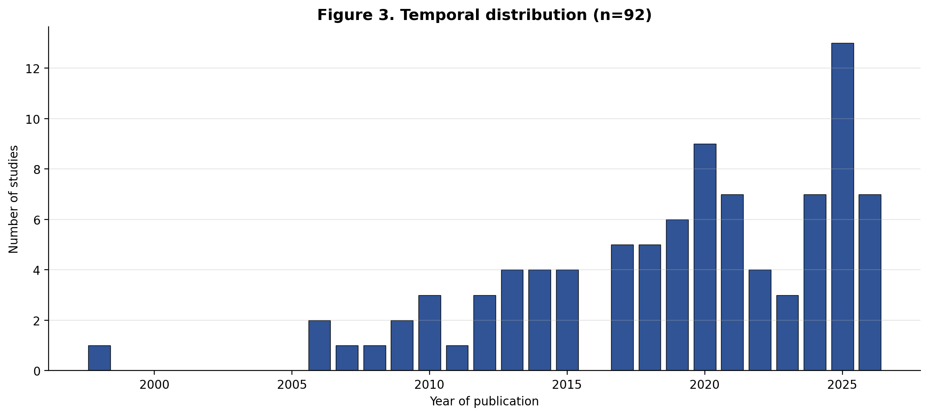

Supplementary Figure S2. Tier stratification
Distribution of included studies by inclusion tier: Tier 1 = at least one core metacognitive concept present; Tier 2 = no core concept but multiple (>=3) adjacent concepts present.
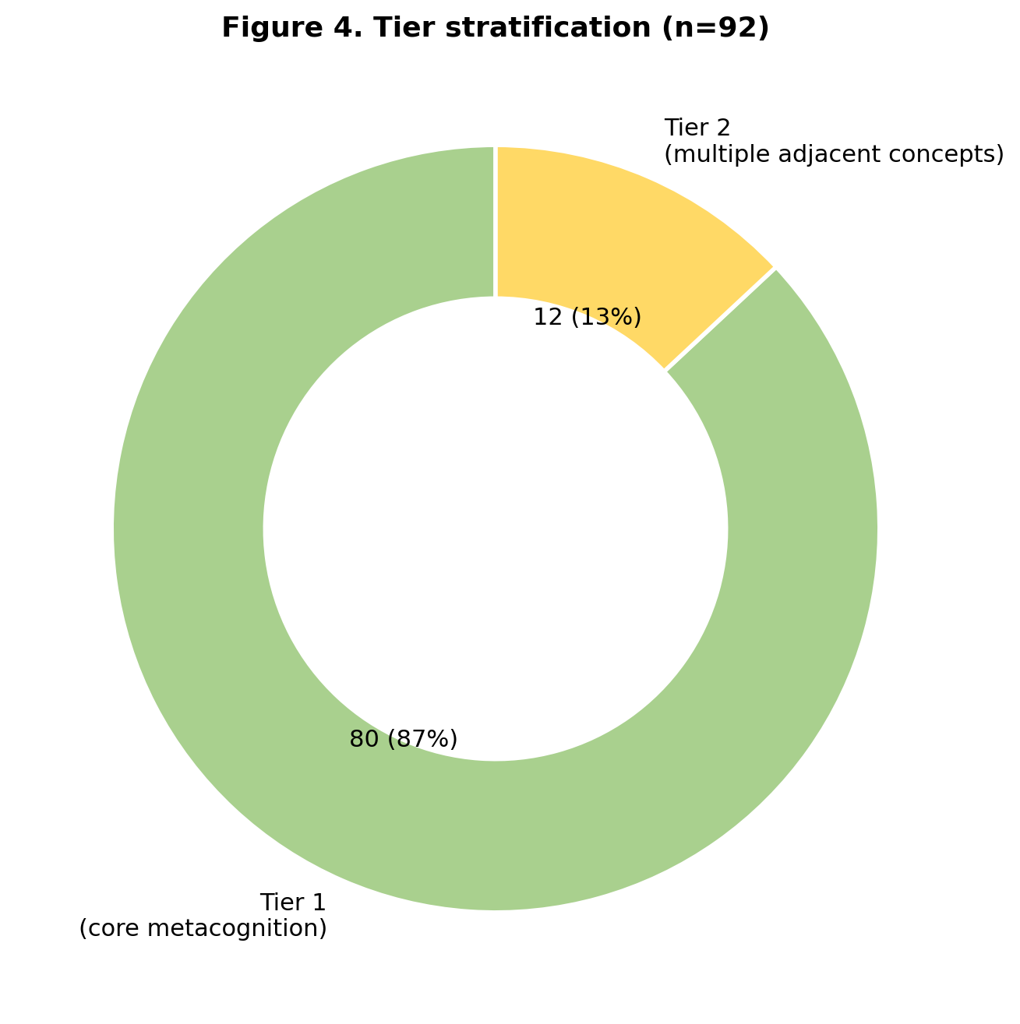

Supplementary Figure S3. Distribution by medical specialty
Visualisation of Supplementary Table ST1.
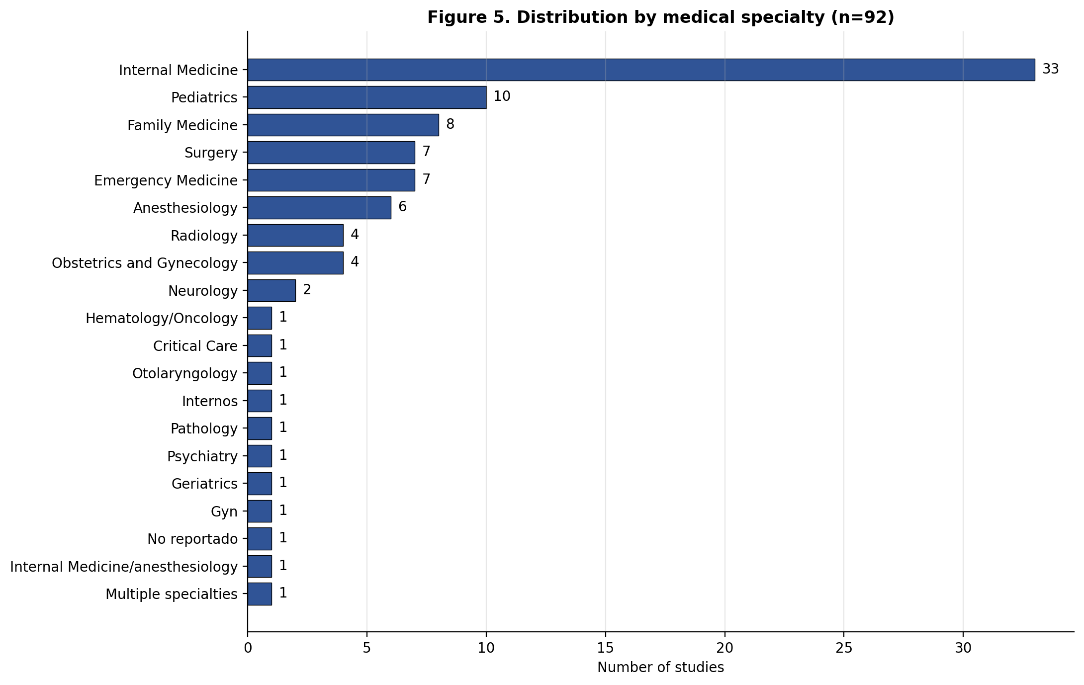

Supplementary Figure S4. Distribution by study design
Visualisation of Supplementary Table ST2. RCT includes cluster RCTs.
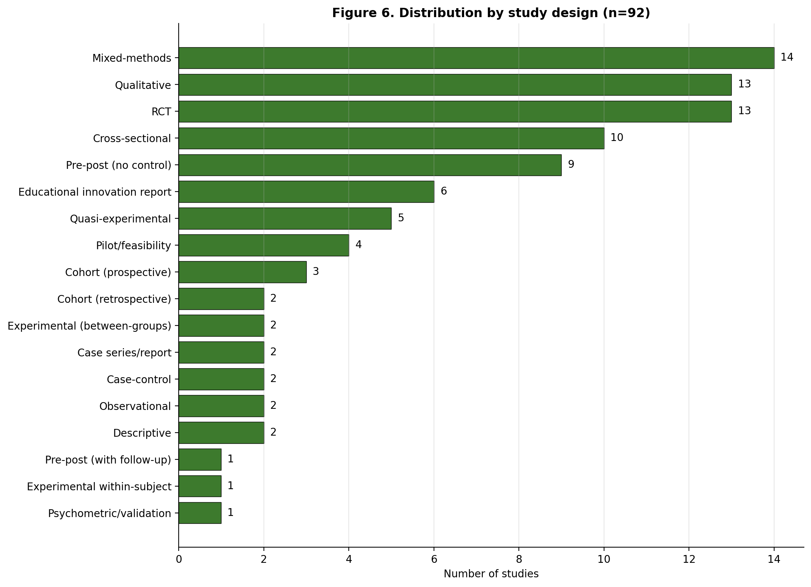

Supplementary Figure S5. Geographic distribution
Visualisation of Supplementary Table ST3.
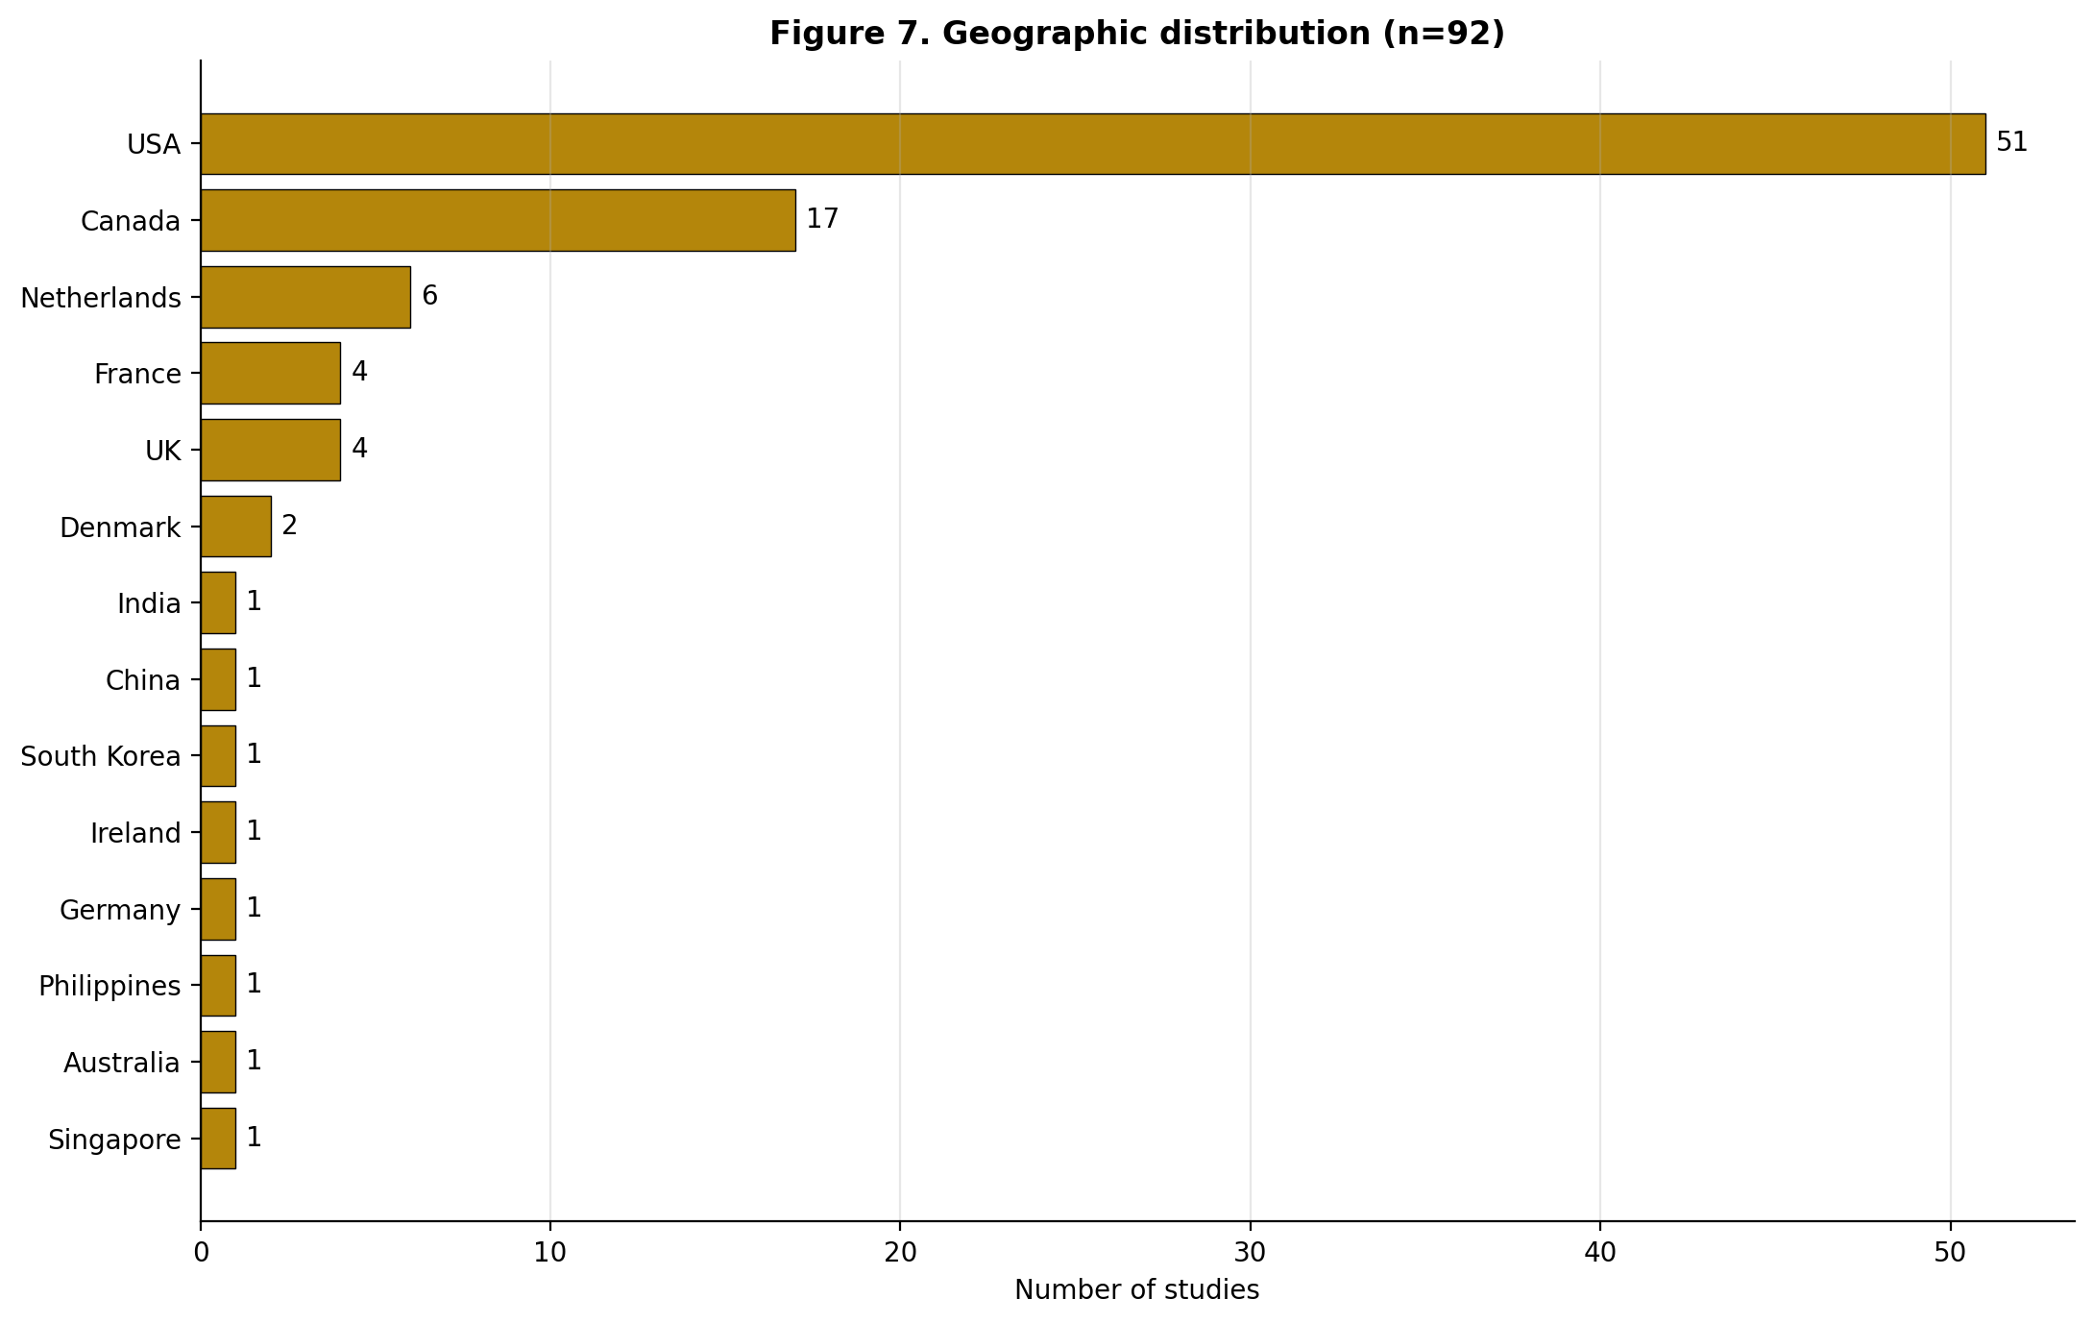

— End of Additional file 5 —

