Supplementary material 1: Digital Twin
API Data Structure
The World Triathlon API (v1) returns race results at /v1/programs/{prog_id}/results. The top-level results field is a dictionary (dict) with keys results (list of athlete records), headers (column metadata), and pagination fields. Each athlete record contains splits as an ordered five-element list in [swim, T1, bike, T2, run] sequence.

WBGT Race Window

WBGT was computed as the means of hourly estimates within a 3-hour window from scheduled programme start. Where start times were not recorded in the API (~12% of events), a default of 07:00 UTC was used, consistent with the prevalent morning start slot at championship events.
Power Analysis for Individual Slope Estimation

Minimum criteria of ≥3 races spanning ≥3°C WBGT balance statistical power against athlete inclusion rates. At n=3 with a true slope of −0.05 z·°C⁻¹, approximate power at α=0.05 is ~15%; at n=5 it reaches ~25%; at n=10 it exceeds 60%. These thresholds identify athletes with detectable slopes while maximising the qualifying pool (380 men / 260 women). A full Bayesian hierarchical model pooling information across athletes would provide better-calibrated individual estimates and is recommended for confirmatory analyses.
Digital Twin Feature Construction
Historical features (z_swim_hist, z_bike_hist, z_run_hist, z_total_hist) were constructed using a strictly expanding window (shift-1 lag) to prevent data leakage. Missing historical features were imputed to 0.0 (population mean z-score — the correct Bayesian prior for unknown history). This preserves the full competitive field including debut athletes.
WBGT Backfill Procedure
After initial WBGT reconstruction (covering 50/339 races), a systematic backfill was performed using run_wbgt_backfill.py, fetching Open-Meteo historical data for all races with available latitude/longitude/date information. Final coverage: 301/339 races (88.8%). The 38 remaining races lacked reliable coordinate data or fell outside the Open-Meteo archive range.
Model outputs were deployed as an interactive digital twin web application within the Claude Cowork environment (Sonnet 4.6 and 5, Opus 4.8, Anthropic, 2026). The application enables athlete-specific race-day prediction and strategic planning via the following integrated modules:
Split-time z-score conversion. Users may enter historical split times in HH:MM:SS, MM:SS, or decimal-seconds format. Times are converted to within-population z-scores using sex-stratified population norms derived from the 10-year dataset (men: swim 18:30 ± 1:25; bike 54:45 ± 1:55; run 30:45 ± 1:30; women: swim 20:30 ± 1:40; bike 62:00 ± 2:25; run 36:00 ± 1:45). A toggle allows entry in either time or direct z-score mode.
Composite podium probability. A three-discipline composite z-score is computed as a weighted sum of swim, bike, and run z-scores using empirically derived OLS regression coefficients, normalised for inter-discipline correlations (r = 0.35):
z_comp = (w_s*z_s + w_b*z_b + w_r*z_r) / sqrt(w_s^2 + w_b^2 + w_r^2 + 2r(w_s*w_b + w_s*w_r + w_b*w_r))
where w_s / w_b / w_r are empirical discipline weights (men: 0.107/0.456/0.434; women: 0.099/0.479/0.419) and z_r is the heat-adjusted run z-score prediction. This replaces the prior time-fraction weighting assumption with data-driven weights. Podium probability (top-3) is computed as:
(podium) = Φ( (θ_3 − z_comp) / σ_f )
where θ_3 is the podium threshold z-score (men: −1.60; women: −1.50) derived from historical finish distributions, and σ_f = 0.75 represents field-to-field variability. Results are displayed as SVG semicircle dial gauges with square-root scaling (See Figure 1).
WBGT risk forecast table. Given an athlete’s heat-tolerance slope and the projected venue WBGT, the application renders a table forecasting run z-score, finish percentile, and time penalty at each heat risk level, with the current venue category highlighted.
Athletes enter historical split times or z-scores for swim, bike, and run. The tool computes a composite podium probability using a time-weighted combination of all three-discipline z-scores, normalised for inter-discipline correlation, and displays results as SVG semicircle dial gauges. A WBGT risk forecast table shows athlete-specific predicted run z-score, finish percentile, and pace adjustment at each World Triathlon Heat Stress flag level (Green/Blue/Orange/Red/Black).
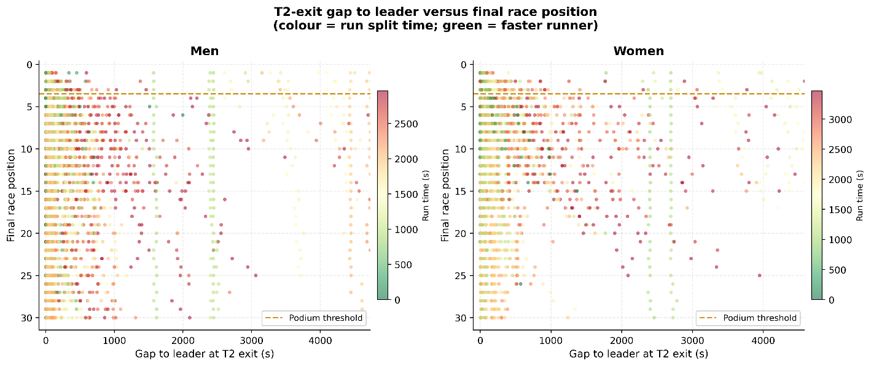
Figure 1. T2 exit gap to leader vs final finishing position, colored by running split time. Athletes with small T2 gaps and fast run splits cluster at top positions. Athletes entering the run >60 s behind rarely reach podium confirming pre-run position as a necessary but not sufficient condition for championship success.

Automated Monthly Model Update
To ensure model coefficients remain current, a scheduled pipeline executes on the 1st of each month (cron: 0 8 1 * *). On each execution the pipeline: (i) queries the World Triathlon API for events completed since the previous update; (ii) appends validated records to the master dataset; (iii) re-estimates population norms; (iv) re-fits the heat model and digital twin; and (v) injects updated constants into the deployed artifact. An update log records new records added, coefficient drift, and execution date.
All analyses were implemented in Python 3.11 using pandas 2.x, numpy 1.26, statsmodels 0.14, xgboost 3.2, and matplotlib 3.8. The pipeline is structured as five sequential phases and is fully reproducible from raw API responses. All code, data schema documentation, and the digital twin web application are available at https://github.com/drmarcocardinale-hub/Olympic-Triathlon-
The digital twin can be directly accessed at: https://drmarcocardinale-hub.github.io/Olympic-Triathlon-/triathlon_twin_artifact.html

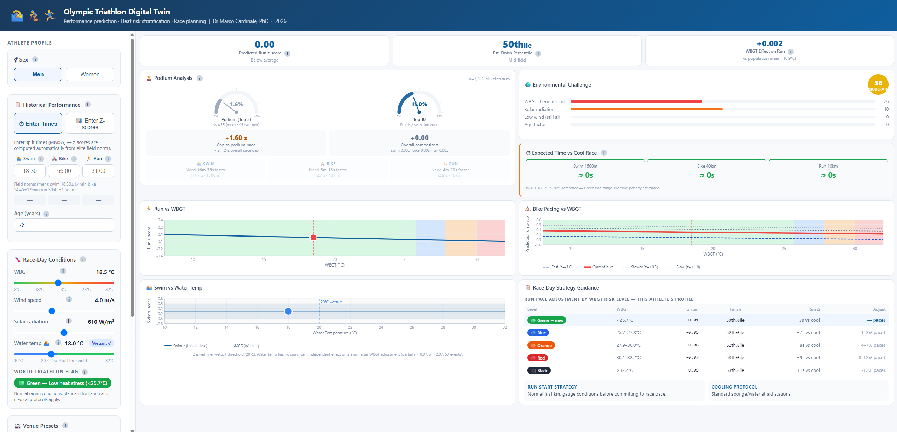

Figure 2. The online Digital Twin as it can be addressed from the repository.

