Biochemical signatures in growth hormone deficiency: a pilot study using metabolomics approaches by direct infusion-mass spectrometry

Breno Sena De San-Martin^{1†}, Vinícius Guimarães Ferreira^{2,5†}, Mariana Rechia Bitencourt³, Paulo Cesar Gonçalves Pereira³, Danielle Zildeana Sousa Furtado¹, Rodolfo Guimarães Ferreira⁶, Emanuel Carrilho^{2,5}, Luciani Renata Silveira Carvalho^{3*}, Nilson Antônio Assunção^{1,4*}

¹ Escola Paulista de Medicina, Universidade Federal de São Paulo, CEP 04039-032, São Paulo, SP, Brazil.
² Instituto de Química de São Carlos, Universidade de São Paulo, CEP 13566-590, São Carlos, SP, Brazil.
³ Unidade de Endocrinologia do Desenvolvimento, Laboratório de Hormônios e Genética Molecular LIM42, Faculdade de Medicina da Universidade de São Paulo (FMUSP), CEP 01246-000, São Paulo, SP, Brazil.
⁴ Departamento de Química, Instituto de Ciências Ambientais, Químicas e Farmacêuticas, Universidade Federal de São Paulo, CEP 09972-270, Diadema, SP, Brazil
⁵ Instituto Nacional de Ciência e Tecnologia de Bioanalítica – INCTBio, CEP 13083-970, Campinas, SP, Brazil.
⁶ TCL Soluções, CEP 14.027-250, Ribeirão Preto, SP, Brazil.

† These authors contributed equally to this work.

* Corresponding Authors:
Nilson Assunção. Address: Rua Pedro de Toledo, 781, 15º andar, Laboratório de Espectrometria de Massas Aplicadas a Biomoléculas, CEP 04039-032, São Paulo, SP, Brazil. Phone number: +55 11 55764821. E-mail: nilson.assuncao@unifesp.br

Luciani Renata Silveira de Carvalho. Address: Av. Dr. Enéas de Carvalho Aguiar, 155, 2º andar, bloco 6, CEP 05403-000, São Paulo, SP, Brazil. Phone number: +55 11 2661 7512. E-mail: luciani.carvalho@hc.fm.usp.br

Supplementary material
Table S1: Putative annotation of significative important metabolites for metabolomics approach.
GDHon vs. GHDoff
m/z | VIP | CI 95% | AUC | P-value | Name | Formula | Adduct/Ion | ppm | GHDoff | GHDon | Database ID
58.3731 | 4.6604 | 0.604-0.941 | 0.71 | 2.66E-03 | L-argininium (1+) | C6H15N4O2 | [M+3H]+ | 1 | High | Low | HMDB0062762
58.3726 | 3.371 | 0.658-0865 | 0.70 | 5.55E-03 | L-Capreomycidine | C6H12N4O2 | [M+3H]3+ | 0 | Low | High | 72278
58.3342 | 2.6298 | 0.495-0.856 | 0.69 | 1.60E-02 | Thiodiacetic acid | C4H6O4S | [M+2H+Na]+ | 1 | High | Low | HMDB0042032
74.6774 | 2.7238 | 0.682-0.949 | 0.65 | 1.95E-02 | N-Formylmethionine | C6H11NO3S | [M+2Na+H]3+ | 2 | High | Low | 4233
95.1319 | 2.7182 | 0.658-0.961 | 0.66 | 2.21E-02 | Tyrosylglycine | C11H14N2O4 | [M+H+2Na]+ | 5 | High | Low | HMDB0028853
118.0895 | 4.5899 | 0.586-0.902 | 0.64 | 2.28E-02 | Iodotyrosine | C9H10INO3 | [M+H+2Na]+ | 2 | High | Low | HMDB0000021
404.3406 | 3.5192 | 0.617-0.913 | 0.58 | 2.76E-02 | Dodecanoylcarnitine | C19H37NO4 | [M+H]+ | 5 | Low | High | HMDB0002250
109.0389 | 2.1054 | 0.580-0.869 | 0.62 | 3.32E-02 | Dimethylurea | C3H8N2O | [M+Na-2H]- | 5 | High | Low | HMDB0029198;  4228;
404.3375 | 2.895 | 0.689-0.961 | 0.58 | 3.64E-02 | Tetradecanoylcarnitine | C21H41NO4 | [M+CH3OH+H]+ | 1 | Low | High | HMDB0005066
74.5522 | 2.4719 | 0.478-0.854 | 0.68 | 3.72E-02 | 2-amino-6-hydroxyhexanoic acid | C6H10O3 | [M+2H]+ | 2 | High | Low | HMDB0142963
404.3783 | 3.4241 | 0.623-0.904 | 0.73 | 4.31E-02 | TG (16:0/16:0/16:0) | C51H98O6 | [M+2H]+ | 5 | High | Low | HMDB0005356
404.3345 | 2.6046 | 0.623-0.907 | 0.58 | 4.40E-02 | trans-Hexadec-2-enoyl carnitine | C23H43NO4 | [M+2Na+H]3+ | 1 | High | Low | C23H43NO4
86.9988 | 2.6603 | 0.635-0.949 | 0.60 | 4.50E-02 | Citric acid | C6H8O7 | [M+3Na]+ | 5 | High | Low | HMDB0000094;  124;
102.9997 | 3.4984 | 0.489-0.852 | 0.67 | 4.76E-02 | [(3-methylbut-2-en-1-yl) oxy] sulfonic acid | C5H10O4S | [M+H+K]+ | 5 | High | Low | HMDB0136691
102.9764 | 4.9944 | 0.658-0.941 | 0.69 | NA | Glyoxal | C2H2O2 | [M+2Na-H]+ | 2 | High | Low | 70070
251.9795 | 2.6789 | 0.620-0.957 | 0.67 | NA | Guanidinosuccinic acid | C5H9N3O4 | [M+2K-H]+ | 5 | Low | High | HMDB0003157
155.0065 | 2.106 | 0.527-0.879 | 0.56 | NA | (S)-Ureidoglycolic acid | C3H6N2O4 | M+Na-2H]- | 5 | High | Low | HMDB0001005
404.3537 | 2.0469 | 0.609-0.897 | 0.65 | NA | N-(5Z,8Z,11Z,14Z-tetracosatetraenoyl) -ethanolamine | C26H45NO2 | [M+H]+ | 3 | Low | High | 36754
72.1239 | 2.0313 | 0.547-0.902 | 0.65 | NA | Pyridoxine | C8H11NO3 | [M+H+2Na]+ | 4 | High | Low | HMDB0000239
311.9364 | 1.944 | 0.532-0.879 | 0.64 | NA | TG (18:1(9Z)/20:2n6/20:1(11Z)) | C61H110O6 | [M-3H]- | 1 | High | Low | HMDB0050042;  37356;
118.0157 | 1.8024 | 0.638-0.928 | 0.57 | NA | Glutaminylglutamic acid | C10H17N3O6 | [M+H+2K]+ | 5 | High | Low | HMDB0028796
118.4204 | 1.7715 | 0.602-0.911 | 0.55 | NA | Docosapentaenoic acid (22n-3) | C22H34O2 | [M+2H+Na]+ | 4 | High | Low | HMDB0006528;  194;
GHDon vs. Healthy Controls
m/z | VIP | CI 95% | AUC | P-value | Name | Formula | Adduct/Ion | ppm | Healthy | GHDon | Database ID
242.1812 | 2.5888 | 0.495-0.901 | 0.70 | 4.91E-03 | 2-Hydroxylauroylcarnitine | C19H37NO5 | [M+2Na]+ | 5 | Low | High | HMDB0013164
242.1072 | 2.4192 | 0.531-0.917 | 0.72 | 9.61E-03 | Cysteinyl-Arginine | C9H19N5O3S | [M+H-2H2O]+ | 4 | Low | High | HMDB0028769;  85621;
95.0475 | 2.4106 | 0.416-0.856 | 0.64 | 9.71E-03 | L-Glutamic acid | C5H9NO4 | [M+2H]+ | 4 | Low | High | HMDB0011173
95.052 | 2.3112 | 0.431-0.678 | 0.63 | 1.36E-02 | cyclo(Leucyl-phenylalanyl) | C15H20N2O2 | [M+2H+Na]+ | 1 | Low | High | HMDB0094673
242.1798 | 2.3104 | 0.41-0.867 | 0.63 | 1.49E-02 | Phophatidylethanolamine(16:1) | C39H76NO7P | [M+2H+Na]+ | 0 | High | Low | HMDB0008952
354.9366 | 2.1236 | 0.547-0.904 | 0.72 | 2.54E-02 | Deoxyribose triphosphate | C5H13O13P3 | [M-H2O-H]- | 1 | Low | High | 69447
162.0643 | 1.8045 | 0.682-0.949 | 0.84 | 2.61E-02 | Histidinal | C6H9N3O | [M+Na]+ | 3 | High | Low | HMDB0012234;  300;
199.1298 | 2.1302 | 0.546-0.898 | 0.73 | 2.63E-02 | Tetracosapentaenoic acid (24:5n-6) | C24H38O2 | [M+H+K]+ | 5 | Low | High | HMDB0006322
180.0057 | 1.7908 | 0.658-0.961 | 0.83 | 2.74E-02 | 2-Aminomuconic acid semialdehyde | C6H7NO3 | [M+K]+ | 0 | Low | High | HMDB0001280;  3248;
68.7188 | 2.0056 | 0.671-0.969 | 0.86 | 2.75E-02 | Labienoxime | C13H23NO | [M-3H]- | 1 | High | Low | HMDB0036031;  91209;
180.0769 | 1.7833 | 0.649-0.949 | 0.83 | 2.85E-02 | 2-Phenylaminoadenosine | C16H18N6O4 | [M+2H]+ | 1 | Low | High | HMDB0001069
95.0496 | 2.0698 | 0.469-0.870 | 0.66 | 2.87E-02 | Phenol | C6H6O | [M+H]+ | 0 | Low | High | 128
108.9937 | 2.0352 | 0.689-0.961 | 0.86 | 2.99E-02 | Oxalic acid | C2H2O4 | [M+F]- | 0 | Low | High | 113
242.1014 | 1.7679 | 0.657-0.954 | 0.84 | 3.20E-02 | Fumarycarnitine | C11H17NO6 | [M+H-H2O]+ | 5 | Low | High | HMDB0013134
242.1143 | 2.0462 | 0.480-0.893 | 0.67 | 3.25E-02 | N-(gamma-L-Glutamyl)amino-D-proline | C10H17N3O5 | [M+H-H2O]+ | 1 | High | Low | HMDB0038516
298.0087 | 2.0242 | 0.554-0.878 | 0.67 | 3.29E-02 | Glucosamine 6-phosphate | C6H14NO8P | [M+K]+ | 1 | Low | High | HMDB0001254
180.0833 | 1.7338 | 0.636-0.954 | 0.83 | 3.38E-02 | 4-oxo-Retinoic acid | C20H26O3 | [M+2Na]+ | 0 | Low | High | HMDB0006285
180.0066 | 1.7545 | 0.620-0.957 | 0.83 | 3.39E-02 | Homocysteine | C4H9NO2S | [M+2Na-H]+ | 0 | Low | High | HMDB0000742;  3526;
274.2834 | 1.8817 | 0.684-0.954 | 0.85 | 3.40E-02 | Phosphatidylethanolamine(18:2/22:5) | C45H78NO7P | [M+H+2Na]+ | 0 | Low | High | HMDB0011425
180.0623 | 1.8354 | 0.686-0.961 | 0.85 | 3.58E-02 | 2-Oxovaleric acid | C5H8O3 | [M+ACN+Na]+ | 4 | High | Low | HMDB0001865
80.0366 | 1.718 | 0.626-0.945 | 0.83 | 3.62E-02 | 2-Isopropylmaleate | C7H10O4 | [M+2H]2+ | 1 | Low | High | 3279
97.7199 | 2.2048 | 0.673-0.966 | 0.86 | 3.74E-02 | S-Farnesyl Thioacetic Acid | C17H28O2S | [M-3H]3- | 1 | Low | High | 43440
298.0068 | 1.9887 | 0.441-0.856 | 0.62 | 3.77E-02 | Methyl glucosinolate | C8H15NO9S2 | [M+H-2H2O]+ | 2 | Low | High | HMDB0038429
80.0358 | 1.6975 | 0.615-0.954 | 0.83 | 3.95E-02 | Biopterin | C9H11N5O3 | [M+3H]3+ | 2 | Low | High | 247
305.0638 | 1.7104 | 0.677-0.972 | 0.87 | 3.98E-02 | Glycerophosphoglycerol | C6H15O8P | [M+Na-2H]- | 2 | Low | High | HMDB0240316
274.2731 | 1.8473 | 0.570-0.903 | 0.80 | 4.01E-02 | Diphosphoinositol tetrakisphosphate | C6H20O30P8 | [M+3H]+ | 4 | Low | High | HMDB0006230
95.0503 | 1.9389 | 0.476-0.856 | 0.68 | 4.34E-02 | 3-Oxohexanoic acid | C6H10O3 | [M+H-2H2O]+ | 0 | High | Low | HMDB0010717
180.0632 | 1.6624 | 0.559-0.954 | 0.83 | 4.37E-02 | N-Acetylproline | C7H11NO3 | [M+Na]+ | 0 | Low | High | HMDB0094701
242.1612 | 1.6992 | 0.653-0.949 | 0.84 | 4.44E-02 | 3-O-Sulfogalactosylceramide (d18:1/12:0) | C36H69NO11S | [M+3H]+ | 4 | High | Low | HMDB0012311
77.0176 | 3.0822 | 0.640-0.939 | 0.82 | 4.48E-02 | threo-(Homo)3-isocitrate | C9H14O7 | [M-3H]3- | 2 | High | Low | HMDB0003518
397.13 | 3.3895 | 0.671-0.976 | 0.86 | 4.58E-02 | S-Adenosylmethionine | C15H23N6O5S | [M-H]- | 1 | High | Low | HMDB0001185;
81.6543 | 1.6792 | 0.751-0.964 | 0.86 | 4.64E-02 | [(3-methylbut-2-en-1-yl) oxy] sulfonic acid | C5H10O4S | [M+H+2K]+ | 3 | Low | High | HMDB0136691
242.1086 | 1.9328 | 0.508-0.860 | 0.68 | 4.75E-02 | Trypanothione | C27H49N9O10S2 | [M+3H]+ | 1 | High | Low | HMDB0060520
108.9189 | 2.2641 | 0.615-0.949 | 0.82 | 4.78E-02 | Methylselenic acid | CH4O2Se | [M-H20-H]- | 3 | Low | High | HMDB0060489;  72663;
180.0422 | 1.6569 | 0.635-0.949 | 0.83 | 4.79E-02 | Glycerylphosphorylethanolamine | C5H14NO6P | [M+H-2H2O]+ | 0 | Low | High | 5151
298.0184 | 1.9038 | 0.489-0.845 | 0.57 | 4.96E-02 | UDP-L-rhamnose | C15H24N2O16P2 | [M+2Na]+ | 3 | Low | High | HMDB0012305
GHDoff vs. Healthy controls
m/z | VIP | CI 95% | AUC | P-value | Name | Formula | Adduct/Ion | ppm | Healthy | GHDoff | Database ID
92.974 | 2.0596 | 0.591-0.911 | 0.74 | 2.18E-02 | Formylphosphonate | CH3O4P | [M+H-H2O]+ | 3 | Low | High | 63591
102.9761 | 1.7514 | 0.590-0.916 | 0.73 | 1.15E-02 | Oxalaldehyde | C2H2O2 | [M+2Na-H]+ | 5 | High | Low | 70070
129.0511 | 1.6529 | 0.603-0.910 | 0.73 | 9.95E-03 | (2Z) -2-(phenylmethylidene)heptanoic acid | C14H18O2 | [M+H+K]+ | 4 | High | Low | HMDB0133155
162.0136 | 1.8247 | 0.611-0.907 | 0.75 | 1.01E-02 | L-Aspartate-semialdehyde | C14H18O2 | M+2Na-H | 0 | High | Low | HMDB0012249;  3244;
162.0153 | 1.833 | 0.541-0.869 | 0.70 | 3.48E-02 | 6-Hydroxynicotinic acid | C6H5NO3 | [M+Na]+ | 5 | High | Low | HMDB0002658;  64950;
162.0496 | 1.6722 | 0.598-0.910 | 0.73 | 9.32E-03 | 5-Aminopentanoic acid | C5H11NO2 | [M+2Na-H]+ | 3 | High | Low | HMDB0000883
162.0557 | 2.059 | 0.585--0910 | 0.74 | 1.80E-02 | Hippuric acid | C9H9NO3 | [M+H-H2O]+ | 1 | Low | High | HMDB0000714;  6902;
162.0643 | 2.1709 | 0.611-0.934 | 0.75 | 6.82E-03 | Histidinal | C6H9N3O | [M+Na]+ | 3 | Low | High | HMDB0012234
180.0623 | 1.8045 | 0.614-0.910 | 0.75 | 5.20E-03 | Tiglylglycine | C7H11NO3 | [M+Na]+ | 5 | High | Low | HMDB0000959
180.0825 | 1.5974 | 0.649-0933 | 0.78 | 1.80E-03 | 4-Oxo-13-cis-retinoate | C20H26O3 | [M+2Na]+ | 5 | High | Low | HMDB0012789
199.1 | 4.5674 | 0.463-0.832 | 0.69 | NS | LysoPI(16:0/0:0) | C25H49O12P | [M+2H+Na]+ | 0 | High | Low | HMDB0061695;  46744;
199.1011 | 5.6246 | 0.548-0.948 | 0.73 | 1.23E-02 | PI (18:3(6Z,9Z,12Z)/0:0) | C27H47O12P | [M+3H]3+ | 1 | Low | High | 81181
199.1021 | 4.7376 | 0.527-904 | 0.74 | 9.77E-03 | 15-Keto-prostaglandin F2a | C20H32O5 | [M+2Na]+ | 2 | Low | High | HMDB0004240;  36104;
199.1297 | 1.803 | 0.616-0910 | 0.75 | 7.14E-03 | Tetracosapentaenoic acid (24:5n-3) | C24H38O2 | [M+H+K]+ | 4 | High | Low | HMDB0006323
199.1383 | 4.5707 | 0.490-0.833 | 0.68 | 4.23E-02 | 3b-Hydroxy-5-cholenoic acid | C24H38O3 | [M+H+Na]+ | 5 | Low | High | HMDB0000308
199.1818 | 1.6313 | 0.596-0.919 | 0.75 | 3.10E-02 | Diacylglycerol(34:1) | C37H70O5 | [M+3H]3+ | 2 | High | Low | HMDB0056065
199.186 | 1.5017 | 0.609-0.921 | 0.74 | 1.83E-02 | Cholest-5-en-3b-yl (9Z-tetradecenoic acid) | C41H70O2 | [M+3H]3+ | 2 | High | Low | HMDB0062458
251.0227 | 1.8389 | 0.615-0.907 | 0.75 | 1.40E-02 | 5-Sulfosalicylic acid | C7H6O6S | [M+CH3OH+H]+ | 3 | High | Low | HMDB0011725
251.0302 | 1.6338 | 0.600-0.917 | 0.75 | 6.77E-03 | L-Arginine | C6H14N4O2 | [M+2K-H]+ | 2 | Low | High | HMDB0000517
251.0332 | 1.761 | 0.589-0.911 | 0.75 | 9.99E-03 | 3-Sulfopyruvic acid | C3H4O6S | [M+2ACN+H]+ | 0 | Low | High | HMDB0004045
251.0362 | 1.8834 | 0.551-0-901 | 0.71 | 2.77E-02 | Taurine | C2H7NO3S | [2M+H]+ | 2 | High | Low | HMDB0000251
251.9795 | 2.0179 | 0.656-0.943 | 0.79 | 1.53E-03 | Guanidinosuccinic acid | C5H9N3O4 | [M+2K-H]+ | 5 | High | Low | HMDB0003157
267.1318 | 1.6327 | 0.623-0.920 | 0.77 | 4.23E-03 | L-Canaline | C4H10N2O3 | [2M-H]- | 2 | High | Low | HMDB0012251
269.2038 | 1.9263 | 0.547-0.919 | 0.75 | 5.99E-03 | PG (16:0/22:1(11Z)) | C44H85O10P | [M+3H]3+ | 1 | Low | High | 79024
343.9345 | 1.5311 | 0.656-0.941 | 0.78 | 1.03E-03 | Triacylglycerol (64:12) | C67H106O6 | [M+2H+Na]+ | 1 | Low | High | HMDB0053620
351.1595 | 1.61117 | 0.609-0.947 | 0.76 | 2.12E-03 | Ethyl cinnamate | C11H12O2 | [2M-H]- | 2 | Low | High | HMDB33834
366.295 | 1.5313 | 0.655-0.933 | 0.78 | 2.17E-03 | 15-Keto-prostaglandin F2a | C22H39NO5 | [M+H-2H2O]+ | 0 | High | Low | 45960
367.1362 | 5.1641 | 0.657-0.913 | 0.75 | 6.56E-03 | 2-Octenedioic acid | C8H12O4 | [2M+Na]+ | 0 | High | Low | HMDB0000341
367.1416 | 1.72222 | 0.603-0.917 | 0.75 | 3.85E-03 | Phosphorylcholine | C5H15NO4P | [2M+H]- | 3 | High | Low | HMDB0001565
367.1469 | 1.91805 | 0.596-0.923 | 0.75 | 3.25E-03 | Phosphatidylinositol trifosfato (34:1) | C43H84O22P4 | [M+2H+Na]- | 3 | Low | High | HMDB0010150
367.192 | 1.535 | 0.645-0.939 | 0.79 | 6.73E-04 | Cortisone acetate | C23H30O6 | [M+H-2H2O]+ | 1 | Low | High | HMDB0015459

Table S2: putative annotation of significative important lipids using the lipidomics approach.
GHDon vs. GHDoff
m/z | vip | CI (95%) | AUC | P-value | Name | Formula | Adduct/Ion | ppm | GHDon | GHDoff | Database ID
293.1750 | 1.3644 | 0.571-0.919 | 0.88 | 1.10E-02 | 25-Hydroxyvitamin D2 25-(b-glucuronide) | C34H52O8 | [M-2H]2- | 5 | High | Low | HMDB0010360;  LMST05010021
326.1939 | 1.5403 | 0.306-0.800 | 0.90 | 4.00E-02 | 3-Hydroxyoctanoyl carnitine | C15H29NO5 | [M+Na]+ | 0 | Low | High | HMDB0061634
349.1810 | 1.6417 | 0.608-0.934 | 0.78 | 1.50E-02 | 8(R)-Hydroperoxylinoleic acid | C18H32O4 | [M+K-2H]- | 5 | Low | High | HMDB0004706
371.7261 | 1.5500 | 0.585-0.926 | 0.88 | NA | N-methyl arachidonoyl amine | C21H35NO | [M+H]+ | 2 | Low | High | LMFA08020007
GHDon vs. Healthy controls
m/z | vip | CI (95%) | AUC | P-value | Name | Formula | Adduct/Ion | ppm | Healhty | GHDon | Database id
122.9749 | 3.123 | 0.765-0.984 | 0.91 | 1.76E-02 | Sulfoacetaldehyde | C9H6Cl2O4 | [M-2H]2- | 1 | Low | High | 63298
457.2485 | 2.016 | 0.71-0.95 | 0.88 | 9.08E-03 | Dihydroxyacetone phosphate | C21H43O6P | [M+Cl]- | 1 | Low | High | HMDB0011142;  LMGP10060006
332.2050 | 3.580 | 0.777-0991 | 0.91 | 1.52E-02 | Lactosyl ceramide (d18:1/20:0) | C50H95NO13 | [M+H+2K]+ | 1 | Low | High | HMDB0011593
758.5650 | 1.900 | 0.76-0996 | 0.88 | 1.80E-02 | Cardiolipin(74:0) | C83H162O17P2 | [M+H+Na]+ | 2 | Low | High | HMDB0073126;  LMGP12010575
205.1677 | 1.702 | 0.766-0.99 | 0.91 | 1.94E-02 | DG(16:0/20:3) | C39H70O5 | [M-3H]- | 3 | Low | High | HMDB0240593;  LMGL02010398
441.7844 | 2.500 | 0.79-1.0 | 0.91 | 1.98E-02 | Phosphatidylserine(20:1/20:1) | C46H86NO10P | [M+H+K]+ | 1 | Low | High | HMDB0112552
355.2276 | 1.771 | 0.76-1.0 | 0.91 | 2.11E-02 | Estradiol valerate | C23H32O3 | [M-H]- | 1 | Low | High | LMST02010039
457.2849 | 1.658 | 0.739-0.978 | 0.88 | 2.48E-02 | 2,4-Undecadiene-8,10-diynoate isobutylamide | C15H19NO | [2M-H]- | 2 | Low | High | HMDB0039106
247.1494 | 2.056 | 0.764-0.99 | 0.90 | NA | Phosphatidic acid(20:5/20:3) | C43H69O8P | [M-3H]- | 4 | Low | High | HMDB0115211;  LMGP10010874
199.0962 | 2.935 | 0.744-0.993 | 0.91 | NA | 2-Hydroxydecanedioic acid | C10H18O5 | [M-H2O-H]- | 4 | Low | High | 5413
GHDoff vs Healthy controls
m/z | vip | CI (95%) | AUC | P-value | Name | Formula | Adduct/Ion | ppm | Healthy | GHDoff | Database ID
280.2346 | 1.723 | 0.521-0.881 | 0.72 | 2.53E-03 | Palmitic acid | C16H29D3O2 | [M+Na-2H]- | 3 | Low | High | 96756
339.3251 | 1.536 | 0.539-0.879 | 0.73 | 7.74E-03 | Docosanoic acid | C22H44O2 | [M-H]- | 5 | Low | High | HMDB0000944;  260;  LMFA01010022
388.3919 | 2.206 | 0.306-0.687 | 0.51 | NA | 5alpha-Cholestanol | C27H48O | [M+NH4-H2O]+ | 3 | High | Low | HMDB0000908
388.3194 | 2.552 | 0.409-0.789 | 0.61 | NA | Linoleyl carnitine | C25H45NO4 | [M+H-2H2O]+ | 5 | Low | High | HMDB0006469;  58412
414.3254 | 3.997 | 0.467-0.835 | 0.66 | 3.45E-02 | SM(d18:0/22:0) | C45H93N2O6P | [M+H+K]+ | 4 | Low | High | HMDB0012091;  LMSP03010000
412.7644 | 2.784 | 0.459-0.835 | 0.65 | 2.24E-02 | PC (18:3/20:5) | C46H76NO8P | [M+H+Na]2+ | 1 | Low | High | HMDB0008182;  59628;  LMGP01010000
273.181 | 2.040 | 0.57-0.725 | 0.72 | 4.67E-02 | Myristic acid | C14H28O2 | [M+2Na-H]+ | 3 | Low | High | HMDB0000806;  LMFA01010014
370.1748 | 3.074 | 0.476-0.844 | 0.66 | 8.00E-03 | Glycerol 3-oxotetradecanoate | C17H33O6 | [M+K-2H]- | 4 | High | Low | 94395

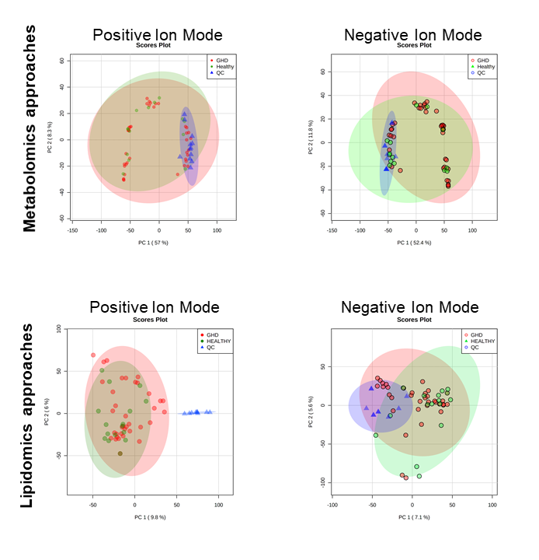
Figure S1: Application of a PCA model to investigate the reproducibility of metabolomic and lipidomic approaches
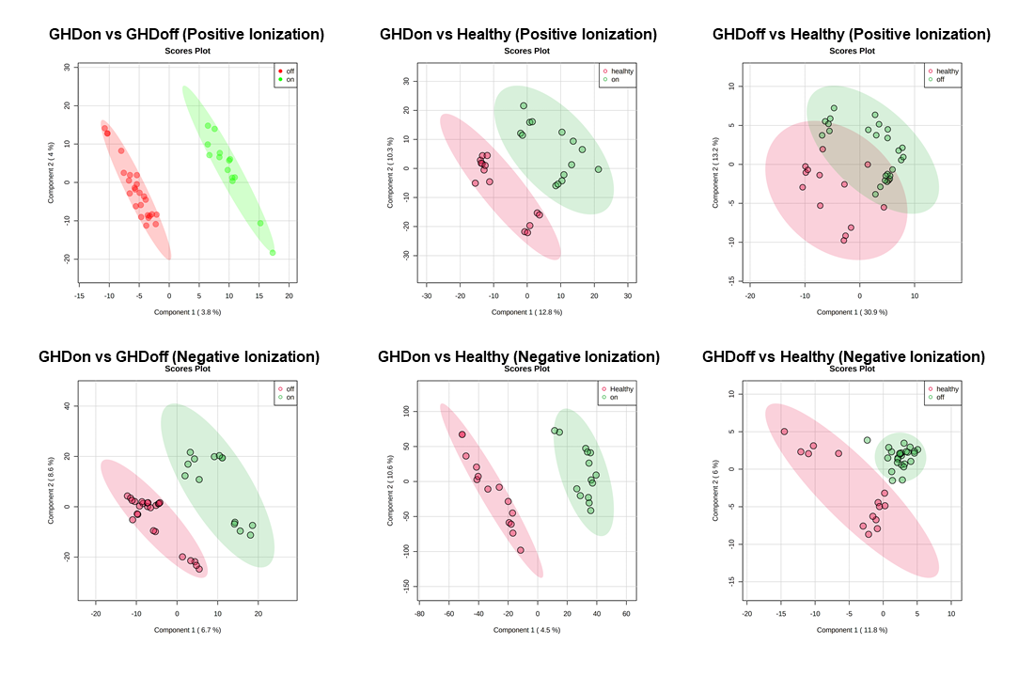
Figure S2: PLS-DA of the comparative analysis in the selection of features by untargeted metabolomics
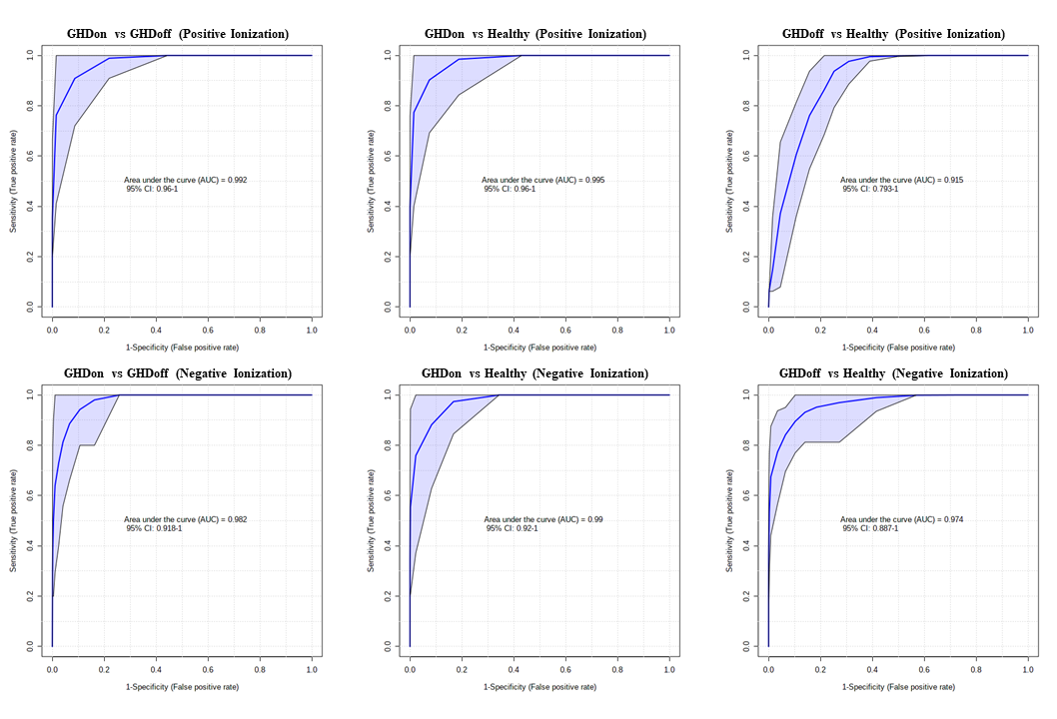
Figure S3: ROC curve to determine the predictive accuracy of each PLS-DA model used in the selection of the VIP score > 1.5 of comparative analysis for the global metabolomics approach.
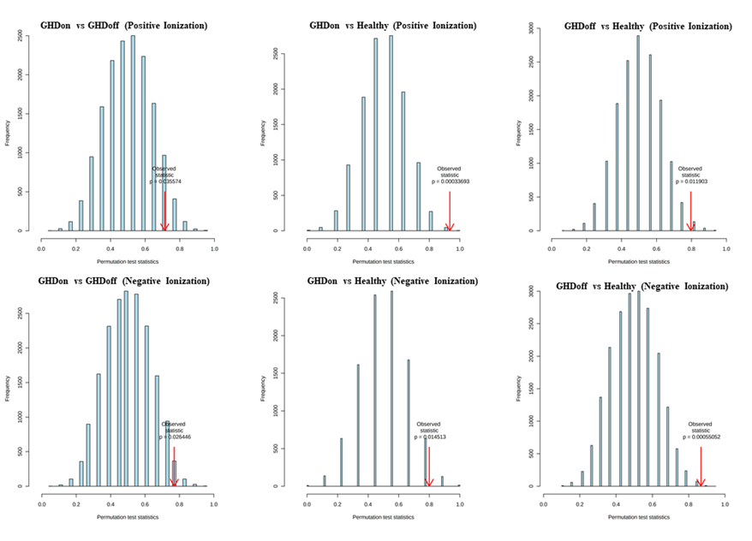
Figure S4: Permutation test of each PLS-DA model used in the selection of the VIP score > 1.5 of comparative analysis for the global metabolomics approach.
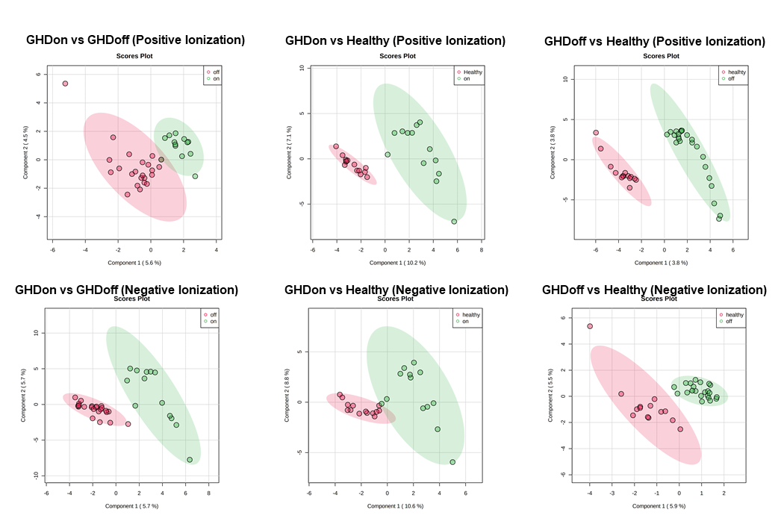

Figure S5: PLS-DA of the comparative analysis in the selection of features by untargeted lipidomics

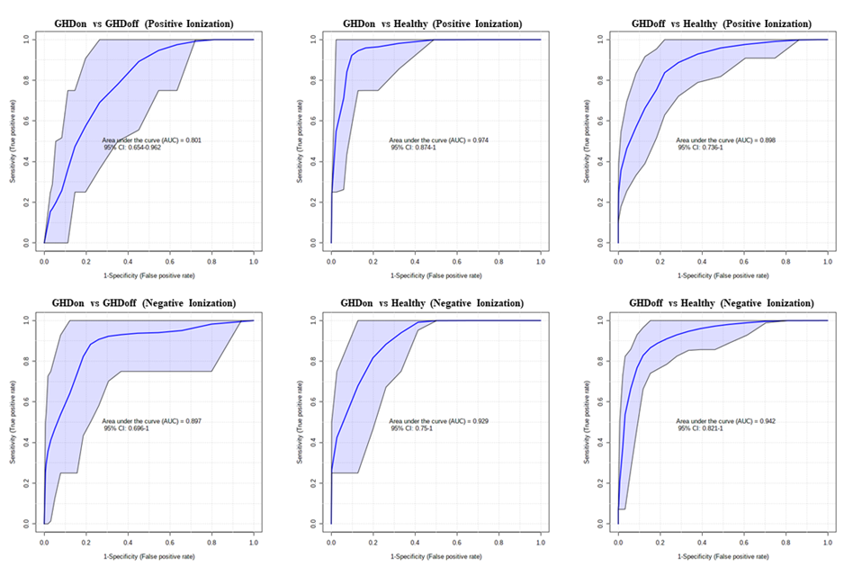
Figure S6: ROC curve to determine the predictive accuracy of each PLS-DA model used in the selection of the VIP score > 1.5 of comparative analysis for the lipidomics approach.

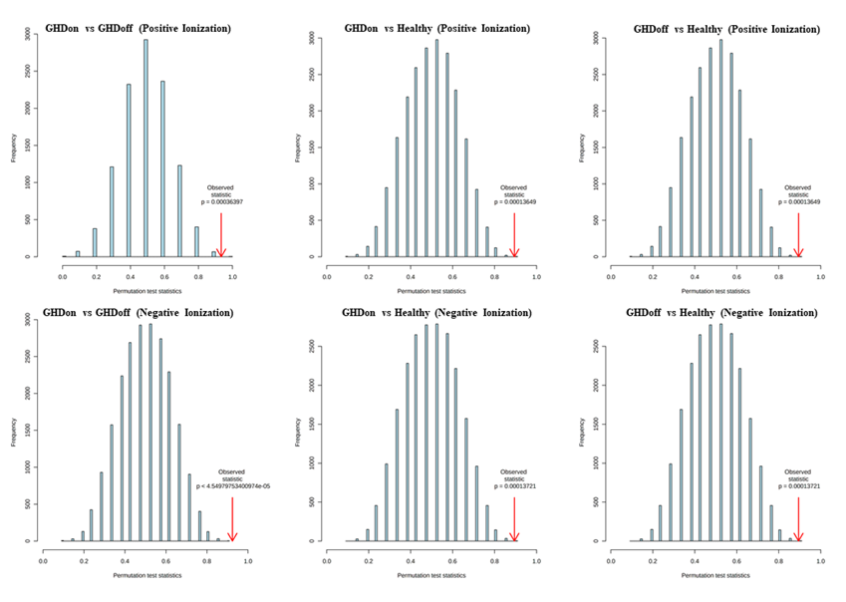
Figure S7: Permutation test of each PLS-DA model used in the selection of the VIP score > 1.5 of comparative analysis for the lipidomics approach.

