Supplementary Information
Supplementary Information 1 Scripts for quantifications in QuPath
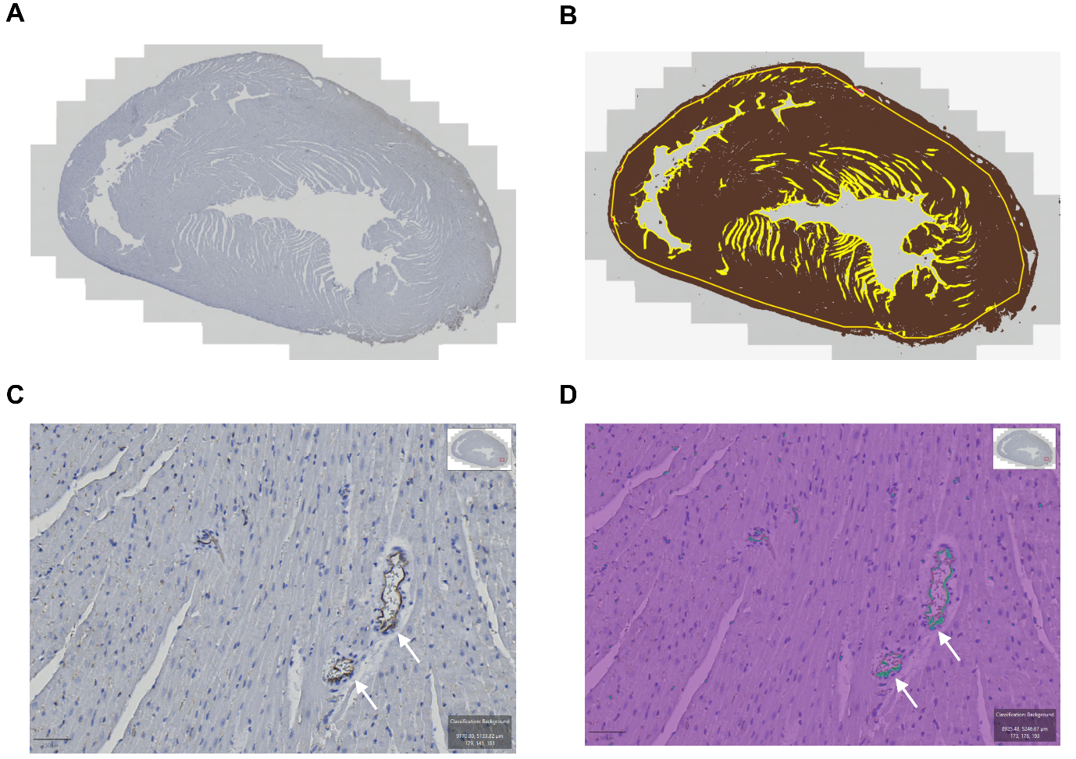
s SI2 Images of histological staining and classifiers. A CD31 staining is chosen for illustration. (A) Whole cardiac tissue slide. (B) Threshold for detection of tissue. (C) Image of vessels positive for CD31 with arrows marking the staining and (D) image of pixel classification for quantification of CD31 expression.
//Threshold
setImageType('BRIGHTFIELD_H_DAB');
setColorDeconvolutionStains('{"Name" : "H-DAB default", "Stain 1" : "Hematoxylin", "Values 1" : "0.65111 0.70119 0.29049", "Stain 2" : "DAB", "Values 2" : "0.26917 0.56824 0.77759", "Background" : " 255 255 255"}');
selectAnnotations();
createAnnotationsFromPixelClassifier("Tissue_CD68", 1.0E7, 2000.0, "SPLIT")

//Pixel classification
setImageType('BRIGHTFIELD_H_DAB');
setColorDeconvolutionStains('{"Name" : "H-DAB default", "Stain 1" : "Hematoxylin", "Values 1" : "0.65111 0.70119 0.29049", "Stain 2" : "DAB", "Values 2" : "0.26917 0.56824 0.77759", "Background" : " 255 255 255"}');
selectAnnotations();
AddPixelClassifierMeasurements(“CD68_DOX_002_v2”, “CD68_DOX_002_v2)

Supplementary Information 2 [⁶⁴Cu]Cu-DOTATATE PET uptake values at baseline
ROI | Group | Animals (n) | SUVmean (g/mL) ± SD | p-value
Inferior wall | Control | 2 | 0.208 ± 0.02 | 0.458
Inferior wall | 10.5 mg/kg | 9 | 0.177 ± 0.04 | 0.458
Inferior wall | 12.5 mg/kg | 3 | 0.210 ± 0.05 | 0.458
Septum | Control | 2 | 0.232 ± 0.00 | 0.740
Septum | 10.5 mg/kg | 9 | 0.276 ± 0.14 | 0.740
Septum | 12.5 mg/kg | 3 | 0.221 ± 0.05 | 0.740
Anterior wall | Control | 2 | 0.184 ± 0.0 | 0.806
Anterior wall | 10.5 mg/kg | 9 | 0.225 ± 0.12 | 0.806
Anterior wall | 12.5 mg/kg | 3 | 0.187 ± 0.04 | 0.806
Lateral wall | Control | 2 | 0.222 ± 0.04 | 0.836
Lateral wall | 10.5 mg/kg | 9 | 0.245 ± 0.11 | 0.836
Lateral wall | 12.5 mg/kg | 3 | 0.207 ± 0.04 | 0.836

Supplementary Information 3 [⁶⁴Cu]Cu-DOTATATE PET uptake values
 | SUV_{max} (g/mL) ± SD
ROI | Baseline | Group | Week 4 | p-value  (baseline vs. week 4) | Week 7 | p-value  (week 4 vs. week 7)
Inferior wall | 0.2458 ± 0.04 | Control | 0.3007 ± 0.03 | 0.1979 | 0.2761 ± 0.04 | 0.9923
Inferior wall | 0.2458 ± 0.04 | 10.5 mg/kg | 0.4944 ± 0.16 | <0.0001 | 0.7734 ± 0.14 | <0.0001
Inferior wall | 0.2458 ± 0.04 | 12.5 mg/kg | 0.6915 ± 0.17 | <0.0001 | N/A | N/A
Septum | 0.2484 ± 0.06 | Control | 0.3091 ± 0.04 | 0.1136 | 0.2626 ± 0.04 | 0.7564
Septum | 0.2484 ± 0.06 | 10.5 mg/kg | 0.5110 ± 0.16 | <0.0001 | 0.8015 ± 0.18 | <0.0001
Septum | 0.2484 ± 0.06 | 12.5 mg/kg | 0.6897 ± 0.11 | <0.0001 | N/A | N/A
Anterior wall | 0.1993 ± 0.04 | Control | 0.2636 ± 0.05 | 0.0775 | 0.2291 ± 0.02 | 0.9405
Anterior wall | 0.1993 ± 0.04 | 10.5 mg/kg | 0.3962 ± 0.10 | 0.0001 | 0.5962 ± 0.09 | 0.0044
Anterior wall | 0.1993 ± 0.04 | 12.5 mg/kg | 0.4927 ± 0.09 | <0.0001 | N/A | N/A
Lateral wall | 0.2295 ± 0.05 | Control | 0.2760 ±0.03 | 0.3904 | 0.2768 ± 0.01 | >0.999
Lateral wall | 0.2295 ± 0.05 | 10.5 mg/kg | 0.4645 ± 0.16 | <0.0001 | 0.6990 ± 0.16 | 0.0005
Lateral wall | 0.2295 ± 0.05 | 12.5 mg/kg | 0.6012 ± 0.16 | <0.0001 | N/A | N/A

Supplementary Information 4 Heamatology
 | Baseline | Week 2 | p-value  (baseline vs. week 2) | Week 5 | p-value  (week 2 vs. week 5) | Week 7
WBC (10³/µL) | 10.34 ± 1.31 | 8.862 ± 2.46 | 0.5307 | 7.964 ± 2.88 | 0.7841 | 2.210 ± 0.55
Neutrophils (10³/µL) | 1.184 ± 0.27 | 2.168 ±1.18 | 0.5556 | 2.510 ± 1.20 | 0.9987 | 0.835 ± 0.40
Lymphocytes (10³/µL) | 8.512 ± 0.89 | 4.814 ± 1.09 | 0.0003 | 3.886 ± 1.09 | 0.4731 | 1.175 ± 0.02
Monocytes (10³/µL) | 0.596 ± 0.20 | 1.820 ± 1.17 | 0.3222 | 1.534 ± 0.91 | 0.9745 | 0.145 ± 0.12
Eosinophils (10³/µL) | 0.032 ± 0.02 | 0.018 ± 0.01 | 0.4364 | 0.022 ± 0.01 | 0.9697 | 0.050 ± 0.00
Basophils (10³/µL) | 0.012 ± 0.01 | 0.042 ± 0.05 | 0.3530 | 0.012 ± 0.02 | 0.3530 | 0.005 ± 0.01
Neutrophils % | 11.36 ± 1.71 | 23.56 ± 6.80 | 0.0430 | 31.28 ± 7.88 | 0.2674 | 36.75 ± 8.98
Lymphocytes % | 82.54 ± 2.41 | 57.24 ± 17.43 | 0.0153 | 49.80 ± 7.43 | 0.7215 | 54.45 ± 12.5
Monocytes % | 5.660 ± 1.26 | 18.54 ± 11.21 | 0.0547 | 18.50 ± 5.61 | >0.999 | 5.850 ± 3.61
Eosinophils % | 0.340 ± 0.17 | 0.240 ± 0.05 | 0.7611 | 0.260 ± 0.09 | 0.9972 | 2.500 ± 0.42
Basophils % | 0.100 ± 0.07 | 0.420 ± 0.44 | 0.3002 | 0.160 ± 0.11 | 0.4687 | 0.450 ± 0.35
RBC (10⁶/µL) | 9.614 ± 0.53 | 8.300 ± 0.68 | 0.1466 | 5.462 ±1.23 | 0.0012 | 1.600 ± 1.02
Hemoglobin (g/dL) | 17.20 ± 0.81 | 15.10 ± 1.30 | 0.0447 | 10.30 ± 1.45 | 0.0001 | N/A
Hematocrit % | 48.06 ± 2.25 | 41.22 ± 3.36 | 0.0882 | 25.86 ± 5.98 | 0.0003 | 8.400 ± 3.82
MCV (fL) | 50.02 ± 0.68 | 49.62 ± 0.58 | 0.9971 | 47.40 ± 0.32 | 0.6977 | 56.05 ± 11.4
MCH (pg) | 17.86 ± 0.31 | 18.16 ± 0.29 | >0.999 | 19.46 ± 3.89 | >0.999 | 298.4 ± 180
MCHC (g/dL) | 35.76 ± 0.23 | 36.64 ± 0.27 | >0.999 | 41.06 ± 8.02 | 0.9994 | 510.1 ± 217
RDW-CV % | 12.16 ± 0.15 | 13.28 ± 0.81 | 0.9750 | 13.80 ± 0.60 | 0.9973 | 26.00 ± 15.3
Platelets (10³/µL) | 488.0 ± 91.2 | 888.4 ± 269 | 0.0819 | 913.0 ± 319 | 0.9984 | 483.0 ± 89.1
MPV (pL) | 7.360 ± 0.38 | 6.780 ± 0.38 | 0.0903 | 4.400 ± 0.57 | 0.9997 | 4.400 ± 0.57

