Supplemetary Materials

Table S1
Descriptive statistics (mean, standard deviation, skewness, kurtosis and range)
Item | M | SD | Skewness | Kurtosis | Range
Anhedonia (1) | 4.98 | 2.627 | .136 | -1.097 | 9
DepressedMood (2) | 4.48 | 2.788 | .350 | -1.093 | 9
Anxiety (3) | 4.58 | 2.751 | .310 | -1.097 | 9
Worrying (4) | 4.31 | 2.825 | .413 | -1.070 | 9
EsportsStress (5) | 3.82 | 2.716 | .707 | -.662 | 9
GamePreoccupation (6) | 4.75 | 2.894 | .231 | -1.195 | 9
SleepQuantity (7) | 5.52 | 2.933 | -.032 | -1.259 | 9
SleepQuality (8) | 5.40 | 3.020 | .023 | -1.326 | 9
PhysicalFatigue (9) | 4.96 | 2.655 | .155 | -1.075 | 9
MentalFatigue (10) | 5.53 | 2.702 | -.116 | -1.092 | 9
Pain (11) | 3.67 | 2.779 | .718 | -.763 | 9
LackSupportEsports (12) | 3.61 | 2.945 | .769 | -.780 | 9
LackSupportPersonal (13) | 4.24 | 3.035 | .436 | -1.230 | 9
LackEmotionControl (14) | 4.24 | 2.781 | .484 | -.968 | 9
LackAutonomy (15) | 3.60 | 2.817 | .741 | -.793 | 9
LackSkill (16) | 5.68 | 2.823 | -.179 | -1.113 | 9
LackConnection (17) | 4.45 | 3.179 | .379 | -1.289 | 9

Table S2
Pearson zero-order correlations between the variables
 | 1 | 2 | 3 | 4 | 5 | 6 | 7 | 8 | 9 | 10 | 11 | 12 | 13 | 14 | 15 | 16
1 | - | - | - | - | - | - | - | - | - | - | - | - | - | - | - | -
2 | .635 | - | - | - | - | - | - | - | - | - | - | - | - | - | - | -
3 | .513 | .657 | - | - | - | - | - | - | - | - | - | - | - | - | - | -
4 | .514 | .633 | .661 | - | - | - | - | - | - | - | - | - | - | - | - | -
5 | .351 | .413 | .413 | .414 | - | - | - | - | - | - | - | - | - | - | - | -
6 | .330 | .360 | .341 | .326 | .391 | - | - | - | - | - | - | - | - | - | - | -
7 | .332 | .385 | .378 | .353 | .239 | .306 | - | - | - | - | - | - | - | - | - | -
8 | .422 | .444 | .465 | .417 | .281 | .294 | .701 | - | - | - | - | - | - | - | - | -
9 | .462 | .534 | .496 | .493 | .340 | .350 | .565 | .610 | - | - | - | - | - | - | - | -
10 | .509 | .621 | .570 | .522 | .355 | .310 | .510 | .517 | .617 | - | - | - | - | - | - | -
11 | .382 | .457 | .490 | .462 | .399 | .302 | .319 | .367 | .500 | .405 | - | - | - | - | - | -
12 | .285 | .334 | .338 | .343 | .498 | .334 | .184 | .204 | .262 | .275 | .368 | - | - | - | - | -
13 | .427 | .481 | .423 | .433 | .381 | .334 | .297 | .327 | .350 | .386 | .384 | .495 | - | - | - | -
14 | .461 | .529 | .538 | .465 | .439 | .375 | .344 | .350 | .387 | .431 | .421 | .398 | .453 | - | - | -
15 | .380 | .419 | .394 | .383 | .547 | .412 | .272 | .276 | .326 | .309 | .423 | .550 | .462 | .501 | - | -
16 | .315 | .362 | .356 | .321 | .322 | .309 | .325 | .325 | .384 | .411 | .295 | .263 | .316 | .393 | .327 | -
17 | .383 | .397 | .380 | .355 | .358 | .332 | .285 | .299 | .327 | .346 | .390 | .397 | .387 | .414 | .444 | .403
Note. All correlations were significant at the 0.01 level.

Table S3
Relative Importance Network RawOutStrength (i.e., sum of the weights of outgoing edges based on raw lmg/R² contributions)
Node | RawOutStrength | Node | RawOutStrength
DepressedMood | 0.6892 | Anhedonia | 0.4557
Anxiety | 0.6162 | EsportsStress | 0.4144
PhysicalFatigue | 0.5969 | LackSupportEsports | 0.4141
SleepQuality | 0.5841 | LackSupportPersonal | 0.4012
MentalFatigue | 0.5712 | Pain | 0.3841
Worrying | 0.5369 | LackConnection | 0.3388
SleepQuantity | 0.5149 | LackSkill | 0.2739
LackAutonomy | 0.5118 | GamePreoccupation | 0.2624
LackEmotionControl | 0.4668

Table S4
Directed Acyclic Graph predictability (i.e., adjusted R²; proportion of variance in a node explained by its parents)
Node | AdjR² | Node | AdjR²
SleepQuality | 0.5742 | LackSupportPersonal | 0.3556
Worrying | 0.5048 | LackEmotionControl | 0.3427
Anxiety | 0.4311 | EsportsStress | 0.2985
MentalFatigue | 0.4306 | LackSkill | 0.2695
Anhedonia | 0.4031 | LackConnection | 0.2664
PhysicalFatigue | 0.3805 | LackAutonomy | 0.2503
Pain | 0.3677 | GamePreoccupation | 0.2076
SleepQuantity | 0.3600 | DepressedMood | 0.0000
LackSupportEsports | 0.3564

Table S5
Bayesian Gaussian Graphical Copula Model partial correlations (i.e., conditional dependencies)
From | To | Strength | From | To | Strength
SleepQuantity | SleepQuality | 0.4846 | Depressed  Mood | LackSupport  Personal | 0.1669
Anhedonia | Depressed  Mood | 0.3406 | MentalFatigue | LackSkill | 0.1509
Anxiety | Woryying | 0.3104 | Anxiety | Pain | 0.1504
LackSupport  Esports | LackSupport  Personal | 0.3025 | LackEmotion  Control | LackSkill | 0.1439
LackSupport  Esports | Lack  Autonomy | 0.2819 | LackSupport  Personal | LackEmotion  Control | 0.1396
Physical  Fatigue | MentalFatigue | 0.2784 | Game  Preoccupation | Lack  Autonomy | 0.1365
Depressed  Mood | MentalFatigue | 0.2623 | EsportsStress | Game  Preoccupation | 0.1273
EsportsStress | Lack  Autonomy | 0.2496 | Pain | Lack  Connection | 0.1246
Physical  Fatigue | Pain | 0.2401 | SleepQuantity | MentalFatigue | 0.1178
Depressed  Mood | Worrying | 0.2332 | Worrying | EsportsStress | 0.1111
SleepQuality | Physical  Fatigue | 0.2328 | SleepQuantity | Physical  Fatigue | 0.1107
EsportsStress | LackSupport  Esports | 0.2327 | Anxiety | MentalFatigue | 0.1068
LackSkill | Lack  Connection | 0.2151 | Anhedonia | Lack  Connection | 0.1068
LackEmotion  Control | Lack  Autonomy | 0.2134 | Anhedonia | LackEmotion  Control | 0.0973
Anxiety | LackEmotion  Control | 0.1994 | Worrying | Physical  Fatigue | 0.0939
Lack  Autonomy | Lack  Connection | 0.1871 | Anhedonia | SleepQuality | 0.0851
Depressed  Mood | Anxiety | 0.1805 | Anxiety | SleepQuality | 0.0735

Table S6
Directed Acyclic Graph edge-level arc.strength scores (i.e., the change in score when arc is removed, based on their BIC-g score)
From | To | BIC-g | From | To | BIC-g
Depressed  Mood | Anxiety | -286.1222 | EsportsStress | LackSupport  Esports | -39.1168
Depressed  Mood | Anhedonia | -261.4783 | Depressed  Mood | LackEmotion  Control | -37.1618
MentalFatigue | Physical  Fatigue | -242.4665 | Anxiety | Mental  Fatigue | -36.2857
Lack  Autonomy | EsportsStress | -178.6969 | Lack  Autonomy | Game  Preoccupation | -31.7089
SleepQuantity | SleepQuality | -168.1569 | Anxiety | Pain | -31.0572
LackEmotion  Control | Lack  Autonomy | -144.6639 | Lack  Autonomy | Pain | -29.3295
Anxiety | Worrying | -95.7986 | Mental  Fatigue | Sleep  Quantity | -29.0749
LackSupport  Esports | LackSupport  Personal | -88.1268 | Mental  Fatigue | LackSkill | -28.9347
Depressed  Mood | MentalFatigue | -85.1812 | Lack  Connection | LackSkill | -27.6299
Depressed  Mood | LackSupport  Personal | -78.8811 | Lack  Autonomy | Lack  Connection | -24.8625
Lack  Autonomy | LackSupport  Esports | -77.2598 | Pain | Lack  Connection | -22.2313
Physical  Fatigue | SleepQuantity | -71.9590 | EsportsStress | Game  Preoccupation | -21.2582
Depressed  Mood | Worrying | -63.8263 | Anxiety | SleepQuality | -16.2709
Physical  Fatigue | Pain | -48.3029 | LackEmotionControl | LackSkill | -14.4021
Anxiety | LackEmotion  Control | -44.2507 | LackSupport  Esports | Lack  Connection | -11.2569
Physical  Fatigue | SleepQuality | -39.4228

Table S7
Directed Acyclic Graph edge-level directional probabilities (i.e., the proportion of bootstrapped networks wherein the edge pointed from node A to node B)
From | To | Direction | From | To | Direction
MentalFatigue | LackSkill | 0.9727 | Lack  Autonomy | LackSupport  Esports | 0.6803
LackEmotion  Control | LackSkill | 0.9324 | Anxiety | SleepQuality | 0.6707
Lack  Autonomy | Game  Preoccupation | 0.9287 | Lack  Autonomy | EsportsStress | 0.6703
Depressed  Mood | LackSupport  Personal | 0.8978 | Depressed  Mood | Worrying | 0.6557
Lack  Autonomy | Lack  Connection | 0.8864 | MentalFatigue | Sleep  Quantity | 0.6513
Anxiety | Pain | 0.8771 | Anxiety | Worrying | 0.6459
Depressed  Mood | Anhedonia | 0.8589 | Physical  Fatigue | Sleep  Quantity | 0.6408
EsportsStress | Game  Preoccupation | 0.8479 | Sleep  Quantity | SleepQuality | 0.6388
Depressed  Mood | LackEmotion  Control | 0.8131 | Lack  Autonomy | Pain | 0.6250
Anxiety | LackEmotion  Control | 0.8002 | MentalFatigue | Physical  Fatigue | 0.6141
Physical  Fatigue | Pain | 0.7927 | Depressed  Mood | MentalFatigue | 0.5748
Pain | Lack  Connection | 0.7429 | EsportsStress | LackSupport  Esports | 0.5672
LackSupport  Esports | Lack  Connection | 0.7189 | Depressed  Mood | Anxiety | 0.5466
Physical  Fatigue | SleepQuality | 0.7058 | Anxiety | MentalFatigue | 0.5271
LackEmotion  Control | Lack  Autonomy | 0.6944 | Lack  Connection | LackSkill | 0.5172
LackSupport  Esports | LackSupport  Personal | 0.6820

Table S8
Bayesian Gaussian Graphical Copula Model expected influence (i.e., sum of absolute node level partial correlations)
Node | Expected Influence | Node | Expected Influence
DepressedMood | 1.1835 | EsportsStress | 0.7208
LackAutonomy | 1.0685 | SleepQuantity | 0.7131
Anxiety | 1.0209 | LackConnection | 0.6336
PhysicalFatigue | 0.9558 | Anhedonia | 0.6298
MentalFatigue | 0.9161 | LackSupportPersonal | 0.6089
SleepQuality | 0.8759 | Pain | 0.5151
LackSupportEsports | 0.8171 | LackSkill | 0.5099
LackEmotionControl | 0.7935 | GamePreoccupation | 0.2638
Worrying | 0.7487

Table S9
Bayesian Gaussian Graphical Copula Model degree (i.e., number of connections of a node)
Node | Degree | Node | Degree
Anxiety | 6 | SleepQuality | 4
DepressedMood | 5 | Worrying | 4
LackAutonomy | 5 | LackSkill | 3
LackEmotionControl | 5 | LackSupportEsport | 3
MentalFatigue | 5 | LackSupportPersonal | 3
PhysicalFatigue | 5 | Pain | 3
Anhedonia | 4 | SleepQuantity | 3
EsportsStress | 4 | GamePreoccupation | 2
LackConnection | 4

Table S10
Bayesian Gaussian Graphical Copula Model betweenness (i.e., frequency with which a node lies on shortest paths between others)
Node | Betweenness | Node | Betweenness
LackAutonomy | 0.1417 | Anhedonia | 0.0666
LackEmotionControl | 0.1322 | LackSupportPersonal | 0.0454
Worrying | 0.1298 | SleepQuality | 0.0385
Anxiety | 0.1223 | LackSkill | 0.0336
DepressedMood | 0.1035 | Pain | 0.0323
LackConnection | 0.0967 | LackSupportEsports | 0.0211
EsportsStress | 0.0937 | SleepQuantity | 0.0042
MentalFatigue | 0.0878 | GamePreoccupation | 0.0000
PhysicalFatigue | 0.0838

Table S11
Bayesian Gaussian Graphical Copula Model eigenvector (i.e., connection to other important nodes)
Node | Eigenvector | Node | Eigenvector
Anxiety | 1.000 | Pain | 0.5262
MentalFatigue | 0.8411 | LackConnection | 0.4956
DepressedMood | 0.8396 | LackAutonomy | 0.4923
PhysicalFatigue | 0.7640 | LackSkill | 0.4758
LackEmotionControl | 0.7065 | LackSupportPersonal | 0.4316
Worrying | 0.6988 | EsportsStress | 0.3972
SleepQuality | 0.6825 | LackSupportEsports | 0.3076
Anhedonia | 0.6343 | GamePreoccupation | 0.2071
SleepQuantity | 0.5327

Table S12
Directed Acyclic Graph betweenness (i.e., frequency with which a node lies on shortest paths between others, normalized)
Node | Betweenness | Node | Betweenness
LackAutonomy | 0.0563 | Anhedonia | 0.0000
LackEmotionControl | 0.0438 | DepressedMood | 0.0000
LackSupportEsports | 0.0250 | EsportsStress | 0.0000
LackConnection | 0.0208 | GamePreoccupation | 0.0000
MentalFatigue | 0.0208 | LackSkill | 0.0000
Pain | 0.0178 | LackSupportPersonal | 0.0000
Anxiety | 0.0104 | SleepQuality | 0.0000
PhysicalFatigue | 0.0104 | Worrying | 0.0000
SleepQuantity | 0.0021

Table S13
Directed Acyclic Graph InExpectedInfluence (i.e., sum of incoming edge weights to a node based on BIC score)
Node | InExpected  Influence | Node | InExpected  Influence
Anxiety | -286.1222 | LackSupportEsports | -116.3766
Anhedonia | -261.4783 | Pain | -108.6896
PhysicalFatigue | -242.4665 | SleepQuantity | -101.0339
SleepQuality | -223.8506 | LackEmotionControl | -81.4124
EsportsStress | -178.6969 | LackSkill | -70.9668
LackSupportPersonal | -167.0079 | LackConnection | -58.3508
Worrying | -159.6249 | GamePreoccupation | -52.9670
LackAutonomy | -144.6639 | DepressedMood | 0.00000
MentalFatigue | -121.4669

Table S14
Directed Acyclic Graph OutExpectedInfluence (i.e., sum of outgoing edge weights from a node based on BIC score)
Node | OutExpected  Influence | Node | OutExpected  Influence
DepressedMood | -812.6509 | LackConnection | -27.6299
LackAutonomy | -341.8577 | Pain | -22.2313
MentalFatigue | -300.4760 | Anhedonia | 0.00000
Anxiety | -223.6631 | GamePreoccupation | 0.00000
SleepQuantity | -168.1569 | LackSkill | 0.00000
PhysicalFatigue | -159.6847 | LackSupportPersonal | 0.00000
LackEmotion  Control | -159.0659 | SleepQuality | 0.00000
LackSupportEsports | -99.3837 | Worrying | 0.00000
EsportsStress | -60.3749

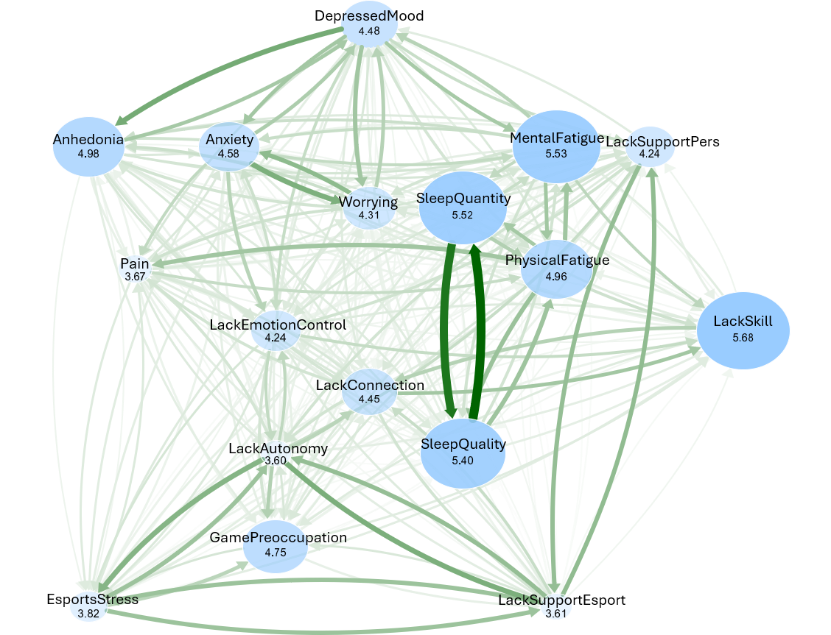
Supplementary Figure 1
Relative Importance Network, edge width based on normalized lmg value
Supplementary Figure 2
Bayesian Gaussian Graphical Copula model with edge labels representing partial correlations
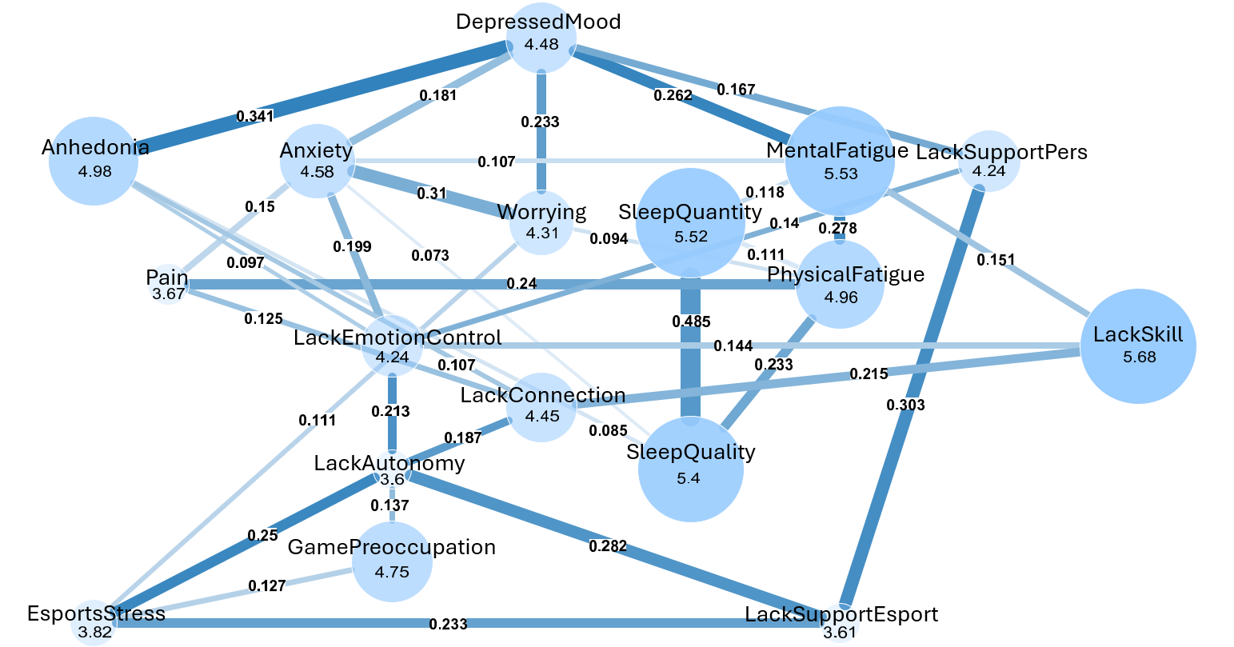

Supplementary Figure 3
Directed Acyclic Graph of the GG custom questionnaire data – based on edge strength (BIC-g scores as edge labels)
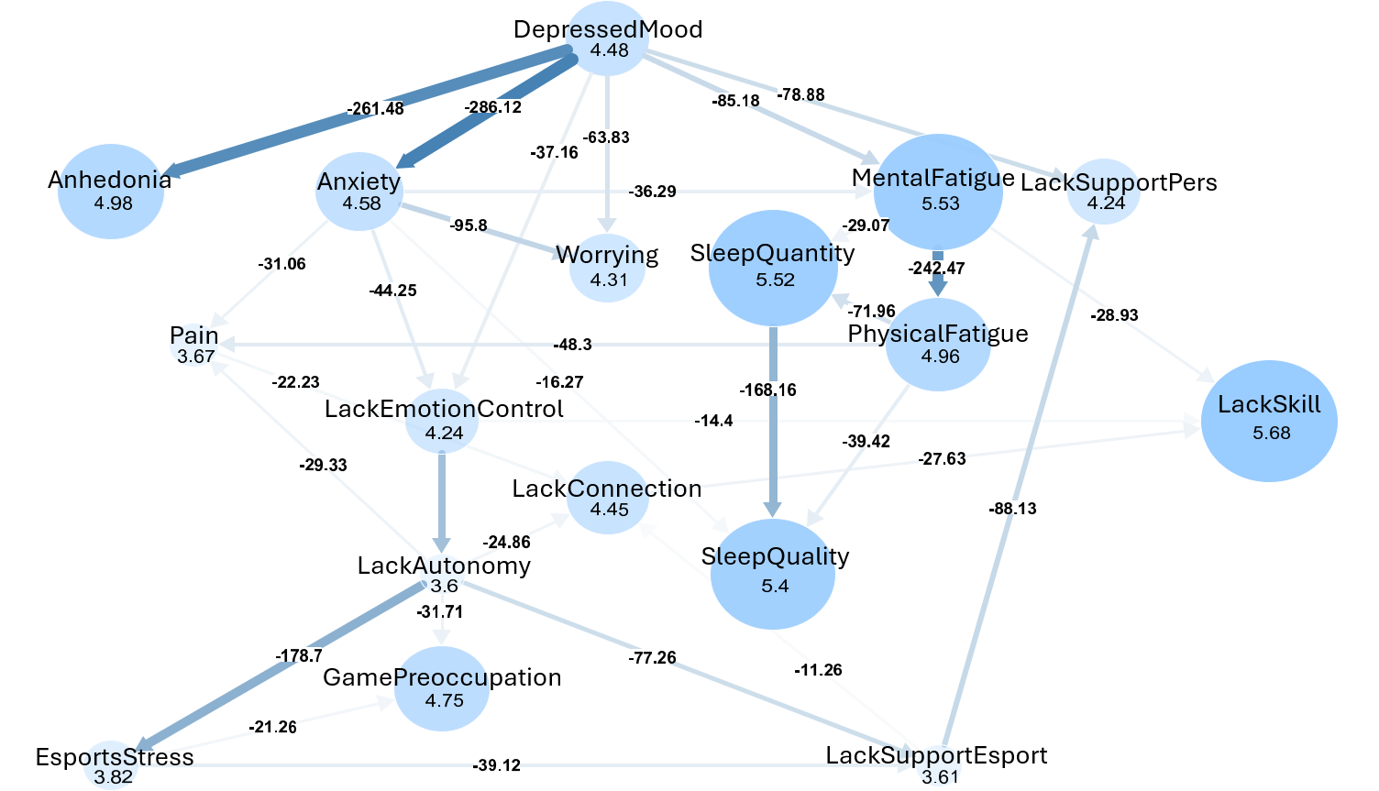
Supplementary Figure 4
Directed Acyclic Graph of the GG custom questionnaire data – based on direction (directional probabilities as edge labels)
