Supplementary Materials

Supplementary Table S1
Bonferroni-Corrected Post Hoc Comparisons of d′ Across N-back Levels
Comparison |  |  | Mean Difference | SE | df | t | p Bonferroni
1-back | vs | 2-back | 0.52 | 0.08 | 61 | 6.45 | < .001
 |  | 3-back | 1.34 | 0.11 | 61 | 11.43 | < .001
 | vs | 4-back | 2.1 | 0.09 | 61 | 22.68 | < .001
2-back | vs | 3-back | 0.82 | 0.11 | 61 | 6.99 | < .001
 |  | 4-back | 1.57 | 0.09 | 61 | 16.99 | < .001
3-back | vs | 4-back | 0.75 | 0.10 | 61 | 7.16 | < .001

Supplementary Table S2
Random Effect components of the primary model (M1) and the covariate adjusted model (M2)
 |  |  | M1 |  |  |  |  |  | M2
Group | Component |  | Variance |  | SD |  | ICC |  | Variance |  | SD | ICC
Subject | Intercept |  | 0.044 |  | 0.21 |  | 0.57 |  | 0.044 |  | 0.21 | 0.571
 | 2 back vs 3 back |  | 0.009 |  | 0.028 |  |  |  | 0.01 |  | 0.1
 | 3 back vs 4 back |  | 0.033 |  | 0.182 |  |  |  | 0.033 |  | 0.182
Residual |  |  | 0.033 |  | 0.182 |  |  |  | 0.033 |  | 0.182
Supplementary Table S3
Fixed Effects Omnibus Tests of LMM with random delay slope included
Effect |  | F |  | df |  | df (res) |  | p
effort |  | 193.72 |  | 2 |  | 915 |  | < .001
delay |  | 31.10 |  | 5 |  | 315 |  | < .001
effort * delay |  | 2.77 |  | 10 |  | 915 |  | 0.002

Supplementary Table S4
Random Variance Components of LMM including random slopes for delay
Group | Component | Variance | SD | ICC
subject | Intercept | 0.044 | 0.210 | 0.570
 | 1 day vs 7 days | 0.016 | 0.127
 | 7 days vs 14 days | 0.018 | 0.135
 | 14 days vs 30 days | 0.029 | 0.172
 | 30 days vs 90 days | 0.028 | 0.169
 | 90 days vs 180 days | 0.036 | 0.192
Residual |  | 0.033 | 0.183
Note. Random variances cannot be computed. Some variance components equal zero.

It is noteworthy in the above tables (Table S3 and S4) that when random slopes for delay alongside random intercept was included in the Linear Mixed Model, to account for baseline individual differences in delay sensitivity. The outcome is consistent with M1 reported in the study, where the interaction effect between delay and effort is significant at 0.01 level and increasing variance across delay contrast indicating that longer delays exhibit greates between-group variability in delay sensitivity. This exactly mirrors the patten we found for the effort slopes as well in M1. However, as discussed in the main paper we could not report this model due to singular fit warnings and model convergence issues due to its complex parameterization. Despite these warnings, Delay x Effort interaction finding confirms that the proposed effect is robust to random effects misspecification and not an artifact of the chosen random effects structure.

Supplemetary Fig. S1a
Group level AUC of Effort
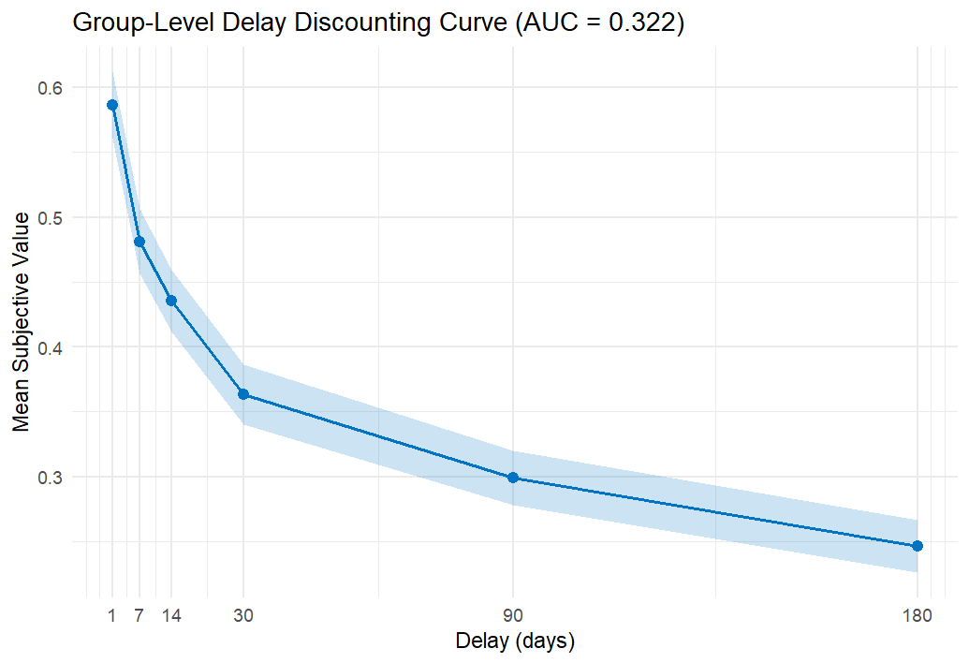
Supplementary Fig. S1b
Group level AUC of Delay
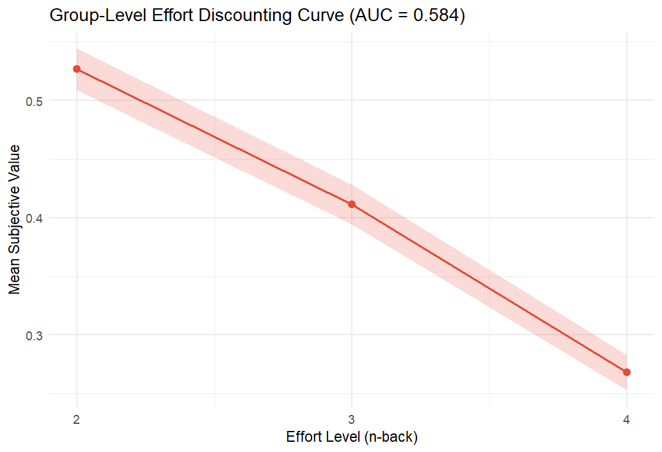
Supplementary Fig. S2
Simulated Power Estimates at current sample size (62) along with sample sizes (N= 75 and N=90)
