Supplementary Figures -
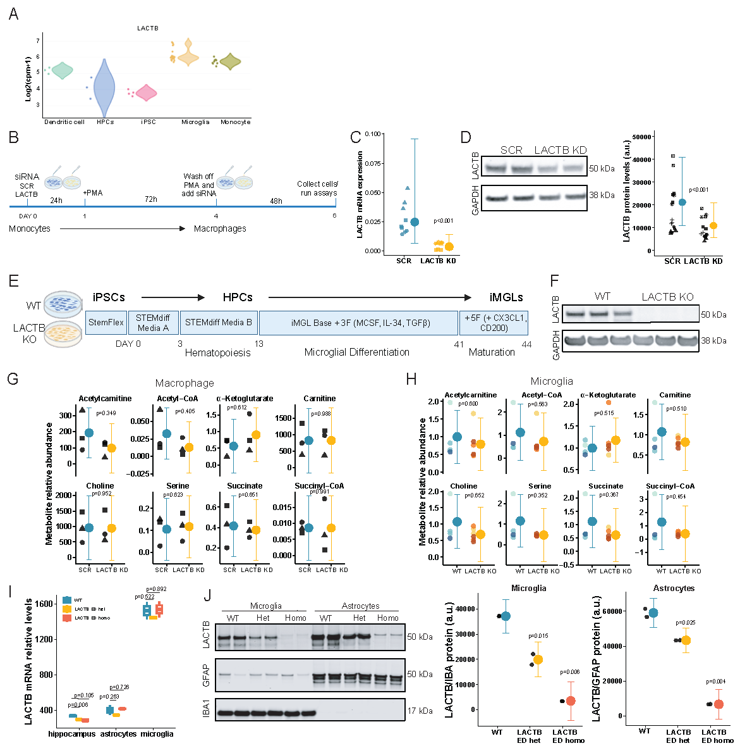Supplementary Figure 1. A) LACTB expression is higher in myeloid cells compared to hematopoietic precursors (HPCs) or induced-pluripotent cells (iPSC). Data from Stemformatics (Abud et al., 2017 dataset ³⁴). B) Experimental design for the differentiation of THP1 monocytes to macrophages, combined with the small-interfering RNA (siRNA) treatment. We observed a 90% and 50% LACTB reduction at mRNA (C) and protein (D) levels, respectively. E) Schematic diagram of the differentiation of induced pluripotent stem cells (iPSC) to microglia (iMGLs). F) Validation of LACTB knock-out iPSC-derived microglia (iMGLs) from WTC11 donor (3 clones per genotype). G, H) Metabolomic analysis in LACTB KD/KO myeloid cells compared to controls. I) LACTB expression levels in isolated microglia, astrocytes and hippocampal lysate in control and LACTB enzymatically dead (ED) mice. J) LACTB protein levels, assessed by an antibody targeting the active site, in WT and LACTB ED mice (n=2). Graphs display individual data points (left) alongside estimated marginal means with 95% confidence intervals (right). For the raw data dot colors indicate distinct xenotransplanted microglia clones. Statistical details are provided in Table 1.
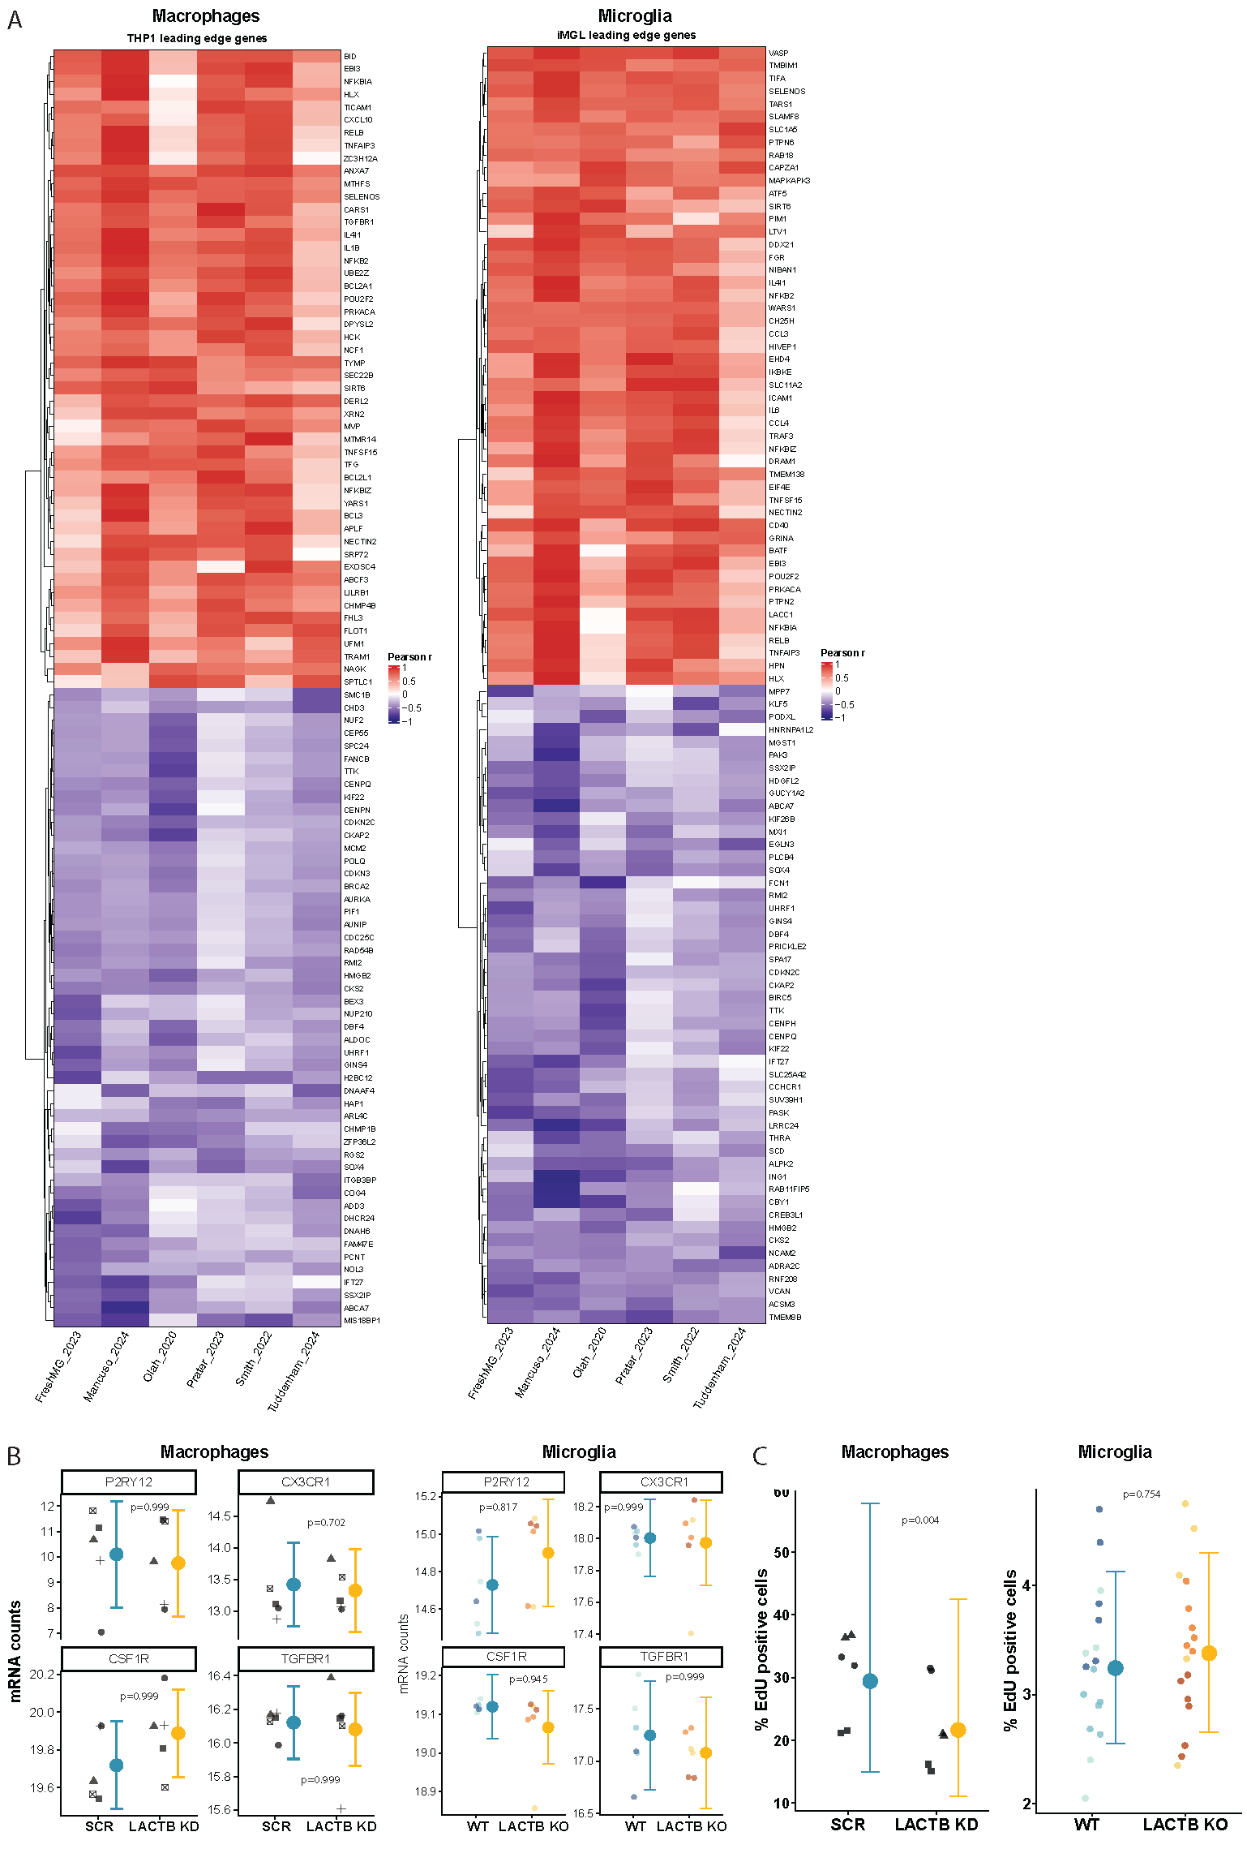
Supplementary Figure 2. A) Heatmap of Pearson coefficients between LACTB expression and leading-edge genes identified in THP1 KD and iMGL KO bulk-RNAseq GSEA across clusters in re-analyzed publicly-available datasets ^{39–44}, which were consistently positively- (mean r > 0.1) or negatively-correlated (r mean < -0.1) across studies. B) mRNA expression of differentiation markers in control and LACTB KD THP1 macrophages (n = 4) and LACTB KO WTC11 microglia (n=3 independent clones, 2 independent differentiations per clone). Graphs show normalized (adjusted) transcript counts. C) Cell proliferation (EdU assay) in control and LACTB KD THP1 macrophages (n=3) or LACTB KO WTC11 microglia (n=3 clones, 2 independent differentiations per clone). Graphs display individual data points (left) alongside estimated marginal means with 95% confidence intervals (right). For the raw data, dot shapes represent independent macrophage differentiations, and dot colors indicate distinct microglia clones. Statistical details are provided in Table 1.
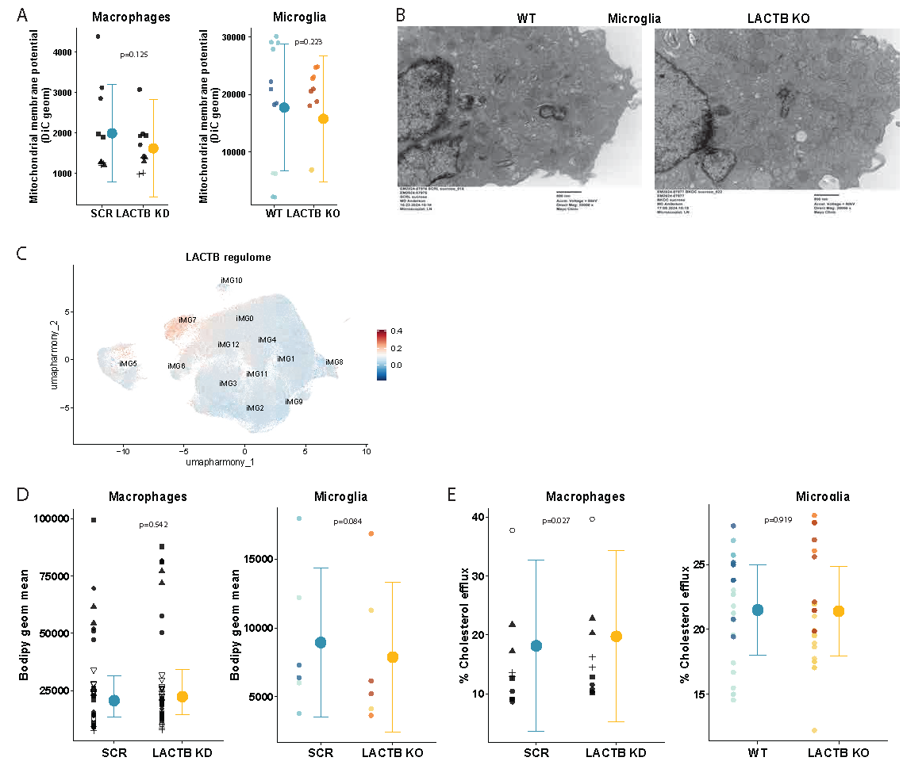
Supplementary Figure 3. A) Mitochondrial membrane potential in LACTB KD/KO myeloid cells compared to SCR/WT. B) Representative electron microscopy images of LACTB KO compared to WT iMGLs. C) UMAP showing module scores from ARACNe-inferred LACTB co-expression module across iMGLs, with highest enrichment in iMG7, a ribosomal processing-associated cluster. D-E) Lipid droplet accumulation (D) and cholesterol efflux (E) in LACTB KD/KO myeloid cells compared to SCR/WT. Graphs display individual data points (left) alongside estimated marginal means with 95% confidence intervals (right). For the raw data, dot shapes represent independent macrophage differentiations, and dot colors indicate distinct microglia clones. Statistical details are provided in Table 1.
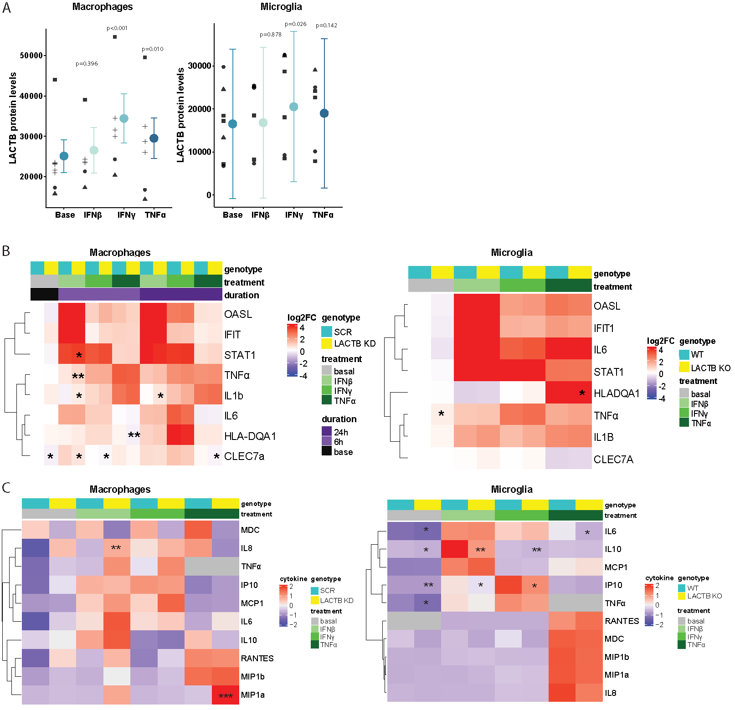
Supplementary Figure 4. A) LACTB protein levels in THP1 macrophages or WTC11 iMGLs stimulated with IFN-β, IFN-γ, or TNF-α for 24 hours. B) mRNA expression (log2FC) in control and LACTB KD/KO myeloid cells at baseline or after stimulation with IFN-β, IFN-γ, or TNF-α (THP1 macrophages, for 6 and 24h hours n=3; WTC11 iMGLs, for 24 hours, n=3 clones, 2 differentiations each). C) Levels of cytokines in control and LACTB KD/KO myeloid cells at baseline or following stimulation with IFN-β, IFN-γ, or TNF-α for 24 hours (THP1 macrophages, n=2 independent differentiations; WTC11 iMGLs, n=3 clones). Statistical details are provided in Table 1. *p<0.05, **p<0.01, ***p<0.001.
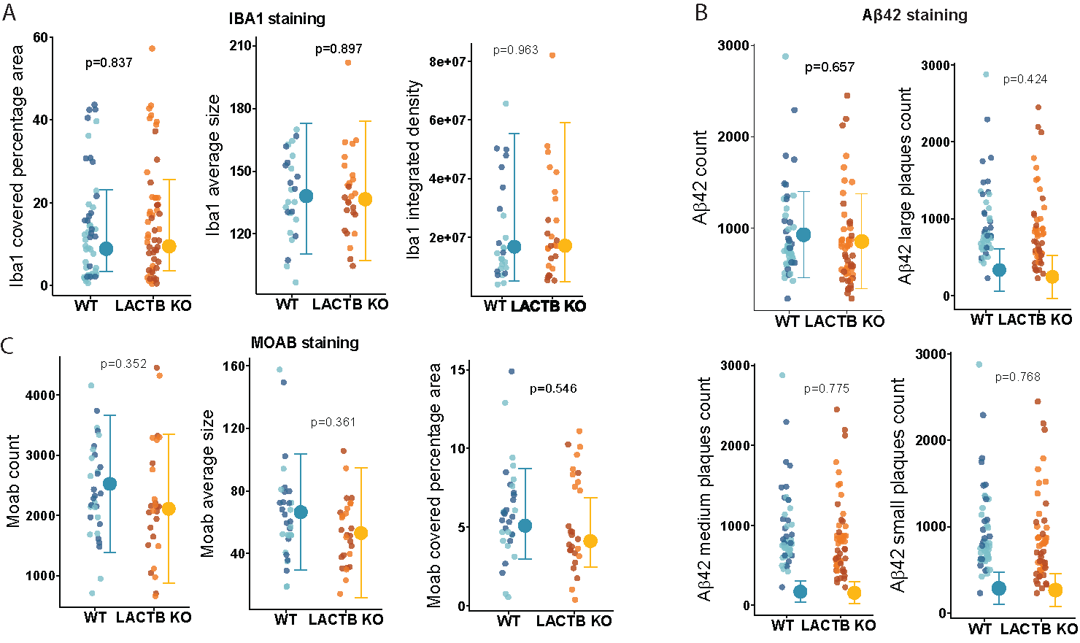
Supplementary Figure 5. Immunohistochemistry analysis of (A) percentage of area covered, integrated density and average size of microglia (Iba1+ cells), (B) number of small (0-20 μm), medium (20-40 μm) and large (> 40 μm) amyloid plaques stained by Aβ42 and C) number of plaques and average size of plaques stained by the amyloid marker MOAB (n=2 clones per genotype, 4 mice injected per clone). Graphs display individual data points (left) alongside estimated marginal means with 95% confidence intervals (right). For the raw data, dot colors indicate distinct microglia clones. Statistical details are provided in Table 1.

