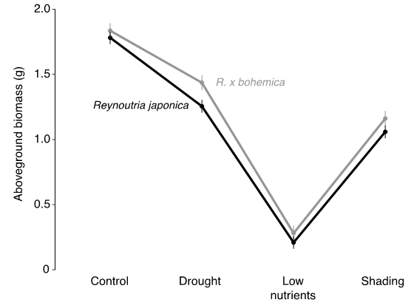
Fig. S1. Biomass responses to the stress treatments, separately for the two knotweed species (the significant Treatment x Species interaction in Table 1). The data are means and standard errors estimated from the linear mixed model.

