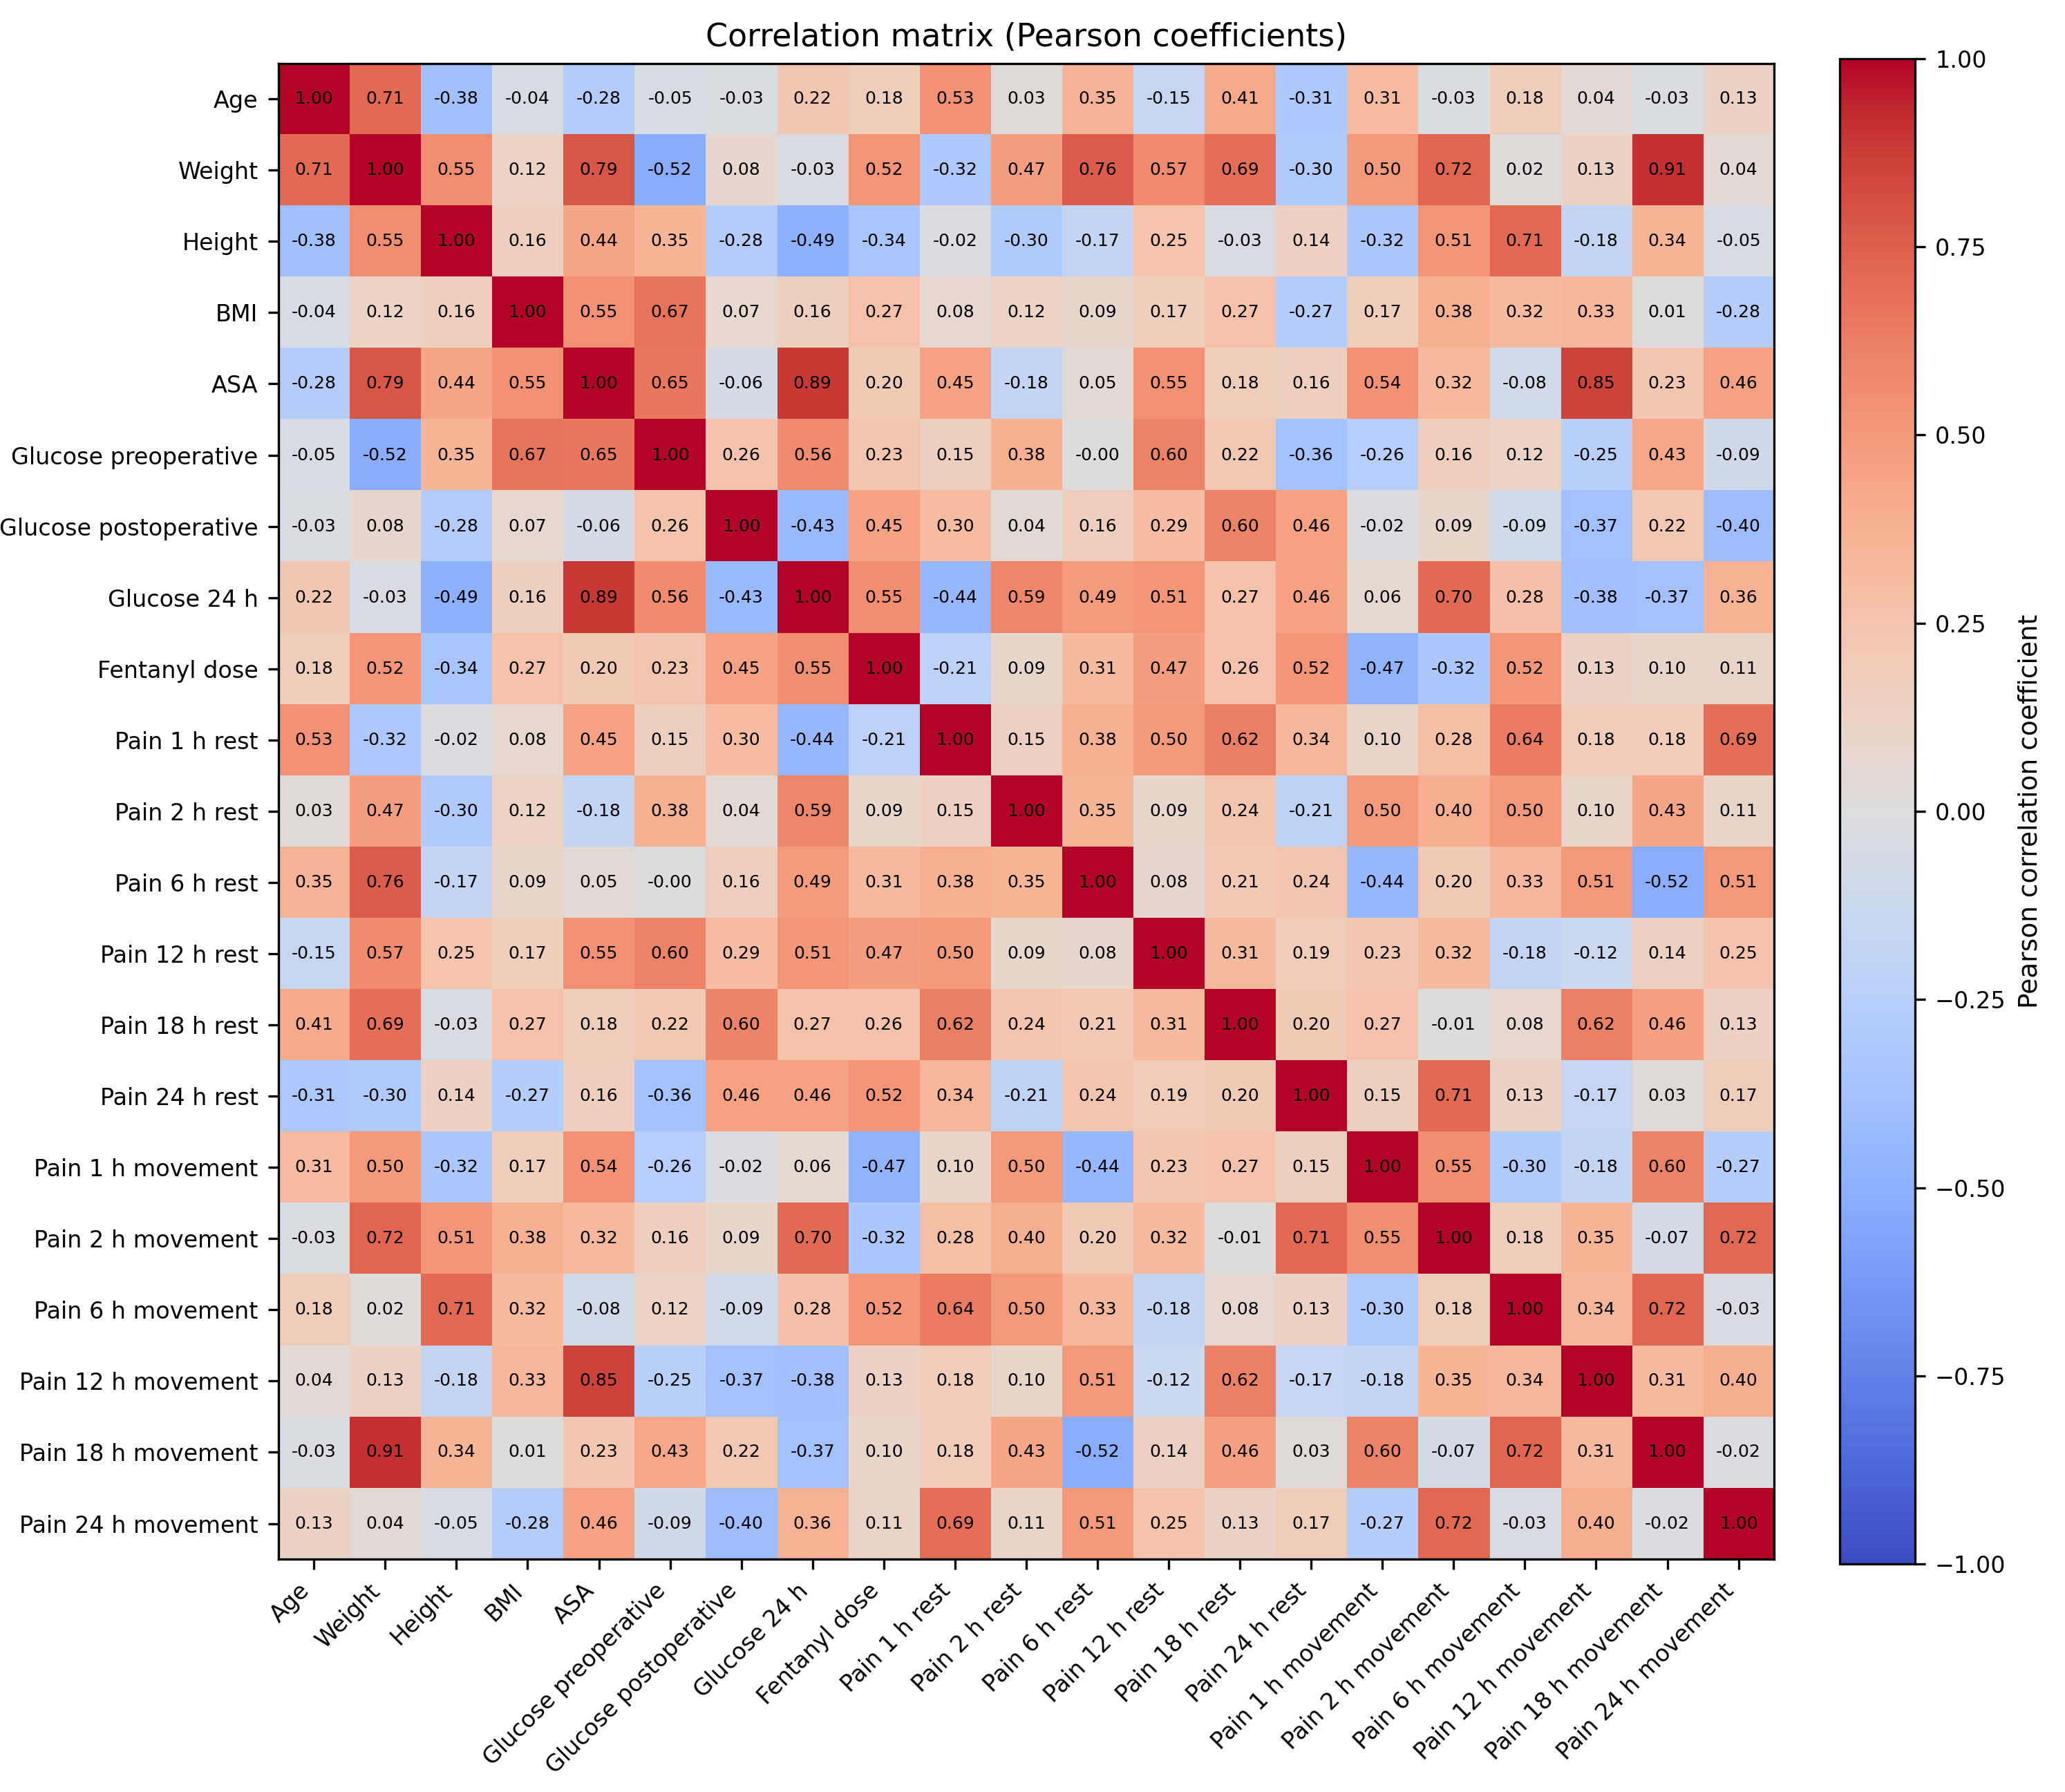
Supplementary Figure S1. Exploratory Pearson correlation matrix of clinical and anesthesiological variables.

