Sleeve Lobectomy After Neoadjuvant Therapy for Non-Small Cell Lung Cancer: A Systematic Review and Meta-analysis
Supplementary Material
Hussein Mussa Muafa¹; Mansoor Khalid Mansoor Ayish²
Corresponding author: Hussein Mussa Muafa; Email: h.m.muafa@gmail.com; ORCID: 0000-0002-5290-025X

Supplementary Methods: Search strategy
Example PubMed strategy: ("Lung Neoplasms"[Mesh] OR NSCLC[tiab] OR "non-small cell lung cancer"[tiab] OR "lung cancer"[tiab]) AND ("sleeve lobectomy"[tiab] OR "sleeve resection"[tiab] OR "bronchial sleeve"[tiab] OR bronchoplasty[tiab] OR bronchoplastic[tiab] OR "bronchovascular sleeve"[tiab] OR "double sleeve"[tiab] OR "extended sleeve"[tiab] OR "pulmonary artery reconstruction"[tiab]) AND (neoadjuvant[tiab] OR induction[tiab] OR preoperative[tiab] OR chemotherapy[tiab] OR chemoradiotherapy[tiab] OR immunotherapy[tiab] OR chemoimmunotherapy[tiab] OR "immune checkpoint inhibitor"[tiab] OR "PD-1"[tiab] OR "PD-L1"[tiab]). Equivalent syntax was adapted for Embase, Scopus/Web of Science, Cochrane CENTRAL, and Google Scholar.

Supplementary Table S1. Extracted event counts used for meta-analysis
Analysis code | Study | Intervention events/total | Comparator events/total
A | Ohta 2003 | 7/20 | 3/28
A | Burfeind 2005 | 8/19 | 19/54
A | Bagan 2009 | 10/42 | 29/117
A | Milman 2009 (CRT) | 9/21 | 20/43
A | Gomez-Caro 2012 (CRT) | 10/26 | 17/53
A | Gonzalez 2013 | 15/28 | 35/71
A | Comacchio 2019 | 22/49 | 42/110
A | Li 2023 (PSM) | 25/97 | 24/97
B | Ohta 2003 | 1/20 | 0/28
B | Burfeind 2005 | 1/19 | 0/54
B | Milman 2009 (CRT) | 0/21 | 2/43
B | Gonzalez 2013 | 3/28 | 2/71
B | Comacchio 2019 early bronchial | 3/49 | 10/110
C | Maurizi 2013 | 11/39 | 12/39
C | Cusumano 2014 | 5/51 | 15/68
C | Teng 2024 (PSM) | 42/104 | 12/26
C | Chen 2025 (SL combined) | 6/60 | 11/34
D | Maurizi 2013 | 0/39 | 1/39
D | Cusumano 2014 | 2/51 | 2/68
D | Teng 2024 (PSM) | 1/104 | 2/26
D | Chen 2025 | 0/60 | 1/34
E | Liang 2021 | 0/10 | 1/10
E | Chen 2023 | 2/14 | 10/33
E | Chen 2024 | 11/56 | 20/83
F | Liang 2021 | 1/10 | 0/10
F | Chen 2024 | 15/56 | 5/83
G | Jaradeh 2022 (NCDB) | 10/84 | 2/92
H | Wang 2026 | 17/74 | 16/60

Supplementary Table S2. Risk-of-bias summary using ROBINS-I logic
Study | Confounding | Selection | Intervention classification | Missing data | Outcome measurement | Overall judgment | Notes
Rendina et al. 1997 | Low | Moderate | Moderate | Low-moderate | Moderate | Moderate-serious | ROBINS-I domain-level judgment; non-randomized evidence.
Veronesi et al. 2002 | Low | Moderate | Moderate | Low-moderate | Moderate | Moderate-serious | ROBINS-I domain-level judgment; non-randomized evidence.
Ohta et al. 2003 | Low | Moderate | Moderate | Low-moderate | Moderate | Moderate-serious | ROBINS-I domain-level judgment; non-randomized evidence.
Burfeind et al. 2005 | Low | Moderate | Moderate | Low-moderate | Moderate | Moderate-serious | ROBINS-I domain-level judgment; non-randomized evidence.
Ludwig et al. 2008 | Low | Moderate | Moderate | Low-moderate | Moderate | Moderate-serious | ROBINS-I domain-level judgment; non-randomized evidence.
Bagan et al. 2009 | Low | Moderate | Moderate | Low-moderate | Moderate | Moderate-serious | ROBINS-I domain-level judgment; non-randomized evidence.
Milman et al. 2009 | Low | Moderate | Moderate | Low-moderate | Moderate | Moderate-serious | ROBINS-I domain-level judgment; non-randomized evidence.
Gomez-Caro et al. 2012 | Low | Moderate | Moderate | Low-moderate | Moderate | Moderate | ROBINS-I domain-level judgment; non-randomized evidence.
Gonzalez et al. 2013 | Low | Moderate | Moderate | Low-moderate | Moderate | Moderate-serious | ROBINS-I domain-level judgment; non-randomized evidence.
Maurizi et al. 2013 | Low | Moderate | Moderate | Low-moderate | Moderate | Moderate-serious | ROBINS-I domain-level judgment; non-randomized evidence.
Toyooka et al. 2013 | Low | Moderate | Moderate | Low-moderate | Moderate | Serious | ROBINS-I domain-level judgment; non-randomized evidence.
Cusumano et al. 2014 | Low | Moderate | Moderate | Low-moderate | Moderate | Moderate-serious | ROBINS-I domain-level judgment; non-randomized evidence.
Toyooka et al. 2015 | Low | Moderate | Moderate | Low-moderate | Moderate | Serious | ROBINS-I domain-level judgment; non-randomized evidence.
Comacchio et al. 2019 | Low | Moderate | Moderate | Low-moderate | Moderate | Moderate-serious | ROBINS-I domain-level judgment; non-randomized evidence.
Chen et al. 2020 | Low | Moderate | Moderate | Low-moderate | Moderate | Serious | ROBINS-I domain-level judgment; non-randomized evidence.
Koryllos et al. 2020 | Low | Moderate | Moderate | Low-moderate | Moderate | Moderate-serious | ROBINS-I domain-level judgment; non-randomized evidence.
Liang et al. 2021 | Low | Moderate | Moderate | Low-moderate | Moderate | Moderate-serious | ROBINS-I domain-level judgment; non-randomized evidence.
Dai et al. 2022 | Low | Moderate | Moderate | Low-moderate | Moderate | Moderate-serious | ROBINS-I domain-level judgment; non-randomized evidence.
Jaradeh et al. 2022 | Low | Moderate | Moderate | Low-moderate | Moderate | Moderate | ROBINS-I domain-level judgment; non-randomized evidence.
Bao et al. 2022 | Low | Moderate | Moderate | Low-moderate | Moderate | Moderate-serious | ROBINS-I domain-level judgment; non-randomized evidence.
Li et al. 2023 | Low | Moderate | Moderate | Low-moderate | Moderate | Moderate | ROBINS-I domain-level judgment; non-randomized evidence.
Chen et al. 2023 | Low | Moderate | Moderate | Low-moderate | Moderate | Moderate-serious | ROBINS-I domain-level judgment; non-randomized evidence.
Teng et al. 2024 | Low | Moderate | Moderate | Low-moderate | Moderate | Moderate | ROBINS-I domain-level judgment; non-randomized evidence.
Chen et al. 2024 | Low | Moderate | Moderate | Low-moderate | Moderate | Moderate | ROBINS-I domain-level judgment; non-randomized evidence.
Han et al. 2024 | Low | Moderate | Moderate | Low-moderate | Moderate | Moderate-serious | ROBINS-I domain-level judgment; non-randomized evidence.
Ma et al. 2025 | Low | Moderate | Moderate | Low-moderate | Moderate | Moderate | ROBINS-I domain-level judgment; non-randomized evidence.
Yang et al. 2025 | Low | Moderate | Moderate | Low-moderate | Moderate | Moderate-serious | ROBINS-I domain-level judgment; non-randomized evidence.
Chen et al. 2025 | Low | Moderate | Moderate | Low-moderate | Moderate | Moderate-serious | ROBINS-I domain-level judgment; non-randomized evidence.
Hu et al. 2025 | Low | Moderate | Moderate | Low-moderate | Moderate | Moderate-serious | ROBINS-I domain-level judgment; non-randomized evidence.
Wang et al. 2026 | Low | Moderate | Moderate | Low-moderate | Moderate | Moderate | ROBINS-I domain-level judgment; non-randomized evidence.
Fukui et al. 2026 | Low | Moderate | Moderate | Low-moderate | Moderate | Moderate-serious | ROBINS-I domain-level judgment; non-randomized evidence.

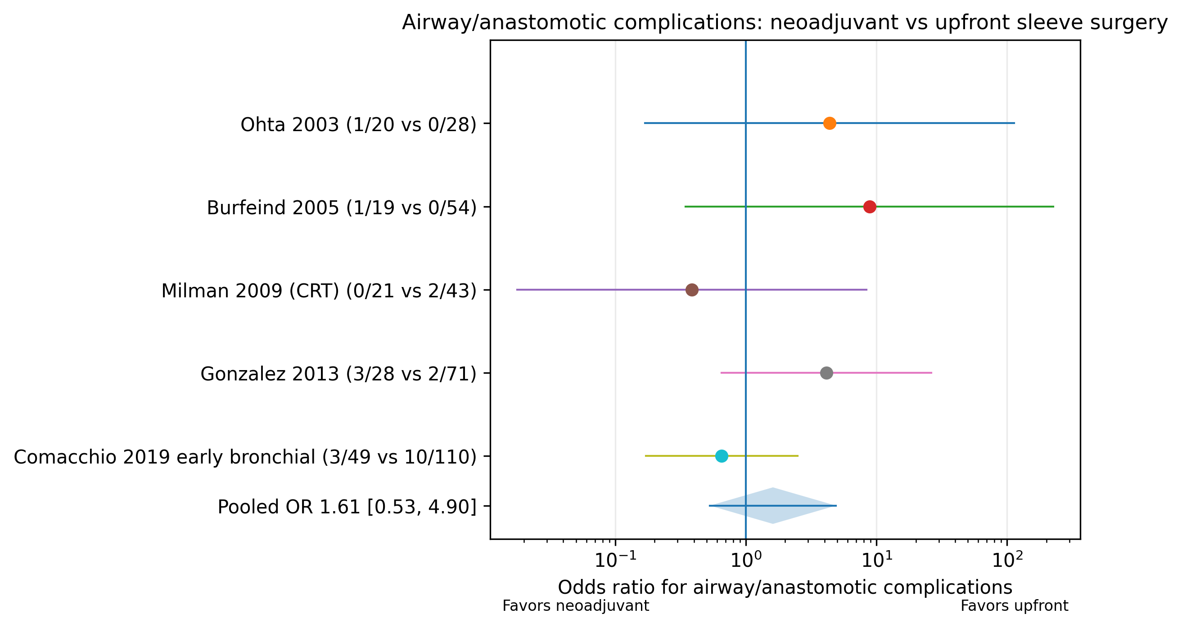
Supplementary Figure S1. Forest plot of airway/anastomotic complications: neoadjuvant therapy versus upfront sleeve surgery.

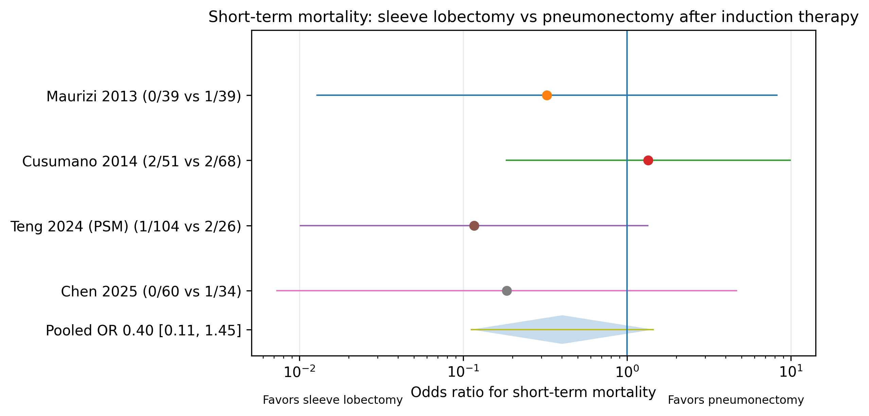
Supplementary Figure S2. Forest plot of short-term mortality: sleeve lobectomy versus pneumonectomy after induction therapy.

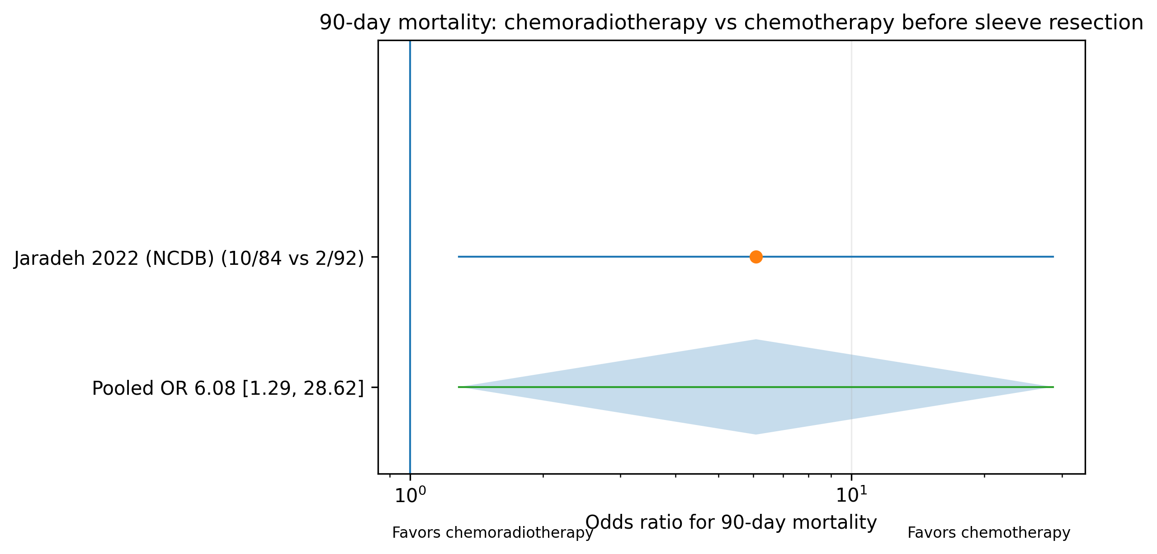
Supplementary Figure S3. Forest plot of 90-day mortality: chemoradiotherapy versus chemotherapy before sleeve resection.

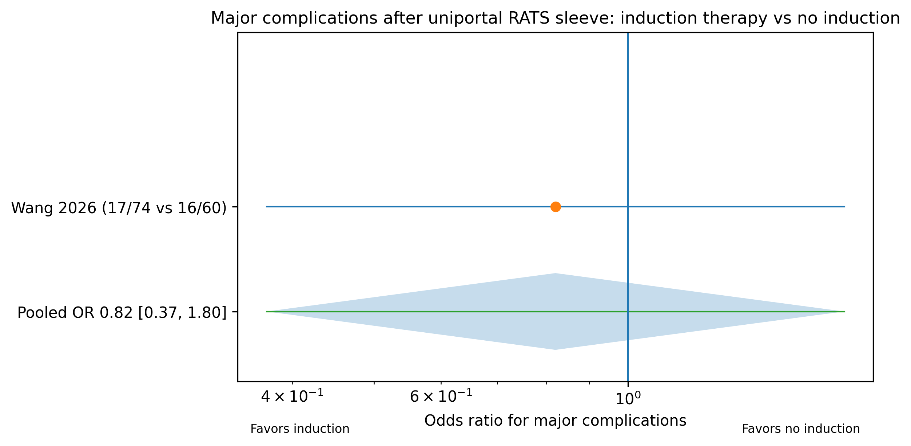
Supplementary Figure S4. Forest plot of major complications after uniportal RATS sleeve: induction therapy versus no induction.

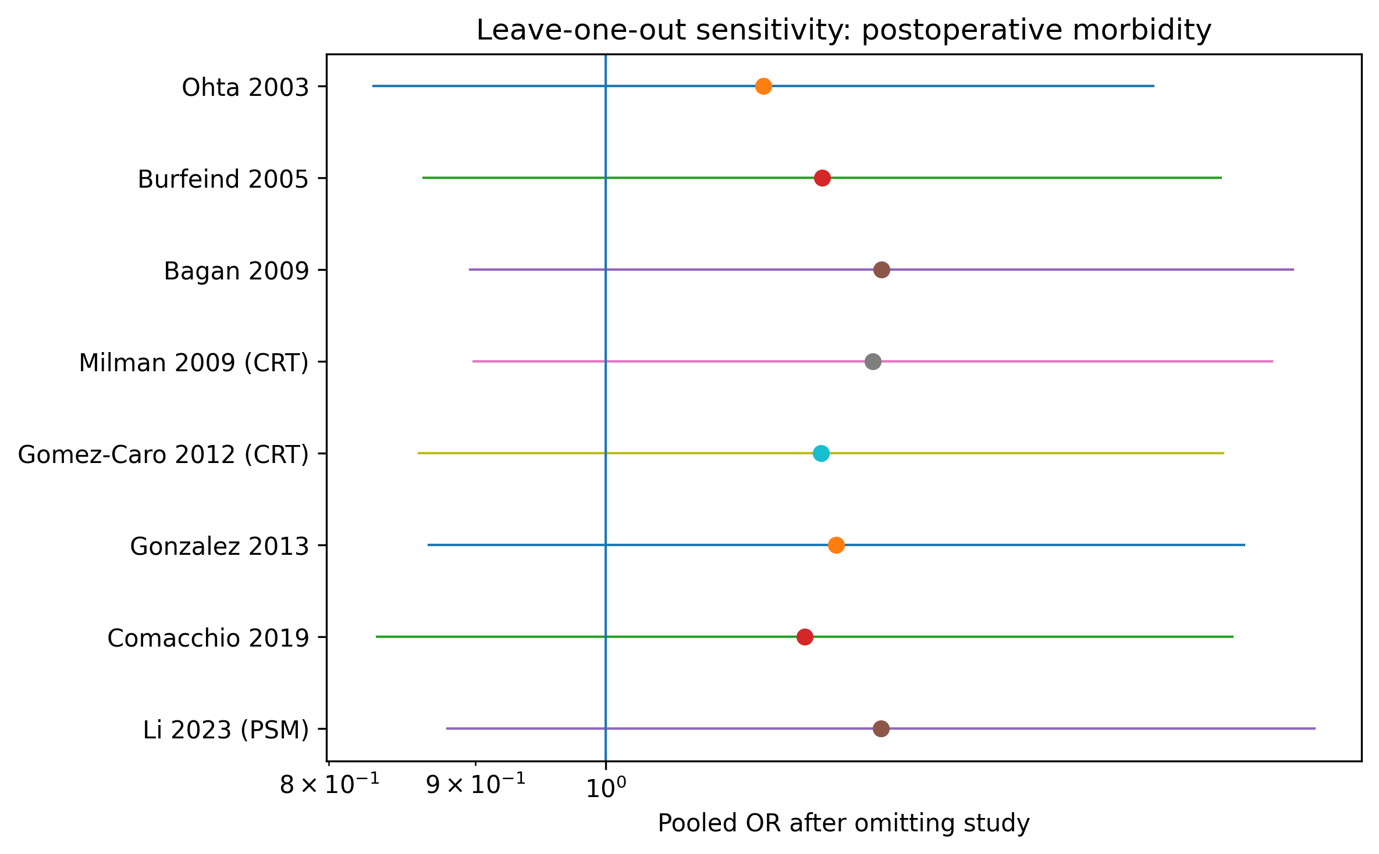
Supplementary Figure S5. Leave-one-out sensitivity analysis for postoperative morbidity.

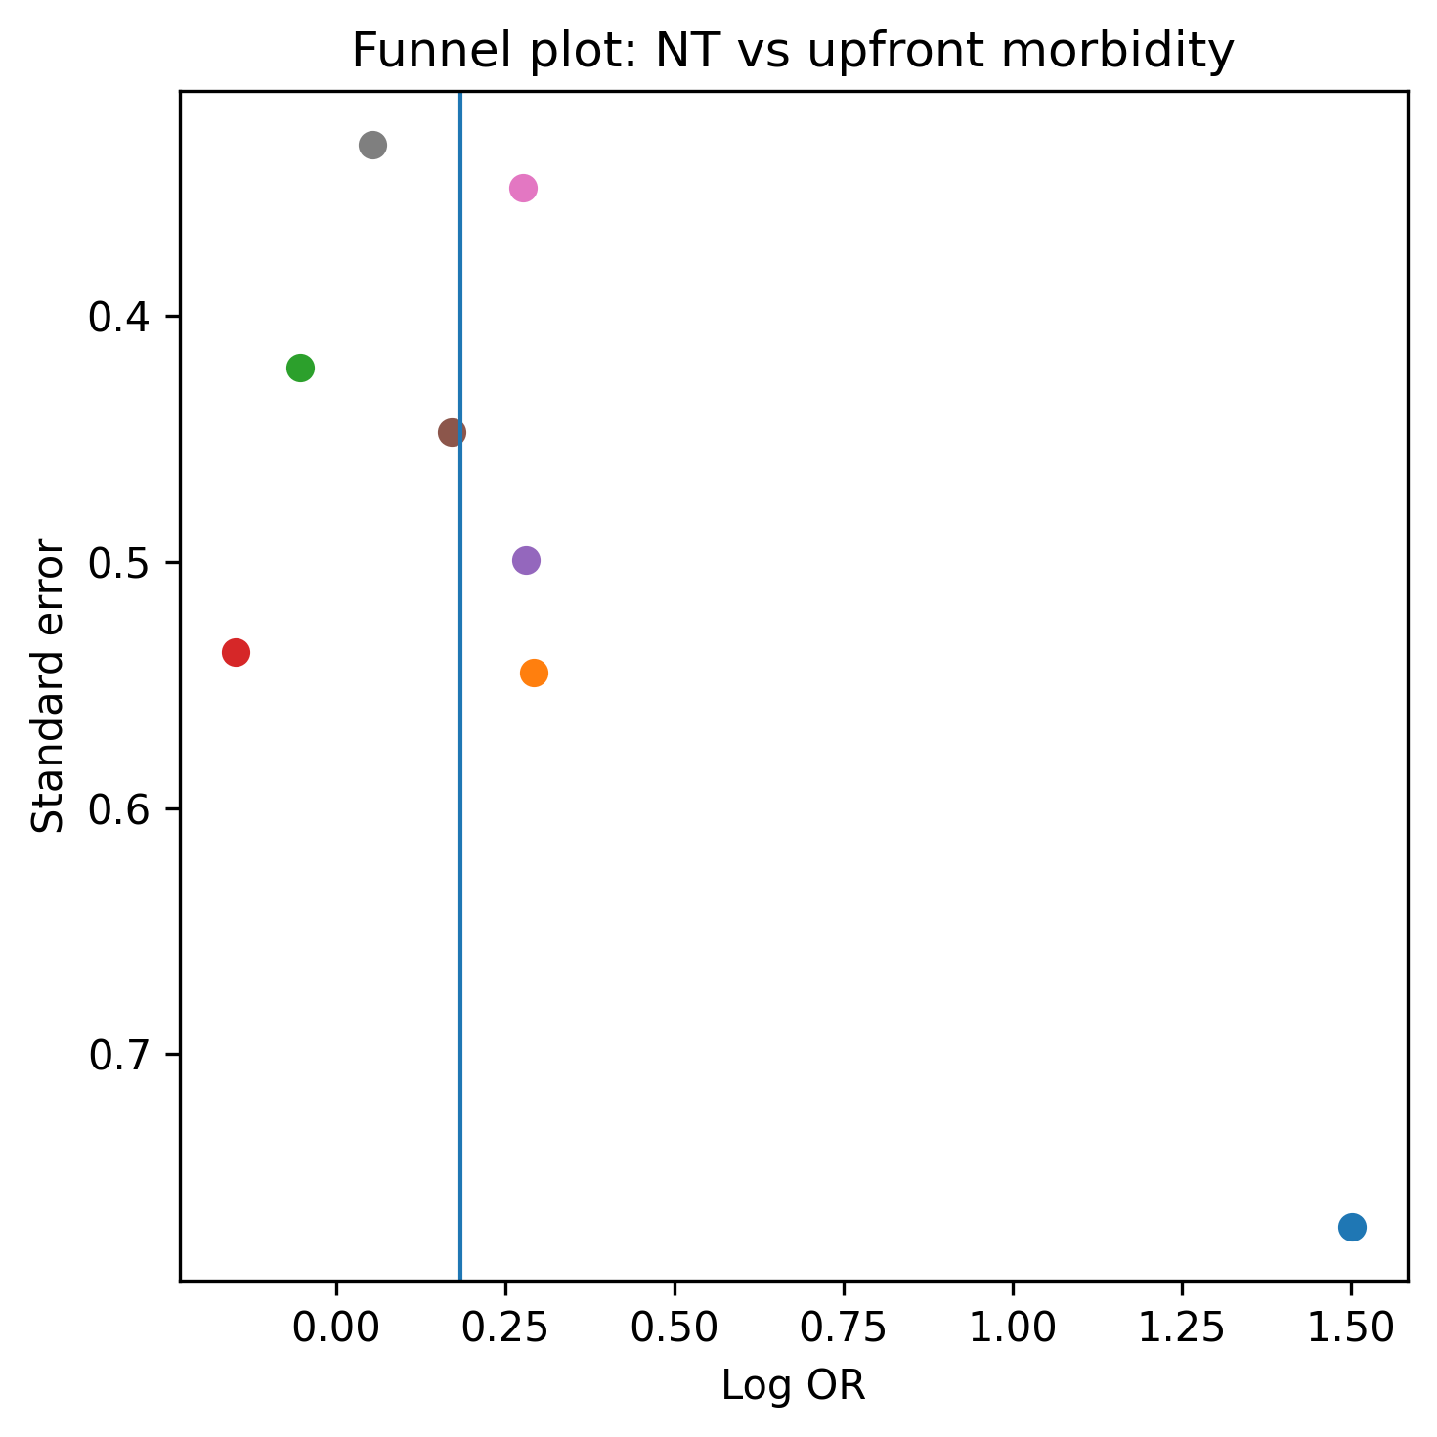
Supplementary Figure S6. Funnel plot for postoperative morbidity analysis.

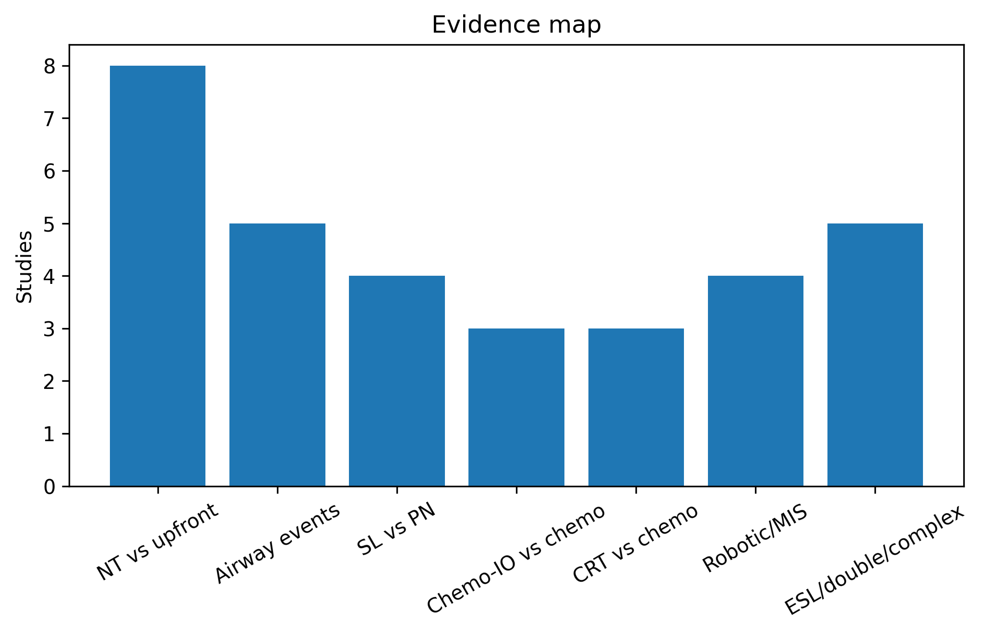
Supplementary Figure S7. Evidence map showing major synthesis domains.

