Supplementary material 3

A quality assurance guide for qualitative birth observation narratives
This QA guide consists of:
- A reminder on the objective of the qualitative birth observation
- A description of the expected content and quality of the data collection output (narrative)
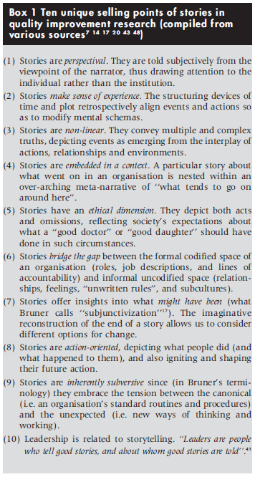
- A suggested step-wise approach to get to the narrative
Textbox 1 Copied from Greenhalgh et al (2005)
Reminder:
The objective of the qualitative birth observation is to collect rich, meaningful qualitative data on quality of care provided in (emergency) obstetric wards that can help inform the redesign of the health system to better serve women, children and their families to enjoy safe, quality and impactful care.
Data collection output:
It is expected that the qualitative birth observation results into a comprehensive qualitative narrative on what happens in the labour room. A narrative is a story that seeks to understand (the quality of) care in terms of human experiences, interactions and purposes. Therefore, it should go beyond what happens (e.g. vital parameters are taken or not), but seeks to understand why (e.g. there seems to be lack of time, protocols are not known, equipment is missing etc). It is therefore essential for the researcher to elaborately document on what happens, when, where and with whom and make sense of the why and how (5 W’s and H), including all factors observed that affect the quality of care at any moment, e.g. staff has no time, all occupied, equipment not available, equipment not at the right place etc.
Box 1 outlines ten unique selling points of stories in quality improvement research as documented by Greenhalgh et al.
Table 1 provides examples on how to reflect deeper on certain activities, including the role of materials, personal interaction, clinical processes and reflexivity of the observer.
Table 1 Examples of how one can makes sense of what happens
Activity | Why and how? (examples)
Vital parameters are not taken | There seems to be lack of time (people are running around), protocols are not known, equipment is missing etc.
Woman is counseled on interventions being taken | What is told to the woman? What are the words being used? Does she seem to understand the information (is this checked with her)? Is she asked for consent? What is the process of consent, etc.
Woman received an episiotomy | Why was the episiotomy performed? What was the indication? Did this indication seem accurate or was it a matter of ‘normality’ (reflexivity of the observer)? How was the woman counseled about this? Etc.

How to get to a narrative:
- Step 1 is to make notes as much and comprehensive as possible during the observation. This also includes a case description (who, when, where).
The birth observation tool is a tool that guides the observer through a) the stages of labour and b) reflect on the seven dimensions on quality of care as defined by the WHO.
It is up to the researcher on how they make the notes, but the annexed note taking sheet may be of support.
- As soon as the observation is completed the observer uses the notes to develop a comprehensive narrative. For quality check of the narrative, please check:
- Various stages of labour observed?
- Sevens domains of quality included?
- Documented on the Who, When, Where, What, Why and How?

Greenhalgh T, Russell J, Swinglehurst D. Narrative methods in quality improvement research. Qual Saf Health Care. 2005 Dec;14(6):443-9. doi: 10.1136/qshc.2005.014712. PMID: 16326792; PMCID: PMC1744090.

