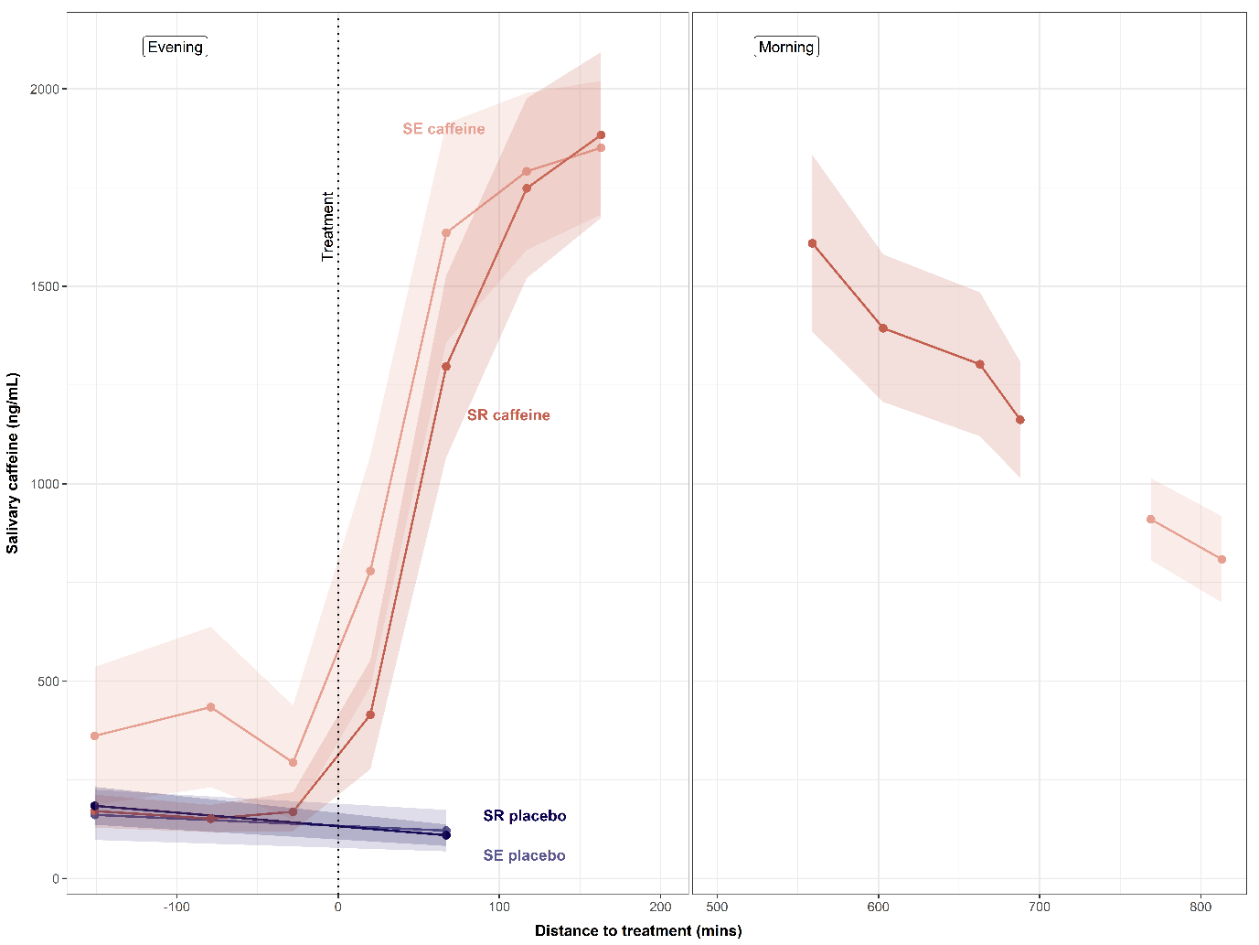
Supplementary Figure 1. Manipulation check: Salivary caffeine and placebo concentrations across evening and morning sampling timepoints by sleep history group
Note. Mean salivary caffeine concentrations (± SEM, shaded ribbons) across seven pre-bedtime sampling timepoints and two to four morning samples (samples 8–11 for Sleep Restriction [SR]; samples 8–9 for Sleep Extension [SE]), separated by sleep history group (SE: light orange and blue; SR: red and dark blue, for caffeine and placebo, respectively). The x-axis represents time relative to caffeine administration (0 = administration timepoint) with the dashed vertical line marking the time of caffeine administration. Salivary caffeine concentrations did not differ significantly between SE and SR at the final pre-bedtime sample (sample 7; SE: M = 1,764 ng/mL, SR: M = 1,883 ng/mL; t(35.3) = −0.46, p = .65).
Supplementary Figure 2. Mean of individual subjective sleepiness after drug administration
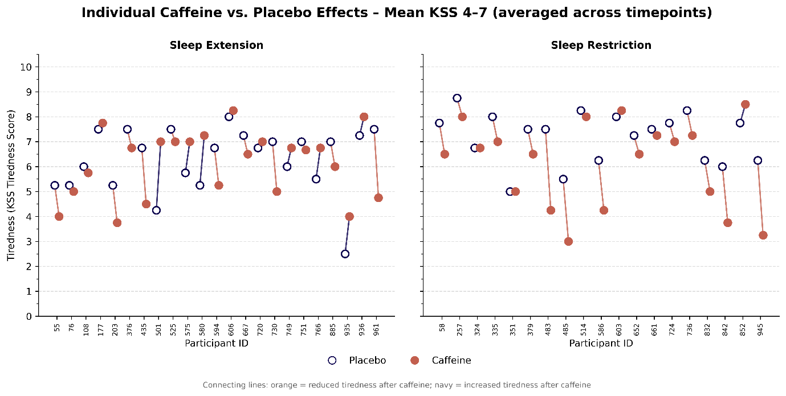
Note. Each pair of points represents one participant's mean Karolinska Sleepiness Scale (KSS) score under caffeine (filled orange circles) and placebo (open navy circles) conditions. Connecting lines indicate the within-person difference. KSS range 1–9 with higher scores indicating greater sleepiness.
Supplementary Table 1. Participant Characteristics by Sleep Condition
Characteristic | Sleep Restriction | Sleep Extension | Total | p-value
Sample size, n | 21 | 24 | 45
Age | 16.44 (1.21) | 15.98 (1.05) | 16.20 (1.14) | p= 0.18
BMI | 22.05 (2.81) | 21.39 (1.94) | 21.70 (2.38) | = 0.36
Sex, n (%) |  |  |  | = 0.55
Male | 9 (42.9%) | 13 (54.2%) | 22 (48.9%)
Female | 12 (57.1%) | 11 (45.8%) | 23 (51.1%)
Pubertal maturation, n (%) |  |  |  | = 0.72
Pre-pubertal | 1 (4.8%) | 1 (4.2%) | 2 (4.4%)
Mid-pubertal | 3 (14.3%) | 6 (25.0%) | 9 (20.0%)
Late-pubertal | 5 (23.8%) | 7 (29.2%) | 12 (26.7%)
Post-pubertal | 12 (57.1%) | 10 (41.7%) | 22 (48.9%)
Health and Sleep Measures, Mean (SD)
Physical health (Kidsscreen) | 20.90 (1.79) | 20.42 (2.04) | 20.64 (1.92) | = 0.40
Psychological well-being (Kidsscreen) | 30.24 (2.07) | 29.38 (3.98) | 29.78 (3.23) | = 0.38
Subjective sleep quality (PSQI) | 2.86 (1.28) | 3.79 (1.22) | 3.36 (1.32) | = 0.02
Chronotype (MCTQ) | 3.84 (0.74) | 4.03 (0.74) | 3.93 (0.74) | = 0.43
Corrected midpoint of sleep (MCTQ, HH:MM) | 03:52 (00:44) | 03:56 (00:43) | 03:54 (00:43) | = 0.77
Daytime sleepiness (ESS) | 6.14 (2.57) | 4.75 (2.40) | 5.40 (2.55) | = 0.07 (0.049)
Self-Reported Sleep Duration (HH:MM), Mean (SD)
Weekdays | 07:51 (00:33) | 07:56 (00:40) | 07:54 (00:36) | = 0.65
Weekends | 09:13 (01:04) | 09:12 (00:59) | 09:12 (01:01) | = 0.96
Note. Values are presented as mean (SD) for continuous variables and n (%) for categorical variables. p-values reflect independent samples t-tests for continuous variables (Age, BMI) and summated scale scores (Kidsscreen, PSQI, ESS, chronotype, sleep duration, midpoint of sleep). Fisher's exact test was used for Sex. Pubertal maturation was tested with chi-square (4 × 2 table); given a minimum expected cell frequency < 5, results should be interpreted with caution. For PSQI and ESS, Mann-Whitney U tests (in brackets for ESS) yielded consistent results except for ESS (U = 338, p = .049), which approached significance; all participants scored below clinical cut-offs (PSQI < 5; ESS < 11), indicating both groups comprised good sleepers without excessive daytime sleepiness. BMI = Body Mass Index; PSQI = Pittsburgh Sleep Quality Index; MCTQ = Munich Chronotype Questionnaire; ESS = Epworth Sleepiness Scale.

Supplementary Table 2. Sleep parameters and frontal SWA/SWE by sleep history, drug condition, and timeframe
Sleep Parameter | Timeframe | Sleep Extension |  | Sleep Restriction
 |  | Placebo | Caffeine | Placebo | Caffeine
WASO (min) | 1h  6h  9.5h | 12.23 (5.56)  25.86 (10.47) | 20.24 (19.98)  41.56 (24.01) | 10.45 (5.52) | 10.20 (3.97)
TST (min) | 1h  6h  9.5h | 48.70 (6.11)  337.79 (8.67)  524.95 (25.32) | 43.12 (9.14)  325.68 (23.54)  503.40 (38.58) | 56.12 (4.23)  346.89 (7.12) | 55.41 (2.80)  346.12 (4.63)
N1 (min) | 1h  6h  9.5h | 5.03 (2.36)  18.75 (7.84)  37.47 (11.90) | 7.62 (5.50)  24.27 (13.02)  46.81 (21.49) | 3.24 (1.59)  18.82 (8.32) | 4.18 (2.77)  21.51 (12.45)
N2 (min) | 1h  6h  9.5h | 10.14 (4.19)  168.82 (14.88)  257.08 (16.38) | 12.29 (4.95)  157.91 (24.82)  239.09 (24.77) | 10.67 (4.40)  146.04 (25.55) | 12.03 (4.64)  146.98 (16.61)
N3 (min) | 1h  6h  9.5h | 33.48 (7.89)  95.36 (14.20)  105.46 (18.72) | 23.17 (11.38)  83.14 (18.24)  93.47 (20.42) | 41.93 (7.24)  102.84 (14.89) | 38.45 (5.63)  96.12 (14.18)
REM (min) | 1h  6h  9.5h | 0.04 (0.14)  54.85 (13.89)  124.94 (26.28) | 0.04 (0.14)  60.37 (16.14)  124.02 (22.69) | 0.28 (0.59)  79.19 (18.67) | 0.75 (1.84)  81.51 (20.35)
NREM (min) | 1h  6h  9.5h | 48.66 (6.08)  282.94 (17.64)  400.00 (26.50) | 43.07 (9.12)  265.31 (20.78)  379.38 (37.17) | 55.84 (4.20)  267.70 (18.67) | 54.66 (2.81)  264.61 (19.62)
%N1 | 1h  6h  9.5h | 10.38 (4.61)  5.54 (2.28)  7.11 (2.16) | 18.19 (12.07)  7.48 (3.99)  9.22 (4.00) | 5.82 (2.81)  5.42 (2.37) | 7.58 (5.19)  6.21 (3.60)
%N2 | 1h  6h  9.5h | 21.49 (10.33)  49.99 (4.36)  49.05 (3.41) | 29.86 (13.35)  48.49 (6.83)  47.52 (3.80) | 19.48 (9.71)  42.11 (7.43) | 21.60 (7.98)  42.48 (4.89)
%N3 | 1h  6h  9.5h | 68.05 (11.05)  28.20 (3.95)  20.10 (3.47) | 51.86 (20.50)  25.62 (5.67)  18.60 (3.91) | 74.21 (10.07)  29.65 (4.31) | 69.51 (10.25)  27.77 (4.12)
%REM | 1h  6h  9.5h | 16.27 (4.22)  23.73 (4.60) | 18.41 (4.64)  24.66 (4.09) | 22.82 (5.34) | 23.53 (5.77)

%NREM | 1h  6h  9.5h | 83.73 (4.22)  76.27 (4.60) | 81.59 (4.64)  75.34 (4.09) | 77.18 (5.34) | 76.47 (5.77)
Sleep efficiency (%) | 1h  6h  9.5h | 81.16 (10.18)  93.83 (2.41)  92.28 (4.43) | 71.86 (15.23)  90.47 (6.54)  88.64 (6.80) | 93.54 (7.05)  96.45 (1.99) | 92.35 (4.66)  96.19 (1.31)
W (min) | 1h  6h  9.5h | 11.30 (6.11)  22.21 (8.67)  43.91 (25.16) | 16.88 (9.14)  34.32 (23.54)  64.57 (38.77) | 3.88 (4.23)  12.77 (7.16) | 4.59 (2.80)  13.71 (4.71)
SOL (min) | 1h  6h  9.5h | 9.96 (6.23) | 14.08 (8.45) | 2.32 (2.86) | 3.34 (2.95)
Latency N2 (min) | 1h  6h  9.5h | 15.01 (5.85) | 21.99 (8.96) | 5.57 (2.96) | 6.94 (3.75)
Latency N3 (min) | 1h  6h  9.5h | 23.94 (6.80) | 34.17 (11.95) | 15.28 (7.07) | 16.60 (4.43)
Latency REM (min) | 1h  6h  9.5h | 100.63 (38.04) | 97.47 (37.77) | 72.01 (22.13) | 76.38 (25.34)
SWA (uV²) | 1h  6h  9.5h | 2084.76 (1139.48)  774.29 (362.83)  568.85 (283.80) | 1740.76 (1293.05)  790.01 (413.75)  601.29 (299.49) | 2413.36 (1083.09)  933.88 (357.90) | 2188.78 (1241.52)  849.76 (311.09)
SWE (log10 uV²·s) | 1h  6h  9.5h | 6.65 (0.27)  7.24 (0.25)  7.30 (0.25) | 6.44 (0.40)  7.18 (0.26)  7.26 (0.25) | 6.82 (0.22)  7.27 (0.17) | 6.75 (0.22)  7.22 (0.18)
Note. Values are mean (SD). Timeframes are 1h, 6h, and 9.5h starting from lights off. Wake after sleep onset (WASO) reflects the total minutes spent awake after initially falling asleep. Total sleep time (TST) is the total number of minutes of actual sleep recorded. Sleep efficiency is the percentage of time in bed spent asleep. Sleep architecture was quantified as the duration (minutes) and proportion (%) of each sleep stage: N1 (light sleep, stage 1 NREM), N2 (intermediate sleep, stage 2 NREM), N3 (deep or slow-wave sleep, stage 3 NREM), REM (rapid eye movement sleep), and NREM (total non-REM sleep, i.e., N1 + N2 + N3). Sleep onset latency (SOL) is the time in minutes from lights off to the first epoch of any sleep stage, latency to N2, N3, and REM indicate the time elapsed in minutes from sleep onset to the first occurrence of each respective stage and therefore shown for one timeframe only. Wake time (W) reflects total minutes of wakefulness recorded during the sleep period. WASO, %REM, and %NREM were omitted for the 1-hour epoch, as sleep stage variables require sufficient sleep duration to yield reliable estimates. The 9.5h timeframe is available only for sleep extension and used to compare to SR 6h. Slow-wave activity (SWA) reflects the power of EEG oscillations in the slow-wave frequency range (0.75–4.5 Hz) during N2 and N3 sleep, expressed in µV². Slow-wave energy (SWE) is the cumulative slow-wave activity across the sleep period, log-transformed (log₁₀ µV²·s) to normalize its distribution; higher values indicate greater overall homeostatic sleep pressure discharged during the night.

Supplementary Table 3. Subjective measures by sleep and drug condition
Outcome | Sleep condition | Drug condition | n | Mean | SD
Subjective Sleepiness (KSS 3) | Sleep Extension | Placebo | 24 | 5.25 | 1.51
Subjective Sleepiness (KSS 3) | Sleep Extension | Caffeine | 23 | 5.35 | 1.5
Subjective Sleepiness (KSS 3) | Sleep Restriction | Placebo | 19 | 5.26 | 1.69
Subjective Sleepiness (KSS 3) | Sleep Restriction | Caffeine | 21 | 5.1 | 1.7
Subjective Sleepiness (KSS 4) | Sleep Extension | Placebo | 23 | 5.83 | 1.59
Subjective Sleepiness (KSS 4) | Sleep Extension | Caffeine | 23 | 5.78 | 1.51
Subjective Sleepiness (KSS 4) | Sleep Restriction | Placebo | 19 | 6.63 | 1.54
Subjective Sleepiness (KSS 4) | Sleep Restriction | Caffeine | 21 | 6.29 | 1.55
Subjective Sleepiness (KSS 5) | Sleep Extension | Placebo | 24 | 5.83 | 1.63
Subjective Sleepiness (KSS 5) | Sleep Extension | Caffeine | 23 | 5.78 | 1.76
Subjective Sleepiness (KSS 5) | Sleep Restriction | Placebo | 19 | 7.05 | 1.39
Subjective Sleepiness (KSS 5) | Sleep Restriction | Caffeine | 21 | 5.95 | 2.04
Subjective Sleepiness (KSS 6) | Sleep Extension | Placebo | 24 | 6.25 | 1.67
Subjective Sleepiness (KSS 6) | Sleep Extension | Caffeine | 22 | 5.95 | 1.65
Subjective Sleepiness (KSS 6) | Sleep Restriction | Placebo | 19 | 7.63 | 0.9
Subjective Sleepiness (KSS 6) | Sleep Restriction | Caffeine | 21 | 6.0 | 2.07
Subjective Sleepiness (KSS 7) | Sleep Extension | Placebo | 24 | 6.71 | 1.52
Subjective Sleepiness (KSS 7) | Sleep Extension | Caffeine | 23 | 6.91 | 1.16
Subjective Sleepiness (KSS 7) | Sleep Restriction | Placebo | 19 | 7.37 | 1.26
Subjective Sleepiness (KSS 7) | Sleep Restriction | Caffeine | 20 | 6.35 | 1.95
Getting to Sleep (LSEQ) | Sleep Extension | Placebo | 23 | 46.36 | 11.34
Getting to Sleep (LSEQ) | Sleep Extension | Caffeine | 22 | 49.16 | 11.98
Getting to Sleep (LSEQ) | Sleep Restriction | Placebo | 19 | 67.88 | 16.61
Getting to Sleep (LSEQ) | Sleep Restriction | Caffeine | 21 | 66.22 | 18.19
Quality of Sleep (LSEQ) | Sleep Extension | Placebo | 23 | 39.23 | 11.4
Quality of Sleep (LSEQ) | Sleep Extension | Caffeine | 22 | 37.77 | 10.55
Quality of Sleep (LSEQ) | Sleep Restriction | Placebo | 19 | 50.7 | 17.33
Quality of Sleep (LSEQ) | Sleep Restriction | Caffeine | 21 | 54.78 | 15.71
Awakening from Sleep (LSEQ) | Sleep Extension | Placebo | 23 | 62.49 | 15.76
Awakening from Sleep (LSEQ) | Sleep Extension | Caffeine | 22 | 58.93 | 13.59
Awakening from Sleep (LSEQ) | Sleep Restriction | Placebo | 19 | 52.47 | 21.6
Awakening from Sleep (LSEQ) | Sleep Restriction | Caffeine | 21 | 51.09 | 15.08
Behaviour following Sleep (LSEQ) | Sleep Extension | Placebo | 23 | 49.14 | 19.87
Behaviour following Sleep (LSEQ) | Sleep Extension | Caffeine | 22 | 51.53 | 11.96
Behaviour following Sleep (LSEQ) | Sleep Restriction | Placebo | 19 | 36.34 | 19.5
Behaviour following Sleep (LSEQ) | Sleep Restriction | Caffeine | 21 | 38.88 | 22.72
Note. Subjective sleepiness (measured by Karolinska Sleepiness Scale, KSS) is shown separately for each time of assessment (KSS 3-7). KSS3 refers to the time pre-treatment (caffeine vs placebo), all other assessments were conducted post treatment. Higher values indicate higher subjective sleepiness. Subjective sleep quality was measured 15 minutes after scheduled wake-up by the Leeds Sleep Evaluation Questionnaire (LSEQ) where values below 50 indicate worse sleep evaluation compared to a usual night. Values are presented as n, mean (SD).

