Horseshoe Salinity Pattern in the Upper Indian Ocean and its Decadal Variability
Limonlisa Sahu¹, Balaji Senapati^{2*}, Mihir K. Dash¹, Swadhin K. Behera³
¹Centre for Ocean, River, Atmosphere and Land Sciences, Indian Institute of Technology Kharagpur, Kharagpur, West Bengal, India
²Department of Meteorology, University of Reading, Reading, UK
³Application Laboratory, VAiG, Japan Agency for Marine-Earth Science and Technology, Yokohama, Kanagawa, Japan
Contents of the file:
- Tables: Supplementary Table 1
- Figures: Supplementary Figure 1-18

Datasets | EOF Modes | Variance (%) | Errors | Results
ARGO -75m | EOF1 | 10.62 | 1.12 | Significant
ARGO -75m | EOF2 | 6.57 | 0.69 | Significant
EN4 - 75m | EOF1 | 9.59 | 0.48 | Significant
EN4 - 75m | EOF2 | 5.91 | 0.35 | Significant
Table S1. Significance of EOF modes using the North Criteria test for both ARGO and EN4 datasets.
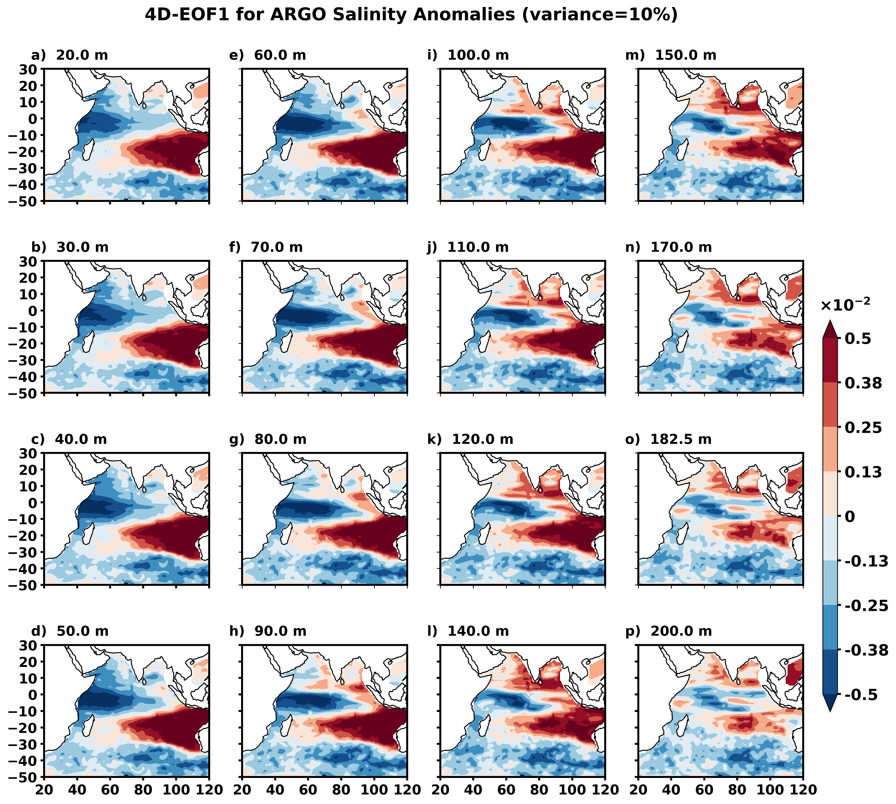
Figure S1. Spatial structure of the 4D-EOF1 mode derived from ARGO data, representing the dominant pattern of upper-ocean salinity variability in the Indian Ocean at different depths: (a) 20m, (b) 30m, (c) 40m, (d) 50m, (e) 60m, (f) 70m, (g) 80m, (h) 90m, (i) 100m, (j) 110m, (k) 120m, (l) 140m, (m) 150m, (n) 170m, (o) 180m, and (p) 200m.
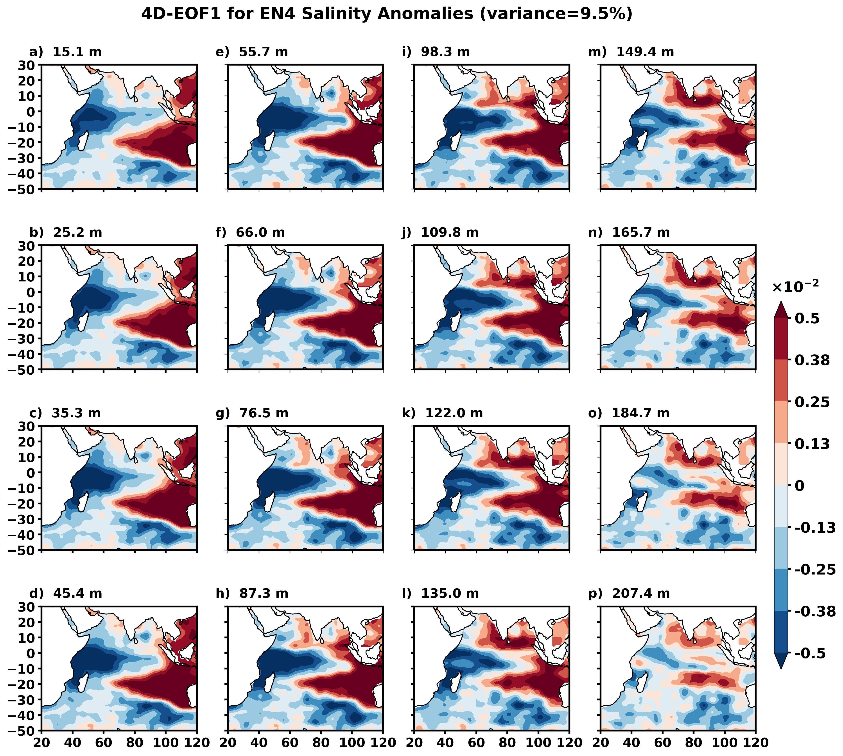
Figure S2. Spatial structure of the 4D-EOF1 mode derived from EN4 data, representing the dominant pattern of upper-ocean salinity variability in the Indian Ocean at different depths: (a) 15m, (b) 25m, (c) 35m, (d) 45m, (e) 55m, (f) 66m, (g) 76m, (h) 87m, (i) 98m, (j) 109m, (k) 122m, (l) 135m, (m) 150m, (n) 165m, (o) 185m, and (p) 207m.
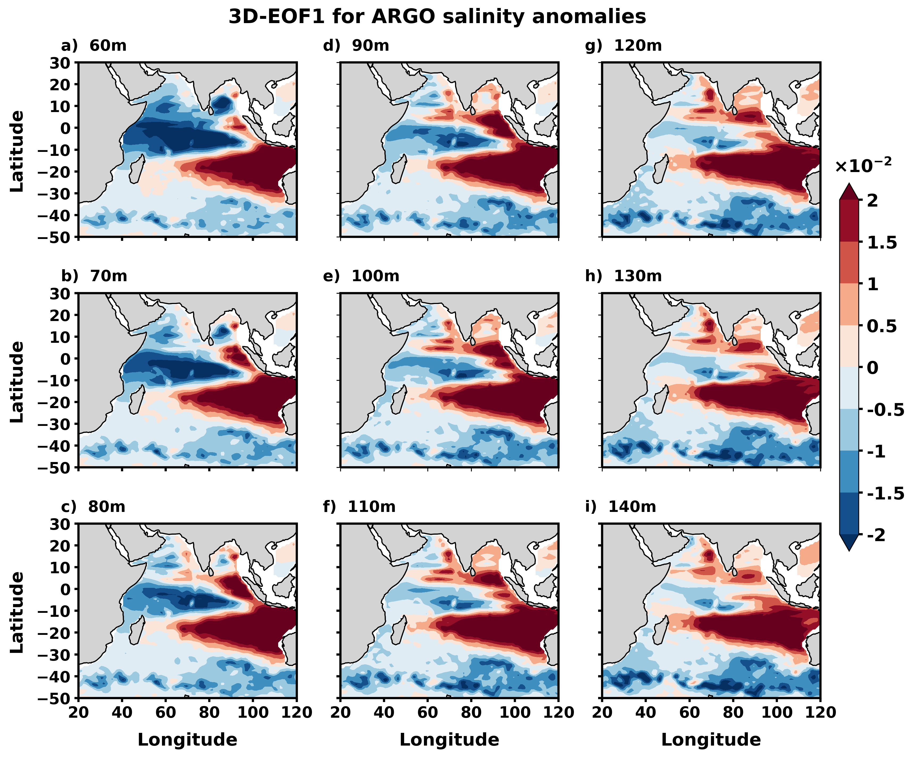
Figure S3. Spatial structure of the first 3D-EOF (EOF1) mode representing the dominant pattern of salinity variability in the upper Indian Ocean derived from ARGO data at depths of (a) 60m, (b) 70m, (c) 80m, (d) 90m, (e) 100m, (f) 110m, (g) 120m, (h) 130m, and (i) 140m respectively.
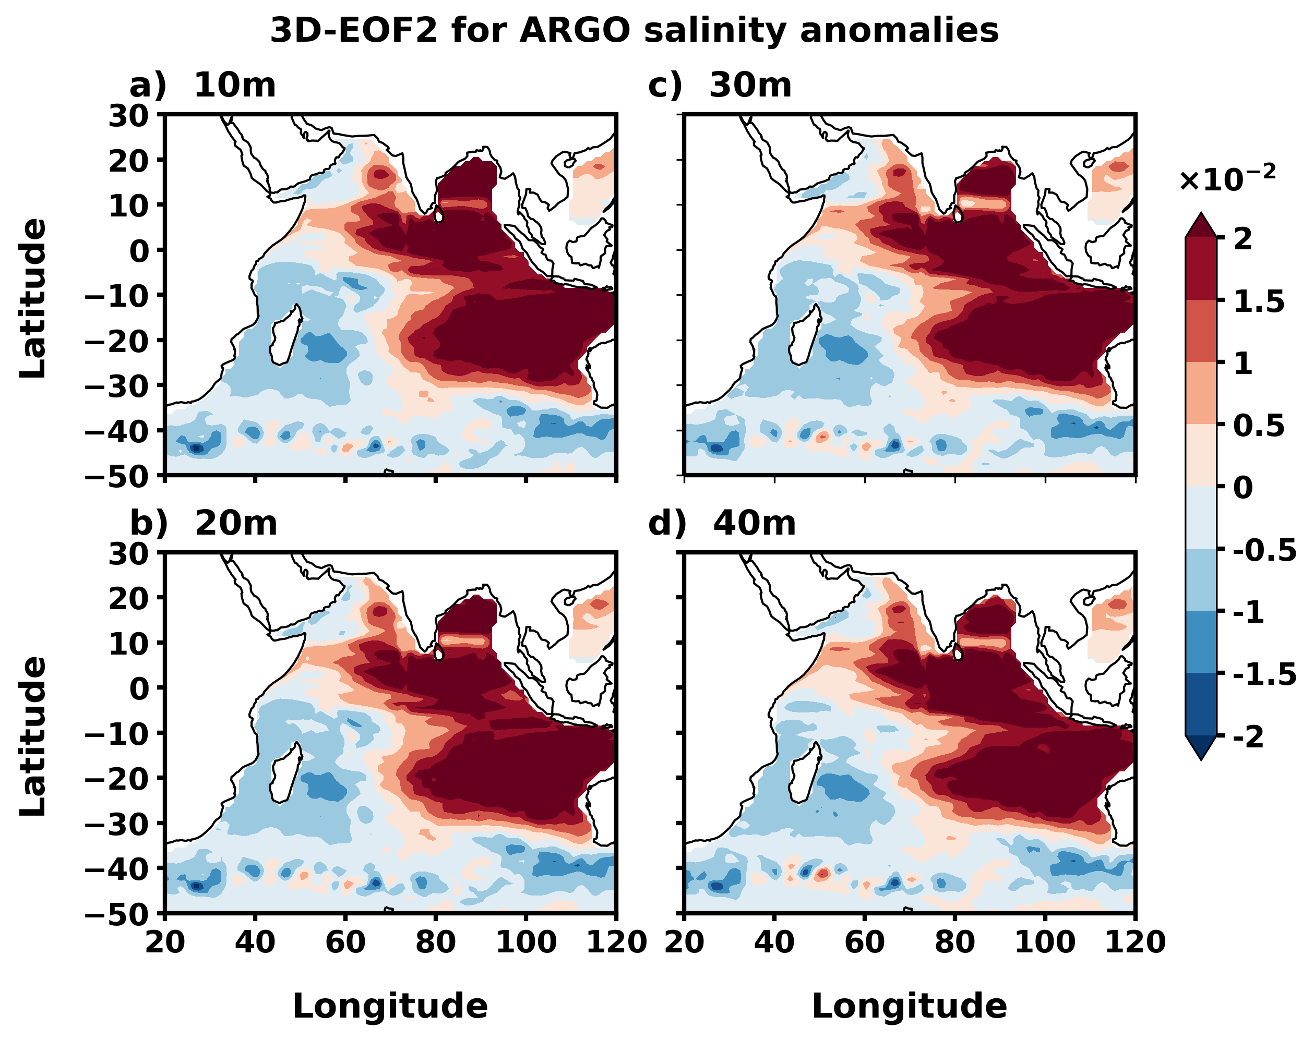
Figure S4. Spatial pattern of the second EOF mode (EOF2) of ARGO salinity anomalies obtained from 3D-EOF analysis at different depths: (a) 10m, (b) 20m, (c) 30m, and (d) 40m. The Horseshoe Salinity Pattern is consistently evident across all depth levels.
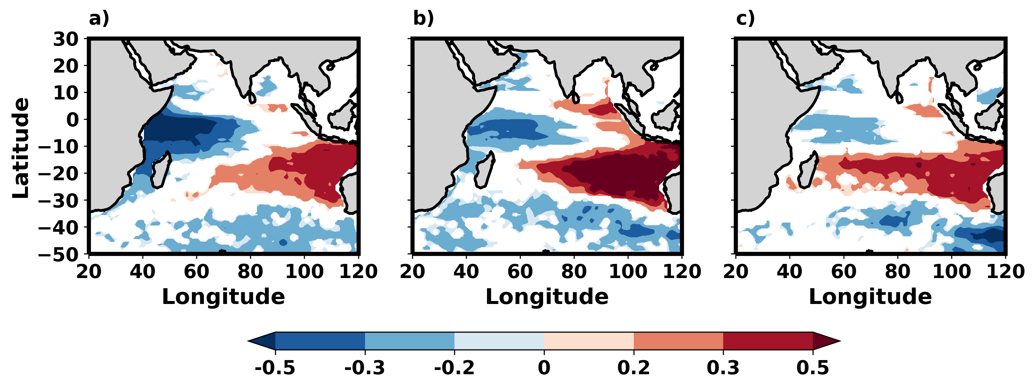
Figure S5. Point correlation map between ARGO salinity anomaly at 80m and point time series (pointed in yellow dots in Fig. 1a) from (a) WTIO, (b) SETIO, and (c) SSIO regions. Values satisfying the 95% confidence interval are shaded.
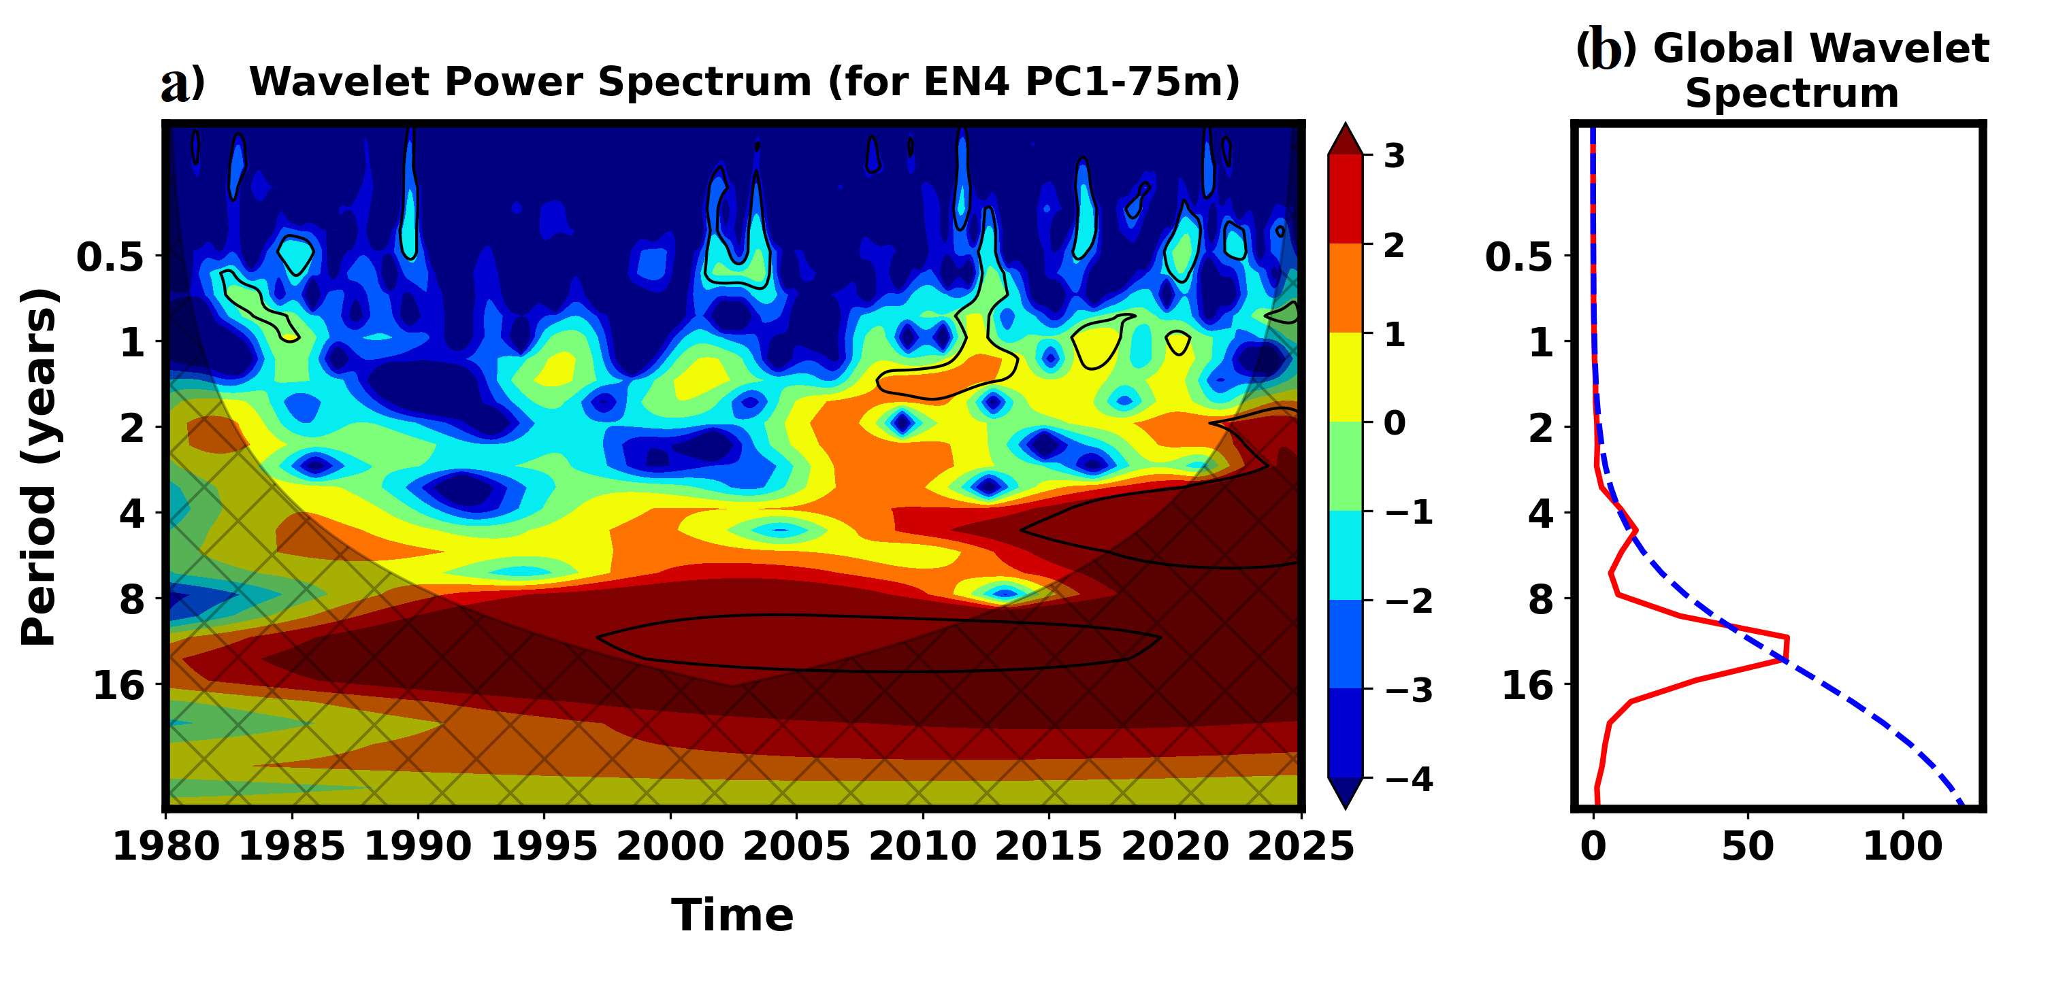
Figure S6. Wavelet power spectra (a) and global wavelet spectra (b) of the first principal component (PC1) of salinity anomalies from EN4 at 75 m depth. Black contours in (a) indicate regions significant at the 95% confidence level, and the hatched areas denote the cone of influence. In (b), the red line represents the observed global wavelet power, while the blue dashed line shows the red-noise background spectrum used for significance testing, highlighting the dominant decadal variability band in the 75 m salinity record.
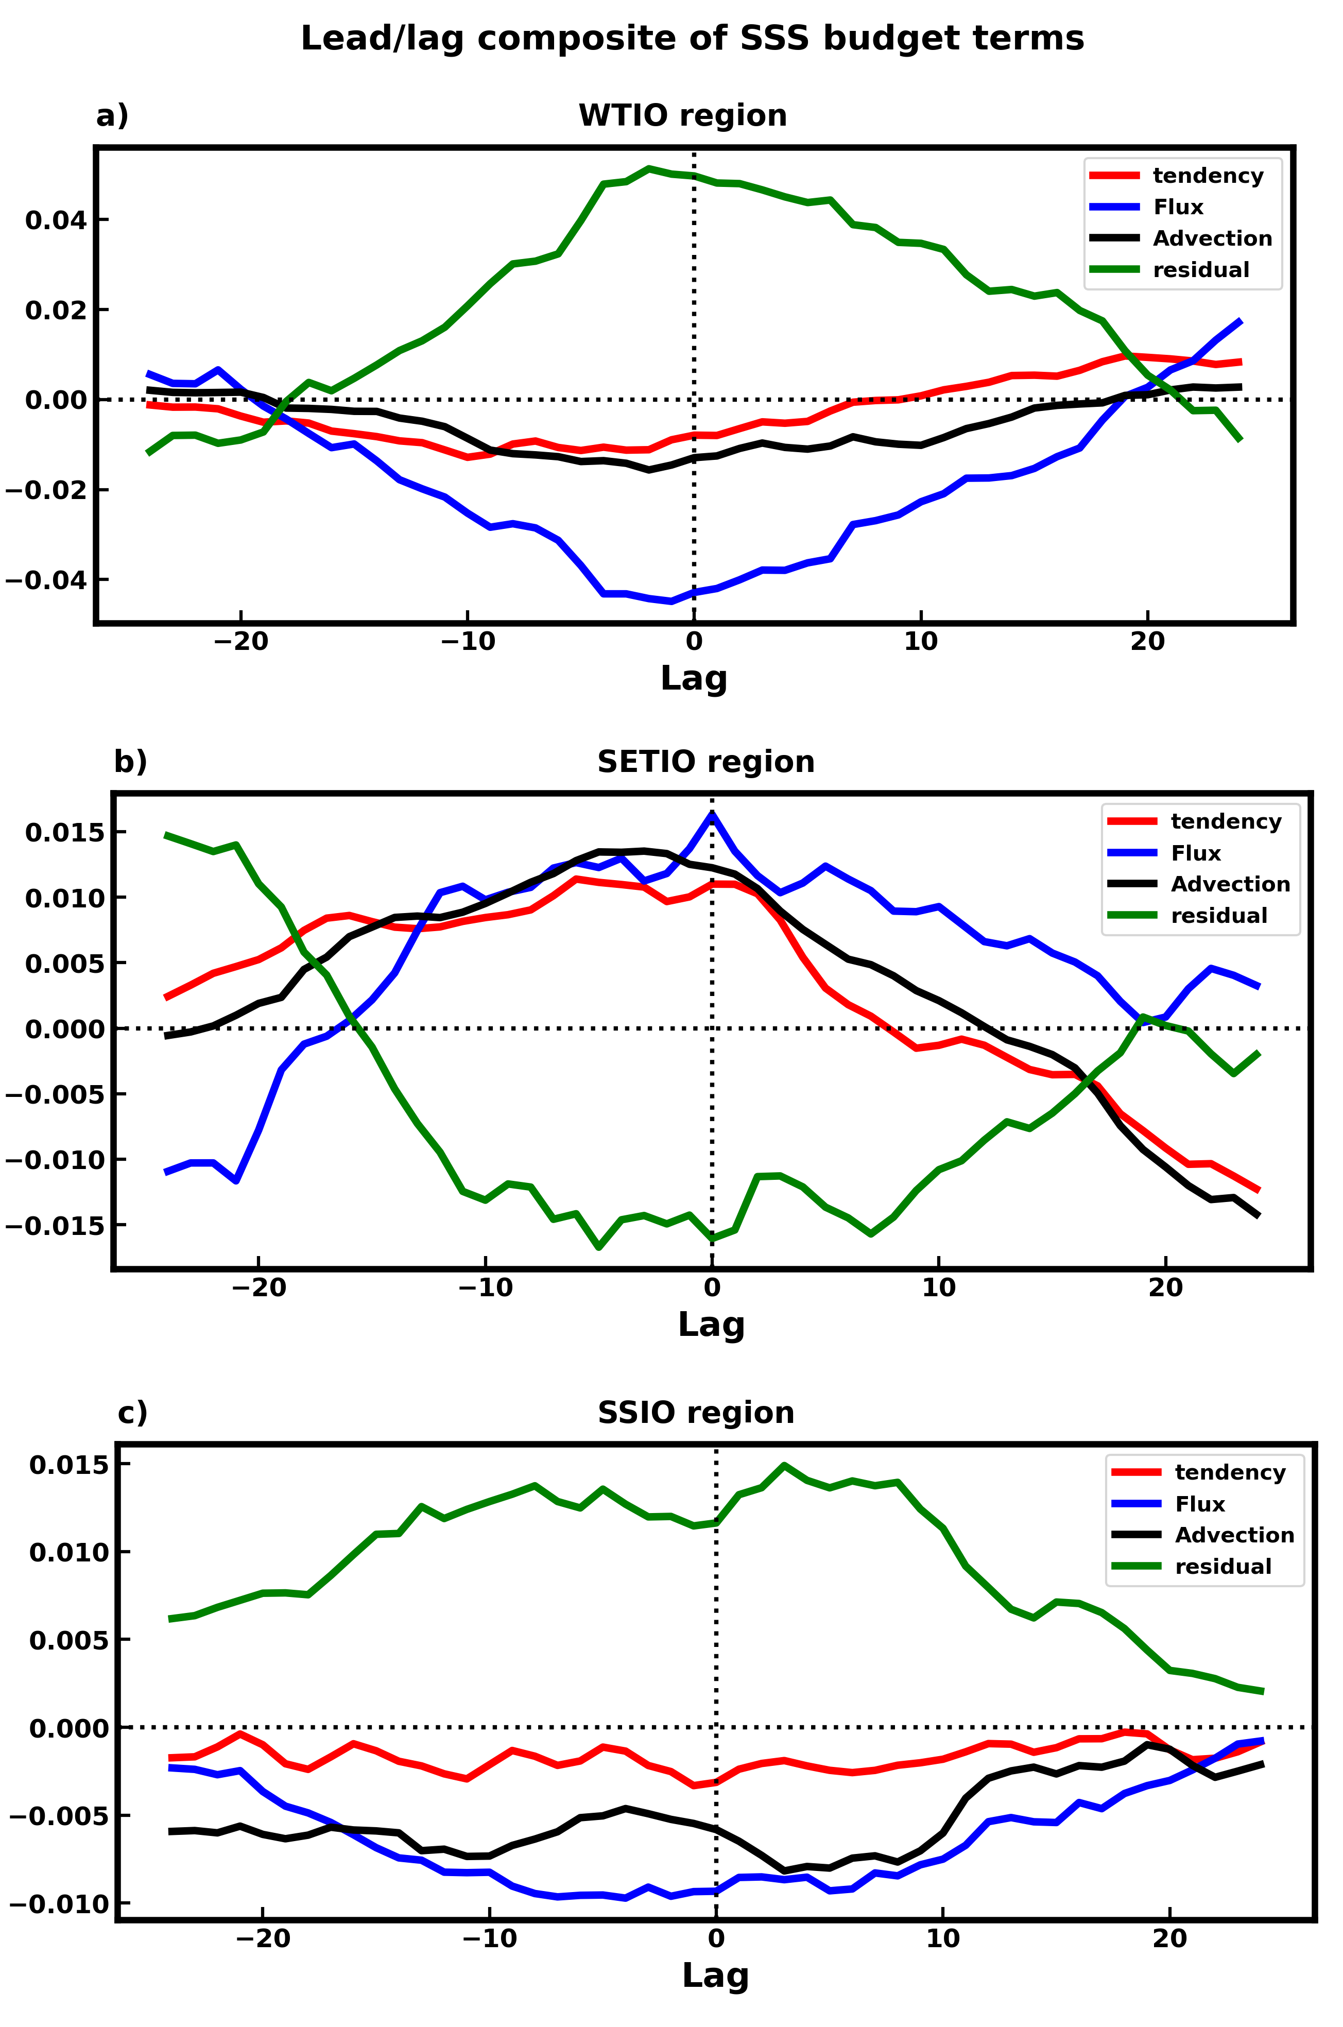
Figure S7. Lead-lag composite differences between positive-growth and negative-growth phases of different SSS budget terms over (a) WTIO region, (b) SETIO region, and (c) SSIO region. The composites for both phases are constructed over identical time periods, consistent with the budget analysis used in Figs. 4 & 5, to ensure a direct and consistent comparison across all terms and regions. The values in the Y-axis are in the PSU month⁻¹ unit.
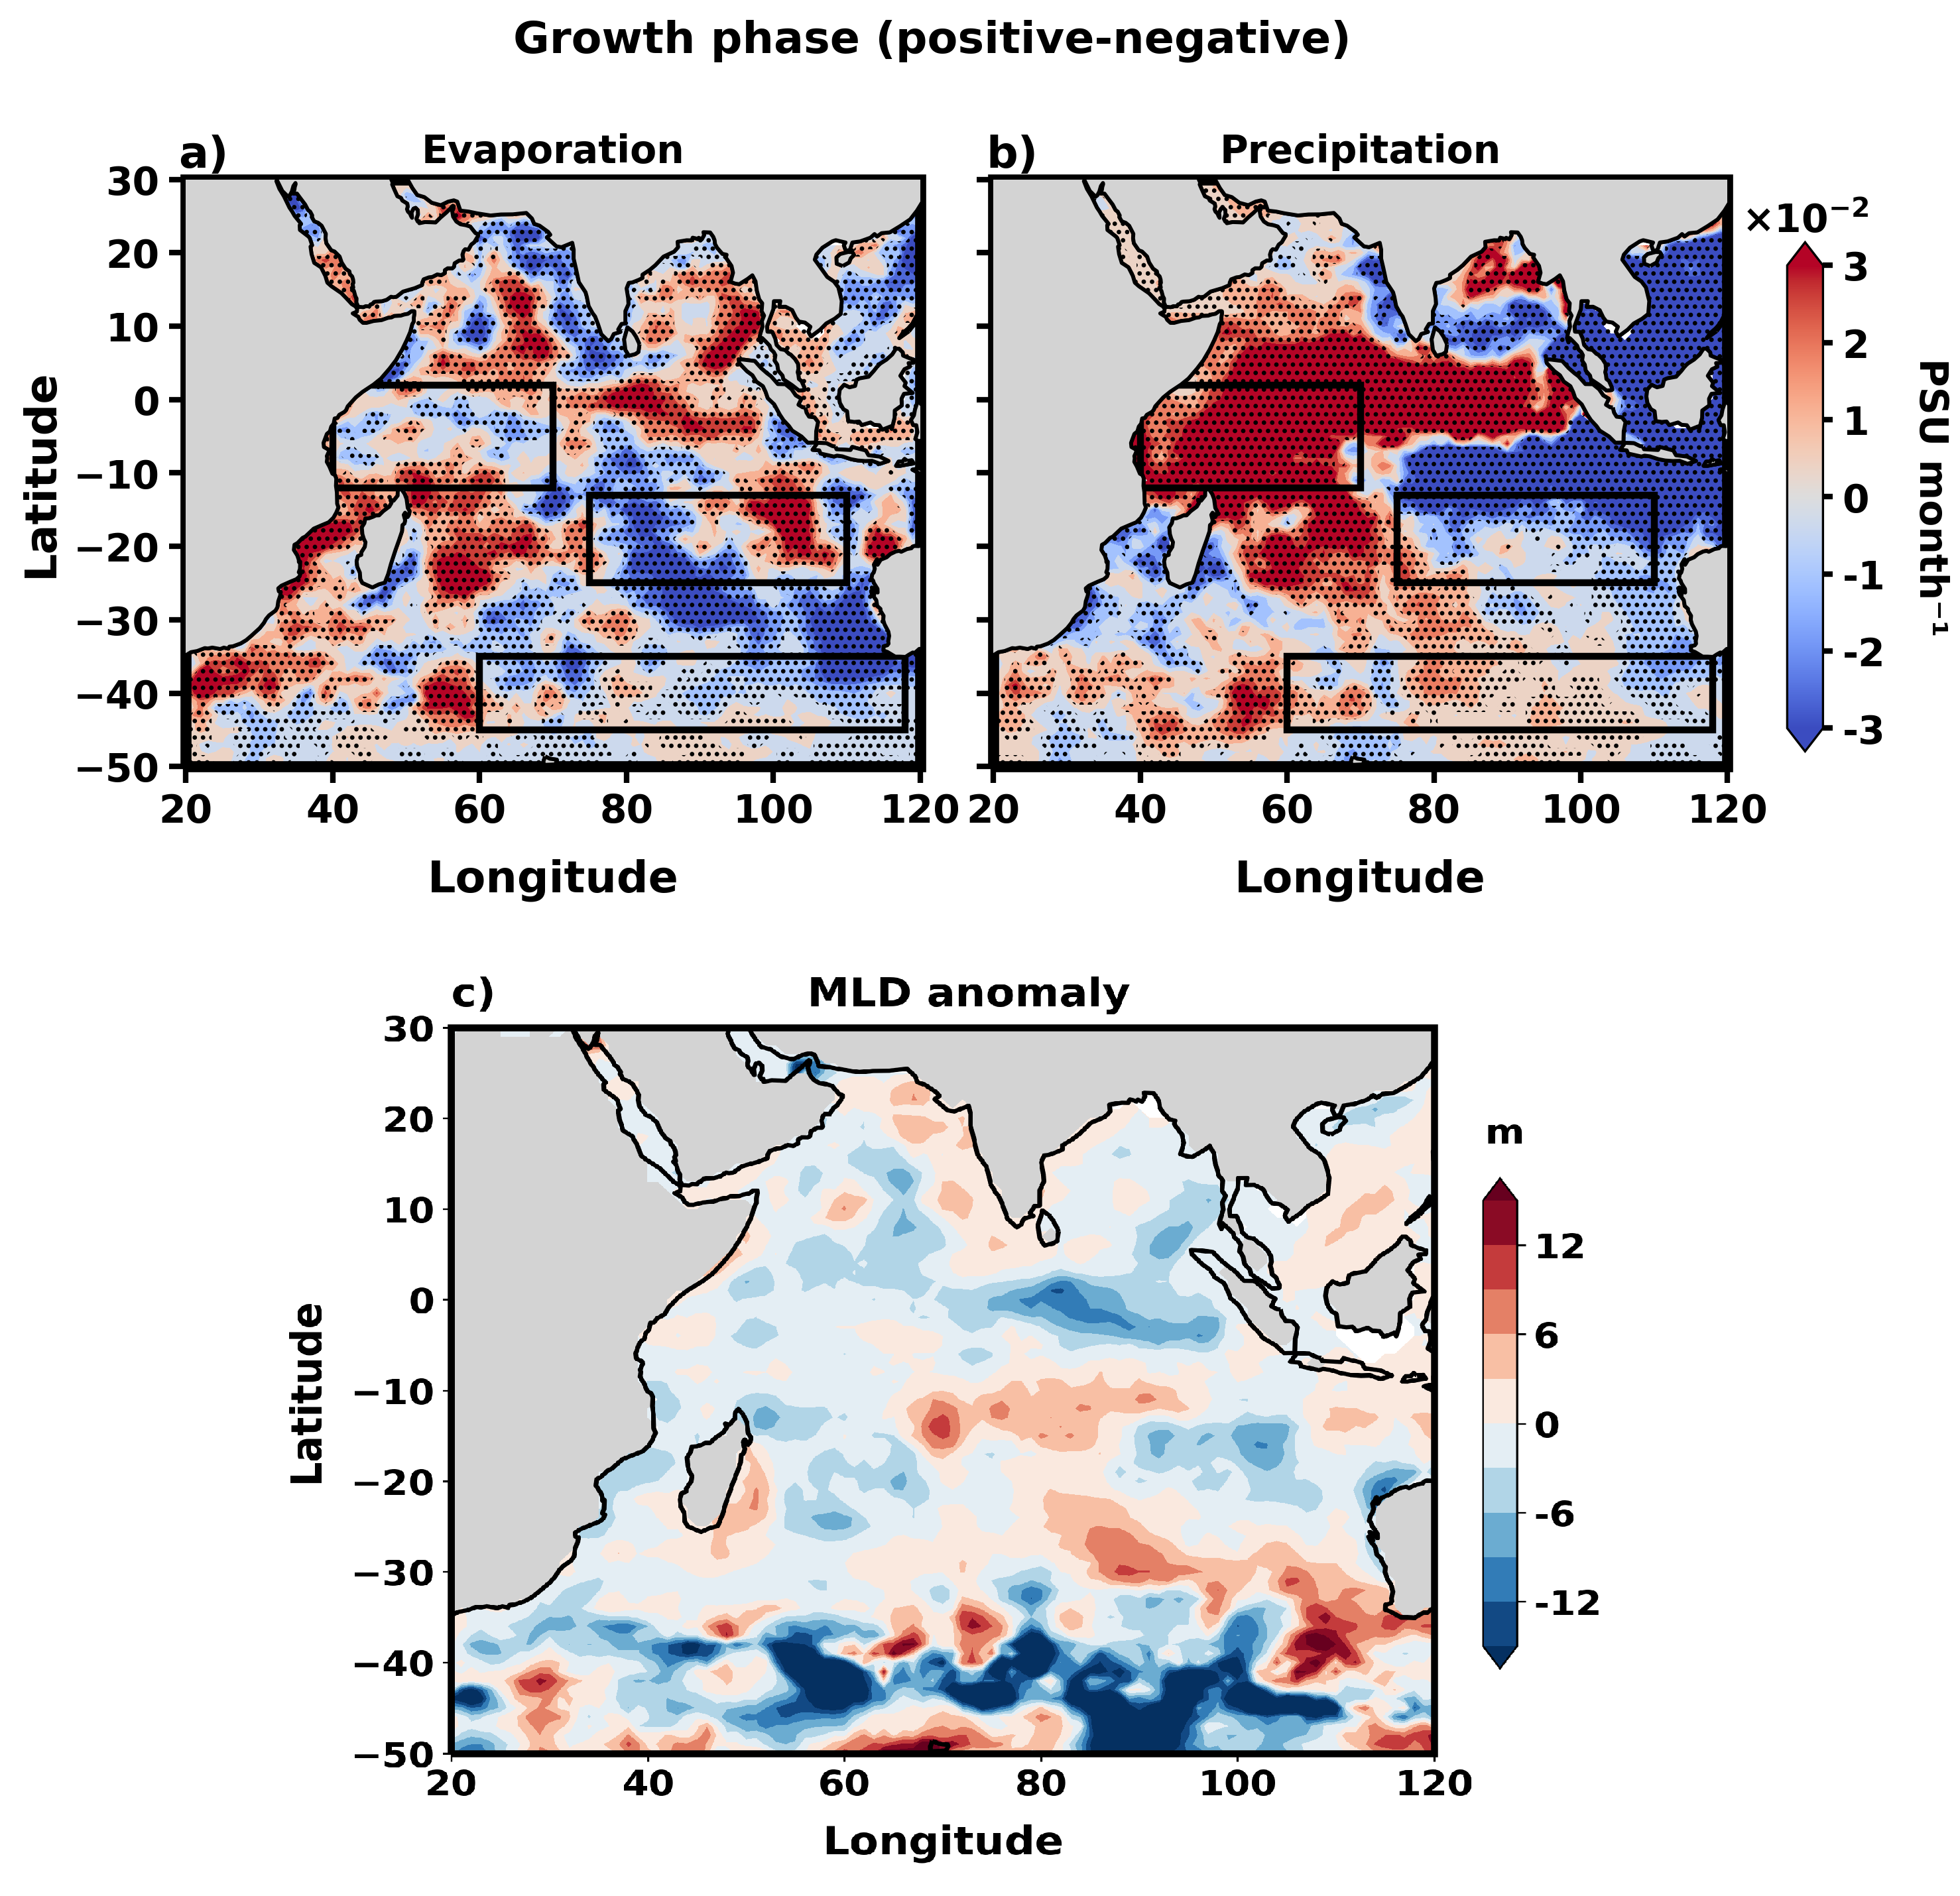
Figure S8. Composites of differences between the positive and negative phases during the EN4 PC1 growth period: (a) evaporation and (b) precipitation (both in PSU month⁻¹). (c) Filtered mixed layer depth (MLD) anomaly (m), representing key components of the freshwater flux term in Equation 2. Values outside the dotted regions are significant at the 95% level.
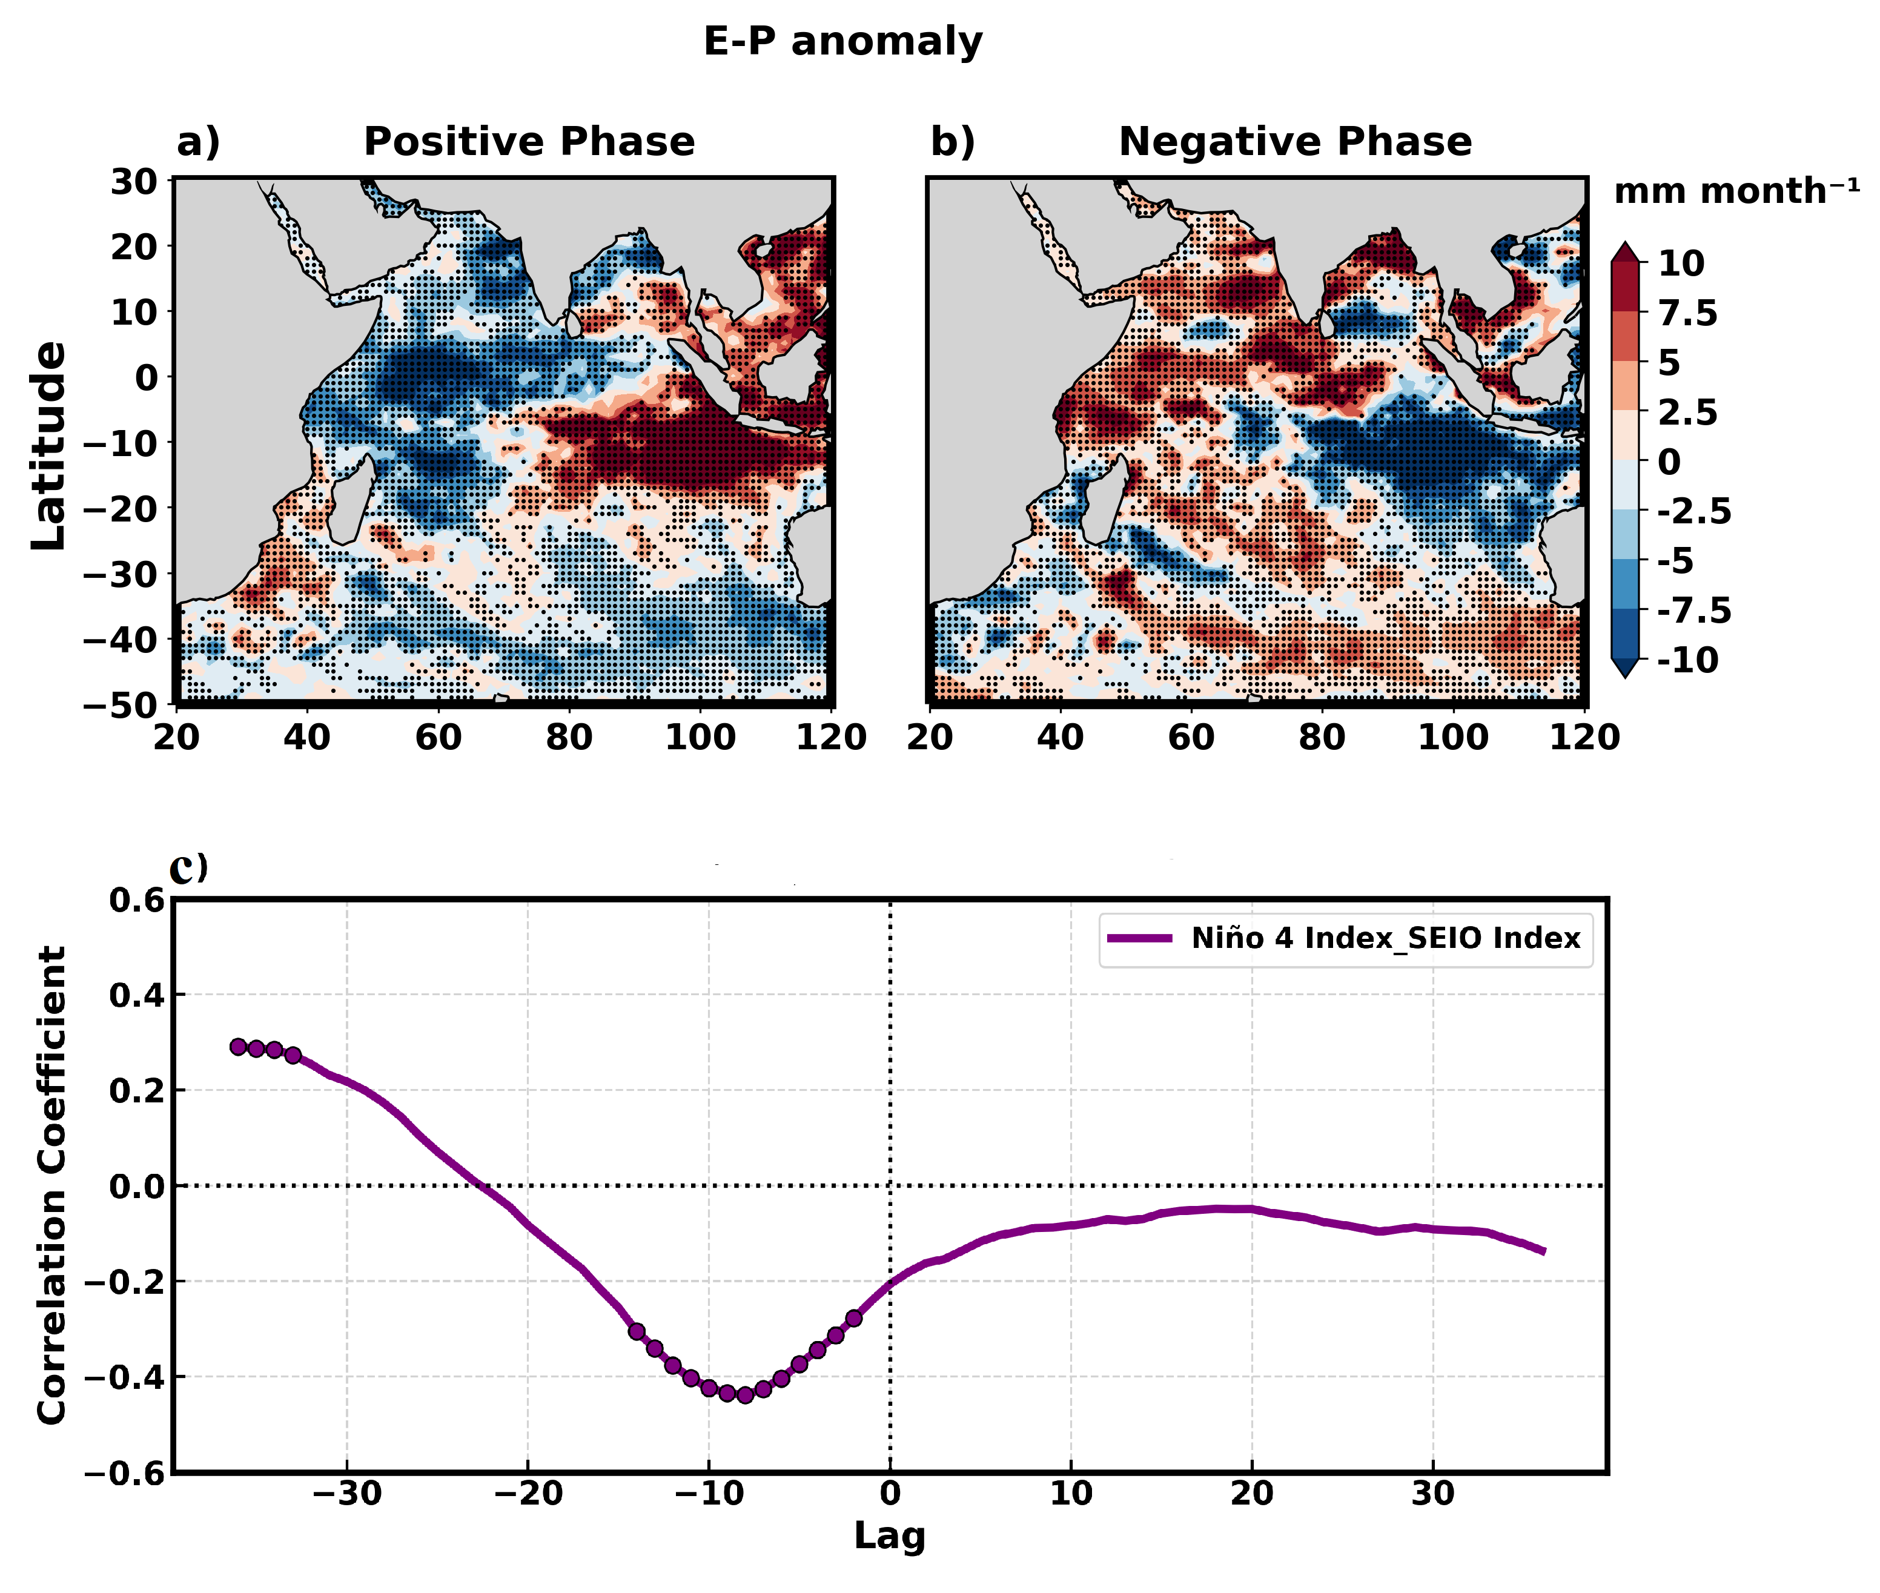
Figure S9. Composite maps of filtered (8-16 years) evaporation minus precipitation (in mm month⁻¹) during (a) positive and (b) negative phases of the HSP. Values outside the dotted regions are significant at the 95% confidence interval using students’ t-test. (c) Lead–lag correlation between the Niño-4 and SEIO index. Positive lag values indicate that the Niño-4 index leads the SEIO index. Closed circles mark correlations significant at the 95% confidence level (two‐tailed Student’s t‐test).
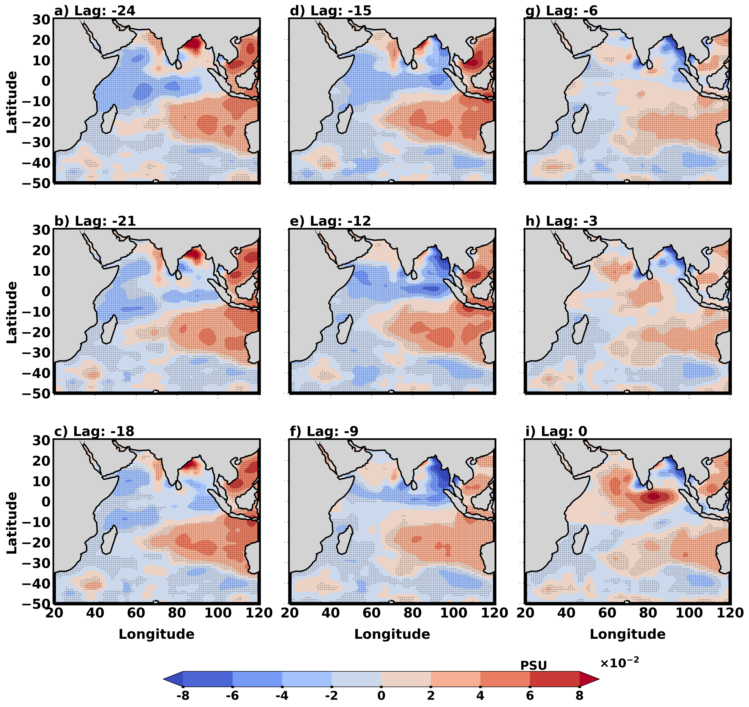
Figure S10. Regression coefficients of sea surface salinity (SSS; PSU × 10⁻²) onto the standardized south-eastern Indian Ocean (SEIO) index at successive lag months. Negative lags indicate that changes in SSS follow variations in the SEIO index. The strongest relationship emerges at a lag of –17 months. Panels illustrate the spatial evolution of the regression patterns at (a) –33, (b) –30, (c) –27, (d) –24, (e) –21, (f) –18, (g) –15, (h) –12, (i) –9, (j) –6, (k) –3, and (l) 0 months. Dotted regions indicate statistically significant values at the 95% confidence level.
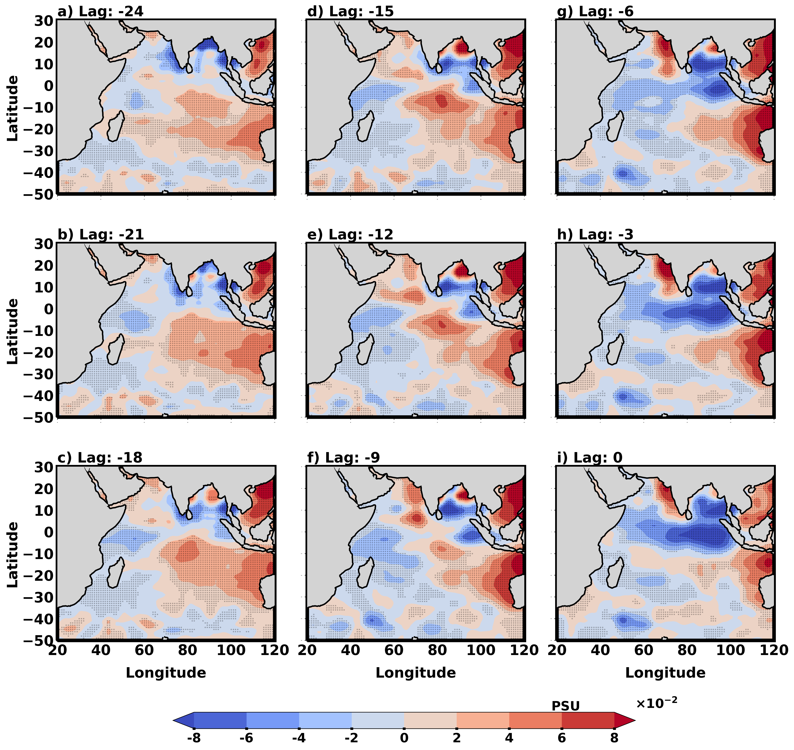
Figure S11. Regression coefficients of sea surface salinity (SSS; PSU × 10⁻²) onto the standardized Niño-4 index at successive lag months. Negative lags indicate that changes in SSS follow variations in the Niño-4 index. The strongest relationship emerges at a lag of -9 months. Panels illustrate the spatial evolution of the regression patterns at (a) -33, (b) -30, (c) -27, (d) -24, (e) -21, (f) -18, (g) -15, (h) -12, (i) -9, (j) -6, (k) -3, and (l) 0 months. Dotted regions indicate statistically significant values at the 95% confidence level.
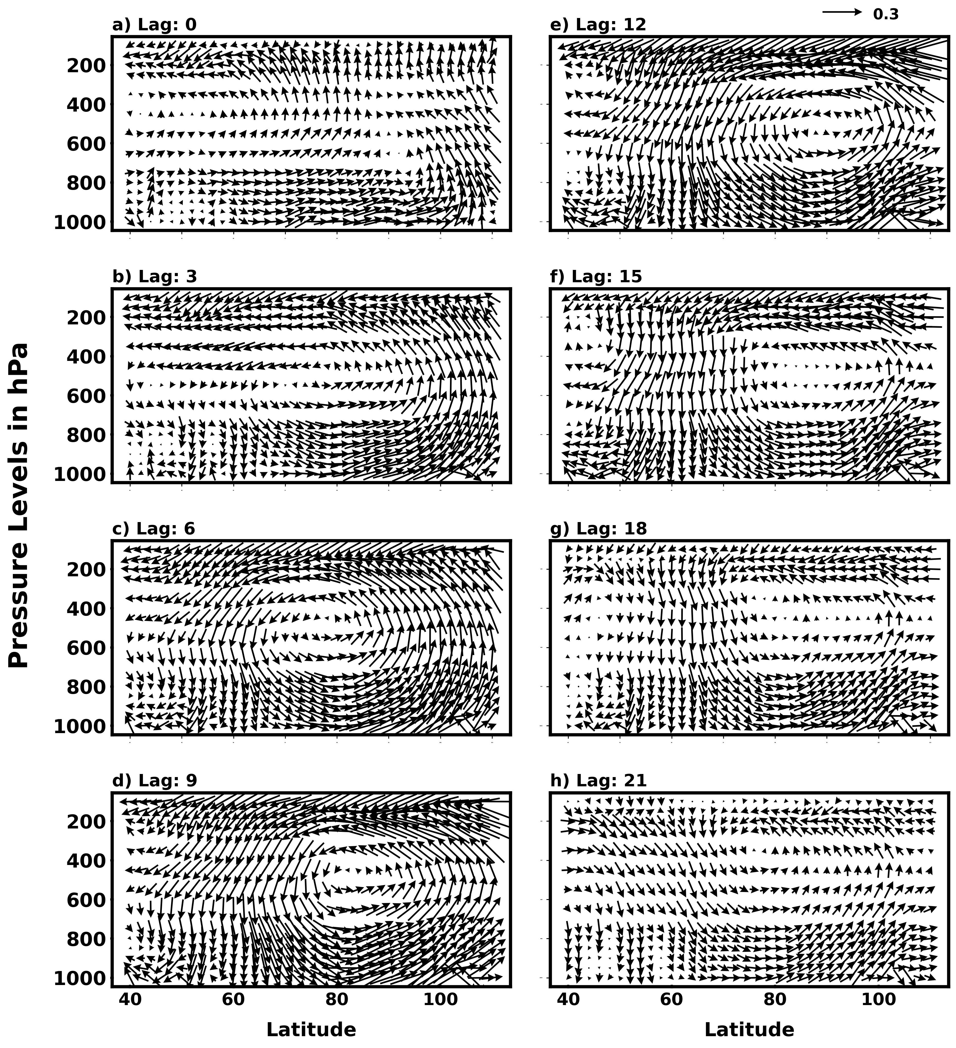
Figure S12. Correlation between the south-eastern Indian Ocean (SEIO) index (green line; Fig. 8a) and anomalous zonal circulation, represented by zonal wind (u) and vertical velocity (w), at lead times of (a) 0, (b) 3, (c) 6, (d) 9, (e) 12, (f) 15, (g) 18, and (h) 21 months. The analysis is averaged latitudinally between 3°N and 25°S. Vertical velocity (w) is multiplied by –200. Only wind anomalies that exceed the 95% significance level are plotted. The SEIO index leads the zonal circulation anomalies.
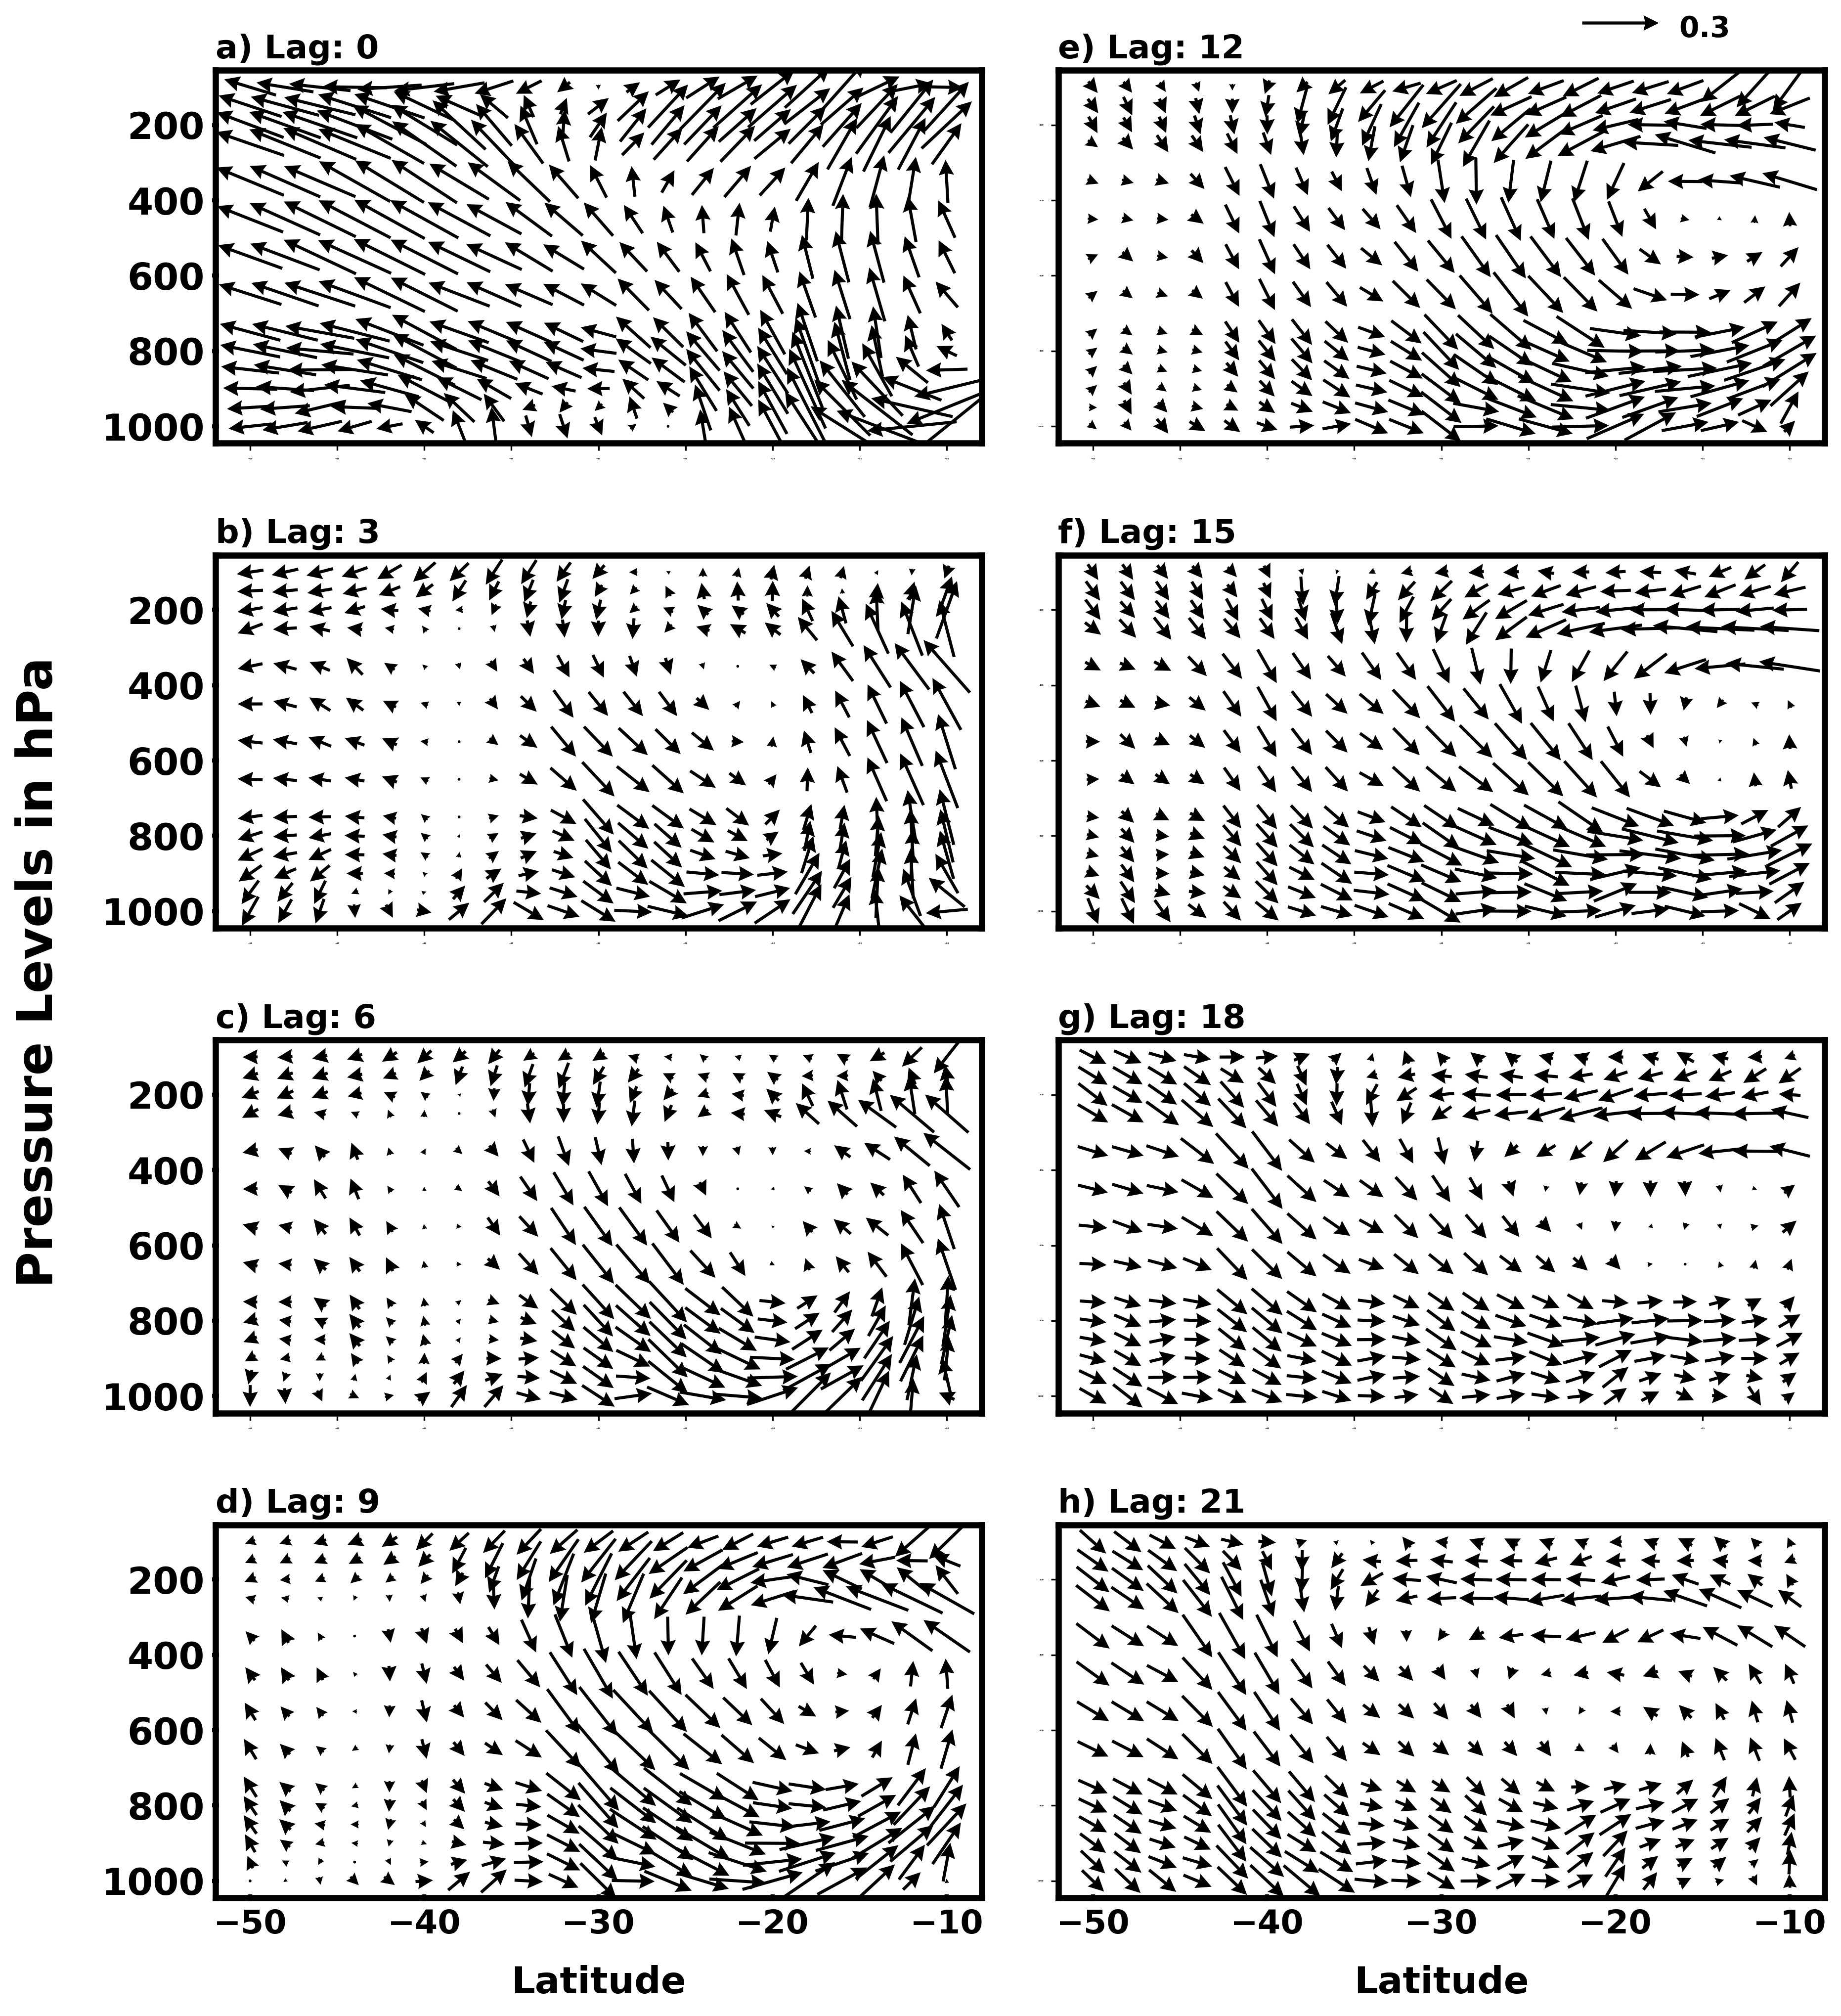
Figure S13. Correlation between the south-eastern Indian Ocean (SEIO) index (green line; Fig. 8a) and anomalous meridional circulation, represented by meridional wind (v) and vertical velocity (w), at lead times of (a) 0, (b) 3, (c) 6, (d) 9, (e) 12, (f) 15, (g) 18, and (h) 21 months. The analysis is averaged longitudinally over 60°E–120°E. Vertical velocity (w) is multiplied by –200. Only wind anomalies that exceed the 95% significance level are plotted. The SEIO index leads the meridional circulation anomalies.
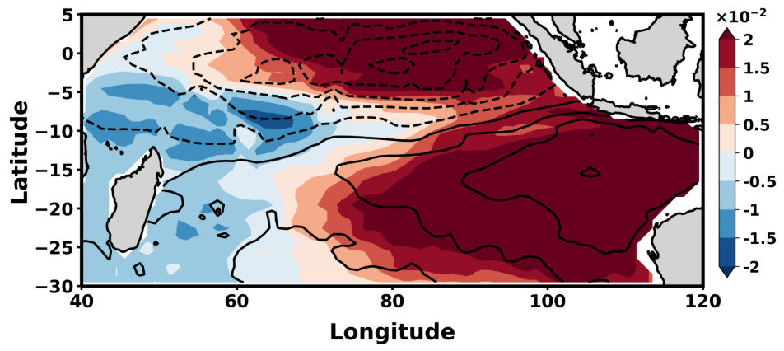
Figure S14: Spatial patterns of the leading EOF modes of surface salinity anomalies obtained from 3D-EOF analysis of ARGO data, with EOF2 shown as shaded and EOF1 as contours.
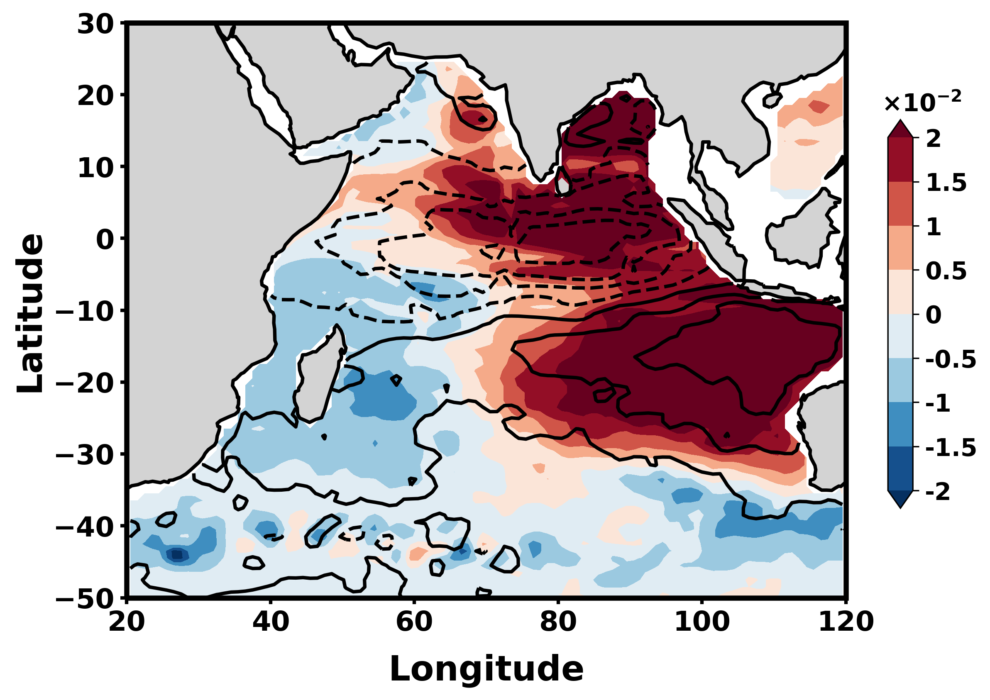
Figure S15. Spatial patterns of the leading EOF modes of surface salinity anomalies obtained from 3D-EOF analysis of ARGO data, with EOF2 shown as shaded and EOF1 as contours.
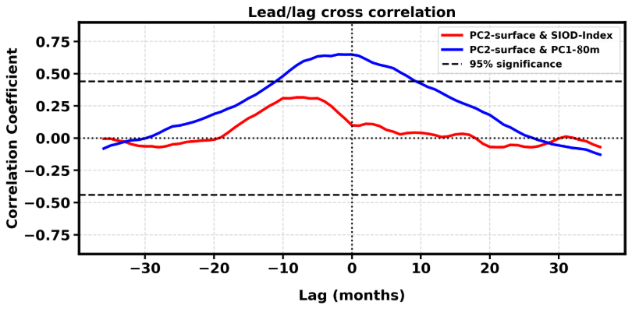
Figure S16. Lead/lag correlation between the surface PC2 from the ARGO 3D-EOF and (i) the S-IOD index (red line) and (ii) PC1 at 80m (blue line) depth. Positive lag values indicate that the S-IOD index and the PC1-80m lead the PC2- surface, while negative lag values indicate that they lag the PC2-surface. Dotted black lines denote correlations significant at the 95% confidence level based on a two-tailed Student’s t-test.
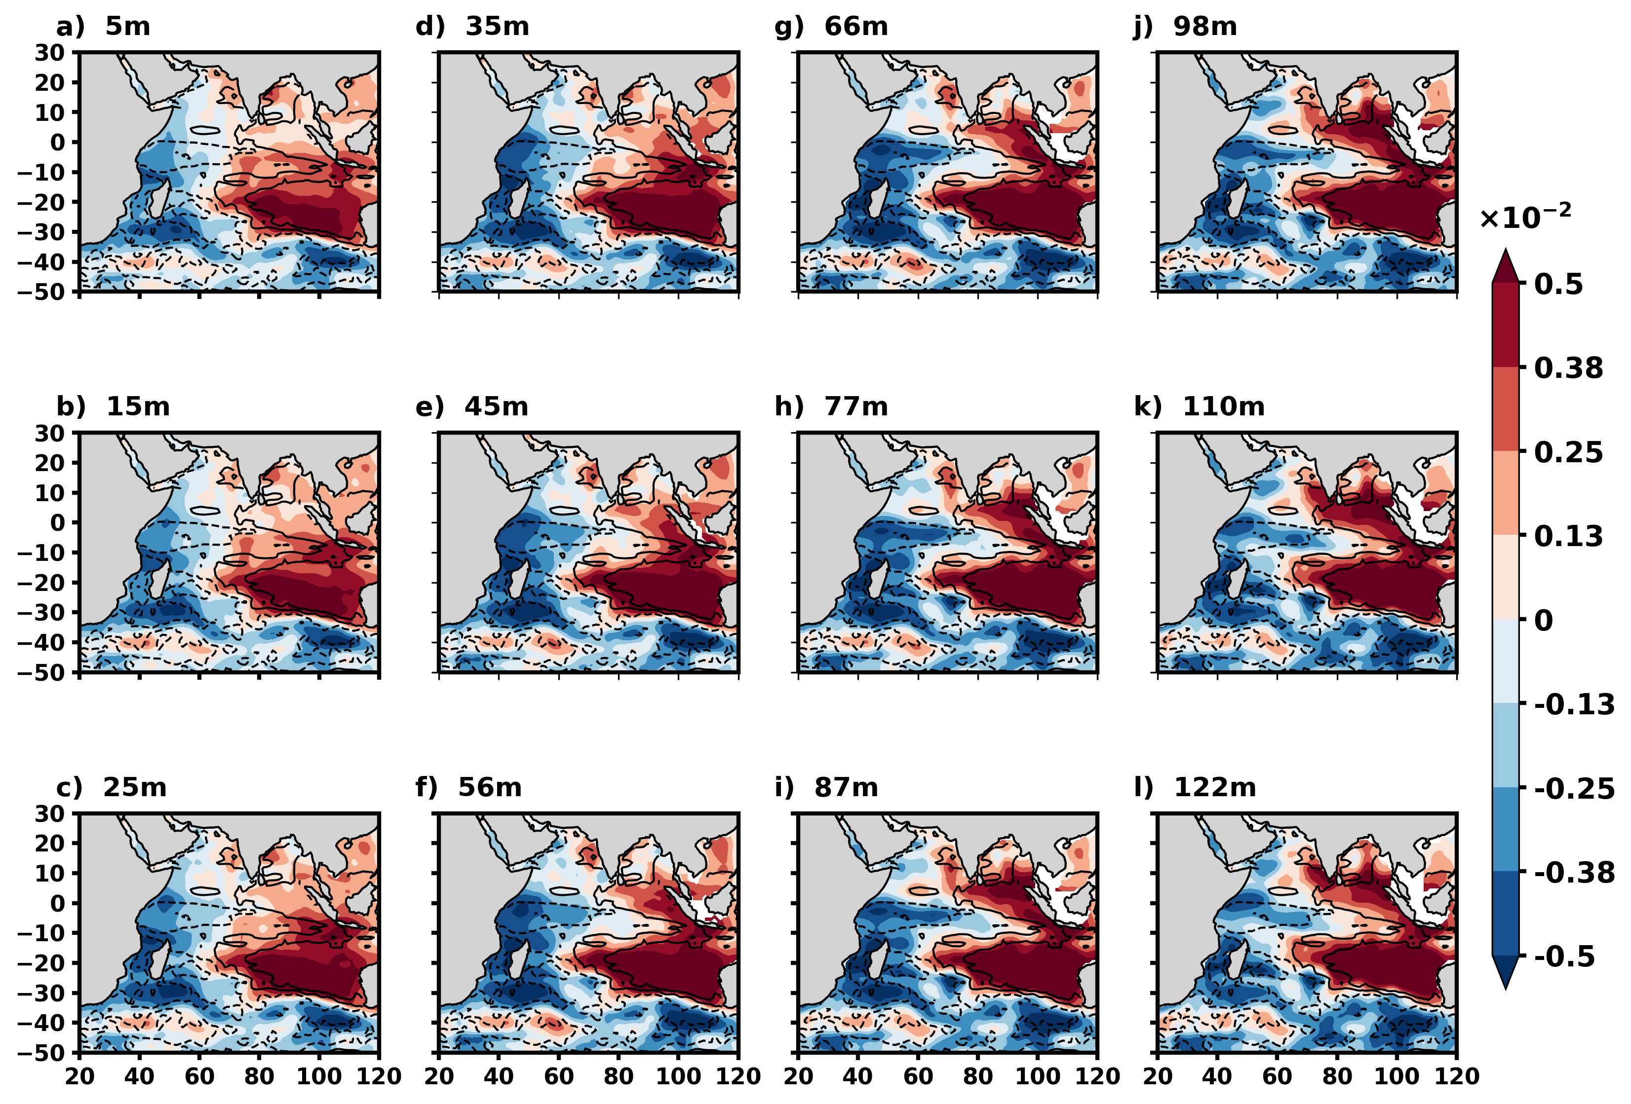
Figure S17. Vertical structure of the leading EOF mode (EOF1) of EN4 salinity anomalies obtained from a 4D-EOF analysis at selected depth levels: (a) 5m, (b) 15m, (c) 25m, (d) 35m, (e) 45m, (f) 56m, (g) 66m, (h) 77m, (i) 87m, (j) 98m, (k) 11m, and (l) 122 m. Shading denotes the EOF1 salinity anomaly pattern from EN4 at each depth. Contours represent the corresponding ARGO 4D-EOF1 pattern at 80m, included to illustrate the spatial consistency between the two datasets. Prior to the EOF computation, salinity dipole variability was regressed out up to a 6-month lag from both EN4 and ARGO salinity anomalies to isolate the Horseshoe Salinity Pattern (HSP). The resulting fields show a coherent HSP throughout the upper 120 m, indicating a robust vertical extension of the leading mode.
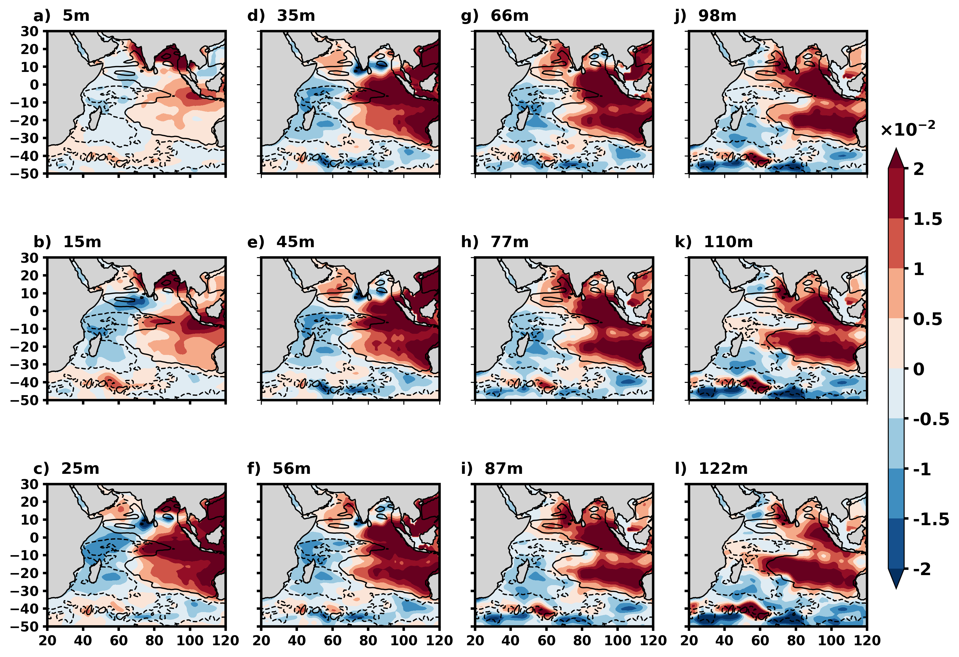Figure S18. Same as Figure S17 but for 3D-EOF for all depths.

