Additional file 1
Supplementary Materials for: Oliguria, renal function, hemodynamics, and acid-base abnormalities with 0-48-hour urine-fluid trajectories for mortality risk stratification in acute myocardial infarction: a retrospective MIMIC-IV study
This file contains supporting information for submission to BMC Cardiovascular Disorders, including supplementary methods, quality-control tables, trajectory analyses, landmark analyses, treatment-trajectory adjustment results, sensitivity analyses, calibration assessment, decision-curve analysis, and supplementary figures.
This supplement provides detailed definitions, quality-control tables, trajectory outcomes, landmark analyses, treatment-trajectory adjustment results, additional sensitivity analyses, calibration assessment, decision-curve analysis, and supplementary figures.

Supplementary Methods

Supplementary ORHA definition
ORHA was operationalized as a domain-based predictor framework. The four domains were: Oliguria, represented by body-weight-normalized urine output and oliguria status; Renal function, represented by creatinine, blood urea nitrogen, renal comorbidity, AKI-related variables, and renal replacement therapy context; Hemodynamics, represented by heart rate, blood pressure, mean arterial pressure, and vasopressor exposure; and Acid-base abnormalities, represented by lactate, pH, bicarbonate, base excess, anion gap, and oxygenation-related measures. No point score or manual weighting scheme was assigned. ORHA served as an interpretable feature-domain structure for prediction modeling and association analyses.
Vital signs and laboratory predictors used the ICU day-1 window from ICU admission -6 h to +24 h. Input-output and treatment variables used 0-6 h, 6-12 h, 12-24 h, and 24-48 h after ICU admission. Treatment variables included vasopressors, furosemide, CRRT, and invasive ventilation.
Urine output was normalized by cleaned body weight and window duration. Oliguria was defined as <0.5 mL/kg/h. Net fluid balance was calculated as total input minus total output. Persistent oliguria and persistent positive balance were defined as the presence of the exposure in at least two trajectory windows.
The strict 48 h landmark cohort included patients alive and hospitalized at 48 h after ICU admission. Treatment-adjusted models included age, diabetes, congestive heart failure, renal disease, vasopressor-positive window count, furosemide exposure, CRRT exposure, and invasive ventilation exposure.
Machine-learning models used preprocessing pipelines within each training fold. Continuous variables were imputed with training-fold medians and categorical variables with training-fold modes. Missingness indicators were included for continuous predictors.

Supplementary Tables
Supplementary Table S1. Input-output trajectory file QC
Window | Rows | Unique stay_id | Input sum nonmissing | Output sum nonmissing | Urine sum nonmissing | Input sum median | Output sum median | Urine sum median
0-6 h | 2097 | 2097 | 2031 | 1908 | 1855 | 1400.00 | 700.00 | 475.00
6-12 h | 2097 | 2097 | 1952 | 1963 | 1953 | 593.67 | 500.00 | 410.00
12-24 h | 2097 | 2097 | 2053 | 2027 | 2019 | 828.40 | 900.00 | 745.00
24-48 h | 2097 | 2097 | 1895 | 1923 | 1912 | 1262.45 | 1360.00 | 1210.00

Supplementary Table S2. Window-specific urine and fluid balance by outcome
Window | Group | N | Urine output, mL/kg/h | Oliguria <0.5 mL/kg/h | Net fluid balance, mL | Net fluid balance, mL/kg | Positive fluid balance
0-6 h | Survivors | 1812 | 1.05 (0.56, 1.76) | 334 (20.9%) | 750.0 (-85.6, 2780.3) | 9.29 (-1.10, 33.77) | 1172 (71.9%)
0-6 h | In-hospital deaths | 285 | 0.68 (0.28, 1.21) | 103 (40.4%) | 852.6 (119.2, 2830.7) | 11.59 (1.50, 35.84) | 201 (77.6%)
6-12 h | Survivors | 1812 | 0.89 (0.53, 1.50) | 382 (22.6%) | 83.6 (-274.5, 859.2) | 1.08 (-3.34, 10.63) | 888 (55.6%)
6-12 h | In-hospital deaths | 285 | 0.49 (0.24, 1.01) | 131 (50.8%) | 592.5 (17.9, 1445.9) | 6.91 (0.15, 18.79) | 190 (75.7%)
12-24 h | Survivors | 1812 | 0.81 (0.50, 1.27) | 440 (25.1%) | -102.9 (-625.0, 465.0) | -1.32 (-7.68, 5.84) | 763 (44.2%)
12-24 h | In-hospital deaths | 285 | 0.44 (0.23, 0.85) | 149 (56.7%) | 777.5 (10.2, 2388.5) | 8.50 (0.10, 30.61) | 199 (75.4%)
24-48 h | Survivors | 1812 | 0.67 (0.33, 1.12) | 604 (36.3%) | -300.3 (-1042.8, 393.8) | -3.54 (-12.79, 4.97) | 577 (36.8%)
24-48 h | In-hospital deaths | 285 | 0.42 (0.12, 0.91) | 139 (56.3%) | 1153.3 (153.0, 2477.5) | 15.48 (2.29, 35.83) | 202 (80.2%)

Supplementary Table S3. Fluid balance trajectory outcomes
Trajectory class | N | Deaths | Mortality, % | Median urine 0-48h, mL/kg/h | Median net balance 0-48h, mL/kg
Missing | 34 | 7 | 20.60 | NA | NA
Persistent positive balance | 1194 | 219 | 18.30 | 0.726 | 48.92
No positive-balance windows | 97 | 10 | 10.30 | 1.056 | NA
Cumulative non-positive balance | 485 | 32 | 6.600 | 1.096 | -17.48
Transient positive balance | 287 | 17 | 5.900 | 0.864 | 20.10

Supplementary Table S4. Trajectory logistic regression
Model | Exposure | N | Events | OR | 95% CI lower | 95% CI upper | P value
Unadjusted | Persistent oliguria in >=2 windows | 2048 | 271 | 3.988 | 3.064 | 5.191 | <0.001
Adjusted | Persistent oliguria in >=2 windows | 2048 | 271 | 3.480 | 2.638 | 4.591 | <0.001
Unadjusted | Each additional oliguria window | 2097 | 285 | 1.729 | 1.567 | 1.907 | <0.001
Adjusted | Each additional oliguria window | 2097 | 285 | 1.586 | 1.432 | 1.756 | <0.001
Unadjusted | Positive balance in >=2 windows | 2063 | 278 | 3.270 | 2.344 | 4.563 | <0.001
Adjusted | Positive balance in >=2 windows | 2063 | 278 | 2.361 | 1.652 | 3.376 | <0.001
Unadjusted | Net fluid balance per 10 mL/kg | 1502 | 216 | 1.087 | 1.065 | 1.109 | <0.001
Adjusted | Net fluid balance per 10 mL/kg | 1502 | 216 | 1.068 | 1.045 | 1.091 | <0.001
Unadjusted | High-risk urine/fluid trajectory phenotype | 2097 | 285 | 2.829 | 2.028 | 3.946 | <0.001
Adjusted | High-risk urine/fluid trajectory phenotype | 2097 | 285 | 2.016 | 1.410 | 2.881 | <0.001

Supplementary Table S5. Early death and early discharge counts
Total N | Hospital deaths | Deaths before 48 h from ICU | Deaths before 48 h by survival_days | Hospital exit before 48 h alive | ICU out before 48 h alive
2097 | 285 | 50 | 17 | 43 | 700

Supplementary Table S6. Landmark cohort summary
Cohort | N | In-hospital deaths after/overall landmark | Event rate, % | Median ICU LOS, h | Median ICU-to-hospital-exit, h
Full trajectory cohort | 2097 | 285 | 13.60 | 65.50 | 141.40
Exclude deaths before 48 h | 2047 | 235 | 11.50 | 67.70 | 144.20
Strict 48 h hospital landmark | 2004 | 235 | 11.70 | 68.90 | 145.70
ICU-observable 48 h cohort | 1336 | 224 | 16.80 | 98.40 | 185.20

Supplementary Table S7. Strict 48 h landmark urine trajectory outcomes
Cohort | Trajectory class | N | Events | Mortality, % | Median urine 0-48h, mL/kg/h | Median net balance 0-48h, mL/kg
Strict 48 h hospital landmark | Adequate urine output | 762 | 57 | 7.500 | 1.205 | 7.650
Strict 48 h hospital landmark | Late/worsening oliguria | 523 | 61 | 11.70 | 0.622 | 24.44
Strict 48 h hospital landmark | Missing | 44 | 11 | 25.00 | NA | 38.91
Strict 48 h hospital landmark | Oliguria recovery | 244 | 33 | 13.50 | 0.851 | 35.45
Strict 48 h hospital landmark | Persistent/intermittent oliguria | 239 | 58 | 24.30 | 0.339 | 54.86
Strict 48 h hospital landmark | Single-window oliguria | 192 | 15 | 7.800 | 0.882 | 14.72

Supplementary Table S8. Landmark logistic regression
Cohort | Model | Exposure | N | Events | OR | 95% CI lower | 95% CI upper | P value | Note
Full cohort | Unadjusted | Persistent oliguria in >=2 windows | 2048 | 271 | 3.988 | 3.064 | 5.191 | <0.001 | NA
Full cohort | Adjusted | Persistent oliguria in >=2 windows | 2048 | 271 | 3.480 | 2.638 | 4.591 | <0.001 | NA
Full cohort | Unadjusted | Each additional oliguria window | 2097 | 285 | 1.729 | 1.567 | 1.907 | <0.001 | NA
Full cohort | Adjusted | Each additional oliguria window | 2097 | 285 | 1.586 | 1.432 | 1.756 | <0.001 | NA
Full cohort | Unadjusted | Positive balance in >=2 windows | 2063 | 278 | 3.270 | 2.344 | 4.563 | <0.001 | NA
Full cohort | Adjusted | Positive balance in >=2 windows | 2063 | 278 | 2.361 | 1.652 | 3.376 | <0.001 | NA
Full cohort | Unadjusted | Net fluid balance per 10 mL/kg | 1502 | 216 | 1.087 | 1.065 | 1.109 | <0.001 | NA
Full cohort | Adjusted | Net fluid balance per 10 mL/kg | 1502 | 216 | 1.068 | 1.045 | 1.091 | <0.001 | NA
Full cohort | Unadjusted | High-risk urine/fluid trajectory phenotype | 2097 | 285 | 2.829 | 2.028 | 3.946 | <0.001 | NA
Full cohort | Adjusted | High-risk urine/fluid trajectory phenotype | 2097 | 285 | 2.016 | 1.410 | 2.881 | <0.001 | NA
Exclude deaths before 48 h | Unadjusted | Persistent oliguria in >=2 windows | 2001 | 224 | 3.581 | 2.695 | 4.757 | <0.001 | NA
Exclude deaths before 48 h | Adjusted | Persistent oliguria in >=2 windows | 2001 | 224 | 3.140 | 2.330 | 4.233 | <0.001 | NA
Exclude deaths before 48 h | Unadjusted | Each additional oliguria window | 2047 | 235 | 1.662 | 1.494 | 1.848 | <0.001 | NA
Exclude deaths before 48 h | Adjusted | Each additional oliguria window | 2047 | 235 | 1.536 | 1.375 | 1.715 | <0.001 | NA
Exclude deaths before 48 h | Unadjusted | Positive balance in >=2 windows | 2013 | 228 | 3.483 | 2.400 | 5.055 | <0.001 | NA
Exclude deaths before 48 h | Adjusted | Positive balance in >=2 windows | 2013 | 228 | 2.642 | 1.774 | 3.934 | <0.001 | NA
Exclude deaths before 48 h | Unadjusted | Net fluid balance per 10 mL/kg | 1476 | 190 | 1.086 | 1.063 | 1.108 | <0.001 | NA
Exclude deaths before 48 h | Adjusted | Net fluid balance per 10 mL/kg | 1476 | 190 | 1.069 | 1.045 | 1.094 | <0.001 | NA
Exclude deaths before 48 h | Unadjusted | High-risk urine/fluid trajectory phenotype | 2047 | 235 | 2.932 | 2.029 | 4.236 | <0.001 | NA
Exclude deaths before 48 h | Adjusted | High-risk urine/fluid trajectory phenotype | 2047 | 235 | 2.192 | 1.479 | 3.249 | <0.001 | NA
Strict 48 h hospital landmark | Unadjusted | Persistent oliguria in >=2 windows | 1960 | 224 | 3.533 | 2.659 | 4.695 | <0.001 | NA
Strict 48 h hospital landmark | Adjusted | Persistent oliguria in >=2 windows | 1960 | 224 | 3.135 | 2.326 | 4.227 | <0.001 | NA
Strict 48 h hospital landmark | Unadjusted | Each additional oliguria window | 2004 | 235 | 1.650 | 1.484 | 1.835 | <0.001 | NA
Strict 48 h hospital landmark | Adjusted | Each additional oliguria window | 2004 | 235 | 1.534 | 1.374 | 1.713 | <0.001 | NA
Strict 48 h hospital landmark | Unadjusted | Positive balance in >=2 windows | 1971 | 228 | 3.361 | 2.315 | 4.879 | <0.001 | NA
Strict 48 h hospital landmark | Adjusted | Positive balance in >=2 windows | 1971 | 228 | 2.603 | 1.748 | 3.877 | <0.001 | NA
Strict 48 h hospital landmark | Unadjusted | Net fluid balance per 10 mL/kg | 1462 | 190 | 1.085 | 1.062 | 1.107 | <0.001 | NA
Strict 48 h hospital landmark | Adjusted | Net fluid balance per 10 mL/kg | 1462 | 190 | 1.069 | 1.045 | 1.094 | <0.001 | NA
Strict 48 h hospital landmark | Unadjusted | High-risk urine/fluid trajectory phenotype | 2004 | 235 | 2.809 | 1.943 | 4.060 | <0.001 | NA
Strict 48 h hospital landmark | Adjusted | High-risk urine/fluid trajectory phenotype | 2004 | 235 | 2.151 | 1.451 | 3.190 | <0.001 | NA
ICU-observable 48 h cohort | Unadjusted | Persistent oliguria in >=2 windows | 1299 | 213 | 3.409 | 2.521 | 4.610 | <0.001 | NA
ICU-observable 48 h cohort | Adjusted | Persistent oliguria in >=2 windows | 1299 | 213 | 3.133 | 2.285 | 4.297 | <0.001 | NA
ICU-observable 48 h cohort | Unadjusted | Each additional oliguria window | 1336 | 224 | 1.563 | 1.405 | 1.738 | <0.001 | NA
ICU-observable 48 h cohort | Adjusted | Each additional oliguria window | 1336 | 224 | 1.498 | 1.341 | 1.674 | <0.001 | NA
ICU-observable 48 h cohort | Unadjusted | Positive balance in >=2 windows | 1308 | 217 | 2.920 | 1.945 | 4.381 | <0.001 | NA
ICU-observable 48 h cohort | Adjusted | Positive balance in >=2 windows | 1308 | 217 | 2.383 | 1.552 | 3.659 | <0.001 | NA
ICU-observable 48 h cohort | Unadjusted | Net fluid balance per 10 mL/kg | 1089 | 183 | 1.068 | 1.046 | 1.091 | <0.001 | NA
ICU-observable 48 h cohort | Adjusted | Net fluid balance per 10 mL/kg | 1089 | 183 | 1.055 | 1.032 | 1.079 | <0.001 | NA
ICU-observable 48 h cohort | Unadjusted | High-risk urine/fluid trajectory phenotype | 1336 | 224 | 2.453 | 1.659 | 3.627 | <0.001 | NA
ICU-observable 48 h cohort | Adjusted | High-risk urine/fluid trajectory phenotype | 1336 | 224 | 1.949 | 1.286 | 2.954 | 0.0017 | NA

Supplementary Table S9. Treatment trajectory file QC
Window | Rows | Unique stay_id | Vasopressor any, n | Furosemide any, n | CRRT any, n | Invasive ventilation any, n | phenylephrine any, n | vasopressin any, n | dopamine any, n | epinephrine any, n | norepinephrine any, n
0-6 h | 2097 | 2097 | 814 | 476 | 129 | 957 | 578 | 47 | 121 | 108 | 229
6-12 h | 2097 | 2097 | 908 | 563 | 129 | 987 | 620 | 79 | 152 | 153 | 307
12-24 h | 2097 | 2097 | 983 | 846 | 129 | 877 | 665 | 109 | 176 | 173 | 355
24-48 h | 2097 | 2097 | 1037 | 1139 | 130 | 684 | 712 | 141 | 180 | 185 | 398

Supplementary Table S10. Treatment exposure by outcome
Group | Variable | Value
Survivors | Any vasopressor 0-48 h | 886 (48.9%)
Survivors | Norepinephrine 0-48 h | 275 (15.2%)
Survivors | Phenylephrine 0-48 h | 657 (36.3%)
Survivors | Vasopressin 0-48 h | 90 (5.0%)
Survivors | Dopamine 0-48 h | 154 (8.5%)
Survivors | Epinephrine 0-48 h | 165 (9.1%)
Survivors | Furosemide 0-48 h | 1026 (56.6%)
Survivors | CRRT 0-48 h | 76 (4.2%)
Survivors | Invasive ventilation 0-48 h | 935 (51.6%)
Survivors | Vasopressor-positive windows | 0.0 (0.0, 4.0)
Survivors | Furosemide-positive windows | 1.0 (0.0, 3.0)
Survivors | CRRT duration, min | 0.0 (0.0, 0.0)
Survivors | Invasive ventilation hours | 3.0 (0.0, 20.0)
In-hospital deaths | Any vasopressor 0-48 h | 197 (69.1%)
In-hospital deaths | Norepinephrine 0-48 h | 150 (52.6%)
In-hospital deaths | Phenylephrine 0-48 h | 91 (31.9%)
In-hospital deaths | Vasopressin 0-48 h | 58 (20.4%)
In-hospital deaths | Dopamine 0-48 h | 60 (21.1%)
In-hospital deaths | Epinephrine 0-48 h | 36 (12.6%)
In-hospital deaths | Furosemide 0-48 h | 147 (51.6%)
In-hospital deaths | CRRT 0-48 h | 54 (18.9%)
In-hospital deaths | Invasive ventilation 0-48 h | 216 (75.8%)
In-hospital deaths | Vasopressor-positive windows | 3.0 (0.0, 4.0)
In-hospital deaths | Furosemide-positive windows | 1.0 (0.0, 3.0)
In-hospital deaths | CRRT duration, min | 0.0 (0.0, 0.0)
In-hospital deaths | Invasive ventilation hours | 35.2 (2.1, 47.3)

Supplementary Table S11. Window-specific treatment exposure by outcome
Window | Group | Vasopressor any | Furosemide any | CRRT any | Invasive ventilation any | Vasopressor drug count
0-6 h | Survivors | 701 (38.7%) | 407 (22.5%) | 76 (4.2%) | 776 (42.8%) | 0.0 (0.0, 1.0)
0-6 h | In-hospital deaths | 113 (39.6%) | 69 (24.2%) | 53 (18.6%) | 181 (63.5%) | 0.0 (0.0, 1.0)
6-12 h | Survivors | 756 (41.7%) | 474 (26.2%) | 76 (4.2%) | 795 (43.9%) | 0.0 (0.0, 1.0)
6-12 h | In-hospital deaths | 152 (53.3%) | 89 (31.2%) | 53 (18.6%) | 192 (67.4%) | 1.0 (0.0, 1.0)
12-24 h | Survivors | 811 (44.8%) | 742 (40.9%) | 76 (4.2%) | 682 (37.6%) | 0.0 (0.0, 1.0)
12-24 h | In-hospital deaths | 172 (60.4%) | 104 (36.5%) | 53 (18.6%) | 195 (68.4%) | 1.0 (0.0, 2.0)
24-48 h | Survivors | 851 (47.0%) | 1001 (55.2%) | 76 (4.2%) | 497 (27.4%) | 0.0 (0.0, 1.0)
24-48 h | In-hospital deaths | 186 (65.3%) | 138 (48.4%) | 54 (18.9%) | 187 (65.6%) | 1.0 (0.0, 2.0)

Supplementary Table S12. Treatment-trajectory adjusted logistic regression
Cohort | Model | Exposure | N | Events | OR | 95% CI lower | 95% CI upper | P value | Note
Full cohort | Clinical adjusted | Persistent oliguria in >=2 windows | 2048 | 271 | 3.817 | 2.913 | 5.001 | <0.001 | NA
Full cohort | Clinical + treatment-trajectory adjusted | Persistent oliguria in >=2 windows | 2048 | 271 | 2.899 | 2.167 | 3.878 | <0.001 | NA
Full cohort | Clinical adjusted | Each additional oliguria window | 2097 | 285 | 1.681 | 1.520 | 1.859 | <0.001 | NA
Full cohort | Clinical + treatment-trajectory adjusted | Each additional oliguria window | 2097 | 285 | 1.463 | 1.314 | 1.630 | <0.001 | NA
Full cohort | Clinical adjusted | Positive balance in >=2 windows | 2063 | 278 | 3.312 | 2.365 | 4.639 | <0.001 | NA
Full cohort | Clinical + treatment-trajectory adjusted | Positive balance in >=2 windows | 2063 | 278 | 2.174 | 1.509 | 3.133 | <0.001 | NA
Full cohort | Clinical adjusted | Net fluid balance per 10 mL/kg | 1502 | 216 | 1.086 | 1.064 | 1.108 | <0.001 | NA
Full cohort | Clinical + treatment-trajectory adjusted | Net fluid balance per 10 mL/kg | 1502 | 216 | 1.053 | 1.029 | 1.078 | <0.001 | NA
Full cohort | Clinical adjusted | High-risk urine/fluid trajectory phenotype | 2097 | 285 | 2.891 | 2.064 | 4.050 | <0.001 | NA
Full cohort | Clinical + treatment-trajectory adjusted | High-risk urine/fluid trajectory phenotype | 2097 | 285 | 1.922 | 1.336 | 2.767 | <0.001 | NA
Strict 48 h landmark cohort | Clinical adjusted | Persistent oliguria in >=2 windows | 1960 | 224 | 3.397 | 2.538 | 4.545 | <0.001 | NA
Strict 48 h landmark cohort | Clinical + treatment-trajectory adjusted | Persistent oliguria in >=2 windows | 1960 | 224 | 2.464 | 1.793 | 3.387 | <0.001 | NA
Strict 48 h landmark cohort | Clinical adjusted | Each additional oliguria window | 2004 | 235 | 1.611 | 1.445 | 1.795 | <0.001 | NA
Strict 48 h landmark cohort | Clinical + treatment-trajectory adjusted | Each additional oliguria window | 2004 | 235 | 1.376 | 1.223 | 1.548 | <0.001 | NA
Strict 48 h landmark cohort | Clinical adjusted | Positive balance in >=2 windows | 1971 | 228 | 3.444 | 2.363 | 5.019 | <0.001 | NA
Strict 48 h landmark cohort | Clinical + treatment-trajectory adjusted | Positive balance in >=2 windows | 1971 | 228 | 2.348 | 1.563 | 3.529 | <0.001 | NA
Strict 48 h landmark cohort | Clinical adjusted | Net fluid balance per 10 mL/kg | 1462 | 190 | 1.085 | 1.063 | 1.108 | <0.001 | NA
Strict 48 h landmark cohort | Clinical + treatment-trajectory adjusted | Net fluid balance per 10 mL/kg | 1462 | 190 | 1.054 | 1.028 | 1.080 | <0.001 | NA
Strict 48 h landmark cohort | Clinical adjusted | High-risk urine/fluid trajectory phenotype | 2004 | 235 | 2.910 | 2.005 | 4.224 | <0.001 | NA
Strict 48 h landmark cohort | Clinical + treatment-trajectory adjusted | High-risk urine/fluid trajectory phenotype | 2004 | 235 | 2.016 | 1.349 | 3.014 | <0.001 | NA

Supplementary Table S13. Model performance after treatment-trajectory adjustment
Cohort | Model | N | Events | Features | AUROC | AUPRC | Brier score
Full cohort | Static ORHA + urine-fluid trajectory | 2097 | 285 | 129 | 0.885 | 0.542 | 0.090
Full cohort | Static ORHA + trajectory + treatment trajectory | 2097 | 285 | 189 | 0.876 | 0.526 | 0.094
Full cohort | Static ORHA + trajectory + treatment + scores | 2097 | 285 | 199 | 0.899 | 0.572 | 0.083
Strict 48 h landmark cohort | Static ORHA + urine-fluid trajectory | 2004 | 235 | 129 | 0.869 | 0.482 | 0.087
Strict 48 h landmark cohort | Static ORHA + trajectory + treatment trajectory | 2004 | 235 | 189 | 0.868 | 0.461 | 0.090
Strict 48 h landmark cohort | Static ORHA + trajectory + treatment + scores | 2004 | 235 | 199 | 0.891 | 0.498 | 0.081

Supplementary Table S14. Baseline characteristics by outcome
Characteristic | Survivors | In-hospital deaths | SMD
Age, years | 70.1 (61.4, 79.1) | 75.8 (66.0, 83.8) | 0.350
Male sex | 1172 (64.7%) | 158 (55.4%) | -0.189
Diabetes | 749 (41.3%) | 130 (45.6%) | 0.086
Congestive heart failure | 864 (47.7%) | 164 (57.5%) | 0.198
Chronic renal disease | 477 (26.3%) | 113 (39.6%) | 0.283
Chronic pulmonary disease | 471 (26.0%) | 114 (40.0%) | 0.298
Cerebrovascular disease | 222 (12.3%) | 48 (16.8%) | 0.130
SAPS II | 35.0 (28.0, 43.0) | 51.0 (40.0, 63.0) | 1.136
SOFA | 5.0 (2.0, 8.0) | 11.0 (8.0, 14.0) | 1.393
Charlson comorbidity index | 6.0 (4.0, 8.0) | 8.0 (6.0, 9.0) | 0.650
Creatinine, average | 1.0 (0.8, 1.5) | 1.7 (1.1, 2.8) | 0.418
BUN, average | 19.5 (14.5, 30.0) | 34.0 (23.5, 52.0) | 0.685
Lactate, average | 1.7 (1.3, 2.3) | 2.7 (1.6, 4.4) | 0.758
pH, average | 7.4 (7.3, 7.4) | 7.3 (7.3, 7.4) | -0.466
Base excess, average | -0.6 (-2.7, 0.9) | -4.0 (-7.0, -1.0) | -0.660
Day-1 urine output, mL/kg/h | 0.9 (0.6, 1.4) | 0.6 (0.2, 1.0) | -0.460
Day-1 oliguria | 305 (16.8%) | 118 (41.4%) | 0.541
Day-1 positive fluid balance | 1198 (66.1%) | 219 (76.8%) | 0.238
0-48 h vasopressor exposure | 886 (48.9%) | 197 (69.1%) | 0.411
0-48 h furosemide exposure | 1026 (56.6%) | 147 (51.6%) | -0.101
0-48 h CRRT exposure | 76 (4.2%) | 54 (18.9%) | 0.461
0-48 h invasive ventilation | 935 (51.6%) | 216 (75.8%) | 0.503

Supplementary Table S15. Cross-validated model performance with bootstrap confidence intervals
Cohort | Model | N | Events | Features | AUROC | AUROC 95% CI | AUPRC | AUPRC 95% CI | Brier score | Brier 95% CI | Calibration intercept | Calibration slope | Observed/expected
Full cohort | Static ORHA | 2097 | 285 | 84 | 0.876 | 0.857-0.892 | 0.530 | 0.470-0.594 | 0.095 | 0.086-0.103 | -0.733 | 0.765 | 0.748
Full cohort | Static ORHA + urine-fluid trajectories | 2097 | 285 | 129 | 0.884 | 0.865-0.900 | 0.549 | 0.479-0.609 | 0.091 | 0.083-0.099 | -0.684 | 0.792 | 0.764
Full cohort | Static ORHA + trajectories + scores | 2097 | 285 | 139 | 0.898 | 0.879-0.915 | 0.575 | 0.511-0.640 | 0.084 | 0.077-0.093 | -0.665 | 0.792 | 0.782

Supplementary Table S16. Fold-level model performance
Cohort | Model | Fold | N | Events | AUROC | AUPRC | Brier score
Full cohort | Static ORHA | 1 | 420 | 57 | 0.884 | 0.578 | 0.095
Full cohort | Static ORHA | 2 | 420 | 57 | 0.857 | 0.454 | 0.101
Full cohort | Static ORHA | 3 | 419 | 57 | 0.884 | 0.542 | 0.096
Full cohort | Static ORHA | 4 | 419 | 57 | 0.881 | 0.530 | 0.093
Full cohort | Static ORHA | 5 | 419 | 57 | 0.881 | 0.621 | 0.088
Full cohort | Static ORHA + urine-fluid trajectories | 1 | 420 | 57 | 0.885 | 0.543 | 0.097
Full cohort | Static ORHA + urine-fluid trajectories | 2 | 420 | 57 | 0.861 | 0.444 | 0.102
Full cohort | Static ORHA + urine-fluid trajectories | 3 | 419 | 57 | 0.907 | 0.567 | 0.084
Full cohort | Static ORHA + urine-fluid trajectories | 4 | 419 | 57 | 0.889 | 0.582 | 0.087
Full cohort | Static ORHA + urine-fluid trajectories | 5 | 419 | 57 | 0.889 | 0.652 | 0.083
Full cohort | Static ORHA + trajectories + scores | 1 | 420 | 57 | 0.890 | 0.573 | 0.088
Full cohort | Static ORHA + trajectories + scores | 2 | 420 | 57 | 0.865 | 0.472 | 0.096
Full cohort | Static ORHA + trajectories + scores | 3 | 419 | 57 | 0.924 | 0.639 | 0.076
Full cohort | Static ORHA + trajectories + scores | 4 | 419 | 57 | 0.906 | 0.562 | 0.084
Full cohort | Static ORHA + trajectories + scores | 5 | 419 | 57 | 0.909 | 0.675 | 0.075

Supplementary Table S17. Calibration by risk decile
Model | Risk decile | N | Mean predicted risk | Observed mortality | Events
Static ORHA | 1 | 210 | 0.009 | 0.000 | 0
Static ORHA | 2 | 210 | 0.012 | 0.005 | 1
Static ORHA | 3 | 209 | 0.016 | 0.005 | 1
Static ORHA | 4 | 210 | 0.023 | 0.005 | 1
Static ORHA | 5 | 210 | 0.037 | 0.033 | 7
Static ORHA | 6 | 209 | 0.067 | 0.086 | 18
Static ORHA | 7 | 210 | 0.125 | 0.148 | 31
Static ORHA | 8 | 209 | 0.244 | 0.230 | 48
Static ORHA | 9 | 210 | 0.476 | 0.276 | 58
Static ORHA | 10 | 210 | 0.808 | 0.571 | 120
Static ORHA + urine-fluid trajectories | 1 | 210 | 0.009 | 0.000 | 0
Static ORHA + urine-fluid trajectories | 2 | 210 | 0.012 | 0.000 | 0
Static ORHA + urine-fluid trajectories | 3 | 209 | 0.016 | 0.005 | 1
Static ORHA + urine-fluid trajectories | 4 | 210 | 0.023 | 0.014 | 3
Static ORHA + urine-fluid trajectories | 5 | 210 | 0.034 | 0.038 | 8
Static ORHA + urine-fluid trajectories | 6 | 209 | 0.062 | 0.048 | 10
Static ORHA + urine-fluid trajectories | 7 | 210 | 0.117 | 0.162 | 34
Static ORHA + urine-fluid trajectories | 8 | 209 | 0.235 | 0.196 | 41
Static ORHA + urine-fluid trajectories | 9 | 210 | 0.468 | 0.286 | 60
Static ORHA + urine-fluid trajectories | 10 | 210 | 0.802 | 0.610 | 128
Static ORHA + trajectories + scores | 1 | 210 | 0.009 | 0.000 | 0
Static ORHA + trajectories + scores | 2 | 210 | 0.010 | 0.014 | 3
Static ORHA + trajectories + scores | 3 | 209 | 0.013 | 0.000 | 0
Static ORHA + trajectories + scores | 4 | 210 | 0.018 | 0.014 | 3
Static ORHA + trajectories + scores | 5 | 210 | 0.027 | 0.029 | 6
Static ORHA + trajectories + scores | 6 | 209 | 0.047 | 0.029 | 6
Static ORHA + trajectories + scores | 7 | 210 | 0.095 | 0.124 | 26
Static ORHA + trajectories + scores | 8 | 209 | 0.210 | 0.158 | 33
Static ORHA + trajectories + scores | 9 | 210 | 0.480 | 0.352 | 74
Static ORHA + trajectories + scores | 10 | 210 | 0.829 | 0.638 | 134

Supplementary Table S18. Net fluid balance threshold sensitivity analysis
Cohort | Exposure | N | Events | OR | 95% CI lower | 95% CI upper | P value
Full cohort | Cumulative net fluid balance >30 mL/kg | 2097 | 285 | 1.471 | 1.089 | 1.986 | 0.0118
Full cohort | Cumulative net fluid balance >40 mL/kg | 2097 | 285 | 1.603 | 1.187 | 2.164 | 0.0021
Full cohort | Cumulative net fluid balance >50 mL/kg | 2097 | 285 | 1.733 | 1.276 | 2.354 | <0.001
Full cohort | Cumulative net fluid balance >60 mL/kg | 2097 | 285 | 2.007 | 1.466 | 2.749 | <0.001
Strict 48 h landmark | Cumulative net fluid balance >30 mL/kg | 2004 | 235 | 1.862 | 1.339 | 2.589 | <0.001
Strict 48 h landmark | Cumulative net fluid balance >40 mL/kg | 2004 | 235 | 1.962 | 1.413 | 2.724 | <0.001
Strict 48 h landmark | Cumulative net fluid balance >50 mL/kg | 2004 | 235 | 2.263 | 1.622 | 3.158 | <0.001
Strict 48 h landmark | Cumulative net fluid balance >60 mL/kg | 2004 | 235 | 2.505 | 1.784 | 3.517 | <0.001

Supplementary Table S19. CRRT-exclusion and no-furosemide sensitivity analyses
Sensitivity cohort | Exposure | N | Events | OR | 95% CI lower | 95% CI upper | P value
Exclude 0-48 h CRRT | Persistent oliguria in >=2 windows | 1928 | 222 | 3.208 | 2.368 | 4.345 | <0.001
Exclude 0-48 h CRRT | Each additional oliguria window | 1967 | 231 | 1.545 | 1.374 | 1.737 | <0.001
Exclude 0-48 h CRRT | Positive balance in >=2 windows | 1941 | 228 | 2.325 | 1.583 | 3.416 | <0.001
Exclude 0-48 h CRRT | Net fluid balance per 10 mL/kg | 1413 | 179 | 1.055 | 1.028 | 1.084 | <0.001
Exclude 0-48 h CRRT | High-risk urine/fluid phenotype | 1967 | 231 | 2.192 | 1.472 | 3.264 | <0.001
No 0-48 h furosemide exposure | Persistent oliguria in >=2 windows | 879 | 125 | 2.448 | 1.547 | 3.875 | <0.001
No 0-48 h furosemide exposure | Each additional oliguria window | 924 | 138 | 1.276 | 1.099 | 1.482 | 0.0014
No 0-48 h furosemide exposure | Positive balance in >=2 windows | 894 | 132 | 1.637 | 0.910 | 2.944 | 0.0999
No 0-48 h furosemide exposure | Net fluid balance per 10 mL/kg | 595 | 101 | 1.008 | 0.987 | 1.030 | 0.4397
No 0-48 h furosemide exposure | High-risk urine/fluid phenotype | 924 | 138 | 1.467 | 0.832 | 2.588 | 0.1854
Strict landmark excluding CRRT | Persistent oliguria in >=2 windows | 1844 | 178 | 2.791 | 2.000 | 3.894 | <0.001
Strict landmark excluding CRRT | Each additional oliguria window | 1878 | 184 | 1.463 | 1.285 | 1.666 | <0.001
Strict landmark excluding CRRT | Positive balance in >=2 windows | 1853 | 181 | 2.587 | 1.675 | 3.998 | <0.001
Strict landmark excluding CRRT | Net fluid balance per 10 mL/kg | 1375 | 155 | 1.056 | 1.027 | 1.086 | <0.001
Strict landmark excluding CRRT | High-risk urine/fluid phenotype | 1878 | 184 | 2.421 | 1.543 | 3.799 | <0.001

Supplementary Figures
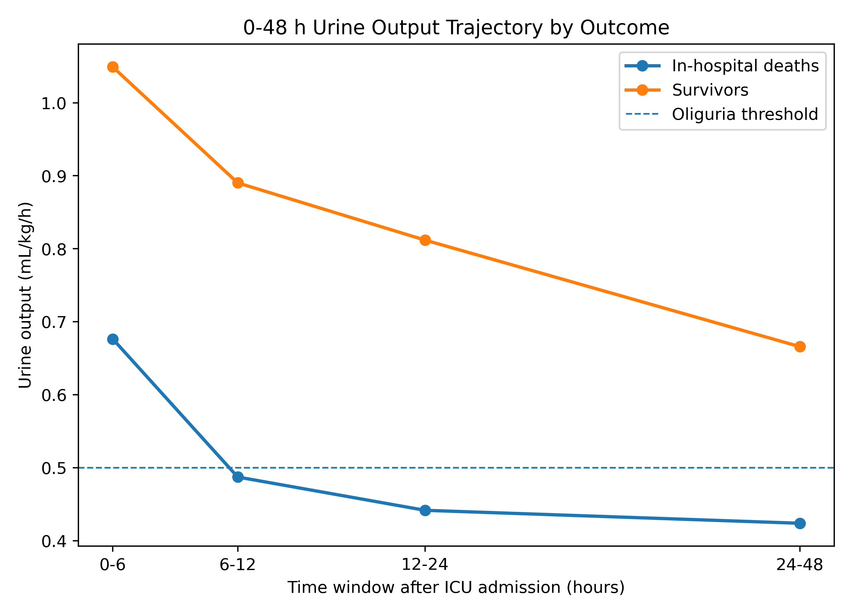
Supplementary Figure S1. 0-48 h urine output trajectory by outcome.
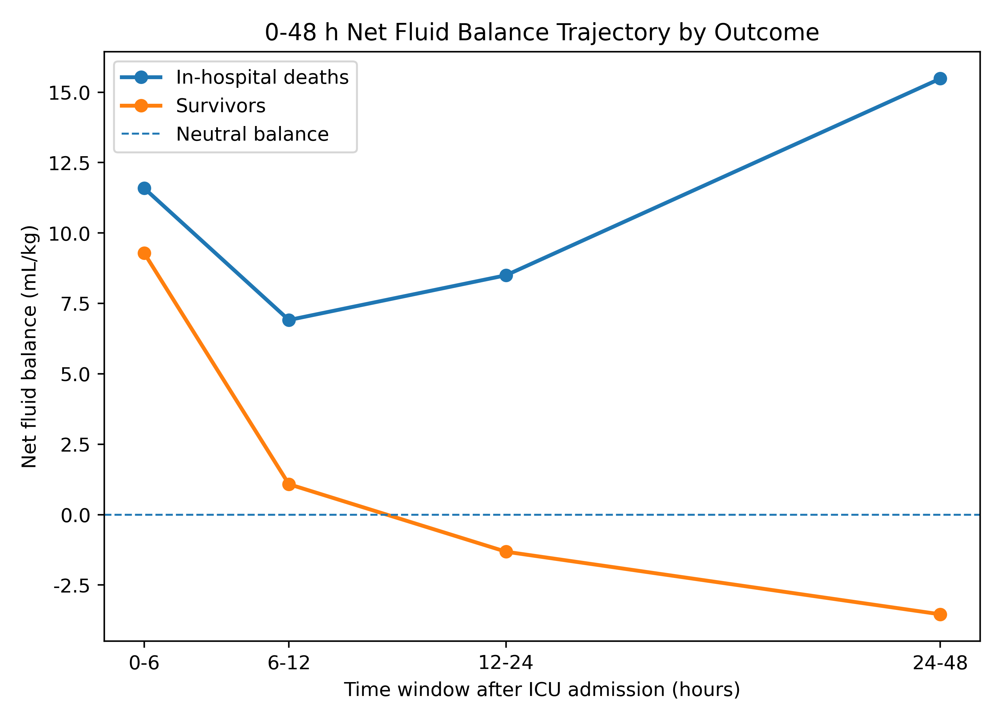
Supplementary Figure S2. 0-48 h net fluid balance trajectory by outcome.
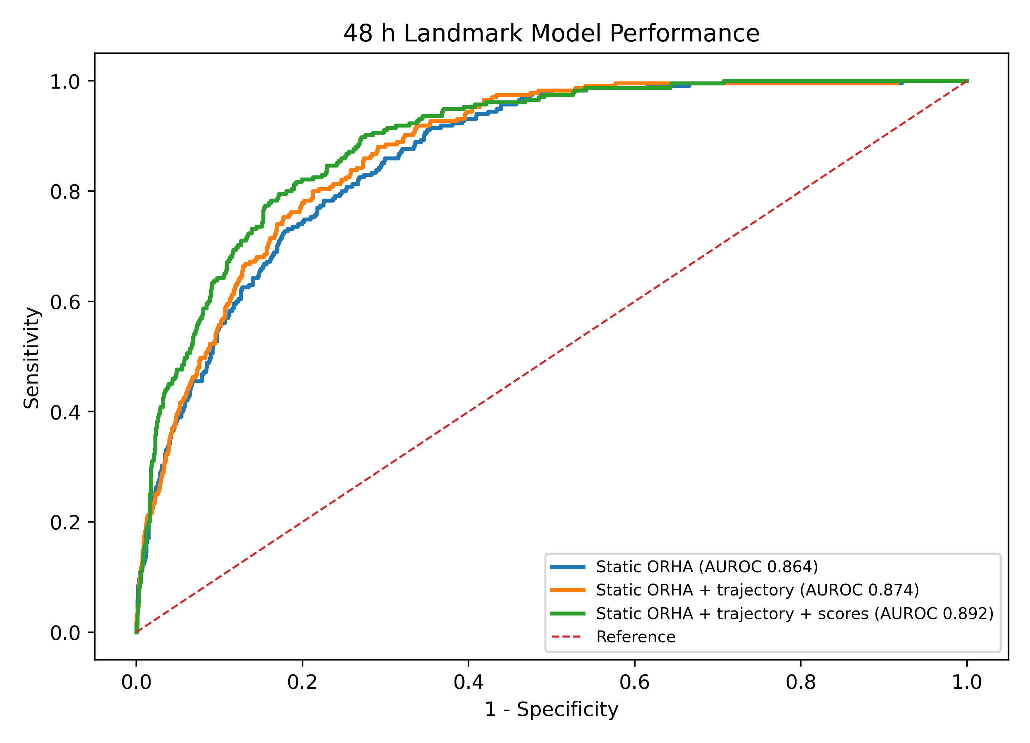
Supplementary Figure S3. Strict 48 h landmark ROC comparison.
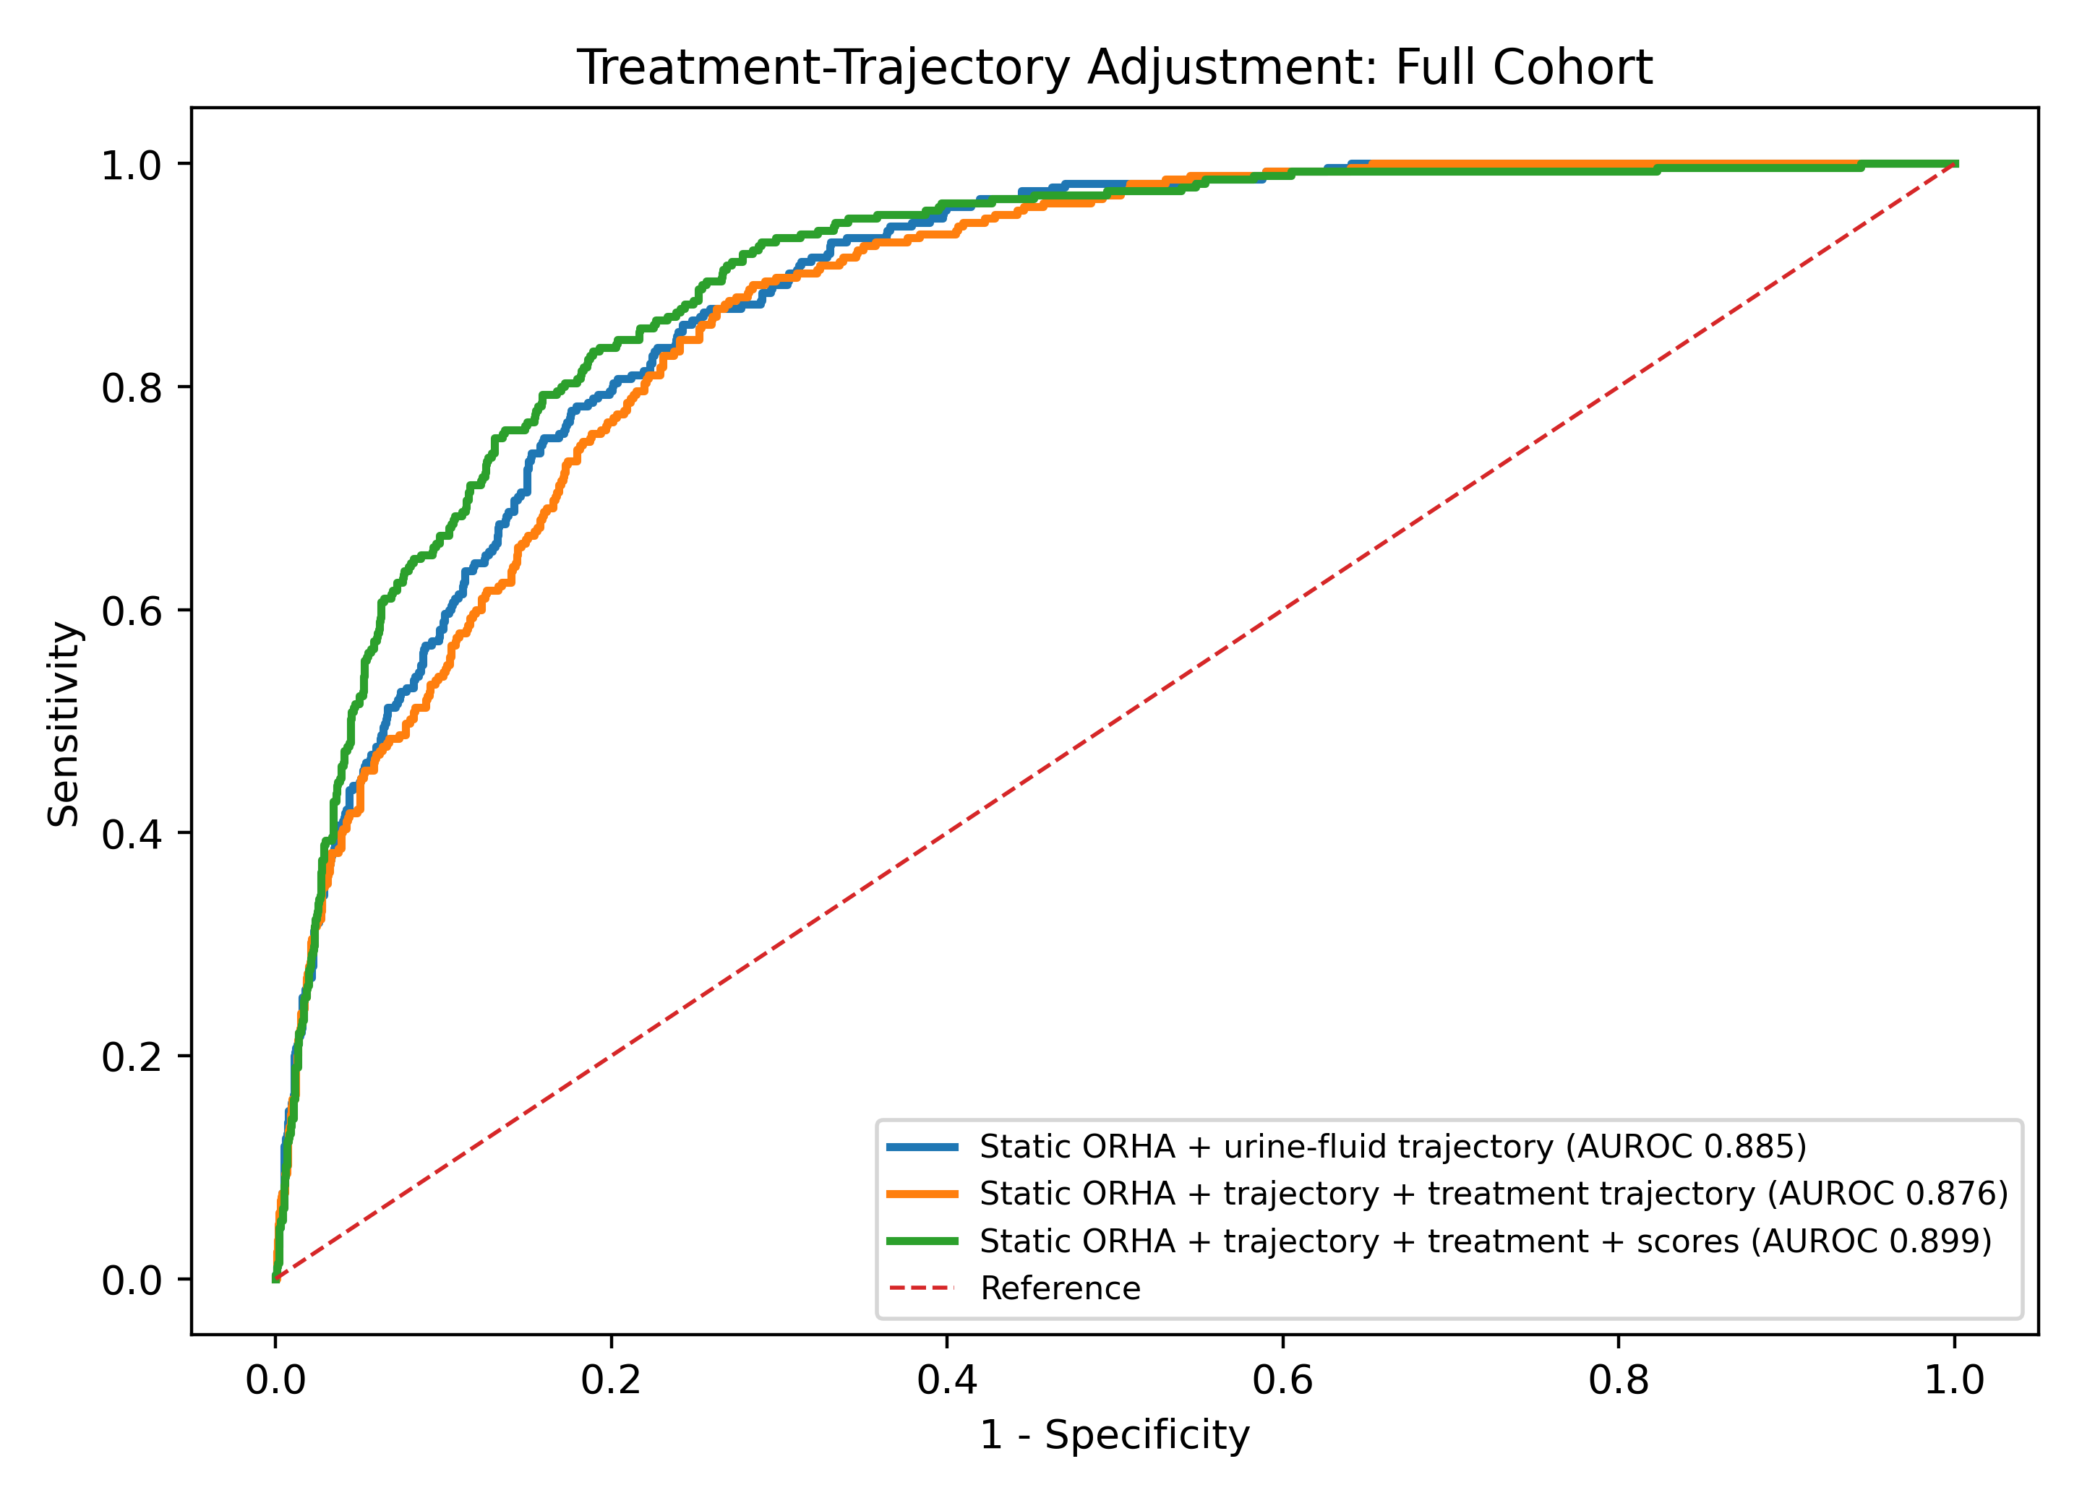
Supplementary Figure S4. Treatment-trajectory adjustment ROC comparison in the full cohort.
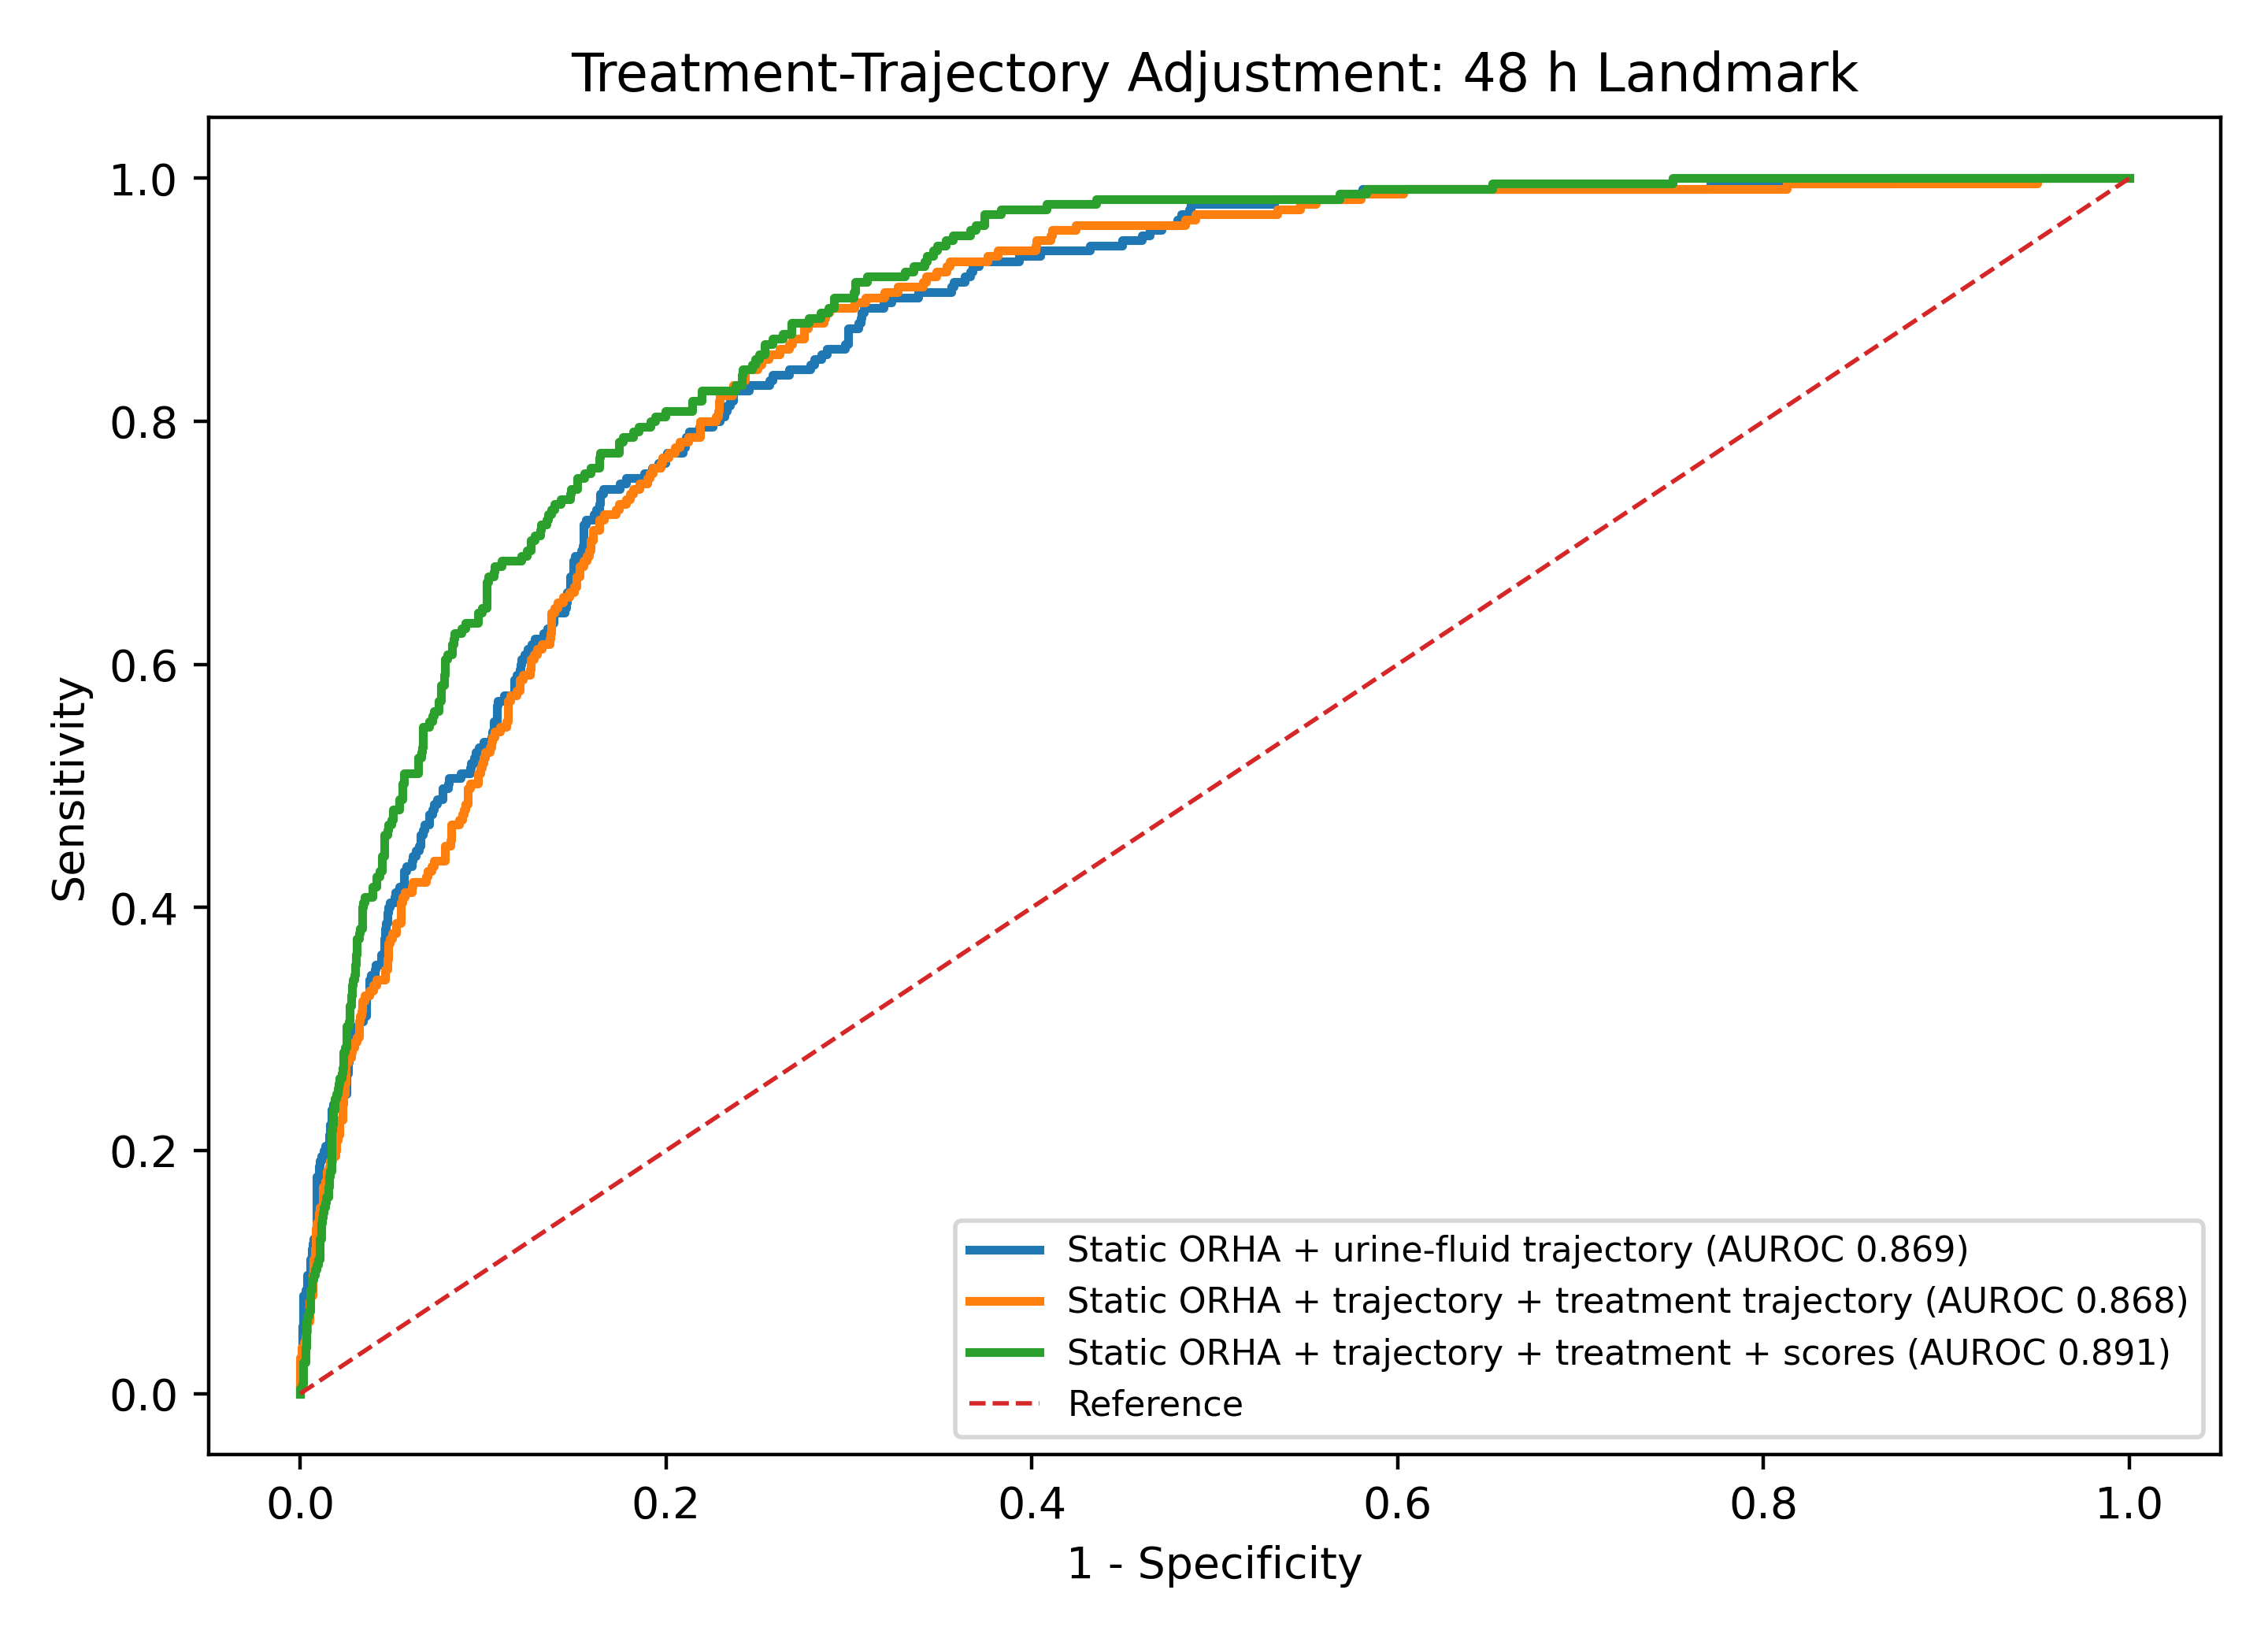
Supplementary Figure S5. Treatment-trajectory adjustment ROC comparison in the strict 48 h landmark cohort.
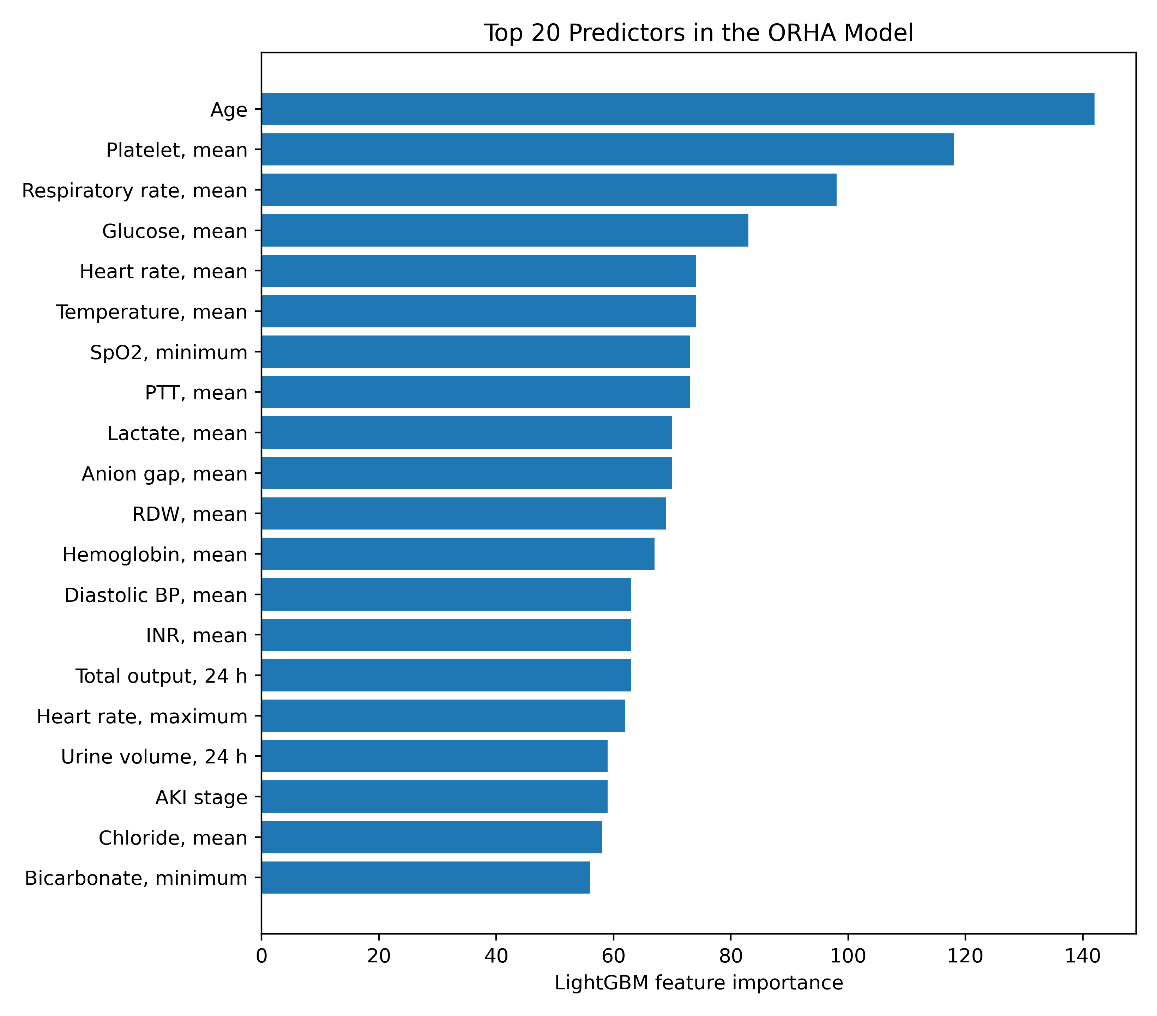
Supplementary Figure S6. Top predictors in the static ORHA model.
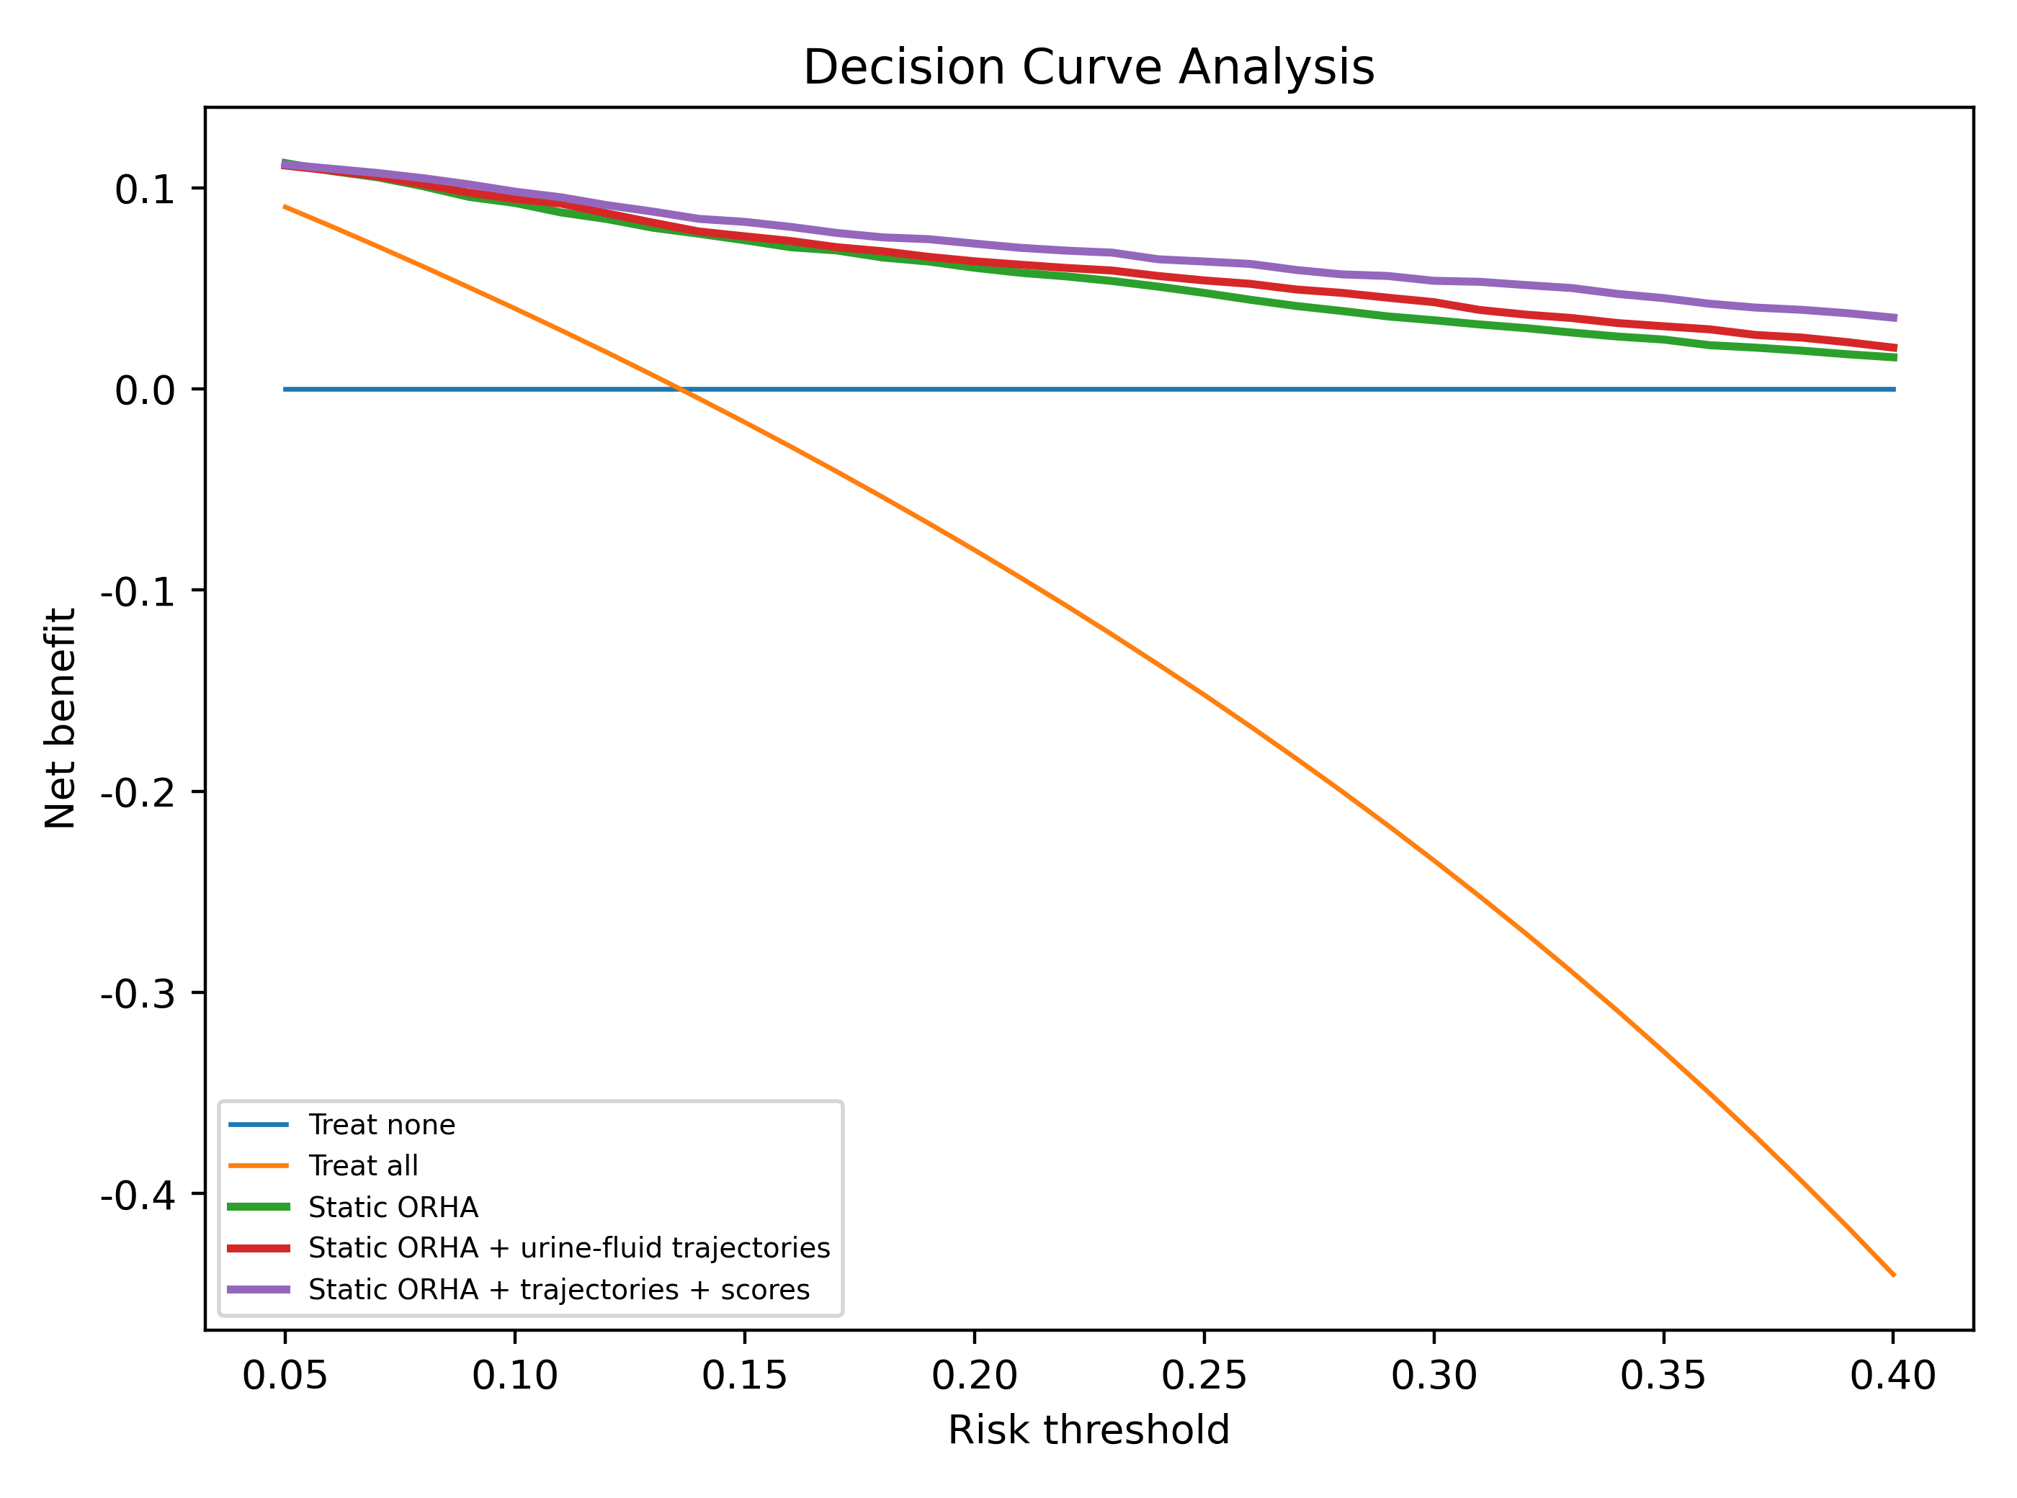
Supplementary Figure S7. Decision-curve analysis in the full cohort.

Supplementary References
1. Byrne RA, Rossello X, Coughlan JJ, Barbato E, Berry C, Chieffo A, et al. 2023 ESC Guidelines for the management of acute coronary syndromes. European Heart Journal. 2023;44:3720-3826. doi:10.1093/eurheartj/ehad191.
2. Johnson AEW, Bulgarelli L, Shen L, Gayles A, Shammout A, Horng S, Pollard TJ, et al. MIMIC-IV, a freely accessible electronic health record dataset. Scientific Data. 2023;10:1. doi:10.1038/s41597-022-01899-x.
3. Johnson A, Bulgarelli L, Pollard T, Gow B, Moody B, Horng S, Celi LA, Mark R. MIMIC-IV (version 3.1). PhysioNet. 2024. https://doi.org/10.13026/kpb9-mt58.
4. Collins GS, Moons KGM, Dhiman P, Riley RD, Beam AL, Van Calster B, et al. TRIPOD+AI statement: updated guidance for reporting clinical prediction models that use regression or machine learning methods. BMJ. 2024;385:e078378.
5. Vasey B, Nagendran M, Campbell B, Clifton DA, Collins GS, Denaxas S, et al. Reporting guideline for the early-stage clinical evaluation of decision support systems driven by artificial intelligence: DECIDE-AI. BMJ. 2022;377:e070904. doi:10.1136/bmj-2022-070904.
6. Kellum JA, Romagnani P, Ashuntantang G, Ronco C, Zarbock A, Anders HJ. Acute kidney injury. Nature Reviews Disease Primers. 2021;7:52. doi:10.1038/s41572-021-00284-z.
7. Ostermann M, Zarbock A, Goldstein S, Kashani K, Macedo E, Murugan R, et al. Recommendations on acute kidney injury biomarkers from the Acute Disease Quality Initiative consensus conference. JAMA Network Open. 2020;3:e2019209. doi:10.1001/jamanetworkopen.2020.19209.
8. Kidney Disease: Improving Global Outcomes Acute Kidney Injury Work Group. KDIGO Clinical Practice Guideline for Acute Kidney Injury. Kidney International Supplements. 2012;2:1-138.
9. Evans L, Rhodes A, Alhazzani W, Antonelli M, Coopersmith CM, French C, et al. Surviving Sepsis Campaign: international guidelines for management of sepsis and septic shock 2021. Intensive Care Medicine. 2021;47:1181-1247. doi:10.1007/s00134-021-06506-y.
10. Samsky MD, Morrow DA, Proudfoot AG, Hochman JS, Thiele H. Cardiogenic shock after acute myocardial infarction: a review. JAMA. 2021;326:1840-1850. doi:10.1001/jama.2021.18323.
11. Thiele H, Zeymer U, Akin I, Behnes M, Rassaf T, Mahabadi AA, et al. Extracorporeal life support in infarct-related cardiogenic shock. New England Journal of Medicine. 2023;389:1286-1297. doi:10.1056/NEJMoa2307227.
12. Lawton JS, Tamis-Holland JE, Bangalore S, Bates ER, Beckie TM, Bischoff JM, et al. 2021 ACC/AHA/SCAI guideline for coronary artery revascularization. Journal of the American College of Cardiology. 2022;79:e21-e129. doi:10.1016/j.jacc.2021.09.006.
13. Goldberger AL, Amaral LAN, Glass L, Hausdorff JM, Ivanov PC, Mark RG, et al. PhysioBank, PhysioToolkit, and PhysioNet: components of a new research resource for complex physiologic signals. Circulation. 2000;101:e215-e220. doi:10.1161/01.CIR.101.23.e215.
14. Ronco C, Bellasi A, Di Lullo L. Cardiorenal syndrome: an overview. Advances in Chronic Kidney Disease. 2018;25:382-390. doi:10.1053/j.ackd.2018.08.004.
15. Malbrain MLNG, Van Regenmortel N, Saugel B, De Tavernier B, Van Gaal PJ, Joannes-Boyau O, et al. Principles of fluid management and stewardship in septic shock: it is time to consider the four D's and the four phases of fluid therapy. Annals of Intensive Care. 2018;8:66. doi:10.1186/s13613-018-0402-x.
16. Zampieri FG, Machado FR, Biondi RS, Freitas FGR, Veiga VC, Figueiredo RC, et al. Effect of slower versus faster intravenous fluid bolus rates on mortality in critically ill patients: the BaSICS randomized clinical trial. JAMA. 2021;326:830-838. doi:10.1001/jama.2021.11444.
17. Semler MW, Self WH, Wanderer JP, Ehrenfeld JM, Wang L, Byrne DW, et al. Balanced crystalloids versus saline in critically ill adults. New England Journal of Medicine. 2018;378:829-839. doi:10.1056/NEJMoa1711584.
18. Van Calster B, McLernon DJ, van Smeden M, Wynants L, Steyerberg EW. Calibration: the Achilles heel of predictive analytics. BMC Medicine. 2019;17:230. doi:10.1186/s12916-019-1466-7.
19. Vickers AJ, van Calster B, Steyerberg EW. A simple, step-by-step guide to interpreting decision curve analysis. Diagnostic and Prognostic Research. 2019;3:18. doi:10.1186/s41512-019-0064-7.
20. Wolff RF, Moons KGM, Riley RD, Whiting PF, Westwood M, Collins GS, et al. PROBAST: a tool to assess the risk of bias and applicability of prediction model studies. Annals of Internal Medicine. 2019;170:51-58. doi:10.7326/M18-1376.
21. Ke G, Meng Q, Finley T, Wang T, Chen W, Ma W, et al. LightGBM: a highly efficient gradient boosting decision tree. Advances in Neural Information Processing Systems. 2017;30:3146-3154.
22. Hyland SL, Faltys M, Hüser M, Lyu X, Gumbsch T, Esteban C, et al. Early prediction of circulatory failure in the intensive care unit using machine learning. Nature Medicine. 2020;26:364-373. doi:10.1038/s41591-020-0789-4.
23. Shillan D, Sterne JAC, Champneys A, Gibbison B. Use of machine learning to analyse routinely collected intensive care unit data: a systematic review. Critical Care. 2019;23:284. doi:10.1186/s13054-019-2564-9.

