Supplementary Figure 1. Within-case comparison between stable and pre-hypotension windows.
The stable control window was defined as T0 -15 to -10 min, and the pre-hypotension window was defined as T0 -5 to -0.5 min. The strict analysis retained cases with little hypotension during the stable window. Compared with the stable window, the pre-hypotension window showed lower MAP, lower BIS, and a higher BIS <40 time proportion.
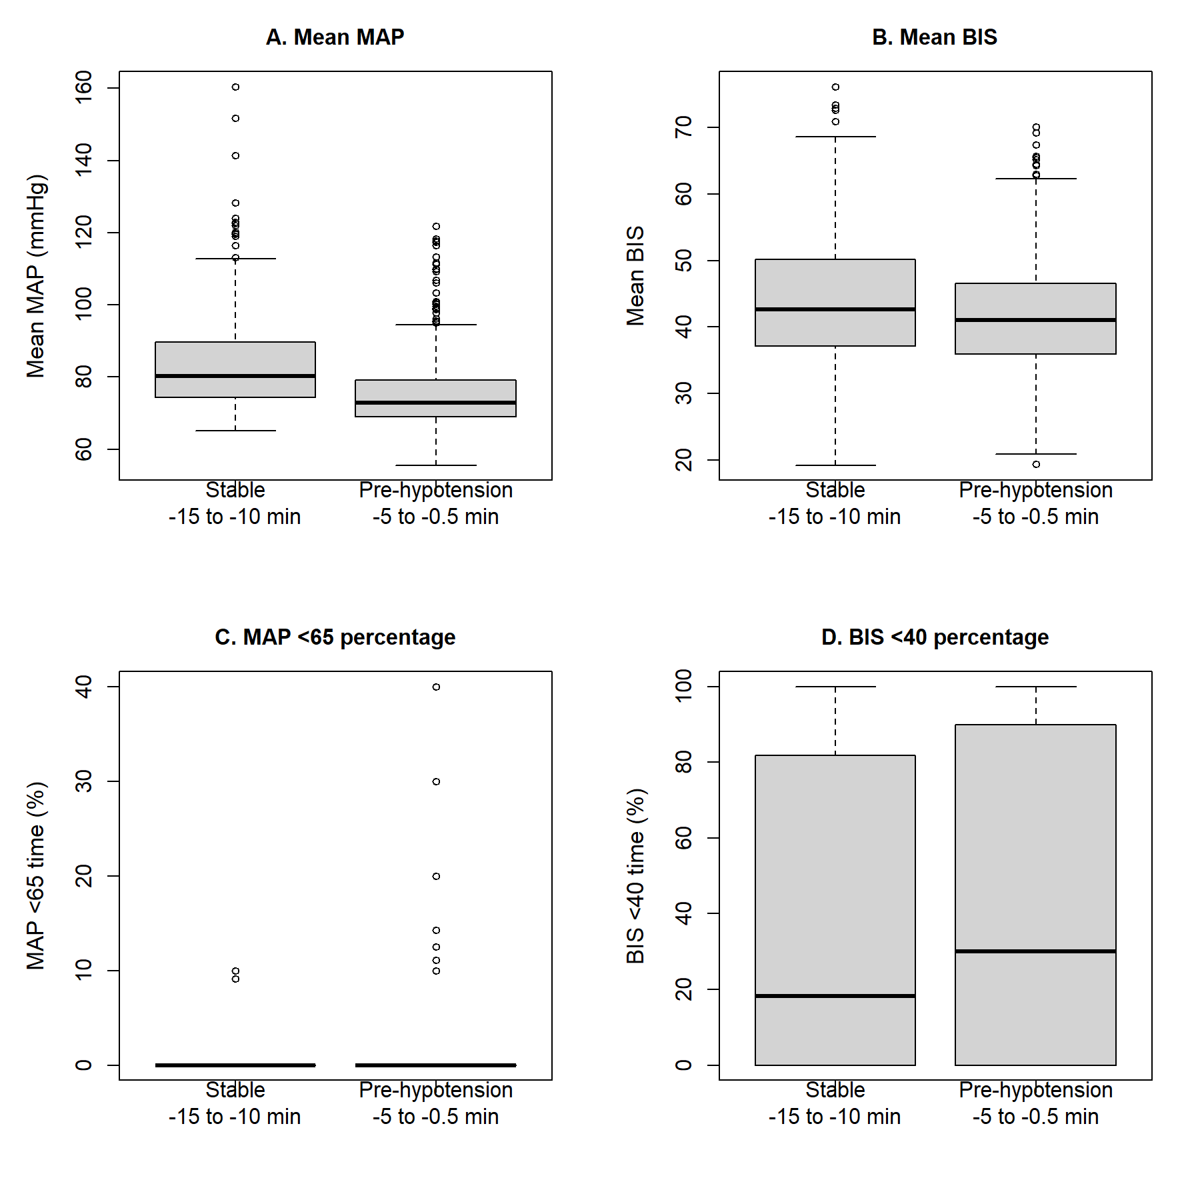

Supplementary tables
Supplementary Table 1. MAP <65 time proportion across BIS <40 exposure groups.
BIS <40 exposure groups were defined as 0%, >0% to 10%, 10% to 30%, and >=30% of valid BIS monitoring time. Values summarize the MAP <65 time proportion across exposure groups.
BIS <40 exposure group | N | Mean MAP <65 time, % | Median MAP <65 time, % | Q1, % | Q3, %
0% | 8 | 16.989742 | 17.586712 | 10.888202 | 23.871650
>0% to 10% | 215 | 11.536874 | 7.147777 | 3.505832 | 14.992990
10% to 30% | 288 | 10.131983 | 5.503376 | 2.008889 | 14.134290
>=30% | 883 | 7.628408 | 4.168275 | 1.198715 | 9.342790
Supplementary Table 2. Complete cohort flow and case inclusion.
Step | N | Excluded or not included | Description
All VitalDB surgical cases | 6,388 |  | All surgical cases available in the VitalDB database.
Prescreened eligible cases | 2,103 | 4,285 did not meet prespecified screening criteria | Noncardiac general anesthesia cases with surgical duration >2 h.
Cases with complete BIS and invasive arterial pressure tracks | 1,428 | 675 did not have complete BIS and invasive arterial pressure tracks | Cases with BIS/BIS, ART_SBP, ART_MBP, and ART_DBP tracks.
Cases included after signal quality control | 1,394 | 34 were excluded after signal quality control | Cases remaining after excluding short or physiologically implausible BIS/MAP recordings.
Cases included in adjusted complete-case models | 1,380 | 14 had missing covariate data for adjusted regression models | Cases with complete covariate data for the primary adjusted regression models.
Cases included in event-aligned analysis | 1,050 | 344 did not have a qualified first hypotension event or sufficient peri-event BIS/MAP data | Cases with a qualified first MAP <65 mmHg event lasting at least 60 s and sufficient peri-event BIS/MAP data.
Cases included in strict within-case paired-window analysis | 729 | 321 did not meet the strict within-case paired-window criteria | Cases retained for strict within-case comparison between the stable control and pre-hypotension windows.
The prescreened eligible cohort was defined as noncardiac general anesthesia cases with surgical duration >2 h. Adjusted complete-case models and event-aligned analyses were both derived from the quality-controlled cohort and should be interpreted as separate analytic subsets.
Supplementary Table 3. RECORD reporting checklist for the present study.
RECORD-related domain | How it was addressed in this study | Manuscript location
Study design and data source | The study was described as a retrospective observational database study using the publicly available VitalDB database. | Abstract; Methods: Data source and ethical considerations
Data access and database description | The VitalDB database, case information table, and track list were described. Data were obtained through the VitalDB API. | Methods: Data source and study cohort
Participant selection | The screened case identifiers, cases with complete BIS and arterial pressure tracks, cases after signal quality control, and complete-case model sample were reported. | Methods: Quality control; Results; Supplementary Table 2
Exposure and outcome definitions | BIS <40 exposure, MAP <65 hypotension burden, substantial hypotension burden, hypotension onset T0, and within-case windows were explicitly defined. | Methods: Signal processing; Event-aligned analysis; Within-case analysis
Data cleaning and signal quality control | Physiologic range filters, monitoring-duration requirements, and exclusion of implausible arterial pressure records were described. | Methods: Signal processing and quality control
Handling of missing data | Complete-case samples were reported for adjusted regression models. | Methods: Covariates; Results
Statistical methods | Case-level correlation, regression models, sensitivity analysis, event-aligned analysis, and within-case paired-window analysis were described. | Methods: Statistical analysis
Flow of participants/cases | The number of screened cases, complete-track cases, quality-controlled cases, and complete-case models was reported. | Results; Supplementary Table 2
Data availability | The source database is publicly available through VitalDB. Derived analytic datasets and code can be made available upon reasonable request, depending on journal policy. | Data availability statement
Interpretation and limitations | Residual confounding, signal artifacts, time-varying clinical interventions, and lack of external validation were discussed. | Discussion: Limitations
Supplementary Table 4. Extended adjustment models including intraoperative management variables.
Model | Outcome | Exposure | Effect measure | Estimate | 95% CI | P value | N
Extended logistic regression | MAP <65 time proportion >=10% | BIS <40 time proportion per 10% increase | Adjusted OR | 0.883 | 0.836 to 0.933 | <0.001 | 1,199
Extended linear regression | MAP <65 time proportion | BIS <40 time proportion per 10% increase | Adjusted beta | -0.505 | -0.716 to -0.294 | <0.001 | 1,199
Extended models additionally adjusted for operation duration, estimated blood loss, intraoperative crystalloid and colloid volume, red blood cell transfusion, fresh frozen plasma transfusion, ephedrine dose, and phenylephrine dose. BIS <40 exposure was modeled per 10% increase in valid monitoring time.
Supplementary Table 5. Bootstrap internal validation of the main adjusted logistic model.
Model | N | Bootstrap samples | Bootstrap median OR | 95% bootstrap interval | Proportion OR <1
Main adjusted logistic model | 1,380 | 1,000 | 0.885 | 0.844 to 0.928 | 100%
Bootstrap validation was performed using 1000 resamples with replacement. The table reports the bootstrap median odds ratio, percentile-based 95% bootstrap interval, and the proportion of bootstrap estimates with OR <1.

The first author：Shenao Xi
Conceptualization，writing-original draft
Co-corresponding author：Xingyu Wang
Study design and co-revising the manuscript
corresponding author：Huiyu Luo
Finalizing the manuscript for submission

