Supplementary File

Hourly Air Quality Forecasting Using Ensemble Learning: Insights from an Arid Urban Atmosphere

Abdullah Kaviani Rad ¹, Mohammad Javad Nematollahi ^{2,*}

- Department of Natural Resources and Environmental Engineering, College of Agriculture, Shiraz University, Shiraz 71946-85111; Iran
- Department of Geology, Faculty of Sciences, Urmia University, Urmia 57561-51818; Iran

* Corresponding author: mj.nematollahi@urmia.ac.ir, Tel: +98 (44) 31942140, ORCID: 0000-0003-1486-0127

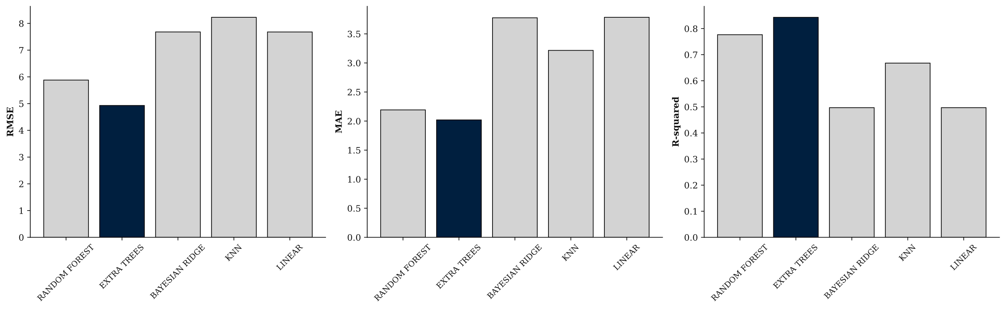
Figure S1. Performance benchmark of five imputation methods (Random Forest, Extra Trees, Bayesian Ridge, KNN, and Linear Regression) evaluated across air pollutants.

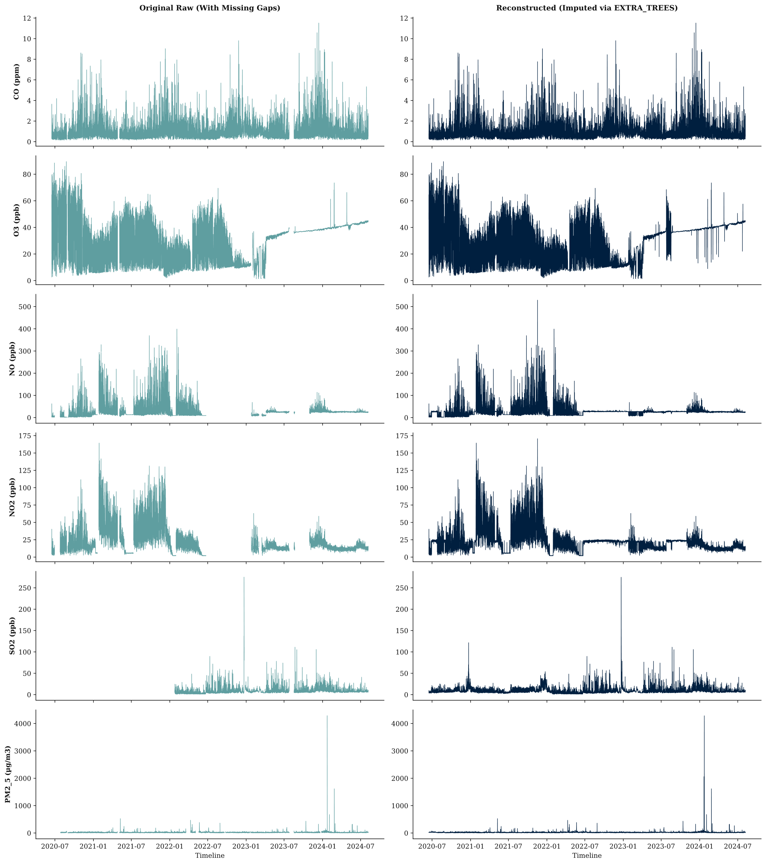
Figure S2. Comparative timeline visualization of raw (with missing gaps) versus imputed time series for pollutants using the Extra Trees model.

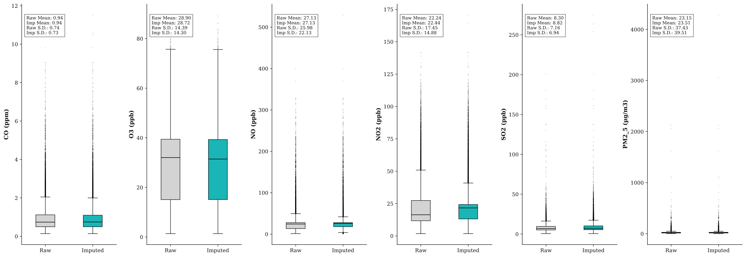
Figure S3. Boxplot comparison of pollutant distributions before (raw) and after (imputed) applying the Extra Trees imputation model.

