SUPPLEMENTARY FIGURES

AR cooperates with SMAD4 to maintain skeletal muscle homeostasis

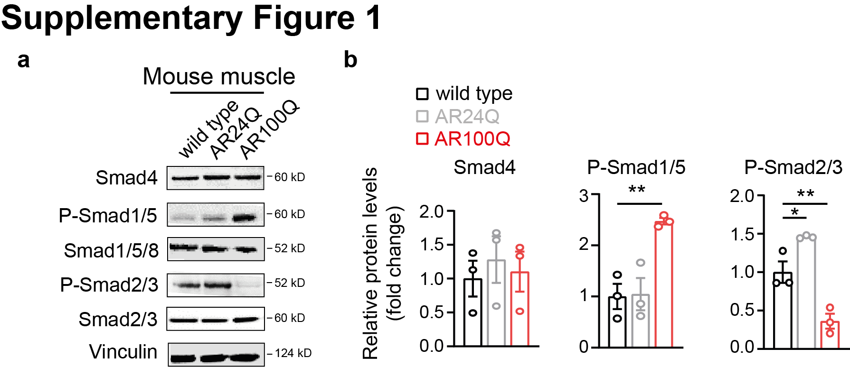

Supplementary Figure 1. a, Whole cell extracts from skeletal muscle of 11-weeks old male AR24Q, AR100Q SBMA and wild type mice were resolved by SDS PAGE followed by immunoblotting using Smad4, P-Smad1/5, Smad1/5/8, P-Smad2/3, and Smad2/3 antibodies and using Vinculin as loading control. Size is expressed in kilodaltons (KD) and displayed next to the blot. b, Quantification of Smad4, P-Smad1/5 and P-Smad2/3 levels relative to the non-phosphorylated Smad (where applicable) and normalised to Vinculin. Data are mean ± s.e.m. Each dot represents one replicate.

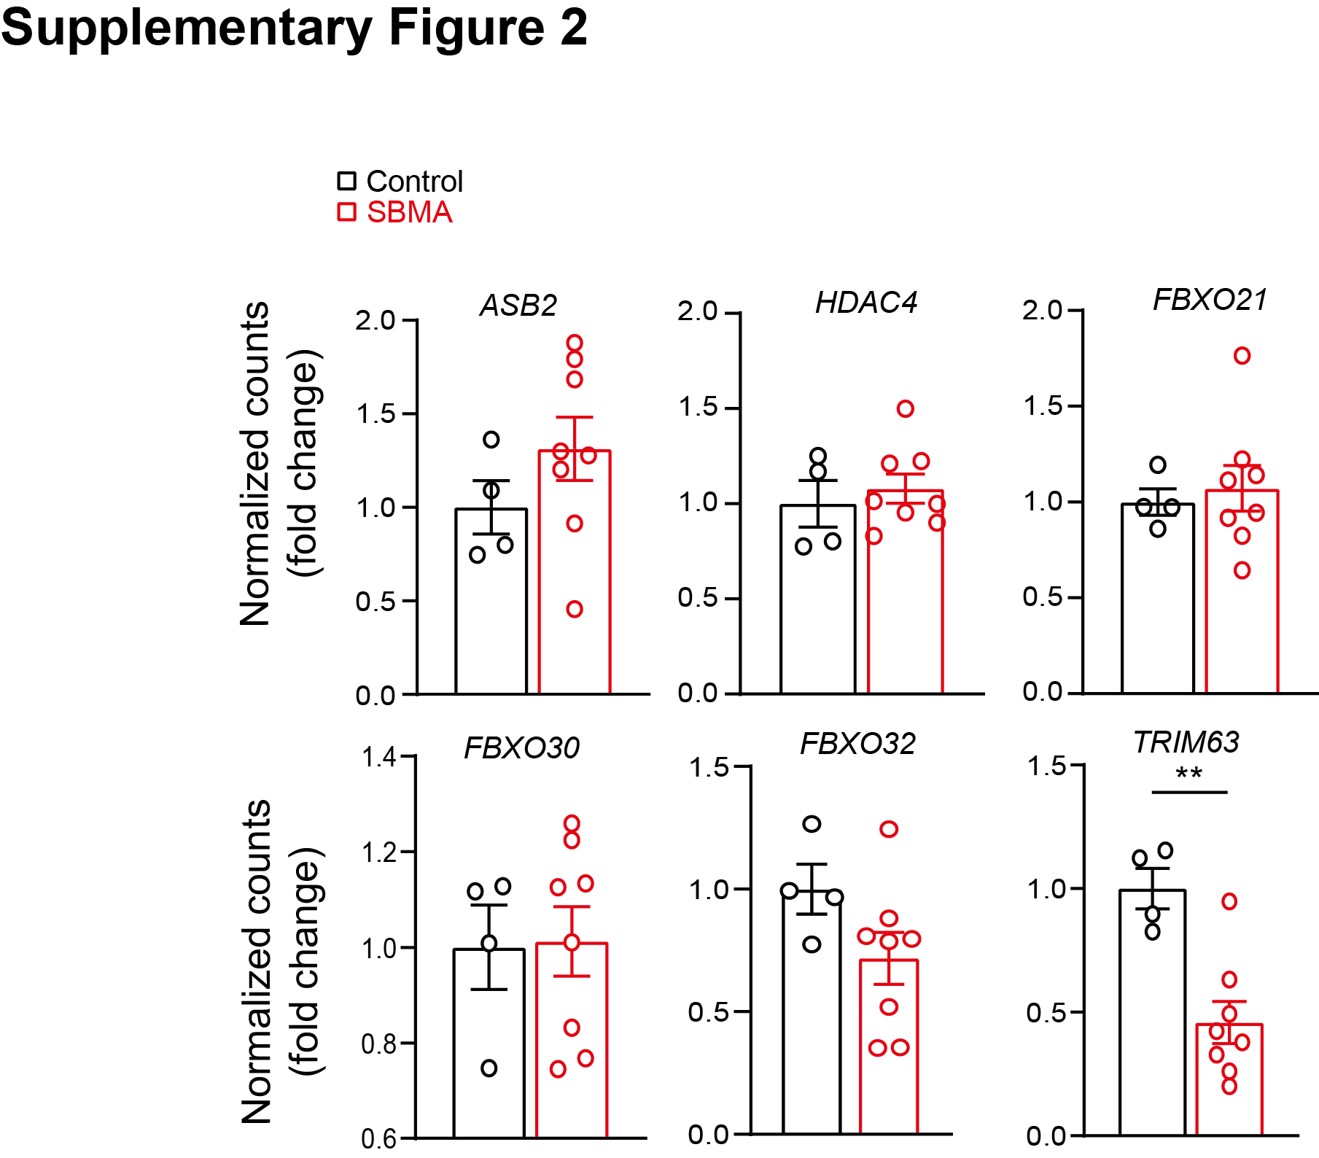

Supplementary Figure 2. mRNA expression levels, expressed as log-normalized counts, of genes involved in muscle atrophy in the RNA-seq dataset from skeletal muscle of SBMA compared to unaffected individuals.
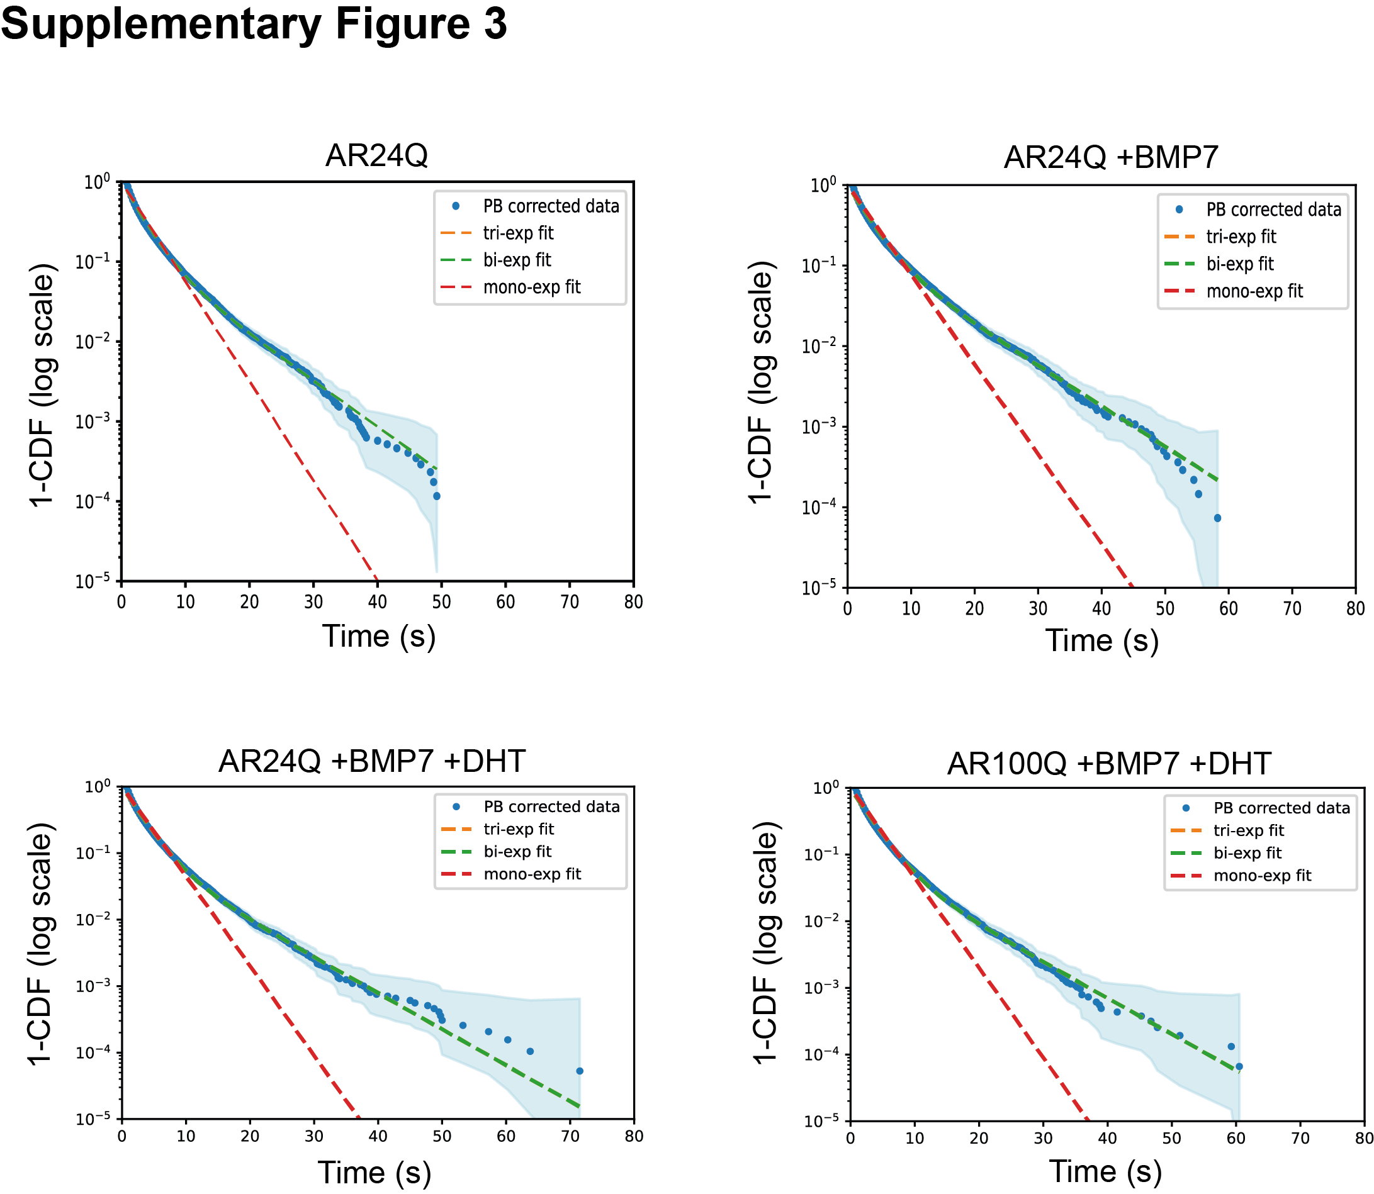

Supplementary Figure 3. The complement of the cumulative distribution function (1-CDF) was plotted as a function of time, corrected for photobleaching and fit to multi-exponential models. A double exponential model was found to best fit the data. The shaded region represents the upper and lower bounds of the 95% confidence interval.

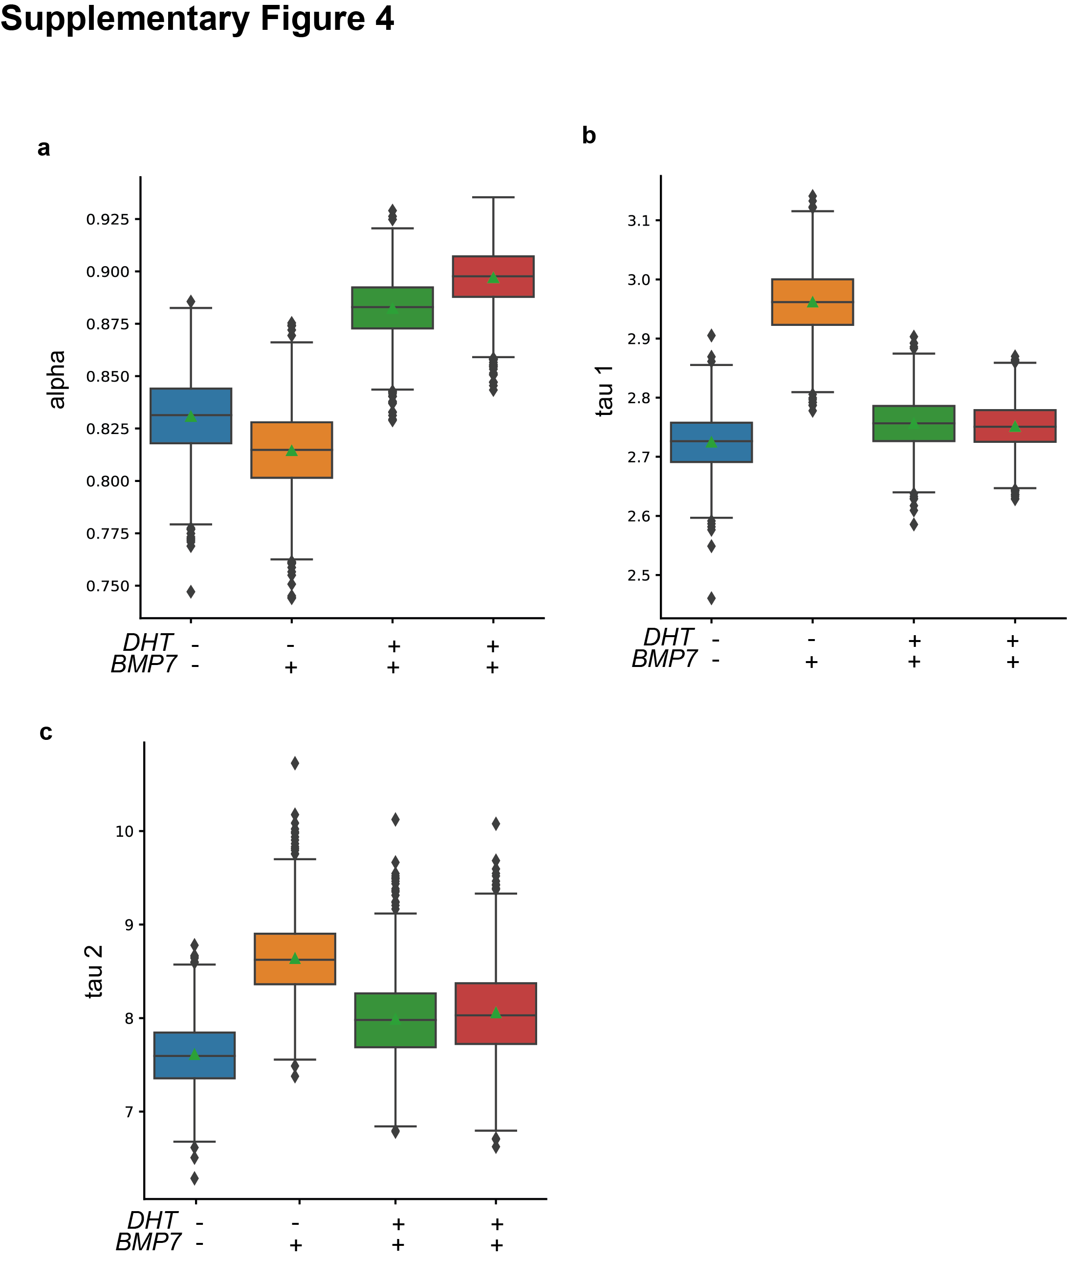

Supplementary Figure 4. a, Fractional contribution of the short (~3 s) and long (~8 s) lifetime distributions in C2C12 AR24Q and AR100Q C2C12 cells expressing Smad4-Halo upon DHT 10 nM and BMP7 50 ng/mL for 12 hours, showing that the fast component dominates the residence time distribution. b,c, Decomposition of the exponential fits, expressed as tau 1 and tau 2 (1-alpha), is displayed. Data are expressed as violin plots, where median and interquartile range are indicated (n = 1000 data points per condition).

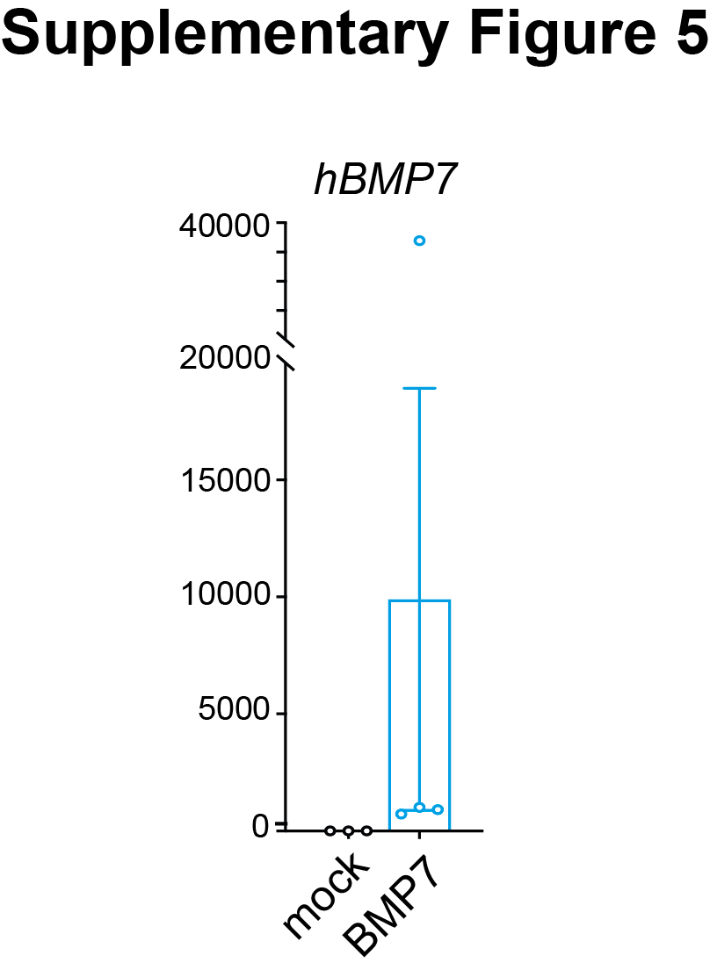

Supplementary Figure 5. mRNA expression levels of known human BMP7 (hBMP7) normalised to Gapdh housekeeping gene in skeletal muscle from SBMA mice treated AAV9-BMP7-eGFP (BMP7) compared to AAV9-eGFP (mock). Data are mean ± s.e.m. Each dot represents one mouse.

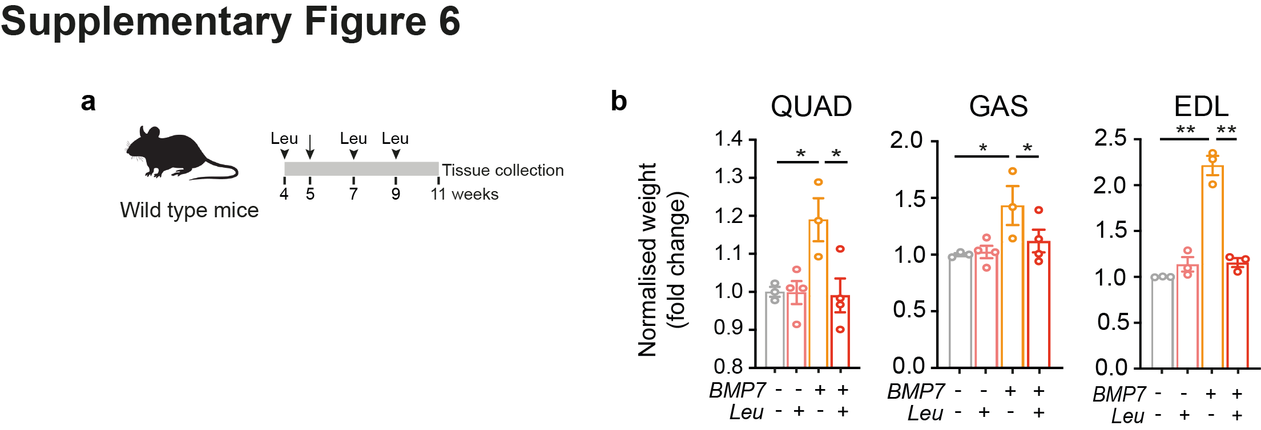

Supplementary Figure 6. a, Experimental design; arrow indicates the timing of the AAV9 intravenous injection, arrowheads indicate the timing of the leuprorelin acetate (Leu) subcutaneous injections at a dose of 100 µg per administration. b, Weight of the entire muscle normalised to whole body weight from wild type mice upon the indicated treatments. QUAD: quadriceps; GAS: gastrocnemius; EDL: extensor digitorum longus. Data are mean ± s.e.m. Each dot represents one mouse.

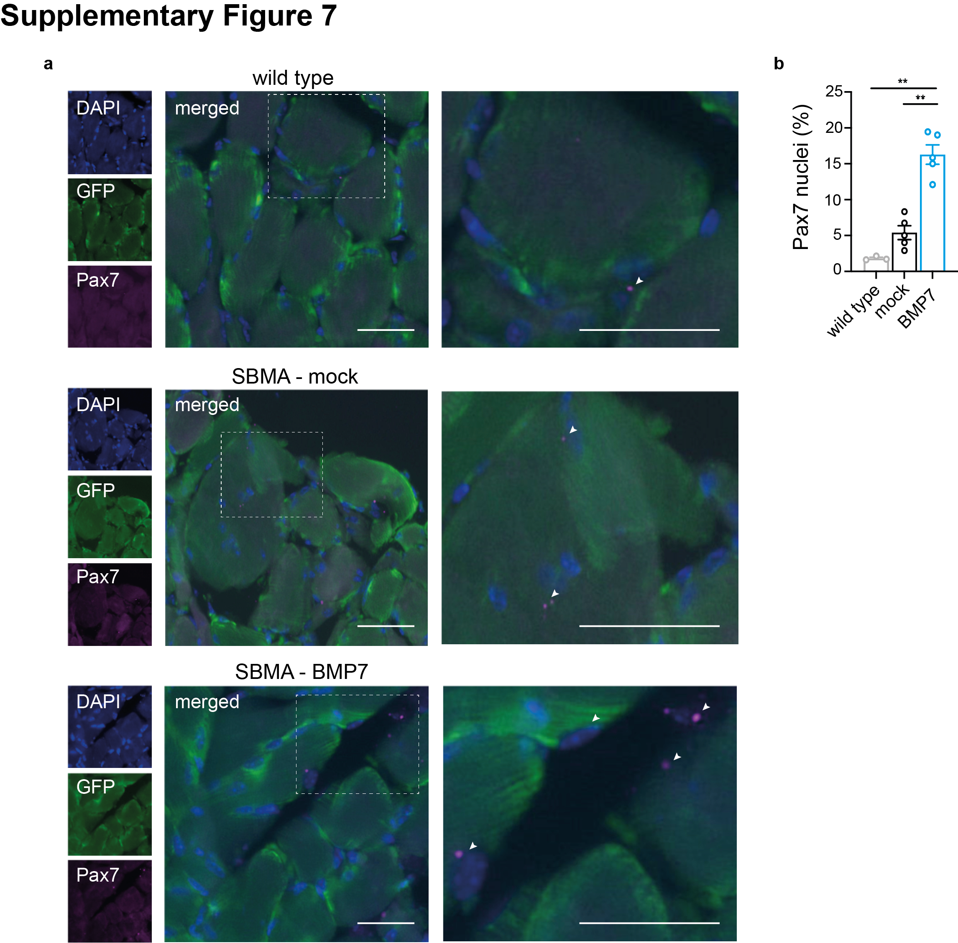

Supplementary Figure 7. a, Representative images of skeletal muscle from wild type and SBMA mice, treated with AAV9-eGFP (mock) or AAV9-BMP7-eGFP (BMP7), stained with Pax7 antibody (magenta) and DAPI (blue). Arrowheads indicate the Pax7 signal. Representative magnification of myofiber is shown on the side. Scale bar, 50 µm. b, Quantification of number of Pax7 positive cells relative to total cells. Data are mean ± s.e.m. Each dot represents one mouse.

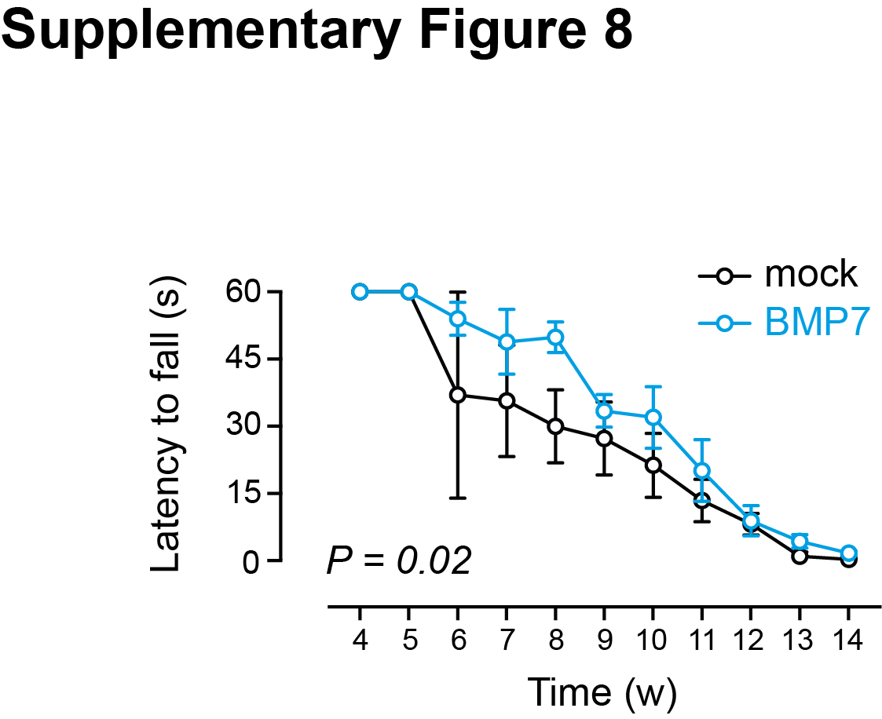

Supplementary Figure 8. Rotarod performances over time, expressed as mean ± s.e.m. latency to fall, of SBMA mice treated with AAV9-control and AAV9-BMP7 (two-way ANOVA).

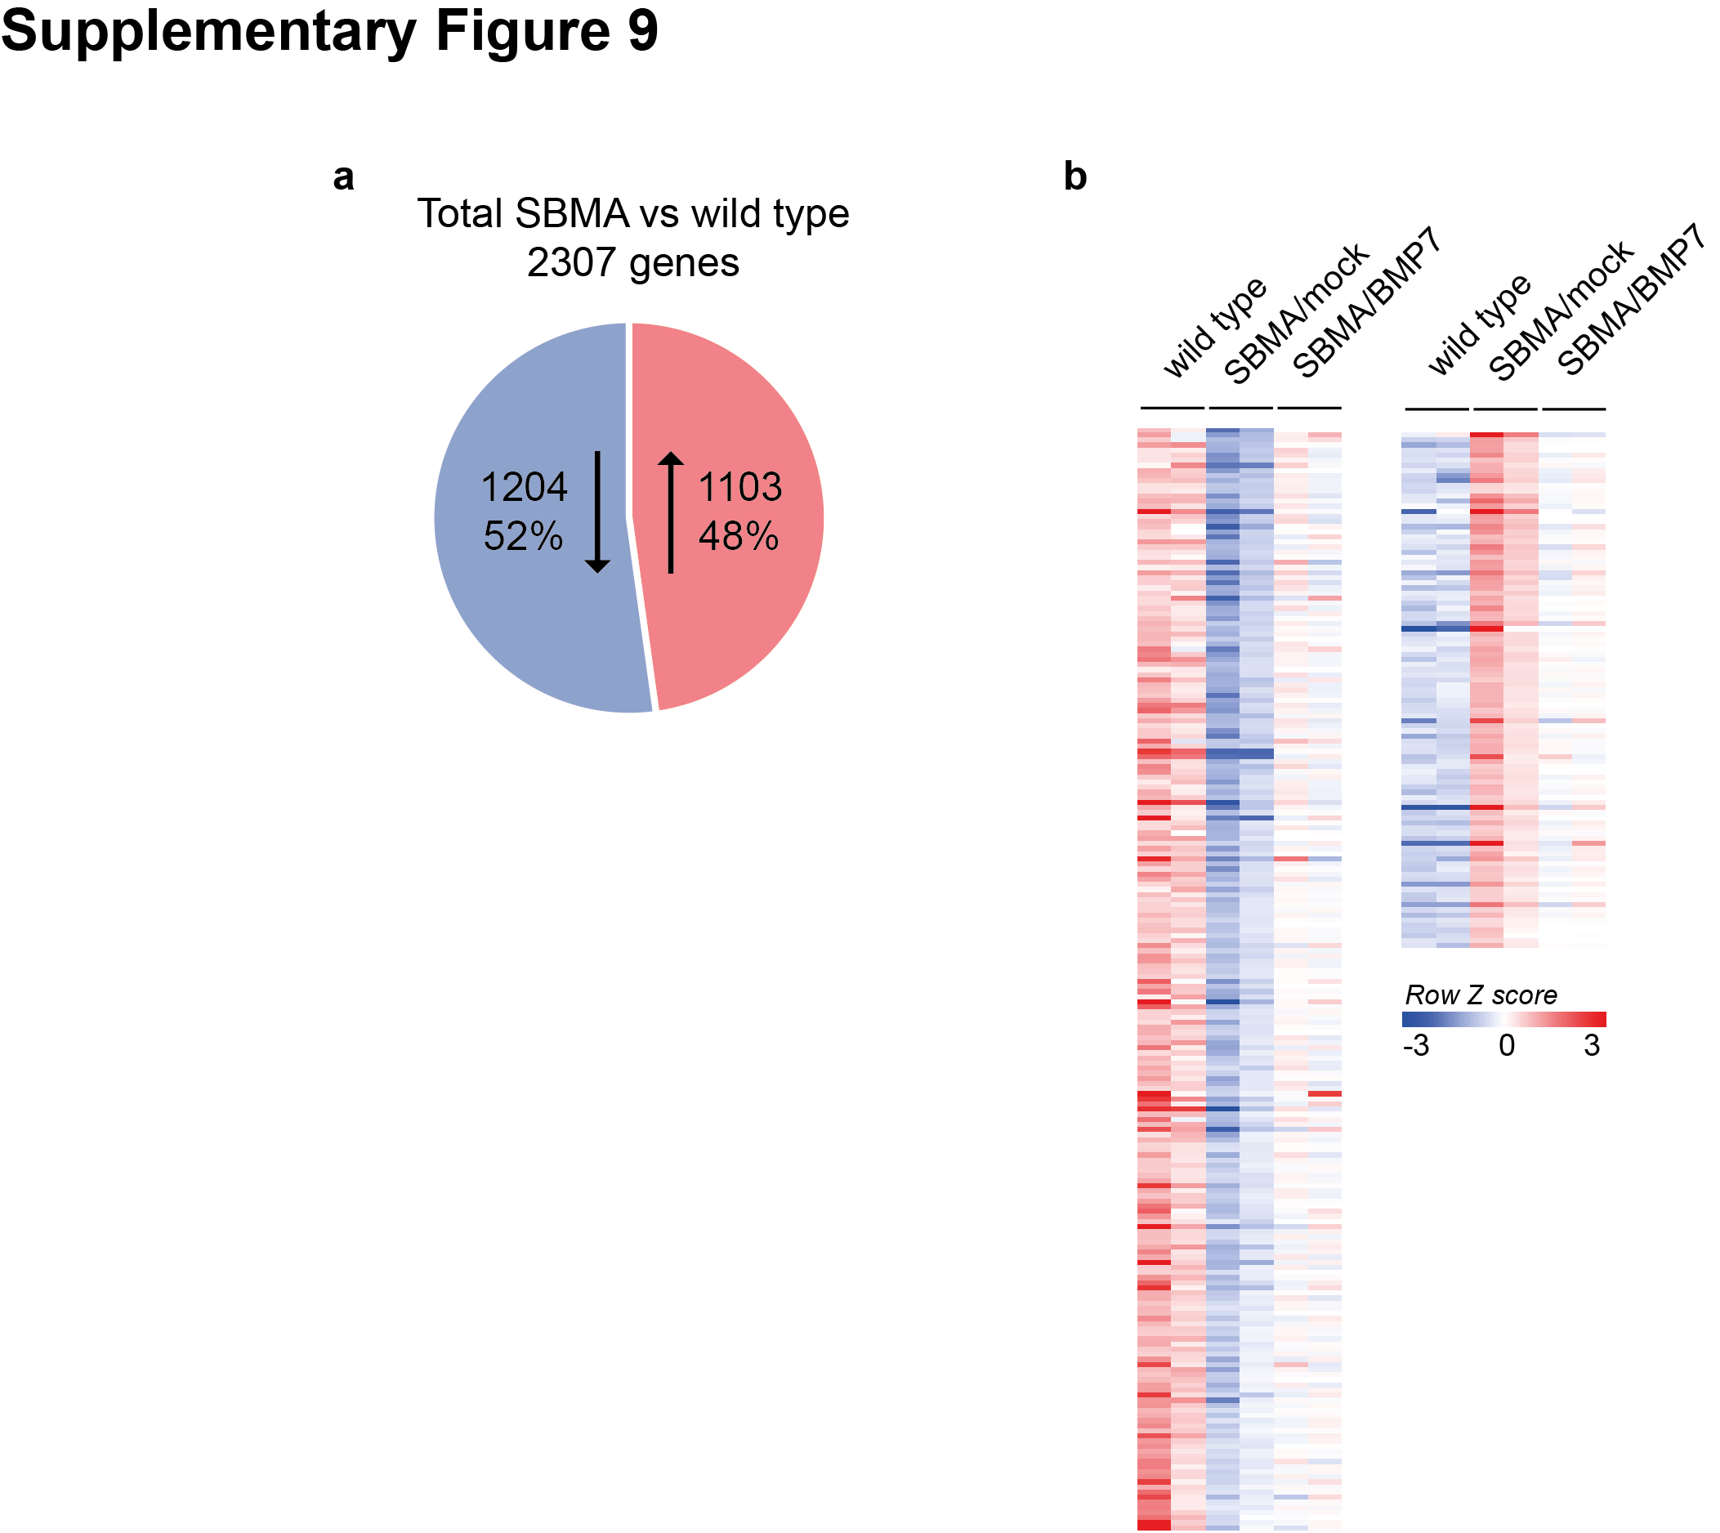

Supplementary Figure 9. a, Pie chart shows the proportion of upregulated (red) and downregulated (blue) transcripts in quadriceps muscle from SBMA mice compared to wild type mice. b, Heat map of z-scores for the top differentially expressed genes, showing partial restoration in skeletal muscle of BMP7-treated SBMA mice compared to mock-treated littermates.

