Table S1. Participants demographics and baseline characteristics by CMM outcome
Variables | CMM = 0 (n = 5048) | CMM = 1 (n = 346) | P
Age, years | 58.00 (52.00, 64.00) | 60.00 (54.00, 64.00) | 0.001
CumLE8 | 202.49 (178.66, 227.14) | 183.21 (159.64, 207.85) | <.001
SBP, mmHg | 128.00 (115.00, 143.00) | 135.00 (122.00, 150.75) | <.001
DBP, mmHg | 75.00 (68.00, 84.00) | 78.00 (70.25, 86.00) | <.001
Height, m | 1.58 (1.52, 1.64) | 1.56 (1.51, 1.62) | 0.026
Weight, kg | 57.70 (51.00, 65.20) | 61.55 (53.82, 69.15) | <.001
WC, cm | 84.00 (77.30, 91.00) | 89.00 (82.40, 96.00) | <.001
BMI, kg/m² | 23.04 (20.86, 25.50) | 25.10 (22.33, 27.34) | <.001
BUN, mg/dL | 15.13 (12.63, 18.15) | 14.80 (12.52, 17.70) | 0.228
Cr, mg/dL | 0.76 (0.64, 0.87) | 0.75 (0.64, 0.87) | 0.590
CRP, mg/L | 0.94 (0.53, 1.97) | 1.29 (0.67, 2.30) | <.001
FPG, mg/dL | 101.52 (93.96, 110.52) | 108.09 (99.18, 124.88) | <.001
HbA1c, % | 5.10 (4.90, 5.40) | 5.30 (5.00, 5.80) | <.001
HDL-C, mg/dL | 50.26 (40.98, 60.70) | 45.81 (37.89, 53.74) | <.001
LDL-C, mg/dL | 113.27 (92.78, 135.70) | 121.01 (96.26, 146.52) | <.001
TC, mg/dL | 189.82 (166.62, 214.18) | 199.29 (175.13, 229.06) | <.001
TG, mg/dL | 102.66 (73.46, 149.57) | 124.79 (90.27, 187.18) | <.001
UA, mg/dL | 4.23 (3.54, 5.06) | 4.29 (3.50, 5.19) | 0.531
Education, n (%) |  |  | 0.514
< High school | 2922 (57.88) | 207 (59.83)
≥ High school | 2126 (42.12) | 139 (40.17)
Married, n (%) | 4541 (89.96) | 311 (89.88) | 1.000
Male, n (%) | 2396 (47.46) | 126 (36.42) | <.001
Smoking, n (%) | 1987 (39.36) | 109 (31.50) | 0.004
Drinking, n (%) | 2018 (39.98) | 117 (33.82) | 0.027
Diabetes, n (%) | 177 (3.51) | 52 (15.03) | <.001
Dyslipidemia, n (%) | 377 (7.47) | 72 (20.81) | <.001
Antihypertensive, n (%) | 785 (15.55) | 117 (33.82) | <.001
Antidiabetic, n (%) | 98 (1.94) | 38 (10.98) | <.001
Lipid-lowering, n (%) | 185 (3.66) | 43 (12.43) | <.001

Table S2. Participants demographics and baseline characteristics by Cluster
Variables | Cluster 1 (n = 1402) | Cluster 2 (n = 2429) | Cluster 3 (n = 1563) | P
CMM, n (%) | 148 (10.56) | 149 (6.13) | 49 (3.13) | <.001
Age, years | 60.00 (54.00, 66.00) | 58.00 (53.00, 64.00) | 56.00 (49.00, 61.00) | <.001
cumLE8 | 160.71 (146.79, 170.35) | 200.35 (189.65, 210.00) | 239.99 (229.28, 251.78) | <.001
SBP, mmHg | 142.00 (130.00, 155.75) | 129.00 (116.00, 143.00) | 118.00 (109.00, 129.00) | <.001
DBP, mmHg | 82.00 (74.00, 90.00) | 75.00 (68.00, 84.00) | 71.00 (64.00, 77.00) | <.001
Height, m | 1.60 (1.54, 1.66) | 1.58 (1.52, 1.64) | 1.56 (1.51, 1.62) | <.001
Weight, kg | 62.40 (54.30, 70.70) | 57.80 (51.30, 65.00) | 54.90 (49.00, 61.40) | <.001
WC, cm | 88.80 (81.12, 96.20) | 84.20 (78.00, 91.00) | 81.00 (75.00, 87.50) | <.001
BMI, kg/m² | 24.48 (21.69, 27.30) | 23.05 (20.90, 25.54) | 22.36 (20.52, 24.44) | <.001
BUN, mg/dL | 15.42 (12.94, 18.71) | 15.18 (12.69, 18.12) | 14.71 (12.27, 17.60) | <.001
Cr, mg/dL | 0.80 (0.69, 0.93) | 0.76 (0.66, 0.87) | 0.70 (0.61, 0.80) | <.001
CRP, mg/L | 1.28 (0.68, 2.60) | 0.94 (0.53, 2.00) | 0.77 (0.46, 1.54) | <.001
FPG, mg/dL | 106.02 (97.24, 120.42) | 101.88 (94.32, 110.70) | 98.82 (92.34, 106.02) | <.001
HbA1c, % | 5.20 (4.90, 5.60) | 5.10 (4.90, 5.40) | 5.10 (4.80, 5.30) | <.001
HDL-C, mg/dL | 46.39 (37.89, 56.83) | 49.48 (40.98, 60.31) | 52.96 (44.07, 62.63) | <.001
LDL-C, mg/dL | 123.71 (99.45, 147.97) | 114.43 (93.94, 136.86) | 105.93 (88.14, 125.26) | <.001
TC, mg/dL | 204.12 (177.84, 230.80) | 190.59 (168.17, 214.56) | 179.00 (159.67, 201.42) | <.001
TG, mg/dL | 126.56 (86.73, 188.51) | 105.32 (75.22, 151.34) | 89.39 (66.38, 123.90) | <.001
UA, mg/dL | 4.62 (3.83, 5.57) | 4.26 (3.58, 5.07) | 3.87 (3.29, 4.61) | <.001
Education, n (%) |  |  |  | 0.004
< High school | 773 (55.14) | 1400 (57.64) | 956 (61.16)
≥ High school | 629 (44.86) | 1029 (42.36) | 607 (38.84)
Married, n (%) | 1224 (87.30) | 2182 (89.83) | 1446 (92.51) | <.001
Male, n (%) | 905 (64.55) | 1173 (48.29) | 444 (28.41) | <.001
Smoking, n (%) | 942 (67.19) | 955 (39.32) | 199 (12.73) | <.001
Drinking, n (%) | 728 (51.93) | 988 (40.68) | 419 (26.81) | <.001
Diabetes, n (%) | 115 (8.20) | 85 (3.50) | 29 (1.86) | <.001
Dyslipidemia, n (%) | 188 (13.41) | 184 (7.58) | 77 (4.93) | <.001
Antihypertensive, n (%) | 437 (31.17) | 389 (16.01) | 76 (4.86) | <.001
Antidiabetic, n (%) | 76 (5.42) | 45 (1.85) | 15 (0.96) | <.001
Lipid-lowering, n (%) | 108 (7.70) | 92 (3.79) | 28 (1.79) | <.001

Table S3 Collinearity analysis using variance inflation factor (VIF).
Variable | VIF
TC | 13.5527
LDL-C | 10.6634
TG | 5.4795
Gender | 3.5074
HDL-C | 3.0838
SBP | 2.6157
Smoking | 2.5535
Hypertension | 2.4126
Antihypertensive | 2.3273
mLE8 | 2.3051
DBP | 2.2876
Diabetes | 2.1448
Antidiabetic | 2.0960
FPG | 1.9547
HbA1c | 1.9417
WC | 1.6484
Age | 1.5988
Cr | 1.5015
Dyslipidemia | 1.4882
UA | 1.4817
Lipid-lowering | 1.4814
Drinking | 1.4519
BUN | 1.1856
BMI | 1.1505
Marriage | 1.1231
Education | 1.1054
Heart disease | 1.0822
CRP | 1.0261
Stroke | 1.0201

Table S4 Sensitivity analysis of the association between mLE8 and CMM with comprehensive adjustment for covariates with VIF values below 5.
Variables | Model1 |  |  | Model2 |  |  | Model3 |  |  | Model4
Variables | HR (95%CI) | P |  | HR (95%CI) | P |  | HR (95%CI) | P |  | HR (95%CI) | P
mLE8(per 10-unit) | 0.74 (0.70 ~ 0.78) | <.001 |  | 0.80 (0.75 ~ 0.84) | <.001 |  | 0.82 (0.76 ~ 0.88) | <.001 |  | 0.88 (0.82 ~ 0.95) | 0.001
mLE8
Q1 | 1.00 (Reference) |  |  | 1.00 (Reference) |  |  | 1.00 (Reference) |  |  | 1.00 (Reference)
Q2 | 0.74 (0.63 ~ 0.88) | <.001 |  | 0.70 (0.59 ~ 0.83) | <.001 |  | 0.87 (0.72 ~ 1.04) | 0.123 |  | 0.98 (0.81 ~ 1.19) | 0.852
Q3 | 0.56 (0.46 ~ 0.67) | <.001 |  | 0.50 (0.42 ~ 0.61) | <.001 |  | 0.72 (0.58 ~ 0.89) | 0.003 |  | 0.87 (0.70 ~ 1.09) | 0.231
Q4 | 0.35 (0.28 ~ 0.43) | <.001 |  | 0.30 (0.24 ~ 0.38) | <.001 |  | 0.50 (0.38 ~ 0.65) | <.001 |  | 0.66 (0.50 ~ 0.87) | 0.004
HR: Hazard Ratio, CI: Confidence Interval
Model 1: Crude.
Model 2: Adjusted for age, gender, marriage, education.
Model 3: Adjusted for Model 2 + smoking, drinking, hypertension, diabetes, dyslipidemia, SBP, DBP, WC, BMI.
Model 4: Adjusted for Model 3 + heart disease, stroke, Antidiabetic, Lipid-lowering, Antihypertensive, BUN, Cr, CRP, FPG, HbA1c, HDL-C, UA

Table S5. Cox regression results for the association of mLE8 control level and cumulative mLE8 with CMM after comprehensive covariate adjustment.
Variables | Model 1 |  | Model 2 |  | Model 3 |  | Model 4
Variables | HR (95%CI) | P | HR (95%CI) | P | HR (95%CI) | P | HR (95%CI) | P
CumLE8(per 10-unit) | 0.87 (0.84-0.90) | <0.001 | 0.84 (0.82-0.87) | <0.001 | 0.88 (0.85-0.92) | <0.001 | 0.92 (0.88-0.96) | <0.001
CumLE8
Q1 | 1.00 (Reference) |  | 1.00 (Reference) |  | 1.00 (Reference) |  | 1.00 (Reference)
Q2 | 0.63 (0.48-0.81) | <0.001 | 0.57 (0.44-0.75) | <0.001 | 0.73 (0.55-0.98) | 0.033 | 0.81 (0.60-1.08) | 0.153
Q3 | 0.50 (0.38-0.66) | <0.001 | 0.42 (0.32-0.56) | <0.001 | 0.59 (0.43-0.82) | 0.002 | 0.73 (0.52-1.02) | 0.065
Q4 | 0.24 (0.17-0.35) | <0.001 | 0.19 (0.13-0.27) | <0.001 | 0.28 (0.18-0.44) | <0.001 | 0.36 (0.23-0.56) | <0.001
Cluster group
Cluster 1 | 1.00 (Reference) |  | 1.00 (Reference) |  | 1.00 (Reference) |  | 1.00 (Reference)
Cluster 2 | 0.58 (0.46-0.72) | <0.001 | 0.51 (0.41-0.65) | <0.001 | 0.69 (0.53-0.90) | 0.006 | 0.81 (0.61-1.06) | 0.122
Cluster 3 | 0.29 (0.21-0.40) | <0.001 | 0.23 (0.16-0.32) | <0.001 | 0.36 (0.24-0.53) | <0.001 | 0.46 (0.30-0.69) | <0.001
HR: Hazard Ratio, CI: Confidence Interval
Model 1: Crude.
Model 2: Adjusted for age, gender, marriage, education.
Model 3: Adjusted for Model 2 + smoking, drinking, hypertension, diabetes, dyslipidemia, SBP, DBP, WC, BMI.
Model 4: Adjusted for Model 3 + heart disease, stroke, Antidiabetic, Lipid-lowering, Antihypertensive, BUN, Cr, CRP, FPG, HbA1c, HDL-C, UA

Table S6. Proportional Hazards Assumption Test (Schoenfeld Residuals Method)
Variables | P-value | P-value after stratification by Heartdisease, stroke, and Antihypertensive | P-value after stratification by Heartdisease, stroke, Antihypertensive,and diabetes
mLE8 | 0.381 | 0.544 | 0.928
age | 0.011 | 0.075 | 0.090
SBP | 0.933 | 0.594 | 0.583
DBP | 0.978 | 0.696 | 0.723
WC | 0.022 | 0.030 | 0.059
BMI | 0.388 | 0.938 | 0.909
BUN | 0.288 | 0.327 | 0.368
Cr | 0.987 | 0.685 | 0.681
CRP | 0.068 | 0.040 | 0.054
glucose | 0.877 | 0.287 | 0.771
hbalc | 0.326 | 0.797 | 0.149
hdl-c | 0.957 | 0.934 | 0.659
UA | 0.762 | 0.443 | 0.599
gender | 0.621 | 0.476 | 0.396
marriage | 0.293 | 0.456 | 0.433
education | 0.941 | 0.981 | 0.983
smoking | 0.376 | 0.406 | 0.346
drinking | 0.792 | 0.951 | 0.955
hypertension | 0.460 | 0.149 | 0.118
diabetes | 0.269 | 0.010 | /
dyslipidemia | 0.140 | 0.538 | 0.806
heartdisease | <0.001 | / | /
stroke | 0.008 | / | /
Antidiabetic | 0.612 | 0.674 | 0.057
Lipidlowering | 0.830 | 0.560 | 0.313
Antihypertensive | 0.044 | / | /
GLOBAL | <0.001 | 0.027 | 0.112

Table S7. Multivariable stratified Cox regression results
Variables | HR (95% CI) | P value
age | 1.0 (0.99–1.01) | 0.700
gender | 0.83 (0.67–1.05) | 0.127
marriage | 0.90 (0.72–1.13) | 0.393
education | 1.02 (0.88–1.18) | 0.794
smoking | 0.78 (0.62–0.97) | 0.030
drinking | 1.00 (0.84–1.20) | 0.942
SBP | 1.00 (0.99–1.00) | 0.483
DBP | 0.99 (0.98–1.00) | 0.161
WC | 1.01 (1.00–1.02) | <0.001
BMI | 0.99 (0.99–1.00) | 0.751
BUN | 0.98 (0.96–1.02) | 0.077
Cr | 0.88 (0.56–1.36) | 0.574
CRP | 1.00 (0.99–1.01) | 0.499
glucose | 1.00 (0.99–1.00) | 0.581
hba1c | 1.25 (1.14–1.38) | <0.001
hdl-c | 0.99 (0.98–0.99) | 0.004
UA | 1.05 (0.99–1.12) | 0.093
hypertension | 1.75 (1.42–2.17) | <0.001
dyslipidemia | 1.80 (1.46–2.21) | <0.001
Antidiabetic | 0.87 (0.60–1.28) | 0.500
Lipid-lowering | 0.83 (0.63–1.08) | 0.181
mLE8 | 0.98 (0.97–0.99) | <0.001
Note: The model was stratified by heart disease, stroke, antihypertensive, and diabetes. HR, hazard ratio; CI, confidence interval.

Table S8. Incremental predictive value of indicators derived from NRI and IDI
Model | NRI(95%CI) | P | IDI(95%CI) | P
Baseline model | Reference | Reference | Reference | Reference
Baseline model + mLE8 | 0.084 (0.042～0.136) | <0.001 | 0.003 (0.000-0.006) | 0.022

Table S9. Baseline characteristics of participants randomly divided by a 7:3 ratio into a training cohort and a validation cohort
Variables | Total (n = 8815) | Training cohort (n = 6170) | Validation cohort (n = 2645) | P value
Age, years | 59.32 ± 9.28 | 59.29 ± 9.23 | 59.40 ± 9.37 | 0.598
Male, n (%) | 4139 (46.95%) | 2904 (47.07%) | 1235 (46.69%) | 0.747
Married, n (%) | 7757 (88.00%) | 5436 (88.10%) | 2321 (87.75%) | 0.640
Education, n (%) |  |  |  | 0.898
< high school | 5270 (59.78%) | 3686 (59.74%) | 1584 (59.89%)
≥ high school | 3545 (40.22%) | 2484 (40.26%) | 1061 (40.11%)
Smoking, n (%) | 3472 (39.39%) | 2443 (39.59%) | 1029 (38.90%) | 0.543
Drinking, n (%) | 3475 (39.42%) | 2453 (39.76%) | 1022 (38.64%) | 0.325
Hypertension, n (%) | 2175 (24.67%) | 1512 (24.51%) | 663 (25.07%) | 0.576
Diabetes, n (%) | 388 (4.40%) | 289 (4.68%) | 99 (3.74%) | 0.048
Dyslipidemia, n (%) | 760 (8.62%) | 520 (8.43%) | 240 (9.07%) | 0.322
Heart disease, n (%) | 898 (10.19%) | 630 (10.21%) | 268 (10.13%) | 0.911
Stroke, n (%) | 127 (1.44%) | 77 (1.25%) | 50 (1.89%) | 0.020
Antihypertensive , n (%) | 1602 (18.17%) | 1117 (18.10%) | 485 (18.34%) | 0.795
Antidiabetic , n (%) | 234 (2.65%) | 176 (2.85%) | 58 (2.19%) | 0.077
Lipid-lowering , n (%) | 385 (4.37%) | 259 (4.20%) | 126 (4.76%) | 0.233
SBP, mmHg | 132.61 ± 22.58 | 132.33 ± 22.24 | 133.27 ± 23.37 | 0.077
DBP, mmHg | 76.71 ± 12.84 | 76.47 ± 12.78 | 77.27 ± 12.99 | 0.008
WC, cm | 84.20 (77.50, 91.60) | 84.10 (77.60, 91.30) | 84.50 (77.20, 92.00) | 0.547
BMI, kg/m2 | 23.07 (20.80, 25.68) | 23.05 (20.84, 25.64) | 23.12 (20.75, 25.76) | 0.747
BUN | 15.15 (12.58, 18.23) | 15.15 (12.55, 18.23) | 15.15 (12.60, 18.23) | 0.834
Creatinine | 0.76 (0.66, 0.88) | 0.76 (0.66, 0.88) | 0.76 (0.64, 0.88) | 0.895
CRP | 1.02 (0.55, 2.14) | 1.03 (0.55, 2.18) | 1.00 (0.54, 2.08) | 0.504
FPG | 102.06 (94.32, 112.14) | 102.06 (94.32, 112.32) | 102.06 (94.14, 111.96) | 0.741
HbA1c | 5.10 (4.90, 5.40) | 5.10 (4.90, 5.40) | 5.10 (4.90, 5.40) | 0.014
HDL-C | 51.48 ± 15.32 | 51.51 ± 15.43 | 51.40 ± 15.05 | 0.746
Uric acid | 4.45 ± 1.25 | 4.46 ± 1.25 | 4.44 ± 1.23 | 0.497
mLE8 | 66.71 ± 13.31 | 66.66 ± 13.26 | 66.84 ± 13.42 | 0.559
CMM, n (%) | 812 (9.21%) | 568 (9.21%) | 244 (9.22%) | 0.977

Table S10. Baseline characteristics of participants between the CMM and non-CMM groups into a training cohort.
Variables | Total (n = 6170) | Without CMM (n = 5602) | CMM (n = 568) | P
mLE8 | 66.43 (57.86, 75.71) | 67.14 (58.57, 76.43) | 60.71 (52.14, 68.57) | <.001
Age, years | 58.00 (52.00, 65.00) | 58.00 (52.00, 65.00) | 60.00 (54.00, 66.00) | <.001
SBP, mmHg | 129.00 (116.00, 145.00) | 129.00 (116.00, 144.00) | 135.50 (123.00, 151.00) | <.001
DBP, mmHg | 75.00 (68.00, 84.00) | 75.00 (68.00, 84.00) | 78.00 (70.00, 87.00) | <.001
BMI, kg/m2 | 23.05 (20.84, 25.64) | 22.90 (20.71, 25.39) | 25.06 (22.32, 27.60) | <.001
FPG, mg/dL | 102.06 (94.32, 112.32) | 101.70 (93.96, 111.24) | 109.98 (99.00, 123.66) | <.001
HbA1c, % | 5.10 (4.90, 5.40) | 5.10 (4.90, 5.40) | 5.30 (5.00, 5.80) | <.001
HDL-C, mg/dL | 49.48 (40.59, 60.31) | 49.87 (40.98, 60.70) | 45.62 (36.73, 55.67) | <.001
TC, mg/dL | 191.37 (167.78, 215.72) | 190.59 (167.01, 214.95) | 197.17 (174.65, 222.29) | <.001
TG, mg/dL | 103.54 (74.34, 151.34) | 101.78 (73.46, 148.68) | 122.13 (88.50, 181.43) | <.001
UA, mg/dL | 4.31 (3.57, 5.16) | 4.29 (3.57, 5.13) | 4.41 (3.60, 5.33) | 0.031
Male, n (%) | 2904 (47.07) | 2669 (47.64) | 235 (41.37) | 0.004
Smoking, n (%) | 2443 (39.59) | 2249 (40.15) | 194 (34.15) | 0.005
Hypertension, n (%) | 1512 (24.51) | 1237 (22.08) | 275 (48.42) | <.001
Diabetes, n (%) | 289 (4.68) | 202 (3.61) | 87 (15.32) | <.001
Dyslipidemia, n (%) | 520 (8.43) | 386 (6.89) | 134 (23.59) | <.001
Heart disease, n (%) | 630 (10.21) | 473 (8.44) | 157 (27.64) | <.001
Stroke , n(%) | 77 (1.25) | 56 (1.00) | 21 (3.70) | <.001

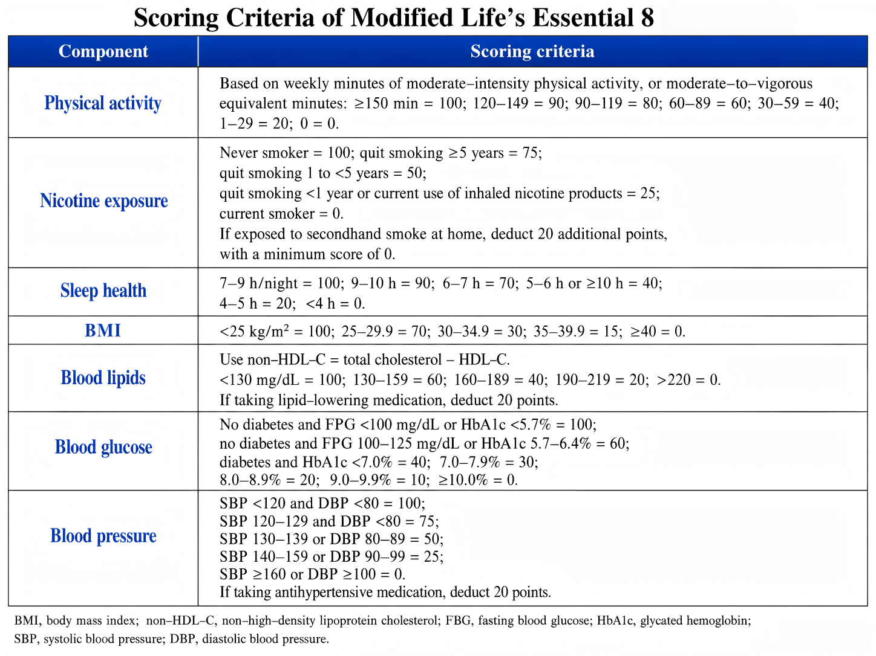
Fig. S1 Scoring Criteria for the Modified Life’s Essential 8 (mLE8)

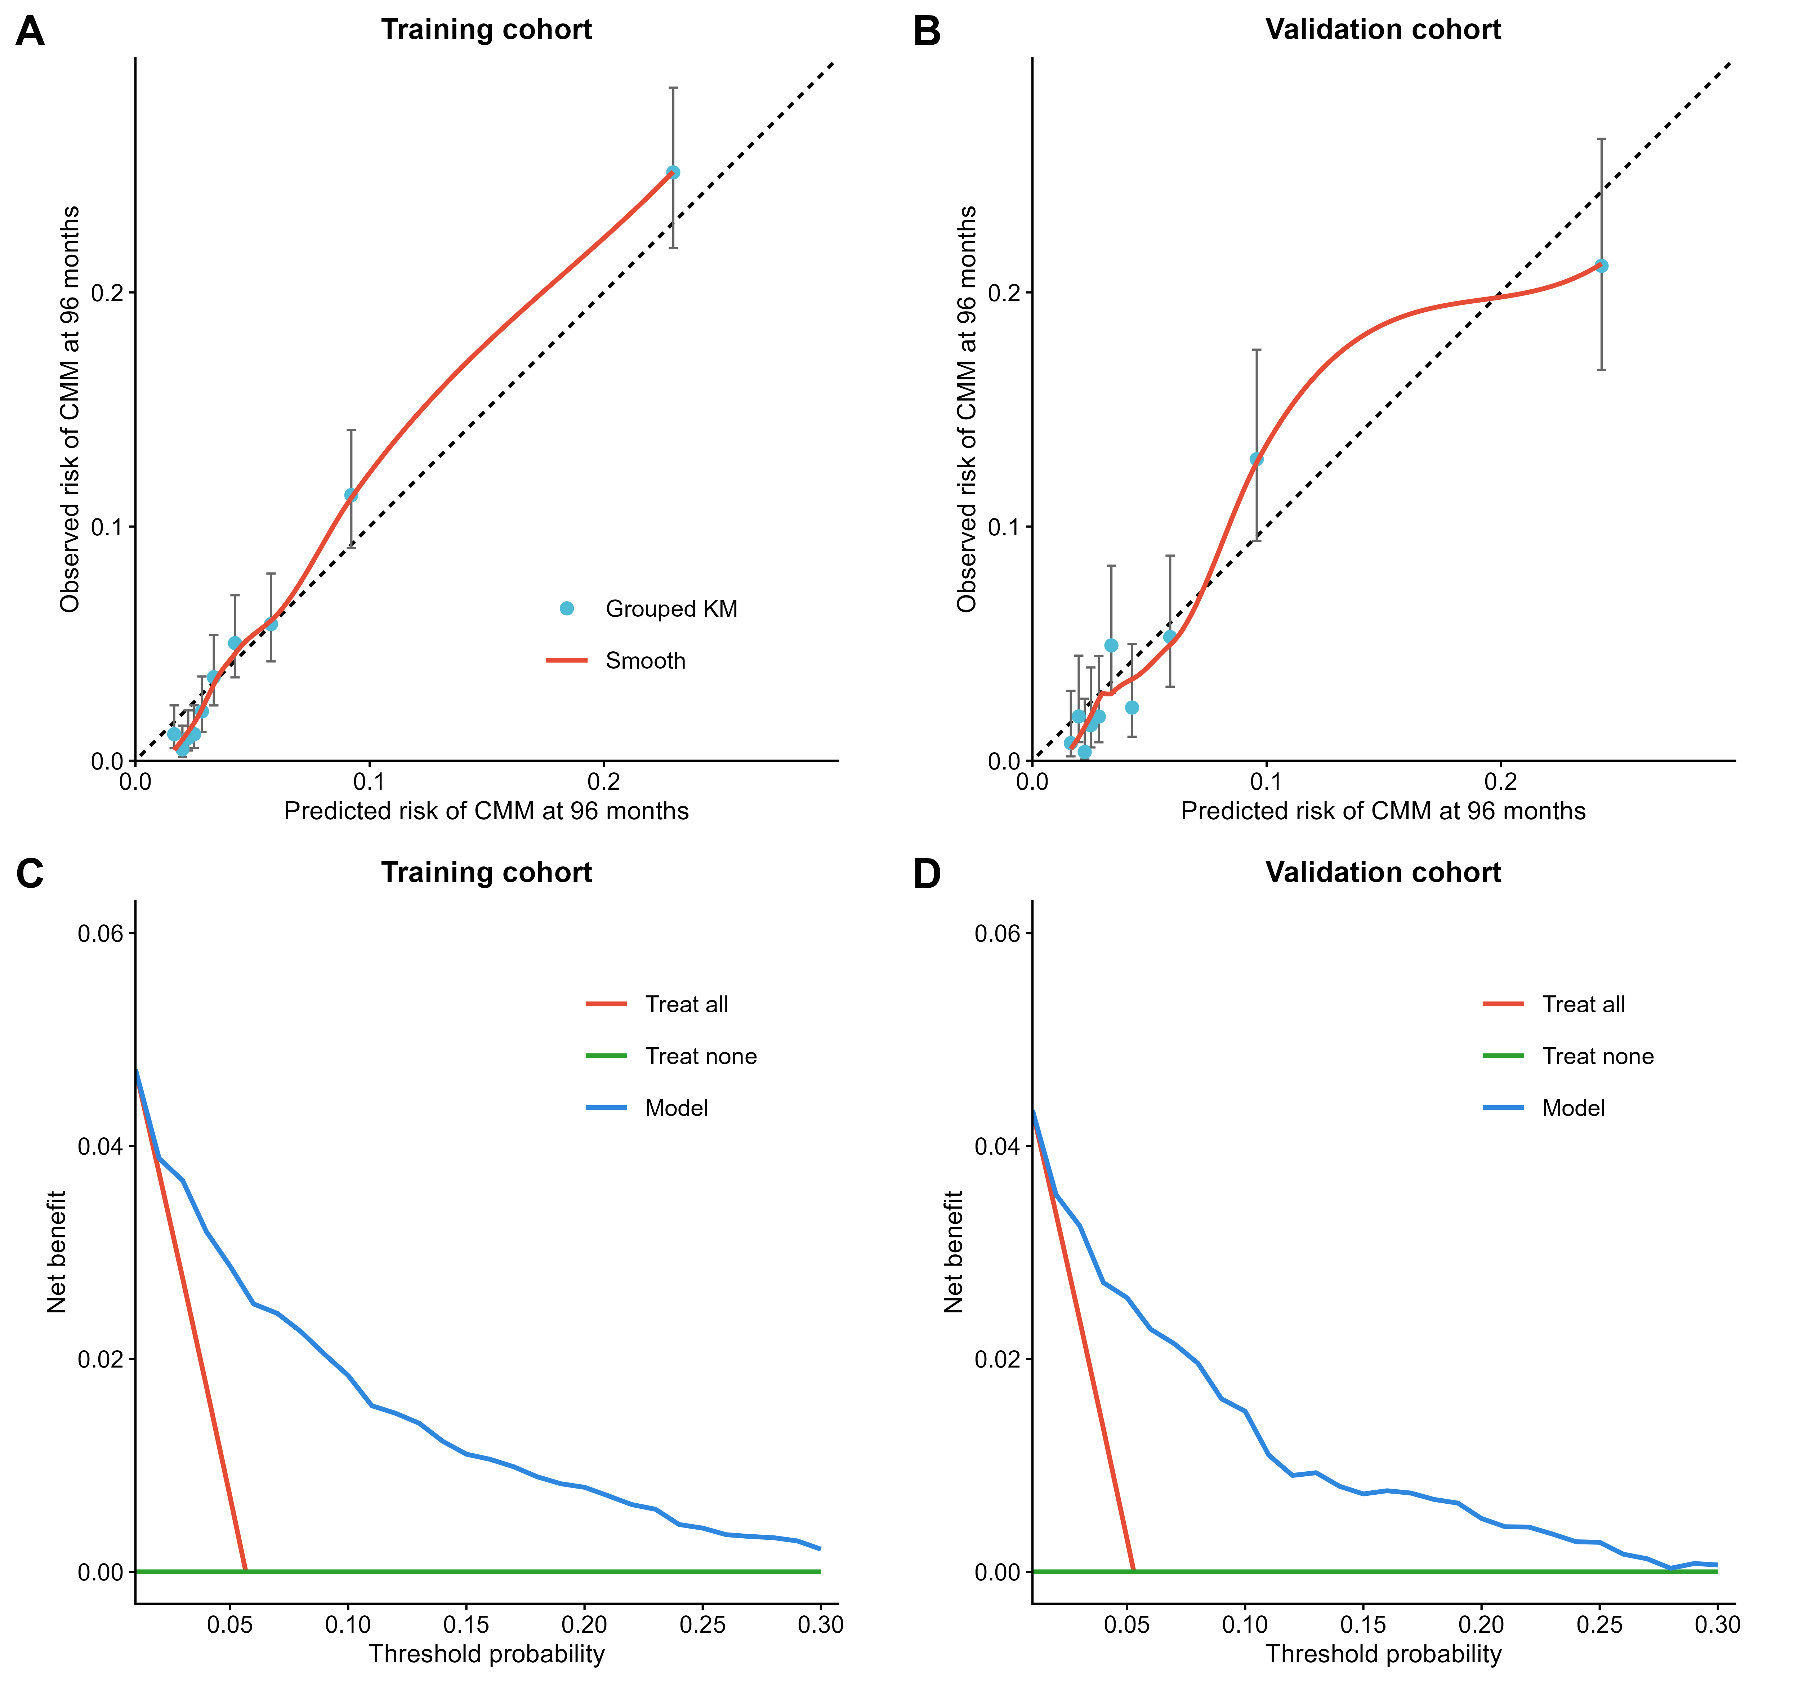
Fig.S2 Calibration and decision curve analyses of the multivariable Cox prediction model in the training and validation cohorts

