Supporting Information of Mutation-induced conformational remodeling explains gain- and loss-of-function phenotypes in Euglena gracilis phytoene synthase
Toto Subroto^{1,2,}*, Regaputra Satria Janitra², Alifiana Ainunnisa², Artery Syahidillah², Mia Tria Novianti^{2,3}, Vicki Nishinarizki^{1,4}, Ade Rizqi Ridwan Firdaus^{1,4}, Muhammad Yusuf^{1,2}, Iman Permana Maksum¹
1Department of Chemistry, Faculty of Mathematics and Natural Sciences, Universitas Padjadjaran, Jatinangor, 45363, West Java, Indonesia
2Research Center for Molecular Biotechnology and Bioinformatics, Universitas Padjadjaran, Bandung, 40133, West Java, Indonesia
3Biotechnology Study Program, Indonesian School of Pharmacy, Bandung, 40266, West Java, Indonesia
4Center for Sustainable Resource Science, RIKEN, Kanagawa, 230-0045, Japan Correspondence: t.subroto@unpad.ac.id

STRUCTURAL MODELING OF CrtB

The amino acid sequence of CrtB was retrieved from UniProt (accession ID: A0A0U5ARE7). The three-dimensional structure of native CrtB was modeled using AlphaFold 31. Structural modeling was performed for residues 52–406, as previous studies have shown that truncation of residues 1–51 (Δ51) enhances carotenoid production (unpublished experimental observations). Throughout this paper, the term native refers to the Δ51 construct. The AlphaFold 3 model predicted residues 52–109 as an extended, largely unstructured N-terminal region (Figure S1 left); however, several residues within this segment formed non-native contacts with the folded core of the protein. To eliminate these artificial interactions the model was manually refined using BIOVIA Discovery Studio 20202 prior to subsequent simulations (Figure S1 right). Protonation states were assigned at pH 7.0 using the PDB2PQR web server3.

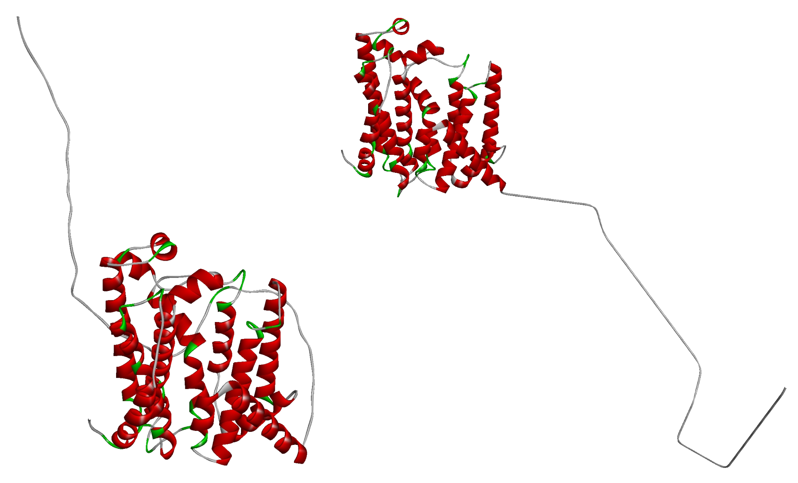
Figure S1. Predicted three-dimensional structure of CrtB generated by AlphaFold 3 (left) and the manually refined model with the N-terminal region adjusted to remove non-native contacts (right).

The resulting model was subsequently relaxed by a 500 ns MD simulation employing the generalized Born (GB) implicit solvent model (igb = 8) at 294.15 K. During the initial equilibration stage, backbone atoms of residues 52–116 were restrained with a force constant of
10 kcal·mol-1·Å-2 for 10 ps. The remaining simulation was conducted without positional restraints, while covalent bonds involving hydrogen atoms were constrained using the SHAKE algorithm. A non-bonded interaction cutoff of 999 Å was applied to effectively mimic an infinite cutoff distance. Temperature regulation was performed using a Langevin thermostat with a collision frequency of 1 ps-1. MD simulations were performed using Amber 244 with the FF14SBonlysc force field5,6.

Conformational clustering was performed using CPPTRAJ7 on the final 100 ns of the MD trajectory. The optimal number of conformational clusters was first determined using the hierarchical agglomerative clustering algorithm, followed by k-means clustering to identify representative structures for each cluster.
Mutant structures were generated by introducing point mutations into the representative structure of the most populated conformational cluster identified by k-means clustering using BIOVIA Discovery Studio 2020. The investigated mutations included Y197A, E121H, and L349F, with residue numbering corresponding to the truncated CrtB sequence (residues 52–406). These mutations were selected based on a previous study demonstrating that Y197A and E121H enhance carotenoid production relative to the native protein, whereas L349F reduces carotenoid production (citation).

STRUCTURAL REFINEMENT OF CrtB

Explicit-solvent MD simulations of 200 ns were performed to refine the structures of native and mutant CrtB proteins. For the native protein, the representative structure of the most populated conformational cluster identified by k-means clustering was used as the initial model, whereas mutant structures were generated from the corresponding native structure as described above. Protonation states were assigned at pH 7.0 using the PDB2PQR web server. All simulations were carried out using Amber 24 with the FF14SB5 force field for proteins and the TIP3P8 model for water molecules and counter ions.
Prior to MD simulations, each system underwent four stages of energy minimization, each consisting of 5000 cycles. In the first stage, only water molecules and ions were relaxed while all

protein atoms were restrained with a force constant of 10 kcal·mol-1·Å-2. In the second stage, water molecules, ions, and protein side chains were relaxed while protein backbone atoms were restrained using the same force constant. The third and fourth minimization stages involved relaxation of the entire system. The first three stages employed the steepest descent algorithm, whereas the fourth stage used the conjugate gradient algorithm.
The systems were subsequently heated from 0 to 294.15 K over 30 ps under constant-volume (NVT) conditions while restraining all protein atoms with a force constant of 10 kcal·mol-1·Å-2. Temperature regulation was performed using a Langevin thermostat with a collision frequency of 2 ps-1. Equilibration was then carried out under constant-pressure (NPT) conditions at 1 bar to stabilize the system density. Six equilibration stages of 1.5, 1.5, 3, 3, 3, and 3 ns were performed
with progressively decreasing backbone restraints of 10, 5, 5, 1, 0.5, and 0 kcal·mol-1·Å-2, respectively. Starting from the third equilibration stage, covalent bonds involving hydrogen atoms were constrained using the SHAKE algorithm.
Production MD simulations were conducted for 200 ns using a Langevin thermostat with a collision frequency of 5 ps-1 and a Berendsen barostat for pressure regulation. A non-bonded interaction cutoff of 9 Å was applied throughout the simulations. Three additional independent replicates were initiated from the heating stage, resulting in a total of four replicas for each system. Trajectory analyses were performed using CPPTRAJ and focused on the final 100 ns of the simulations. Conformational clustering of the combined trajectories from all four replicas was first carried out using hierarchical agglomerative clustering to determine the optimal number of conformational states, followed by k-means clustering to identify representative structures for each cluster.

VALIDATION OF REFINED CrtB MODELS METHODS
The refined CrtB models were validated using the SAVES v6.1 web server (https://saves.mbi.ucla.edu/). Structural quality assessment included ERRAT for evaluating non-bonded atomic interactions, VERIFY3D for assessing the compatibility between the three-dimensional (3D) structure and its corresponding one-dimensional (1D) amino acid sequence, and PROCHECK to evaluate the stereochemical quality of the protein structures through Ramachandran plot analysis. The validation analyses were performed using representative structures extracted from the most populated conformational cluster identified by k-means clustering of the final 100 ns trajectories from four independent explicit-solvent MD simulations.

RESULTS

Summary of ERRAT, VERIFY 3D, and Ramachandran Plot

Structural validation demonstrated that all refined native and mutant CrtB models possessed acceptable stereochemical quality. ERRAT scores exceeded 94% for all structures, indicating good non-bonded atomic interactions. VERIFY3D analysis showed that approximately 78–81% of residues had compatible 3D–1D profiles, while Ramachandran plot analysis revealed that ~89 –91% of residues were located in the most favoured regions. Collectively, these results support the reliability of the refined models and suggest that the dominant MD-derived conformations

retained acceptable structural integrity throughout the simulations, supporting their suitability for subsequent structural and mechanistic analyses.

Table S1. Structural validation parameters of the refined native and mutant apo CrtB models based on representative structures from the dominant clusters obtained from MD simulations.

 | ERRAT | VERIFY 3D | Ramachandran Plot*
Native | 96.199% | 78.06% | 90.8%
Y197A | 96.481% | 81.20% | 88.6%
E121H | 94.512% | 80.57% | 90.8%
L349F | 99.415% | 78.63% | 90.2%
*) Percentage of residues in the most favoured regions

Ramachandran Plot

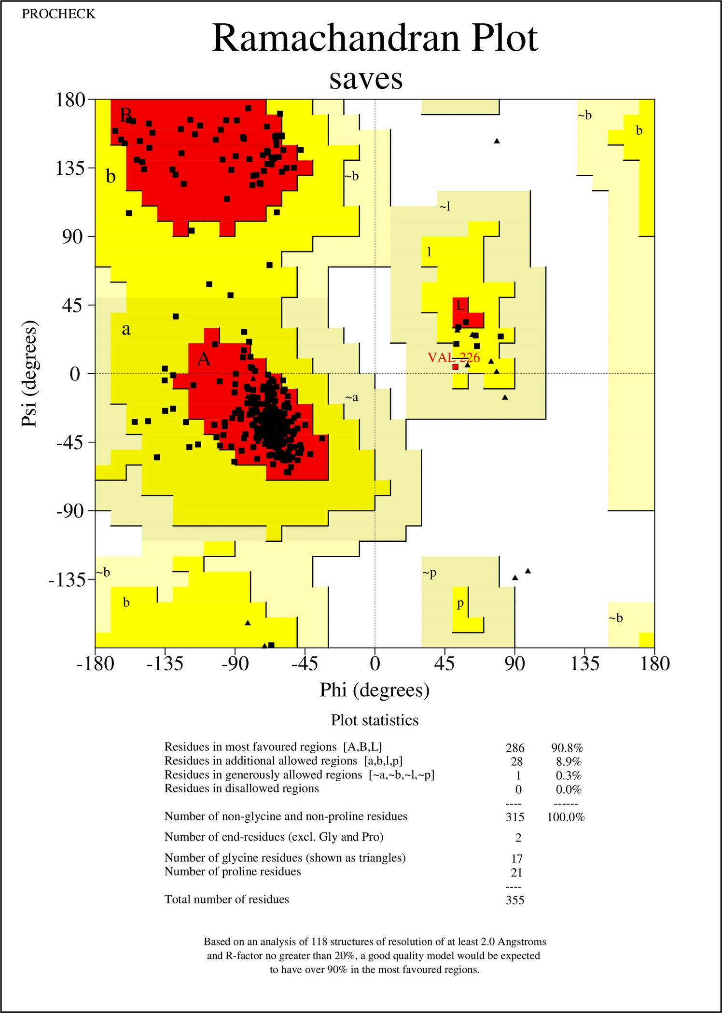

Figure S2. Ramachandran plot of the refined native CrtB model.

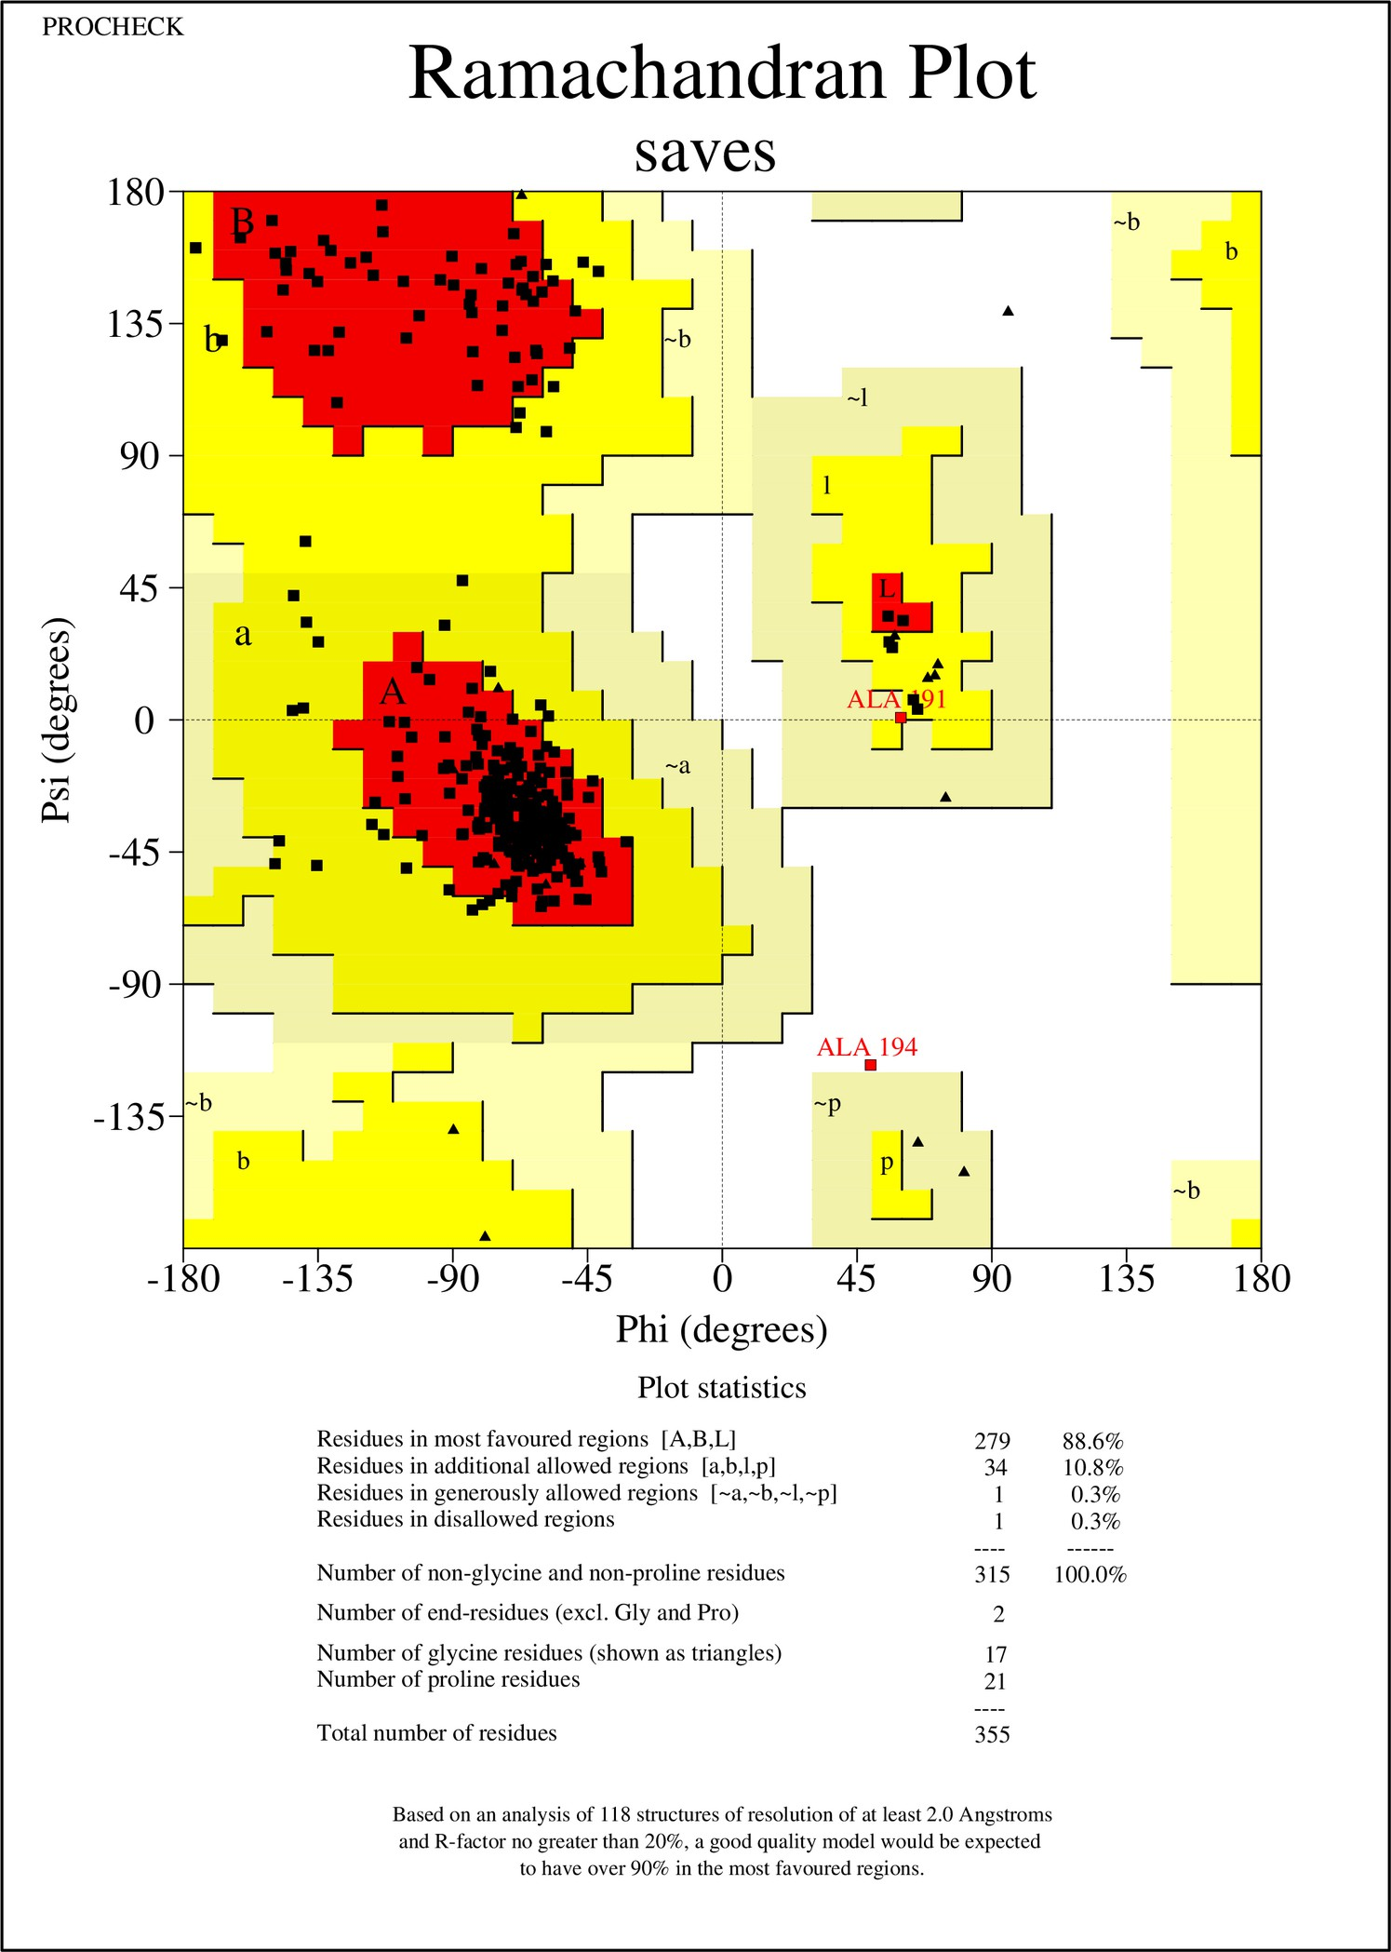

Figure S3. Ramachandran plot of the refined Y197A CrtB model.

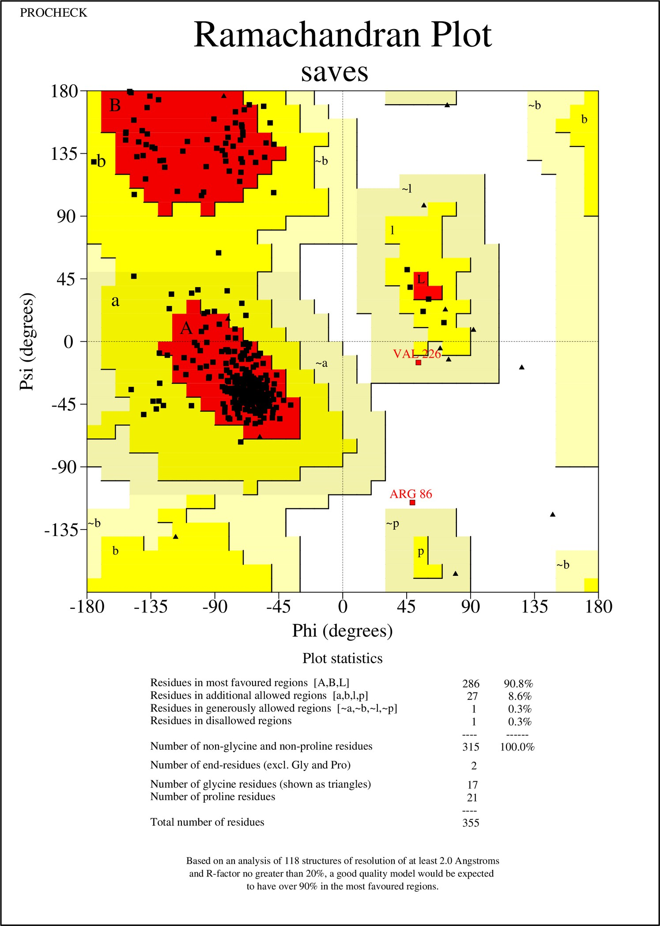

Figure S4. Ramachandran plot of the refined E121H CrtB model.

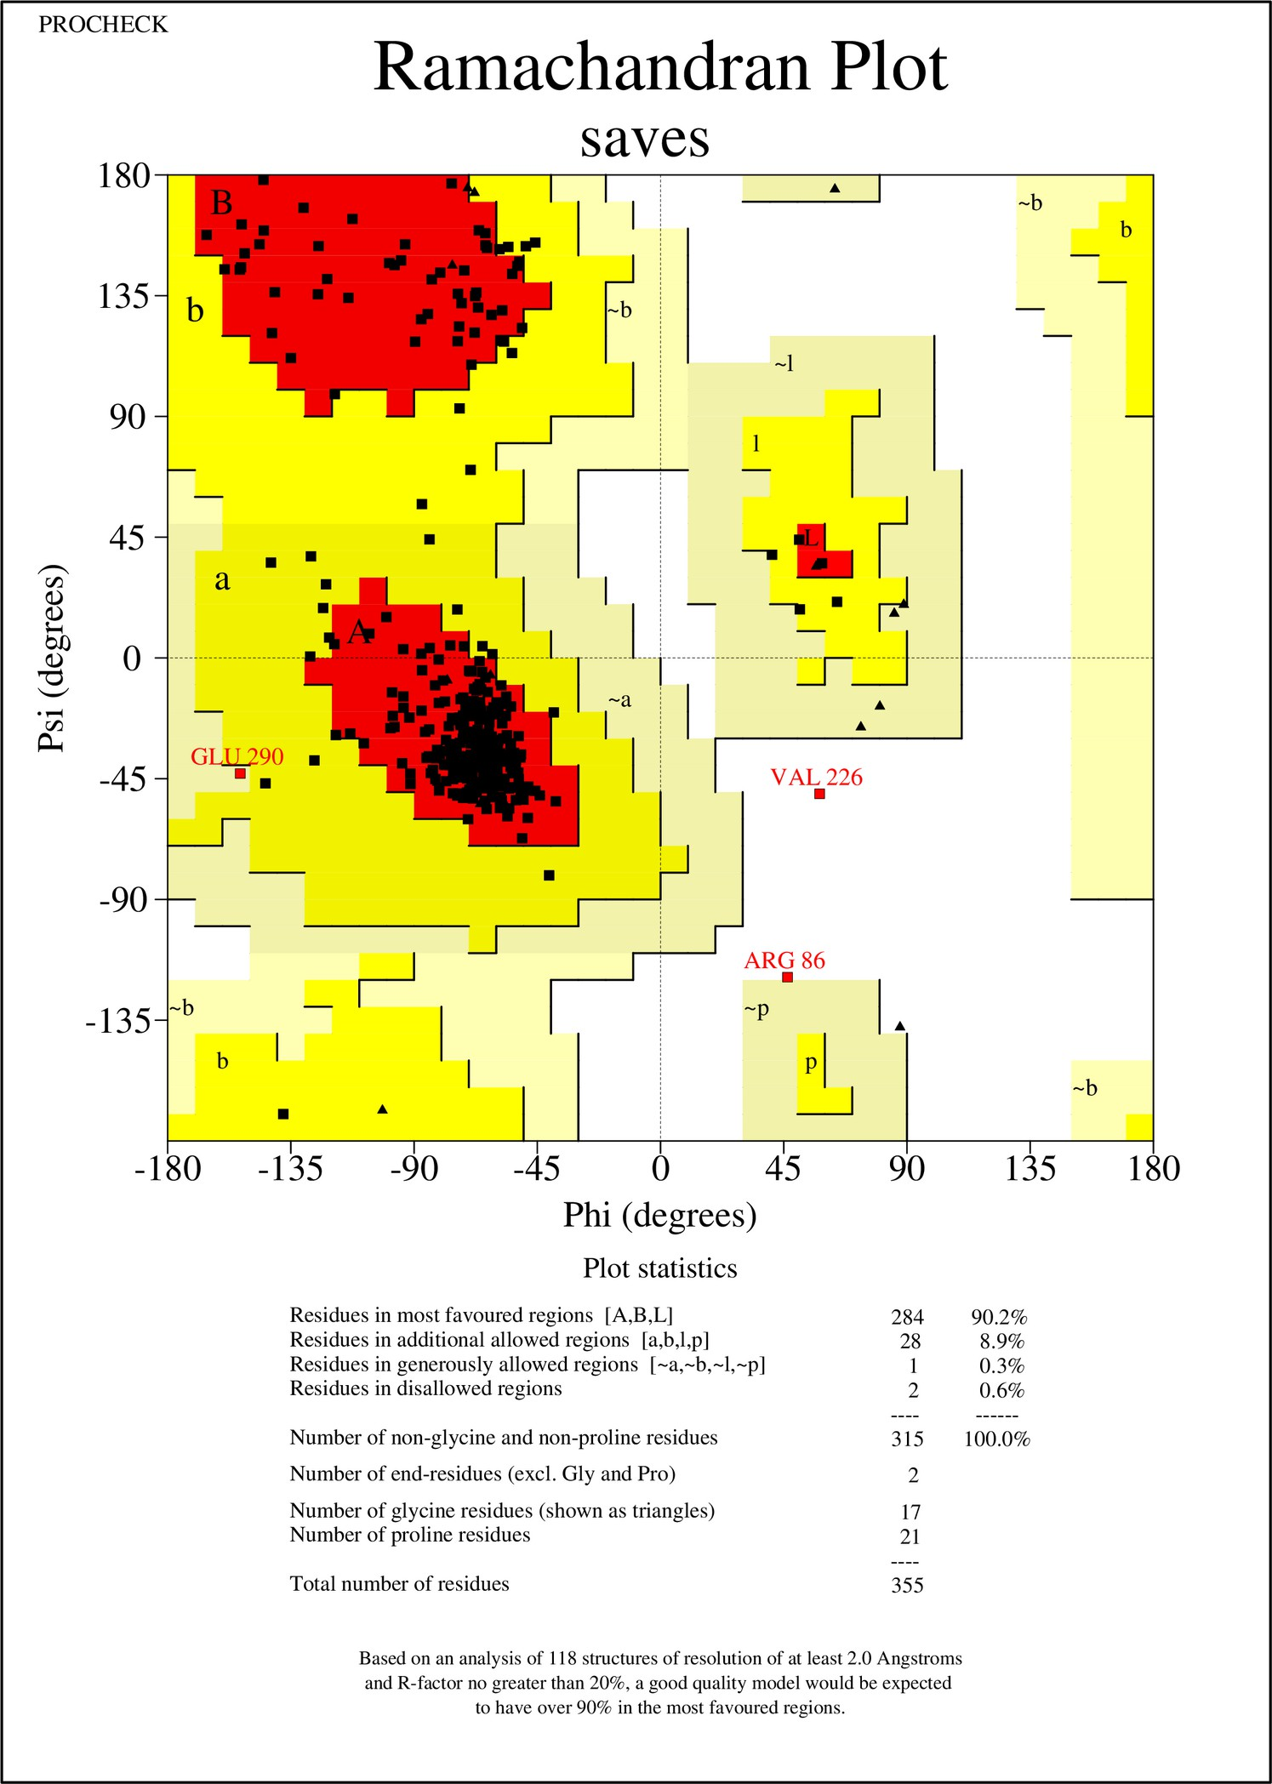

Figure S5. Ramachandran plot of the refined L349F CrtB model.

ANALYSIS OF MOLECULAR DYNAMICS SIMULATIONS

Table S2. Predicted physicochemical properties of native and mutant apo CrtB proteins, including isoelectric point (pI), optimum pH for stability, net charge at pH 7.0, and folding free energy (ΔG_{fold}) at pH 7.

 | pI | Optimum pH Stability | Charge at pH 7 | ΔG_{fold} at pH 7 (kcal/mol)
Native | 6.71 | 4.7 | -0.50 | 1.17
Y197A | 5.99 | 4.6 | -1.76 | -1.12
E121H | 7.14 | 4.8 | 0.23 | -2.99
L349F | 6.24 | 4.4 | -1.53 | 12.05

Table S3. Average global, Asp-rich 1, Asp-rich 2, and hydrophobic flap SASA values of native and mutant apo CrtB proteins.

 | SASA (Å2)
 | Global | Asp-rich 1 | Asp-rich 2 | Hydrophobic Flap
Native | 18564.93 ± 392.53 | 267.15 ± 68.35 | 128.97 ± 29.82 | 259.06 ± 44.96
Y197A | 18444.70 ± 599.81 | 235.64 ± 29.50 | 121.05 ± 49.98 | 257.77 ± 49.80
E121H | 18526.67 ± 673.87 | 236.58 ± 57.30 | 137.35 ± 42.70 | 235.05 ± 40.24
L349F | 18573.98 ± 398.34 | 262.33 ± 34.35 | 112.15 ± 28.22 | 211.00 ± 67.25

Table S4. Average backbone Rg values of native and mutant apo CrtB proteins.

 | Rg (Å) | %ΔRg (mutant-native)
Native | 21.16 ± 0.30 | 0.00
Y197A | 20.98 ± 0.26 | -0.85
E121H | 20.81 ± 0.40 | -1.65
L349F | 21.06 ± 0.25 | -0.47

Table S5. Weighted average binding site and hydrophobic flap volumes of native and mutant apo CrtB proteins across all conformational clusters sampled.

 | Weighted Average Volume (Å3)
 | Average Binding Site | Hydrophobic Flap
Native | 2023.53 | 609.99
Y197A | 1922.94 | 541.62
E121H | 1941.93 | 580.55
L349F | 1899.12 | 396.89

Raw Data for the Calculation of Weighted Average Volume

Table S6. Raw data for the calculation of weighted average binding site volume of native and mutant apo CrtB proteins across all conformational clusters sampled.

 | Native |  |  | Y197A |  |  | E121H |  |  | L349F
 | Fraction | Volume / Å | Fraction* Volume / Å | Fraction | Volume / Å | Fraction* Volume / Å | Fraction | Volume / Å | Fraction* Volume / Å | Fraction | Volume / Å | Fraction* Volume / Å
Cluster 0 | 0.245 | 1870.08 | 458.17 | 0.211 | 1826.26 | 385.34 | 0.251 | 1723.68 | 432.64 | 0.251 | 2042.90 | 512.77
Cluster 1 | 0.144 | 1719.22 | 247.57 | 0.196 | 1844.33 | 361.49 | 0.221 | 1584.40 | 350.15 | 0.113 | 912.94 | 103.16
Cluster 2 | 0.130 | 2362.41 | 307.11 | 0.140 | 1766.40 | 247.30 | 0.168 | 2579.51 | 433.36 | 0.107 | 1763.23 | 188.67
Cluster 3 | 0.120 | 2446.29 | 293.55 | 0.110 | 1969.61 | 216.66 | 0.160 | 1722.14 | 275.54 | 0.105 | 2239.58 | 235.16
Cluster 4 | 0.110 | 1671.42 | 183.86 | 0.080 | 2431.53 | 194.52 | 0.070 | 2021.17 | 141.48 | 0.101 | 2188.87 | 221.08
Cluster 5 | 0.106 | 2338.76 | 247.91 | 0.064 | 1946.39 | 124.57 | 0.059 | 2878.30 | 169.82 | 0.090 | 1547.27 | 139.25
Cluster 6 | 0.069 | 2347.14 | 161.95 | 0.061 | 2023.22 | 123.42 | 0.023 | 2921.60 | 67.20 | 0.088 | 2117.91 | 186.38
Cluster 7 | 0.057 | 1733.86 | 98.83 | 0.054 | 1481.40 | 80.00 | 0.019 | 1349.92 | 25.65 | 0.061 | 2196.56 | 133.99
Cluster 8 | 0.014 | 1609.70 | 22.54 | 0.045 | 2551.03 | 114.80 | 0.015 | 1643.90 | 24.66 | 0.052 | 2015.94 | 104.83
Cluster 9 | 0.005 | 1807.81 | 9.04 | 0.039 | 1919.43 | 74.86 | 0.014 | 1530.83 | 21.43 | 0.032 | 2307.66 | 73.85

Total | 1.000 |  | 2030.53 | 1.000 |  | 1922.94 | 1.000 |  | 1941.93 | 1.000 |  | 1899.12
Δ(mutant  -native) |  |  | 0.00 |  |  | -107.59 |  |  | -88.59 |  |  | -131.41

Table S7. Raw data for the calculation of weighted average volumes of the hydrophobic flap pocket in native and mutant apo CrtB proteins calculated across all sampled conformational clusters.

 | Native |  |  | Y197A |  |  | E121H |  |  | L349F
 | Fraction | Volume / Å | Fraction* Volume / Å | Fraction | Volume / Å | Fraction* Volume / Å | Fraction | Volume / Å | Fraction* Volume / Å | Fraction | Volume / Å | Fraction* Volume / Å
Cluster 0 | 0.245 | 605.87 | 148.44 | 0.211 | 437.44 | 92.30 | 0.251 | 542.57 | 136.19 | 0.251 | 457.85 | 114.92
Cluster 1 | 0.144 | 472.66 | 68.06 | 0.196 | 485.36 | 95.13 | 0.221 | 497.14 | 109.87 | 0.113 | 32.86 | 3.71
Cluster 2 | 0.130 | 796.72 | 103.57 | 0.140 | 426.33 | 59.69 | 0.168 | 711.17 | 119.48 | 0.107 | 191.69 | 20.51
Cluster 3 | 0.120 | 480.89 | 57.71 | 0.110 | 482.38 | 53.06 | 0.160 | 566.05 | 90.57 | 0.105 | 675.23 | 70.90
Cluster 4 | 0.110 | 566.44 | 62.31 | 0.080 | 799.32 | 63.95 | 0.070 | 563.32 | 39.43 | 0.101 | 502.88 | 50.79
Cluster 5 | 0.106 | 897.23 | 95.11 | 0.064 | 652.91 | 41.79 | 0.059 | 863.77 | 50.96 | 0.090 | 124.28 | 11.19
Cluster 6 | 0.069 | 495.32 | 34.18 | 0.061 | 774.86 | 47.27 | 0.023 | 810.78 | 18.65 | 0.088 | 508.90 | 44.78
Cluster 7 | 0.057 | 522.08 | 29.76 | 0.054 | 653.16 | 35.27 | 0.019 | 63.27 | 1.20 | 0.061 | 515.57 | 31.45

Cluster 8 | 0.014 | 555.14 | 7.77 | 0.045 | 770.18 | 34.66 | 0.015 | 417.11 | 6.26 | 0.052 | 585.13 | 30.43
Cluster 9 | 0.005 | 616.50 | 3.08 | 0.039 | 474.87 | 18.52 | 0.014 | 568.07 | 7.95 | 0.032 | 569.06 | 18.21
Total | 1.000 |  | 609.99 | 1.000 |  | 541.62 | 1.000 |  | 580.55 | 1.000 |  | 396.89
Δ(mutant  -native) |  |  | 0.00 |  |  | -68.36 |  |  | -29.43 |  |  | -213.10

REFERENCES

- Abramson, J. et al. Accurate structure prediction of biomolecular interactions with AlphaFold
3. Nature 630, 493–500 (2024).
- BIOVIA, Dassault Systèmes, Discovery Studio Modeling Environment, Release 2020, San Diego: Dassault Systèmes, 2020.
- Jurrus, E. et al. Improvements to the APBS biomolecular solvation software suite. Protein Sci.
27, 112–128 (2018).
- Case, D. A. et al. Amber 2024. (University of California, San Francisco, 2024).
- Maier, J. A. et al. ff14SB: Improving the Accuracy of Protein Side Chain and Backbone Parameters from ff99SB. J. Chem. Theory Comput. 11, 3696–3713 (2015).
- Nguyen, H., Roe, D. R. & Simmerling, C. Improved Generalized Born Solvent Model Parameters for Protein Simulations. J. Chem. Theory Comput. 9, 2020–2034 (2013).
- Roe, D. R. & Cheatham, T. E. PTRAJ and CPPTRAJ: Software for Processing and Analysis of Molecular Dynamics Trajectory Data. J. Chem. Theory Comput. 9, 3084–3095 (2013).
- Jorgensen, W. L., Chandrasekhar, J., Madura, J. D., Impey, R. W. & Klein, M. L. Comparison of simple potential functions for simulating liquid water. J. Chem. Phys. 79, 926–935 (1983).

