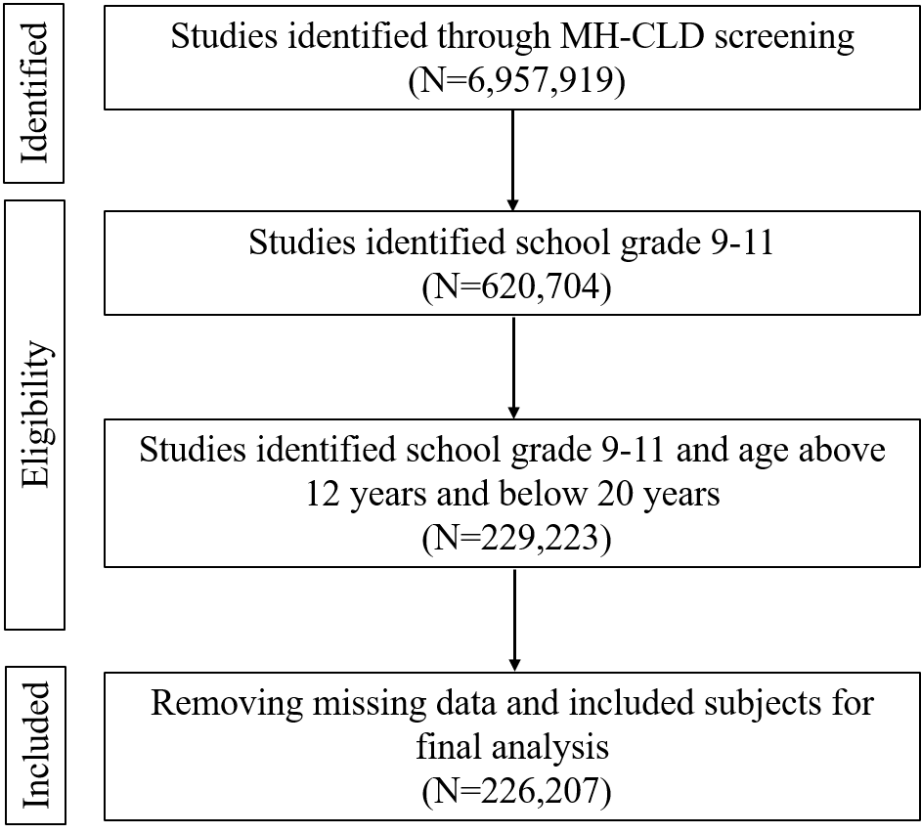
Supplementary Figure S1. Flow diagram of participant selection from the 2023 Mental Health Client-Level Dataset (MH-CLD).

Supplementary Table S1. Prevalence of oppositional defiant disorder (ODD) and unadjusted and adjusted odds ratios according to demographic and substance use characteristics among U.S. adolescents (N = 226,207).

Characteristics | Oppositional Defiant Disorder (ODD)
Characteristics | No, N (%) | Yes, N (%) | UOR  (95% CI, P-Value) | AOR  (95% CI, P-Value)
Age: 12-14Yrs | 24919 (92.5) | 2016 (7.5) | Reference | Reference
15-17Yr | 133691 (93.1) | 9845 (6.9) | 0.91 (0.87-0.96, p<0.001) | 0.86 (0.82-0.91, p<0.001)
18-20Yrs | 53403 (95.8) | 2333 (4.2) | 0.54 (0.51-0.57, p<0.001) | 0.47 (0.44-0.50, p<0.001)
Sex: Male | 86830 (90.6) | 9043 (9.4) | Reference | Reference
Female | 124849 (96.0) | 5139 (4.0) | 0.40 (0.38-0.41, p<0.001) | 0.40 (0.38-0.41, p<0.001)
Race: Non-White | 70839 (91.7) | 6439 (8.3) | Reference | Reference
White | 129581 (94.6) | 7360 (5.4) | 0.62 (0.60-0.65, p<0.001) | 0.63 (0.61-0.65, p<0.001)
Alcohol Use: No | 208739 (93.8) | 13772 (6.2) | Reference | Reference
Yes | 3274 (88.6) | 422 (11.4) | 1.95 (1.76-2.16, p<0.001) | 2.09 (1.88-2.32, p<0.001)
Cocaine Use: No | 211904 (93.7) | 14191 (6.3) | Reference | Reference
Yes | 109 (97.3) | 3 (2.7) | 0.41 (0.10-1.09, p=0.128) | 0.34 (0.06-1.07, p=0.128)
Cannabis Use: No | 203483 (93.9) | 13160 (6.1) | Reference | Reference
Yes | 8530 (89.2) | 1034 (10.8) | 1.87 (1.75-2.00, p<0.001) | 1.77 (1.65-1.90, p<0.001)
Opioid Use: No | 210990 (93.7) | 14081 (6.3) | Reference | Reference
Yes | 1023 (90.1) | 113 (9.9) | 1.66 (1.35-2.00, p<0.001) | 1.82 (1.48-2.22, p<0.001)

Note: Values are presented as n (%) and odds ratios (ORs) with 95% confidence intervals (CIs). UOR as unadjusted odds ratios, were estimated using univariable logistic regression, and adjusted odds ratios (AOR) were estimated using multivariable logistic regression adjusting for age, sex, race, alcohol use, cannabis use, cocaine use, and opioid use. The reference category for each variable is indicated in the table. Statistical significance was defined as p < 0.05.

Supplementary Table S2. Baseline characteristics of propensity score-matched samples by substance use exposure.

Predictors | Alcohol use |  |  |  | Cannabis use
Predictors | Total, N (%) | Yes, N (%) | No, N (%) | p | Total, N (%) | Yes, N (%) | No, N (%) | p
Total N (%) | 7200 | 3600 (50.00) | 3600 (50.00) |  | 18016 | 9008 (50.00) | 9008 (50.00)
Age in years
12-14 | 368 (5.11) | 184 (5.11) | 184 (5.11) | 1.00 | 1220 (6.77) | 610 (6.77) | 610 (6.77) | 0.98
15-17 | 4300 (59.72) | 2150 (59.72) | 2150 (59.72) |  | 11054 (61.36) | 5527 (61.36) | 5527 (61.36)
18-20 | 2532 (35.17) | 1266 (35.17) | 1266 (35.17) |  | 5742 (31.87) | 2871 (31.87) | 2871 (31.87)
Sex
Male | 3420 (47.50) | 1710 (47.50) | 1710 (47.50) | 1.00 | 9784 (54.31) | 4892 (54.31) | 4892 (54.31) | 0.97
Female | 3780 (52.50) | 1890 (52.50) | 1890 (52.50) |  | 8232 (45.69) | 4116 (45.69) | 4116 (45.69)
Race
Non-White | 2660 (36.94) | 1330 (36.94) | 1330 (36.94) | 0.99 | 6924 (38.43) | 3462 (38.43) | 3462 (38.43) | 1.00
White | 4540 (63.06) | 2270 (63.06) | 2270 (63.06) |  | 11092 (61.57) | 5546 (61.57) | 5546 (61.57)
Predictors | Cocaine use |  |  |  | Opioid use
Predictors | Total, N (%) | Yes, N (%) | No, N (%) | p | Total, N (%) | Yes, N (%) | No, N (%) | p
Total N (%) | 208 | 104 (50.00) | 104 (50.00) |  | 2144 | 1072 (50.00) | 1072 (50.00)
Age in years
12-14 | 10 (4.81) | 5 (4.81) | 5 (4.81) | 0.97 | 176 (8.21) | 88 (8.21) | 88 (8.21) | 1.00
15-17 | 80 (38.46) | 40 (38.46) | 40 (38.46) |  | 1180 (55.04) | 590 (55.04) | 590 (55.04)
18-20 | 118 (56.73) | 59 (56.73) | 59 (56.73) |  | 788 (36.75) | 394 (36.75) | 394 (36.75)
Sex
Male | 112 (53.85) | 56 (53.85) | 56 (53.85) | 1.00 | 1028 (47.95) | 514 (47.95) | 514 (47.95) | 0.98
Female | 96 (46.15) | 48 (46.15) | 48 (46.15) |  | 1116 (52.05) | 558 (52.05) | 558 (52.05)
Race
Non-White | 66 (31.73) | 33 (31.73) | 33 (31.73) | 1.00 | 788 (36.75) | 394 (36.75) | 394 (36.75) | 1.00
White | 142 (68.27) | 71 (68.27) | 71 (68.27) |  | 1356 (63.25) | 678 (63.25) | 678 (63.25)

Note: Values are presented as n (%). Propensity score matching was performed separately for alcohol, cannabis, cocaine, and opioid use. Exposed and non-exposed groups were matched 1:1 using nearest-neighbor matching without replacement. Covariate balance was assessed for age, sex, and race. p-values compare baseline characteristics between exposed and non-exposed groups after matching.

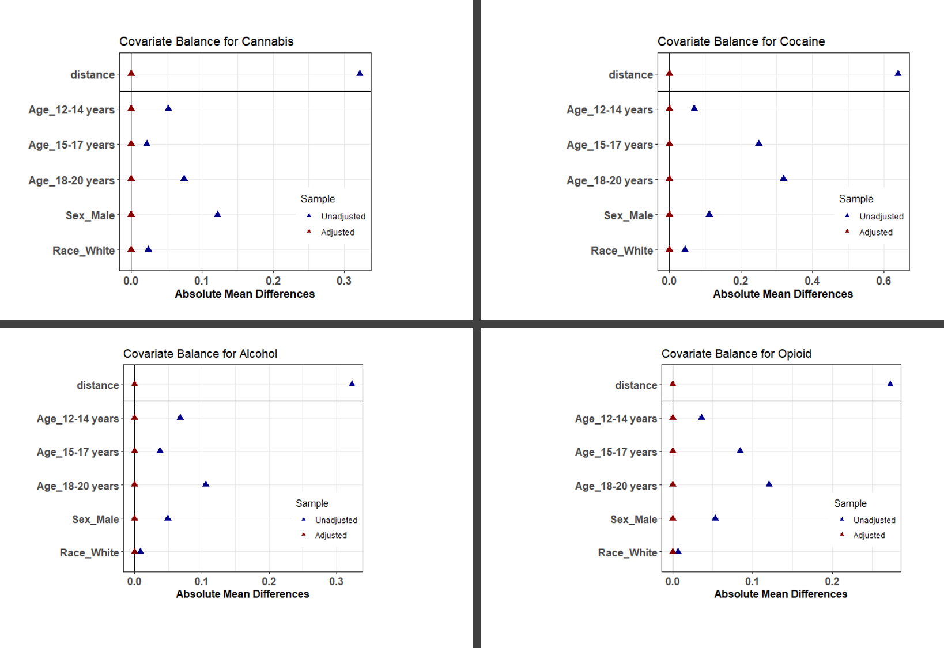
Supplementary Figure S2. Covariate balance before and after propensity score matching for alcohol, cannabis, cocaine, and opioid use. Absolute standardized mean differences (ASMDs) for age, sex, and race/ethnicity are shown before matching (blue triangles) and after matching (red triangles). ASMD values below 0.10 indicate adequate covariate balance.

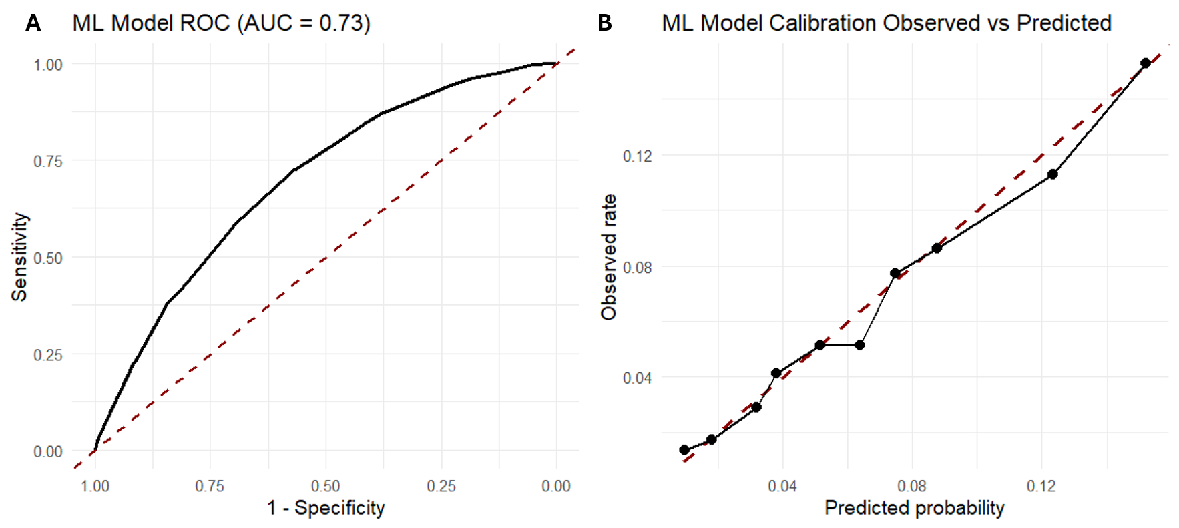
Supplementary Figure S3. Receiver operating characteristic curve and calibration plot for the machine learning model predicting oppositional defiant disorder. A) shows the receiver operating characteristic (ROC) curve for the machine learning model, with an area under the curve (AUC) of 0.73. B) shows model calibration by comparing observed ODD prevalence with predicted probabilities.

