Extended data for
Revealing the Widespread Mosaic of Shifting Cultivation Across the Tropics

Table S1. The distribution of samples for the models at different stages.
 | High tree cover woodland |  | Shifting cultivation | Other | Conventional Agriculture | Mixed woody plantation | Sum
DRC model （4 class） | 2601 | 1617 |  | 1263 | 1475 | 0 | 6956
Africa model （4 class） | 3878 | 3391 |  | 2829 | 3183 | 0 | 13281
Africa model （5 class） | 3878 | 3165 |  | 2829 | 3211 | 1432 | 14515
global model （5 class） | 5149 | 4231 |  | 3831 | 5391 | 4626 | 23228
Dual-time global model  （5 class） | 12342 | 19828 |  | 11404 | 18884 | 21558 | 84016
Table S2. Confusion matrix of models developed iteratively.
DRC model (4 classes, 1392 test samples)
Class | Tree cover | Shifting C. |  | Others | Agriculture |  | Recall
Tree cover | 516 |  | 2 | 1 | 1 |  | 0.99
Shifting C. | 6 |  | 287 | 0 | 2 |  | 0.97
Others | 43 |  | 3 | 165 | 42 |  | 0.65
Agriculture | 1 |  | 22 | 34 | 267 |  | 0.82
Precision | 0.91 |  | 0.91 | 0.82 | 0.86
Total accuracy: 88.72% |  |  |  | Overall F1-score: 0.8872
Africa model (4 classes, 2657 test samples)
Class | Tree cover |  | Shifting C. | Others | Agriculture |  | Recall
Tree cover | 727 |  | 14 | 32 | 2 |  | 0.94
Shifting C. | 13 |  | 563 | 14 | 61 |  | 0.86
Others | 75 |  | 30 | 400 | 61 |  | 0.71
Agriculture | 5 |  | 50 | 563 | 563 |  | 0.85
Precision | 0.89 |  | 0.86 | 0.81 | 0.82
Total accuracy: 84.62% |  |  |  | Overall F1-score: 0.8479
Africa model (5 classes, 2903 test samples)
Class | Tree cover |  | Shifting C. | Others | Agriculture | Plantation | Recall
Tree cover | 738 |  | 13 | 25 | 0 | 0 | 0.95
Shifting C. | 16 |  | 492 | 13 | 34 | 51 | 0.81
Others | 75 |  | 17 | 409 | 57 | 5 | 0.73
Agriculture | 5 |  | 35 | 68 | 543 | 20 | 0.81
Plantation | 1 |  | 134 | 6 | 14 | 132 | 0.46
Precision | 0.88 |  | 0.71 | 0.79 | 0.84 | 0.63
Total accuracy: 79.21% |  |  |  | Overall F1-score: 0.7927
Global model (5 classes, 2323 test samples)
Class | Tree cover |  | Shifting C. | Others | Agriculture | Plantation | Recall
Tree cover | 471 |  | 7 | 23 | 2 | 12 | 0.91
Shifting C. | 6 |  | 288 | 10 | 23 | 82 | 0.70
Others | 31 |  | 7 | 313 | 25 | 7 | 0.82
Agriculture | 4 |  | 20 | 46 | 433 | 50 | 0.78
Plantation | 10 |  | 54 | 12 | 16 | 371 | 0.71
Precision | 0.90 |  | 0.77 | 0.77 | 0.87 | 0.71
Total accuracy: 80.78% |  |  |  | Overall F1-score: 0.8076
Note: the sampling in DRC and first round in Africa did not include the class woody plantation. The mixed woody plantation was introduced after checking the Africa model’s predictions. Shifting C. refers to shifting cultivation.
Table S3. Strata table.
Stratum | Definition | Num. of Samples | Area of strata | weights
1 | SC in our map and SC-related forest loss | 100 | 942,358 | 0.02153
2 | SC in our map but not in forest loss driver | 100 | 1,217,412 | 0.02782
3 | SC-related forest loss but not in our map, with low confidence non-SC pixels (0.33-0.67) | 100 | 766,831 | 0.01752
4 | Rest of the map | 100 | 40,836,288 | 0.93313

Table S4. Validation of the final map showing the raw error matrix (counts), weighted error matrix (Wi), user’s accuracy (UA) and producer’s accuracy (PA) for each class. Overall accuracy (OA) is in the bottom right corner.
Map/ Ref. | Tree cover | Shif. Cult. | Others | Conv.Agri. | Mixed P. | Total (Wi) | User Accuracy (UA)
Tree cover | 0.2583 | 0.0019 | 0.0005 | 0 | 0.0004 | 0.2611 | 98.9%
Shif. Cult. | 0.0015 | 0.0360 | 0.0012 | 0.0007 | 0.0031 | 0.0425 | 84.7%
Others | 0.0097 | 0.0014 | 0.2563 | 0.0102 | 0.0470 | 0.3246 | 79.0%
Conv. Agri. | 0 | 0.0021 | 0.0099 | 0.2180 | 0.0106 | 0.2406 | 90.6%
Mixed P. | 0.0093 | 0.0027 | 0.0095 | 0 | 0.1098 | 0.1313 | 83.6%
Total | 0.2788 | 0.0441 | 0.2774 | 0.2289 | 0.1709
User Accuracy (UA) | 92.6% | 81.7% | 92.4% | 95.2% | 64.3% |  | Overall  87.8%

Table S5. Country comparison at local scale. By collecting statistics from literature, we compared our results with previously published local-scale estimates from regional studies. The ability to conduct direct intercomparison with these earlier estimates varies considerably on a case-to-case basis due to differences in data sources, methodologies, and the timing of assessments. Despite these variations, our shifting cultivation map demonstrates strong alignment with regional estimates and effectively captures local-scale characteristics.
Country | DRC  (Mha) | Indonesia  (Mha) | Myanmar  (Mha) | Laos  (Mha)
Previous studies | Nearly 30¹ | 11.4² | 0.3-10.2² | 7.6³
Our | 39.7 | 14.5 | 8.6 | 6.1

Table S6. Biome table.
Code | Name | Definition
1 | Tropical & Subtropical Moist Broadleaf Forests | Humid tropical forests characterised by high rainfall and year-round warm temperatures, with dense, multi-layered vegetation and very high biodiversity (e.g., rainforests).
2 | Tropical & Subtropical Dry Broadleaf Forests | Seasonal tropical forests with a pronounced dry season, where many trees shed leaves to conserve water.
3 | Tropical & Subtropical Coniferous Forests | Warm-climate forests are dominated by conifer species, often found in mountainous or seasonally dry tropical regions.
7 | Tropical & Subtropical Grasslands, Savannas & Shrublands | Warm regions dominated by grasses with scattered trees or shrubs, often shaped by fire and grazing.
Other: Temperate Broadleaf & Mixed Forests, Temperate Conifer Forests, Boreal Forests / Taiga, Temperate Grasslands, Savannas & Shrublands, Flooded Grasslands & Savannas, Montane Grasslands & Shrublands, Tundra, Mediterranean Forests, Woodlands & Scrub, Deserts & Xeric Shrublands, Mangroves

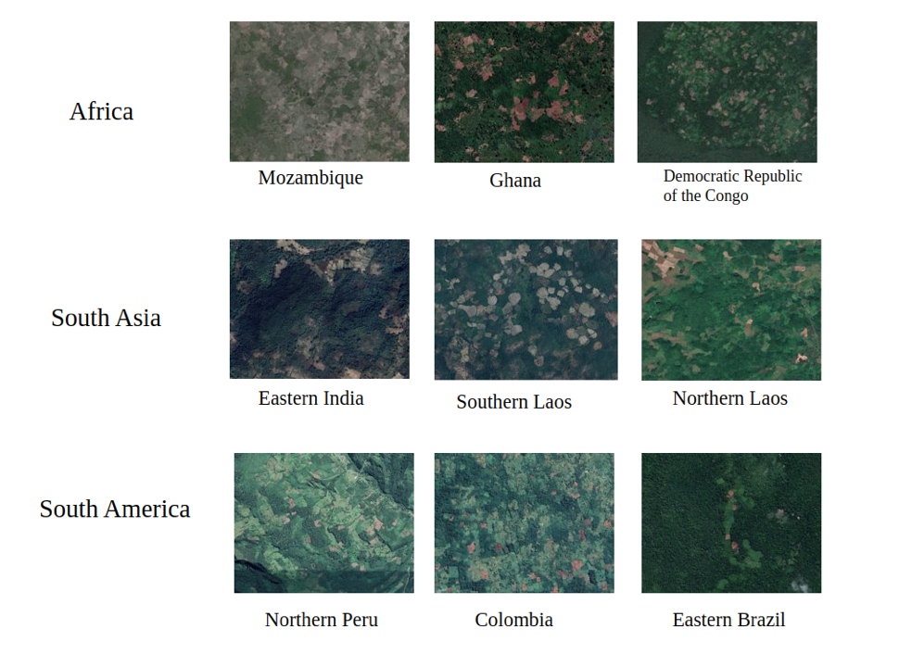
Fig. S1 | Different shifting cultivation patterns across the pantropics. Image source: Google Earth Imagery.
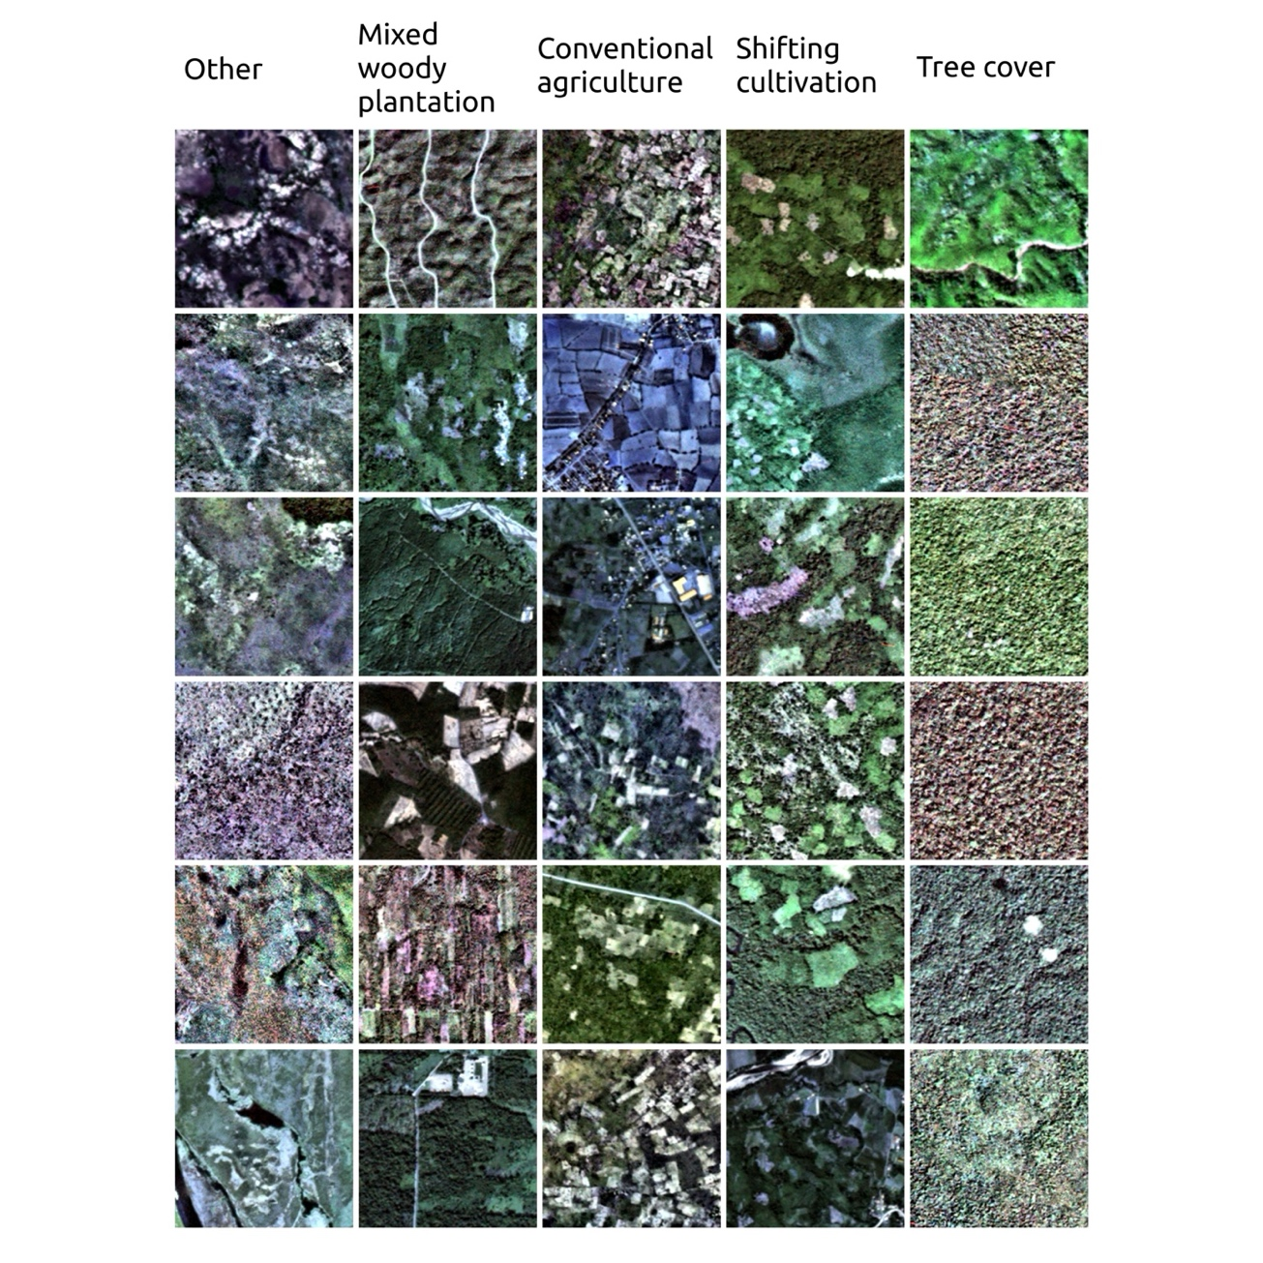Fig. S2 | Examples of visual representations of the different classes.
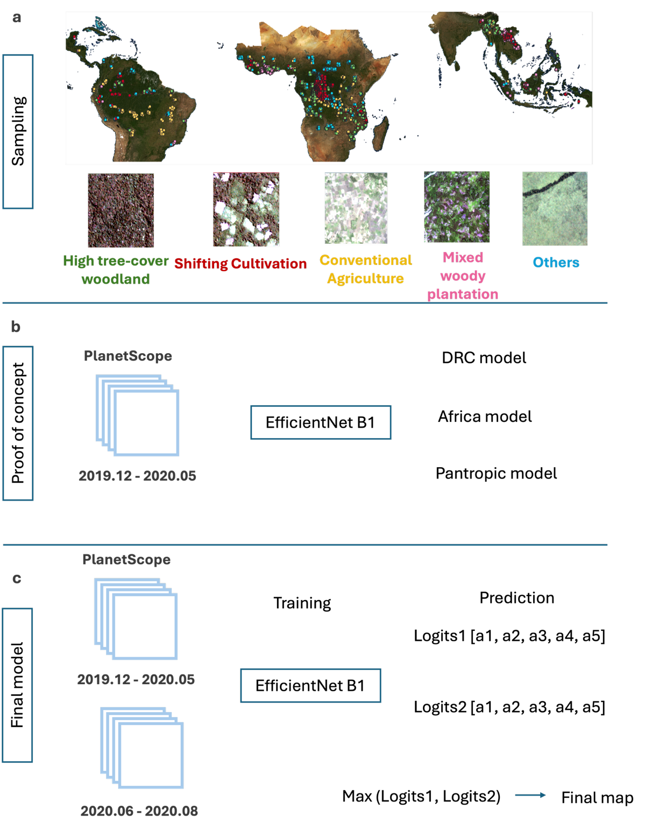
Fig. S3 | Overview of the model development workflow. a, Training sample locations across the three study continents (Americas, Africa, Asia-Oceania), coloured by land-use class, with representative PlanetScope image patches illustrating the five mapped classes: high tree-cover woodland, shifting cultivation, conventional agriculture, mixed woody plantation, and Others. Class label colours correspond to the sample point colours shown on the maps above. b, Phased model development strategy, progressing from the Democratic Republic of the Congo (DRC) model to the Africa-scale model and finally the pantropical model, using PlanetScope imagery (December 2019–May 2020) and an EfficientNet-B1 architecture. c, Dual-mosaic training and prediction approach used for the final model.

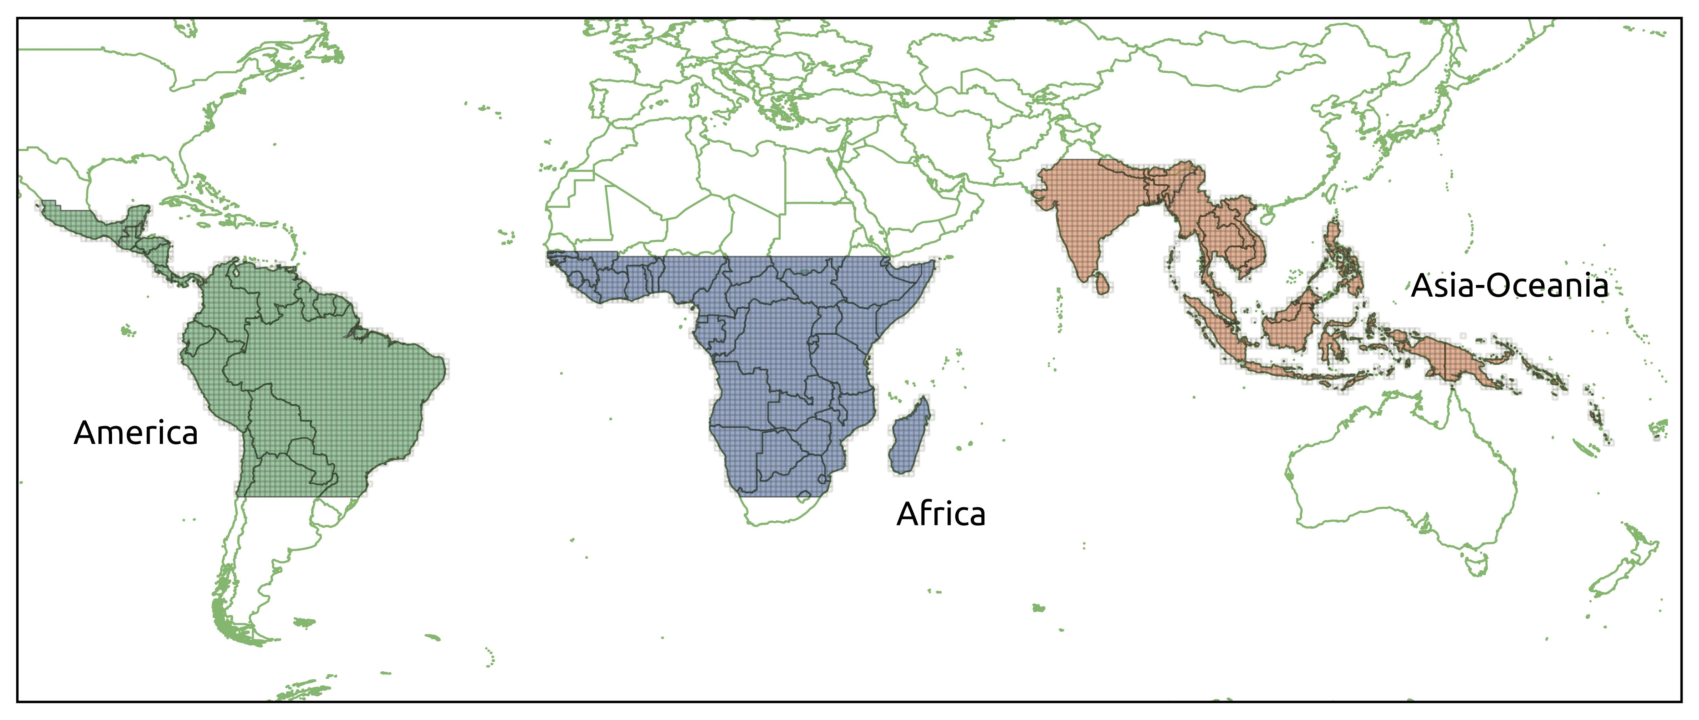Fig. S4 | Extent of study area.

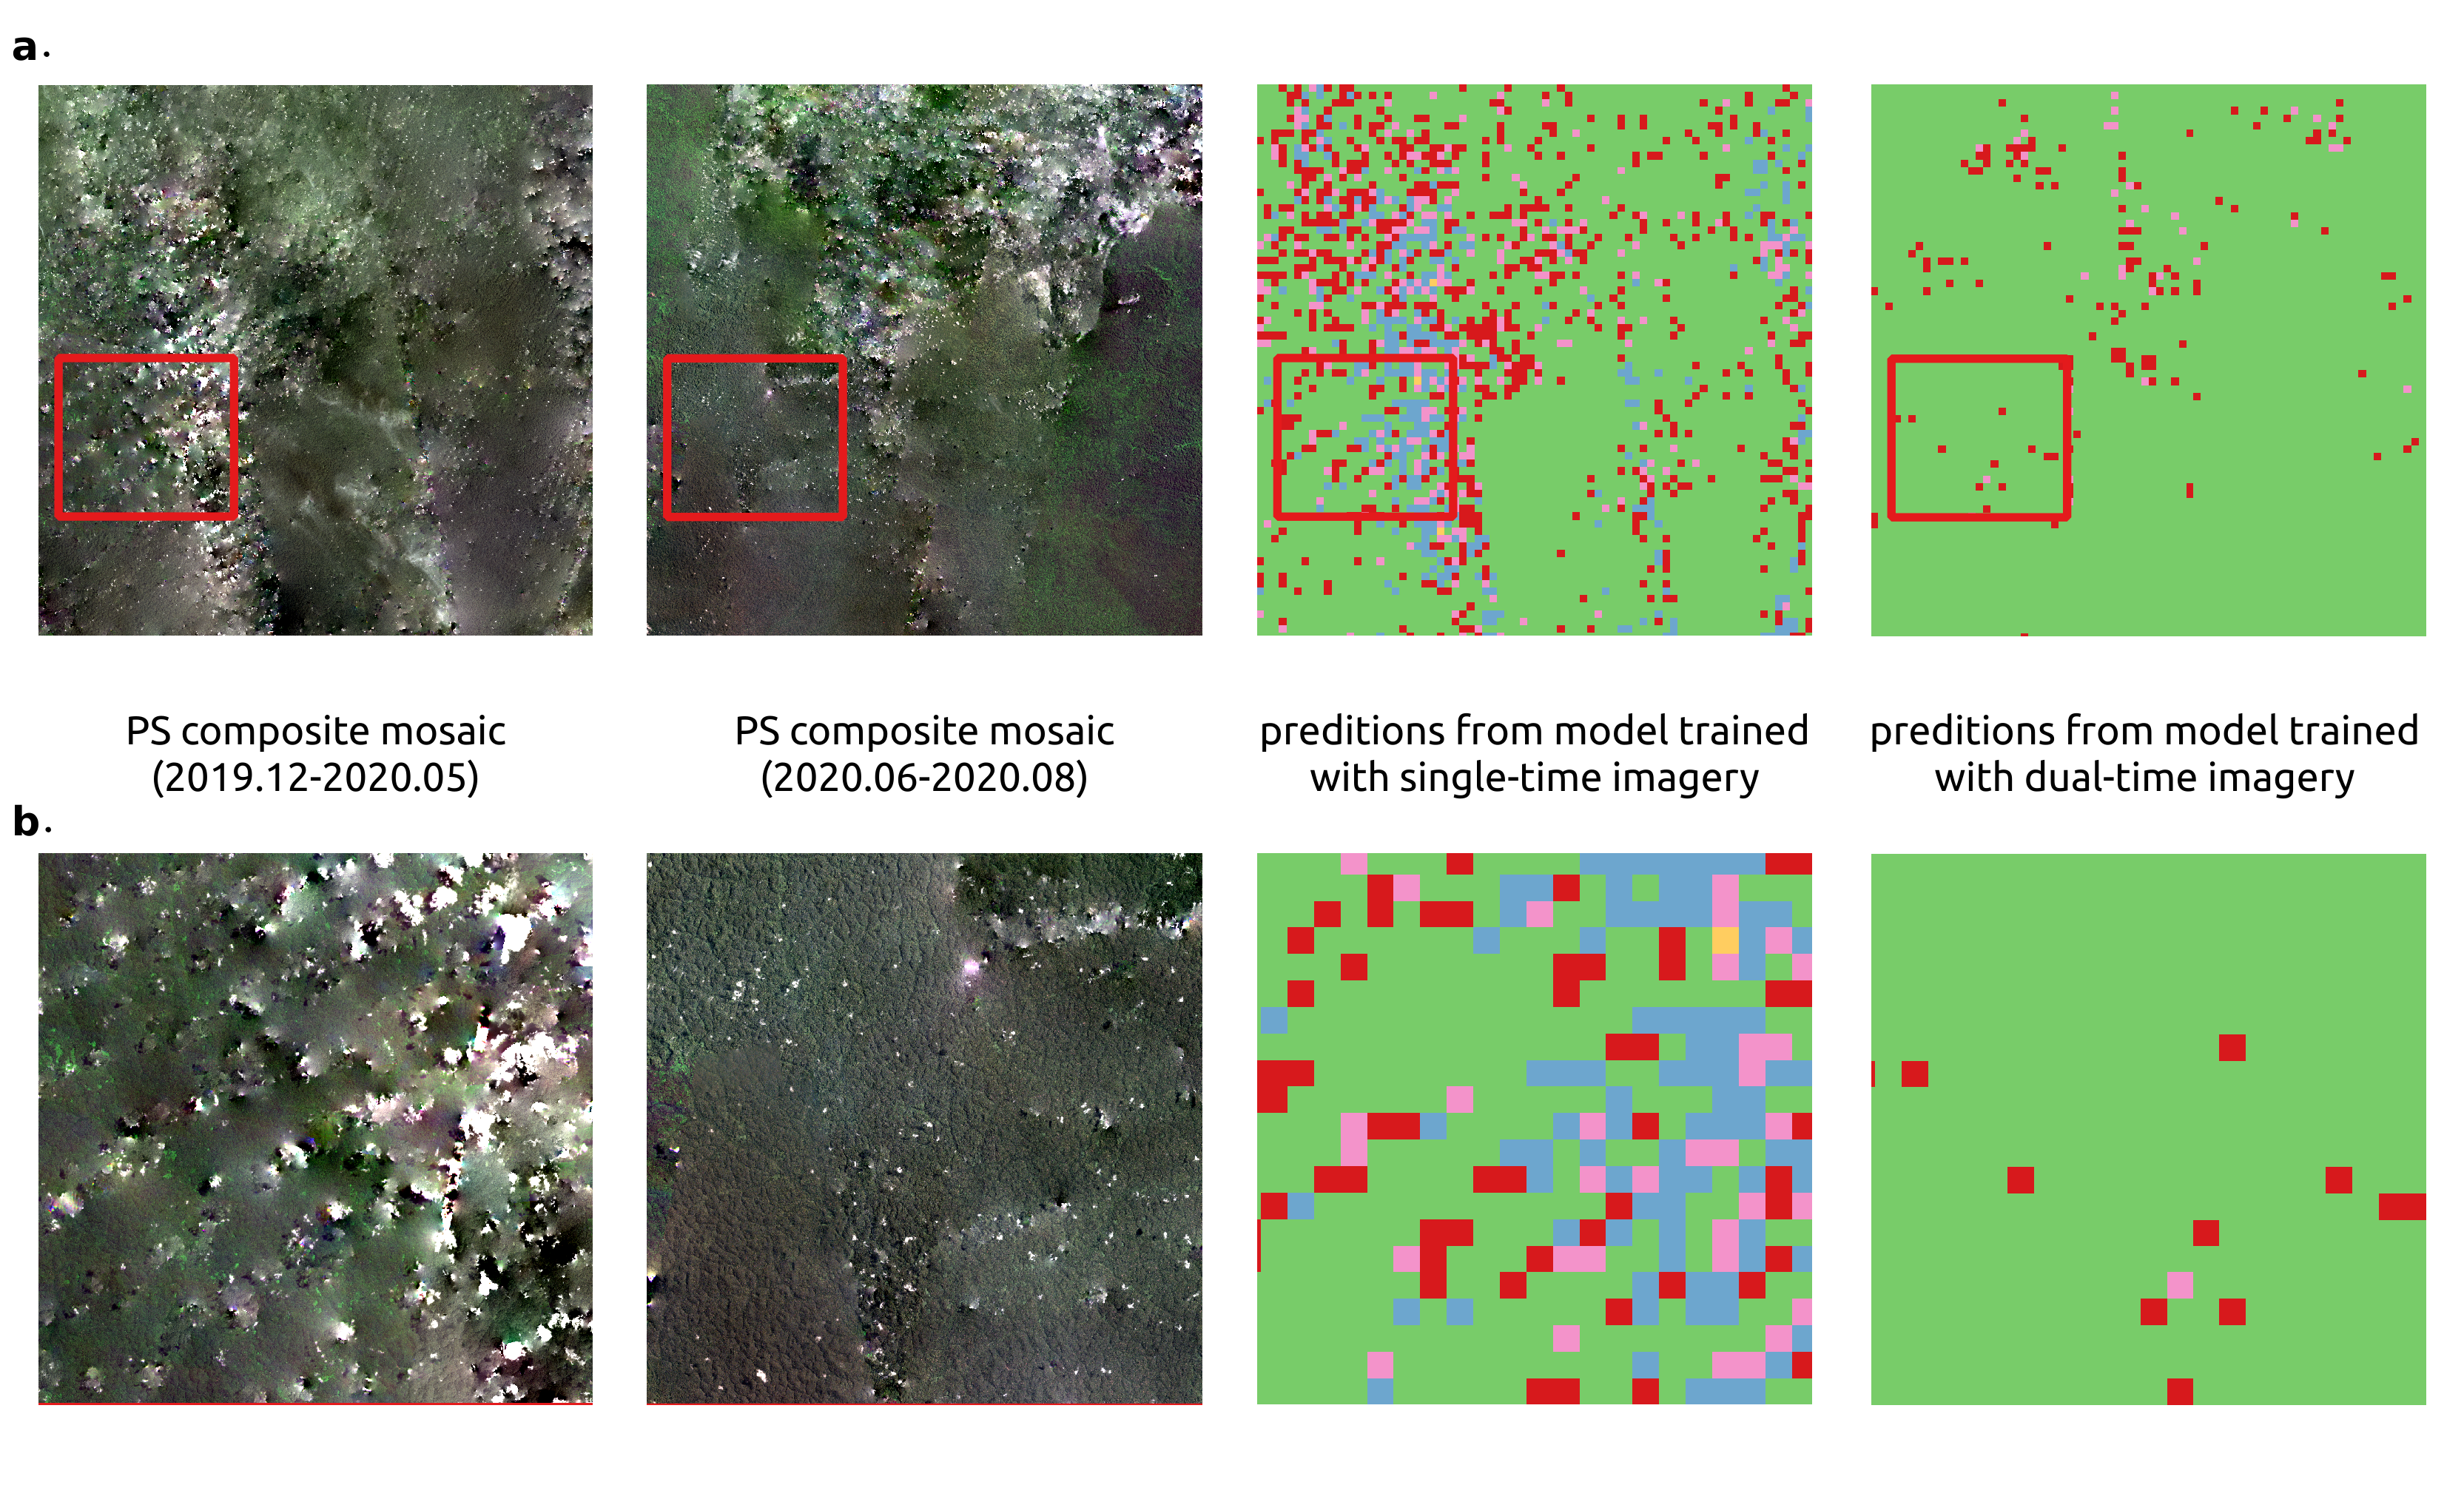Fig. S5 | Cloud removal example.

Fig. S6 | Global patterns of shifting cultivation within agricultural systems. a, Percentage of total agricultural area under shifting cultivation for each country/region, where total agricultural area is defined as the sum of shifting cultivation, conventional agriculture, and mixed woody plantation classes from this study's prediction map. b, Countries/regions where shifting cultivation constitutes more than 50% of combined crop production area. Combined crop production area comprises shifting cultivation (this study) and permanent annual cropland (Potapov et al.) as two distinct, non-overlapping categories; the Potapov et al.⁴ dataset explicitly excludes shifting cultivation by definition. Countries/regions are shown only where both datasets provide coverage.

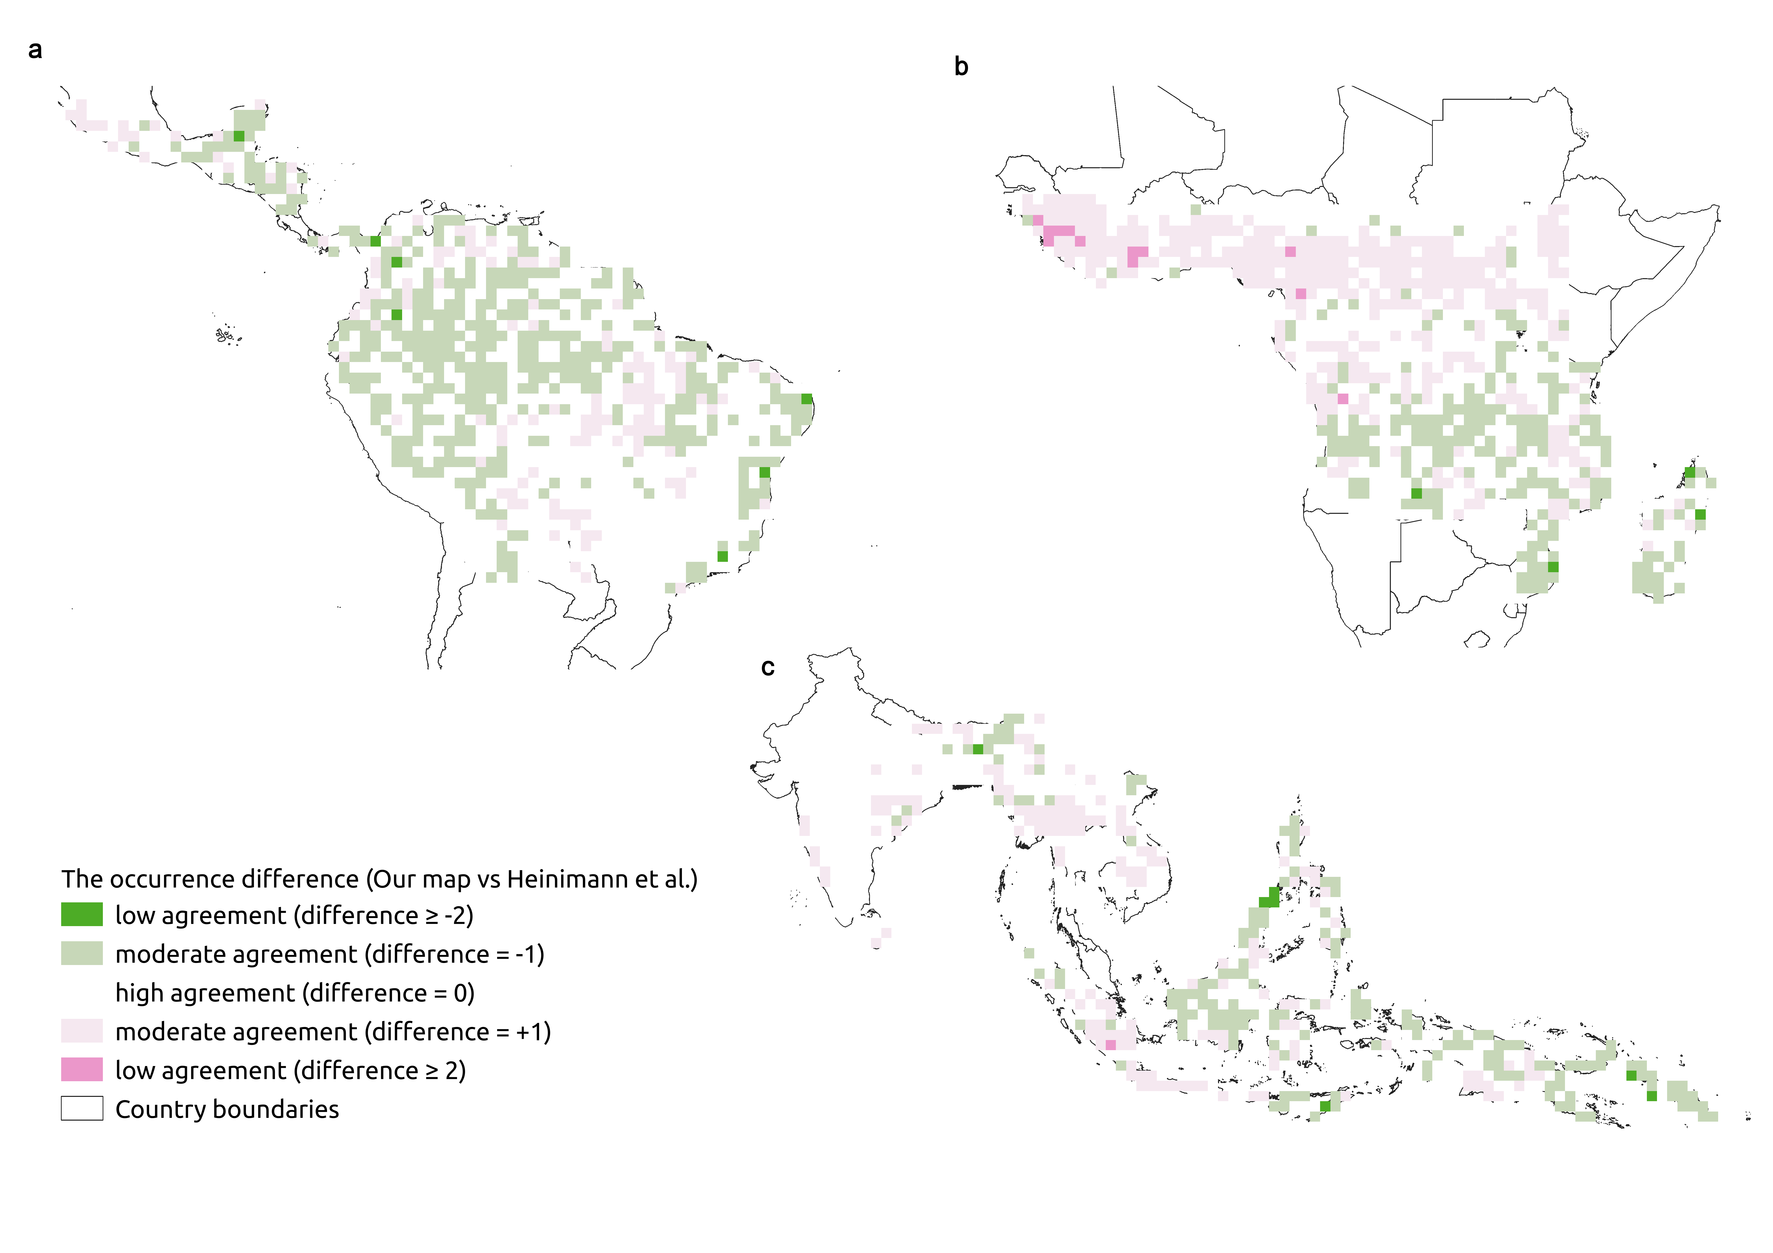Fig. S7 | Level of differences (calculated for 1 degree grid cells) when compared with Heinemann et al.’s ⁵ visual interpretation. (a) Americas, (b) Africa, (c) Asia-Oceania

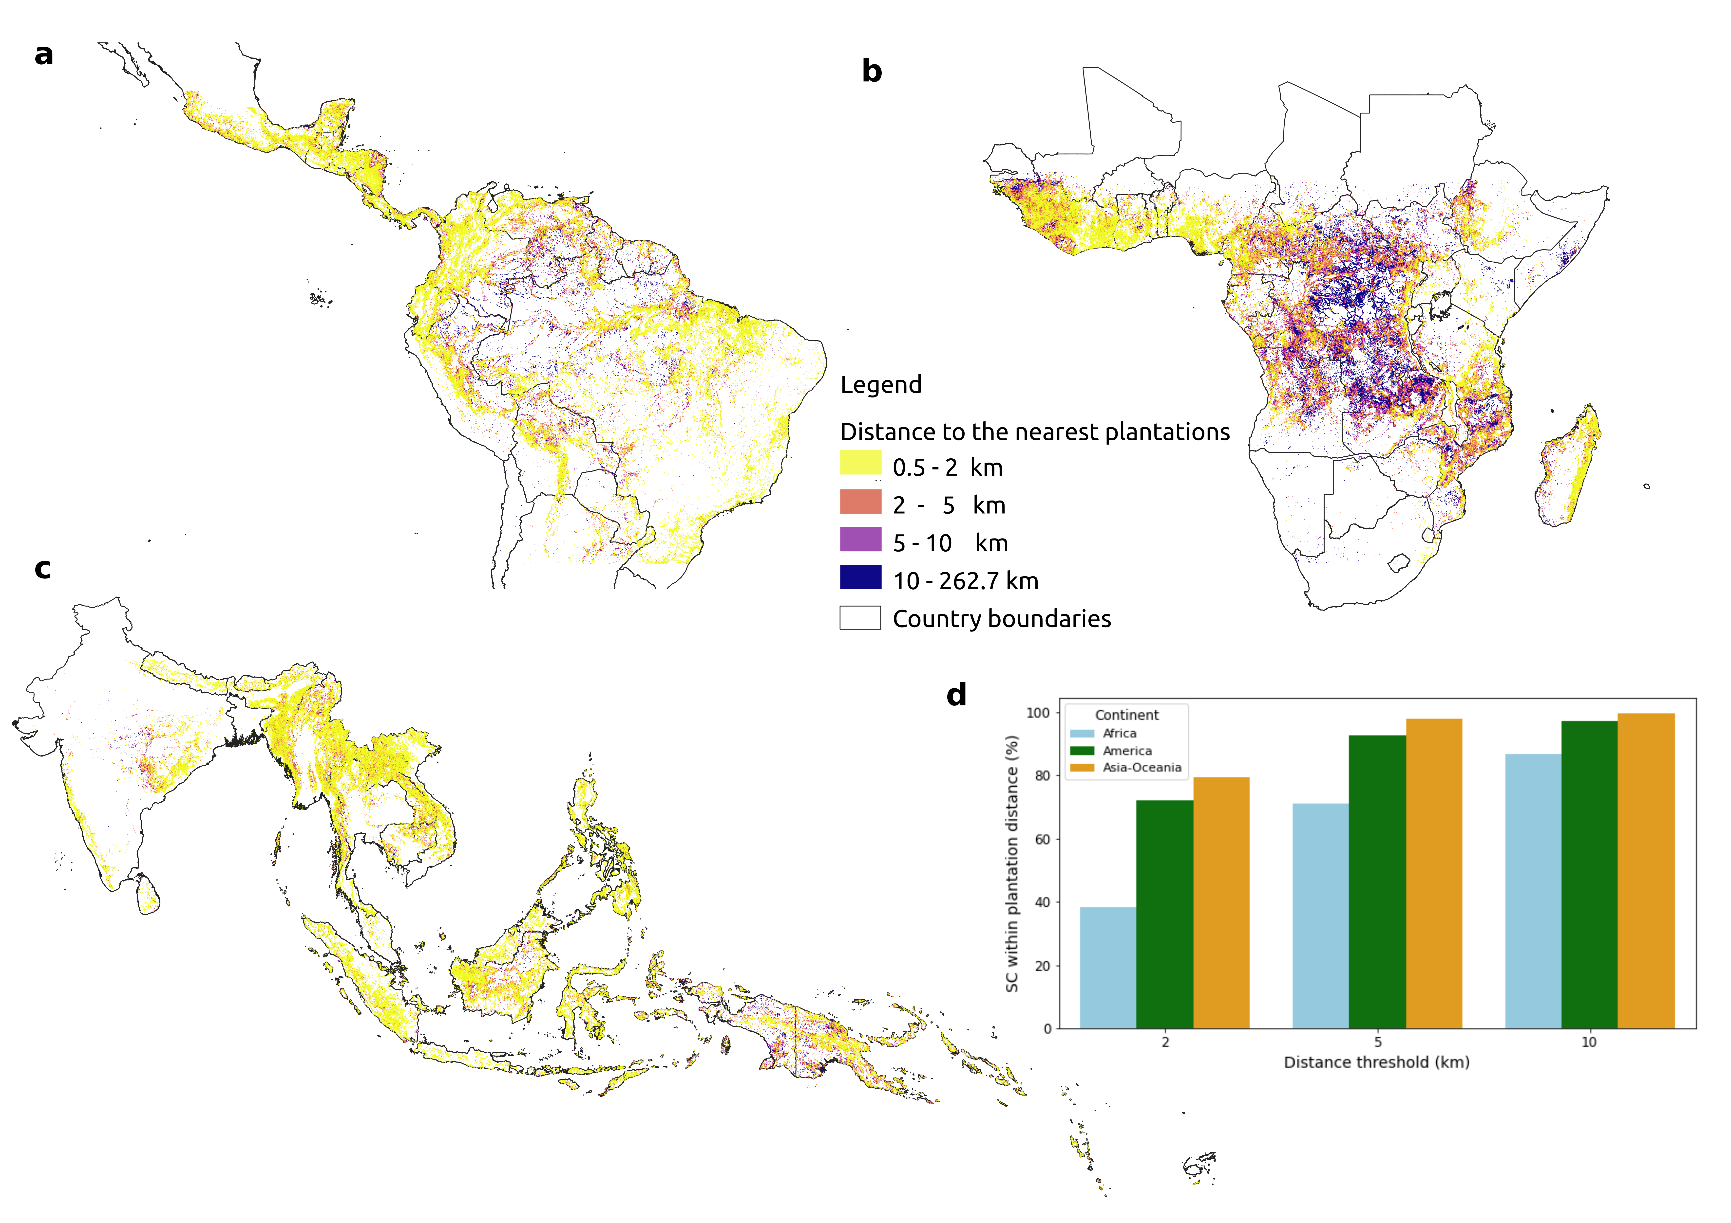Fig. S8 | Distance to the nearest plantations.

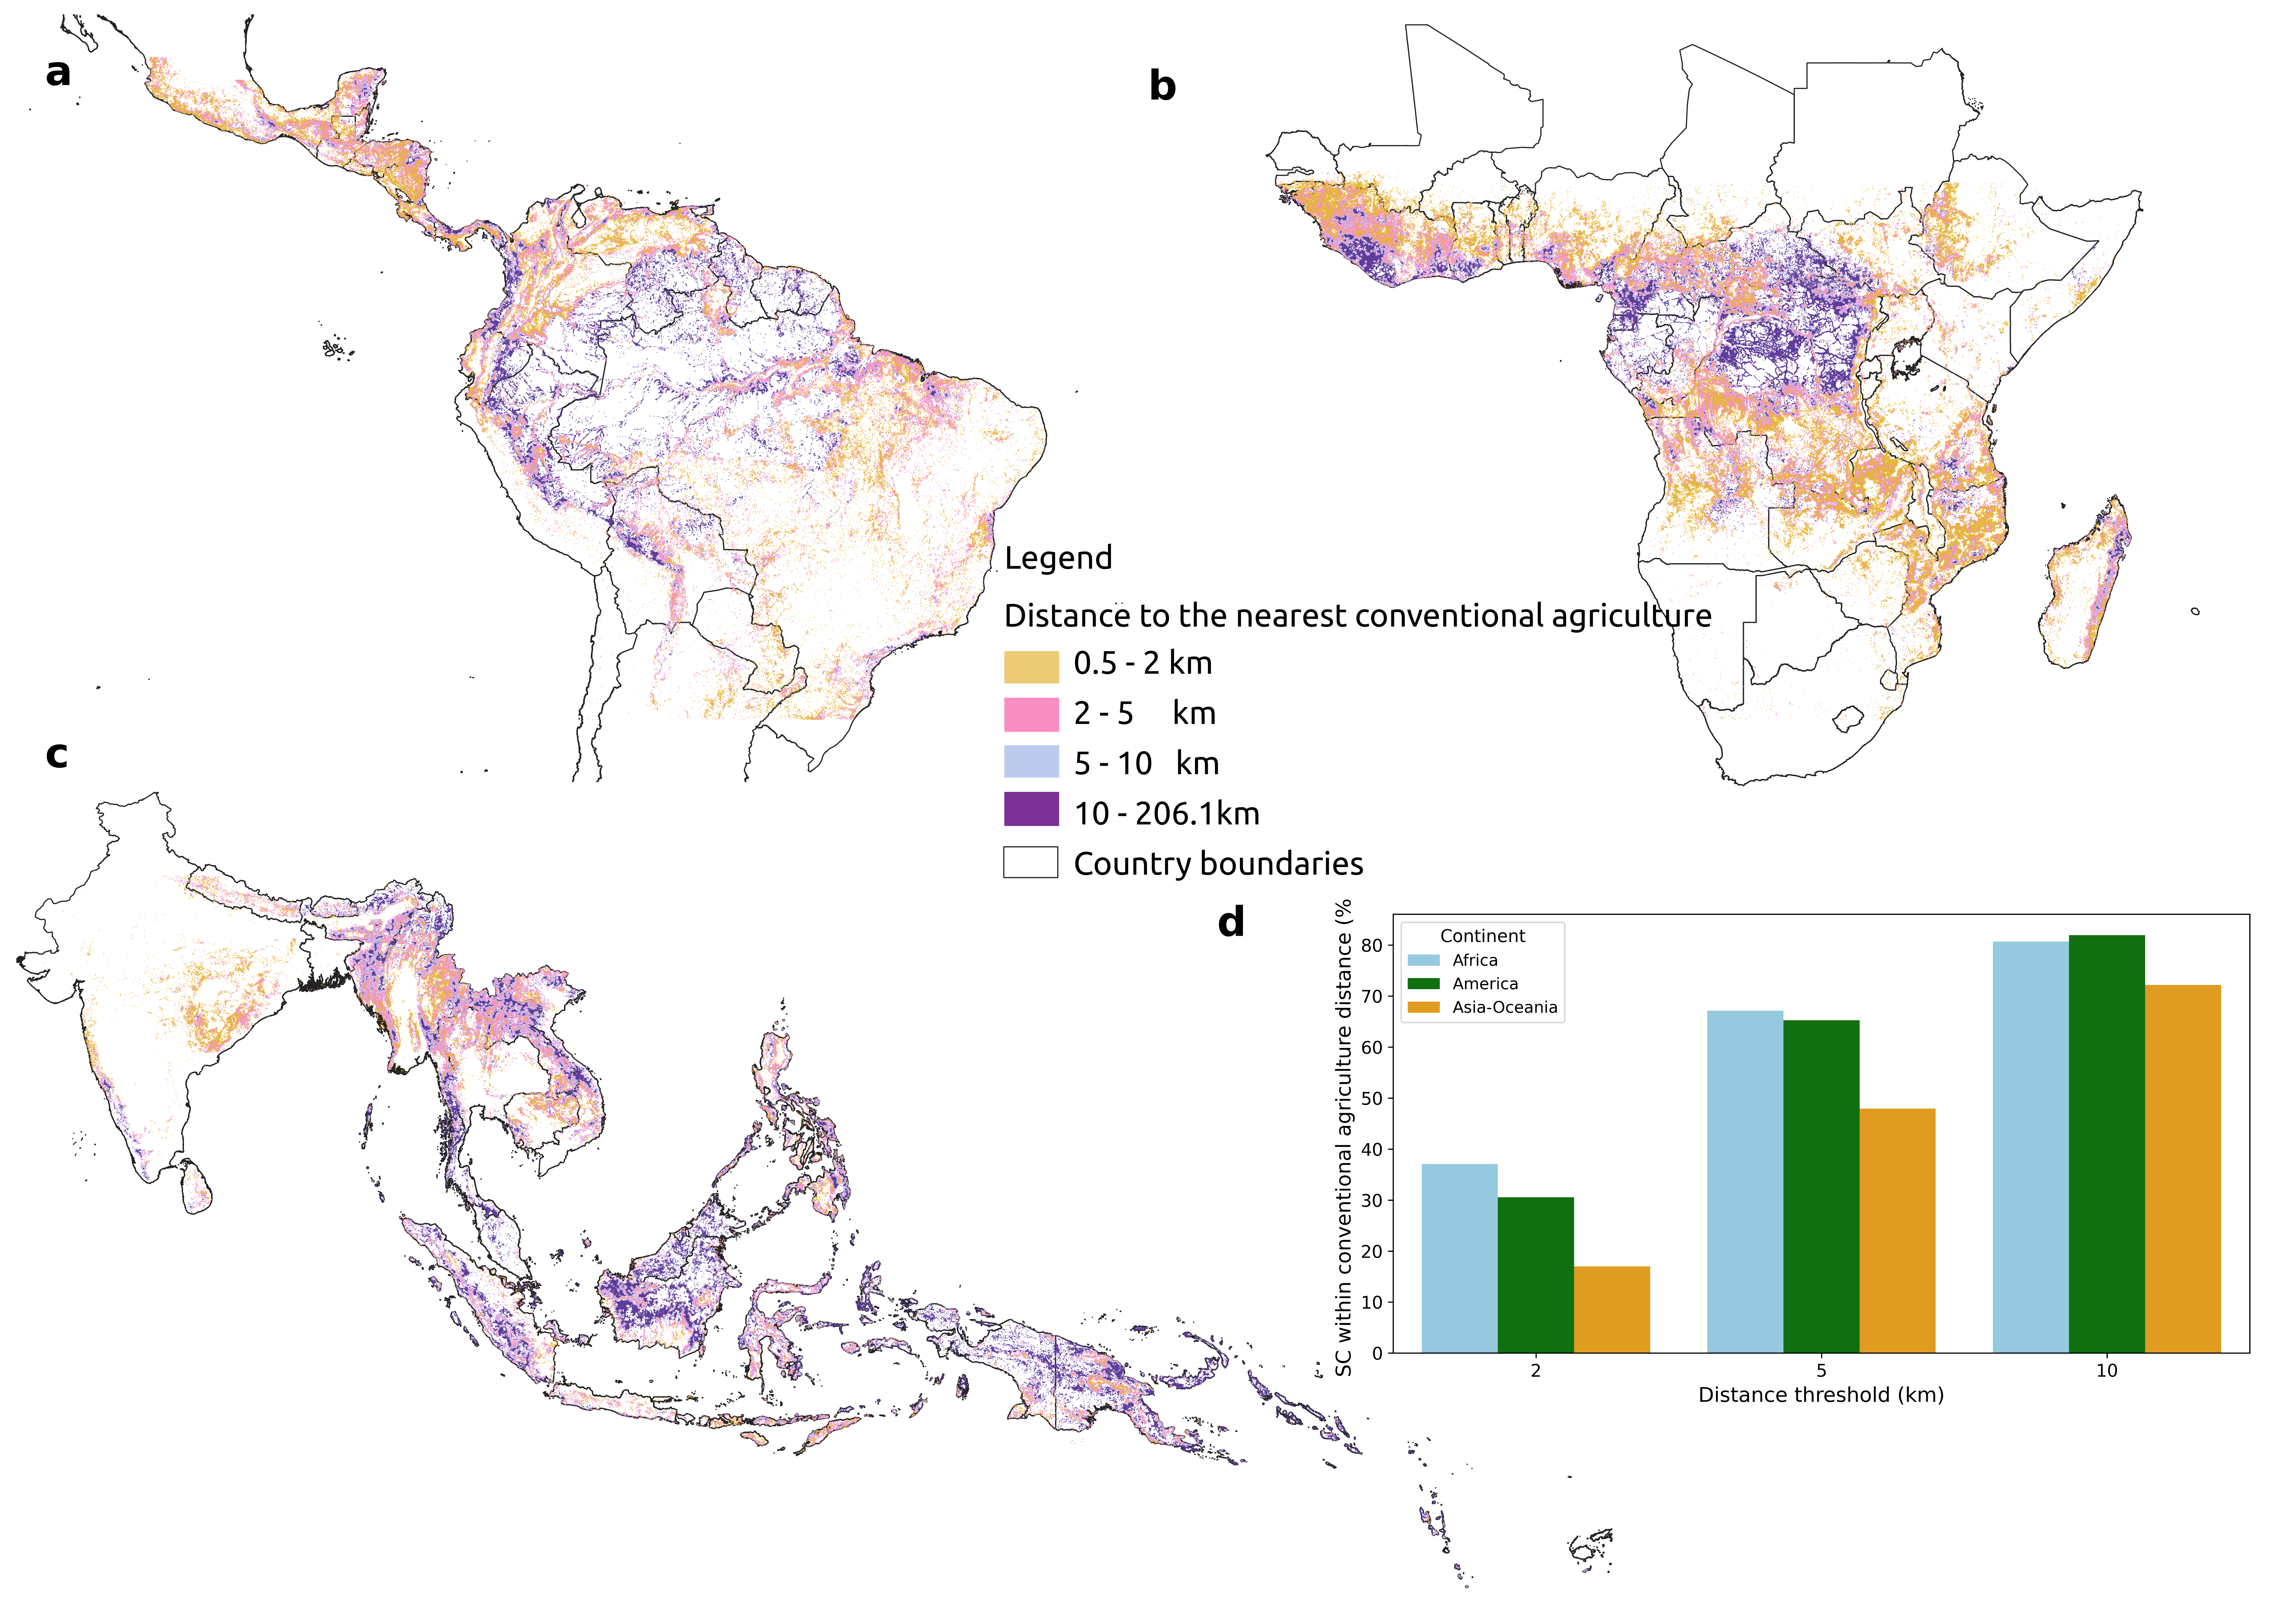Fig. S9 | Distance to the nearest conventional agriculture.
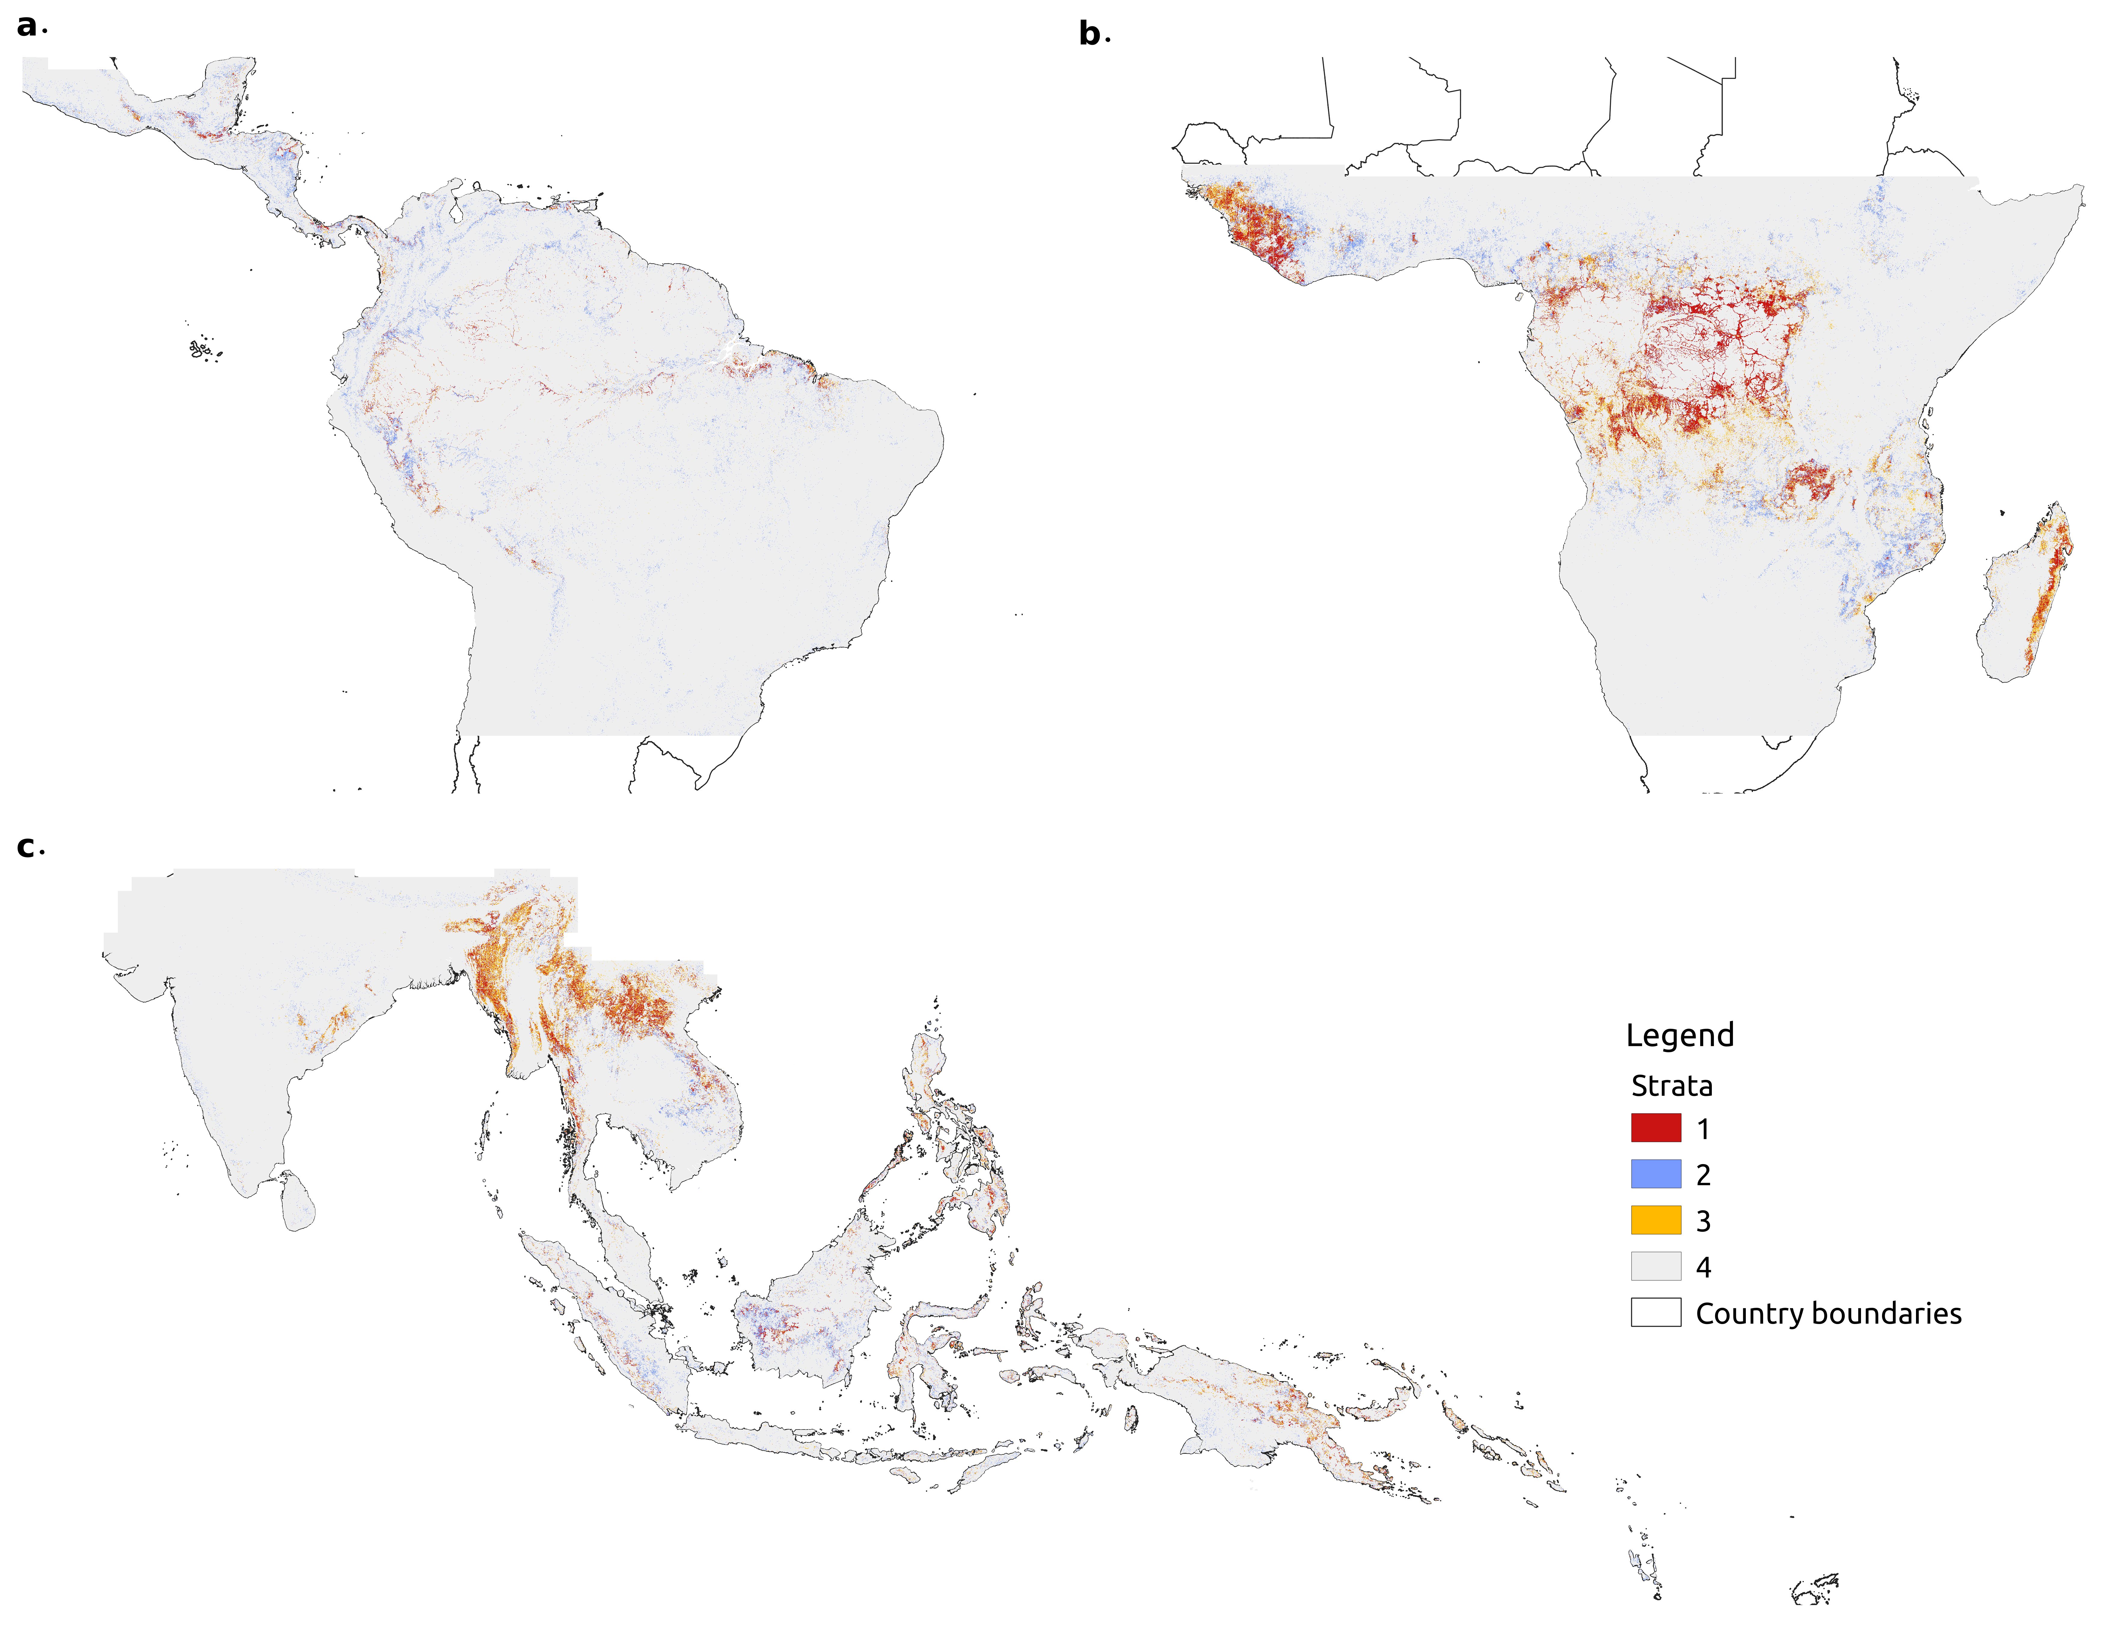Fig. S10 | The four strata for validation points sampling.

Fig. S11 | Distribution of validation pixels for the map accuracy assessment.
Fig. S12 | Comparison of national permanent cropland (%) and shifting cultivation (%) across countries, by continent and total GDP. Bubbles are coloured by continent, with size represents the value of GDP (Current USD). Bubbles above the 1:1 dashed line indicate countries where shifting cultivation exceeds permanent cropland area; these countries (n = 37) were used for the Spearman rank correlation analysis. Points below the dashed line (muted colours) indicate countries where permanent cropland exceeds shifting cultivation and were shown for context only. Permanent cropland area from Potapov et al.⁴, which explicitly excludes shifting cultivation. The inset shows an enlarged view of countries with cropland ≤ 5% and shifting cultivation ≤ 10%.

Fig. S13 | Comparison of national permanent cropland (%) and shifting cultivation (%) across countries, by continent and GDP per capita. Bubbles are coloured by continent, with size represents GDP per capita (Current USD). Bubbles above the 1:1 dashed line indicate countries where shifting cultivation exceeds permanent cropland area; these countries (n = 36) were used for the Spearman rank correlation analysis. Points below the dashed line (muted colours) are shown for context only. Permanent cropland area from Potapov et al.⁴. The inset shows an enlarged view of countries with cropland ≤ 5% and shifting cultivation ≤ 10%.

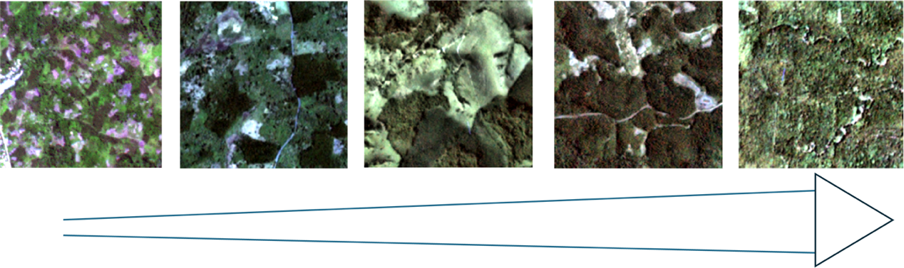
Fig. S14 | Illustration of the wide range in visual composition of samples in the mixed woody plantation class.

Fig. S15 | Examples of misclassified shifting cultivation at the forest-agriculture frontier.

Reference
1. Molinario, G., Hansen, M. C. & Potapov, P. V. Forest cover dynamics of shifting cultivation in the Democratic Republic of Congo: A remote sensing-based assessment for 2000-2010. Environmental Research Letters 10, 2000–2010 (2015).
2. Schmidt-Vogt, D. et al. An assessment of trends in the extent of swidden in southeast asia. Hum. Ecol. 37, 269–280 (2009).
3. Chen, S., Olofsson, P., Saphangthong, T. & Woodcock, C. E. Monitoring shifting cultivation in Laos with Landsat time series. Remote Sens. Environ. 288, 113507 (2023).
4. Potapov, P. et al. Global maps of cropland extent and change show accelerated cropland expansion in the twenty-first century. Nat. Food 3, 19–28 (2022).
5. Heinimann, A. et al. A global view of shifting cultivation: Recent, current, and future extent. PLoS One 12, 1–21 (2017).

