Supplementary Figures and Tables

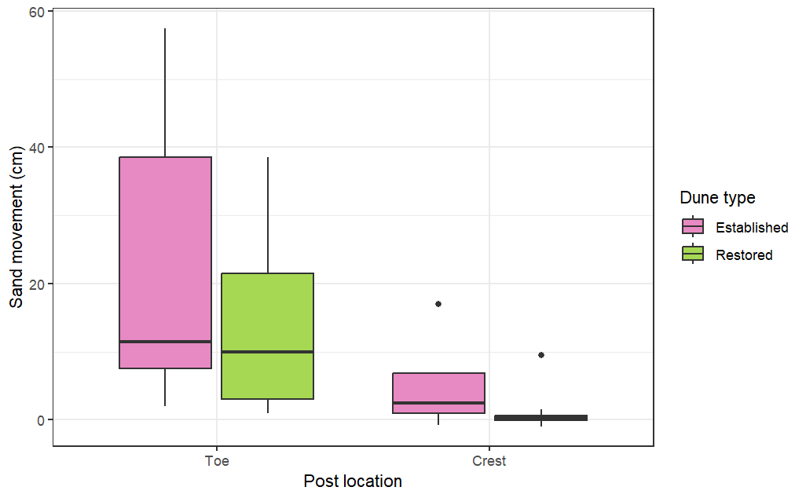
a
b
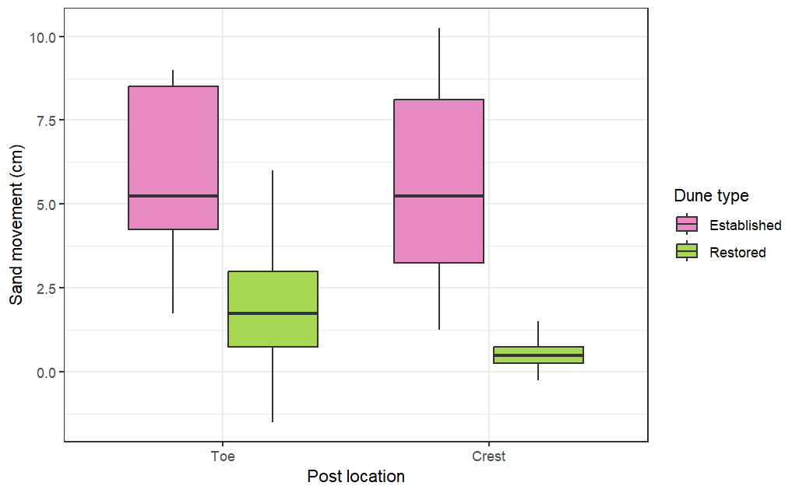
Fig 1S Sand movement (cm) in the established (pink) and restored (green) dune at the toe and crest during (a) Hurricane Ian (2022) and (b) Hurricane Helene (2024). Although analyses were performed with transformed data, raw values are used here for visualization purposes
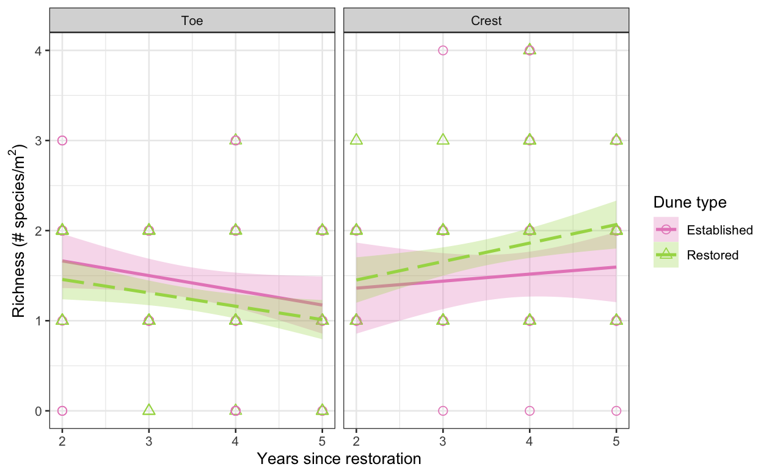
Fig 2S Species richness (the number of species per 1x1 m plot) over time in Tybee’s established (circles, solid line) and restored (triangles, dashed line) dune at the toe and crest. Circles represent measurements collected in March, June, and September for years two through five since restoration with shaded areas indicating 95% confidence intervals. See Table 2S for linear mixed model results

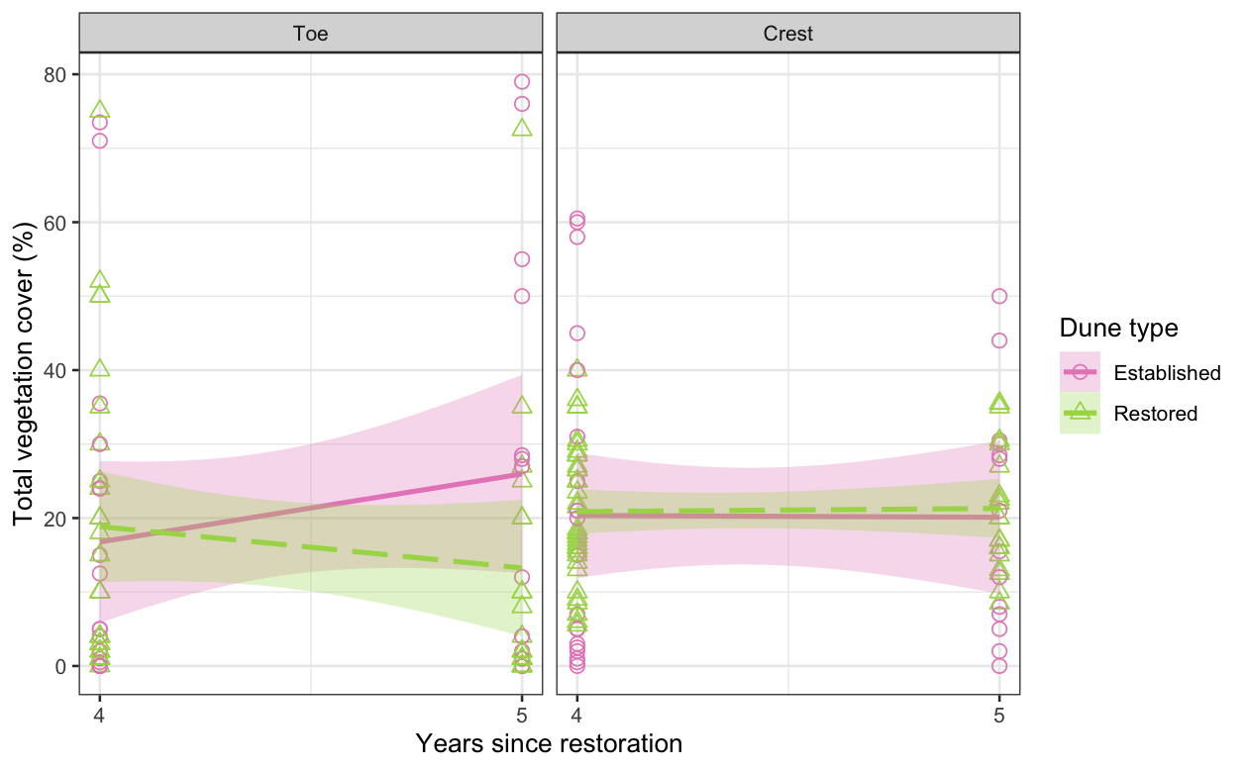
Fig 3S Total vegetation cover (%) in Tybee’s established (circles, solid line) and restored (triangles, dashed line) dune at the toe and crest. Circles represent measurements collected in March, June, and September for years four and five since restoration with shaded areas indicating 95% confidence intervals. See Table 4S for linear mixed model results

Table 1S. Linear mixed model results examining the effects of years since restoration and dune type (established vs. restored) on sand movement (cm) at the toe and crest. Measurements were collected quarterly at signposts between September 2022 (two years post-restoration) and June 2025 (five years post-restoration). Number of observations: toe = 182; crest = 201. Asterisks denote statistically significant effects (p < 0.05). See Methods for guidance on interpreting model output.
Dune location
Toe | Fixed Effect | Estimate | SE | DF | p
 | (Intercept) | 8.7975 | 3.2616 | 175 | 0.00767*
 | Years since restoration | -1.8595 | 0.8247 | 175 | 0.02539*
 | Dune type (Restored) | 2.232 | 3.8046 | 175 | 0.5582
 | Month (June) | 2.5315 | 1.3682 | 175 | 0.06596
 | Month (September) | 1.7265 | 1.4822 | 175 | 0.24568
 | Month (December) | 4.9903 | 1.5933 | 175 | 0.00204*
 | Years since restoration × Dune type (Restored) | -1.1908 | 1.0416 | 175 | 0.25449
 | Random Effect | Variance | SD | N (groups)
 | Signpost ID | 0 | 0 | 33
 | Residual (Error) | 45.85 | 6.771 | —
Crest | Fixed Effect | Estimate | SE | DF | p
 | (Intercept) | 9.5652 | 2.0549 | 108.0289 | <0.00001*
 | Years since restoration | -1.406 | 0.5016 | 114.3385 | 0.005945*
 | Dune type (Restored) | -8.5553 | 2.1316 | 110.6249 | <0.001*
 | Month (June) | -0.202 | 0.5995 | 166.5449 | 0.736633
 | Month (September) | -0.6481 | 0.661 | 169.0748 | 0.328206
 | Month (December) | 0.2893 | 0.6639 | 170.9004 | 0.663543
 | Years since restoration × Dune type (Restored) | 1.3216 | 0.55 | 149.8886 | 0.017482*
 | Random Effect | Variance | SD | N (groups)
 | Signpost ID | 1.438 | 1.199 | 22
 | Residual (Error) | 9.165 | 3.027 | —

Table 2S. Results for generalized linear mixed models with Poisson distributions examining the effects of years since restoration and dune type (established vs. restored) on species richness (# species/m²) at the toe and crest. Measurements were collected in March, June, and September from 1x1 meter plots at signposts between June 2022 (two years post-restoration) and June 2025 (five years post-restoration). Number of observations: toe = 167; crest = 169. Asterisks denote statistically significant effects (p < 0.05). See Methods for guidance on interpreting model output.
Dune location
Toe | Fixed Effect | Estimate | SE | DF | p
 | (Intercept) | 1.3251 | 0.325732 | 133.939622 | <0.0001*
 | Years since restoration | -0.08728 | 0.083226 | 155.445746 | 0.296
 | Dune type (Restored) | -0.115315 | 0.415418 | 124.462121 | 0.782
 | Month (June) | 0.418897 | 0.086149 | 129.659016 | <0.0001*
 | Month (September) | 0.500163 | 0.096726 | 131.115798 | <0.0001*
 | Years since restoration × Dune type (Restored) | 0.005538 | 0.108194 | 156.995071 | 0.959
 | Random Effect | Variance | SD | N (groups)
 | Signpost ID | 0.2438 | 0.4938 | 33
 | Residual (Error) | 0.2015 | 0.4488 | —
Crest | Fixed Effect | Estimate | SE | DF | p
 | (Intercept) | 0.41329 | 0.50606 | 119.58174 | 0.416
 | Years since restoration | 0.1757 | 0.12079 | 141.09627 | 0.148
 | Dune type (Restored) | -0.01013 | 0.544 | 109.977 | 0.985
 | Month (June) | 0.4861 | 0.1198 | 144.04875 | <0.0001*
 | Month (September) | 0.55333 | 0.13612 | 144.43494 | <0.0001*
 | Years since restoration × Dune type (Restored) | 0.11022 | 0.13242 | 153.11848 | 0.406
 | Random Effect | Variance | SD | N (groups)
 | Signpost ID | 0.2294 | 0.479 | 22
 | Residual (Error) | 0.4033 | 0.635 | —

Table 3S. Linear mixed model results examining the effects of years since restoration and dune type (established vs. restored) on midpoint of total percent cover class at the toe and crest. Measurements were collected in March, June, and September from 1x1 meter plots at signposts between June 2022 (two years post-restoration) and June 2025 (five years post-restoration). Number of observations: toe = 167; crest = 169. Asterisks denote statistically significant effects (p < 0.05). See Methods for guidance on interpreting model output.
Dune location
Toe | Fixed Effect | Estimate | SE | DF | p
 | (Intercept) | -23.138 | 9.049 | 137.353 | 0.0116*
 | Years since restoration | 9.272 | 2.262 | 160.839 | <0.0001*
 | Dune type (Restored) | 17.588 | 11.611 | 128.226 | 0.1323
 | Month (June) | 9.331 | 2.249 | 130.933 | <0.0001*
 | Month (September) | 12.221 | 2.528 | 132.101 | <0.00001*
 | Years since restoration × Dune type (Restored) | -5.126 | 2.935 | 160.998 | 0.0827
 | Random Effect | Variance | SD | N (groups)
 | Signpost ID | 247.8 | 15.74 | 33
 | Residual (Error) | 137.3 | 11.72 | —
Crest | Fixed Effect | Estimate | SE | DF | p
 | (Intercept) | 49.6048 | 10.2087 | 116.6926 | <0.00001*
 | Years since restoration | -7.2498 | 2.2671 | 162.9166 | 0.001664*
 | Dune type (Restored) | -39.1797 | 11.3656 | 87.1162 | <0.001*
 | Month (June) | 1.5878 | 2.0378 | 142.2525 | 0.437168
 | Month (September) | 0.6126 | 2.3167 | 142.4632 | 0.791827
 | Years since restoration × Dune type (Restored) | 9.5141 | 2.4438 | 161.9768 | <0.001*
 | Random Effect | Variance | SD | N (groups)
 | Signpost ID | 233.8 | 15.29 | 22
 | Residual (Error) | 116.6 | 10.80 | —

Table 4S. Linear mixed model results examining the effects of years since restoration and dune type (established vs. restored) on total percent cover at the toe and crest. Measurements were collected in March, June, and September from 1x1 meter plots at signposts between March 2024 (four years post-restoration) and June 2025 (five years post-restoration). Number of observations: toe = 80; crest = 90. Asterisks denote statistically significant effects (p < 0.05). See Methods for guidance on interpreting model output.
Dune location
Toe | Fixed Effect | Estimate | SE | DF | p
 | (Intercept) | -38.665 | 20.46 | 71.619 | 0.062831
 | Years since restoration | 11.562 | 4.304 | 60 | 0.009334*
 | Dune type (Restored) | 61.307 | 25.961 | 72.351 | 0.020894*
 | Month (June) | 13.641 | 2.991 | 60 | <0.0001*
 | Month (September) | 13.898 | 3.956 | 60 | <0.001*
 | Years since restoration × Dune type (Restored) | -14.804 | 5.503 | 60 | 0.009236*
 | Random Effect | Variance | SD | N (groups)
 | Signpost ID | 316.5 | 17.79 | 16
 | Residual (Error) | 143.1 | 11.96 | —
Crest | Fixed Effect | Estimate | SE | DF | p
 | (Intercept) | 31.9231 | 13.0769 | 80.1985 | 0.0168*
 | Years since restoration | -2.7688 | 2.7630 | 67.2649 | 0.3199
 | Dune type (Restored) | 0.8461 | 16.1359 | 80.7249 | 0.9583
 | Month (June) | 4.0556 | 1.8183 | 67.2366 | 0.0291*
 | Month (September) | -5.5285 | 2.4020 | 67.5736 | 0.0244*
 | Years since restoration × Dune type (Restored) | -0.1259 | 3.4641 | 67.6928 | 0.9711
 | Random Effect | Variance | SD | N (groups)
 | Signpost ID | 123.07 | 11.094 | 19
 | Residual (Error) | 59.51 | 7.715 | —

Table 5S. Linear mixed model results examining the effects of years since restoration and dune type (established vs. restored) on midpoint of total percent cover class at the toe and crest. Measurements were collected in March, June, and September from 1x1 meter plots at signposts between March 2024 (four years post-restoration) and June 2025 (five years post-restoration). Number of observations: toe = 80; crest = 90. Asterisks denote statistically significant effects (p < 0.05). See Methods for guidance on interpreting model output.
Dune location
Toe | Fixed Effect | Estimate | SE | DF | p
 | (Intercept) | -57.186 | 20.187 | 71.565 | 0.005989*
 | Years since restoration | 16.081 | 4.249 | 60 | <0.001*
 | Dune type (Restored) | 78.455 | 25.613 | 72.301 | 0.003076*
 | Month (June) | 12.203 | 2.952 | 60 | <0.001*
 | Month (September) | 10.023 | 3.905 | 60 | 0.012779*
 | Years since restoration × Dune type (Restored) | -18.894 | 5.432 | 60 | <0.001*
 | Random Effect | Variance | SD | N (groups)
 | Signpost ID | 305.7 | 17.48 | 16
 | Residual (Error) | 139.4 | 11.81 | —
Crest | Fixed Effect | Estimate | SE | DF | p
 | (Intercept) | 18.0722 | 17.5261 | 74.5674 | 0.3058
 | Years since restoration | 0.3127 | 3.8214 | 67.5531 | 0.935
 | Dune type (Restored) | 17.9840 | 21.5722 | 75.3235 | 0.4071
 | Month (June) | 4.5139 | 2.5151 | 67.5054 | 0.0772
 | Month (September) | -3.9834 | 3.3181 | 68.0738 | 0.2341
 | Years since restoration × Dune type (Restored) | -3.7152 | 4.7827 | 68.3352 | 0.44
 | Random Effect | Variance | SD | N (groups)
 | Signpost ID | 95.97 | 9.797 | 19
 | Residual (Error) | 113.86 | 10.671 | —

Table 6S. Linear mixed model results examining the effects of years since restoration and dune type (established vs. restored) on Uniola paniculata cover at the toe and crest. Measurements were collected in March, June, and September from 1x1 meter plots at signposts between March 2024 (four years post-restoration) and June 2025 (five years post-restoration). Number of observations: toe = 68; crest = 88. Asterisks denote statistically significant effects (p < 0.05). See Methods for guidance on interpreting model output.
Dune location
Toe | Fixed Effect | Estimate | SE | DF | p
 | (Intercept) | -44.712 | 26.778 | 56.912 | 0.1005
 | Years since restoration | 11.868 | 5.629 | 49.683 | 0.0401*
 | Dune type (Restored) | 63.927 | 32.210 | 57.605 | 0.0519
 | Month (June) | 9.669 | 3.757 | 48.917 | 0.0132*
 | Month (September) | 9.390 | 4.836 | 48.618 | 0.0580
 | Years since restoration × Dune type (Restored) | -14.167 | 6.912 | 49.249 | 0.0457*
 | Random Effect | Variance | SD | N (groups)
 | Signpost ID | 336.7 | 18.35 | 16
 | Residual (Error) | 177.3 | 13.32 | —
Crest | Fixed Effect | Estimate | SE | DF | p
 | (Intercept) | 31.2151 | 13.290 | 77.1355 | 0.02140*
 | Years since restoration | -2.7160 | 2.8250 | 65.1019 | 0.33989
 | Dune type (Restored) | 1.9926 | 16.1913 | 77.9168 | 0.90237
 | Month (June) | 2.6501 | 1.8386 | 65.3672 | 0.15424
 | Month (September) | -6.9665 | 2.410 | 65.5789 | 0.00521*
 | Years since restoration × Dune type (Restored) | -0.5037 | 3.4917 | 65.5149 | 0.88574
 | Random Effect | Variance | SD | N (groups)
 | Signpost ID | 116.47 | 10.792 | 19
 | Residual (Error) | 58.14 | 7.625 | —

Table 7S. Linear mixed model results examining the effects of years since restoration and dune type (established vs. restored) on Ipomoea imperati cover at the toe and crest. Measurements were collected in March, June, and September from 1x1 meter plots at signposts between March 2024 (four years post-restoration) and June 2025 (five years post-restoration). Number of observations: toe = 68; crest = 88. Asterisks denote statistically significant effects (p < 0.05). See Methods for guidance on interpreting model output.
Dune location
Toe | Fixed Effect | Estimate | SE | DF | p
 | (Intercept) | 1.0465 | 11.4511 | 54.6552 | 0.927515
 | Years since restoration | 0.5012 | 2.4975 | 51.6719 | 0.841720
 | Dune type (Restored) | -2.5545 | 13.7971 | 53.6135 | 0.853812
 | Month (June) | 6.0632 | 1.6795 | 50.4524 | 0.000703*
 | Month (September) | 6.2225 | 2.1682 | 49.9769 | 0.006003*
 | Years since restoration × Dune type (Restored) | -0.6051 | 3.0812 | 50.8119 | 0.845089
 | Random Effect | Variance | SD | N (groups)
 | Signpost ID | 10.12 | 3.182 | 16
 | Residual (Error) | 36.21 | 6.018 | —
Crest | Fixed Effect | Estimate | SE | DF | p
 | (Intercept) | -1.0343 | 1.3520 | 69.5167 | 0.44685
 | Years since restoration | 0.3093 | 0.2995 | 66.2105 | 0.30559
 | Dune type (Restored) | 0.6638 | 1.6376 | 70.5286 | 0.68645
 | Month (June) | 0.2895 | 0.1944 | 67.0564 | 0.14114
 | Month (September) | 0.8716 | 0.2544 | 67.4026 | 0.00105*
 | Years since restoration × Dune type (Restored) | -0.2422 | 0.3687 | 67.3309 | 0.51347
 | Random Effect | Variance | SD | N (groups)
 | Signpost ID | 0.2042 | 0.4519 | 19
 | Residual (Error) | 0.6541 | 0.8088 | —

