Supporting Information for
On the feasibility of all-solid-state batteries with LLZO as a single electrolyte

Kostiantyn V. Kravchyk,^{1,2} Dogan Tarik Karabay^{1,2} and Maksym V. Kovalenko^{1,2*}
¹ Laboratory for Thin Films and Photovoltaics, Empa – Swiss Federal Laboratories for Materials Science and Technology, Überlandstrasse 129, CH-8600 Dübendorf, Switzerland
² Laboratory of Inorganic Chemistry, Department of Chemistry and Applied Biosciences, ETH Zürich, Vladimir-Prelog-Weg 1, CH-8093 Zürich, Switzerland

Corresponding Authors:
*E-mails: kravchyk@inorg.chem.ethz.ch and mvkovalenko@ethz.ch

LCO positive electrode

Electronic conductivity in LCO:

The conduction of electrons in the LCO can be described by following generalized Ohm’s Law:
$i_{LCO}=-σ_{LCO,eff}∇∅_{LCO}$ (1)
where $i_{LCO}$ is the current density(in A m⁻¹), $∇∅_{LCO}$ is the potential gradient, and $σ_{LCO,eff}$ represents the effective electronic conductivity of LCO (in S m⁻¹), which can be calculated as follows:
$σ_{LCO,eff}= ε_{LCO}^{1.5}σ_{LCO}$ (2)
where $σ_{LCO}$ is the electronic conductivity of LCO (in S m⁻¹);$ε_{LCO}^{1.5}$ is Bruggeman factor, representing volume fraction and tortuosity of LCO in positive electrode.

Li-ion diffusion in LCO (LCO particles are considered to be perfect spheres surrounded by LLZO electrolyte):

$\frac{∂c_{{Li}^{+}}}{∂t}=∇.(D_{{Li}^{+}}∇c_{{Li}^{+}})$ (3)

where $c_{{Li}^{+}}$ is the Li-ion concentration (in mol m⁻³), $t$ is time (in sec) and $D_{{Li}^{+}}$ is the intercalation diffusivity in LCO particles (in m² s⁻¹).

In order to solve the equation, the following two boundary conditions were applied:

${\left.\frac{∂c_{{Li}^{+}}}{∂r}\right|}_{r=0}=0$ (4)

${\left.-D_{{Li}^{+}}\frac{∂c_{{Li}^{+}}}{∂r}\right|}_{r=r_{p}}=\sum_{m}{\frac{v_{Liθ,m}i_{v,m}}{n_{m}F}\frac{r_{p}}{3ε_{LCO}}}$ (5)
where $c_{{Li}^{+}}$ is the species concentration (in mol m⁻³) , $r_{p}$ is the particle mean center-surface distance (in m), $D_{{Li}^{+}}$ is the intercalation diffusivity constant (in m² s⁻¹), $ε_{LCO}$ is volume fraction of LCO in the electrode, $v_{Liθ,m}$ and $n_{m}$ are stoichiometric numbers of Li ions and electrons required for electrochemical lithiation/delithiation of LCO, $F$ is Faraday`s constant (96485 C mol⁻¹), and $i_{v,m}$ is the applied current (in A m⁻²).

The first condition (4) elucidates the particle diffusion rate at the center of LCO particles. The condition stems from the fact that the diffusion rate should be zero at the center of the sphere.

The second condition (5) implies the diffusion rate at the outer surface of spherical LCO particles. The diffusion rate at $r=r_{p}$ is equalized to the reaction rate at the surface.

Li-ion transport in LLZO:

The conduction of Li ions in the LLZO can be described by following generalized Ohm’s Law:
$i_{LLZO}=-σ_{LLZO,eff}∇∅_{LLZO}$ (6)
where $i_{LLZO}$ is the current density(in A/m), $∇∅_{LLZO}$ is the potential gradient, and $σ_{LLZO,eff}$ represents the effective Li-ion conductivity of LLZO (in S m⁻¹), which can be calculated as follows:
$σ_{LLZO,eff}= ε_{LLZO}^{1.5}σ_{LLZO}$ (7)
where $σ_{LLZO}$ is the Li-ion conductivity of LLZO (in S m⁻¹);$ε_{LLZO}^{1.5}$ is Bruggeman factor, representing volume fraction and tortuosity of LLZO in positive electrode.

Butler-Volmer kinetics in positive electrode:

$i_{loc,expr}=i_{0} \left(exp\left(\frac{α_{a}Fη}{RT}\right)-exp\left(\frac{-α_{c}Fη}{RT}\right)\right)$ (8)
where $i_{loc,expr}$ is the local exchange current density, $α_{a}$ and $α_{c}$ are the anodic and cathodic transfer coefficients, $η$ is the local over potential (in V), $T$ is the temperature (in K), and $i_{0}$ can be expressed as follows:

$i_{0}=i_{0,ref}\left(T\right){\left(\frac{c_{{Li}^{+}}}{c_{{Li}^{+},ref}}\right)}^{α_{c}}{\left(\frac{{c_{{Li}^{+},max}-c}_{{Li}^{+}}}{c_{{Li}^{+},max}-c_{{Li}^{+},ref}}\right)}^{α_{a}} \left(9\right), { c}_{{Li}^{+},ref}=\frac{c_{{Li}^{+},max}}{2}$ (10)

where${ c}_{{Li}^{+},ref}$ is reference lithium concentration of cathode at equilibrium state (in mol m⁻³), $c_{{Li}^{+},max}$ are reference and maximum lithium concentrations (in mol m⁻³), $i_{0,ref}$ is reference exchange current density of electrode (in A m⁻²), $c_{{Li}^{+}}$ is the lithium concentration on the surface of the active particles (in mol m⁻³).

The initial charge of LCO electrode ($Q_{cell}$) was calculated as follows :

$Q_{cell}=c_{{Li}^{+},max}\left({soc}_{max}-{soc}_{min}\right)∙F∙A∙L_{pos}∙ε_{LCO}$ (11)

where $c_{{Li}^{+},max}$ is maximum lithium concentration, $ε_{LCO}$ is solid phase concentration, ${soc}_{max}$ and ${soc}_{min}$ are maximum and minimum state of charge and $L_{pos}$ is the thickness of the positive electrode. Apart from them, $F$ and $A$ are Faraday’s constant (96485 C mol⁻¹), and area of the cell (in m²), respectively.

Li negative electrode

The electronic conductivity in Li negative electrode is governed by generalized Ohm’s Law as indicated above for LCO cathode.

Butler-Volmer kinetics is described as follows:$i_{loc,expr}=i_{0} \left(exp\left(\frac{α_{a}Fη}{RT}\right)-exp\left(\frac{-α_{c}Fη}{RT}\right)\right)$ (12)
where $i_{0}=i_{0,ref}$.

LLZO solid-state electrolyte

The electrolyte was modeled as single-ion conductor, considering solely the ionic conductivity of electrolyte while calculating the charge. Temperature dependence of Li-ion conductivity of LLZO is considered while performing simulations at different temperatures.

The conduction of Li ions in the LLZO solid-state electrolyte is described by following generalized Ohm’s Law:
$i_{LLZO}=-σ_{LLZO}∇∅_{LLZO}$ (13)

where $σ_{LLZO}$ is the ionic conductivity of LLZO (in S m⁻¹) and $∇∅_{LLZO}$ is electrolyte phase potential gradient.

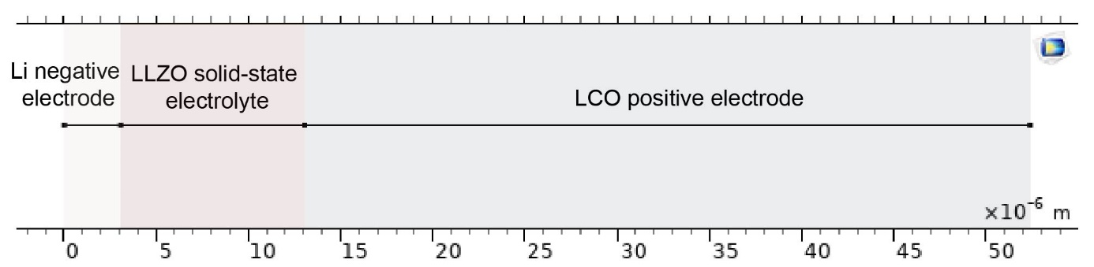
Figure S1. Schematic of the model used for simulations.

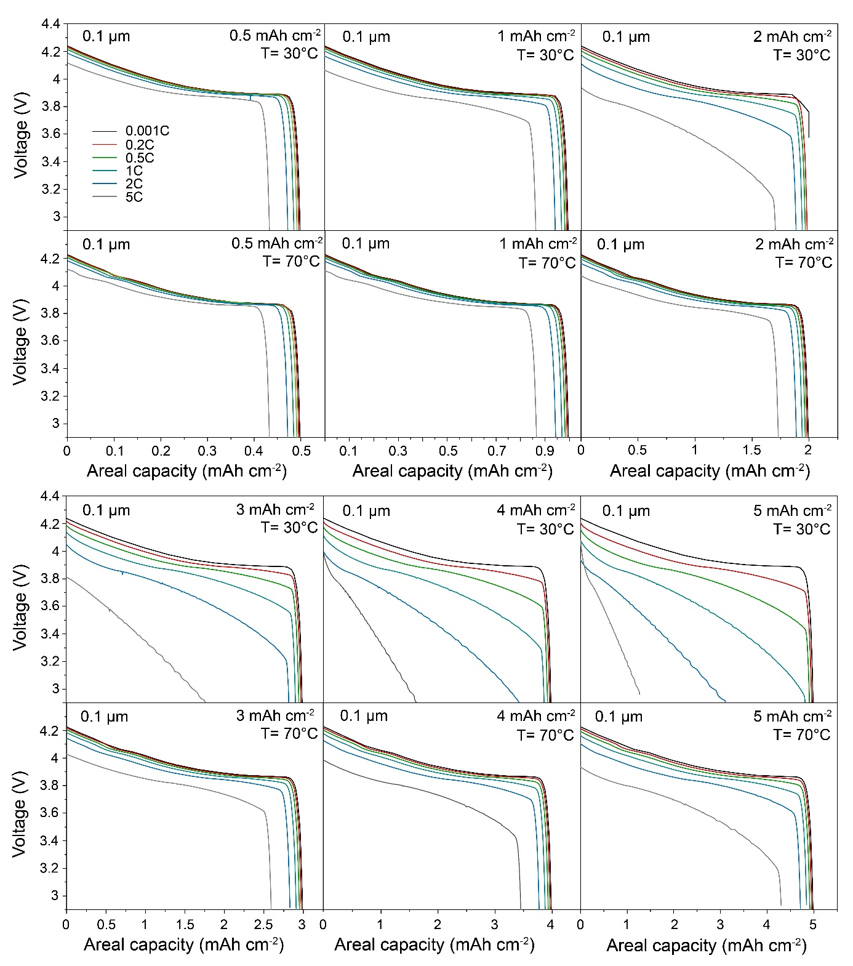
Figures S2. Simulated voltage profiles of Li/LLZO/LCO all-solid-state battery at different cathode areal capacities (0.5, 1, 2, 3, 4, and 5 mAh cm⁻²), C rates (0.001C, 0.2C, 0.5C, 1C, 2C, and 5C) and temperatures (30°C and 70°C). LLZO thickness is constant of 0.1 µm. LCO cathode is composed of 70 vol.% of LCO and 30 vol.% of LLZO.
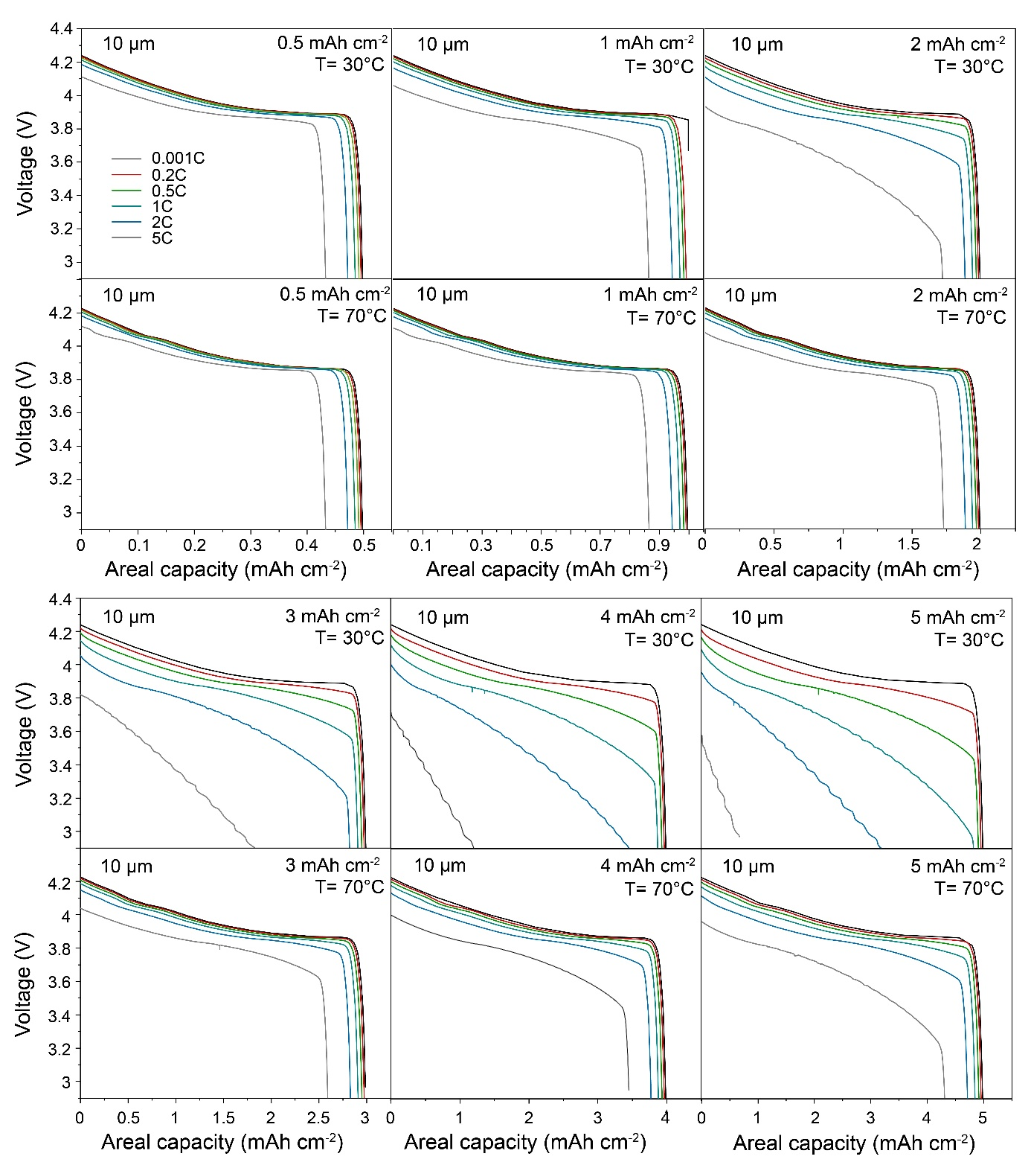
Figures S3. Simulated voltage profiles of Li/LLZO/LCO all-solid-state battery at different cathode areal capacities (0.5, 1, 2, 3, 4, and 5 mAh cm⁻²), C rates (0.001C, 0.2C, 0.5C, 1C, 2C, and 5C) and temperatures (30°C and 70°C). LLZO thickness is constant of 10 µm. LCO cathode is composed of 70 vol.% of LCO and 30 vol.% of LLZO.

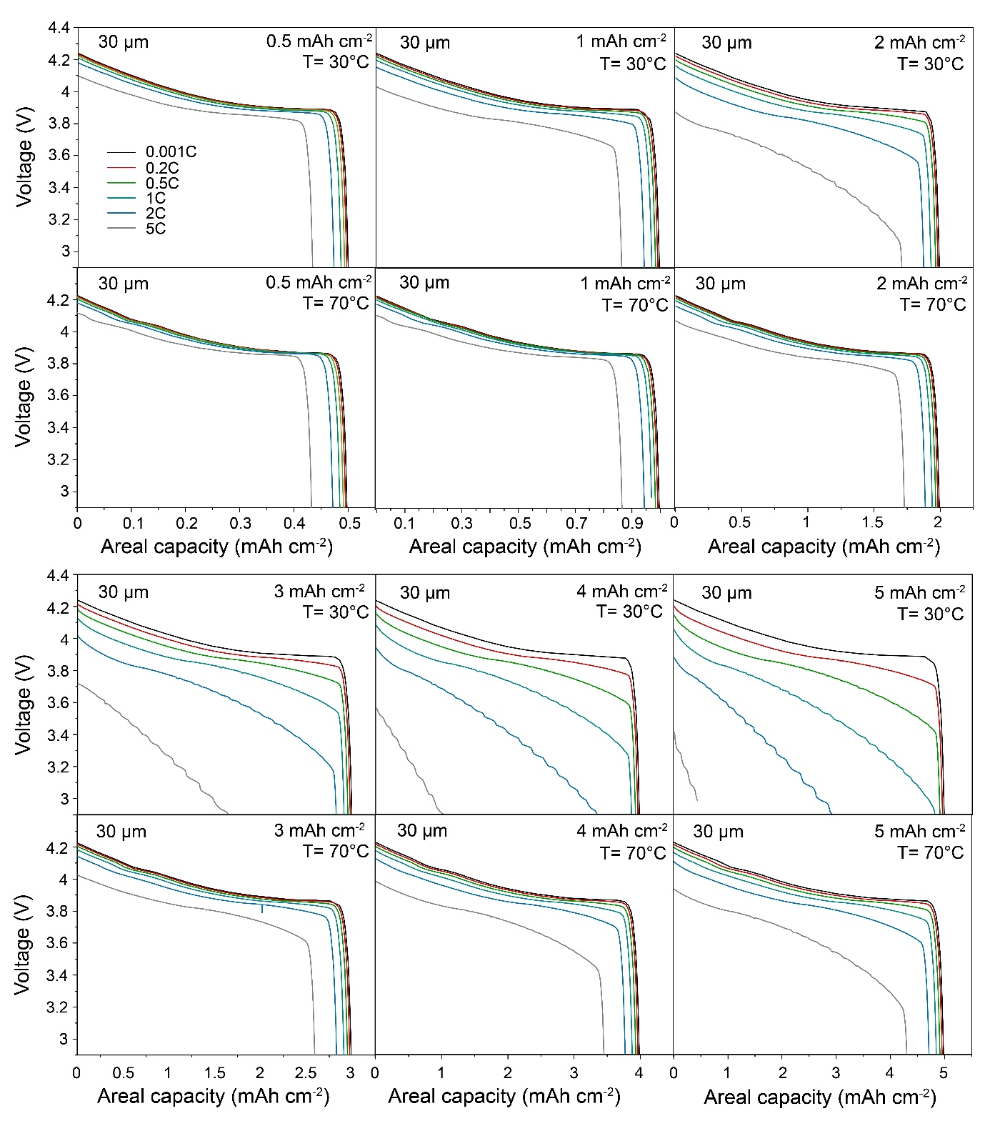
Figures S4. Simulated voltage profiles of Li/LLZO/LCO all-solid-state battery at different cathode areal capacities (0.5, 1, 2, 3, 4, and 5 mAh cm⁻²), C rates (0.001C, 0.2C, 0.5C, 1C, 2C, and 5C) and temperatures (30°C and 70°C). LLZO thickness is constant of 30 µm. LCO cathode is composed of 70 vol.% of LCO and 30 vol.% of LLZO.

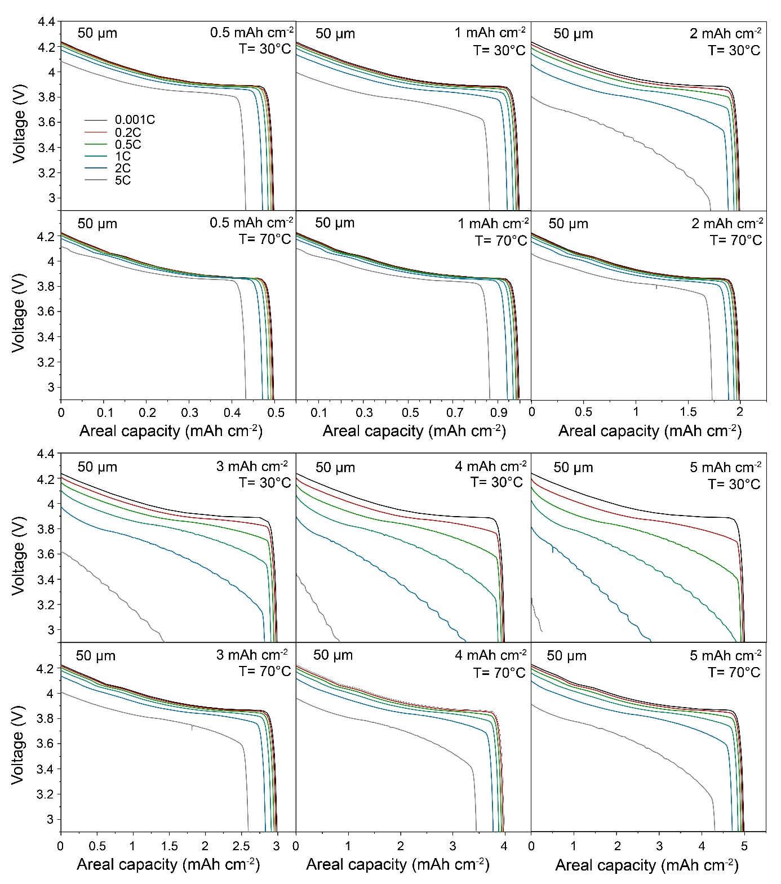
Figures S5. Simulated voltage profiles of Li/LLZO/LCO all-solid-state battery at different cathode areal capacities (0.5, 1, 2, 3, 4, and 5 mAh cm⁻²), C rates (0.001C, 0.2C, 0.5C, 1C, 2C, and 5C) and temperatures (30°C and 70°C). LLZO thickness is constant of 50 µm. LCO cathode is composed of 70 vol.% of LCO and 30 vol.% of LLZO.

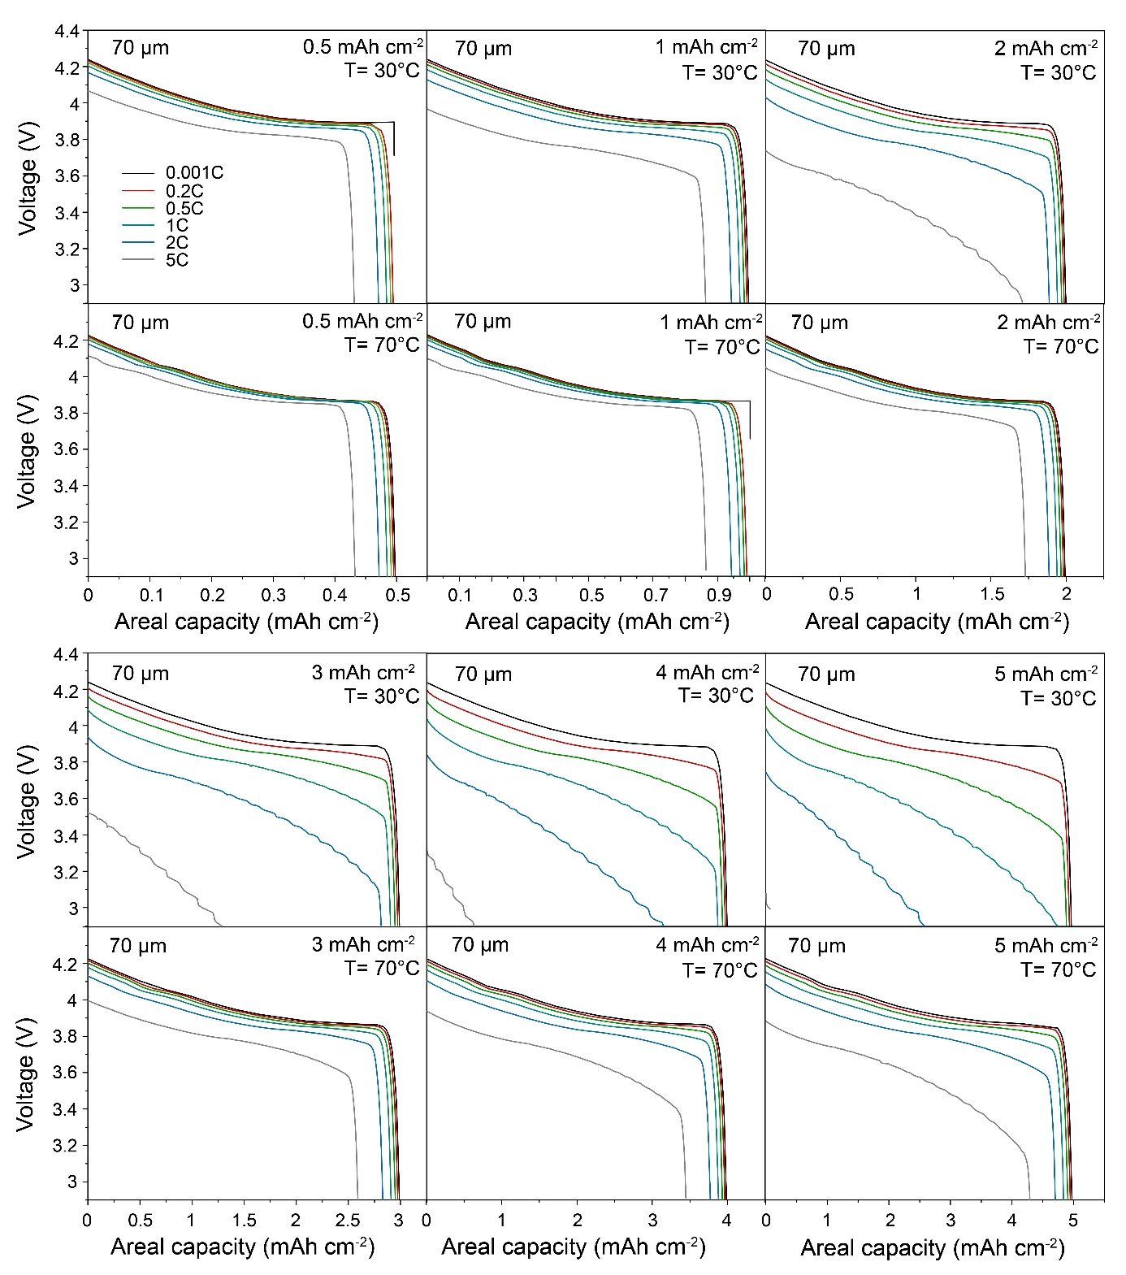
Figures S6. Simulated voltage profiles of Li/LLZO/LCO all-solid-state battery at different cathode areal capacities (0.5, 1, 2, 3, 4, and 5 mAh cm⁻²), C rates (0.001C, 0.2C, 0.5C, 1C, 2C, and 5C) and temperatures (30°C and 70°C). LLZO thickness is constant of 70 µm. LCO cathode is composed of 70 vol.% of LCO and 30 vol.% of LLZO.

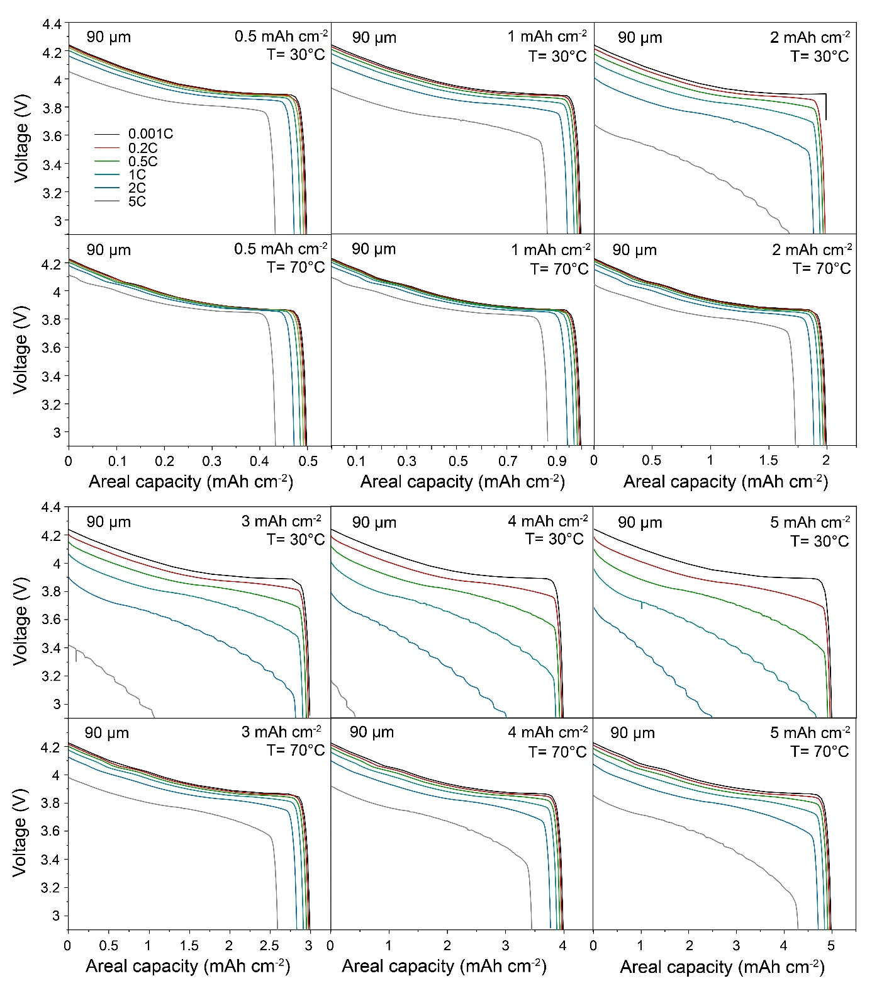
Figures S7. Simulated voltage profiles of Li/LLZO/LCO all-solid-state battery at different cathode areal capacities (0.5, 1, 2, 3, 4, and 5 mAh cm⁻²), C rates (0.001C, 0.2C, 0.5C, 1C, 2C, and 5C) and temperatures (30°C and 70°C). LLZO thickness is constant of 90 µm. LCO cathode is composed of 70 vol.% of LCO and 30 vol.% of LLZO.

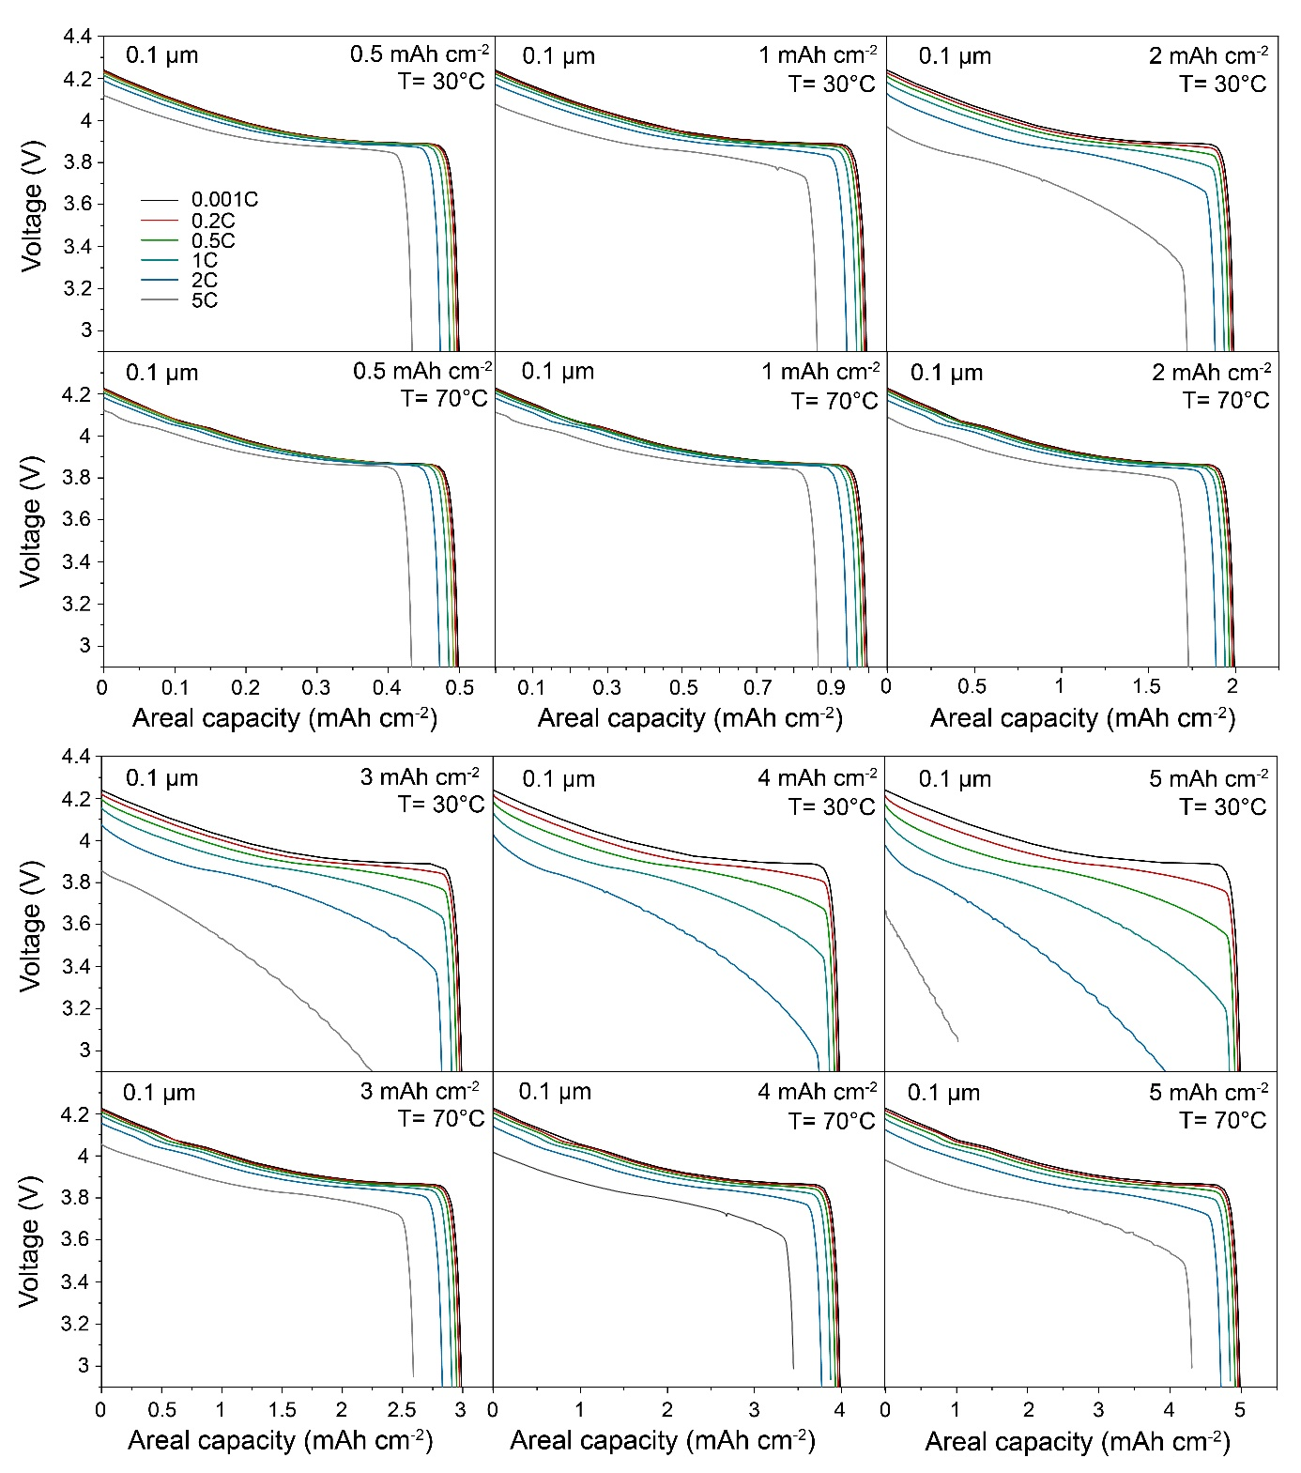
Figures S8. Simulated voltage profiles of Li/LLZO/LCO all-solid-state battery at different cathode areal capacities (0.5, 1, 2, 3, 4, and 5 mAh cm⁻²), C rates (0.001C, 0.2C, 0.5C, 1C, 2C, and 5C) and temperatures (30°C and 70°C). LLZO thickness is constant of 0.1 µm. LCO cathode is composed of 60 vol.% of LCO and 40 vol.% of LLZO.

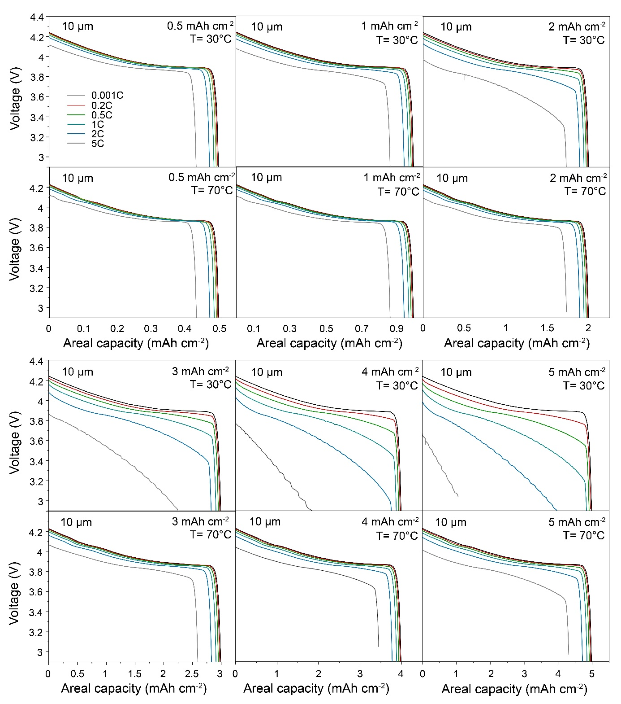
Figures S9. Simulated voltage profiles of Li/LLZO/LCO all-solid-state battery at different cathode areal capacities (0.5, 1, 2, 3, 4, and 5 mAh cm⁻²), C rates (0.001C, 0.2C, 0.5C, 1C, 2C, and 5C) and temperatures (30°C and 70°C). LLZO thickness is constant of 10 µm. LCO cathode is composed of 60 vol.% of LCO and 40 vol.% of LLZO.
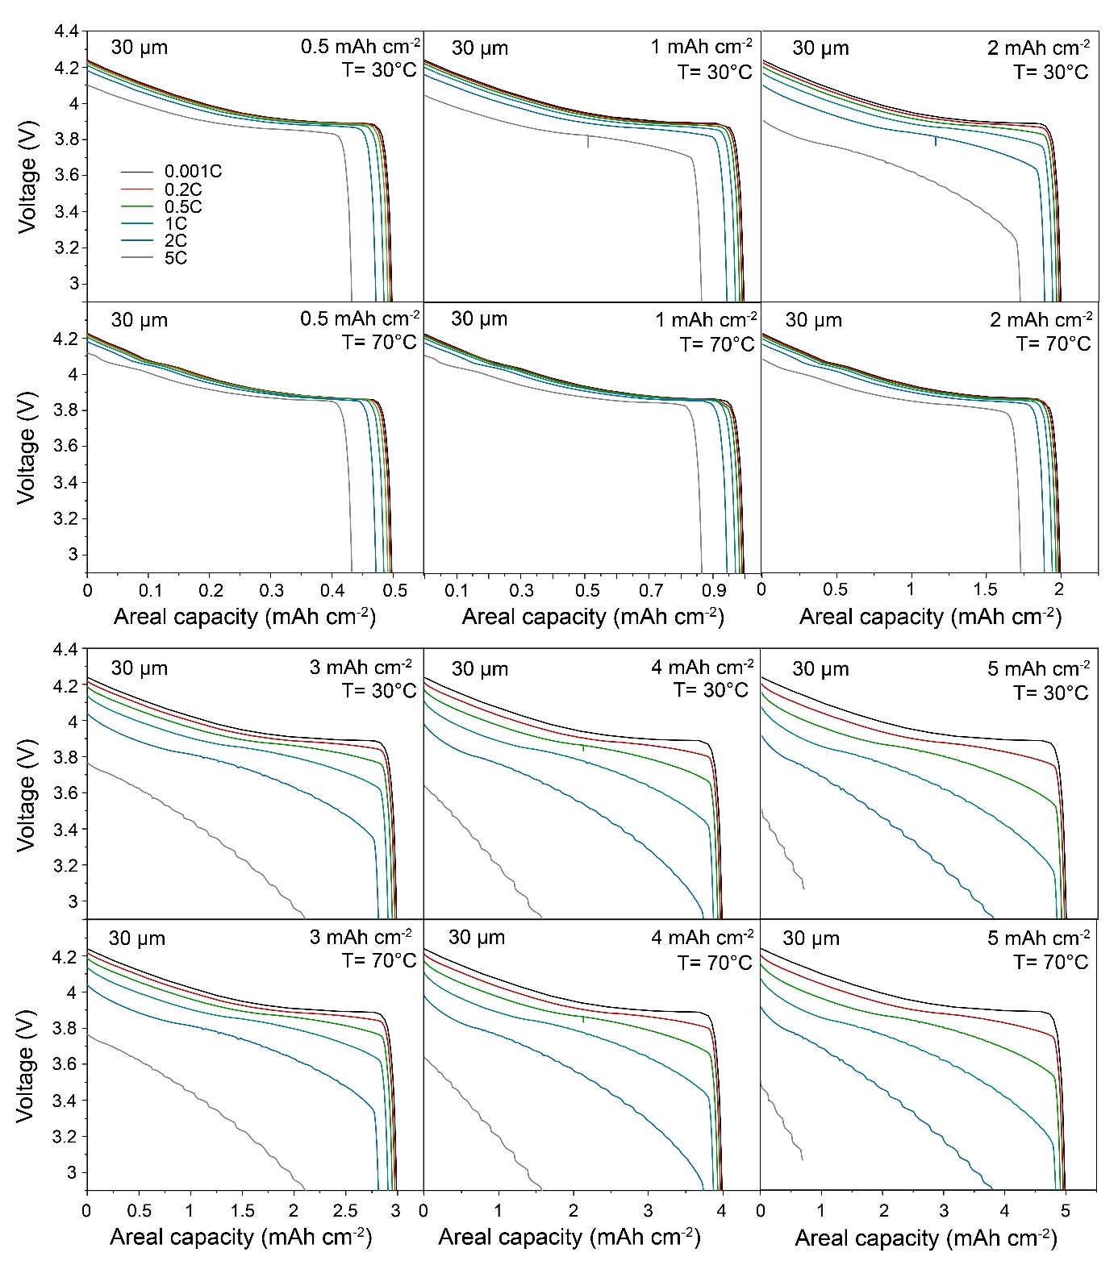
Figures S10. Simulated voltage profiles of Li/LLZO/LCO all-solid-state battery at different cathode areal capacities (0.5, 1, 2, 3, 4, and 5 mAh cm⁻²), C rates (0.001C, 0.2C, 0.5C, 1C, 2C, and 5C) and temperatures (30°C and 70°C). LLZO thickness is constant of 30 µm. LCO cathode is composed of 60 vol.% of LCO and 40 vol.% of LLZO.

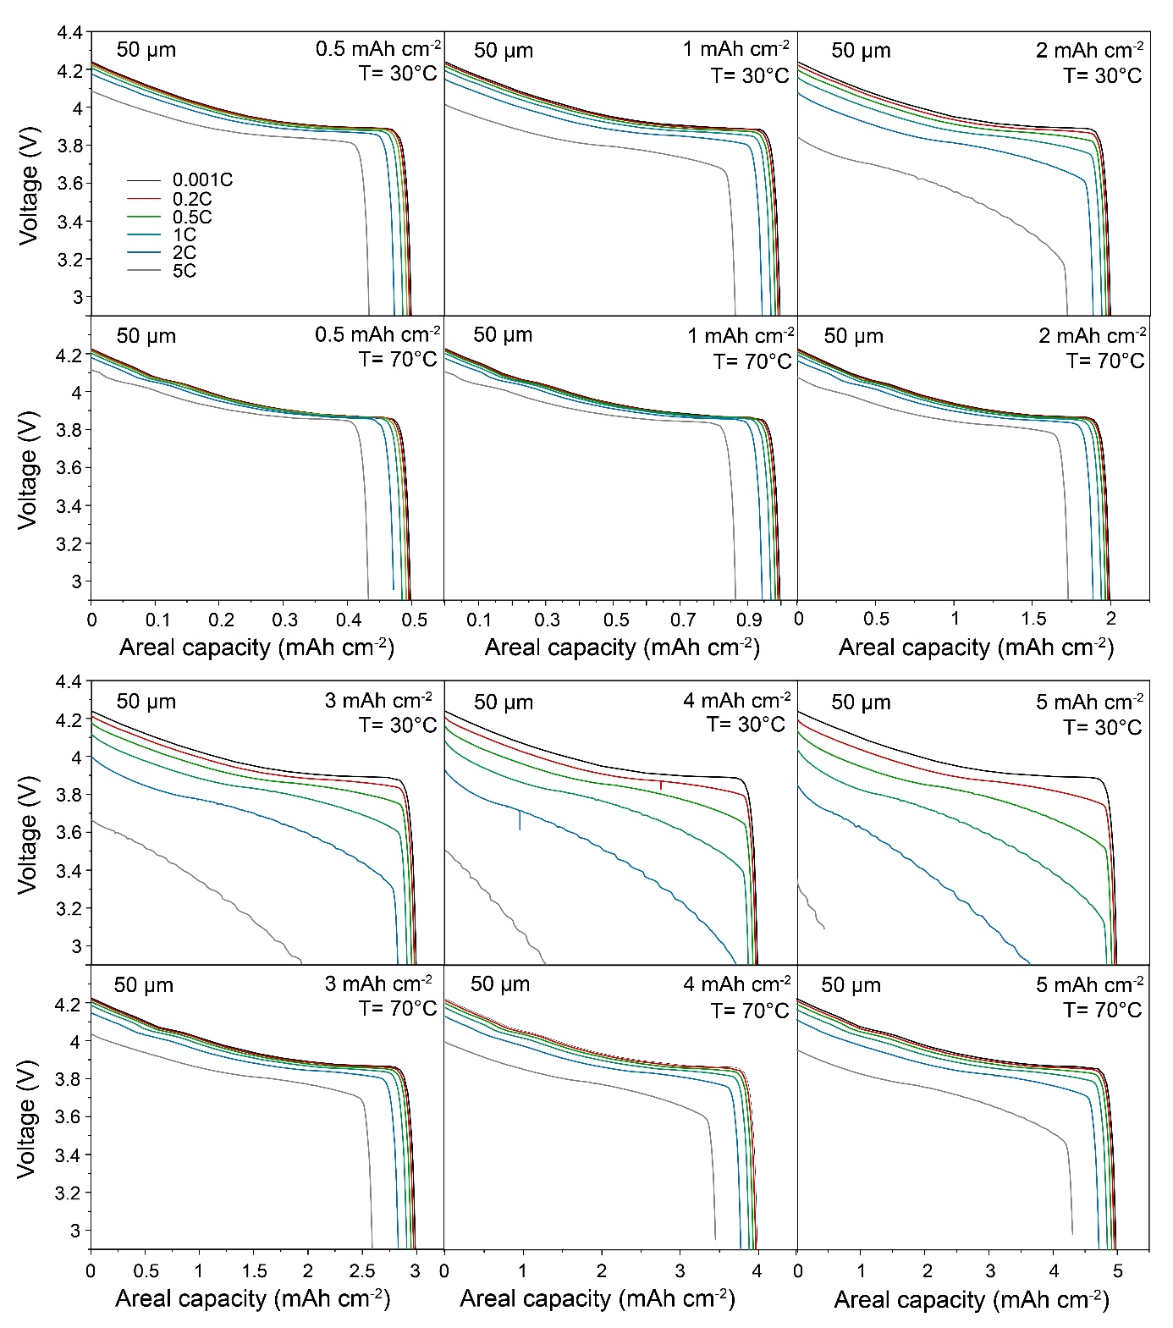
Figures S11. Simulated voltage profiles of Li/LLZO/LCO all-solid-state battery at different cathode areal capacities (0.5, 1, 2, 3, 4, and 5 mAh cm⁻²), C rates (0.001C, 0.2C, 0.5C, 1C, 2C, and 5C) and temperatures (30°C and 70°C). LLZO thickness is constant of 50 µm. LCO cathode is composed of 60 vol.% of LCO and 40 vol.% of LLZO.

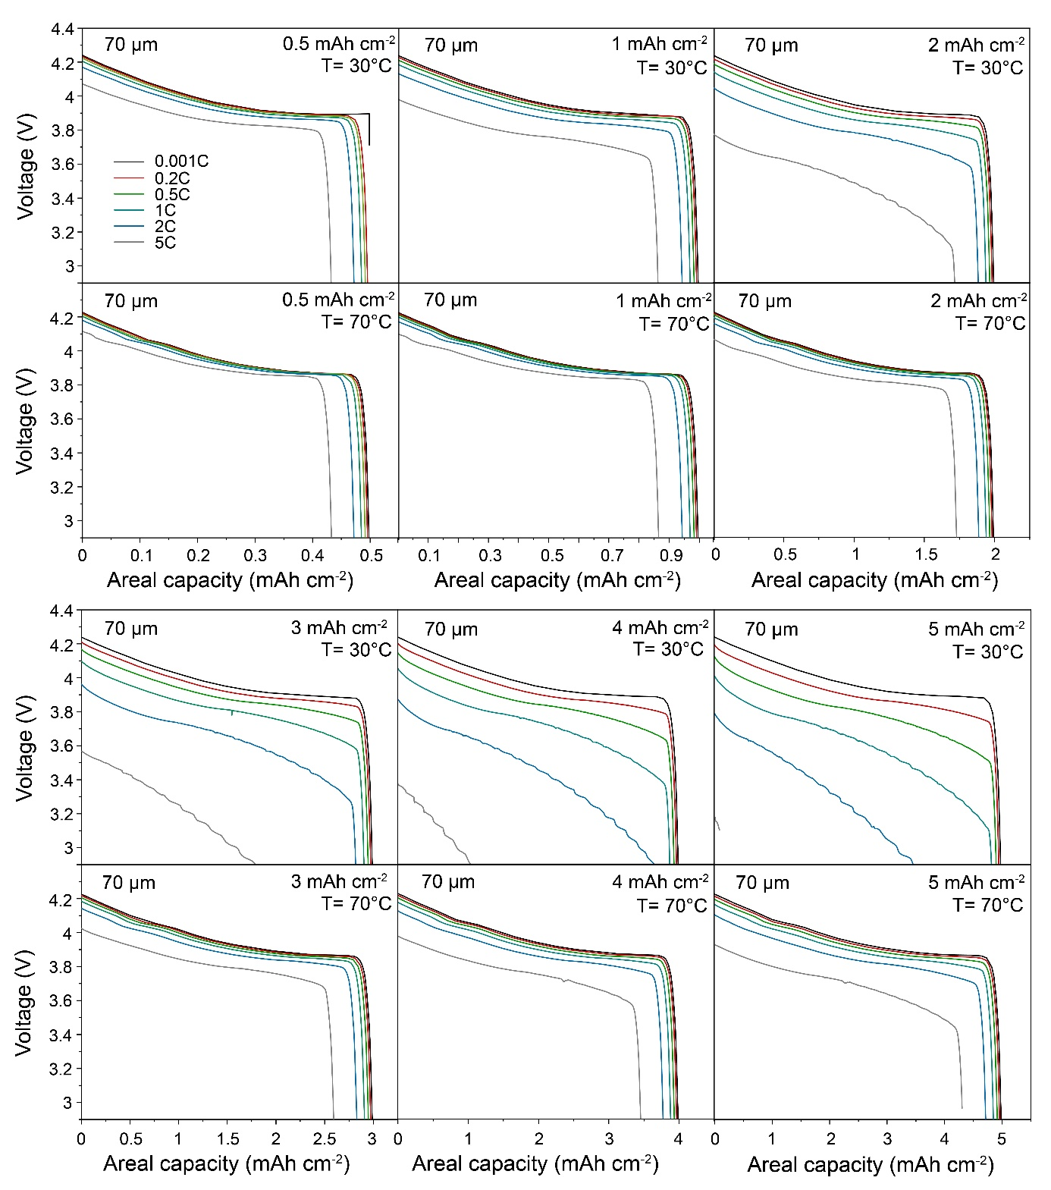
Figures S12. Simulated voltage profiles of Li/LLZO/LCO all-solid-state battery at different cathode areal capacities (0.5, 1, 2, 3, 4, and 5 mAh cm⁻²), C rates (0.001C, 0.2C, 0.5C, 1C, 2C, and 5C) and temperatures (30°C and 70°C). LLZO thickness is constant of 70 µm. LCO cathode is composed of 60 vol.% of LCO and 40 vol.% of LLZO.

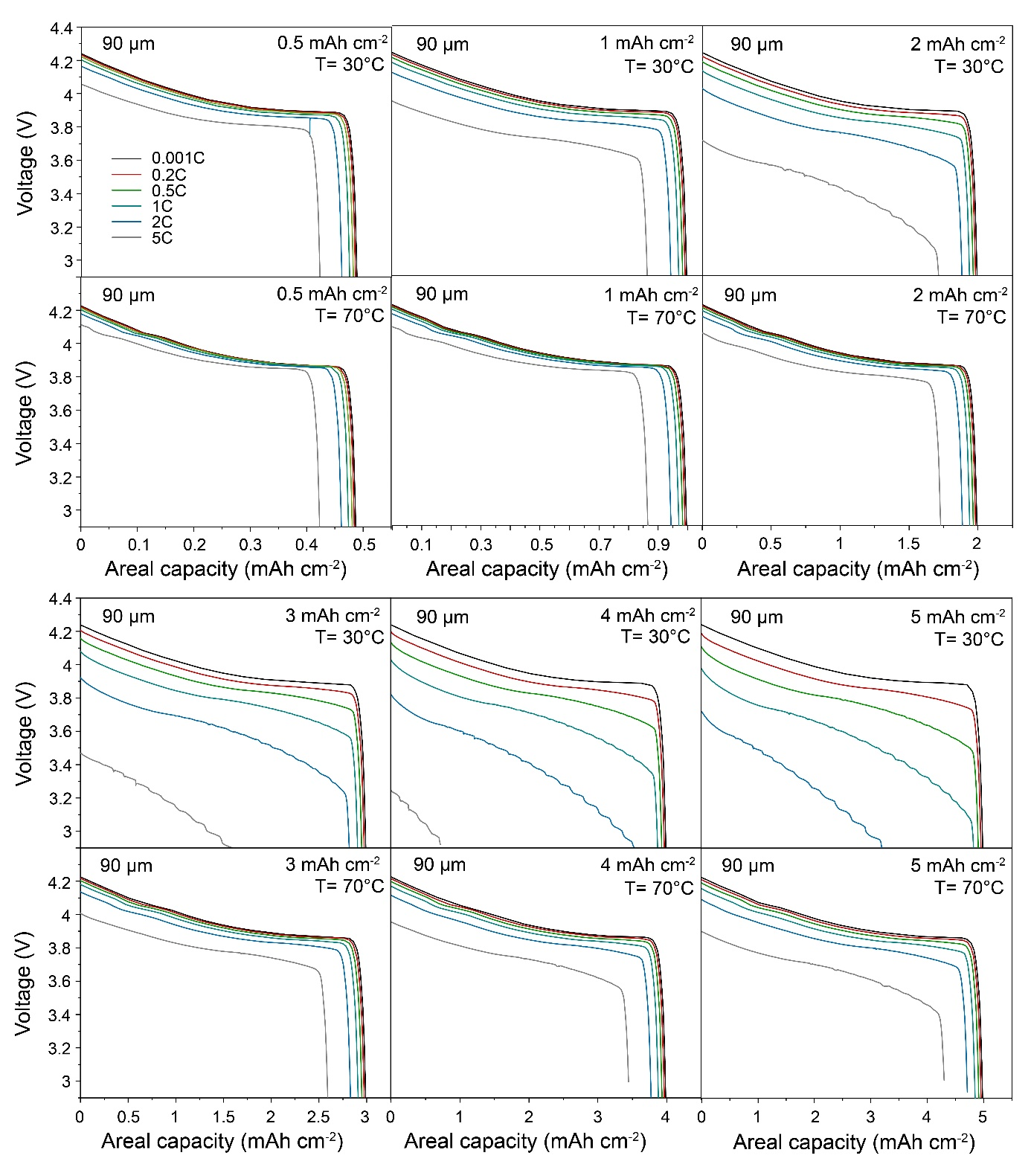
Figures S13. Simulated voltage profiles of Li/LLZO/LCO all-solid-state battery at different cathode areal capacities (0.5, 1, 2, 3, 4, and 5 mAh cm⁻²), C rates (0.001C, 0.2C, 0.5C, 1C, 2C, and 5C) and temperatures (30°C and 70°C). LLZO thickness is constant of 90 µm. LCO cathode is composed of 60 vol.% of LCO and 40 vol.% of LLZO.

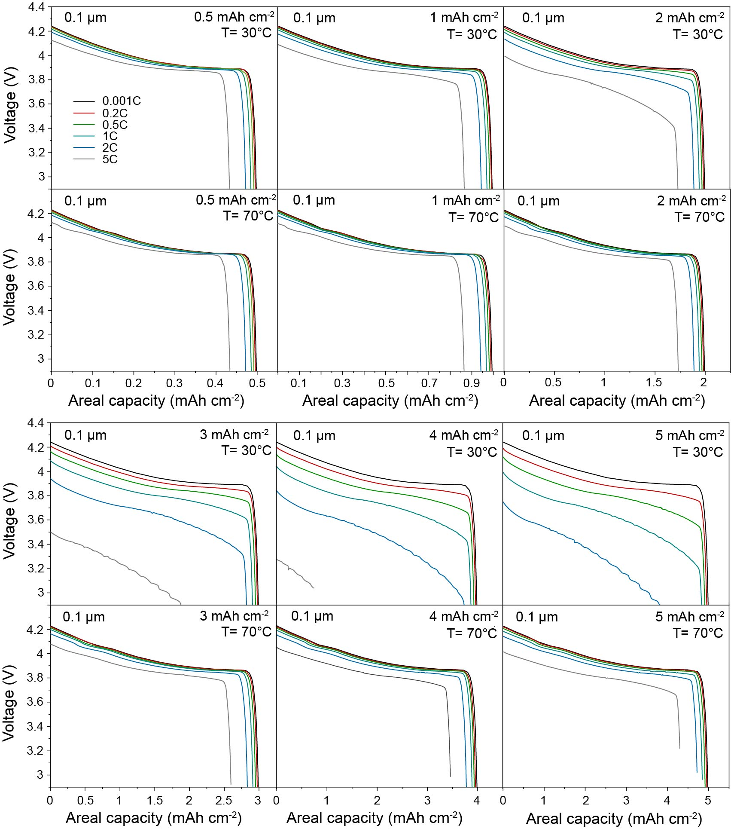
Figures S14. Simulated voltage profiles of Li/LLZO/LCO all-solid-state battery at different cathode areal capacities (0.5, 1, 2, 3, 4, and 5 mAh cm⁻²), C rates (0.001C, 0.2C, 0.5C, 1C, 2C, and 5C) and temperatures (30°C and 70°C). LLZO thickness is constant of 0.1 µm. LCO cathode is composed of 50 vol.% of LCO and 50 vol.% of LLZO.

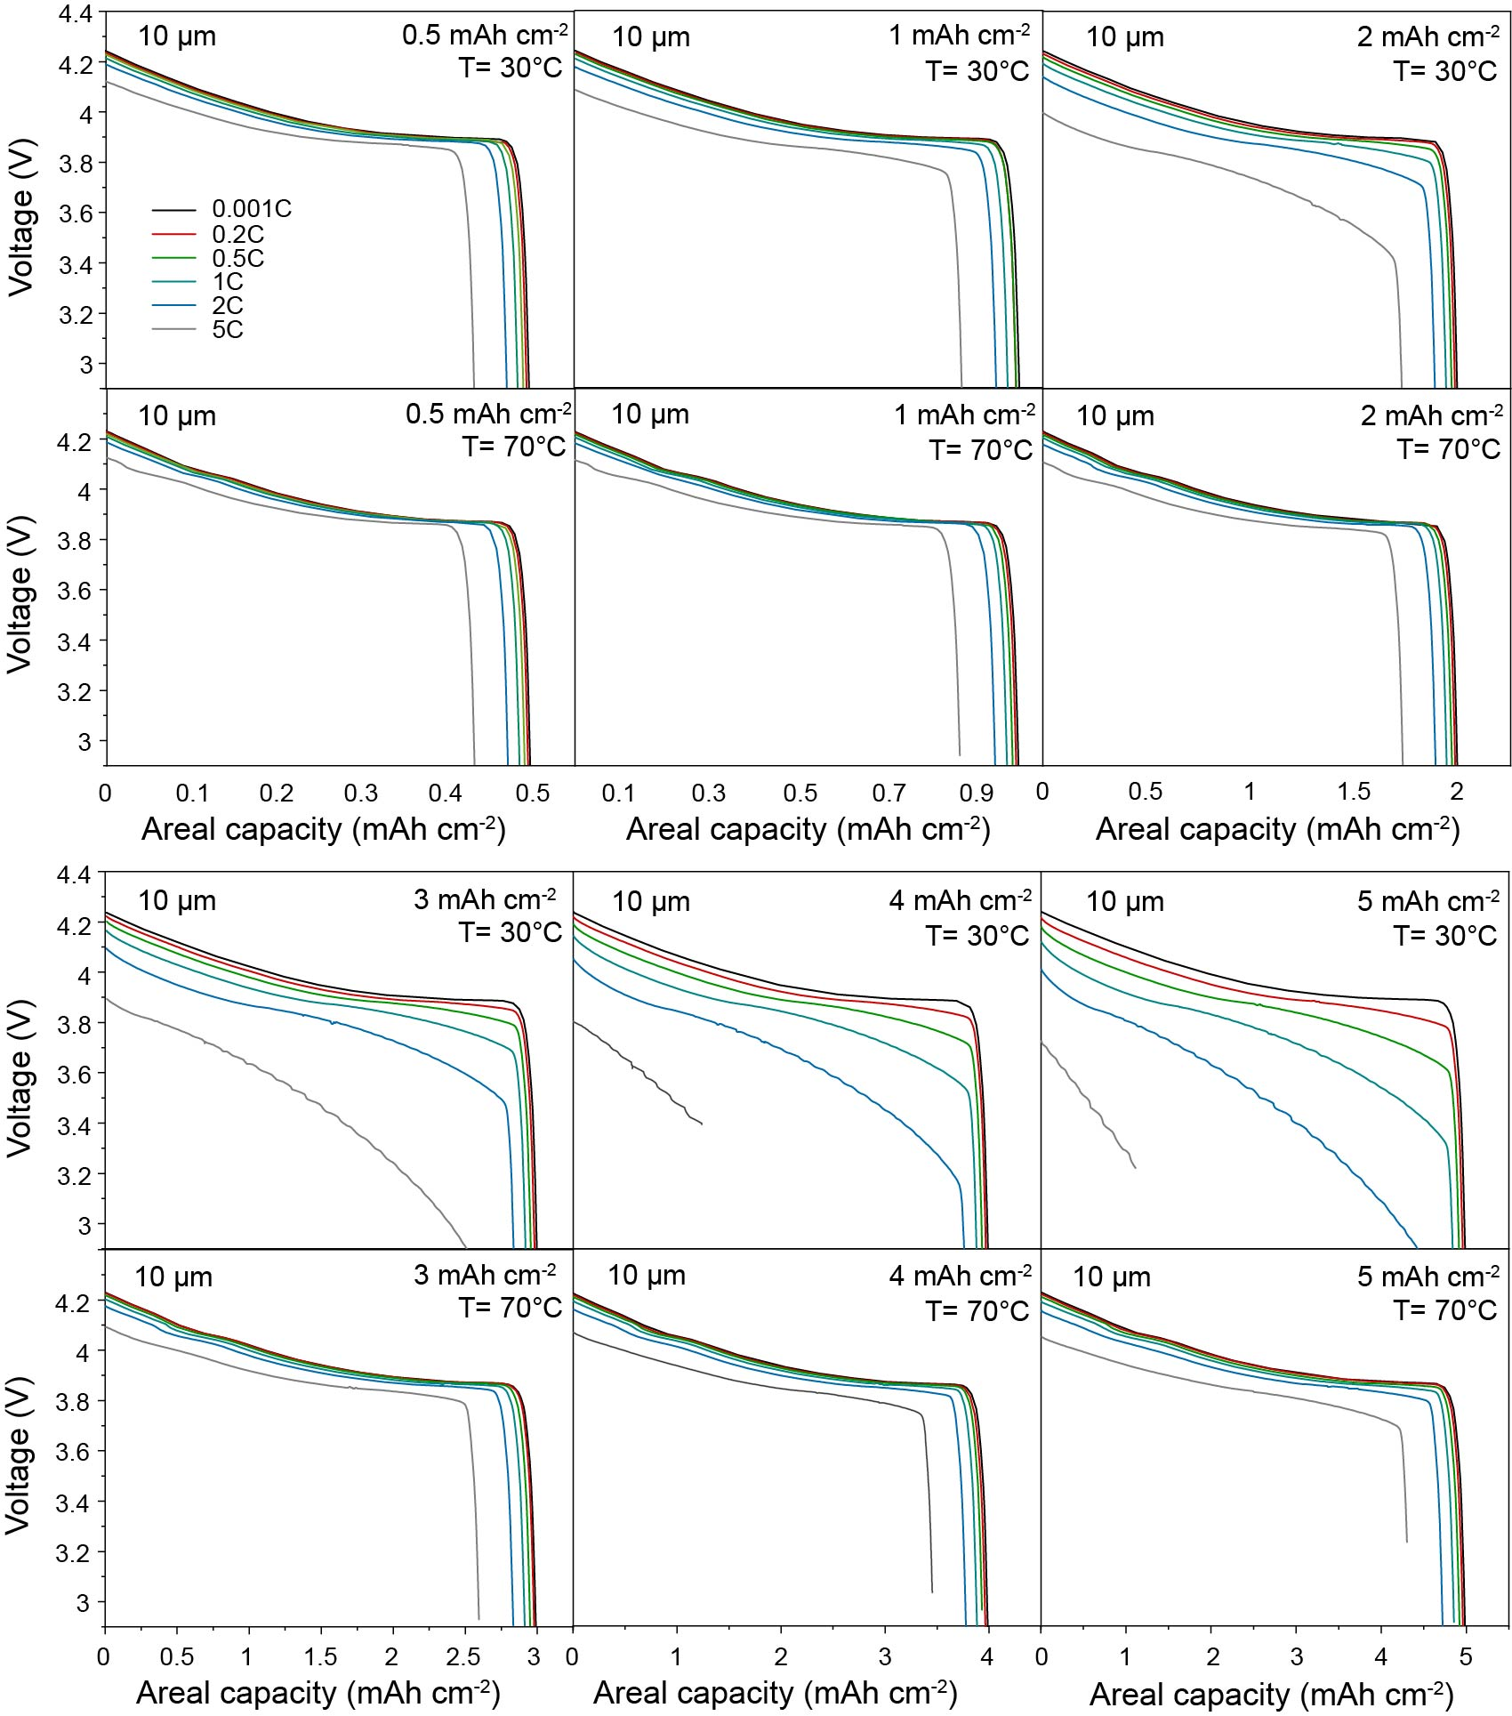
Figures S15. Simulated voltage profiles of Li/LLZO/LCO all-solid-state battery at different cathode areal capacities (0.5, 1, 2, 3, 4, and 5 mAh cm⁻²), C rates (0.001C, 0.2C, 0.5C, 1C, 2C, and 5C) and temperatures (30°C and 70°C). LLZO thickness is constant of 10 µm. LCO cathode is composed of 50 vol.% of LCO and 50 vol.% of LLZO.

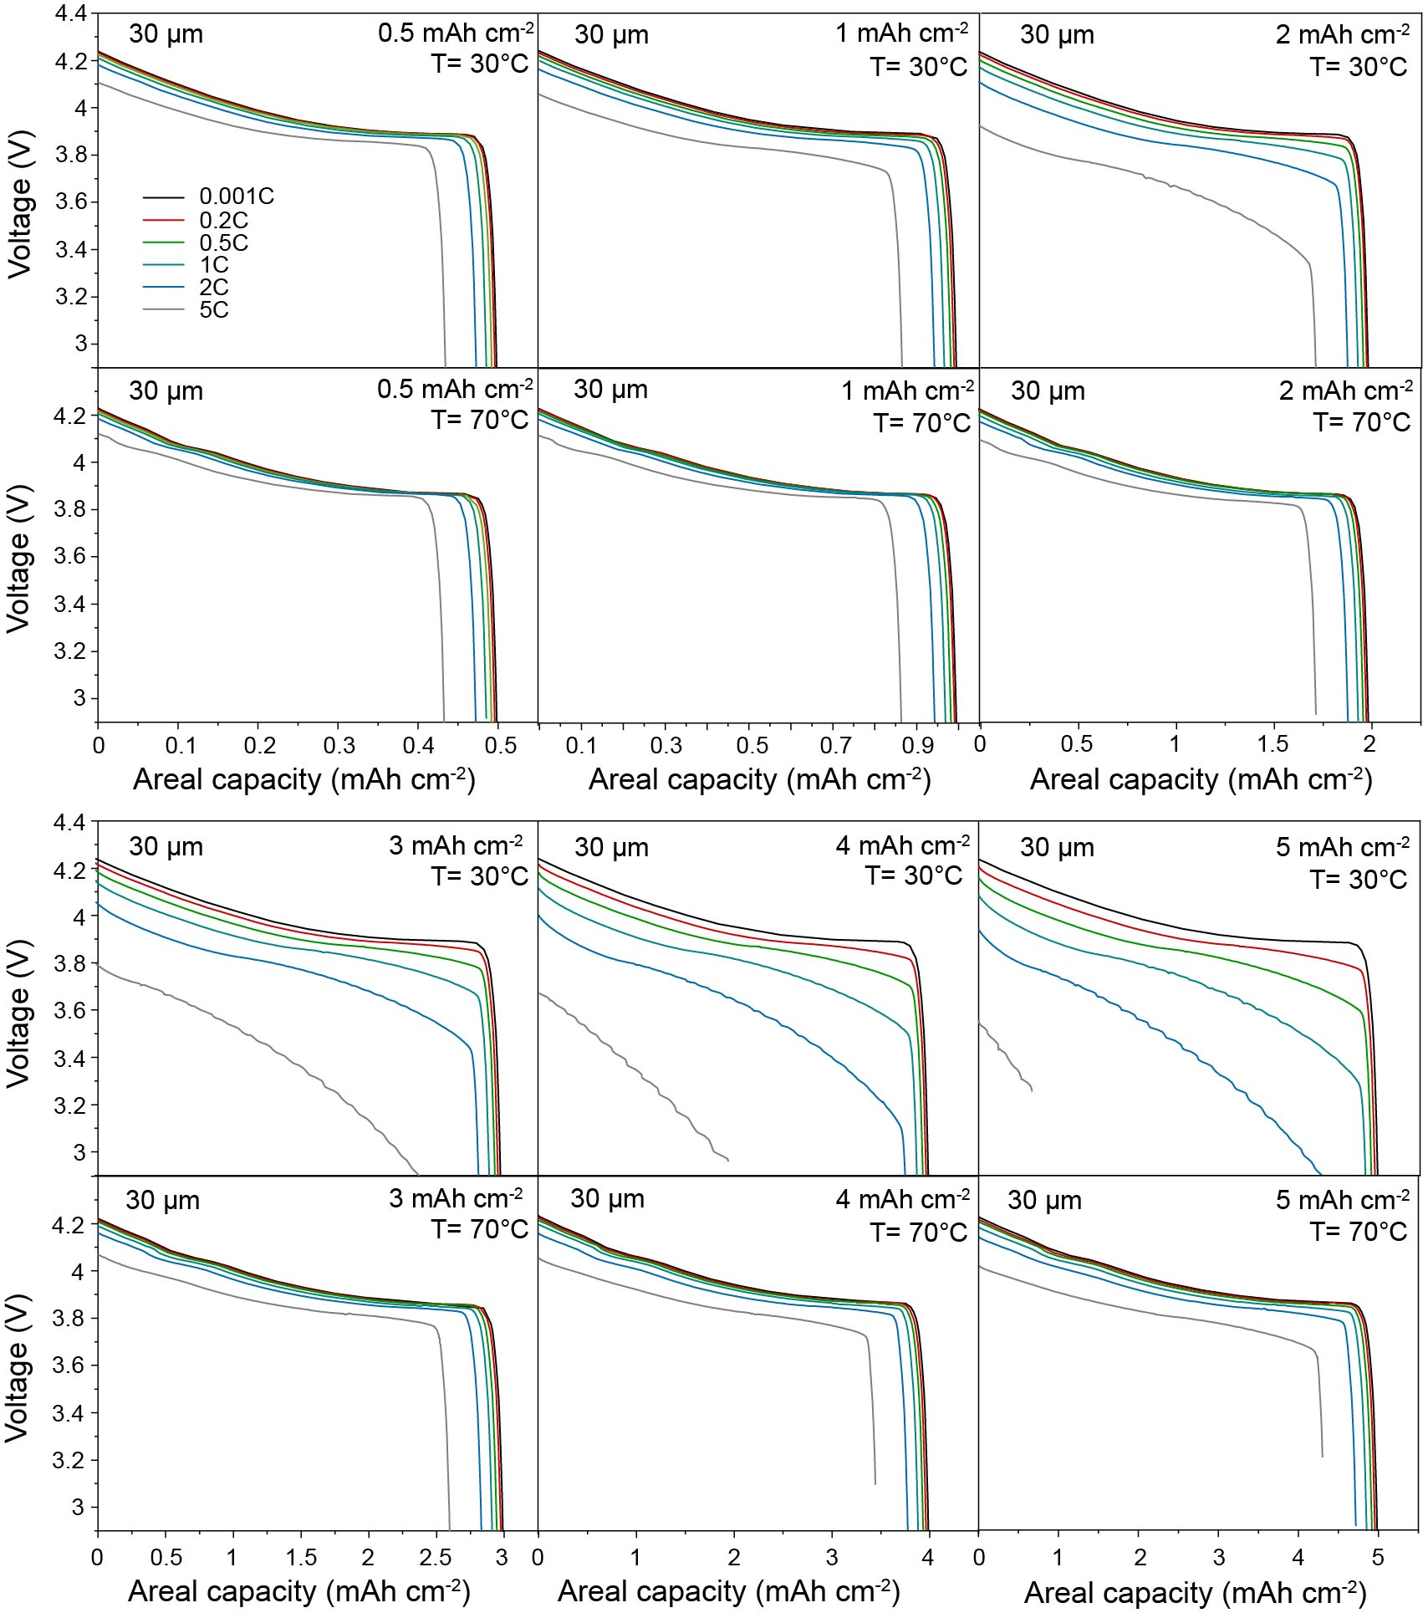
Figures S16. Simulated voltage profiles of Li/LLZO/LCO all-solid-state battery at different cathode areal capacities (0.5, 1, 2, 3, 4, and 5 mAh cm⁻²), C rates (0.001C, 0.2C, 0.5C, 1C, 2C, and 5C) and temperatures (30°C and 70°C). LLZO thickness is constant of 30 µm. LCO cathode is composed of 50 vol.% of LCO and 50 vol.% of LLZO.

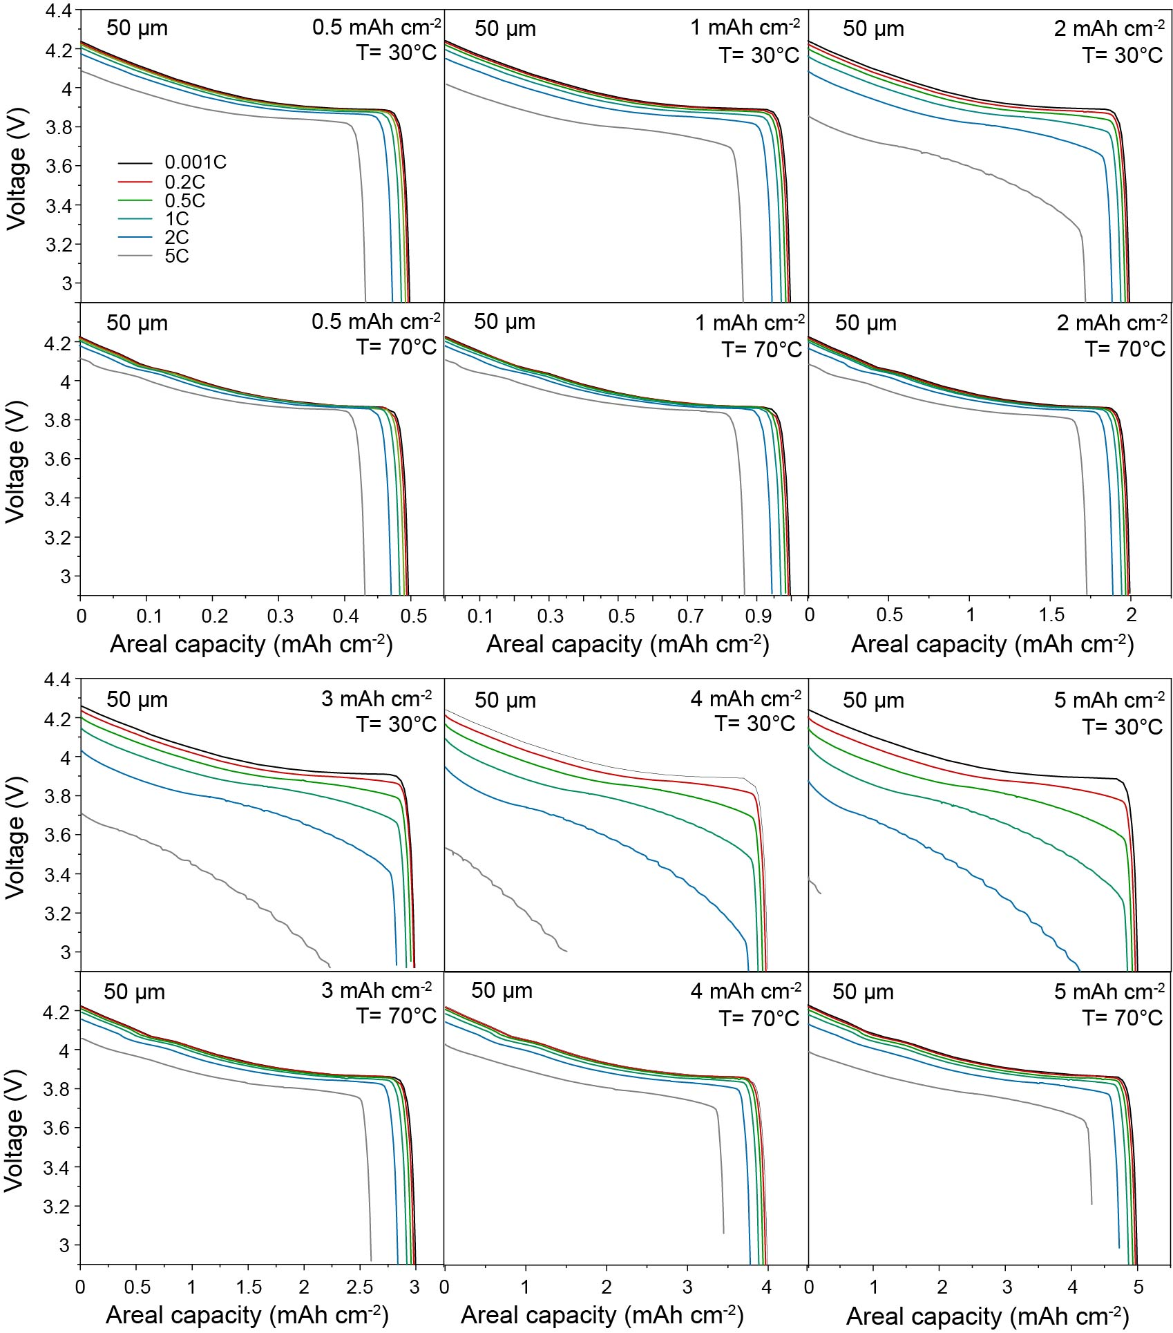
Figures S17. Simulated voltage profiles of Li/LLZO/LCO all-solid-state battery at different cathode areal capacities (0.5, 1, 2, 3, 4, and 5 mAh cm⁻²), C rates (0.001C, 0.2C, 0.5C, 1C, 2C, and 5C) and temperatures (30°C and 70°C). LLZO thickness is constant of 50 µm. LCO cathode is composed of 50 vol.% of LCO and 50 vol.% of LLZO.

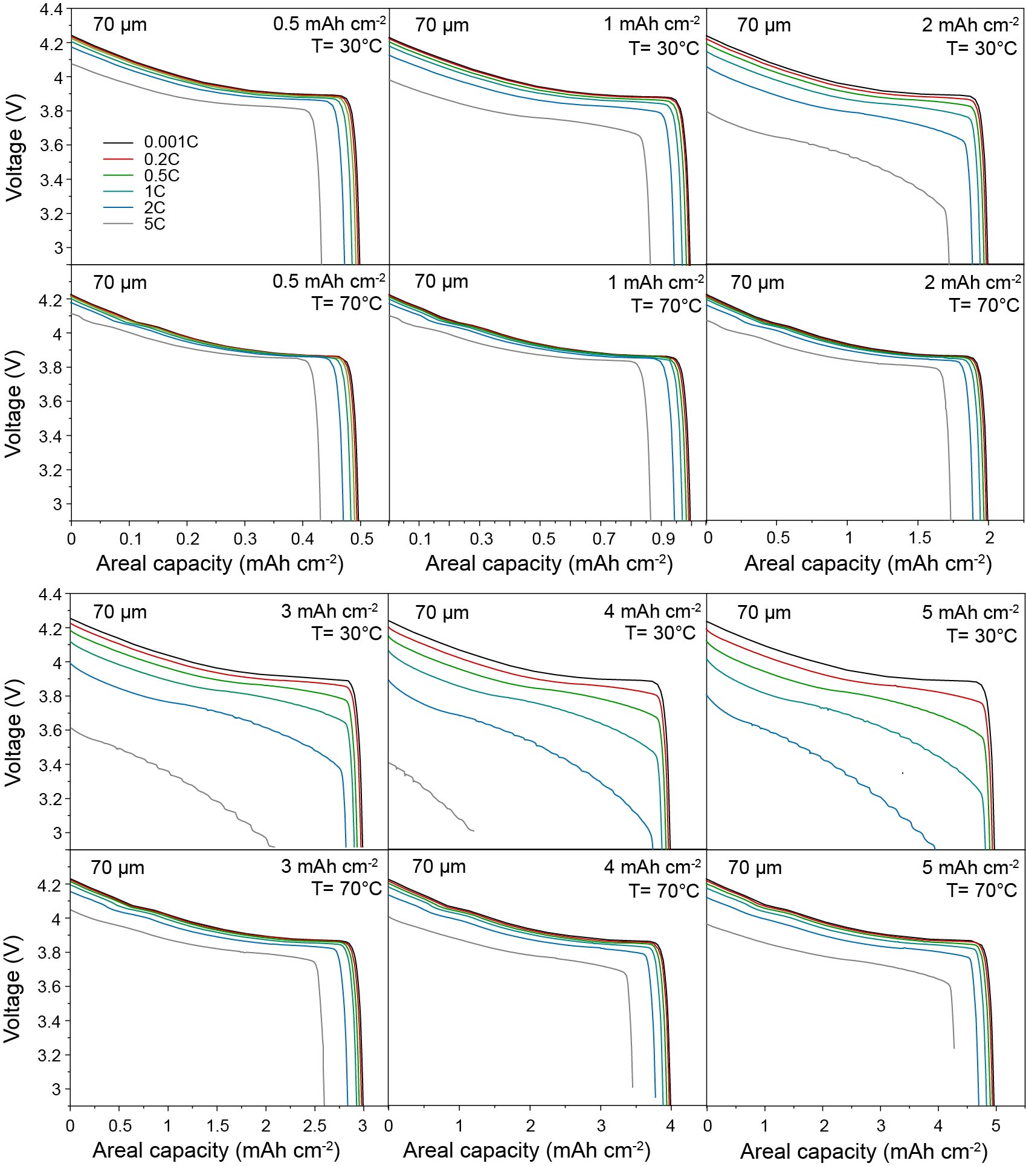
Figures S18. Simulated voltage profiles of Li/LLZO/LCO all-solid-state battery at different cathode areal capacities (0.5, 1, 2, 3, 4, and 5 mAh cm⁻²), C rates (0.001C, 0.2C, 0.5C, 1C, 2C, and 5C) and temperatures (30°C and 70°C). LLZO thickness is constant of 70 µm. LCO cathode is composed of 50 vol.% of LCO and 50 vol.% of LLZO.

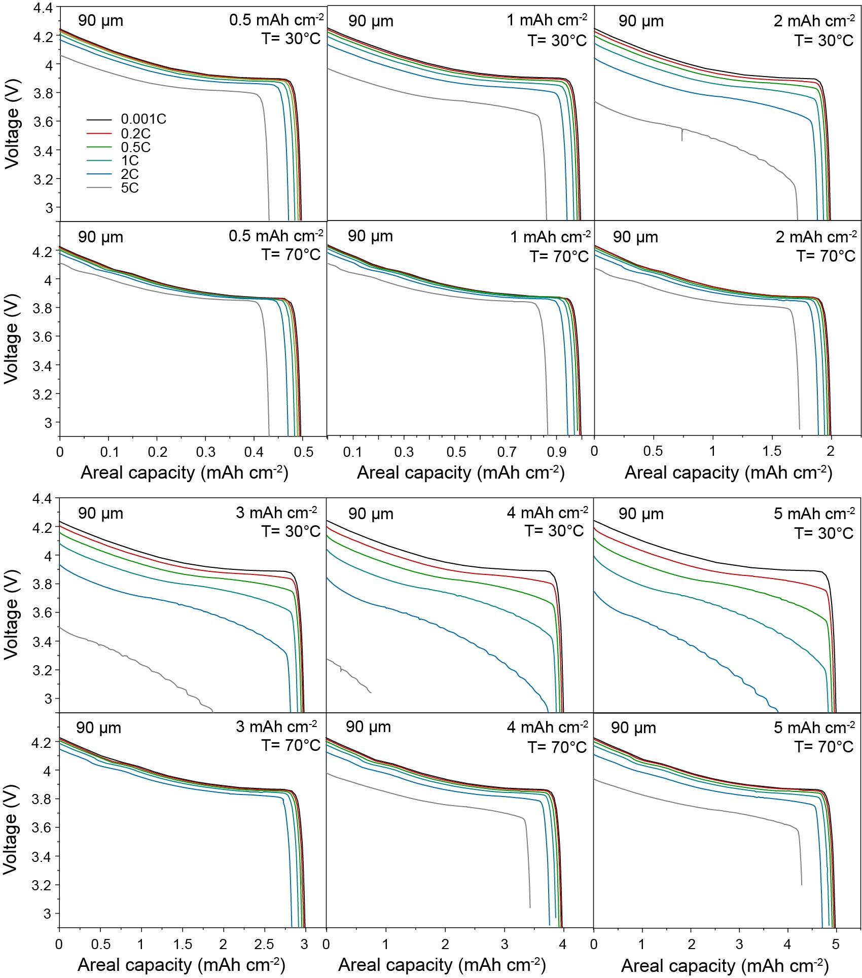
Figures S19. Simulated voltage profiles of Li/LLZO/LCO all-solid-state battery at different cathode areal capacities (0.5, 1, 2, 3, 4, and 5 mAh cm⁻²), C rates (0.001C, 0.2C, 0.5C, 1C, 2C, and 5C) and temperatures (30°C and 70°C). LLZO thickness is constant of 90 µm. LCO cathode is composed of 50 vol.% of LCO and 50 vol.% of LLZO.

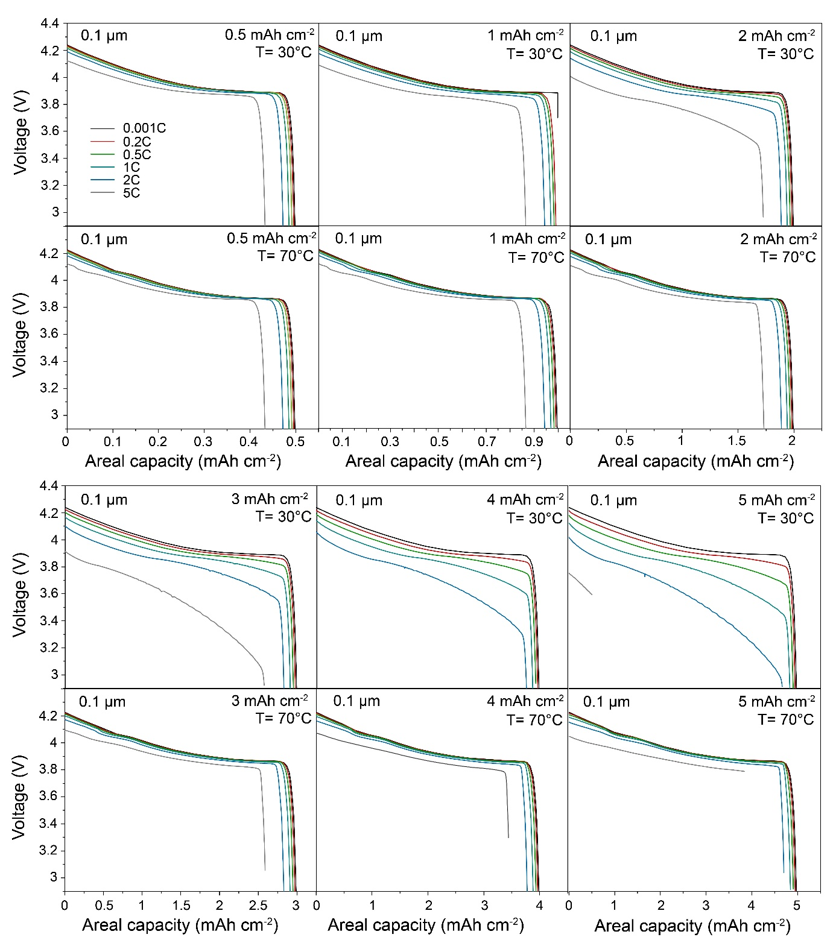
Figures S20. Simulated voltage profiles of Li/LLZO/LCO all-solid-state battery at different cathode areal capacities (0.5, 1, 2, 3, 4, and 5 mAh cm⁻²), C rates (0.001C, 0.2C, 0.5C, 1C, 2C, and 5C) and temperatures (30°C and 70°C). LLZO thickness is constant of 0.1 µm. LCO cathode is composed of 40 vol.% of LCO and 60 vol.% of LLZO.

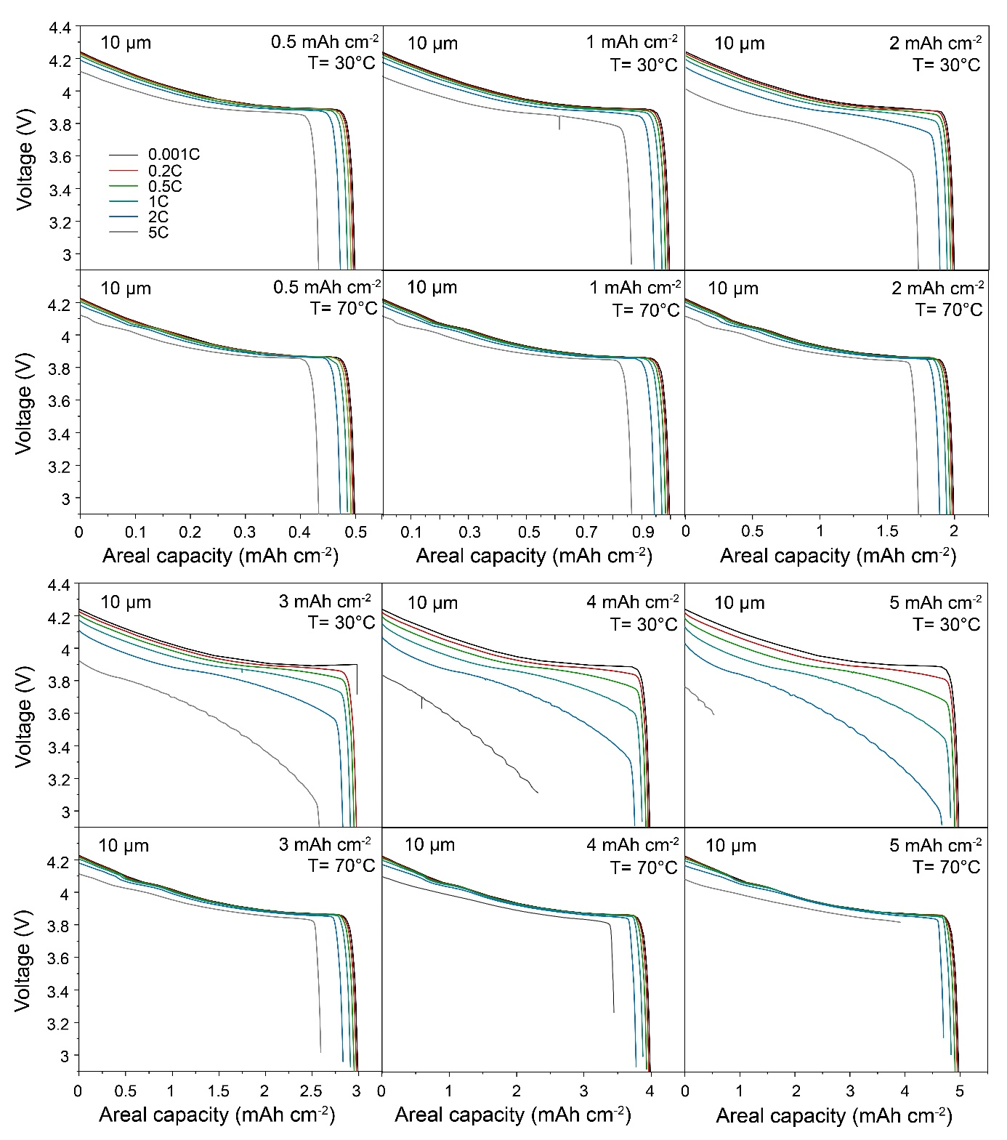
Figures S21. Simulated voltage profiles of Li/LLZO/LCO all-solid-state battery at different cathode areal capacities (0.5, 1, 2, 3, 4, and 5 mAh cm⁻²), C rates (0.001C, 0.2C, 0.5C, 1C, 2C, and 5C) and temperatures (30°C and 70°C). LLZO thickness is constant of 10 µm. LCO cathode is composed of 40 vol.% of LCO and 60 vol.% of LLZO.

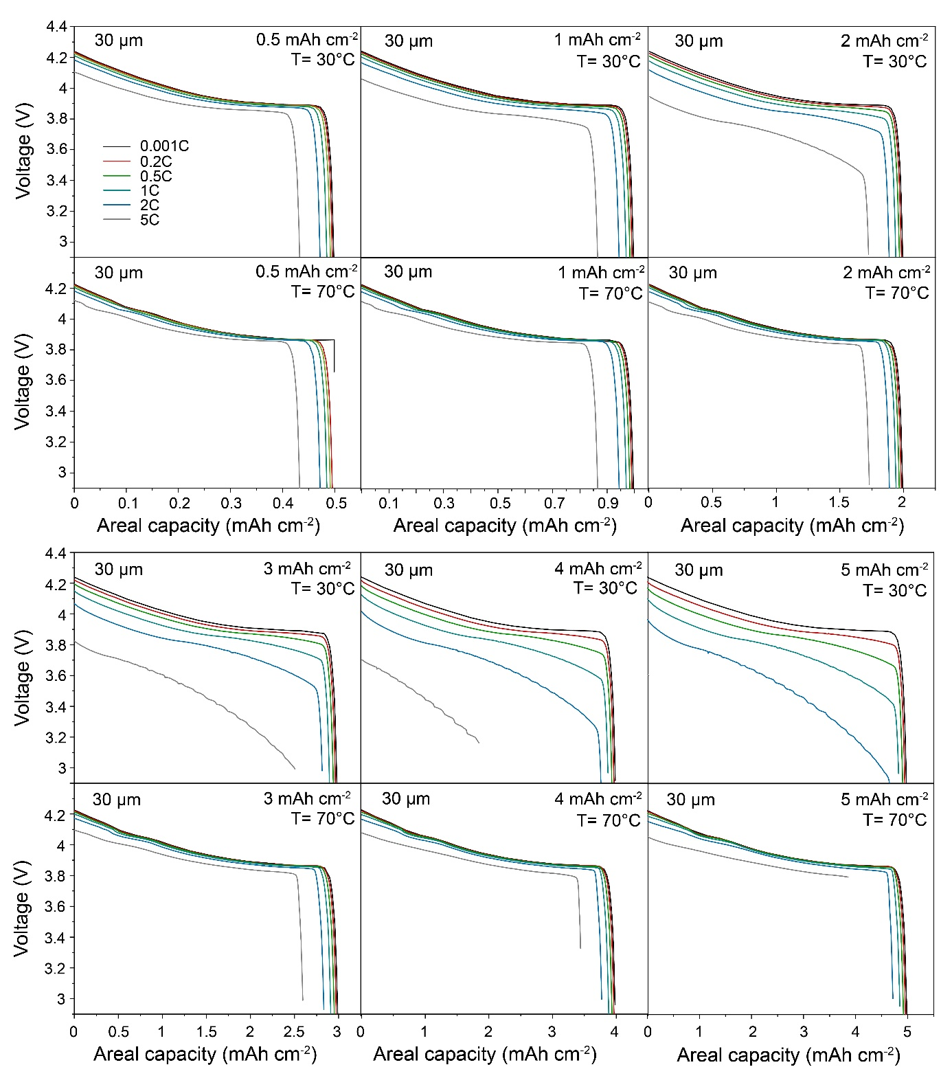
Figures S22. Simulated voltage profiles of Li/LLZO/LCO all-solid-state battery at different cathode areal capacities (0.5, 1, 2, 3, 4, and 5 mAh cm⁻²), C rates (0.001C, 0.2C, 0.5C, 1C, 2C, and 5C) and temperatures (30°C and 70°C). LLZO thickness is constant of 30 µm. LCO cathode is composed of 40 vol.% of LCO and 60 vol.% of LLZO.

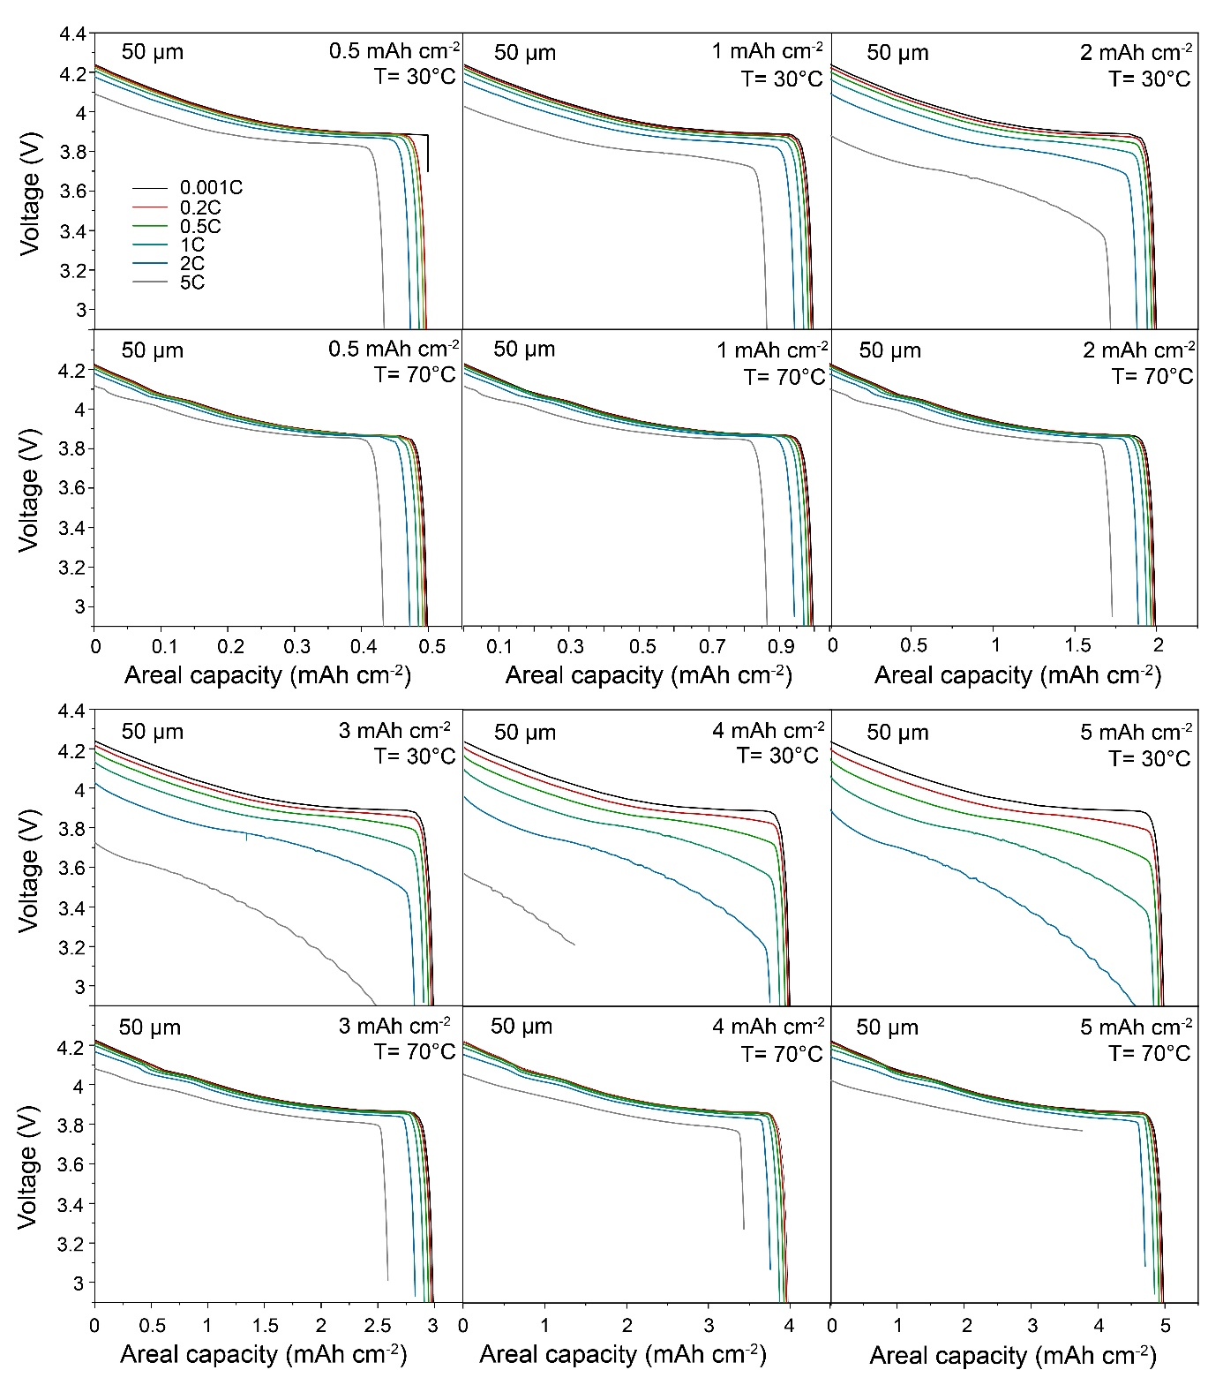
Figures S23. Simulated voltage profiles of Li/LLZO/LCO all-solid-state battery at different cathode areal capacities (0.5, 1, 2, 3, 4, and 5 mAh cm⁻²), C rates (0.001C, 0.2C, 0.5C, 1C, 2C, and 5C) and temperatures (30°C and 70°C). LLZO thickness is constant of 50 µm. LCO cathode is composed of 40 vol.% of LCO and 60 vol.% of LLZO.

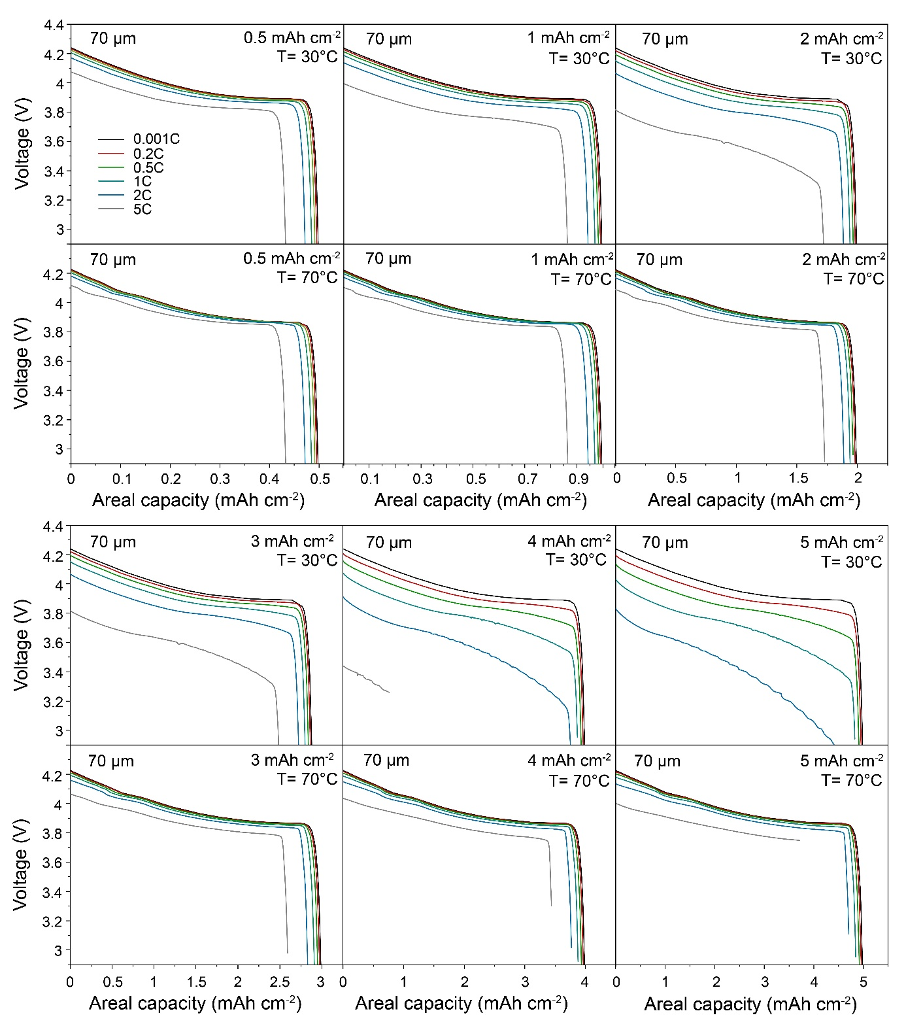
Figures S24. Simulated voltage profiles of Li/LLZO/LCO all-solid-state battery at different cathode areal capacities (0.5, 1, 2, 3, 4, and 5 mAh cm⁻²), C rates (0.001C, 0.2C, 0.5C, 1C, 2C, and 5C) and temperatures (30°C and 70°C). LLZO thickness is constant of 70 µm. LCO cathode is composed of 40 vol.% of LCO and 60 vol.% of LLZO.

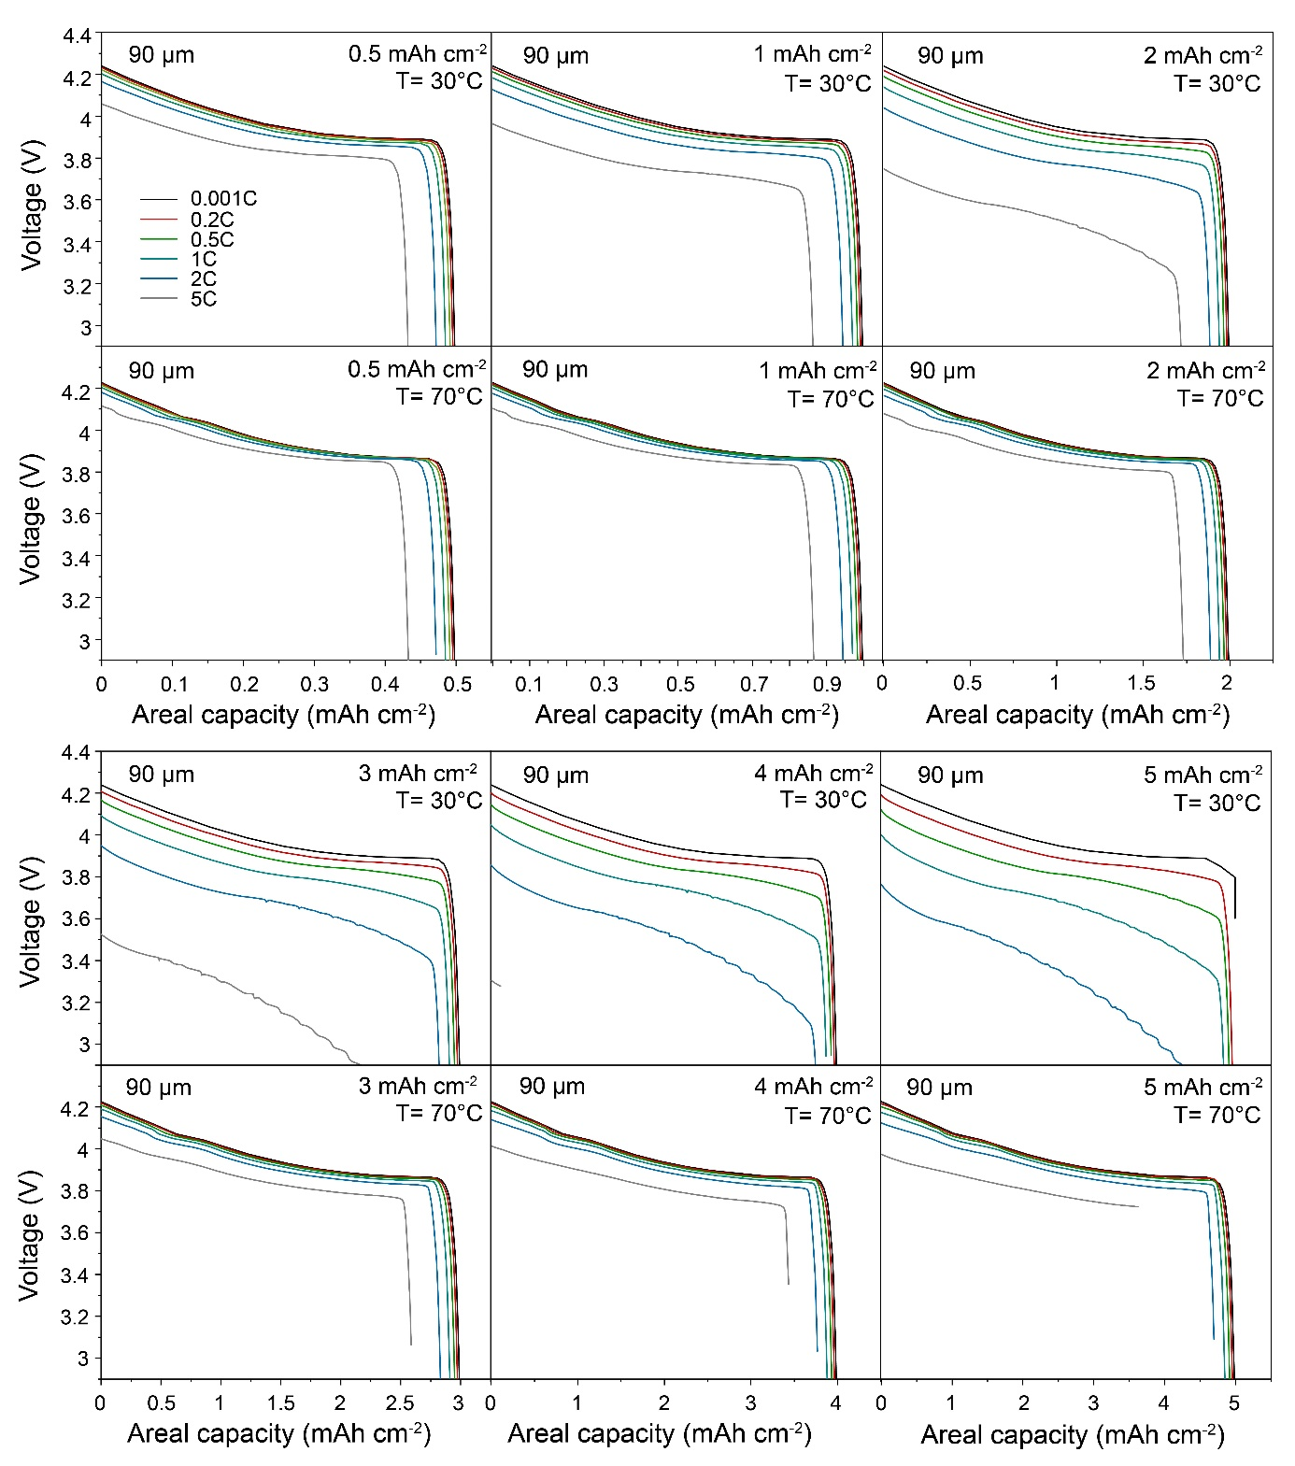
Figures S25. Simulated voltage profiles of Li/LLZO/LCO all-solid-state battery at different cathode areal capacities (0.5, 1, 2, 3, 4, and 5 mAh cm⁻²), C rates (0.001C, 0.2C, 0.5C, 1C, 2C, and 5C) and temperatures (30°C and 70°C). LLZO thickness is constant of 90 µm. LCO cathode is composed of 40 vol.% of LCO and 60 vol.% of LLZO.

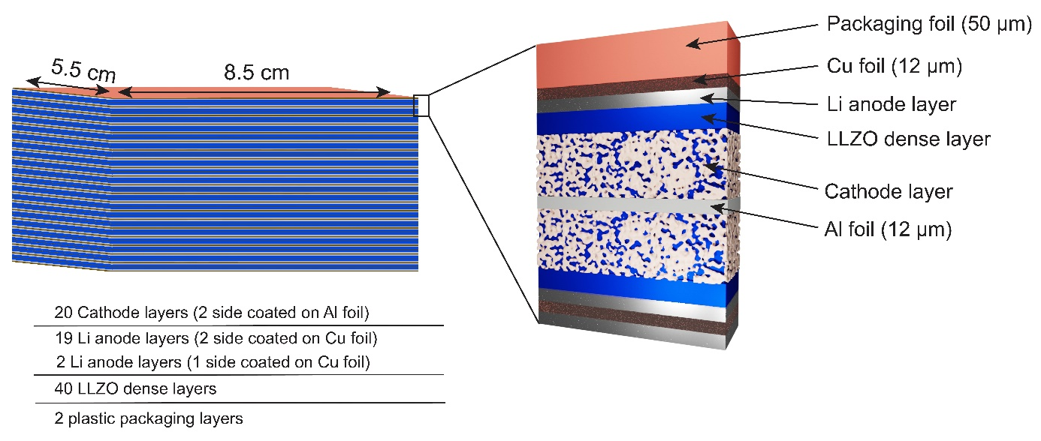
Figure S26. Schematics of the battery considered in this work for assessing the energy densities of Li-garnet SSBs.

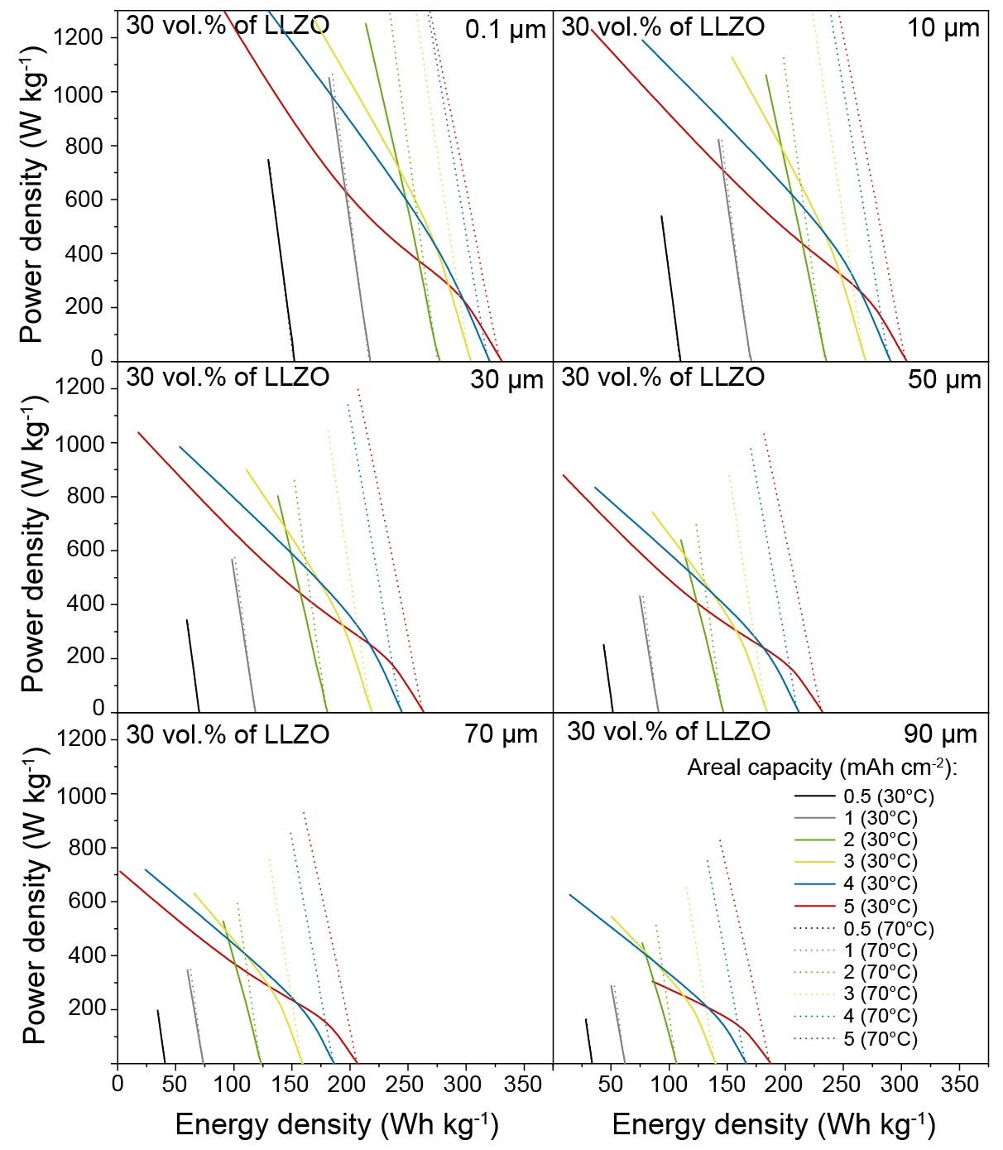
Figures S27. Gravimetric Ragone plots of Li/LLZO/LCO all-solid-state battery comprising LLZO solid electrolyte of different thicknesses (0.1 µm, 10 µm, 50 µm, 70 µm, and 90 µm) simulated at cathode areal capacities of 0.5, 1, 2, 3, 4, and 5 mAh cm⁻², and temperatures of 30°C and 70°C. The composition of LCO cathode is constant (70 vol.% of LCO and 30 vol.% of LLZO).

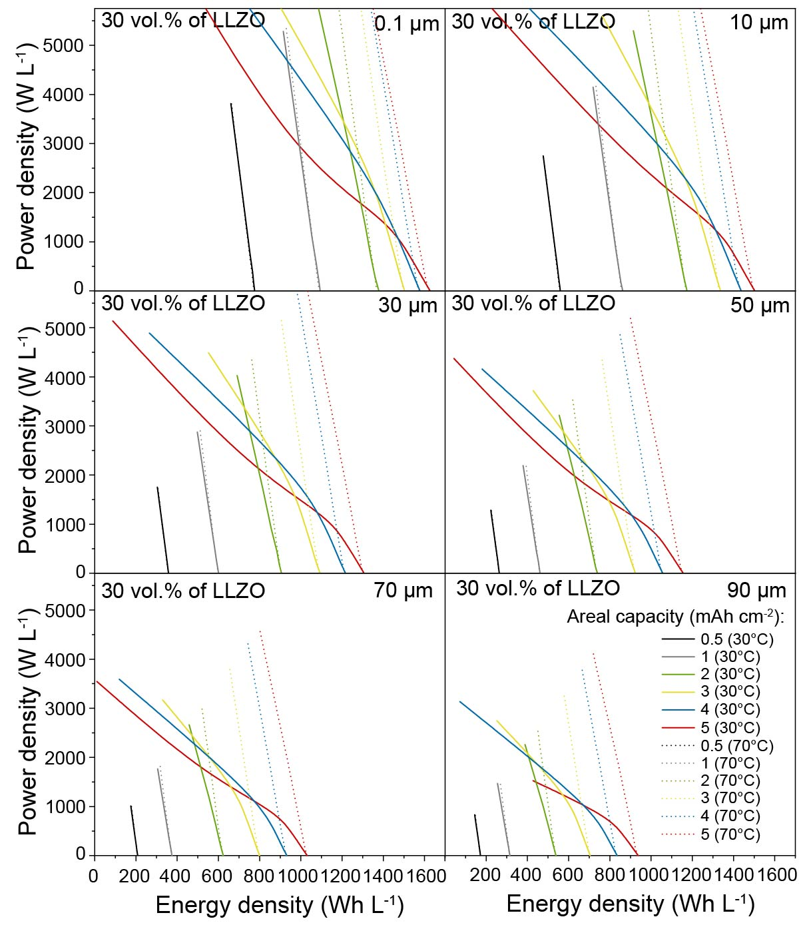
Figures S28. Volumetric Ragone plots of Li/LLZO/LCO all-solid-state battery comprising LLZO solid electrolyte of different thicknesses (0.1 µm, 10 µm, 50 µm, 70 µm, and 90 µm) simulated at cathode areal capacities of 0.5, 1, 2, 3, 4, and 5 mAh cm⁻², and temperatures of 30°C and 70°C. The composition of LCO cathode is constant (70 vol.% of LCO and 30 vol.% of LLZO).

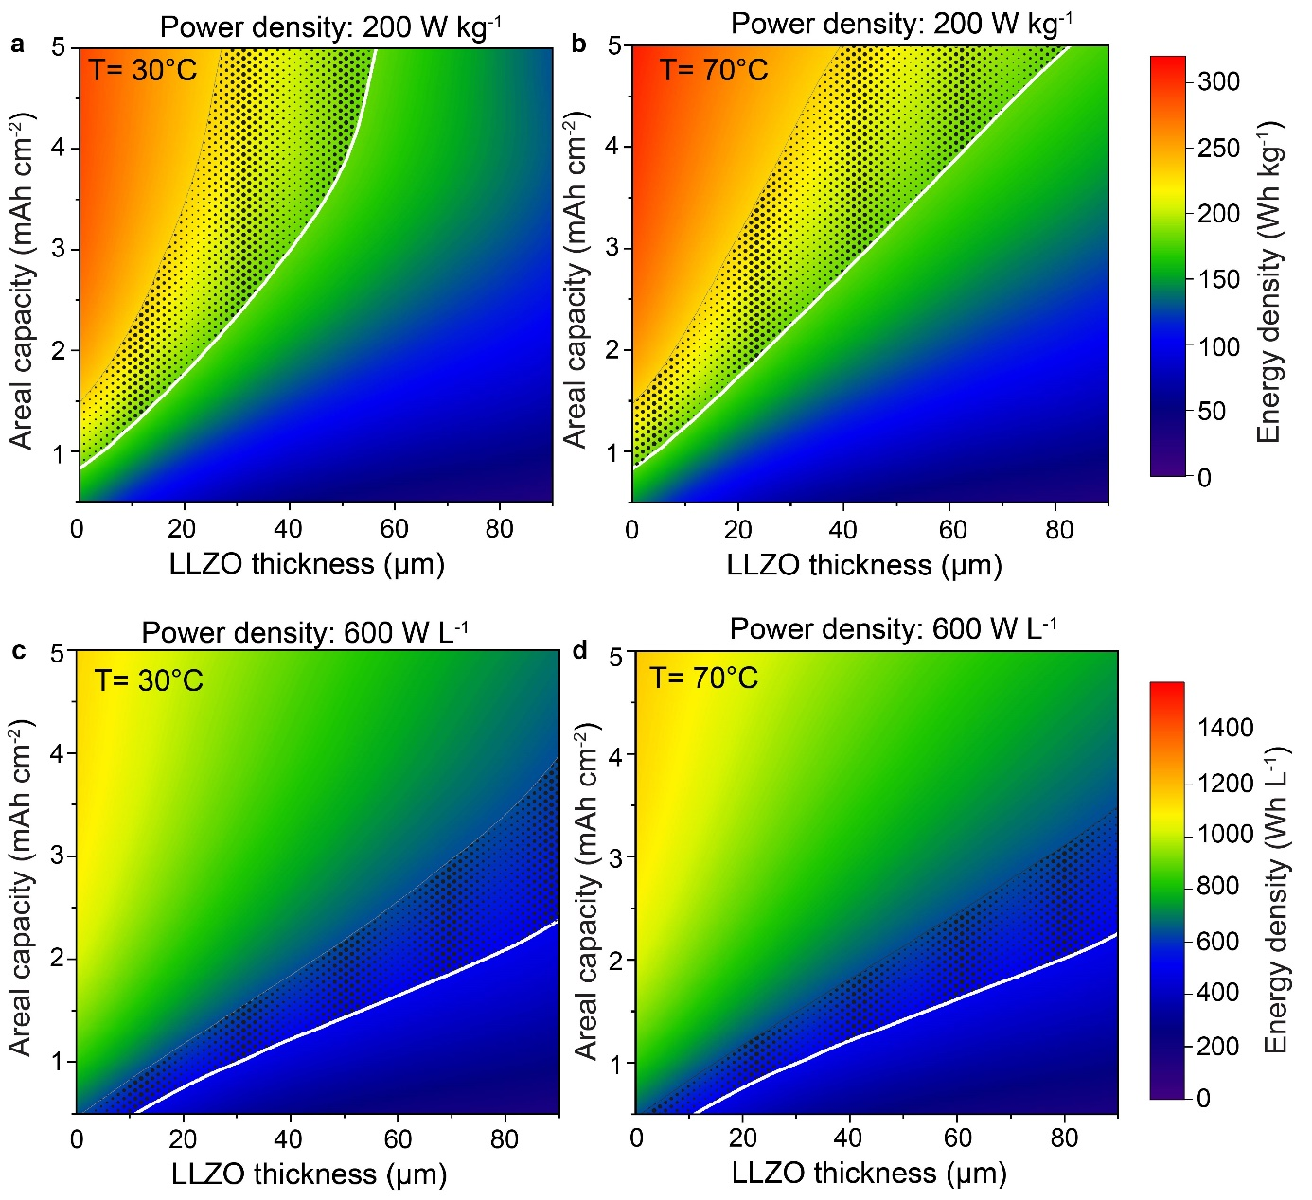
Figure 29. Simulated gravimetric (a, b) and volumetric (c, d) energy densities of Li/LLZO/LCO all-solid-state battery vs. cathode areal capacity and LLZO thickness plotted at power densities of 200 W kg⁻¹ and 600 W L⁻¹ and temperatures of 30°C and 70°C. The composition of LCO cathode is constant (70 vol.% of LCO and 30 vol.% of LLZO). The areal capacity (thickness) of the Li metal anode corresponds to 200% of cathode areal capacity.

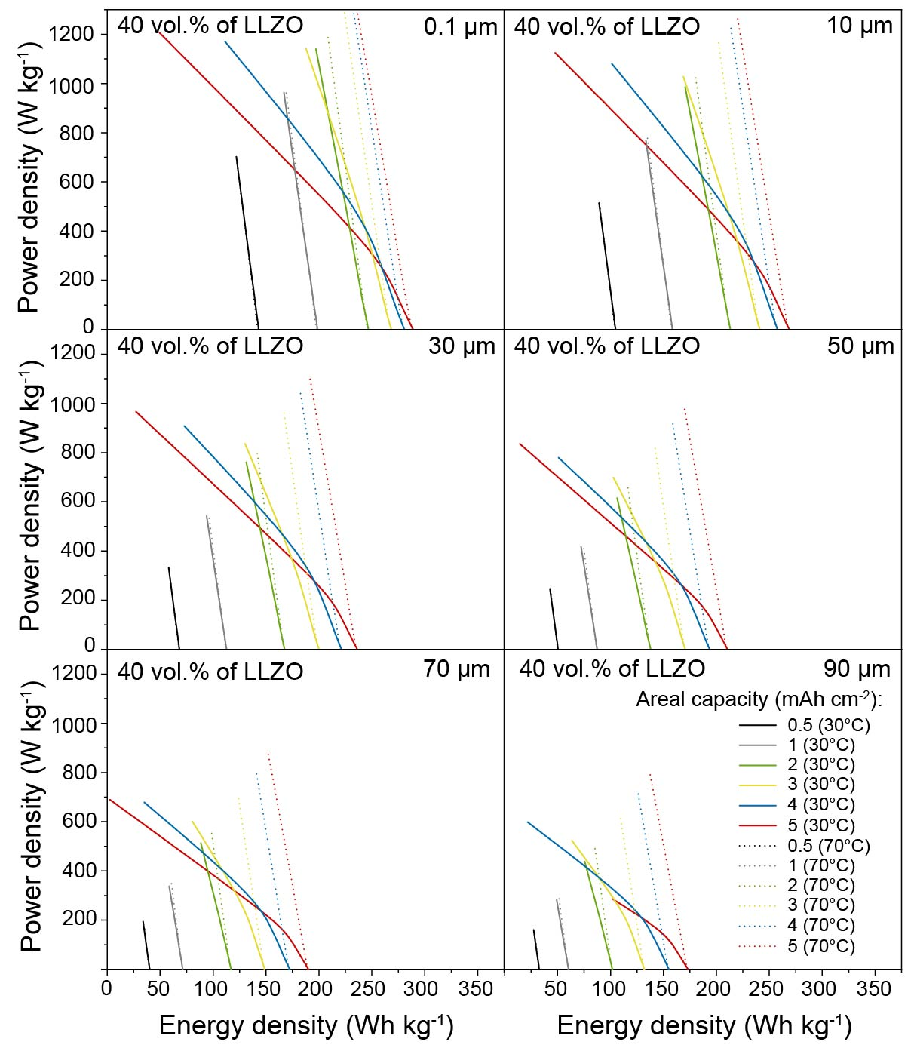
Figures S30. Gravimetric Ragone plots of Li/LLZO/LCO all-solid-state battery comprising LLZO solid electrolyte of different thicknesses (0.1 µm, 10 µm, 50 µm, 70 µm, and 90 µm) simulated at cathode areal capacities of 0.5, 1, 2, 3, 4, and 5 mAh cm⁻², and temperatures of 30°C and 70°C. The composition of LCO cathode is constant (60 vol.% of LCO and 40 vol.% of LLZO).

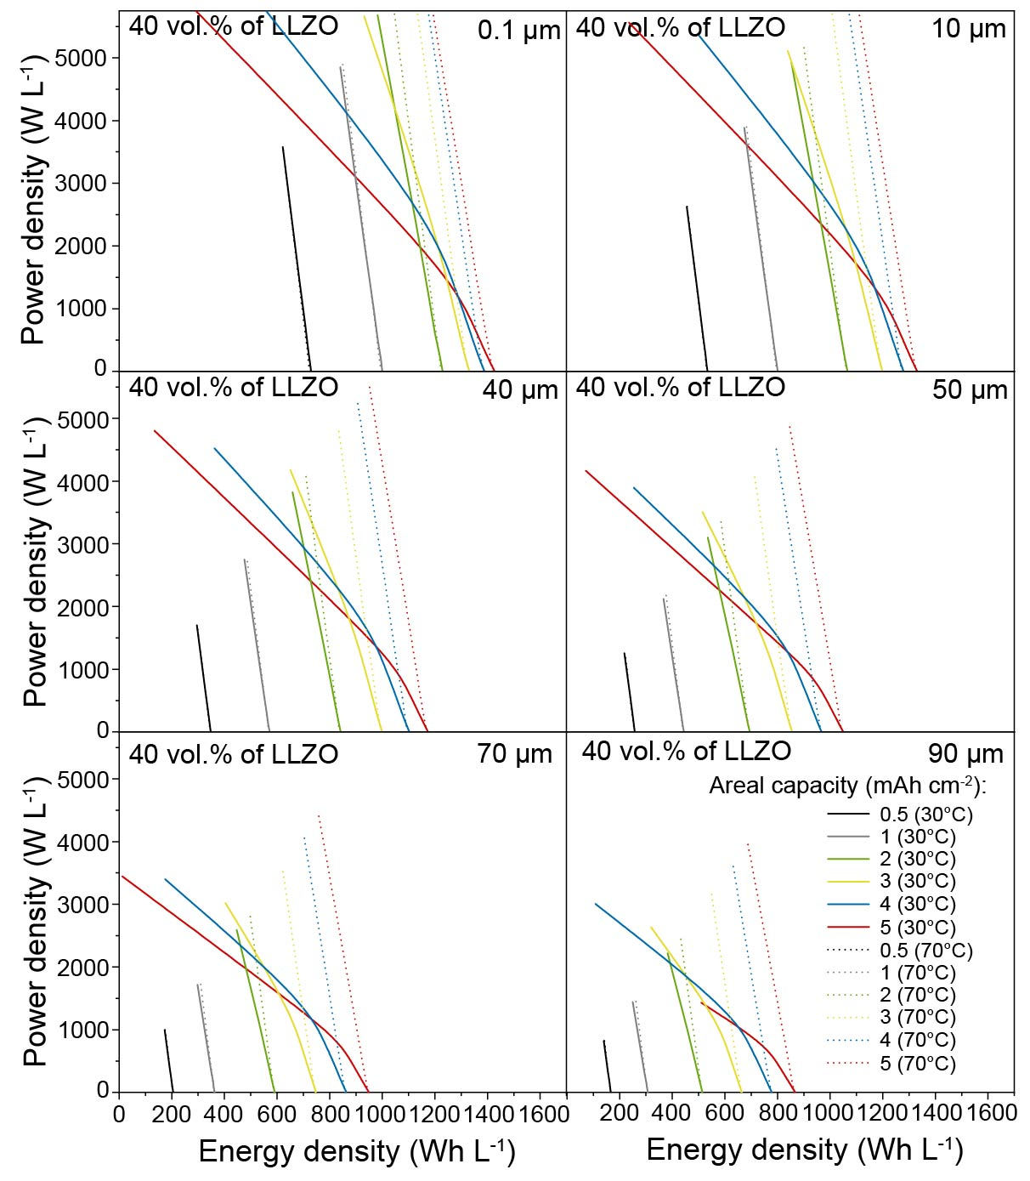
Figures S31. Volumetric Ragone plots of Li/LLZO/LCO all-solid-state battery comprising LLZO solid electrolyte of different thicknesses (0.1 µm, 10 µm, 50 µm, 70 µm, and 90 µm) simulated at cathode areal capacities of 0.5, 1, 2, 3, 4, and 5 mAh cm⁻², and temperatures of 30°C and 70°C. The composition of LCO cathode is constant (60 vol.% of LCO and 40 vol.% of LLZO).

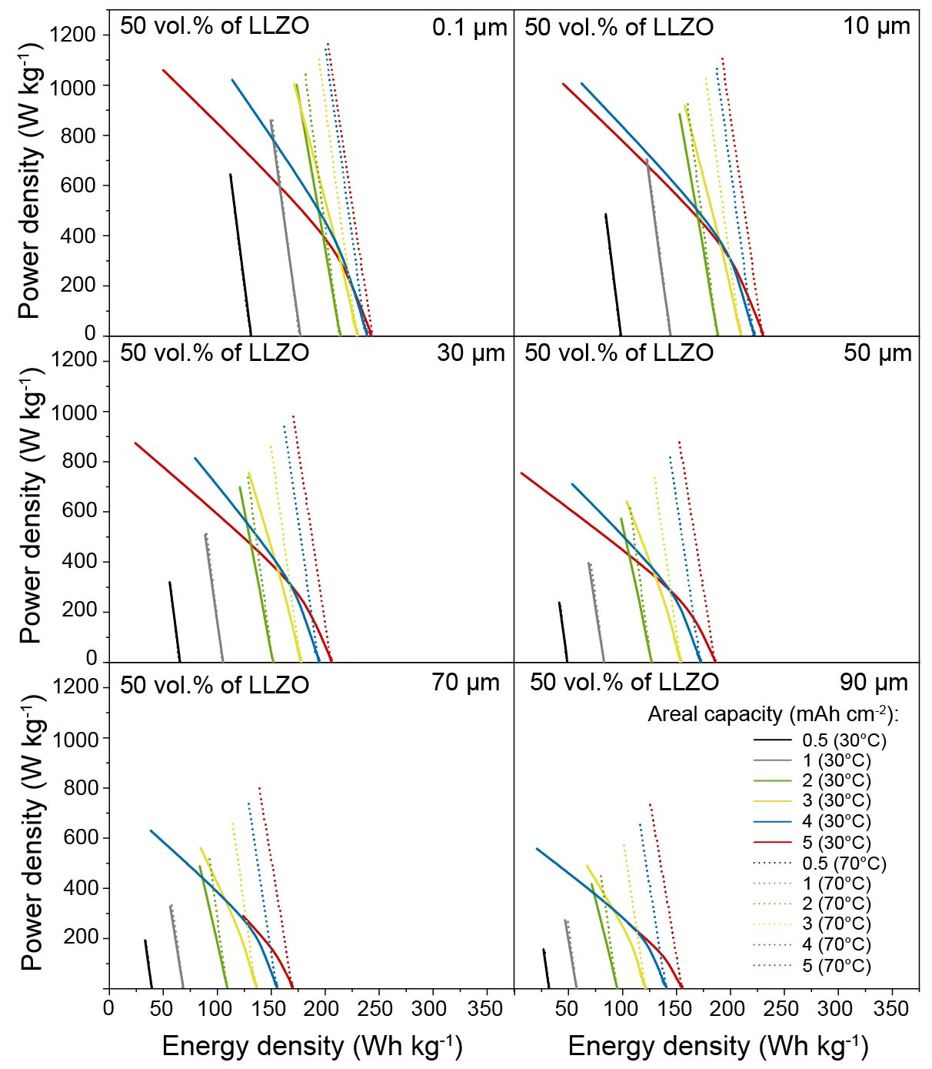

Figures S32. Gravimetric Ragone plots of Li/LLZO/LCO all-solid-state battery comprising LLZO solid electrolyte of different thicknesses (0.1 µm, 10 µm, 50 µm, 70 µm, and 90 µm) simulated at cathode areal capacities of 0.5, 1, 2, 3, 4, and 5 mAh cm⁻², and temperatures of 30°C and 70°C. The composition of LCO cathode is constant (50 vol.% of LCO and 50 vol.% of LLZO).

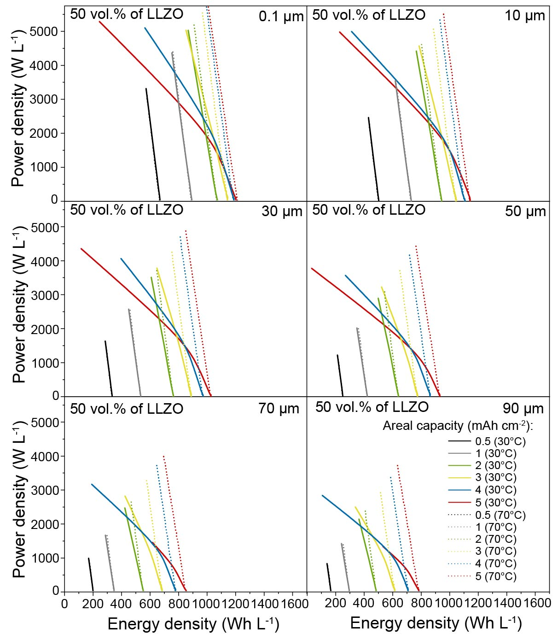

Figures S33. Volumetric Ragone plots of Li/LLZO/LCO all-solid-state battery comprising LLZO solid electrolyte of different thicknesses (0.1 µm, 10 µm, 50 µm, 70 µm, and 90 µm) simulated at cathode areal capacities of 0.5, 1, 2, 3, 4, and 5 mAh cm⁻², and temperatures of 30°C and 70°C. The composition of LCO cathode is constant (50 vol.% of LCO and 50 vol.% of LLZO).

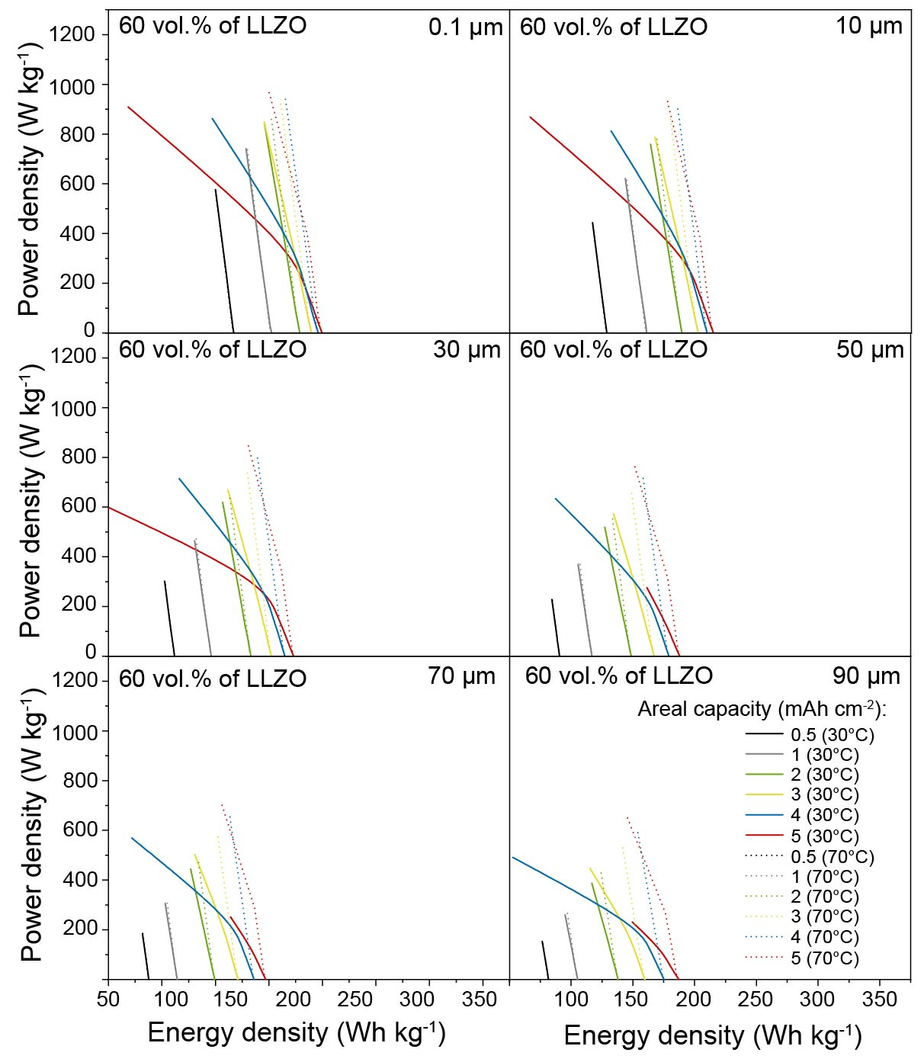
Figures S34. Gravimetric Ragone plots of Li/LLZO/LCO all-solid-state battery comprising LLZO solid electrolyte of different thicknesses (0.1 µm, 10 µm, 50 µm, 70 µm, and 90 µm) simulated at cathode areal capacities of 0.5, 1, 2, 3, 4, and 5 mAh cm⁻², and temperatures of 30°C and 70°C. The composition of LCO cathode is constant (40 vol.% of LCO and 60 vol.% of LLZO).

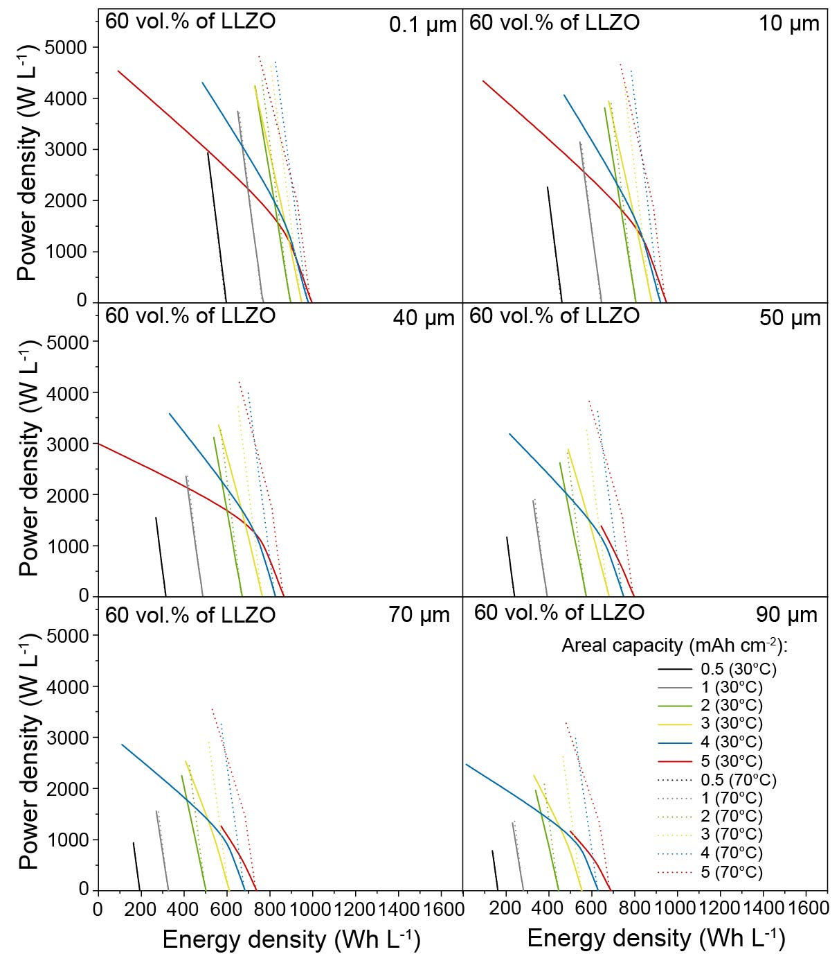
Figures S35. Volumetric Ragone plots of Li/LLZO/LCO all-solid-state battery comprising LLZO solid electrolyte of different thicknesses (0.1 µm, 10 µm, 50 µm, 70 µm, and 90 µm) simulated at cathode areal capacities of 0.5, 1, 2, 3, 4, and 5 mAh cm⁻², and temperatures of 30°C and 70°C. The composition of LCO cathode is constant (40 vol.% of LCO and 60 vol.% of LLZO).

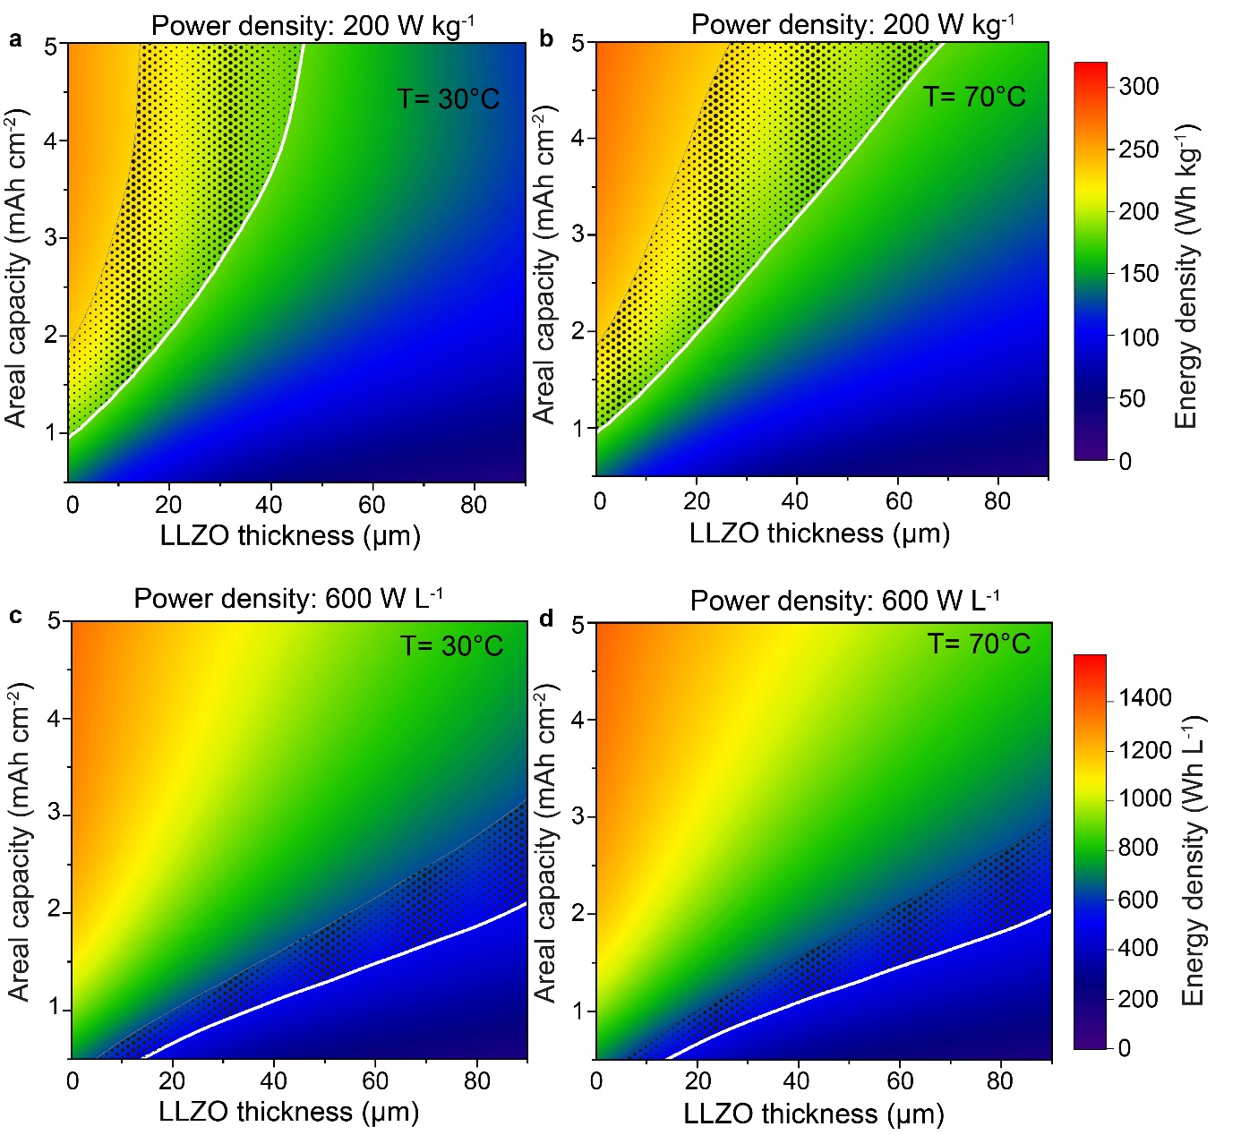
Figure S36. Simulated gravimetric (a, b) and volumetric (c, d) energy densities of Li/LLZO/LCO all-solid-state battery vs. cathode areal capacity and LLZO thickness plotted at power densities of 200 W kg⁻¹ and 600 W L⁻¹ and temperatures of 30°C and 70°C. The composition of LCO cathode is constant (60 vol.% of LCO and 40 vol.% of LLZO). The areal capacity (thickness) of the Li metal anode corresponds to 20% of cathode areal capacity.

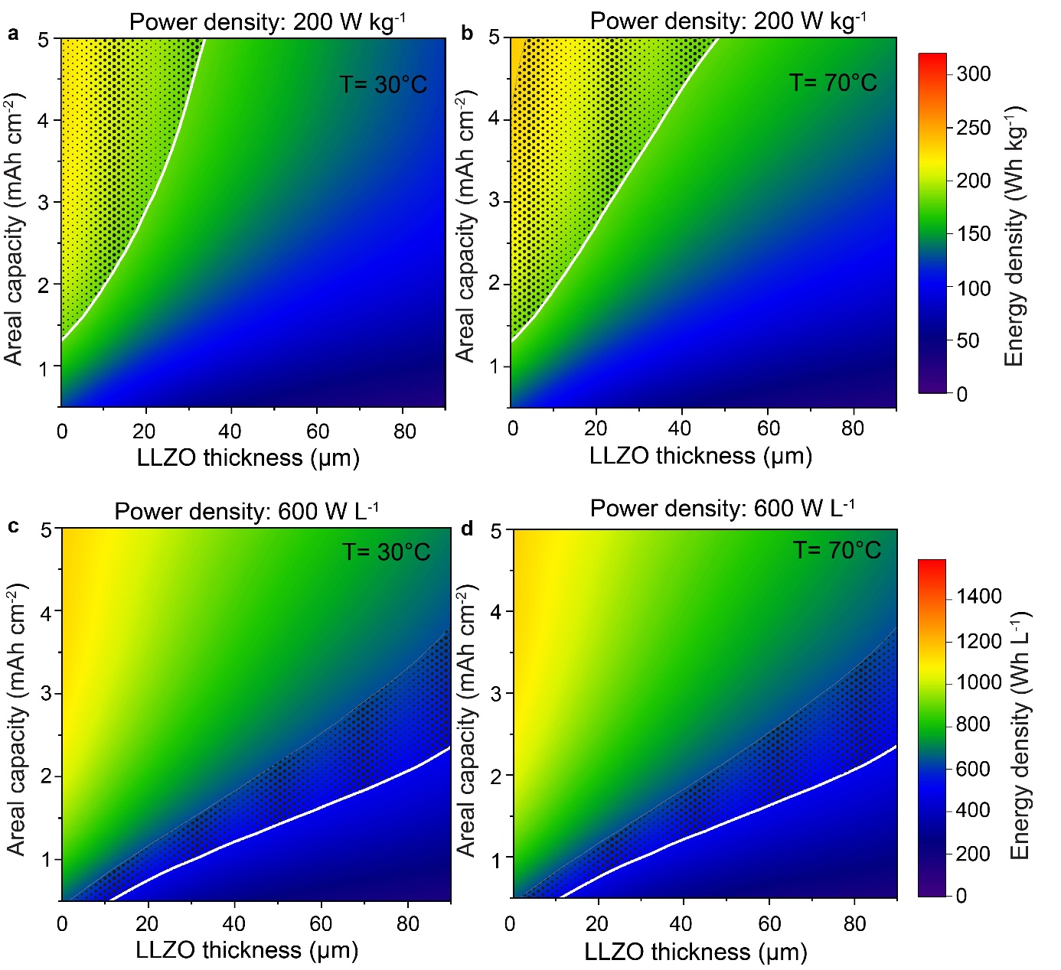
Figure S37. Simulated gravimetric (a, b) and volumetric (c, d) energy densities of Li/LLZO/LCO all-solid-state battery vs. cathode areal capacity and LLZO thickness plotted at power densities of 200 W kg⁻¹ and 600 W L⁻¹ and temperatures of 30°C and 70°C. The composition of LCO cathode is constant (50 vol.% of LCO and 50 vol.% of LLZO). The areal capacity (thickness) of the Li metal anode corresponds to 20% of cathode areal capacity.

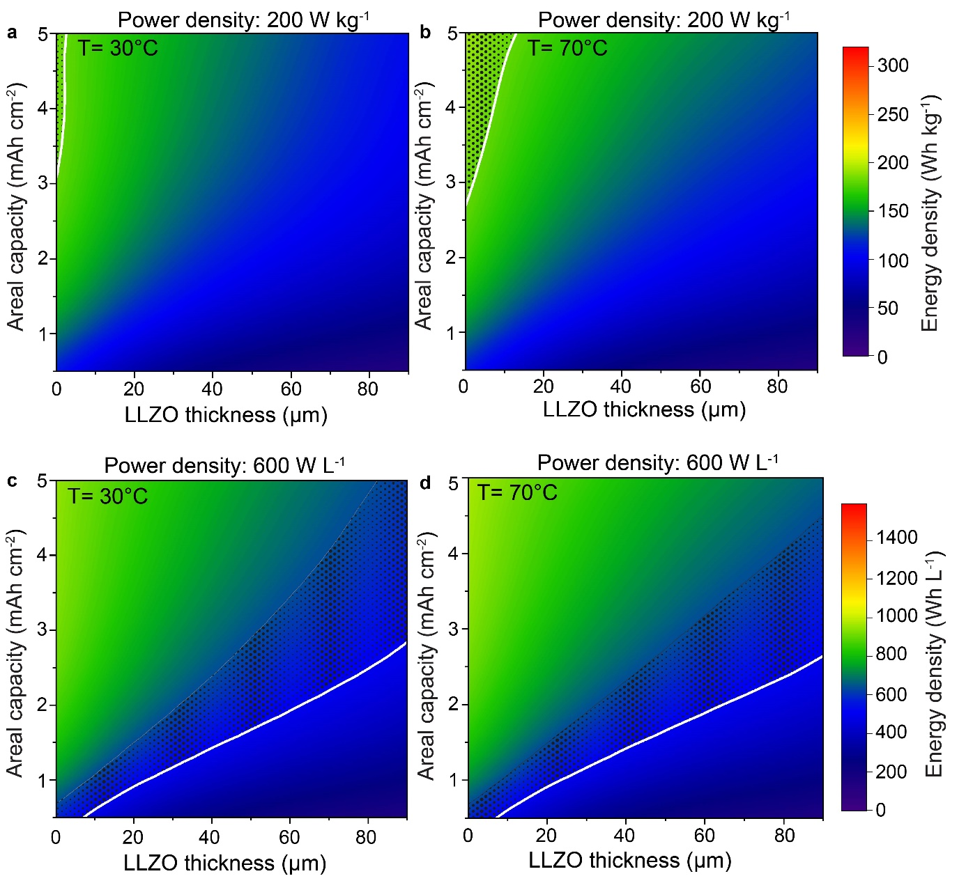
Figure S38. Simulated gravimetric (a, b) and volumetric (c, d) energy densities of Li/LLZO/LCO all-solid-state battery vs. cathode areal capacity and LLZO thickness plotted at power densities of 200 W kg⁻¹ and 600 W L⁻¹ and temperatures of 30°C and 70°C. The composition of LCO cathode is constant (40 vol.% of LCO and 60 vol.% of LLZO). The areal capacity (thickness) of the Li metal anode corresponds to 20% of cathode areal capacity.

Figure S39. Comparison of gravimetric (a) and volumetric (b) Ragone plots of the solid-state system (Li/LLZO/LLZO+LCO) obtained using standard and expended simulations (T = 30°C). Expended simulations were performed by integrating additional parameters, such as LLZO/Li (0.1 Ω cm²) and LLZO/LCO (50 Ω cm²) interfacial resistances and the 13% porosity in LCO/LLZO solid-state cathode. Cathode composition for standard simulation was 60 vol.% of LCO/40 vol.% of LLZO. Cathode composition for expended simulations was 60 vol.% of LCO/27 vol.% of LLZO/13 vol.% of porosity.

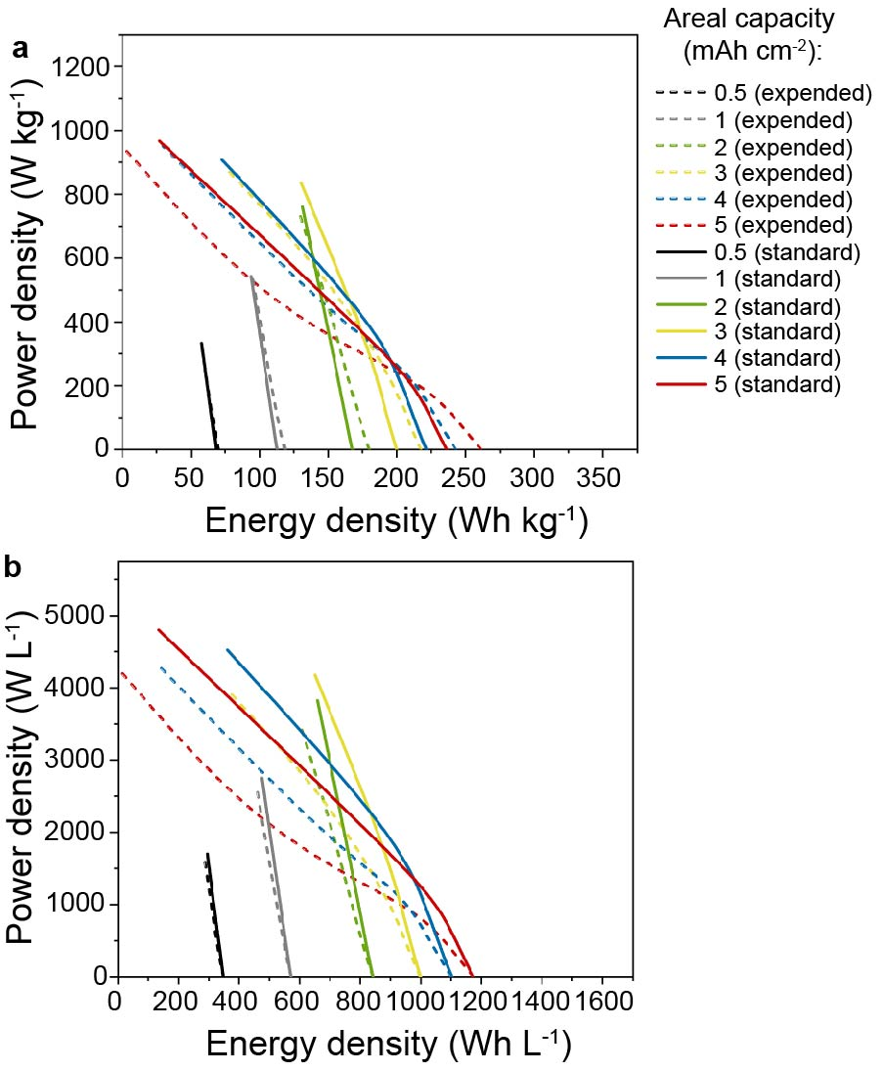

Table S1. Parameters used for simulations.

Parameters | Value | Symbol
Ionic conductivity of LLZO electrolyte at 30°C | 2.85·10⁻⁴ S m⁻¹ | $$σ_{LLZO}$$
Ionic conductivity of LLZO electrolyte at 70°C | 1.7·10⁻³ S m⁻¹ | $$σ_{LLZO}$$
Anodic apparent transfer coefficient | 0.5 | $$α_{a}$$
Cathodic apparent transfer coefficient | 0.5 | $$α_{c}$$
Reference exchange current density of negative metallic lithium electrode | 400 A m⁻² | $$i_{0,ref}$$
Reference exchange current density of positive LCO electrode | 0.0543 A m⁻² | $$i_{0,ref}$$
Initial concentration of Li ions in Positive Electrode | 44949 mol m⁻³ | $$c_{{Li}^{+},init}$$
Maximum concentration of Li ions in positive Electrode | 49973 mol m⁻³ | $$c_{{Li}^{+},max}$$
Concentration of Li per volume of negative electrode | 77111 mol m⁻³ | $$c_{{Li}^{+},max}$$
Minimum state of charge of positive electrode | 0.43 | $${soc}_{min}$$
Maximum electrode state of charge of positive Electrode | 0.93 | $${soc}_{max}$$
Electronic conductivity of positive electrode | 0.113 S m⁻¹ | $$σ_{LCO}$$
Electronic conductivity of negative electrode | 6.0·10⁵ S m⁻¹ | $$σ$$
Diffusivity of positive electrode | 5.0·10⁻¹³ m² s⁻¹ | $$D_{{Li}^{+}}$$
Particle radius in positive electrode | 5.0·10⁻⁷ m | $$r_{p}$$

Table S2. Parameters used for the calculations of energy density.

Parameters | Value
Battery dimensions | 5.5 cm ˟ 8.5 cm
Density of Li | 0.534 g cm⁻³
Number of Li anode layers (2 side coated on Cu foil) | 19
Number of Li anode layers (1 side coated on Cu foil) | 2
Density of LiCoO₂ | 5.05 g cm⁻³
Number of LCO cathode layers (2 side coated on Al foil) | 20
Density of LLZO | 5.1 g cm⁻³
Number of LLZO dense layers | 40
Thickness of Al foil | 12 µm
Density of Al | 2.7 g cm⁻³
Thickness of Cu foil | 12 µm
Density of Cu | 8.96 g cm⁻³
Packaging foil | 50 µm
Areal weight of packaging foil | 10.5 mg cm⁻²
Number of packaging foil layers | 2

Table S3. Comparison of the gravimetric and volumetric energy densities of the solid-state system (Li/LLZO/LLZO+LCO) at gravimetric and volumetric power density of 200 W kg⁻¹ and 600 W L⁻¹ (corresponding to ca. 1h of a full discharge) obtained using standard and expended simulations. The latter were performed by integrating additional parameters, such as LLZO/Li (0.1 Ω cm²) and LLZO/LCO (50 Ω cm²) interfacial resistances and the 13% porosity in LCO/LLZO solid-state cathode.

Standard simulations
Cathode composition: 60 vol.% of LCO/40 vol.% of LLZO
T = 30°C; LLZO thickness = 30 µm;

Expended simulations
Cathode composition: 60 vol.% of LCO/27 vol.% of LLZO/13 vol.% of porosity
T = 30°C; LLZO thickness = 30 µm;

Areal capacity, mAh cm⁻² | Energy density, Wh kg⁻¹  (standard simulation) | Energy density, Wh kg⁻¹  (expended simulation) | ∆, Wh kg⁻¹ | ∆, %
0.5 | 62.2 | 62.2 | 0 | 0
1 | 105.5 | 108.9 | 3.4 | 3.22
2 | 158.3 | 165.9 | 7.6 | 4.8
3 | 187.2 | 197.5 | 10.3 | 5.50
4 | 203.7 | 214.0 | 10.3 | 5.06
5 | 211.2 | 216.0 | 4.8 | 2.27
Areal capacity, mAh cm⁻² | Energy density, Wh L⁻¹  (standard simulation) | Energy density, Wh L⁻¹  (expended simulation) | ∆, Wh L⁻¹ | ∆, %
0.5 | 329.0 | 323.7 | 5.3 | 1.61
1 | 550.4 | 542.0 | 8.4 | 1.53
2 | 813.8 | 799.5 | 14.3 | 1.76
3 | 959.9 | 939.4 | 20.5 | 2.14
4 | 1048.1 | 1017.2 | 30.9 | 2.95
5 | 1104.5 | 1054.2 | 50.3 | 4.55

