Additional file 1

 | Forward primer 5’-3’ | Reverse primer 5’-3’ | TH (°C)
Catalase 1 | AAAAGCAGGCTTCATGGATC CCTCTAAGTATCG | CAAGAAAGCTGGGTCTCAC ATTGTAGGCTTCACAG | 60
Catalase 2 | AAAAAGCAGGCTTCATGGAT CCTTACAAGTACCG | CAAGAAAGCTGGGTCTCAT ATGCTTGGTCTCACAT | 60
Catalase 3 | AAAAAGCAGGCTTCATGGAT CCTTACAAGTATCG | CAAGAAAGCTGGGTCTCAC ATTGTAGGCCTTATAT | 60

Additional file 2
Motif | Sequence | Description
1 | PTCDIKHLTCEEAJRVGGANTPVA | Catalase clade 1
2 | EVGIPEDYRHIDGFSVKPETL | Catalase clade 1
3 | KLLQTRIFSYADTQRHRLGPNYLQLPVNAPKCAHHNNHHDGFMNFMHRDE | Catalase clade 1
4 | TKDLYDSIAAGNYPEWKLFIQTMDPEHEDKFDFDPLDVTKTWPEDILPLQ | Catalase clade 1
5 | TNEIREIWINYWSQADKSPGQ | Catalase clade 1
6 | GNFDLVGNNFPVFFIRDGMKFPDMVHALK | Catalase clade 1
7 | INKAGKAHYVKFHWK | Catalase clade 1
8 | EVBYFPSRYDPVRHAEQYPIP | Catalase clade 1
9 | FDPYKYRPGSAYSDP | Catalase clade 1
10 | LLEDYHLVEKLANFD | Catalase clade 1

Additional file 3
No. | Gene Name | Locus Name | Species
1 | VvCAT1 | GSVIVT01013367001 | Vitis vinifera L.
1 | AtCAT1 | AT1G20630 | Arabidopsis thaliana (Linn.) Heynh.
2 | AtCAT2 | AT4G35090 | Arabidopsis thaliana (Linn.) Heynh.
3 | AtCAT3 | AT1G20620 | Arabidopsis thaliana (Linn.) Heynh.
1 | GmCAT1 | Glyma.04G017500 | Glycine max (Linn.) Merr.
2 | GmCAT2 | Glyma.06G017900 | Glycine max (Linn.) Merr.
3 | GmCAT3 | Glyma.14G223500 | Glycine max (Linn.) Merr.
4 | GmCAT4 | Glyma.17G261700 | Glycine max (Linn.) Merr.
1 | TcCAT1 | Thecc1EG000075t1 | Theobroma cacao L.
2 | TcCAT2 | Thecc1EG034390t1 | Theobroma cacao L.
1 | GrCAT1 | Gorai.002G115900 | Gossypium raimondii Ulbr.
2 | GrCAT2 | Gorai.009G187600 | Gossypium raimondii Ulbr.
3 | GrCAT3 | Gorai.003G002800 | Gossypium raimondii Ulbr.
1 | CsCAT1 | Cucsa.077510 | Cucumis sativus
2 | CsCAT2 | Cucsa.272110 | Cucumis sativus
3 | CsCAT3 | Cucsa.272120 | Cucumis sativus
1 | AlCAT1 | AL1G33580.t2 | Arabidopsis lyrata v2.1
2 | AlCAT2 | AL7G16130.t1 | Arabidopsis lyrata v2.1
3 | AlCAT3 | AL1G33590.t1 | Arabidopsis lyrata v2.1
1 | BdCAT1 | Bradi5g13250.1 | Brachypodium distachyon
1 | CicCAT1 | Ciclev10000948m | Citrus clementina v1.0
2 | CicCAT2 | Ciclev10017962m | Citrus clementina v1.0
3 | CicCAT3 | Ciclev10000951m | Citrus clementina v1.0
1 | CisCAT1 | orange1.1g044386m | Citrus sinensis v1.0
2 | CisCAT2 | orange1.1g042356m | Citrus sinensis v1.0
1 | MtCAT1 | Medtr3g115370.1 | Medicago truncatula
2 | MtCAT2 | Medtr1386s0010.1 | Medicago truncatula
1 | OsCAT1 | LOC_Os03g03910.1 | Oryza sativa
2 | OsCAT2 | LOC_Os06g51150.1 | Oryza sativa
3 | OsCAT3 | LOC_Os02g02400.1 | Oryza sativa
1 | SbCAT1 | Sobic.001G517700.1.p | Sorghum bicolor v3.1.1
2 | SbCAT2 | Sobic.004G011566.1.p | Sorghum bicolor v3.1.1
3 | SbCAT3 | Sobic.010G274500.2.p | Sorghum bicolor v3.1.1

Additional file 4
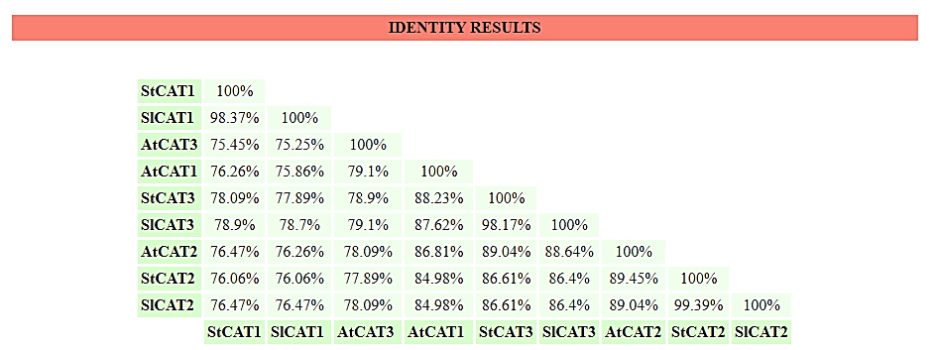
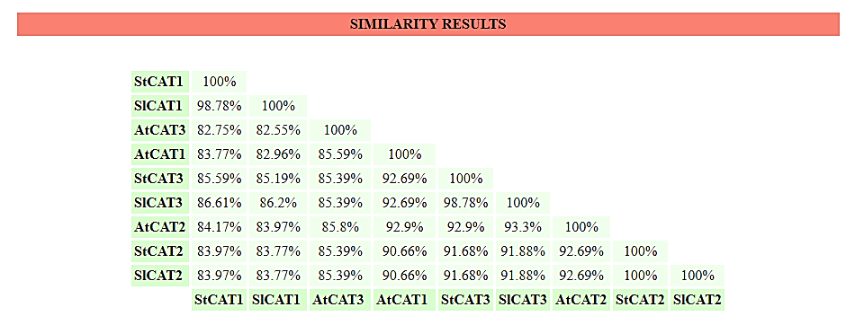
Additional file 5

d1m7sa_ --------------------TDTLTRDNGAVVGDNQ---NSQTAGAQGPVLLQDVQLLQK
StCAT1 -----MD--PSKYRPSSAYDTPFLTTNAGGPVYNNV---SSLTVGPRGPVLLEDYYLIEK
StCAT2 -----MD--PYKYRPSSAFNSPFCTTNSGAPVWNNN---SSLTVGARGPVLLEDYHLVEK
StCAT3 -----MD--PYKYRPSSAANSPFMTTNSGAPVYNNN---SSLTVGTRGPILLEDYHLLEK
c2j2mD_ ---------------------KKLTTNQGVPIGDNQ---NSRTAGRRGPTLLEDYQLIEK
c4qoqC_ --------------------HKNLTTNQGVPVGDNQ---NSRTAGHRGPSFLDDYHLIEK
c3ej6D_ ----EVDARQRLKEVEVDDNGQFMTTDFGGNIEEQ----FSLKAGGRGSTLLEDFIFRQK
c1sy7B_ ---------------------ARLTTDYGVKQTTADDWLRIVSDDKIGPSLLEDPFARER
c1p81A_ (34)RNEKLNSLEDVRKGSENYALTTNQGVRIADDQ---NSLRAGSRGPTLLEDFILREK
d1p80a2 (34)RNEKLNSLEDVRKGSENYALTTNQGVRIADDQ---NSLRAGSRGPTLLEDFILREK
Consensus/80% .......................bTTs.Gs.lhssp...sSbpsG.RGPsLLEDabLbEK

d1m7sa_ LQRFDRERIPERVVHARGTGVKGEFTASADISDLSKATVF-KSGEKTPVFVRFSSVVHGN
StCAT1 LATFDREKIPERVVHARGASAKGFFEVTHDISHLSCADFLRAPGAQTPVICRFSTVVHER
StCAT2 LANFDRERIAERVVHARGASAKGFFEVTHDIAHLTCADFLRAPGVQTPVIVRFSTVIHER
StCAT3 LANFDRERIPERVVHARGASAKGFFEVTHDISHLTCADFLRAPGVQTPVIVRFSTVIHER
c2j2mD_ IAHFDRERVPERVVHARGFGAHGVFKVKNSMKKYTKAAFLQEEGTEVPVFARFSTVIHGT
c4qoqC_ LAHFDRERIPERVVHARGAGAYGVFEVENSMEKHTRAAFLSEEGKQTDVFVRFSTVIHPK
c3ej6D_ LQHFDHERIPERVVHARGAGAHGIFTSYGDWSNITAASFLGAKDKQTPVFVRFSTVAGSR
c1sy7B_ IMRFDHERIPERVVHARGSGAFGKFKVYESASDLTMAPVLTDTSRETPVFVRFSTVLGSR
c1p81A_ ITHFDHERIPERIVHARGSAAHGYFQPYKSLSDITKADFLSDPNKITPVFVRFSTVQGGA
d1p80a2 ITHFDHERIPERIVHARGSAAHGYFQPYKSLSDITKADFLSDPNKITPVFVRFSTVQGGA
Consensus/80% lhpFD+ERIPERVVHARGttA+GbFps.psbtclTpAsFLp..s.pTPVbVRFSTVhh.p

d1m7sa_ HSPETLRDPHGFATKFYTADGNWDLVGNNFPTFFIRDAIKFPDMVHAFKPDPRTNLDN--
StCAT1 GSPESIRDIRGFAVKFYTREGNFDLVGNNVPVFFNRDAKSFPDTIRALKPNPKSHIQE--
StCAT2 GSPETLRDPRGFAVKFYTREGNFDLVGNNFPVFFIRDGMKFPDMVHALKPNPKSHIQE--
StCAT3 GSPETLRDPRGFAVKFYTREGNFDLVGNNFPVFFVRDGMKFPDMVHALKPNPKSHIQE--
c2j2mD_ HSPETLRDPRGFSVKFYTEEGNWDFVGNNLPVFFIRDAMKFPDMVHSLKPDPRTNIQD--
c4qoqC_ GSPETLRDPRGFAVKFYTEEGNYDLVGNNLPIFFIRDALKFPDMVHSLKPDPVTNIQD--
c3ej6D_ GSADTARDVHGFATRFYTDEGNFDIVGNNIPVFFIQDAIRFPDLIHSVKPSPDNEVPQAA
c1sy7B_ GSADTVRDVRGFAVKFYTEEGNWDLVGNNIPVFFIQDAIKFPDVIHAGKPEPHNEVPQAQ
c1p81A_ GSADTVREIRGFATKFYTEEGIFDLVGNNTPIFFIQDAHKFPDFVHAVKPEPHWAIPQGQ
d1p80a2 GSADTVRQIRGFATKFYTEEGIFDLVGNNTPIFFIQDAHKFPDFVHAVKPEPHWAIPQGQ
Consensus/80% GSs-TlRD.RGFAsKFYTcEGNaDLVGNNhPlFFIpDAbKFPDblHtlKPpP+spl.p..

d1m7sa_ --DSRRFDFFSHVPEATRTLTLLYSNEGTPAGYRFMDGNGVHAYKLVNAKGEVHYVKFHW
StCAT1 --NWRILDFFSFLPESLHTFAFFYDDVCLPTDYRHMEGFGVHAYQLINKEGKAHYVKFHW
StCAT2 --NWRVLDFFSHHPESLHMFTFLFDDIGIPQDYRHMDGSGVHTFTLINRAGKSTYVKFHW
StCAT3 --NWRILDFFSHHPESLHMFSFLFDDLGIPQDYRHMDGFGVNTYMLINKAGKAQYVKFHW
c2j2mD_ --PDRYWDFMTLRPESTNMLMHIFTDEGIPASYRKMRGSSVHSFKWVNAHGNTVYIKLRW
c4qoqC_ --PDRYWDFMTLTPESTHMLTWLFSDEGIPANYAEMRGSGVHTFRWVNKYGETKYVKYHW
c3ej6D_ TAHDSAWDFFSSQPSALHTLFWAMSGNGIPRSYRHMDGFGIHTFRLVTEDGKSKLVKWHW
c1sy7B_ SAHNNFWDFQFNHTEATHMFTWAMSDRAIPRSLRMMQGFGVNTYTLINAQGKRHFVKFHW
c1p81A_ SAHDTFWDYVSLQPETLHNVMWAMSDRGIPRSYRTMEGFGIHTFRLINAEGKATFVRFHW
d1p80a2 SAHDTFWDYVSLQPETLHNVMWAMSDRGIPRSYRTMEGFGIHTFRLINAEGKATFVRFHW
Consensus/80% ..p.pbbDFb*bpPEthHhbhahbsDbGIP.sYRpMcG.GlH*apLlN..GcspaVKaHW

d1m7sa_ KSLQGIKNLDPKEVAQVQSKDYSHLTNDLVGAIKKGDFPKWDLYVQVLKPEELAKFDFDP
StCAT1 KPTCGVKCMSEEEAIRVGGTNHSHATKDLYDSIAAGNYPEWKLFIQTMDPEDVDKFDFDP
StCAT2 KPTCGVKSLLEEEAIRVGGANHSHATQDLYDSIAAGNYPEWKLFIQIMDPDHEDKFDFDP
StCAT3 KPTCGVKCLLDEEAIKVGGANHSHATKDLYDSISAGNYPEWKLFIQTIDPDHEDRFDFDP
c2j2mD_ VPKEGVHNLSADEATEVQGKDFNHASNDTFQAIENGDFPEWDLFVQVLDPADVENFDFDP
c4qoqC_ RPSEGIRNLSMEEAAEIQANDFQHATRDLYDRIEKGNYPAWDLYVQLMPLSDYDELDYDP
c3ej6D_ KTKQGKAALVWEEAQVLAGKNADFHRQDLWDAIESGNAPSWELAVQLIDEDKAQAYGFDL
c1sy7B_ TPELGVHSLVWDEALKLAGQDPDFHRKDLWEAIENGAYPKWKFGIQAIAEEDEHKFDFDI
c1p81A_ KPLAGKASLVWDEAQKLTGRDPDFHRRELWEAIEAGDFPEYELGFQLIPEEDEFKFDFDL
d1p80a2 KPLAGKASLVWDEAQKLTGRDPDFHRRELWEAIEAGDFPEYELGFQLIPEEDEFKFDFDL
Consensus/80% +P..G..sLs.-EA.cl.Gps.sahppDLa-tIpsGsaPcWcLhlQhbs.-c..cFDFD.

d1m7sa_ LDATKIWPD--VPEKKIGQMVLNKNVDNFFQETEQVAMAPANLVPGIEPSEDRLLQGRVF
StCAT1 LDVTKTWPEDLLPLIPVGRLVLNRNIDNFFAENEQLAFNPGHIVPGIYYSEDKLLQTRIF
StCAT2 LDVTKTWPEDILPLQPVGRLVLNKNIDNFFNENEQLAFCPSIVVPGVYYSDDKMLQTRIF
StCAT3 LDVTKIWPEDILPLQPVGRLVLNKNIDNFFAENEQLAFCPAIIVPGVYYSDDKLLQTRVF
c2j2mD_ LDATKDWFEDVIPFQHVGTMTLNKNVDNYFAETESVGFNPGVLVPGMLPSEDKLLQGRLF
c4qoqC_ CDPTKTWSEEDYPLQKVGRMTLNRNPENFFAETEQAAFTPSALVPGIEASEDKLLQGRLF
c3ej6D_ LDPTKFLPEEFAPLQVLGEMTLNRNPMNYFAETEQISFQPGHIVRGVDFTEDPLLQGRLY
c1sy7B_ LDATKIWPEDLVPVRYIGEMELNRNPDEFFPQTEQIAFCTSHVVNGIGFSDDPLLQGRNF
c1p81A_ LDPTKLIPEELVPVQRVGKMVLNRNPDNFFAENEQAAFHPGHIVPGLDFTNDPLLQGRLF
d1p80a2 LDPTKLIPEELVPVQRVGKMVLNRNPDNFFAENEQAAFHPGHIVPGLDFTNDPLLQGRLF
Consensus/80% LDsTKhbPE-hlPlp.lGcbsLN+N.DNFFsEsEQhAFpPthlVPGl.h*-D.LLQsRlF

d1m7sa_ SYADTQMYRLG-ANGLSLPVNQPKVAVNNGNQDGALNTGHTTSGVNYEPSRLEPR----P
StCAT1 AYADTQRHRIG-PNYMQLPVNAPKCGHHNNHRDGAMNMTHRDEEVDYLPSRFDPC----R
StCAT2 SYSDTQRYRLG-PNYLQLPANAPKCAHHNNHYDGSMNFMHRDEEIDYFPSRYDQV----R
StCAT3 SYADTQRHRLG-PNYLQLPVNAPKCAHHNNHHEGFMNFMHRDEEVNYFPSRLDPC----R
c2j2mD_ SYSDTQRHRIG-PNYQQLPINCPFAQVNNYQRDGAMPFKQQTSSVNYEPNRYQDE----P
c4qoqC_ SYPDTQRHRLG-ANYMRIPVNCPYAPVHNNQQDGFMTTTRPSGHINYEPNRYDDQ----P
c3ej6D_ SYLDTQLNRHRGPNFEQLPINRPVSGVHNNHRDGQGQAWIHKNIHHYSPSYLNKGYPAQA
c1sy7B_ SYFDTQISRLG-VNFQELPINRPVCPVMNFNRDGAMRHTISRGTVNYYPNRFDA----CP
c1p81A_ SYTDTQISRLGGPNFHEIPINRPTCPYHNFQRDGMHRMGIDTNPANYEPNSINDNWPRET
d1p80a2 SYTDTQISRLGGPNFHEIPINRPTCPYHNFQRDGMHRMGIDTNPANYEPNSINDNWPRET
Consensus/80% SYsDTQbpRlG.sNabplPlN.P.sshpN.ppDGhbphhbpsp.hsYbPspbss......

d1m7sa_ ADD----KARYSELPLSG-TTQQAKITREQNFKQAGDLYRSYSAKEKTDLVQKFGESLAD
StCAT1 P-AE---QYPIPACVLNG-RRTNCVIPKENNFKQAGERYRSWESDRQDRYITKWVESLSD
StCAT2 H-AE---VYPIPSTVCSG-KREKCIIQKENNFKQPGERYRTFTPDRQERFIRRWVEALSD
StCAT3 H-AE---QYPIPPRVLTG-KREKVIIEKENNFKQPGEHYRSWAPGRQERFVCRWVDALSD
c2j2mD_ KQTP---EYTEDTQPLHDDIHGRLEIEKTNNFGQAGEVYRRMTEEEQMALLNNLVNDLQQ
c4qoqC_ KENP---HYKESEPVLHGDRMVRQKIEKPNDFKQAGEKYRSYSEEEKQALIKNLTADLKG
c3ej6D_ NQTVGRGFFTTPGRTASGVLNRELSATFDDHYTQPRLFFNSLTPVEQQFVINAIRFEASH
c1sy7B_ PASLKEGGYLEYAQKVAGIKARARSAKFKEHFSQAQLFYNSMSPIEKQHMINAFGFELDH
c1p81A_ PPGPKRGGFESYQERVEGNKVRERSPSFGEYYSHPRLFWLSQTPFEQRHIVDGFSFELSK
d1p80a2 PPGPKRGGFESYQERVEGNKVRERSPSFGEYYSHPRLFWLSQTPFEQRHIVDGFSFELSK
Consensus/80% ..s.....a....p.lpG.p.pp..hpb.ppapQs.bbapSb*s.cpp.blp.bs.pLsc

d1m7sa_ TLT--ESKNIMLSYLYKEDPNYGTRVAEVAKGDLSKVKSLAASLKD--------------
StCAT1 PRVTHEIRSIWISYLSQADKSCGQKVASRLTVKPTM------------------------
StCAT2 PRITYEIRSIWITYWSQADKSLGQKLASRLNVRPSI------------------------
StCAT3 LRATHEIRSIWISYWSQADKSLGQKLASRLNIRPTM------------------------
c2j2mD_ VRHEN-TVLLAICNFYRADASLGEKLSEALNVDIKPF-----------------------
c4qoqC_ VN-EK-TKLLAICNFYRADEDYGQRLADSLGVDIRSYL----------------------
c3ej6D_ VTNEQ-VKKNVLEQLNKISNDVAKRVAVALGLEAPQPDPTY----YHNN--VTRGVSIFN
c1sy7B_ CEDPV-VYGRMVQRLADIDLGLAQTIAEMVGGEAPTTTNH----PNHGRKTINLSQTEFP
c1p81A_ VVRPY-IRERVVDQLAHIDLTLAQAVAKNLGIELTDDQLNITPPPDVNGLKKDPSLSLYA
d1p80a2 VVRPY-IRERVVDQLAHIDLTLAQAVAKNLGIELTDDQLNITPPPDVNGLKKDPSLSLYA
Consensus/80% s.....h+.bhlsbb.phD.sbtpplAp.Lslc.s.........................

