Supporting Information

Title: Amphipathic Dendritic Poly-peptides Carrier to Deliver Antisense Oligonucleotides against Multi-drug Resistant Bacteria in vitro and in vivo

Zhou Chen, Xinggang Mao, Yue Hu, Mingzhi Wang, Bo Ma, Hui Zhao, Zheng Hou, Mingkai Li, Jingru Meng, Dan nie, Xiaoxing Luo, Xiaoyan Xue
Keywords: Antibacterial strategy; Antisense; Dendritic poly-peptides; Multidrug-resistant bacteria; Nanoparticles

Figure S1. The HPLC and mass spectra of DPP1-DPP6. The purity of DPP1 was 98.19% (a), the [M+3]³⁺ m/z was 950.90 (c). The purity of DPP2 was 98.49% (b), the [M+3]³⁺ m/z was 979.65 (d). The purity of DPP3 was 99.34% (e), the [M+3]³⁺ m/z was 1007.2 (g). The purity of DPP4 was 98.06% (f), the [M+3]³⁺ m/z was 802.3 (h). The purity of DPP5 was 98.12% (i), the [M+3]³⁺ m/z was 802.2 (k). The purity of DPP6 was 98.18% (j), the [M+3]³⁺ m/z was 950.6 (l).

Figure S2. The HPLC and mass spectra of DPP7-DPP12. The purity of DPP7 was 98.06% (a), the [M+3]³⁺ m/z was 1013.2 (c). The purity of DPP8 was 98.09% (b), the [M+2]²⁺ m/z was 1363.0 (d). The purity of DPP9 was 99.82% (e), the [M+3]³⁺ m/z was 896.7 (g). The purity of DPP10 was 98.06% (f), the [M+2]²⁺ m/z was 1207.1 (h). The purity of DPP11 was 98.12% (i), the [M+3]³⁺ m/z was 1000.7 (k). The purity of DPP12 was 98.18% (j), the [M+2]²⁺ m/z was 1188.2 (l).

Figure S3. The identification of L-DPP, ASOs, and DSPE-mPEG2000. (a, b) The HPLC and mass spectra of linear DPP (L-DPP). The purity of L-DPP was 96.12% (a), the [M+4]⁴⁺ m/z was 781.75 (b). The mass spectra of 2’-OMe modified ASOs (c), mismatched ASOs (d) and FAM-labled ASOs (e). (f) The NMR spectrum of DSPE-mPEG2000.

Figure S4. The screening of the N/P ratio of ADs. ADs with N/P molar ratio ranging from 1 to 16 of ASOs/DPP2, ASOs/DPP3, ASOs/DPP4, ASOs/DPP5, ASOs/DPP6, ASOs/DPP8, ASOs/DPP9, ASOs/DPP10, ASOs/DPP11, and ASOs/DPP12 by 1% agarose gel electrophoresis.

Figure S5. The encapsulation of ASOs and binding rate of DSPE-mPEG2000 in the nanoparticles. (a) Standard curve of FAM-labeled ASOs. Concentration versus fluorescence intensity. (b) The encapsulation of ASOs by different DPPs, the results showed that the encapsulation of ASOs was above 85% except DPP10 and DPP12. (c) Standard curve of FITC-labeled DSPE-mPEG2000. Fluorescence intensity versus the concentration of DSPE-mPEG2000. (d) The binding rate of DSPE-mPEG2000 in DP-AD2, DP-AD7, DP-AD8 and DP-AD10, the results showed that the binding rate of DPSE-mPEG2000 in DP-ADs were about 50%.
Figure S6. Screening the molar ratio of DSPE-mPEG2000 in DP-ADs. (a) FAM-positive ratio ESBLs-E. coli were detected by flow cytometry after incubating with DP-AD7_{anti-acpP}, in which the DPSE-mPEG-PEG2000: ASOs rate ranged from 0.25 to 2, for 1 h in dark at 37 °C. AD7 in dd H₂O and free ASOs were used as positive and negative control, respectively. There was the highest FAM positive rate and strongest fluorescent intensity when the rate of DSPE-mPEG2000: ASOs was 0.5. (b-e) The growth curve of ESBLs-E. coli treated with DP-AD7_{anti-acpP} with DSPE-mPEG2000: ASOs of 0.25 (b), 0.5 (c), 1 (d) and 2 (e). Free ASOs and piperacillin were used as negative and positive control, respecitively. DP-AD7_{anti-acpP} could significantly inhibit the bacterial growth compared with DP-AD7_{mismatch} groups when the molar rate was 0.25 or 0.5, but no significant difference when the molar rate was 1 or 2. To ensure the stability and the delivery efficiency, we chose the molar rate of DSPE-mPEG2000: ASOs = 0.5 to prepare DP-AD.

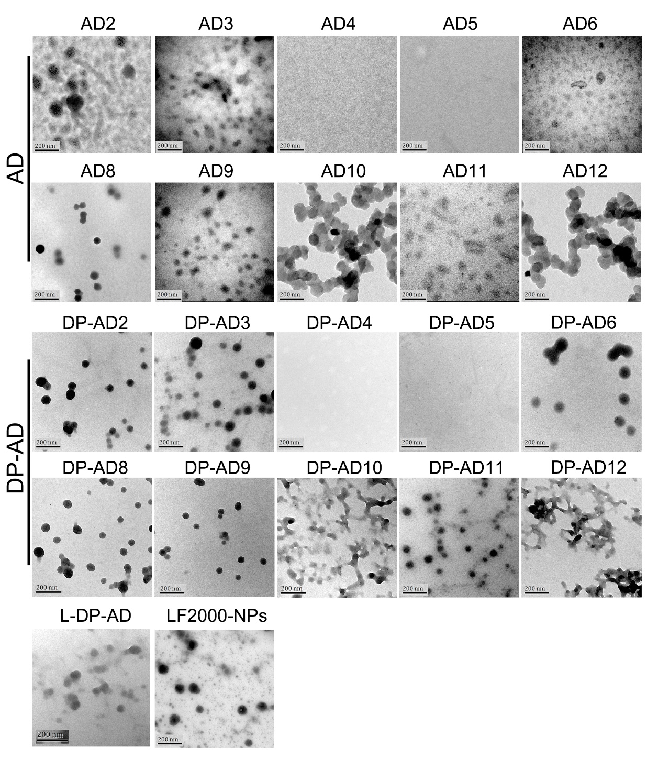
Figure S7. The characteristics of the nanoparticles. The morphologies of ADs (upper panel), DP-ADs (lower panel), L-DP-AD and LF2000-NPs observed by TEM.

Figure S8. Uptake efficiencies and growth curves of DP-ADs in E. coli and S. aureus. FAM-positive ratio of E. coli (a) and S. aureus (b) were tested by flow cytometry after incubation with FAM-labeled DP-ADs for 1 h in dark at 37 °C. Free FAM-labeled ASOs (red) and LF2000-NPs (light blue) were used as negative and positive controls, respectively.

Figure S9. Uptake profiles of DP-ADs by E. coli and S. aureus. FAM-positive ratio of E. coli (left panel) and ESBLs-E. coli (right panel) were tested by flow cytometry after incubating with FAM-labeled L-DP-AD (light blue), DP-AD4 (orange), DP-AD5 (light green), DP-AD10 (dark green) and DP-AD12 (light brown) for 1 h in dark at 37 °C, respectively. Free FAM-labeled ASOs (red) was used as negative control.

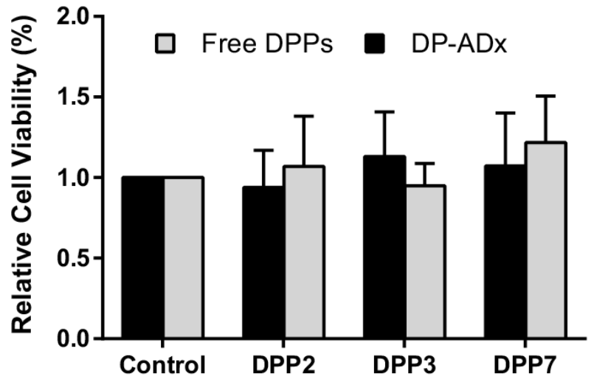
Figure S10. The cytotoxicity of amphipathic DPP2, DPP3, DPP7 and DP-AD2, DP-AD3 and DP-AD7 in HIEC cells.

Figure S11. Uptake efficiencies of DP-AD7 incubated at different temperature. Uptake efficiency of DP-AD7 by the tested bacterial strains when incubated at 37 °C or 4 °C.

Figure S12. Growth inhibitory effect of DP-AD7_{anti-acpP} in bacteria. Growth curves of E. coli (a), ESBLs-E. coli (b), S. aureus (c) and MRSA (d) treated with 0.25, 0.5 and 1 μM DP-AD7_{anti-acpP} and DP-AD7_{mismatch}, and L-DP-AD. LF2000-NPs and ceftazidime were used as positive control groups, while free ASOs were used as negative control.

Figure S13. Gene expression effect of DP-AD7_{anti-acpP} in bacteria. Fold change of acpP mRNA level of E. coli (a), ESBLs-E. coli (b), S. aureus (c) and MRSA (d) treated with different concetrations of DP-AD7_{anti-acpP}. Ceftazidime and LF2000-NPs_{anti-acpP} were used as positive control, and free ASOs were used as negative control.

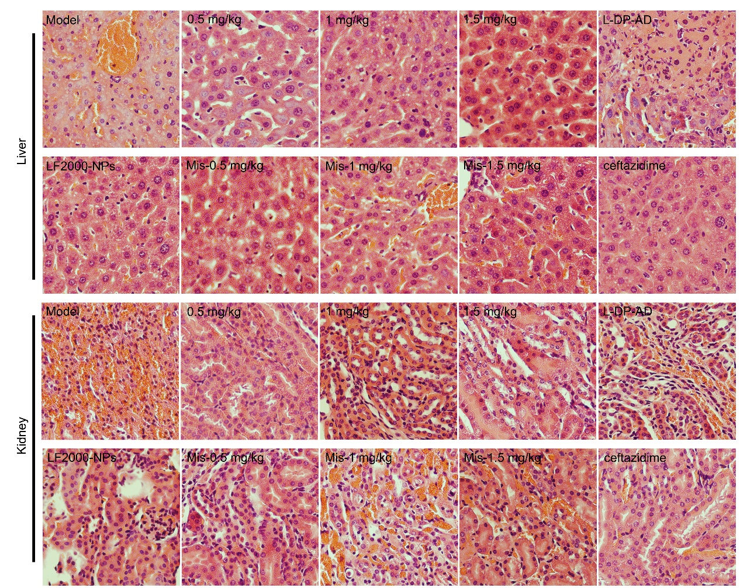
Figure S14. Histological morphology of the organs. Liver (upper panel) and kidney (lower panel) stained with hematoxylin and eosin in normal BALB/c mice and sepsis models treated with DP-AD7_{anti-acpP} (0.5, 1 or 1.5 mg/kg), DP-AD7_{mismatch} (0.5, 1 or 0.5 mg/kg), L-DP-AD_{anti-acpP}, LF2000-NPs_{anti-acpP} and ceftazidime, respectively. (Original magnification, ×40).

Supplementary Tables
Table S1. The sequences, property and the number of His residues of DPPs.
No. | Sequence ^{a)} | Property ^{b)} | Number of His residues
DPP1 | 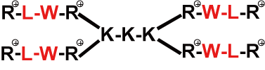 | H | 0
DPP2 | 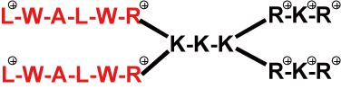 | A | 0
DPP3 | 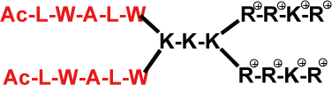 | A | 0
DPP4 | 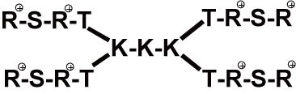 | H | 0
DPP5 | 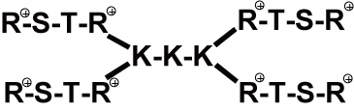 | H | 0
DPP6 | 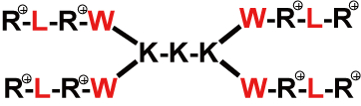 | H | 0
DPP7 | 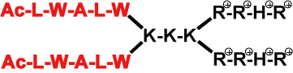 | A | 2
DPP8 | 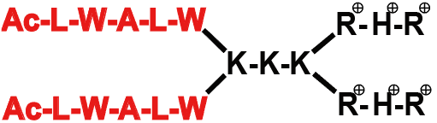 | A | 2
DPP9 | 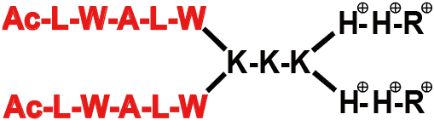 | A | 4
DPP10 | 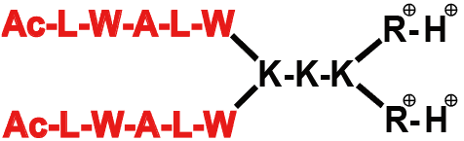 | A | 2
DPP11 |  | A | 4
DPP12 | 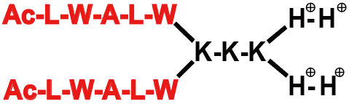 | A | 4
L-DPP | Ac-LWALWK(Ac)K(Ac)K(Ac)RRHRRRHR^{c)}
Note: ^{a)} The hydrophobic amino acids are presented in red, and the hydrophilic amino acids are presented in black. The positive charges are indicated by .
^{b)} “H” means hydrophilic, “A” means amphipathic.
^{c)} L-DPP was the amphipathic poly-peptide with the same amino acid of DPP7, 9 positive charge and 2 His residues.
Table S2. The purity, m/z values and positive charge number of DPPs.
Peptide | Purity (%) | m/z |  | Positive charge number
Peptide | Purity (%) | Theoretical value | Measured value | Positive charge number
DPP1 | 98.19 | 2849.7 | 2849.7 | 12
DPP2 | 98.49 | 2935.7 | 2935.8 | 12
DPP3 | 99.34 | 3018.7 | 3018.6 | 10
DPP4 | 98.06 | 2403.8 | 2403.9 | 12
DPP5 | 98.12 | 2403.8 | 2403.9 | 12
DPP6 | 98.18 | 2848.6 | 2848.8 | 12
DPP7 | 98.06 | 3036.9 | 3036.6 | 10
DPP8 | 98.09 | 2724.3 | 2724.0 | 8
DPP9 | 99.82 | 2686.3 | 2687.1 | 8
DPP10 | 98.06 | 2411.9 | 2412.2 | 6
DPP11 | 98.12 | 2998.5 | 2999.6 | 10
DPP12 | 98.18 | 2373.4 | 2374.4 | 6
L-DPP | 96.12 | 3121.6 | 3122.8 | 9

Table S3. The solvents and concentration of store solutions of DPPs.
DPPs | Mass (mg) | Solvents | Volume (μl) | Concentration of store solutions (mM)
DPP1 | 2.00 | dd H₂O | 38.5 | 18.2
DPP2 | 2.00 | Ethanol | 30.4 | 22.2
DPP3 | 2.00 | 25% ACN | 33.0 | 20.0
DPP4 | 2.00 | dd H₂O | 49.8 | 16.7
DPP5 | 2.00 | dd H₂O | 49.8 | 16.7
DPP6 | 2.00 | 20% ACN | 42.0 | 16.7
DPP7 | 2.00 | 25% ACN | 33.0 | 20.0
DPP8 | 2.00 | 25% ACN | 29.4 | 25.0
DPP9 | 2.00 | 25% ACN | 29.8 | 25.0
DPP10 | 2.00 | 25% ACN | 24.9 | 33.3
DPP11 | 2.00 | 25% ACN | 33.3 | 20.0
DPP12 | 2.00 | 25% ACN | 25.3 | 33.3
L-DPP | 2.00 | 25% ACN | 28.5 | 22.5

Table S4. The size and zeta potential of DP-AD (± s, n=3).
Nanoparticles | Size (nm) |  | PDI |  | Zeta potential (mV)
Nanoparticles | dd H₂O | M-H broth | dd H₂O | M-H broth | Zeta potential (mV)
DP-AD1 | 150.4±17.4 | 155.4±8.6 | 0.161±0.09 | 0.207±0.06 | 33.05±0.07
DP-AD2 | 135.9±8.8 | 141.5±2.1 | 0.213±0.07 | 0.188±0.03 | 31.15±2.76
DP-AD3 | 131.2±23.3 | 131.8±14.6 | 0.162±0.06 | 0.276±0.02 | 32.55±5.87
DP-AD6 | 138.1±7.6 | 134.6±9.2 | 0.104±0.02 | 0.160±0.01 | 31.40±11.17
DP-AD7 | 134.1±31.0 | 132.5±29.0 | 0.326±0.04 | 0.300±0.02 | 31.40±1.27
DP-AD8 | 131.2±21.1 | 147.3±14.7 | 0.212±0.05 | 0.218±0.01 | 31.51±1.32
DP-AD9 | 140.3±14.8 | 150.6±12.4 | 0.234±0.11 | 0.149±0.02 | 27.92±2.13
DP-AD10 | 495.5±120.1 | 700.3±85.4 | 0.357±0.14 | 0.362±0.12 | 8.942±0.32
DP-AD11 | 135.6±9.6 | 149.7±9.6 | 0.125±0.08 | 0.155±0.08 | 25.44±3.21
DP-AD12 | 378.2±86.9 | 680.6±75.4 | 0.386±0.18 | 0.401±0.15 | 10.61±2.55
L-DP-AD | 123.1±7.6 | 130.5±12.7 | 0.416±0.21 | 0.415±0.13 | 30.20±1.80

Table S5. The positive ratio of bacteria after co-incubating with FAM-labeled DP-AD. (± s, n=3).
Bacteria | E. coli (%) | ESBLs-E. coli (%)
Free ASOs | 1.65±1.02 | 2.51±1.95
LF2000 | 52.20±3.25 | 54.82±6.98
DP-AD1 | 7.54±1.84 | 18.86±8.46
DP-AD2 | 92.50±5.49 | 71.11±3.52
DP-AD3 | 95.50±6.25 | 96.46±4.13
DP-AD6 | 9.36±1.99 | 37.63±7.42
DP-AD7 | 92.62±5.12 | 92.32±3.21
DP-AD8 | 93.42±3.19 | 94.21±7.71
DP-AD9 | 40.33±5.16 | 34.36±10.42
DP-AD10 | 11.51±8.31 | 2.26±1.91
DP-AD11 | 10.93±5.22 | 16.28±13.14
DP-AD12 | 11.88±2.78 | 4.98±3.14

Table S6. The minimum inhibitory concentration of DPPs to bacteria (μg/ml).
 | DPP2 | DPP3 | DPP7 | DPP8
E. coli | 16 | 16 | 16 | 32
ESBLs-E. coli | 16 | 16 | 32 | 32
S. aureus | 16 | 32 | 16 | 16
MRSA | 16 | 16 | 32 | 16

