Supplementary material
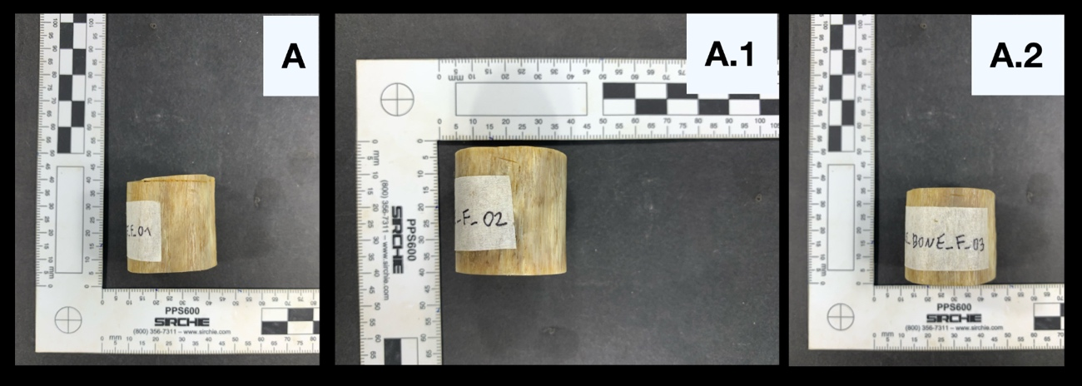
Figure S1: Fresh femur samples before the compression test. Height is 30mm. A = fresh femur 1, A.1 = fresh femur 2 and A.2 = fresh femur 3.
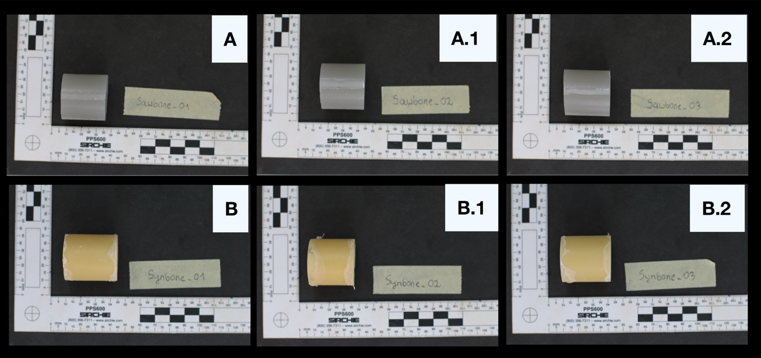
Figure S2: Sawbone (A) and Synbone (B) samples before the compression test. Height is 30mm. A = Sawbone 1, A.1 = Sawbone 2, A.2 = Sawbone 3, B = Synbone 1, B.1 = Synbone 2 and B.2 = Synbone 3.
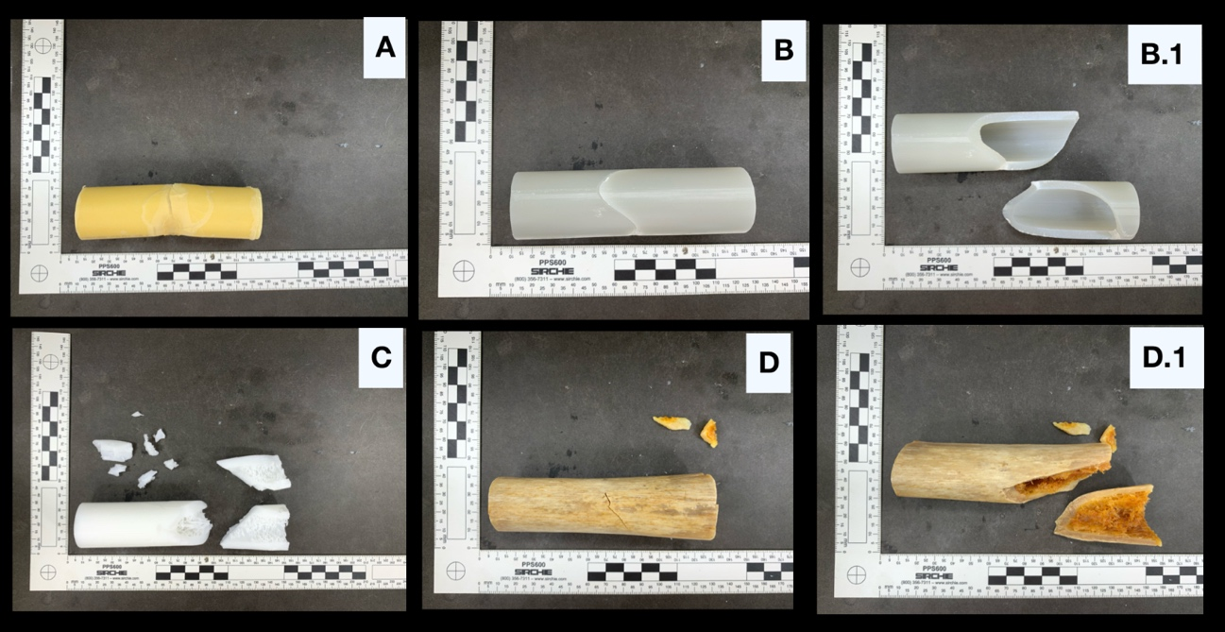

Figure S3: A representation of one sample per group after the 3-point bending test. A = Synbone 1, B & B.1 = Sawbone 1, C = PhyB F4K 1 and D & D.1 fresh femur

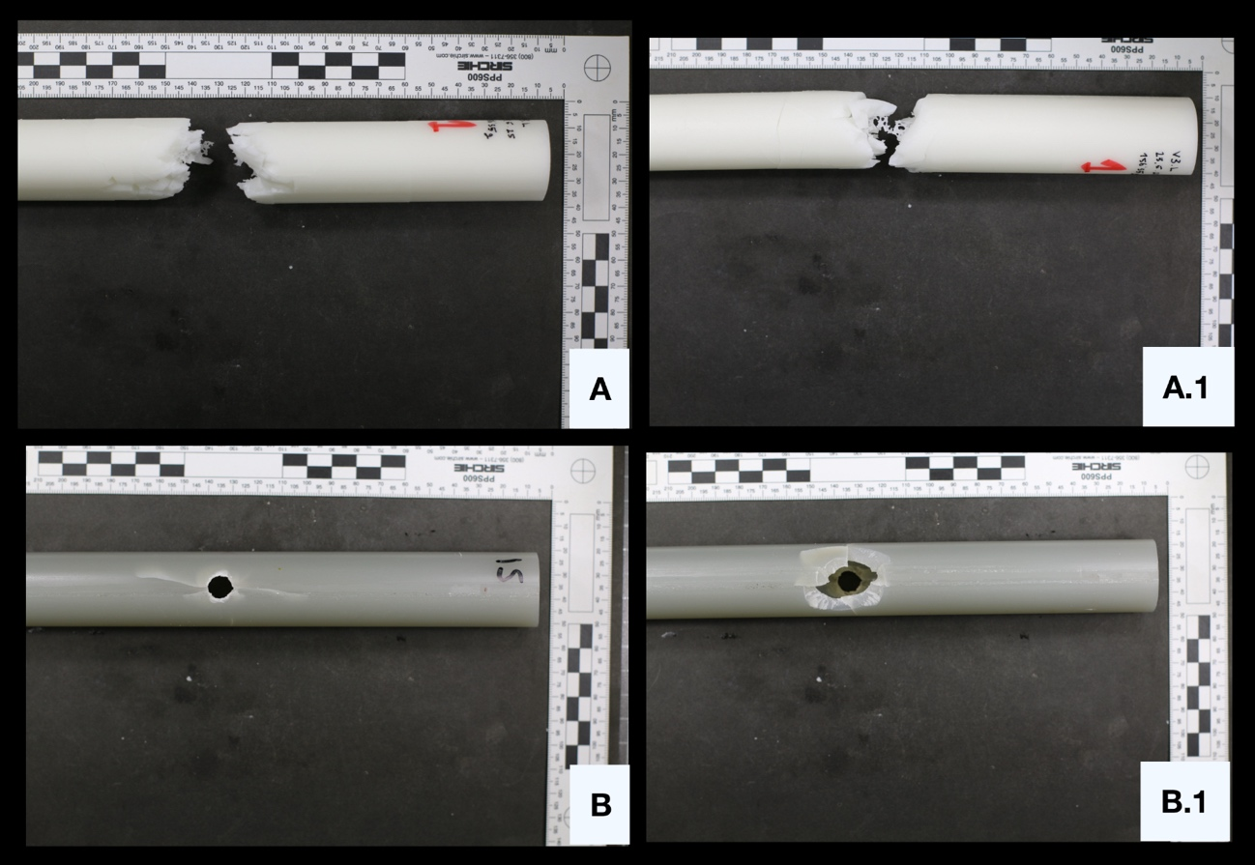
Figure S4: A representation of the PhyB F4K and Sawbone model after the GST experiment. A = PHyB F4K side view, A.1 = PhyB F4K side view, B = Sawbone entrance site and B.1 = Sawbone exit site.

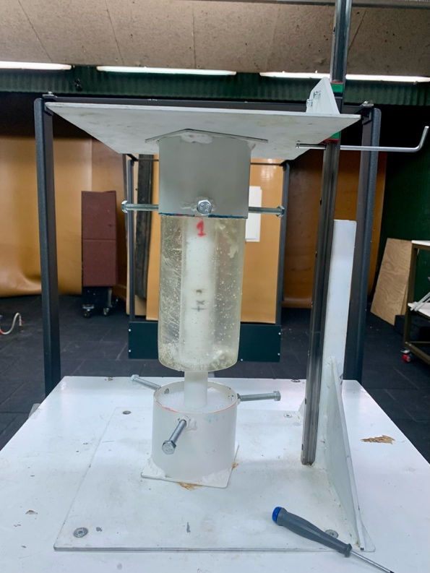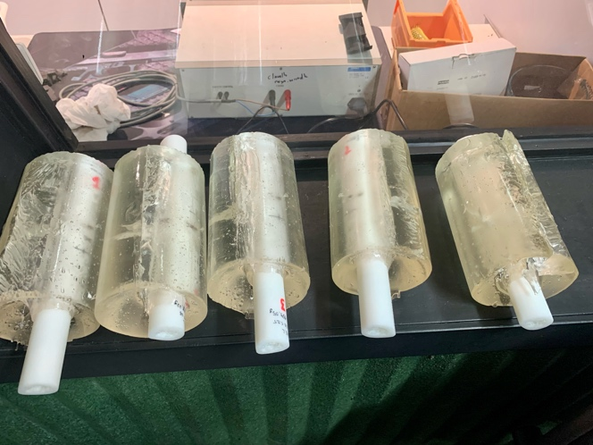
Figure S5: Phygital samples included in ballistic gel. (Left) Gelatine block placed in sample holder before shooting

