Supplemental information

Maternal Rbm24a orchestrates temporal organization and maintains homeostasis of germ granules to safeguard germ cell fate

Yizhuang Zhang, Ziping Fu, Jiayi Zhou, Panfeng Li, Ang Li, Ye Hong, De-Li Shi, Ming Shao
Supplementary information
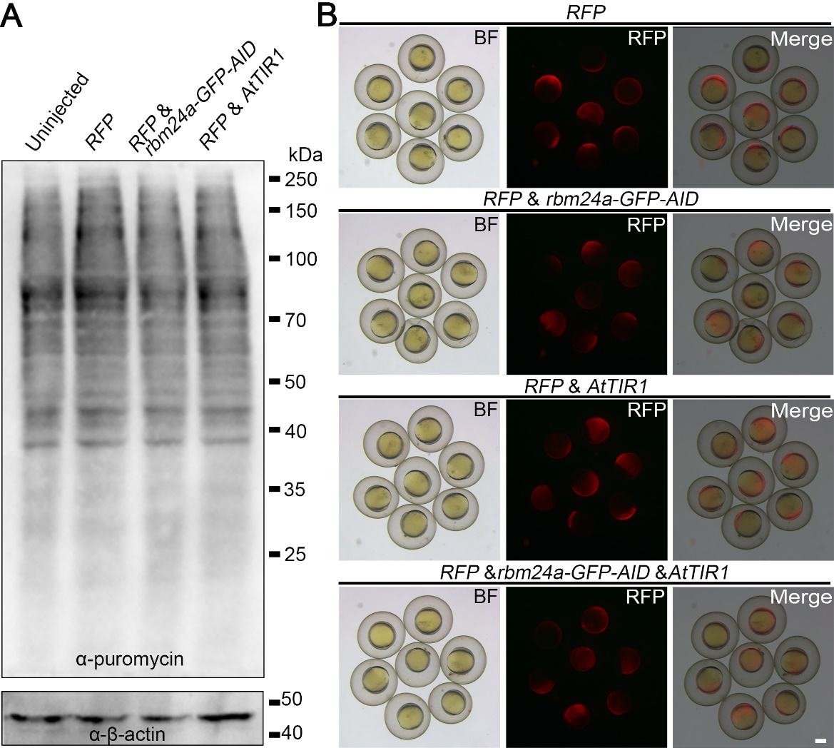
Figure S1. Assessment of translational stress following mRNA injection
(A) Puromycin incorporation assay demonstrating that mRNA injection does not induce dsRNA-mediated global translational inhibition
(B) mRNAs used in this study were co-injected with a reporter RFP mRNA; RFP translation remained unaffected, indicating that co-injected mRNAs do not impair translational efficiency.
Scale bar: 200 μm.
Figure S2. Transgenic zebrafish line enabling AID-mediated degradation of Rbm24a
(A) A homozygous rbm24a-GFP-AID KI & Tg(ef1α:AtTIR1;CMV:RFP) (hdTg) with tissue-specific GFP signal and homogeneous RFP expression.
(B) Quantification of the number of embryos obtained per spawn from wild-type (WT) and hdTg breeders.
(C) Survival assay of wild-type and hdTg embryos.
(D) Rbm24a-GFP-AID expression in hmTg and hdTg embryos at 5 hpf and 8 hpf.
(E) Quantification of Rbm24a-GFP-AID expression shown in D.
(F) Morphological assessment of hdTg embryos continuously treated with 1 mM K-NAA from the 1-cell stage. Untreated WT and hdTg siblings serve as negative controls; rbm24a CRISPants act as positive controls.
P values were calculated by unpaired Student’s t test. Scale bars: 250 μm.

Figure S3. Tissue-specific AID efficiency on Rbm24a in zebrafish embryos
(A) Gantt chart summarizing the eight K-NAA treatment windows. The fluorescence read-outs were collected at 24 hpf.
(B) Representative Rbm24a-GFP-AID expression in the heart after the indicated K-NAA treatments.
(C) Quantification of myocardial GFP intensity.
(D) Bright-field images at 2 dpf and 3 dpf illustrating normal morphology (upper panels) and severe pericardial edema (lower panels).
(E) Incidence of edema in the cohorts analyzed in D.
(F) Representative skeletal muscle expression of Rbm24a-GFP-AID.
(G) Quantification of GFP levels in somites.
(H) and (I) Rbm24a-GFP-AID expression in skeletal muscle of untreated (H) and K-NAA treated (I) 24-hpf embryos revealed by confocal imaging.
(J) and (K) Magnified confocal image of H and I.
(L) Rbm24a-GFP-AID signal in the lens of untreated and K-NAA treated embryos at 24 hpf.
(M) Quantification of GFP intensity in the lens after different treatments.
(N) and (O) Rbm24a-GFP-AID distribution in the lens of untreated and K-NAA-treated embryos at 24 hpf.
(P) Inefficient degradation of Rbm24a-GFP-AID in inner ear hair cells.
(Q) Quantification of GFP expression in inner ear hair cells in untreated and K-NAA treated embryos at 24 hpf.
(R) and (S) Single-plane confocal images of anterior and posterior hair-cell clusters in untreated (R) and treated (S) embryos.
Values are mean ± SD. P values were calculated by unpaired Student’s t test. Scale bars: N-S 20 μm; others: 100 μm.

Figure S4. Time-resolved K-NAA treatment of hdTg embryos reveals an early essential role for Rbm24a in PGC maintenance.
(A-F) Representative nanos3 expression in untreated (A, D), 0-3 hpf K-NAA-treated (B, E), and 3–6 hpf K-NAA-treated (C, F) embryos at 6 hpf (A-C) and 24 hpf (D-F).
(G) Phenotypic analysis of hdTg embryos following time-course K-NAA treatment.
(H, I) Loss of Rbm24a-GFP-AID signal in PGCs of K-NAA-treated hdTg embryos at 24 hpf, whereas expression is retained in untreated controls.
(J) Testis morphology in untreated adult hdTg fish.
(K) Abnormal testis morphology in adult hdTg fish treated with K-NAA from 1–4 hpf.
(L) Testis sections with H&E staining showing germ cells in untreated hdTg fish. SG, spermatogonia; SS, spermatocytes; ST, spermatids; SP, spermatozoa.
(M) Absence of germ cells in the testes of K-NAA-treated hdTg fish.
Scale bars: 250 μm.
Figure S5. Early depletion of maternal Rbm24a causes reduced germ granule size at 4 hpf
(A) Representative images of germ granules in untreated control embryos and Rbm24a early-depleted embryos at 4 hpf.
(B) Quantification of germ granule size at 4 hpf in control and Rbm24a-depleted embryos.
The horizontal line indicates the mean value of each group.
P values were calculated by unpaired Student’s t test. Scale bar: 20 μm.
Figure S6. Temporal dynamics of Rbm24a-dependent stability of germ plasm mRNAs
(A) Expression profiles of five canonical germ plasm mRNAs during early development, based on RNA-seq data from White et al., 2017.⁴⁴
(B) During developmental progression, Rbm24a localization exhibits pronounced temporal dynamics. In particular, Rbm24a displays robust co-localization with Piwil1 at 4 hpf; however, this spatial correlation progressively diminishes after the onset of gastrulation.
(C, D) Depletion of Rbm24a at later stages does not alter the stability of nanos3 mRNA, either at the 6-somite stage (C) or at 24 hpf (D).
(E, F) Removal of Rbm24a at gastrulation abolishes ca15b expression in embryos at either the 6-somite stage (E) or 24 hpf (F).
Scale bars: 10 μm.
Figure S7. zGrad-mediated degradation of Rbm24a-GFP and its impact on PGC formation.
(A, B) Injection of zGrad mRNA abolishes Rbm24a-GFP fluorescence in rbm24a-GFP KI embryos.
(C) Western blot validation of Rbm24a-GFP degradation following zGrad mRNA injection in rbm24a-GFP KI embryos.
(D) Loss of PGC markers in zGrad mRNA–injected rbm24a-GFP KI embryos at the shield stage and 24 hpf.
(E) Schematic illustrating generation of a transgenic line ubiquitously expressing zGrad and RFP.
(F) RFP expression in a Tg(ef1α:zGrad;CMV:RFP) embryo.
(G) Transgenesis does not affect fecundity, as measured by the number of embryos per spawn.
(H) Survival of transgenic fish is comparable to that of wild-type controls.
(I) Tg(ef1α:zGrad;CMV:RFP) embryos exhibit normal development at 27 hpf.
Values are mean ± SD. P values were calculated by unpaired Student’s t test. Scale bars: 250 μm.

