Supplementary Material

Supplementary Table 1. Rationale behind each type of sample collection.

Tissue Type | Amount of Sample Collected | Rationale Behind Sample Collection
Blood | 20 mL | Blood represents the mesoderm germ layer. Blood was collected in EDTA tubes, DNA was extracted from leukocytes. Cell free DNA was collected from blood as well, cell free DNA flows through the blood stream.
Buccal | A single swab | DNA from buccal cells were extracted. A buccal sample represents the ectoderm germ layer.
Urine | 50 mL | DNA was extracted from urethral cells and free-floating DNA in urine. Urine represents the endoderm germ layer.
Sputum | 4 mL | DNA was collected from sputum in a saliva kit. Sputum represents the mesoderm and ectoderm germ layers and is similar to whole blood.
Hair | Multiple shafts with hair follicles | DNA was extracted from hair follicles. Hair represents the ectoderm germ layer.
Nail | Multiple toe nail clippings | DNA was extracted from nail clippings. Nails represent the ectoderm germ layer.

Supplementary Table 2. Phenotypes of 21 probands whose parents tested positive for low-level somatic mosaicism via amplicon NGS.
Gene | Variant | ACMG | DD/NDD | Proband phenotype | Symptoms in Probands Initially Referred for ES testing
CACNA1C | c.694G>C | VUS | DD | Timothy Syndrome [MIM:601005] | Prenatal history of polyhydramnios
COL6A3 | c.218A>G | VUS | NDD | Bethlem myopathy [MIM:58810] | History of global developmental delays, history of neuroregression post seizures, hypotonia, relative macrocephaly, and failure to thrive.
COL11A1 | c.3816+2dupT | Pathogenic | NDD | Stickler Syndrome 2: [MIM:604841] | Bilateral talipies equinovarus, retinal lattice degeneration, sensourineal hearing loss, and dysmorphic features.
DLL4 | c.586G>A | Likely pathogenic | NDD | Adams-Oliver syndrome [OMIM:616589] | History of IUGR, failure to thrive, idiopathic vein thrombosis, s/p splendectomy,and spleno renal shunt, complicated gastrointestinal bleeds
HUWE1 | c.12257G>A | Likely pathogenic | DD | Mental retardation, X-linked, turner type [MIM:30076] | Delayed motor milestones, delayed speech, autism spectrum disorder behavior problems, intellectual disability, ataxia, lack of coordination, dysmorphic features, sleep disturbances, sleep,apnea
IFT172 | c.4161-1G>A | Pathogenic | NDD | Retinitis pigmentosa [MIM:616394] | Developmental delays, autism spectrum disorder, delayed speech, nystagmus, retinal folds, retinal detachment, strabismus, ablymopia and myopia.
KIF1A | c.1132C>T | VUS | NDD | Polyhydramnios | Gastrointestinal dysmotility ,delayed motor milestones, visual impairment, static encephalopathy attributed to birth trauma, patient foramen ovale, brain atrophy
KIF1A | c.757G>A | Pathogenic | DD | Mental retardation, autosomal dominant 9 [MIM:614255] | Polyhydramnios, intrauterine growth restriction, respiratory failure, primary apnea of newborn, pulmonary edema, atelectasis, flexion contractures, congenital multiple arthrogryposis
NRXN2 | c.3382G>A | VUS | DD | Autism spectrum disorder | Global developmental delays, a history of speech regression, aggressive behavior, and macrocephaly
PDCD10 | c.474+5G>A | Pathogenic | NDD | Cerebral cavernous malformations 3 [MIM:603285] | Neutropenia, thrombocytopenia, a history of deep vein thrombosis and brain abscesses
PIGA | c.986T>C | Likely pathogenic | DD | Multiple congenital anomalies-hypotonia-seizures syndrome 2 [MIM:300868] | Delayed motor milestones, delayed visual maturation, epileptic encephalopathy, deep gray matter diffusion, hypsarrythmia, hypertonia and postnatal failure to thrive
PTEN | c.542T>C | Pathogenic | NDD | Cowden syndrome 1 [OMIM:158350] | Thoracic aortic aneurism, abnormal tricuspid valve morphology, abnormal aortic arch morphology, myopia, macrocephaly, cognitive impairment, and autistic behavior
PTPN11 | c.923A>G | Pathogenic | DD | Noonan syndrome 1 [MIM:163950] | Short stature, feeding difficulties, mild speech delay, mild dysmorphic features, down slanting palpebral, fissures, and posteriorly rotated ears
PTPN11 | c.923A>G | Pathogenic | DD | Noonan syndrome 1 [MIM:163950] | Atrioventricular septal defect, polyvalvular thickening, bicuspid aortic valve, deep sacral dimple
PTPN11 | c.922 A>G | Pathogenic | DD | Noonan syndrome 1 [MIM:163950] | Connective tissue disorder, delayed speech and language development, delayed motor milestones, developmental regression, seizures, hypertelorism, abnormality of the external nose
RBFOX1 | c.474 + 6T>C | VUS | DD | Autism spectrum disorder | Intractable epilepsy, global developmental delay, intellectual disability, autism, Floating Harbor Syndrome
SMARCA2 | c.2254 G>A | Likely pathogenic | DD | Nicolaides-Baraister syndrome [MIM:601358] | Global developmental delay, developmental regression, delayed cranial suture closure, dry cracking skin, fine hair, failure to thrive, sister has significant history of Asperger’s syndrome and ADHD
SMARCA4 | c.2936G>A | Pathogenic | DD | Coffin Siri syndrome 4 [MIM: 614609] | Congenital diaphragmatic hernia, dextrocardia, pulmonary hypoplasia, polyhydramnios, cleft palate, macrocephaly, dysmorphic features
TPM1 | c.475 G>A | Likely pathogenic | NDD | Cardiomyopathy [MIM:115196] | Cardiac arrest, tricuspid regurgitation, mitral regurgitation
USP7 | c.238A>T | Likely pathogenic | DD | Intellectual disability and autism spectrum disorder [PMID: 26365382] | Motor delays, aortic root dilation, generalized hypotonia abdominal distension, syndactyly and dysmorphic features
ZBTB20 | c.1916G>A | Likely pathogenic | DD | Primrose syndrome [MIM:259050] | Developmental delay, delayed speech, intellectual disability, macrocephaly, possible craniosynostosis

DD, developmental disorder, NDD, non-developmental disorder.

Supplementary Table 3. Comparison of the levels of parental mosaicism taken over two time points in DNA extracted from lymphocytes in the same individual. NA, none accountable. ND, not detectable

Parent | Gene | Variant | Year of First Blood Sample | Year of Second Blood Sample | Percent VAF in First Blood Sample | Percent VAF in Second Blood Sample
M1 | IQSEC2 | c.3279G>A | 2012 | 2021 | NA | 14%
M1 | USP7 | c.238A>T | 2018 | 2021 | 11% | 9%
M2 | PTPN11 | c.923A>G | 2019 | 2021 | 0.3% | 0.3%
M3 | PTPN11 | c.923A>G | 2017 | 2021 | 0.3% | 0.3%
M4 | COL11A1 | c.3816+2dupT | 2018 | 2021 | 0.2% | ND
M5 | CACNA1C | c.694G>C | 2019 | 2021 | 2% | ND

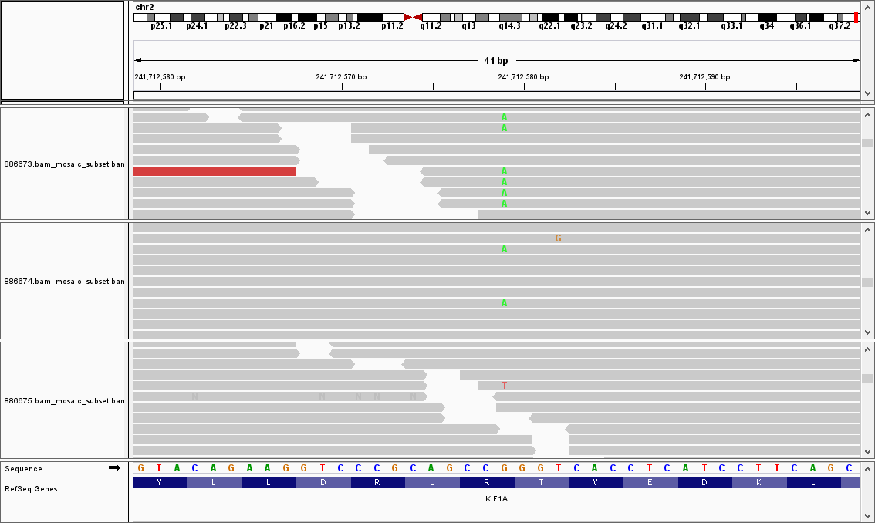
Father
Mother
Proband

Supplementary Figure 1. Visualization of the c.757G>A variant in exon 13 of the KIF1A gene seen in trio ES BAM files from a mother and the proband. Trios identified automatically via a bioinformatics script that queried the ES database at BG were screened manually for alternate reads at the position of the clinically relevant variant.

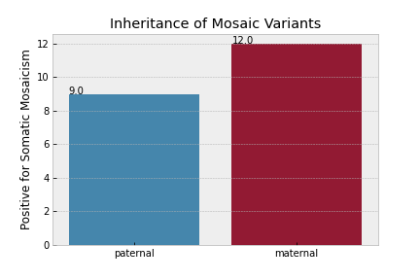
Supplementary Figure 2. Parental origin of the 21 mosaic variants identified via amplicon NGS.

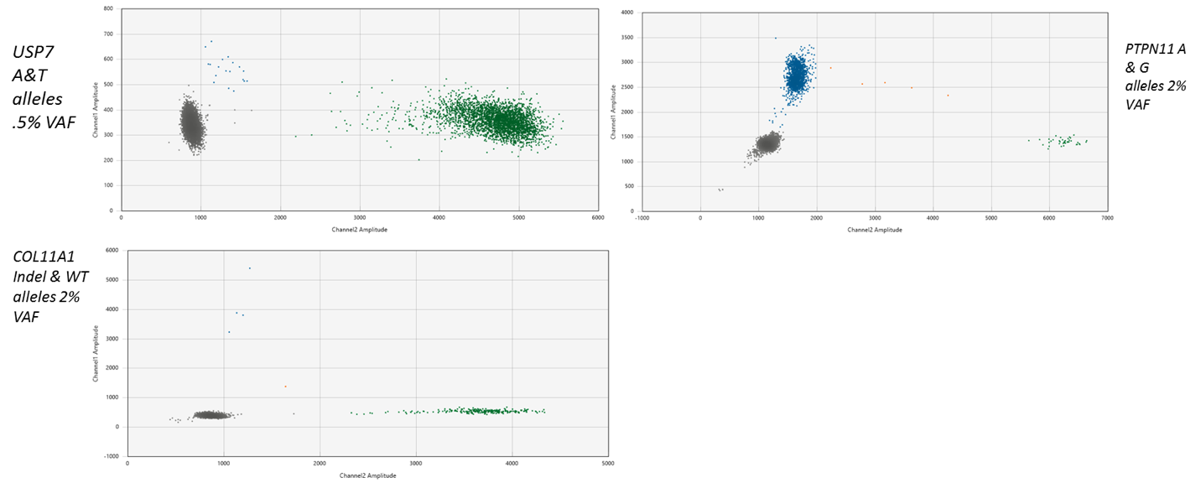

Supplemental Figure 3. Results of ddPCR experiments performed to determine the limit of detection (LOD) using gblocks.

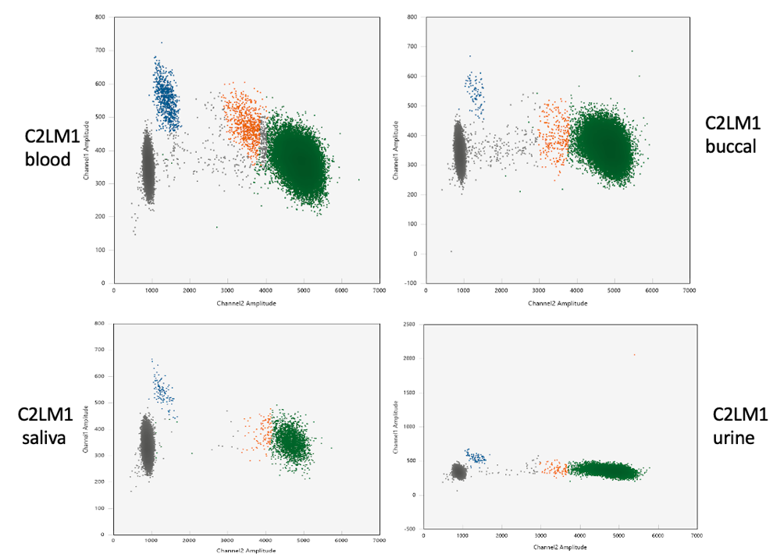
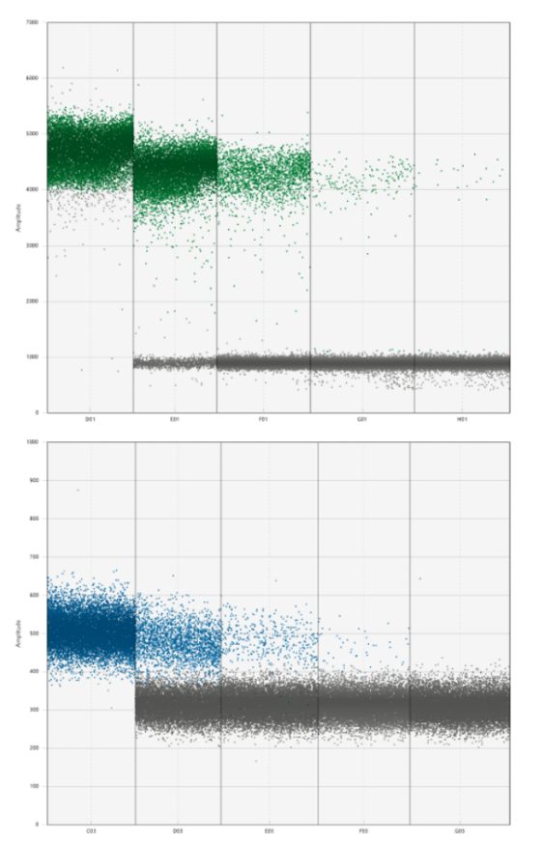

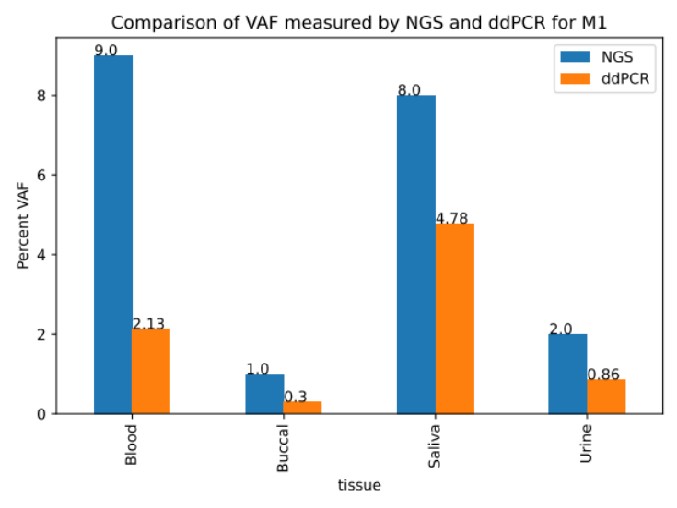

Supplementary Figure 4. a) USP7 T allele dilution series (4070 copies/ul to 2.65 copies/ul) in parent M1. b) A allele dilution series (6868 copies/ul to 0.0833 copies/ul). c) ddPCR 2-D plots of droplets of USP7: T and A alleles in different tissues. d) comparison of VAF between NGS and ddPCR across tissue type.

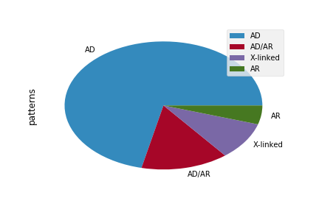
Supplementary Figure 5. Pie graph showing inheritance pattern of positive mosaic cases.

