DESCRIPTIVE ANALYSES

This section presents a descriptive and graphical analysis of the main variables included in the study. The normality test for quantitative variables is also reported to determine whether parametric or non-parametric tests should be used in subsequent hypothesis testing.
When the number of observations is greater than 50, the Kolmogorov-Smirnov statistic is considered for the normality test; when the number of observations is below 50, the Shapiro-Wilk statistic is used. If the p value of the normality test is significant (p < 0.05), the null hypothesis of normal distribution is rejected and the variable is considered not normally distributed. Conversely, when the p value is not significant (p > 0.05), the data may be considered compatible with a normal distribution.
Age | Mean | SD | Lower CI | Upper CI | Median | P25 | P75
 | 47.55 | 13.30 | 44.11 | 50.99 | 49.50 | 35.50 | 58.00

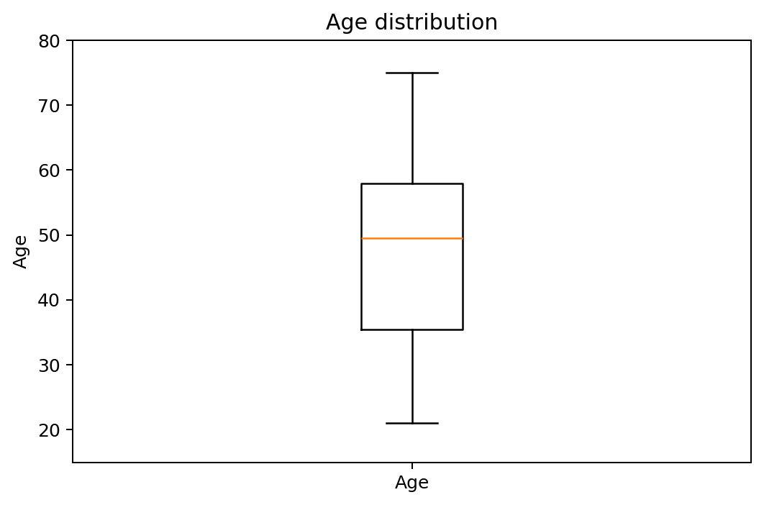
Figure 1. Age distribution.

Variable | Category | N | %
Sex | Male | 34 | 56.7%
Sex | Female | 26 | 43.3%
Tooth type | Premolar | 10 | 16.7%
Tooth type | Molar | 50 | 83.3%
Removal technique | Selective | 30 | 50.0%
Removal technique | Complete | 30 | 50.0%
Pulp exposure | No | 36 | 60.0%
Pulp exposure | Yes | 24 | 40.0%
Preoperative pulp vitality | Negative | 0 | 0.0%
Preoperative pulp vitality | Positive | 60 | 100.0%
Postoperative pulp vitality | Negative | 1 | 1.7%
Postoperative pulp vitality | Positive | 59 | 98.3%
Pulp vitality at 6 months | Negative | 11 | 18.3%
Pulp vitality at 6 months | Positive | 49 | 81.7%
Restoration success | No | 11 | 18.3%
Restoration success | Yes | 49 | 81.7%

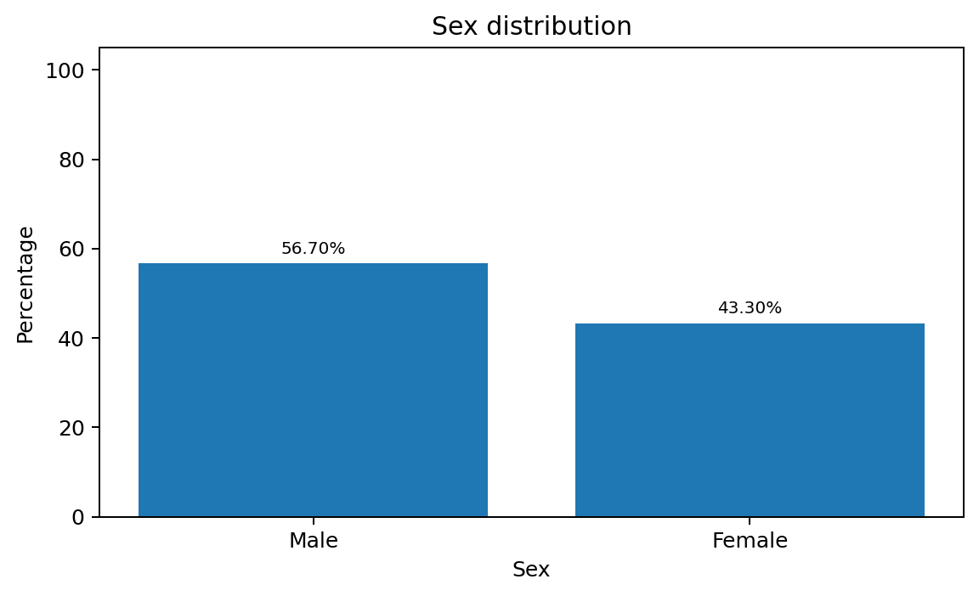
Figure 2. Sex distribution.
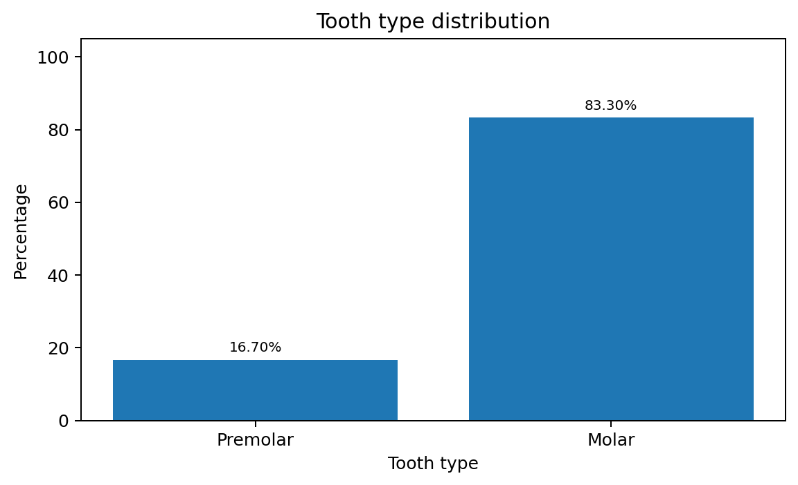
Figure 3. Tooth type distribution.
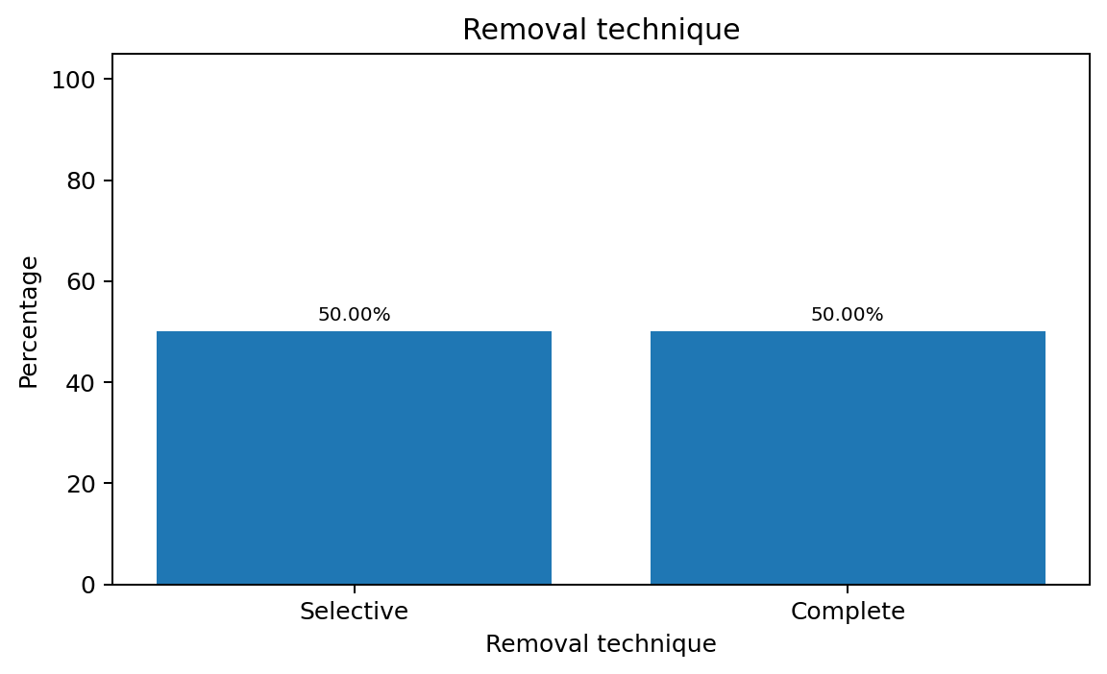
Figure 4. Distribution by removal technique.
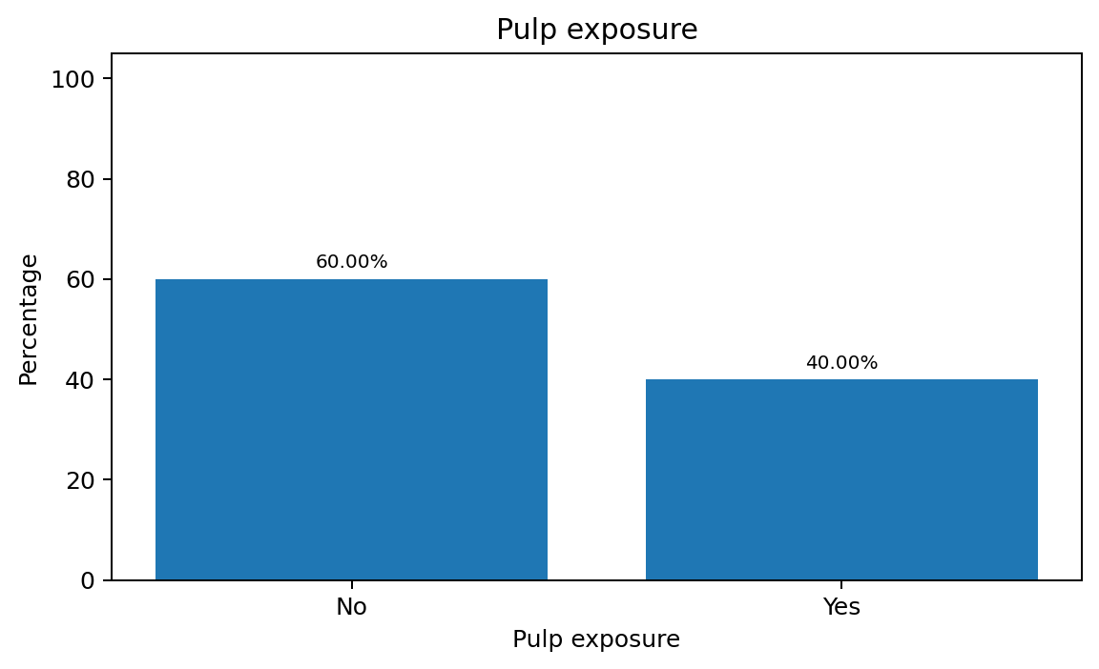
Figure 5. Pulp exposure.
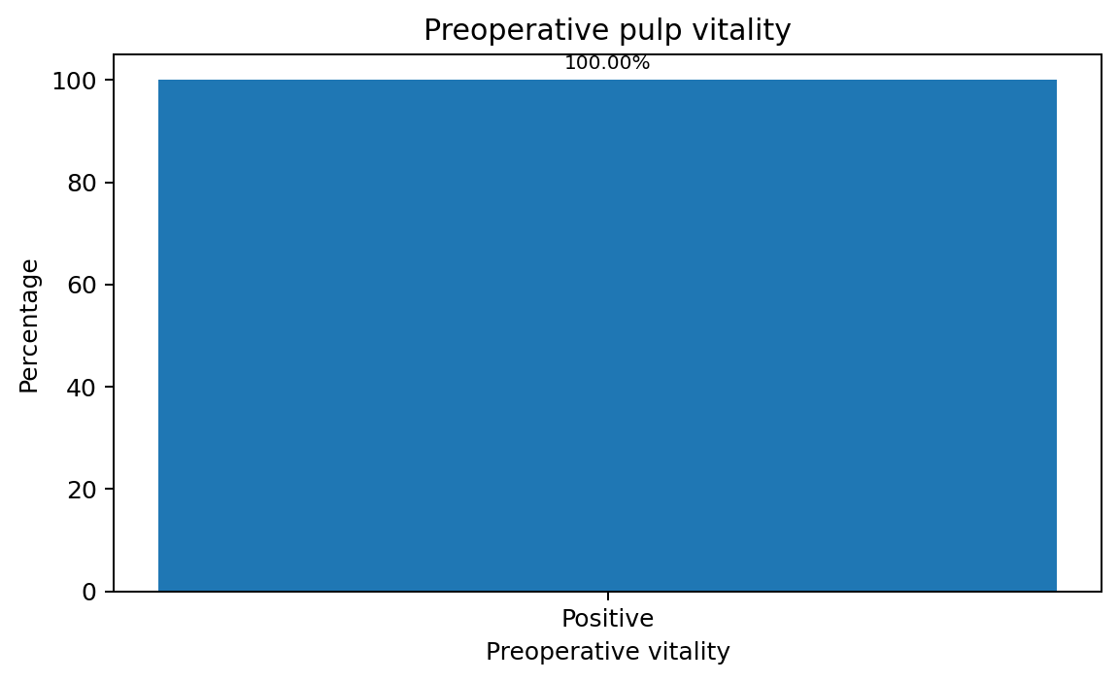
Figure 6. Preoperative pulp vitality.
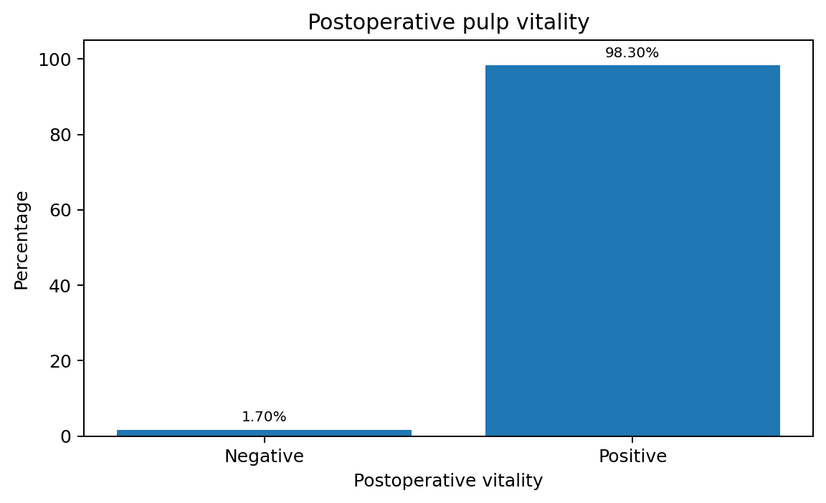
Figure 7. Postoperative pulp vitality.
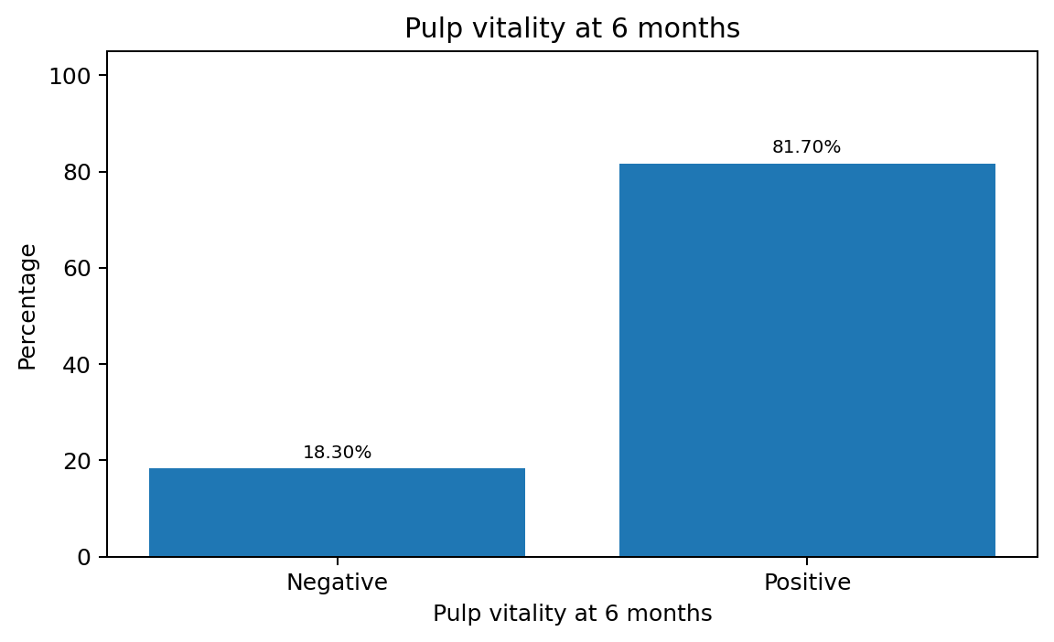
Figure 8. Pulp vitality at 6 months.
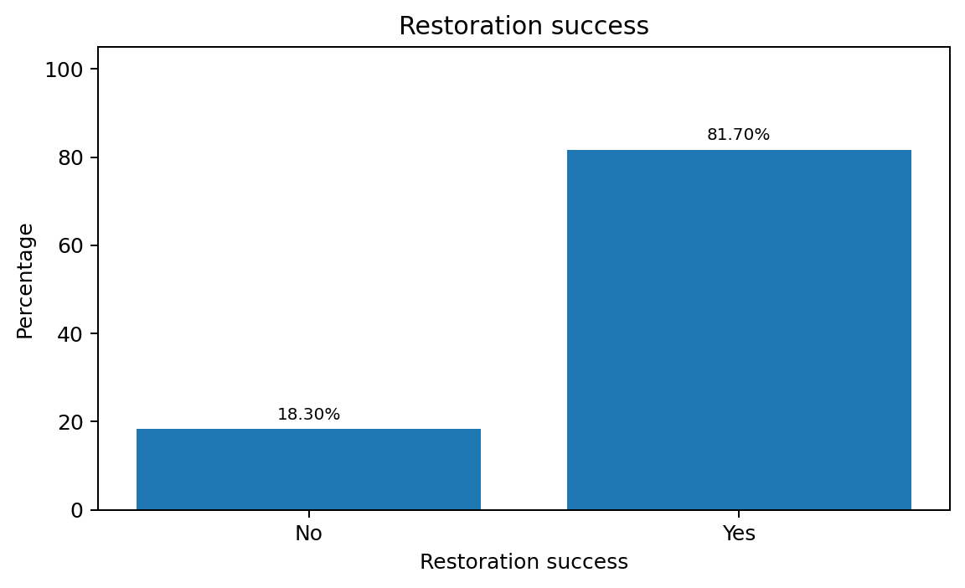
Figure 9. Restoration success.

HYPOTHESIS TESTING

INDEPENDENCE TESTS

This section assesses whether the main study variables are independent of selected factors. For quantitative variables, mean values are compared across the groups defined by qualitative or categorical variables.
Different independence tests are used depending on whether the quantitative variable follows a normal distribution within the categories of the qualitative variable. Parametric tests are used when the assumption of normality is met, whereas non-parametric tests are used when it is not. The type of test also depends on whether the categorical variable has two categories or more than two categories.
Among parametric tests, Student's t-test is used when the categorical variable has two categories, while analysis of variance (ANOVA) is used when it has three or more categories. Before applying a parametric test, Levene's test for homogeneity of variances is performed. Among non-parametric tests, the Mann-Whitney U test is used for two categories and the Kruskal-Wallis test for three or more groups. When independence between two qualitative variables is assessed, the chi-square test is applied.
All statistical tests were performed at a 95% confidence level using IBM SPSS Statistics version 29.0.
Factor | Category | Mean age | SD | Mann-Whitney p value
Removal technique | Selective | 48.90 | 13.19 | 0.412
Removal technique | Complete | 46.20 | 13.50
Pulp exposure | No | 47.39 | 13.72 | 0.994
Pulp exposure | Yes | 47.79 | 12.94
Restoration success | No | 51.00 | 16.16 | 0.450
Restoration success | Yes | 46.78 | 12.64

In the independence tests, when the p value is not significant (p > 0.05), there is no statistically significant difference in mean age between groups at the 95% confidence level.
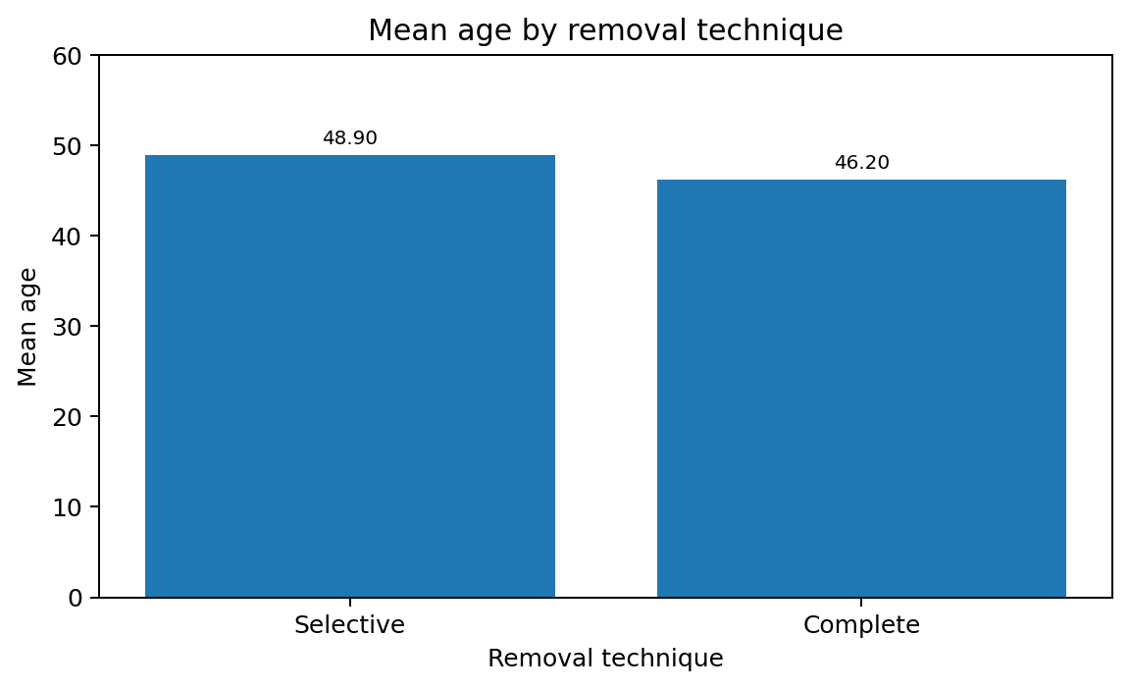
Figure 10. Mean age by removal technique.
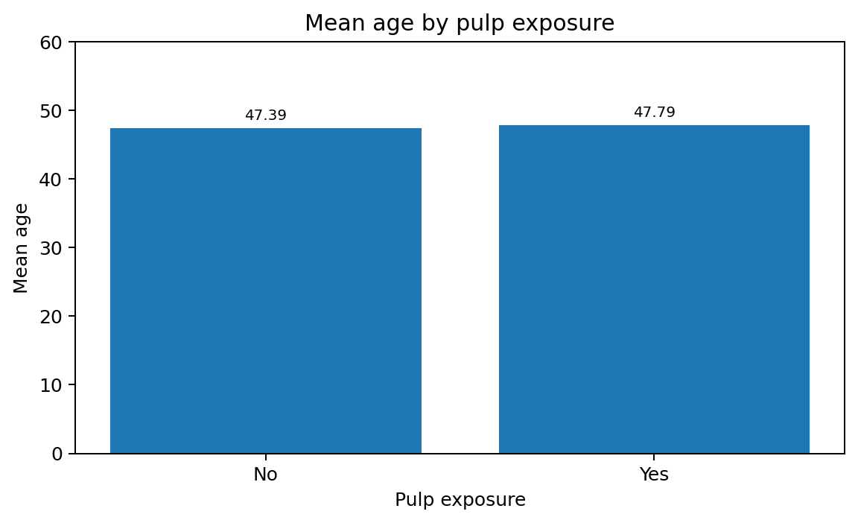
Figure 11. Mean age by pulp exposure.
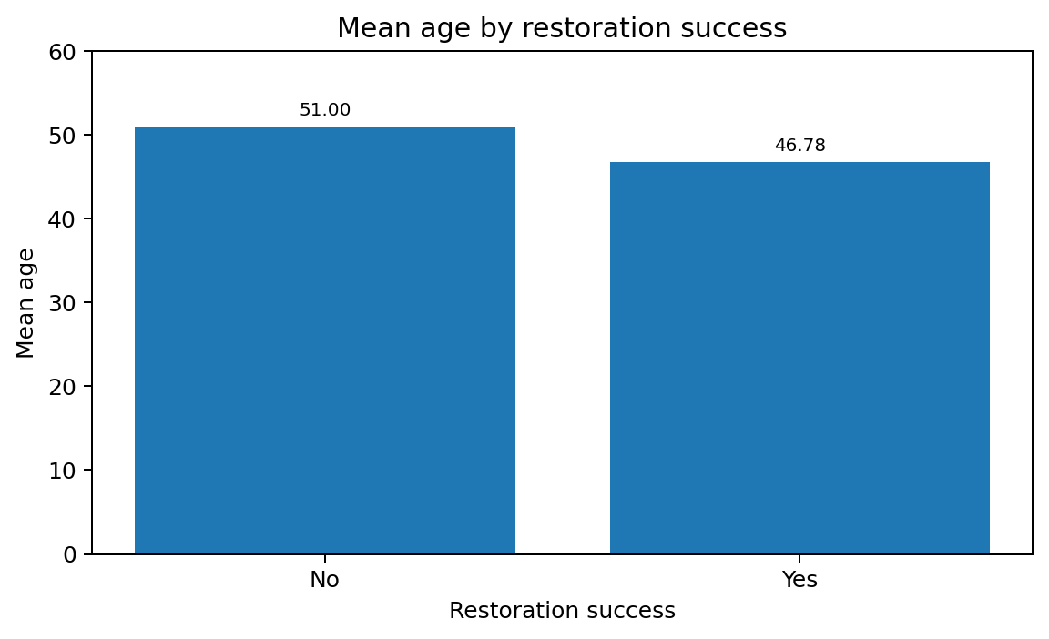
Figure 12. Mean age by restoration success.

Variable | Category | Selective n | Selective % | Complete n | Complete % | Chi-square p value
Sex | Male | 16 | 53.3% | 18 | 60.0% | 0.602
Sex | Female | 14 | 46.7% | 12 | 40.0%
Tooth type | Premolar | 4 | 13.3% | 6 | 20.0% | 0.488
Tooth type | Molar | 26 | 86.7% | 24 | 80.0%
Pulp exposure | No | 17 | 56.7% | 19 | 63.3% | 0.598
Pulp exposure | Yes | 13 | 43.3% | 11 | 36.7%
Preoperative pulp vitality | Negative | 0 | 0.0% | 0 | 0.0% | 0.999
Preoperative pulp vitality | Positive | 30 | 100.0% | 30 | 100.0%
Postoperative pulp vitality | Negative | 0 | 0.0% | 1 | 3.3% | 0.313
Postoperative pulp vitality | Positive | 30 | 100.0% | 29 | 96.7%
Pulp vitality at 6 months | Negative | 3 | 10.0% | 8 | 26.7% | 0.045*
Pulp vitality at 6 months | Positive | 27 | 90.0% | 22 | 73.3%
Restoration success | No | 3 | 10.0% | 8 | 26.7% | 0.045*
Restoration success | Yes | 27 | 90.0% | 22 | 73.3%

When the p value of the chi-square independence test is not significant (p > 0.05), no statistically significant association between the variables is observed at the 95% confidence level. When the p value is significant (p < 0.05), the null hypothesis of independence is rejected and a statistically significant association between the variables is considered present.
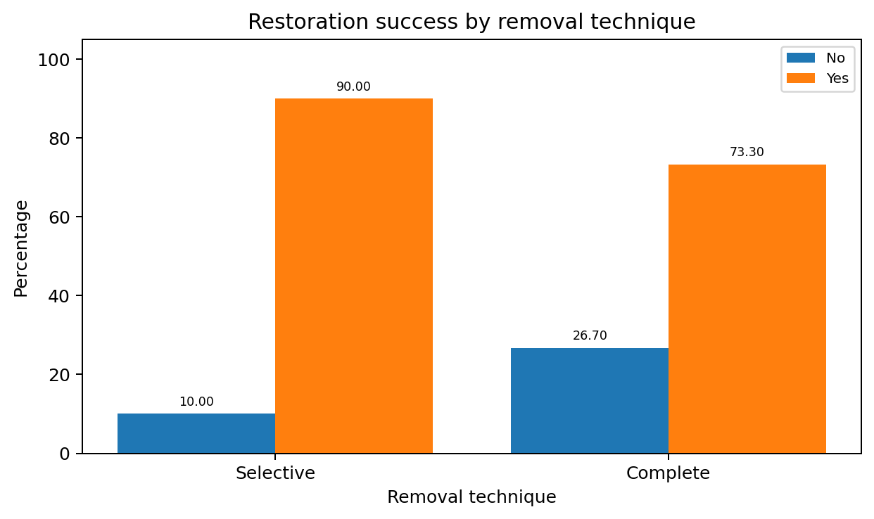
Figure 13. Restoration success by removal technique.
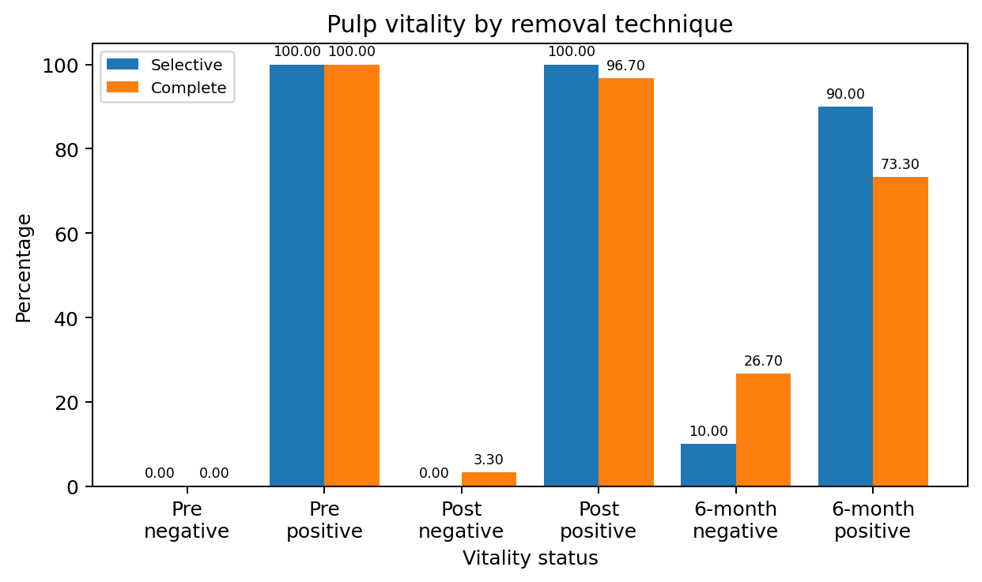
Figure 14. Pulp vitality by removal technique.
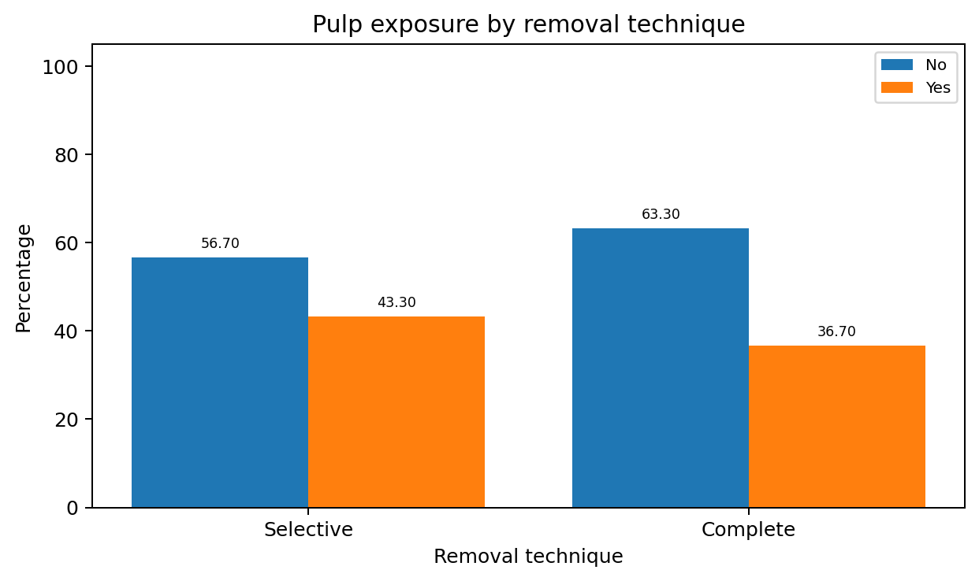
Figure 15. Pulp exposure by removal technique.
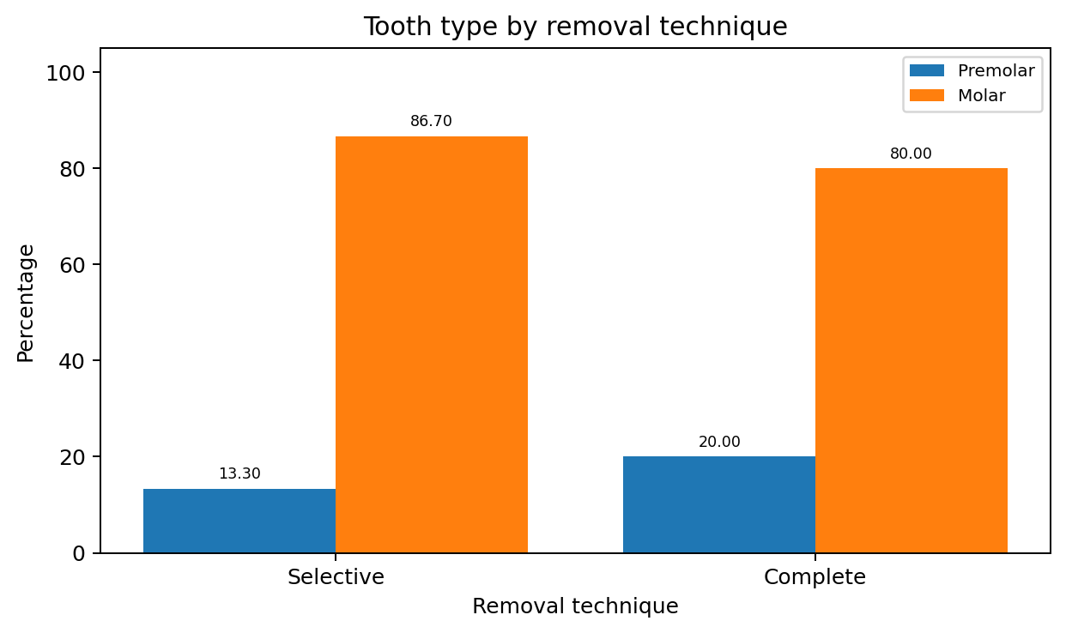
Figure 16. Tooth type by removal technique.
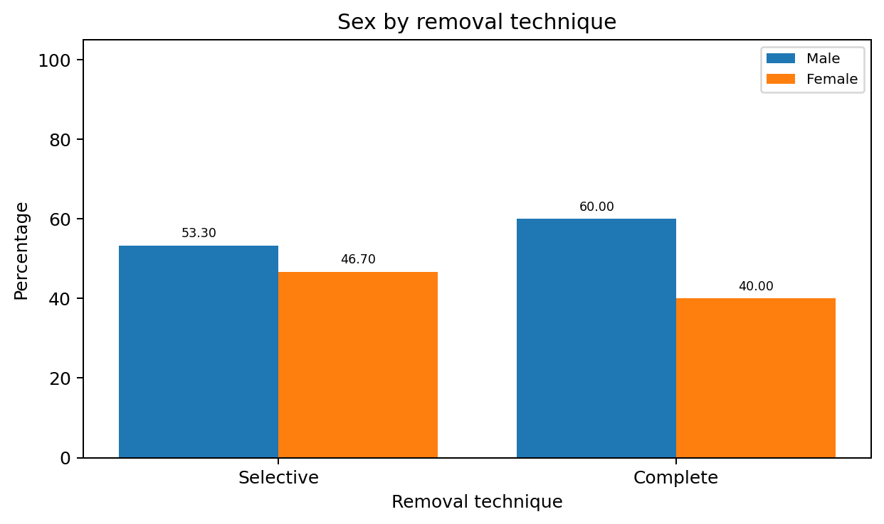
Figure 17. Sex by removal technique.

Variable | Category | Male n | Male % | Female n | Female % | Chi-square p value
Pulp exposure | No | 23 | 67.6% | 13 | 50.0% | 0.167
Pulp exposure | Yes | 11 | 32.4% | 13 | 50.0%
Preoperative pulp vitality | Negative | 0 | 0.0% | 0 | 0.0% | 0.999
Preoperative pulp vitality | Positive | 34 | 100.0% | 26 | 100.0%
Postoperative pulp vitality | Negative | 0 | 0.0% | 1 | 3.8% | 0.249
Postoperative pulp vitality | Positive | 34 | 100.0% | 25 | 96.2%
Pulp vitality at 6 months | Negative | 6 | 17.6% | 5 | 19.2% | 0.875
Pulp vitality at 6 months | Positive | 28 | 82.4% | 21 | 80.8%
Restoration success | No | 6 | 17.6% | 5 | 19.2% | 0.875
Restoration success | Yes | 28 | 82.4% | 21 | 80.8%

When the p value of the chi-square independence test is not significant (p > 0.05), no statistically significant association between the variables is observed at the 95% confidence level. When the p value is significant (p < 0.05), the null hypothesis of independence is rejected and a statistically significant association between the variables is considered present.
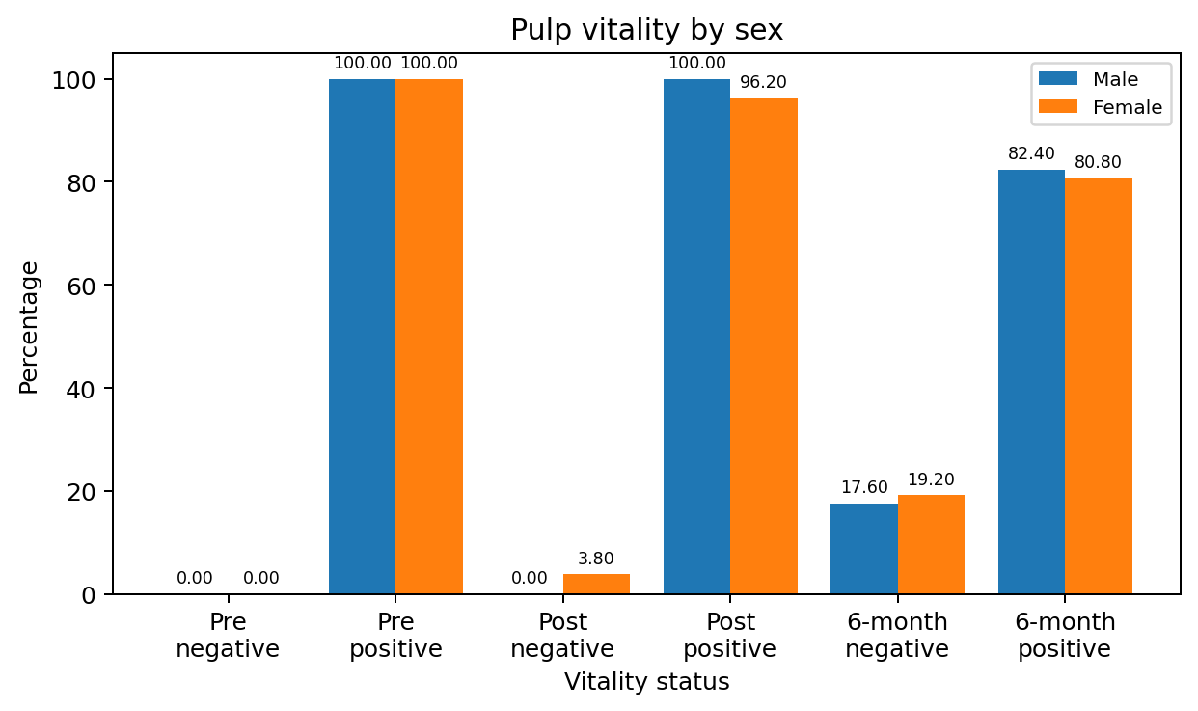
Figure 18. Pulp vitality by sex.
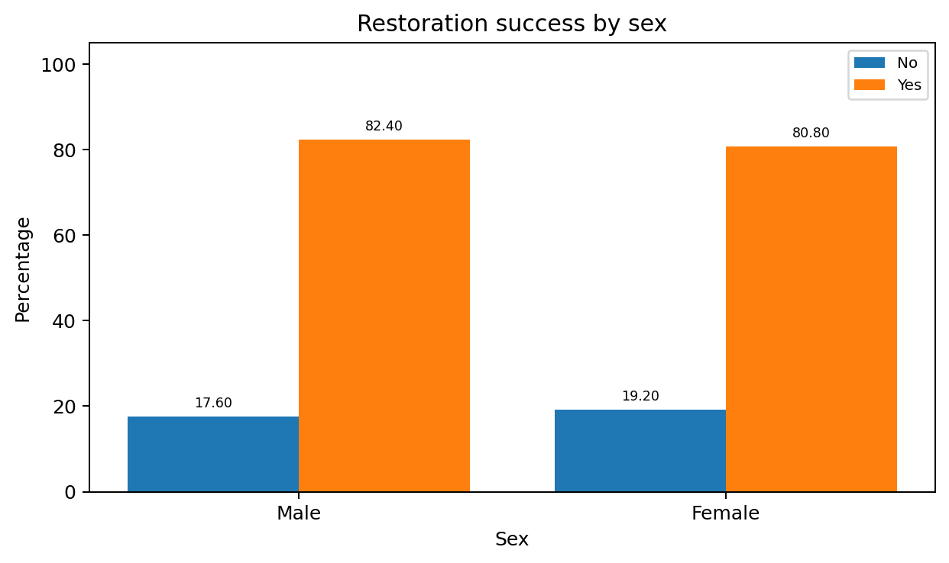
Figure 19. Restoration success by sex.
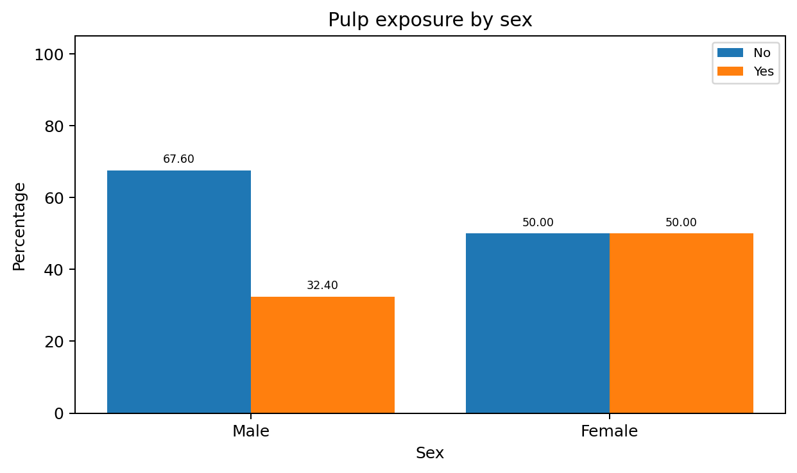
Figure 20. Pulp exposure by sex.

RELATED-SAMPLES TESTS

This section assesses whether statistically significant differences can be detected between the PRE and POST status of the study variables. For binary data, McNemar's test was used. This test is commonly applied in repeated-measures designs, where each subject's response is obtained twice: before and after a specified event. McNemar's test determines whether the initial response rate is equal to the final response rate and is useful for detecting changes in responses caused by an experimental intervention in before-after designs.
In related-samples tests, when the p value is significant (p < 0.05), a statistically significant difference in the response distribution between the PRE and POST status is considered present at the 95% confidence level.
Removal technique | Preoperative vitality | Postoperative negative n (%) | Postoperative positive n (%) | Total n (%) | McNemar p value
Selective | Positive | 0 (0.0%) | 30 (100.0%) | 30 (100.0%) | 1.000
Complete | Positive | 1 (3.3%) | 29 (96.7%) | 30 (100.0%) | 1.000
Total | Positive | 1 (1.7%) | 59 (98.3%) | 60 (100.0%) | 1.000

Table. McNemar test comparing preoperative and postoperative pulp vitality.
Removal technique | Preoperative vitality | 6-month negative n (%) | 6-month positive n (%) | Total n (%) | McNemar p value
Selective | Positive | 3 (10.0%) | 27 (90.0%) | 30 (100.0%) | 1.000
Complete | Positive | 8 (26.7%) | 22 (73.3%) | 30 (100.0%) | 1.000
Total | Positive | 11 (18.3%) | 49 (81.7%) | 60 (100.0%) | 1.000

Table. McNemar test comparing preoperative and 6-month pulp vitality.
Removal technique | Postoperative vitality | 6-month negative n (%) | 6-month positive n (%) | Total n (%) | McNemar p value
Selective | Positive | 3 (10.0%) | 27 (90.0%) | 30 (100.0%) | 1.000
Complete | Negative | 1 (100.0%) | 0 (0.0%) | 1 (100.0%) | 0.342
Complete | Positive | 7 (24.1%) | 22 (75.9%) | 29 (100.0%)
Complete total |  | 8 (26.7%) | 22 (73.3%) | 30 (100.0%)
Overall | Negative | 1 (100.0%) | 0 (0.0%) | 1 (100.0%) | 0.654
Overall | Positive | 10 (16.9%) | 49 (83.1%) | 59 (100.0%)
Overall total |  | 11 (18.3%) | 49 (81.7%) | 60 (100.0%)

Table. McNemar test comparing postoperative and 6-month pulp vitality.

