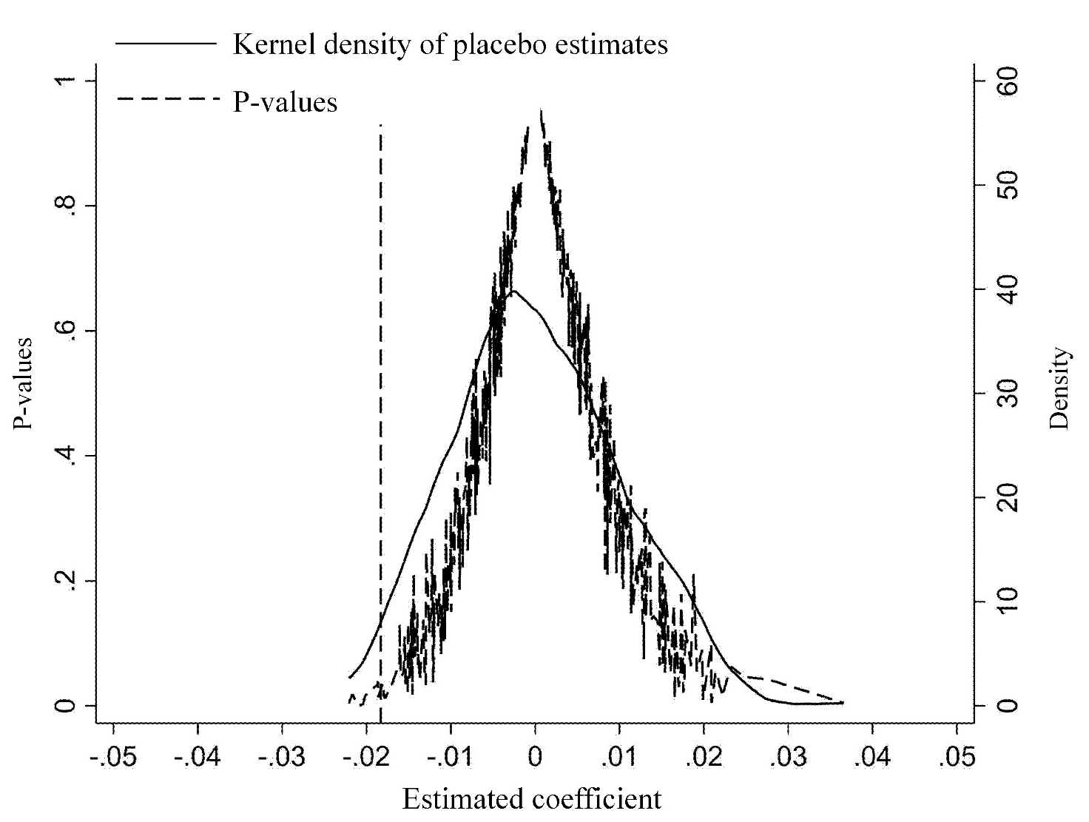
Supplementary Fig. S1. Placebo test results.

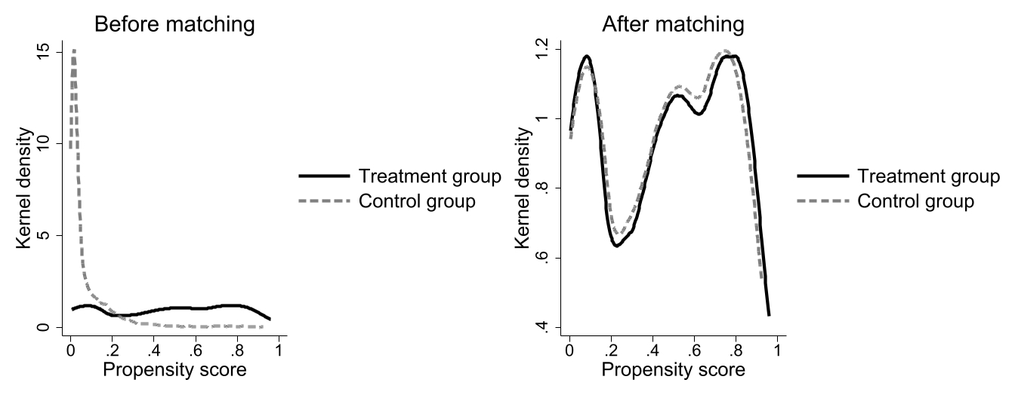
Supplementary Fig. S2. Propensity-score density before and after matching.

Supplementary Table S1 Heterogeneity analysis
Variable | Age | Gender | Chronic disease | ADL impairment | Having children | Residence | Region
Healthy City pilot policy | 0.1277**  (0.0576) | -0.0084  (0.0083) | -0.0252**  (0.0103) | -0.0197**  (0.0076) | -0.0739**  (0.0359) | -0.0075  (0.0110) | -0.0047  (0.0095)
Healthy City pilot policy × Age | -0.0021**  (0.0009)
Healthy City pilot policy × Male |  | -0.0173*  (0.0097)
Healthy City pilot policy × Chronic disease |  |  | 0.0138  (0.0103)
Healthy City pilot policy × ADL impairment |  |  |  | 0.0180*  (0.0103)
Healthy City pilot policy × Having children |  |  |  |  | 0.0578*  (0.0340)
Healthy City pilot policy × Urban residence |  |  |  |  |  | -0.0162  (0.0130)
Healthy City pilot policy × Central region |  |  |  |  |  |  | -0.0210  (0.0222)
Healthy City pilot policy × Western region |  |  |  |  |  |  | -0.0183*  (0.0106)
Constant | -0.0710  (0.1118) | -0.0663  (0.1123) | -0.0528  (0.1115) | -0.0683  (0.1125) | -0.0651  (0.1124) | -0.0725  (0.1118) | 0.0433  (0.1352)
Observations | 28,193 | 28,193 | 28,193 | 28,193 | 28,193 | 28,193 | 26,700
Adjusted R² | 0.362 | 0.362 | 0.362 | 0.362 | 0.362 | 0.362 | 0.360
Note: Robust standard errors clustered at the city level are reported in parentheses. The outcome variable is CH-RDI. All models adjust for covariates, city fixed effects, and year fixed effects. The eastern region is used as the reference group in the regional heterogeneity analysis. * p < 0.10, ** p < 0.05, *** p < 0.01.

