Supplementary Material
COF-AgNPs Nanoenzymes Combined with Multimodal Machine Learning for Dual-model Detection of Hg²⁺ in Aquatic Products
Fuhou Li^{a, c, 1}, Lulu Ye^{a, c, 1}, Jingyi Ye^{a, c}, Zhiwei Xu^{a, c}, Qi Ming^{a, c}, Yumeng Guo^{a, c}, Yachen Wang^{a, c}, Junhuan Wang^{a, c}, Weixia Wang^{a, c}, Jinri Chen^{a, b, c, d,} *
ª School of Ocean Food and Biological Engineering, Jiangsu Ocean University, 59 Cangwu Road, Haizhou, Lianyungang 222005, China
^{b} State Key Laboratory of Genetic Engineering, MOE Engineering Research Centre of Gene Technology, School of Life Sciences, Fudan University, Shanghai 200438, China
^{c} Jiangsu Institute of Marine Resources Development, 59 Cangwu Road, Haizhou, Lianyungang 222005, China
^{d} Nanjing Baichai Biotechnology Co., Ltd., Nanjing 211100, China
*Corresponding author. Tel: +86-518-85895920; Fax: +86-518-85895920; E-mail: chenjinri@jou.edu.cn (J. Chen).
¹ These authors contribute equally

Experimental
Materials and reagents
Mercuric nitrate (Hg(NO₃)₂), 1,3,5-tris(4-aminophenyl) benzene (TPB), p-benzoquinone (p-BQ), 2,5-divinylterephthalaldehyde (DVA), polyvinylpyrrolidone (PVP), dimethyl sulfoxide (DMSO), tetrahydrofuran (THF), L-histidine, and TMB were got from Shanghai Aladdin Reagent Co., Ltd. (Shanghai, China). Silver nitrate (AgNO₃), acetonitrile (ACN), acetic acid (HAc), anhydrous ethanol, glucose, sodium citrate, sodium acetate, isopropyl alcohol, and various metal salts (including K₂SO₄, NaNO₃, KH₂PO₄, MgSO₄·7H₂O, KCr(SO₄)₂·12H₂O, KAl(SO₄)₂·12H₂O, CaCl₂·2H₂O, MnSO₄, NH₄Fe(SO₄)₂·12H₂O, NiSO₄·6H₂O, CuSO₄·5H₂O, ZnSO₄·7H₂O, CdCl₂, Pb(NO₃)₂) were sourced from Beijing Sinopharm Chemical Reagent Co., Ltd. (Beijing, China). All the chemical reagents are of analytical purity level.

Instruments
The structure of the material was examined using a Japanese JEM-2100 Plus transmission electron microscope (TEM), a Germany Zeiss Sigma 300 scanning electron microscope (SEM), and a Japanese Rigaku SmartLab X-ray diffraction (XRD). The chemical composition, valence states of elements and functional groups of the material were determined using a K-Alpha X-ray photoelectron spectrometer (XPS) from Thermo Scientific of the USA and a Nicolet-iS10 Fourier Transform Infrared Spectrometer (FTIR) from the USA. Zeta potential of the material was measured using a Zetasizer Nano dynamic light scattering (DLS) instrument from the UK. Absorbance values of the material were recorded using a Muktisjan SkyHigh full-wavelength microplate reader from Singapore.

Enzymatic activity test of COFs-AgNPs
To verify the feasibility of COF-AgNPs nano-enzyme for Hg²⁺ detection, 50 μL of COF-AgNPs solution (1 mg/mL) was mixed with 1 mL of HAc-NaAc buffer (0.1 M, pH 5.0). Two sets of solutions were prepared: one set was spiked with Hg²⁺ standard solution (final concentration of 20 μM), while the other set served as the blank control without Hg²⁺. Meanwhile, COFs were used as a control, and the reaction system was prepared following the same procedure, also with and without Hg²⁺ addition. After incubating all groups at room temperature for 10 min, 200 μL of TMB substrate (0.5 mM) was sequentially added to initiate the reaction. The absorbance was measured at 652 nm after the reaction. The feasibility of Hg²⁺ detection was verified by analyzing the absorbance change of the COF-AgNPs group before and after Hg²⁺ addition, as well as the difference compared to the COFs control group.
To further explore the mechanism of the catalytic reaction, the role of reactive oxygen species (ROS) in the oxidation process was investigated. Considering that enzyme-catalyzed reactions usually involve electron transfer and ROS generation, specific free radical scavengers (isopropyl alcohol (IPA) as the ·OH scavenger, p-benzoquinone (p-BQ) for capturing ·O²⁻ radicals, and histidine (His) for quenching singlet oxygen (¹O₂)) were used for mechanism verification in this work [1]. The specific operation was as follows: in the above optimal reaction system, IPA (1 mM), p-BQ (0.5 mM), and His (1 mM) were added separately, with other conditions kept unchanged. The contribution of key ROS was determined by comparing the absorbance changes at 652 nm among different groups.
To evaluate the selectivity of the sensor, the response of COF-AgNPs nano-enzymes to multiple interfering ions (Al³⁺, Pb²⁺, Mg²⁺, Cd²⁺, Ca²⁺, Mn²⁺, SO₄²⁻, CO₃²⁻, Cl-, PO₄³⁻, K⁺, Zn²⁺, Na⁺, Ni²⁺, Cu²⁺) was measured in parallel under the same optimal conditions. The test concentration for all interfering ions was set to 10 times that of Hg²⁺.
Mimic enzymes steady-state kinetic studies
To further evaluate the effect of Hg²⁺ on the oxidase-mimetic activity of COF-AgNPs nano-enzymes, steady-state kinetic analysis was performed. Catalytic activity was measured in COF-AgNPs nano-enzyme systems both with and without Hg²⁺ by varying the substrate TMB concentration. The double reciprocal form of the Michaelis–Menten equation, namely the Lineweaver–Burk equation (Eq. (1)), was employed to calculate the key kinetic parameters: maximum reaction rate (v_{max}) and Michaelis constant (k_{m}) [2].
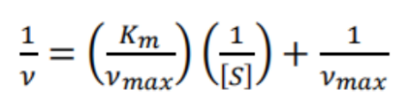 (1)
Here, [S] represents the substrate TMB concentration. K_{m} reflects the affinity between the nano-enzyme and the substrate, while v_{max} characterizes the maximum rate of the catalytic reaction.
The conversion between absorbance and reaction velocity was performed using the Lambert–Beer law (Eq. (2)) [3], where A represents the absorbed light, ε is the molar absorption coefficient that quantifies the substance's light absorption at a specific wavelength, b is the optical path length, and c is the concentration of the absorbing substance.
$A = εbc$ (2)

Optimization of the experimental conditions
Optimization of reaction temperature
To investigate the effect of temperature on detection sensitivity, COF-AgNPs (50 μL, 1.0 mg/mL) and TMB (200 μL, 0.5 mM) were added to the HAc-NaAc buffer (1mL, pH 5.0) system, followed by the addition of Hg²⁺ standard solution (final concentration of 10 μM). The resulting mixture was incubated at different temperatures (4, 10, 20, 30, 40, 50, 60, 70 and 80 °C) for 10 min. Immediately after reaction completion, the absorbance values at 652 nm were measured for both the Hg²⁺-containing group and the control group. The optimal reaction temperature was determined based on the principle of maximizing the absorbance difference.

Optimization of reaction time
To determine the optimal reaction time, experiments were conducted under fixed conditions: HAc-NaAc buffer (1 mL, pH 5.0), TMB (200 μL, 0.5 mM), COF-AgNPs (50 μL, 1.0 mg/mL), and Hg²⁺ standard solution (final concentration of 10 μM). The reaction was carried out at 25 °C, and the absorbance changes at 652 nm were monitored in real time at different time points for both the Hg²⁺-containing group and the control group. The optimal reaction time was selected based on the absorbance difference reaching a plateau and remaining stable.

Optimization of nano-enzyme amount
To determine the optimal dosage of COF-AgNPs nano-catalysts, the reaction conditions were fixed as follows: HAc-NaAc buffer (1 mL, pH 5.0), TMB (200 μL, 0.5 mM), reaction temperature (25 °C), and reaction time (10 min). Hg²⁺ standard solution (final concentration of 10 μM) was then added, and the dosage of COF-AgNPs was varied (0.25, 0.5, 1.0, 1.5, and 2.0 mg/mL). The effects of COF-AgNPs dosage on the reaction were evaluated by measuring the absorbance at 652 nm for both Hg²⁺-containing and Hg²⁺-free control groups. The optimal nanozyme dosage was selected based on maximizing the absorbance difference between the two groups.

Optimization of buffer pH
Given the significant influence of pH on nanozyme catalytic activity and reaction kinetics, the amounts of COF-AgNPs (50 μL, 1.0 mg/mL) and TMB (200 μL, 0.5 mM), as well as the reaction temperature (25 °C), were fixed in the reaction system. Hg²⁺ standard solution (final concentration of 10 μM) was then added, and the reaction was conducted for 10 min in HAc-NaAc buffers at different pH values (2.0, 3.0, 4.0, 5.0, 6.0, 7.0, and 8.0). Absorbance values at 652 nm were measured using a microplate reader. The optimal reaction pH was determined by analyzing the trend of absorbance difference between the Hg²⁺-containing group and the control group as a function of pH.

Optimization of TMB amount
To determine the optimal amount of the chromogenic substrate TMB, the following conditions were fixed in an HAc-NaAc buffer (1 mL, pH 5.0) system: COF-AgNPs nano-catalyst amount (50 μL, 1.0 mg/mL), reaction temperature (25 °C), and reaction time (10 min), followed by the addition of Hg²⁺ standard solution (final concentration of 10 μM). The effects of varying TMB concentrations (0.2, 0.3, 0.4, 0.5, 0.6, 0.7, 0.8, 0.9, and 1.0 mM) on the reaction system were investigated. After the reaction, the absorbance was measured at 652 nm. The optimal TMB amount was selected based on maximizing the absorbance difference between the Hg²⁺-containing system and the Hg²⁺-free system.

Construction of Multimodal ML
To automatically discover hidden and high-value quantitative relationships and patterns from complex actual detection data, and to overcome the limitations faced by traditional analysis methods, the analysis method of ML was adopted in this work for the study of real sample detection.
The ML processing flow is shown in the Fig. S1. Firstly, we collected the initial ML input data, including spectral and RGB measurements. A multimodal data acquisition strategy was used to construct a Hg²⁺ sample set (n=752) with a concentration gradient ranging from 0.01 to 50 μM. Spectral data were obtained using a Muktisjan SkyHigh microplate reader, capturing high-resolution spectra across the 400–800 nm wavelength range, resulting in 400-dimensional feature vectors. RGB data were acquired by capturing reaction system images under standard D65 illumination (5500K) with an iPhone Xs smartphone, and RGB channel values were extracted using Color Picker software.
Secondly, the second step involves data preprocessing, feature extraction, and dataset division. On the Matlab platform, five preprocessing methods (multiplicative scatter correction (MSC), standard normal variate (SNV), first-order derivative (D1), and second-order derivative (D2), savitzky-golay (SG) smoothing) were employed to process the original spectral data. The processed results were compared with the original spectral data to determine the most suitable processing method. Then three feature selection algorithms (principal component analysis (PCA), successive projections algorithm (SPA), and competitive adaptive reweighted sampling (CARS)) were implemented using the Python scikit-learn library to select key wavelength variables, thereby reducing the 400-dimensional high-resolution spectral data to 10-dimensional feature vectors. After that, a stratified sampling strategy was adopted to randomly divide the dataset (comprising spectral data and RGB data) into a training set (n=526) and a test set (n=226) in a 7:3 ratio.
Finally, the selection and training of the ML model, and the verification of the final detection results. This work employed three different sets of feature groups as input data for model training: spectral features, RGB features, and the fused features combining spectral data and RGB data. It then conducted a systematic evaluation of the performance of five ML algorithms (random forest (RF), support vector machine (SVM), linear discriminant analysis (LDA), k-nearest neighbor (k-NN)). These five algorithms were selected due to their widespread applicability and superior performance in spectral and image-based detection tasks [4–6]. To improve the stability of model, this work used grid search to optimize the models’ hyperparameters and adopted five-fold cross-validation. To obtain the best training model, multiple indicators such as recall rate, accuracy, precision rate and F1 score were used to evaluate the training results [7, 8].
After determining the optimal ML model, the real detection results were predicted using the optimal model. And the predicted results were compared with the real detection results to evaluate the feasibility of applying the optimal ML model.

Table S1. Comparison of Michaelis-Menten constants (k_{m}) and maximum initial reaction rates (ν_{max}) of different silver-based nanozymes with TMB as substrate.
Nanozymes | Substance | k_{m} (mM) | ν_{max} (10⁻⁸ M·s⁻¹) | reference
HRP | TMB | 0.434 | 10 | [9]
Fe₃O₄@Ag | TMB | 0.61 | 11.11 | [10]
FA@AgNPs | TMB | 0.12 | 5.20 | [11]
COF-Au-Ag | TMB | 0.665 | 0.395 | [12]
Fe-N-C SAzymes | TMB | 2.6 | 5.6 | [13]
COF-AgNPs | TMB | 0.642 | 8.64 | This work
COF-AgNPs-Hg²⁺ | TMB | 0.366 | 10.722 | This work

Table S2. Comparison of COF-AgNPs with other reported nanomaterials for Hg²⁺ detection.
Nanomaterials | Linear range (µM) |  | LOD (µM) | Reference
CuNP |  | 0.050~10.0 | 0.185 | [14]
rGO/PEG/Ag |  | 0.02~1.0/1.0~5.0 | 0.0197 | [15]
COF-Au-Ag |  | 0.050~20.0 | 0.026 | [12]
AgNPs |  | 0~600 | 0.348 | [16]
Ag@GO |  | 10.0~100.0 | 0.338 | [17]
Ag₃PO₄ nanocubes |  | 0.1~7.0 | 0.02 | [9]
COF-AgNPs |  | 0.05~0.5/5~50 | 0.0103 | This work

Fig. S1
Fig. S1. A dual-mode rapid detection process for mercury ions (Hg²⁺) in aquatic products using a multimodal ML-assisted nano-enzyme colorimetric sensor.

Fig. S2
Fig. S2. Synthesis diagram of COFs.
Fig. S3
Fig. S3. (A) SEM image of COFs; (B) TEM image of COFs; (C) XPS pattern of COFs; (D) C 1s XPS spectrum of COFs; (E) FT-IR spectra of TAP, DVA, COFs and COF-AgNPs; (F) XRD patterns of COFs and COF-AgNPs.

Fig. S4
Fig. S4. High-resolution XPS spectra of (A) C 1s, (B) O 1s and (C) N 1s in COFs and COF-AgNPs.

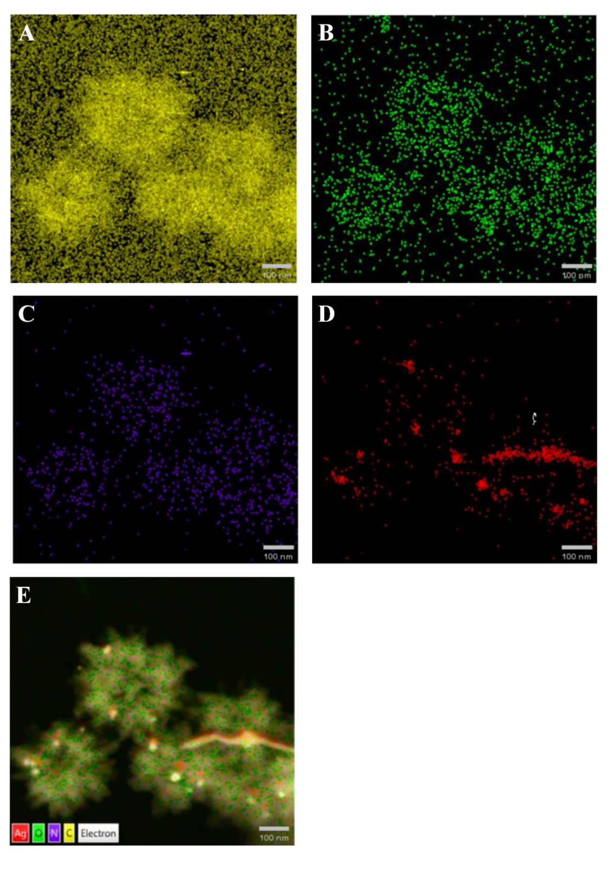
Fig. S5
Fig. S5. EDS spectra of elemental analysis of nano-enzyme COF-AgNPs. (A) Distribution mapping of C element; (B) Distribution mapping of O element; (C) Distribution mapping of N element; (D) Distribution mapping of Ag element; (E) Overlay mapping of C, O, N and Ag elements.
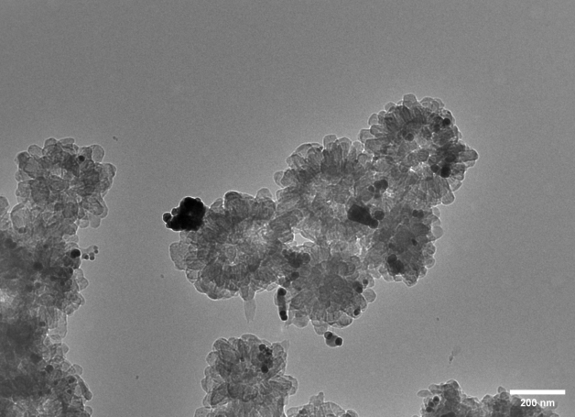
Fig. S6
Fig. S6. TEM images of nano-enzyme COF-AgNPs in the presence of Hg²⁺.

Fig. S7
Fig. S7. (A) Steady-state kinetic analysis and (B) corresponding Lineweaver-Burk plots of nano-enzyme COF-AgNPs at different TMB concentrations; (C) UV-Vis absorption spectra and actual photographs of the system treated with different quenchers (20 μM Hg²⁺).

Fig. S8
Fig. S8. Optimization parameters of nano-enzyme COF-AgNPs. (A) Optimizations of reaction temperature; (B) Optimizations of reaction time; (C) Optimizations of concentration of the COF-AgNPs; (D) Optimizations of pH value; (E) Optimizations of TMB concentration.
Fig. S9
Fig. S9. (A) Performance metrics of ML models under different preprocessing methods; (B) Comparative performance of models with different feature extraction approaches; (C) Performance comparison among different machine learning models; (D) Evaluation of different data fusion strategies.
Fig. S10
Fig. S10. SHAP value feature importance plot.

References
1. Liao LH, Tong SM, Luo XG, Liu GY, Wu FS (2022) Iron porphyrin-based porous organic polymer with high peroxidase-like activity as colorimetric sensor for glutathione and ascorbic acid assay. Microchim Acta 189:384. https://doi.org/10.1007/s00604-022-05471-7
2. Ortega-Liebana MC, Hueso JL, Fernandez-Pacheco R, Irusta S, Santamaria J (2018) Luminescent mesoporous nanorods as photocatalytic enzyme-like peroxidase surrogates. Chem Sci 9:7766–7778. https://doi.org/10.1039/C8SC03112F
3. Zhang ZY, Liu D, Zhang XS, Luo XL, Lin WM, Li ZH, Huang JH (2023) Silver nanoparticles deposited carbon microspheres nanozyme with enhanced peroxidase-like catalysis for colorimetric detection of Hg²⁺ in seafood. Microchim Acta 190:340. https://doi.org/10.1007/s00604-023-05921-w
4. Aqeel M, Sohaib A, Iqbal M, Rehman HU, Rustam F (2024) Hyperspectral identification of oil adulteration using machine learning techniques. Curr. Res Food Sci 8:100773. https://doi.org/10.1016/j.crfs.2024.100773
5. Pu HB, Yu JX, Sun DW, Wei QY, Wang Z (2023) Feature construction methods for processing and analysing spectral images and their applications in food quality inspection. Trends Food Sci Technol 138:726–737. https://doi.org/10.1016/j.tifs.2023.06.036
6. Wang XX, Bouzembrak Y, Lansink AO, Van Der Fels‐Klerx HJ (2022) Application of machine learning to the monitoring and prediction of food safety: A review. Comp Rev Food Sci Food Safe 21:416–434. https://doi.org/10.1111/1541-4337.12868
7. Tian CY, Lee Y, Song Y, Elmasry M, Yoon M, Kim DH, Cho SY (2024) Machine-Learning-Enhanced Fluorescent Nanosensor Based on Carbon Quantum Dots for Heavy Metal Detection. ACS Appl Nano Mater 7:5576–5586. https://doi.org/10.1021/acsanm.4c00359
8. Sujon KM, Hassan R, Choi K, Samad MA (2025) Accuracy, precision, recall, f1-score, or MCC? empirical evidence from advanced statistics, ML, and XAI for evaluating business predictive models. J Big Data 12:268. https://doi.org/10.1186/s40537-025-01313-4
9. Zhang Y, Ju P, Sun LP, Wang Z, Zhai XF, Jiang FH, Sun CJ (2020) Colorimetric determination of Hg²⁺ based on the mercury-stimulated oxidase mimetic activity of Ag₃PO₄ microcubes. Microchim Acta 187:422. https://doi.org/10.1007/s00604-020-04399-0
10. Wang Y, Cheng C, Ma RF, Xu ZR, Ozaki Y (2022) In situ SERS monitoring of intracellular H₂O₂ in single living cells based on label-free bifunctional Fe₃O₄@Ag nanoparticles. Analyst 147:1815–1823. https://doi.org/10.1039/D2AN00035K
11. Tang YL, Lv X, Gou WX, Zhou XM, Hao JK, Feng J, Qi YJ, Hu L, Yan ZQ (2022) Ag nanozyme strengthened by folic acid: Superior peroxidase-mimicking activity and application for visual monitoring of dopamine. Anal Bioanal Chem 414:6611–6620. https://doi.org/10.1007/s00216-022-04222-0
12. Wang ZY, Wang D, Wang LC, Chen HL, Li YY, Zheng WH, Shang JZ, Lu LM, Mao GJ, Qiao YC, Wang H (2025) Construction of covalent organic framework-loaded gold–silver composites with the catalysis enhanced by mercury: A turn-on colorimetric detection and removal strategy for mercury. Microchem J 215:114237. https://doi.org/10.1016/j.microc.2025.114237
13. Xu WQ, Jiao L, Yan HY, Wu Y, Chen LJ, Gu WL, Du D, Lin YH, Zhu CZ (2019) Glucose Oxidase-Integrated Metal-Organic Framework Hybrids as Biomimetic Cascade Nanozymes for Ultrasensitive Glucose Biosensing. ACS Appl Mater Interfaces 11:22096–22101. https://doi.org/10.1021/acsami.9b03004
14. Li Q, Wu F, Mao M, Ji X, Wei LY, Li JY, Ma L (2019) A dual-mode colorimetric sensor based on copper nanoparticles for the detection of mercury-(II) ions. Anal Methods 11:4014–4021. https://doi.org/10.1039/C9AY00843H
15. Wang YS, Cheng SS, Liu ML, Liu J, Zhang ST, Hu WP (2022) Generated Mercury(I) as a Peroxidase-like Activity Modulator via Stimulating the Expression of Active Sites of Silver Nanoparticles for Environmental Hg²⁺ Detection. ACS Appl Nano Mater 5:2048–2056. https://doi.org/10.1021/acsanm.1c03781
16. Alula MT, Madingwane ML, Yan HD, Lemmens P, Zhe L, Etzkorn M (2022) Biosynthesis of bifunctional silver nanoparticles for catalytic reduction of organic pollutants and optical monitoring of mercury (II) ions using their oxidase-mimic activity. Environ Sci Pollut Res 29:81938–81953. https://doi.org/10.1007/s11356-022-21619-7
17. Zangeneh Kamali K, Pandikumar A, Jayabal S, Ramaraj R, Lim HN, Ong BH, Bien CSD, Kee YY, Huang NM (2016) Amalgamation based optical and colorimetric sensing of mercury(II) ions with silver@graphene oxide nanocomposite materials. Microchim Acta 183:369–377. https://doi.org/10.1007/s00604-015-1658-6

