Appendix 1. Questionnaire

If you consent to participate in this survey, please put a check mark in the □ below and write the date on which you responded to the survey.
□ I hereby consent to participate in this study.
Response date (using the format Month/Day/Year): _____/_____/2021
1) The following questions are about you. For multiple-choice questions, please circle the answer that applies to you. For questions that include parentheses ( ), please write your answer inside the parentheses.
Age （ ） years
Sex
- Male
- Female
Height （ ）cm
Weight （ ）kg
History of smoking
- Yes
- No
History of alcohol consumption
- Yes
- No
Medical history (past illnesses)
- Hypertension
- Diabetes
- Dyslipidemia
- Bronchial asthma
- Chronic obstructive pulmonary disease (COPD)
- Myocardial infarction
- Melanoma
- Connective tissue/rheumatic disease
- Immune deficiency disease
- Chronic kidney disease
- Other（ ）
Obstetric history (women)
- I had a pregnancy before I was infected with coronavirus.
- I was pregnant when I was infected with coronavirus.
- I have never been pregnant.

2) The following questions are about the course of your coronavirus infection. Please circle the answers that apply to you.
I was diagnosed with pneumonia | 1. | Yes | 2. | No | 3. | I don’t know
I was administered oxygen once or more | 1. | Yes | 2. | No | 3. | I don’t know
I was put on a ventilator once or more | 1. | Yes | 2. | No | 3. | I don’t know
I was treated with ECMO once or more | 1. | Yes | 2. | No | 3. | I don’t know
I was prescribed antivirals¹ | 1. | Yes | 2. | No | 3. | I don’t know
I was prescribed steroids² | 1. | Yes | 2. | No | 3. | I don’t know
Notes: 1) Antivirals are drugs used to treat COVID-19, such as remdesivir (Veklury), favipiravir (Avigan), ivermectin (Stromectol), lopinavir/ritonavir (Kaletra), hydroxychloroquine (Plaquenil), and azithromycin (Zithromax).
2) Steroids refer to drugs that inhibit inflammation, such as dexamethasone (Dexart), prednisolone (Predonin), and methylprednisolone (Solu-Medrol).

3) The following questions are about the after effects of COVID-19. Please note whether you experienced the following symptoms. If yes, please write the duration of that symptom in days. If you are unsure, please write the approximate duration.

Example: If you had a symptom for 20 days starting on day 30 after coronavirus infection, please respond as follows:
○1. Yes 2. No
1. If yes, A. Since infection ○. B. Since day (30) after infection
○a. For （20） days b. Ongoing

Fever
1. Yes 2. No
1. If yes, A. Since infection B. Since day ( ) after infection
a. For（ ）days b. Ongoing

Fatigue (Sluggishness)
1. Yes 2. No
1. If yes, A. Since infection B. Since day ( ) after infection
a. For（ ）days b. Ongoing

Shortness of breath (Difficulty breathing)
1. Yes 2. No
1. If yes, A. Since infection B. Since day ( ) after infection
a. For（ ）days b. Ongoing

Joint pain
1. Yes 2. No
1. If yes, A. Since infection B. Since day ( ) after infection
a. For（ ）days b. Ongoing

Myalgia (Muscle pain)
1. Yes 2. No
1. If yes, A. Since infection B. Since day ( ) after infection
a. For（ ）days b. Ongoing

Chest pain
1. Yes 2. No
1. If yes, A. Since infection B. Since day ( ) after infection
a. For（ ）days b. Ongoing

Cough
1. Yes 2. No
1. If yes, A. Since infection B. Since day ( ) after infection
a. For（ ）days b. Ongoing

Abdominal pain (Stomach pain)
1. Yes 2. No
1. If yes, A. Since infection B. Since day ( ) after infection
a. For（ ）days b. Ongoing

Dysosmia (loss of smell)
1. Yes 2. No
1. If yes, A. Since infection B. Since day ( ) after infection
a. For（ ）days b. Ongoing

Dysgeusia (loss of taste)
1. Yes 2. No
1. If yes, A. Since infection B. Since day ( ) after infection
a. For（ ）days b. Ongoing

Nasal discharge
1. Yes 2. No
1. If yes, A. Since infection B. Since day ( ) after infection
a. For（ ）days b. Ongoing

Bloodshot eyes
1. Yes 2. No
1. If yes, A. Since infection B. Since day ( ) after infection
a. For（ ）days b. Ongoing

Headache
1. Yes 2. No
1. If yes, A. Since infection B. Since day ( ) after infection
a. For（ ）days b. Ongoing

Phlegm
1. Yes 2. No
1. If yes, A. Since infection B. Since day ( ) after infection
a. For（ ）days b. Ongoing

Sore throat
1. Yes 2. No
1. If yes, A. Since infection B. Since day ( ) after infection
a. For（ ）days b. Ongoing
Diarrhea
1. Yes 2. No
1. If yes, A. Since infection B. Since day ( ) after infection
a. For（ ）days b. Ongoing

Nausea/vomiting
1. Yes 2. No
1. If yes, A. Since infection B. Since day ( ) after infection
a. For（ ）days b. Ongoing

Loss of appetite
1. Yes 2. No
1. If yes, A. Since infection B. Since day ( ) after infection
a. For（ ）days b. Ongoing

Hair loss
1. Yes 2. No
1. If yes, A. Since infection B. Since day ( ) after infection
a. For（ ）days b. Ongoing
- In patches ii. Diffuse hair loss iii. Don’t know

Depression
1. Yes 2. No
1. If yes, A. Since infection B. Since day ( ) after infection
a. For（ ）days b. Ongoing

Loss of concentration
1. Yes 2. No
1. If yes, A. Since infection B. Since day ( ) after infection
a. For（ ）days b. Ongoing

Memory disturbance (forgetfulness)
1. Yes 2. No
1. If yes, A. Since infection B. Since day ( ) after infection
a. For（ ）days b. Ongoing

Appendix 2. The number of participants with COVID-19 symptoms and the persistence of symptoms
Symptoms | Number (%ª) | Lasting more than 4 weeks (%ª) | Lasting more than 12 weeks (%ª) | Late onset (%^{b})
Fever | 293 (64.1) | 12 (2.6) | 1 (0.2) | 2 (0.7)
Fatigue | 292 (64.0) | 93 (20.4) | 47 (10.3) | 8 (2.7)
Dysosmia | 219 (47.9) | 104 (22.8) | 62 (13.6) | 4 (1.8)
Cough | 214 (46.8) | 68 (14.9) | 21 (4.6) | 4 (1.9)
Dysgeusia | 185 (40.6) | 69 (15.1) | 30 (6.6) | 2 (1.1)
Headache | 173 (37.9) | 32 (7.0) | 18 (3.9) | 3 (1.7)
LoA | 171 (37.6) | 24 (5.3) | 9 (2.0) | 0 (0)
SoB | 163 (35.7) | 55 (12.0) | 25 (5.5) | 4 (2.5)
Joint pain | 153 (33.5) | 20 (4.4) | 15 (3.3) | 5 (3.3)
Sore throat | 139 (30.5) | 12 (2.6) | 5 (1.1) | 1 (0.7)
LoC | 137 (30.0) | 95 (20.8) | 70 (15.3) | 10 (7.3)
Depression | 125 (27.5) | 79 (17.3) | 55 (12.0) | 16 (12.8)
Myalgia | 113 (24.7) | 16 (3.5) | 11 (2.4) | 3 (2.7)
Diarrhea | 111 (24.3) | 6 (1.3) | 4 (0.9) | 2 (1.8)
Sputum | 109 (23.9) | 25 (5.5) | 13 (2.8) | 2 (1.8)
Hair loss | 103 (22.7) | 73 (16.0) | 29 (6.3) | 58 (56.3)
MD | 102 (22.5) | 88 (19.3) | 78 (17.1) | 17 (16.7)
Runny nose | 96 (21.1) | 14 (3.1) | 9 (2.0) | 0 (0)
Chest pain | 92 (20.1) | 32 (7.0) | 18 (3.9) | 7 (7.6)
Abdominal pain | 47 (10.3) | 3 (0.7) | 1 (0.2) | 0 (0)
Nausea | 36 (7.9) | 4 (0.9) | 3 (0.7) | 0 (0)
Conjunctivitis | 32 (7.0) | 4 (0.9) | 1 (0.2) | 0 (0)
Abbreviations: LoA, loss of appetite; SoB, shortness of breath; LoC, loss of concentration; MD, memory disturbance.
ªCalculated by dividing the number of patients by the total number of participants (n = 457).
^{b}Calculated by dividing the number of patients by the number of participants who experienced the symptoms (N = 457).

Appendix 3. Acute symptoms associated with COVID-19
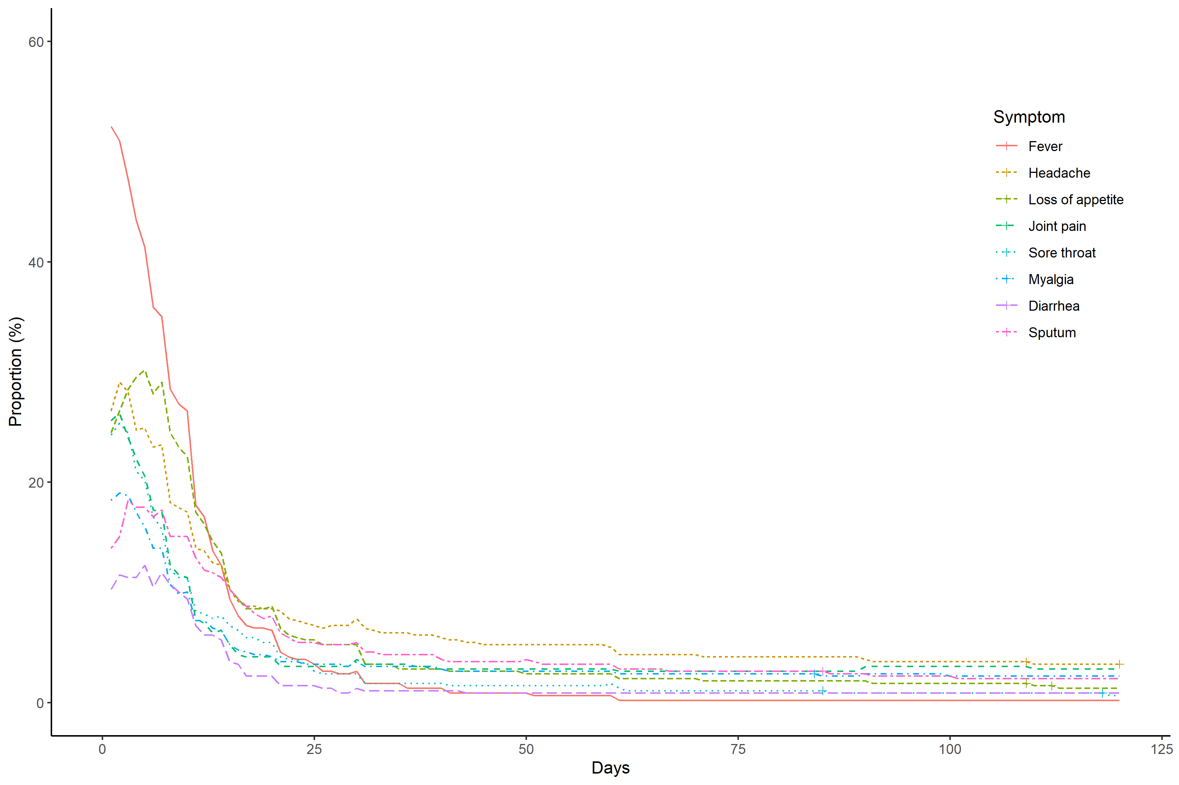

Appendix 4a. Risk factors for development of fatigue in patients with COVID-19
Appendix 4b. Risk factors for persistence of fatigue among patients with fatigue
Appendix 5a. Risk factors for development of dysgeusia in patients with COVID-19
Appendix 5b. Risk factors for persistence of dysgeusia among patients with dysgeusia
Appendix 6a. Risk factors for development of dysosmia in patients with COVID-19
Appendix 6b. Risk factors for persistence of dysosmia among patients with dysosmia
Appendix 7. Risk factors for development of hair loss in patients with COVID-19

