Supplementary file

Neuroprotective Effect of Phytochemically Characterized Fractions of Semecarpus anacardium Against Cerebral Ischemia-Reperfusion Injury in Rats
Mallappa Shalavadi*, Shubham Teli, Bhushan Khombare
Department of Pharmacology, BVV Sangha’s Hanagal Shri Kumareshwar College of Pharmacy Bagalkote-587101, Karnataka, India.

*Corresponding author: Dr. Mallappa Shalavadi, Department of Pharmacology, B.V.V. Sangha’s Hanagal Shri Kumareshwar College of Pharmacy, Bagalkote-587101.
Email: mallappashalvadi@bvvs-hskcop.ac.in, Mobile No: +91-7829631092, ORCID: 0000-0002-7496-6372.

Co-Authors
1. Mr. Shubham Teli
Department of Pharmacology, B.V.V. Sangha’s Hanagal Shri Kumareshwar College of Pharmacy, Bagalkote-587101.
Email: shubhamteli02@gmail.com, ORCID: 0000-0002-0587-3260

2. Mr. Bhushan Khombare
Department of Pharmacology, B.V.V. Sangha’s Hanagal Shri Kumareshwar College of Pharmacy, Bagalkote-587101.
Email: bhushankhombare@gmail.com, ORCID: 0009-0007-4011-3113

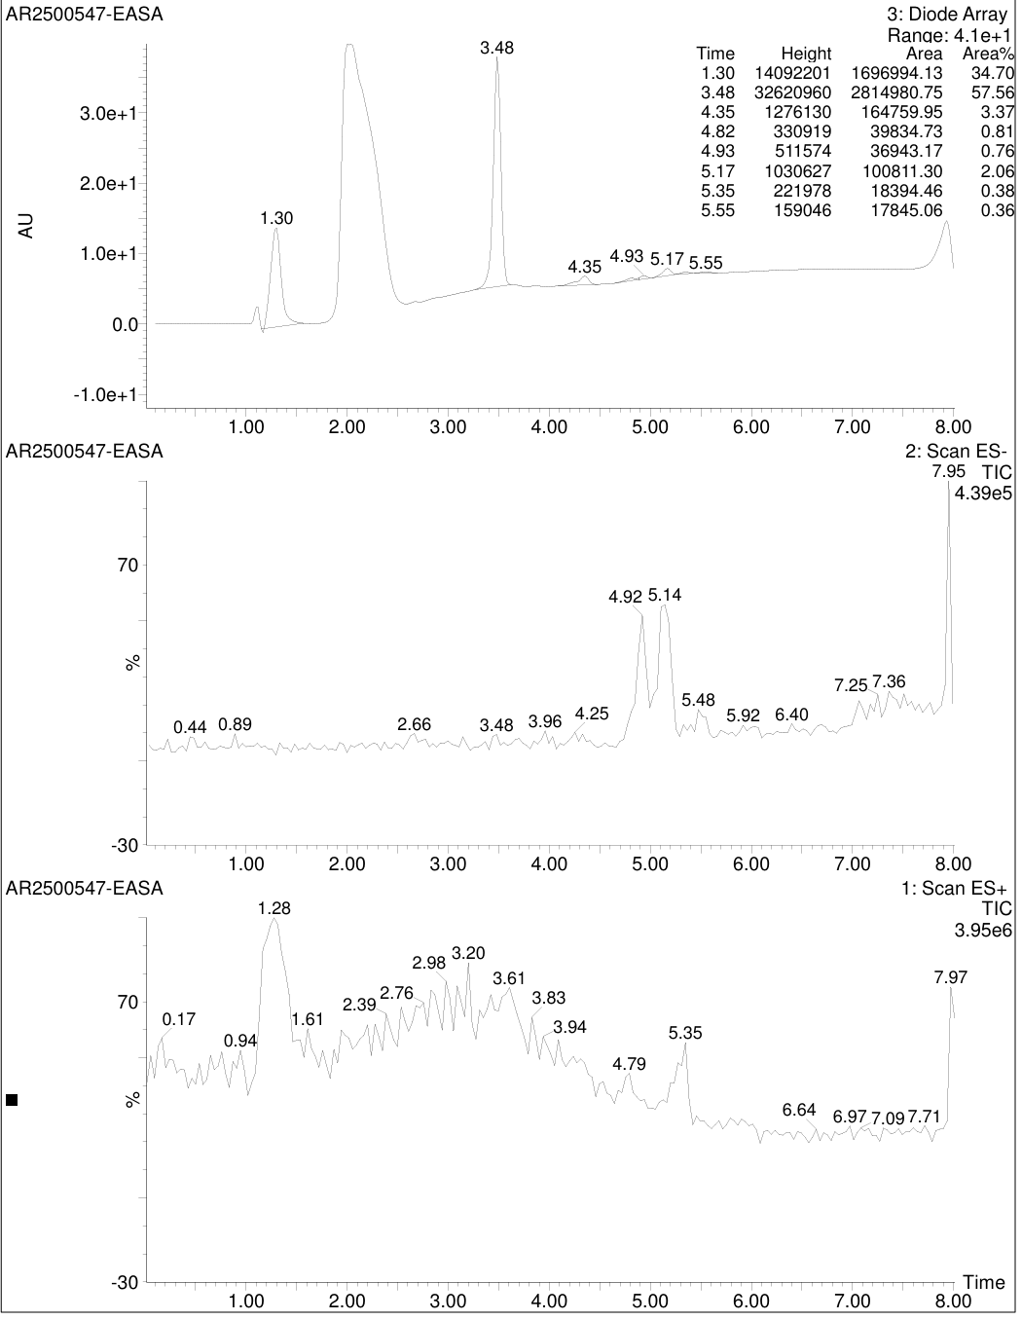

Fig. 14. LC chromatogram of Ethyl acetate extract of Semecarpus anacardium
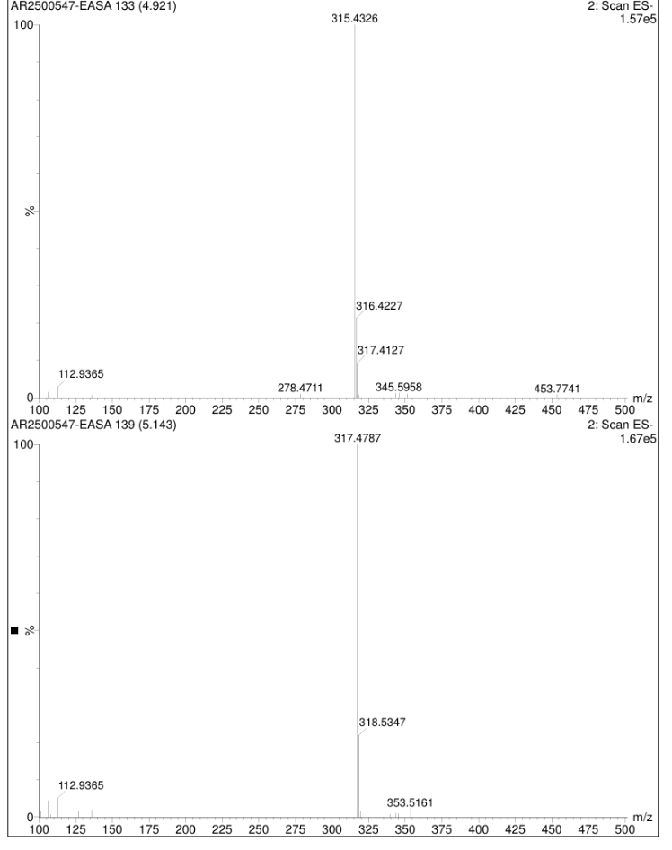
Fig. 15 MS graph of Ethyl acetate extract of Semecarpus anacardium

Table 7: Effect of HESA & EASA on Oxidative Stress Parameters in Unilateral Cerebral Ischemia-Reperfusion in Rats
GROUPS | LPO | CAT | SOD | GSH
SHAM | 91.95±8.000 | 0.5417±0.0172 | 428.3±7.126 | 61.01±3.05
Disease Control | 457.8±28.13 ª | 0.0331±0.00175 ª | 127.0±15.44 ª | 9.239±0.468 ª
HESA 87.5 mg/kg | 293.7±27.73*** | 0.1594±0.0084*** | 171.8±27.12* | 23.18±1.513***
HESA 175 mg/kg | 246.3±32.14*** | 0.2362±0.0127*** | 234.3±12.41* | 38.43±2.221***
HESA 350 mg/kg | 204.9±31.25*** | 0.3230±0.0117*** | 342.2±18.49*** | 52.31±2.739***
EASA 87.5mg/kg | 245.8±18.68*** | 0.2085±0.0446*** | 248.2±20.23** | 35.25±1.478***
EASA 175mg/kg | 152.2±9.713*** | 0.3961±0.0050*** | 383.1±47.01*** | 54.25±1.882***
EASA 350 mg/kg | 99.27±12.12*** | 0.5373±0.0171*** | 455.9±19.24*** | 66.84±1.136***

All the values are expressed as Mean±SEM, n=6, One way Analysis of Variance [ANOVA], followed by multiple comparison Tuckey’s test. ªp<0.001 as compared to sham group and *p<0.05, **p<0.01, ***p<0.001 as compared to Control group. HESA: Hydroalcohol Extract of Semecarpus anacardium, EASA: Ethyl acetate extract of Semecarpus anacardium.

Fig. 16: All values are expressed as Mean±SEM, n=4, One way Analysis of Variance [ANOVA], followed by multiple comparison Tuckey’s test. ªp<0.001, ^{b}p<0.01and ^{c}p<0.05 as compared to sham group and ***p<0.001 as compared to disease control group. HESA: Hydroalcohol Extract of Semecarpus anacardium, EASA: Ethyl acetate extract of Semecarpus anacardium.

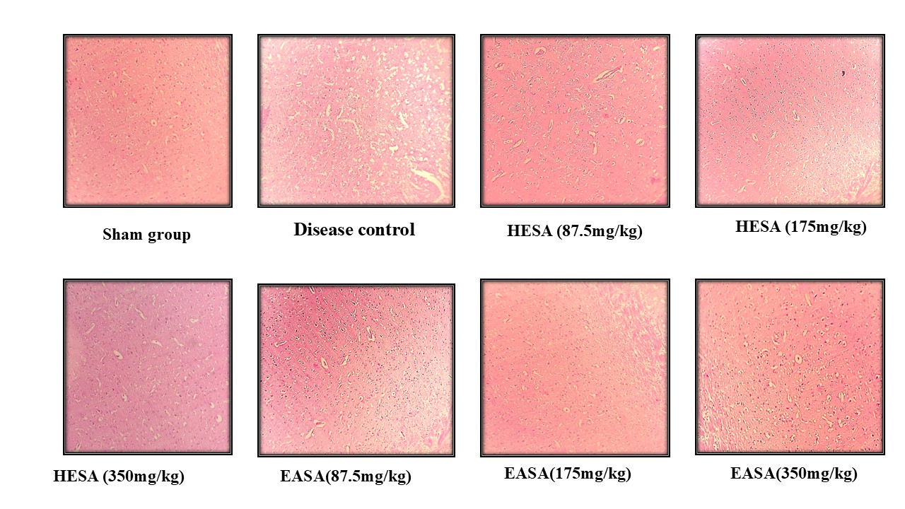

Fig. 17: Effect of HESA & EASA on histopathology in Unilateral Cerebral Ischemia-Reperfusion in Rats. Photographic images (10X) of brain section from different treatment groups stained with Haematoxylin and Eosin. In disease control group, density of cells was decreased, increased neutrophils infiltration, Cell architecture is completely altered and increased haemorrhage and neuronal cell death was observed. Whereas, all treated groups of HESA (87.5,175,350mg/kg) & EASA (87.5,175,350mg/kg) there is significant increase cell density, decreased neutrophil infiltration, decreased neuronal death and haemorrhage, normal cellular architecture was observed, which is comparable with sham group. HESA: Hydroalcohol Extract of Semecarpus anacardium, EASA: Ethyl acetate extract of Semecarpus anacardium.

