Supplementary

S1: Pipeline verification results
A systematic bias was observed between apparent $CV_{input}$ and $CV_{GT}$ prior to any simulation, inherent to the ECGI-derived CV estimation, dependent on the activation sequence used (Durrer-based: CV-RE: −29.23 ± 2.29%; Purkinje-based: CV-RE: 10.09 ± 1.70%). Given this input-level discrepancy, $CV_{in silico}$ was compared directly against $CV_{GT}$ rather than $CV_{input}$ to avoid compounding the initial bias, with both activation sequences reporting persistent biases (Purkinje-based: CV-RE: -8.50 ± 3.78%; Durrer-based: CV-RE: −32.08 ± 1.25%).
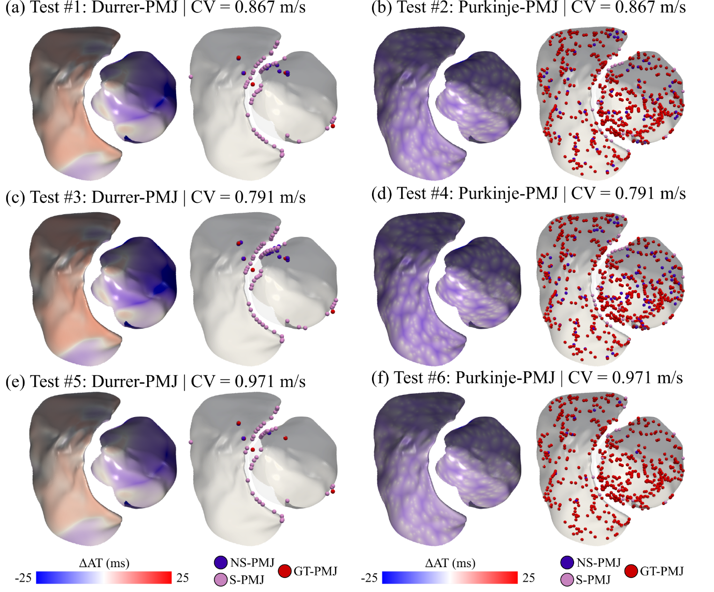
Figure S 1. Endocardial maps replication and Purkinje-Myocardial junction (PMJ) identification. All tests endocardial results showing (left) the absolute difference between the endocardial activation map estimated after backwards propagation minus ground truth endocardial activation map (ΔAT) and (right) the endocardium with mapped ground truth PMJs (GT-PMJ) and estimated ones, classified by supplementary (S-PMJ) and non-supplementary (NS-PMJ). Supplementary PMJs were predominantly located on the endocardial borders coinciding with the missing septum. AT: activation time; CV: conduction velocity.
Regarding the estimation of endocardial activation maps, on Figure S 1, the absolute differences between estimated endocardial activation map and the ground truth maps and the estimated PMJs are shown per case. Tests using Durrer-based activation exhibited an AT-RMSE of 8.73 ± 1.35 ms, while Purkinje-based activation cases showed a slightly higher AT-RMSE of 9.75 ± 0.98 ms (Table S 1). In Durrer-activated cases, AT-RMSE tended to increase within the LV, resulting in faster activation toward the basal regions and comparatively slower activation in the RV (12.67 ms vs 3.97 ms). In contrast, Purkinje-based activation generated generally faster ventricular activation, with more uniform timing across regions and comparable AT-RMSE values in the LV and RV (10.06 ms vs. 9.57 ms), both biased toward earlier-than-ground-truth activation. PMJ identification also varies by activation strategy (Table S 1).
Durrer-based cases identified fewer PMJs (mean: 8.7 vs. 5 ground-truth), with larger spatial and temporal errors compared to Purkinje-based cases (Durrer-based: PMJ-DE: 5.98 ± 1.06 mm; PMJ-AE: 28.59 ± 5.40 ms). In Durrer-based cases, anterior PMJs were captured accurately, whereas those on the septum and the basal inferolateral LV wall were not identified. In contrast, Purkinje-based cases identified a subset of the denser ground-truth network (mean: 54.33 vs. 558 ground-truth), achieving lower spatial and temporal errors (Purkinje based: PMJ-DE: 1.61 ± 0.18 mm; PMJ-AE: 5.82 ± 2.50 ms). The spatial distribution of identified PMJs was homogeneous across cases, but their number decreased as CV increased.
Table S 1. Verification test results for six synthetic cases combining two activation strategies (Durrer-based: #1, #3, #5; Purkinje-based: #2, #4, #6) and three repolarization patterns (apex-to-base, Voronoi, and mixed). Endocardial metrics: number of identified Purkinje-Myocardial junctions (PMJs), spatial (PMJ-DE) and temporal (PMJ-AE) localization errors, and activation time error (AT-RMSE) over non-septal regions. Epicardial metrics: activation (AT-RMSE) and repolarization (RT-RMSE) time errors, and conductance scaling factor errors for g_{Ks} and g_{Kr}. Values represent mean ± standard deviation. g_{Kr}: rapid delayed rectifier potassium current conductance scaling factor; g_{Ks}: slow delayed rectifier potassium current conductance scaling factor.
 |  | Endocardium |  |  |  | Epicardium
Test ID | PMJs |  | PMJ-DE  (mm) | PMJ-AE  (ms) | AT-RMSE (ms) | AT-RMSE (ms) | RT-RMSE (ms) | g_{Ks}-RMSE | g_{Kr}-RMSE
#1 | 9 |  | 6.30 ± 4.90 | 28.59 ± 17.27 | 8.67 | 21.70 | 21.44 | 1.44 | 0.30
#2 | 64 |  | 1.71 ± 0.98 | 4.32 ± 5.73 | 9.95 | 3.54 | 14.17 | 1.51 | 0.63
#3 | 14 |  | 6.84 ± 4.70 | 33.99 ± 21.69 | 10.11 | 26.35 | 26.23 | 1.57 | 0.34
#4 | 88 |  | 1.72 ± 1.11 | 4.42 ± 5.72 | 10.61 | 3.86 | 16.60 | 1.29 | 0.64
#5 | 3 |  | 4.79 ± 5.53 | 23.20 ± 12.29 | 7.41 | 16.81 | 15.14 | 1.56 | 0.55
#6 | 11 |  | 1.41 ± 0.81 | 8.71 ± 8.11 | 8.69 | 7.81 | 8.36 | 1.06 | 0.33
Mean | 31.50 ± 35.48 |  | 3.80 ± 2.49 | 17.20 ± 13.03 | 9.24 ± 1.19 | 13.35 ± 9.67 | 16.99 ± 6.18 | 1.41 ± 0.20 | 0.47 ± 0.16

Epicardial activation reconstruction yielded coherent wavefront patterns for both activation strategies. Durrer-based sequences showed markedly higher epicardial AT-RMSE than Purkinje-based cases (21.62 ± 4.77 ms vs. 5.07 ± 2.38 ms, respectively; Table S 1). The normalized Cumulative distribution functions (CDFs) (Figure S 2a) reflected these activation-dependent patterns: in Durrer-based tests, simulated activation progressed more slowly than ground truth across the epicardium, whereas Purkinje-based tests showed close overlap between ground-truth and simulated curves, with the exception of test #6, where ground-truth activation was clearly faster than estimated. Spatially, errors predominantly accumulated at basal regions (Figure S 2b).
Activation sequence properties were associated with differences in repolarization accuracy: Purkinje-based activation yielded lower RT-RMSE compared to Durrer-based sequences (13.04 ± 4.24 ms vs. 20.94 ± 5.56 ms, respectively), in agreement with their corresponding epicardial activation errors (Table S 1). Regarding repolarization heterogeneity patterns, apex-to-base configurations yielded lower reconstruction errors than Voronoi-based distributions for both conductance layers (g_{Ks}-RMSE: 1.26 ± 0.19 vs. 1.55 ± 0.03; g_{Kr}-RMSE: 0.32 ± 0.02 vs. 0.61 ± 0.05, respectively). The lowest overall repolarization error was achieved in test #6 (RT-RMSE = 8.36 ms), combining Purkinje-based activation with apex-to-base gradients for both conductance layers, while tests #1 and #3 exhibited the highest errors (RT-RMSE = 21.70 ms), both corresponding to Durrer-based activation. The normalized CDFs revealed sequence-dependent timing offsets (Figure S 2d): Durrer-based tests showed simulated repolarization occurring slightly later than ground truth, whereas Purkinje-based tests showed a subtle reversal, with simulations repolarizing marginally earlier. Apex-to-base–only tests produced smooth CDF curves, while Voronoi-containing tests exhibited sharper transitions consistent with their more heterogeneous spatial distributions, nonetheless these sharper transitions are also replicated by the test results. Estimated repolarization maps exhibited spatial distributions consistent with ground-truth patterns across different gradients, with the largest discrepancies localized to basal regions (Figure S 2c).
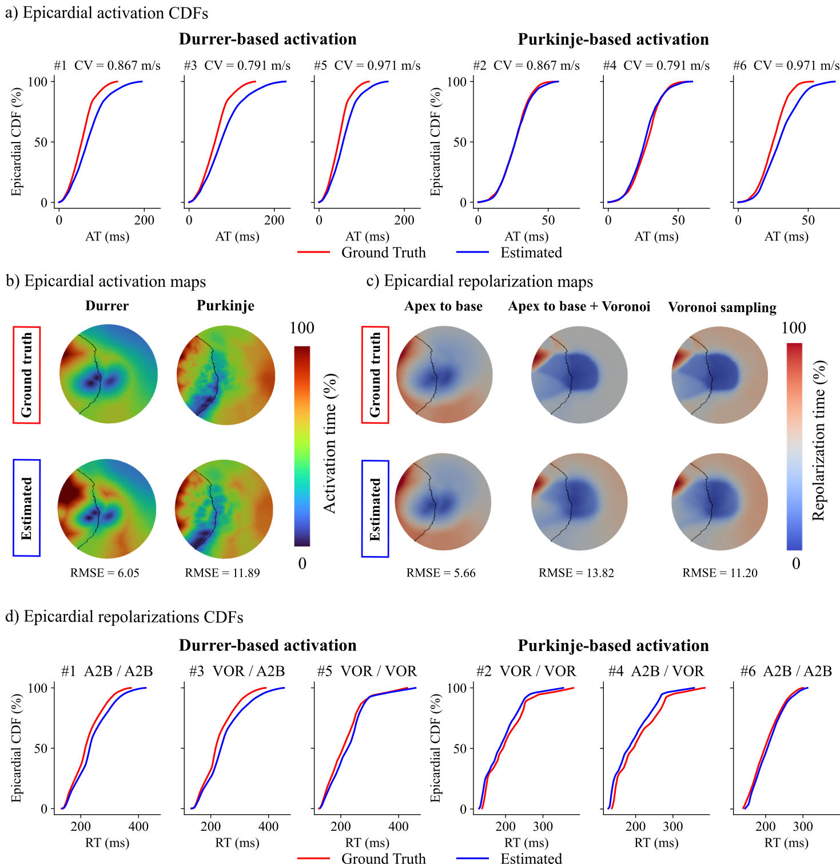
Figure S 2. Verification tests epicardial activation and repolarization results. (a) Activation cumulative distribution functions (CDFs) of ground truth (red) and estimated ones (blue) for all six-test group by activation sequence. (b) Normalized activation time maps for Durrer-based Purkinje-Myocardial junctions (PMJs) (test #1) and Purkinje-based PMJs (test #2) activation sequences. (c) Normalized repolarization time maps for different heterogeneity patterns of g_{Ks} and aging repolarization (AgR): apex-to-base (A2B) for g_{Ks} and g_{Kr} (test #1), A2B for g_{Ks} and Voronoi sampling (VOR) for g_{Kr} (test #4), and VOR for g_{Kr} and gKr (test #2). (d) Repolarization CDFs for the six tests. RMSE values are provided for each comparison. The dark line indicates the ventricles insertion. CV: conduction velocity; g_{Ks}: slow delayed rectifier potassium current conductance scaling factor.

S2: MyoFit46 participant selection
MyoFit46 cohort is composed of 505 UK participants. For this study we excluded 121 participants due to incomplete dataset, with a complete dataset referring to the existence of cardiovascular magnetic resonance (CMR) images including late gadolinium enhancement (LGE) and electrocardiographic imaging (ECGI). Of the remaining 384 participants, 354 were excluded from the final cohort as they do not fulfil the inclusion/exclusion criteria for the healthy reference group. The criteria that led to the exclusion of most subjects were related to the >2% LGE burden and hypertension. A corresponding flow chart is shown in Figure S 3.
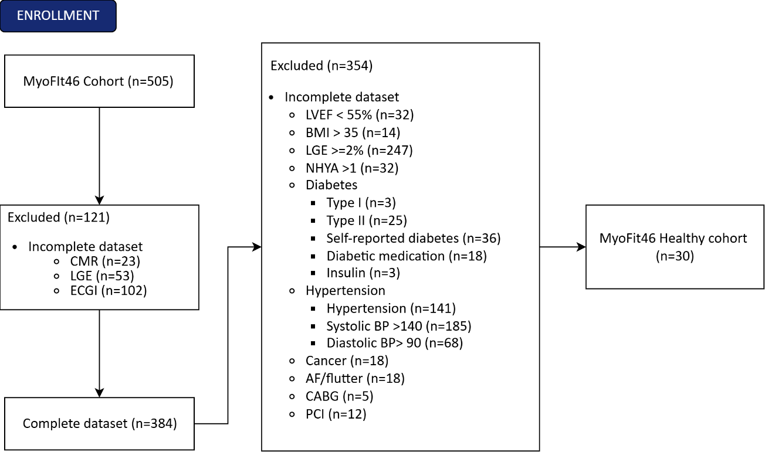
Figure S 3. MyoFit46 healthy cohort selection flow chart diagram. Starting from the full MyoFit46 cohort (n=505), 121 participants were excluded due to incomplete multimodal datasets, yielding a complete dataset of 384 participants. Of these, 354 were further excluded based on predefined inclusion/exclusion criteria, resulting in a final healthy reference cohort of 30 participants. Note that individual subjects may fulfil more than one exclusion criterion; counts therefore do not sum to 505. AF: atrial fibrillation; BMI: body mass index; BP: blood pressure; CABG: coronary artery bypass graft; CMR: cardiovascular magnetic resonance; ECGI: electrocardiographic imaging; LGE: late gadolinium enhancement; LVEF: left ventricular ejection fraction; NHYA: New York Heart Association functional class; PCI: percutaneous coronary intervention.

S3: Post-hoc g_{Kr} analysis (healthy)
Table S 2 summarizes the post-hoc pairwise comparisons following the Friedman tests for AgR↓ and AgR↑ distribution across longitudinal and circumferential regions in the healthy cohort. A significant longitudinal gradient was found in both ventricles along the longitudinal axis under AgR↑, being more prominent at basal regions and progressively less frequent toward the apex. Circumferential analyses also revealed significant regional heterogeneity for both AgR↓ and AgR↑, although differences were less consistent than those observed longitudinally.
Table S 2. Post-hoc pairwise comparisons of aging repolarization (AgR) compensation class distributions across longitudinal and circumferential regions in the healthy MyoFit46 cohort. Results of post-hoc pairwise Wilcoxon signed-rank tests with Benjamini–Hochberg correction (p_{adj}) following significant Friedman omnibus tests for longitudinal (Basal, Mid, Apical) and circumferential (Lateral, Inferior, Anterior) regional comparisons of AgR↓ (shortening) and AgR↑ (prolongation) class prevalence. Bold values indicate p_{adj} < 0.05. AgR: aging repolarization; Ant: anterior; g_{Kr}: rapid delayed rectifier potassium current conductance scaling factor; Inf: inferior; Lat: lateral; LV: left ventricle; RV: right ventricle.
Comparison (Friedman p) | Pair | p_{adj}
LV Longitudinal — AgR↓ (Friedman p = 0.045)
 | Base vs Mid | 0.005
 | Base vs Apex | 0.006
 | Mid vs Apex | 0.039
LV Longitudinal — AgR↑ (Friedman p = <0.001)
 | Base vs Mid | <0.001
 | Base vs Apex | <0.001
 | Mid vs Apex | <0.001
RV Longitudinal — AgR↓ (Friedman p = 0.016)
 | Base vs Mid | 0.002
 | Base vs Apex | 0.005
 | Mid vs Apex | 0.517
RV Longitudinal — AgR↑ (Friedman p = <0.001)
 | Base vs Mid | <0.001
 | Base vs Apex | <0.001
 | Mid vs Apex | 0.005
LV Circumferential — AgR↓ (Friedman p = <0.01)
 | Lat vs Inf | 0.045
 | Lat vs Ant | 0.009
 | Inf vs Ant | 0.009
RV Circumferential — AgR↓ (Friedman p = <0.01)
 | Lat vs Inf | 0.010
 | Lat vs Ant | 0.010
 | Inf vs Ant | 0.919
RV Circumferential — AgR↑ (Friedman p = <0.001)
 | Lat vs Inf | <0.001
 | Lat vs Ant | 0.280
 | Inf vs Ant | <0.001

S4: MyoFit46 early-stage hypertensive (eHTN) demographics
The eHTN cohort encompasses 47 participants (26 females) selected from the 505 MyoFit46 participants. Table S 3 summarizes the clinical and demographic characteristics of this cohort. Sex differences were found on anthropometric measures (height, weight, and body surface area), indexed cardiac volumes (end-diastolic, end-systolic, and stroke volume indices), left ventricular mass index, maximal wall thickness, and core late gadolinium enhancement burden. Among ECGI parameters, males presented significant longer AT90 than females. For the in silico parameters, females presented statistically higher median g_{Ks} and AgR scale factors, consistent with the sex-specific repolarization differences observed in the healthy cohort, while males exhibited a significantly higher number of PMJs. The remaining in silico electrophysiological parameters were not significantly different between sexes.
Table S 3. MyoFit46 early-stage hypertensive (eHTN) cohort demographic. Variables are expressed as median and interquartile range and Mann-Whitney U test with Benjamini–Hochberg correction was used for sex group comparison (p_{adj}-value). ARI90: time to 90% of epicardial tissue activation-repolarization interval; AgR: Aging repolarization; AT90: time to 90% of epicardial activation; BMI: body mass index; BSA: body surface area; CV: conduction velocity; D-BP: diastolic blood pressure; $D_{f}$: Fiber-direction diffusion coefficient; ECV: extracellular fluid volume; EDVi: end-diastolic volume indexed; EF: ejection fraction; eGFR: estimated glomerular filtration rate; ESVi: end-systolic volume indexed; LA-EDVi: indexed left atrial end-diastolic volume; g_{Ks}: slow delayed rectifier potassium current conductance scaling factor; LGE: late gadolinium enhancement; LVMi: indexed left ventricular mass; MWT: maximal wall thickness; PMJs: Purkinje-myocardial junctions; RR: R-R interval; RT90: time to 90% of epicardial repolarization; S-BP: systolic blood pressure; SVi: indexed stroke volume; T1: native T1 relaxation time.
Variable | All (n=47) | Female (n=26) | Male (n=21) |  | p_{adj}-value
Demographics
Age (years) | 76.48 [76.00–77.03] | 76.48 [76.07–77.04] | 76.39 [75.68–76.75] |  | 0.578
Height (cm) | 163.70 [159.25–173.10] | 159.75 [155.12–162.43] | 175.00 [167.90–177.40] |  | 0.004
Weight (kg) | 71.00 [61.40–82.45] | 62.85 [57.75–73.40] | 79.80 [72.60–89.30] |  | 0.004
BSA (m²) | 1.78 [1.60–1.94] | 1.66 [1.57–1.77] | 1.95 [1.85–2.06] |  | 0.004
BMI (kg/m²) | 25.54 [23.51–29.06] | 25.84 [23.35–28.68] | 24.82 [23.96–29.46] |  | 0.833
S-BP (mmHg) | 146.33 [141.67–156.00] | 144.83 [142.08–154.92] | 150.67 [140.67–161.00] |  | 0.838
D-BP (mmHg) | 83.67 [78.50–89.67] | 83.50 [79.00–88.75] | 85.67 [77.67–90.33] |  | 0.991
eGFR (𝑚𝐿/𝑚𝑖𝑛/1.73𝑚²) | 91.90 [89.45–94.80] | 91.80 [89.43–93.75] | 92.20 [89.90–98.30] |  | 0.524
CMR parameters
EDVi (ml/m²) | 69.92 [63.59–81.14] | 65.83 [57.39–74.28] | 77.42 [69.60–86.97] |  | 0.006
ESVi (ml/m²) | 21.25 [16.29–24.80] | 18.01 [15.13–23.09] | 22.84 [18.36–33.33] |  | 0.030
SVi (ml/m²) | 49.27 [45.23–56.49] | 47.97 [42.89–51.25] | 53.04 [47.98–58.67] |  | 0.015
EF (%) | 71.15 [65.34–74.62] | 72.13 [68.47–74.94] | 67.19 [63.26–73.96] |  | 0.170
LVMi (g/m²) | 49.75 [43.74–55.69] | 45.78 [40.54–49.51] | 55.73 [52.90–61.58] |  | 0.004
MWT (mm) | 10.96 [9.96–12.38] | 10.65 [9.16–11.17] | 12.36 [11.62–12.73] |  | 0.004
LA-EDVi (ml/m²) | 6.80 [5.07–8.46] | 5.59 [3.90–7.76] | 7.67 [5.46–9.10] |  | 0.068
T1 (ms) | 1292.49 [1262.37–1317.49] | 1293.04 [1280.84–1311.09] | 1279.43 [1241.51–1331.67] |  | 0.367
MPR | 2.66 [2.35–3.00] | 2.58 [2.42–2.85] | 2.83 [2.31–3.65] |  | 0.314
Core LGE (%) | 0.00 [0.00–0.02] | 0.00 [0.00–0.00] | 0.00 [0.00–0.47] |  | 0.008
ECV (%) | 26.20 [24.63–28.05] | 27.00 [25.16–28.22] | 25.28 [24.34–26.56] |  | 0.180
ECGI parameters
RR (ms) | 1001.00 [899.00–1047.50] | 992.50 [878.00–1047.75] | 1002.00 [900.00–1045.00] |  | 0.912
CV (m/s) | 0.89 [0.80–1.03] | 0.93 [0.80–1.03] | 0.89 [0.81–0.92] |  | 0.578
AT90 (ms) | 53.38 [49.40–58.41] | 51.74 [44.11–57.56] | 54.36 [52.20–61.67] |  | 0.045
RT90 (ms) | 302.38 [277.21–336.91] | 316.84 [276.94–336.14] | 299.49 [283.64–336.89] |  | 0.991
ARI90 (ms) | 336.72 [308.21–357.92] | 337.03 [306.96–355.09] | 332.72 [311.64–358.73] |  | 0.838
In silico parametrization
$D_{f}$ (cm²/ms) | 0.0023 [0.0019–0.0032] | 0.0024 [0.0022–0.0033] | 0.0021 [0.0015–0.0029] |  | 0.073
g_{Ks} | 2.20 [1.34–3.02] | 2.89 [2.22–3.28] | 1.34 [1.16–1.92] |  | 0.004
AgR | 1.02 [0.97–1.14] | 1.13 [1.02–1.23] | 0.97 [0.95–1.01] |  | 0.004
PMJs | 20.00 [12.50–50.50] | 14.00 [9.25–25.25] | 50.00 [20.00–98.00] |  | 0.004

S5: eHTN and healthy demographic comparison
Table S 4 summarizes the demographic and clinical comparison between the healthy and eHTN cohorts. The only statistically significant differences were observed in systolic and diastolic blood pressure, both elevated in the eHTN cohort (p_{adj} = 0.014), confirming the expected distinction between groups. A trend towards higher left ventricular mass index in the eHTN cohort was found but did not reach statistical significance. The same pattern was observed for AT90, RT90, and ARI90, all directionally longer in the eHTN cohort but not reaching significance after correction. Remaining demographic, structural CMR, and in silico electrophysiological parameters were not significantly different between cohorts.
Table S 4. Demographics comparison between healthy and early-stage hypertensive (eHTN) MyoFit46 cohort. Variables are expressed as median and interquartile range and Mann-Whitney U test with Benjamini–Hochberg correction was used for sex group comparison (p_{adj}-value). ARI90: time to 90% of epicardial tissue activation-repolarization interval; AgR: Aging repolarization; AT90: time to 90% of epicardial activation; BMI: body mass index; BSA: body surface area; CV: conduction velocity; D-BP: diastolic blood pressure; $D_{f}$: Fiber-direction diffusion coefficient; ECV: extracellular fluid volume; EDVi: end-diastolic volume indexed; EF: ejection fraction; eGFR: estimated glomerular filtration rate; ESVi: end-systolic volume indexed; LA-EDVi: indexed left atrial end-diastolic volume; g_{Ks}: slow delayed rectifier potassium current conductance scaling factor; LGE: late gadolinium enhancement; LVMi: indexed left ventricular mass; MWT: maximal wall thickness; PMJs: Purkinje-myocardial junctions; RR: R-R interval; RT90: time to 90% of epicardial repolarization; S-BP: systolic blood pressure; SVi: indexed stroke volume; T1: native T1 relaxation time.
Variable | Healthy (n=30) | eHTN (n=47) | p_{adj}-value
Demographics
Age (years) | 76.68 [76.33–77.44] | 76.48 [76.00–77.03] | 0.161
Height (cm) | 162.95 [160.85–172.75] | 163.70 [159.25–173.10] | 0.925
Weight (kg) | 66.20 [59.50–74.88] | 71.00 [61.40–82.45] | 0.313
BSA (m²) | 1.72 [1.61–1.82] | 1.78 [1.60–1.94] | 0.499
BMI (kg/m²) | 24.92 [21.74–26.75] | 25.54 [23.51–29.06] | 0.264
S-BP (mmHg) | 123.00 [118.50–130.75] | 146.33 [141.67–156.00] | 0.014
D-BP (mmHg) | 72.83 [66.08–78.16] | 83.67 [78.50–89.67] | 0.014
eGFR (mL/min/1.73m²) | 90.15 [77.03–95.45] | 91.90 [89.45–94.80] | 0.569
CMR parameters
EDVi (ml/m²) | 67.76 [61.72–74.26] | 69.92 [63.59–81.14] | 0.439
ESVi (ml/m²) | 20.15 [17.23–24.17] | 21.25 [16.29–24.80] | 0.864
SVi (ml/m²) | 48.69 [44.23–50.23] | 49.27 [45.23–56.49] | 0.351
EF (%) | 70.06 [66.59–73.52] | 71.15 [65.34–74.62] | 0.864
LVMi (g/m²) | 46.18 [41.26–50.26] | 49.75 [43.74–55.69] | 0.160
MWT (mm) | 10.54 [9.53–11.29] | 10.96 [9.96–12.38] | 0.311
LA-EDVi (ml/m²) | 6.44 [4.75–7.52] | 6.80 [5.07–8.46] | 0.461
T1 (ms) | 1297.82 [1282.34–1319.39] | 1292.49 [1262.37–1317.49] | 0.617
MPR | 2.68 [2.06–3.20] | 2.66 [2.35–3.00] | 0.805
Core LGE (%) | 0.00 [0.00–0.04] | 0.00 [0.00–0.02] | 0.864
ECV (%) | 27.78 [24.93–28.98] | 26.20 [24.63–28.05] | 0.514
ECGI parameters
RR (ms) | 931.25 [855.50–993.88] | 1001.00 [899.00–1047.50] | 0.160
AT90 (ms) | 50.20 [44.26–54.04] | 53.38 [49.40–58.41] | 0.160
RT90 (ms) | 275.32 [232.17–320.89] | 302.38 [277.21–336.91] | 0.160
ARI90 (ms) | 308.13 [275.97–338.91] | 336.72 [308.21–357.92] | 0.160
CV (m/s) | 0.83 [0.73–0.94] | 0.89 [0.80–1.03] | 0.375
In silico parametrization
Df (cm²/ms) | 0.0020 [0.0015–0.0026] | 0.0023 [0.0019–0.0032] | 0.313
g_{Ks} | 2.59 [1.87–3.19] | 2.20 [1.34–3.02] | 0.992
AgR | 1.02 [0.99–1.13] | 1.02 [0.97–1.14] | 0.375
PMJs | 20.00 [15.00–44.50] | 20.00 [12.50–50.50] | 0.560

S6: eHTN population replication
Figure S 4 summarizes the agreement between ECGI-derived and simulated epicardial dynamics for both activation (Figure S 4a, c) and repolarization (Figure S 4b, d). Panels (a) and (b) report the CDF of activated and repolarized tissue against normalized time: the solid line represents the mean ECGI CDF, used as a temporal anchor, while the shaded region encodes the interquartile range of the paired percentile differences between in silico and ECGI CDFs. Panels (c) and (d) display point-to-point mean absolute AT and RT errors on a 2D projection of the mean eHTN anatomy derived from the mean eHTN cohort.
Activation CDFs showed close agreement between in silico and ECGI curves, with a narrow and stable interquartile range throughout the sequence. Spatially, activation errors were not uniformly distributed: RV activation tended to occur earlier in the ECGI than in the in silico estimates, while the LV–RV insertion showed delayed activation, and the anterior LV wall exhibited a heterogeneous trend toward earlier activation. These regional patterns are consistent with known limitations of ECGI in resolving septal and basal activation.
Repolarization CDFs similarly showed close agreement, with a slight tendency for in silico repolarization to precede ECGI repolarization toward the end of the sequence. However, point-to-point errors revealed that repolarization times were longer in the in silico estimates than in the ECGI across most of the epicardial surface, with the exception of localized regions where the direction reverses. Mean AT-RMSE and RT-RMSE were 12.5 ± 3.2 ms and 15.9 ± 3.6 ms, respectively, neither differing significantly from the healthy cohort values (both p > 0.05).
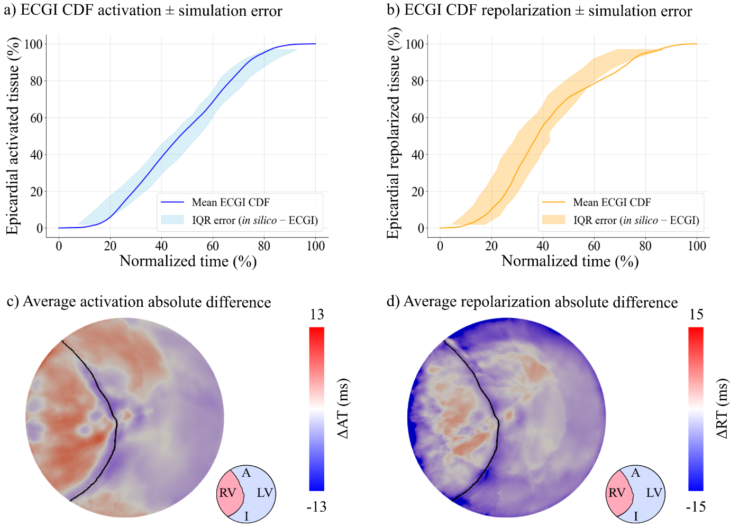
Figure S 4. Replication of in vivo epicardial dynamics by personalized Digital Twins across the MyoFit46 cohort. Agreement between electrocardiographic imaging (ECGI)-derived and in silico epicardial (a, c) activation and (b, d) repolarization dynamics across the eHTN MyoFit46 cohort. For both phases, panels are displayed from top to bottom: (a, b) the normalized mean ECGI cumulative distribution function (CDF) of activated and repolarized tissue, with shading indicating the interquartile range (IQR) of subject-specific discrepancies (in silico CDF minus ECGI CDF); (c, d) a flattened epicardial representation of the mean eHTN anatomy showing the point-to-point mean absolute error (in silico – ECGI) across the 47 participants, ΔAT for activation times (AT) and ΔRT for repolarization times (RT). The anatomical orientation of the flattened representation is indicated by the inset schematic, where RV and LV denote the right and left ventricles and A and I denote the anterior and inferior regions, respectively.

S7: Digital Twin Atlas of eHTN aging

S7.1: Activation sequence
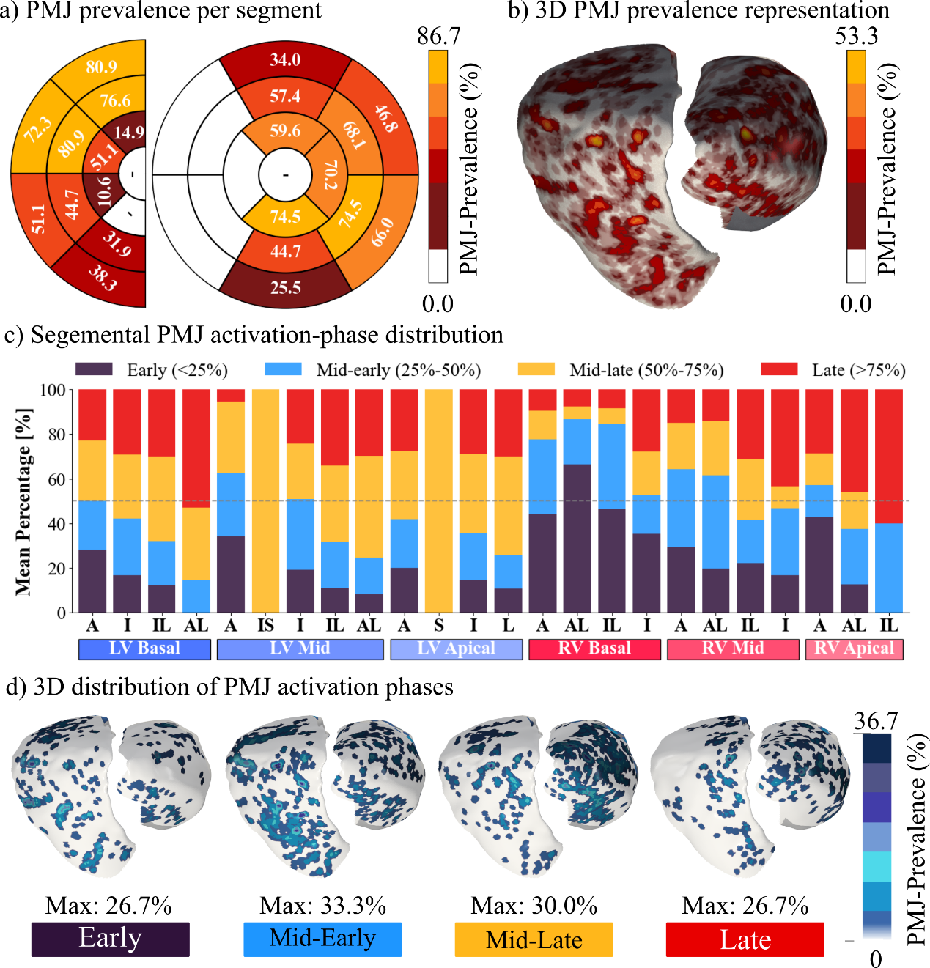
Figure S 5 summarizes the spatial distribution, prevalence, and activation-phase dynamics of PMJs across the cohort. Panels (a) and (b) show PMJ prevalence across the 17-segment LV model and the 13 additional RV segments, as well as their 3D representations, while panels (c) and (d) characterize activation-phase profiles and their anatomical stratification.
Figure S 5. Spatial distribution, prevalence, and activation-phase dynamics of Purkinje-Myocardial Junctions (PMJs) across the early-stage hypertensive (eHTN) MyoFit46 cohort. (a) PMJ prevalence expressed as the percentage of participants with at least one PMJ within each segment, displayed separately for the left ventricle (LV) and right ventricle (RV) bull's-eye. Color scale ranges from white (low prevalence) to dark red (high prevalence). (b) Three-dimensional endocardial representation of the eHTN mean anatomy showing the spatial density of PMJ hotspots across the LV and RV, with color intensity reflecting local PMJ prevalence. (c) Mean percentage of activation-phase profiles of PMJs per anatomical segment. Activation times were normalized from 0% (first PMJ activated) to 100% (last PMJ activated) for each participant to remove inter-subject temporal variability. Stacked bars illustrate the fraction of PMJs activated during four defined phases: Early (<25%, dark purple), Mid-early (25–50%, blue), Mid-late (50–75%, amber), and Late (>75%, red). Segments are grouped anatomically by region (LV Basal, LV Mid, LV Apical, RV Basal, RV Mid, RV Apical), with LV and RV walls aligned for direct comparison. (d) eHTN mean anatomy endocardial surfaces showing the spatial distribution of PMJs stratified by activation phase, from Early (leftmost) to Late (rightmost). Color intensity reflects local PMJ density within each phase. This representation highlights regional transitions: early activation is concentrated on the LV anterior wall and RV base, consistent with classical anatomical landmarks, while late-activated PMJs are distributed broadly across the remaining endocardium. A: anterior; AS: antero-septal; IS: inferoseptal; I: inferior; IL: inferolateral; AL: anterolateral; S: septal; L: lateral
PMJ prevalence was highest in the LV mid anterior and anterolateral walls (80.9% and 76.6%, respectively) and in the RV anterior and lateral mid and basal regions (up to 74.5%) (Figure S 5a), forming six main hotspots above 35% prevalence: two in the LV mid anterior and anterolateral walls, one in the LV mid inferolateral wall, and three along the RV lateral wall with a longitudinal distribution, together with two in the mid and basal anterior RV (Figure S 5b). In contrast, the LV apical and septal regions and the RV inferior wall showed consistently low prevalence. Regarding PMJ activation phases (Figure S 5c), the basal and mid anterior RV regions, together with the anterior LV mid-base, exhibited the highest concentration of early and mid-early activation. The remaining endocardial regions were predominantly activated during mid-late and late phases, consistent with the patterns observed in the healthy cohort. Figure S 5d further illustrates the anatomical distribution of phase-specific PMJs across the endocardial surface. Overall, mid-early and mid-late phases showed the broadest spatial coverage across both ventricles, while late-phase PMJs showed a more restricted distribution, concentrated mainly at the RV apex and anterior LV regions.

S7.2: Regional repolarization heterogeneities

S7.2.1: Baseline repolarization
Figure S 6 displays the analysis of g_{Ks} distribution encompassing (a) regional comparison and (b-c) 3D representation using principal component analysis for the calculation of mean and modes of variation of the 3D g_{Ks}. From a chamber point of view, RV presented significantly higher g_{Ks} values than LV (p_{adj} < 0.05, Figure S 6 a), with an apex-to-base decay of g_{Ks} values observed in both ventricles (all p_{adj}< 0.05, Figure S 6 a). Figure S 6 b shows the apico-basal gradient, characterized by higher g_{Ks} values at the RV apex decaying progressively toward the base. The first three PCA modes of variation (Figure S 6 c), collectively capturing 75% of inter-subject repolarization variability, reveal the dominant spatial patterns: Mode 1 reflects the overall amplitude of the longitudinal gradient; Mode 2 captures a transmural gradient from the RV anterolateral wall toward the LV inferolateral wall; and Mode 3 reflects the opposite pattern, from the RV inferolateral wall toward the LV anterolateral wall.
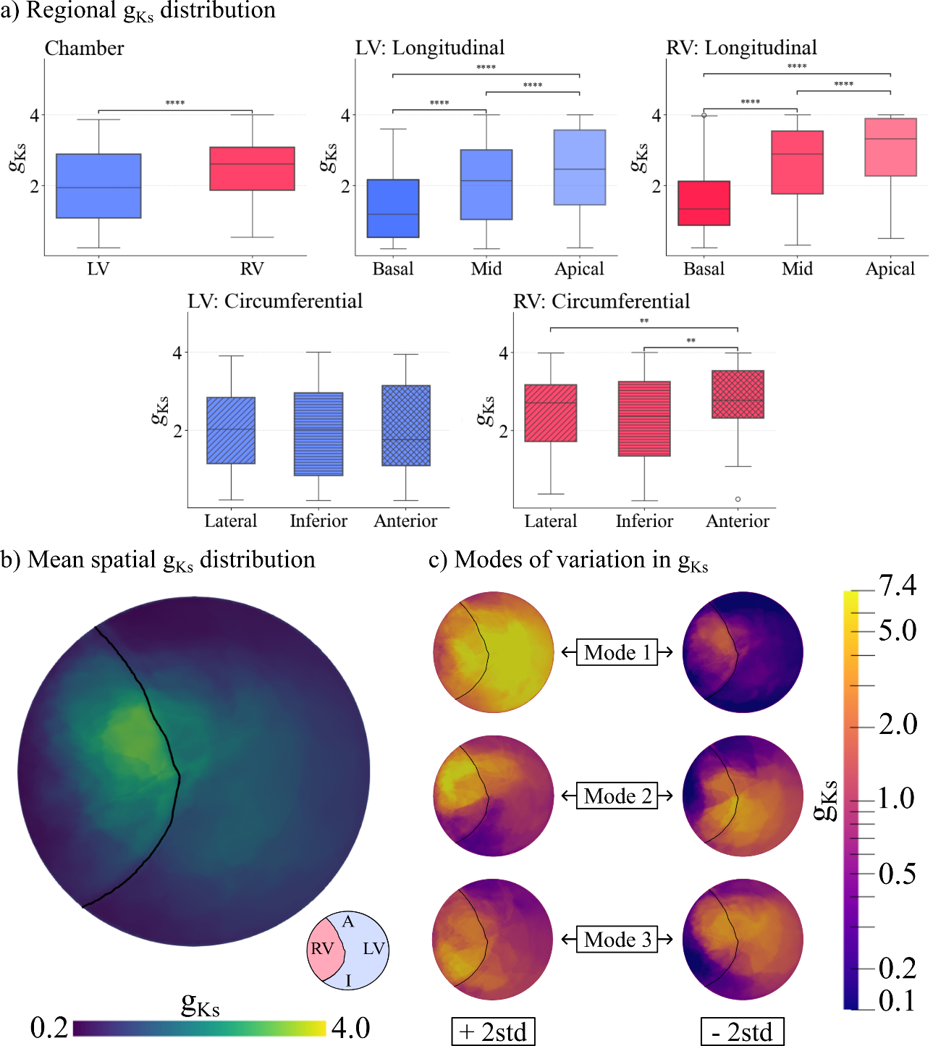
Figure S 6. Baseline repolarization atlas: regional distribution and principal modes of variation of the g_{Ks} across the eHTN MyoFit46 cohort. (a) Boxplots of g_{Ks} scaling factors comparing inter-chamber (left ventricle (LV) vs. right ventricle (RV)), LV longitudinal (Basal, Mid, Apical), and RV longitudinal distributions. Statistical significance was assessed using the Mann-Whitney U test with Benjamini–Hochberg correction (* p_{adj}<0.05, *** p_{adj}<0.001). (b) Cohort-mean g_{Ks} map displayed on the flattened biventricular endocardial surface. The black curve delineates the LV–RV boundary. An apex-to-base gradient is visible in both chambers. (c) Three leading principal modes of variation (Modes 1–3) derived from principal component analysis of the spatially resolved g_{Ks} maps across participants. For each mode, the positive (left) and negative (right) extremes (mean ± 2 standard deviations (std)) are shown on the flattened biventricular surface, illustrating the dominant spatial patterns of inter-subject variability. The anatomical orientation of the flattened epicardial representation is indicated by the inset schematic, where RV and LV denote right and left ventricles, respectively, and A and I denote anterior and inferior regions.

S7.2.2: Aging repolarization
The AgR layer was applied to all 47 eHTN participants, with age-related repolarization adaptation required in every subject. Across the cohort, AgR= was the dominant class, covering a median of 64.8% of the epicardial surface, followed by AgR↑ and AgR↓ in comparable global proportions (13.4% and 12.1%, respectively, Table S 5).
Spatially, AgR= predominated across the LV, particularly at the mid and apical regions, while the RV showed lower neutral coverage and greater contribution from the other two classes (Figure S 7 b). AgR↑ was concentrated at the basal regions of both ventricles, with a marked base-to-apex decreasing gradient and virtual absence at the apex (Figure S 7 a). AgR↓ showed the opposite spatial pattern, being largely absent from the LV and concentrated in the RV, increasing progressively from base to apex along the lateral and inferior walls (Figure S 7 c).
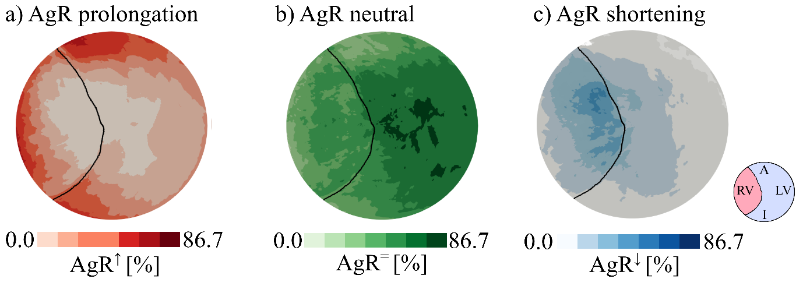
Figure S 7. Aging repolarization (AgR) adaptation was required in every participant (n=47). Population-level prevalence maps of AgR compensation classes across the early-stage hypertensive (eHTN) MyoFit46 cohort. Each map displays the proportion of participants exhibiting a given AgR compensation state at each epicardial point, ranging from 0 (no subject) to 100 (n=47). a) AgR↑ prolongation compensation prevalence. b) AgR⁼ neutral prevalence (no compensation). c) AgR↓ shortening compensation prevalence. The black line indicates the left ventricle (LV) — right ventricle (RV) insertion. The anatomical orientation of the flattened epicardial representation is indicated by the inset schematic, where RV and LV denote right and left ventricles, respectively, and A and I denote anterior and inferior regions.
Table S 5. Regional distribution of aging repolarization (AgR) classes across the early-stage hypertensive (eHTN) MyoFit46 cohort. Median [interquartile range] epicardial surface percentage covered by AgR↓(shortening), AgR⁼(neutral), and AgR↑(prolongation) compensation per region across 47 subjects. Medians are computed independently per class and do not sum to 100%. Chamber comparisons were assessed using the Wilcoxon signed-rank test; longitudinal and circumferential comparisons using the Friedman omnibus test. LV: Left ventricle; RV: right ventricle.
Region | AgR↓ (%) | AgR↑ (%) | AgR⁼ (%)
Global | 12.1 [1.5–37.3] | 13.4 [3.3–26.9] | 64.8 [45.3–75.8]
Chamber
LV | 2.0 [0.0–30.9] | 10.6 [3.4–24.0] | 69.1 [54.0–84.5]
RV | 24.1 [2.6–50.7] | 9.9 [2.1–25.9] | 61.0 [33.3–72.0]
p-value | <0.001 | 0.718 | <0.001
Longitudinal LV
LV Base | 0.4 [0.0–19.1] | 31.8 [9.0–48.4] | 58.7 [37.9–70.4]
LV Mid | 1.7 [0.0–27.2] | 1.2 [0.0–18.8] | 74.2 [53.0–90.6]
LV Apex | 0.7 [0.0–35.6] | 0.0 [0.0–3.6] | 86.3 [46.8–99.4]
p-value | 0.011 | <0.001 | <0.01
Longitudinal RV
RV Base | 8.2 [0.8–24.2] | 32.1 [5.6–60.4] | 41.1 [24.6–67.1]
RV Mid | 24.3 [3.0–60.5] | 0.7 [0.0–9.8] | 55.4 [27.5–80.2]
RV Apex | 30.0 [0.0–75.2] | 0.0 [0.0–0.1] | 68.2 [22.4–98.2]
p-value | <0.01 | <0.001 | 0.259
Circumferential LV
LV Lateral | 0.1 [0.0–11.6] | 4.1 [0.0–17.6] | 82.9 [53.3–91.5]
LV Inferior | 0.0 [0.0–19.0] | 8.0 [0.0–41.0] | 63.7 [17.9–93.7]
LV Anterior | 0.2 [0.0–25.2] | 18.0 [0.6–34.7] | 65.9 [33.0–80.8]
p-value | 0.151 | <0.01 | 0.027
Circumferential RV
RV Lateral | 11.6 [0.0–59.4] | 8.2 [0.9–31.7] | 51.2 [22.6–82.8]
RV Inferior | 10.2 [0.0–70.5] | 0.0 [0.0–0.0] | 71.2 [16.7–100.0]
RV Anterior | 16.2 [1.5–51.1] | 12.9 [1.5–23.5] | 57.4 [21.5–80.3]
p-value | 0.327 | <0.001 | 0.455

S8: eHTN and healthy atlases comparison

S8.1: Regional comparison of PMJ prevalence
To characterize the PMJ distribution differences at segment resolution, Table S 6 reports the prevalence of PMJ per AHA segment for each eHTN and healthy cohorts.
Globally, PMJ prevalence did not differ significantly between the healthy and eHTN cohorts (Wilcoxon signed-rank p = 0.62), with comparable distributions across LV and RV regions. The largest observed differences were in segments 12 (LV mid anterolateral, −18.6 pp), 16 (LV apical lateral, +20.2 pp), and 24 (RV mid anterolateral, −22.0 pp).
Table S 6. Segment-level Purkinje-Myocardial junction (PMJ) prevalence comparison between healthy and early-stage hypertensive (eHTN) MyoFit46 cohorts. Percentage of participants with at least one PMJ within each segment for the healthy (n=30) and eHTN (n=47) cohorts, and the absolute difference in percentage points (Δ, pp). Segments are numbered according to the standard 17-segment left ventricular model extended to include right ventricular segments (18–30). Segments 2, 3, 8, 9, 14, and 17 were excluded from phase analysis due to insufficient prevalence but are retained here for completeness.
Segment | Healthy prevalence (%) | eHTN prevalence (%) | Δ (pp)
1 | 46.7 | 34.0 | -12.6
2 | 0.0 | 0.0 | +0.0
3 | 0.0 | 0.0 | +0.0
4 | 16.7 | 25.5 | +8.9
5 | 56.7 | 66.0 | +9.3
6 | 43.3 | 46.8 | +3.5
7 | 63.3 | 57.4 | -5.9
8 | 0.0 | 0.0 | +0.0
9 | 0.0 | 2.1 | +2.1
10 | 46.7 | 44.7 | -2.0
11 | 66.7 | 74.5 | +7.8
12 | 86.7 | 68.1 | -18.6
13 | 46.7 | 59.6 | +12.9
14 | 0.0 | 2.1 | +2.1
15 | 63.3 | 74.5 | +11.1
16 | 50.0 | 70.2 | +20.2
17 | 3.3 | 0.0 | -3.3
18 | 76.7 | 80.9 | +4.2
19 | 76.7 | 72.3 | -4.3
20 | 46.7 | 51.1 | +4.4
21 | 36.7 | 38.3 | +1.6
22 | 83.3 | 76.6 | -6.7
23 | 86.7 | 80.9 | -5.8
24 | 66.7 | 44.7 | -22.0
25 | 40.0 | 31.9 | -8.1
26 | 20.0 | 14.9 | -5.1
27 | 60.0 | 51.1 | -8.9
28 | 13.3 | 10.6 | -2.7
29 | 0.0 | 0.0 | +0.0
30 | 6.7 | 0.0 | -6.7

S8.2: PMJ activation phase comparison
Table S 7 quantifies the differences between healthy and eHTN groups in PMJ activation-phase fractions at segment level, while Figure S 8 summarizes between-cohort differences in PMJ activation-phase composition. A significant reduction in the Late-phase fraction was identified in the eHTN cohort (median Δ = −7.89 pp, p_{adj} = 0.021), with the largest single-segment difference observed at AHA 18 (RV basal inferior, −35.86 pp). This reduction was directionally consistent across the majority of segments and was accompanied by a shift toward the Mid-early phase (median Δ = +5.10 pp, padj = 0.098). Early and Mid-late fractions showed no significant group differences after correction. No sign test gives statistically significant results after correction Table S 8.
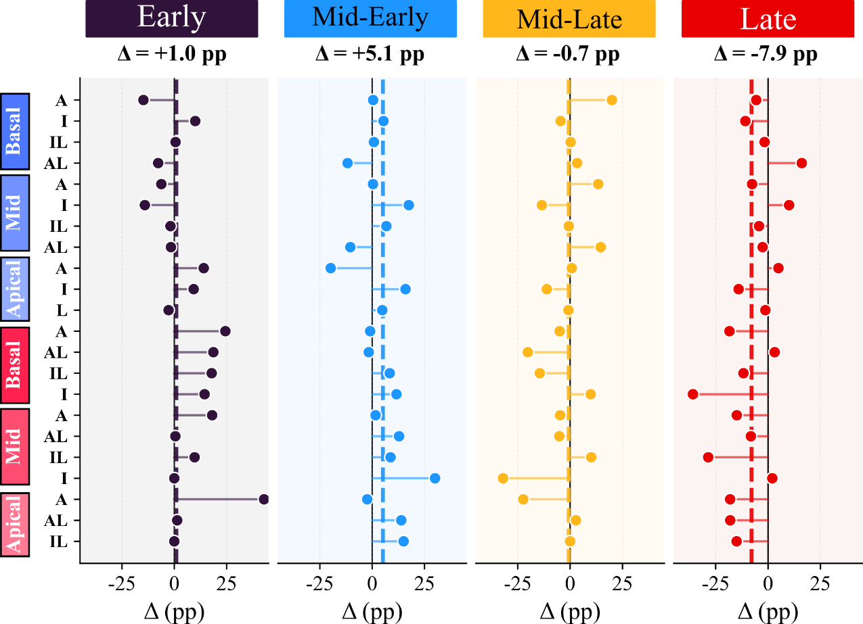
Table S 7. Comparison of Purkinje-Myocardial junction (PMJ) activation-phase distributions between healthy and early-stage hypertensive (eHTN) MyoFit46 cohorts. Median difference in percentage point (pp) contribution of each activation phase across segments, with interquartile range (IQR). Activation times were normalized per subject from 0% (first PMJ activated) to 100% (last PMJ activated). Phases are defined as: Early (<25%), Mid-early (25–50%), Mid-late (50–75%), and Late (>75%). Statistical comparison was performed using the Wilcoxon signed-rank test across segments with Benjamini–Hochberg correction (p_{adj}). A positive Δ indicates a higher phase fraction in the eHTN cohort relative to healthy. Max |Δ| indicates the segment with the largest absolute between-group difference.
Figure S 8. Segment-level differences in Purkinje-Myocardial junction (PMJ) activation-phase fractions between early-stage hypertensive (eHTN) and healthy MyoFit46 cohorts. Each panel displays the per-segment difference (Δ, percentage points (pp)) in the fraction of PMJs activated during a given phase — Early (<25%), Mid-early (25–50%), Mid-late (50–75%), and Late (>75%) — computed as eHTN minus healthy. Each circle represents the per-segment difference in one segment. Segments are grouped anatomically along the vertical axis by region (Left ventricle (LV) Basal, LV Mid, LV Apical, Right ventricle (RV) Basal, RV Mid, RV Apical). Positive values indicate a higher phase fraction in the eHTN cohort; negative values indicate a higher fraction in the healthy cohort. The dashed vertical line indicates the mean difference across all segments for each activation phase. Activation times were normalized per subject from 0% (first PMJ activated) to 100% (last PMJ activated) prior to phase classification.

Quantity | Median Δ (pp) |  | IQR | p-value | p_{adj} | Max |Δ| (pp) (segment)
Early |  | +0.99 pp | [-1.76, +14.36] | 0.073 | 0.098 | +42.86 pp (29)
Mid-early |  | +5.10 pp | [-0.64, +12.53] | 0.050 | 0.098 | +30.00 pp (22)
Mid-late |  | -0.72 pp | [-9.63, +3.20] | 0.322 | 0.322 | -32.03 pp (22)
Late |  | -7.89 pp | [-14.98, -1.37] | 0.005 | 0.021 | -35.86 pp (18)

Table S 8 Comparison of Purkinje-Myocardial junction (PMJ) activation-phase distributions between healthy and early-stage hypertensive (eHTN) MyoFit46 cohorts. Per-phase sign test of PMJ activation-phase distributions between healthy and eHTN MyoFit46 cohorts. For each activation phase, segment-level differences (eHTN − healthy) were classified as positive (+), negative (−), or tied (0), and tested for directional consistency using a two-sided sign test (exact binomial) across the n = 22 segments. Benjamini–Hochberg correction (p_{adj}) was applied across the four phase-level tests. Phases are defined as: Early (<25%), Mid-early (25–50%), Mid-late (50–75%), and Late (>75%).
Quantity | eHTN > Healthy | eHTN < Healthy | Tied | p-value | p_{adj}
Early | 13 | 7 | 2 | 0.263 | 0.351
Mid-early | 16 | 6 | 0 | 0.052 | 0.105
Mid-late | 9 | 12 | 1 | 0.664 | 0.664
Late | 5 | 17 | 0 | 0.017 | 0.068

S8.3: Baseline repolarization comparison
Regional g_{Ks} comparisons between the healthy and eHTN cohorts are detailed in Table S 9. No statistically significant differences were observed after Benjamini–Hochberg correction across all anatomical regions. The most notable absolute differences were found at the RV basal level (−0.797) and LV anterior circumferential region (−0.621), both trending toward lower g_{Ks} values in the eHTN cohort, though neither reached significance. Sign test identified that 11 out of 15 regions showed decreased g_{Ks} but did not reach statistical significance (p-value= 0.119). These results indicate that, at the regional level of analysis defined here, the apico-basal g_{Ks} structure is preserved in the eHTN cohort and does not deviate significantly from healthy normative reference.
Table S 9. Regional comparison of g_{Ks} scaling factors between healthy and early-stage hypertensive (eHTN) MyoFit46 cohorts. Median g_{Ks} values per anatomical region for healthy (H, n=30) and eHTN (n=47) cohorts, absolute difference (Δ), and p-values from the Mann-Whitney U test with Benjamini–Hochberg correction (p_{adj}). Regions are stratified by chamber (left ventricle (LV) vs. right ventricle (RV)), longitudinal level (Basal, Mid, Apical), and circumferential wall (Lateral, Inferior, Anterior). No statistically significant differences were observed after correction. g_{Ks}: slow delayed rectifier potassium current conductance scaling factor.
Region | Median g_{Ks} (Healthy) | Median g_{Ks} (eHTN) | Δ | p | p_{adj}
Global | 2.486 | 2.278 | -0.209 | 0.248 | 0.490
Chamber
LV | 2.016 | 1.948 | -0.068 | 0.270 | 0.514
RV | 2.864 | 2.608 | -0.256 | 0.257 | 0.514
LV longitudinal
Basal | 1.479 | 1.187 | -0.293 | 0.116 | 0.469
Mid | 2.132 | 2.137 | +0.005 | 0.455 | 0.592
Apical | 2.443 | 2.465 | +0.022 | 0.481 | 0.592
RV longitudinal
Basal | 2.136 | 1.339 | -0.797 | 0.131 | 0.469
Mid | 2.881 | 2.891 | +0.009 | 0.620 | 0.620
Apical | 3.280 | 3.315 | +0.035 | 0.562 | 0.605
LV circumferential
Lateral | 2.280 | 2.030 | -0.249 | 0.294 | 0.514
Inferior | 2.227 | 2.027 | -0.200 | 0.478 | 0.592
Anterior | 2.386 | 1.765 | -0.621 | 0.107 | 0.469
RV circumferential
Lateral | 2.896 | 2.717 | -0.179 | 0.270 | 0.514
Inferior | 2.556 | 2.372 | -0.184 | 0.507 | 0.592
Anterior | 3.358 | 2.781 | -0.577 | 0.134 | 0.469

S8.4: Aging repolarization comparison
Table S 10 reports the region-level differences in AgR compensation class prevalence between the healthy and eHTN cohorts. A global directional trend toward increased AgR↑ and reduced AgR↓ was observed in the eHTN group across most regions. The largest increase in AgR↑ was observed in the RV basal longitudinal region (+28.22 pp), followed by the LV basal longitudinal region (+24.73 pp). The most pronounced reductions in AgR↓ were found in the RV anterior circumferential region (−37.42 pp) and the RV inferior circumferential region (−31.18 pp). Despite the magnitude of some regional differences, none reached statistical significance after Benjamini–Hochberg correction. The overall predominance of positive AgR↑ differences and negative AgR↓ differences across regions constitutes the primary evidence for a cohort-level shift toward delayed repolarization in the eHTN group. In Table S 11 are reported the sign test results by AgR class.
Table S 10. Regional comparison of aging repolarization (AgR) compensation class distributions between healthy and early-stage hypertensive (eHTN) MyoFit46 cohorts. Absolute difference (Δ, percentage points) in the epicardial surface fraction covered by each AgR compensation class — AgR↑ (prolongation, g_{Kr}<1), AgR↓ (shortening, g_{Kr}>1), and AgR= (neutral) — between eHTN (n=47) and healthy (n=30) cohorts, with Benjamini–Hochberg-corrected p-values (p_{adj}). A positive Δ indicates a higher proportion in the eHTN cohort. Regions are stratified by chamber, longitudinal level, and circumferential wall. No statistically significant between-group differences were observed after correction.
Region | AgR↑ |  | AgR↓ |  | AgR=
Region | Δ | p_{adj} | Δ | p_{adj} | Δ | p_{adj}
Global | +9.63 | 0.433 | -4.17 | 0.707 | +1.90 | 0.969
Chamber
LV | +7.87 | 0.433 | -1.69 | 0.707 | -6.04 | 0.707
RV | +7.90 | 0.433 | -7.44 | 0.707 | +0.41 | 0.969
LV longitudinal
Basal | +24.73 | 0.433 | -0.41 | 0.820 | -9.57 | 0.438
Mid | +0.94 | 0.707 | -2.19 | 0.971 | -4.97 | 0.969
Apical | +0.00 | 0.821 | -1.11 | 0.707 | -1.13 | 0.980
RV longitudinal
Basal | +28.22 | 0.433 | -7.67 | 0.707 | -11.57 | 0.707
Mid | +0.66 | 0.707 | -8.43 | 0.820 | +3.29 | 0.992
Apical | +0.00 | 0.707 | -8.00 | 0.707 | +10.71 | 0.868
LV circumferential
Lateral | +3.29 | 0.707 | -0.99 | 0.707 | -5.32 | 0.707
Inferior | +6.83 | 0.707 | +0.00 | 0.707 | -19.40 | 0.543
Anterior | +15.98 | 0.433 | -4.05 | 0.543 | +1.72 | 0.836
RV circumferential
Lateral | +7.96 | 0.433 | +4.37 | 0.969 | -17.48 | 0.707
Inferior | +0.00 | 0.707 | -31.18 | 0.707 | +16.34 | 0.731
Anterior | +10.77 | 0.438 | -37.42 | 0.438 | +20.24 | 0.707

Table S 11. Regional-level differences in aging repolarization (AgR) classes between early-stage hypertensive (eHTN) and healthy MyoFit46 cohorts. Per-segment sign test of AgR class redistribution between healthy and eHTN MyoFit46 cohorts. For each AgR class (AgR↑, APD prolongation; AgR↓, APD shortening; AgR=, neutral), segment-level differences (eHTN − healthy) in class contribution were classified as positive (eHTN > healthy), negative (eHTN < healthy), or tied, and tested for directional consistency using a two-sided sign test (exact binomial) across regions. Benjamini–Hochberg correction (padj) was applied across the three class-level tests.
Quantity | eHTN > Healthy | eHTN < Healthy | Tied | p-value | p_{adj}
AgR↑ | 12 | 0 | 3 | <0.001 | 0.001
AgR↓ | 3 | 11 | 1 | 0.057 | 0.086
AgR= | 8 | 7 | 0 | 1.000 | 1.000

S9: Inclusion / exclusion criteria
Participants were selected from the MyoFit46 cohort according to predefined inclusion and exclusion criteria designed to identify a healthy reference subgroup free from conditions known to alter cardiac electrophysiology or myocardial structure. Criteria spanned functional status, metabolic and hemodynamic profile, respiratory health, oncological history, cardiac rhythm, cardiovascular history, ventricular function, and myocardial tissue characterization. End-stage renal disease was an exclusion criterion applied at the recruitment stage, so all enrolled participants had suitable renal function by default. The detailed list of inclusion/exclusion criteria is listed on Table S 12.
Table S 12. Inclusion/exclusion criteria for healthy reference subgroup. End-stage renal disease was already an exclusion criterion for recruitment so by default all recruited participants had suitable renal function. BMI – body mass index; ECGI: electrocardiographic imaging; LGE: late gadolinium enhancement; LVEF: left ventricular ejection fraction; NYHA: New York Heart Association.
Category | Inclusion Criteria | Exclusion Criteria
Functional status | NYHA functional class I | NYHA ≥ II
Body composition | BMI < 35 kg/m² | BMI ≥ 35 kg/m²
Metabolic status | No diabetes mellitus; not receiving antidiabetic medication | Diagnosed diabetes mellitus or treatment with antidiabetic medication
Blood pressure | No history of hypertension; not receiving antihypertensive medication; diastolic systemic pressure <90 mmHg; systolic blood pressure < 140 mmHg. | Diagnosed hypertension or current antihypertensive therapy; diastolic systemic pressure ≥ 90 mmHg; systolic blood pressure ≥ 140 mmHg.
Respiratory health | No major chronic respiratory disease | Chronic obstructive pulmonary disease, interstitial lung disease, or other chronic pulmonary pathology
Oncological history | No active malignancy | Active or recently treated cancer
Cardiac rhythm | Sinus rhythm on resting ECGI | History of atrial fibrillation, atrial flutter or high burden of ventricular ectopy
Cardiovascular history | No previously known major cardiovascular disease | Previous myocardial infarction, coronary artery bypass graft, percutaneous coronary intervention, or heart failure
Cardiac function | LVEF ≥ 55% | LVEF < 55%
Myocardial tissue characterization | LGE burden < 2% of LV mass | LGE burden ≥ 2%

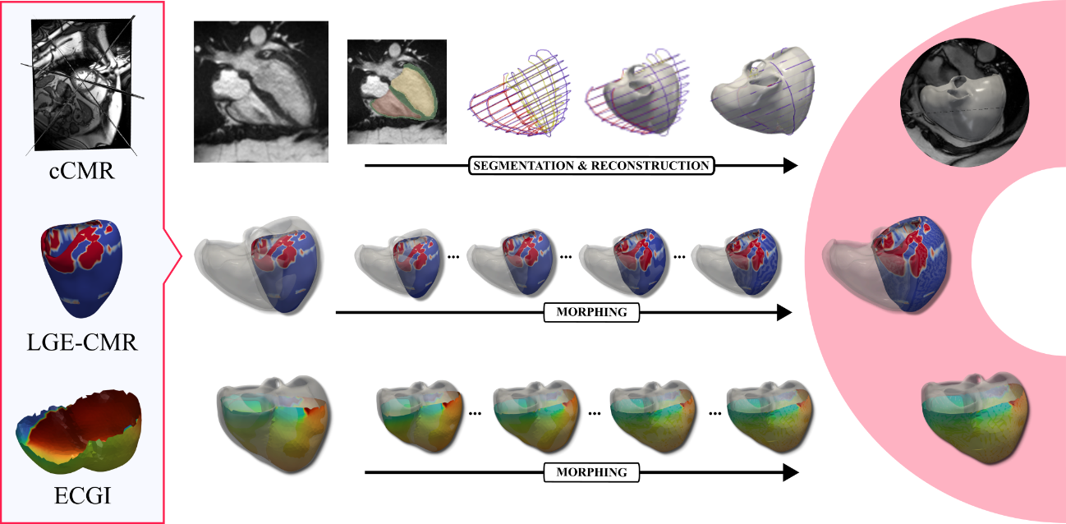
S10: Methodology of multimodal clinical data integration
Figure S 9. Methodology used for the integration of multimodal clinical data into the Digital Twins. Top row: Subject-specific biventricular anatomy is reconstructed from manual segmentations of end-diastolic cine cardiac magnetic resonance (cCMR) images, short- and long-axis images, followed by a mesh morphing algorithm to generate a continuous 3D model. Middle row: Late gadolinium enhancement (LGE) images are segmented to extract a 3D representation of the subject-specific LGE burden, which is then adapted to the end-diastolic heart model. Bottom row: Epicardial activation and repolarization maps derived from electrocardiographic imaging (ECGI) are filtered and geometrically registered to the same cCMR derived end-diastolic anatomy. The resulting personalized model (right) combines structural, tissue-characterization, and electrophysiological data into a unified computational framework.
Multimodal clinical data integration constitutes the first stage of the DT personalization pipeline. Subject-specific biventricular anatomy, myocardial fibrosis burden, and epicardial electrophysiology were derived from cine-CMR, LGE, and ECGI respectively, and co-registered to a common end-diastolic reference frame via a mesh morphing algorithm. The resulting unified anatomical and functional representation served as the direct input to the subsequent personalization stages. A schematic overview of this integration workflow is provided in Figure S 9.

S11: Apparent CV correlation with electrical diffusion
Apparent median Conduction Velocity (CV) was measured using inverse gradient methodology¹ from the estimated activation maps from the ECGI inverse problem solution. This CV cannot be directly imposed on our proposed electrophysiology (EP) Digital Twins (DTs) framework. This framework used the monodomain formulation² for the replication of activation potential propagation along the myocardium. This is not an explicit parameter but rather an emergent property determined by the tissue’s electrical diffusivity (D) and the ionic model governing membrane dynamics. This tensor $D$ contains the electrical diffusivity along the fibers ($D_{f}$) and two orthogonal directions ($D_{o}$). In our DT framework we use a ratio between $D_{f}$ and $D_{o}$of 3 to 1.
In order to find the correlation between $D$ and the CV, we used the EP benchmark defined by Niederer et al. work³. The EP transmural heterogeneity was introduced and defined by three transmural equal layers representing the endocardial cells, mid cells and epicardial cells with their representative ion channels conductance modifications reported in⁴. In this framework we run simulations with initial stimulus on the endocardium and varying $D_{f}$. Obtained activation maps were used to solve the inverse gradient to compute the apparent CV from the benchmark framework. For better comparison with measured ECGI CV, we filter those velocities below 0.05 m/s and higher than 2.5 m/s. From each $D_{f}$ we compute the median CV on the epicardium.
Final correlation can be found in Figure S 10. We obtained a second order polynomial relationship between median epicardial CV and $D_{f}$. We use this relationship such that given the measured median CV on the ECGI we obtained the expected $D_{f}$ on the monodomain formulation.
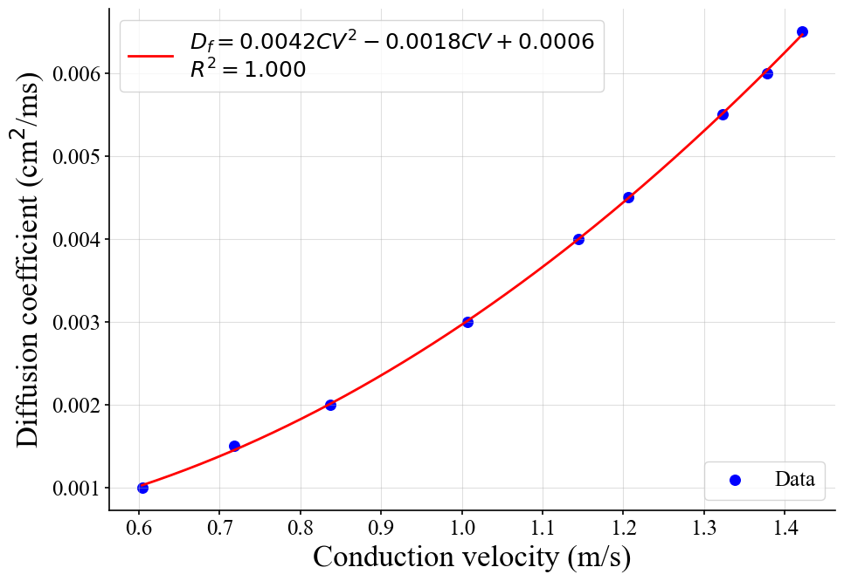
Figure S 10. Obtained correlation between electrical diffusion along the fiber ($D_{f}$) and conduction velocity (CV).

S12: Baseline and aging repolarization layers estimation
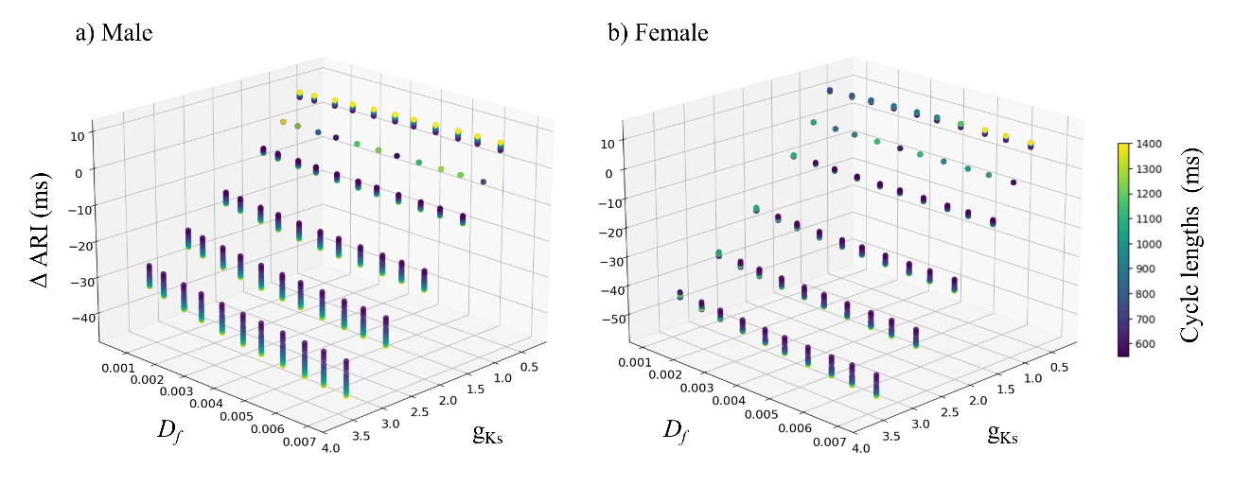
Regional heterogeneities in ventricular repolarization were tuned by modulating the local expression of the slow delayed rectifier potassium current, represented by a scaling factor over the baseline conductance (g_{Ks}). To achieve a subject-specific representation, local g_{Ks} values were adjusted based on Activation-Repolarization Intervals (ARIs) derived from ECGI records. To characterize the relationship between g_{Ks} and ARI, the EP benchmark model described by Niederer et al.³ was employed. Transmural heterogeneity was incorporated through three equal layers representing endocardial, mid-myocardial, and epicardial cells, with ionic conductance modifications as reported in O’Hara et al.⁴.
Figure S 11. Increment of the mean Activation-Repolarisation Interval (Δ ARI (ms)) regarding the diffusion coefficient (D_{f}), the cycle length and the g_{Ks} in male (a) and female (b). g_{Ks}: slow delayed rectifier potassium current conductance scaling factor.
Simulations were performed across physiologically ranges of g_{Ks} scaling factors (0.2-4), pacing cycle lengths (550–1400 ms) and tissue’s electrical diffusivity ($D_{f}$) (0.001–0.007), for both female and male phenotypes. The bounds of the g_{Ks} scaling factor were chosen to exclude non-physiological values while remaining consistent with, and moderately extending, the inter-subject variability reported in gene expression data from healthy human ventricles^{5–7}.
Integrating these electrophysiological parameters enabled the construction of a multidimensional characterization of how they jointly modulate the ARI, as illustrated in Figure S 11. This characterization allowed regional g_{Ks} adjustments to be estimated under subject-specific electrophysiological conditions, improving the personalization of the repolarization properties.
The resulting characterization was used to estimate local g_{Ks} adjustments by relating the differences between simulated and ECGI-derived ARI after running subject-specific simulations with the estimated CV and activation sequence, while accounting for individual sex, heart rate, and $D_{f}$. The epicardial g_{Ks} values obtained through this process were subsequently propagated transmurally, assuming a homogeneous transmural g_{Ks} gradient.
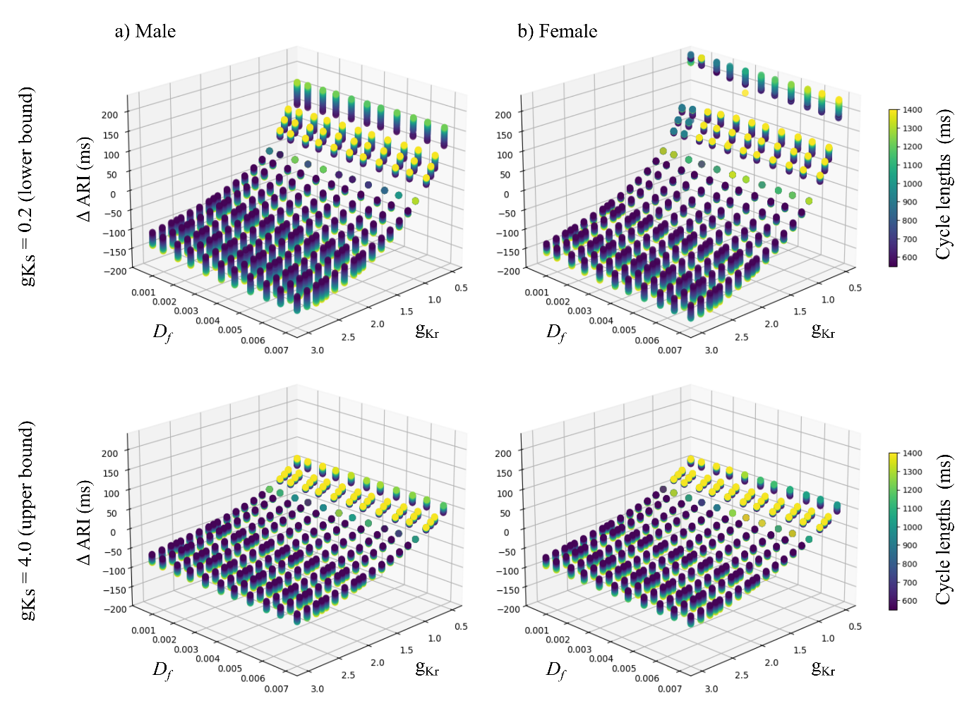
To account for the extreme ARIs observed in the in vivo ECGI data, a second repolarization layer was introduced to capture the pronounced electrophysiological remodeling associated with aging^{8–10}. In this step, a local scaling factor was applied to the rapid delayed rectifier potassium current (g_{Kr}), selected for its primary contribution to action potential duration prolongation¹¹.
Figure S 12. Increment of the mean Activation-Repolarisation Interval (Δ ARI (ms)) regarding the diffusion coefficient (D_{f}), the cycle length and the g_{Kr} in male (a) and female (b) for g_{Ks} = 0.2 (first row) and g_{Ks} = 4.0 (second row). g_{Kr}: rapid delayed rectifier potassium current conductance scaling factor.
The g_{Kr}–ARI relationship was characterized using the same benchmark model and transmural structure described above. Simulations were performed across plausible ranges of g_{Kr} scaling factors (0.5–3.0), pacing cycle lengths (550–1400 ms), and tissue electrical diffusivity (0.001–0.007) for both sexes. Because this aging-related repolarization layer was only applied to regions where g_{Ks} had reached its predefined limits (0.2-fold or 4.0-fold), g_{Ks} values were fixed at those boundary values in these simulations.
This second characterization (see Figure S 12) was used to estimate local g_{Kr} adjustments by relating simulated and ECGI-derived ARIs after subject-specific simulations incorporating the estimated CV, activation sequence, and initial g_{Ks} adjustments, while accounting for individual sex and heart rate and $D_{f}$. The resulting epicardial g_{Kr} values, together with the previously obtained g_{Ks} values, were then propagated transmurally across the ventricular wall assuming homogeneous gradients for both scaling factors.

S13: Pipeline verification test design
To assess the accuracy, robustness, and reliability of the personalization pipeline, a series of benchmark tests were performed. Ground-truth was defined using the forward solution of a DT with prescribed CV, activation sequence, and repolarization properties (see Table S 13). These known DTs were then used as inputs to the proposed pipeline, with the expectation that the resulting personalized DTs would recover properties close to the ground-truth.
Three CV values spanning the interquartile range of ECGI-derived CV measurements were tested. To facilitate the identification of sources of CV error, three CV definitions were considered: $CV_{input}$, the value used to generate the ground-truth simulations; $CV_{GT}$, the apparent CV measured from the ground-truth activation maps; and $CV_{in silico}$, the apparent CV obtained from the estimated activation maps. Activation sequences followed two strategies — Durrer-based¹² and Purkinje-based PMJs¹³ — and two repolarization spatial patterns were prescribed for both g_{Ks} and g_{Kr}: an apex-to-base gradient¹⁴ and a spatially heterogeneous Voronoi distribution. All test combinations are listed in Table S 13.
Table S 13. List of verification tests. Durrer-based Purkinje-Myocardial Junctions (PMJs) refers to the use of early activation sites identified in ¹². Purkinje-based PMJs using artificial Purkinje network for the selection of PMJs. Repolarization property patterns include an apex-to-base gradient (A2B), and a heterogeneous random distribution generated using Voronoi sampling (Voronoi). AgR: aging repolarization; CV_{input}: Input conduction velocity; g_{Ks}: slow delayed rectifier potassium current conductance scaling factor.
Test ID | $CV_{input}$ [m/s] |  | Activation sequence | Baseline repolarization (g_{Ks}) | Aging repolarization (AgR)
#1 |  | 0.867 | Durrer-based PMJs | A2B | A2B
#2 |  | 0.867 | Purkinje based PMJs | Voronoi | Voronoi
#3 |  | 0.791 | Durrer-based PMJs | Voronoi | A2B
#4 |  | 0.791 | Purkinje based PMJs | A2B | Voronoi
#5 |  | 0.971 | Durrer-based PMJs | Voronoi | Voronoi
#6 |  | 0.971 | Purkinje based PMJs | A2B | A2B

Pipeline reliability was quantified using the metrics summarized in Table S 14. For PMJ evaluation, supplementary points located on endocardial mesh boundaries near regions lacking explicit activation data (e.g., the septum or basal areas) were excluded from spatial localization error (PMJ-DE) but retained for activation time error (PMJ-AE), as they act as active sources in the estimated simulations
Table S 14. Verification metrics used to evaluate pipeline accuracy. AgR-RMSE: root mean square error of the aging repolarization scaling factor; CV: conduction velocity; CV-RE: conduction velocity relative error; PMJ: Purkinje-myocardial junction; PMJ-DE: PMJ detection error; PMJ-AE: PMJ activation-time error; AT-RMSE: root mean square error of activation times; RT-RMSE: root mean square error of repolarization times; g_{Ks}-RMSE: root mean square error of the slow delayed rectifier potassium current conductance scaling factor.
Metric | Definition
CV-RE | Relative error between median ground-truth and estimated apparent CV.
PMJ-DE | Mean distance between each estimated PMJ and its nearest ground-truth PMJ.
PMJ-AE | Mean absolute activation-time error between estimated and ground-truth PMJs.
AT-RMSE | Root mean square error of activation times. Used for epicardial and endocardial maps.
RT-RMSE | Root mean square error of repolarization times.
g_{Ks}-RMSE | Root mean square error of g_{Ks} scaling factors.
AgR-RMSE | Root mean square error of aging repolarization (AgR) scaling factors.

References
1. Barnette, A. R. et al. Estimation of 3-D conduction velocity vector fields from cardiac mapping data. IEEE Trans. Biomed. Eng. 47, 1027–1035 (2000).
2. Vázquez, M. et al. A massively parallel computational electrophysiology model of the heart. Int. J. Numer. Methods Biomed. Eng. 27, 1911–1929 (2011).
3. Niederer, S. A. et al. Verification of cardiac tissue electrophysiology simulators using an N-version benchmark. Philos. Trans. R. Soc. Math. Phys. Eng. Sci. 369, 4331–4351 (2011).
4. O’Hara, T., Virág, L., Varró, A. & Rudy, Y. Simulation of the Undiseased Human Cardiac Ventricular Action Potential: Model Formulation and Experimental Validation. PLOS Comput. Biol. 7, e1002061 (2011).
5. Gaborit, N. et al. Gender-related differences in ion-channel and transporter subunit expression in non-diseased human hearts. J. Mol. Cell. Cardiol. 49, 639–646 (2010).
6. Ambrosi, C. M., Yamada, K. A., Nerbonne, J. M. & Efimov, I. R. Gender Differences in Electrophysiological Gene Expression in Failing and Non-Failing Human Hearts. PLOS ONE 8, e54635 (2013).
7. Cicci, L. et al. Personalising cardiac electrophysiology models from CT and ECG for 3D activation imaging and tissue characterisation. Preprint at https://doi.org/10.21203/rs.3.rs-8873590/v1 (2026).
8. Mirza, M., Strunets, A., Shen, W.-K. & Jahangir, A. Mechanisms of Arrhythmias and Conduction Disorders in Older Adults. Clin. Geriatr. Med. 28, 555–573 (2012).
9. Lazzarini, E. et al. Stress-induced premature senescence is associated with a prolonged QT interval and recapitulates features of cardiac aging. Theranostics 12, 5237–5257 (2022).
10. Pham, T. V. & Rosen, M. R. Sex, hormones, and repolarization. Cardiovasc. Res. 53, 740–751 (2002).
11. Altomare, C. et al. IKr Impact on Repolarization and Its Variability Assessed by Dynamic Clamp. Circ. Arrhythm. Electrophysiol. 8, 1265–1275 (2015).
12. Durrer, D. et al. Total Excitation of the Isolated Human Heart. Circulation 41, 899–912 (1970).
13. Gonzalez-Martin, P. et al. Electromechanical evaluation of conduction system pacing techniques in a patient-specific virtual cohort: an in silico clinical trial. https://www.authorea.com/users/1023656/articles/1383560-electromechanical-evaluation-of-conduction-system-pacing-techniques-in-a-patient-specific-virtual-cohort-an-in-silico-clinical-trial (2026).
14. Szentadrassy, N. et al. Apico–basal inhomogeneity in distribution of ion channels in canine and human ventricular myocardium. Cardiovasc. Res. 65, 851–860 (2005).

