Framework for tracking development of multi-commodity energy hubs
Michael J. F. Jenks^{1*}, Rosa Kappert², Joke M. Westra³, Rick Wolbertus¹

¹Faculty of Technology, Energy and Innovation, Amsterdam University of Applied Sciences, Rhijnspoorplein 2, 1091 GC, Amsterdam, The Netherlands, m.j.f.jenks@hva.nl, r.wolbertus@hva.nl
²Hanze University of Applied Sciences, Zernikeplein 7, 9747 AC, Groningen, The Netherlands, r.kappert@pl.hanze.nl
³Windesheim University of Applied Sciences, Campus 2, 8017 CA, Zwolle, The Netherlands, j.m.westra@windesheim.nl
*corresponding author, Michael J. F. Jenks, m.j.f.jenks@hva.nl

Supplementary Information

Energy carrier usage in the Netherlands
The calculations and references for Figure 1 from the main text is shown below. Figure 1 is repeated here for reference.
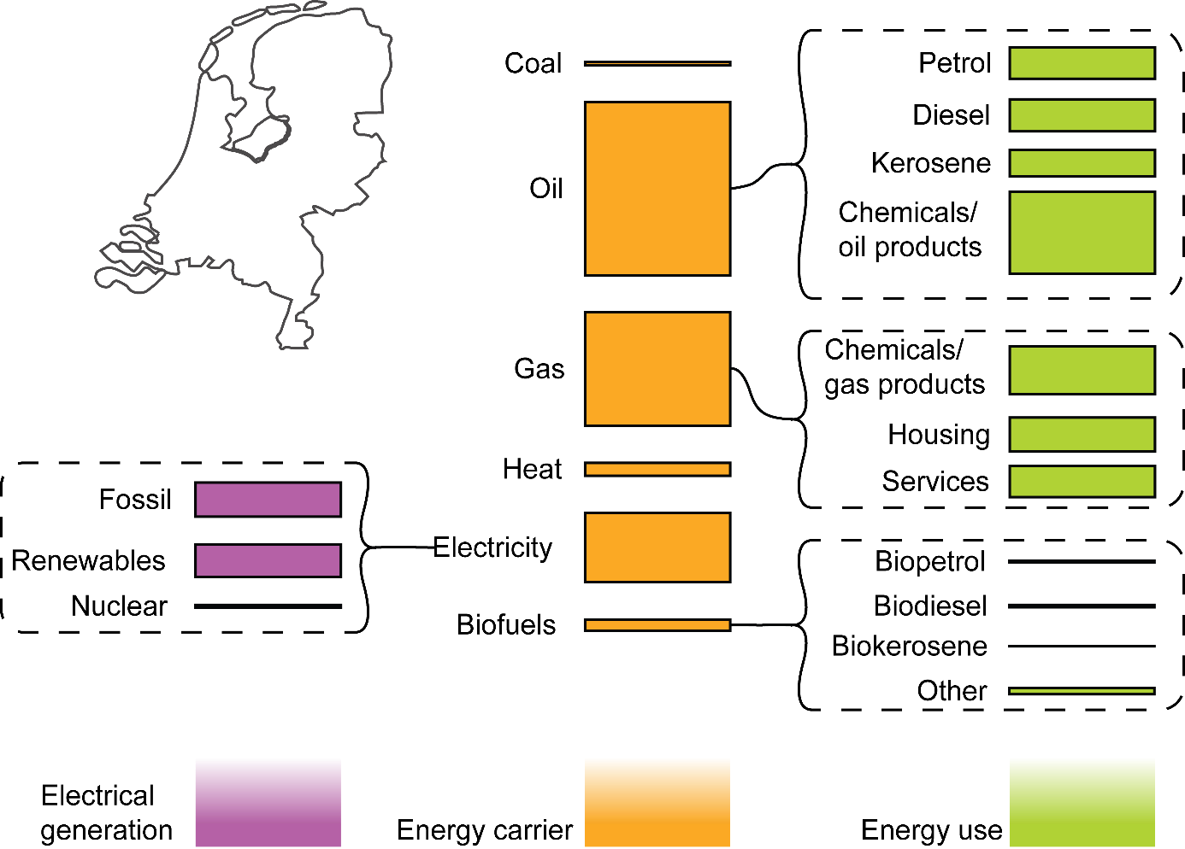
Figure 1: Energy generation (for electricity), energy carriers and energy usage for selected carriers in the Netherlands in 2023.

The data for the first column (purple) of Figure 1 is shown below in Table 1.
Table 1: The sources of electrical energy generation in the Netherlands in 2023.
Variable | Value [units] [ref]
Fossil source | 209020 TJ [1]
Renewables | 199735 TJ [1]
Nuclear | 15430 TJ [1]
Note: The total electrical energy generation here is larger than the total electrical consumption in the energy carrier table. It is assumed that these differences are due to measurements at different places in the system.

The data for the second column (orange) of Figure 1 is shown below in Table 2.
Table 2: The energy carrier consumption in the Netherlands in 2023.
Variable | Value [units] [ref]
Coal consumption | 16758 TJ [2]
Oil consumption | 915386 TJ [2]
Natural gas consumption | 600299 TJ [2]
Heat consumption | 68717 TJ [2]
Electricity consumption | 366245 TJ [2]
Biofuels consumption | 59834 TJ [2]

The data for the third column (green) of Figure 1 is shown below in Table 3.
Table 3: The usage of various energy carriers in the Netherlands in 2023.
Variable | Value [units] [ref]
Petrol | 168500 TJ [3]
Diesel | 170900 TJ [3]
Kerosene | 140000 TJ [3]
Chemicals/oil products | 435986 TJ [3]
Chemicals/gas products | 279300 TJ [4]
Housing | 200700 TJ [4]
Services* | 186600 TJ [4]
Biopetrol | 10800 TJ [3]
Biodiesel | 12000 TJ [3]
Biokerosene | 2600 TJ [3]
Other** | 34434 TJ
* services are a combination of the following categories in the reference data (Totaal binnenlands Vervoer, Diensten, afval, water en reparative, A Landbouw, bosbouw en visserij, Overige afnemers onbekend)
** ‘Other’ is a calculated category since the Biofuels consumption was larger than the stated uses for Biopetrol, Biodiesel, and Biokerosene.

Methodology for creating Energy Hub database
To give structure and overview to the search process the initial list was searched per province. The steps are summarised as follows:
- The following prompt was used: “Could you give me a list of every single energy hub project you can find in “Province”, including housing communities, transport, company areas and individual companies.” in ChatGPT model “gpt-5-t-mini”.
- Check energy hubs list to see whether they matched our criteria of: “An energy hub is a smartly controlled, decentralised energy system in which the generation, consumption, storage, and conversion of different energy carriers are mutually coordinated in a specific area” [5].
- Sort energy hubs into relevant category of mobility, housing, industrial parks and large industry.
- Search energy hub website and associated news articles for further details about progress of hub, contact persons, address and any other relevant information.
- Compared our lists to other databases and expanded ours with relevant hubs [6, 7].
In addition we used Claude.ai to query whether there were any additional energy hub projects in The Netherlands that were missed during this process mentioned above.

Expert interview process
On the 9th March 2026 there was an expert interview conducted online. There were 11 expert respondents who work as Lector or Associate Lector at Universities of Applied Sciences across the Netherlands (including Groningen, Zwolle, Enschede, The Hague and Amsterdam). The question they were asked to rank were given as
Ranking question: Wat zijn de belangrijkste doelen van een energiehub?*
- Uitbreiden ondanks netcongestie
- Kosten omlaag / verdienmodel
- CO2 en duurzaamheid (ideëel)
- Resilience / zelfvoorzienend
- Verduurzamingsverplichtingen
Translated into English:
What are the primary objectives of an energy hub?
- Enabling expansion despite grid congestion
- Reducing costs and creating revenue opportunities
- Reducing CO₂ emissions and improving sustainability
- Increasing resilience and energy self-sufficiency
- Meeting decarbonization and sustainability obligations
*The question allows respondents to rank all or some of the provided items. Results are calculated using the Borda count method[8], where the highest-ranked item receives points equal to the total number of items, with points decreasing for each lower rank position. Items that are not selected receive 0 points.
A limitation of this interview process is that all participants work at similar institutions. As a result, shared institutional perspectives and biases may be reflected in the final results. Furthermore, the sample size was relatively small, comprising only 11 participants.

References
1. Centraal Bureau voor de Statistiek (CBS) (2026) Production and export of electricity at record levels. https://www.cbs.nl/en-gb/news/2026/11/production-and-export-of-electricity-at-record-levels. Accessed 18 May 2026
2. International Energy Agency (IEA) (2024) The Netherlands - Countries & Regions. https://www.iea.org/countries/the-netherlands/energy-mix. Accessed 29 Apr 2026
3. Centraal Bureau voor de Statistiek (CBS) (2025) Consumption of energy from renewable sources rises to 20 percent. https://www.cbs.nl/en-gb/news/2025/23/consumption-of-energy-from-renewable-sources-rises-to-20-percent. Accessed 18 May 2026
4. Centraal Bureau voor de Statistiek (CBS) (2026) Energiebalans; aanbod en verbruik, sector. https://opendata.cbs.nl/#/CBS/nl/dataset/83989NED/table?dl=8ED53. Accessed 18 May 2026
5. Delft University of Technology (2024) Energy hub as powerful concept in energy transition. https://www.tudelft.nl/en/stories/articles/energyhubs. Accessed 6 Feb 2026
6. Sustainable Scale-Up Foundation Energy Hubs in Nederland. https://www.sustainablescale-up.com/energy-hubs-in-nederland. Accessed 21 Apr 2026
7. Kennisplatform Energiehubs (2025) Initiatievenradar. https://www.energiehubs.nl/initiatieven. Accessed 21 Apr 2026
8. Black D (1987) The theory of committees and elections. Cambridge University Press, Cambridge, pp 156–185

