Supplementary Materials
Intelligent wireless theranostic contact lens for close-loop electrical sensing and regulation of glaucoma
Cheng Yang^{1,3}, Qianni Wu², Junqing Liu⁴, Jingshan Mo¹, Xiangling Li^{1,5}, Chengduan Yang^{1,3}, Ziqi Liu¹, Jingbo Yang^{1,5}, Lelun Jiang⁵, Weirong Chen², Hui-jiuan Chen¹, Ji Wang³, Xi Xie^{1,3}*

- State Key Laboratory of Optoelectronic Materials and Technologies, Guangdong Province Key Laboratory of Display Material and Technology, School of Electronics and Information Technology, Sun Yat-Sen University, Guangzhou, 510006, China
- State Key Laboratory of Ophthalmology, Zhongshan Ophthalmic Center, Sun Yat-Sen University, Guangzhou, 510006, China
- The First Affiliated Hospital of Sun Yat-Sen University, Sun Yat-Sen University, Guangzhou, 510006, China
- Department of Cardiology, the First Affiliated Hospital of Jinan University, Guangzhou 510630, China
- School of Biomedical Engineering, Sun Yat-Sen University, Guangzhou, 510006, China

Email: xiexi27@mail.sysu.edu.cn

S1. Discussion on the potential clinical applications of WTCL:
- WTCL for the acute angel-close glaucoma before surgery: for acute angle-closure glaucoma featured with sudden rise of IOP, it is usually accompanied by headache, nausea and vomiting that hinders manually self-administrations by patients, while the delayed reduction of IOP will inevitably causes ischemic infarcts and damage optic nerve¹. The WTCL may provide a new theranostic strategy for patients who suffer from acute angle-closure patients during the emergent occurrence of high IOP, especially for those patients lack accompanies or nursing in-house. This would reduces the risks of vision damages caused by sharply increased IOP and endows precious time for patients to appeal further medical intervention. Although the patients may not like to wear the WTCL for long term, this device can be used for acute angle-closure glaucoma patients before surgery. In clinical cases, many acute angle-closure glaucoma patients need to be treated with medicines to reduce IOP until it is stable and suitable for surgery, and this pre-surgery period generally takes ~1 week. This scenario would be easier for patients to accept the use of WTCL since a surgery has been scheduled. The WTCL can be applied on this pre-surgery period, which could continuously monitor the IOP states and prevent emergent occurrence of high IOP.
- WTCL used as contact lens bandage for glaucoma combined diseases after surgery: the WTCL is essentially a smart ophthalmic bandage, which could be applied in clinical scenario that bandage contact lens needs to be used after ophthalmic surgery. For example, many patients experience combined cataract-glaucoma, where cataract surgeries are performed to treat the acute angle-closure glaucoma. Owing to release of proteins liberated by manipulation of intraocular structures during surgery, obstruction of trabecular outflow by inflammatory and viscoelastic material may occur and induce transient high IOP spikes after cataract operation². The postoperative IOP rise can triggers ocular pain, corneal oedema, glaucomatous nerve damage or anterior ischaemic optic neuropathy, if not treated in time³. For example, in one clinical case (July, 2021) at Zhongshan Ophthalmic Hospital of Sun Yat-sun University, a patient (male, ~60-years-old) possessed glaucoma combined with cataract was treated with cataract surgery. During the night right after the cataract surgery, the nurse found his IOP suddenly increased to ~47 mmHg. After emergent treatments to reduce his IOP, his IOP was found to be ~45 mmHg on the next day, where the doctors were unclear when the IOP occurred again. These patients would benefit if the high IOP states could be monitored and regulated timely. Since many patients are suggested to wear bandage contact lens after cataract surgery to protect the wound for couple of days, the replacement of conventional contact lens with smart contact lens IOP sensor after surgery would be easier to be accepted for patients. Similarly, after glaucoma laser surgery, there are risks that the blood or tissue residues after surgery may cause obstruction of lachrymal duct that induced emergent case of high IOP. The WTCL can be applied on this post-surgery period to reduce the IOP risks.

- WTCL as drug release platform for ophthalmic diseases related to high IOP: contact lens for continuous drug releases have been widely reported⁴, which possesses clinical significance in that the contact lens platform could enhance the bioavailability of ophthalmic drugs for the therapies on chronic ocular diseases. For example, controlled-release systems of ophthalmic drugs for the treatment of uveitis are desirable to reduce side effects of pharmaceutical agents, while uveitis and the treatment can induce elevated IOP clinically. The combined functions of contact lens-based sustained drug delivery and intelligent IOP sensors of WTCL would find some clinical utilities if the ophthalmic disease is associated with high IOP.

- WTCL as scientific tools for in vivo animal experiments: the WTCL could also serve as scientific tools for in vivo animal experiments, where the wearing of contact lens on animals during the experimental period can be ensured. For the biomedical researchers study how disease progress or therapeutic techniques induce IOP fluctuation⁵, this WTCL platform could provide continuous IOP monitoring on animals.

S2. Advances of WTCL
S2.1. Challenges of integrated wireless contact lens for closed-loop IOP monitor and regulation
Although the contact lens sensing and delivery technologies have been independently developed by other investigators, the integration of these two wireless functionalities possesses critical challenge on the device structure, rather than a straightforward process of “sensing” plus “delivery”. The key challenge is how to achieve wireless channel separation to avoid cross-coupling between two wireless functionalities on the curved contact lens with limited surface, while the electrode surface area needs to be sufficiently large in order to maintain sensor sensitivity and delivery efficiency. The key merits of our WTCL include the proposed highly sensitive cantilever sensor that allows integration of delivery coils/electrode that compete with sensor surface and even partially block the sensor. We explain these in detail below and compare our device to commercial IOP contact lens sensor or other groups’ sensors to clarify the critical challenges.
First, in order to achieve dual- or multi-functions on a single contact lens device, the wireless channels need to be sufficiently separated. For conventional devices with sufficient size, the cross-coupling can be avoided by spatially separation of different channels. However, for contact lens or implantable devices with ultra-small surface area, spatial separation is rarely possible. Instead, we employed the strategy of frequency separation for our WTCL. The wireless coupling frequencies for sensing and delivery need to be sufficiently separated, for example, one in the range of 1 MHz and the other one in the range or 100 MHz or even GHz. Otherwise, the wireless radiation for sensing could undesirably trigger non-target drug delivery if the frequency separation is insufficiently large.
According to the wireless radiation equation , lower coupling frequency requires larger number of coils, larger coil diameter, or larger capacitance. In order to accommodate operations at MHz for delivery and other one for sensing at higher frequency, the total coils area of these two coils on a single circuit plane would exceed the surface area of contact lens (as we showed in Supporting Information S5.1, where we designed several coils parameters during device optimization). Many reported contact lens IOP sensors as well as the commercial Sensimed contact lens sensor (Figure S2.1a) are very unlikely to directly add a second coils next to the first coils on the same circuit plane for wireless drug delivery (Figure S2.1b-left).
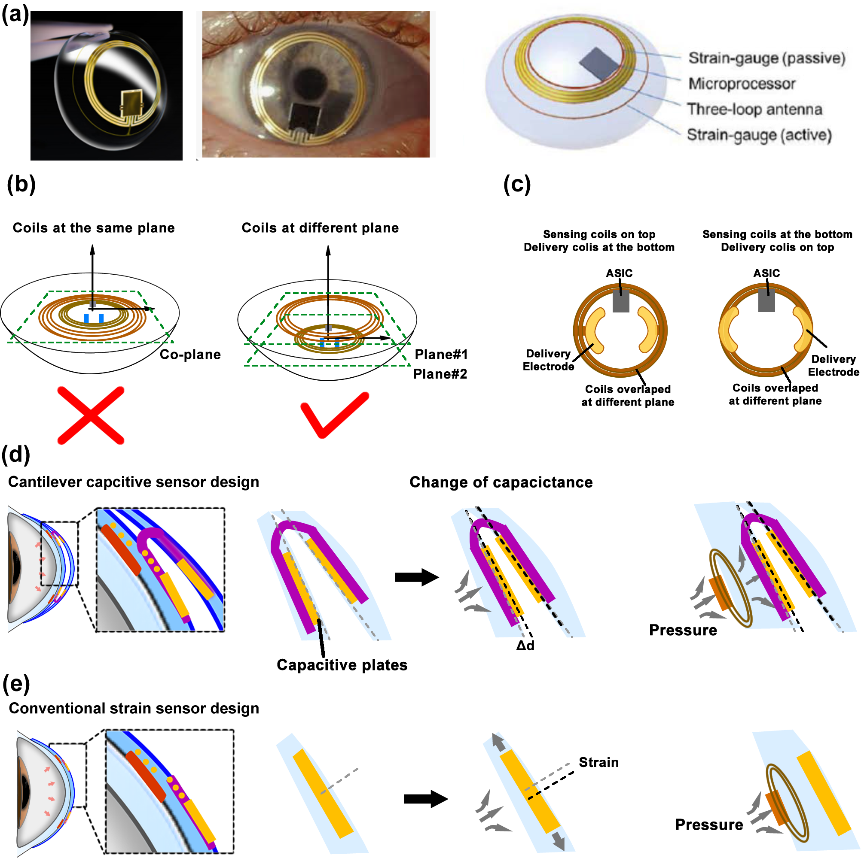
Figure S2.1. (a) Optical image and schematic diagram of IOP monitoring contact lens developed by SENSIMED (figures from https://www.sensimed.ch/). (b) Left: schematic showing the design with both wireless drug delivery and wireless sensing circuits directly deployed on the same circuit planes. Right: schematic showing the design with wireless drug delivery and wireless sensing circuits deployed on different circuit planes. (c) Left: Schematic showing the designs of delivery coils underneath the sensing coils. Right: Schematic showing the designs of delivery coils on top of the sensing coils. (d) Schematic showing the sensing mechanism of the cantilever capacitive sensor-based contact lens, where the capacitive plates were sensitively displaced upon pressing. (e) Schematic showing the sensing mechanism of strain sensor-based contact lens, where the sensor measured the resistance change of strain gauge embedded into the periphery of a soft silicone contact lens upon pressing.

Second, in order to ensure that IOP sensing module is able to detect mechanical signals sensitively, while drug delivery module can achieve wireless power supply stably, we proposed a multi-layers circuit design for our WTCL (Figure S2.1b-right). However, this multi-layers circuit design is also challenging to employ for many other contact lens sensors, because the lower layer of delivery coils would easily block the upper layer of sensors. Taken the commercial Sensimed contact lens sensor as example (https://www.sensimed.ch/), this sensor measured the circumferential changes of the eyeball at the corneoscleral interface by an active strain gauge embedded into the periphery of a soft silicone contact lens. The output is an equivalent of the electric voltage (mV) that are transmitted to the recorder via an integrated ASIC chip and coils. This strain gauge is less compatible with a secondary layer of delivery coils with electrodes. The drug delivery electrodes need to be in direct contact with the corneal surface, while the sensor is also more favorable to be close to the cornea. If the delivery coils are underneath the sensing coils, the delivery electrodes need to extrude from the coils to be in close contact with the eye surface (Figure S2.1c-left). In this case, both delivery electrodes and sensor chip would occupy a large amount of space of eye surface, and the rigidity of the electronics near the eye centers would cause more uncomfortable feeling. On the other hand, if the sensing coils are underneath the delivery coils (Figure S2.1c-right), the delivery electrodes could be overlapping with the coils positions to be in close contact with the eye surface. However, the delivery coils blocking the underneath sensor could greatly reduce the sensitivity especially for strain sensor, since the strain could be significantly buffered by the delivery coils (Figure S2.1d and S2.1e).

S2.2. Limits of established contact lens devices for IOP monitoring and drug release.
Although optical methods for IOP monitoring could also be wireless, the optical methods are less likely to be developed as continuous monitoring sensor for contact lens because the requirements of bulky recording modules of spectrometer or camera placed on the face. Camera is also difficult to be close to the eye as wearable recording system due to the requirement of certain focal distance. Moreover, the spectrometer or camera need to be directly aligned to the eyes, which will block the visions. Therefore, the spectrometer or camera are unsuitable to be worn as continuous recorders. The optical methods are usually less compatible with patients’ motion since they can be easily interfered by the environmental lightness. The sensing sensitivity of optical methods are often lower than electrical methods, requiring large change of eyeball curvature to induce readable signals. The accuracy is also highly susceptible to the environments.

S3. The fabrication and structure of the WTCL.
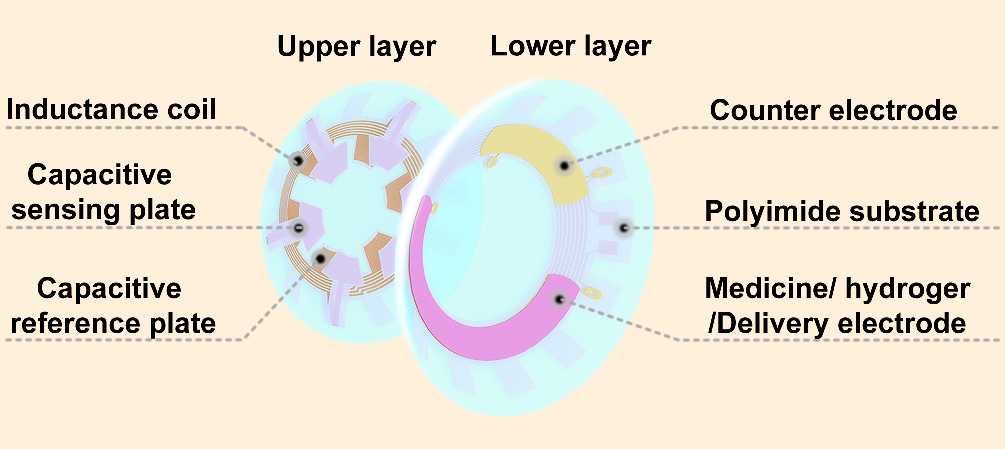
Figure S3.1 Structure of the WTCL. The reference plates and 5 coils of inductance were embedded in the upper lens, while dangling sensing plates that aligned with reference plate contacted the front surface of the lower lens, with a dielectric air film between the reference and sensing plates forming a variable capacitor. Drug delivery circuit was embedded in the lower lens, while the drugs-coated iontophoretic electrodes on the bottom side of delivery circuit were exposed and would be in contact with the cornea.

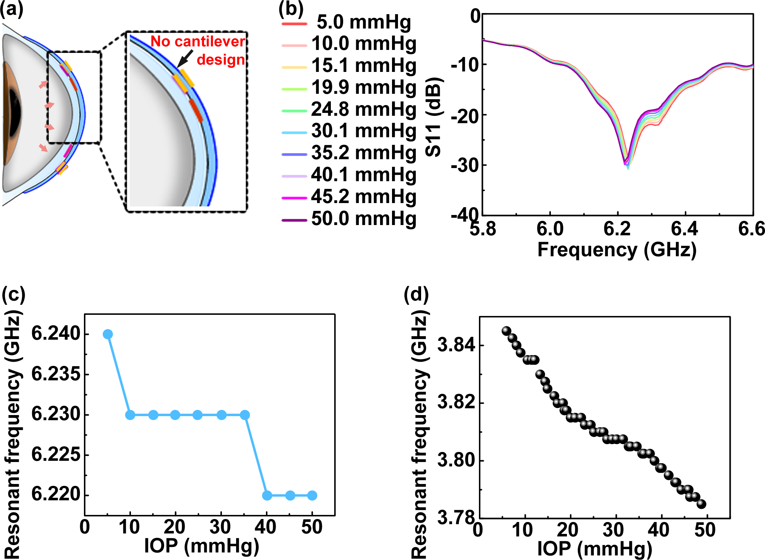

Figure S3.2. Data showing that the sensitivity of non-cantilever-based capacitive pressure sensor embedded with PDMS between capacitive plates is significantly lower. (a) Schematic IOP sensing performance of the WTCL without cantilever design. (b)The reflection spectra and (c) Resonant frequency versus IOP value of contact lens capacitive sensor without cantilever-based design. The measurements were performed on porcine eyeball at different IOP. (d) Resonant frequency versus IOP value of WTCL devices with cantilever-based sensor design (Device-I from Figure 3d of Manuscript), for comparison to (c). These results shown that cantilever design enables linear and sensitive IOP responsion.

Table S1. Detailed parameters and size of WTCL
Contact lens | Contact lens diameter (mm) | 14.15
Contact lens | Base curve of lower contact lens (mm) | 8.6
Contact lens | Base curve of upper contact lens (mm) | 8.24
Contact lens | Thickness of each contact lens (μm) | 120
IOP Monitoring  circuits | Outer diameter of IOP sensing circuit d₁ (μm) | 10300
IOP Monitoring  circuits | Inner diameter of IOP sensing circuit d₂ (μm) | 7900
IOP Monitoring  circuits | Inner diameter of capacitor d₃ (μm) | 5000
IOP Monitoring  circuits | Branch length of IOP sensing circuit d₄ (μm) | 2566
WPT  circuits | Branch width of WPT circuit d₅ (μm) | 1222
WPT  circuits | Branch length of WPT circuit d₆ (μm) | 986
WPT  circuits | Outer diameter of WPT circuit d₇ (μm) | 10800
WPT  circuits | Inner diameter of WPT circuit d₈ (μm) | 7450
WPT  circuits | Space of the inductance electrode (μm) | 70
WPT  circuits | Width of the inductance electrode (μm) | 80
WPT  circuits | Central angle of drug carrier’s electrode θ (deg) | 180
WPT  circuits | Central angle of counter electrode α (deg) | 50

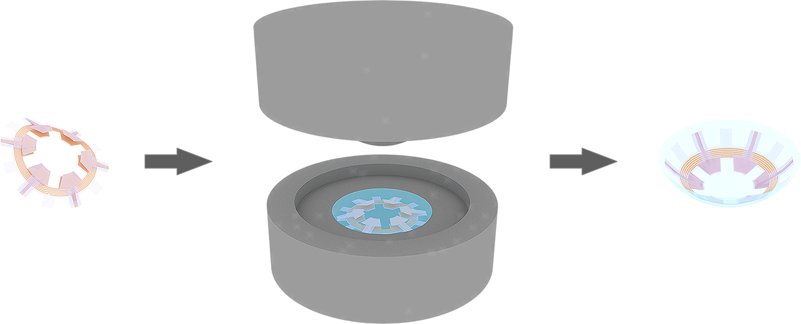

Figure S3.3 (a) Schematic illustration of the cast-molding technique.
Cast-molding technique: the flexible IOP sensing circuit was folded, and positioned into the metal mold of contact lens. Polydimethylsiloxane (PDMS, Sylgard 184, Dow Corning) and curing agent were mixed according to the ration of 10:1 and then stirred sufficiently. The PDMS solution was placed in vacuum with pressure of 10 Pa for 30 min to remove bubbles, and then injected into the mold. After vacuum treatment (10 Pa, 30 min), the bottom mold and top mold were assembled and placed into oven (80 ℃, 1.5 h). Finally, the contact lens embedded with circuit was detached from mold carefully.

S4. Supporting Information for the performance characterization of the IOP sensing module.
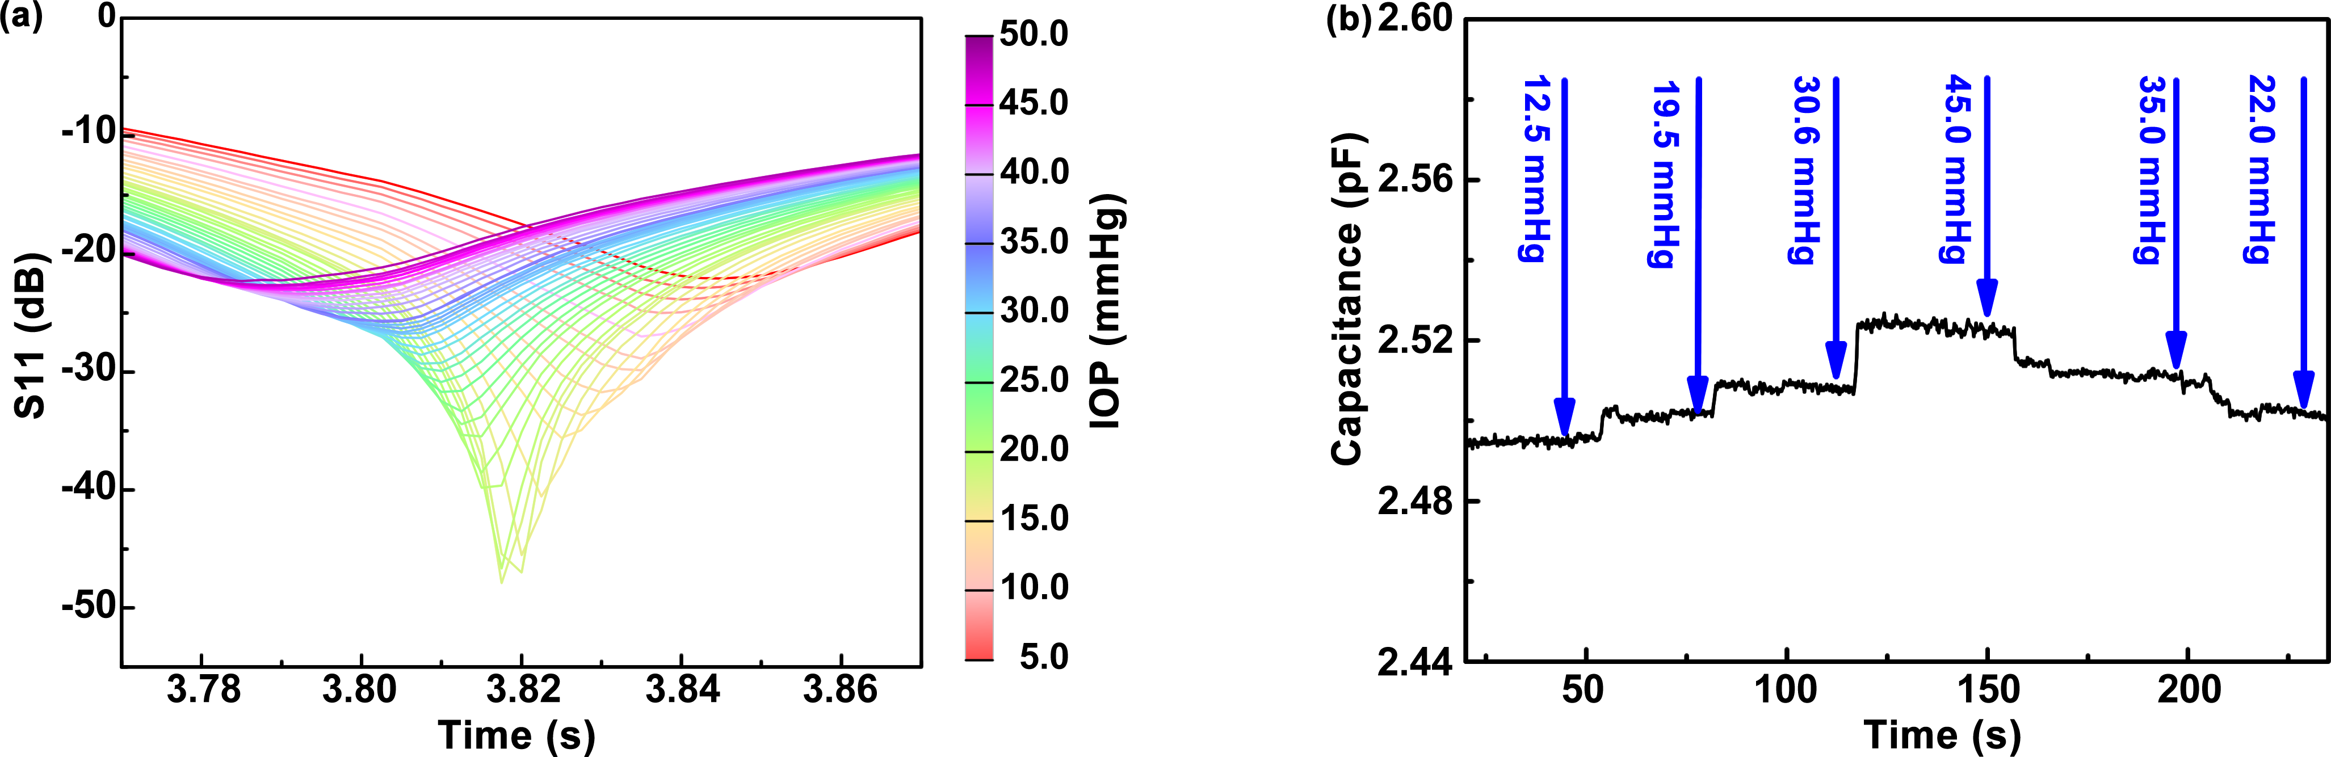
Figure S4.1 (a) The detailed reflection spectra of device-I following IOP ranging from 5 to 55 mmHg with the step of 1 mmHg. The static sensing performance was conducted by stepwise increase of IOP, which was controlled by microinfusion pump that drove saline solution into the anterior chamber and monitored by a pressure gauge. Meanwhile, the resonance frequencies of WTCL worn on the porcine eyeball at different IOP (5-50 mmHg) were recorded by Network analyzer connected to IOP reading coil (diameter: 17 mm, turns: 1) of the integrated antenna that was positioned above WTCL with nearly 6 mm-distance, where the resonant frequency of IOP monitoring module was found to shift to the lower frequency at higher IOP. (b) Capacitance change of the pressure sensing module as a function of time when the IOP was changed. During experiments, the WTCL was worn on porcine eyeball, and the IOP in porcine eye was controlled by the volume of infused saline solution with microinfusion pump. Meanwhile, a pressure gauge was adopted to track the IOP value. The capacitance formed by reference, sensing plates, and air film was connected with LCR meter (Changzhou Tonghui Electronic Co. Ltd., China) to recorded the value changes. Theoretically the resonant frequency is in inversely related to the capacitance according to the LCR circuit equation . The results were consistent with the theoretical prediction in that the increase of IOP would reduce the distance between the reference and sensing plates, hence led to the elevation of capacitance value.

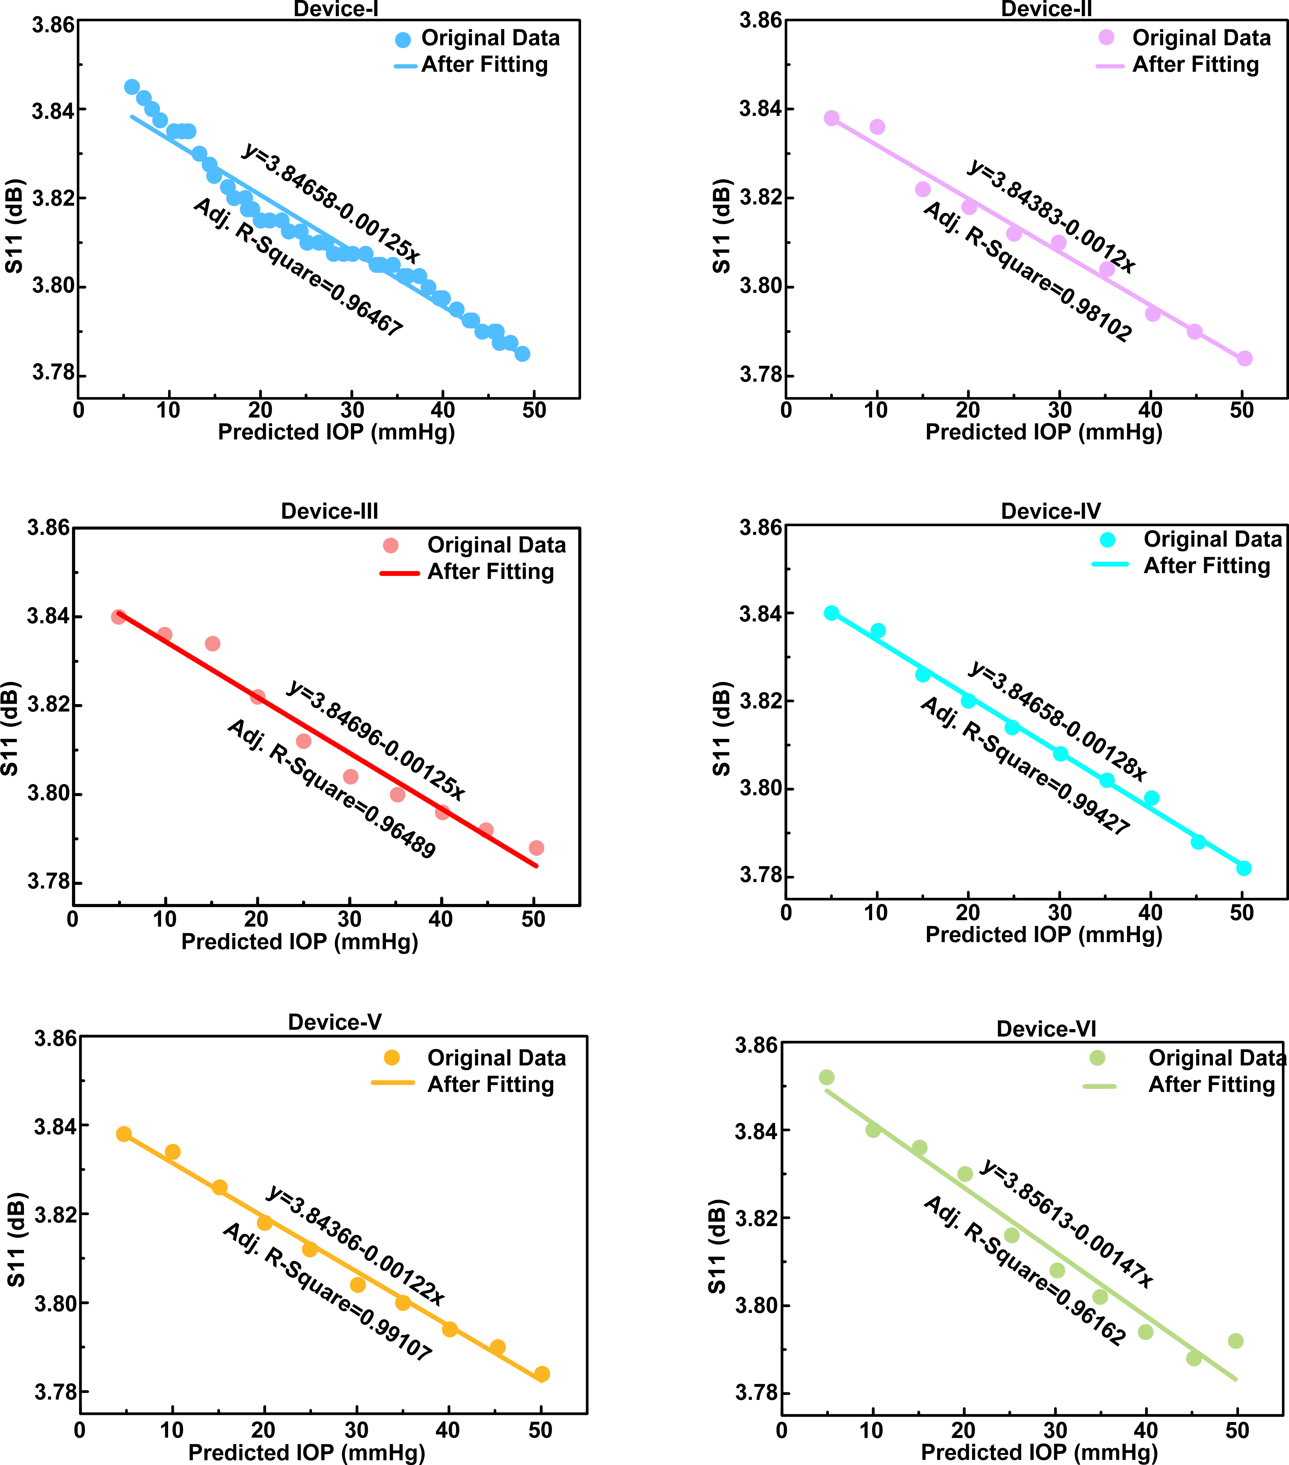
Figure S4.2 The relation of resonant frequency versus IOP value of six representative WTCL devices worn on the porcine eyeball at different IOP (5-50 mmHg). The values of resonant frequency were collected from reflection spectra of each representative WTCL devices. The IOP values were validated by commercial gauge. The relations of resonant frequency versus IOP value were processed by linear fitting. These results demonstrated that signal responses of these sensors were linearly correlated to the reference IOP.

Table S2. Summary of the performance of wearable and implantable IOP sensors reported in the literature.
Wearable / Implantable | Sensing  mechanism | Dielectric  material | Response  characteristics | Ref
 | Capacitance | Ecoflex | About 2.2 MHz/mmHg | ⁶
 | Capacitance | Air | 23 kHz/mmHg | ⁷
 | Inductor | Phthalocyanine | 8 kHz/mmHg | ⁸
Wearable | Inductor | Parylene C | 57 kHz/mmHg | ⁹
 | Inductor | Parylene C | 35.1 kHz/mmHg | ¹⁰
 | Capacitance | Air | 1.25 MHz/mmHg | This work
 | Capacitance |  | 243 kHz/mmHg | ¹¹
Implantable | Capacitance |  | 1.14 MHz/mmHg | ¹²
 | Capacitance |  | 156 kHz/mmHg | ¹³

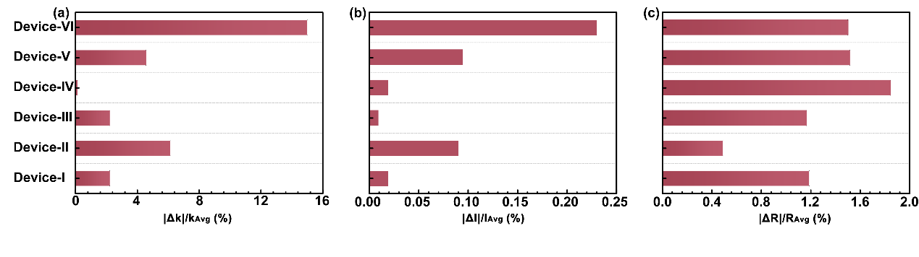
Figure S4.3 Assessment of the reproducibility of the six IOP sensors, where the (a) Normalized slope, (b) normalized intercept, and (c) normalized R-Square of each sensor were quantified. Normalized slope was defined as , where k represents linear fitting slope of IOP response from each sensor, k_{Avg} denotes the average value of all slopes. Normalized intercept was defined as , where I represents linear fitting intercept of IOP response from each sensor, I_{Avg} denotes average value of all intercept. Normalized R-Square was defined as , where R represents linear fitting R-Square of IOP response from each sensor, R_{Avg} denotes average value of all R-Square. These results showed that the linear relations of all the six devices overlapped well (variations of the normalized slope, intercept, and R-Square were <15%, <0.25%, and <2%, respectively) with each other, indicating the reliability and repeatability of the fabricated device using our design.

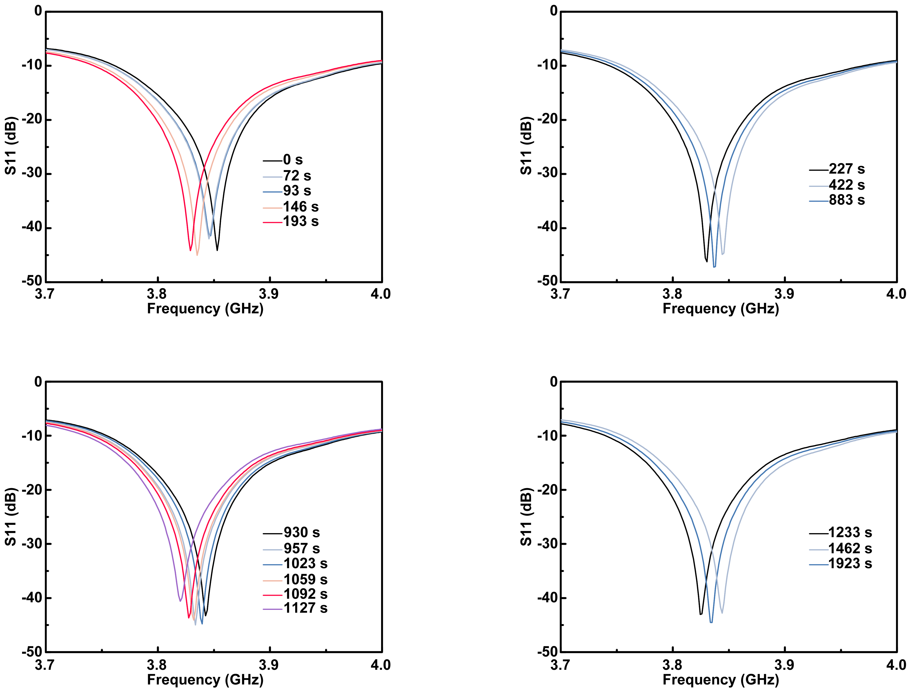
Figure S4.4 The detailed reflection spectra recorded during the continuous monitoring of IOP via WTCL. During the experiment process, saline solution was injected into the anterior chamber of porcine eye to elevate the IOP from 4.5 mmHg to 30 mmHg. Then, the pressure decreases down to 13 mmHg with the continuous leaking of solution from eyeball. Sequentially, saline was filled into eyeball to raise the pressure again. The corresponding reflection spectra in these four phases involving IOP elevation and decreasing collected wirelessly.

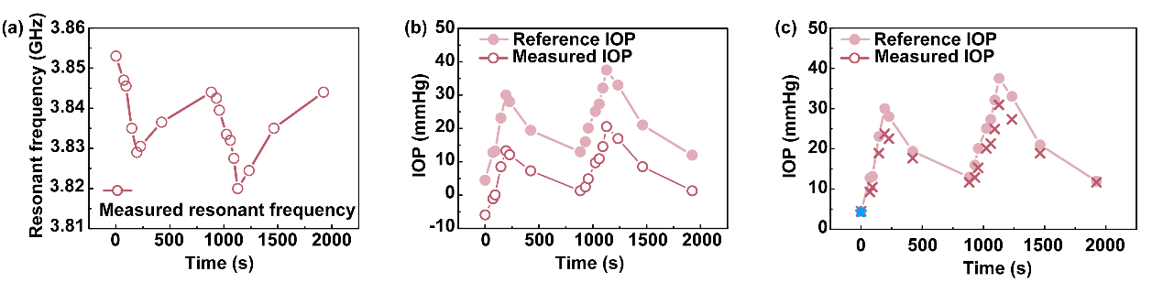
Figure S4.5 Illustration and analysis of the wireless IOP sensing experiment on the porcine eyeball during the continuous IOP monitoring process. (a) Wireless recorded resonant frequency of IOP sensing module during the continuous IOP monitoring. In the experiment process, saline solution was intermittently injected into the anterior chamber of porcine eye to induce IOP fluctuations. Meanwhile, IOP reading coil of integrated antenna could recorded the changes of resonant frequency wirelessly by WTCL worn on the in vitro eye. In addition, commercial pressure gauge was connected to the anterior chamber by a disposable intravenous infusion needle to independently track the reference IOP. (b) Reference IOP recorded by pressure gauge and measured IOP calculated from resonant frequency during the measurement process without calibration. (c) Measured IOP after calibration. Reference IOP was also shown as a control group. In the calibration process, the measured IOP calculated from resonant frequency was calibrated to the reference IOP (indicated with blue asterisk). Specifically, the measured IOP were proportionally scaled up according to the difference between the first measured IOP (at time points t=0 s) and the first reference IOP.

S5. Supporting Information for the performance characterization of the WPT module of the WTCL.
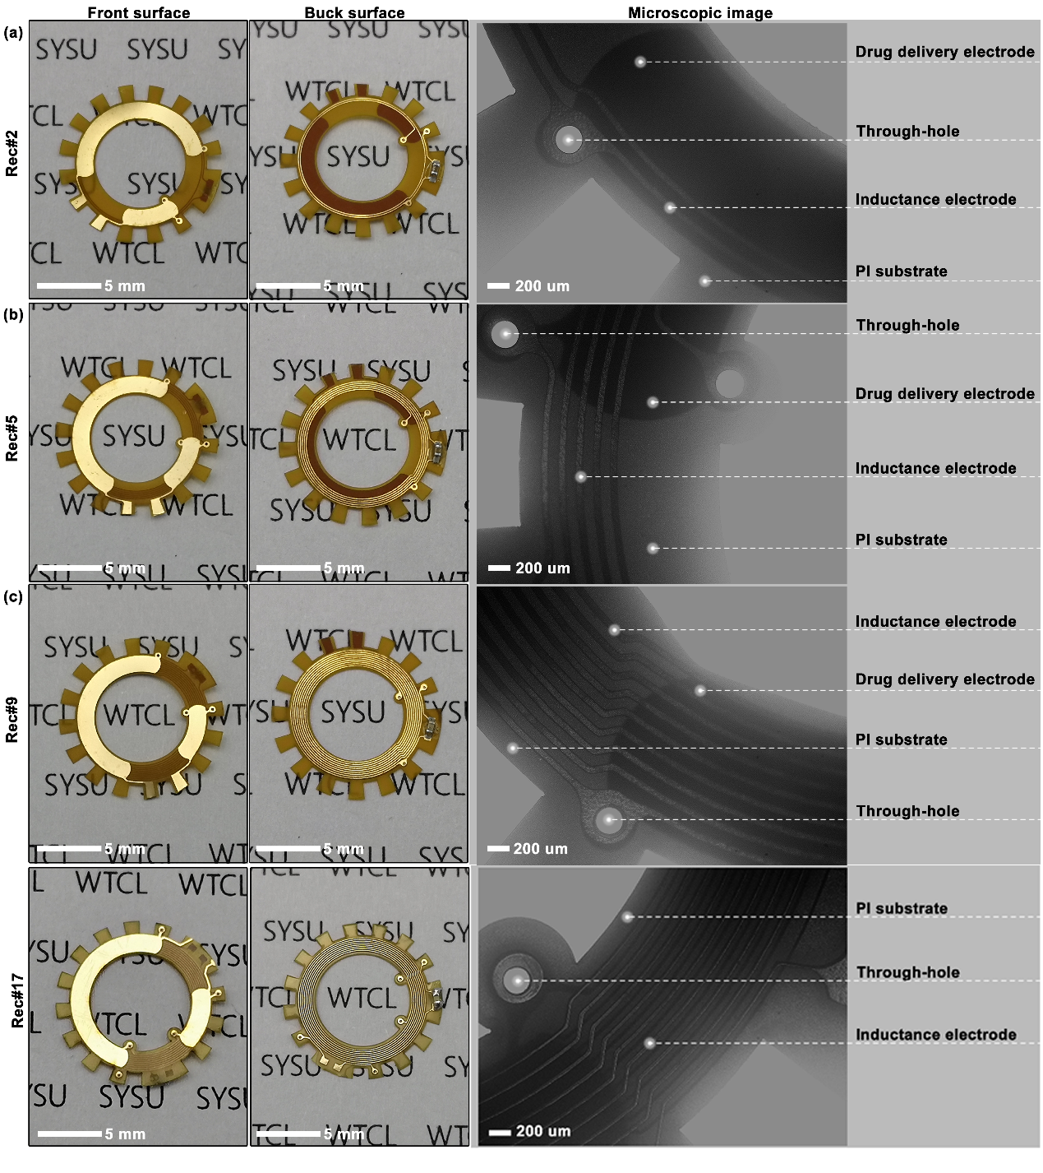
Figure S5.1 Optical and microscopic images of four WPT receive circuits (Rec#2, Rec#5, Rec#9, Rec#17). These four types of WPT receivers with 2, 5, 9, and 17 coils-design (namely Rec#2, Rec#5, Rec#9, and Rec#17, respectively) were designed to achieve optimal performance coupled with transmitter.

Table S3. Detailed parameters and size of four WPT receiver circuits.
 | Rec#2 | Rec#5 | Rec#9 | Rec#17
Number of layers | 2 | 2 | 2 | 3
Number of coil turns | 2 | 5 | 9 | 17
Width of the inductance electrode (μm) | 60 | 60 | 60 | 60/30
Space of the inductance electrode (μm) | 90 | 90 | 90 | 90/120
The inner diameter of inductance coil (mm) | 9.44 | 8.54 | 7.34 | 7.82
The outer diameter of inductance coil (mm) | 9.86 | 9.86 | 9.86 | 10.43
Parasitic resistance () | 1.5 | 2.8 | 4.5 | 23.5
Capacitor matched with inductance coil (nF) | 82 | 39 | 22 | 3.3

Table S4. Detailed parameters and size of WPT transmitter circuits.
Inductor (μH) | Capacitor matched with inductance coil (pF) | Parasitic resistance ()
180 | 196 | 2.9

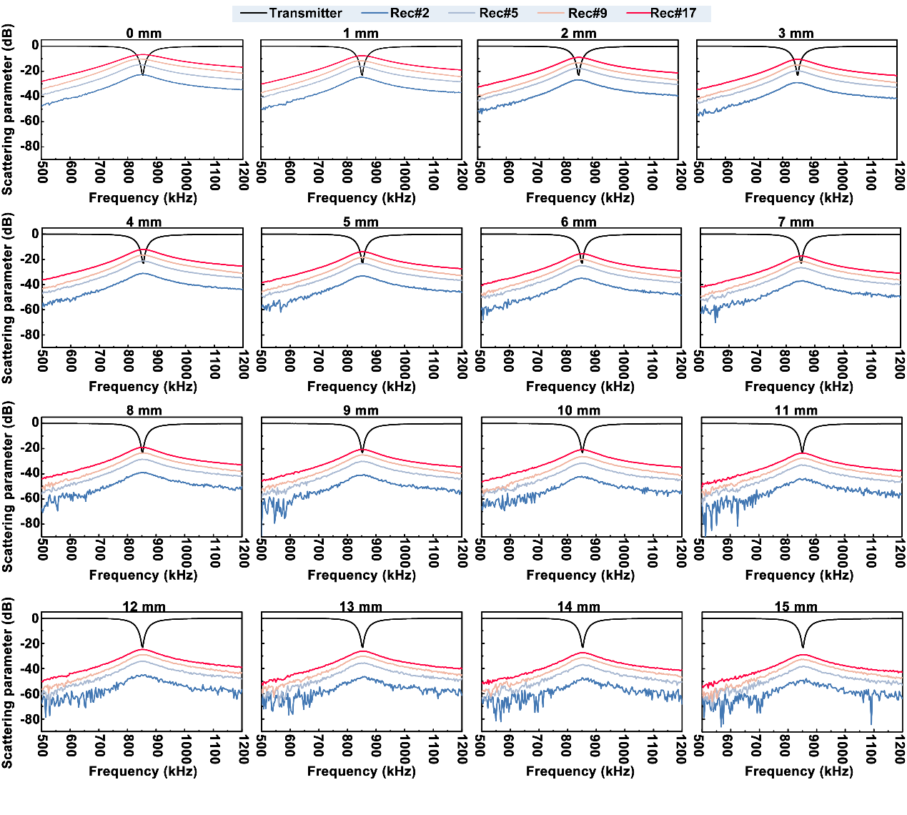
Figure S5.2. The influence of radiation distanced (0 mm to 15 mm with step of 1 mm) on scattering parameter spectra between the WPT coil/four receivers. In these experiments, the integrated antenna and WTCL, aligned with identical axis, were connected with network analyzer. The results of all receivers showed that the resonant frequency of transmitter and all receivers remain at 850 kHz. Insert loss (S21) of all receivers revealed that S21 of Rec#17 was significantly higher than other circuits under identical radiation distance. It indicated that the Rec#17 was better matched with the WPT transmitter compared to other receive circuits. Hence, the combination of transmitter and Rec#17 possessed the potential to provide optimized electric power for iontophoretic delivery.

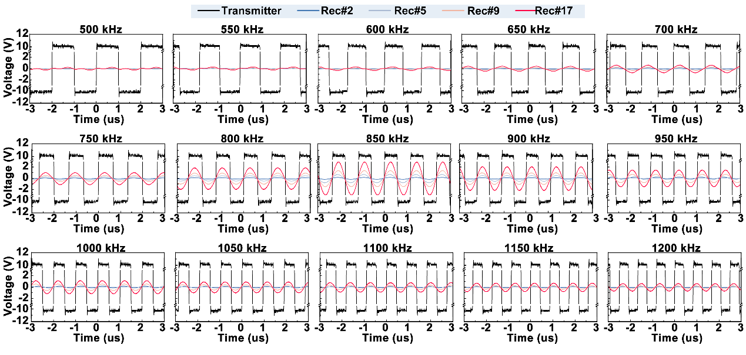
Figure S5.3. The influence of frequencies (500 KHz to 1200 KHz with step of 50 KHz) on wireless voltage supply performance of four WPT systems. In these tests, the integrated antenna and WTCL, aligned with identical axis, were connected with waveform generator and oscilloscope, respectively. The distance between integrated antenna and WTCL was set at 6 mm. Sequentially, a series of square wave with different frequency (500 kHz to 1200 kHz with step of 50 kHz) were exerted on transmitter. Then the collected voltage of four receivers were recorded by oscilloscope in turn. Results shown that all of receivers exhibit higher values of voltage peak to peak (Vpp) at 850 kHz.

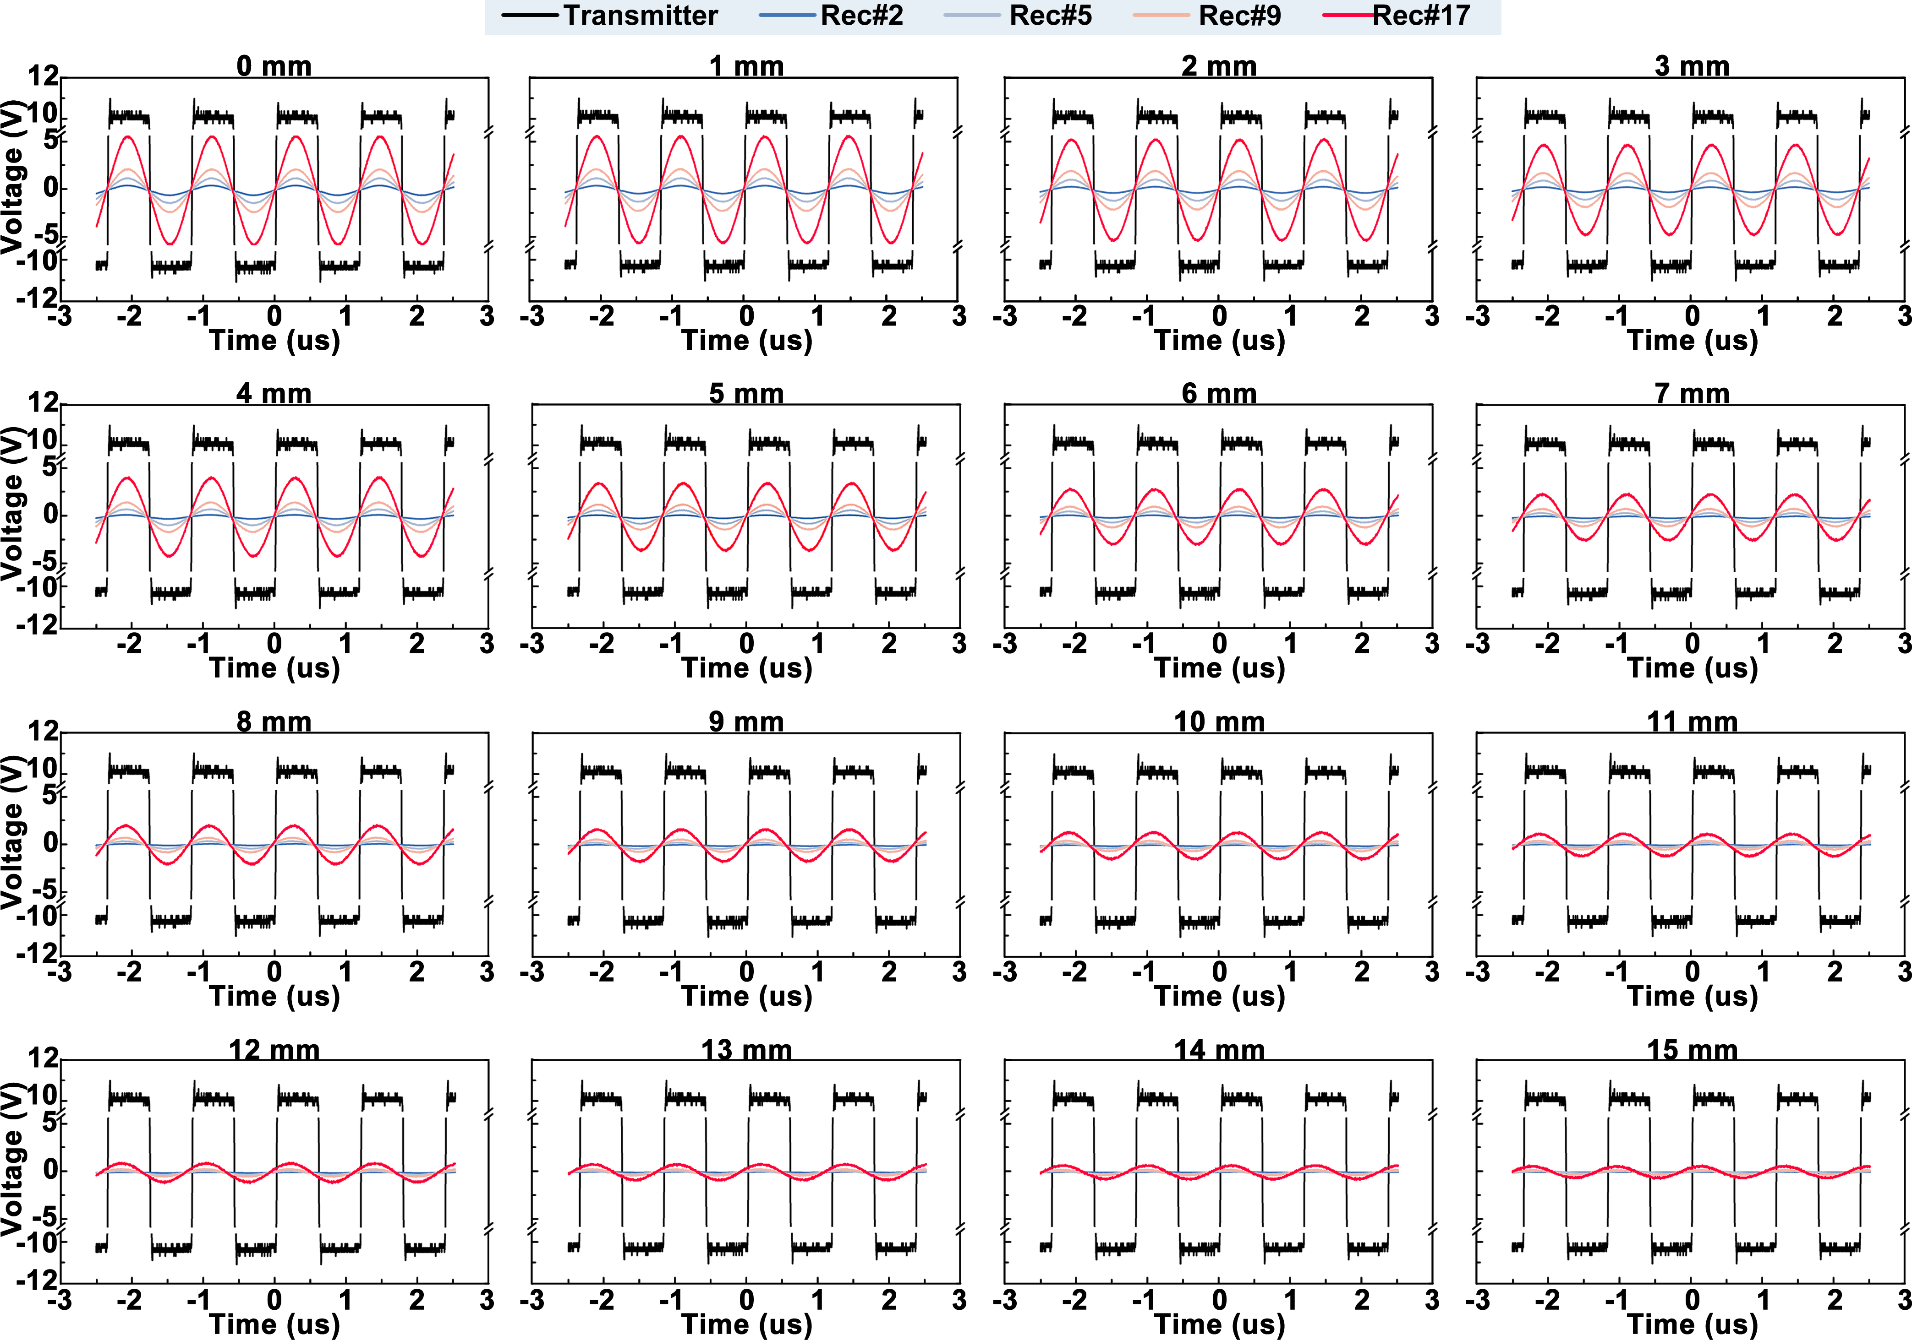
Figure S5.4. The influence of radiation distances (0 mm to 15 mm with step of 1 mm) on wireless voltage supply performance of four WPT systems. In these tests, the integrated antenna and WTCL, aligned with identical axis, were connected with waveform generator and oscilloscope, respectively. The square voltage wave exerted on transmitter of integrated antenna was kept with 20 Vpp at 850 kHz. In these tests, the Rec#17 exhibited higher voltage compared to the other three circuits under conditions of same radiation distance.

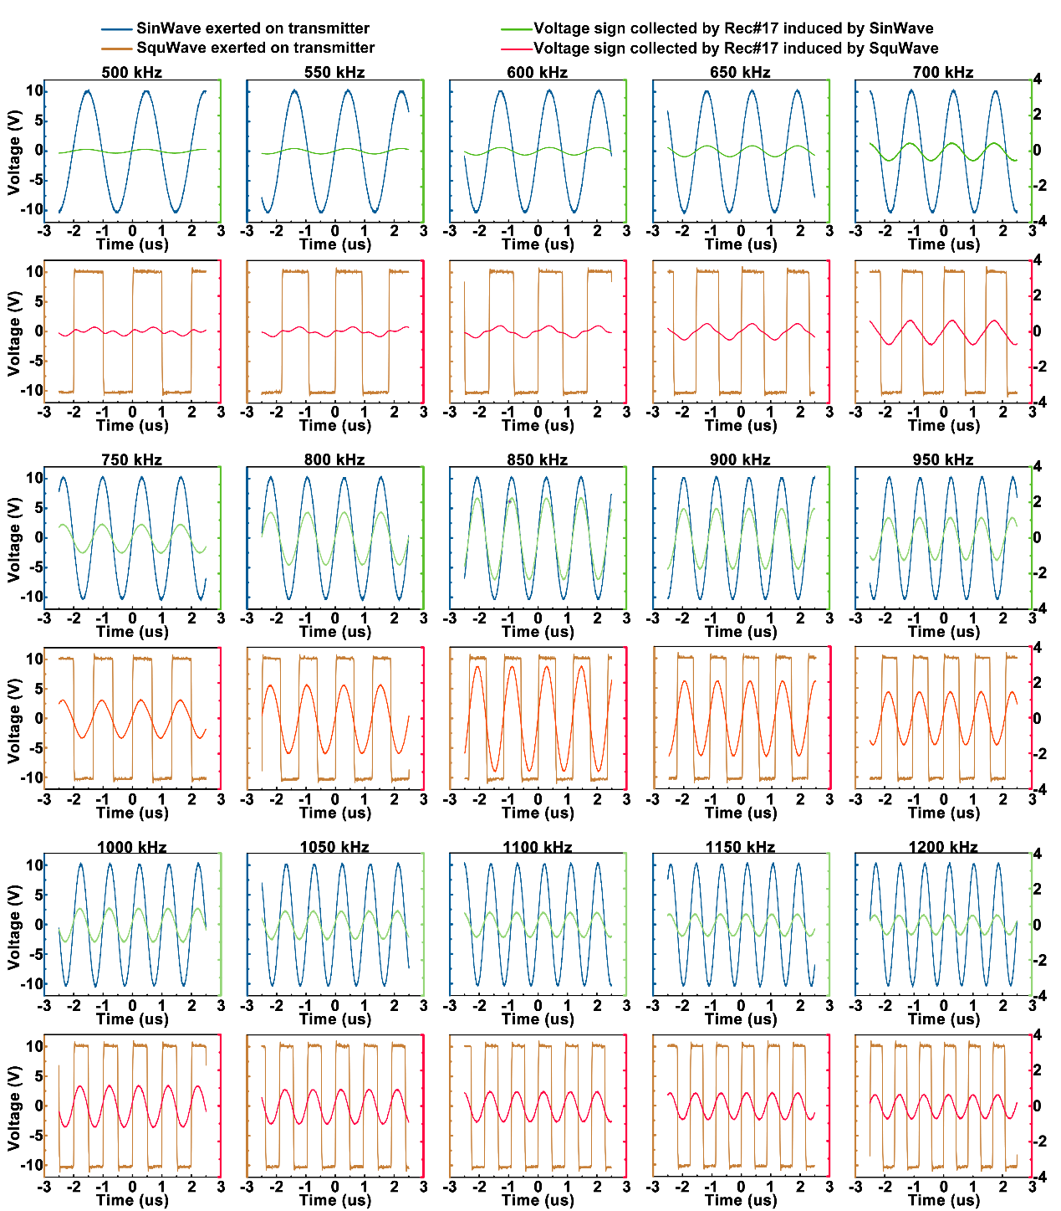
Figure S5.5. The influence of square wave and sine wave’s frequencies (20 Vpp, 500 KHz to 1200 KHz with step of 50 KHz) on the performance of wireless power supply via WPT systems (Transmitter and Rec#17 with the radiation distance of 6 mm). In these tests, the integrated antenna and WTCL, aligned with identical axis, were connected with waveform generator and oscilloscope, respectively. The distance between integrated antenna and WTCL was kept at 6 mm. These figures reveal that 850 kHz remain was the optimal frequency for the WPT system consist of the Rec#17 and transmitter to acquire higher voltage regardless of voltage waveform.
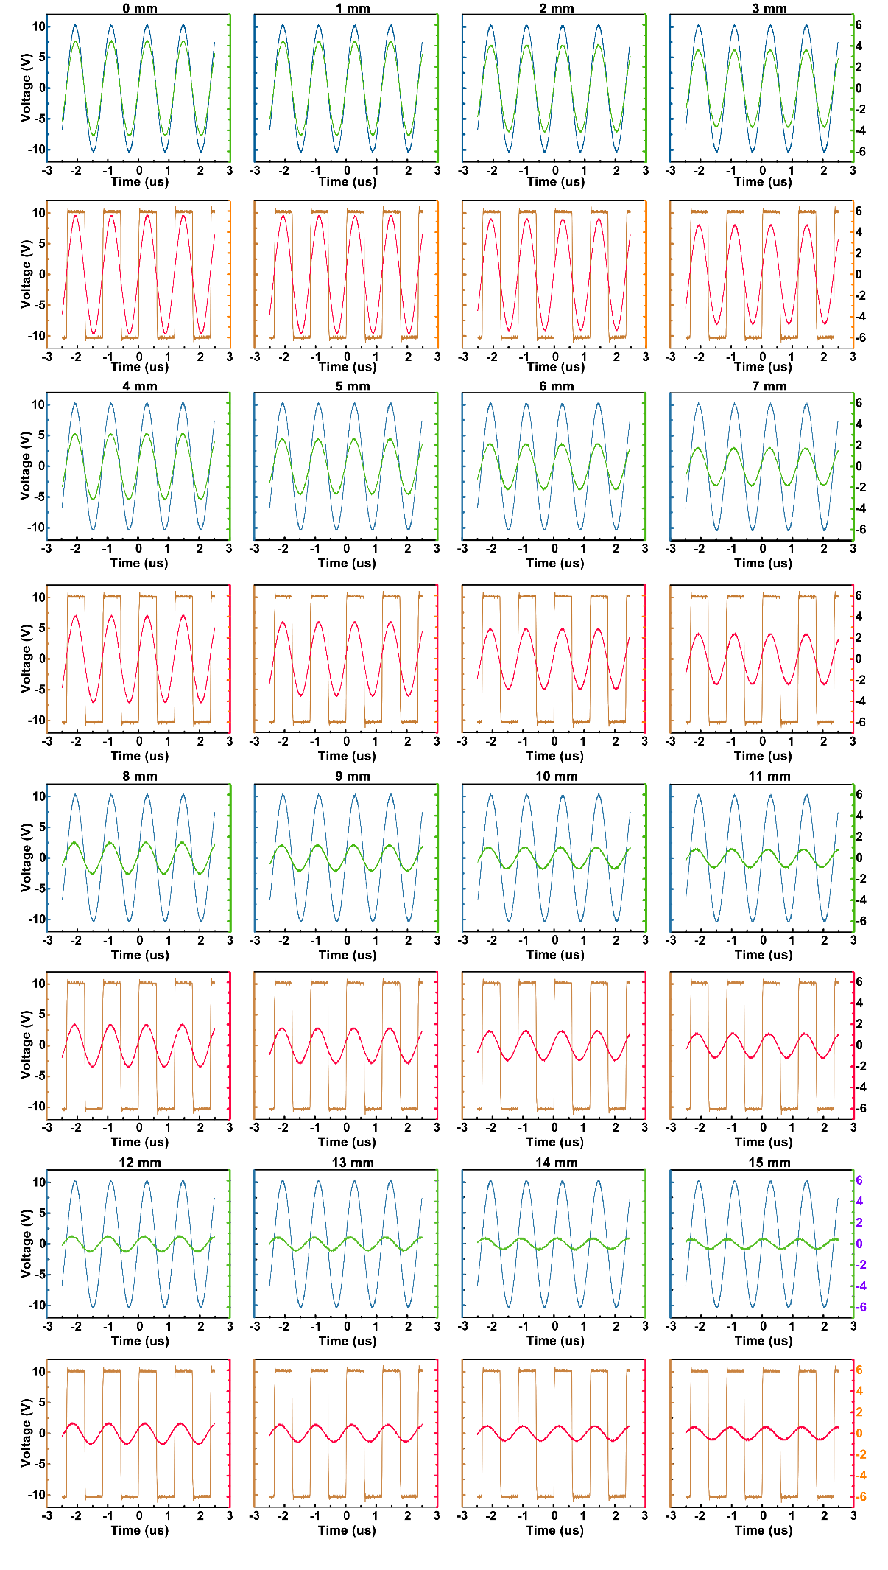
Figure S5.6. The influence of radiation distances (0 mm to 15 mm with step of 1 mm) on wireless power supply performance of the fourth WPT systems (Transmitter and Rec#17). In these tests, the integrated antenna and WTCL, aligned with identical axis, were connected with waveform generator and oscilloscope, respectively. The voltage wave exerted on transmitter of integrated antenna was set at 20 Vpp and 850 kHz. Results shown that Vpp of Rec#17 induced by the sine voltage wave exerted on transmitter was slightly lower than the Vpp via SquWave. It further demonstrated that the square voltage wave exerted on transmitter possessed the potential to provide higher transferred voltage in receiver circuit.

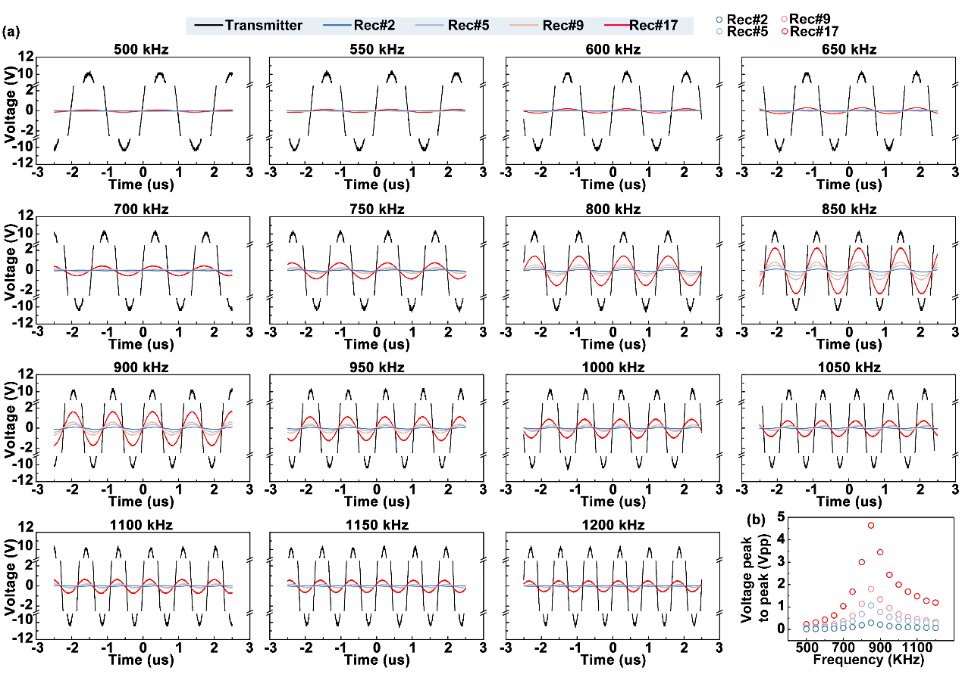
Figure S5.7. (a) Vpp recorded from different receivers induced by sine voltage (20 Vpp) with different frequencies exerted on transmitter. In these tests, the integrated antenna and WTCL, aligned with identical axis, were connected with waveform generator and oscilloscope, respectively. The distance between integrated antenna and WTCL was set at 6 mm. (b) The Vpp were plotted as a function of frequency. Similar to the activation by square wave voltage, the acquired Vpp on receiver circuit induced by transmitter with sine wave were also maximized at 850 kHz. The results reveal that 850 kHz was the optimal operation frequency of these receiver circuits for supplying higher Vpp.

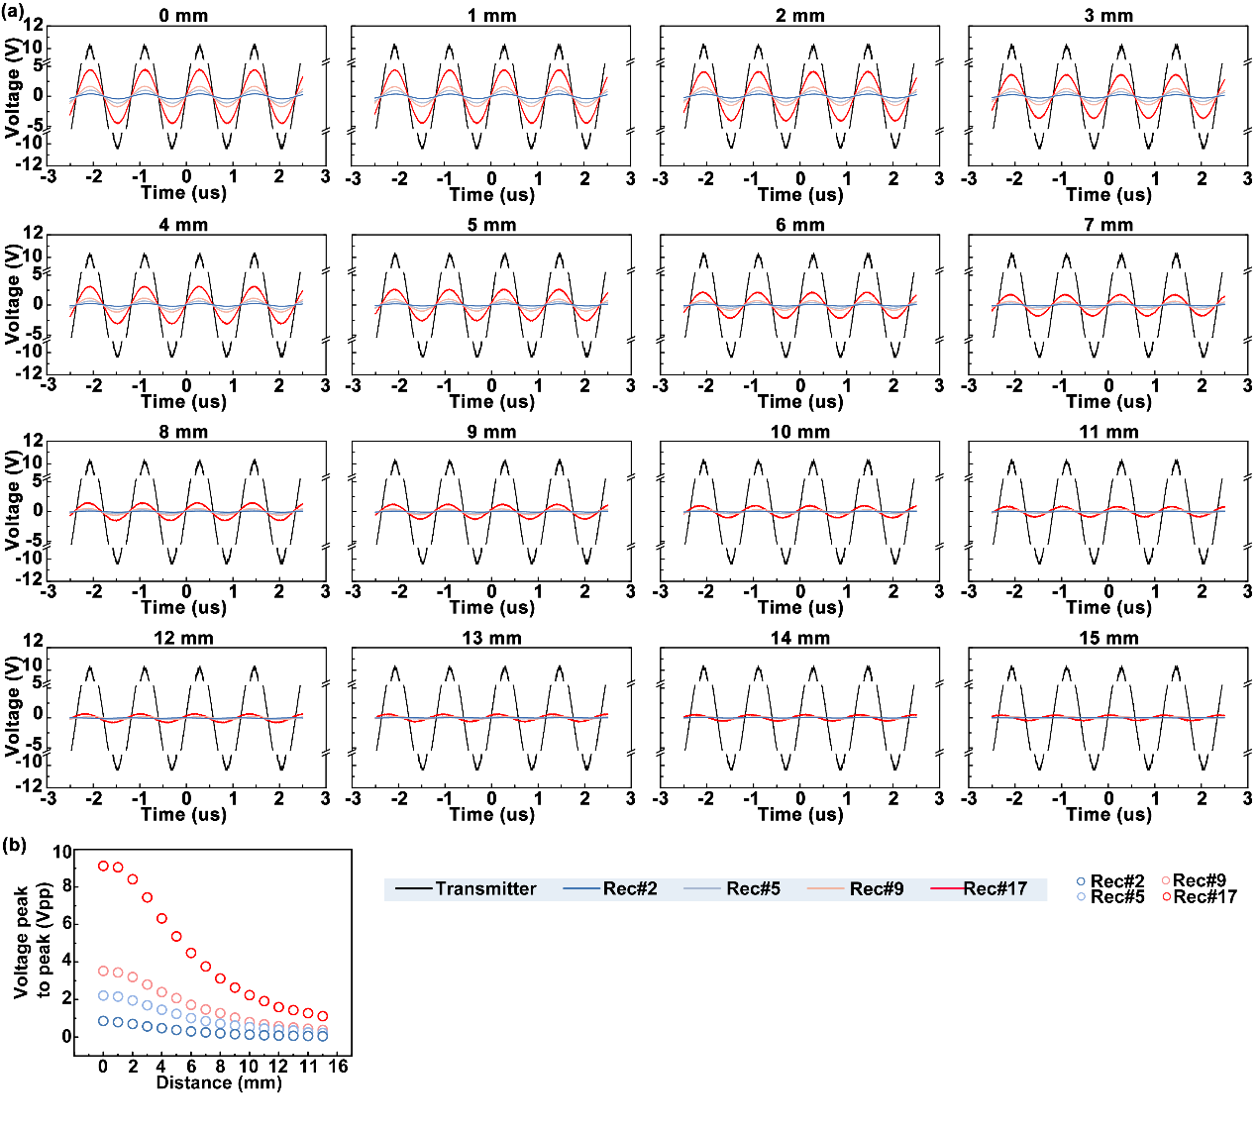
Figure S5.8. (a) Vpp recorded from different receivers induced by sine voltage applied on transmitter under different radiation distances (0 to 15 mm with the step of 1 mm). In these tests, the integrated antenna and WTCL, aligned with identical axis, were connected with waveform generator and oscilloscope, respectively. The voltage wave exerted on transmitter of integrated antenna was kept with 20 Vpp at 850 kHz. (b) The Vpp values were plotted as a function of radiation distance.

S4. Theoretical calculations for the performance of WPT groups.
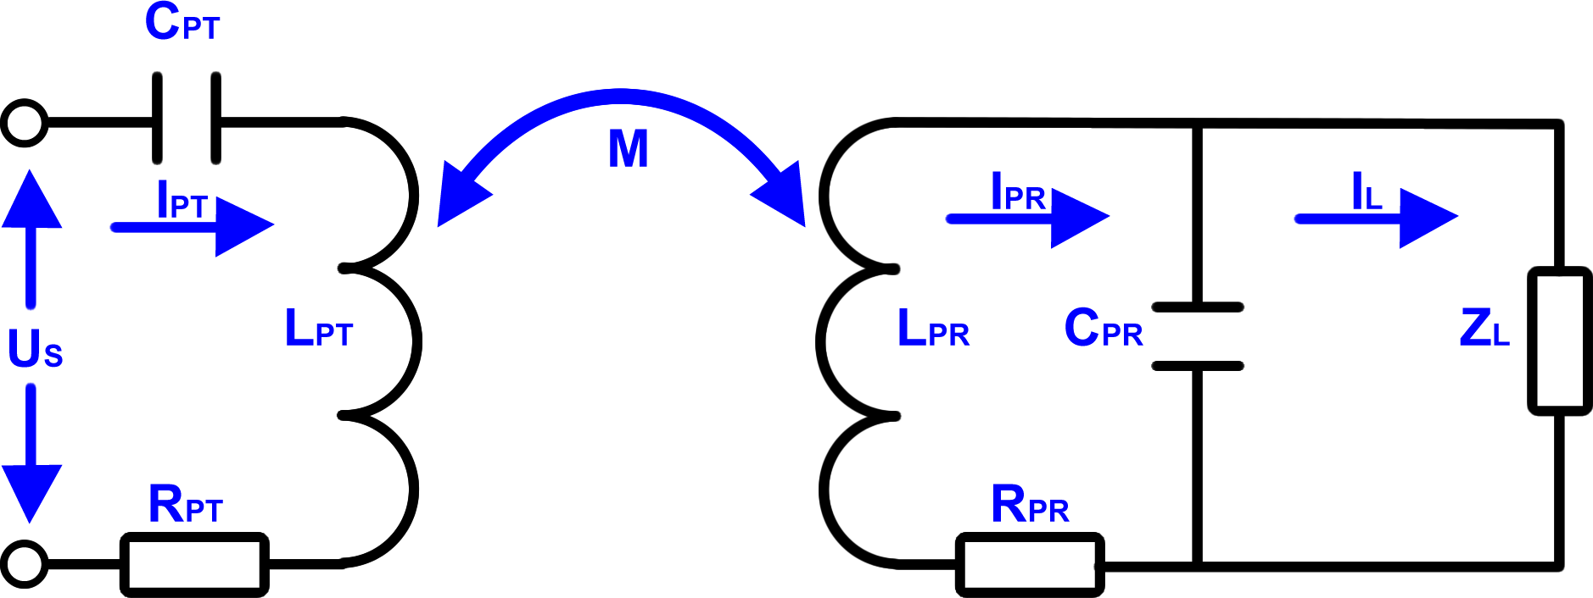
Figure S6.1. Schematic circuit for the derivation of the power transfer efficiency equation. U_{s}, R_{PT}, L_{PT}, C_{PT}, I_{PT} refer to the alternating voltage supplied for the transmitter, parasitic resistance, inductor, capacitor and alternating current in transmitter. Correspondingly, R_{PR}, L_{PR}, C_{PR}, R_{L} denote the parasitic resistance, inductor, capacitor and electric load in receiver circuit. I_{PR} represents the total alternating current in receiver circuit. I_{L} is the alternating current flow through electric load.

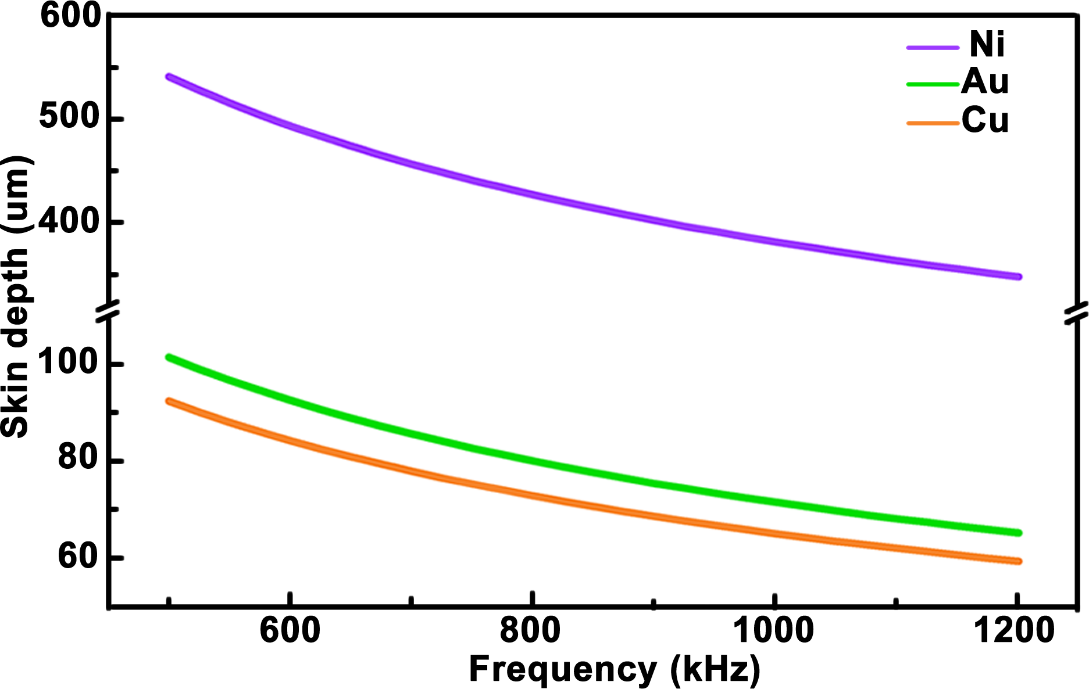
Figure S6.2. Calculated skin depth of conductor composited of Ni, Au, and Cu in the frequency range from 500 kHz to 1.2 MHz. Detailed parameters (relative magnetic permeability and conductivity of the conductive matter) were listed in Table S5. Calculation results show that the skin depth decreased gradually as the operation frequency increases from 500 kHz to 1.2 MHz. Moreover, the skin depth of Au, Cu, and Ni are 78.19 um, 71.23 um, and 415.19 um, respectively at alternating current in 850 kHz. The parameters of these conductive materials are thicker than its practical thickness in WPT receiver circuits. It indicated that alternating current with frequency of 850 kHz was distributed in the whole cross-section of the conductor, which suggested almost negligible power loss caused by skin effect needed to be considered in the WPT subsystem.

Table S5. Relative magnetic permeability and conductivity of the conductive matter¹⁴.
Conductive materials | Relative magnetic permeability | Conductivity σ (S/m)
Copper (Cu) | 0.999900 | 5.88×10⁷
Nickle (Ni) | 120 | 1.44×10⁴
Gold (Au) | 0.999983 | 4.88×10⁷

S7. Characterization of cross-coupling between IOP monitoring and WPT activated iontophoresis of the WTCL.
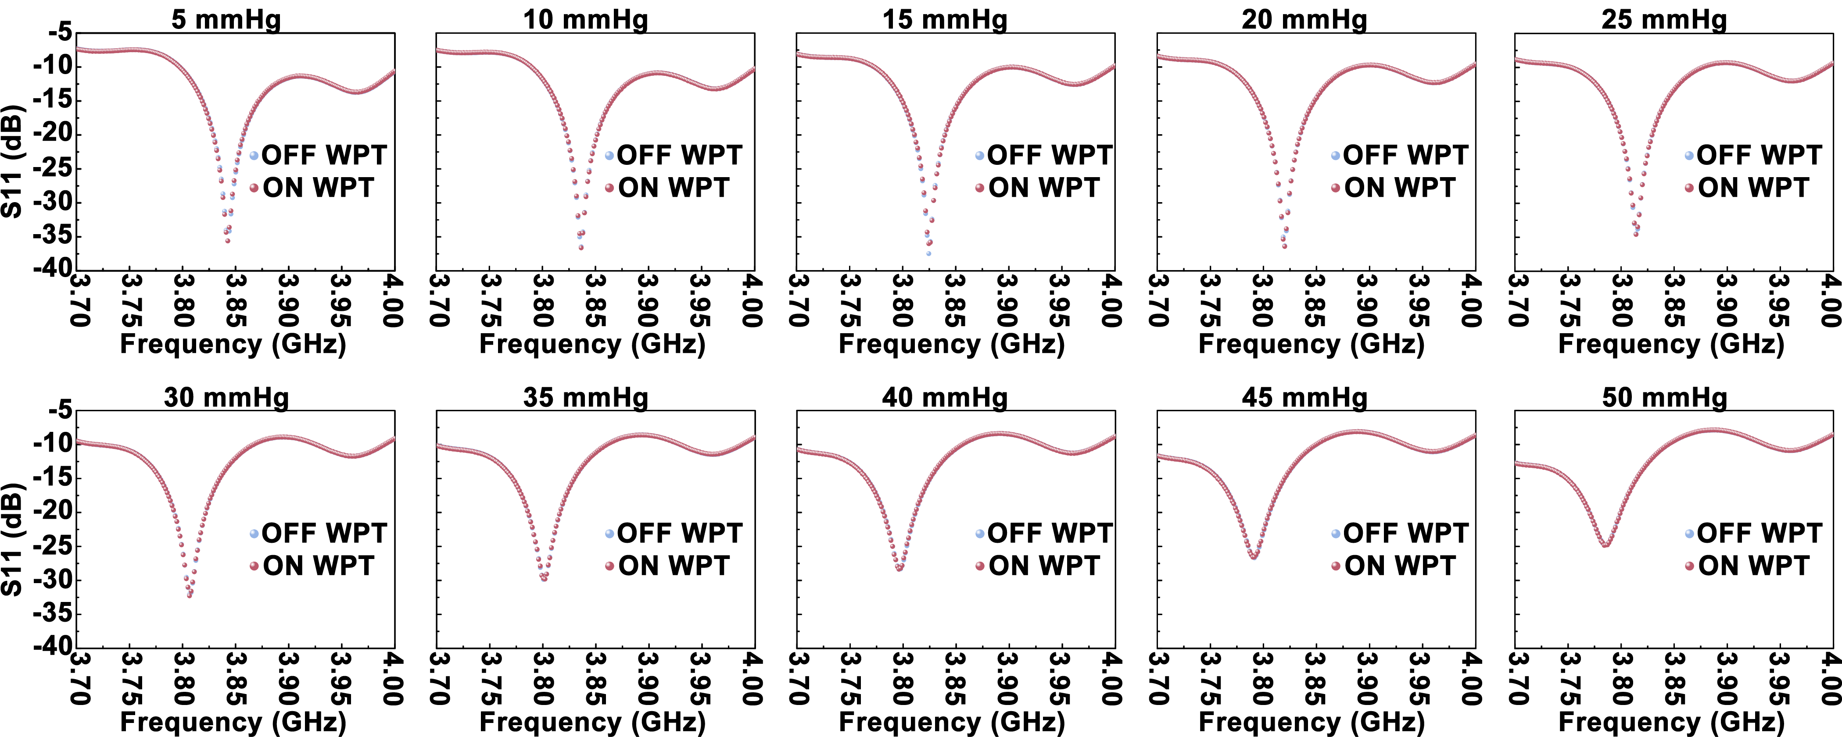
Figure S7.1. The influence generated by the radiation of WPT transmitter to IOP sensing performance. The distance between integrated antenna and WTCL was set at 6 mm. Network analyzer was connected to the IOP reading coil of the integrated antenna to monitor the physiological pressure transduced by WTCL. Saline solution were injected into the anterior chamber of porcine eyes via a infusion needles (0.45×13.5 mm) controlled by syringe pump to achieve IOPs ranging from 5 to 50 mmHg with the step of 5 mmHg. During the process of IOP sensing, the power generated by waveform generator for WPT transmitter was turned on and off to evaluate the S11 response of the IOP monitoring module.

S8. Theoretical simulations of iontophoretic medicines administration via COMSOL Multiphysics 5.5.
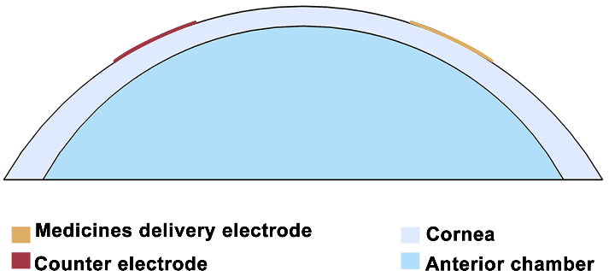
Figure S8.1. Sectional view of 3D model of ocular drug delivery with the structures and components imitating the actual scenario, which was simulated using COMSOL Multiphysics 5.5 to evaluate the feasibility of enhanced trans-corneal drug delivery by the iontophoretic electrode on WTCL.

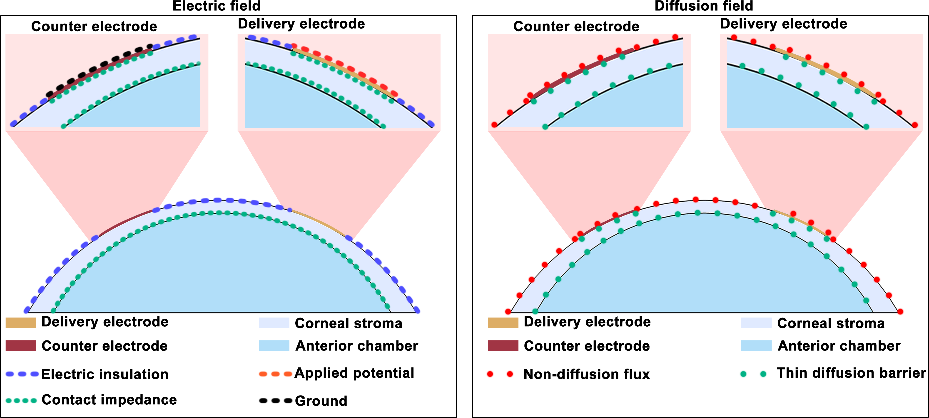
Figure S8.2. Boundary condition of the COMSOL delivery model. Anterior segment of the eye was modeled as aqueous humor, cornea including epithelial cell, stroma, and endothelial cell layer. The cornea presented a diffusion barrier for the drug molecules. The total drug amount in this system was set as constant, initially 100% loaded in the hydrogel. The average concentration of the drugs in the aqueous humor volume was quantified to evaluate the delivery efficiency.

Table S6. Detailed parameters and size of four WPT receiver circuits.
Components | Symbol | Value | Definition
pHEMA hydrogel | Hh | 50µm | The thickness of pHEMA hydrogel.
pHEMA hydrogel | σh | 0.2 S/m | The electrical conductivity of pHEMA hydrogel.
pHEMA hydrogel | Dh | 0.1 | The relative diffusivity of brimonidine in pHEMA hydrogel.
pHEMA hydrogel | Ap | 16.98 mm² | The area of pHEMA hydrogel
pHEMA hydrogel | Cg0 | 1 mmol/m³ | Medicinesof brimonidine concentration in hydrogel
Counter electrode | An | 4.78 mm² | The area of counter electrode
Corneal stroma | σc¹⁵ | 0.2 S/m | The electrical conductivity of corneal stroma.
Corneal stroma | Dc | 0.1 | The relative diffusivity of brimonidine in corneal stroma.
Corneal stroma | Hst | 300 µm | The thickness of corneal stroma.
Corneal epithelial cell layer | Hepc | 100 µm | The thickness of corneal epithelial cell layer (modeled as the top boundary of the corneal layer).
Corneal epithelial cell layer | σepc | 0.021 S/m | The electrical conductivity of corneal epithelial cell layer.
Corneal epithelial cell layer | Depc | 0.01 | The relative diffusivity of brimonidine in corneal epithelial cell layer.
Corneal endothelial cells layer | Hepe | 100 µm | The thickness of corneal endothelial cells layer (modeled as the bottom boundary of the corneal layer).
Corneal endothelial cells layer | σepe | 0.021 S/m | The electrical conductivity of corneal endothelial cells layer.
Corneal endothelial cells layer | Depe | 0.01 | The relative diffusivity of brimonidine in corneal endothelial cells layer.
Aqueous humor | σa | 2.1 S/m | The electrical conductivity of aqueous humor.
Brimonidine | Da | 1E-9 m^2/s | The diffusivity of brimonidine in aqueous humor.
Brimonidine | Z | 2 | Charge of brimonidine
Electric potential | U0 | Variable

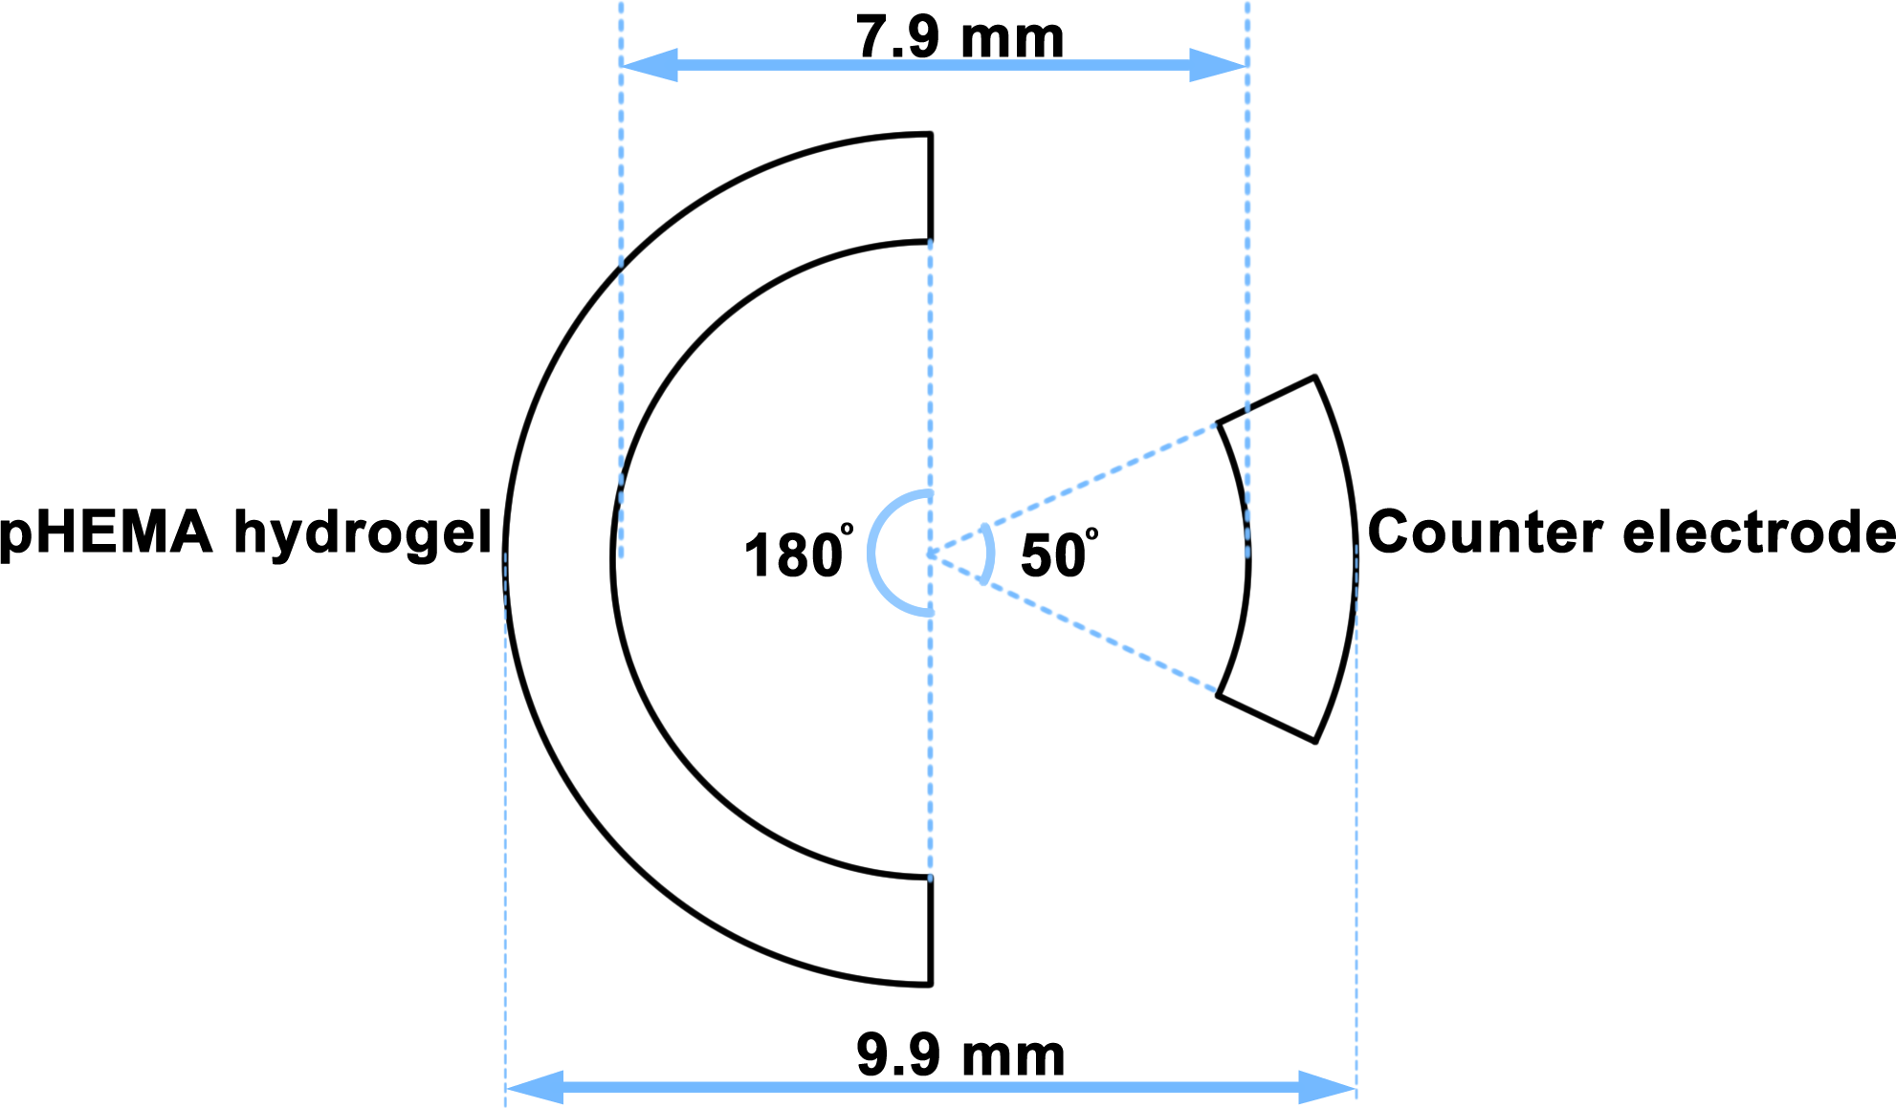
Figure S8.3. The CAD diagram showing the 2D dimensions of iontophoretic electrode in the simulation model. Counter electrode and pHEMA hydrogel that served as reservoir to load bio-active compounds were attached on cornea. Furthermore, the back surface of hydrogel was attached to the drug delivery electrode. The counter electrode was labeled with ground in electric field.

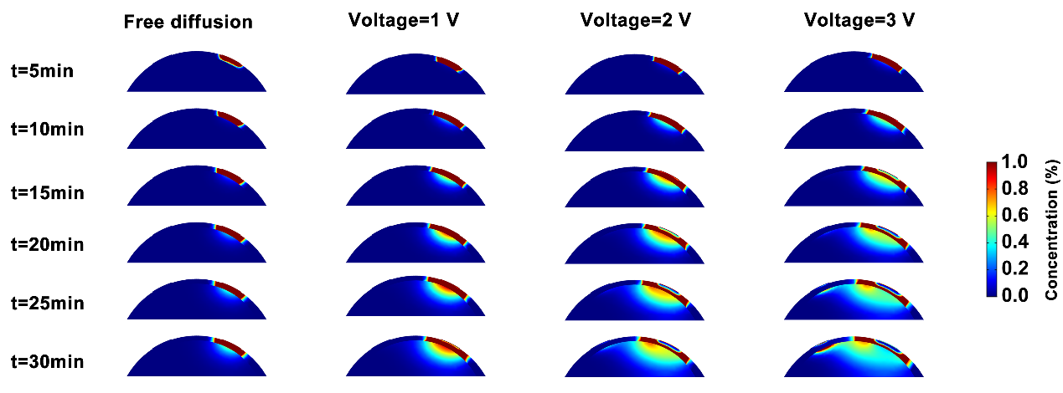
Figure S8.4. Illustration of the diffusion profile of drug molecules in the anterior region of the eye after iontophoresis at 0, 1, 2 and 3 V for t=5 min to 30 min with the step of 5 min via WTCL. Under constant electrical voltages, the electrode generated electric field across cornea. For drug delivery, the initial drug concentration was set as Cg0 in hydrogel. Drug molecules were driven into aqueous humor across corneal barriers by the effect of electrophoresis under the means of this electric field. The average drug concentration in the anterior chamber (aqueous humor) was calculated to evaluate the medicines administration efficiency.

S9. Supporting information for in vivo experiments.
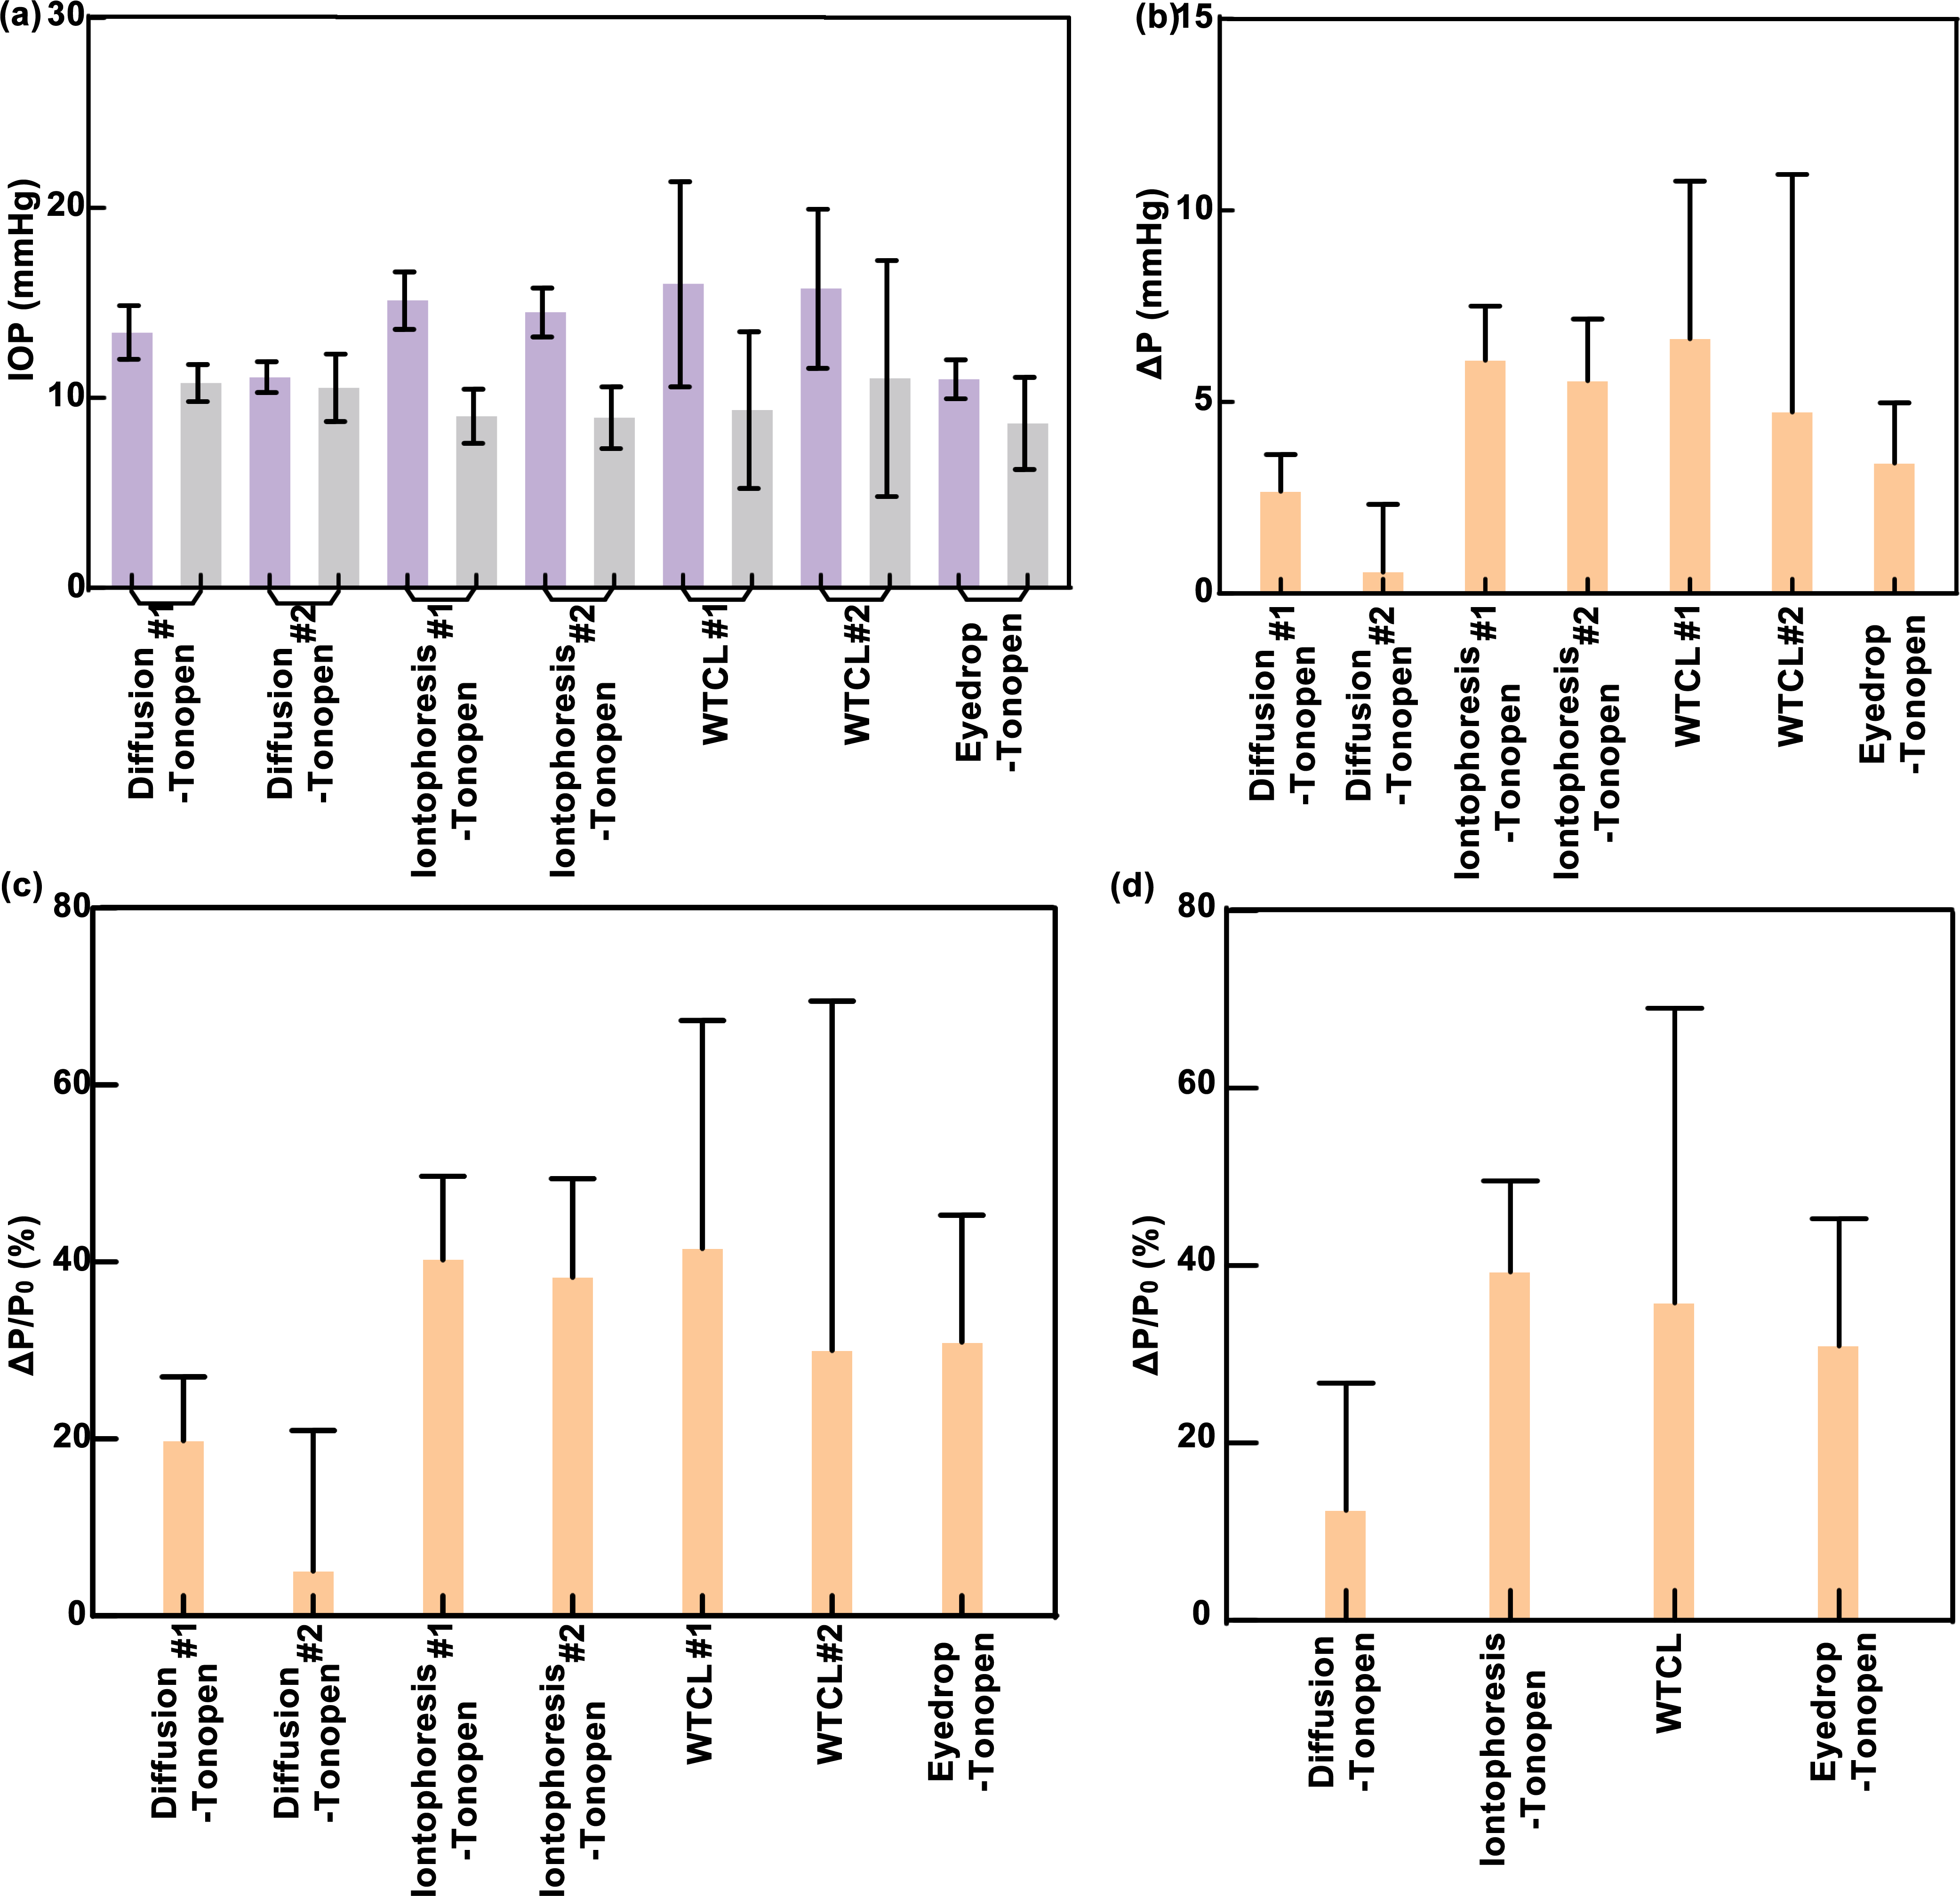
Figure S9.1. Assessment of IOP reduction effect after 0.5 hour of drug administration, summarizing based on Figure 6e-6h in main text. (a) Analysis of the measured IOP value (either by WTCL or TonoPen) recorded in the different period of experiments. The purple columns refers to the IOP data in the initial period (in 1 hour) before drug delivery. The gray columns represent the IOP data recorded right (in 0.5 hour) after drug delivery. (b) IOP changes (ΔP) at different delivery experiments. ΔP could be expressed as: , where P denotes the real-time IOP recorded in 0.5 hour after drug delivery, P_{0Avg} represents the average IOP before drug delivery. (c) Normalized IOP changes (ΔP/P_{0Avg}) in different drug delivery experiments. ΔP/P_{0Avg} could be expressed as: , where P denotes the real-time IOP recorded in 0.5 hour right after drug delivery, while P_{0Avg} represents the average IOP before drug delivery. (d) Assessment of IOP reduction effect by different drug delivery methods. ΔP recorded from different experimental animal groups in the same delivery approach were averaged to calculate ΔP/P_{0Avg} for analyzing IOP reduction effect.

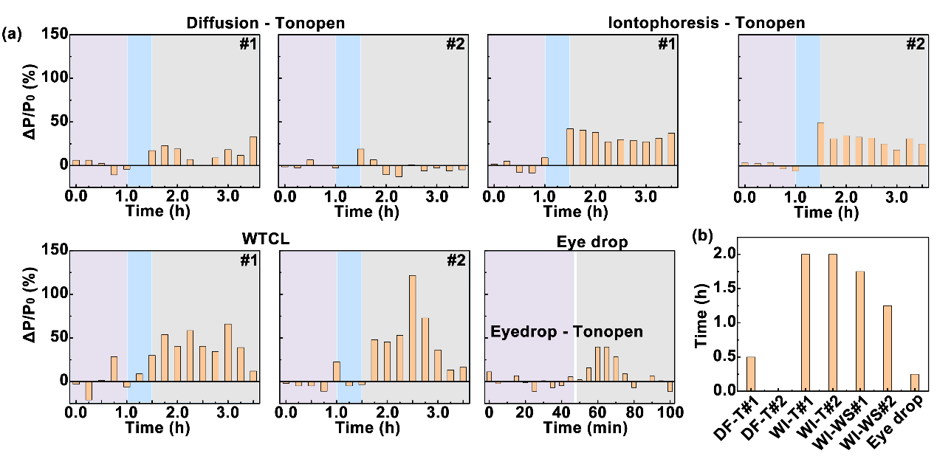
Figure S9.2. Analysis of the duration of IOP reduction. (a) ΔP/P_{0Avg} at each time point by different drug delivery approach. (b) Quantifications of IOP reduction duration by different drug delivery approach. ΔP/P_{0Avg}≥20% was identified as the effective IOP regulation¹⁶, and the period during which the IOP meet this criteria was defined as the effective IOP regulation period.
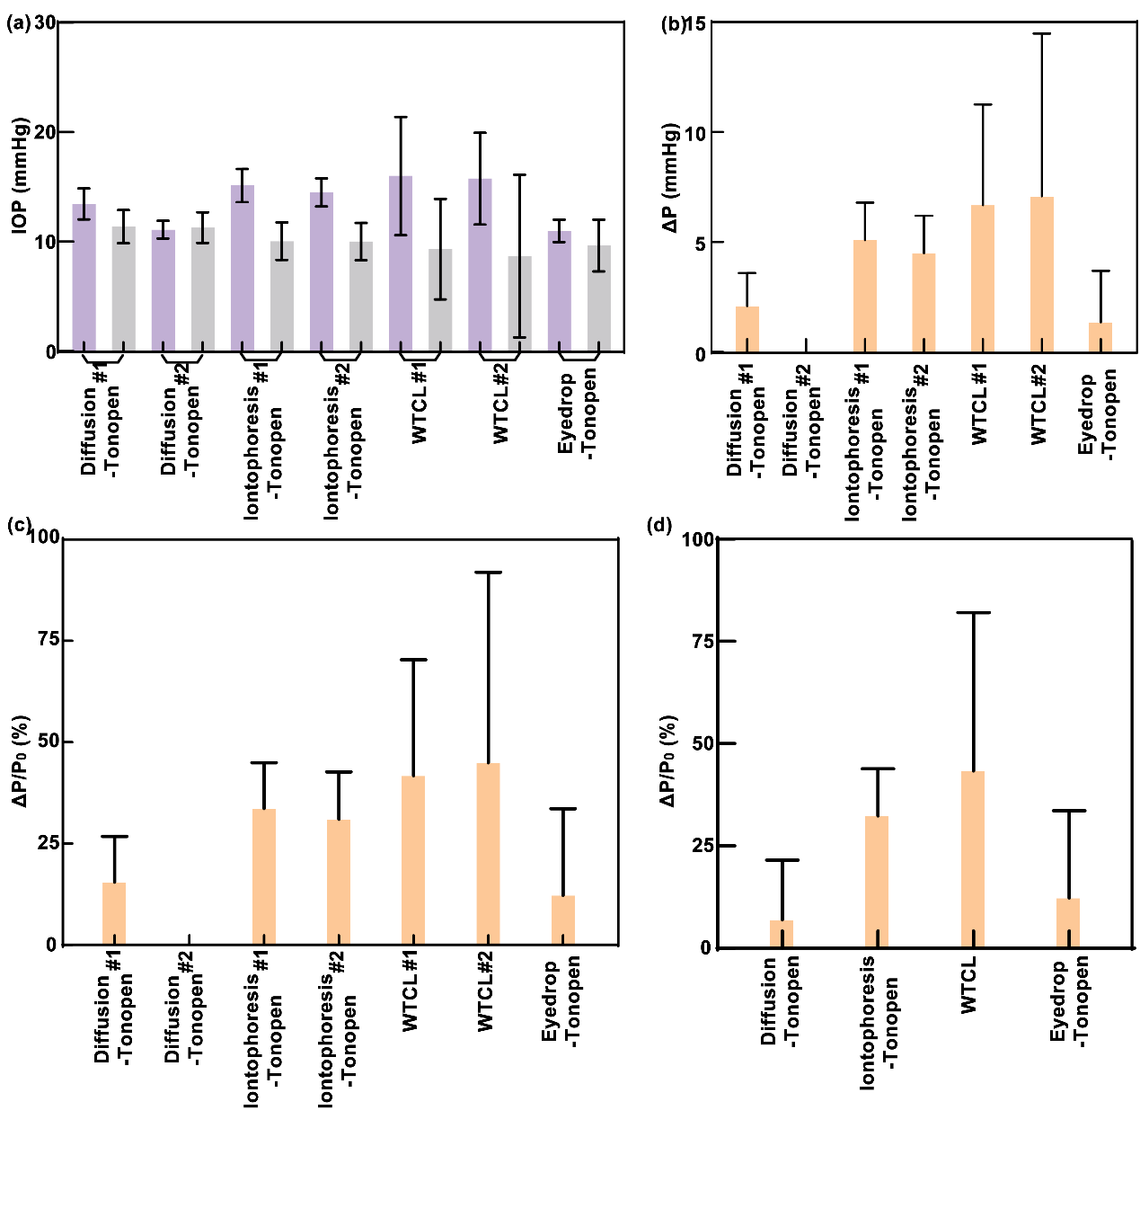
Figure S9.3. Assessment of IOP reduction effect after 2 hour of drug administration, summarizing based on Figure 6e-6h in main text. (a) Analysis of the measured IOP value (either by WTCL or TonoPen) recorded in the different period of experiments. The purple columns refers to the IOP data in the initial period (in 1 hour) before drug delivery. The gray columns represent the IOP data recorded in 2 hours after drug delivery. (b) IOP changes (ΔP) at different delivery experiments. ΔP could be expressed as: , where P denotes the real-time IOP recorded in 2 hours after drug delivery, P_{0Avg} represents the average IOP before drug delivery. (c) Normalized IOP changes (ΔP/P_{0Avg}) in different drug delivery experiments. ΔP/P_{0Avg} could be expressed as: , where P denotes the real-time IOP recorded in 2 hour after drug delivery, while P_{0Avg} represents the average IOP before drug delivery. (d) Assessment of IOP reduction effect by different drug delivery methods. ΔP recorded from different experimental animal groups in the same delivery approach were averaged to calculate ΔP/P_{0Avg} for analyzing IOP reduction effect.

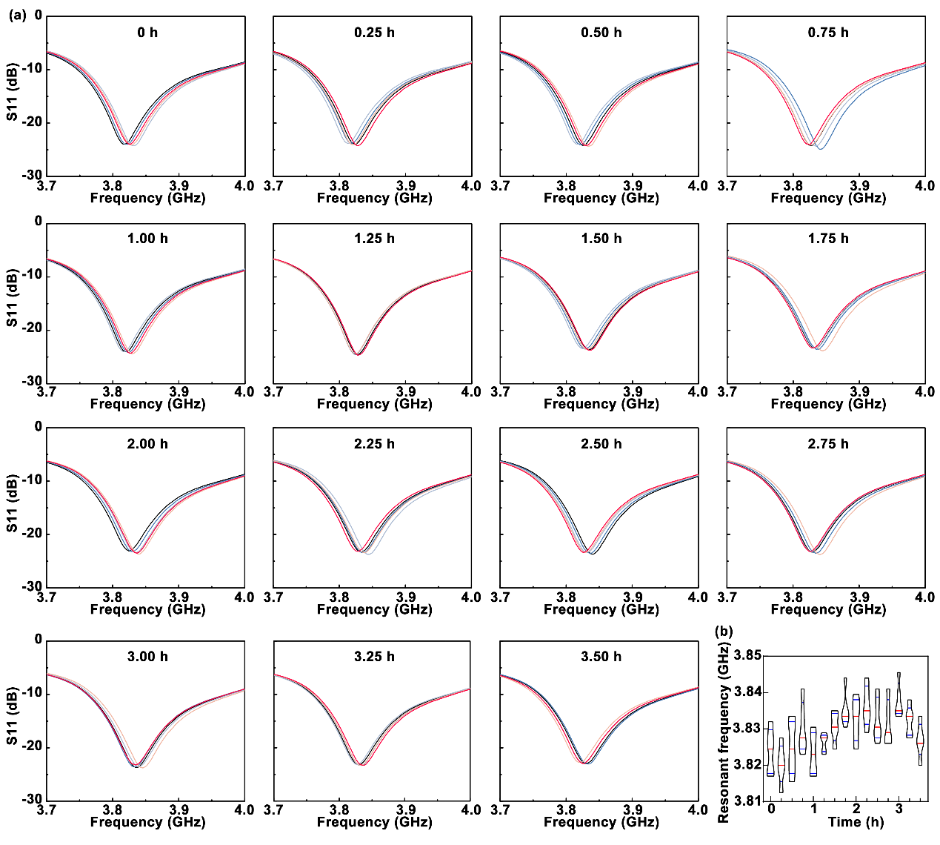
Figure S9.4. (a) Scattering parameters of IOP sensing module at each measurement time point during the WTCL#1 experimental group in Figure 6g in main text. During synergistic IOP monitoring and in situ drug delivery by WTCL, the scattering parameter of IOP monitoring module was recorded wirelessly by network analyzer every 15 minutes, while the resonant frequency measurements were repeated for 5 times at each time point. (b) Resonant frequency fluctuations as the function of time. The resonant frequency could be further converted to IOP, according to the standard curve of resonant frequency-IOP.

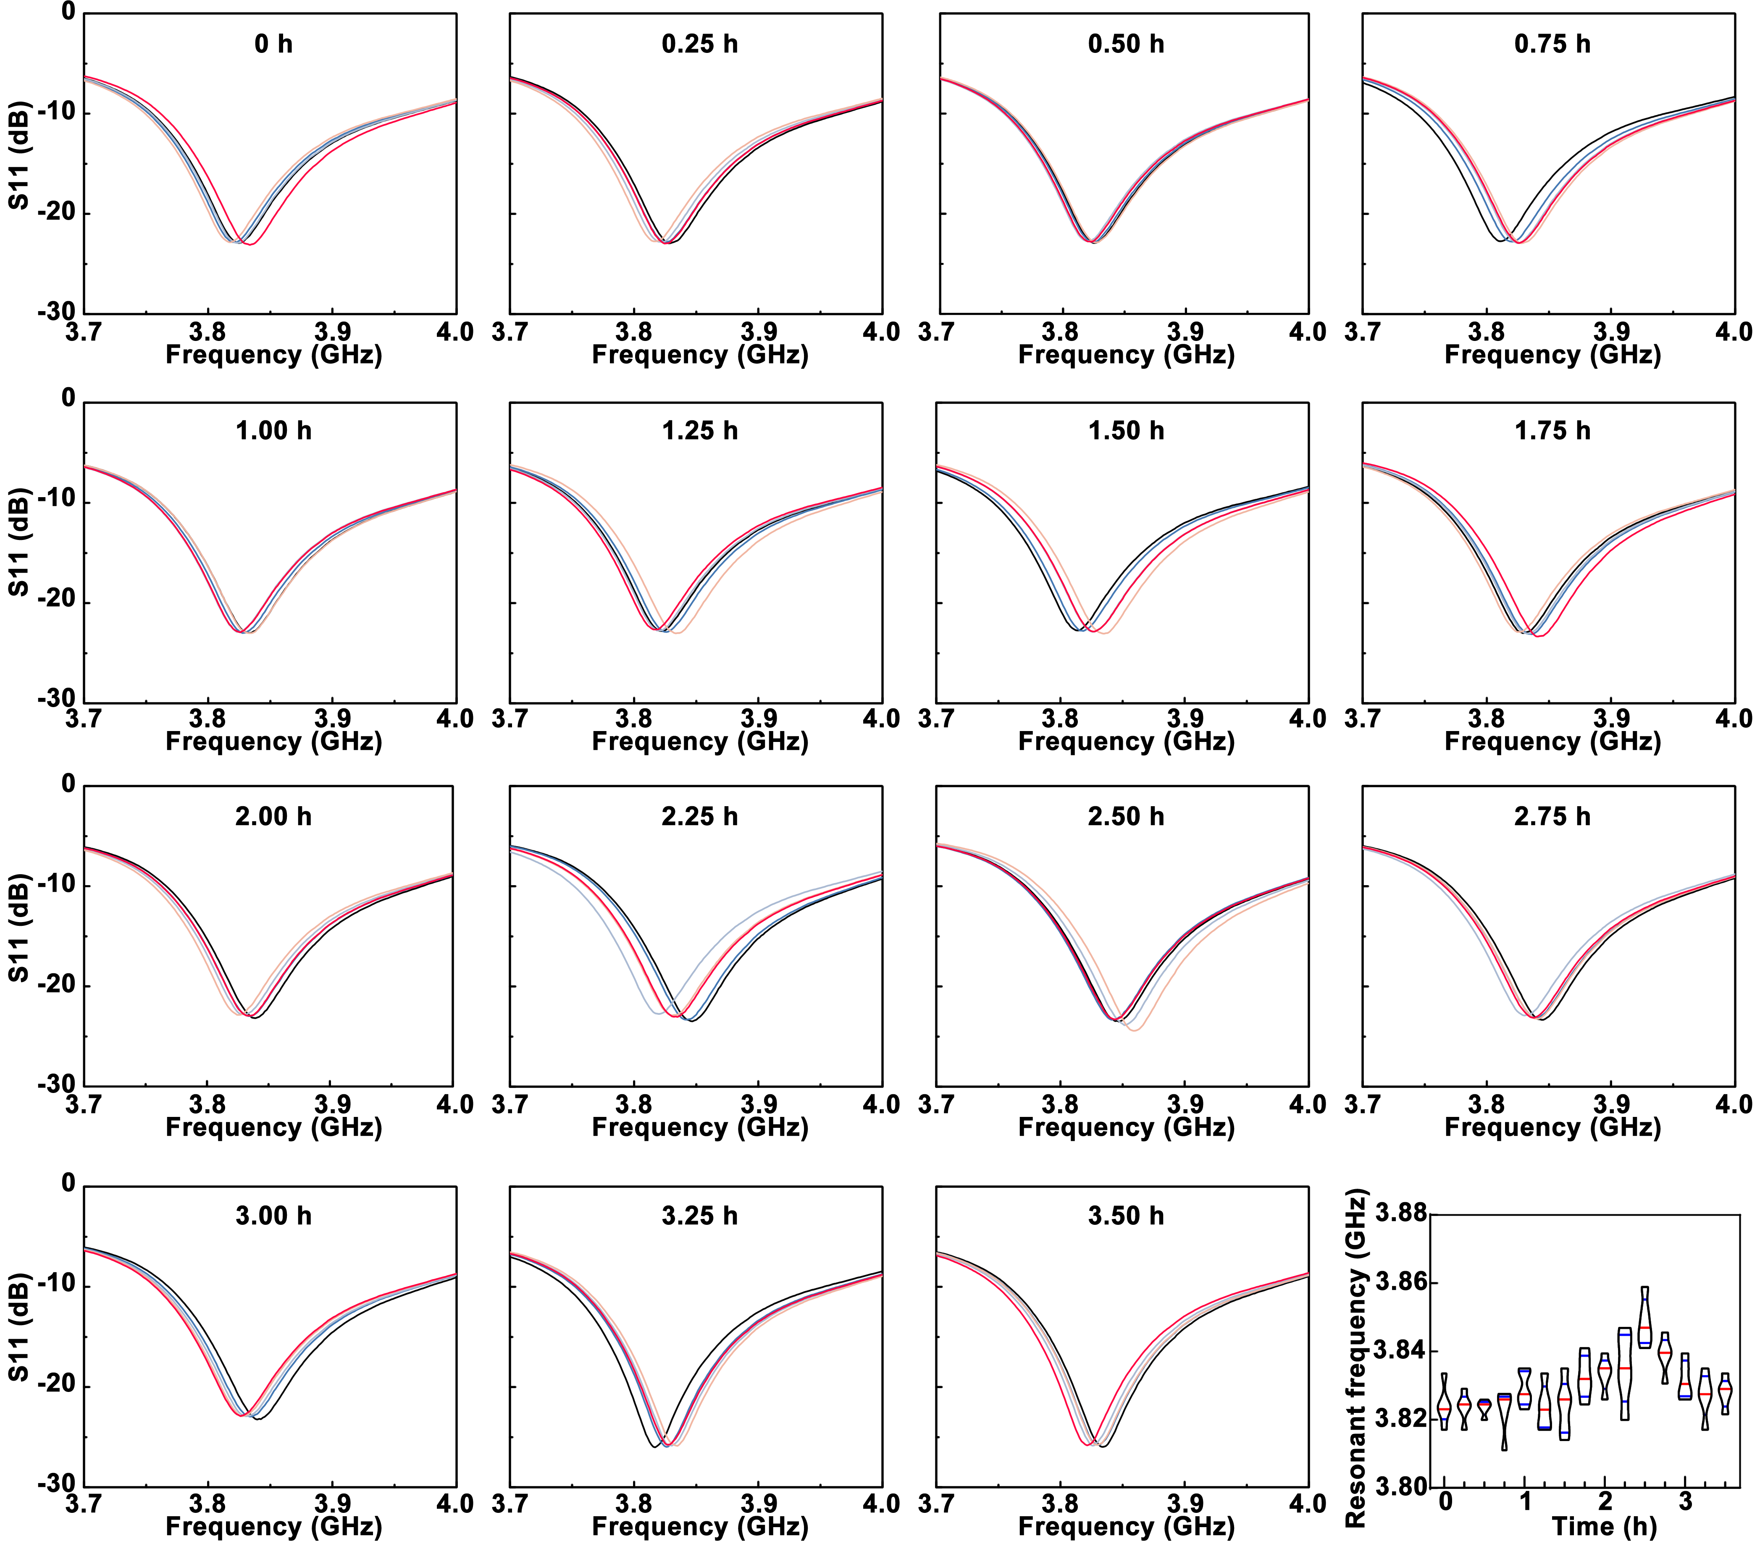
Figure S9.5. (a) Scattering parameters of IOP sensing module at each measurement time point during the WTCL#2 experimental group in Figure 6g in main text. During synergistic IOP monitoring and in situ drug delivery by WTCL, the scattering parameter of IOP monitoring module was recorded wirelessly by network analyzer every 15 minutes, while the resonant frequency measurements were repeated for 5 times at each time point. (b) Resonant frequency fluctuations as the function of time. The resonant frequency could be further converted to IOP, according to the standard curve of resonant frequency-IOP.

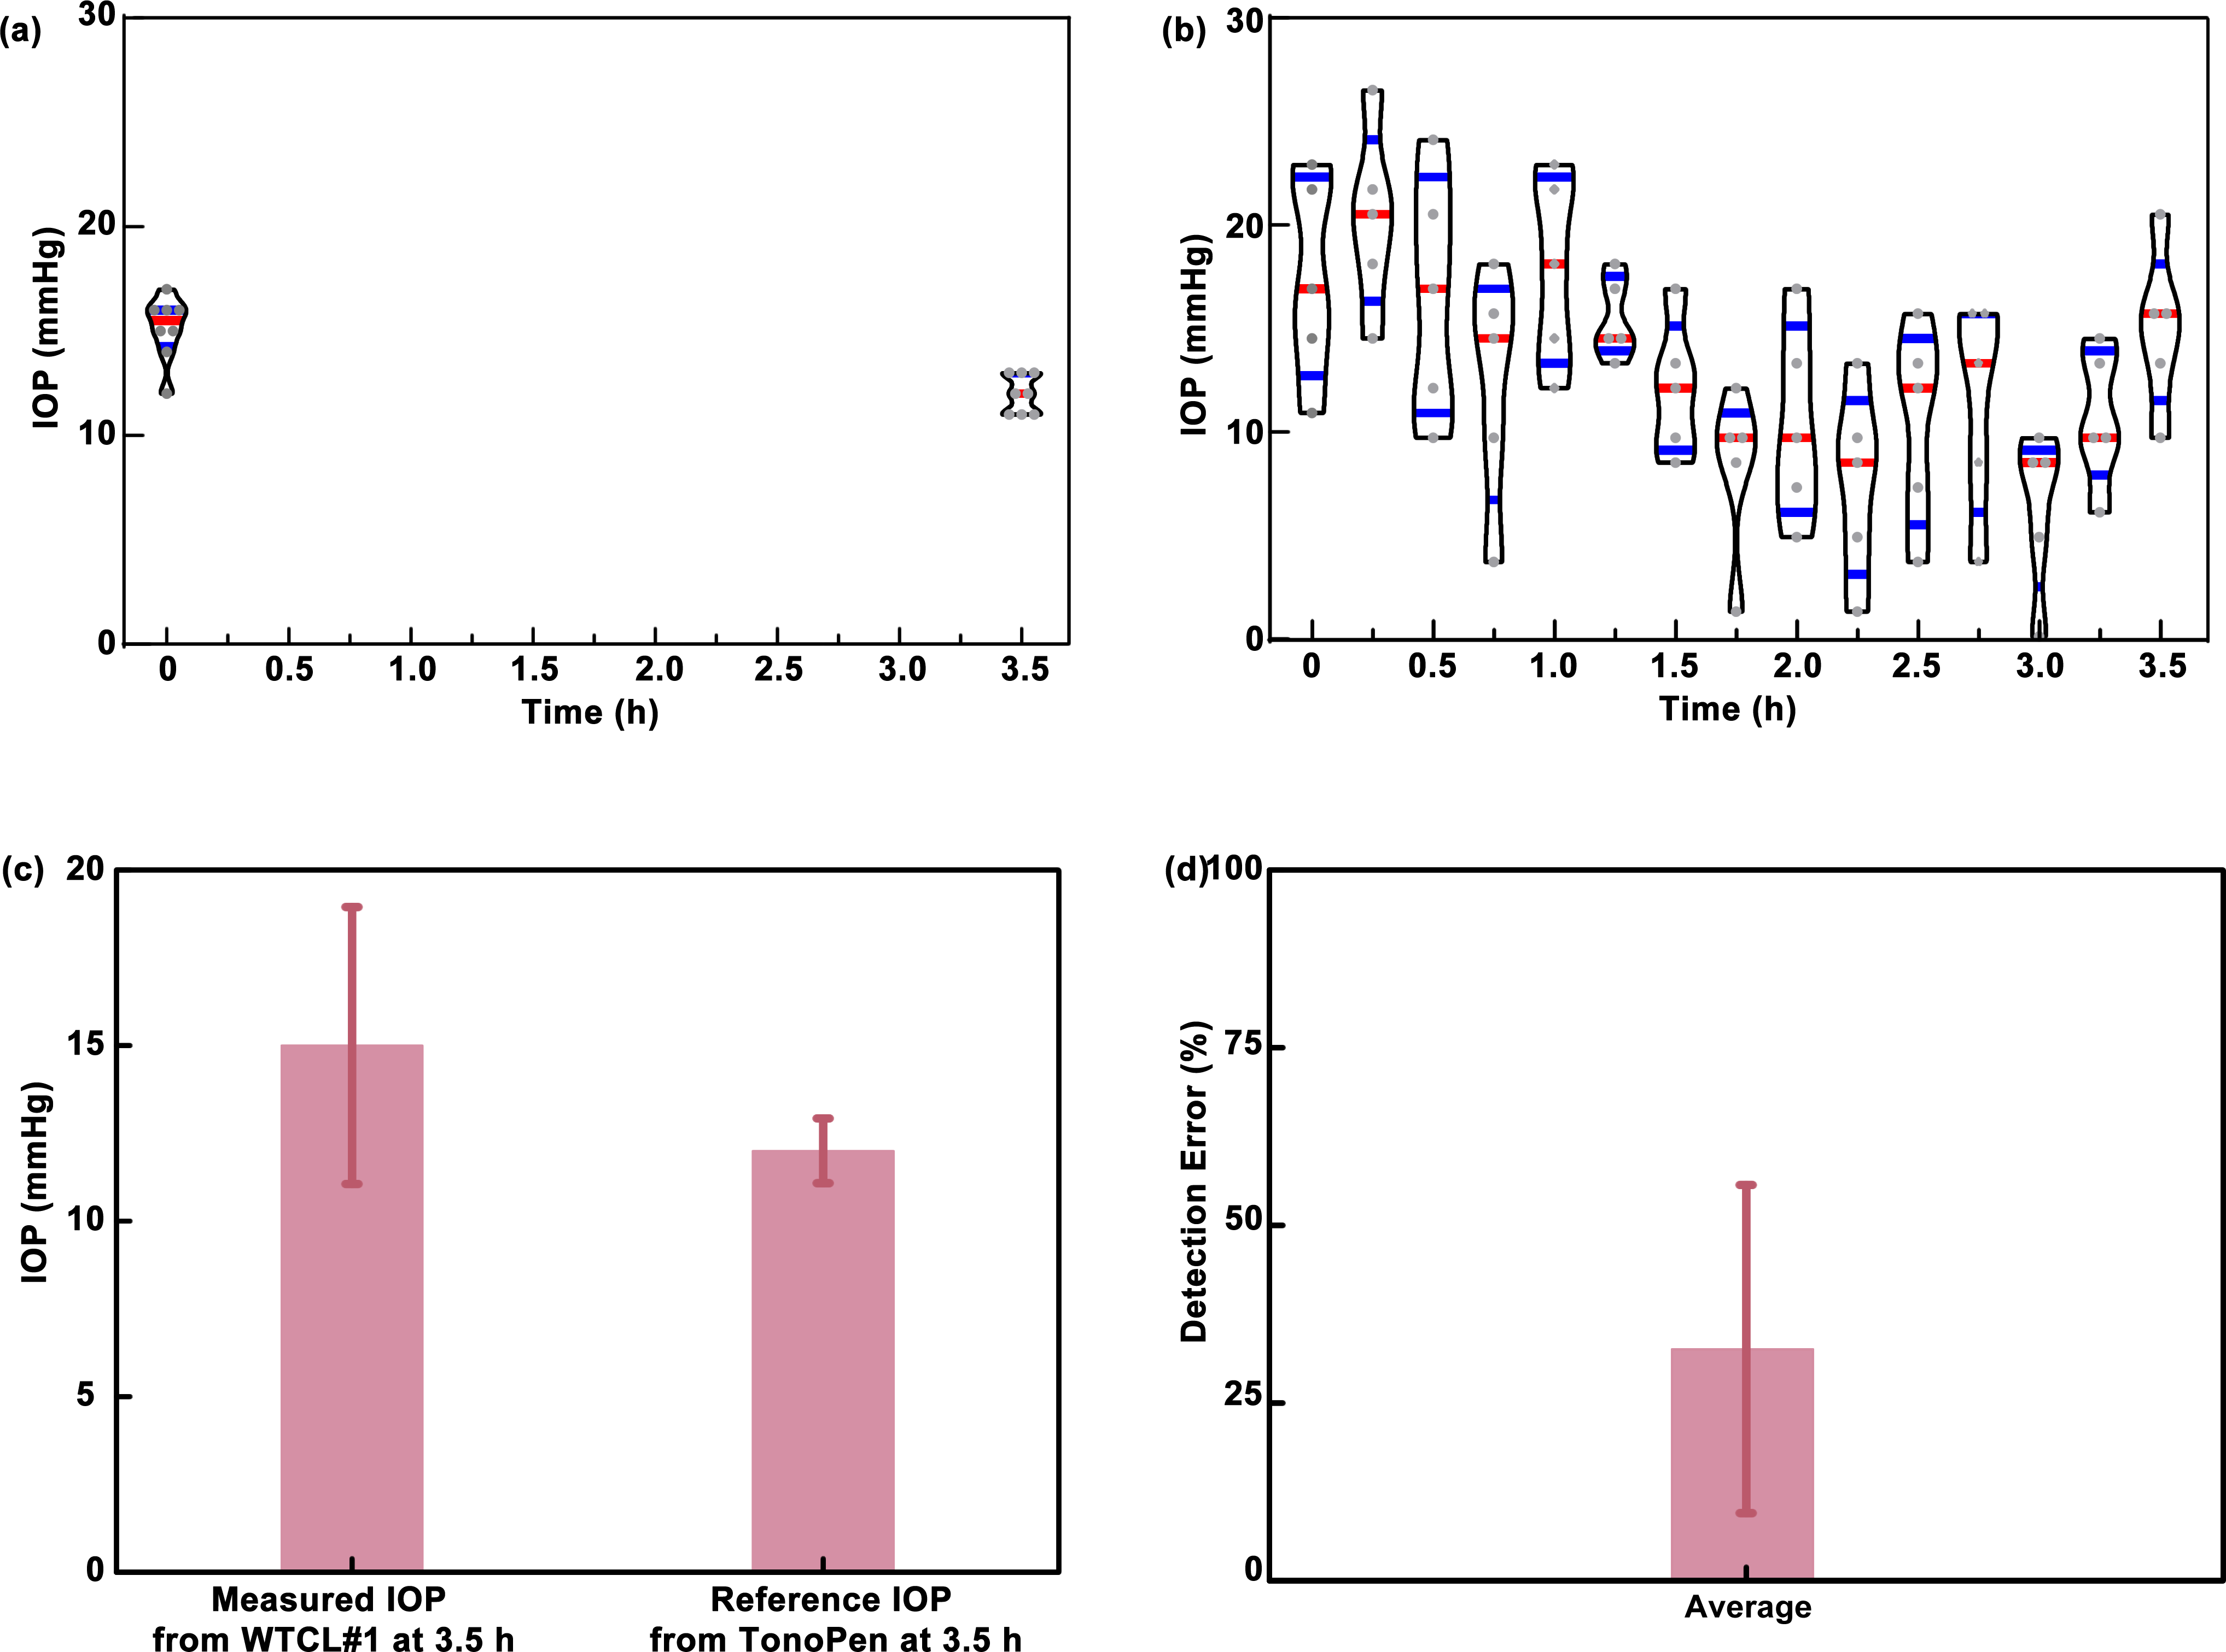
Figure S9.6. (a) Reference IOP values, related to Figure 6g (I) in main text, captured by Tonopen before and after WTCL#1 experiment in Figure 6g in main text, which could be employed to calibrate the measured IOP and analyze detection error. (b) IOP values calculated from the resonant frequency values of WTCL#1 experiment in Supporting Information Figure S6.1, without calibration using the reference data via Tonopen measurement. (c) The measured IOP via WTCL#1 at the end of experiment (initially calibrated with the reference IOP provided by Tonopen), and the comparison to the reference IOP measured via Tonopen at the end of experiment. (d) The detection error of IOP monitoring using WTCL with calibration. The detection error could be expressed as where P represents the real-time pressure recorded by WTCL at 3.5 h, P_{Avg} denotes the average IOP collected by TonoPen at 3.5 h.
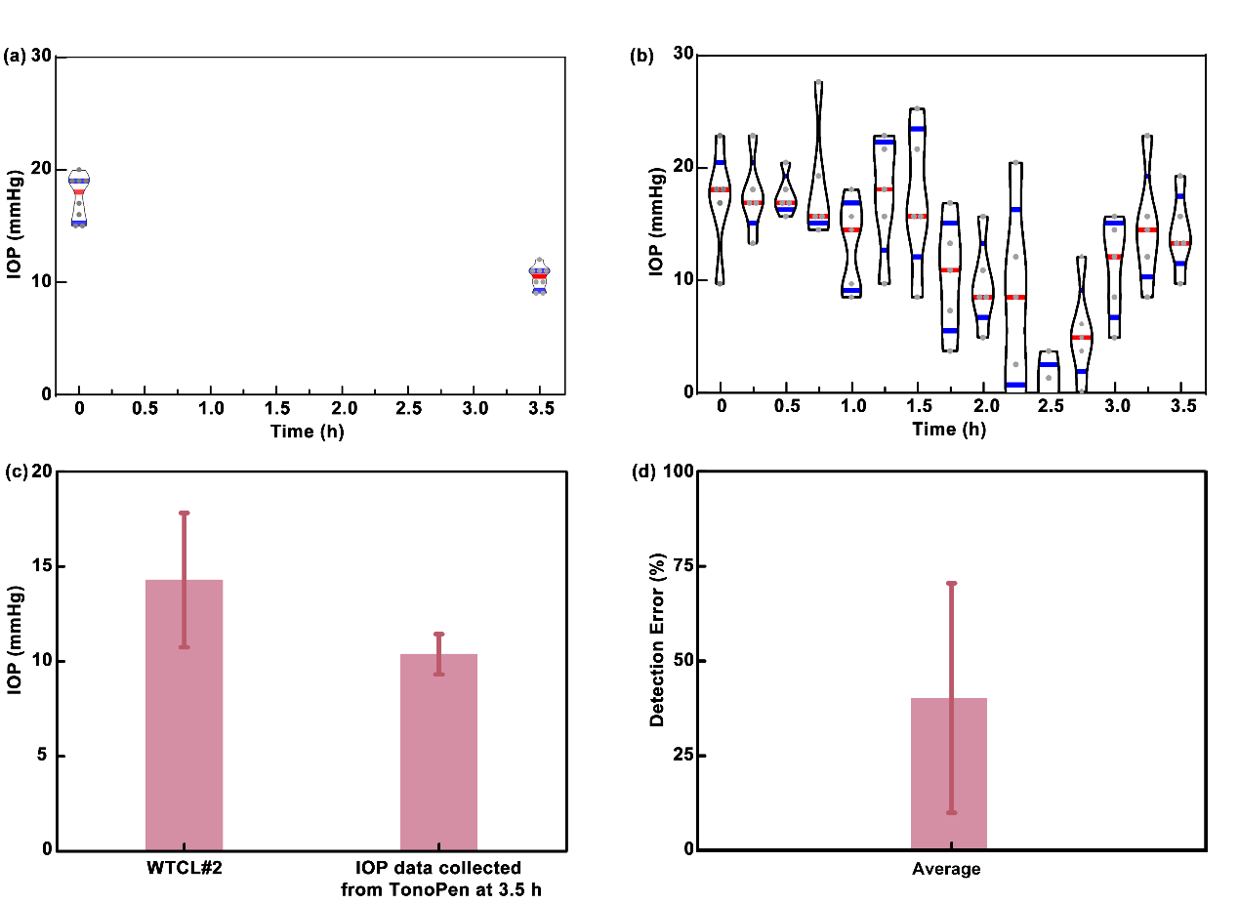
Figure S9.7. (a) (a) Reference IOP values, related to Figure 6g (II) in main text, captured by Tonopen before and after WTCL#2 experiment in Figure 6g in main text, which could be employed to calibrate the measured IOP and analyze detection error. (b) IOP values calculated from the resonant frequency values of WTCL#2 experiment in Supporting Information Figure S6.2, without calibration using the reference data via Tonopen measurement. (c) The measured IOP via WTCL#2 at the end of experiment (initially calibrated with the reference IOP provided by Tonopen), and the comparison to the reference IOP measured via Tonopen at the end of experiment. (d) The detection error of IOP monitoring using WTCL with calibration. The detection error could be expressed as where P represents the real-time pressure recorded by WTCL at 3.5 h, P_{Avg} denotes the average IOP collected by TonoPen at 3.5 h.

S10. Thermal analysis
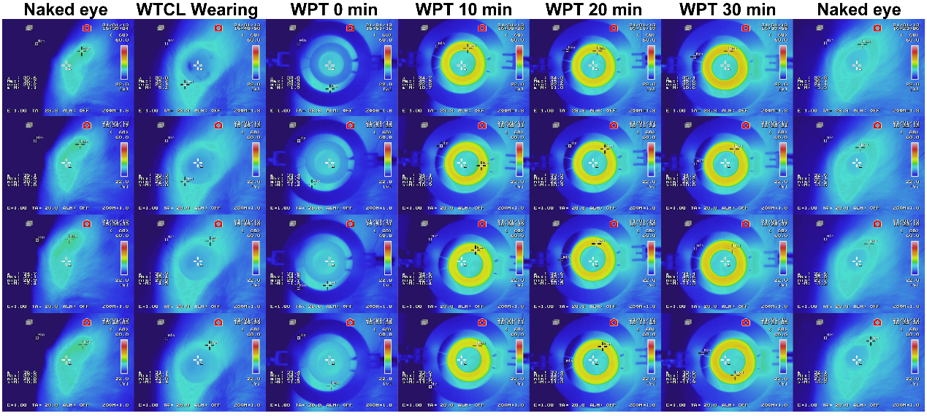
Figure S10.1. Time slot infrared images showing the temperature variations of the ocular surface tissue, WTCL, and integrated antenna measured by infrared camera during the 30 min WPT process. WTCL was worn on rabbit’s eye, and integrated antenna connected to waveform generator was posited above WTCL with the distance of 6 mm. Square voltage with 20 Vpp at 850 kHz produced from waveform generator was exerted on WPT transmitter. At each time point, 4 infrared images were recorded.

Reference:
1 Kessing;, S. V. & Thygesen;, J. Primary angle-closure and angle-closure glaucoma. (Kugler Publications, 2007).
2 Shingleton, B. J., Wadhwani, R. A., O’Donoghue, M. W., Baylus, S. & Hoey, H. Evaluation of intraocular pressure in the immediate period after phacoemulsification. J. Cataract Refract. Surg. 27, 524-527 (2001).
3 Rainer, G. et al. Effect of dorzolamide and latanoprost on intraocular pressure after small incision cataract surgery. J. Cataract Refract. Surg. 25, 1624-1629, doi:https://doi.org/10.1016/S0886-3350(99)00260-6 (1999).
4 Carvalho, I. M. et al. Sustained drug release by contact lenses for glaucoma treatment-A review. J. Control. Release 202, 76-82 (2015).
5 Kim, J. et al. Intraocular Pressure Monitoring Following Islet Transplantation to the Anterior Chamber of the Eye. Nano Lett. 20, 1517-1525 (2020).
6 Kim, J. et al. Wearable smart sensor systems integrated on soft contact lenses for wireless ocular diagnostics. Nat. Commun. 8, 14997 (2017).
7 Chen, G.-Z., Chan, I.-S. & Lam, D. C. C. Capacitive contact lens sensor for continuous non-invasive intraocular pressure monitoring. Sens. Actuator A-Phys. 203, 112-118, doi:10.1016/j.sna.2013.08.029 (2013).
8 Chen, G.-Z., Chan, I.-S., Leung, L. K. K. & Lam, D. C. C. Soft wearable contact lens sensor for continuous intraocular pressure monitoring. Med. Eng. Phys. 36, 1134-1139, doi:10.1016/j.medengphy.2014.06.005 (2014).
9 Kouhani, M. H. M., Weber, A. & Li, W. in 2017 IEEE 30th International Conference on Micro Electro Mechanical Systems (MEMS). 557-560.
10 Kouhani, M. H. M., Wu, J., Tavakoli, A., Weber, A. J. & Li, W. Wireless, passive strain sensor in a doughnut-shaped contact lens for continuous non-invasive self-monitoring of intraocular pressure. Lab Chip 20, 332-342, doi:10.1039/c9lc00735k (2020).
11 Chen, P., Saati, S., Varma, R., Humayun, M. S. & Tai, Y. Wireless Intraocular Pressure Sensing Using Microfabricated Minimally Invasive Flexible-Coiled LC Sensor Implant. J. Microelectromech. Syst. 19, 721-734 (2010).
12 Chen, P., Rodger, D. C., Saati, S., Humayun, M. S. & Tai, Y. Microfabricated Implantable Parylene-Based Wireless Passive Intraocular Pressure Sensors. J. Microelectromech. Syst. 17, 1342-1351, doi:10.1109/JMEMS.2008.2004945 (2008).
13 Crum, B. Parylene Based Wireless Intraocular Pressure Sensor for Glaucoma Research, Michigan State University, (2013).
14 Zhang, Y. et al. High precision epidermal radio frequency antenna via nanofiber network for wireless stretchable multifunction electronics. Nat. Commun. 11, 5629 (2020).
15 Klyce, S. D. Electrical profiles in the corneal epithelium. 226, 407-429 (1972).
16 Jonas, J. B. et al. Glaucoma. Lancet 390, 2183-2193, doi:10.1016/s0140-6736(17)31469-1 (2017).

