Supporting information

Magnetic carbon aerogel catalyst for nitro reduction by a liquid organic hydrogen carrier, considering the effect of preparation method on catalytic activity

Anahita Arastofar, Hossein Tavakol*

Department of Chemistry, Isfahan University of Technology, Isfahan 84156-83111, Iran; Tell (Fax): +98-31-33913241; E-mail: h_tavakol@iut.ac.ir ; a.arastofar@ch.iut.ac.ir

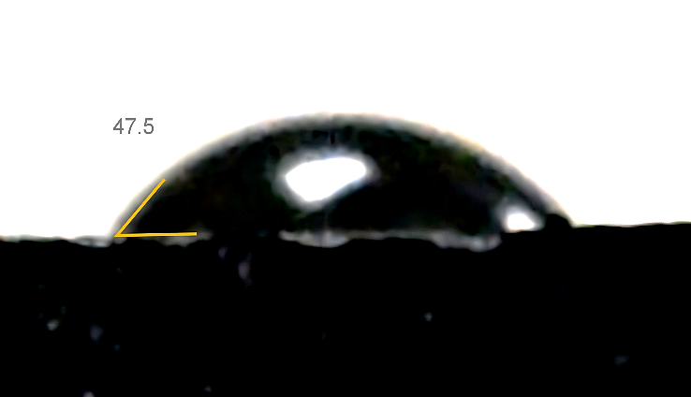  b) | 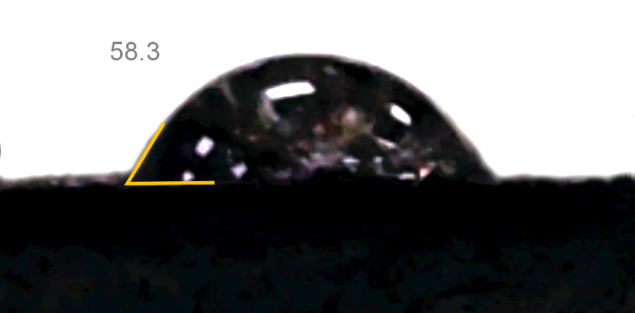  a)
Figure S1. Water contact angle images of (a) CNT aerogel and (b) Fe₃O₄–CNT magnetic aerogel.

Figure S2. The UV-Vis spectra (left) and standard diagram (right) for correlation between the adsorption of aniline solutions at 232 nm and their concentrations.

Figure S3. UV–Vis absorption spectra for the optimization of catalyst loading.

Figure S4. UV–Vis absorption spectra for the optimization of reaction temperature.

Figure S5. UV–Vis absorption spectra for the optimization of NaOH amount.

Figure S6. UV–Vis absorption spectra for the optimization of reaction time.

