Supplementary Information for
Affinity-driven salt steering for fouling-free solar evaporation and brine conditioning
Ahmed Mortuza Saleque^{1,2,*}, Afrah Harafan^{1,2*}, Uma Pratheebha Umaiya Kunjaram^{1*}, Khalid Hazazi³, Sunmiao Fang^{1,2}, Waleed Saeed³, Zhiping Lai², Qiaoqiang Gan^{1,2,4†}
¹ Sustainable Photonics Energy Research Laboratory, Material Science and Engineering, Physical Sciences and Engineering (PSE) Division, King Abdullah University of Science and Technology (KAUST); Thuwal 23955-6900, Saudi Arabia.
² Center for Renewable Energy & Storage Technologies (CREST), King Abdullah University of Science and Technology (KAUST); Thuwal 23955-6900, Saudi Arabia.
³ EXPEC Advanced Research Center (EXPEC ARC); Aramco, Saudi Arabia.
⁴ Environmental Science and Engineering Program (EnSE), King Abdullah University of Science and Technology (KAUST); Thuwal 23955-6900, Saudi Arabia.
* These three authors contribute equally to this work.
† Correspondence: qiaoqiang.gan@kaust.edu.sa

Contents
Supplementary Note S1 3
Materials and Methods 3
Preparation of the Carbon-coated Fabric 3
3D Printing of the Inner Template Mesh and shelves 3
Characterization 4
Supplementary Note S2 6
Salt regulation mechanism of the rotating solar evaporator (48 h operation) 6
Residual salt accumulation on the container floor in the blade-assisted rotating evaporator 6
Extended-length salt steering and evaporation performance 7
Water contact angle and salt crystallization on various surfaces 8
Supplementary Note S3 9
Computational analysis of ion–surface interactions 9
Time-dependent crystallization on oxide-coated slope collectors 12
Supplementary Note S4 14
Ion concentration 14
Mass balance analysis of ion partitioning during real oilfield brine treatment 14
Supplementary Note S5 16
Diameter and speed optimization 16
Theoretical Basis and Calculations for Rotating Evaporator Optimization 17
Supplementary Note S6 19
Cost analysis 19
Methodology 19
Cost breakdown 19
Sensitivity Analysis 21
Comparative Analysis 21
Global Potential Estimation for Rotating Solar Evaporator Technology 24
Solar Irradiance and Production Estimates 25
References 26

Supplementary Note S1

Materials and Methods
The solar absorber was fabricated by coating carbon black powder (Sid Richardson Carbon & Energy Co.) onto non-woven fabric (Texwipe™ TX612). The cylindrical architecture was designed using Shapr3D software and later 3D printed using Formlabs Form 3 printer. Cylindrical architectures with diameters ranging from 1 to 6 cm, were fabricated to evaluate the influence of diameter size on performance. Each architecture featured narrow gaps measuring 4 mm in width and 4 mm in length, strategically designed to facilitate vapor escape (the corresponding image of the 3D model with gaps is provided in Fig. S1). The final cylinder-shaped evaporator was assembled by affixing the fabricated carbon-coated fabric onto the 3D-printed cylindrical structure.
The light absorptance of the solar absorber was measured using a UV-Vis-NIR spectrometer (IS200-4, Thorlabs coupled with an Ocean Optics USB 2000+ UV-Vis spectrometer and an Ocean Optics Jaz Portable spectrometer). The microstructure of the solar absorber was analyzed using scanning electron microscope (SEM) imaging (Carl Zeiss AURIGA FIB-SEM). The surface temperature distribution was characterized using an IR camera (FLIR ONE Pro®). Surface wettability was assessed by introducing a water droplet onto the material surface, with the process recorded using a high-resolution camera (FLIR USB2, CMLN-13S2C-CS). The evaluation of evaporation efficiency occurred within a controlled laboratory setup specifically designed for this purpose. This setup encompassed a precision microbalance, meticulously capturing mass changes, a Xenon Arc solar simulator, and an electric motor (rated power 2W, 6/12V, 30 rpm DC motor) configured for low RPM rotation facilitation.

Preparation of the Carbon-coated Fabric
The carbon-coated fabric (CCF) was fabricated using commercially available materials: Texwipe™ TX611 non-woven fabric and carbon powder obtained from Sid Richardson Carbon & Energy Co. A total of 2 g of carbon powder was dispersed uniformly in 400 ml of water. To enhance the adhesion of the carbon powder to the cellulose fibers, 8 ml of acetic acid was added into the solution. This solution was prepared by combining the components in a 1000 ml beaker and subjected to thorough dispersion using an ultrasonic cleaner (Branson Ultrasonics BransonicTM B200) for a duration of 5 min. Following preparation, the white fabric was immersed into the solution containing the aforementioned chemicals and subjected to vibrations and stirring for 3 minutes to ensure uniform dispersion of carbon particles throughout the fabric. Following this, the carbon-coated fabric was dried on a hot plate at a temperature of 80 ºC. This process was repeated three times to achieve the desired uniform black coloration on the photothermal material, ensuring the consistency and effectiveness of the coating.

3D Printing of the Inner Template Mesh and shelves
The 3D printing process was conducted using a commercial low-force stereolithography (LFS) printer, specifically the Formlabs Form 3 from the USA. This printer used a high-intensity laser with an XY resolution of 25 μm and a laser power of 250 mW at the vat. The build space provided dimensions of 14.5 cm × 14.5 cm × 18.5 cm, with the layer thickness being adjustable within the range of 25 to 300 µm. Upon completion of the printing process, the 3D-printed objects underwent post-curing for 20 min using the Form Cure (model 3B+). Subsequently, the printed objects were cleaned by immersion in isopropyl alcohol and subjected to ultrasonication for 15 min. This cleaning step was performed to effectively remove any residual, unreacted resin from the printed surfaces. Figure S1a shows the 3D printed rotating cylinder and Fig. S1b shows the rotor with CCF covering.
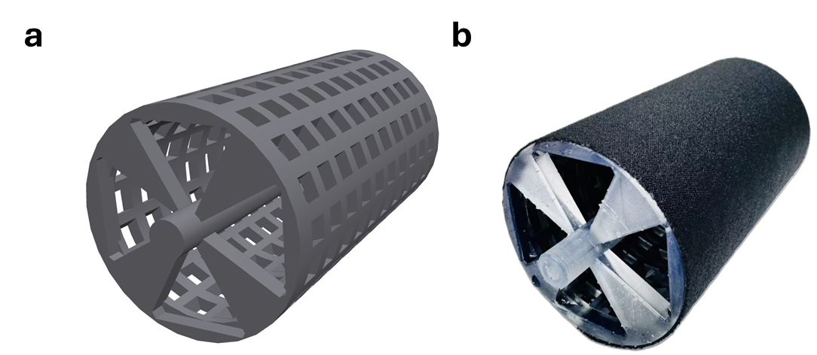
Fig. S1 | Three-dimensional rotating cylinder. a, 3D model of the cylinder template with narrow gaps measuring 4 mm in width and 4 mm in length. b, Optical image of the cylinder after wrapping with CCF.

Characterization
Carbon black was applied to a non-woven fabric to fabricate CCF, offering both cost-effectiveness and exceptional optical absorption exceeding 97% in wet condition with 26 wt% brine as shown in the UV-Vis-NIR spectrum in Fig. S2a. This makes it economical and efficient alternative to expensive nanoparticle-based materials. Detailed information regarding the materials, fabrication process, and characterization techniques are provided in the methods section. During operation, the cylinder is partially submerged in hypersaline brine, where the black CCF absorbs intense heat, driving the evaporation of water molecules. Strategically placed openings at the top and bottom of each cylinder facilitates efficient vapor release during operation. This process effectively separates freshwater from the saline mixture, leaving behind salt and impurities for collection.
The scanning electron microscope (SEM) image of CCF shown in Fig. S2b reveals the presence of micrometer-sized pore channels and a fibrous structure that facilitates efficient water transport through the solar-absorbing layer. The hydrophilic properties of the CCF were evaluated by measuring the water contact angle. When a 10 μL droplet of 26 wt% saline brine was applied, the water contact angle was determined to be 0°, as shown in Fig. S2c, confirming the super-hydrophilic nature of the evaporator. Additionally, the water uptake capacity of CCF was investigated, demonstrating that water was drawn up to a height of 24 cm within 60 min. This strong capillary action was visualized using an infrared (IR) camera and is presented in Fig. S3a and the corresponding curve is plotted in Fig. S3b.

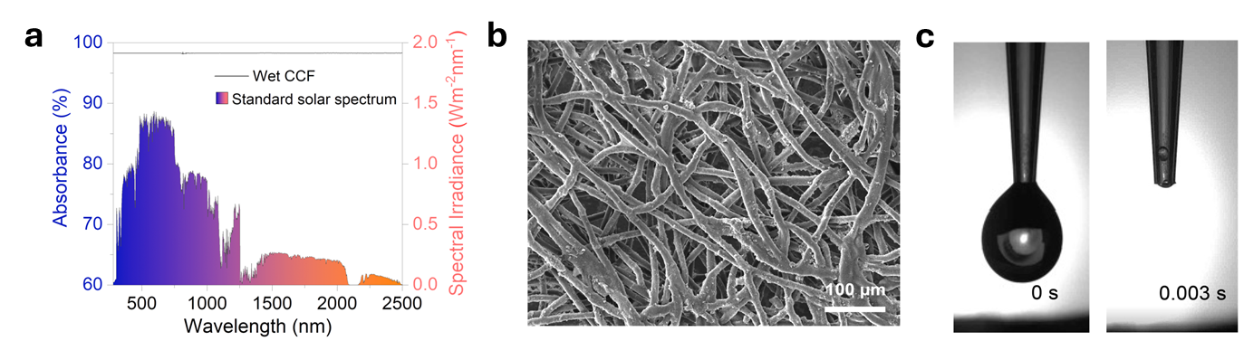
Fig. S2 | Characterization of carbon-coated fabric. a, UV-Vis-NIR spectra of the carbon-coated fabric (CCF) under wet conditions with 26 wt% brine. b, SEM image of the CCF surface. c, Water contact angle measurement of the CCF.

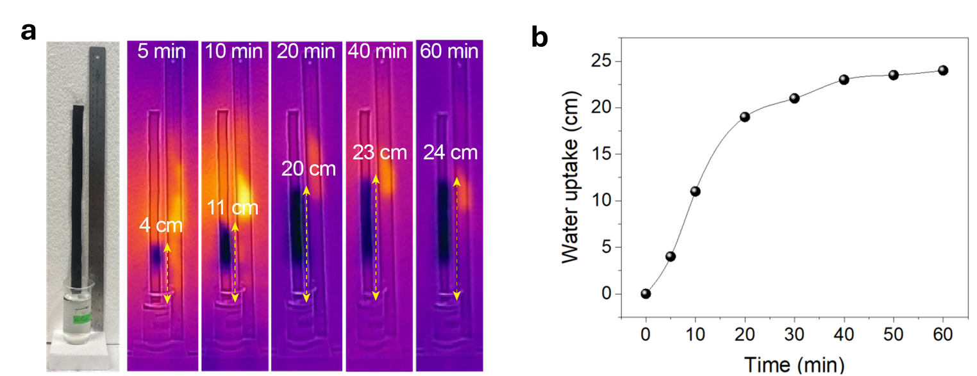
Fig. S3 | Water uptake performance of the CCF. a, Water transport behavior of the CCF with 26 wt% brine recorded with IR camera. b, Water transport distance over time for the CCF.

Supplementary Note S2

Salt regulation mechanism of the rotating solar evaporator (48 h operation)
To evaluate the robustness of this design under extreme hypersaline conditions, we performed continuous evaporation tests using 26 wt% synthetic NaCl brine under 1 sun illumination. In each cycle, 300 mL of brine was introduced into the container, and salt deposition on the rotor surface, blade, and Al-foil slope was monitored throughout operation. After every 8 h, the blade and Al-foil slope became heavily loaded with crystallized salt, while nearly the entire 300 mL brine volume had evaporated. The crystallized salts were then harvested by mechanical scraping from the blade and Al-foil slope, after which the container was rapidly refilled with fresh brine and the experiment was resumed. Owing to the continuous sweeping action of the blade, which removed concentrated brine and incipient salt deposits from the CCF surface before persistent surface fouling could develop, the rotating evaporator remained free of visible salt accumulation even after 48 h of repeated operation, as shown in Fig. S4.

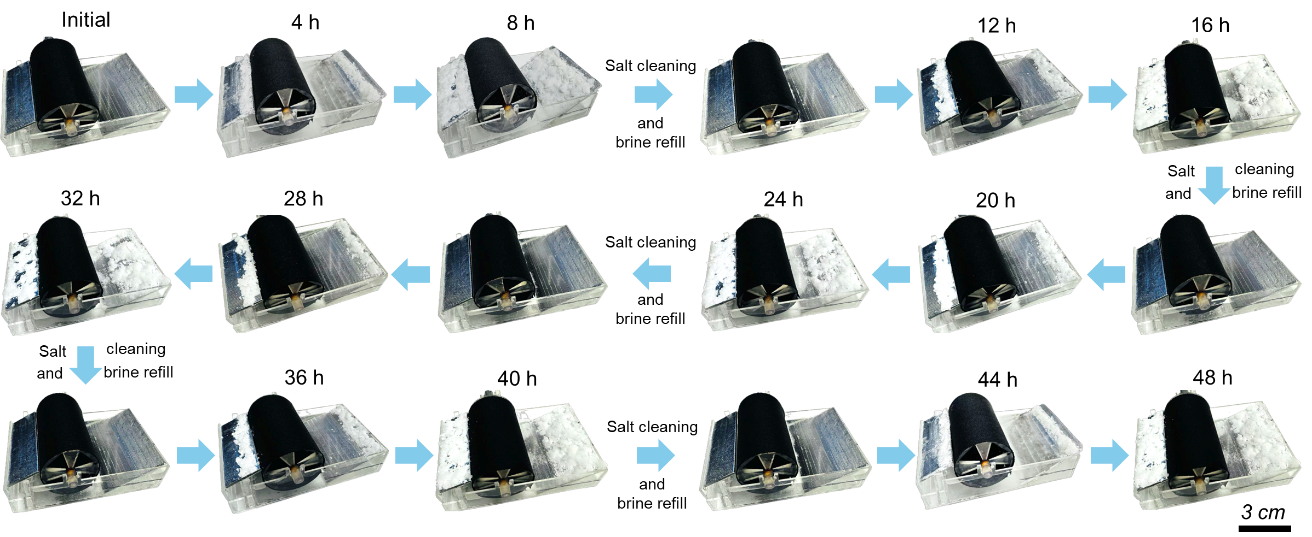
Fig. S4 | Long-term salt regulation of the rotating solar evaporator under extreme hypersaline conditions. Continuous 48 h operation under 1 sun illumination with 26 wt% synthetic NaCl brine shows that the rotating evaporator surface remains free of visible salt accumulation owing to the continuous sweeping action of the blade.

Residual salt accumulation on the container floor in the blade-assisted rotating evaporator
To isolate the function of the mechanical blade, we examined the rotating evaporator in the absence of the Al-foil slope. As shown in Fig. S5, the blade continuously removed the saturated brine film from the rotating cylinder, thereby maintaining a salt-free evaporative surface throughout operation. Nevertheless, the displaced salts did not remain suspended or self-harvest in a controlled manner; instead, they accumulated progressively on the bottom of the container. This result shows that blade-assisted scraping is sufficient to prevent rotor fouling, but insufficient to spatially direct the final crystallization site. The persistent floor deposition therefore motivated the introduction of Al-foil slope as an affinity-guided crystallization surface to capture salts away from both the evaporator and the container base.
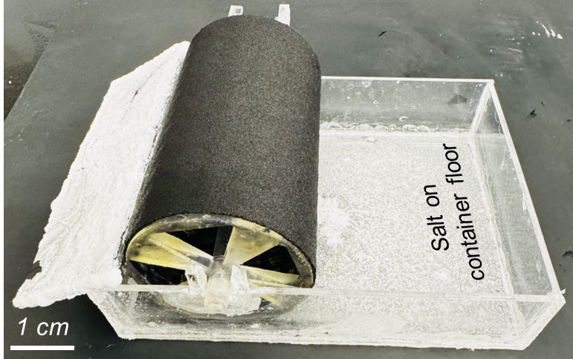
Fig. S5 | Blade-assisted scraping prevents rotor fouling but does not eliminate salt deposition on the container floor.

Extended-length salt steering and evaporation performance
To further evaluate the spatial robustness of the affinity-guided crystallization strategy, the system length was extended to 20 cm while maintaining the same operating principle. As shown in Fig. S6a, even in the longer configuration, crystallized salts continued to accumulate preferentially on the Al-foil, while the container floor remained largely clear. This result confirms that the salt-steering effect is not limited to short-range geometric proximity but is instead governed by the surface affinity of the Al-oxide layer, which continues to direct salt deposition toward the foil under physically extended conditions.
We next examined the evaporation performance of the system across a wide salinity range. In the absence of the blade, evaporation performance deteriorated markedly with increasing salinity because of progressive salt accumulation on the evaporative surface (Fig. S6b). At 26 wt% synthetic salinity, the evaporation rate decreased from 3.11 to 0.73 kg m⁻² h⁻¹, corresponding to a 76.5% reduction. Even at a moderate salinity of 10 wt%, the evaporation rate was reduced by 59.2% as presented in Fig. S6b. In contrast, the complete system integrating rotation, the blade, and the Al-foil maintained a nearly constant evaporation rate of ~3.0 kg m⁻² h⁻¹ under 1 sun illumination and 1.5 m s⁻¹ wind, even at 26 wt% salinity (Fig. S6c). These results highlight the synergistic roles of mechanical salt displacement and affinity-guided crystallization in decoupling high-flux evaporation from salt deposition, thereby enabling stable operation under hypersaline conditions where conventional static solar evaporators and floating crystallizer systems typically fail.

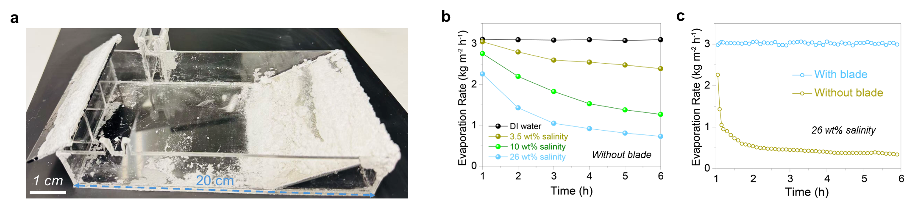
Fig. S6 | Extended-length salt steering and evaporation performance. a, Photographic image of the 20 cm long system, showing that crystallized salts continue to accumulate preferentially on the Al-foil while the container floor remains largely clear, confirming that salt steering persists under extended-length conditions. b, Evaporation performance of the system without the mechanical blade as a function of synthetic brine salinity, showing progressive performance degradation due to salt fouling. c, Evaporation performance of the complete system integrating rotation, the blade, and the Al-foil, demonstrating stable high evaporation rates across a wide salinity range.

Water contact angle and salt crystallization on various surfaces
To identify the most suitable material for salt collection, we compared the wettability and salt creeping performance of several low-cost candidates. As shown in Fig. S7a, Al foil exhibited the lowest water contact angle (~49.8°), indicating the highest hydrophilicity among tested substrates, including blackened Al foil, plastic film, and expanded polystyrene foam. To evaluate salt creeping behavior, saturated brine droplets were applied to each surface and evaporated under 1 sun illumination. As illustrated in Fig. S7b, Al foil again outperformed the alternatives, showing the most extensive salt spreading.
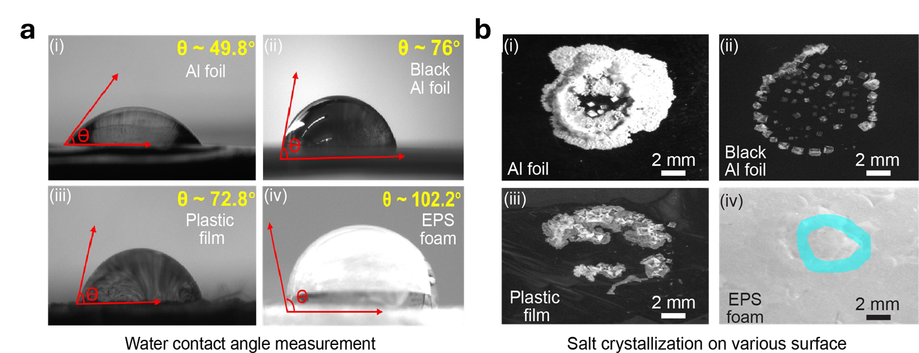
Fig | S7. Water contact angle of CCF and salt crystallization on various surfaces. a, Water contact angle measurements of various low-cost materials; Al foil exhibited the lowest angle confirming its superior hydrophilicity. b, Salt creeping behavior of saturated brine droplets on Al foil, blackened Al foil, EPS foam, and plastic film under 1 sun illumination; Al foil showed the most pronounced salt creeping effect.

Supplementary Note S3

Computational analysis of ion–surface interactions
Computational details
All calculations were performed within the framework of density functional theory (DFT) using the projector augmented-wave (PAW) method, as implemented in the Vienna ab initio simulation package (VASP)¹. The exchange–correlation interaction was described using the generalized gradient approximation (GGA) in the Perdew–Burke–Ernzerhof (PBE) form². Long-range van der Waals interactions were included using the DFT-D3 correction scheme ³. A plane-wave cutoff energy of 480 eV was employed. The electronic self-consistent convergence criterion was set to 10⁻⁴ eV. Brillouin-zone integration was carried out using a k-point mesh with a density of 0.04 × 2π Å⁻¹. All structures were fully relaxed until the residual force on each atom was below 0.03 eV Å⁻¹.
Identical electrolyte conditions used in Molecular Dynamics (MD) simulations
To enable direct comparison of ion-specific interfacial behavior under a common electrolyte environment, the MD simulations were constructed using a model multicomponent brine in which NaCl, LiCl, MgCl₂, and CaCl₂ were introduced at identical bulk molar concentrations. This design was not intended to reproduce the exact composition of the real oilfield brine; rather, it was used as a controlled comparative system in which each salt species experiences the same nominal bulk concentration, so that differences in interfacial accumulation and transport arise primarily from differences in ion–surface affinity and hydration behavior rather than from unequal initial abundance.
For the production simulations, each salt was introduced at a concentration of 0.25 M, corresponding to a total cation concentration of 1.0 M and a total chloride concentration of 1.5 M. This concentration range was selected as a practical compromise between physical relevance and statistical sampling in finite-size interfacial MD simulations. Moderate electrolyte concentrations are commonly used in interfacial MD studies because they provide sufficient ion populations to resolve interfacial density profiles and transport behavior over accessible simulation timescales while avoiding excessive crowding effects associated with highly saturated model systems.
Table S1. Electrolyte composition used in the MD model system under identical bulk concentration conditions
Salt species | Dissociated cation | Cation valence | Bulk salt concentration (M) | Cation concentration contributed (M) | Cl⁻ concentration contributed (M)
NaCl | Na⁺ | +1 | 0.25 | 0.25 | 0.25
LiCl | Li⁺ | +1 | 0.25 | 0.25 | 0.25
MgCl₂ | Mg²⁺ | +2 | 0.25 | 0.25 | 0.50
CaCl₂ | Ca²⁺ | +2 | 0.25 | 0.25 | 0.50
Total | — | — | — | 1.00 | 1.50

For the MD model system, NaCl was introduced at a bulk concentration of 0.25 M, corresponding to a bulk Na⁺ concentration of 0.25 mol L⁻¹. This can be converted to Na⁺ mass density as follows:
$$0.25 {\text{mol L}}^{-1}=250 {\text{mol m}}^{-3}$$Using the molar mass of Na⁺:
$$M_{{\text{Na}}^{+}}=22.99 {\text{g mol}}^{-1}=0.02299 {\text{kg mol}}^{-1} \\ ρ_{{\text{Na}}^{+}}=250×0.02299=5.75 {\text{kg m}}^{-3}$$
Thus, the nominal bulk Na⁺ density in the MD simulation is 5.75 kg m⁻³.
As shown in Fig. 2c of the main manuscript, the simulated Na⁺ density near the Al₂O₃ interface is much higher than this bulk value. Averaging the Na⁺ density over the interfacial region from 0 to 8 nm gives an average Na⁺ density of 100.3 kg m⁻³, which is:
$$\frac{100.3}{5.75}=17.4$$times higher than the nominal bulk Na⁺ density. This confirms strong local Na⁺ enrichment near the Al₂O₃ surface.
For comparison, the saturation concentration of NaCl in water at room temperature is approximately 5.4 M ⁴. The Na⁺-equivalent saturation density can therefore be estimated as:
$$5.4 {\text{mol L}}^{-1}=5400 {\text{mol m}}^{-3} \\ ρ_{{\text{Na}}^{+},\text{sat}}=5400×0.02299=124 {\text{kg m}}^{-3}$$
Therefore, the average interfacial Na⁺ density from the MD simulation, 100.3 kg m⁻³, reaches:
$$\frac{100.3}{124}=0.81$$or approximately 81% of the Na⁺-equivalent saturation density of NaCl. This is already close to the saturation-equivalent level, even though the initial bulk NaCl concentration in the MD model was only 0.25 M. Under actual evaporative operation, continuous water removal would further concentrate ions at the interface. Therefore, the Na⁺-enriched interfacial region near the Al₂O₃ surface is expected to rapidly reach local supersaturation, favouring NaCl nucleation and crystallization on the Al-foil surface.
A similar comparison was made for Li⁺, Mg²⁺ and Ca²⁺. The saturation-equivalent cation density was calculated from the approximate room-temperature solubility of the corresponding chloride salts using:
$$ρ_{\text{cation,sat}}=C_{\text{salt,sat}}×M_{\text{cation}}$$where $C_{\text{salt,sat}}$is the saturated molar concentration of the chloride salt and $M_{\text{cation}}$is the molar mass of the corresponding cation.
Average simulated Ca²⁺ density:
$$ρ_{{\text{Ca}}^{2+}}=36.21 {\text{kg m}}^{-3}$$Using approximate CaCl₂ saturation concentration of 5.0 M ⁵:
$$5.0 {\text{mol L}}^{-1}=5000 {\text{mol m}}^{-3} \\ ρ_{{\text{Ca}}^{2+},\text{sat}}=5000×0.04008=200.4 {\text{kg m}}^{-3} \\ \frac{36.21}{200.4}=0.18$$Ca²⁺ reaches only approximately 18% of the CaCl₂ saturation-equivalent density.
Average simulated Mg²⁺ density:
$$ρ_{{\text{Mg}}^{2+}}=1.078 {\text{kg m}}^{-3}$$Using approximate MgCl₂ saturation concentration of 5.0 M ⁶:
$$5.0 {\text{mol L}}^{-1}=5000 {\text{mol m}}^{-3} \\ ρ_{{\text{Mg}}^{2+},\text{sat}}=5000×0.02431=121.6 {\text{kg m}}^{-3} \\ \frac{1.078}{121.6}=0.0089$$
Mg²⁺ reaches only approximately 0.9% of the MgCl₂ saturation-equivalent density.
Average simulated Li⁺ density:
$$ρ_{{\text{Li}}^{+}}=0.686 {\text{kg m}}^{-3}$$Using approximate LiCl saturation concentration of 13.5 M ⁷:
$$13.5 {\text{mol L}}^{-1}=13500 {\text{mol m}}^{-3} \\ ρ_{{\text{Li}}^{+},\text{sat}}=13500×0.00694=93.7 {\text{kg m}}^{-3} \\ \frac{0.686}{93.7}=0.0073$$Li⁺ reaches only approximately 0.7% of the LiCl saturation-equivalent density.
Therefore, the average interfacial densities of Ca²⁺, Mg²⁺ and Li⁺ are much lower relative to their corresponding chloride-salt saturation-equivalent densities. The simulated Ca²⁺ density is 36.21 kg m⁻³, corresponding to ~18% of the CaCl₂ saturation-equivalent density (~200.4 kg m⁻³). The simulated Mg²⁺ density is 1.078 kg m⁻³, corresponding to only ~0.9% of the MgCl₂ saturation-equivalent density (~121.6 kg m⁻³). Similarly, the simulated Li⁺ density is 0.686 kg m⁻³, corresponding to only ~0.7% of the LiCl saturation-equivalent density (~93.7 kg m⁻³). Therefore, unlike Na⁺, these ions remain far below their corresponding chloride-salt saturation-equivalent densities and are less likely to nucleate as chloride salts under the same interfacial conditions. This comparison supports the preferential formation of NaCl-rich crystals on the Al₂O₃-containing Al-foil surface, while Li⁺, Mg²⁺ and Ca²⁺ mostly remain mainly in the residual liquid phase.
DFT results
To evaluate the intrinsic affinity of the Al₂O₃ surface toward the major cations present in the brine, DFT calculations were performed for Li⁺, Mg²⁺, Ca²⁺, and Na⁺ adsorbed at the Al–O surface site. The calculated adsorption energies are summarized in Fig. S8. Among all investigated cations, Na⁺ exhibits the most negative adsorption energy (−2.51 eV), indicating the strongest thermodynamic affinity toward the oxygen-rich Al₂O₃ surface. In comparison, the adsorption energies of Li⁺, Mg²⁺, and Ca²⁺ are −1.01, −1.12, and −1.34 eV, respectively. The substantially stronger Na⁺ adsorption suggests that the Al₂O₃ surface preferentially stabilizes Na⁺ relative to the other cations, consistent with the experimentally observed salt-steering behavior. This stronger interfacial affinity provides a molecular-level basis for preferential Na⁺ enrichment at the oxide interface, which in turn promotes localized NaCl nucleation and deposition on the Al-foil during evaporation.
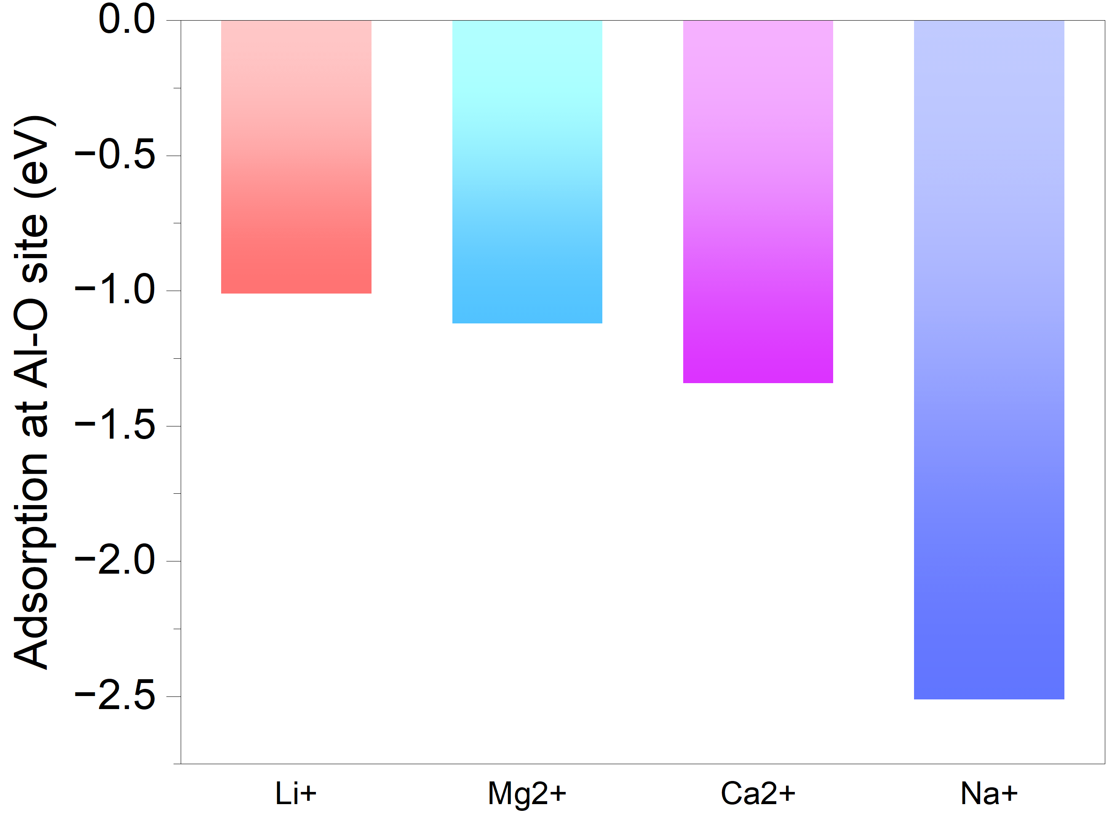
Fig. S8 | Adsorption energy. DFT-calculated adsorption energies of Li⁺, Mg²⁺, Ca²⁺, and Na⁺ at the Al–O surface site of Al₂O₃. Na⁺ shows the most negative adsorption energy (−2.51 eV), indicating the strongest thermodynamic affinity for the oxide surface.

Time-dependent crystallization on oxide-coated slope collectors
To further validate the role of oxide surface chemistry in salt steering, we performed time-dependent static evaporation experiments using slope collectors coated with ZnO, TiO₂, Cu₂O and Al₂O₃. A 3.5 wt% NaCl solution was used under 1 sun illumination. These experiments were conducted without the 3D rotating cylindrical evaporator and without the mechanical blade, so that the intrinsic crystallization behavior of each oxide-coated slope could be isolated. Because the rotating evaporator was absent, the evaporation rate was lower than that of the complete system, and the crystallization process occurred over a longer timescale.
As shown in Fig. S9, the four oxide surfaces exhibited distinctly different crystallization behaviors under identical evaporation conditions. For ZnO and TiO₂, only negligible salt deposition was observed over 9 h. Cu₂O induced limited crystallization, mainly near the concentrated brine region. In sharp contrast, the Al₂O₃-coated slope showed substantial and progressive salt accumulation, confirming its stronger ability to guide NaCl deposition. This result shows that salt collection on Al₂O₃ does not require the presence of the rotating cylinder; rather, the Al₂O₃ surface itself provides a favorable crystallization interface. The rotating cylinder and blade in the complete device mainly accelerate evaporation, continuously deliver concentrated brine to the collector, and prevent fouling of the evaporator surface.
Importantly, salt accumulation on Al₂O₃ was observed along the wetted and receding brine region of the slope, indicating that crystallization is promoted at the oxide–brine contact region rather than occurring only as random precipitation after complete drying. This observation is consistent with the proposed affinity-guided mechanism, in which the negatively charged Al₂O₃ surface enriches cations near the interface and locally promotes NaCl-rich crystallization during evaporation. To further confirm that this effect is not limited to 3.5 wt% NaCl, similar experiments were also performed with 3.0 wt% and 2.5 wt% NaCl solutions. Substantial salt accumulation was still observed on the Al₂O₃ surface at these lower salinities, as shown in the main manuscript. These results demonstrate that Al₂O₃ can guide NaCl crystallization even from moderately saline brines, supporting its role as an active affinity-guided crystallization collector.
Together with the molecular dynamics simulations, DFT adsorption-energy calculations and zeta-potential measurements, these oxide-comparison experiments provide experimental evidence that the Al₂O₃ surface promotes Na⁺ enrichment and NaCl-rich crystallization at the oxide–brine interface, whereas ZnO, TiO₂ and Cu₂O show much weaker salt-collection behavior under the same conditions.
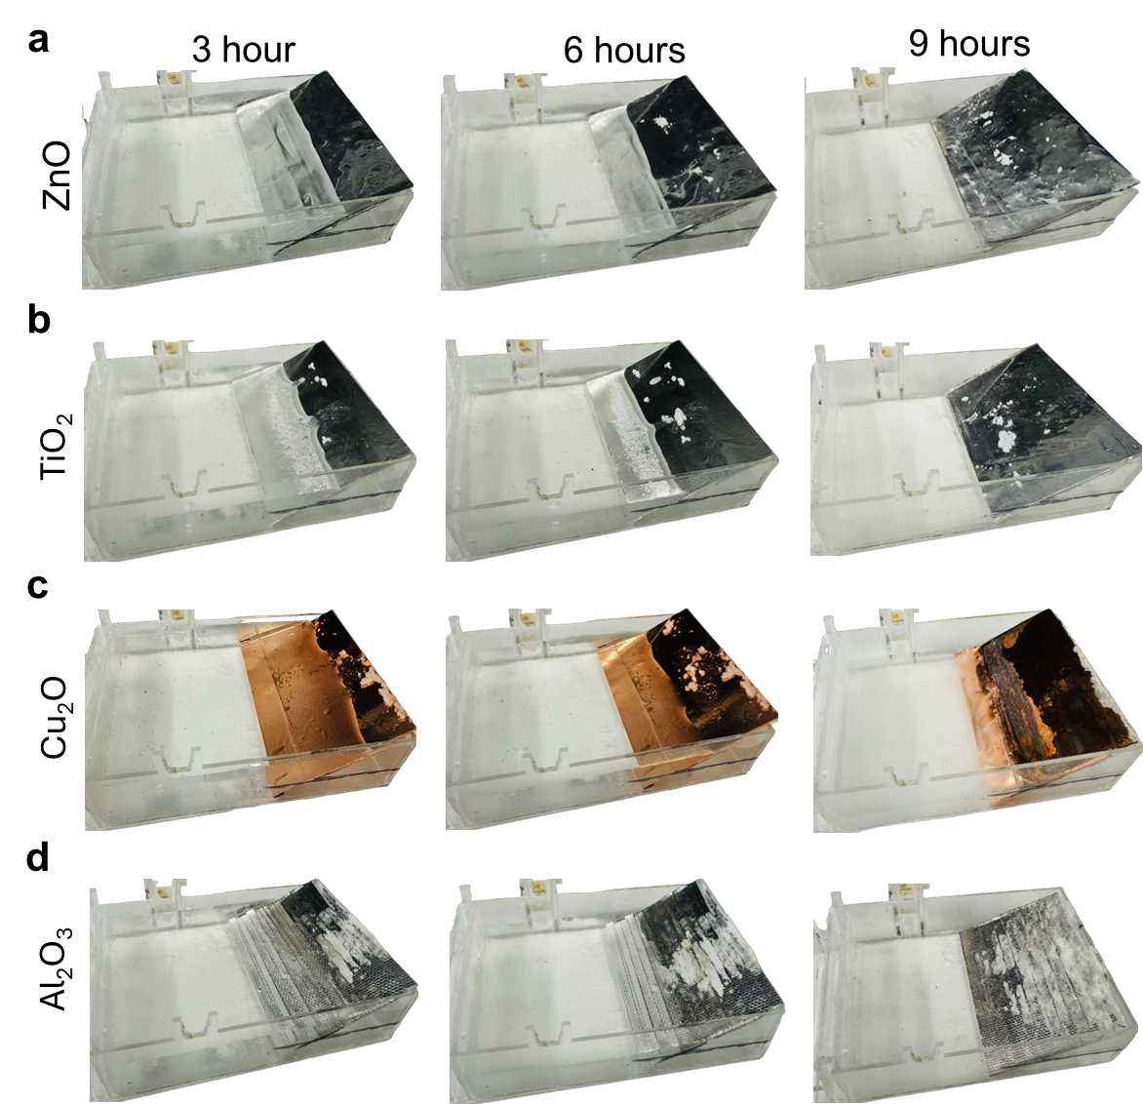
Fig. S9 | Time-dependent salt crystallization on oxide-coated slope collectors under static evaporation. Optical images showing salt deposition on oxide-coated slope collectors after 3, 6 and 9 h of evaporation using 3.5 wt% NaCl solution under 1 sun illumination. a, ZnO-coated slope, showing negligible salt deposition over 9 h. b, TiO₂-coated slope, showing negligible salt deposition with only sparse crystals after prolonged evaporation. c, Cu₂O-coated slope, showing limited salt crystallization near the concentrated brine region. d, Al₂O₃-coated slope, showing substantial and progressive salt accumulation along the wetted slope region, indicating strong affinity-guided crystallization behavior.

Supplementary Note S4

Ion concentration
The ionic compositions of the initial oilfield brine and the residual brine obtained after evaporation (volume reduction from 500 mL to 116 mL) were determined via ICP-OES. During evaporation, the crystallized salts were removed from the system, and XRD analysis confirmed that these salts were predominantly sodium chloride as shown in Fig. 3f (main manuscript). ICP-OES measurements were then performed on the remaining liquid phase, and the resulting ion concentrations are presented in Table S2.
Table S2. Ion concentrations measured by ICP-OS in real oilfield brine before processing and in the residual brine following 76.8% evaporation and crystallized-salt removal
Ions | Initial concentration (ppm) | After evaporation (initial volume 500 mL and final volume 116 mL) and salt removal (ppm)
Na⁺ | 86,211.5 | 45,021.46
Li⁺ | 268 | 1,152.5
Mg²⁺ | 1,174.08 | 3,439.1
Ca²⁺ | 20,853.91 | 61,806.2

The crystallized salts collected during evaporation were redissolved in deionized water to form a saturated solution, and their ionic composition was quantified by ICP-OS. The results, provided in Table S3, show that the recovered solids consist overwhelmingly of sodium chloride. Na⁺ accounts for approximately 91.6% (18,315.66 ppm) of the dissolved ions, whereas Li⁺ is present only in trace amounts (~0.15 ppm; <0.001%). Ca²⁺ and Mg²⁺ constitute 7.9% (1,574.46 ppm) and 0.46% (90.87 ppm), respectively. This composition explains the substantial decrease in dissolved Na⁺ observed in the residual brine after evaporation, as the dominant crystallizing phase is NaCl. In contrast, Li⁺, Mg²⁺ and Ca²⁺ remain predominantly in the liquid phase, leading to their enrichment as the brine volume decreases.
Table S3. Ionic composition of crystallized salts collected during brine evaporation
Ions | Concentration (ppm) | Proportion of total ions (%)
Na⁺ | 18,315.66 | 91.67%
Li⁺ | trace | trace
Mg²⁺ | 90.87 | 0.46%
Ca²⁺ | 1,574.46 | 7.9%

Mass balance analysis of ion partitioning during real oilfield brine treatment
To quantitatively evaluate ion partitioning during treatment of the real oilfield brine, a mass balance analysis was performed for the four major cations, Na⁺, Li⁺, Mg²⁺, and Ca²⁺, by comparing their total inventories in the feed brine, the residual brine after evaporation and salt removal, and the harvested crystalline salts. The initial ion masses were calculated from the measured ICP-OES concentrations of the feed brine and the initial liquid volume of 500 mL. The residual ion masses were calculated from the ICP-OES concentrations of the residual brine after treatment and the remaining liquid volume of 116 mL, corresponding to 76.8% evaporation of the initial brine volume. The ion contents of the harvested salts were determined by ICP-OES after digesting 0.24 g of the collected salt in 10 mL of deionized water, and the measured concentrations were scaled to the total harvested salt mass of 49 g.
The mass balance for each ion was calculated according to the following relations:
$$m_{i,initial}=C_{i,initial}×V_{initial} \\ m_{i,residual}=C_{i,residual}×V_{residual} \\ m_{i,salt}=C_{i,digest}×V_{digest}×\frac{m_{harvested salt}}{m_{digested salt}}$$where $m$ is the ion mass, $C$ is the ion concentration determined by ICP-OES, and $V$is the corresponding liquid volume. Here, $V_{initial}=0.500$L, $V_{residual}=0.116$L, $V_{digest}=0.010$L, $m_{harvested salt}=49$g, and $m_{digested salt}=0.2369$g.
As summarized in Table S4, the Na⁺ inventory decreased from 43.11 g in the feed brine to 5.22 g in the residual brine, while 36.11 g of Na⁺ was recovered in the harvested crystalline salts. In contrast, Li⁺ remained largely in the residual brine, with 0.134 g retained in solution and only 0.0003 g detected in the harvested salts. This confirms that the collected solids are overwhelmingly Na⁺ rich, whereas Li⁺ remains preferentially in the liquid phase. Similarly, Mg²⁺ and Ca²⁺ were distributed between the residual brine and the harvested salts, with the majority remaining in solution after treatment. The mass balance closure for all four ions was over 95%, confirming the internal consistency of the ion-partitioning analysis.
These results provide quantitative support for the selective salt-separation mechanism proposed in the main text. Specifically, the system preferentially removes Na⁺ rich crystalline salts while retaining Li⁺ in the residual brine, thereby directly lowering the Na⁺/Li⁺ ratio and conditioning the brine into a composition that is more favorable for downstream lithium recovery.
Table S4. Mass balance analysis of major cations during treatment of real oilfield
Ion | Initial concentration (ppm) | Initial ion mass (g) | Residual concentration after evaporation and salt removal (ppm) | Residual ion mass (g) | Concentration in digested harvested salt (ppm) | Ion mass in harvested salts (g) | Residual + harvested (g) | Mass balance closure (%)
Na⁺ | 86,211.50 | 43.11 | 45,021.46 | 5.22 | 18,315.66 | 36.11 | 41.33 | 95.8
Li⁺ | 268 | 0.134 | 1,152.50 | 0.131 | 0.15 | 0.0003 | 0.1313 | 97.9
Mg²⁺ | 1,174.08 | 0.587 | 3,439 | 0.38 | 90.87 | 0.17 | 0.56 | 95.4
Ca²⁺ | 20,853.91 | 10.43 | 61,806 | 7.1 | 1,574.46 | 3.2 | 10.3 | 98.8

Supplementary Note S5

Diameter and speed optimization
Fig. S10a presents the evaporation rate (in kg m⁻² h⁻¹) as a function of rotational speed (in rpm) for cylinders of different diameters. An increase in cylinder diameter led to a higher evaporation rate, primarily due to the larger available surface area. For example, the surface area of the 5 cm diameter cylinder is 0.0141 m², compared to only 0.0057 m² for the 2 cm diameter cylinder. Larger diameters also enhance capillary water transport and heat absorption, contributing to higher interfacial evaporation flux. However, performance did not increase monotonically with diameter. While the 3 cm diameter cylinder achieved the highest evaporation rate of 3.11 kg m⁻² h⁻¹ at 10 rpm, the 6 cm diameter showed significantly lower rate of 1.97 kg m⁻² h⁻¹, despite having a greater surface area (0.0169 m²). This decline is attributed to the increased centrifugal force (~0.0331 m/s² at 10 rpm), which can destabilize the water film and reduce the effective wetted area. In contrast, the centrifugal force for the 3 cm diameter at the same speed (~0.0164 m/s²) promotes optimal film thinning without displacing water from the surface.
Similarly, at low speeds (e.g., 1–3 rpm), surface velocities were too low to ensure effective surface renewal, resulting in prolonged water residence time and increased heat loss to the bulk. For instance, the surface velocity of a 3 cm diameter cylinder at 2 rpm is only 0.0031 m/s, leading to inefficient evaporation. As speed increased, evaporation improved due to enhanced water transport—peaking at 10 rpm—beyond which excessive centrifugal force led to water loss and reduced performance. For example, at 15 rpm, the centrifugal force rose to ~0.0236 m/s², contributing to performance decline. Importantly, the optimal diameter of 3 cm and speed of 10 rpm are only valid for the fixed cylinder length of 9 cm used in these experiments. This combination yields an aspect ratio (diameter/length) of 0.33, which appears to balance capillary-driven wetting, gravitational drainage, and centrifugal dynamics. If the length is increased, a larger diameter may be needed to maintain uniform capillary flow and thermal efficiency; similarly, a shorter length would benefit from smaller diameters to avoid excessive water loading and film instability.
Thermal imaging (Fig. S10b) demonstrates the influence of rotational speed on temperature distribution across the cylindrical evaporator. At a low speed of 2 rpm, a pronounced thermal gradient is observed: the upper half of the cylinder—directly exposed to solar irradiance prior to capturing the IR image—reaches an average surface temperature of 28 °C, while the lower half remains significantly cooler at 21 °C. This disparity reflects prolonged water residence time due to lower rotational speed, allowing substantial conductive heat loss into the bulk water. In contrast, at 10 rpm, the temperature distribution becomes much more uniform. The upper and lower halves of the cylinder reaches average surface temperatures of 26.4 °C and 25.2 °C, respectively. The rapid rotation facilitates continuous film renewal and reduces bulk water residence time of rotor, thereby minimizing thermal dissipation into the bulk and sustaining a more consistent interfacial temperature across the entire surface. Uniform heating also minimizes localized stress or thermal degradation of the CCF layer, contributing to the long-term durability of the system.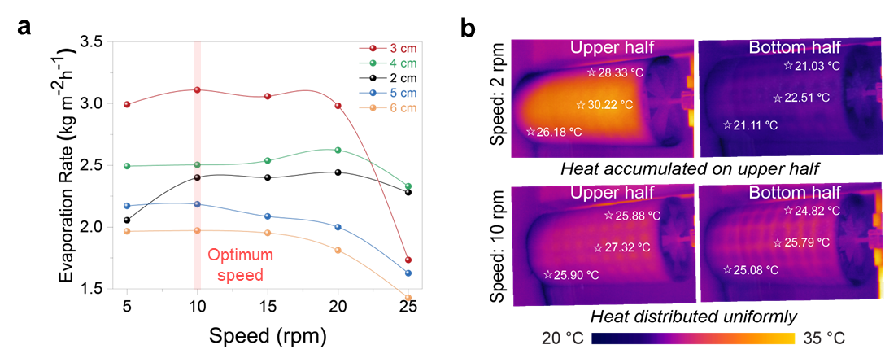
Fig. S10 | Rotor diameter and speed optimization. a, Evaporation rate as a function of rotational speed for different cylinder diameters, measured under 1 sun illumination using DI water. Highest evaporation rate was obtained with 3 cm diameter rotor at 10 rpm speed. b, Infrared (IR) thermal images of the rotor at 2 rpm (top) and 10 rpm (bottom), showing differences in surface temperature distribution.

Theoretical Basis and Calculations for Rotating Evaporator Optimization
- Centrifugal Force:
The centrifugal force acting on water film over the rotating cylinder is given by:
$$F_{c}=mω^{2}r$$
Where:
$F_{c}$: centrifugal force (N)
$m$: mass of water (kg)
$m$: angular velocity (rad/s)
$r$: radius of the cylinder (m)
Angular velocity is related to rotational speed (in rpm) as: $ω=\frac{2πN}{60}$
Calculations:
- For 1 cm diameter (r = 0.005 m) at 10 rpm: $ω=1.047\frac{rad}{s}=> ω^{2}r≈0.0055 m/{s^{2}}$
- For 5 cm diameter (r = 0.025 m) at 10 rpm: $ω^{2}r≈0.0276 m/{s^{2}}$
- For 6 cm diameter (r = 0.03 m) at 10 rpm: $ω^{2}r≈0.0331 m/{s^{2}}$
- For 5 cm diameter at 15 rpm: $ω^{2}r≈0.0617 m/{s^{2}}$
These values illustrate how increased speed, or radius substantially increases the outward force on the liquid, potentially leading to film breakage and water loss.
2. Surface Velocity The tangential surface velocity of the rotor is: $v_{s}=ωr$
Calculation:
- 5 cm cylinder at 1 rpm: $ω≈0.105\frac{rad}{s}, v_{s}=0.00263\frac{m}{s}$
At such low velocities, water renewal at the interface is slow, and more heat is lost to the bulk water.
3. Surface Area of Cylinder The lateral surface area is calculated as: $A=2πrl$
where:
$r$: radius (m)
$l$: length (m), fixed at 9 cm = 0.09 m
Calculation:
- 1 cm diameter: $A=0.00283 m^{2}$
- 5 cm diameter: $A=0.0141 m^{2}$
- 6 cm diameter: $A=0.0169 m^{2}$
4. Heat Loss to Bulk Water Heat loss due to conduction into bulk water: $Q=kAΔT$
where:
$Q$: heat loss (W)
$k$: thermal conductivity of water (0.6 W/m·K)
$ΔT$: temperature difference (K)
At low rotational speeds, high residence time leads to more heat loss, reducing interfacial temperature and evaporation flux.

Supplementary Note S6

Cost analysis
We estimated the cost per ton of salt production using a 1 m² size spatially controlled rotating evaporator considering the installation site in Kingdom of Saudi Arabia (KSA). The system leverages KSA's abundant solar resources (average insolation 2,200 kWh/m²/year) to achieve efficient salt extraction with minimal operational costs.

Methodology
The cost analysis follows a standardized engineering economics approach, evaluating all capital expenditures (CAPEX), operational expenditures (OPEX), and maintenance costs. From our experimental data presented in the main manuscript, we consider the following data for this analysis:
- Evaporation rate: 3 kg m⁻² h⁻¹
- Daily operation: 8 hours
- Annual operating days: 300 days
- System lifetime: 10 years (10 years of amortization for CAPEX)
- Brine source: On-site availability (no purchase/transport costs)
- All costs in USD considering the factory price from China

Cost breakdown
- Capital Expenditures (CAPEX)

Table S5. Capital expenditures (CAPEX) for 1m² 3D rotating cylindrical evaporator
Component |  | Unit Cost | Quantity | Total Cost (USD) | Reference
Evaporator Core | Aluminum cylindrical structure | $130.00 | 1 system | $130.00 | ⁸
Evaporator Core | Carbon-coated fabric | $2.00/m² | 1 m² | $2.00 | ⁹
Evaporator Core | Aluminum foil | $15.00 | 1 system | $15.00 | ¹⁰
Power System | Solar panels (80W) | $0.125/W | 80 W | $10.00 | ¹¹
Power System | DC motor (180V) | $82.00 | 1 unit | $82.00 | ¹²
Structural Components | Support framework | $120.00 | 1 system | $120.00 | ¹³
Structural Components | Condensation system | $180.00 | 1 system | $180.00 | ¹⁴
Control & Safety | Microcontroller & sensors | $56.00 | 1 set | $56.00 | ¹⁵
Control & Safety | Weatherproof housing | $75.00 | 1 unit | $75.00 | ¹⁶
Control & Safety | Safety features | $25.00 | 1 system | $25.00 | ¹⁷
Installation | Site preparation & setup | $180.00 | 1 system | $180.00 | Local contractor estimate
Total CAPEX |  |  |  | $875.00

- Operational Expenditures (OPEX)
Table S6. Annual operational expenditures (OPEX) for 1m2 3D rotating cylindrical evaporator
Component |  | Unit Cost | Annual Quantity | Total Cost (USD) | Reference
Energy | Auxiliary power | $0.048/kWh | 25 kWh | $1.20 | ¹⁸
Monitoring & Control | Remote monitoring service | $58.00/year | 1 year | $58.00 | ¹⁹
Total OPEX |  |  |  | $59.20

- Maintenance Costs as a part of OPEX
Table S7. Annual maintenance cost for 1m2 3D rotating cylindrical evaporator
Component |  | Unit Cost | Annual Quantity | Total Cost (USD) | Reference
Consumables | Fabric replacement | $2.00/m² | 1 m² | $2.00 | ⁹
Consumables | Carbon black replenishment | $2.00/kg | 0.5 kg | $1.00 | ²⁰
Preventive Maintenance | Motor servicing | $10.00/service | 0.5 service | $5.00 | Local service provider
Preventive Maintenance | System calibration | $14.00/calibration | 0.5 calibration | $7.00 | Local calibration lab
Testing & Quality | Water quality testing | $10.00/test | 2 tests | $20.00 | Environmental lab in KAUST
Testing & Quality | Performance verification | $28.00/verification | 1 verification | $28.00 | Third-party inspector
Spare Parts | Bearings & seals | $10.00/set | 1 set | $10.00 | ²¹
Spare Parts | Electronic components | $10.00/year | 1 year | $10.00 | ²²
Cleaning & Lubrication | Cleaning agents | $5.00/year | 1 year | $5.00 | ²³
Cleaning & Lubrication | Lubricants | $4.00/year | 1 year | $4.00 | ²³
Total Maintenance Cost |  |  |  | $92.00

Production Calculation
- Evaporation rate: 3 kg m⁻² h⁻¹ (water)
- Salt extraction rate: 0.58 kg m⁻² h⁻¹ (estimated from our experimental results)
- Daily operation: 8 hours
- Annual operating days: 300 days
- Annual salt production: 0.58 kg/m²/h × 8 h/day × 300 days = 1,392 kg = 1.392 tons

Total Annual Cost
- CAPEX: $875.00 (10 years of amortization) i.e. Annual CAPEX: $87.5
- OPEX (excluding maintenance cost): $59.20
- Maintenance: $92.00
- Total OPEX: $151.20
- Total Annual Cost: $238.70
Cost per Ton of Salt
$238.70 / 1.392 tons = $171.50 per ton

Sensitivity Analysis
Sensitivity analysis evaluated the impact of parameter variations on cost per ton salt. Key findings:
Table S8. Sensitivity analysis for 1m² 3D rotating cylindrical evaporator
Parameter | Base Case | Variation | Cost per ton (USD) | Change (%) | Impact Assessment
Solar panel cost | $0.125/W | +20% ($0.15/W) | $147.10 | 0.08% | Low sensitivity due to small share of total CAPEX
Solar panel cost | $0.125/W | -20% ($0.10/W) | $146.86 | -0.08% | Low sensitivity due to small share of total CAPEX
Daily operating hours | 8 hours | 10 hours | $117.58 | -20.00% | High sensitivity; increased production significantly lowers unit cost
Daily operating hours | 8 hours | 6 hours | $195.96 | 33.30%
System lifetime | 10 years | 15 years | $129.02 | -12.20% | High sensitivity; longer amortization reduces annual CAPEX burden
System lifetime | 10 years | 7 years | $170.07 | 15.70%
Motor cost | $82.00 | +20% ($98.40) | $147.99 | 0.69% | Moderate sensitivity; significant component of CAPEX
Motor cost | $82.00 | -20% ($65.60) | $145.97 | -0.69% | Moderate sensitivity; significant component of CAPEX
Aluminum structure cost | $130.00 | +20% ($156.00) | $148.58 | 1.09% | Moderate sensitivity; significant component of CAPEX
Aluminum structure cost | $130.00 | -20% ($104.00) | $145.38 | -1.09% | Moderate sensitivity; significant component of CAPEX

Comparative Analysis
Energy consumption required to produce one ton of salt using the proposed 3D rotating evaporator
To estimate the energy requirement of the rotating solar evaporator at scale, we begin with the experimentally measured evaporation performance. As shown in Fig. S6b and c, the system achieves an evaporation flux of approximately 2.34 kg m⁻² h⁻¹ when processing real oilfield brine. Using a cylindrical rotor of 3 cm diameter and 9 cm length (evaporative area 0.0085 m²), the system yielded 49.1 g of crystalline salt per day under 1-sun conditions. Considering ~22% collection loss (industry average), we can consider a round figure of 38 g useable salt. This corresponds to a salt production flux of:
$$J_{\text{salt}}=\frac{0.038 kg}{0.0085 m^{2}}≈4.47 kg m^{-2} {day}^{-1}$$
The evaporative surface area required to produce 1 ton (1000 kg) of salt per day is therefore:
$$A_{\text{req}}=\frac{1000}{4.47}≈223.7 {\text{m}}^{2}$$
At this scale, the rotating assembly can be constructed from lightweight aluminum sheet or polymeric panels with very low moment of inertia. The hydrodynamic drag is minimal because only a thin wet film is lifted and shed during rotation. Practical rotary systems of this size exhibit a specific drag torque on the order of τ ≈ 0.2 N. m m⁻². Thus, the total torque required to rotate an array with 223.7 m² evaporative area at 10 rpm is:
$$τ_{\text{total}}≈223.7×0.2=44.7\text{ N. m}.$$
The mechanical power needed at this rotational speed is:
$$P=2πfτ_{\text{total}}=2π\left(\frac{10}{60}\right)\text{44.7= 46.81 W }$$
Accounting for gearbox friction, misalignment losses, and a conservative engineering safety factor, a realistic electrical input of approximately 160 W is sufficient to drive the full system.
Assuming 8 hours of operation per day—the same interval used in field testing—the electrical energy required to produce 1 ton of salt is:
$$E_{\text{total}}=160\text{ W}×8\text{ h}=1.28\text{ kWh}$$
Such a low energy demand can be fully offset using small photovoltaic panels, rendering the rotating evaporator effectively energy-neutral in practice.
Time required to evaporate 1000 L of brine
The experimentally measured evaporation rate of 2.34 kg m⁻² h⁻¹ corresponds closely to 2.34 L m⁻² h⁻¹ for brines, because the density of hypersaline solutions is near 1 kg L⁻¹. With an operational window of 8 hours per day, the daily evaporation per square meter is:
$$E_{\text{daily}}=2.34×8=18.7 L m^{-2} {day}^{-1}$$The time required for a 1 m² module to fully evaporate 1000 L of brine is thus:
$$t=\frac{1000}{18.7}≈53.4\text{ days}$$

Table S9. Comparative analysis
Method | Cost per ton (USD) | Energy Use (kWh/ton) | Typical time to process 1000 L brine (1 m² module) | Remarks | Ref.
Rotating Solar Evaporator | 171.50 | 1.28 | 54 days | PV-supplied energy (zero grid OPEX); scalable area reduces time | This study
Conventional Ponds | 60 | 0 | 365–720 days | Extremely slow (12–24 months) | ^{24,25}
Electrodialysis | 470 | 180 | 4.1 days | High electricity cost | ^{26–29}
Mechanical Vapor Compression | 200 | 450 | 1 day | Very energy-intensive | ^{30–33}
Forward Osmosis | 170 | 80 | 3 days | Draw regeneration costly; multi-step process | ^{34,35}
Reverse Osmosis (RO) | 150 | 120 | 2 days | Limited by osmotic pressure at high salinity | ^{36–38}
Multi-Effect Distillation (MED) | 200 | 300 | 1 day | High thermal energy demand | ^{39–42}
Membrane Distillation | 200 | 300 | 4 days | Heat-intensive; fouling-prone | ^{43–46}

Table S10. Comparison of Na⁺/Li⁺ ratio reduction technologies
Mechanism | Brine type | Feed Na⁺/Li⁺ | Output Na⁺/Li⁺ | Energy/Inputs | Distinctive aspect | Ref.
Affinity-driven slat steering | Real oilfield brine | 321.68 | 39.06 | Solar energy | Only solar-driven system that reduces Na⁺/Li⁺ directly in bulk hypersaline brine | This work
Li₀.₃FePO₄ electro-intercalation | Synthetic high-Na brine | 184 | 1.33 | Continuous DC power, membranes | Alters a product stream, not the bulk brine | ⁴⁷
LiFePO₄ intercalation | Synthetic seawater | 100 | 0.023 | Electrical power; redox mediator | Purifies Li in electrode phase; does not tune brine composition | ⁴⁸
Multi-step electrochemical DLE | Synthetic & real geothermal brines (Salton Sea) | 77 | LiOH product with Na suppressed | Electrochemical + bipolar membrane electrodialysis | High-energy; operates only after pre-conditioning | ⁴⁹
Adsorption–desorption | Salt lake brine | 48.6 | Li-enriched eluate | Sorbent + electricity | Only increases Li in eluate; feed brine remains unchanged | ⁵⁰
Solvent extraction | Salt lake brine (China) | High Na⁺/Li⁺ | Reduced Na⁺ in organic phase | Organic solvents | Requires solvent regeneration & multi-phase separation | ⁵¹

Table S10 places the proposed affinity-driven salt-steering evaporator in the broader landscape of lithium-extraction technologies that attempt to manage, suppress, or overcome high Na⁺/Li⁺ ratios. A clear pattern emerges: although electro-intercalation⁴⁷, sorption⁵⁰, solvent-extraction⁵¹, and hybrid electrochemical⁴⁹ processes exhibit outstanding intrinsic Li⁺/Na⁺ selectivity, none of these technologies reduce the Na⁺/Li⁺ ratio of the bulk brine. Instead, they generate a small Li-enriched product phase, while the feed brine—typically possessing moderate Na⁺/Li⁺ ratios (≈50–200)—remains compositionally unchanged. Moreover, these approaches invariably require continuous electrical energy, specialized electrodes, ion-exchange membranes, chemical sorbents, or organic solvents, limiting their applicability in remote or resource-constrained environments.
By contrast, the affinity-guided salt-steering solar evaporator reported in this work directly lowers the Na⁺/Li⁺ ratio in the entire brine volume and does so using solar energy alone. This distinction is fundamental: rather than enriching lithium through chemical or electrochemical selectivity, the system physically removes NaCl from hypersaline brine via affinity-guided crystallization on Al₂O₃ surfaces, thereby lowering Na⁺ while simultaneously concentrating Li⁺ through evaporation. Importantly, this effect is demonstrated using real oilfield brine with an exceptionally high Na⁺/Li⁺ ratio (≈321.68)—a brine chemistry that most DLE platforms cannot directly process—yet the system reduces this value to ≈39.06, placing the output squarely within the operable regime for many downstream DLE technologies.
Equally significant is that this is achieved without membranes, electrodes, chemical regenerants, or draw solutions, and without generating secondary waste streams. The hardware consists solely of mechanical rotation, photothermal surfaces, and Al₂O₃-based salt steering, making the platform low-cost, scalable, and field-deployable in arid regions with strong solar resources.
Taken together, the comparison in Table S10 highlights a critical gap in current lithium-extraction strategies—namely, the absence of a solar-driven, reagent-free technology that upgrades highly sodium-rich brines before DLE—and demonstrates that the present work fills this gap uniquely. Rather than replacing DLE, the salt-steering evaporator serves as a front-end Na⁺-conditioning step that enables existing DLE technologies to operate on brines that previously required energy-intensive pre-processing. This positions the method as a superior and complementary platform for improving the accessibility and sustainability of lithium recovery from hypersaline resources.

Global Potential Estimation for Rotating Solar Evaporator Technology
With increasing global demand for lithium-ion batteries and growing water scarcity in arid regions, this technology offers a dual-value proposition of efficient mineral extraction and water conservation.
Data Sources
Solar Irradiance Data
Solar irradiance data was obtained from the Global Solar Atlas (https://globalsolaratlas.info), the data is provided under the Creative Commons Attribution 4.0 International License (CC BY 4.0) allowing for free use and distribution with proper attribution.
Methodology
Production Estimation
The salt and water production potential at each location was calculated using the following methodology:
Evaporation Rate Calculation:
Evaporation Rate (kg/m²/h) = 3.0 × (Local GHI / 1.2)
Where 3.0 kg/m²/h is the evaporation rate at 1.2 kW/m² (from our outdoor experiments).
Salt Extraction Rate Calculation:
Salt Extraction Rate (kg/m²/h) = 0.58 × Local GHI
Where 0.58 kg/m²/h is the salt extraction rate at 1 kW/m² (from indoor experiments).
Annual Production Calculation:
- Daily operating hours: 8 hours
- Annual operating days: 300 days
- Annual salt production (ton/m²) = (Salt Extraction Rate × 8 × 300) / 1000
Value Estimation:
The economic value of produced salt and water was estimated using:
Salt Value:
- Market price: $150/ton (conservative estimate for industrial salt)
- Annual salt value ($/m²) = Annual salt production (ton/m²) × $150

Solar Irradiance and Production Estimates
Table S11. Solar irradiance and production estimation
Location | Country | Average solar irradiance (kW/m²) | Estimated evaporation rate (kg/m²/h) | Estimated salt extraction rate (kg/m²/h) | Annual salt production (ton/m²) | Annual Salt Value ($/m²)
Salar de Atacama | Chile | 1.50 | 3.75 | 0.87 | 2.44 | $366.00
Salar de Uyuni | Bolivia | 1.30 | 3.25 | 0.75 | 2.10 | $315.00
Salar del Olaroz | Argentina | 1.30 | 3.25 | 0.75 | 2.10 | $315.00
Lake Wells | Australia | 1.25 | 3.13 | 0.73 | 2.03 | $304.50
Jadar Li Project | Saudi Arabia | 1.20 | 3.00 | 0.70 | 1.96 | $294.00
Qinghai's Qaidam Basin | China | 1.20 | 3.00 | 0.70 | 1.96 | $294.00
Great Salt Lake | USA | 1.20 | 3.00 | 0.70 | 1.96 | $294.00

References
1. Kresse, G. & Joubert, D. From Ultrasoft Pseudopotentials to the Projector Augmented-Wave Method. doi:https://doi.org/10.1103/PhysRevB.59.1758.
2. Perdew, J. P., Burke, K. & Ernzerhof, M. Generalized Gradient Approximation Made Simple. Phys. Rev. Lett. 77, 3865–3868 (1996).
3. Grimme, S., Antony, J., Ehrlich, S. & Krieg, H. A consistent and accurate ab initio parametrization of density functional dispersion correction (DFT-D) for the 94 elements H-Pu. J. Chem. Phys. 132, (2010).
4. Archer, D. G. Thermodynamic Properties of the NaCl+H2O System. II. Thermodynamic Properties of NaCl(aq), NaCl⋅2H2O(cr), and Phase Equilibria. J. Phys. Chem. Ref. Data 21, 793–829 (1992).
5. Lassin, A. & André, L. A revised description of the binary CaCl2-H2O chemical system up to solution-mineral equilibria and temperatures of 250 °C using Pitzer equations. Extension to the multicomponent HCl-LiCl-NaCl-KCl-MgCl2-CaCl2-H2O system. J. Chem. Thermodyn. 176, 106927 (2023).
6. Christov, C. Chemical Equilibrium Model of Solution Behavior and Bishofite (MgCl ₂ ·6H ₂ O(cr)) and Hydrogen−Carnallite (HCl·MgCl ₂ ·7H ₂ O(cr)) Solubility in the MgCl ₂ + H ₂ O and HCl−MgCl ₂ + H ₂ O Systems to High Acid Concentration at (0 to 100) °C. J. Chem. Eng. Data 54, 2599–2608 (2009).
7. Monnin, C., Dubois, M., Papaiconomou, N. & Simonin, J.-P. Thermodynamics of the LiCl + H ₂ O System. J. Chem. Eng. Data 47, 1331–1336 (2002).
8. Alibaba.com. Hot Sale 4x8 Aluminum Sheets 1100aa 1050 1060 5052 3003 0.7mm Board Aluminum Plate Sheet Metal Prices. https://www.alibaba.com/product-detail/Hot-Sale-4x8-Aluminum-Sheets-1100aa_1601298059858.html?spm=a2700.galleryofferlist.p_offer.d_title.692713a0UmMQCd&priceId=009d0fc64056463a9d1decc3666238d8.
9. Alibaba.com. Chinese Factories Non Woven Raw Material Nonwoven Fabric Eco-friendly High Quality Professional Spunlace Non Woven Fabric. https://www.alibaba.com/product-detail/Chinese-Factories-Non-Woven-Raw-Material_1601316779167.html?spm=a2700.galleryofferlist.topad_classic.d_title.174f13a0yPn2Wz&priceId=ab84d0c114b3494db6683360df152145.
10. Alibaba.com. Metallized Polyester Film/Reflective Mylar 6/8/12 Micron BOPP/PE/PET/CPP Coating Aluminum Foil Mylar Metallized Film. https://www.alibaba.com/product-detail/Metallized-Polyester-Film-Reflective-Mylar-6_1600440012818.html?spm=a2700.prosearch.normal_offer.d_title.3bc267af6t0340&priceId=1480b376a7e948148a30677950c48cea.
11. Alibaba.com. High Quality Wholesale Cheap Price Solar Panels Best Selling Customizable 80w Solar Panels. https://www.alibaba.com/product-detail/High-Quality-Wholesale-Cheap-Price-Solar_1601444452926.html?spm=a2700.prosearch.normal_offer.d_title.172e67afeD6DGl&priceId=0d527e95a9004566bc73e6b0bcb68eea.
12. Alibaba.com. Universal 180V Carbon Brush Dc Treadmill Motor 2Hp. https://www.alibaba.com/product-detail/Universal-180V-Carbon-Brush-Dc-Treadmill_1600479958531.html?spm=a2700.galleryofferlist.normal_offer.d_title.659313a06rWWOz&priceId=826b3cb81d134351b58a9a4f19925d5a.
13. Alibaba.com. Manufacturer Supply Aluminum Spacer Bar Anti-Theft Security Window Frame Built-in Aluminum Spacer Bar Durable IGU Sealing bar. https://www.alibaba.com/product-detail/Manufacturer-Supply-Aluminum-Spacer-Bar-Anti_1601571682142.html?spm=a2700.galleryofferlist.normal_offer.d_title.5ba313a06PymtG&priceId=00b92385551143329c18d47e9655377e.
14. Alibaba.com. Xintao Factory Wholesale 1220*2440mm Clear Pmma Perspex Panel Cast Acrylic Sheet. https://www.alibaba.com/product-detail/Xintao-Factory-Wholesale-1220-2440mm-Clear_1600307332686.html?spm=a2700.galleryofferlist.topad_classic.d_title.7dbf13a0c47wkM&priceId=f5fe1023ebd04197b3a5e6da848a0222.
15. Alibaba.com. ACEBOTT Super Starter Kit Including Breadboard 1602 IIC Jumper Wire Set R3 for Arduino UNO with Tutorial. https://www.alibaba.com/product-detail/ACEBOTT-Super-Starter-Kit-Including-Breadboard_1600986720139.html?spm=a2700.galleryofferlist.p_offer.d_title.277413a0mHKyYg&priceId=57196725dae34815beb0f7ac3f671cad.
16. Alibaba.com. Electronic Device Outdoor IP65 Waterproof Cable Junction Box Housing OEM DIY Wall Mount Plastic Enclosure Design Custom ABS Ip67Electronic Device Outdoor IP65 Waterproof Cable Junction Box Housing OEM DIY Wall Mount Plastic Enclosure Design Custom ABS Ip6. https://www.alibaba.com/product-detail/Electronic-Device-Outdoor-IP65-Waterproof-Cable_1600898425316.html?spm=a2700.prosearch.normal_offer.d_title.20a467afa2zbS3&priceId=3e9bdda02aad424796f173a95f463c97https://www.alibaba.com/product-detail/Electronic-Dev.
17. Alibaba.com. 22mm Metal Emergency Stop Push Button. https://www.alibaba.com/product-detail/22mm-Metal-Emergency-Stop-Push-Button-_10000021383671.html?spm=a2700.galleryofferlist.topad_classic.d_title.543113a0CV6AWp&priceId=c1626ab40cfb4e699cf0bb3138ae2286.
18. Energy cost in Saudi Arabia. https://www.se.com.sa/en.
19. Alibaba.com. Tzone TT18-4G-S 4G/5G Data Logger Real Time Temperature/humidity/light/location Monitor for Cold Chain Logistic. https://www.alibaba.com/product-detail/Tzone-TT18-4G-S-4G-5G_1600790532428.html?spm=a2700.galleryofferlist.topad_classic.d_title.39cb13a0HJBwYs&priceId=20264a80718a49e78203eda5f3de25e5https://www.alibaba.com/product-detail/Tzone-TT18-4G-S-4G-5G_1600790532.
20. Alibaba.com. Active Carbon Black Activated Charcoal Powder. https://www.alibaba.com/product-detail/Free-Sample-Cheap-Price-Powder-Active_1600572442411.html?spm=a2700.galleryofferlist.p_offer.d_title.6c3913a06FDkCf&priceId=bc1b7601593f490591e09452b39ad82bhttps://www.alibaba.com/product-detail/Free-Sample-Cheap-Pric.
21. Alibaba.com. Wholesale 6244M Flanged Ball Bearing High Precision Single Row ZZ Seals Deep Groove Ball Bearing with Rapid Prototyping TypeWholesale 6244M Flanged Ball Bearing High Precision Single Row ZZ Seals Deep Groove Ball Bearing with Rapid Prototyping Type. http://alibaba.com/product-detail/Wholesale-6244M-Flanged-Ball-Bearing-High_1601548064538.html?spm=a2700.galleryofferlist.p_offer.d_title.10e813a0o5FwS1&priceId=ccabb3d0176b40f495e3a79ed47fb87bhttp://alibaba.com/product-detail/Wholesale-6244M-Flanged-Ball.
22. Alibaba.com. Voltage Regulator Step Down 2a 12v to 4.2v Dc Dc ConverterVoltage Regulator Step Down 2a 12v to 4.2v Dc Dc Converter. https://www.alibaba.com/product-detail/Good-Quality-Voltage-Regulator-Step-Down_1600058355582.html?spm=a2700.prosearch.topad_classic.d_title.6fd367afUvQwPp&priceId=2f12c7a4a0004f28aaf5b6463fae18a2https://www.alibaba.com/product-detail/Good-Quality-Voltage.
23. Alibaba.com. Solvent Series Cleaning Agent THIF-305Solvent Series Cleaning Agent THIF-305. https://www.alibaba.com/product-detail/Solvent-Series-Cleaning-Agent-THIF-305_62253048200.html?spm=a2700.galleryofferlist.normal_offer.d_title.6f6313a0N1Dash&priceId=eacbd9052d6747b6932bc8a93d391923https://www.alibaba.com/product-detail/Solvent-Series-Cle.
24. Xu, J. et al. Solar-driven interfacial desalination for simultaneous freshwater and salt generation. Desalination 484, 114423 (2020).
25. Azi Wibisono, R., Ika Nuzula, N., Giri D. Kartika, A., Efendy, M. & Sri W. Pratiwi, W. Effectiveness and Efficiency of Seawater Evaporation Using Traditional Methods and the Innovative Flow Down System in Salt Production. BIO Web Conf. 157, 01001 (2025).
26. Tanaka, Y., Ehara, R., Itoi, S. & Goto, T. Ion-exchange membrane electrodialytic salt production using brine discharged from a reverse osmosis seawater desalination plant. J. Memb. Sci. 222, 71–86 (2003).
27. Cassaro, C. et al. Electrodialysis with Bipolar Membranes for the Sustainable Production of Chemicals from Seawater Brines at Pilot Plant Scale. ACS Sustain. Chem. Eng. 11, 2989–3000 (2023).
28. Yan, H. et al. Multistage-batch electrodialysis to concentrate high-salinity solutions: Process optimisation, water transport, and energy consumption. J. Memb. Sci. 570–571, 245–257 (2019).
29. Senanayake, P. S. et al. Enhancing the efficiency of electrodialysis brine concentrator to reduce the levelized cost of salt production through dynamic model-based simulations. Desalination 598, 118416 (2025).
30. Shamet, O. & Antar, M. Mechanical vapor compression desalination technology – A review. Renewable and Sustainable Energy Reviews 187, 113757 (2023).
31. Turek, M., Dydo, P. & Klimek, R. Salt production from coal-mine brine in ED–evaporation–crystallization system. Desalination 184, 439–446 (2005).
32. Jamil, M. A. & Zubair, S. M. On thermoeconomic analysis of a single-effect mechanical vapor compression desalination system. Desalination 420, 292–307 (2017).
33. Farahat, M. A., Fath, H. E. S., El-Sharkawy, I. I., Ookawara, S. & Ahmed, M. Energy/exergy analysis of solar driven mechanical vapor compression desalination system with nano-filtration pretreatment. Desalination 509, 115078 (2021).
34. Panagopoulos, A. Assessing the Energy Footprint of Desalination Technologies and Minimal/Zero Liquid Discharge (MLD/ZLD) Systems for Sustainable Water Protection via Renewable Energy Integration. Energies (Basel). 18, 962 (2025).
35. Turek, M. et al. Improving the Performance of a Salt Production Plant by Using Nanofiltration as a Pretreatment. Membranes (Basel). 12, 1191 (2022).
36. Atia, A. A., Allen, J., Young, E., Knueven, B. & Bartholomew, T. V. Cost optimization of low-salt-rejection reverse osmosis. Desalination 551, 116407 (2023).
37. Al-Amoudi, A. S., Ihm, S., Farooque, A. M., Al-Waznani, E. S. B. & Voutchkov, N. Dual brine concentration for the beneficial use of two concentrate streams from desalination plant - Concept proposal and pilot plant demonstration. Desalination 564, 116789 (2023).
38. Chen, X. & Yip, N. Y. Unlocking High-Salinity Desalination with Cascading Osmotically Mediated Reverse Osmosis: Energy and Operating Pressure Analysis. Environ. Sci. Technol. 52, 2242–2250 (2018).
39. Ghenai, C., Kabakebji, D., Douba, I. & Yassin, A. Performance analysis and optimization of hybrid multi-effect distillation adsorption desalination system powered with solar thermal energy for high salinity sea water. Energy 215, 119212 (2021).
40. Liponi, A., Wieland, C. & Baccioli, A. Multi-effect distillation plants for small-scale seawater desalination: thermodynamic and economic improvement. Energy Convers. Manag. 205, 112337 (2020).
41. Shamet, O. et al. Multi-stage humidification–dehumidification system integrated with a crystallizer for zero liquid discharge of desalination brine. Energy Convers. Manag. 307, 118340 (2024).
42. Alhaj, M., Mabrouk, A. & Al-Ghamdi, S. G. Energy efficient multi-effect distillation powered by a solar linear Fresnel collector. Energy Convers. Manag. 171, 576–586 (2018).
43. Malaguti, M., Presson, L. K., Tiraferri, A., Hickenbottom, K. L. & Achilli, A. Productivity, selectivity, and energy consumption of pilot-scale vacuum assisted air-gap membrane distillation for the desalination of high-salinity streams. Desalination 582, 117511 (2024).
44. Tufa, R. A. et al. Integrated membrane distillation-reverse electrodialysis system for energy-efficient seawater desalination. Appl. Energy 253, 113551 (2019).
45. Alawad, S. M. et al. Zero liquid discharge of desalination brine via innovative membrane distillation system coupled with a crystallizer. Results in Engineering 25, 103417 (2025).
46. Miladi, R., Frikha, N., Kheiri, A. & Gabsi, S. Energetic performance analysis of seawater desalination with a solar membrane distillation. Energy Convers. Manag. 185, 143–154 (2019).
47. Xiong, J., He, L. & Zhao, Z. Lithium extraction from high-sodium raw brine with Li0.3FePO4 electrode. Desalination 535, 115822 (2022).
48. Kim, J.-S. et al. An Electrochemical Cell for Selective Lithium Capture from Seawater. Environ. Sci. Technol. 49, 9415–9422 (2015).
49. Kong, L. et al. Electro-driven direct lithium extraction from geothermal brines to generate battery-grade lithium hydroxide. Nat. Commun. 16, 806 (2025).
50. Sun, Y., Wang, Y., Liu, Y. & Xiang, X. Highly Efficient Lithium Extraction from Brine with a High Sodium Content by Adsorption-Coupled Electrochemical Technology. ACS Sustain. Chem. Eng. 9, 11022–11031 (2021).
51. Zhang, L. et al. Recovery of lithium from salt lake brine with high Na/Li ratio using solvent extraction. J. Mol. Liq. 362, 119667 (2022).

