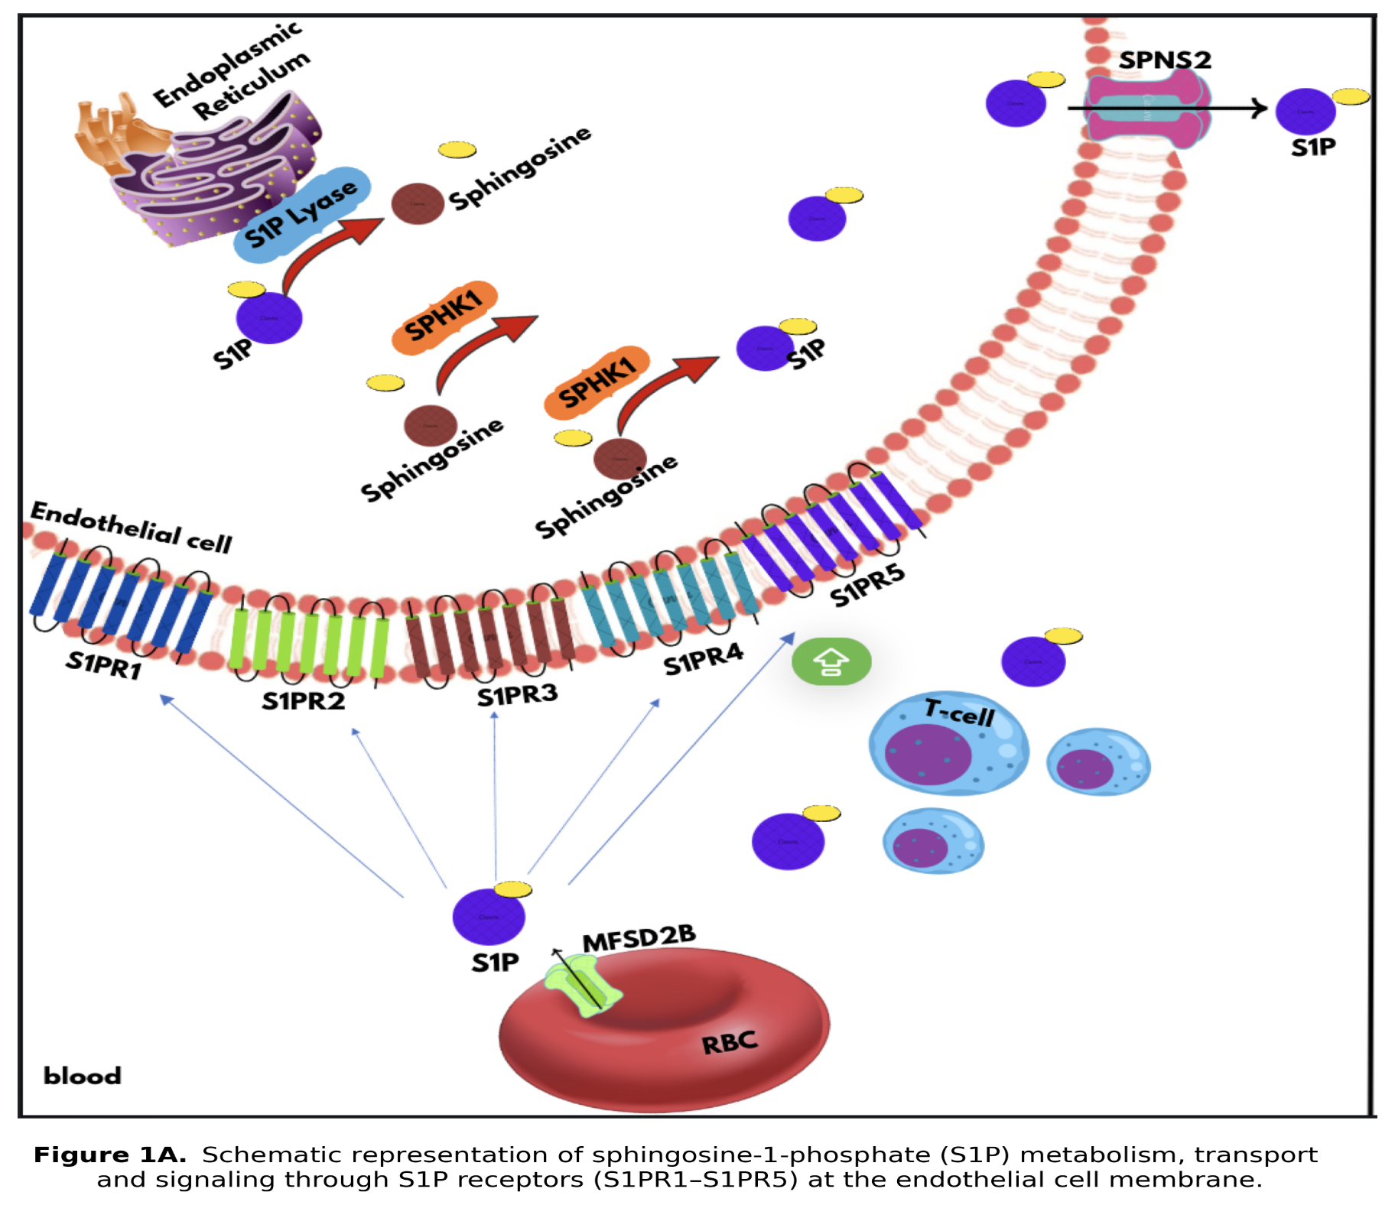

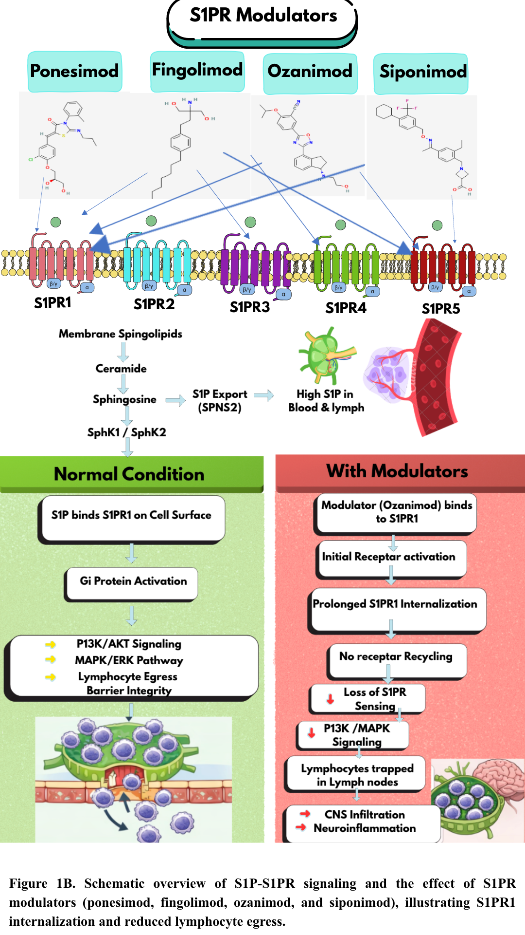

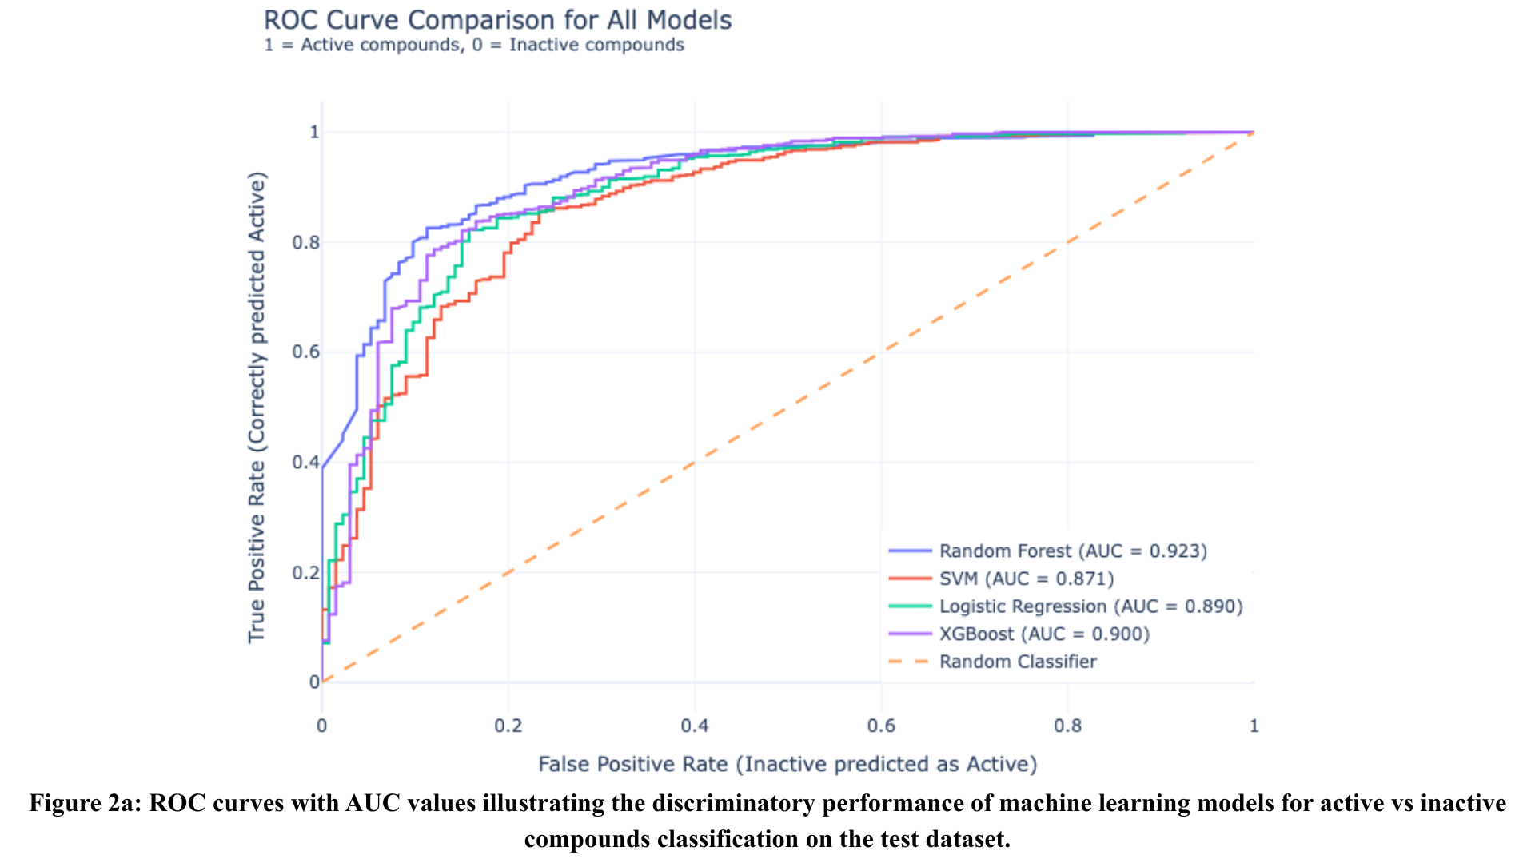

Figure 2a: ROC Curve (Model Performance): ROC curve analysis evaluating the performance of machine learning models in classifying active versus inactive compounds. The Random Forest model achieved the highest predictive accuracy with an AUC of 0.923, followed by XGBoost and Logistic Regression. These results validate the robustness of the computational screening approach in identifying potential lead candidates with high discriminatory power.

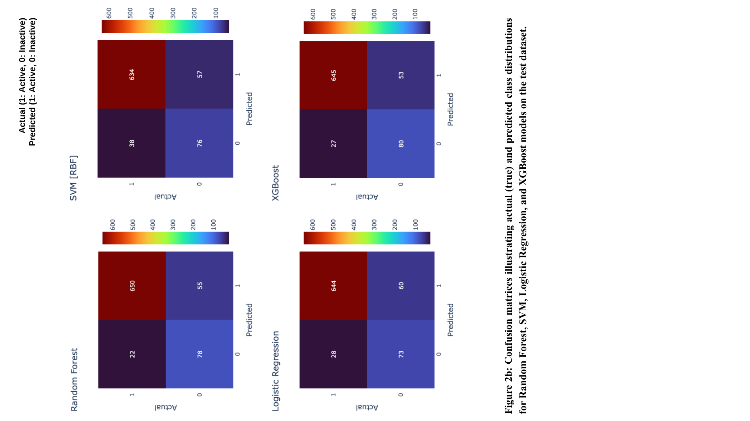

Figure 2b: Confusion Matrices (Model Classification): Confusion matrices illustrating the classification performance of four machine learning models on the test dataset. The matrices display the distribution of true positives, true negatives, and misclassifications (false positives and false negatives) for active versus inactive compounds. Among the evaluated models, Random Forest demonstrated superior predictive performance, characterized by the highest number of correct classifications and minimal prediction errors
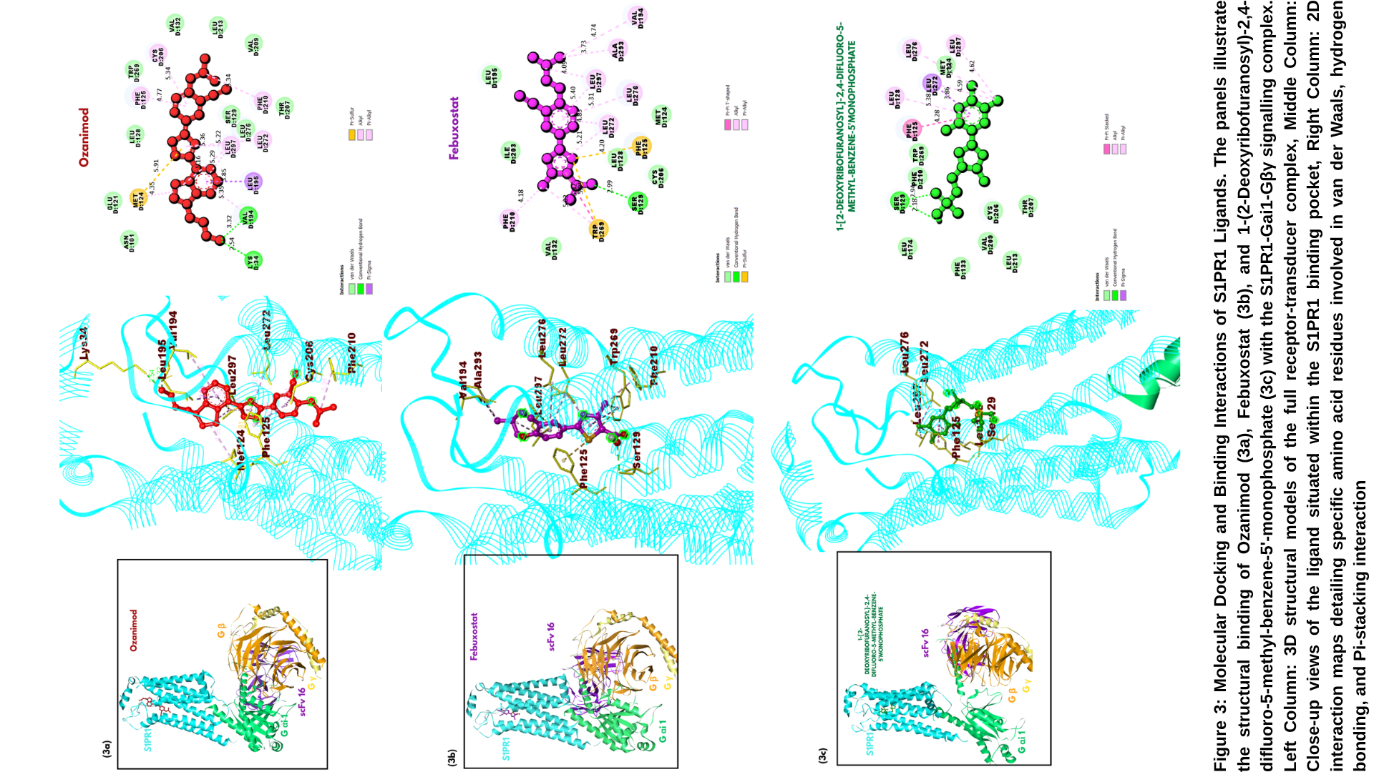
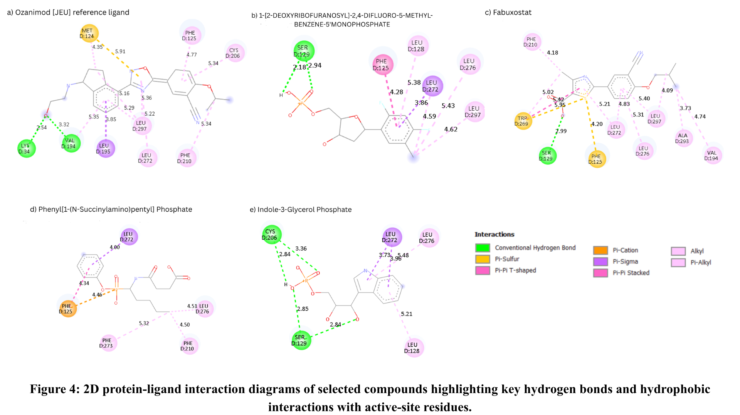
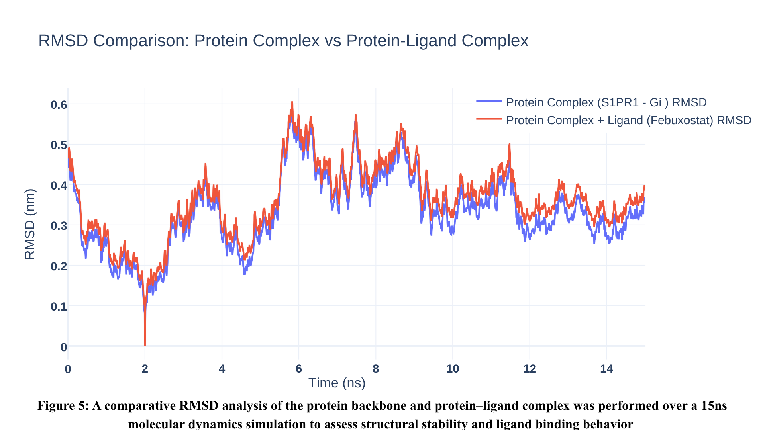
Figure 5: RMSD Comparison (Structural Stability): Root Mean Square Deviation (RMSD) profiles of the S1PR1-Gi complex and the ligand-bound system. Both trajectories exhibit a high degree of overlap, indicating that the binding of Febuxostat does not destabilize the structural integrity of the heterotrimeric signaling complex. The system achieves a stable plateau after 12 ns, confirming conformational convergence suitable for binding site analysis.
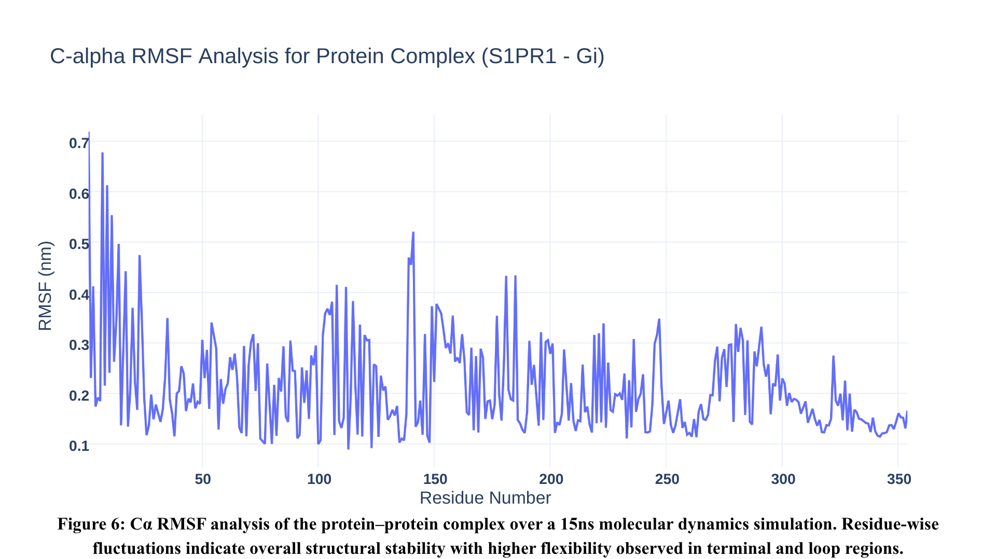
Figure 6: Cα- RMSF Analysis (Residue-Level Flexibility): Residue-wise fluctuations of the S1PR1-Gi complex measured via Cα-RMSF. The transmembrane helical regions demonstrate high structural rigidity with fluctuations under 0.3 nm, while elevated peaks are observed at the N-terminal and flexible loop regions. This fluctuation profile confirms that the core signaling architecture remains stable throughout the 15 ns production run.
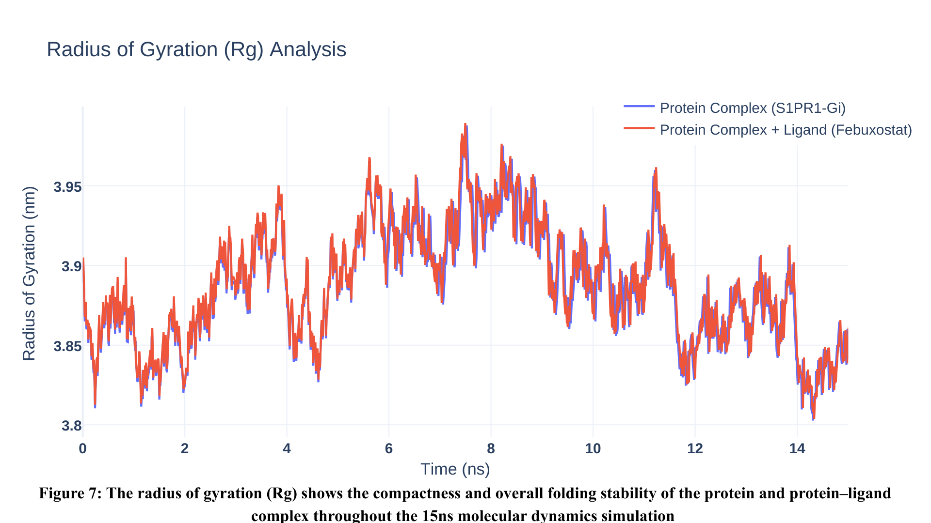
Figure 7: Radius of Gyration (Structural Compactness): Radius of Gyration (Rg) of the S1PR1-Gi complex over the 15 ns simulation. The consistent Rg values, fluctuating within a narrow range of 3.8 nm to 4.0 nm, indicate that the heterotrimeric complex maintains a highly compact and well-folded globular state. The lack of divergence between the complex protein and bound systems further confirms that ligand binding does not induce structural expansion.
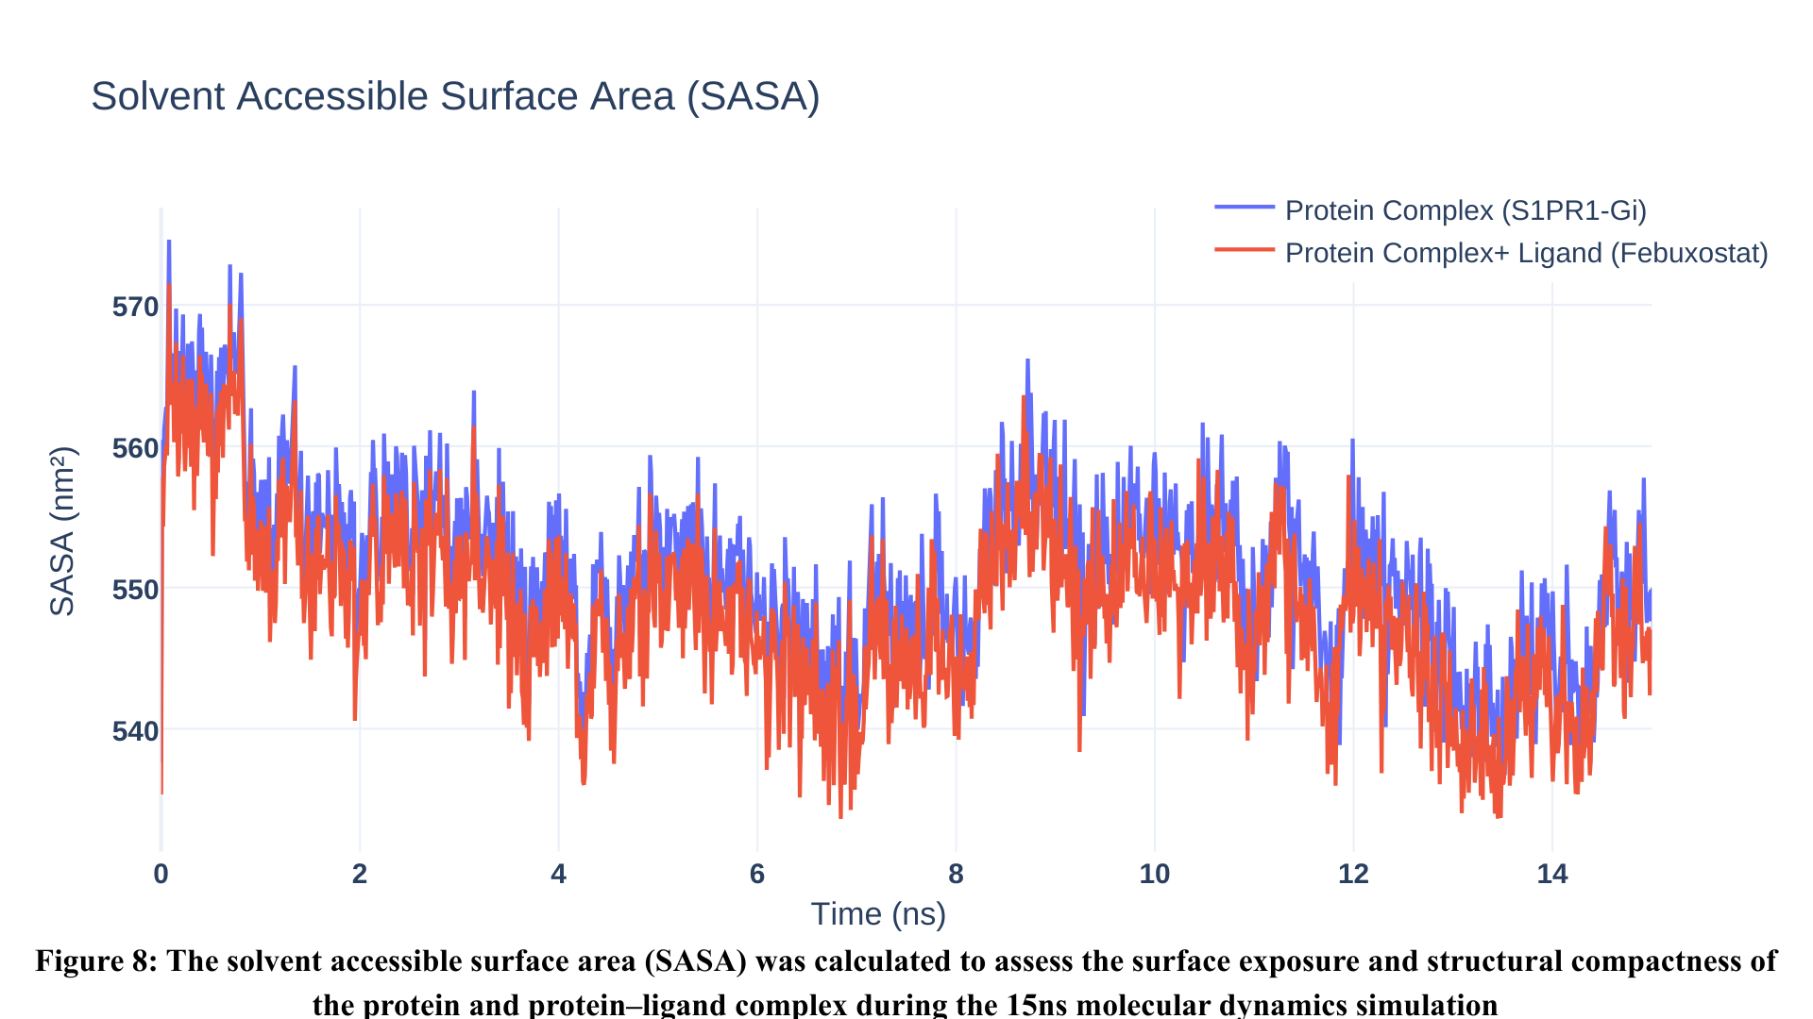
Figure 8: Solvent Accessible Surface Area (SASA) analysis monitoring the surface exposure of the protein and protein-ligand complexes. A gradual decrease in surface area is observed during the first 5 ns, followed by a stable plateau, suggesting the system achieves a more buried and compact hydrophobic core. The slightly lower SASA values for the Febuxostat-bound system indicate effective occupancy of the binding pocket, shielding internal residues from the solvent environment.

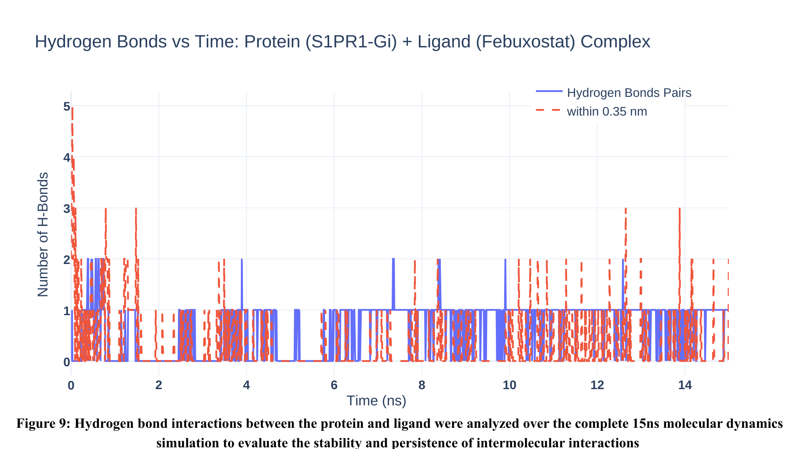
Figure 9: Hydrogen Bond Interactions: Monitoring of intermolecular hydrogen bond pairs between Febuxostat and the S1PR1 binding pocket over 15 ns. The analysis reveals the presence of at least one persistent hydrogen bond throughout the majority of the simulation, indicating a stable polar anchoring of the ligand. These consistent interactions contribute to the overall binding affinity and residence time of the inhibitor within the orthosteric site.

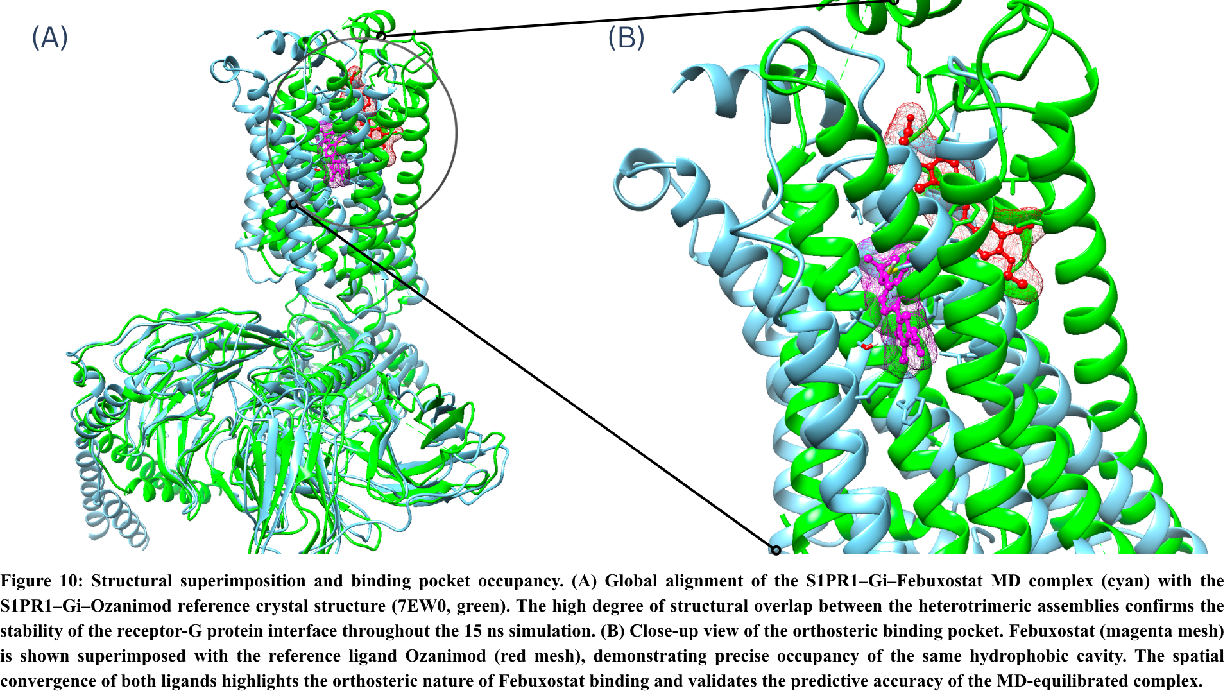

TABLES:

Table I: Overall Performance Comparison Table

Model | Accuracy | AUC | Class 0 (Inactive class) |  |  | Class 1 (Active class)
Model | Accuracy | AUC | Precision (Class 0) | Recall (Class 0) | F1  (Class 0) | Precision (Class 1) | Recall (Class 1) | F1  (Class 1)
Logistic Regression | 0.89 | 0.89 | 0.72 | 0.55 | 0.62 | 0.91 | 0.96 | 0.94
Random Forest | 0.90 | 0.92 | 0.78 | 0.59 | 0.67 | 0.92 | 0.97 | 0.94
SVM | 0.88 | 0.87 | 0.67 | 0.57 | 0.62 | 0.92 | 0.94 | 0.93
XGBoost | 0.90 | 0.90 | 0.75 | 0.6 | 0.67 | 0.92 | 0.96 | 0.94

Table I Comparative performance analysis of Machine Learning models for S1PR1 modulator classification. Precision, recall, and F1-score are reported for both inactive (Class 0) and active (Class 1) compounds.
Table II: Top-ranked compounds identified by the Random Forest model from the virtual screening of 12,309 compounds from Drug-bank dataset.
Rank | Compounds | Predicted  Probablity | PredictedActivity | LogP | Molecular Weight  (Da) | Binding  Affinity  (kcal/mol
1 | Ceralifimod | 1 | 1 | 4.96 | 435.564 | -8.27
2 | Ponesimod* | 1 | 1 | 4.26 | 460.983 | -8.456
3 | Etrasimod* | 1 | 1 | 6.92 | 457.492 | -11.07
4 | Siponimod* | 1 | 1 | 6.77 | 516.604 | -10.921
5 | Ozanimod* | 1 | 1 | 3.63 | 404.47 | -9.255
6 | Cenerimod | 0.995 | 1 | 4.06 | 453.539 | -9.88
7 | ASP-4058 | 0.985 | 1 | 5.62 | 442.319 | -10.635
8 | Fingolimod* | 0.97 | 1 | 3.2 | 307.478 | -7.272
9 | GSK-2018682 | 0.96 | 1 | 5.05 | 440.887 | -9.502
10 | 1-Monohexanoyl-2-Hydroxy-Sn-Glycero-3-Phosphate | 0.953 | 1 | 0.58 | 270.218 | -5.484
11 | Udifitimod | 0.945 | 1 | 4.39 | 379.544 | -
12 | S-[2-({N-[(2S)-2-hydroxy-3,3-dimethyl-4-(phosphonooxy)butanoyl]  -beta-alanyl}amino)ethyl] octanethioate | 0.925 | 1 | 1.72 | 484.552 | -6.879
13 | Amiselimod | 0.923 | 1 | 3.66 | 377.447 | -7.513
14 | 1-DECYL-3-TRIFLUORO ETHYL-SN-GLYCERO-2-PHOSPHOMETHANOL | 0.921 | 1 | 4.85 | 408.394 | -6.782
15 | S-[2-({N-[(2S)-2-hydroxy-3,3-dimethyl-4-(phosphonooxy)butanoyl]  -beta-alanyl}amino)ethyl] hexanethioate | 0.92 | 1 | 0.94 | 456.498 | -6.683
16 | (R)-2-(FORMYLOXY)-3-(PHOSPHONOOXY)PROPYL PENTANOATE | 0.92 | 1 | 0.37 | 284.201 | -5.554
17 | BMS-986104 | 0.915 | 1 | 4.71 | 329.528 | -8.937
18 | METHOXYUNDECYLPHOSPHINIC ACID | 0.912 | 1 | 4.3 | 250.319 | -5.803
19 | (2,2-DIPHOSPHONOETHYL)(DODECYL)DIMETHYLPHOSPHONIUM | 0.9 | 1 | 4.86 | 419.396 | -7.047
20 | Lysophosphotidylserine | 0.891 | 1 | 3.31 | 485.555 | -6.667
21 | (2R)-3-(phosphonooxy)propane-1,2-diyl diheptanoate | 0.89 | 1 | 3.49 | 396.417 | -6.662
22 | N-Hexylphosphonate Ethyl Ester | 0.885 | 1 | 2.78 | 194.211 | -5.523
23 | D-pantetheine 4'-phosphate | 0.882 | 1 | -0.96 | 358.353 | -5.714
24 | 1-O-Octyl-2-Heptylphosphonyl-Sn-Glycero-3-Phosphoethanolamine | 0.88 | 1 | 4.99 | 489.527 | -5.509
*Denotes FDA-approved, clinically advanced S1PR modulators.
Table II represents virtual screening results of top candidates identified by the Random Forest model, showing a strong correlation between high predicted probability and significant binding affinities.

Table III: Top-Ranked Ligands Identified from Molecular Docking Based on Binding Affinity Against S1PR1

Rank | Ligands | Binding affinity(kcal/mol)
1 | Adomeglivant | -11.314
2 | 4-(6-(((4-Methylcyclohexyl)amino)methyl)-1,4-dihydroindeno  (1,2-C)pyrazol-3-YL)benzoic acid | -11.268
3 | Etrasimod | -11.07
4 | Vamotinib | -10.989
5 | Siponimod | -10.921
6 | Ponatinib | -10.677
7 | Sorafenib | -10.638
8 | ASP 4058 | -10.635
9 | Tegobuvir | -10.563
10 | CM 4307 | -10.5

Table III Top sorted lowest binding affinities against S1PR1 where, Adomeglivant (−11.314 kcal/mol) and other candidates also showed the lowest docking score, indicating strong predicted binding affinity. However ADMET evaluation revealed unfavorable pharmacokinetic parameters, leading to its exclusion from further analysis.

Table IV: Predicted Binding Energies (kcal/mol) and SMILES Notations for Screened Compounds

PubChem CID | Drug  Candidates | Canonical  SMILES | Binding Affinity (kcal/mol)
46937086 | 1-[2-DEOXYRIBOFURANOSYL]  -2,4-DIFLUORO-5-METHYL-  BENZENE-5'MONOPHOSPHATE | O[C@H]1C[C@@H](O[C@@H]1COP(=O)(O)O)c1cc(C)c(cc1F)F | -8.142
134018 | FABUXOSTAT | N#Cc1cc(ccc1OCC(C)C)c1nc(c(s1)C(=O)O)C | -7.505
444107 | PHENYL  [1-(N-SUCCINYLAMINO)  PENTYL]PHOSPHONATE | CCCC[C@@H]([P@](=O)(Oc1ccccc1)O)NC(=O)CCC(=O)O | -7.403
444150 | Indole-3-Glycerol Phosphate | O[C@@H]([C@H](c1c[nH]c2c1cccc2)O)COP(=O)(O)O | -7.065
52938427 | OZANIMOD-  [JEU-Reference-ligand] | CC(C)OC1=C(C=C(C=C1)C2=NC(=NO2)C3=C4CC[C@@H](C4=CC=C3)NCCO)C#N | -9.45

Table IV Predicted binding energies and canonical SMILES notations for selected drug candidates. Values obtained via molecular docking simulations highlight the binding affinity of screened compounds with Ozanimod as the reference ligand.

Table V : Molecular Docking Scores and Drug-likeness Evaluation of Selected Candidates based on Lipinski and Veber Rules

PubChemCID | Drug  Candidates | Binding Affinity  (kcal/mol) | Drug-likeness
PubChemCID | Drug  Candidates | Binding Affinity  (kcal/mol) | Molecular weight  Da | H-bond acceptors | H-bond donors | MlogP | Lipinski violations | Veber violations
46937086 | 1-[2-DEOXYRIBOFURANOSYL]  -2,4-DIFLUORO-5-METHYL-  BENZENE-5'MONOPHOSPHATE | -8.142 | 324.21 | 8 | 3 | 0.71 | 0 | 0
134018 | FABUXOSTAT | -7.505 | 316.37 | 5 | 1 | 1.46 | 0 | 0
444107 | PHENYL  [1-(N-SUCCINYLAMINO)  PENTYL]PHOSPHONATE | -7.403 | 343.31 | 6 | 3 | 1.2 | 0 | 1
444150 | Indole-3-Glycerol Phosphate | -7.065 | 287.21 | 6 | 5 | -1.08 | 0 | 0
Table V Drug-likeness evaluation and molecular docking scores for selected candidates. Physicochemical properties were assessed using Lipinski’s "Rule of Five" and Veber’s rules to determine oral bioavailability. Zero violations for most candidates indicate high potential for favorable pharmacokinetic profiles.

Table VI : Predicted ADMET Profiles and Safety Assessment of Top-Ranked Drug Candidates.

Pub  Chem CID | Drug  Candidates | Absorption |  | Distribution | Metabolism |  | Excretion | Toxicity
Pub  Chem CID | Drug  Candidates | GI absorption | Intestinal absorption (human)  (%) | BBB permeant | CYP2D6 inhibitor | CYP3A4 inhibitor | Total Clearance | hERG I inhibitor | Hepatotoxicity | AMES toxicity
46937086 | 1-[2-DEOXYRIBOFURANOSYL]  -2,4-DIFLUORO-5-METHYL-  BENZENE-5'MONOPHOSPHATE | High | 62.58 | No | No | No | 0.305 | No | No | No
134018 | FABUXOSTAT | High | 94.132 | No | No | No | 0.303 | No | No | No
444107 | PHENYL  [1-(N-SUCCINYLAMINO)  PENTYL]PHOSPHONATE | High | 39.978 | No | Yes | No | 0.195 | No | No | No
444150 | Indole-3-Glycerol Phosphate | High | 55.264 | No | No | No | 0.317 | No | No | No

Table VI . Predicted ADMET (Absorption, Distribution, Metabolism, Excretion, and Toxicity) profiles and safety assessment of lead candidates. Results indicate high gastrointestinal absorption and favorable safety profiles, with no predicted AMES toxicity or hepatotoxicity for the selected compounds.

Table VII : Comparative Analysis of Intermolecular Interactions by PLIP Analysis.

Interaction  Type | Key  Residues | S1PR1-Ozanimod Complex  (Reference) | S1PR1-Febuxostat-Complex
Interaction  Type | Key  Residues | S1PR1-Ozanimod Complex  (Reference) | Frame 12.6ns | Frame 14.2ns | Frame 15.0ns
Hydrophobic | PHE 125 | Present | Absent | Absent | Absent
Hydrophobic | PHE 210 | Present | Present | Present | Present
Hydrophobic | LEU 195 | Present | Present | Present | Present
π-Stacking | PHE 125 | Absent | Present | Present | Present
π-Stacking | PHE 210 | Absent | Present | Present | Present
H-Bond | LYS 34 | Present | Absent | Absent | Absent
H-Bond | SER 129 | Absent | Present | Absent | Absent

*Reference interactions were identified via PLIP analysis of the crystal structure PDB ID: 7EW0.
Table VII The table summarizes the binding site interactions of the S1PR1–Febuxostat complex across three representative MD simulation snapshots (12.6 ns, 14.2 ns, and 15.0 ns) compared to the S1PR1–Ozanimod reference crystal structure. Interactions were identified using the Protein-Ligand Interaction Profiler (PLIP). Key residues such as PHE 210 and LEU 195 demonstrate highly conserved hydrophobic anchoring across all analyzed frames, matching the reference complex behavior. Variations in polar interactions (SER 129 vs. LYS 34) highlight the unique stabilizing features of the Febuxostat scaffold

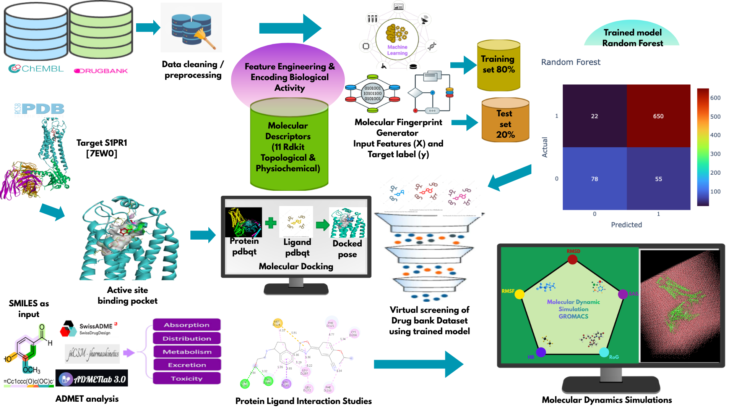
Schematic overview of the integrated AI-driven drug discovery workflow for S1PR1, illustrating data retrieval (ChEMBL, DrugBank, PDB), preprocessing and feature engineering, molecular descriptor and fingerprint generation, machine learning–based virtual screening, molecular docking, downstream interaction analysis and MD simulation

