Supplementary Figures
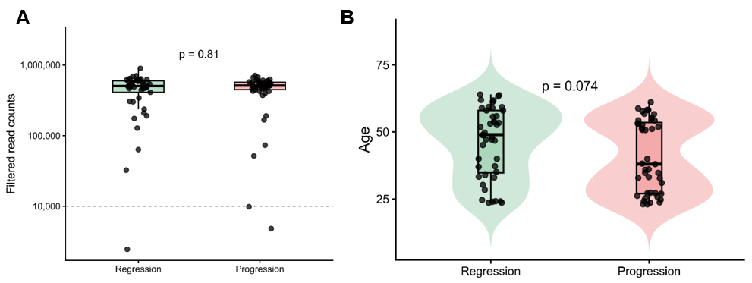
Supplementary Figure 1. Sequencing depth and age distribution across clinical outcomes. (A) Total sequencing depth per sample, shown as read counts on a log scale for regression and progression groups. (B) Age distribution of participants stratified by clinical outcome (regression vs progression). Statistical significance was assessed using a Mann–Whitney U test.
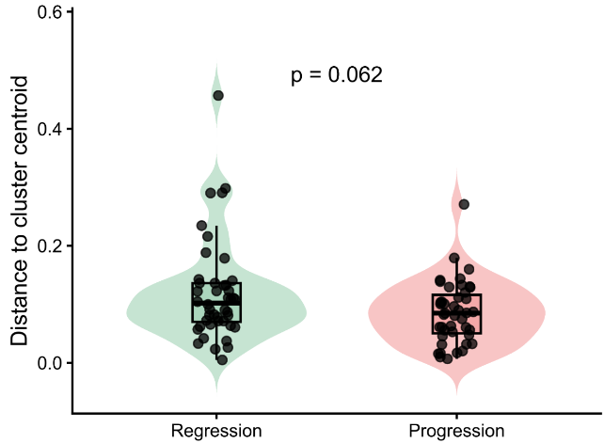

Supplementary Figure 2. Distance to microbiome cluster centroid by clinical outcome. Violin and boxplots showing Bray-Curtis distance to the group centroid for samples classified as regression or progression. Distances were calculated from the beta diversity ordination space to evaluate within-group microbiome dispersion. Statistical significance was assessed using a Mann–Whitney U test.

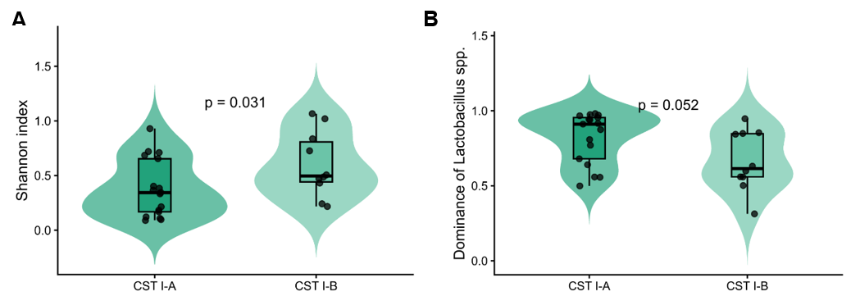
Supplementary Figure 3. Microbial diversity and Lactobacillus dominance across CST I subtypes. (A) Alpha diversity (Shannon index) comparing CST I-A and CST I-B samples. (B) Relative dominance of Lactobacillus spp. in CST I subtypes. Statistical significance was assessed using a Mann–Whitney U test.

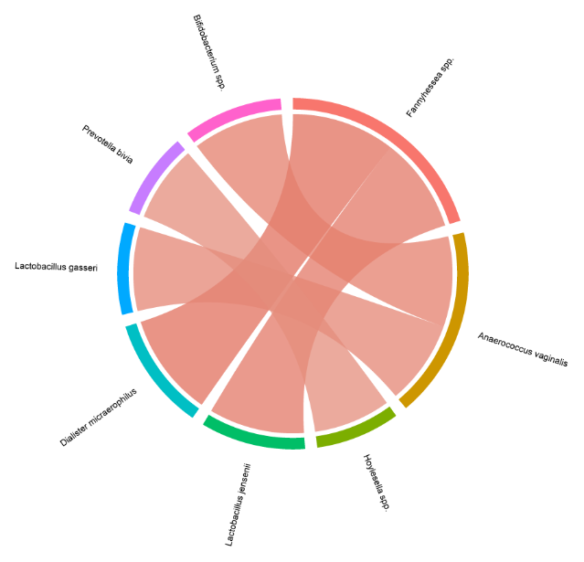

Supplementary Figure 4. Microbial co-occurrence network within CST I-A. Chord diagram illustrating co-occurrence relationships among bacterial species within CST I-A samples. Each segment represents a microbial taxon, and connecting ribbons indicate positive associations based on co-abundance patterns across samples.
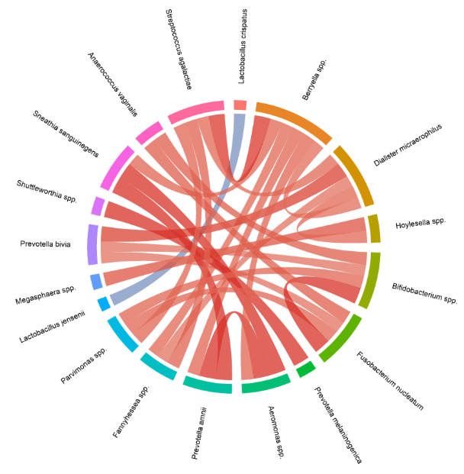

Supplementary Figure 5. Microbial co-occurrence network within CST I-B. Chord diagram illustrating co-occurrence relationships among dominant bacterial species within CST I-B samples. Each segment represents a microbial taxon, and connecting ribbons indicate positive associations based on co-abundance patterns across samples.

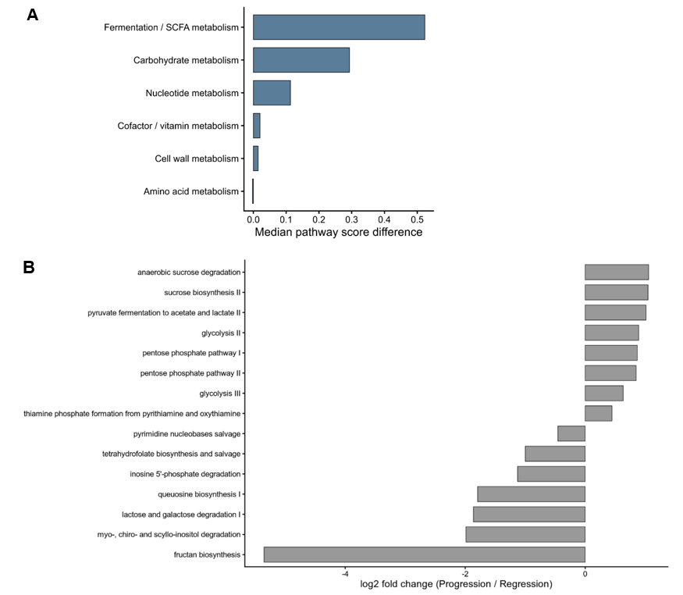
Supplementary Figure 6. Functional pathway differences at cohort-wide and CST-specific levels. (A) Functional module differences between CST I-B and CST I-A samples, summarized as differences in median pathway scores. (B) Top differentially abundant MetaCyc pathways, as inferred using PICRUSt2, between regression and progression groups in the study cohort, ranked by effect size (log2 fold change). Although several pathways related to carbohydrate metabolism and fermentation exhibit directional shifts, statistical significance was limited across the cohort.

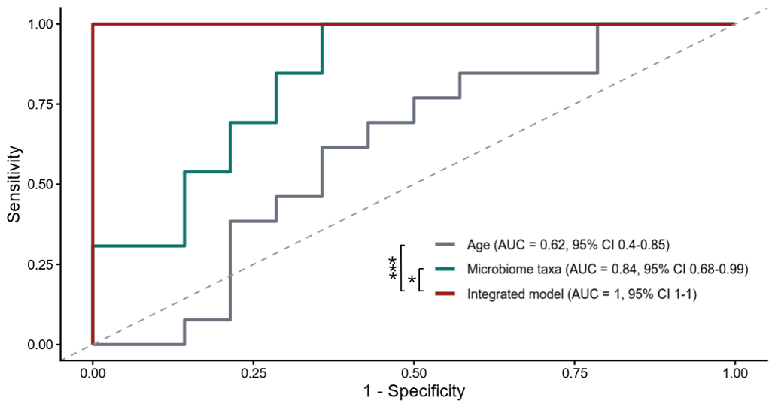
Supplementary Figure 7. Exploratory predictive modeling within CST I samples. ROC curves comparing the performance of age, microbiome-based, and integrated models within the CST I subset (n = 27). The model incorporating microbiome taxa achieved good discrimination (AUC = 0.84). Inclusion of functional pathway scores resulted in apparent near-perfect discrimination (AUC = 1.00). Comparisons of ROC curves were performed using paired DeLong tests. * p < 0.05; *** p < 0.001.

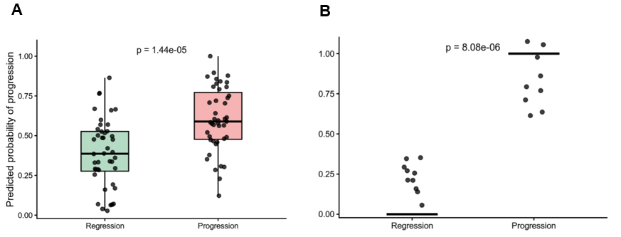
Supplementary Figure 8. Predicted probabilities from integrated logistic regression models. (A) Predicted probabilities of progression generated by the integrated model in the full LSIL cohort. Boxplots indicate the median and interquartile range. (B) Predicted probabilities of progression generated by the integrated logistic regression model distinguishing CST I samples. Statistical significance was assessed using a Mann–Whitney U test.

