Table S1
Parameter Estimates | Estimate | 95% CI | p-value
Internalizing problems T2
(Intercept) | 4.58 | [-10.54, 23.41] | 0.531
Internalizing problems T1 | 2.01 | [0.93, 3.76] | < .001***
Parental burnout | 1.78 | [0.38, 3.14] | 0.020*
Cognitive empathy | 0.75 | [-0.46, 1.89] | 0.224
Affective empathy | 0.65 | [-0.81, 2.16] | 0.411
Child age | 0.06 | [-0.26, 0.32] | 0.668
Child gender | 0.11 | [-2.05, 2.13] | 0.922
Parental depression | 0.28 | [-0.76, 1.44] | 0.584
Cognitive empathy x Parental burnout | 0.64 | [-0.57, 2.11] | 0.260
Affective empathy x Parental burnout | 1.63 | [0.40, 3.11] | 0.007**
Externalizing problems T2
(Intercept) | 13.40 | [-3.24, 32.88] | 0.107
Externalizing problems T1 | 4.33 | [2.85, 5.99] | < .001***
Parental burnout | 2.02 | [0.08, 3.96] | 0.037**
Cognitive empathy | 0.16 | [-0.90, 1.29] | 0.751
Affective empathy | 1.09 | [-0.19, 2.74] | 0.120
Child age | -0.004 | [-0.34, 0.28] | 0.968
Child gender | -1.28 | [-3.56, 1.08] | 0.270
Parental depression | -0.41 | [-1.99, 1.25] | 0.588
Cognitive empathy x Parental burnout | -1.48 | [-1.78, 1.10] | 0.457
Affective empathy x Parental burnout | 1.24 | [-0.20, 2.97] | 0.093*

Table S1. Results of the non-parametric bootstrap analyses examining the associations between parental burnout and children's behavioral problems.

Table S2

Parameter Estimates | Estimate | 95% CI | p-value
Anxious/Withdrawn
(Intercept) | 5.78 | [-4.56, 13.91] | 0.234
Parental burnout | 1.01 | [0.36, 1.62] | 0.003**
Affective empathy | 0.18 | [-0.55, 0.75] | 0.664
Cognitive empathy | 0.34 | [-0.24, 0.99] | 0.230
Parental depression | 0.07 | [-0.52, 1.01] | 0.808
Child age | 0.07 | [-0.09, 0.25] | 0.394
Child gender | 0.49 | [-0.50, 1.53] | 0.407
Affective empathy x Parental burnout | 0.68 | [0.17, 1.31] | < .001***
Cognitive empathy x Parental burnout | 0.16 | [-0.31, 1.02] | 0.544
Acting Out
(Intercept) | 9.21 | [-4.74, 22.00] | 0.207
Parental burnout | 1.29 | [0.34, 2.11] | 0.003**
Affective empathy | 0.04 | [-0.75, 0.90] | 0.928
Cognitive empathy | 0.84 | [0.15, 1.59] | 0.013*
Parental depression | 0.59 | [-0.30, 1.80] | 0.187
Child age | 0.11 | [-0.12, 0.35] | 0.331
Child gender | -0.62 | [-1.94, 0.75] | 0.394
Affective empathy x Parental burnout | 0.35 | [-0.39, 1.25] | 0.354
Cognitive empathy x Parental burnout | 0.14 | [-0.53, 0.77] | 0.658

Table S2. Moderation analyses examining the associations between parental burnout and children’s emotional distress

Supplementary robustness analyses
Given the high correlation between internalizing and externalizing symptoms, we conducted supplementary robustness analyses in which the model predicting internalizing symptoms additionally controlled for Time 4 externalizing symptoms, and the model predicting externalizing symptoms additionally controlled for Time 4 internalizing symptoms.
Internalizing problems were predicted by parental burnout (β = 0.21, SE = 0.10, p = .032), children's internalizing problems at Time T1 (β = 0.27, SE = 0.10, p = .010), and children's externalizing problems at Time T1 (β = 0.24, SE = 0.10, p = .020). Importantly, parental burnout interacted with children's affective empathy (β = 0.19, SE = 0.09, p = .026), such that the association between parental burnout and internalizing problems' change become stronger as child's affective empathy increases from low (β = 0.49, SE = 0.80, p = .54), to medium (β = 1.69, SE = 0.61, p = .01), to high (β = 2.88, SE = 0.81, p = .00) (see Figure S1).

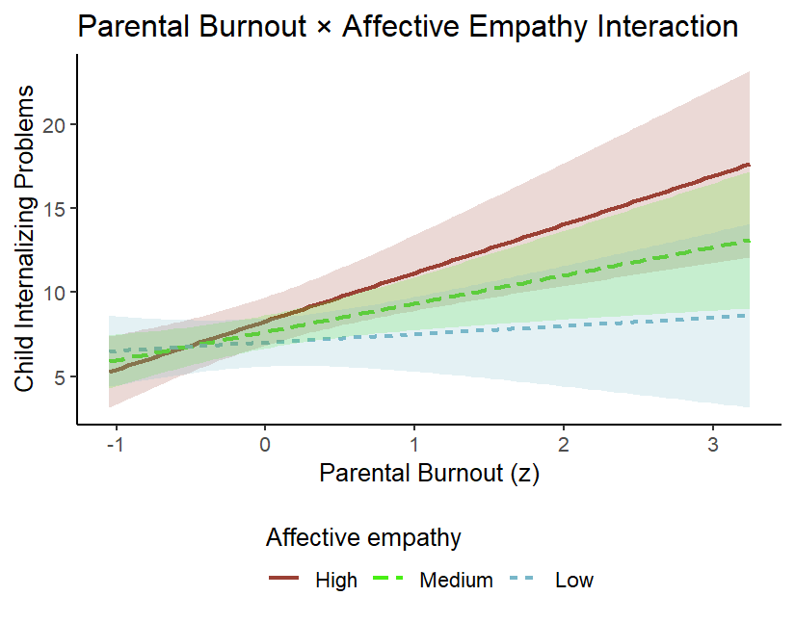

Figure S1. The interaction between parental burnout and children’s affective empathy predicting internalizing problems.
Externalizing problems were predicted by parental burnout (β = 0.27, SE = 0.10, p = .006), and children's externalizing problems at Time T1 (β = 0.55, SE = 0.09, p = .00). The interaction between parental burnout and child's affective empathy approached significance (β = 0.15, SE = 0.08, p = .070), showing a trend in the same direction as in the internalizing model.

