Supporting information for

How Individuals Efficiently Search for Creative Concepts: A Value-Guided Search Account

This file includes:

Supplementary Methods (Method S1-S3)

Supplementary Results (Result S1-S3)

Supplementary figures (Figure S1-S5)

Supplementary Table S1~S9

SI references

Supplementary methods

Method S1: K-means cluster
To determine the number of semantic clusters for the study, we did not rely on the elbow plot alone. Recent methodological work has emphasized that elbow plots are intuitive but inherently subjective, and that some data sets may show no clear elbow or multiple plausible elbows (Schubert, 2023; Steinley, 2006). Accordingly, we evaluated a plausible range of candidate K values using multiple internal criteria rather than treating a single visual inflection point as decisive.
Figure S1 presents four complementary diagnostics across K = 8-20: inertia, average silhouette width, the Calinski-Harabasz index (Caliński & Harabasz, 1974), and initialization stability. The inertia curve showed gradual flattening rather than a single sharp bend. The silhouette values improved modestly toward larger K values, whereas the Calinski-Harabasz index favored smaller solutions. This lack of convergence across indices is consistent with prior work showing that no single cluster-validity criterion is universally optimal and that different indices emphasize different properties of cluster structure (Batool & Hennig, 2021; Hennig, 2007; Rousseeuw, 1987).
Given this pattern, we interpreted the middle range of K values as a defensible candidate region rather than searching for a uniquely optimal solution. Within that region, K = 15 lies near the center of the admissible band and showed acceptable initialization stability, indicating that it was not an idiosyncratic outcome of one random start. We therefore selected K = 15 as a representative solution because it provided a reasonable balance of interpretability, semantic resolution, and methodological defensibility.
To show that the substantive correlational results did not depend on a single arbitrary partition, Figure S2 summarizes the association between cluster flexibility and downstream creative outcomes across neighboring K values. The positive relations with AUT flexibility remained directionally consistent across the tested solutions and were strongest around the selected mid-range K values, indicating that the main correlational pattern was robust rather than specific to a single cluster count.

Figure S1
Internal Validity and Initialization Stability Across Candidate K Values
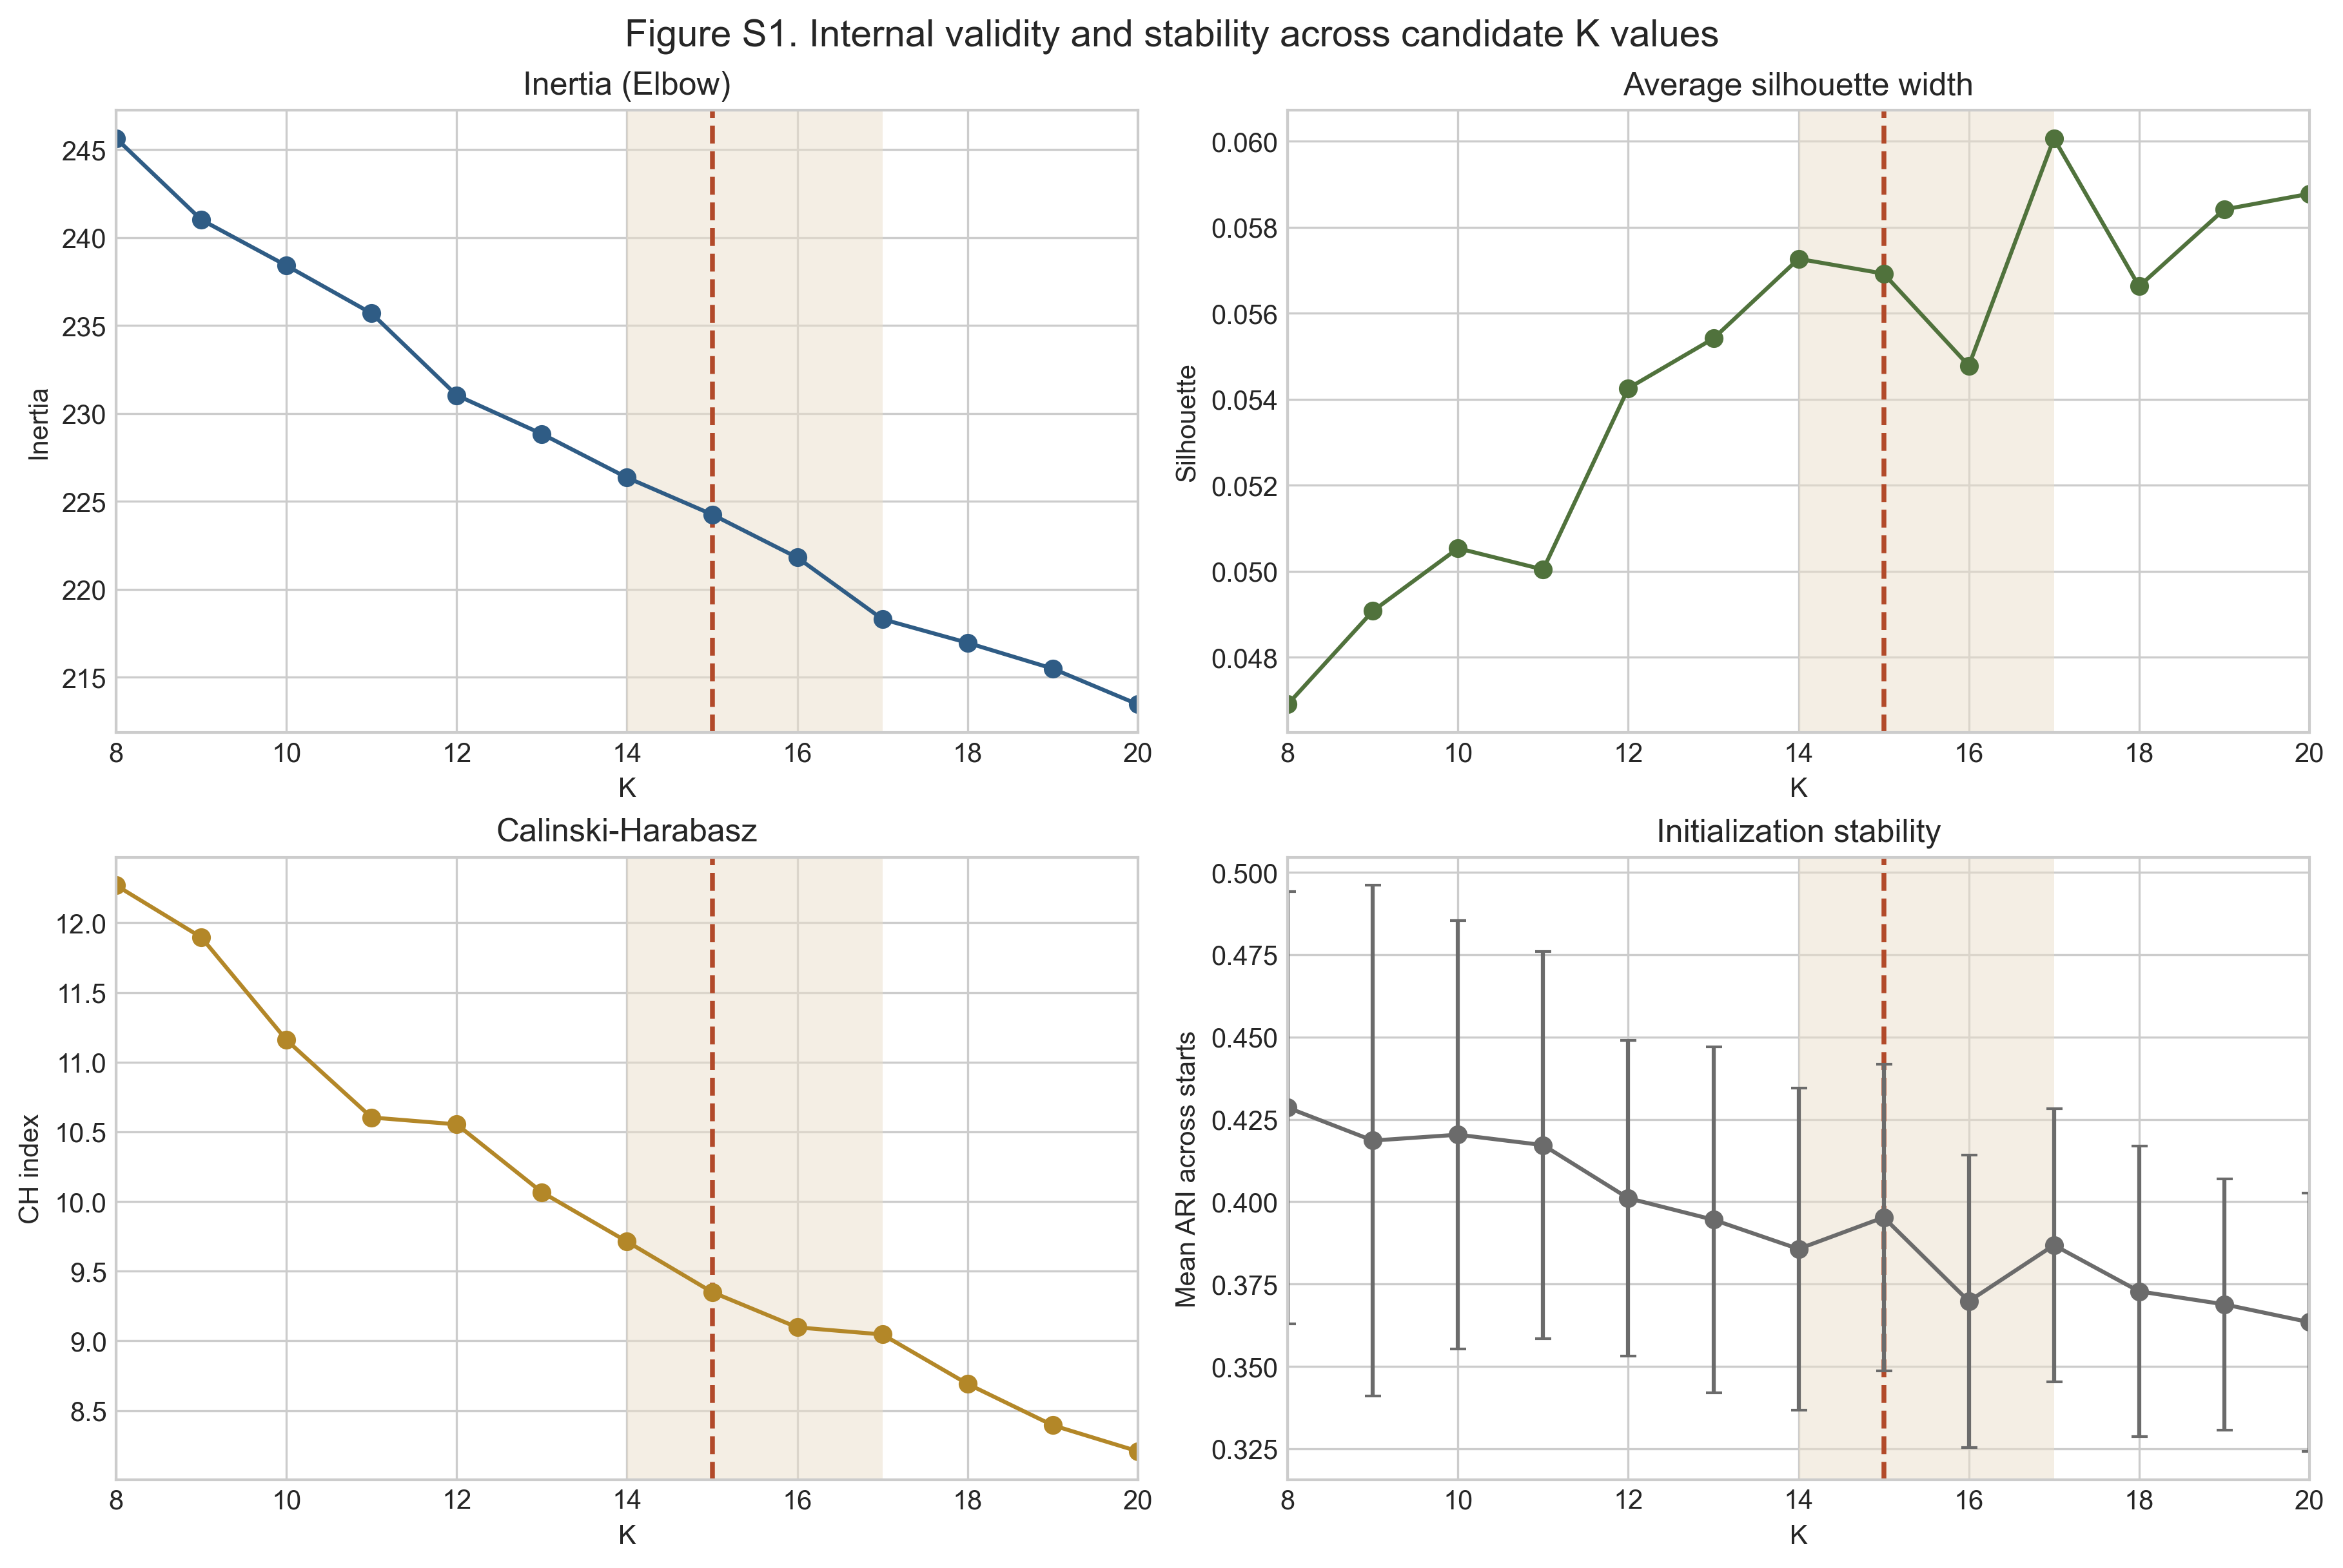
Note. The shaded band marks the focal mid-range candidate interval, and the dashed line marks the selected solution K = 15. Higher silhouette, Calinski-Harabasz, and initialization stability values indicate better performance, whereas lower inertia indicates improved fit with increasing model complexity.
Figure S2
Correlation Robustness of Cluster Flexibility Across Neighboring K Values
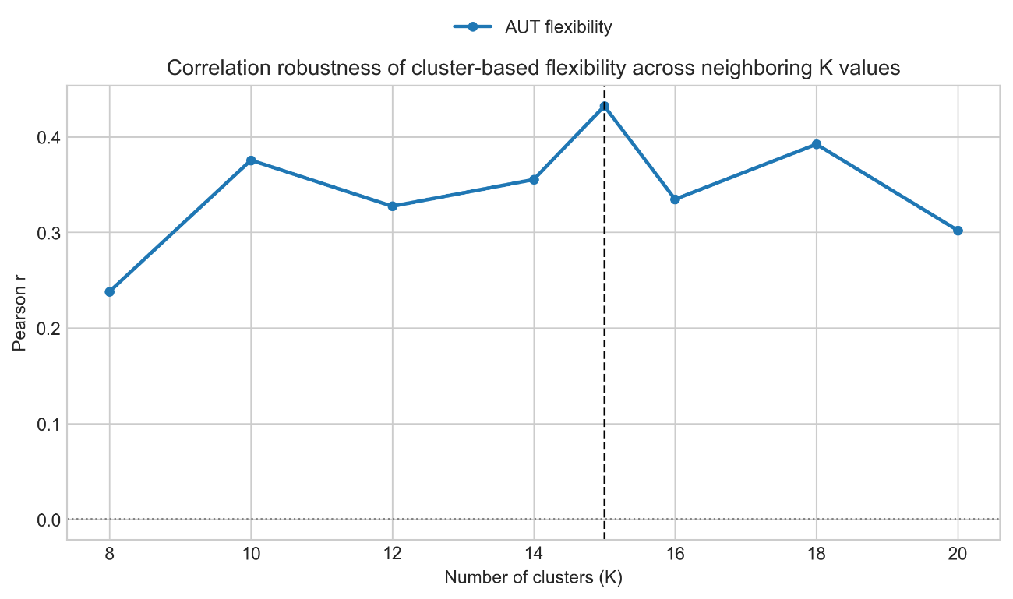
Note. The figure summarizes correlations between cluster flexibility and downstream creativity flexibilities across candidate K values. The most consistent positive relations are observed for AUT flexibility.

Method S2: Model construction.

To formally characterize candidate-concept search as a dynamic process, we constructed three complementary computational models: a value model, a walk model, and a selection model. Together, these models describe how individuals explore semantic space, evaluate encountered concepts, and decide whether to further develop a concept toward a complete creative response. The value model specifies how the value of a concept is constructed under task goals, the walk model captures how semantic exploration is biased by value while balancing exploration and exploitation, and the selection model formalizes how value guides the decision to commit to a concept. Jointly, these models provide an integrated, process-level account of value-guided candidate-concept search before complete ideas are generated. To examine the mechanism underlying the exploration–exploitation balance during semantic exploration, we implemented and compared constant-temperature and dynamic-temperature walk models.

1. Selection model.
We modeled whether participants chose to select the currently centered concept for further development of a creative idea. This binary decision was modeled using a logistic function:
$$\begin{aligned}P\left(y_{i}=1\right)=\frac{1}{1+exp\left(-\left(β_{0}+β_{1}V_{i}\right)\right)}\#\left(Eq. 1\right)\end{aligned}$$
In this equation the $β_{0}$ means the decision threshold of the subject, the higher of $β_{0}$ the lenient decision criterion of the individual. The $β_{1}$ means the decision temperatures of the individual, the higher of the $β_{1}$ , the more random the decision process.
To evaluate what guides this selection choice, we implemented four competing models where $V$ corresponds to: novelty, appropriateness, concept value, or a uniform random baseline.

2. Value model.
To model how value $V$_{i} is constructed from a concept’s novelty $N$ and appropriateness $A$ , we followed prior work on creativity evaluation and value-based decision models compared twelve candidate formulations(Battistello et al., 2025; Lopez-Persem et al., 2024), including:
$$\begin{aligned}V_{i}=α*N_{i}\#\left(Eq. 2\right)\end{aligned}$$
$$\begin{aligned}V_{i}=β*A_{i}\#\left(Eq. 3\right)\end{aligned}$$
$$\begin{aligned}V_{i}=α*N+β*A_{i}\#\left(Eq. 4\right)\end{aligned}$$
$$\begin{aligned}V_{i}=α*N_{i}+\left(1-α\right)*A_{i}\#\left(Eq. 5\right)\end{aligned}$$
$$\begin{aligned}V_{i}=α*N_{i}+β*A_{i}+γ*N_{i}*A_{i}\#\left(Eq. 6\right)\end{aligned}$$
$$\begin{aligned}V_{i}=α*N_{i}+\left(1-α\right)*A_{i}+γ*N_{i}*A_{i}\#\left(Eq. 7\right)\end{aligned}$$
$$\begin{aligned}V_{i}={\left(α*N_{i}^{τ}+\left(1-α\right)*A_{i}^{τ}\right)}^{1/τ}\#\left(Eq. 8\right)\end{aligned}$$
$$\begin{aligned}V_{i}={\left(α*N_{i}^{τ}+β*A_{i}^{τ}\right)}^{1/τ}\#\left(Eq. 9\right)\end{aligned}$$
$$\begin{aligned}V_{i}=α*N_{i}^{τ}+\left(1-α\right)*A_{i}^{τ}\#\left(Eq. 10\right)\end{aligned}$$
$$\begin{aligned}V_{i}=α*N_{i}^{τ}+β*A_{i}^{τ}\#\left(Eq. 11\right)\end{aligned}$$
$$\begin{aligned}V_{i}=α*N_{i}^{τ}+\left(1-α\right)*A_{i}^{λ}\#\left(Eq. 12\right)\end{aligned}$$
$$\begin{aligned}V_{i}=α*N_{i}^{τ}+β*A_{i}^{λ}\#\left(Eq. 13\right)\end{aligned}$$
In the above 12 models, the first six assume that novelty and appropriateness have linear effects on concept value, with or without interaction terms. The remaining six introduce nonlinear combinations using exponentiation (e.g., power means), allowing for flexible integration of $O$ and $E$ through parameters such as $τ$ and $λ$. These models reflect different hypotheses about how individuals weigh and combine novelty and appropriateness when evaluating the potential of a concept.

3. Walk model.
For the walk process, we establish a walk model to predict the direction of the exploration process. In the exploration, subject need to choose a direction to walk between the four concepts and we conduct four different models to predict the choice by the distance, novelty, appropriateness and value respectively, and use the random model as a baseline model.

$$\begin{aligned}P\left(y_{i}=j\right)=\frac{exp\left(V_{i,j}/T\right)}{\sum_{k=1}^{4}{exp}\left(V_{i,k}/T\right)}\#\left(Eq. 14\right)\end{aligned}$$
Here, $V_{i,j}$ represents the value assigned to concept $j$, and $T$ is the temperature parameter, where lower temperature more deterministic (i.e., value-sensitive) choices, and higher temperature reflect more random exploration.
To evaluate what guides this directional choice, we implemented four competing models where $V$ corresponds to: semantic distance, novelty, appropriateness, value. We also included a uniform random-choice model as a baseline, in which each concept’s value was randomly generated.

4. Dynamic temperature model and fixed temperature model

To further characterize the exploration–exploitation balance during the walk process, we extended the walk model to compare constant-temperature and dynamic-temperature variants. For each answer interval, we divided the exploration trials between two successive responses into an early phase and a late phase. In the constant-temperature model, a single temperature parameter was applied to all exploration trials within an answer interval, assuming a stable level of stochasticity throughout the search process. In contrast, the dynamic-temperature model allowed the temperature parameter to differ between the early and late phases of exploration, permitting distinct levels of exploratory variability before and after the midpoint of the search interval. This formulation enables the model to capture potential shifts between more exploratory and more exploitative search states during semantic exploration.

Method S3: Activation Matrix Construction and Simulation

General Method
To construct the activation space for simulation, we first extracted conceptual representations from participants’ Alternative Uses Task (AUT) responses. Across all participants, we identified a total of 1,004 unique concepts that were present in the Word2Vec vocabulary. These concepts were used to construct a semantic network consisting of 1,004 nodes.
Semantic distances between concepts were computed using cosine similarity derived from pretrained Word2Vec embeddings. This procedure yielded a 1004×1004 distance matrix, representing the pairwise semantic positions of all concepts in the network. Cosine similarity was calculated according to the following equation:
$$\cos\left(θ\right)=\frac{A⋅B}{\left|A\right|\left|B\right|}$$
where A and B denote the Word2Vec embedding vectors of two concepts, and θ is the angle between them in the embedding space.
To model concept activation dynamics, we adopted a K-nearest-neighbor (KNN) activation framework, motivated by the assumption that individuals can only attend to and evaluate a limited set of candidate concepts at any given moment. In this framework, each column of the activation matrix corresponds to a currently activated center concept. For a given center concept j, only its K nearest semantic neighbors were considered available for activation at the next step. Concepts outside this neighborhood were assigned an activation probability of zero. For concepts within the neighborhood, the activation probability was calculated by the following equation:
$$M=\left\{\begin{aligned}\frac{exp\left(V_{i,j}/T\right)}{\sum_{k∈N_{k(j)}}{\left(V_{k,j}/T\right)}}, &if D_{i,j}∈top-K(D_{⋅,j}) \\ 0, &otherwise\end{aligned}\right.$$

where y denotes the candidate concept selected at the next step, and j denotes the currently activated center concept. V_{i,j} represents the value assigned to candidate concept i given the current center concept j. T is a temperature parameter controlling the degree of stochastic exploration, with lower values corresponding to more deterministic, value-driven selection. D_{i,j} denotes the semantic distance between concepts i and j, and top-K(D⋅,j) denotes the set of the K smallest distance values in column j of the distance matrix. K$∈N_{k(j)}$ represents the corresponding set of K nearest neighbors of concept j. Concepts outside this neighborhood are assigned zero activation probability.

Simulation Models
We compared five activation models that differ in how activation probabilities are biased within the KNN neighborhood:
Random Model
Within the K nearest neighbors, all concepts were assigned equal activation probability (1/K). This model corresponds to a classic random walk constrained by local attentional limits.
Distance Model
Activation probabilities within the K-concept neighborhood were biased by semantic distance between the candidate concept and the currently activated concept. Specifically, distances were transformed via a softmax function such that closer concepts were more likely to be activated. This model captures distance-based associative activation.
Value Model
Activation probabilities within the K-concept neighborhood were biased by the estimated value of each concept. Value was approximated using a quadratic function of the semantic distance between each concept and the cue word. Importantly, this approximation does not assume that semantic distance fully determines value, but rather that it provides partial information relevant to value construction.
Individual-level parameters of the value function were obtained from hierarchical Bayesian modeling based on participants’ performance in the semantic exploration task and post-task concept ratings. In prior analyses, the fitted value estimates correlated moderately with participants’ directly reported value ratings (mean r=0.46), indicating that the approximation captures meaningful but incomplete information about concept value.
Crucially, this model does not assume that semantic distance is value. Instead, if a value-biased activation model predicts participants’ reported AUT concepts better than the random model, this provides evidence that value-related information biases exploratory trajectories beyond random associative processes.
Jump Model
Building on the random model, this model allowed a fixed probability (0.1 at each step) of randomly jumping to any of the 1,004 concepts in the network. This mechanism corresponds to theoretical accounts emphasizing controlled jumps to distant semantic regions.
Reset Model
Also based on the random model, this variant introduced a fixed probability (0.1 at each step) of resetting activation to the original cue word. This mechanism captures theoretical proposals emphasizing periodic returns to the task cue to maintain goal relevance during search.

Supplementary results

Result S1: Model parameters and creativity performance
To examine whether the cognitive mechanisms captured by the model relate to real-world creative ability, we tested whether individual differences in model parameters predicted performance on the Alternative Uses Task. Each of the model’s three core components—value construction, exploration dynamics, and selection threshold—corresponded to distinct dimensions of creative output.
First, for value construction, the weight participants placed on novelty (α) during post-task evaluations was positively associated with the rated novelty of their AUT responses (r = .33, p = .002). This supports the interpretation of α as a psychological marker of individuals’ preference for novelty in idea evaluation, which in turn influences the generative process.
Second, for exploration dynamics, we found that the ratio of natural switches (i.e., stepwise transitions between semantic clusters) was positively associated with flexibility in the AUT (r = .31, p = .003), while the ratio of controlled switches (i.e., deliberate cross-cluster jumps) was negatively associated with flexibility (r = –.39, p < .001). This suggests that flexibility may emerge from natural association rather than from explicit efforts to jump across semantic categories.
Third, for decision threshold, the parameter β₀ was significantly associated with both fluency (r = .45, p < .001) and flexibility (r = .39, p < .001). Participants with more lenient selection thresholds—i.e., those willing to elaborate on a broader range of concepts—produced more ideas and explored more conceptual clusters.
Together, these results demonstrate that the model not only captures the process dynamics of creative search, but also accounts for meaningful individual differences in creative performance.

Figure S3

Relationships between individual model parameters and creative performance
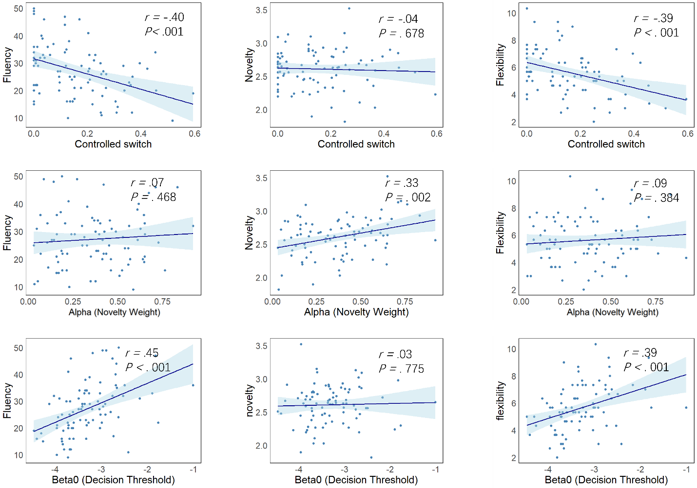
Note. Correlations between individual cognitive parameters and creative performance. Top row: Natural switch frequency was positively associated with flexibility (r = .31, p = .003), with weaker associations with fluency (r = .18, p = .083) and no association with novelty. Second row: Controlled switch frequency showed significant negative correlations with both fluency (r = –.40, p < .001) and flexibility (r = –.39, p < .001), but not with novelty. Third row: The novelty weight parameter (α) positively predicted novelty scores (r = .33, p = .002), with no significant associations with fluency or flexibility. Bottom row: The decision threshold parameter (β₀) was positively correlated with fluency (r = .45, p < .001) and flexibility (r = .39, p < .001), but not with novelty. Shaded regions indicate 95% confidence intervals.

Result S2: Additional simulation validation across temperatures

Figure S4

Effects of exploration temperature on simulation performance

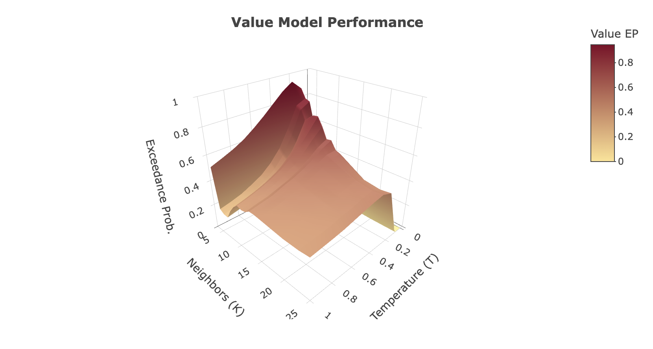
Note. Simulation results showing how model performance varies as a function of the exploration temperature parameter (T), with neighborhood size fixed at K = 6. Each panel depicts estimated model frequency and exceedance probability for the value-guided model relative to distance-based and random models across a wide range of temperature values (T = 1.0 to 0.001). The value-guided model shows its strongest advantage at intermediate temperature levels, corresponding to a balanced exploration–exploitation regime. At high temperatures, model behavior becomes highly stochastic, reducing the influence of value signals, whereas at very low temperatures, overly deterministic search leads to premature convergence and reduced performance.

To assess the robustness of the simulation results with respect to the exploration temperature, we conducted a systematic scan of the temperature parameter while fixing the neighborhood size at K = 6. The temperature values tested were 1.0, 0.8, 0.6, 0.4, 0.2, 0.1, 0.01, and 0.001.

The results revealed a clear non-linear relationship between temperature and model performance. When temperature was high (T = 1.0), the value-guided model showed little advantage over the distance-based and random models. Under this condition, choice behavior was highly stochastic, and value information exerted minimal influence on the search process, leading to comparable performance across models.

As temperature decreased into a moderate range (approximately 0.8 to 0.1), the value-guided model consistently outperformed all comparison models. In this range, the value model achieved the highest estimated model frequency and exceedance probability, indicating that value signals were sufficiently strong to guide search while still allowing adequate exploration of the semantic space.

However, when temperature was further reduced to very low levels (T = 0.01 and below), model performance declined markedly. Under these highly deterministic conditions, the value-guided model no longer outperformed the random baseline and in some cases performed worse. This decline suggests that excessively strong value control can lead to premature convergence on locally high-value concepts, limiting exploration and reducing the model’s ability to reproduce human creative outputs.

Overall, these findings indicate that the effectiveness of value-guided search critically depends on an intermediate level of stochasticity. Both excessive randomness and excessive determinism impair performance, whereas a balanced exploration–exploitation regime yields the closest correspondence to human creative behavior. Importantly, this pattern emerges from a parameter scan rather than parameter fitting, demonstrating that the observed advantage of the value model reflects a structural property of the search mechanism rather than an artifact of optimized parameter selection.

Result S3: Additional simulation validation across AUT items

Figure S5. Replication of simulation results across additional AUT items

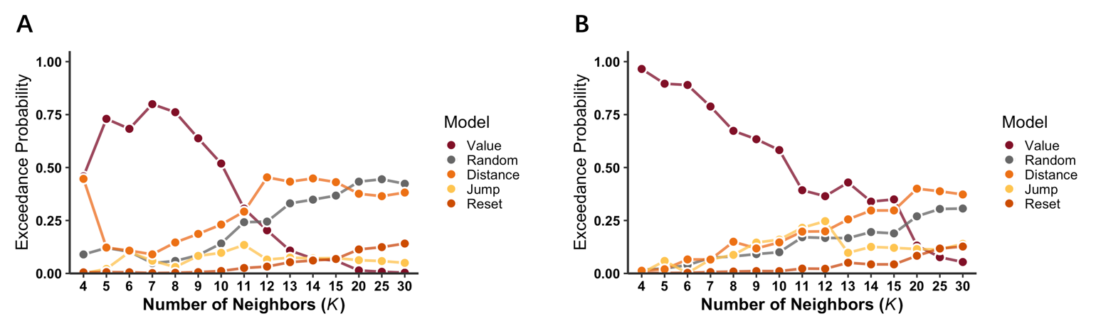

Note. Simulation results for two additional Alternative Uses Task items beyond the primary item reported in the main text. Using identical model structures, parameter settings, and evaluation procedures, the value-guided model consistently outperformed distance-based and random models under intermediate parameter regimes. The relative ordering of models was preserved across items, indicating that the advantage of value-guided semantic search generalizes across different semantic domains and is not item-specific.

To examine the stability and generalizability of the simulation results, we extended the simulation analysis to two additional Alternative Uses Task (AUT) items beyond the primary item reported in the main text. The same modeling framework, parameter settings, and evaluation procedures were applied to these additional items.

Across both additional AUT items, the simulation results closely mirrored those reported in the main analysis. In each case, the value-guided model consistently outperformed the distance-based and random models under intermediate parameter regimes, while differences between models diminished under extreme parameter settings. As in the primary item, the value model showed its strongest advantage when both neighborhood size and exploration temperature were within a moderate range, and its performance declined when search became either overly random or overly deterministic.

Moreover, the relative ordering of models was preserved across items, with the value-guided model yielding the highest estimated model frequency and exceedance probability, followed by the distance-based model and the random baseline. This consistency indicates that the observed advantage of value-guided search is not specific to a single semantic structure or item-specific network configuration, but instead reflects a general property of the proposed search mechanism.

Table S1. Model comparison of alternative models of concept selection in Study 1.
 | ELPD_diff |  | ELPD |  | P |  | LOOIC |  | DIC
 | Estimate | SE | Estimate | SE | Estimate | SE | Estimate | SE | Estimate | delta
value | 0.00 | 0.00 | -2163.81 | 41.81 | 162.52 | 6.03 | 4327.63 | 83.61 | 4152 | 0.00
appr | -407.89 | 42.40 | -2571.69 | 36.43 | 144.07 | 5.80 | 5143.39 | 72.85 | 4987 | 835
novelty | -932.79 | 42.97 | -3096.60 | 32.90 | 134.90 | 5.91 | 6193.21 | 65.81 | 6048 | 1896
rand | -1304.49 | 40.66 | -3468.31 | 23.58 | 94.34 | 1.50 | 6936.61 | 47.16 | 6838 | 2686
Note. ELPD = expected log predictive density; SE = standard error; P = effective number of parameters; LOOIC = leave-one-out information criterion; DIC = deviance information criterion. Δ indicates the difference in DIC relative to the best-fitting model (value-based). Smaller values of LOOIC and DIC indicate better model fit. For model comparison, differences of about 2–4 points are considered weak, 4–10 points substantial, and >10 points strong evidence favoring the model with the lower value (Spiegelhalter et al., 2002; Vehtari et al., 2017). The value-based model provided the best account of participants’ concept selection decisions, substantially outperforming the attribute-based and random-choice models.

Table S2. Pairwise Comparisons of decision model accuracy in Study 1(Bonferroni-corrected)
Contrast | Mean Difference | SE | t(60) | p (Bonf.)
value-novelty | 0.134 | 0.014 | 9.33 | <.001
value-appr | -0.001 | 0.002 | -0.006 | <.001
value-rand | -0.001 | 0 | -0.002 | <.001
novelty-appr | -0.068 | 0.004 | -0.076 | <.001
novelty-rand | -0.03 | 0.004 | -0.038 | <.001
appr-rand | 0.754 | 0.332 | 0.102 | <.001
Note. Bonferroni-adjusted p values are reported. “value” = value-based model; “novelty” = novelty-based model; “appr” = appropriateness-based model; “rand” = random-choice model. As shown, the value-based model consistently achieved higher predictive accuracy than novelty, appropriateness, and random-based models, supporting the robustness of concept value as the key determinant of concept selection.
Table S3. Model comparison of alternative models of value construction in Study 1.
 | ELPD_diff |  | ELPD |  | P |  | LOOIC |  | DIC
 | Estimate | SE | Estimate | SE | Estimate | SE | Estimate | SE | Estimate | delta
model8 | 0 | 0 | -25146.61 | 66.36 | 196.72 | 6.03 | 50293.21 | 83.61 | 50299 | 0
model12 | -15.58 | 7.58 | -25162.19 | 65.62 | 172.41 | 6.03 | 50324.37 | 83.61 | 50336 | 37
model10 | -55.37 | 9.14 | -25201.98 | 64.85 | 177.83 | 6.03 | 50403.96 | 83.61 | 50413 | 114
model5 | -57.29 | 9.32 | -25203.9 | 65.95 | 182.92 | 6.03 | 50407.8 | 83.61 | 50419 | 120
model3 | -60.49 | 9.08 | -25207.1 | 65.44 | 176.85 | 6.03 | 50414.2 | 83.61 | 50420 | 121
model9 | -67 | 8.7 | -25213.59 | 65.06 | 168.35 | 6.03 | 50427.19 | 83.61 | 50443 | 144
model11 | -69.29 | 9.9 | -25215.9 | 66.25 | 168.8 | 6.03 | 50431.81 | 83.61 | 50444 | 145
model7 | -266.01 | 11.42 | -25412.62 | 67.78 | 112.84 | 6.03 | 50825.24 | 83.61 | 50849 | 550
model4 | -452.34 | 8.95 | -25598.95 | 65.3 | 85.94 | 6.03 | 51197.9 | 83.61 | 51203 | 904
model6 | -468.05 | 9.16 | -25614.66 | 65.52 | 86.01 | 6.03 | 51229.32 | 83.61 | 50503 | 1204
model2 | -2051.9 | 8.02 | -27198.51 | 56.1 | 73.88 | 6.03 | 54397.03 | 83.61 | 54416 | 4117
model1 | -3454.72 | 7.32 | -28601.33 | 52.14 | 45.39 | 6.03 | 57202.66 | 83.61 | 57245 | 5946
Note. ELPD = expected log predictive density; SE = standard error; P = effective number of parameters; LOOIC = leave-one-out information criterion; DIC = deviance information criterion. ΔDIC indicates the difference in DIC relative to the best-fitting model (model8). Smaller values of LOOIC and DIC indicate better model fit. For interpretation, differences of about 2–4 points are considered weak, 4–10 points substantial, and >10 points strong evidence favoring the model with the lower value (Spiegelhalter et al., 2002; Vehtari et al., 2017).

Table S4. Group-level parameter estimates for the best-fitting value model in Study 1
 |  |  |  |  |  | 95% Confidence Intervals
parameters |  |  | Estimate | SE | Lower |  | Upper
α_{-creative}(novelty weight) |  |  | 0.674 | 0.027 | 0.622 |  | 0.726
α_{-general}(novelty weight) |  |  | 0.145 | 0.020 | 0.104 |  | 0.185
β_{-creative} (appropriateness weight) |  |  | 0.303 | 0.029 | 0.247 |  | 0.359
β_{-general} (appropriateness weight) |  |  | 0.809 | 0.019 | 0.771 |  | 0.847
τ_{-creative} (substitution parameter) |  |  | 0.725 | 0.019 | 0.688 |  | 0.762
τ_{-general}(substitution parameter) |  |  | 1.393 | 0.007 | 1.381 |  | 1.406
Note. Estimates are group-level means with standard errors and 95% confidence intervals, reported separately for the general-use and creative-use conditions.

Table S5. Paired comparisons of group-level parameters across task contexts (Study 1)
 |  |  | statistic | df | p |  | Effect Size
α_{-general} | α_{-creative} | Student's t | -17.227 | 60 | <.001 | Cohen's d | -2.206
β_{-general} | β_{-creative} | Student's t | 14.441 | 60 | <.001 | Cohen's d | 1.849
τ_{-general} | τ_{-creative} | Student's t | 34.437 | 60 | <.001 | Cohen's d | 4.409
β₀_{-general} | β₀_{-creative} | Student's t | 1.968 | 60 | 0.054 | Cohen's d | 0.252
Note. All tests are paired-sample t-tests comparing parameter estimates between the general-use and creative-use conditions. Effect sizes are reported as Cohen’s d (paired).

Table S6. Model comparison of alternative models of value construction in Study 2.
 | ELPD_diff |  | ELPD |  | P |  | LOOIC |  | DIC
 | Estimate | SE | Estimate | SE | Estimate | SE | Estimate | SE | Estimate | delta
model8 | 0 | 0 | -44596.47 | 93.46 | 230.91 | 6.59 | 89192.94 | 186.91 | 89160 | 0
model5 | -272.5 | 42.31 | -44868.97 | 90.69 | 199.42 | 4.68 | 89737.94 | 181.39 | 89728 | 568
model7 | -326.44 | 47.38 | -44922.91 | 94.03 | 153.82 | 5.26 | 89845.81 | 188.07 | 89814 | 654
model12 | -517.99 | 54.12 | -45114.46 | 84.85 | 176.3 | 3.77 | 90228.91 | 169.7 | 90212 | 1052
model10 | -535.38 | 54.02 | -45131.85 | 84.81 | 174.55 | 3.74 | 90263.7 | 169.62 | 90250 | 1090
model9 | -587.16 | 54.41 | -45183.63 | 85.17 | 169.37 | 3.79 | 90367.26 | 170.35 | 90351 | 1191
model11 | -587.89 | 54.35 | -45184.36 | 85.12 | 169.06 | 3.77 | 90368.73 | 170.23 | 90353 | 1193
model3 | -594.15 | 54.49 | -45190.62 | 85.32 | 176.4 | 3.85 | 90381.24 | 170.64 | 90364 | 1204
model4 | -990.24 | 62.22 | -45586.71 | 88.68 | 100.8 | 2.92 | 91173.41 | 177.36 | 91153 | 1993
model6 | -991.55 | 62.33 | -45588.02 | 88.81 | 103.2 | 2.94 | 91176.03 | 177.61 | 91155 | 1995
model2 | -2580.24 | 55.67 | -48176.71 | 83.36 | 85.23 | 2.33 | 96353.41 | 166.72 | 96347 | 7187
model1 | -5139.99 | 72.4 | -50736.46 | 72.76 | 36.75 | 0.8 | 101472.93 | 145.51 | 101495 | 12335
Note. ELPD = expected log predictive density; SE = standard error; P = effective number of parameters; LOOIC = leave-one-out information criterion; DIC = deviance information criterion. ΔDIC indicates the difference in DIC relative to the best-fitting model (model8). Smaller values of LOOIC and DIC indicate better model fit. For interpretation, differences of about 2–4 points are considered weak, 4–10 points substantial, and >10 points strong evidence favoring the model with the lower value (Spiegelhalter et al., 2002; Vehtari et al., 2017).

Table S7. Model comparison of alternative models of concept selection in Study 2.
 | ELPD_diff |  | ELPD |  | P |  | LOOIC |  | DIC
 | Estimate | SE | Estimate | SE | Estimate | SE | Estimate | SE | Estimate | delta
value | 0 | 0 | -5124.494 | 52.04 | 79.3 | 1.37 | 10248.99 | 104.07 | 10249 | 0
novelty | -72.88 | 17.03 | -5197.376 | 52.28 | 73.03 | 1.05 | 10394.75 | 104.55 | 10394 | 145
appr | -118.63 | 13.64 | -5243.124 | 52.03 | 71.62 | 1.03 | 10486.25 | 104.06 | 10485 | 236
rand | -121.56 | 14.41 | -5246.054 | 52.08 | 71.32 | 1.02 | 10492.11 | 104.16 | 10491 | 242
Note. ELPD = expected log predictive density; SE = standard error; P = effective number of parameters; LOOIC = leave-one-out information criterion; DIC = deviance information criterion. Δ indicates the difference in DIC relative to the best-fitting model (value-based). Smaller values of LOOIC and DIC indicate better model fit. For model comparison, differences of about 2–4 points are considered weak, 4–10 points substantial, and >10 points strong evidence favoring the model with the lower value (Spiegelhalter et al., 2002; Vehtari et al., 2017). The value-based model provided the best account of participants’ concept selection decisions, substantially outperforming the attribute-based and random-choice models.

Table S8. Model comparison of alternative models of concept walk in Study 2.
 | ELPD_diff |  |  | ELPD |  | P |  | LOOIC |  | DIC
 | Estimate |  | SE | Estimate | SE | Estimate | SE | Estimate | SE | Estimate | delta
value |  | 0 | 0 | -4877.084 | 7.671 | 26.628 | 0.712 | 9754.168 | 15.341 | 9753.488 | 0
appr |  | -24.286 | 6.72 | -4901.37 | 3.139 | 7.833 | 0.209 | 9802.739 | 6.277 | 9802.714 | 49.226
semantic |  | -26.933 | 7.211 | -4904.017 | 2.55 | 2.491 | 0.149 | 9808.035 | 5.1 | 9810.584 | 57.096
novelty |  | -29.071 | 7.759 | -4906.154 | 1.514 | 3.678 | 0.097 | 9812.309 | 3.028 | 9813.333 | 59.845
rand |  | -29.265 | 7.689 | -4906.348 | 1.702 | 6.328 | 0.127 | 9812.697 | 3.404 | 9812.883 | 59.395
Note. ELPD = expected log predictive density; SE = standard error; P = effective number of parameters; LOOIC = leave-one-out information criterion; DIC = deviance information criterion. Δ indicates the difference in DIC relative to the best-fitting model (value-based). Smaller values of LOOIC and DIC indicate better model fit. For model comparison, differences of about 2–4 points are considered weak, 4–10 points substantial, and >10 points strong evidence favoring the model with the lower value (Spiegelhalter et al., 2002; Vehtari et al., 2017). The value-based model provided the best account of participants’ concept selection decisions, substantially outperforming the attribute-based and random-choice models.
Table S9
Preregistration Scope, Deviations, and Interpretive Implications
Element | Preregistration | Revised manuscript | Interpretive implication
Study 1 | Study 1 was not included in the preregistration. | Study 1 is reported as the first study in the paper.
Theoretical focus | The preregistration framed the project in terms of conscious control and cognitive mechanisms in early creative processing. | The revised manuscript emphasizes value-guided exploration and exploration-exploitation regulation. | The broad topic overlaps, but the final theoretical framing was not fully preregistered.
Hypotheses | The preregistration stated broad aims, but did not clearly specify precise directional predictions or explicit value-based hypotheses. | The revised manuscript advances more specific theoretical claims. | The work is only partially confirmatory at the level of general aims; specific predictions should be interpreted cautiously.
Design and task structure | The preregistration described a single exploration study without different conditions and outlined an earlier task structure. | The revised manuscript reports a two-condition Study 1 and a more developed Study 2 task implementation. | The final procedures reflect later study development rather than a fully prespecified protocol.
Measures | The preregistration broadly anticipated rating-based measures. | The revised manuscript reports more refined value-related measures and study-specific operationalizations. | Broad measurement intent was preregistered, but the final operationalization was only partially preregistered.
Analysis plan | The preregistration indicated a general intention to analyze exploration behavior and compare models, but did not fully specify the analytic pipeline, model space, or computational predictions. | The revised manuscript reports a substantially more specific set of analyses and model-based interpretations. | The analytic direction was broadly preregistered, but the specific analyses are only partially preregistered and in important respects exploratory.
Confirmatory vs. exploratory status of results | The preregistration did not clearly specify which analyses would count as confirmatory, nor did it provide sufficiently precise predictions for all reported outcomes. | The revised manuscript reports results from both Study 1 and Study 2, including theory development and model-based analyses that go beyond the specificity of the preregistration. | Study 1 should be treated as non-preregistered. In Study 2, only the broad investigation of exploration can be linked to the preregistration. Specific predictions, model implementations, and extended theoretical interpretations should be treated as exploratory or at most partially confirmatory.
Note. The table below clarifies the relationship between the preregistration and the revised manuscript. Study 1 was not preregistered because its data had already been collected before the preregistration was filed. The preregistration applied only to the exploration component of Study 2 and captured an earlier, broadly specified version of that study. We therefore distinguish preregistered scope from later theoretical, methodological, and analytic developments. Interpretively, we do not treat the manuscript as a fully confirmatory test of a preregistered set of predictions. Study 1 is non-preregistered because data collection was completed before preregistration. For Study 2, the preregistration supports the general investigation of exploration, but the specific theoretical framing, detailed predictions, and model-based analyses were not fully prespecified and should therefore be interpreted as exploratory or only partially confirmatory.

SI References

Batool, F., & Hennig, C. (2021). Clustering with the average silhouette width. Computational Statistics & Data Analysis, 158, Article 107190. https://doi.org/10.1016/j.csda.2021.107190
Battistello, G., Moreno-Rodriguez, S., Volle, E., & Lopez-Persem, A. (2025). Subjective valuation as a domain-general process in creative thinking. Communications Psychology, 3, Article 108. https://doi.org/10.1038/s44271-025-00285-8
Caliński, T., & Harabasz, J. (1974). A dendrite method for cluster analysis. Communications in Statistics - Simulation and Computation, 3(1), 1-27. https://doi.org/10.1080/03610917408548446
Hennig, C. (2007). Cluster-wise assessment of cluster stability. Computational Statistics & Data Analysis, 52(1), 258-271. https://doi.org/10.1016/j.csda.2006.11.025
Lopez-Persem, A., Moreno-Rodriguez, S., Ovando-Tellez, M., Bieth, T., Guiet, S., Brochard, J., & Volle, E. (2024). How subjective idea valuation energizes and guides creative idea generation. American Psychologist, 79(3), 290–303. https://doi.org/10.1037/amp0001315
Plummer, M. (2003). JAGS: A program for analysis of Bayesian graphical models using Gibbs sampling. In K. Hornik, F. Leisch, & A. Zeileis (Eds.), Proceedings of the 3rd International Workshop on Distributed Statistical Computing.
Rousseeuw, P. J. (1987). Silhouettes: A graphical aid to the interpretation and validation of cluster analysis. Journal of Computational and Applied Mathematics, 20, 53-65. https://doi.org/10.1016/0377-0427(87)90125-7
Schubert, E. (2023). Stop using the elbow criterion for k-means and how to choose the number of clusters instead. ACM SIGKDD Explorations Newsletter, 25(1), 36-42. https://doi.org/10.1145/3606274.3606278
Spiegelhalter, D. J., Best, N. G., Carlin, B. P., & van der Linde, A. (2002). Bayesian measures of model complexity and fit. Journal of the Royal Statistical Society: Series B (Statistical Methodology), 64(4), 583–639. https://doi.org/10.1111/1467-9868.00346
Steinley, D. (2006). K-means clustering: A half-century synthesis. British Journal of Mathematical and Statistical Psychology, 59(1), 1-34. https://doi.org/10.1348/000711005x48266
Vehtari, A., Gelman, A., & Gabry, J. (2017). Practical Bayesian model evaluation using leave-one-out cross-validation and WAIC. Statistics and Computing, 27(5), 1413–1432. https://doi.org/10.1007/s11222-016-9699-4

