Evolutionary engineering of Wickerhamomyces subpelliculosus and Kazachstania gamospora for baking

*Thandiwe Semumu¹, Amparo Gamero ², Teun Boekhout^{3,4},*Nerve Zhou¹
¹Department of Biological Sciences and Biotechnology, Botswana International University of Science and Technology, Private Bag 16, Central District, Palapye, Botswana
²Department of Preventive Medicine and Public Health, Food Science,Toxicology and Forensic Medicine, Faculty of Pharmacy, University of Valencia, Avda. Vicent Andrés Estellés S/N, 46100 Burjassot (València), Spain
³Westerdijk Fungal Biodiversity Institute, Utrecht, The Netherlands
⁴Institute of Biodiversity and Ecosystem Dynamics (IBED), University of Amsterdam, Amsterdam, The Netherland
*Corresponding Authors
thandiwe.semumu@studentmail.biust.ac.bw
zhoun@biust.ac.bw
Supplementary Materials

Supplementary Data

Supplementary Table 1. Averages from syringes for fermentative capacity.
Time (h) | Kg_1 | Kg_2 | Kg_3 | Ws_1 | Ws_2 | Ws_3 | Anc Kg | Anc Ws | Control
0 | 0.000 | 0.000 | 0.000 | 0.000 | 0.000 | 0.000 | 0.000 | 0.000 | 0.000
2 | 5.4 ± 0.894 | 0 | 5.0 ± 0 | 5.0 ± 0 | 5.0 ± 0 | 3.0 ± 0 | 0.667 ± 0.577 | 0.333 ± 0.577 | 0.333 ± 0.577
4 | 11.4 ± 0.894 | 1.0 ± 0 | 8.6 ± 0.894 | 8.6 ± 0.894 | 11.0 ± 0 | 5.0 ± 0 | 1.0 ± 0 | 1.0 ± 0 | 0.667 ± 0.577
6 | 17.4 ± 0.894 | 1.0 ± 0 | 14.2 ± 1.095 | 18.2 ± 1.095 | 18.2 ± 1.095 | 13.8 ± 1.095 | 1.0 ± 0 | 1.0 ± 0 | 1.0 ± 0
8 | 31.4 ± 1.673 | 1.0 ± 0 | 25.8 ± 3.033 | 27.8 ± 1.095 | 33.0 ± 2.449 | 22.6 ± 0.894 | 2.333 ± 1.155 | 1.0 ± 0 | 1.667 ± 1.155
10 | 38.2 ± 2.28 | 3.0 ± 1.414 | 35.0 ± 2.828 | 34.6 ± 0.894 | 39.0 ± 1.414 | 28.6 ± 0.894 | 3.0 ± 0 | 1.667 ± 1.155 | 1.667 ± 1.155
12 | 41.4 ± 2.191 | 3.4 ± 0.894 | 41.8 ± 1.095 | 42.2 ± 1.095 | 42.6 ± 1.673 | 32.2 ± 1.095 | 3.0 ± 0 | 2.333 ± 1.155 | 3.333 ± 0.577
14 | 45.0 ± 2.828 | 3.8 ± 1.095 | 43.8 ± 1.789 | 46.2 ± 1.095 | 44.2 ± 3.033 | 37.4 ± 1.673 | 3.0 ± 0 | 2.333 ± 1.155 | 5.0 ± 0
16 | 46.2 ± 3.033 | 4.0 ± 1.414 | 45.0 ± 2.449 | 50.6 ± 0.894 | 45.8 ± 2.683 | 43.4 ± 0.894 | 3.0 ± 0 | 2.333 ± 1.155 | 5.0 ± 0
18 | 47.2 ± 3.899 | 4.8 ± 2.049 | 45.8 ± 1.789 | 54.6 ± 0.894 | 49.8 ± 1.095 | 49.0 ± 2.0 | 3.667 ± 1.155 | 2.333 ± 1.155 | 10.333 ± 1.155

Table 2. Yield CO₂ data.Figure 1B was drawn from this data.
 | OD_{600nm} | Final volume of CO₂ accumulated (mL) | Mass of cells (mg) | Yield CO₂
Kg_1 | 34.76 ± 3.790 | 47.2 ± 3.898 | 23.17333 ± 2.527 | 2.059071 ± 0.297
Kg_2 | 51.3 ± 6.849 | 4.8 ± 2.049 | 34.21333 ± 4.566 | 0.145526 ± 0.074
Kg_3 | 31.2 ± 2.619 | 45.8 ± 1.788 | 20.8 ± 1.746 | 2.210166 ± 0.139
Ws_1 | 37.92 ± 6.032 | 54.6 ± 0.894 | 25.28 ± 4.022 | 2.20942 ± 0.391
Ws_2 | 30.44 ± 1.639 | 49 ± 2 | 20.29333 ± 1.093 | 2.420023 ± 0.160
Ws_3 | 35.4 ± 3.078 | 49 ± 2 | 20.69333 ± 4.243 | 2.455269 ± 0.543
Anc Kg | 27.4 ± 1 | 3.666667 ± 1.155 | 18.26667 ± 0.667 | 0.202258 ± 0.071
Anc Ws | 29.06667 ± 2.444 | 2.333333 ± 1.155 | 19.37778 ± 1.629 | 0.123519 ± 0.066
Control | 12.33333 ± 3.534 | 10.33333 ± 1.155 | 8.222222 ± 2.356 | 1.343258 ± 0.453

Table 3. Data with weights of dough before fermentation, after fermentation and after baking.
This was used to calculate percentage change after fermentation and after baking
 | Kg_1 | Kg_2 | Kg_3 | Ws_1 | Ws_2 | Ws_3 | Anc Kg | Anc Ws | Control | NC
Initial weight (g) | 60.59 ±3.71 | 60.68 ±3.71 | 63.61 ±3.89 | 62.89 ±3.85 | 63.45 ±3.8 | 72.41 ±4.43 | 64.29 ±3.93 | 60.52 ±3.70 | 65.23 ±3.99 | 63.21 ±3.87
After fermentation (g) | 58.35 ±3.57 | 58.77 ±3.59 | 58.21 ±3.56 | 57.21 ±3.50 | 58.34 ±3.57 | 67.47 ±4.13 | 63.07 ±3.86 | 58.69 ±3.59 | 63.65 ± 3.89 | 63.21 ±3.87
After baking (g) | 41.12 ±2.51 | 43.21 ±2.64 | 32.97 ±2.01 | 36.15± 2.21 | 33.29 ±2.03 | 47.89 ±2.93 | 44.49 ±2.72 | 40.30 ±2.46 | 47.52 ±2.91 | 63.21 ±3.871
Percentage change after fermentation (%) | 3.69 ± 0.22 | 3.152 ± 0.19 | 8.91 ± 0.54 | 9.38 ± 0.57 | 8.42 ± 0.51 | 8.15 ± 0.49 | 2.01 ±0.12 | 3.02 ±0.18 | 2.61 ±0.15 | 0
Percentage change after baking (%) | 32.13 ± 0.43 | 28.83 ± 0.30 | 50.57 ± 0.41 | 44.13 ± 0.45 | 49.77 ±0.45 | 40.47 ±0.42 | 32.68 ±0.24 | 33.37 ± 0.31 | 29.23 ±0.31 | 0

Table 4. Univariate tests of significance for CO₂ production
Effect | Univariate Tests of Significance for CO₂ ( mL) (fermentative capa) Sigma-restricted parameterization Effective hypothesis decomposition
Effect
  SS
  Degree of
  Freedom
  MS
  F
  p
 | 56927.03 | 1 | 56927.03 | 15437.84 | 0.00
  Intercept
 | 18319.97 | 7 | 2617.14 | 709.73 | 0.00
  Treatment
 | 118.00 | 32 | 3.69
  Error

Table 5. Univariate tests of significance for CO₂ production rate
Effect | Univariate Tests of Significance for Rate ( mL/h) (fermentative capacity) Sigma-restricted parameterization Effective hypothesis decomposition
Effect
  SS
  Degree of
  Freedom
  MS
  F
  p
 | 1.209471 | 1 | 1.209471 | 8201.649 | 0.000000
  Intercept
 | 0.206210 | 7 | 0.029459 | 199.764 | 0.000000
  Treatment
 | 0.002359 | 16 | 0.000147
  Error

Table 6. Univariate tests of significance for CO₂ yield
Effect | Univariate Tests of Significance for CO₂ ( mL) (fermentative capacity) Sigma-restricted parameterization Effective hypothesis decomposition
Effect
  SS
  Degree of
  Freedom
  MS
  F
  p
 | 105.7074 | 1 | 105.7074 | 1221.880 | 0.000000
  Intercept
 | 32.7827 | 7 | 4.6832 | 54.134 | 0.000000
  Treatment
 | 2.7684 | 32 | 0.0865
  Error

Table 7. Univariate tests of significance for bread heights
Effect | Univariate Tests of Significance for Height (Bread heights ) Sigma-restricted parameterization Effective hypothesis decomposition
Effect
  SS
  Degr. of
  Freedom
  MS
  F
  p
 | 995.3280 | 1 | 995.3280 | 7511.343 | 0.000000
  Intercept
 | 64.7520 | 9 | 7.1947 | 54.295 | 0.000000
  Treatment
 | 2.6502 | 20 | 0.1325
  Error

Table 8. Post-hoc Tukey HSD for CO₂ production
Tukey HSD test; variable CO₂ (mL) (fermentative capa). Approximate probabilities for Post Hoc Tests Error: Between MS = 3.6875, df = 32.000
  Treatment
  {Kg_1}
  52.200
  {Kg_3}
  50.800
  (Ws_1)
  8.6000
  {Ws_2}
  59.600
  {Ws_3}
  54.000
  {Anc Kg}
  54.000
  {Anc Ws}
  7.4000
  {Control}
  15.200
Kg_1 |  | 0.939348 | 0.000138 | 0.000152 | 0.811025 | 0.811025 | 0.000138 | 0.000138
Kg_3 | 0.939348 |  | 0.000138 | 0.000138 | 0.180786 | 0.180786 | 0.000138 | 0.000138
Anc Kg | 0.000138 | 0.000138 |  | 0.000138 | 0.000138 | 0.000138 | 0.972981 | 0.000257
Ws_1 | 0.000152 | 0.000138 | 0.000138 |  | 0.001528 | 0.001528 | 0.000138 | 0.000138
Ws_2 | 0.811025 | 0.180786 | 0.000138 | 0.001528 |  | 1.000000 | 0.000138 | 0.000138
Ws_3 | 0.811025 | 0.180786 | 0.000138 | 0.001528 | 1.000000 |  | 0.000138 | 0.000138
Anc Ws | 0.000138 | 0.000138 | 0.972981 | 0.000138 | 0.000138 | 0.000138 |  | 0.000143
Control | 0.000138 | 0.000138 | 0.000257 | 0.000138 | 0.000138 | 0.000138 | 0.000143

Table 9. Post-hoc Tukey HSD data for CO2 production rate
Tukey HSD test; variable Rate ( mL/h) (fermentative capacity) Approximate Probabilities for Post Hoc Tests Error: Between MS = 0.00015, df = 16.000
  Treatment
  {Kg_1}
  0.25330
  {Kg_3}
  0.22550
  {Ws_1}
  0.06280
  {Ws_2}
  0.29330
  {Ws_3}
  0.27470
  {Anc Kg}
  0.37710
  {Anc Ws}
  0.12770
  {Control}
  0.18150
Kg_1 |  | 0.161845 | 0.000175 | 0.016829 | 0.422353 | 0.000175 | 0.000175 | 0.000202
Kg_3 | 0.161845 |  | 0.000175 | 0.000243 | 0.002868 | 0.000175 | 0.000175 | 0.007715
Anc Kg | 0.000175 | 0.000175 |  | 0.000175 | 0.000175 | 0.000175 | 0.000299 | 0.000175
Ws_1 | 0.016829 | 0.000243 | 0.000175 |  | 0.583724 | 0.000177 | 0.000175 | 0.000175
Ws_2 | 0.422353 | 0.002868 | 0.000175 | 0.583724 |  | 0.000175 | 0.000175 | 0.000175
Ws_3 | 0.000175 | 0.000175 | 0.000175 | 0.000177 | 0.000175 |  | 0.000175 | 0.000175
Anc Ws | 0.000175 | 0.000175 | 0.000299 | 0.000175 | 0.000175 | 0.000175 |  | 0.001249
Control | 0.000202 | 0.007715 | 0.000175 | 0.000175 | 0.000175 | 0.000175 | 0.001249

Table 10. Post-hoc Tukey HSD data for CO₂ yield
Tukey HSD test; variable CO₂ ( mL) (fermentative capacity) Approximate Probabilities for Post Hoc Tests Error: Between MS = 0.08651, df = 32.000
  Treatment
  {Kg_1}
  2.0591
  {Kg_3}
  2.2102
  {Ws_1}
  0.20479
  {Ws_2}
  2.2094
  {Ws_3}
  2.4200
  {Anc Kg}
  2.4553
  {Anc Ws}
  0.12352
  {Control}
  1.3228
Kg_1 |  | 0.991198 | 0.000138 | 0.991453 | 0.535144 | 0.418688 | 0.000138 | 0.008425
Kg_3 | 0.991198 |  | 0.000138 | 1.000000 | 0.945596 | 0.885461 | 0.000138 | 0.001019
Anc Kg | 0.000138 | 0.000138 |  | 0.000138 | 0.000138 | 0.000138 | 0.999837 | 0.000157
Ws_1 | 0.991453 | 1.000000 | 0.000138 |  | 0.944610 | 0.883886 | 0.000138 | 0.001029
Ws_2 | 0.535144 | 0.945596 | 0.000138 | 0.944610 |  | 0.999999 | 0.000138 | 0.000165
Ws_3 | 0.418688 | 0.885461 | 0.000138 | 0.883886 | 0.999999 |  | 0.000138 | 0.000153
Anc Ws | 0.000138 | 0.000138 | 0.999837 | 0.000138 | 0.000138 | 0.000138 |  | 0.000142
Control | 0.008425 | 0.001019 | 0.000157 | 0.001029 | 0.000165 | 0.000153 | 0.000142

Table 11. Post-hoc Tukey HSD data for bread heights
Tukey HSD test; variable Height (Bread heights ) Approximate Probabilities for Post Hoc Tests Error: Between MS = .13251, df = 20.000
  Treatment
  {NC}
  3.1000
  {Control}
  5.1000
  {Anc Kg}
  3.9000
  {Kg_1}
  7.0000
  {Kg_2}
  4.9000
  {Kg_3}
  6.7000
  {Anc Ws}
  5.1000
  {Ws_1}
  7.5000
  {Ws_2}
  7.4000
  {Ws_3}
  6.9000
NC |  | 0.000221 | 0.241332 | 0.000179 | 0.000368 | 0.000179 | 0.000221 | 0.000179 | 0.000179 | 0.000179
Control | 0.000221 |  | 0.017820 | 0.000267 | 0.999421 | 0.001066 | 1.000000 | 0.000187 | 0.000188 | 0.000368
Anc Kg | 0.241332 | 0.017820 |  | 0.000179 | 0.071238 | 0.000179 | 0.017820 | 0.000179 | 0.000179 | 0.000179
Kg_1 | 0.000179 | 0.000267 | 0.000179 |  | 0.000201 | 0.988145 | 0.000267 | 0.792711 | 0.930034 | 0.999998
Kg_2 | 0.000368 | 0.999421 | 0.071238 | 0.000201 |  | 0.000368 | 0.999421 | 0.000179 | 0.000186 | 0.000221
Kg_3 | 0.000179 | 0.001066 | 0.000179 | 0.988145 | 0.000368 |  | 0.001066 | 0.241332 | 0.399098 | 0.999421
Anc Ws | 0.000221 | 1.000000 | 0.017820 | 0.000267 | 0.999421 | 0.001066 |  | 0.000187 | 0.000188 | 0.000368
Ws_1 | 0.000179 | 0.000187 | 0.000179 | 0.792711 | 0.000179 | 0.241332 | 0.000187 |  | 0.999998 | 0.597037
Ws_2 | 0.000179 | 0.000188 | 0.000179 | 0.930034 | 0.000186 | 0.399098 | 0.000188 | 0.999998 |  | 0.792711
Ws_3 | 0.000179 | 0.000368 | 0.000179 | 0.999998 | 0.000221 | 0.999421 | 0.000368 | 0.597037 | 0.792711

Supplementary Figures

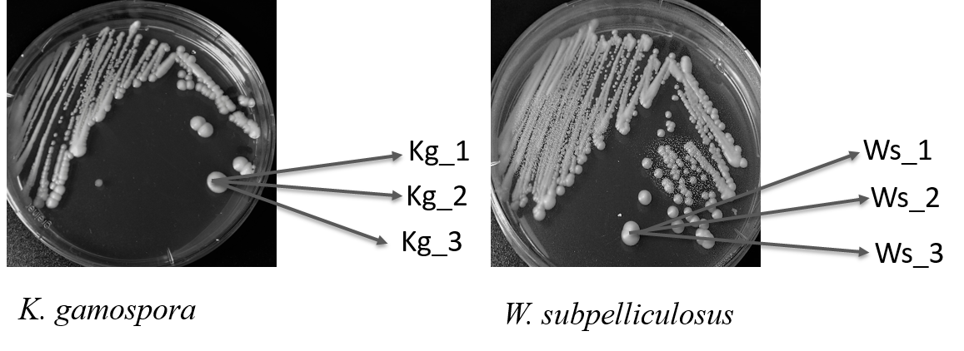
Supplementary Figure 1. Graphic view of the designation of strain identities. A single colony from K. gamospora plate was picked and used to inoculate into three parallel replicate Eppendorf tubes containing flour dough and designated as Kg_1, Kg_2, and Kg_3. Similarly replicates of colony from W. subpelliculosus plates were designated as Ws_1, Ws_2, and Ws_3.

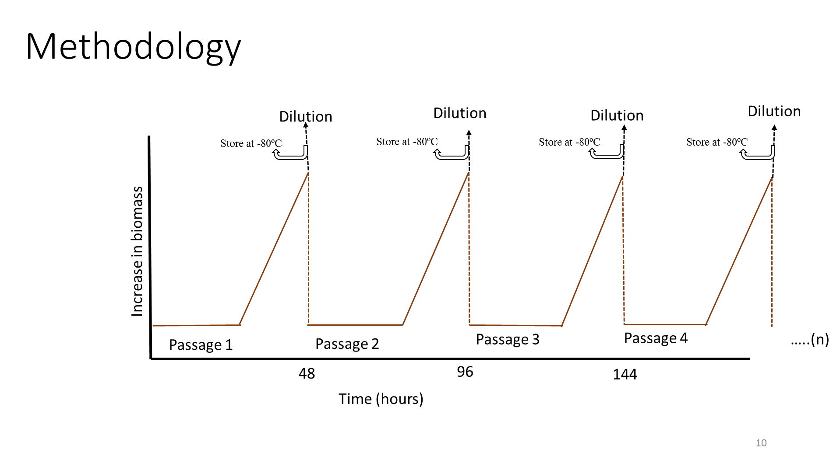
Supplementary Figure 2. Evolutionary engineering scheme used to evolve yeasts.
A single colony of cells was inoculated into flour and allowed to grow for 48 hours (Passage 1). After 48 hours of incubation, a pipette tip full of flour was used to inoculate a new tube with fresh and sterile flour, represented as Dilution. The remaining fermented flour was stored at ˗80 ºC. The red line shows the increment in yeast cell biomass (not investigated in this thesis). This procedure was repeated for 60 passages were serially diluted into a new tube and the previous tube was cryopreserved for future reference.

