Table 3. Synthesis of functionalized aromatic heterocyclesª
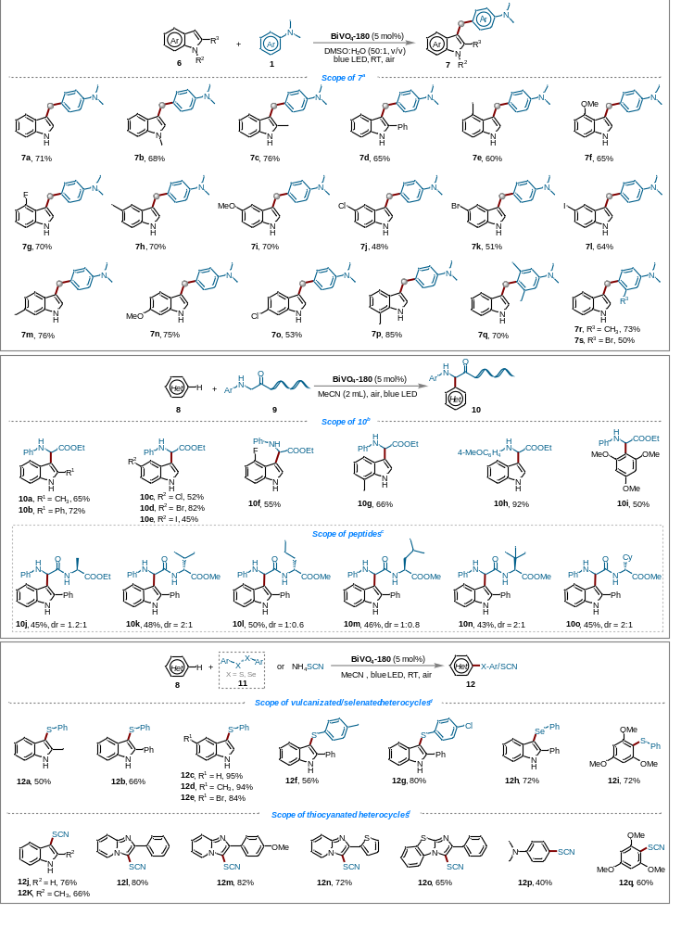
ªReaction conditions C: 6 (0.2 mmol), 1 (0.6 mmol), BiVO₄-180 (5 mol%), DMSO/H₂O (2.04 mL, v/v = 50/1) with the irradiation of blue LED (3 W) under air at room temperature for 3 h. Isolated yields were given. ^{b}Reaction conditions D: 8 (0.2 mmol), 9 (0.4 mmol), BiVO₄-180 (5 mol%), MeCN (2 mL) with the irradiation of blue LED (10 W) under air at room temperature for 24-72 h. Isolated yields were given. ^{c}Reaction for 72 h at 55 ºC. ^{d}Reaction conditions D: 8 (0.2 mmol), 11 or NH₄SCN (0.4 mmol), BiVO₄ (5 mol%), MeCN (2 mL) with the irradiation of blue LED (10 W) under air at room temperature for 5-24 h. Isolated yields were given.

