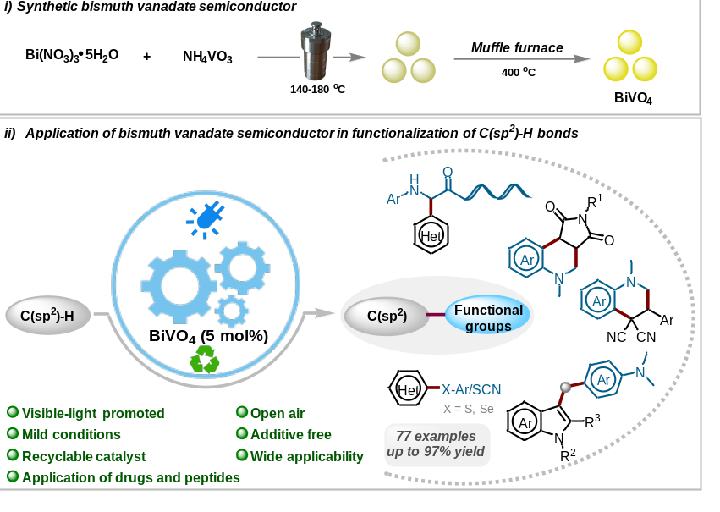
Scheme 1. Synthesis of BiVO₄ and its application in photocatalytic C-H functionalization.
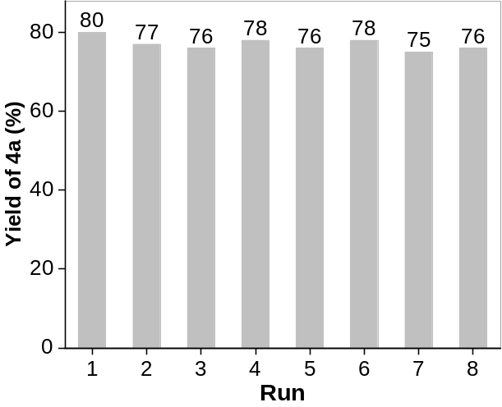
Scheme 2. Recyclability of the catalyst.
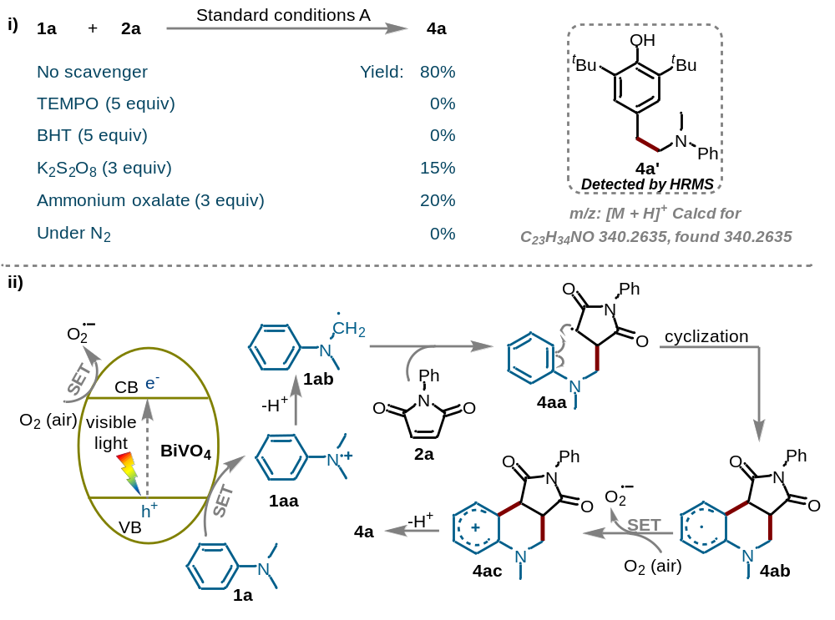
Scheme 3. i) Control experiments, ii) Plausible mechanism.

