Supplementary Material

Supplementary Table 1: All 23 microRNA Taqman advanced assays used in the custom pre-coated 384 well plates (Thermo Fisher Scientific, cat#44279775).
microRNA | Assay ID
hsa-miR-181a-5p | 477857_mir
hsa-miR-320a-3p | 478594_mir
hsa-miR-148a-3p | 477814_mir
hsa-miR-19a-3p | 479228_mir
hsa-miR-339-5p | 478040_mir
hsa-miR-21-5p | 477975_mir
hsa-miR-145-5p | 477916_mir
hsa-miR-16-5p | 477860_mir
hsa-miR-18a-5p | 478551_mir
hsa-miR-126-5p | 477888_mir
hsa-miR-92a-3p | 477827_mir
hsa-miR-99b-5p | 478343_mir
hsa-miR-222-3p | 477982_mir
hsa-miR-29c-5p | 478005_mir
hsa-miR-151a-5p | 478505_mir
hsa-miR-425-5p | 478094_mir
hsa-miR-374b-5p | 478389_mir
hsa-miR-153-3p | 477922_mir
hsa-miR-125a-5p | 477884_mir
hsa-miR-30b-5p | 478007_mir
hsa-miR-155-5p | 477927_mir
hsa-miR-221-3p | 477981_mir
hsa-miR-205-5p | 477967_mir

Supplementary Table 2: Baseline and threshold settings per microRNA of the qPCR analysis. Values indicated with an asterisk were determined by the Thermo Fisher cloud system as default baseline.
microRNA | Baseline minimum | Baseline maximum | Threshold
hsa-miR-125a-5p | 7 | 13 | 0.150
hsa-miR-126-5p | 10 | 20 | 0.050
hsa-miR-145-5p | 6 | 12 | 0.170
hsa-miR-148a-3p | 6 | 12 | 0.120
hsa-miR-151a-5p | 9 | 18 | 0.040
hsa-miR-153-3p | 9 | 22 | 0.100
hsa-miR-155-5p | 6 | 16 | 0.200
hsa-miR-16-5p | 6* | 12* | 0.110
hsa-miR-181a-5p | 6 | 14 | 0.081
hsa-miR-18a-5p | 11 | 21 | 0.040
hsa-miR-19a-3p | 8* | 15* | 0.055
hsa-miR-205-5p | 3* | 15* | 0.080
hsa-miR-21-5p | 3* | 15* | 0.120
hsa-miR-221-3p | 6 | 14 | 0.100
hsa-miR-222-3p | 3* | 15* | 0.100
hsa-miR-29c-5p | 8 | 15 | 0.180
hsa-miR-30b-5p | 7 | 13 | 0.070
hsa-miR-320a-3p | 6 | 15 | 0.050
hsa-miR-339-5p | default | default | 0.080
hsa-miR-374b-5p | 13 | 20 | 0.095
hsa-miR-425-5p | default | default | 0.130
hsa-miR-92a-3p | default | default | 0.090
hsa-miR-99b-5p | default | default | 0.040

Supplementary Table 3: Overview of binary participants’ characteristics of the breast cancer and healthy control cohort. Variables presented are: having a history of breast disease (benign and/or malignant), having a history of benign breast disease, having undergone breast surgery, having provided breastfeeding, currently smoking, having smoked or currently smoking (ever), currently consuming alcohol, and having consumed or currently consuming alcohol (ever). Significance was tested using Fishers exact, for variables containing groups smaller than 5 (indicated with an asterisk), or with a chi-square test. P values of these tests are given in the last column.
 | Breast Cancer (N = 135) |  |  | Healthy Controls (N = 114) |  |  | Comparison
 | Yes | No | Missing | Yes | No | Missing | P value
Breast disease history* | 23 (24.0%) | 73 (76.0%) | 39 | 1 (100%) | 0 (0%) | 113 | 0.247
Previous benign lump | 30 (24.2%) | 94 (75.8%) | 11 | 22 (19.5%) | 91 (80.5%) | 1 | 0.471
Previous breast surgery | 13 (10.5%) | 111 (89.5%) | 11 | 7 (6.2%) | 106 (93.8%) | 1 | 0.341
Breastfeeding | 84 (67.7%) | 40 (32.3%) | 11 | 89 (78.8%) | 24 (21.2%) | 1 | 0.078
Smoking current* | 15 (12.5%) | 105 (87.5%) | 15 | 3 (2.7%) | 110 (97.4%) | 1 | 0.006
Smoking ever | 66 (55.0%) | 54 (45.0%) | 15 | 54 (47.8%) | 59 (52.2%) | 1 | 0.332
Alcohol current | 99 (82.5%) | 21 (17.5%) | 15 | 93 (82.3%) | 20 (17.7%) | 1 | 1.000
Alcohol ever | 103 (85.8%) | 17 (14.2%) | 15 | 99 (87.6%) | 14 (12.4%) | 1 | 0.837

Supplementary Table 4: Overview of participants’ characteristics of the breast cancer and healthy control cohorts. Variables presented are breast density, the combination variable of parity with and without breastfeeding, age at first birth, smoking, alcohol use, location of breast tumor, histological subtype, number of positive lymph nodes, focality of the tumor, diameter of the tumor in cm, diameter of the tumor in categories, and mitotic count. Significance was tested using Fishers exact, for variables containing groups smaller than 5 (indicated with an asterisk), or with a chi-square test. P values of these tests are given in the last column.
 | Breast Cancer (N = 135) | Healthy Controls (N = 114) | Comparison
Breast density | n (%) | n (%) | NA
A | 12 (13.3%) | NA | NA
B | 33 (36.7%) | NA | NA
C | 34 (37.8%) | NA | NA
D | 11 (12.2%) | NA | NA
Missing | 45 | 114 | NA
Parity and breastfeeding | n (%) | n (%) | 0.104
Nulliparous | 20 (16.1%) | 15 (13.3%) | 0.104
Parous and no breastfeeding | 20 (16.1%) | 9 (8.0%) | 0.104
Parous with breastfeeding | 84 (67.7%) | 89 (67.7%) | 0.104
Missing | 11 | 1 | 0.104
Age at first birth | n (%) | n (%) | 0.277
<30 years old | 62 (59.6%) | 50 (51.0%) | 0.277
≥ 30 years old | 42 (40.4%) | 48 (49.0%) | 0.277
Missing | 31 | 16 | 0.277
Smoking* | n (%) | n (%) | 0.016
No, never | 54 (45.0%) | 59 (52.2%) | 0.016
No, in the past yes | 51 (42.5%) | 51 (45.1%) | 0.016
Yes | 15 (12.5%) | 3 (2.7%) | 0.016
Missing | 11 | 2 | 0.016
Alcohol* | n (%) | n (%) | 0.859
No, never | 17 (14.3%) | 14 (12.4) | 0.859
No, but in the past yes | 4 (3.4%) | 6 (5.3%) | 0.859
Yes, <1 times a week | 39 (32.8%) | 39 (34.5%) | 0.859
Yes, >1 times a week | 59 (49.6%) | 54 (47.8%) | 0.859
Missing | 16 | 1 | 0.859
Breast cancer laterality | n (%) | n (%) | NA
Left | 68 (50.4%) | NA | NA
Right | 63 (46.7%) | NA | NA
Left and right | 4 (3.0%) | NA | NA
Missing | 0 | NA | NA
Histological subtype | n (%) | n (%) | NA
Invasive carcinoma no special type | 82 (78.1%) | NA | NA
Invasive lobular carcinoma | 23 (21.9%) | NA | NA
Missing | 30 | NA | NA
Number of positive lymph nodes | n (%) | n (%) | NA
0 | 98 (79.7%) | NA | NA
1 | 24 (19.5%) | NA | NA
2 | 1 (0.8%) | NA | NA
Missing | 12 | NA | NA
Focality | n (%) | n (%) | NA
Unifocal | 96 (78.1%) | NA | NA
Multifocal | 23 (18.7%) | NA | NA
Bilateral | 4 (3.3%) | NA | NA
Missing | 12 | NA | NA
Diameter tumor categories | n (%) | n (%) | NA
≤ 2 cm | 92 (70.8%) | NA | NA
> 2 cm | 38 (29.2%) | NA | NA
Missing | 5 | NA | NA
Diameter tumor | Millimeter | Millimeter | NA
Median | 14 | NA | NA
Interquartile range | 11.6-21.0 | NA | NA
Missing | 5 | NA | NA
Mitotic count | Number | Number | NA
Median | 4 | NA | NA
Interquartile range | 2-8 | NA | NA
Missing | 14 | NA | NA

Supplementary Table 5: Overview of nipple aspirate fluid sample characteristics of the breast cancer and healthy control cohorts. The data is split into three groups: the affected breast of the breast cancer patient, the contralateral breast of the breast cancer patient, and the healthy controls (including samples of both left and right breasts). The variables include the absolute microRNA concentration (measured with Qubit), the microRNA input in categories for cDNA synthesis, the cloudiness, the viscosity, and the RAL color. To test for significant differences between affected, contralateral, and healthy controls, a Kruskal Wallis test (microRNA concentration) and a chi square test (others), with pairwise comparison with Bonferroni Holm correction (given in P value column between brackets), was used.
 | Affected breast  (N = 129) | Contralateral breast  (N = 124) | Healthy Controls  (N = 211) | P value
Absolute microRNA concentration | ng/µL | ng/µL | ng/µL | 0.502
Median | 2.2 | 2.2 | 2.2 | 0.502
Interquartile range | 1.0-3.8 | 1.0-4.5 | 1.3-4.2 | 0.502
Too low samples | 3 | 4 | 1 | 0.502
microRNA input | n (%) | n (%) | n (%) | 0.075
< 2 ng | 34 (26.4%) | 36 (29.0%) | 37 (17.6%) | 0.075
2 ng | 21 (16.3%) | 21 (16.9%) | 50 (23.8%) | 0.075
4 ng | 74 (57.4%) | 67 (54.0) | 123 (57.4%) | 0.075
Missing | 0 | 012 | 1 | 0.075
Cloudiness | n (%) | n (%) | n (%) | 0.006 (BC vs. HC = 0.038; CL vs. HC = 0.017)
Cloudy | 61 (47.3%) | 55 (44.7%) | 128 (61.0%) | 0.006 (BC vs. HC = 0.038; CL vs. HC = 0.017)
Clear | 68 (52.7%) | 68 (55.3%) | 82 (39.1%) | 0.006 (BC vs. HC = 0.038; CL vs. HC = 0.017)
Missing | 0 | 1 | 1 | 0.006 (BC vs. HC = 0.038; CL vs. HC = 0.017)
Viscosity | n (%) | n (%) | n (%) | 0.008 (no significance in pairwise comparison)
Viscous | 25 (19.4%) | 24 (19.4%) | 67 (31.9%) | 0.008 (no significance in pairwise comparison)
Watery | 104 (80.6%) | 100 (80.7%) | 143 (68.1%) | 0.008 (no significance in pairwise comparison)
Missing | 0 | 0 | 1 | 0.008 (no significance in pairwise comparison)
Color | n (%) | n (%) | n (%) | 0.575
Colorless | 35 (27.3%) | 35 (28.2%) | 49 (25.2%) | 0.575
White | 24 (18.8%) | 23 (7.3%) | 40 (15.2%) | 0.575
Beige | 29 (22.7%) | 26 (21.0%) | 49 (23.3%) | 0.575
Yellow | 17 (13.3%) | 9 (7.3%) | 32 (15.2%) | 0.575
Green | 11 (8.6%) | 18 (14.5%) | 23 (11.0%) | 0.575
Orange/bloody | 12 (9.4%) | 13 (10.5%) | 13 (6.2%) | 0.575
Missing | 1 | 0 | 1 | 0.575

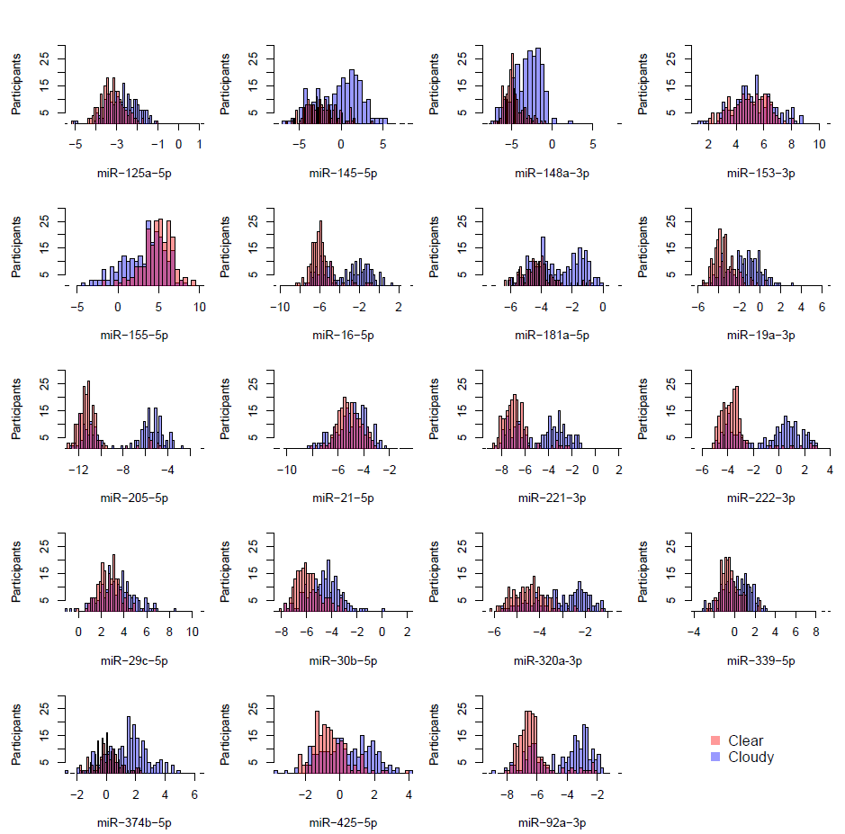
Supplementary Figure 1: Overview of microRNA distribution divided by cloudiness. Histograms of all microRNAs are given, where the blue bars indicate the cloudy samples and the red bars indicate the clear samples. The purple areas are bars where the ∆Ct of cloudy and clear overlaps. The x-axis represents the microRNA concentration in ∆Ct and the y-axis presents the number of participants.

Supplementary Table 6: Overview of differences in normalized microRNA expression levels in the context of participant and tumor characteristics (45 variables). The ∆Ct value of microRNA expression levels were corrected for nipple aspirate fluid cloudiness and RNA input. The statistical test used is indicated in the second column. Rows 2-6 of sheet 1 shows the P value of the interrogated microRNAs based on the nipple aspirate fluid characteristics. Rows 9-26 of sheet 1 shows the P value of the interrogated microRNAs based on the characteristics obtained through the questionnaire. Rows 28-40 of sheet 1 shows the P value of the interrogated microRNAs based on the tumor characteristics. The significant P values (P ≤ 0.05) are indicated in green, while non-significant values are indicated in red (P > 0.05, before Bonferroni Holm correction). Row 42 - 46 of sheet 1 shows the Pearson/Spearman correlation coefficients. Variables that are indicated with an asterisk contain more than two groups, and therefore a post-hoc test (Tukey HSD) was performed, of which the results are represented in separate sheets (indicated by variable name). Sheet 2 indicates the significance of all variables after Bonferroni Holm correction. Categories for each variable can be found in Table S3-5.

Supplementary Table 7: Contingency table of nipple aspirate color and cloudiness. A Chi-squared test was used with Bonferroni post-hoc test to determine significance.
 | Clear | Cloudy | P value
Colorless | 117 | 5 | <0.001
White | 18 | 69 | <0.001
Beige | 37 | 68 | 0.091
Yellow | 18 | 40 | 0.106
Green/brown | 5 | 47 | <0.001
Orange/bloody | 22 | 16 | 1.000

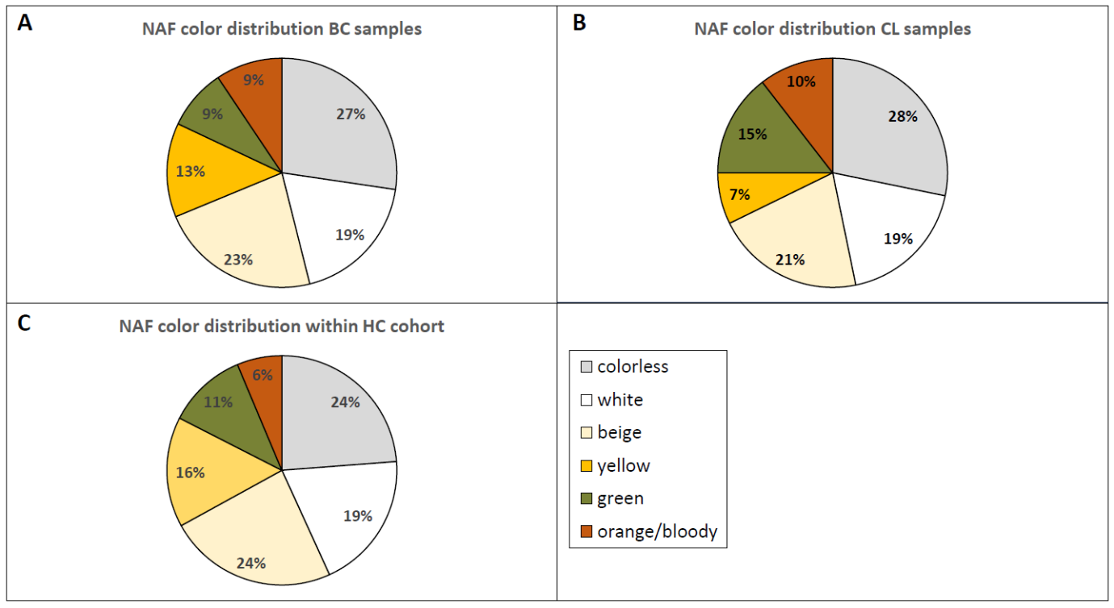
Supplementary Figure 2: Pie charts of nipple aspirate fluid color distribution within the affected breast samples (breast cancer (BC)), contralateral breast samples (CL) and healthy control samples (HC). Legend indicates the different colors of nipple aspirate fluid: colorless, white, beige, yellow, green, orange/bloody. Percentages for each color are indicated within the pie charts.

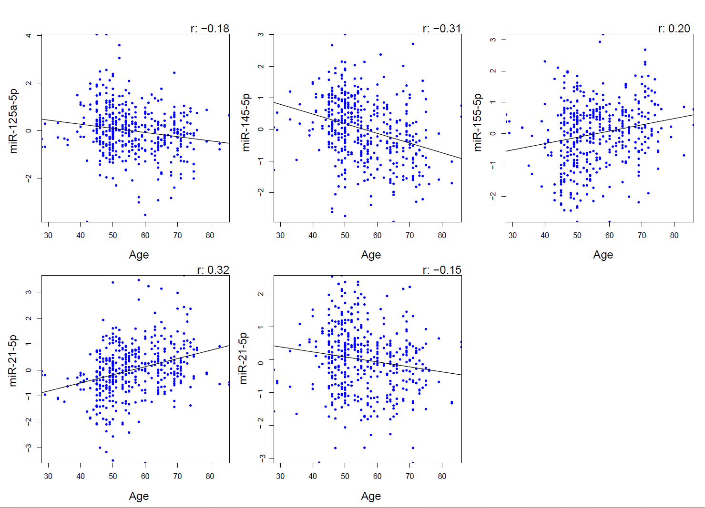
Supplementary Figure 3: Correlation plots of age of nipple aspirate fluid collection and microRNA expression level. The expression levels are given as ΔCt values and age is given in years. The Pearson correlation coefficient analysis is given in the upper right corner of each plot.

Supplement 2: Detailed explanation of the categorical variables with significant differences in microRNA expression levels between categories after Bonferroni Holm correction. This includes the variables parity combined with breastfeeding, and breastfeeding.

Supplementary Table 8: Expression level of 20 microRNAs in breast cancer patients and healthy controls. Median RT-qPCR Ct value, range, and number of missing values (undetermined Ct value) are indicated per microRNA. For healthy controls, both left and right breast samples (if present) were taken along. For patients, the affected and contralateral breast are shown separately. Four samples from the healthy control group were excluded from this table due to poor quality. Similarly, one sample from the contralateral group was excluded.
 | Healthy controls (N = 207) |  |  | Affected breast (N = 129) |  |  | Contralateral breast (N = 123)
 | Median Ct | Range | Missing | Median Ct | Range | Missing | Median Ct | Range | Missing
miR-125a-5p | 21.8 | 18.8-30.6 | 0 | 21.6 | 19.4-27.8 | 0 | 21.6 | 18.4-30.7 | 1
miR-145-5p | 23.2 | 16.3-32.4 | 2 | 23.8 | 17.4-32.1 | 2 | 23.3 | 17.5-31.3 | 2
miR-148a-3p | 20.9 | 17.4-35.3 | 0 | 20.6 | 17.4-27.2 | 0 | 20.0 | 16.9-27.7 | 0
miR-153-3p | 30.2 | 27.4-34.7 | 2 | 29.7 | 23.0-34.1 | 0 | 29.8 | 26.4-32.6 | 0
miR-155-5p | 29.1 | 19.8-36.0 | 0 | 29.0 | 20.4-35.4 | 0 | 28.6 | 20.8-37.8 | 0
miR-16-5p | 19.6 | 14.0-34.1 | 0 | 19.2 | 10.8-27.8 | 0 | 19.2 | 13.4-27.1 | 0
miR-181a-5p | 21.1 | 17.7-28.9 | 0 | 20.5 | 17.4-26.8 | 0 | 20.7 | 17.7-29.5 | 0
miR-19a-3p | 22.2 | 18.3-32.4 | 0 | 22.0 | 16-3.26.0 | 0 | 21.4 | 17.5-28.1 | 0
miR-205-5p | 14.1 | 11.8-23.7 | 0 | 14.4 | 11.8-23.4 | 0 | 13.8 | 11.2-23.1 | 0
miR-21-5p | 20.0 | 15.0-27.7 | 0 | 19.6 | 15.5-25.7 | 0 | 19.4 | 14.8-24.4 | 0
miR-221-3p | 18.3 | 16.2-26.5 | 2 | 18.1 | 16.1-26.0 | 0 | 18.1 | 15.7-26.1 | 0
miR-222-3p | 22.0 | 19.0-32.6 | 0 | 21.6 | 19.1-29.8 | 0 | 21.7 | 18.5-29.2 | 0
miR-29c-5p | 27.9 | 24.6-37.0 | 0 | 27.2 | 23.3-34.8 | 0 | 27.2 | 23.6-36.3 | 0
miR-30b-5p | 19.6 | 16.7-32.8 | 0 | 19.1 | 15.2-28.0 | 0 | 18.8 | 16.1-31.7 | 0
miR-320a-3p | 20.8 | 18.2-26.1 | 0 | 20.5 | 16.9-27.1 | 0 | 20.4 | 17.7-26.6 | 0
miR-339-5p | 24.4 | 21.2-34.9 | 0 | 24.3 | 20.9-30.4 | 0 | 24.1 | 21.2-34.2 | 0
miR-374b-5p | 25.7 | 23.0-32.0 | 0 | 25.0 | 21.1-31.4 | 0 | 24.7 | 22.1-31.3 | 0
miR-425-5p | 24.8 | 20.2-31.9 | 0 | 24.5 | 17.4-32.2 | 0 | 24.1 | 20.6-31.3 | 0
miR-92a-3p | 19.1 | 15.4-27.4 | 0 | 18.9 | 12.4-25.4 | 0 | 18.8 | 14.5-27.8 | 0
miR-99b-5p | 24.9 | 22.1-30.7 | 0 | 24.6 | 21.7-31.2 | 0 | 24.5 | 21.8-30.7 | 0

Supplementary Table 9: Analysis of ΔCt among healthy controls (HC), the affected breast (BC), and the contralateral breast (CL). Significance was tested using a t-test (first two columns) and a paired t-test for the comparison of the affected and contralateral breast within one patient (last column). The ΔCt was corrected for cloudiness and RNA input.
 | HC vs. BC | HC vs. CL | BC vs. CL
miR-125a-5p | 0.044 | 0.040 | 0.476
miR-145-5p | 0.004 | 0.164 | 0.027
miR-148a-3p | 0.009 | 0.018 | 0.760
miR-153-3p | 0.004 | 0.108 | 0.030
miR-155-5p | 0.179 | 0.407 | 0.585
miR-16-5p | 0.180 | 0.470 | 0.287
miR-181a-5p | 0.048 | 0.364 | 0.676
miR-19a-3p | 0.518 | 0.443 | 0.184
miR-205-5p | 0.588 | 0.730 | 0.125
miR-21-5p | 0.017 | 0.093 | 0.730
miR-221-3p | 0.754 | 0.729 | 0.066
miR-222-3p | 0.210 | 0.160 | 0.064
miR-29c-5p | 0.002 | 0.008 | 0.652
miR-30b-5p | 0.032 | 0.093 | 0.655
miR-320a-3p | 0.480 | 0.582 | 0.086
miR-339-5p | 0.078 | 0.099 | 0.500
miR-374b-5p | 0.008 | 0.053 | 0.501
miR-425-5p | 0.137 | 0.207 | 0.273
miR-92a-3p | 0.076 | 0.110 | 0.112

Supplementary Table 10: Relative microRNA expression in breast cancer patients versus healthy controls. A linear regression was performed for each individual microRNA, also including age, nipple aspirate fluid cloudiness, and RNA input in this model. Fold changes, lower limit and upper limit of the 95% confidence interval, and P value are given for each microRNA. This analysis was performed with 129 breast cancer samples (except for miR-145-5p that contained 1 missing) and 113 healthy control samples.
microRNA | Fold change | Lower limit | Upper limit | P value
miR-125a-5p | 1.036 | 0.898 | 1.194 | 0.627
miR-145-5p | 0.560 | 0.362 | 0.866 | 0.009
miR-148a-3p | 1.287 | 0.991 | 1.671 | 0.059
miR-153-3p | 1.566 | 1.179 | 2.080 | 0.002
miR-155-5p | 1.672 | 1.072 | 2.608 | 0.024
miR-16-5p | 1.234 | 0.885 | 1.722 | 0.214
miR-181a-5p | 1.222 | 0.962 | 1.551 | 0.100
miR-19a-3p | 1.184 | 0.881 | 1.592 | 0.263
miR-205-5p | 0.919 | 0.594 | 1.423 | 0.705
miR-21-5p | 1.414 | 1.125 | 1.776 | 0.003
miR-221-3p | 0.880 | 0.629 | 1.232 | 0.456
miR-222-3p | 1.073 | 0.751 | 1.533 | 0.698
miR-29c-5p | 1.413 | 1.085 | 1.839 | 0.010
miR-30b-5p | 1.236 | 0.978 | 1.561 | 0.076
miR-320a-3p | 1.041 | 0.844 | 1.284 | 0.705
miR-339-5p | 1.227 | 0.968 | 1.556 | 0.091
miR-374b-5p | 1.334 | 1.071 | 1.662 | 0.010
miR-425-5p | 1.196 | 0.958 | 1.494 | 0.114
miR-92a-3p | 1.171 | 0.895 | 1.532 | 0.248

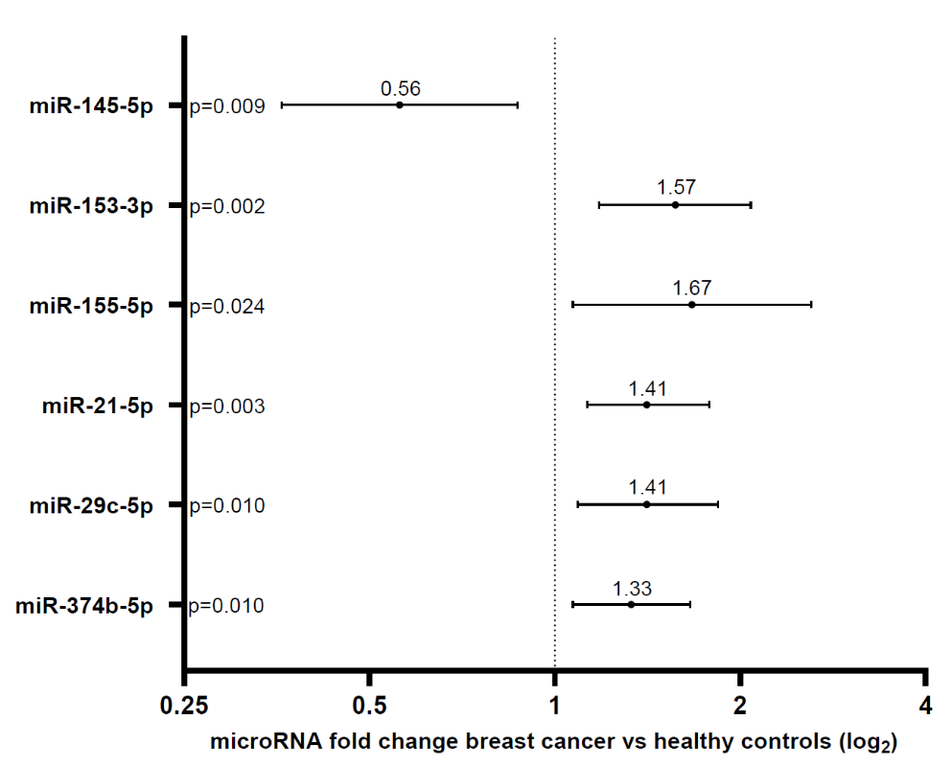
Supplementary Figure 4: Relative microRNA (microRNA) expression in breast cancer patients versus healthy controls. The y-axis indicate the significant microRNAs (P value given). The x-axis represents the fold change (logarithmic scale), with 95% confidence interval. This analysis was performed with 129 breast cancer samples (except for miR-145-5p that contained 1 missing) and 113 healthy control samples. Values larger than 1 indicate upregulation of the microRNA in breast cancer patients, while values below 1 indicate downregulation of the microRNA.
Supplementary Table 11: Breast cancer adjusted odds ratios (OR) based on individual microRNA expression levels. A logistic regression was performed based on individual microRNA expression levels, including age, nipple aspirate fluid cloudiness, and RNA input as covariates. Adjusted odds ratios, lower limit and upper limit of the 95% confidence interval, and P value are given for each microRNA. This analysis was performed with 129 breast cancer samples (except for miR-145-5p that contained 1 missing) and 113 healthy control samples.
microRNA | Adjusted odds ratio | Lower limit | Upper limit | P value
miR-125a-5p | 1.087 | 0.779 | 1.524 | 0.624
miR-145-5p | 0.862 | 0.766 | 0.963 | 0.010
miR-148a-3p | 1.192 | 0.996 | 1.435 | 0.059
miR-153-3p | 1.312 | 1.106 | 1.572 | 0.002
miR-155-5p | 1.134 | 1.019 | 1.268 | 0.023
miR-16-5p | 1.096 | 0.951 | 1.267 | 0.208
miR-181a-5p | 1.186 | 0.972 | 1.453 | 0.095
miR-19a-3p | 1.097 | 0.935 | 1.293 | 0.256
miR-205-5p | 0.978 | 0.877 | 1.090 | 0.692
miR-21-5p | 1.375 | 1.115 | 1.717 | 0.004
miR-221-3p | 0.946 | 0.819 | 1.089 | 0.443
miR-222-3p | 1.027 | 0.899 | 1.173 | 0.696
miR-29c-5p | 1.273 | 1.061 | 1.546 | 0.012
miR-30b-5p | 1.205 | 0.983 | 1.495 | 0.079
miR-320a-3p | 1.046 | 0.834 | 1.312 | 0.698
miR-339-5p | 1.195 | 0.977 | 1.488 | 0.095
miR-374b-5p | 1.280 | 1.071 | 1.664 | 0.011
miR-425-5p | 1.189 | 0.962 | 1.479 | 0.112
miR-92a-3p | 1.111 | 0.932 | 1.328 | 0.243

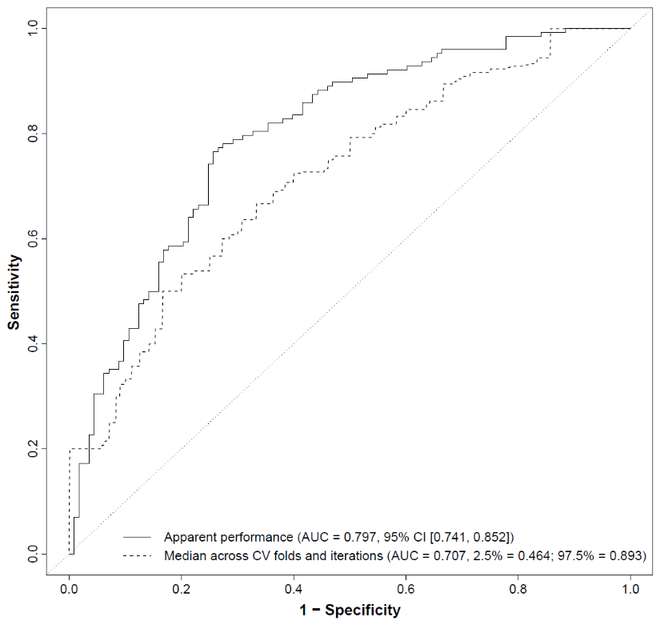
Supplementary Figure 5: Receiver operating characteristics curve illustrating the performance of a 20-microRNA model to differentiate breast cancer patients and healthy controls. This model does not include the variable age. The x-axis indicates 1 minus specificity, and the y-axis indicates sensitivity. The solid line indicates the ROC curve of the LASSO regression model without cross-validation, while the dotted line shows cross-validation results. Area under the curve (AUC) values together with the 95% confidence interval of the apparent AUC and the 2.5th and 97.5th percentile of the cross-validated AUC are given in the right corner.
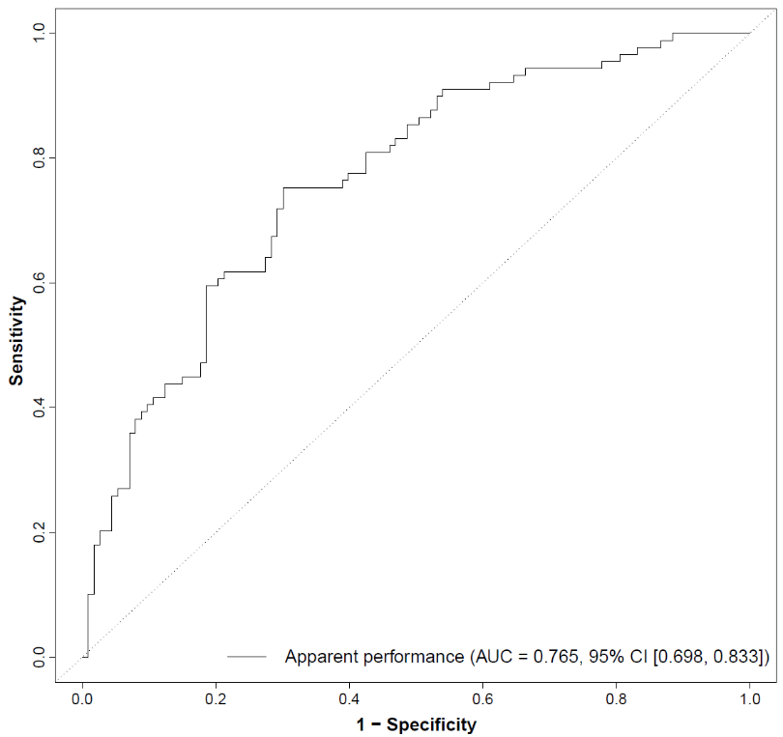
Supplementary Figure 6: Receiver operating characteristics curve illustrating the performance of a 20-microRNA model to differentiate between Luminal A-like breast cancer and healthy controls. This model also contains the variable age. The x-axis indicates 1 minus specificity, and the y-axis indicates sensitivity. The area under the curve (AUC) value and 95% confidence interval is given in the right corner.

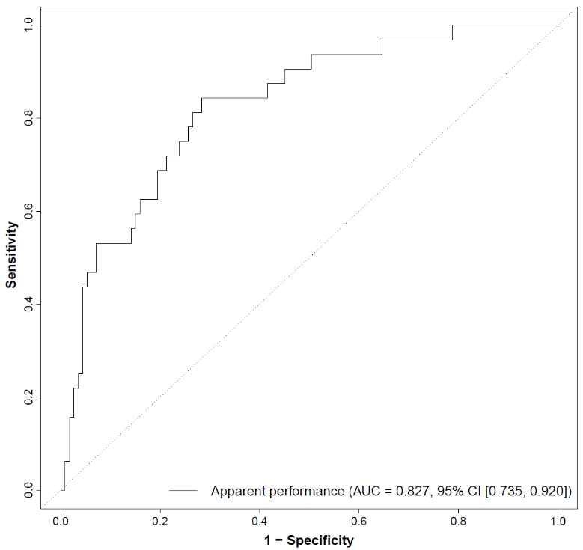
Supplementary Figure 7: Receiver operating characteristics curve illustrating the performance of a 20-microRNA model to differentiate between Luminal B-like breast cancer and healthy controls. This model also contains the variable age. The x-axis indicates 1 minus specificity, and the y-axis indicates sensitivity. The area under the curve (AUC) value and 95% confidence interval is given in the right corner.

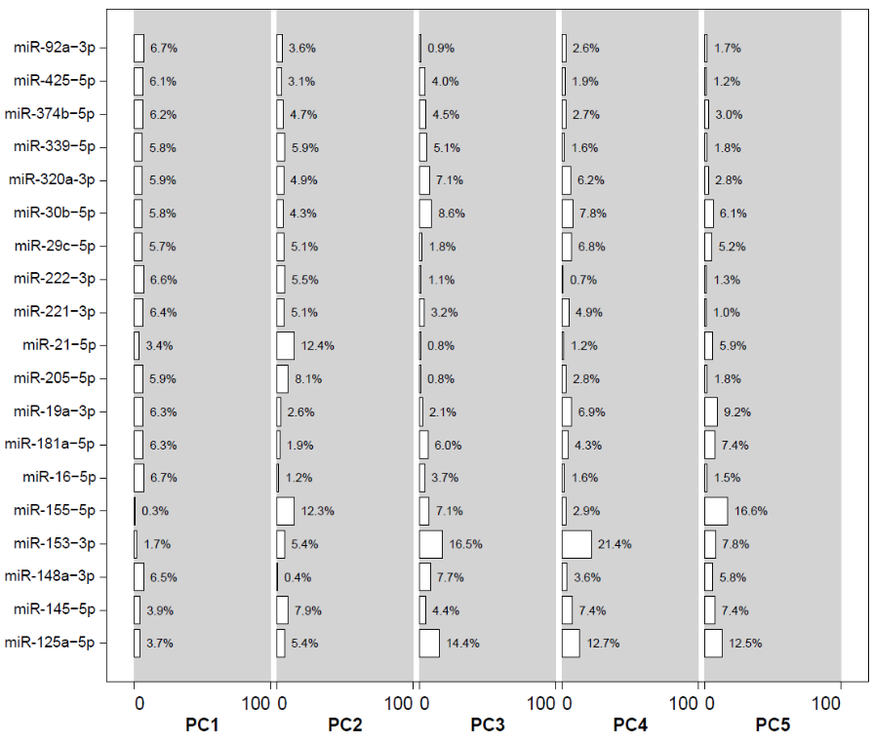
Supplementary Figure 8: Overview of microRNA distribution across the five principal components included in the model. The x-axis shows the percentage (0 to 100%) per principal component (PC1-PC5). The y-axis lists the microRNAs in our panel, with each bar showing the contribution of the individual microRNA to the principal component.
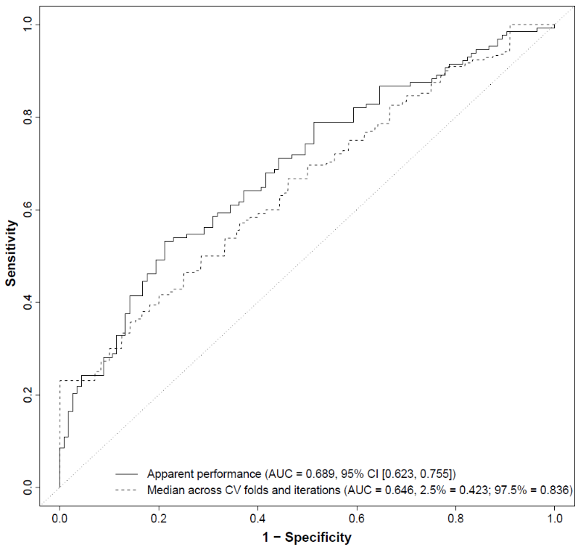
Supplementary Figure 9: Receiver operating characteristics curve illustrating the performance of a principal component model to differentiate between breast cancer patients and healthy controls. The principal components (PC1-5) in this model are based on a 20-microRNA panel together with age that explain 80% of variance within the principal component analysis. The x-axis indicates 1 minus specificity, and the y-axis indicates sensitivity. The solid line indicates the ROC curve of the LASSO regression model without cross-validation, while the dotted line shows cross-validation results. Area under the curve (AUC) values together with the 95% confidence interval of the apparent AUC and the 2.5th and 97.5th percentile of the cross-validated AUC are given in the right corner.

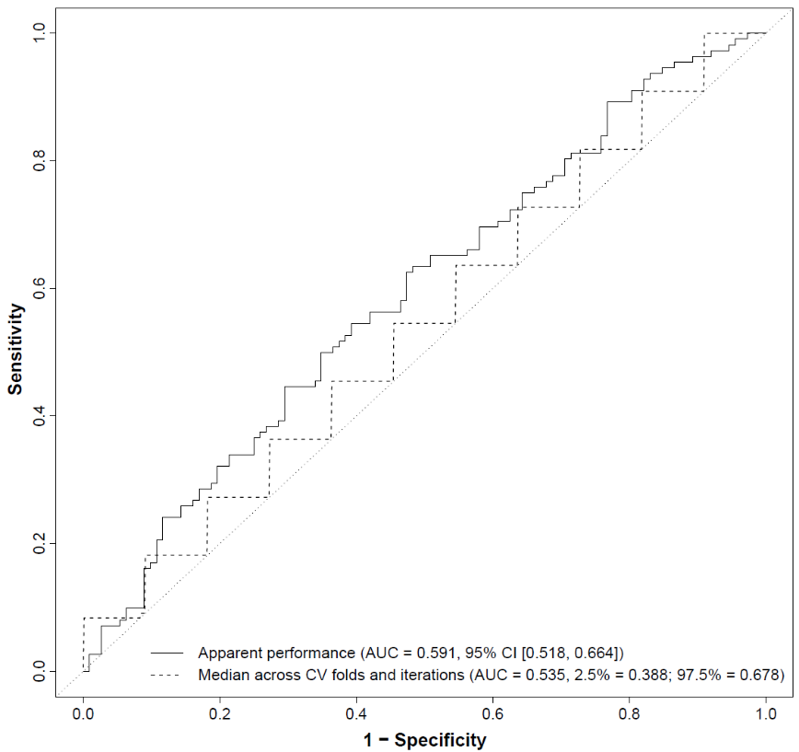
Supplementary Figure 10: Receiver operating characteristics curve illustrating the performance of a 20-microRNA model to differentiate the between affected and contralateral breast within breast cancer patients. This model does not include the variable age. The x-axis indicates 1 minus specificity, and the y-axis indicates sensitivity. The solid line indicates the ROC curve of the LASSO regression model without cross-validation, while the dotted line shows cross-validation results. Area under the curve (AUC) values together with the 95% confidence interval of the apparent AUC and the 2.5th and 97.5th percentile of the cross-validated AUC are given in the right corner.

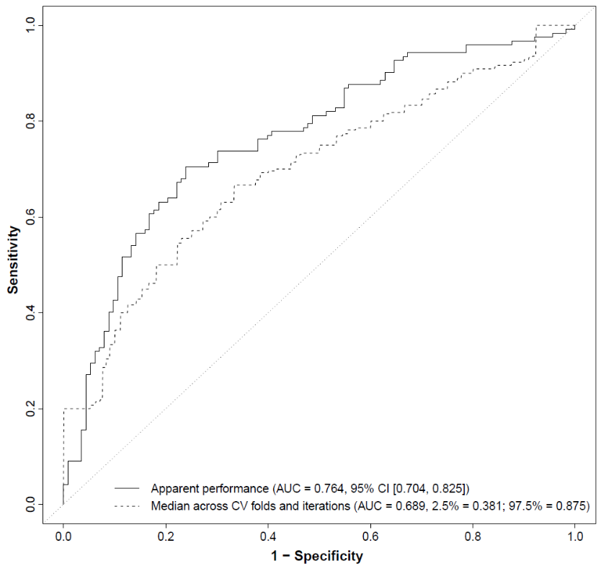
Supplementary Figure 11: Receiver operating characteristics curve illustrating the performance of a 20-microRNA model to differentiate the between contralateral breast of breast cancer patients and healthy controls. This model does not include the variable age. The x-axis indicates 1 minus specificity, and the y-axis indicates sensitivity. The solid line indicates the ROC curve of the LASSO regression model without cross-validation, while the dotted line shows cross-validation results. Area under the curve (AUC) values together with the 95% confidence interval of the apparent AUC and the 2.5th and 97.5th percentile of the cross-validated AUC are given in the right corner.

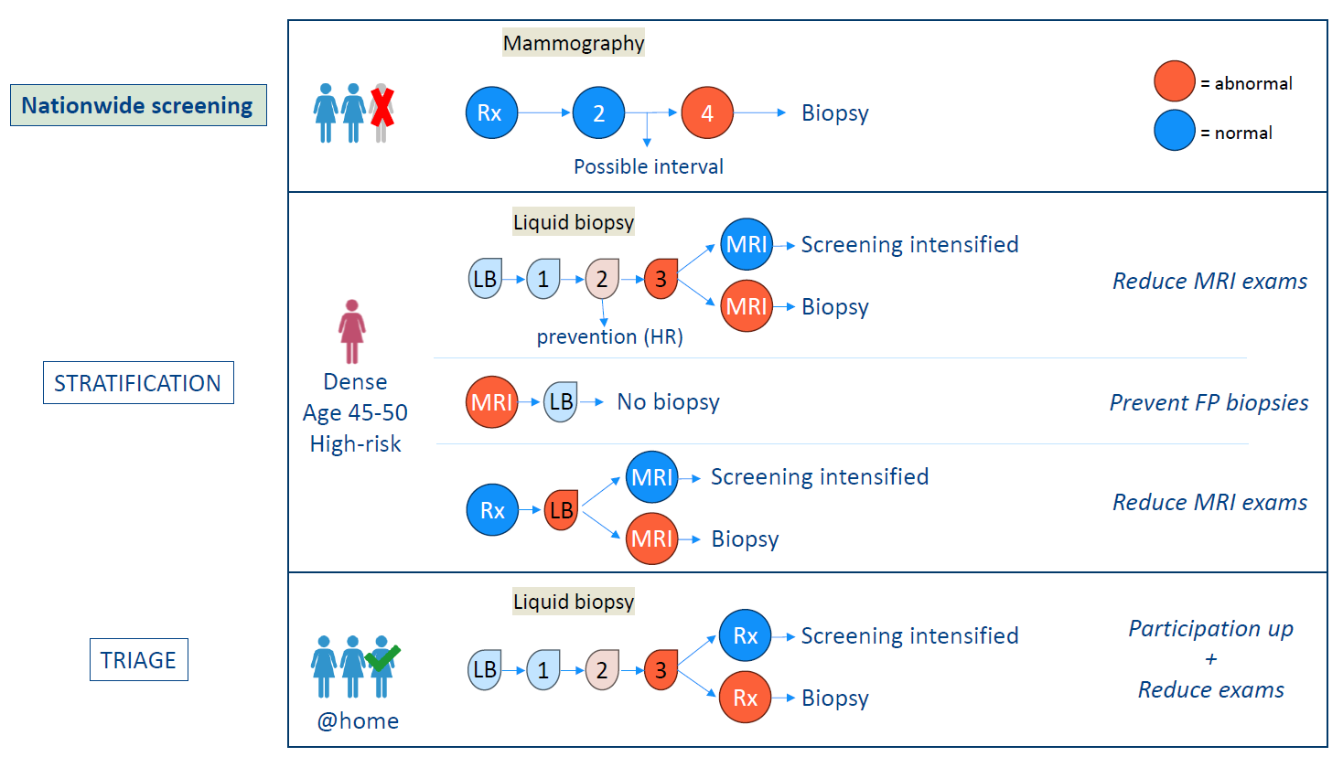
Supplementary Figure 12: Potential clinical strategies for implementing a nipple aspirate fluid microRNA panel in breast cancer detection. The upper box shows the current nationwide screening program, in which mammography (Rx) is used. When an abnormal result is obtained (orange circle), a biopsy is performed. One women is crossed out, since not the entire population participates in this screening, mainly due to the discomfort of mammography screening. The middle panel shows the possible ways of using the nipple aspirate fluid (NAF) microRNA test for stratification, for example in women with dense breast tissue, women aged 45-50, and/or women with an increased risk of developing breast cancer. Liquid biopsy (LB) as a primary test allows for more frequent screening, thereby possibly detecting interval cancers. Moreover, it could be used to detect breast cancer in an early stage, allowing for prevention. Furthermore, a positive LB test could stratify for magnetic resonance imaging (MRI), thereby reducing the number of MRI examinations. In the context of MRI, a LB test with a high negative predictive value could be used to prevent additional biopsies after a false-positive (FP) MRI result. Additionally, in women with dense breasts, a positive LB test after negative mammography could stratify for additional MRI. The last panel shows the possible way of using the NAF miRNA test for triage. Here a primary LB test could increase screening participation (especially in an at home setting). When a positive result is obtained in the LB, additional mammography could be performed.

Supplement 3: Questionnaire for the participants of this study. The first two pages were only filled out by the healthy volunteers before the start of the study, to determine if they were suitable as a healthy control. The other pages contain the questions that were filled out by both the healthy volunteers and the breast cancer patients. This document was presented to the participants in Dutch.

